

T LEVEL IN ANIMAL CARE AND MANAGEMENT
Supporting the development of contextualised core skills: critical thinking
ET-FOUNDATION.CO.UK

INTRODUCTION
Critical thinking
These critical thinking resources are contextualised for staff and learners working in the Animal and Agriculture curriculum areas. They are designed with a broad focus so that they can be adjusted to regional contexts.
Throughout the T Level course, learners need to develop Core Skill C (CSC) – critical thinking. Skill development may be evidenced through:
- problem-solving
- decision-making
- researching and planning, to include questioning
- evaluating pros and cons
- using logic and reasoned argument
- synthesising
- concluding.
These materials aim to support learners to develop these skills. It will be crucial for learners to have the opportunity to practise and hone these skills across their T Level course of study, including their Industry Placement.
The resources are designed as a framework for contextualised learning, discussion, problem-solving and self-reflection. The lessons are designed to incorporate a range of pedagogies including collaborative, reflective, inquiry and problem-based learning approaches.
The lessons should be delivered consecutively with sufficient time between them for learners to reflect on the knowledge, skills and behaviours gained. The teacher should highlight opportunities for further practice and direct learners to some of the extension activities included.
There is an expectation that teachers will adapt delivery and resources to meet the needs of individual learners. The teacher should support learners on their learning journeys. They should highlight opportunities for further practice and extension activities. Where possible, teachers should further contextualise scenarios and tasks to maximise benefits to individuals.
The lessons are designed to provide learners with:
- an understanding of the skills, knowledge and behaviours required for effective critical thinking
- an understanding of the common barriers to effective critical thinking
- an understanding of personal strengths and areas for development in relation to critical thinking
- a range of strategies and techniques that can be applied to solve problems
- enhanced skills and behaviours that can be applied in critical thinking situations.
Communication is an essential life skill and is also needed by learners to be successful in their T Level studies. Communication and critical thinking are closely linked, especially in T Level studies. Clear communication helps learners organise and express their thoughts logically, aiding problem-solving and decision-making.
Critical thinking encourages questioning, analysing information and forming well-reasoned arguments, which are essential for discussions, reports and collaboration. Strong communication skills ensure learners can explain complex ideas, justify their viewpoints, and engage effectively with peers and professionals, enhancing both their academic success and workplace readiness.
In this T Level there are embedded communication requirements, based on the general English competencies (GEC):
EC1: Conveying technical information to different audiences.
EC2: Presenting information and data.
EC3: Creating texts for difference purpose and audience
EC4: Summarising information and ideas
EC5: Synthesising information
EC6: Taking part in or leading discussions
Communication also features as a Core Skill in the T Level in Animal care and management, specifically Core Skill B (CSB) – communication. The development of this skill may be evidenced through:
- reading, writing, listening and speaking through the use of visual, oral and written methods
- demonstrating active listening
- building rapport
- engaging an audience
- adapting style and tone to audience needs and nature of the message.
Core Skills are assessed through the Employer-Set Project (ESP) and one or more examinations.
This resource has been developed to enable providers to plan for and develop in learners the oral communication skills needed to support them as they progress in their T Level studies, engage in their Industry Placement and particularly to complete their ESP assessment.
Communication is a Core Skill in some T Levels. As such, this resource may also be useful for those delivering other T Levels courses, such as Engineering manufacturing.

This resource has three sections:
Framework for Learning
The resource includes a Framework for Learning (FfL). This covers 20 hours of learning, and there is a diagram to show how the content of those hours has been sequenced and scaffolded. There is also a narrative that explains the sequencing and scaffolding in more detail.
Lesson plans
There is a lesson plan for each stage in the sequencing and scaffolding of learning in the FfL. Lesson plans include details of the support materials that are required to support delivery, including those found in this resource.
Support materials
The support materials identified in the lesson plans are also available towards the end of this document.
NOTE:
Each lesson will have a slide deck to help facilitate the learning objective and guide the teacher and learners. There is also a lesson plan for each lesson to fully support all teachers and their learners’ outcomes.

SECTION 1: FRAMEWORK FOR LEARNING
The Framework for Learning (FfL) sets out one approach to scaffolding and sequencing the development of critical thinking skills.
Effective critical thinking requires learners to be able to understand and apply the key concepts, behaviours, skills and knowledge of critical thinking and how they relate to the land-based industry.
For learners to accurately evaluate and make judgements, they must be able to assess the quality and relevance of information. They must also be able to recognise and reflect on the influence of their own perspectives, abilities and personal biases. Furthermore, effective critical thinkers must be reflective and continually develop their gaps in knowledge or current abilities.
There is also a rationale that provides more information on how the content is sequenced and scaffolded.
Sequencing and scaffolding
The following diagram shows how the development of critical thinking skills will be sequenced and scaffolded through this FfL.
The development of critical thinking skills in these lessons is carefully sequenced and scaffolded to ensure learners progressively build their understanding, skills and behaviours.
The structure follows a logical progression where each lesson builds upon prior knowledge and prepares learners for increasingly complex thinking tasks. Throughout each lesson, the teacher encourages their learners to explore additional topics and, where relevant, use further examples from the industry.
Lessons 1 and 2
Lessons 1 and 2, introduce the skills, knowledge and behaviours of critical thinking.
To develop these skills, lessons 1 and 2 focus on self-reflection, supporting learners to identify their current abilities, perspectives and biases while introducing foundational concepts such as logical reasoning, questioning and self-awareness.
As learners develop their self-reflection skills, they will be developing a clearer understanding of their own abilities and perspectives before moving onto the next lesson.
By the end of lesson 2, learners will have progressed to exercises designed to help them identify barriers to critical thinking including bias, the impact of perspective and influential language.
Lesson 3
Lesson 3 continues the development of learners’ attention to detail. They will learn techniques that will strengthen their ability to recognise the quality and structure of information provided. They will acquire an improved ability to identify, interpret and respond to arguments and different levels of reasoning.
Through a range of activities, lesson 3 strengthens learners’ ability to analyse information quality, recognise bias and evaluate sources critically.
Through lessons 1, 2 and 3, learners will have investigated the fundamentals of critical thinking and developed some of the skills needed to be a critical thinker.
At this stage, learners will have begun to recognise that there are differences in the quality of information they encounter.
Lesson 4 and 5
Lessons 4 and 5 aim to develop learners’ questioning techniques and their interrogation of information sources, progressing to identifying misleading or ambiguous information.
In lesson 4, learners will develop their abilities to effectively question, interrogate and challenge the sources of information and facts provided to them, in order to ensure that the information they use to make decisions is robust and reliable.
Lesson 5 cultivates these abilities further. By this point, learners will be ready to assess more complex material, including complicit, misleading and ambiguous information. Learners will look at legitimate sources of information and further develop their analytical skills.
Lesson 6
Lesson 6 introduces data interpretation and analysis, helping learners assess the credibility of numerical and graphical information.
Critical thinking situations often require supplementary or complementary information in the form of data, charts or graphs. Learners will learn to recognise the most appropriate use of data and identity when the presentation of data can be misleading.
This lesson is designed only as an introduction to data interpretation and analysis, and more detailed instruction should be developed across their whole course of study in order for learners to become fully proficient in this skill set.
Lesson 7
Lesson 7 aims to enhance learners’ analytical and reflective thinking, and the application of structured evaluation models to decision-making processes through a range of activities.
For example, learners will investigate models of evaluation and reflection, which are required to make effective decisions. Learners will develop skills to help them form better judgements and come to conclusions in order to make informed decisions. Learners will be introduced to a range of tools and models.
Learners should have now progressed to a point where they are regularly reflecting, developing and improving the skills and behaviours introduced in the preceding lessons.

Lesson 8 and 9
The final steps of the FfL come into play in lessons 8 and 9 when learners reflect on the skills they have developed and are given the opportunity to practise across a range of scenarios.
Lessons 8 and 9 provide real-world and industry-specific scenarios where learners apply their skills through case studies and simulations.
Lesson 10
Lesson 10 consolidates learning by assessing each learner’s overall development of critical thinking skills. The structured approach used in the previous nine lessons will have supported learners to develop a high level of analytical and evaluative skill, preparing them for solving complex problems in their respective fields.
Lesson 10 is therefore a contextualised case study, which will require learners to apply the skills, knowledge and behaviours needed to think critically. This lesson requires learners to apply their skills, knowledge and behaviours developed in the previous nine lessons. Learners will not only be assessed and given feedback but will also further develop their critical thinking skills by putting them into practice.
The activities in lesson 10 will result in learners developing a tool kit of problem-solving techniques to help support critical thinking and methods to encourage deeper processing skills. This will aim to achieve higher-level thinking developed throughout the 10 lessons.

FRAMEWORK FOR LEARNING

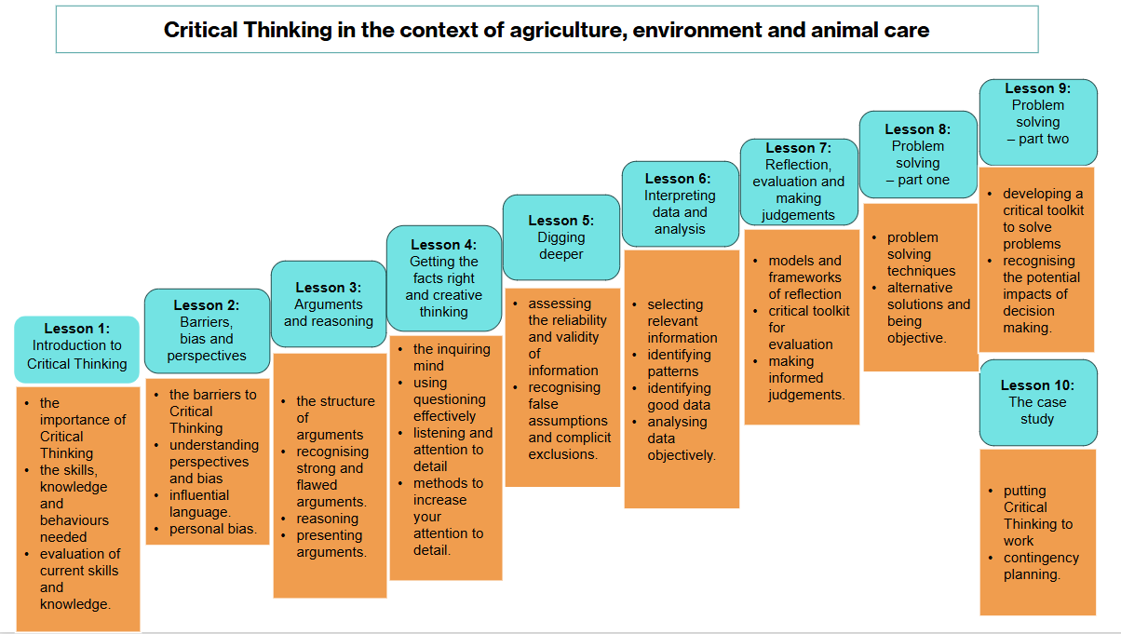

SECTION 2: LESSON PLANS
This section includes 10 lesson plans. The lesson plans follow the FfL. The lesson plans include the:
- lesson title
- targeted specification content coverage
- lesson number in the sequence
- total amount of time required to deliver the lesson
- teacher and learner activities to be undertaken throughout the lesson
- resources needed to deliver the lesson (see note below)
- details of how the lesson supports the development of English, maths or digital skills (where appropriate)
- details of how the lesson can be adapted to meet learners with specific needs
- next steps in learning, such as homework activities and links to the next lesson.
Note:
There is an assumption that the learning environment will include the following:
- materials to take notes (for example, pens, highlighter pens, paper, sticky notes, digital device and software)
- equipment to present a slide deck, classroom computer and projector or smartboard
- flipchart paper and holder
- access to digital devices (for example, computer, laptop, tablet) for all learners and printer
- internet access
- learner access to word-processing, spreadsheet and presentation software.

Lesson 1
Title: Introduction to critical thinking
Targeted content reference: Industry Placement, common core working in agriculture, environment and the animal care sector
Lesson sequence number: 1
Timing: 2 hours
Prior learning:
Learners will need a basic understanding of the animal industry, animal husbandry, health and preventative medicine. Learners should have experience of using verbal communication skills and should be proficient at the use of mind maps and the use of technology for research.
Timing | Teacher activity | Learner activity | Support materials
30 minutes | Present Learning outcomes lesson 1 slide.  Confirm understanding of learning outcomes via questioning.  Compile questions and give answers. | Listen and take notes.  Consider the questions they need to ask to clarify understanding.  Write these down and share with the teacher. | Slide deck  Activity sheet: Scenarios  Examples hand-out: Critical thinking skills  Sticky notes  Activity sheet: Critical thinking skills self-assessment
30 minutes | Introduce the What is critical thinking? slide and the Importance of critical thinking slide. | Listen and take notes.  Ask any clarification questions.
30 minutes | Present Critical thinking – when is it used? slides.  Provide contextualised examples of when critical thinking is used for a business and include short explanations.  Form pairs and ask pairs to generate more examples.  Direct pairs to share their examples with the rest of class. | Listen and take notes.  In pairs, discuss further examples.  Share examples with the rest of the class.
15 minutes | Present the Critical thinking for individuals slide, outlining when critical thinking is needed to make good decisions. | Listen and take notes.
15 minutes | Explain how to create a mind map to develop and summarise ideas.  Form groups of three or four. Instruct learners to create a mind map to summarise when they will need to use critical thinking as individuals.  Support group work and provide hints/prompts to groups as required. | Listen, take notes and ask questions for clarification.  In groups of three or four, create a mind map of critical thinking examples.
15 minutes | Review mind maps and learner summaries.  Facilitate a class discussion on the use of individual critical thinking.  Use slide deck to share examples that the class may have missed. | Put mind maps on walls around the room and walk around to review other groups’ mind maps.  Participate in whole class discussion.  Add further examples to mind maps learnt from the discussion and presentation.
15 minutes | Use slide deck showing speech bubbles – to present critical thinking elements and skills. | Listen and take notes.
15 minutes | Form small groups.  Encourage small group discussions. | In small groups, discuss slide deck prompts.
30 minutes | Form learners into pairs.  Hand out Activity sheets: scenarios.  Instruct learners to read the slide instructions and choose either scenario 1 or 2. | In pairs, with slide deck support, complete the Activity sheets: scenarios for either scenario 1 or 2.
30 minutes | Support learners to review the scenarios.  Prompt learners to help them develop their knowledge of the benefits and risks of good and poor decision-making.  Emphasise the importance of the critical thinking process. | Review scenarios and then verbally feedback to the whole class.  Self-reflect on decision-making.  Make notes on good and bad decision-making.
30 minutes | Present Skills and attitudes for critical thinking slides.  Distribute the Examples hand-out: critical Thinking skills.  Hand out sticky notes to each pair of learners.  Prompt learners to think of the skills and attitudes needed for critical thinking using the examples for ideas.  Ask learners to put ideas onto sticky notes (one idea per sticky note).  Prompt learners to separate their sticky notes into critical thinking skills vs attitudes. | Listen and take notes.  Use the Examples hand-out: critical Thinking skills, to think of the skills and attitudes needed for critical thinking.  In pairs, place ideas onto the sticky notes.  Divide sticky notes into skills and attitudes.
30 minutes | Support learners to review the whole class’s sticky notes.  Discuss the different skills and attitudes needed for critical thinking using the Skills needed for critical thinking and Attitudes needed for critical thinking slides.  Support short discussion. | Review sticky notes from the whole class.  Listen and take notes.  Discuss as a whole class.
30 minutes | Present the What can help critical thinking? and Learning overview slides.  Distribute the Activity sheet: critical thinking skills self-assessment and provide guidance on how to complete the sheet. | Complete the Activity sheet: critical thinking skills self-assessment used for individual review.
Other:
English: Encourage learners to analyse and critique the language used in media examples for stereotypes. Promote increased understanding of technical and industry-specific language.
Digital: Promote different ways of using a range of information technology tools for research. This will enhance learners’ ability to investigate different sources of information effectively.
Adaptation:
SEND: This lesson requires group work. Ensure learners are paired appropriately and ensure individuals can use learning support, learning guides and adaptive technologies as necessary. Provide opportunities for solitary activity for those that find group work overwhelming.
Next steps in learning:
Learners should be directed towards exercises that will develop their critical thinking skills and prepare for lesson 2 on bias and perspectives.
At home, learners can listen to advertisements and watch programmes to identify words that are used to influence others. Learners can identify articles or news reports that use persuasive language.
For developing personal skills, learners can look at a range of free phone apps on logical reasoning, problem-solving, bias development and focus.

Lesson 2
Title: Barriers, bias and perspectives
Targeted content reference: common core business and communication
Lesson sequence number: 2
Timing: 2 hours
Prior learning:
Lesson 1
Learners are expected to have identified articles or news reports that use persuasive language.
Timing | Teacher activity | Learner activity | Support materials
30 minutes | Present Learning outcomes lesson 2 slide. | Take notes and ask any questions. | Slide deck  Sticky notes  Image sheets: Perspectives (cut up into individual images)  “Who and why” prompt sheet  Flipchart paper  Cognitive bias hand-out  Article: Barriers to critical thinking  A3 overview diagram  Barriers review sheet  Influential word list  Computers or phones for research
30 minutes | Present Different perspectives slide.  Hand out Image sheets: Perspectives and sticky notes.  Instruct learners to write a sentence for each image that describes their view of the image on sticky notes.  Instruct individual learners to attach sticky notes onto individual images on the tables.  Form groups of three or four.  Review sticky notes as a group and support short discussion on different views and perspectives. | Listen and take notes.  Individually write a sentence for each image on a sticky note.  In groups of three or four, discuss individual’s sentences as noted on sticky notes.
30 minutes | Hand out “Who and why” prompt sheet.  Facilitate short discussion. | In same groups, discuss the range of views and discuss the potential different opinions to the images using the “Who and why” prompt sheet.
15 minutes | Ask one learner from each group to share feedback and two whys from their prompt sheet.  Note responses on the flipchart. | Share feedback and two whys with the class.
15 minutes | Present Perspectives: who and why?, Perspective and cognitive bias, Cognitive bias, Dangers of cognitive bias and Cognitive bias poster slides. | Listen and take notes.
10 minutes | Form pairs.  Direct learners to follow the website link on the Cognitive bias hand-out. | In pairs, explore the examples of bias from the website identified on the Cognitive bias hand-out.
10 minutes | Ask learner pairs to choose four types of cognitive bias from the web article.  Support learners to provide examples for each of the four categories that they have experienced. | Select four examples of cognitive bias.  Identify a different example of cognitive bias that they have experienced.
10 minutes | Ask one person from each pair to feed back an example. | Pair representative feedback to the whole class.
35 minutes | Present Barriers to critical thinking slides.  Hand out the Article: barriers to critical thinking.  Ask each learner to read the Article: barriers to critical thinking.  Form groups of three or four.  Hand out A3 overview diagram.  Ask learners to summarise the common barriers to critical thinking on the A3 overview diagram.  Support learners to discuss and add more examples of common barriers to their A3 overview diagram.  Pass the diagrams to another group. Prompt learners to add any barriers that have been missed.  Return the diagrams to the original groups. | Listen and take notes.  As individuals, read the Article: barriers to critical thinking.  Start to develop notes.  Form into groups of three or four.  As a group, write common barriers from the article onto the A3 overview diagram.  Group discussion on wider examples of barriers to critical thinking. Add examples to the A3 overview diagram.  Groups swap diagram with another group and add more examples.
35 minutes | Present Did you find all these barriers? slide.  Keep learners in small groups.  Present Overcoming barriers slide. | Listen and respond to questions.  Listen and join small group discussion on overcoming barriers.
35 minutes | Direct small groups to discuss how barriers to critical thinking can be reduced.  Support learners to add solutions to the outside of the A3 overview diagram.  Hand out the Barriers review sheet.  Ask individual learners to complete the Barriers review sheet. | In small groups, discuss solutions to the barriers.  Add these solutions to the outside of the A3 overview diagram.  Complete the Barriers review sheet.
30 minutes | Present Influential language slides. | Listen and take notes.
30 minutes | Instruct learners to research examples of influential articles.  Guide learners to find a good example of an influential article, blog or news report.  Hand out the Influential words list to support learners.  Instruct learners to identify the persuasive words in the article or blog. The Influential words list can be used to help. | Search a range of websites to find examples of influential articles.  Identify a persuasive article.  Select and identify the words that make the article persuasive.
30 minutes | Form pairs.  Instruct learners to work together to write a persuasive blog on one of the topics highlighted. | In pairs, write a persuasive blog.
30 minutes | Join pairs together into small groups.  Ask learners to present their blogs to the group.  Support groups to vote for the most persuasive blog. | Form into small groups.  Pairs present blog to other pairs in group.  Each group votes for the most persuasive blog.
30 minutes | Present Summary of lesson 2 slide. | Listen and take notes.
30 minutes | Present Homework slide. Confirm learner understanding with questioning.  Inform learners that this will be used in a later activity. | Take note of the homework requirement and follow instructions from the slide deck.
Other:
English: Promote impactful writing as this will help learners to communicate effectively in reports and presentations while also improving their persuasive writing.
Adaptation:
SEND: Ensure learners are paired appropriately and ensure individuals can use learning support, learning guides and adaptive technologies as necessary. Offer opportunities for quiet working for learners who struggle with longer collaborative activities.

Extension: Learners can identify more complex articles and delve deeper into bias in the land-based workplaces.
Next steps in learning:
Learners should be directed towards exercises that will develop their critical thinking skills and knowledge. Prompt learners to complete the homework task.
Prepare for the next lesson on arguments and reasoning. Ask learners to identify when they hear or see weak, strong, logical and illogical arguments in the press.

Lesson 3
Title: Arguments and reasoning
Targeted content reference: common core relationship management
Lesson sequence number: 3
Timing: 2 hours
Prior learning:
Lesson 1 and 2
Homework task should have been completed from lesson 2 and uploaded onto the whole class shared teaching platform.
Learners should be prepared with feedback sentence starters to assist with developing empathetic yet constructive feedback.
Timing | Teacher activity | Learner activity | Support materials
10 minutes | Check that homework has been shared onto the chosen platform. | Add homework to the online platform, if not already completed. | Slide deck  Homework from lesson 2  Find the argument hand-out  Logical fallacies hand-out  Logical fallacies overview  Mix and match arguments hand-out  TB (Bovine tuberculosis) articles hand-out
10 minutes | Instruct learners to work in pairs and briefly discuss the types of influential articles or news they have found.  Ask each pair to discuss and state two ways to identify influential language. | In pairs, discuss the types of influential articles found.  In pairs, discuss and state two ways to identify influential language or bias and feedback to the whole class.
10 minutes | Present the Recap on influence and bias and Learning outcomes lesson 3 slide. | Listen and take notes.
50 minutes | Present Arguments and reasoning slide.  Present The structure of an argument slide.  Support question and answer and short discussion on the difference between the two statements on the slide.  Ask learners to identify the different elements of the arguments.  Present Identify arguments slides.  Form into pairs or small groups.  Give learners the Find the argument hand-out.  Ask learners to use the Find the argument hand-out and identify the arguments, descriptions or explanations. | Listen and take notes.  Use the Find the argument hand-out to identify arguments, descriptions or explanations.
50 minutes | Support question and answer and short discussion on the difference between the two statements on the slide deck. | Join in group question and answer on what makes an argument. Observe and comment on the difference between the two statements.  Form a pair or small group.  Complete the Find the argument hand-out task.  Identify the arguments, descriptions or explanations.  Identify what is an argument.
50 minutes | Present Constructs of strong arguments slide. | Discuss with the group and identify and highlight the key elements of arguments.  Join in with the group discussion.  Listen and take notes.
20 minutes | Present Constructs of weak arguments slide. | Listen and take notes.
20 minutes | Instruct learners to work in pairs.  Present Logical fallacies slide.  Form pairs.  Distribute the Logical fallacies hand-out and Logical fallacies overview.  Present Logical fallacies exercise slide. | In pairs, complete the Logical fallacies exercise using the Logical fallacies overview for support.
20 minutes | Ask learners questions to check their understanding of why logical fallacies create weak arguments. | Support group question and answer.
20 minutes | Present Creating arguments slide. Set the creating arguments task.  Instruct learners to work independently.  Hand out the Mix and match arguments hand-out.  Instruct individuals to create at least three arguments. | Listen and take notes.  Work independently to create a minimum of three arguments from the Mix and match arguments hand-out.
20 minutes | Form pairs. Instruct pairs to improve two of their arguments.  Share good examples with the whole class. | In a pair, improve two of your arguments and discuss.  Share examples with the whole class.
20 minutes | Present Arguments article task slide.  Hand out the TB (Bovine tuberculosis) articles hand-out and highlighting pens.  Instruct individuals to follow the weblinks and read the Badger cull and the TB articles. Set a clear restricted time limit for the activity.  Instruct learners to highlight the key elements of arguments found in the two articles using highlighting pens. | Listen and prepare for task by reading the slide deck.  Follow the links to access the two TB articles.  Read the Badger cull and TB articles.  Using different highlighters identify the elements of arguments in the articles.
20 minutes | Support a whole class discussion to identify the strongest elements of arguments from the articles and examples of fallacies or bias. | Join class discussion.  Participate in question and answer with tutor and group.
20 minutes | Present the Summary of lesson 3 and Homework lesson 3 slides. | Listen and take notes.
Other:
English: Encourage learners to analyse and critique the structure of writing in the media and books. Writing and communication skills are essential to structure clear arguments. Learners should develop strong speaking and listening skills so they can communicate effective and create persuasive arguments and counter arguments.
Digital: Support and promote the use of a range of information technology research tools and teaching and learning technology.
Adaptation:
SEND: During group work, pair learners effectively and ensure learners can use learning support, learning guides or adaptive technology when required. Provide opportunities for solitary or individual activity for those that find groupwork overwhelming.
This lesson includes substantive reading. Provide learners with the opportunity to individually review case study material ahead of the lesson. Ensure the environment is supportive of learners with learning needs.

Extension: Learners can identify more complex articles and delve deeper into arguments.
Next steps in learning:
Learners should be directed towards exercises that continue to develop their critical thinking skills, attention to detail and articles in the press. Prompt learners to practise skills and knowledge. Ask them to review arguments that are presented to them and begin to identify strong and weak elements in those arguments. Continue to prompt learners to use supportive critical thinking and logic apps.

Lesson 4
Title: Getting the facts right and creative thinking skills
Targeted content reference: core pathway animal health and anatomy and physiology
Lesson sequence number: 4
Timing: 2 hours
Prior learning:
Lessons 1 to 3
Learners should understand signs of stress, normal and abnormal animal behaviour, enrichment and welfare.
Timing | Teacher activity |  | Learner activity |  | Support materials
10 minutes | Form pairs.  Present Starter task lesson 4 slide. Instruct pairs to discuss and then to note down answers to the three questions. |  | In pairs, discuss the three starter questions and note down responses to the questions. |  | Slide deck  Video clip: How to place an intravenous (IV catheter)  Hand-out 1: Bloom’s taxonomy  Activity card 1: Bloom’s taxonomy  Activity card 2: TED (tell, explain, describe) model  Activity card 3: Five Ws and H model  Activity card 4: PEEL (point, evidence, explain, link) model  Sticky notes
10 minutes | Facilitate a brief discussion on the starter questions. Highlight examples of the dangers of incorrect facts (for example, the wrong treatment sheet is used or following out of date medication leaflets). |  | Pairs feed back thoughts to the rest of the class.
10 minutes | Present Learning outcomes lesson 4 slide.  Present Introduction lesson 4 slide.  Encourage learners to take notes as necessary. |  | Listen and takes notes as necessary and ask questions if required.
10 minutes | From the Activity: video slide, instruct learners to watch the video clip of how to insert a cannula.  Prompt learners to write as much detail as they can about the process of the cannula insertion. |  | Watch the video clip and write down as many details as you can about the video clip.
10 minutes | Instruct learners to answer the reflection questions on the Activity: video slide. |  | Answer the questions on the slide deck and take notes.
10 minutes | Ask learners to share their answers with the class. |  | Share answers to reflective questions with the class.
10 minutes | Present Techniques to improve attention to detail slide. |  | Listen and take notes.
10 minutes | Form learners into the same pairs.  Instruct learners to discuss how they would apply these techniques when watching the video. |  | In pairs, discuss how these techniques could be applied to watching the video.
10 minutes | Prompt pairs to share answers with the class. |  | Share answers with the class.
15 minutes | Present Four questioning techniques, Bloom’s taxonomy levels, TED model, The 5 Ws and H model, The PEEL model, and Activity: activity cards slides.  Provide learners with Hand-out 1: Bloom’s taxonomy for reference. |  | Listen and take notes.
50 minutes | Form groups of three or four.  Give one of the activity cards to each group. Instruct them to complete the activity, writing notes as required. |  | In groups of three or four, read their allocated activity card.  Take notes.
50 minutes | Instruct groups in turn to pass around each activity to complete, until all of the groups have completed all four activity cards.  Move around the room supporting learners and using probing question and answer. |  | Pass around the different activity cards and complete them, writing notes as per the activity.
15 minutes | Instruct the groups to reflect on the effectiveness of each of the questioning techniques.  Ask individuals to share their reflections. |  | In groups, reflect on the effectiveness of each of the four questioning techniques.  Share reflections.
10 minutes | Present Conclusions lesson 4 slide.  Use probing question and answer to assess learning. |  | Listen and take notes as necessary.  Answer questions when prompted.
10 minutes | Present Homework lesson 4 slide.  Instruct learners that they should upload the homework on the online platform prior to the next session. | Note down the homework task and write deadline in diary.
10 minutes | Ask learners to write on a sticky note the questioning method from this lesson that they found most useful and why. Instruct them to put the sticky note on the board as they leave. | Write on a sticky note the questioning method that you found most useful and why.  Place the sticky note on the whiteboard when leaving.
Other:
English: Encourage learners to formulate and articulate their thoughts clearly in written and spoken formats. Introduce key academic and technical concepts related to critical thinking, for example, questioning methods.
Adaptation:
SEND: Video is included in this lesson. Ensure learners have access to assistive technologies such as screen readers, text magnifiers or voice recognition software for learners with visual or hearing impairments. Ensure the environment is supportive of learners with learning needs.
Extension: Learners can experiment with the use of different questioning techniques.
Next steps in learning:
Learners should continue to think about ensuring attention to detail when completing college work and assessments. They should be encouraged to use the concepts introduced in this session to do this. In preparation for the next lesson, learners should begin to reflect on the validity of information they are presented with by the industry and media.

Lesson 5
Title: Digging deeper and reasoning
Targeted content reference: common core information and data
Lesson sequence number: 5
Timing: 2 hours
Prior learning:
Lessons 1 to 4
Timing | Teacher activity | Learner activity | Support materials
15 minutes | Form groups of three.  Present Starter task lesson 5 slide.  Allocate learners five minutes to discuss with their peers and write notes on the two starter questions.  Ask learners to share their answers to the starter questions with the class. | In groups of three, discuss the two starter questions and note down responses to the questions.  Feed back answers to the starter questions to the class. | Slide deck  Sources A to F sheet  Article 1: The genetic engineering of cows to produce chocolate milk  Article 2: A national survey of anthelmintic resistance in ascarid and strongylid nematodes in Australian thoroughbred horses  Sticky notes
15 minutes | Present Learning outcomes lesson 5 slide. | Listen to the learning outcomes, but there is no requirement to make notes.
15 minutes | Present Introduction lesson 5 slide.  Encourage learners to take notes as necessary. | Listen to the introduction and take notes, and ask questions if required.
10 minutes | Present Source types slides.  Ask probing questions to stretch and challenge learners.  Present Activity: Sources A to F slide. | Listen and takes notes as necessary, and answer questions as instructed.
10 minutes | Form pairs.  Instruct learners to look at the Sources A – F sheet and identify whether they are primary, secondary or tertiary sources and justify why. | In pairs, complete the Sources A to F task.
10 minutes | Ask learners to feed back their answers to the rest of the class. Discuss this as a whole class. | Feedback answers to the class when instructed.
30 minutes | Present Validity and reliability of sources slide.  Ask learners to answer the question on the slide deck and report back answer to the rest of the class.  Present Article 1: The genetic engineering of cows to produce chocolate milk slide. | Listen and take notes.  Answer the question on the slide and report back answer to the rest of the class.  Ask questions if required to ensure that the task is understood.
30 minutes | Instruct learners to individually read Article 1: The genetic engineering of cows to produce chocolate milk and make notes on the reliability and validity of the source.  Ask learners to report back to the group, their thoughts on the reliability and validity of Article 1. | Individually read Article 1: The genetic engineering of cows to produce chocolate milk and make notes on the reliability and validity of the source.  Report back thoughts relating to the reliability and validity of Article 1 to the rest of the class.
30 minutes | Form pairs.  Instruct learners to write a list of the questions they would need to ask about the Article 1 to determine the reliability and validity of the source.  Once learners have produced their list of questions, instruct them to put them in a logical order.  Ask pairs to share their questions with the whole class and collate a list of their questions on the white board.  Instruct learners to copy the list of questions from the board into their notebooks. | In pairs, produce a list of questions that would need to be asked to determine the reliability and validity of the source of Article 1.  Put the questions in a logical order.  Pairs share their questions to whole class.  Copy list of questions from the whiteboard.
30 minutes | Form the same pairs.  Present Article 2: A national survey slide.  Instruct them to read abstract of Article 2: A national survey of anthelmintic resistance in ascarid and strongylid nematodes in Australian thoroughbred horses. | In the same pairs, read the abstract of Article 2: A national survey of anthelmintic resistance in ascarid and strongylid nematodes in Australian thoroughbred horses.
30 minutes | Instruct pairs to use questioning collated in the previous task to ascertain the reliability and validity of Article 2.  Facilitate pairs working through the questions that the learners produced. | What aspects make the article reliable ascertain the reliability and validity of Article 2.
35 minutes | Form the same pairs.  Present Activity: Finding online sources slide.  Instruct learners to find three online sources relating to animal health: one should be credible, one semi-credible and one questionable. Prompt learners to justify their choices. | In the same pairs, find three online sources relating to animal health: one credible, one semi-credible and one questionable. For each source, justify your choice.
35 minutes | Present Conclusion lesson 5 slide.  Present Homework lesson 5 slide. | Listen and make notes as needed. Ask questions to ensure that homework task is understood.
35 minutes | Ask learners to write on sticky notes two things that they have learnt and one thing that they need to work on more.  Instruct them to put the sticky notes on the whiteboard as they leave. | Complete the sticky note activity.  Put the sticky notes on the whiteboard as you leave.
Other:
English: Support learners to develop their abilities to convey technical information to different audiences and develop writing skills. Promote learners’ confidence in their ability to lead discussions and participate in active listening, which will create greater attention to detail.
Adaptation:
SEND: This lesson includes substantial reading. Ensure the environment supports individual and group work. Ensure learners have access to appropriate learning support and assistive technologies.
Extension: Learners who finish the task should be asked to make suggestions as to how to improve the reliability and validity of Article 2. The teacher can then facilitate a group discussion to review whether the article is reliable and valid and for what reasons
Next steps in learning:
Learners should be encouraged to look critically at information sources that they are using to complete assessments and assignments. They should also look critically about what information and data is being presented in the industry and the media. This will prepare them for the lesson 6 and develop their ability to interrogate information to make informed choices relating to reliability and validity.

Lesson 6
Title: Interpreting data and analysis
Targeted content reference: common core information and data
Lesson sequence number: 6
Timing: 2 hours
Prior learning:
Lesson 1 to 5
Experience of using self-reflective tools including RAG (red, amber, green) system.
Experience of using graphs and data tables.
Timing | Teacher activity | Learner activity | Support materials
10 minutes | Present Learning outcomes lesson 6 slide. | Listen to the learning outcomes of the lesson. There is no requirement to write notes. | Slide deck  RAG rating cards  Dataset A: Animal health records at a shelter (January 2002)  Dataset B: Animal health records at a shelter (January 2024)  Red and green pens  Flipchart paper and pens  Graph paper
10 minutes | Present Introduction lesson 6 slide. Advise learners to take notes. | Listen and take notes.
10 minutes | Hand out RAG rating cards.  Present Self-assessment slide. Invite learners to use the RAG rating cards to self-assess based on the statements on the slide.  Support learners with RAG ratings. | Individuals RAG rate their knowledge and understanding of interpreting and analysing datasets based on the self-assessment statements on the slide.
10 minutes | Present Starter task lesson 6 slide.  Explain the scenario and activity. | Listen to the scenario and instructions.
10 minutes | Form pairs.  Advise learners to spend five minutes discussing the scenario and note their responses in their notebooks. | In pairs, discuss the scenario and note down the data that they would collect.
10 minutes | Invite pairs to feed back their ideas to the rest of the class.  Collate ideas by writing them on the white board. | Pairs report thoughts back to the class when invited to do so.  Listen and take notes.
10 minutes | Present Understanding data sources slide.  Invite learners to take notes as you deliver information on understanding data sources. Refer to lesson 5, where information sources were also classified.  Use probing questions to ascertain knowledge and develop, stretch and challenge learners. | Take notes and ask questions.  Answer questions posed.
35 minutes | Form groups of three or four.  Present Data quality assessment (1) slide.  Provide each learner with a copy of Dataset A.  Instruct groups to spend 10 minutes looking critically at and discussing Dataset A.  Explain that the groups should use a green pen to highlight and annotate the good elements of the dataset and a red pen to highlight and annotate the weaker elements of the dataset.  Invite groups to feedback their findings to the class. Ensure that all groups have contributed to the discussion. Use probing stretch and challenge questions where appropriate. | In groups of three or four, critically analyse the data Dataset A and annotate.  Use a green pen to highlight good elements in the dataset.  Use a red pen to highlight weaker elements in the dataset. Add notes to recommend improvements to the dataset.  Report findings back to the class when prompted. Answer questions as asked.
35 minutes | Direct learners to work as individuals.  Present Data quality assessment (2) and (3) slides.  Ask learners to identify the criteria that they used to critique Dataset A. Support learners to create a mind map of the criteria.  Invite learners to present ideas back to the class using direct questioning to ensure that individuals do not dominate the discussion. Produce the mind map on the whiteboard. | Individually produce a mind map identifying the criteria used to critique Dataset A.  Feed back to the class when prompted.
35 minutes | Ask learners to reform into groups.  Present Data quality assessment (4) slide.  Direct learners to return to their annotated Dataset A and give them five minutes to add any more critique points in their red and green pens. | Add additional notes to their mind map as necessary.  Review the mind map annotation on Dataset A. Add more critique if needed based on the previous discussion.
35 minutes | Present Decision-making with data slides.  Form groups of three or four. Provide each learner with a copy of Dataset B.  Provide flipchart paper.  Ask groups to analyse Dataset B to identify patterns and trends. | Listen and take notes.  In groups of three or four, use flipchart paper to note your analysis of Dataset B to answer the question posed.
35 minutes | Direct groups to draw graphs based on the data and write recommendations based on their analysis.  Instruct groups to discuss the validity and reliability of the data source.  Circulate around the class to ensure that learners are clear about the activity and to provide support where necessary.  Ask probing questions to assist learners thinking critically about Dataset B. | Groups look for patterns and trends, and select and draw appropriate graphs.  Analyse the data critically and make recommendations based on the analysis.
35 minutes | Ask groups to present their findings on their flipchart to the whole class and present their recommendations.  Support whole class discussion of their recommendations and graphical presentations. | Groups present findings and recommendations to the whole class and answer questions about their analysis, choice of graph and recommendations.
10 minutes | Present Conclusions lesson 6 slide.  Invite learners to RAG rate themselves based on their developing knowledge of critical data analysis.  Refer back to earlier statements on the Self-assessment slide to prompt reflection. | Listen and take notes.  RAG rate knowledge and understanding of critical analysis of data using RAG rating cards.  Refer to the slide deck self-assessment statements.
10 minutes | Ask learners to write three things that they have learnt on a sticky note and stick the sticky notes on the board.  Collate sticky notes to identify gaps in knowledge and understanding. | Write on sticky notes three things that have been learnt in the session and put on the board.
Other:
English: Support learners to further develop their abilities to convey technical information to different audiences and develop writing skills.
Maths: Process data and understand data and risk.
Adaptation:
SEND: This lesson requires the use of tables and graphs. Ensure learners have access to appropriate support and assistive technology and materials.

Extension: Learners can review the validity and reliability of more complex datasets.
Next steps in learning:
Learners should be encouraged to look at data around them to critically examine the validity and reliability of data. They should look at data presented in advertisements, the media and on social media and make informed decisions about its validity.

Lesson 7
Title: Reflection, evaluation and making judgements
Targeted content reference: common core ethics and communication
Lesson sequence number: 7
Timing: 2 hours
Prior learning:
Lessons 1 to 6
Timing | Teacher activity | Learner activity | Support materials
15 minutes | Present Learning outcomes lesson 7 slide. | Listen and make notes. | Worksheet: Reflective models – question  Worksheet: Reflective models – Gibbs’ reflective cycle  Worksheet: Reflective models – Borton’s model  Worksheet: Reflective models – Kolb’s cycle
15 minutes | Present What is reflection? slide.  Present Key aspects to consider slide. | Participate in whole class discussion.
30 minutes | Hand out Worksheet: Reflective models – question.  Present Why is reflection important? (1) slide. Prompt learners to note why they think reflection is important. | Individually complete Worksheet: Reflective models – question.
30 minutes | Ask open questions to gather ideas from the learners. Write answers on the board. | Feed back answers to rest of the class.
30 minutes | Present Why is reflection important? (2) slide. Compare learners’ responses to the slide statements.
20 minutes | Present all Reflective models slides. | Listen and make notes.
55 minutes | Hand out Worksheet: Reflective models – Gibbs’ reflective cycle, Worksheet: Reflective models – Borton’s model and Worksheet: Reflective models – Kolb’s cycle.  Present Activity: Apply the reflection models to the cases slide.  Explain the case studies on the Worksheets.  Explain how to use the reflective models to help with the scenarios. | Read through the Worksheets to understand reflective cycles and the scenarios.  Consider how the reflective models help the situation.  Complete the Worksheets.
55 minutes | Invite the learners to share the reflective models they used.  Encourage class discussions on how the reflective model helped to solve a case study. | Share ideas with the whole class and explain how using the different reflective models helped with tackling the case study.
55 minutes | Form pairs.  Present Activity: Reflect on the models used on the slide. Ask learners which reflective model they preferred and why.  Direct pairs to share their discussions with the whole class.  Present Conclusions lesson 7 slide and draw together main findings from the lesson. | In pairs, discuss the reflective models and which model they preferred to use and why.  Pairs share ideas with whole class.  Listen.
Other:
English: Encourage the development of reading and comprehension skills required to recognise and use reflective language and evaluation.
Adaptation:
SEND: When developing this lesson, ensure all educational needs are met and resources are accessible on the relevant online platforms. Ensure learners are paired appropriately and ensure individuals can use learning support, learning guides and adaptive technologies as necessary. This lesson includes substantive reading. Provide learners with the opportunity to individually review case study material ahead of the lesson.
Extension: Learners can reflect on a personal experience and apply one of the models.
Next steps in learning:
After completing the lesson 7, learners can build on their learning by applying reflective models such as Gibbs, Kolb and Borton to real-life experiences, whether in academics, personal growth or the workplace. Keeping a reflection journal can help them regularly analyse their experiences and decision-making processes.

Lesson 8
Title: Problem-solving – part 1
Targeted content reference: common core working in agriculture, environment and the animal care sector
Lesson sequence number: 8
Timing: 2 hours
Prior learning:
Lesson 1 to 7
Timing | Teacher activity | Learner activity | Support materials
30 minutes | Present Learning outcomes lesson 8 slide.  Form pairs.  Present Starter task lesson 8. Introduce problem-solving techniques.  Ask pairs to share their lists with the class and make notes on the white board.  Compare the learner ideas and facilitate a class discussion. | Listen and make notes.  In pairs, discuss and identify common problem-solving techniques.  Share ideas with the class.  Contribute to the class discussion. | Slide deck  Worksheet: Flowchart example  Worksheet: Case study using SWOT, flowchart and root cause  Worksheet: Being objective  Sticky notes
30 minutes | Present Problem-solving techniques slide. | Listen and take notes.
30 minutes | Present SWOT, Root cause and Flowcharts slides. Go over the techniques in more detail. Take time to explain each type of technique for problem-solving, SWOT (strengths, weaknesses, opportunities and threats), flow charts and root cause assessments.  Acknowledge any other techniques learners mentioned on their lists. | Listen and ask questions.
60 minutes | Form pairs.  Hand out the Worksheet: Flowchart example.  Present Worksheet: Flowchart example slide.  Ask pairs to problem-solve, using the scenario on the Worksheet: Flowchart example.  Guide learners through the flowchart example to help them make decisions.  Ask learners to use the flow chart and critical thinking methods to solve the problem. | In pairs, review the scenario on the Worksheet: Flowchart example.  Look at the flowchart method and use this to help solve the problem.  Discuss and explore the different solutions identified by the pairs.
60 minutes | Hand out the Worksheet: Case study using SWOT, flowchart and root cause.  Present Worksheet: Case study using SWOT, flowchart and root cause. Guide learners and explain how the tools can be used. | Individuals review the scenario and complete the task on the Worksheet: Case study using SWOT, flowchart and root cause.
60 minutes | Invite learners to have a class discussion based on the Worksheets.  Encourage individuals to share ideas.  Confirm understanding with question and answer around the task. | Individuals contribute to a class discussion, sharing ideas of problem-solving.
30 minutes | Present Worksheet: Being objective slide. Talk through the concept of being objective. | Listen and take notes.
30 minutes | Hand out Worksheet: Being objective.  Introduce the case study on Worksheet: Being objective.  Select learners to share their responses.  Present Sticky notes slide. | Make notes from the slide deck and input answers into Worksheet: Being objective.  Share responses with the class.
30 minutes | Ask learners to reflect on how being objective can develop further questioning and how being bias could change a viewpoint. Note these on sticky notes.  Ask learners to place their sticky notes on the wall and all learners read each other’s responses.  Ask the class to reflect on ways to problem-solve. Facilitate class discussion about changing viewpoints. | On sticky notes, write details of how being objective can affect questioning, and how being biased can change a viewpoint.  Put sticky notes on wall and view all the class contributions. Take time to read other responses.  Contribute to class discussion.
Other:
English: Expand learners’ vocabulary with problem-solving terms. Practise using conditional structures and modal verbs to suggest possible outcomes.
Digital: Digital software can be used to create problem-solving tools, for example, flowcharts. Additionally, graphic design and formatting skills are improved as learners use shapes, connectors and colour coding.
Adaptation:
SEND: At this stage, learners are required to think critically. Therefore, assess carefully the environment and work area for learners who may struggle with cognitive or sensory overload. This lesson includes substantive reading. Provide learners with the opportunity to individually review case study material ahead of the lesson.

Extension: Learners can identify more complex case studies to practise the use of critical thinking.
Next steps in learning:
Learners can enhance their critical thinking and problem-solving skills by analysing and optimising existing flowcharts. Encouraging peer review and collaborative problem-solving techniques challenges learners to refine decision-making processes and justify different pathways. By progressively building on their flowchart skills, learners gain a deeper understanding of structured thinking and digital literacy, preparing them for more complex problem-solving tasks in various fields.

Lesson 9
Title: Problem-solving – part 2
Targeted content reference: common core communication and information and data; elements of core pathway, such as animal health, sustainability; content links to Employer-set project
Lesson sequence number: 9
Timing: 2 hours
Prior learning:
Previous experience of participating in a debate, including the format, rules and roles such as opening statements, rebuttals and conclusions.
Timing | Teacher activity | Learner activity | Support materials
45 minutes | Present Learning outcomes lesson 9 slide.  Present Decision-making slide. Give examples of where advanced critical thinking skills are needed. | Listen and take notes.  Read example from the slide, and form a discussion based on the question being asked in the Beaver case study. | Slide deck  Beaver case study  Beaver reintroduction worksheet
45 minutes | Present Beaver case study slide. Hand out the Beaver case study.  Facilitate a whole class discussion based on the Beaver case study. Ask the question from the slide deck.  Prompt learners to identify reasons that support and resist the introduction of beavers. | Give verbal answers that can be written on the board.  Answer the question on the slide deck.
45 minutes | Draw two columns on the white board. The pro column is for reintroducing beavers. The con column is against beaver reintroduction.  Gather learners’ ideas and write down responses on the board.  Present Consequences of decisions slides. | Give responses that support and resist the introduction of beavers.  Listen and take notes.
30 minutes | Support whole class discussion and explore the consequences of decision-making.  Hand out the Beaver reintroduction worksheet.  Prompt individual learners to complete the Beaver reintroduction worksheet based on the class discussion and white board notes. | Participate in whole class discussion on the potential consequences of both decisions.  Highlight key information and complete the Beaver reintroduction worksheet individually.
30 minutes | Lead whole class discussion and explore the potential consequences of the case study.  Facilitate a question and answer session. | Feed back answers from the worksheet to support the class discussion.  Ask and answer questions.
30minutes | Present What is a debate? slide.  Introduce the benefits of a debate to identify and challenge different views and perspectives on important issues.  Present What to consider when you debate slide.  Form groups of four.  Explain that each group of four will be split into two pairs. One pair will debate and support the farmer’s view, and the other pair will debate and support the view of the conservationists.  Instruct learners to use the Beaver reintroduction worksheet to plan what they are going to say in the debate.  Support learners to input their key points on a mind map.  Instruct groups to use the Beaver reintroduction worksheet and mind map to defend their case. | Listen.  In groups of four, use the Beaver reintroduction worksheet to help plan the debate.  Individually complete a mind map based on their paired discussions.  Prepare key points to defend their case.
30minutes | Identify and agree with learners the primary speakers from each group of four.  Agree with learners the rules of the debate.  Present Debate: key points slides. Ensure the learners understand the talking points. | Identify the primary speakers for the debate from your group of four.
30minutes | Facilitate class debate. | Take part in class debate and show active listening and speaking skills.
15 minutes | Close debate with the key points summarised from each argument.  Agree with the class how key recommendations for further action would be shared with stakeholders. | Write down the key summary points from the debate.  As a class, agree recommendations and how they will be shared.
15 minutes | Present Exploring perspectives slide. Reinforce the importance of considering different perspectives and how these affect decision-making. | Listen and take notes.
15 minutes | Set homework task by introducing and setting the lesson 10 scenario. Hand out the lesson 10 final case study in preparation for the next lesson. This needs to be viewed by the learners before lesson 10. | Ask questions and discuss the lesson 10 scenario with the teacher.  For homework, read through the lesson 10 case study materials in preparation for the final case study exercise.
Other:
English: Encourage improved speaking confidence and fluency. Promote good pronunciation and intonation and foster collaboration and effective communication between learners.
Adaptation:
SEND: Ensure learners have access to appropriate assistive technologies. When facilitating a debate, teachers should ensure that all learners can fully participate and express their views. Ensure the environment supports any alternative communication methods, such as written responses or assistive technology.

Extension: Learners can identify more complex articles and delve deeper into arguments.
Next steps in learning:
The next steps in learning after this lesson involve preparation for the final case study. Learners can further deepen their understanding by conducting independent research on similar real-world cases that require critical thinking. Applying their learning to a new case study will help reinforce their skills.
To help with preparation for lesson 10, please complete reading on license to release the beaver and the piece of legislation it falls under.

Lesson 10
Title: The case study – consolidation of critical thinking skills
Targeted content reference: common core and core pathways units including communication, information and data, working in the agriculture, environment and care sector. This will also cover animal health, biosecurity and sustainability.
Lesson sequence number: 10
Timing: 2 hours
Prior learning:
Lesson 1 to 9
Learners should have actively participated and made good progress in the previous lesson activities.
Learners should have read and accessed the lesson 10 resources to have an awareness of the lesson 10 structure.
Timing | Teacher activity | Learner activity | Support materials
20 minutes | Present Starter task lesson 10 slide. Instruct learners to create a mind map.  Form groups of three or four.  Explain the aim of the mind map is to expand the learners’ skills, techniques and behaviours developed through the course. | In groups of three or four, create a mind map for the themes that have been explored in the critical thinking lessons.  Make notes as a group. | Slide deck  Case study  Case study considerations  Article 1: Diversification  Article 2: Rising costs of animal feeds and vaccinations – implications for animal management  Article 3: Are animal collections and zoos really beneficial for animals?  Task 1: What key information do you need in order to develop your investment plan?  Task 2: What techniques will be used to help problem-solve. What potential ideas for the development of the business do you need to consider?  Task 3: Project proposal form  Critical thinking skills self-assessment
20 minutes | Instruct the learners to move around the room and explore other groups’ mind maps.  Gather responses and give prompts during the starter task. | Move around the room to explore each other’s mind maps.
20 minutes | Share mind maps and learner responses across the room. | Add to their own mind maps anything they have missed.
10 minutes | Present Learning outcomes lesson 10 slide. | Listen and make notes.
45 minutes | Hand out the Case study, Case study considerations, Articles 1, Article 2, Article 3, Task 1, Task 2 and Task 3 sheets.  Present Case study and articles slide.  Explain the Case study, the three Articles and Tasks 1 and 2.  Instruct individual learners to annotate key themes (i.e. highlight and take notes) in the articles and case study. | Individual learners organise the Case study, Case study considerations, Articles 1, 2 and 3 and Task 1, 2 and 3 ready to complete the activity specified on the slide deck.  Review Articles 1, 2 and 3 and choose the most valid information to help them complete the tasks.  Consider all the criteria provided in the Case study.  Select the most appropriate information and consider the Case study criteria.  Produce notes/highlight/annotate keys themes in Articles 1, 2 and 3 and the Case study.
45 minutes | Form groups of three or four.  Present Task 3: Project proposal slide. Direct learners to the Task 3 sheet.  Encourage decision-making and use of evaluative tools to form ideas and plans to address the case study. | In groups of three or four, follow the instructions on the slide deck. Share individual proposals to come up with a single shared proposal.
30 minutes | Present Swap ideas slide.  Change the groups around so that everyone is working with different learners in order to share findings across groups. | Form into new groups.  Review, share and discuss ideas.  Evaluate each of the proposed plans to agree on a single proposal.
30 minutes | Support learners to select appropriate critical thinking tools and techniques. Facilitate the learning environment | Use appropriate decision-making. Use critical thinking skills and problem-solving techniques to produce a clear and well-informed explanation to justify their choices.
30 minutes | Invite groups to discuss and propose ideas and verbally share thoughts | Share ideas, explanations and justification of choices.
15 minutes | Present Feedback – time to reflect slide. Ask individual learners to reflect on the Case study.  Prompt each learner to review the final outcomes on how they dealt with the Case study.  Ask learners what are the potential consequences of their decisions? Who may be impacted and how?  Prompt learners to share findings and contrast. Support the class to try deeper critical thought processes. Encourage different ways of thinking.  Present Self-reflection task slide. | Individuals reflect on Case study.  Identify what did or did not work and what could be different next time.  Share findings.
15 minutes | Hand out critical thinking skills self-assessment.  Present Conclusions lesson 10 slide.  Encourage learners to continue to practise the skills and behaviours developed throughout all ten lessons. | Complete Critical thinking skills self-assessment.  Listen and take notes.
Other:
English: Learners should have developed a broad range of literacy and communication skills which will improve all aspects of their critical thinking and cognitive development.
Digital: Introduce learners to different software packages, consider the use of collaborative tools for collating and sharing information between class members.
Adaptation:
SEND: Offer a quiet working area for learners who may struggle with sensory overload during collaborative activities.
This lesson includes substantive reading. Provide learners with the opportunity to individually review case study material ahead of the lesson.
Extension: Learners can identify more complex articles and delve deeper into arguments.
Next steps in learning:
Use critical thinking skills in other subjects.
Strength and challenge cards can be used to further develop critical thinking and problem-solving skills. This will be linked to industry problems, common core and Employer-set projects. Cards are presented.

SECTION 3: LESSON SUPPORT MATERIALS
This section includes the hand-outs, worksheets, templates and case study materials referred to in the support materials section of each lesson plan.

The following materials relate to lesson 1: Introduction to critical thinking.

Activity sheet: Scenarios
Examples hand-out: Critical thinking skills
Self-assessment sheet: Critical thinking self-assessment

Activity sheet: Scenarios
Activity sheet

Scenario 1:  You have a small business that includes a flock of 50 sheep. One of your friends has just read an article about foot rot in sheep and suggests that you vaccinate against this.  You already use a combined vaccine against Pasteurella and a range of Clostridia.  Last year your flock suffered from several early abortions. You have also been thinking about giving the ewes a vaccination that can help prevent still births.  You will need to decide whether to vaccinate against foot rot or vaccinate against still births.  You only have enough money available to give one type of additional vaccine to your sheep. |   Vaccination in sheep – what when and why?
Scenario 2:  You have a commercial small holding with a mixture of livestock and domestic animals.  You have just accessed a grazing webinar where they were discussing an article about improving grazing in Farmer’s Weekly.  One of your managers thinks that this would be a good idea. They want you to increase your grazing availability by renting more land and sowing a better variety of grass. They think this would really help your business be more sustainable.  Your other manager is really worried about this cost and thinks that this would be too expensive and a bad idea. |   Why improving grazing productivity helps cut feed costs
Task: Scenario 1
Work in a pair:
Read your given scenario and use the QR code to read the related article.

List the benefits and risks that you may face with each of the decisions. Use the table below to help you.

Vaccinate against foot rot, not early abortion.
Benefits | Risks
Vaccinate against early abortion, not foot rot.
Benefits | Risks
When making complex decisions, there is often additional information that we would need to know. What other information would you need to make a decision?

Task: Scenario 2
Work in a pair:
Read your given scenario and use the QR code to read the related article.

List the benefits and risks that you may face for each decision. Use the table below to help you.

Rent additional grazing and re-seed your pasture with a different grass mix.
Benefits | Risks
Keep to your current grazing area and re-seeding schedules.
Benefits | Risks
When making complex decisions there is often additional information that we would need to know. What other information would you need to make a decision?

Examples hand-out: Critical thinking skills
- voting
- choosing a job or place of study
- choosing a pet
- recognising when someone is lying and responding effectively
- choosing when and what to buy
- recognising fake news
- choosing a driving instructor
- choosing how to intervene in arguments between friends
- persuading others to make better decisions
- creating informative, accurate and persuasive writing
- drawing conclusions and recommendations
- choosing the best feed supplier
- selecting treatment methods or preventative medication
- deciding when to euthanise animals
- deciding when to buy or sell stock
- changing health care routines
- solving problems effectively
- recruiting or firing staff
- selecting new equipment

Self-assessment sheet: Critical thinking self-assessment

4 = excellent 3 = very good 2 = good 1 = poor 0 = very weak
Statements | Rating (0–4)
I can focus clearly on an activity.
I am confident in the use of analytical tools. For example, SWOT (strengths, weaknesses, opportunities and threats), five Ws and H model.
I feel I can confidently highlight weaknesses in the arguments of others.
I often consider positively the perspectives of others.
I know how to identify a line of reasoning.
I am aware of where my experiences, opinions and beliefs may conflict with my judgement and decision-making.
I take my time and consider all of the facts before making a decision.
I take my time and consider other people’s views before making a decision.
I understand what is meant by a valid argument.
I can quickly identify the important key points from articles, the news or reports.
I am confident in identifying persuasive words used in articles or news reports to influence others.
I can recognise inferred meanings in different types of communication.
I find it easy to evaluate information to make good decisions on a regular basis.
I pay good attention to detail.
I regularly consider different points of view fairly.
I am confident in using effective and challenging questions to find the information that I need.
I am comfortable with using questions to discover more about other people’s reasoning.
I am confident in presenting and supporting my own arguments.
I understand how to effectively structure an argument.
I can tell the difference between objective and subjective information.
I understand how to triangulate information I have been given to check for false information or bias.
I am good at analysing and interpreting data.
I am confident when making judgements as I routinely check my facts are correct and my decision is carefully considered.
I am confident that I can identify misleading information.
I am confident that I can identify and challenge ambiguous and vague information.
Score out of 100

Self-reflection
You will return to this self-assessment sheet throughout these lessons.
To develop an effective critical thinking mind set, you will need to practise the techniques, tools and behaviours regularly. Your teacher will direct you to activities, resources and exercises that you can use to improve your critical thinking skills.
You will need all the qualities highlighted above for effective critical thinking. Where you have scored 1 or below in your self-assessment, these areas should be your priority for development.

The following materials relate to lesson 2: Barriers, bias and perspectives.

Image sheets: Perspectives
“Who and why” prompt sheet
Cognitive bias hand-out
A3 overview diagram
Article: Barriers to critical thinking
Barriers review sheet
Influential words list

Image sheets: Perspectives

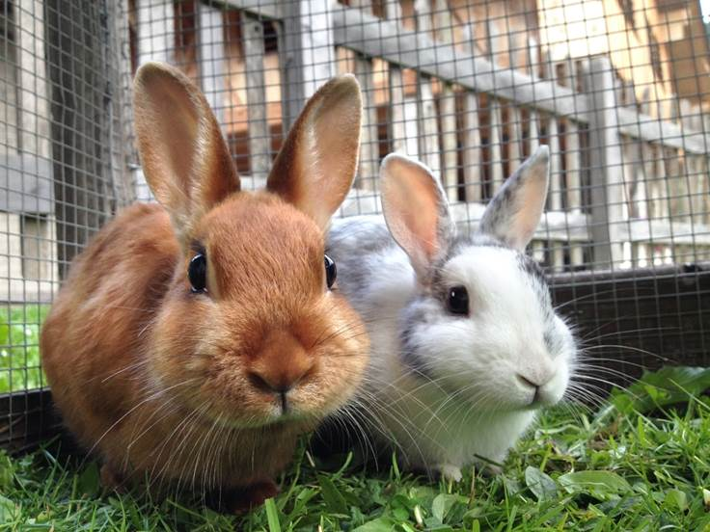
iStock photo

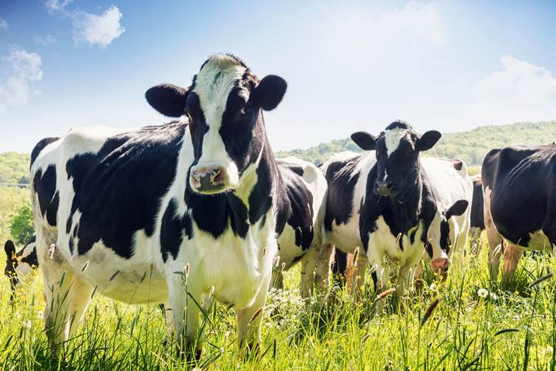
iStock photo


Photograph taken by Walford College and reproduced with permission.


Photograph taken by Walford College and reproduced with permission.


Photograph taken by Walford College and reproduced with permission.

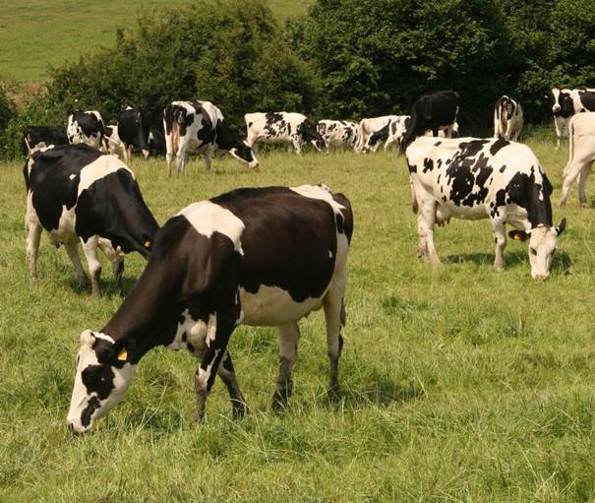
Photograph taken by Walford College and reproduced with permission.

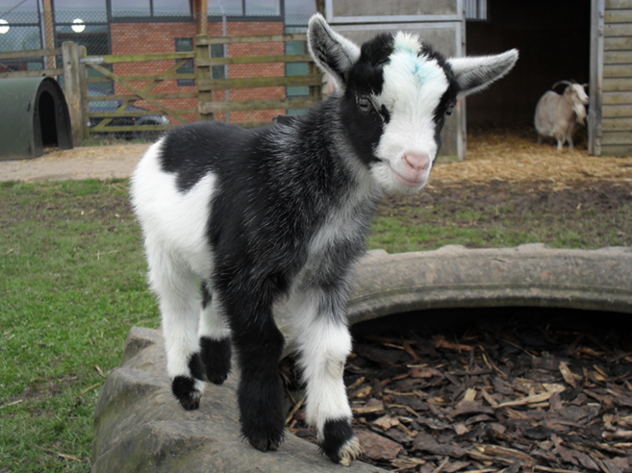
Photograph taken by Walford College and reproduced with permission.

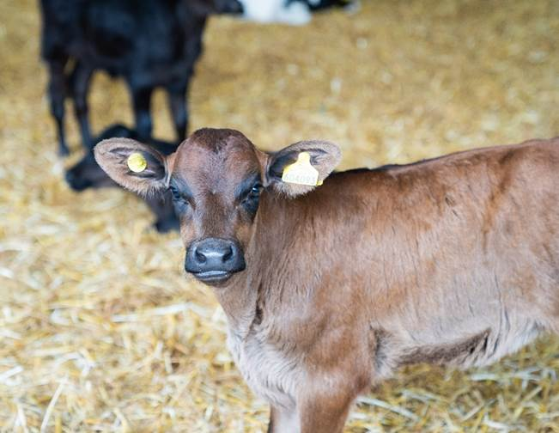
Photograph taken by Walford College and reproduced with permission.

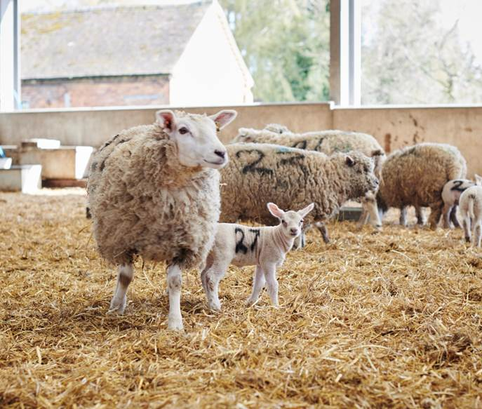
Photograph taken by Walford College and reproduced with permission.

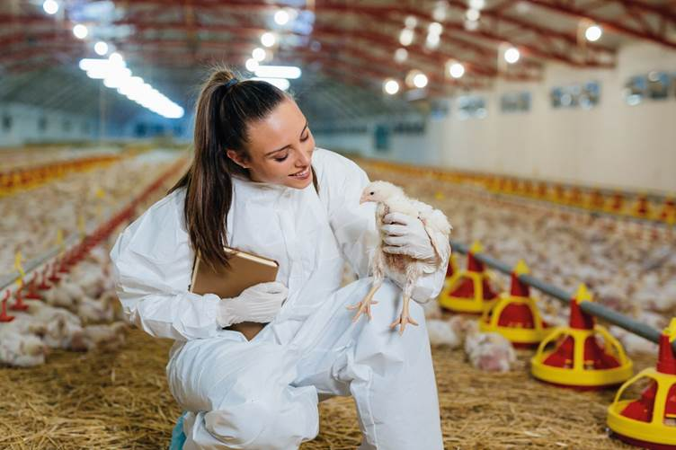
iStock photo
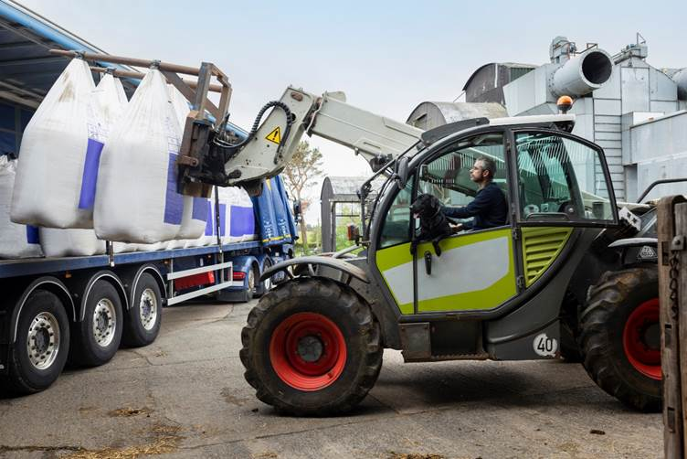
iStock photo


iStock photo


IStock photo

iStock photo

iStock photo

“Who and why” prompt sheet
“Who and why” prompt sheet
Perspective and opinions are based upon our prior experiences, learning and potential biases.

Select images and identify potential people who would have different opinions or views about the image.

Try to identify at least two other viewpoints for each image. The images are not numbered so that any combination of images can be chosen.

Image | Who?  (for example, veterinary nurse, RSPCA officer, researcher) | Opinion/viewpoint | Why?
1
2
3
4

Cognitive bias hand-out

Follow the link below to find an overview of 18 cognitive bias examples.

Desjardins, J (2018). 18 cognitive bias examples show why mental mistakes get made.

A3 overview diagram 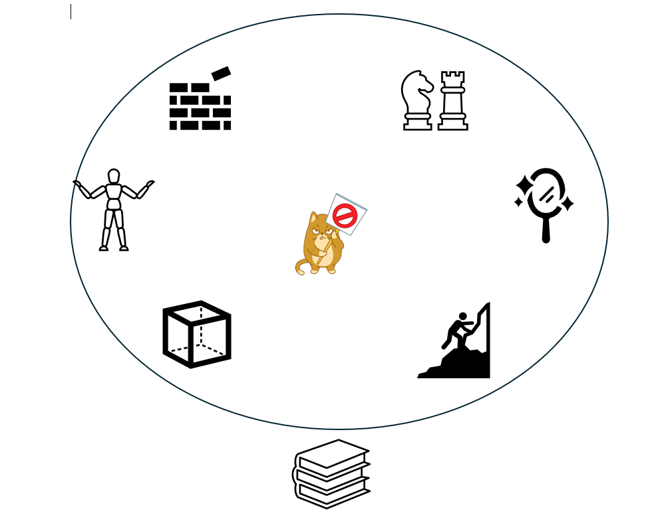

Article: Barriers to critical thinking
Barriers to critical thinking
Bronwen Bray
We must be aware of the factors that affect our ability to think critically. We should also be able to recognise these barriers and find ways to challenge them. There are some barriers that prevent good critical thinking. Summarised below are five of these key areas.
1. Incorrect assumptions
Sometimes assumptions can help us make decisions quickly based on our prior knowledge and experience, but more often they can be incorrect and damaging. They can often:
- Lack logic and appropriate detail. They may not be based on true facts and information may not have been appropriately challenged.

- Be based on bias and be very subjective. They may be based on an individual or groups previous, limited, inexperienced or ignorant views. They may be used because the support already set biases and stereotypes.

These should be challenged and checked against valid and reliable sources of information. Reflection on personal bias or influence is essential. You should be ready to challenge your own perceptions and make changes or gather other views.
2. Lack of confidence to be objective and challenge other views
Individuals must be confident and skilled to challenge preconceptions or other’s views. They must be confident to think differently and question how they think about different situations. This can be challenging but is essential for effective critical thinking.
Programmes that help build confidence, communication and improve self-reflection can help. Being able to have difficult and challenging conversations can improve the quality of information collected.

3. Lack of knowledge and understanding
For effective critical thinking, appropriate levels of knowledge and understanding must be achieved and developed. A lack of knowledge prevents full consideration, reflection and evaluation of the issues.
Continuing with formal education and professional development improves knowledge. Sources of guidance must be valid and reliable. Sources of information should be checked.

4. Personal views and emotions
One of the most difficult barriers to overcome is that of personal views, emotions and bias. Our life experiences filter and change our perception of the world. Our experiences influence all our decisions and, if left unchecked, can lead to catastrophic decision-making. We can also let our emotions blur our perceptions and influence our objectivity.

Keeping emotions in check and continually reflecting on how our own views and experiences may influence decision-making creates a more conducive environment for critical thinking.

5. Misconceptions about the elements of critical thinking
A clear understanding and comprehension of the elements of critical thinking are essential. There can be confusion about how to critique or validate information. Keeping an open mind and reflecting on different views and perspectives is essential. Critical thinking is not about being negative.
Developing a detailed understanding of the elements of critical thinking is essential. Developing the skills, attitudes and behaviours needed for critical thinking over time improves cognitive development and decision-making.

Reference:
Pearson TalentLens (2020). https://www.talentlens.com/Insights/blog/2020/10/5-barriers-to-critical-thinking--and-how-to-challenge-them--.html .

Barriers review sheet
Overcoming personal barriers
Individual critical thinking skills | Score 1= excellent  4 = very weak
Attention to detail when reading

Positive body language

Confidence to challenge ideas

Self-reflection

Analytical skills

Increased subject knowledge

Verbal communication

Recognition of influential and persuasive language

Open minded approach to information

Accurate reading and comprehension of information

Analysis of patterns in data

Concentration

Select five of your lowest scoring personal skills above to develop over the next term.

Influential words list
Influential words and language

suddenly  now  introducing  startling  miracle  magic  special offer | improvement  amazing  sensational  remarkable  revolutionary  limited offer  trust  exciting  superior | quick  easy  wanted  challenge  compare  exclusive  guaranteed  special  revolutionary  one of a kind

The following materials relate to lesson 3: Arguments and reasoning.

Find the argument hand-out
Logical fallacies hand-out
Logical fallacies overview
Mix and match arguments hand-out
TB (Bovine Tuberculosis) articles hand-out

Find the argument hand-out
Find the argument
Plants need nitrogen in order to grow. Although there is nitrogen in the air, plants cannot absorb it from the air. They are reliant on bacteria in the soil. The bacteria turn nitrogen into accessible nitrates. | Legumes make important contributions to ecosystems. Their roots contain nodes which contain nitrogen fixing bacteria. They provide niche environments for small insects which form an essential food supply for birds. Consequently, without legumes, the biodiversity of many regions would be very limited and more should be planted in permanent pastures.
I like animals. They make me feel more relaxed and they look so cuddly. Everyone should have an animal. | Food companies package food in moisture proof bags.
Animals can often eat toxic plants because they look similar to other plants. Experts have highlighted that when dried, some toxic plants lose their sharp taste and become more palatable. Therefore, any toxic plants should be removed from pastures before cutting for forage. | Small amounts of vapour were emitted from the test tube when heated to 40 degrees. When heated at 60 degrees, water droplets gathered on the side. Therefore, this was an effective experiment.
Apples are better for teeth than sugar-coated treats. Some people argue that apples contain acid and that this damages enamel. However, the acid is only present in small quantities. Refined sugars increase levels of bacteria and cause plaque build-up. Therefore, apples are a more beneficial alternative. | It is likely that infectious howling in wolf packs may have helped individuals to synchronise their pack behaviours. Research shows that wolves who quickly join the pack howl early, socialise more quickly and hold higher ranking in wolf packs.

Logical fallacies hand-out
Logical fallacies
Example: “You cannot believe anything that scientist says because he is a convicted criminal.”  Example: “If we legalise the use of controlled drugs, then everyone will be using them, and the industry and society will collapse.”  Example: “You should buy our product. It will make your dog better behaved and it will make your children much happier.”  Example: “You should not be worried about rising food prices and the cost of our feeds; there are much bigger problems, like the rise of rural crime.”  Example: “I have the right to speak my mind. Therefore, I have the right to yell obscenities at someone.”  Example: “Snakes are great pets because they are good pets to look after, and they are good to look after because they are great pets.” | Example: “I met two rude people wearing tweed coats at that dog show, so everyone wearing tweed coats must be rude.”  Example: “My opponent wants to ban horse racing. They are obviously trying to silence free speech and stop all horse riding.”  Example: “Everyone is getting those new grooming kits, and you do not want to be left out. You should get it, too.”  Example: “You are either for vaccination or against vaccination.”  Example: “The vet said that this treatment is safe, so it must be.”

Logical fallacies overview
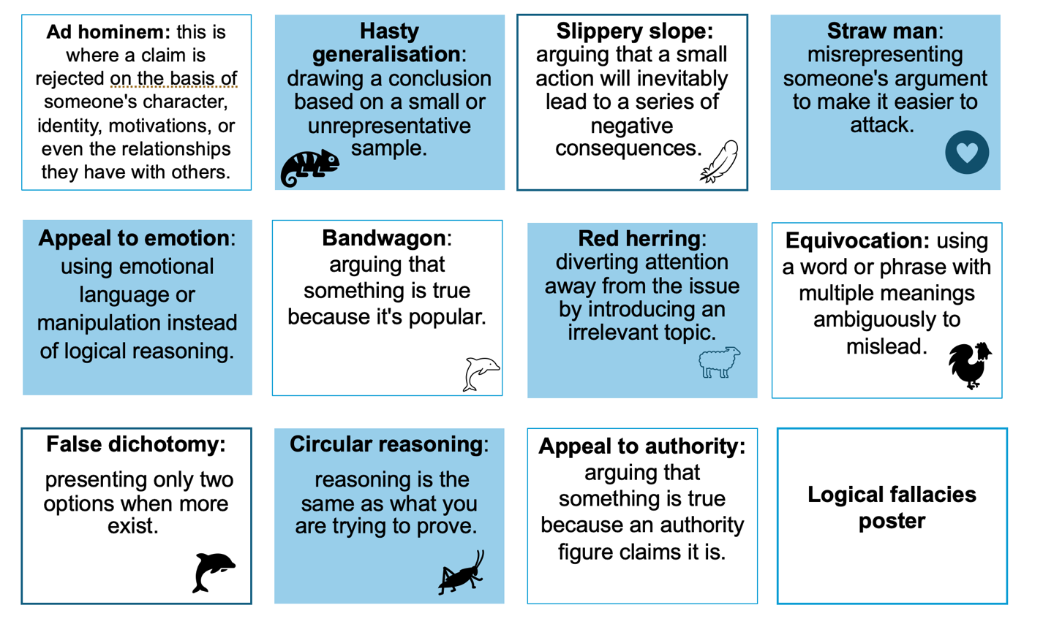

Mix and match arguments hand-out
Arguments mix and match trial

Snails | Foot rot
Mud | Disease
Sun | Better performance
Injections | Skin rash
Sheep | Wet weather
Good quality feed | Respiratory problems
Exercise | Pregnancy
Dusty feed | Longer life
Bathing | Grass growth
Cardboard tubes | Lower costs
Regular cleaning | Increased cost
Training | Happiness
Dirty hands | Lower mortality
Companions | Lameness

TB (Bovine Tuberculosis) articles hand-out
Article 1:
‘TB vaccine may enable elimination of the disease in cattle by reducing its spread.’
Follow the link below to the article on the Cambridge University website.

https://www.cam.ac.uk/research/news/tb-vaccine-may-enable-elimination-of-the-disease-in-cattle-by-reducing-its-spread
Read the article and highlight key points in the text.

Article 2:
‘Badgers are not to blame for TB in cattle.’
Follow the link below to the article on the Badger Trust website.

https://www.badgertrust.org.uk/badger-cull-facts.
Read the article and highlight key points in the text.

The following materials relate to lesson 4: Getting the facts right and creative thinking.
Video clip: How to place an intravenous (IV catheter)
Hand-out 1: Bloom’s taxonomy
Activity card 1: Bloom’s taxonomy
Activity card 2: TED model
Activity card 3: Five Ws and H model
Activity card 4: PEEL model

Video clip: How to place an intravenous (IV catheter)
How to place an intravenous (IV) catheter

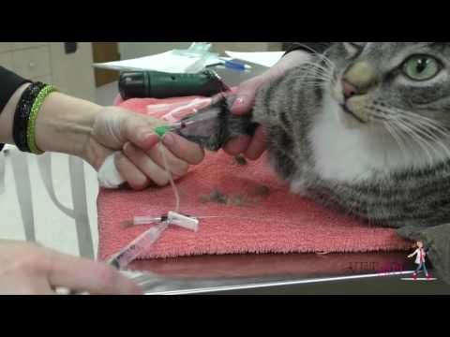

Hand-out 1: Bloom’s taxonomy
Level | Type of question | Example in animal care
Remembering | Fact-based recall | “What are the five animal welfare needs?”
Understanding | Explain concepts | “Why is enrichment important for zoo animals?”
Applying | Use knowledge in context | “How would you design an enclosure for a rabbit?”
Analysing | Examine relationships | “How does stress affect an animal’s immune system?”
Evaluating | Make judgements | “Which is more effective in dog training: positive reinforcement or punishment?”
Creating | Develop new ideas | “Design an ideal animal rescue centre layout and justify your choices.”

Activity card 1: Bloom’s taxonomy
Question creation challenge

Activity: Learners create and answer questions at different levels of Bloom’s taxonomy.
A dog is showing signs of stress.

Create six questions, one for each level of Bloom’s taxonomy, to find more detail.

Reflection: Did the use of Bloom’s taxonomy help gather detailed information?

Activity card 2: TED model (tell, explain, describe)
Client communication role play

Activity: Learner’s practice using TED questioning in a client consultation.

A dog has been brought into a veterinary practice because, for the last two weeks, he has been demonstrating abnormal behaviours around other dogs.

In your group, one learner will take on the role of the owner, one learner will take on the role of the veterinarian and the other learner(s) will observe the interaction between the veterinarian and owner. Using the TED model, the owner and veterinarian need to participate in a professional conservation about the dog.

Reflection: Did the TED questions help gather detailed information?

Activity card 3: Five Ws and H model
Animal welfare investigation

Activity: Learners investigate a case study using the five Ws and H model questions.

An RSPCA inspector was called to investigate a report of a stray dog wandering in a quiet residential area. Upon arrival, the inspector discovered a young mixed-breed dog that appeared extremely underweight with visible ribs and signs of long-term neglect. The dog was frightened, dirty and appeared to be suffering from dehydration and hunger.

Carry out an investigation and write up the case notes using the five Ws and H model.

Reflection: How did structured questioning help in the investigation?

Activity card 4: PEEL model
Writing animal welfare reports

Activity: Learners write structured responses using the PEEL (point, evidence, explain, link) model.

Enrichment is essential in zoos.

Write a response to this statement based on the PEEL method.

Reflection: How does structured questioning improve written communication?

The following materials relate to lesson 5: Digging deeper and reasoning.

Article 1: The genetic engineering of cows to produce chocolate milk
Article 2: A national survey of anthelmintic resistance.
Worksheet: Sources A–F
Sticky notes

Article 1: The genetic engineering of cows to produce chocolate milk
The genetic engineering of cows to produce chocolate milk: a ground-breaking leap in dairy biotechnology
Abstract
In an unprecedented move in agricultural biotechnology, scientists have successfully engineered a new breed of dairy cows capable of producing chocolate milk directly from their udders. This revolutionary advancement opens up new possibilities for the dairy industry, addressing consumer demands for flavoured milk products and reducing the need for post-production flavouring processes. In this study, we explore the genetic modifications, ethical considerations and potential global impact of this innovation.
Introduction
Chocolate milk, a beloved beverage across the world, has long been a favourite of children and adults alike. Traditionally, the process of creating chocolate milk involves the addition of cocoa and sugar to regular milk. However, despite the popularity of this drink, the complex steps involved in mixing and processing these ingredients can be seen as a bottleneck in production, especially in regions with growing demand. To meet this demand more efficiently, researchers have turned to genetic engineering, specifically targeting the milk-producing mammal: the cow.
This article delves into the ground-breaking development of genetically modified cows designed to produce milk infused with cocoa and sugar, eliminating the need for additional flavouring in the dairy industry.
Materials and methods
To achieve chocolate milk production directly from the source, a team of genetic engineers at the Global Dairy Innovation Lab (GDIL) in partnership with the International Biotech Institute (IBI) implemented a multi-step genetic modification process. The team’s approach involved the following:
- Gene isolation: The first step involved isolating genes from the cocoa plant (Theobroma cacao) that are responsible for producing theobromine and caffeine—key compounds in chocolate flavour. Additionally, sugar-producing enzymes from sugar cane were identified to integrate into the bovine genome.
- CRISPR-Cas9 technology: Using CRISPR-Cas9 gene-editing technology, the cocoa flavour-producing genes and sugar enzymes were inserted into the cows’ DNA. This method ensures precise, targeted edits to the cows’ genetic code, allowing for the expression of these new traits directly in their milk-producing cells.
- Integration and testing: The engineered DNA was introduced into embryonic bovine stem cells, which were then implanted into surrogate mothers. Over several generations, scientists carefully monitored milk samples for the presence of cocoa and sugar derivatives, eventually achieving a stable production of chocolate-flavoured milk.
Results
The first successful milk production of chocolate milk occurred in cows genetically modified with the integrated cocoa and sugar-producing genes. Milk samples from these cows were tested for both taste and chemical composition. Remarkably, the milk had a sweet chocolate flavour with a smooth, creamy consistency, much like the commercially available chocolate milk found in stores.
- Flavour profile: The milk exhibited a balance of cocoa bitterness, sweetness from natural sugar and a creamy texture that mimicked traditional chocolate milk without the need for added cocoa powder or sweeteners.
- Milk composition: Genetic tests confirmed that the modified cows’ milk contained high concentrations of naturally occurring cocoa compounds, including theobromine and sugar derivatives, all while maintaining the nutritional profile of regular milk.
- Milk yield: Interestingly, these cows did not experience any reduction in milk production volume. In fact, some cows even showed slight increases in their total milk yield, suggesting that the genetic modifications did not hinder their natural dairy production capabilities.
Discussion
The development of chocolate-producing cows offers many potential benefits. By eliminating the need for post-production chocolate flavouring, dairy producers could reduce manufacturing costs and streamline the production process. Additionally, this innovation has the potential to affect the environment by reducing the energy required for traditional chocolate milk production, which often involves energy-intensive cocoa processing.
However, the ethical implications of genetically modifying livestock for consumer preferences cannot be ignored. The public’s response to genetically engineered animals is often mixed, with concerns about animal welfare, biodiversity and long-term ecological impacts. Although these cows have shown no signs of distress or abnormal behaviour, rigorous ethical reviews and regulations will be necessary as this technology scales.
Potential applications and future directions
The success of chocolate-producing cows paves the way for additional possibilities in the dairy and food industries. Potential applications include:
- Flavoured milk diversity: Genetic modifications could extend beyond chocolate, with future possibilities of cows producing vanilla, strawberry, or even coffee-infused milk directly from their udders.
- Nutrient-rich milk: Future genetic engineering might focus on enhancing the nutritional value of milk by increasing the presence of vitamins, minerals or probiotics naturally in the milk.
- Sustainability: The ability to genetically engineer cows to produce milk with flavouring compounds could reduce the need for artificial flavouring and additives, potentially making dairy farming more sustainable.
Conclusion
The genetic engineering of cows to produce chocolate milk is a revolutionary achievement in agricultural biotechnology. While this breakthrough holds enormous promise for efficiency, sustainability and product innovation, it also raises important ethical and societal questions. Ongoing research will be essential to assess the long-term effects of these genetic modifications on animal welfare and the environment. As the world embraces this new wave of dairy production, it is clear that the future of milk may very well be sweeter than ever before.
Consumer reviews: Public reception of genetically engineered chocolate milk
As with any new food innovation, consumer response to genetically engineered chocolate milk has been mixed, with both enthusiasm and scepticism voiced by the public. After initial trials and limited product availability, we gathered feedback from individuals who had the opportunity to sample this revolutionary milk. Below are some of the most notable reviews:
Jane M., 34, schoolteacher (York): “I was sceptical at first, but I could not resist the idea of milk that is already chocolate-flavoured! The taste is amazing – it is smooth, creamy and just the right amount of sweetness. It tastes just like the chocolate milk I remember from my childhood, only it feels like it is made in a more natural way. I did not notice anything unusual about the milk, and honestly, it is now my go-to drink!”
Tom B., 52, farmer (Shropshire): “Being from a farming background, I was pretty hesitant when I first heard about this. I’ve worked with cows for years, and the idea of genetically modifying them does not sit well with me. I tried the milk out of curiosity, and to be honest, it tastes pretty good. But I’m still not sure how I feel about the whole thing – I think we need to consider the long-term effects before we start scaling this up.”
Sarah L., 26, health enthusiast (London): “I’ve always been a fan of chocolate milk, but I’m cautious about what I put into my body. After reading about how this milk is produced, I had to give it a shot. To me, the taste is spot on – rich chocolate flavour with no artificial aftertaste. But I’m still unsure about the ethics behind genetically modifying animals for consumer convenience. I’d like to see more studies on the health effects of drinking this type of milk before I switch to it regularly.”
Leo D., 40, parent and entrepreneur (Scotland): “I tried it with my kids, and they loved it! They did not even know it was genetically modified milk at first, and to be honest, I did not tell them. The texture is nice and creamy, and they drank it so fast that I did not even get a chance to try a second glass! My wife and I appreciate that it is one less step in making chocolate milk. No powder or syrup needed. I’m all for anything that makes life easier!”
Ella R., 19, university student (Cornwell): “I love the concept, but I’m torn. The chocolate milk is delicious – I’m not going to lie. But I’ve been reading a lot about the potential environmental impact of genetically modified organisms (GMOs), and it has me worried. The milk is great, but I wonder what kind of impact this will have on the farming industry long-term. Is this the future of dairy, or a passing trend?”
David W., 45, nutritionist (Oxford): “The flavour of the milk was delightful – very rich and satisfying, but I was a bit concerned about the nutritional aspect. While it is nice to have chocolate milk without added sugars or artificial flavourings, we have to consider how the genetic modifications might affect the nutritional profile. There needs to be more transparency and research into how this altered milk might affect things like lactose levels, proteins and overall health.”
Conclusion on consumer feedback
The introduction of genetically engineered chocolate milk has sparked widespread discussion. Many consumers have praised the product for its rich, authentic chocolate taste and the convenience it offers. However, concerns around the ethical and environmental implications of genetically modifying cows have been voiced by several individuals, particularly those with an awareness of GMOs or those directly involved in the dairy industry. While the taste appears to be universally appreciated, the full acceptance of genetically engineered milk products may depend on future research addressing both health and ethical concerns.
As the technology progresses and more information becomes available, consumer opinions may continue to evolve, potentially leading to broader acceptance or increased resistance, depending on how these products are marketed and regulated.
Acknowledgments
We would like to thank the GDIL and the IBI for their invaluable contributions to this research. Special thanks to the cows involved in this study for their continued contribution to dairy science.
References
1. Smith, A., et al. (2023). “Genetic Engineering of Dairy Cows: A Review of Methods and Ethical Considerations.” Journal of Agricultural Biotechnology, 12(2), 45-61.
2. Lee, J., et al. (2024). “The Use of CRISPR-Cas9 in Livestock Genetic Engineering.” Biotechnology Advances, 31(4), 78-90.
3. “Milk and Chocolate: The Science Behind the Flavour.” (2022). Dairy Digest, 15(5), 103-115

Article 2: A national survey of anthelmintic resistance.
Read the abstract below for an overview of a published article.
The full text can be found at:
Volume 24, April 2024,

You only need to scan read the abstract and quickly review the format and elements of the article to be able to answer the questions below. You do not need to be able to fully understand the information provided.

A national survey of anthelmintic resistance in ascarid and strongylid nematodes in Australian Thoroughbred horses
Ghazanfar Abbas a, Abdul Ghafar a, Emma McConnell b, Anne Beasley c, Jenni Bauquier a, Edwina J.A. Wilkes d, Charles El-Hage a, Peter Carrigan e, Lucy Cudmore e, John Hurley f, Charles G. Gauci a, Ian Beveridge a, Elysia Ling a, Caroline Jacobson b, Mark A. Stevenson a, Martin K. Nielsen g, Kristopher J. Hughes h, Abdul Jabbar a.

Abstract
This study quantified the extent of anthelmintic resistance (AR) in ascarid and strongylid nematodes against commonly used anthelmintics in Australian Thoroughbred horses. Faecal egg count reduction tests (FECRTs, n = 86) and egg reappearance period (ERP) tests were conducted on 22 farms across Australia. Faecal egg counts (FECs) were determined using the modified McMaster technique, and percent faecal egg count reduction (%FECR) was calculated using the Bayesian hierarchical model and hybrid Frequentist/Bayesian analysis method. The results were interpreted using old (published in 1992) and new (2023) research guidelines of the World Association for the Advancement of Veterinary Parasitology (WAAVP).
The species composition of strongylid nematodes was detected utilising a DNA-metabarcoding method using pre- and post-treatment samples. Resistance was observed in strongylid nematodes to commonly used single-active and combination anthelmintics, including ivermectin (IVM %FECR range: 82%–92%; 95% lower credible interval (LCI) range: 80%–90%), abamectin (ABM: 73%–92%; 65%–88%), moxidectin (MOX: 89%–91%; 84%–89%), oxfendazole (OFZ: 0%–56%; 0%–31%) and its combination with pyrantel (OFZ + PYR: 0%–82%; 0%–78%). Resistance in Parascaris spp. was observed to IVM (10%–43%; 0%–36%), ABM (0%; 0%) and MOX (0%; 0%). When the new thresholds recommended by the WAAVP were used, AR was detected in six additional FECRTs for strongylids and three more tests for Parascaris spp., introducing resistance to OFZ and OFZ + PYR in the latter. Shortened ERPs (four–six weeks) of strongylids were observed in 31 FECRTs in which AR was not detected at two weeks post-treatment for all the anthelmintics tested. Among cyathostomins, Cylicocyclus nassatus, Cylicostephanus longibursatus and Coronocyclus coronatus were the most prevalent species at two weeks post-treatment, whereas the main species appearing at five weeks following treatments with macrocyclic lactones were Cylicocyclus nassatus, Cylicostephanus longibursatus and Cylicocyclus ashworthi. After treatment with OFZ + PYR, the latter three, plus Coronocyclus coronatus and Cyathostomum catinatum, were detected at five weeks post-treatment. Overall, the study highlights the prevalence of AR in both ascarids and strongylid nematodes against commonly used anthelmintic products to control worms in Australian horses. The results indicate that ML combination products provided acceptable efficacy at two weeks. However, ERP calculations suggest that products work less effectively than previously measured. It is suggested to regularly monitor the efficacy of the anthelmintics and consider changing the worm control practices to better manage worms and AR in Australian horses.

What aspects of this article make it reliable?

Sources A to F

Source A

The Diary of Anne Frank
This is a book of the writings from a diary kept by Anne Frank.
Anne Frank was a young Dutch girl who was in hiding for two years with her family during the Nazi occupation of the Netherlands. Anne Frank was captured and put into a Nazi concentration camp where she died of typhus.
The diary has since been published in more than 70 languages.
Activity: Apply the reflection models to the cases

Source B

The Britannica Children’s Encyclopaedia
This is a 424-page, fully illustrated book of factual information on many different subjects aimed at children.
Over 100 experts were involved in putting together this encyclopaedia, ensuring that it is suitably written for its target audience.

Source C
The Economics of Animal Health and Production by Jonathan Rushton.
This is a book that reviews studies that have been written relating to animal health economics. It includes information on gross margins, budgeting, investment and cost-benefit analysis.
The reviews are undertaken by international experts in their field.

Source D

The Central Equine Database
By law, all horses in England, Wales and Scotland must be microchipped, and this microchip number be recorded on the Central Equine Database.

Source E

The Government’s Brexit White Paper
This is an official government paper that was published in 2018 outlining the proposals for any future relationships between the UK and the European Union post-Brexit.

Source F

The Journal of Agriculture and Environmental Ethics
This is a journal that publishes research articles relating to the relationship between humans and animals, the environment and food.

The following materials relate to lesson 6: interpreting data and analysis.

Dataset A: Animal health records at a shelter (January 2002)
Dataset B: Animal health records at a shelter (January 2024)
RAG rating cards

Dataset A: Animal health records at a shelter (January 2002)
Animal ID | Species | Age | Condition | Treatment given | Recovery status | Vaccination | Days in shelter
A1 | dog | old | sick | meds | fine | y | lots
A2 | cat | 3 | cough | antibiotic | better | vaccinated | few
A3 | rabbit | 2 | infection |  | good | n | ?
A4 |  | 5 | parvovirus | fluids | dead | y | 4
A5 | dog |  | fleas | shampoo | recovered |  | 10
A6 | cat | 7 | upper respiratory infection | no treatment | maybe better | y | ?
A7 | rabbit | 3 | gastrointestinal (GI) problem | critical care | unknown | n | 11
A8 | dog | puppy | ear issue |  |  | vaccinated | lots

Dataset B: Animal health records at a shelter (January 2024)
Animal ID | Species | Age | Condition | Treatment given | Recovery status | Days in shelter | Vaccinated (y/n)
101 | dog | 3 | kennel cough | antibiotics | recovered | 14 | y
102 | cat | 5 | upper respiratory | no treatment (mild) | recovered | 7 | y
103 | rabbit | 2 | skin infection | antifungal cream | ongoing | 10 | n
104 | dog | 6 | parvovirus | IV fluids and antibiotics | deceased | 5 | n
105 | cat | 1 | dental issues | dental cleaning | recovered | 12 | y
106 | dog | 4 | kennel cough | antibiotics | recovered | 10 | y
107 | rabbit | 3 | GI stasis | critical care formula | recovered | 8 | n
108 | dog | 2 | ear infection | ear drops | ongoing | 9 | y
109 | cat | 4 | fleas | flea treatment | recovered | 6 | y
110 | dog | 5 | kennel cough | antibiotics | recovered | 12 | y
111 | rabbit | 1 | eye infection | eye drops | recovered | 7 | n
112 | cat | 3 | upper respiratory | antibiotics | recovered | 10 | y
113 | dog | 7 | arthritis | pain management | ongoing | 15 | y
114 | rabbit | 2 | skin infection | antifungal cream | ongoing | 11 | n
115 | dog | 1 | parvovirus | IV fluids and antibiotics | recovered | 14 | n
116 | cat | 6 | dental issues | dental cleaning | recovered | 13 | y
117 | dog | 2 | ear infection | ear drops | ongoing | 10 | y
118 | rabbit | 4 | GI stasis | critical care formula | recovered | 9 | n
119 | dog | 3 | kennel cough | antibiotics | recovered | 11 | y
120 | cat | 2 | fleas | flea treatment | recovered | 5 | y

RAG rating cards

Red

Amber

Green

The following materials relate to lesson 7: Reflection, evaluation and making judgements.

Worksheet: Reflective models – question
Worksheet: Reflective models – Gibbs’ reflective cycle
Worksheet: Reflective models – Borton’s model
Worksheet: Reflective models – Kolb’s cycle

Worksheet: Reflective models – question

Why is reflection important?
Write your answers below:

Worksheet: Reflective models – Gibbs’ reflective cycle
Stages of Gibbs’ reflective cycle:
- Description – What happened?
- Feelings – What were your thoughts and emotions?
- Evaluation – What was good or bad about the experience?
- Analysis – Why did things happen this way? What theories or knowledge apply?
- Conclusion – What could have been done differently?
- Action plan – How will you improve for the future?

Example (animal care scenario):
A veterinary nurse administers the wrong dosage of medication to a dog. They use Gibbs’ reflective cycle to analyse the mistake, recognise emotions (guilt and stress), evaluate what went wrong and create an action plan to double-check dosages in the future.
Best for: deep reflection on emotions, mistakes and improvements.

Activity
Use Gibbs’ reflective cycle to help with this situation:
Sophie is a trainee veterinary nurse. One day, she is asked to administer pain medication to a recovering dog. Because of a miscalculation, she accidentally gives a higher dosage than prescribed. Fortunately, the senior veterinarian catches the mistake early, and no harm comes to the dog. However, Sophie feels extremely guilty and anxious about making future errors.

Worksheet: Reflective models – Borton’s model
Stages of Borton’s model:
- What? – Describe the situation.
- So what? – Analyse why it matters and its impact.
- Now what? – Consider next steps for improvement.
Example (animal care scenario):
- What? A zookeeper notices that an animal is showing signs of stress but is not sure why.
- So what? The zookeeper realises stress could be a result of environmental factors, handling or diet.
- Now what? They decide to monitor the animal, adjust its care routine and consult a specialist.

Best for: Quick reflection and action-oriented thinking.

Activity
Use Borton’s model to help with this situation:
A farmer brings an injured fox to the wildlife rescue centre where Mia works. She quickly assesses the animal and realises she does not have experience handling wild foxes. Unsure of the next step, she calls a senior staff member who advises her on proper handling techniques. After following their guidance, the fox is safely stabilised.

Worksheet: Reflective models – Kolb’s cycle
Stages of Kolb’s cycle:
- Concrete experience – What happened? (the experience itself).
- Reflective observation – What did you notice? (observing and considering what worked and what did not).
- Abstract conceptualization – What did you learn? (connecting the experience to theories or knowledge).
- Active experimentation – How will you apply what you learnt? (trying new approaches in the future).

Example (animal care scenario):
A veterinary learner struggles to calm an anxious cat during an examination.
- Concrete experience: The cat resists handling.
- Reflective observation: The learner notices that their approach may have stressed the cat.
- Abstract conceptualization: Research shows that slow movements and gentle handling reduce feline anxiety.
- Active experimentation: The learner applies a calmer approach in future exams, leading to better results.

Best for: Learning through experience and applying new strategies.

Activity
Use Kolb’s cycle to help this situation:
Jake, an animal care assistant, is responsible for bathing a rescue dog that has a history of abuse. The dog becomes anxious and growls when Jake approaches with a towel. Unsure of how to proceed, he steps back and asks a senior handler for advice. They suggest using slow movements, treats and a soothing voice. Next time, Jake applies these techniques, and the dog remains calm during the bath.

The following materials relate to lesson 8: Problem-solving – part 1.

Worksheet: Flowchart example
Worksheet: Case study using SWOT, flowchart and root cause
Worksheet: Being objective

Worksheet: Flow chart example

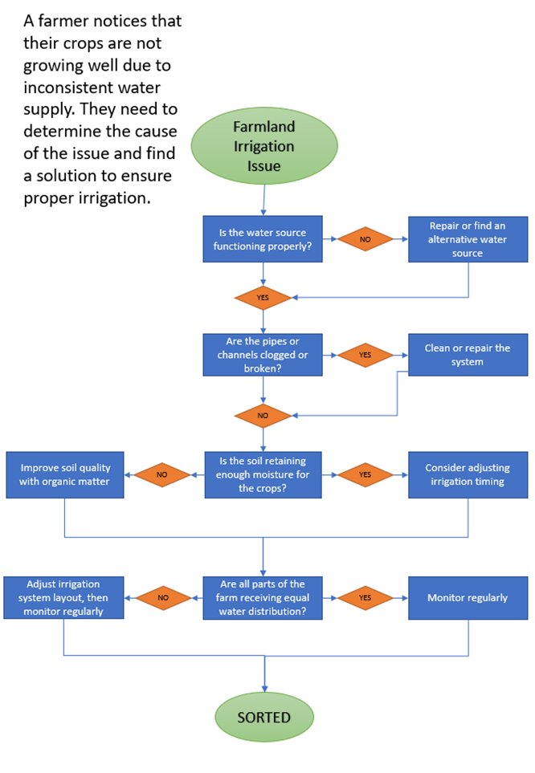

Worksheet: Case study using SWOT, flowchart and root cause
Green Valley, a rural farming community, has been facing a steady decline in agricultural productivity over the past five years. Farmers are struggling with lower crop yields, soil degradation and rising production costs, while young people are leaving because of a lack of job opportunities.
Key issues contributing to the problem include soil erosion, unpredictable weather, limited access to modern farming equipment, inefficient irrigation systems and a lack of government support.
To address these challenges, a SWOT analysis can identify strengths, such as available farmland and experienced farmers, weaknesses, like poor soil health and outdated equipment, opportunities for government grants and new agricultural techniques and threats, such as climate change and market instability.
Write a SWOT analysis of this case.
Strengths | Weaknesses
Opportunities | Threats

A flowchart can map the farming process to pinpoint inefficiencies, while a root cause analysis can reveal deeper issues, such as the lack of sustainable farming practices stemming from insufficient training and funding. By using these tools, the community can develop strategies to revitalise agriculture, improve sustainability and strengthen the local economy.
Make your own flowchart for this case.

Root cause – what could be the route cause for Green Valley’s problem?

Why….

Why….

Why…

Why…

Why…

Worksheet: Being objective
Being objective to solve a problem

Define the problem:
You manage a farm, and the harvest of a key crop (for example, wheat or corn) has been delayed by unexpected heavy rains. Some workers believe the delay was a result of poor planning, while others say the weather was unpredictable. The delay may impact sales and storage logistics.

Describe the problem (avoid blame and the use of emotional words):

Identify key factors (list three factual elements):

Identify possible solutions:

The following materials relate to lesson 9: Problem-solving – part 2.

Beaver case study
Beaver reintroduction worksheet
Plan your debate – mind map your ideas

Beaver case study
Introduction to beaver reintroduction in the UK
Beavers were once native to the UK, but they were hunted to extinction over 400 years ago. In recent years, there have been efforts to reintroduce beavers to help restore natural ecosystems. Beavers are known for building dams, which create wetlands that slow down river flow, reduce flooding and improve water quality. However, there are debates about their potential negative impacts on agriculture and land use.
Key examples of beaver reintroduction projects in the UK:
River Otter beaver trial (Devon)
Location: River Otter, Devon.
Objective: The project was designed to monitor the effects of beavers on the local ecosystem, including how their dam-building impacts flood management and biodiversity.
Results: The trial showed that beavers helped slow floodwaters and created wetlands, benefiting species like waterfowl, insects and fish. However, there were concerns that the beavers’ dams could block drainage systems and impact agricultural land.
Outcome: The trial led to the UK government considering permanent reintroduction of beavers to specific areas where they could help with natural flood management.

Knapdale beaver project (Scotland)
Location: Knapdale, Scotland.
Objective: This project aimed to restore beavers to the wild and study their impacts on freshwater ecosystems.
Results: The beavers created wetlands, which helped filter water and improved conditions for fish populations, especially salmon. However, some farmland near the beaver dams experienced damage from waterlogging and flooding.
Outcome: In 2016, the Scottish government gave permission for beavers to be permanently reintroduced to specific areas where their benefits were clear, though land management around them would need to be adapted.

The benefits of beaver dams
- Flood control: Beaver dams slow down the flow of water, reducing the risk of flash floods during heavy rain. This is especially important in areas like Devon, where flooding can damage infrastructure and agricultural land.
- Water quality: Beaver ponds help filter out pollutants from water, improving water quality for local wildlife and reducing agricultural runoff.
- Biodiversity: Beaver-created wetlands offer habitats for various species, including fish, amphibians, birds and insects. This helps increase overall biodiversity in river systems.

Challenges of beaver reintroduction
- Agricultural damage: Beavers can damage crops, trees and fences by flooding fields or chewing on trees. This poses a challenge for farmers who may lose land to flooding or experience crop damage.
- Increased maintenance costs: Landowners and local authorities may face additional costs for managing beaver populations, such as reinforcing riverbanks, maintaining drainage systems or implementing flood defences.
- Public perception: While many people support beaver reintroduction because of its environmental benefits, there is local resistance in some farming areas where the beavers’ activities could impact livelihoods.

Beaver reintroduction worksheet
Positive consequences | Negative consequences

Plan your debate – mind map your ideas

Key talking points for the debate:

Final decision: Write your recommendations to the government that would help reduce conflict between the farmers and conservationists.

The following materials relate to lesson 10: Consolidation of critical thinking skills.

Case study
Case study considerations
Article 1: Diversification
Article 2: Rising costs of animal feeds and vaccinations – implications for animal management
Article 3: Are animal collections and zoos really beneficial for animals?
Task 1: What key information do you need in order to develop your investment plan?
Task 2: What techniques will be used to help problem-solve. What potential ideas for the development of the business do you need to consider?
Task 3: Project proposal form
Stretch and challenge cards
Critical thinking skills self-assessment

Case study
You and your team have been hired to design, launch and manage a land-based park, a 40-acre project near a growing city.
The park faces significant challenges, including two competing management proposals: one advocating for a conservation-focused animal park and another proposing a commercial breeding farm. In the team there are also two staff members that really want to invest their skills and time to expand into the small animal section.
The outdated cattle barn requires £60,000 in repairs, and recurring health problems in the sheep and goat flock demand immediate attention. The cost for a new animal centre will cost £80,000.
A recent government review revealed a 20% grant increase for rare breed breeding projects, presenting a financial opportunity to consider alongside operational decisions.
Your team must create a park layout that balances animal welfare, visitor engagement and operational efficiency while addressing financial sustainability through ticket sales, grants and sponsorships. Additionally, you must develop a crisis management plan to handle emergencies, such as animal health outbreaks or visitor safety concerns, and ensure the park’s reputation aligns with its mission.
The success of the land-based park depends on your ability to solve problems, make critical decisions and present a comprehensive plan that integrates conservation, education and community engagement. You have been given £300,000 to explore, expand and develop this park. Propose how you plan to invest this money.

Case study considerations
Financial planning
Your second challenge is ensuring the park is financially viable. You need to:
- Ensure your team accounts for construction costs, enclosures and ongoing maintenance costs.
- Identify possible revenue streams.
- Account for contingencies for unexpected expenses, such as veterinary emergencies costs or equipment breakdowns.

Decision about which animals to include in the park
- Suitability: Which species are best suited to the park’s climate and space and your desired outcomes?
- Conservation: Should you include endangered species, and if so, how will you contribute to their protection?

Environmental impact
Operating an animal park or farm can have significant environmental consequences.
- Consider implications for waste management, water usage and energy consumption.
- Explore sustainable practices, such as solar panels, rainwater harvesting or composting.

Article 1: Diversification
The crucial role of farm diversification in land-based industry

Diversification has become an essential strategy for businesses in the UK, allowing them to adapt to modern challenges. For example, as economic pressures mount and climate change continues to disrupt traditional farming methods, diversification offers the only sustainable path forward for farmers looking to survive and thrive. Without diversification, many farms would face financial ruin.
The economic argument of land-based industry development
The economic benefits of farm diversification are undeniable. With fluctuating crop prices and volatile markets, relying solely on traditional farming practices is a recipe for disaster. By diversifying into activities such as agritourism, renewable energy production and specialty crops, farmers can create multiple income streams.
For example, agritourism ventures like farm stays and petting zoos can generate upwards of £50,000 annually, while solar farms on underused land can bring in an additional £75,000 per year.
Livestock diversification is another lucrative avenue. For example, farmers raising alpacas for wool can earn up to £200 per kilogram of fibre, while those breeding rare poultry breeds for enthusiasts and gourmet markets can generate profits of £10,000 annually from just a small flock. According to an article by the Farmers’ Prosperity Initiative, “Diversification has increased farm incomes by over 150% for the majority of UK farmers who adopted it, with some earning as much as £200,000 annually from new ventures alone.” This statistic proves that diversification is not just beneficial but vital for financial stability.
Environmental necessity
Diversification also helps farms become more sustainable in the face of environmental challenges. Monocropping and over-reliance on single types of livestock have been widely criticised for their environmental impact, including soil degradation and biodiversity loss. Diversified farms, on the other hand, foster environmental balance. A 2021 report from the Green Agricultural Alliance claimed that “farms practising diversification see a 40% reduction in soil erosion and a 30% increase in local wildlife populations.” For instance, introducing wildflower meadows and eco-friendly camping facilities can simultaneously enhance biodiversity and generate an extra £40,000 annually.
Landowners are diversifying into aquaculture, such as raising freshwater prawns or trout, and can also earn an impressive £50,000 annually from a modestly sized pond.
Social benefits
Diversification creates jobs and strengthens rural communities. Diversified farms for example often include farm shops, educational tours or even small-scale breweries, all of which generate local employment opportunities. A report by the Rural Futures Network stated that “90% of diversified farms in the UK contribute directly to their local economy, ensuring the survival of rural communities.” For example, farm shops selling locally produced cheeses and artisan goods can make profits of up to £30,000 per year, while craft breweries can rake in an astonishing £100,000 annually. Animal-based attractions, such as falconry experiences or donkey therapy sessions, can bring in an additional £20,000 annually while providing unique services to visitors. This underscores the idea that diversification is more than a choice; it is a social responsibility.
Counterarguments are flawed
Some critics argue that diversification distracts farmers from their primary roles or requires significant initial investment. However, these objections lack substance. Grants and subsidies for diversification projects are widely available, and any short-term effort is outweighed by long-term gains. Opponents are often tied to outdated methods and fail to see the bigger picture. As one farmer aptly put it in the Agricultural Progress Journal, “Diversification saved my farm; I now make £120,000 a year from glamping pods alone – the naysayers do not understand modern farming.”
Conclusion
Farm diversification is not just a beneficial strategy; it is a necessity for the survival of UK agriculture. With undeniable economic, environmental and social benefits, the evidence overwhelmingly supports diversification. Critics, often resistant to change, fail to appreciate the challenges facing today’s farmers. It is imperative that all farms embrace diversification to secure a prosperous future for themselves and the UK’s rural landscape.

References
Department for Environment, Food & Rural Affairs (2023). Chapter 5: Diversification. Available at: https://www.gov.uk/government/statistics/farm-accounts-in-england/chapter-5-diversification--2 (Accessed: 26 January 2025).
Department for Environment, Food & Rural Affairs (2024). Farming evidence – key statistics (accessible version). Available at: https://www.gov.uk/government/publications/farming-evidence-pack-a-high-level-overview-of-the-uk-agricultural-industry/farming-evidence-key-statistics-accessible-version (Accessed: 26 January 2025)
NFU Mutual (n.d.). ‘Farming Diversification Case Studies’. Available at: https://www.nfumutual.co.uk/farming-diversification-case-studies/ (Accessed: 26 January 2025).
Savills (2020). ‘Case studies: three ways to diversify’. Available at: https://www.savills.co.uk/research_articles/229130/308152-0 (Accessed: 26 January 2025).
The Business Barn (n.d.). ‘Farm diversification brings breath of fresh air’. Available at: https://www.thebusinessbarn.co.uk/rural-business-ideas-and-inspiration/rural-business-case-studies/farm-diversification-brings-breath-of-fresh-air/ (Accessed: 26 January 2025).

Article 2: Rising costs of animal feeds and vaccinations – Implications for animal management
Rising costs of animal feeds and vaccinations – implications for animal management

The agricultural sector is currently facing significant challenges as a result of the rising costs of animal feeds and vaccinations. These factors are critical in maintaining livestock health and productivity, which are essential for food security and economic stability. This article examines the causes, consequences and potential solutions to these rising costs, with a focus on their impact on animal management.
Rising costs of animal feeds
Animal feed is the largest operational expense in livestock production, accounting for 60-70% of total costs (FAO, 2023). Over the past decade, feed prices have surged owing to several factors. Climate change-induced droughts and extreme weather have reduced crop yields of key ingredients like maize, soybean and wheat. For instance, the US experienced a 20% reduction in maize yield in 2022 as a result of prolonged drought conditions (USDA, 2023). Additionally, the Russia-Ukraine conflict disrupted global grain supplies, driving prices to historic highs.
The rising cost of feed has significant implications for animal management. Farmers are often forced to reduce feed quality or quantity to mitigate costs, leading to poor animal health, reduced growth rates and lower productivity. Studies indicate that suboptimal feeding practices can lead to a 15% reduction in milk yield among dairy cattle and a 10% decrease in weight gain for meat-producing animals (Smith et al., 2023).
Escalating vaccination costs
Vaccination is a cornerstone of preventive animal health care, protecting livestock from diseases like foot-and-mouth disease (FMD) and avian influenza. However, the costs of vaccines have increased by an average of 30% over the past five years (OIE, 2023). This rise is attributed to higher production costs, regulatory expenses, and the growing demand for vaccines owing to emerging zoonotic diseases. Small-scale farmers are particularly affected by rising vaccination costs. Inadequate vaccination coverage can lead to disease outbreaks, resulting in high mortality rates and significant economic losses. For instance, a 2022 outbreak of FMD in India resulted in the culling of over 50,000 cattle, costing farmers an estimated $12 million (FAO, 2023).
Impact on animal management practices
The combined pressure of rising feed and vaccination costs has forced many farmers to adopt cost-cutting measures that compromise animal welfare. These include reducing herd sizes, cutting back on preventive healthcare and resorting to low-cost, low-quality feeds. Such practices not only threaten animal health but also pose risks to food safety and public health.
Potential solution
To address these challenges, several strategies can be implemented. First, governments and international organisations should provide subsidies or financial assistance to farmers to offset rising feed and vaccine costs. Second, investment in research and development of alternative feed sources, such as insect-based proteins or agricultural by-products, could offer sustainable and cost-effective solutions. Third, implementing regional vaccine production facilities could reduce costs by minimising transportation and import expenses.
Additionally, digital tools like precision feeding systems can optimise feed utilisation and minimise waste. Similarly, mobile vaccination units and community-based vaccination programmes can enhance coverage while reducing costs for small-scale farmers.
Conclusion
The rising costs of animal feeds and vaccinations pose significant challenges to animal management and agricultural sustainability. Addressing these issues requires a multifaceted approach involving financial support, innovation and policy interventions. By prioritising these solutions, stakeholders can ensure the health and productivity of livestock while safeguarding the livelihoods of farmers and food security globally.

References
Barratt, A.S. et al. (2019) ‘Framework for Estimating Indirect Costs in Animal Health using Time Series analysis,’ Frontiers in Veterinary Science, 6. https://doi.org/10.3389/fvets.2019.00190.
Lord’s Library. (2023). “Rising cost of agricultural fertiliser and feed: Causes, impacts and government policy.” Retrieved from https://lordslibrary.parliament.uk/rising-cost-of-agricultural-fertiliser-and-feed-causes-impacts-and-government-policy/
Makkar, H.P.S. (2017) ‘Review: Feed demand landscape and implications of food-not feed strategy for food security and climate change,’ Animal, 12(8), pp. 1744–1754. https://doi.org/10.1017/s175173111700324x.
Pomar, C. and Remus, A. (2019) ‘Precision pig feeding: a breakthrough toward sustainability,’ Animal Frontiers, 9(2), pp. 52–59. https://doi.org/10.1093/af/vfz006.-
Roth, J.A. (2011) ‘Veterinary vaccines and their importance to animal health and public health,’ Procedia in Vaccinology, 5, pp. 127–136. https://doi.org/10.1016/j.provac.2011.10.009.

Article 3: Are animal collections and zoos really beneficial for animals?
Are animal collections and zoos really beneficial for animals?
I have been working with animals for many years, and like many others I am still undecided on whether animals should be kept in captivity.
Small animal collections, like zoos and aquariums, can benefit the public in many ways, including:
Education
Zoos can educate the public about animals, their habitats and the threats they face. They will often offer:
- educational talks and presentations by zoo staff
- live animal shows that demonstrate an animal’s natural behaviours and adaptations.

Conservation
They can help conserve animals by:
- conducting research on animals in their care
- maintaining populations of endangered species
- working with global conservation efforts.

Raising awareness
They often promote awareness of conservation issues and encourage the public to be more environmentally conscious.
Zoos can inspire and fascinate children. They can help people connect better with wildlife and support local communities.
There are growing concerns, however, that these are just money-making enterprises.
There have been many cases of neglect and poor management in the news. Animals can suffer in enclosed environments. Some species are still captures in the wild, and there is a depletion of wild animals to meet the demand from the captive animal industry.
Many species without the stimulation offered by the wild will die in captivity. They will often have more health problems and develop stereotypic behaviours.
Concern groups have regularly highlighted very poor standards of care in some small animal collections. Should animals be held captive? There is even a strong argument against owning pets including dogs, cats and horses.
One of the recent questions raised is whether there should be more legislation and training for animal owners and small businesses to ensure animals are given the best care possible. This is not an argument that is going away.

Task 1: What key information do you need in order to develop your investment plan?

Key information needed for investment
Article 1
Article 2
Article 3

Task 2: What techniques will be used to help problem-solve. What potential ideas for the development of the business do you need to consider?

What questions do you need to ask to gather the right answers?

What is the root cause of the problem?

Can a SWOT be used to help solve the case study?

Could you apply the five Ws and H model?

Could you use PEEL to help structure your points?

Task 3: Proposal sheet

Proposal to tackle the job | What are you going to do?  Final proposal form
Outline your key objectives

Stretch and challenge cards

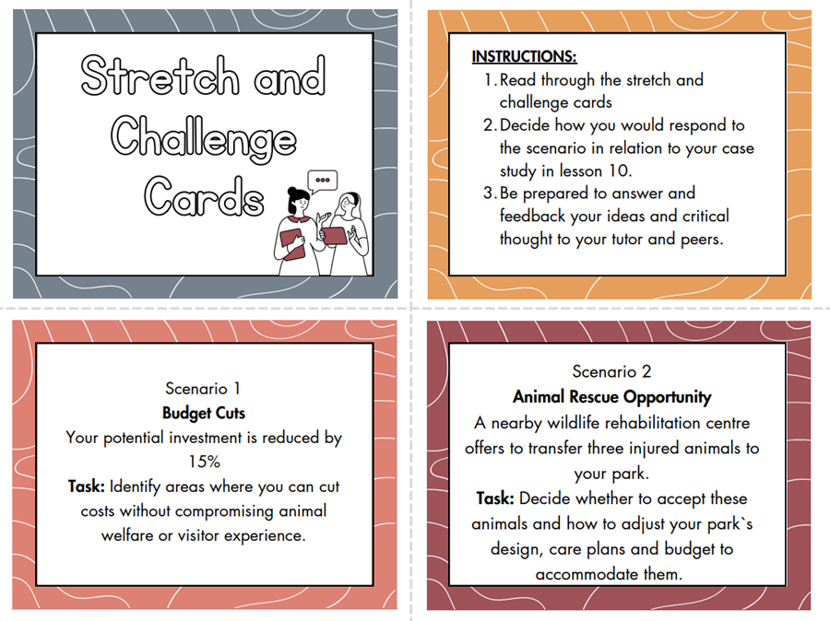

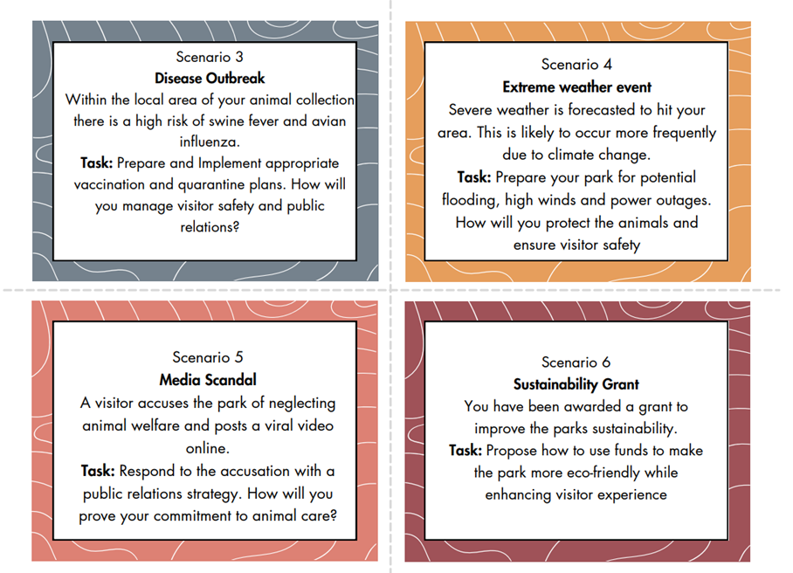
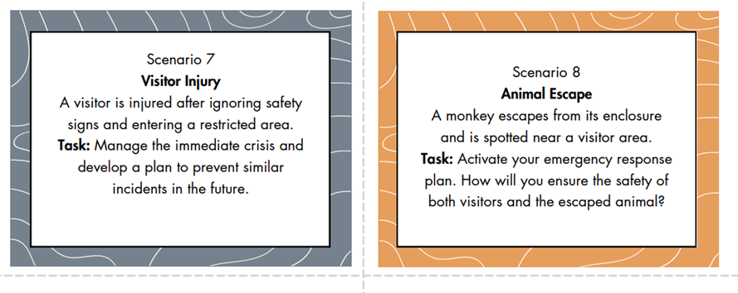

Critical thinking skills self-assessment
4 = excellent 3 = very good 2 = good 1 = poor 0 = very weak
Statements | Rating  (0-4)
I can focus clearly on an activity.
I am confident in the use of analytical tools. For example, SWOT (strengths, weaknesses, opportunities and threats), , five Ws and H model.
I feel I can confidently highlight weaknesses in the arguments of others.
I often consider positively the perspectives of others.
I know how to identify a line of reasoning.
I am aware of where my experiences, opinions and beliefs may conflict with my judgement and decision-making.
I take my time and consider all the facts before making a decision.
I take my time and consider other people’s views before making a decision.
I understand what is meant by a valid argument.
I can quickly identify the important key points from articles, the news or reports.
I am confident in identifying persuasive words used in articles or news reports to influence others.
I can recognise inferred meanings in different types of communication.
I find it easy to evaluate information to make good decisions on a regular basis.
I pay good attention to detail.
I regularly consider different points of view fairly.
I am confident in using effective and challenging questions to find the information that I need.
I am comfortable with using questions to discover more about other people’s reasoning.
I am confident in presenting and supporting my own arguments.
I understand how to effectively structure an argument.
I can tell the difference between objective and subjective information.
I understand how to triangulate information I have been given to check for false information or bias.
I am good at analysing and interpreting data
I am confident when making judgements as I routinely check my facts are correct and my decision is carefully considered.
I am confident that I can identify misleading information.
I am confident that I can identify and challenge ambiguous and vague information.
Score out of 100

Self-assessment
You will return to this self-assessment sheet throughout the course. To develop an effective critical thinking mindset, you will need to practise the techniques, tools and behaviours regularly.
Your teacher will direct you to activities, resources and exercises that you can use to continue to improve your critical thinking skills.
You will need all the qualities highlighted above for effective critical thinking. Where you have scored 1 or below in your self-assessment, these areas should be your priority for ongoing further development.

FUNDED BY


This programme is funded by
the Department for Education
Walford college from the Herefordshire, Ludlow and North Shropshire college group has produced this resource on behalf of the Education and Training Foundation

