Exam questions

Question 1
Steve is writing a report about TV viewing.
He has the following information.

Number of people in the household | 3 | 5 | 5 | 6 | 5 | 2 | 4 | 2
Number of TVs in the household | 2 | 3 | 4 | 4 | 5 | 1 | 3 | 2

Steve thinks there is a relationship between the number of people and the number of TVs in a household.
- Draw a suitable diagram for Steve.
- Describe the relationship between the number of people and the number of TVs in a household.

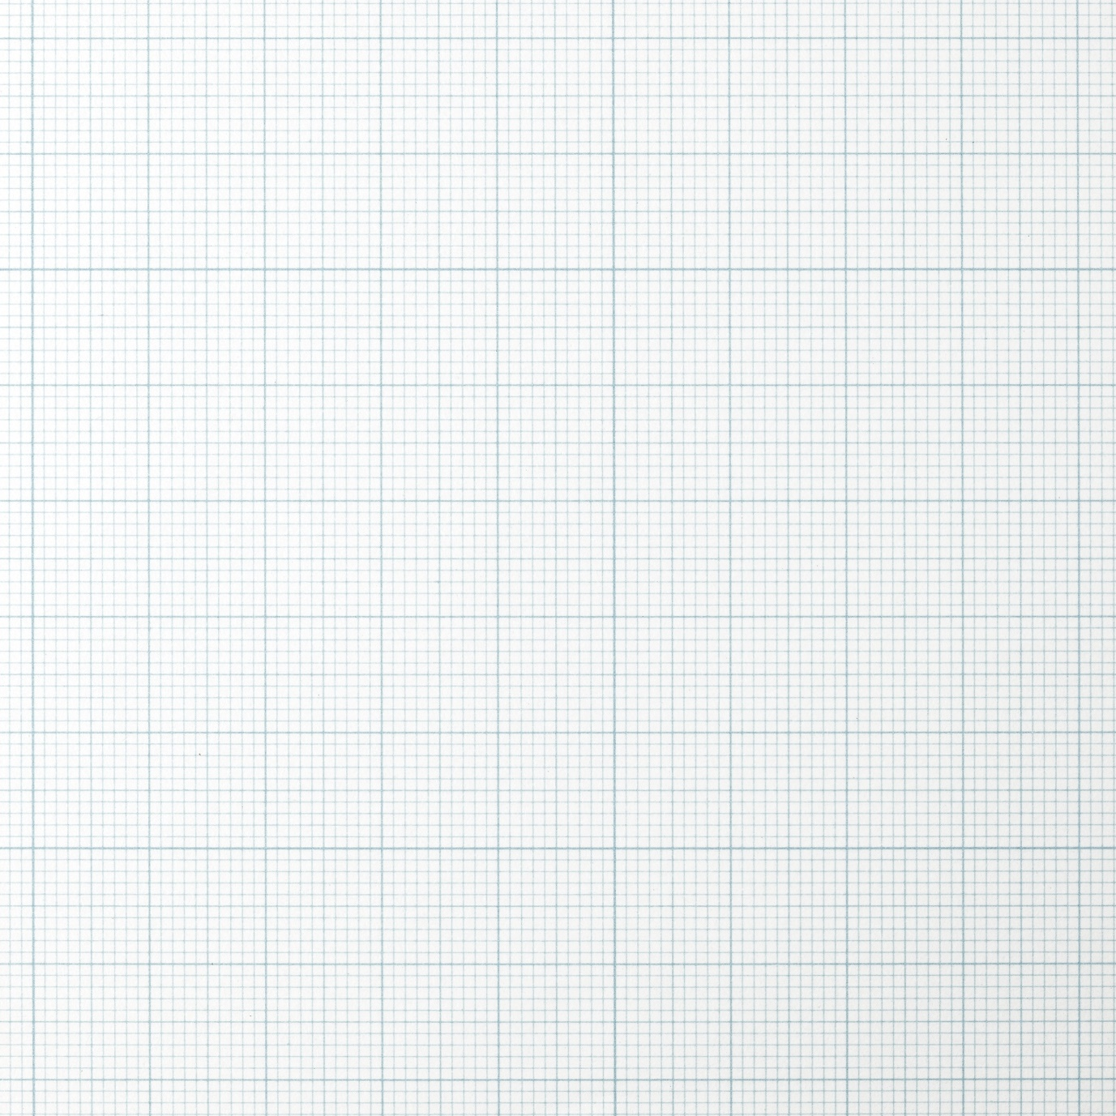

Question 2
The scatter diagram shows some information about the engine size in litres and average fuel consumption in miles per gallon (mpg) of some cars.

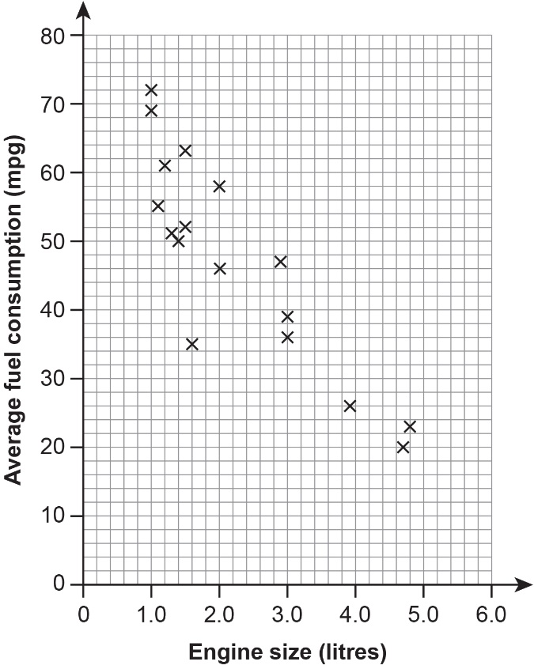

Here is the information for another car
- engine size 2.3 litres, average fuel consumption 36 mpg.
- Plot this information on the scatter graph.
- Draw a line of best fit on the scatter graph.
Mikael buys a car with an engine size of 4.2 litres.
- Use your line of best fit to estimate the average fuel consumption of this car.

…..mpg
- What type of correlation is shown in this scatter diagram?
Tick [✔] a box to show your answer.

unlikely negative even neutral positive likely

