


Introduction
T LEVEL IN DESIGN, SURVEYING AND PLANNING IN CONSTRUCTION
Materials to support contextualisation of science in construction and the built environment
et-foundation.co.uk
This resource has been designed to present one approach to the development of scientific knowledge in the context of the Core Content of the T Level in Design, surveying and planning in construction.

The scientific content is taken from Core Content area 2: science. In particular:
- 2.1 learners must understand material properties, chemical composition, degradation, failure and effects of environmental conditions
- 2.3 learners must understand the structural science of how loads and forces act on buildings.

What makes this Framework for Learning (FfL) especially relevant for T Level learners is how it demonstrates the application of the scientific concepts and principles to the construction and built environment route.

This resource has three sections as follows.

Framework for Learning
The resource includes an FfL. This covers 20 hours of learning over 10 lessons and provides ideas for further development. Lessons can be split over more than one session, therefore enabling flexible delivery models. This allows you to adjust the delivery of the lessons as required. However, the FfL is designed to scaffold learning, and it is recommended that the lessons are delivered in the order presented.

Lesson plans
There is a lesson plan for each lesson specified in the FfL. There are 10 lesson plans. Each lesson plan sets out:
- the lesson title
- the targeted content
- the proposed duration for the lesson
- teacher activities
- learner activities
- time to be allocated to each stage of the lesson
- resource requirements
- information to indicate how the lesson supports English, maths and digital skills development and adaptive learning
- next steps in learning.

Resources
In each lesson plan, there are resources specified. These can be found in a section towards the end of the resource.

Note:

Slide deck: there is a separate slide deck that can be used with the lessons.

Spreadsheet: there is an Excel spreadsheet containing test data.

Section 1: Framework for Learning

The framework sets out one approach to scaffolding and sequencing the development of primary research into the degradation and failure of metals. This resource specifically focuses on the following metals:

- steels (mild, stainless, high-strength)
- aluminium alloys
- copper
- brass.

This resource supports contextualisation of the science content: 2.1 understanding material properties, chemical composition, degradation, failure and effects of environmental conditions and supports the development of Core Skill 4: primary research.

The aim of this resource is to develop the scientific decision-making skill of selecting the correct materials for industry application.

It is recommended that these 20 hours of learning are introduced in term one of year one so that the learning gained can further support the development of Core Content area 2: science.

To maximise this learning, it is expected that learners will have the following prior knowledge:

- Hooke’s law
- primary research
- data gathering
- science report writing
- mathematics – basic arithmetic functions.

The overall outcome of the learning from this resource is for learners to select the correct metal materials for industry applications using informed knowledge about potential degradation based on extrinsic factors. To achieve this outcome, the learning is scaffolded in four phases, as follows.

Phase 1: Building formative scientific knowledge (11 hours)
This phase comprises two aspects of learning. The first focuses on structural science, developing understanding of material properties and chemical composition. This involves a teacher-led, interactive experiment to support understanding of material properties and how experiments are set up and shows how data is gathered.

The second area of learning focuses on the elements of earth science.

Phase 2: Performing scientific investigations (3 hours)
This phase involves learners setting up their own experiment on the effects of environmental conditions on metal, drawing on the outcomes of the learning from phase 1. The investigation will involve an experiment in which learners will individually look at the degradation and effects of environmental conditions on one specific metal. It is anticipated that during this phase, learners will observe the experiments of their peers to reflect how the learning of phase 1 applies to the full range of metals. This phase also considers making predictions of outcomes by setting criteria to gather data.

The experiment should run for four weeks, with learners making weekly observations.

Phase 3: Acquisition of data (4 hours)
This phase is in two sections. The first will focus on developing calculation skills that relate to forces, stress, strain, Young’s modulus and beam reactions. Data to support this learning will come from the teacher-led experiment in phase 1. This learning will help learners to determine the physical capacity of a metal beam under load. The calculations will include beam reactions, sheer force and bending moments. While this phase of learning is being delivered, the experiment from phase 2 will be running.

The second section of learning will take place four weeks after the experiment has started. This learning will build on the knowledge of the criteria used to gather data and make final observations on the experiment.

Phase 4: Making informed decisions (2 hours)
This phase draws together phases 1, 2 and 3 by selecting the correct metal materials for industry applications, using informed knowledge about potential degradation based on extrinsic factors. This phase will use construction case studies.

There are 10 lessons in total. The number of lessons allocated to each phase and the learning topic(s) for each lesson are as follows.
Key
P = phase of learning (1-4)
1-10 = lessons
P1 |  |  |  |  |  | P2 | P3 |  | P4
1 | 2 | 3 | 4 | 5 | 6 | 7 | 8 | 9 | 10

Topic of learning:
- chemical structure of metals.

P1 |  |  |  |  |  | P2 | P3 |  | P4
1 | 2 | 3 | 4 | 5 | 6 | 7 | 8 | 9 | 10
Topics of learning:
- process of chemical bonding of metals
- creation of crystal lattice structures
- introduction to mechanical properties.

P1 |  |  |  |  |  | P2 | P3 |  | P4
1 | 2 | 3 | 4 | 5 | 6 | 7 | 8 | 9 | 10
Topics of learning:
- terminology of mechanical properties
- behaviours associated with the terminology
- stress-strain graphs and the tensile test.

P1 |  |  |  |  |  | P2 | P3 |  | P4
1 | 2 | 3 | 4 | 5 | 6 | 7 | 8 | 9 | 10
Topics of learning:
- how to conduct a tensile test
- conducting the test (teacher-led)
- stress-strain graph
- interpreting the stress-strain graph.

P1 |  |  |  |  |  | P2 | P3 |  | P4
1 | 2 | 3 | 4 | 5 | 6 | 7 | 8 | 9 | 10
Topics of learning:
- forces – tension, compression, shear and bending
- equilibrium
- loadings on simply supported beams – point, uniformly distributed load.

P1 |  |  |  |  |  | P2 | P3 |  | P4
1 | 2 | 3 | 4 | 5 | 6 | 7 | 8 | 9 | 10
Topics of learning:
- weather and climate
- chemical degradation
- effects of environmental conditions on metals.

P1 |  |  |  |  |  | P2 | P3 |  | P4
1 | 2 | 3 | 4 | 5 | 6 | 7 | 8 | 9 | 10
Topics of learning:
- setting up and running an experiment
- predicting outcomes.

P1 |  |  |  |  |  | P2 | P3 |  | P4
1 | 2 | 3 | 4 | 5 | 6 | 7 | 8 | 9 | 10
Topic of learning:
- calculations – force and load, reactions.

P1 |  |  |  |  |  | P2 | P3 |  | P4
1 | 2 | 3 | 4 | 5 | 6 | 7 | 8 | 9 | 10
Topics of learning:
- concluding an experiment
- analysing experiment data.

P1 |  |  |  |  |  | P2 | P3 |  | P4
1 | 2 | 3 | 4 | 5 | 6 | 7 | 8 | 9 | 10
Topics of learning:
- informed decision-making
- using data to make metal specifications in construction.

Framework for Learning: Degradation and failure of metals
Metals
Steel (mild, stainless, high-strength)
Copper
Aluminium alloy
Brass
Phase 1
Building formative scientific knowledge (metals)
11 hours
Phase 2
Performing scientific investigations
3 hours
Phase 3
Acquisition of data (metals)
4 hours
Phase 4
Making informed decisions (metals)
2 hours
From experiments
From calculations
Experiment (4 weeks)
Properties
Extrinsic factors

Title: Chemical composition of metals

Targeted content reference:
CA02 2.1.1 Chemical composition (structure) of metals

Lesson sequence number: 01

Duration: 1 hour

Prior learning
Knowledge of the basic atomic structure
Timing | Teacher activity | Learner activity | Resources
5 minutes | Present the Framework for Learning, which explains what the lessons will focus on.  Set out the context for learning (design, surveying and planning) and the topic of this lesson. | Listen and take notes. | Slide deck  YouTube video “Atom Explained in Simple Terms”  Flip chart/whiteboard and pens  Modelling activity handout  Different-coloured modelling clay or playdough  String or wool  Paper for labels
5 minutes | Present atom composition. | Listen and take notes.
10 minutes | Show the YouTube video “Atom Explained in Simple Terms” (1 minute 43 seconds): https://youtu.be/ajg07Dnc1BQ?feature=shared  At the end of the video, present questions to be answered in pairs:  - What is the name of the core of the atom?  - What are its two component parts?  - What is the name of the particle that orbits around the core?  - Can you tell me anything else about the atom and its construction?  Ask learners to share their answers. Check learners have the correct answers. Refer to slide notes for answers. | Watch the video and take notes.  In pairs, answer questions.  Feed back answers to the teacher.
20 minutes | Present the modelling activity – (10 minutes).  Distribute the Modelling activity handout, different-coloured modelling clay or playdough, string or wool, and paper for labels.  Allocate activity groups (three or four learners per group) and allocate each group an element: hydrogen, carbon, oxygen or nitrogen.  Circulate to ensure learners are clear about the requirements of the activity.  Provide instructions for peer-assessing other groups.  Organise the groups to move around one group at a time to assess any differences in the models (five minutes).  Facilitate feedback from each group, asking for any differences observed in the models.  Put answers on a flip chart or whiteboard. | Listen and clarify the requirements of the activity.  Move to allocated activity groups.  Complete the modelling activity – construct an atomic model of a named molecule.  Peer review groups to assess any differences between the models.  Feed back any differences observed.
15 minutes | Present the activity on chemical composition of metals.  Allocate activity groups (three or four learners per group).  Circulate to ensure learners are clear about the requirements of the activity.  Ask each group to feed back one fact that connects the three images. Go round the class until all their connections have been shared. Put answers on a flip chart or whiteboard. | Move to allocated activity groups.  Using the internet, find an image of a metal bridge, a steel beam and an iron atom.  Discuss how the three images are connected.  Present the connections.
5 minutes | Set out the next steps. | Listen and take notes.
Other information (e.g. adaptive teaching, English, maths and digital)
Differentiation is supported by having written instructions for the activity accompanied by verbal instructions.
Learners complete the activity in pairs or small groups to support any learners with manual dexterity difficulties.
English: speaking and listening skills are developed as part of the group discussions, writing skills through note taking.
Extension activities: construct a second atomic model for a different element.
Support materials: the support materials, including the slide deck, include images that include different colours. This is intentional as it is important for learners to be able to differentiate colours in the context of science in construction and the built environment. If you have a learner with colour vision deficiency, you may need to amend the slides or explore how they may be seen with the learner.
Next steps in learning
The understanding of formative atom structure leads into the next lesson, which will explore how the atomic structure bonds and forms crystal lattices in the following metals: steel (mild, stainless, high-strength), aluminium alloys, copper and brass. This will support the understanding that atoms are the foundation of all things used in construction.

Title: Chemical bonding in metals, crystal lattice structures and properties introduction

Targeted content reference:
CA02 2.1.1 Chemical composition (structure) of metals
CA02 2.1.2 Key properties of construction materials; Metals – steel (mild, stainless, high-strength), aluminium alloys, copper, brass

Lesson sequence number: 02

Duration: 1.5 hours

Prior learning
Completion of lesson 1.
Knowledge of the terminology associated with atomic structure and ability to describe an atom and its parts.
Timing | Teacher activity | Learner activity | Resources
5 minutes | Introduce the lesson and set out the context for learning (science in design, surveying and planning) and the main topic of the lesson. | Listen and take notes. | Slide deck  Whiteboard or flip chart  Pens  Parts of an atom starter activity  Modelling activity instructions  Different-coloured modelling clay or playdough  Cocktail sticks  Modelling activity solutions  Compound Interest: The History of the Atom – Theories and Models (compoundchem.com)  YouTube video “GCSE Chemistry - Metallic Bonding #20” https://www.youtube.com/watch?v=b1y2Q6YX1bQ  Pause and reflect questions handout  Pause and reflect answers handout  YouTube video “Metals 101-2 The Structure of Metals” https://www.youtube.com/watch?v=nXIoOOa7JDI  Metal samples; steel (mild, stainless, high-strength), aluminium alloys, copper, brass  Mechanical properties of metals activity instructions  Material mechanical properties notes sheet  Mechanical properties of metals research handout  https://material-properties.org/material-table/  Atoms and molecules crossword handout  Atoms and molecules crossword solution handout
5 minutes | Present starter activity. Allocate learners into groups of two or three, which they will remain in for the whole session. Hand out Parts of an atom starter activity.  After a few minutes, present starter activity answers. | In allocated groups of two or three, complete the Parts of an atom starter activity.  Compare own answer with answers on the slide.
5 minutes | Present Modelling activity.  Distribute Modelling activity instructions handout, different-coloured modelling clay or playdough and cocktail sticks.  Provide each group with a different molecule to construct.  Molecules are listed below in order of complexity to construct:  - oxygen  - water  - iron oxide  - aluminium chloride  - aluminium oxide  - copper sulphate.  Have the colour key slide on display during the activity. Allow five minutes for the activity.  Circulate to ensure learners are clear about the requirements of the activity.  Distribute Modelling activity solutions handout.  Facilitate presentation of models from each group. | Listen and clarify requirements of the activity.  Learners read and discuss the Modelling activity instructions.  In allocated groups, learners complete the modelling activity to construct a molecular model of a named substance.  Present models to the class as requested.
5 minutes | Present Representation of molecular structure of aluminium (one slide). Note that the slide includes animation with the modelling overlaid with molecular structure. | Listen and take notes.
5 minutes | Present Visual representation of atoms slide.  Show the Compound Interest: The History of Atoms: Theories and Models webpage image. Emphasise further evolution and advise that there are other models in use. | Listen and take notes.
5 minutes | Show the YouTube video “GCSE Chemistry - Metallic Bonding #20” (from 40 seconds to 2 minutes 43 seconds).  Present Chemical bonding in metals (three slides). | Watch video and take notes.  Listen and take notes.
10 minutes | Distribute Pause and reflect questions handout to groups.  Circulate to ensure learners are clear about the requirements of the activity.  Ask each group to answer a question. Repeat until all answers are covered. | In the allocated groups learners discuss and answer the questions.  Share answers with the class.  Correct any incorrect answers.
5 minutes | Show the YouTube video “Metals 101-2 The Structure of Metals” (2 minutes 37 seconds).  Present Crystal lattice structure of metals (two slides). | Watch video and take notes.
15 minutes | Distribute three metal samples to each group and the Mechanical properties of metals activity instructions from supporting materials. There are six samples in total so distribute these randomly between the groups. Metals to use are: steel, stainless steel, high carbon steel, aluminium alloy, copper and brass.  Present Mechanical properties of metals activity (one slide).  Circulate to ensure learners are clear on instructions during the activity and answers are correct. | Listen and clarify requirements of the activity.  In existing groups, examine the metal samples given and consider the questions shown on the slide and Mechanical properties of metals activity instructions.  Learners will touch, squeeze and scratch the samples then make notes on their observations.
15 minutes | Distribute Mechanical properties of metals research handout. Present activity.  Circulate to ensure learners are clear on instructions during the activity.  Facilitate the collating of research information from learners into Mechanical properties of metals research handout on whiteboard or flip chart.  Using notes under slide to expand further as to how and where these properties are useful in practice. | Use the website to acquire the quantitative values for the properties indicated on the Mechanical properties of metals research handout.  Provide the quantitative values.  Complete the Mechanical properties of metals research handout table for all materials.  Listen and take notes.
5 minutes | Present Chemical bonding in metals and crystal lattice structure summary (refer to slides).  Remind learners that this science underpins the properties and deterioration of materials and will assist decision-making for material specification. | Listen and take notes.
10 minutes | Distribute Atoms and molecules crossword handout.  Present activity.  Distribute Atoms and molecules crossword solution handout.  Present next steps. | Complete Atoms and molecules crossword handout.  Mark peer atoms and molecules crossword.
Other information (e.g. adaptive teaching, English, maths and digital)
Adaptive teaching is supported through:
- written and verbal instructions for each activity and visual prompts on slides
- learners completing the activity in small groups to support any learners with fine motor skills.
English: written and oral communication is developed through group discussions, question and answers, note taking, and the development of scientific vocabulary.
Extension activity: if any group completes their model early, provide another more complex molecule to construct.
Support materials: the support materials, including the slide deck, include images that include different colours. This is intentional as it is important for learners to be able to differentiate colours in the context of science in construction and the built environment. If you have a learner with colour vision deficiency, you may need to amend the slides or explore how they may be seen with the learner.
Next steps in learning
The next step will be to deepen knowledge of how the crystal structure of metals informs the typically expected properties of the metals used in construction. The next lesson will also introduce the stress-strain graph.

Title: Mechanical properties, behaviour and the tensile test

Targeted content reference:
CA02 2.1.1 Chemical composition (structure) of metals
CA02 2.1.1. Material properties: tensile strength, toughness, stiffness
CA02 2.1.2 Key properties of construction materials; Metals – steel (mild, stainless, high-strength), aluminium alloys, copper, brass
CA02 2.3.1. Forces – tension
CA02 2.3.2. Stress and strain – tensile

Lesson sequence number: 03

Duration: 1.5 hours

Prior learning
Completion of lesson 2.
Knowledge of the structure of molecules and crystal lattice structures.
Timing | Teacher activity | Learner activity | Resources
5 minutes | Introduce the lesson and set out the context for learning (science in design, surveying and planning) and the main topic of the lesson. | Listen and take notes. | Slide deck  YouTube video “Tensile Testing”  Identifying molecules starter activity  Elastic bands  Stress ball  Paper clips  Modelling clay  Rebar  Springs  Foam sponge  Stress-strain graph images for note taking  YouTube video “Material Properties 101”  Whiteboard/flip chart paper and pens  Mechanical material properties quiz  Mechanical material properties answers
10 minutes | Present starter activity. Hand out Identifying molecules starter activity.  Present Identifying molecules starter activity answers. Refer to slide deck. | Complete the Identifying molecules starter activity.  Check answers against Identifying molecules starter activity answers.
5 minutes | Present Terminology recap slide. (Refer to slide deck.)  Ask questions from the slide to define the terms.  Click to reveal answers. | Listen and take notes.  Answer questions.
15 minutes | Present Mechanical properties terminology (two slides).  Explain the importance of this information in aiding decision-making of materials in the design of structures.  Use notes under slide to expand further as to how and where these properties are useful in practice.  Utilise physical objects to illustrate the definitions on the slides. | Listen and take notes.
15 minutes | Show the video “Tensile Testing” (1 minute 27 seconds) https://youtu.be/FpO2KImasNo?si=ALjw-EOgw6t9NNJx (stop at 47 seconds).  Hand out Stress-strain graph images for note taking.  Present Introducing the tensile test and the stress-strain graph and Calculating Young’s modulus (three slides).  Use notes under slides to assist with explanations and to provide context to design, surveying and planning. | Watch the video and take notes.  Listen and take notes.
10 minutes | Present The behaviour of the metal sample. Summarise the points on the tensile graph to explain plastic behaviour and salient points in the test.  Present Properties observed in the tensile test (two slides). | Listen and take notes.
10 minutes | Show the video “Material Properties 101” from 0:36 to 5:10.  https://youtu.be/BHZALtqAjeM?si=Gn-WmnQ1dgJCnLgm | Watch the video and take notes.
10 minutes | Present Relationship of chemical bonding in metals to properties and Relationship of chemical bonding in metals to behaviour (two slides).  Refer to notes on slides for explanations and questions.  Hand out Mechanical material properties quiz.  Circulate to assist as required. | Listen and take notes.  Answer questions as directed.  Complete the Mechanical material properties quiz.
10 minutes | Provide answers to the Mechanical material properties quiz, asking learners to check their own answers.  Present Properties of metals summary. | Check own answers.
Other information (e.g. adaptive teaching, English, maths and digital)
Adaptive teaching is supported through written instructions and visual prompts on slides. High-contrast colours are used to support visual needs.
English: speaking and listening is developed through questioning and answering.
Support materials: the support materials, including the slide deck, include images that include different colours. This is intentional as it is important for learners to be able to differentiate colours in the context of science in construction and the built environment. If you have a learner with colour vision deficiency, you may need to amend the slides or explore how they may be seen with the learner.
Next steps in learning
This lesson has developed knowledge of the terminology that will be used in the next stage of learning.

Title: The tensile test

Targeted content reference:
CA02 2.1.1. Material properties: tensile strength, toughness, stiffness
CA02 2.1.2 Key properties of construction materials; Metals – steel (mild, stainless, high-strength), aluminium alloys, copper, brass
CA02 2.3.2. Stress and strain – tensile
CS4 – Primary research, use test instruments to determine qualities such as modulus of elasticity

Lesson sequence number: 04

Duration: 2.5 hours

Prior learning
Knowledge of the terminology used to describe properties and behaviour of metals under load.
Timing | Teacher activity | Learner activity | Resources
10 minutes | Introduce the lesson and set out the context for learning (science in design, surveying and planning) and the main topic of the lesson.  Present The tensile test (one slide).  Show “Tensile Testing Basics” by MTS Systems (3 minutes 16 seconds) https://youtu.be/lqR5cp2v1eQ?feature=shared | Listen and take notes.  Watch the video and take notes. | Slide deck  YouTube video “Tensile Testing Basics” by MTS Systems  YouTube video “An Introduction to Stress and Strain” by The Efficient Engineer  Tensile testing instructions  Tensile testing report  Tensile tester  Metal test samples; steel (mild, stainless, high-strength), aluminium alloys, copper, brass  Prior testing data  YouTube video “Using a Stress-Strain Graph to Compare Properties of Materials” by Jumeirah College Science  How to plot graphs in Excel guide
15 minutes | Present What happens during the tensile test? (four slides).  Show “An Introduction to Stress and Strain” by  The Efficient Engineer (to 6:10 only) https://youtu.be/aQf6Q8t1FQE?feature=shared | Listen and take notes.  Watch the video and take notes.
20 minutes | Hand out Tensile testing instructions.  Instruct learners to read the instructions and complete tasks one and two. | Complete the tensile testing tasks one and two.
40 minutes | Complete the tensile testing of all six metals.  As each test is running, explain what is happening. | Watch the tensile test of all six metals being conducted, taking notes of the three chosen for testing.
20 minutes | Review test data from prior testing.  Instruct learners to create their stress-strain graphs. Circulate to assist learners. | Listen and take notes.  Create graphs for tested metals.
45 minutes | Show the video “Using a Stress Strain Graph to Compare Properties of Materials” by Jumeirah College Science (6 minutes 1 second) https://youtu.be/eNPRa_3mOIM?feature=shared  Answer any questions to provide clarification.  Instruct learners to complete their tensile testing report. | Watch the video and take notes.  Ask questions for clarity.  Complete tensile testing report.
Other information (e.g. adaptive teaching, English, maths and digital)
Adaptive teaching is supported through written instructions and visual prompts on slides and documents. High-contrast colours are used to support visual needs. The lesson includes the teacher demonstrating the experiment. There is data available in the Excel spreadsheets that can be used if the provider does not have the facilities to demonstrate the experiment.
English: written communication through report writing and conveying technical information.
Digital: using spreadsheets to access data and create graphs.
Maths: interpretation of data from a spreadsheet.
Support materials: the support materials, including the slide deck, include images that include different colours. This is intentional as it is important for learners to be able to differentiate colours in the context of science in construction and the built environment. If you have a learner with colour vision deficiency, you may need to amend the slides or explore how they may be seen with the learner.
Next steps in learning
Learners may need to complete the report in their own time after the lesson.
The next lesson moves to a new scientific concept of force and load.

Title: Force and load

Targeted content reference:
CA02 2.3.1 Forces – tension, compression, shear and bending
CA02 2.3.3 Loadings on simply supported beams – point and UDL

Lesson sequence number: 05

Duration: 2.5 hours

Prior learning
Knowledge of the primary units of SI measurement.
Timing | Teacher activity | Learner activity | Resources
15 minutes | Introduce the lesson and set out the context for learning (science in design, surveying and planning) and the main topic of the lesson.  Present Force and load basic units (12 slides).  Hand out Force and load basic units terminology quiz.  Read out correct answers. Note: For kilograms, refer learners to the relationship to Newtons. | Listen and take notes.  Complete Force and load basic terminology quiz.  Check answers when given. | Slide deck  Force and load basic units terminology quiz  Force and load basic units terminology quiz answers  YouTube video “Why do Buildings Fall in Earthquakes”  Bridge-building activity instructions  Paper  String  Tape  Scissors  YouTube video “Bridge Design (and Destruction!) part 1”  YouTube video “Bridge Design (and Destruction!) part 2”  Response cards  Lesson summary questions and answers handout  Lesson summary questions and answers teacher information
15 minutes | Present load types (four slides).  Show the TED-Ed video “Why do Buildings Fall in Earthquakes” (4 minutes 51 seconds) https://youtu.be/H4VQul_SmCg | Listen and take notes.  Watch the video and take notes.
20 minutes | Present Load application and Load transfer (four slides).  Pause and reflect – ask learners to give examples from within the classroom or building and state the load type and the transfer of force.  Present Equilibrium (two slides). | Listen and take notes.  Respond with examples when asked.  Listen and take notes.
25 minutes | Present Compression and tension and internal force reactions (five slides).  Present Load, compression and tension in bridges (four slides).  Show MIT “Bridge Design (and Destruction!) Part 1” (5 minutes 9 seconds) https://youtu.be/lBP7739C83s?feature=shared  Present Load, compression and tension in bridges (three slides).  Show MIT “Bridge Design (and Destruction!) Part 2” (4 minutes 30 seconds) https://youtu.be/KBOGRxV49MQ?feature=shared.  Note: Video references American units of measure and it needs to be pointed out to learners that these are not SI units.  Note: Learners may be distracted by subtitles, which can be amended. | Listen, watch and take notes.
65 minutes | Allocate learners into groups of three or four dependent upon class size. Hand out Bridge-building activity instructions, and bridge-building equipment.  Five minutes – teacher explanation of activity.  10 minutes – design time; walk around learner groups supporting design ideas.  15 minutes – building time; circulate to monitor construction activity.  10 minutes – testing time; observe groups in turn adding weights.  15 minutes – class discussion; lead class discussion, taking examples of construction techniques from each group, noting maximum weights on a whiteboard or similar.  10 minutes – conclude by relating to prior learning regarding load transfer in bridges. | Working in allocated groups, complete the bridge-building activity.  Create drawings and designs for proposed construction.  Take notes of design strategy and building technique for discussion at the end.  Construct bridge to design specification.  Observe each group in turn adding weights. Note the maximum weight the bridges support.  Provide information and discussion to compare construction between groups.  Listen and take notes.
10 minutes | Hand out Response cards and Lesson summary questions and answers handout.  Present Lesson summary quiz (eight slides). Display corresponding slide to each question and ask learners to display correct answers using response cards. | Use A and B response cards to answer questions.
Other information (e.g. adaptive teaching, English, maths and digital)
Adaptive teaching is supported through written instructions and visual prompts on slides. High-contrast colours are used to support visual needs.
Extension activities:
- Challenge participants to build bridges of specific lengths or widths.
- Introduce constraints, such as limited amounts of tape or paper, to increase the challenge.
- Use a budget and prices for materials.
- Have participants research famous bridges around the world and try to replicate their designs using paper and tape.
English: speaking and listening skills are developed through questioning and answering; reading and interpretation skills are developed through reading the Bridge-building activity instructions.
Support materials: the support materials, including the slide deck, include images that include different colours. This is intentional as it is important for learners to be able to differentiate colours in the context of science in construction and the built environment. If you have a learner with colour vision deficiency, you may need to amend the slides or explore how they may be seen with the learner.
Next steps in learning
This lesson has developed terminology and language that will be used in force and load calculations delivered in lesson 8 (calculations).

Title: Earth science: weather and climate

Targeted content reference:
C02 2.8.5 Weather and climate – rainfall, temperatures, sunlight, wind, frost
CA02 2.1.1 Degradation: chemical degradation

Lesson sequence number: 06

Duration: 2 hours

Prior learning
This is a new topic, and no previous knowledge is required.
Timing | Teacher activity | Learner activity | Resources
15 minutes | Introduce the lesson and set out the context for learning (science in design, surveying and planning) and the main topic of the lesson.  Introduce Weather charades icebreaker. | Listen and take notes.  Select a weather flashcard and silently mime the weather until it is guessed correctly.  Take turns to mime the weather. | Slide deck  Weather charades icebreaker  YouTube video “What is weather, and how does it work?” by Learn Bright  Weather cycle true/false cards  Weather cycle true/false questions and answers  Weather and deterioration research questions  Access to presentation software
15 minutes | Present Weather and climate (one slide).  Present the Weather cycle (one slide).  Show the video “What is weather, and how does it work?” by Learn Bright (8 minutes 4 seconds) https://youtu.be/nNmWAo0kDGk?feature=shared  Note: This video is aimed at primary school children but selected to present fundamental knowledge in a way that will be engaging. Teachers may prefer to search for an alternative video or cover the key content in their own presentation.  Ask learners to identify key observations from the video. | Listen and take notes.  Watch the video and take notes.  Indicate any key observations to the class.
10 minutes | Weather cycle true/false questions. | Answer questions using Weather cycle true/false cards.
10 minutes | Present The weather (nine slides). | Listen and take notes.
50 minutes | Introduce Weather and deterioration research activity (think, pair, share) (one slide).  Allocate the role of researcher one or two to each learner and distribute Weather and deterioration research questions, asking them to research according to their researcher number.  25 minutes – independent research (THINK).  After research time, ask learners to pair with their research partner to compare ideas and research. They then create a short presentation to share the information with the class.  20 minutes – preparing slides. Remind learners that they will need to prepare a presentation and allow time for this (PAIR). | Complete the Weather and deterioration research activity independently.  Share information with partner.  Prepare digital presentation of research.
20 minutes | 20 minutes – presenting research (SHARE). | Present research.
Other information (e.g. adaptive teaching, English, maths and digital)
Adaptive teaching is supported through written instructions and visual prompts on slides. High-contrast colours are used to support visual needs.
English: reading and interpretation through instructions to accompany activities, listening and speaking through collaboratively preparing and delivering presentations.
Digital: presentation tools for the “think, pair, share” activity.
Support materials: the support materials, including the slide deck, include images that include different colours. This is intentional as it is important for learners to be able to differentiate colours in the context of science in construction and the built environment. If you have a learner with colour vision deficiency, you may need to amend the slides or explore how they may be seen with the learner.
Next steps in learning
This lesson has introduced concepts that can be explored through the experiments conducted in lesson 7.

Title: Running an experiment

Targeted content reference:
CA02 2.1.1 Degradation: chemical degradation
CA02 2.8.5 Weather and climate – rainfall, temperatures, sunlight, wind, frost

Lesson sequence number: 07

Duration: 3 hours (can be split into smaller sessions)

Prior learning
None required.
Timing | Teacher activity | Learner activity | Resources
15 minutes | Introduce the lesson and set out the context for learning (science in design, surveying and planning) and the main topic of the lesson (one slide).  Present Predicting outcomes including example of weather prediction (five slides). | Listen and take notes. | Slide deck  Predicting outcomes activity instructions for teacher  Predicting outcomes activity worksheets one to four  Whiteboard or flip chart and pens  Predicting outcomes activity summary  Table-tennis ball  Tennis ball  Cricket ball  Football  Stopwatch  Tape measure  Metal deterioration experiment instructions  Metal deterioration experiment observation recording sheet  Four test tubes per group  Nails  Three liquids per group  Small labels or markers  Safety goggles  Metal deterioration experiment report template  Solar heat experiment instructions and related resources  Solar heat experiment table for collection of data  Solar heat experiment research topics  Solar heat experiment conclusion notes  Windy day simulation and frost formation experiment instructions and associated equipment  Windy day simulation and frost formation scientific principles explanation
35 minutes | Present Predicting outcomes activity (one slide).  Allocate learners into four groups. Each group will investigate one of the predicting outcomes stages. Introduce Predicting outcomes activity.  Hand out Predicting outcomes activity worksheets one to four and equipment (five minutes).  Circulate to monitor activity and assist as required (10 minutes).  Ask learners to share their predictions. Lead discussion of the findings and conclude the prediction (10 minutes).  Drop the balls and note the times. | Complete the Predicting outcomes activity and worksheet.  Add results to whiteboard or flip chart to collate all data. Collate all prediction data on Predicting outcomes activity summary.
10 minutes | Lead brief discussion to compare the predictions with the outcomes, noting the relevancy of each stage of prediction. | Record outcomes on Predicting outcomes activity summary.

Appropriate time for break or to split this session.
20 minutes | Allocate learners into six groups.  Explain the purpose of the Nail deterioration experiment, i.e. to demonstrate the relationship between environmental factors and metal corrosion, providing insights for understanding the effects of weather material degradation.  Advise learners that this experiment will run for four weeks (minimum) and should be observed weekly to monitor progression of changes. Observations can be recorded using the Metal deterioration observation recording sheet.  Hand out Metal deterioration experiment instructions and equipment and explain how the experiment is to be set up.  Set experiment test tubes up in a safe place where they can be easily observed over the experiment duration. | Listen and take notes.  In allocated groups, set up the experiment.
10 minutes | Instruct learners to complete sections one, two and three in the Metal deterioration experiment report template. | Complete sections one, two and three in the Metal deterioration experiment report template.
40 minutes | Introduce the next experiments: solar heat experiment, windy day simulation and frost formation experiment. State the objectives.  Instruct learners that during the experiments they will also undertake research of real-world contextual applications of the principle of the solar heat experiment.  Hand out the instructions and equipment for both experiments. Allocate a solar heat research topic to each group of learners.  These experiments can run concurrently. The windy day simulation and frost formation experiment is intended to run the duration of the session and the solar heating experiment for 30 minutes. Set up the windy day simulation and frost formation experiment first, followed by the solar heat experiment.  Circulate to help learners set up their experiments and ensure learners are on task and taking data readings regularly. | Listen to instructions then set up experiments as directed.  Take readings from the solar heat experiment as directed, using the Solar heat experiment table for collection of data.  Begin research to discover real-world applications informed by the experiment.
30 minutes | This time is for completion of research and the windy day and frost formation experiment.  There is no data to gather but observations will be discussed at the end. | Completing solar heat experiment research.  Making notes, diagrams, taking temperatures and general observations of the windy day simulation and frost formation experiment.
20 minutes | Lead discussion to collate learner observations.  Conclude this experiment with a brief overview of the science principle behind the formation of frost on a windy day (see notes in support materials). | Contribute to discussion with observations.
Other information (e.g. adaptive teaching, English, maths and digital)
Adaptive teaching is supported through written instructions and visual prompts on slides. High-contrast colours are used to support visual needs.
Maths: measuring with precision when taking readings.
English: speaking and listening through group discussions and synthesising information experiments.
Support materials: the support materials, including the slide deck, include images that include different colours. This is intentional as it is important for learners to be able to differentiate colours in the context of science in construction and the built environment. If you have a learner with colour vision deficiency, you may need to amend the slides or explore how they may be seen with the learner.
Next steps in learning
The content in this lesson introduces concepts and processes that will be developed further through lesson 9.
Learners should be gathering observations and data from their metal deterioration experiment for use in lesson 9.

Title: Force and load calculations

Targeted content reference:
CA02 2.3.5. Calculations including force, stress, strain, Young’s modulus and beam reactions.

Lesson sequence number: 08

Duration: 2 hours

Prior learning
Content from lesson 5.
Timing | Teacher activity | Learner activity | Resources
5 minutes | Introduce the lesson and set out the context for learning (science in design, surveying and planning) and the main topic of the lesson (one slide).  Present Equilibrium recap (two slides). | Listen and take notes. | Slide deck  Whiteboard or flip chart and pens  Shear force calculations worksheet  Shear force calculations worksheet answers  Rulers  Pivot shapes  2 pence coins or other flat discs of equal weight  Equilibrium and bending moments activity instructions  Bending moments calculations worksheet  Bending moments calculations worksheet answers  Reactions calculations worksheet  Reactions calculations worksheet answers
10 minutes | Present Shear force calculations (three slides). | Listen and take notes.
20 minutes | Hand out Shear force calculations worksheet.  Hand out Shear force calculations worksheet solutions. Explain answers with learners, using whiteboard or flip chart as needed to develop calculations or diagrams. | Complete Shear force calculations worksheet.  Check Shear force calculations worksheet answers.
25 minutes | Present Bending moment (one slide).  Present Equilibrium and bending moments activity (four slides).  Introduce Equilibrium and bending moments activity (one slide). Hand out equipment and circulate to assist with setting up. | Listen and take notes.  Set up rulers, pivot and coins. Follow instructions on slide.
25 minutes | Present Bending moment calculation examples (nine slides).  Hand out Bending moments calculations worksheet.  Hand out Bending moments calculations worksheet solutions. Explain answers with learners, using whiteboard or flip chart as needed to develop calculations or diagrams. | Listen and take notes.  Complete Bending moments calculations worksheet.  Check Bending moments calculations answers.
25 minutes | Present Reactions calculations (three slides).  Present Reactions calculations example (two slides).  Hand out Reactions calculations worksheet.  Hand out Reactions calculations worksheet solutions. Explain answers with learners, using whiteboard or flip chart as needed to develop calculations or diagrams. | Listen and take notes.  Complete Reactions calculations worksheet.  Check Reactions calculations answers.
10 minutes | Teacher concludes with a facilitated discussion bringing together learners’ understanding of the process. | Contribute to discussion.
Other information (e.g. adaptive teaching, English, maths and digital)
Adaptive teaching is supported through written instructions and visual prompts on slides. High-contrast colours are used to support visual needs.
Maths: completing worksheet calculations.
English: reading and interpreting questions. Explanation of answers on a flip chart.
Support materials: the support materials, including the slide deck, include images that include different colours. This is intentional as it is important for learners to be able to differentiate colours in the context of science in construction and the built environment. If you have a learner with colour vision deficiency, you may need to amend the slides or explore how they may be seen with the learner.
Next steps in learning
This lesson provides the capability of carrying out the calculations needed to resolve basic structural problems in a later lesson.

Title: Analysing experimental data

Targeted content reference:
CA02 2.1.1
Degradation: natural agents, timber infestation, timber decay, chemical degradation
Effects of environmental conditions: moisture movement, exposure conditions, freeze, thaw, thermal ageing

Lesson sequence number: 09

Duration: 2 hours

Prior learning
During a minimum four-week period prior to this lesson, learners should be gathering observations and data from their metal deterioration experiment in lesson 7.
Timing | Teacher activity | Learner activity | Resources
20 minutes | Introduce the lesson and set out the context for learning (science in design, surveying and construction) and the main topic of the lesson (one slide).  Present Concluding an experiment (eight slides). | Listen and take notes. | Slide deck  Whiteboard or flip chart and pens  Observation data from metal deterioration experiment collected by learners in previous weeks (linked to lesson 7)  Metal deterioration experiment report template (lesson 7)  Presentation software (e.g. PowerPoint or Canva)
40 minutes | Remind learners to be working in the same groups as in lesson 7.  Instruct learners to prepare their data to be shared with the class (20 minutes).  Teacher to observe presentations and collate information ready to share with learners. | Create presentation of data.  Share observation data from each metal experiment in turn.
60 minutes | Instruct learners to complete remaining sections of the Metal deterioration experiment report begun in lesson 7. Teacher adds comments for review in a separate session. | Complete Metal deterioration experiment report.
Other information (e.g. adaptive teaching, English, maths and digital)
English: writing through reports and presentation of synthesised information.
Maths: interpretating and presenting data.
Digital: using presentation software.
Support materials: the support materials, including the slide deck, include images that include different colours. This is intentional as it is important for learners to be able to differentiate colours in the context of science in construction and the built environment. If you have a learner with colour vision deficiency, you may need to amend the slides or explore how they may be seen with the learner.
Next steps in learning
The final lesson in this Framework for Learning draws together all the learning through a series of problem-solving scenarios.

Title: Informed decision-making

Targeted content reference:
CA02.1 Material properties, chemical composition, degradation, failure and effects of environmental conditions
CA02.3 Structural science of how loads and forces act on buildings
CA02.8 Types of earth science and how these impact on design, surveying and planning

Lesson sequence number: 10

Duration: 2 hours

Prior learning
Learning from lessons 1-9.
Timing | Teacher activity | Learner activity | Resources
5 minutes | Introduce the lesson and set out the context for learning (science in design, surveying and construction) and the main topics of the lesson. | Listen and take notes. | Slide deck  Concluding scenarios
15 minutes | Recap with learners the content of the previous lessons. Encourage learners to contribute and ask questions if any of the content was unclear. | Ask questions if concepts were unclear. | Slide deck  Concluding scenarios
90 minutes | Organise learners into pairs.  Instruct learners to complete answers to the concluding scenarios. | Learners work in pairs to answer questions on the three scenarios. | Slide deck  Concluding scenarios
10 minutes | Encourage learners to contribute to self-reflection on what they have learned during this Framework for Learning and how it affected their ability to complete the problem-solving activities. | Reflect on learning and contribute to class discussion. | Slide deck  Concluding scenarios
Other information (e.g. adaptive teaching, English, maths and digital)
Adaptive learning: problem-solving scenarios could be adapted to reflect learner abilities. More time can be allocated to completing problem-solving activities. Each pair of learners could be given one scenario and instructed to present their conclusions.
English: reading and interpreting information, speaking and listening through problem solving in pairs.
Support materials: the support materials, including the slide deck, include images that include different colours. This is intentional as it is important for learners to be able to differentiate colours in the context of science in construction and the built environment. If you have a learner with colour vision deficiency, you may need to amend the slides or explore how they may be seen with the learner.

Section 3: Lesson support materials

Lesson 1 support materials

Modelling activity

This modelling activity is designed to help you understand the formation of an atomic structure.

Materials needed:

- different-coloured modelling clay or playdough
- string or wool
- paper for adding labels.

Instructions

You have 10 minutes to complete this activity.

- Your teacher will allocate you an element to construct.

- Assign colours: assign a specific colour to each element. For example, you could choose red for protons, green for neutrons and black for electrons. Be consistent with your colour-coding throughout the activity.

- Prepare clay balls: take a small amount of modelling clay and roll it into balls to represent the atomic nuclei of your chosen elements. Make sure each type of particle has its own distinct colour.

- Use the string to represent orbits and position the electrons correctly on them.

- Labelling: use labels or small pieces of paper to identify each particle. Write the element’s symbol or name on the labels and attach them near the corresponding clay ball.

If you complete your element early, select another element to construct.

Discuss and explore: as you build your atomic model, discuss the structure of atoms with your team.
Once complete, circulate around the classroom to review your classmates’ models, noting any differences between them.

Lesson 2 support materials

Parts of an atom starter activity

Complete the blanks to name the parts of an atom.

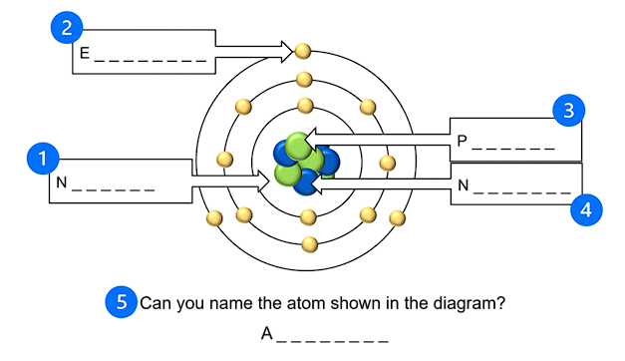

Modelling activity instructions
This modelling activity is designed to help you understand the formation of a molecular structure.

Materials needed:
- different-coloured modelling clay or playdough
- cocktail sticks.

Instructions

You have five minutes to complete this activity.

- Your teacher will allocate a molecule for you to construct.

- Prepare clay balls. Take a small amount of modelling clay and roll it into balls to represent the atoms in your molecule. Use the chart below to correctly match the atom to the colour.

Iron | Hydrogen | Oxygen | Aluminium | Chloride | Copper | Sulphur

- Use the cocktail sticks to join the correct number of atoms to create your molecule.

Discuss and explore: as you build your molecular models, consider and discuss the terminology you might use if you had to explain the structure of the molecule within your group.

Modelling activity solutions
Water (H₂O) | Iron oxide (FE₂O)
Oxygen (O₂) | Aluminium oxide (Al₂O₃)
Aluminium chloride (AlCl₃) | Copper sulphate (CUSO₄)

Pause and reflect questions

Where in the original atomic structure do the electrons that are “given up” exist?

What is the term for an atom that has lost an electron?

What is a delocalised electron?

What is electrostatic attraction?

Which two parts of the atomic structure does it keep together?

What is it about this formation that keeps the metal solid at room temperature?

What properties were noted as being directly linked to the atomic structure of a pure metal?

What property does this give the metal?

Pause and reflect answers

Where in the original atomic structure do the electrons that are “given up” exist?
A: In the outermost shell.

What is the term for an atom that has lost an electron?
A: An ion.

What is a delocalised electron?
A: An electron that has detached from an atom.

What is electrostatic attraction?
A: The force that keeps the structure of a solid together.

Which two parts of the atomic structure does it keep together?
A: Positive ions and negative electrons.

What is it about this formation that keeps the metal solid at room temperature?
A: It has a high melting point.

What properties were noted as being directly linked to the atomic structure of a pure metal?
A: Heat and electrical conductivity, strength, malleability.

What property does this give the metal?
A: Hardness.

Mechanical properties of metals activity instructions
In groups, examine the metal samples.
Consider the questions below and then use the yes/no observations to help you make notes on the Mechanical properties of metals notes sheet.
- Can you squeeze it, bend it or stretch it?

- Does it return to its original shape when you let go?
Yes? – Your material might be elastic if it returns to its original shape, and ductile if it does not.
No? – Your material might be brittle.

- Can you make a mark on its surface? Does it scratch easily?
Yes? – Your material is not hard.
No? – Your material might be hard.

- Is it unusually heavy for its size?
Yes? – Your material might be dense
No? – Your material might not be dense.

Terminology prompts:
- elastic
- ductile
- hard
- dense.

Mechanical properties of metals notes sheet
Mild steel

Stainless steel

High-strength steel

Aluminium alloy

Copper

Brass

Mechanical properties of metals research
Using the web page https://material-properties.org/material-table/ confirm the properties of the three metals you have been given.

Complete the table below.

Strength: the ability of a material to withstand an applied load (force) without failure.

Elasticity: the ability of the material to deform and reform from a load applied and removed.

Yield strength: the quantity of load at which the material ceases to respond elastically.

Hardness: the ability to withstand surface indentation and scratching.

 | Strength | Elasticity | Yield strength | Hardness
Mild steel
Stainless steel
High-strength steel
Aluminium alloy
Copper
Brass

Atoms and molecules crosswo

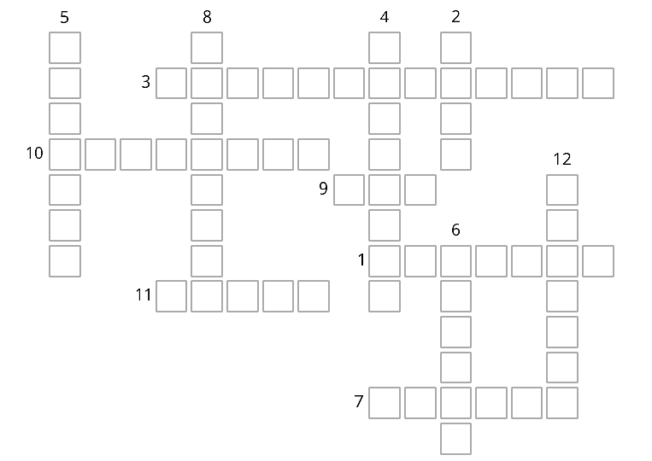

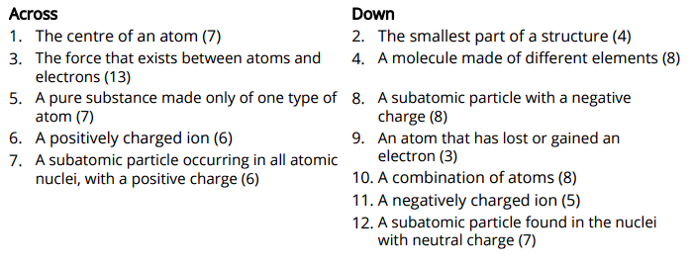

oms and molecules crossword solution

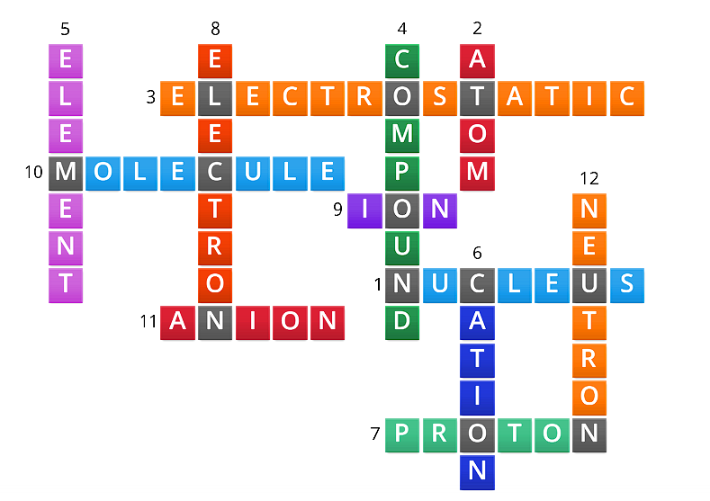

Lesson 3 support materials

Identifying molecules starter activity

Use the key to identify the molecules below.

Key:

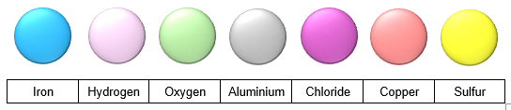

A - - - - - - - - C - - - - - - - (AlCl₃)
C - - - - - S - - - - - - - (CUSO₄)

I - - - O - - - - (FEO₂)

Stress-strain graph images for note taking

F
ΔL

F
ΔL
A
B

Elasticity ________________________________________________________________________________________________________________________________________________

Stress
________________________________________________________________________________________________________________________________________________

Strain
________________________________________________________________________________________________________________________________________________

B
STRESS
STRAIN

Stress-strain graph images for note taking

Stiffness

Young’s modulus

Note
B
Stress
σ
Strain ϵ

Elastic behaviour

Mechanical material properties quiz

- Match the definitions to the mechanical material properties.

Ductility |  | Being deformed permanently with no ability to reverse the deformation
Elasticity |  | Original shape and size are regained when applied forces are removed
Stiffness |  | Great resistance to wear and surface damage
Plasticity |  | Fracture occurs with little elastic behaviour and without significant plastic deformation
Hardness |  | Resistance to deformation while under applied force
Toughness |  | Ability to absorb a lot of energy while experiencing applied force
Brittleness |  | Both elastic and plastic behaviour are observed in response to applied force

- This is a face-centred cubic atomic structure. Copper is a typical example of this type of structure. What properties would you expect to see in this material?
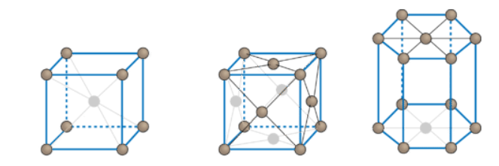
Ductility
Brittleness
Toughness
Hardness

- Select the graph(s) that best answer the questions below.

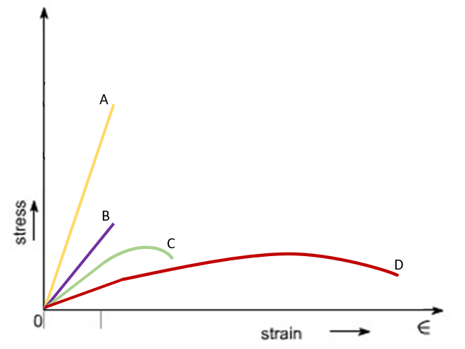

Which material is the strongest?
Which material is the stiffest?
Which material is the toughest?
Which material is the most ductile?
Which materials are brittle?

- This is a body-centred cubic atomic structure. Iron is a typical example of this type of structure. What properties would you expect to see in this material?
Ductility
Brittleness
Toughness
Hardness

Mechanical material properties answers

- Match the definitions to the mechanical material properties.

Ductility |  | Being deformed permanently with no ability to reverse the deformation
Elasticity |  | Original shape and size are regained when applied forces are removed
Stiffness |  | Great resistance to wear and surface damage
Plasticity |  | Fracture occurs with little elastic behaviour and without significant plastic deformation
Hardness |  | Resistance to deformation while under applied force
Toughness |  | Ability to absorb a lot of energy while experiencing applied force
Brittleness |  | Both elastic and plastic behaviour are observed in response to applied force

- This is a face-centred cubic atomic structure. Copper is a typical example of this type of structure. What properties would you expect to see in this material?
Ductility | X
Brittleness
Toughness | X
Hardness

- Select the graph(s) that best answer the questions below.

Which material is the strongest? | A
Which material is the stiffest? | A
Which material is the toughest? | D
Which material is the most ductile? | D
Which materials are brittle? | A |  | B

- This is a body-centred cubic atomic structure. Iron is a typical example of this type of structure. What properties would you expect to see in this material?
Ductility
Brittleness | X
Toughness
Hardness | X

Lesson 4 support materials

Tensile testing instructions
Follow the instructions below to complete this test.

Introduction to the test
Tasks:
- In your group, select three of the metals to test.
- Then, sketch what you think the graphs for each material might look like and make predictions about the expected behaviour and properties of each metal.
- Watch the teacher conduct the test.
- Using the graph and data from the test, describe the behaviour of each metal.
- Compare the metals from the test.
- For each metal tested, suggest a use in construction that can be supported by the metal’s behaviour as seen in the test.

Instructions for learners
Wear gloves when touching the materials and safety glasses when near to the testing area.

Wash your hands afterwards.

Tensile testing report

Materials tested

1
2
3

Test predictions

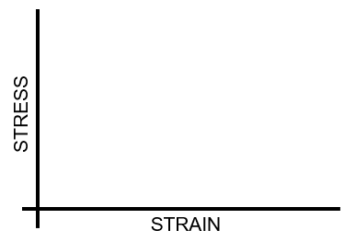 | Notes:
 | Notes:
 | Notes:

Test results

Insert metal one’s graph here.

Describe the material’s behaviour during the test, the properties that can be identified from the test and the process of failure.

Insert metal two’s graph here.

Describe the material’s behaviour during the test, the properties that can be identified from the test and the process of failure.

Insert metal three’s graph here.

Describe the material’s behaviour during the test, the properties that can be identified from the test and the process of failure.

Insert combined metals graph here.

Compare the metals by considering their strength, ductility, brittleness, elasticity, plasticity and toughness.

How to plot graphs in Excel guide
Before creating the graph, paste your data into an Excel spreadsheet in columns headed as stress and strain.

Step 1: plot a chart from Insert tab.

The first step is to insert a chart:

- Go to the Insert tab.
- Then go to the Scatter chart.
- After that, choose a type of chart from the available options.

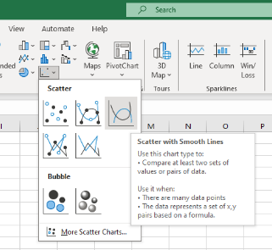
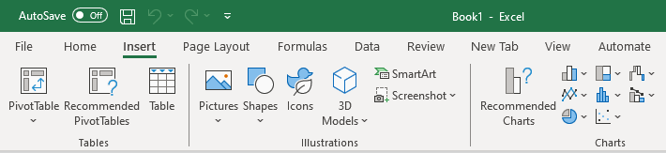
c
b
a

Step 2: add the graph lines.

The next step is to add values to create multiple lines. To do so:

- Using the left mouse, click to activate the graph area.
- Right-click your mouse to bring up the context bar.
- Then, click Select data.

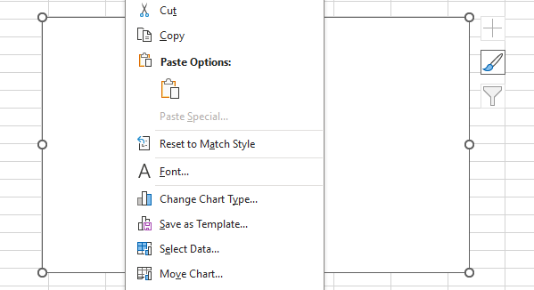

Step 3:
- The Select Data Source window will appear.
- Click Add.
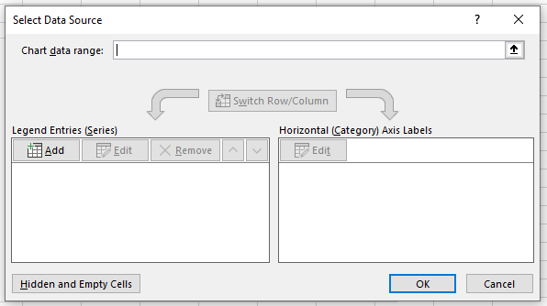
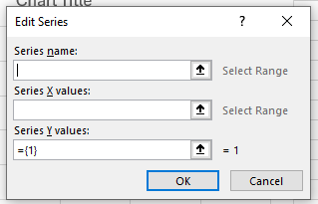

- The edit series window will appear.
- Give a series name. Use the metal whose data you are going to input next, i.e., copper.

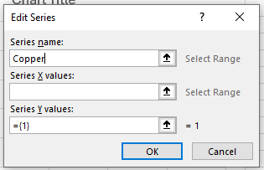
Step 4:
- After that, select your x values for the graph for copper. Select all the cells that include x axis data for copper, i.e. strain. Be careful not to select any empty cells or cells with words.
- Next delete the 1 in curly brackets {1} from the y value series box but leave the = sign.
- Select your y values for the graph for copper, again being careful not to include empty cells.
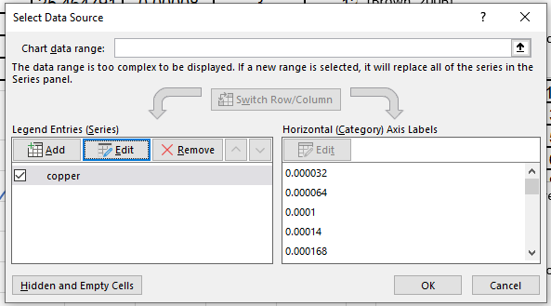
- Finally, click OK and you will be returned to the Select Data Source dialogue box.

Step 5:
- Excel will add a series named copper, and behind the box in your graph space there will be a graph line.
- After that, select Add again to plot another line.
- Repeat the process for as many graph lines as you want to include on the graph.
- When you are finished, click OK to see the graph.

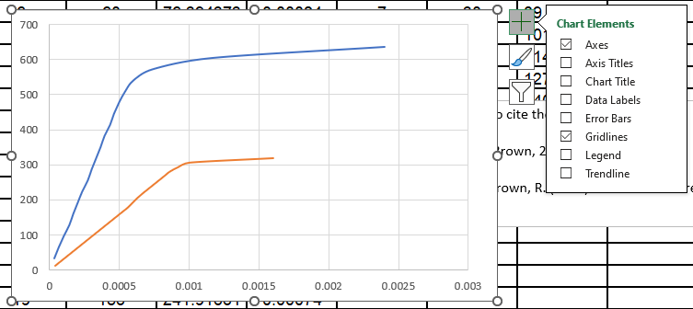

It’s a beautiful graph! But it needs some information to bring clarity to its communication.

Step 6:
Left-click anywhere on the graph to activate the chart editing tools and select the plus sign at the top to reveal the Chart Elements selection box. Here you can tick the boxes for elements of the graph you would like to see.

Useful elements are:
- chart title (can subsequently be edited)
- axis titles (can subsequently be edited)
- legend (this will auto-populate from the data selected earlier).

Tensile testing interpretation guide

Elasticity:
  - Observation on the graph: the linear, elastic region at the beginning.
  - Explanation: in the elastic region, the material deforms under stress, but the deformation is reversible. The slope of this region represents the material’s stiffness or elastic modulus.

Stiffness:
- Observation on the graph: the slope of the initial linear elastic region.
- Explanation: stiffness is a measure of how much a material resists deformation. A steeper slope in the elastic region indicates higher stiffness (Young’s modulus). Stiff materials require higher stress to induce a given amount of deformation.

Plasticity:
- Observation on the graph: the non-linear, plastic region after the yield point.
- Explanation: plasticity refers to the permanent deformation of a material under stress. In the plastic region, the material undergoes irreversible deformation. The yield point marks the onset of plastic observation, deformation where the material starts to deform plastically.

Ductility:
- Observation on the graph: the elongation and deformation in the plastic region before fracture.
- Explanation: ductility is the ability of a material to undergo significant plastic deformation before breaking. A ductile material exhibits a more gradual and elongated plastic region on the stress-strain curve before reaching the fracture point.

Brittleness:
- Observation on the graph: a sudden drop in stress after the yield point, leading to fracture.
- Explanation: brittle materials have limited plastic deformation capacity. The stress-strain curve of brittle materials often shows minimal or no plastic region, and fracture occurs abruptly after the yield point, resulting in a sharp drop in stress.

Toughness:
- Observation on the graph: the area under the entire stress-strain curve.
- Explanation: toughness is a measure of a material’s ability to absorb energy before fracturing. The total area under the stress-strain curve represents the work done on the material, and a larger area indicates higher toughness. Tough materials can absorb more energy before failure.

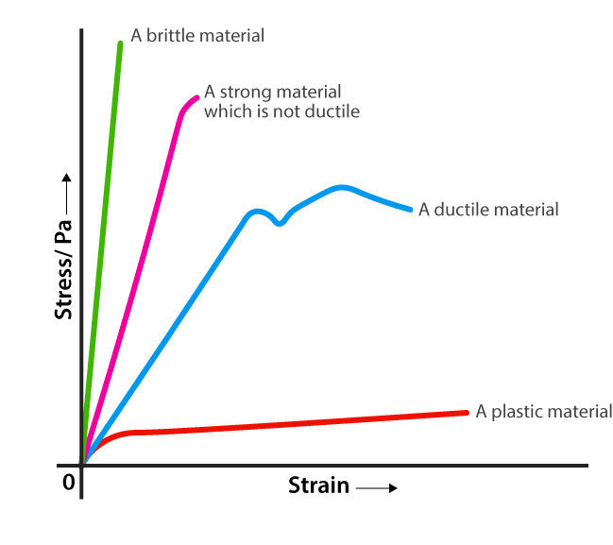
The material that reaches the highest up the y axis is the strongest.

The material with the elastic limit that reaches furthest across the x axis is the most elastic.

The material that stretches the furthest across the x axis completely to point of fracture is the most ductile.

The material with the steepest elastic region is the stiffest.

The material with the largest amount of area under the graph is the toughest.

Lesson 5 support materials

Force and load basic units terminology quiz handout

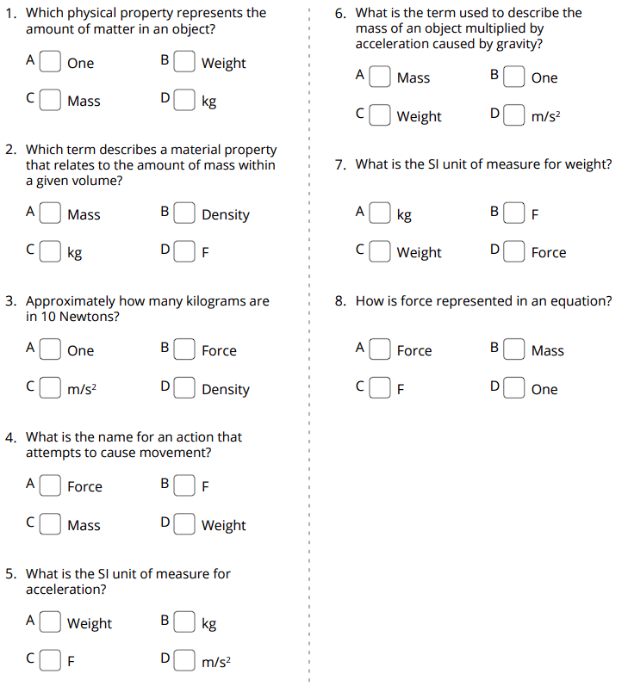

Force and load basic units terminology quiz answers

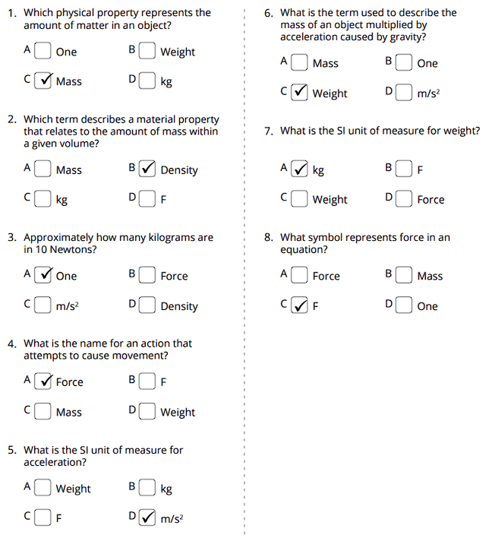

Bridge-building activity instructions

Objective
To design and construct a bridge that can support the weight of small objects, using only paper, string and tape.

Materials needed:
- sheets of A4 paper
- string
- strong adhesive tape
- scissors
- small objects to test the bridge’s strength.

Instructions
Discuss bridge design (10 minutes): before starting the activity, discuss different types of bridges (e.g. arch, beam, suspension) and their basic structures. Use drawings and sketches to design the form and structure of your bridge.

Construction (15 minutes): using the materials in the “construction kit” (paper, string, tape and scissors), begin constructing your bridges. You can fold, roll or cut the paper as needed, but you cannot add further materials.

Testing (15 minutes): once the bridges are completed, it’s time to test their strength:
  - Place your bridges across a gap or space where they can be supported at each end (e.g. between two tables).
  - Gradually add small objects (such as coins or small weights) onto the centre of the bridge to see how much weight it can support before collapsing.

Reflection (10 minutes): after testing, discuss with the class what worked well in the designs and what challenges were faced. Think about how the bridges could be improved if they were built again.
Discuss the engineering principles involved in bridge construction, such as load transfer, compression and tension.

Response cards
Print and laminate enough sets for learners to have a set each.

A
B

Lesson summary questions and answers handout

- What is the definition of force?
  - A push or pull acting on an object, causing it to change its state of motion or shape.
  - The amount of matter in an object.

- What are two examples of external loads that structures may experience?
  - Dead load and live load.
  - Sunlight load and air pressure load.

- What is the difference between dead load and live load?
  - Dead load refers to dynamic forces, while live load refers to static forces.
  - Dead load refers to the permanent weight of a structure, while live load refers to the temporary or variable loads.

- How can tension and compression be compared and contrasted?
  - Compression forces have a squeezing action, while tension forces stretch. They are types of internal forces, but they have opposite effects on the material.
  - Both compression and tension forces cause the material to expand. They are types of external force and have similar effects on the material.

- How does load transfer occur in a simple beam bridge?
  - Load transfer occurs through the support cables suspended from the bridge deck and through the columns to the ground.
  - Load transfer occurs as the loads placed on it are transferred through the beams to the supporting abutments or piers, which then transfer the load to the ground or foundation.

- What is equilibrium?
  - Equilibrium is a state of balance where all forces acting on an object or structure are equal and opposite, resulting in no net force.
  - Equilibrium is the imbalance of forces acting on a structure, resulting in structural instability.

- What are two types of loads that can affect a structure during an earthquake?
  - Types of loads during an earthquake include wind load and electrical load.
  - Types of loads during an earthquake include seismic load and inertial load.

- What is uniform distributed load?
  - A type of load that is evenly distributed over a given length or area of a structure.
  - A type of load that is concentrated at specific points along a structure.

Lesson summary questions and answers teacher information

- What is the definition of force?
- A push or pull acting on an object, causing it to change its state of motion or shape.
- The amount of matter in an object.

- Which gives two examples of external loads that structures may experience.
- Dead load and live load.
- Sunlight load and air pressure load.

- What is the difference between dead load and live load?
- Dead load refers to dynamic forces, while live load refers to static forces.
- Dead load refers to the permanent weight of a structure, while live load refers to the temporary or variable loads.

- How can tension and compression be compared and contrasted?
- Compression forces have a squeezing action, while tension forces stretch. They are types of internal forces, but they have opposite effects on the material.
- Both compression and tension forces cause the material to expand. They are types of external force and have similar effects on the material.

- How does load transfer occur in a simple beam bridge?
- Load transfer occurs through the support cables suspended from the bridge deck and through the columns to the ground.
- Load transfer occurs as the loads placed on it are transferred through the beams to the supporting abutments or piers, which then transfer the load to the ground or foundation.

- What is equilibrium?
- Equilibrium is a state of balance where all forces acting on an object or structure are equal and opposite, resulting in no net force.
- Equilibrium is the imbalance of forces acting on a structure, resulting in structural instability.

- What are two types of loads that can affect a structure during an earthquake?
- Types of loads during an earthquake include wind load and electrical load.
- Types of loads during an earthquake include seismic load and inertial load.

- What is uniform distributed load?
- A type of load that is evenly distributed over a given length or area of a structure.
- A type of load that is concentrated at specific points along a structure.

Lesson 6 support materials

Weather charades icebreaker
  Rain |   Snow
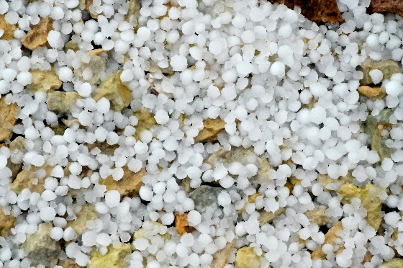  Hail |   Wind
  Fog |   Thunder and lightning
  Sunshine |   Cloud

Photos from Unsplash.

Weather cycle true/false cards
Print the cards and laminate the words true and false back-to-back in each pouch. Create enough for each learner to have their own card.

FALSE
TRUE

Weather cycle true/false questions and answers

1. True or false?
The weather cycle refers to the recurring pattern of atmospheric conditions in a specific area over a short period, typically days or weeks. In contrast, the climate cycle refers to long-term patterns of weather conditions in a region over decades or centuries.

2. True or false?
Key components of the weather cycle include temperature, humidity, air pressure, wind and precipitation (rain). These interact through processes such as evaporation, condensation, atmospheric circulation and air mass movement.

3. True or false?
Solar energy heats the earth’s surface, causing air to warm, rise and form low-pressure areas. This leads to the movement of air masses, the formation of clouds, and the generation of winds and weather patterns.

4. True or false?
The water cycle involves evaporation, condensation, precipitation and run-off. These processes distribute moisture in the atmosphere, which plays a crucial role in forming clouds, rain and other weather phenomena.

5. True or false?
Changes in temperature, humidity and air pressure influence atmospheric stability, the formation of clouds, and the intensity of weather events such as storms and fronts.

6. True or false?
Atmospheric circulation redistributes heat and moisture around the earth, leading to the formation of global wind patterns, which drive weather systems.

7. True or false?
Primary factors that influence weather patterns at the local, regional and global scales include latitude, proximity to large bodies of water, elevation, landforms, prevailing winds, ocean currents and atmospheric conditions.

8. True or false?
The Coriolis effect, caused by the earth’s rotation, deflects winds and ocean currents, leading to the formation of distinct wind patterns and ocean currents in each hemisphere.

9. True or false?
Weather fronts are boundaries between air masses with different temperatures, humidities and air pressures. They often result in changes in weather conditions, including precipitation, temperature shifts and wind changes.

10. True or false?
Human activities can alter local and global weather patterns by changing land use, modifying atmospheric composition, and contributing to climate change through the release of greenhouse gases.

Weather cycle true/false answers

All answers are true!

Weather and deterioration research questions

Solar radiation
Ultraviolet (UV) radiation from the sun can initiate chemical reactions on metal surfaces, leading to oxidation and corrosion. UV radiation accelerates the breakdown of protective coatings on metals, making them more susceptible to corrosion.
Researcher one
Explain the chemical reaction that is taking place.
Describe the likely visible effect that will be seen.
Researcher two
What long-term damage is being done?
How can the damage be prevented or remediated?

Temperature fluctuations
Exposure to solar radiation causes metal surfaces to heat up, leading to thermal expansion and contraction. This cyclic heating and cooling can weaken metal structures over time, leading to fatigue and eventual failure.
Researcher one
Explain the chemical reaction that is taking place.
Describe the likely visible effect that will be seen.
Researcher two
What long-term damage is being done?
How can the damage be prevented or remediated?

Moisture and humidity
Solar radiation can evaporate moisture from metal surfaces, leaving behind salts and other corrosive substances. These residues promote corrosion by providing an electrolyte for electrochemical reactions, accelerating metal deterioration.
Researcher one
Explain the chemical reaction that is taking place.
Describe the likely visible effect that will be seen.
Researcher two
What long-term damage is being done?
How can the damage be prevented or remediated?

Chemical reactions
UV radiation can catalyse photochemical reactions on metal surfaces, leading to the formation of reactive oxygen species and other corrosive agents. These chemical reactions contribute to the breakdown of metal surfaces over time.
Researcher one
Explain the chemical reaction that is taking place.
Describe the likely visible effect that will be seen.
Researcher two
What long-term damage is being done?
How can the damage be prevented or remediated?

Galvanic corrosion
Solar radiation can exacerbate galvanic corrosion, a type of corrosion that occurs when two dissimilar metals are in contact in the presence of an electrolyte. UV radiation accelerates the corrosion of the less noble metal in the galvanic couple, leading to accelerated metal deterioration.
Researcher one
Explain the chemical reaction that is taking place.
Describe the likely visible effect that will be seen.
Researcher two
What long-term damage is being done?
How can the damage be prevented or remediated?

Abrasion and erosion
Wind-blown particles, such as sand, dust or debris, can abrade metal surfaces over time, leading to surface wear and erosion. This abrasive action can remove protective coatings and expose the underlying metal to corrosion.
Researcher one
Explain the chemical reaction that is taking place.
Describe the likely visible effect that will be seen.
Researcher two
What long-term damage is being done?
How can the damage be prevented or remediated?

Moisture exposure
Wind can carry moisture-laden air, including salt spray from oceans or moisture from rain, which can accelerate metal corrosion. Moisture promotes the formation of corrosion-inducing electrolytes on metal surfaces, increasing the rate of corrosion.
Researcher one
Explain the chemical reaction that is taking place.
Describe the likely visible effect that will be seen.
Researcher two
What long-term damage is being done?
How can the damage be prevented or remediated?

Chemical exposure
Wind can transport pollutants, chemicals and industrial emissions that may react with metal surfaces, leading to corrosion or chemical degradation. Certain pollutants, such as sulphur dioxide or acid rain, can react with metals to form corrosive compounds that accelerate metal deterioration.
Researcher one
Explain the chemical reaction that is taking place.
Describe the likely visible effect that will be seen.
Researcher two
What long-term damage is being done?
How can the damage be prevented or remediated?

Rain
Moisture from rainwater accelerates metal corrosion by providing an electrolytic medium for electrochemical reactions to occur. Rainwater can contain dissolved salts and pollutants, which increase the conductivity of water and accelerate the corrosion process.
Researcher one
Explain the chemical reaction that is taking place.
Describe the likely visible effect that will be seen.
Researcher two
What long-term damage is being done?
How can the damage be prevented or remediated?

Frost
Frost forms when water vapour in the air condenses and freezes on metal surfaces, particularly during cold weather conditions. Ice formation can exert mechanical stress on metal structures, leading to surface cracking, pitting or flaking of protective coatings.
Researcher one
Explain the chemical reaction that is taking place.
Describe the likely visible effect that will be seen.
Researcher two
What long-term damage is being done?
How can the damage be prevented or remediated?

Lesson 7 support materials

Predicting outcomes activity instructions for teacher
Materials needed:
- learner worksheets
- table-tennis ball
- tennis ball
- cricket ball
- football
- stopwatch (for timing purposes)
- measuring tape or ruler (for measuring the height).

Objective
To make informed predictions regarding which object hits the ground first when dropped from the same height.

Instructions
- Advise learners that each group will review one of the stages of predicting outcomes to help the class make the prediction of which ball will hit the ground fastest when dropped.
- Allocate the learners into four groups and hand out a Predicting outcomes activity worksheet to each group. Allow learners 10 minutes to complete the task.
- Ask learners to share their findings, using a whiteboard or flip chart if necessary.
- Lead the class discussion to formulate a hypothesis with the learners about which object they think will hit the ground first and discuss their reasoning using the collated information.
- Set up a safe and clear area for the experiment, preferably indoors or in a controlled outdoor environment.
- Use a measuring tape or ruler to measure and mark a consistent height from which to drop the objects. For example, you could choose a height of one metre.
- Gather the table-tennis ball, tennis ball, cricket ball and football, along with the stopwatch.
- One by one, hold each object at the predetermined height and drop them simultaneously (or as close to simultaneously as possible). Make sure to release them from the same height and at the same time.
- Use the stopwatch to time how long it takes for each object to reach the ground. Ensure accuracy by having someone else operate the stopwatch while you release the objects.
- Record the time taken for each object to hit the ground.
- Analyse the results and compare them with the participants’ hypotheses.

Predicting outcomes activity worksheet one

Group one: review background information and existing knowledge.

You are to gather relevant background information and tap into existing knowledge related to this experiment. Normally, this involves studying previous research. However, we will assume there is no previous research and instead create it simply by dropping each ball in turn from the same height and noting the drop time. This provides us with simple historical data and we can create an average of these numbers.

Drop number | Ball 1 | Ball 2 | Ball 3 | Ball 4
1
2
3
4
5
6
7
8
9
10
Average

Predicting outcomes activity worksheet two
Group two: consider variables and potential outcomes.

What are the independent and dependent variables in this experiment? Research how they might affect the outcomes of the experiment and if they need greater or lesser control. Consider two independent and two dependent variables for this.

 | Constraints | Opportunities
Independent variable 1

Independent variable 2

Dependent variable 1

Dependent variable 2

Predicting outcomes activity worksheet three
Group three: use evidence and logic to support predictions.
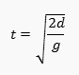
Science can help us make this prediction. As the ball is dropped, the principles of gravitational acceleration can be applied, for example the acceleration experienced by an object caused by the gravitational force exerted by the earth is approximately 9.8 m/s². (The square is because the object accelerates as it freefalls.) To calculate the time it will take to hit the floor, use this formula:
(t) represents the time taken (in seconds)
(d) stands for the distance fallen (in metres)
(g) indicates the acceleration caused by gravity

Logic suggests that they will not all fall at the same speed, however. As a ball falls, it encounters air resistance (collision between the object and the air molecules). The two most common factors that influence this are the cross-sectional area of the object and the speed at which it is moving. Considering the factors below relating to this, how does this change your prediction?

- Air resistance slows the object down as it falls. The greater the area of the falling object, the more resistance will be experienced.

- The faster it falls, the stronger the air resistance.

Predicting outcomes activity worksheet four
Group four: consider alternative outcomes and possible limitations of the predictions.
When making predictions in a science experiment, there might be alternative outcomes and possible limitations. Consider unexpected results that might need more investigation, or there could be multiple possible outcomes – what might they be and what might cause them?
What are the limitations in this experiment that might alter the predictions? Use the suggested headings in the table to consider how these limitations might affect the predictions and final outcomes.

Alternate outcomes
Unexpected results
Multiple possible outcomes
Limitations
Sample size
Uncontrolled variables
Assumptions
Human error

Predicting outcomes activity summary

Record the predictions and final times of the ball drops in the table below. Review the predictions and final times and consider which aspect of the prediction stages was the most useful and why.

 | Predicted time | Actual time
Ball 1

Ball 2

Ball 3

Ball 4

Notes:

Metal deterioration experiment instructions

Materials needed:
1. four test tubes (one per liquid) per group
2. nails (same type and size) (steel (mild, stainless, high-strength), aluminium alloy, copper, brass)
3. three liquids to test (e.g. water, vinegar, oil, lemon juice, salt water)
4. small labels or markers
6. safety goggles (recommended for eye protection).

Objective
To investigate the impact of varying environmental conditions, including exposure to different fluids and weathering, on the chemical degradation of metals over a period of four weeks.

Procedure:
1. Label the test tubes: use small labels or markers to label each test tube with the name of the liquid it will contain. This helps in keeping track of the substances being tested. One tube should be empty of liquid to be the control.
2. Preparing liquids: pour each liquid into the three labelled test tubes, filling them to about one-third or halfway full. There should be enough liquid to submerge the nail fully when upright. Ensure that each test tube contains a different liquid.
3. Adding nails: carefully place one nail into an empty test tube and one into each test tube filled with liquid. Make sure the nails are fully submerged in the liquid.
4. Observation: observe the reactions between the nails and the liquids over time. Note any changes in appearance, such as bubbles, colour changes or the formation of precipitates.
5. Record observations: keep a record of your observations over time (weekly for four weeks minimum), noting any changes or reactions that occur in each test tube. Use the metal deterioration observation recording sheet to keep notes.

Notes
The experiment should be left to run for a recommended observation time of four weeks to observe any long-term reactions or changes.

Encourage learners to make predictions about the reactions based on their knowledge of the properties of the liquids and the nails.

After the experiment, discuss the observations and draw conclusions about how different liquids interact with metal nails under various conditions.

Metal deterioration experiment observation recording sheet

Use the table below to record observations over the four-week duration of this experiment. Use the suggested observation points to guide this but create any others as needed.

Suggested observations:
- no visible changes
- some surface discoloration
- slight corrosion (e.g. appearance of rust)
- greenish patina formation
- minor tarnishing (loss of brightness or dull appearance)
- liquid colour.

Metal being tested | Control  (no liquid) | Liquid 1 | Liquid 2 | Liquid 3
Week 1:
date
Week 2:
date
Week 3:
date
Week 4:
date

Metal deterioration experiment report template
1. Experiment objectives
Clearly state the objectives of the experiment. What were you trying to investigate or observe?

2. Equipment
List all the equipment and materials used during the experiment. Be specific and include quantities.

3. Methodology
Describe the step-by-step procedure followed during the experiment. Look at the instruction sheet for ideas.

4. Observations
Record your observations during and after the experiment. Include photographs to accompany your comments.

5. Conclusions
Summarise the findings based on your observations. What did you learn from the experiment? Use prior learning to inform this section.

Solar heat experiment instructions

Additional notes:

If conducting the experiment indoors using a heat lamp, ensure that the lamp provides consistent heat to all containers.

Materials needed:
- three identical small containers (e.g. plastic cups)
- black paper
- aluminium foil
- white paper
- thermometer or thermometer guns
- stopwatch or timer
- sunlight or heat lamp (if conducting indoors).

Procedure
1. Preparation:
- Label each container as A, B and C.
- Cut pieces of black construction paper, aluminium foil and white paper to fit the bottom of each container. Ensure they are of equal size.

2. Setup:
- Place the black construction paper in Container A, the aluminium foil in Container B and the white paper in Container C.

3. Initial temperature measurement:
- Use the thermometer to measure and record the initial temperature inside each container. This will serve as the baseline temperature.

4. Exposure to sunlight:
- Place all three containers in direct sunlight or under a heat lamp. Ensure they receive equal exposure to sunlight or heat.

5. Temperature monitoring:
- Use the thermometer to periodically measure and record the temperature inside each container at regular intervals (e.g. every five minutes).

6. Observation and data collection:
- Observe and record how the temperature inside each container changes over time. Suggest readings be made every five minutes.
- Note any differences in temperature between the containers with different surfaces (black, aluminium foil, white).

7. Analysis:
- Analyse the data collected to determine which surface absorbed and retained solar heat most effectively.
- Compare the temperature trends and final temperatures reached in each container.

Solar heat experiment table for collection of data

 | Black surface  temp (°C) | Aluminium  temp (°C) | White surface  temp (°C)
Start
+ 5 minutes
+ 10 minutes
+15 minutes
+20 minutes
+ 25 minutes
+ 30 minutes

Solar heat experiment research topics

Objective
Emphasise the importance of understanding material surface properties in harnessing solar energy efficiently and sustainably to enable effective specification of materials in design, surveying and planning.

Research topics

Applications in building design:

How does surface colour and material choice impact the energy efficiency of buildings?
Explore examples of building designs that utilise dark-coloured or light-coloured surfaces to optimise solar heating or cooling.

Solar energy systems:

What is the role of surface property and colour in the design and efficiency of solar energy systems, such as solar panels and solar water heaters?
Discuss how surface colour and material affect the absorption and conversion of solar energy into usable electricity or heat.

Urban heat island effect:

What are urban heat islands and how do surface properties of metals contribute to heat retention or reflection in urban areas?
Discuss strategies for mitigating the urban heat island effect through surface material choices.

Research conclusion:

- Summarise the key points regarding the real-world applications of surface properties in solar heating efficiency in a poster.
- Include the broader implications of surface properties in material choice to limit degradation while providing efficient design.

Solar heat experiment conclusion notes

Conclude the experiment by discussing the results and the role of surface colour and material in absorbing and retaining solar heat.

Surface colour and material are key factors in determining how a surface interacts with solar radiation and heat energy. Dark-coloured surfaces absorb more solar energy and retain heat, while light-coloured surfaces reflect more solar radiation and absorb less heat. Additionally, the material composition of a surface influences its thermal conductivity and heat capacity, affecting its ability to conduct and retain heat. Understanding these principles is essential in various fields, including architecture, urban planning and renewable energy, where efficient use of solar energy plays a critical role.

Examining the role of surface colour and material in absorbing and retaining solar heat is crucial to understanding how different surfaces interact with sunlight and heat energy.

Surface colour
1. Absorption of solar energy:
- Surface colour plays a significant role in determining how much solar energy is absorbed. Darker colours, such as black, absorb more solar radiation compared with lighter colours, like white.
- Dark-coloured surfaces have a higher absorption coefficient, meaning they absorb a greater percentage of incoming solar radiation across a broader range of wavelengths.

2. Reflection of solar energy:
- Light-coloured surfaces, such as white or light-coloured materials, reflect more solar radiation compared with darker surfaces.
- Light-coloured surfaces have a higher albedo, which is the measure of reflectivity of a surface. Higher albedo surfaces reflect more sunlight and absorb less heat.

3. Retention of heat:
- Dark-coloured surfaces, because of their higher absorption of solar radiation, tend to retain more heat. This is because the absorbed solar energy is converted into heat energy, raising the surface temperature.
- Light-coloured surfaces, on the other hand, reflect more solar radiation and absorb less heat, resulting in lower surface temperatures and less heat retention.

Surface material
1. Conductivity of heat:
- The material composition of a surface also influences its ability to conduct and retain heat. Different materials have varying levels of thermal conductivity, which affects how heat is transferred through the surface.
- Materials with high thermal conductivity, such as metals like aluminium, conduct heat more efficiently and may transfer heat away from the surface faster.
- Materials with low thermal conductivity, such as wood or insulation materials, are less efficient at conducting heat and may retain heat more effectively.

2. Heat capacity:
- Heat capacity refers to the amount of heat energy required to raise the temperature of a substance by a certain amount. Materials with higher heat capacities can store more heat energy per unit mass.
- Some materials, like water or concrete, have higher heat capacities compared with others, like metals. This means they can absorb and retain more heat energy before experiencing a significant temperature change.

Windy day simulation and frost formation experiment instructions

Safety precautions:
- Handle the hairdryer or fan with care to avoid injury.
- Supervise the experiment to prevent accidents.

Materials needed:
- small shallow tray or dish
- ice cubes
- thermometer or thermometer gun
- salt (optional)
- hairdryer or fan.

Procedure
1. Preparation:
- Place the small, shallow tray or dish in a stable location where it won’t be disturbed.
- Fill the tray with a layer of ice cubes to create a cold surface.

2. Initial temperature measurement:
- Use the thermometer to measure and record the initial temperature of the ice surface. This will serve as the baseline temperature.

3. Windy day simulation:
- Set the hairdryer or fan to a medium or high speed, depending on the strength of wind you want to simulate.
- Hold the hairdryer or fan approximately 1-2 feet away from the ice surface.
- Turn on the hairdryer or fan and direct the airflow over the ice surface, simulating windy conditions.

4. Observation of frost formation:
- Observe the surface of the ice cubes for the formation of frost.
- Frost forms when water vapour in the air comes into contact with a cold surface and undergoes deposition, transitioning directly from vapour to solid frost.

5. Temperature monitoring:
- Continue to monitor the temperature of the ice surface periodically during the windy day simulation.
- Note any changes in temperature as frost forms.

6. Optional: salt experiment (alternative frost formation):
- Sprinkle a small amount of salt onto a section of the ice surface.
- Observe how the presence of salt affects the formation of frost compared with the unsalted areas.

Conclusion:
- After observing frost formation and monitoring temperature changes, conclude the experiment. Consider the wider implications of this effect that weather conditions can have on metals in design, surveying and planning.

Windy day simulation and frost formation scientific principles explanation

Frost, the solid form of water vapour or gas, typically coats surfaces when the surrounding air is saturated with moisture. It emerges when the temperature of an exterior surface drops below the dew point, the threshold at which atmospheric water vapour condenses into liquid, subsequently freezing into tiny ice crystals known as frost.

This phenomenon is most prevalent in low-lying regions where cooler air, being denser than warm air, accumulates because of its tendency to sink. Consequently, valleys often experience heavier frosts as cool air settles in these areas, laden with more water molecules than warmer air.

This principle of frost formation can be detrimental to metals used in building design for several reasons. First, when water vapour in the air condenses and freezes on metal surfaces, it can create ice that expands as it solidifies. This expansion can exert pressure on the metal, leading to stress and potentially causing cracks or fractures.

Moreover, the repeated formation and melting of frost on metal surfaces can contribute to corrosion. As the frost melts, the water can penetrate tiny cracks or imperfections in the metal’s surface, promoting oxidation and rust formation over time.

While frost formation may seem innocuous, its effects on metal building materials can be significant, leading to structural damage, corrosion and safety concerns if not properly addressed or mitigated in building design and maintenance.

Lesson 8 support materials

Shear force calculations worksheet
1000N
450N
R₂

  - What is the value of R₂?

∑V = 0

1000N = 450N + R₂

= R₂

= R₂

  - Calculate the shear forces acting at fixed point A.

1000N
450N
R₂
600N
1m
2m
2m
A
∑V = 0

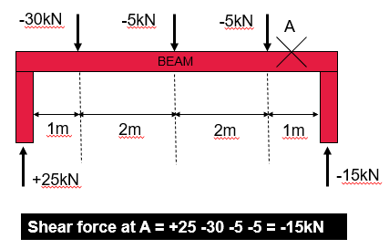

Shear force at A =

  - Calculate the shear forces acting at fixed point A.

300N
250N
R₂
750N
2m
4m
4m
A
∑V = 0

Shear force at A =

  - Calculate the shear forces acting at fixed point A.

400N
750N
∑V = 0
A

3m
3m
1m

850N
R₂

Shear force at A =

Shear force calculations worksheet answers

1000N
450N
R₂

- What is the value of R₂?

∑V = 0

1000N = 450N + R₂

1000N – 450N = R₂

550N = R₂

- Calculate the shear forces acting at fixed point A.

1000N
450N
R₂
600N
1m
2m
2m
A
∑V = 0

Shear force at A = 450N – 600N – 1000N = -1150N

- Calculate the shear forces acting at fixed point A.

300N
250N
R₂
750N
2m
4m
4m
A
∑V = 0

Shear force at A = 250N – 750N – 300N = -800N

- Calculate the shear forces acting at fixed point A.

400N
250N
∑V = 0
A

3m
3m
1m

850N
R₂

Shear force at A = 850N – 400N – 250N = 200N

Equilibrium and bending moments activity instructions
Objective
To demonstrate the concept of equilibrium and balance using rulers and coins.

Materials needed:
- rulers (30cm)
- pivot (prism-shaped object)
- coins (two-pence pieces are great but any coins or flat discs will work as long as they all have the same weight).

Procedure:
- Place a ruler horizontally on a prism.

- Start by placing one coin at a time on each ruler, ensuring that they are placed at the same distance from the centre of the ruler.

- As you add coins to both sides of the rulers, observe what happens. The rulers should remain balanced, with the coins on each side causing an equal but opposite force, resulting in equilibrium.

- Now add different numbers of coins to each side of the rulers. Observe how the position of the coins affects the balance and equilibrium of the rulers.

- Now place coins at different distances from the centre of the ruler. Observe how changing the distance affects the balance and equilibrium of the rulers.

- Try to maintain equilibrium by placing different numbers of coins at different distances from the centre on either side.

Discussion
After the activity, join in the class discussion to share your findings regarding the concept of equilibrium:
- What did you observe when adding coins to the rulers?
- How does the position of the coins affect the balance of the rulers?
- Can you explain why the rulers remain balanced even when coins are added to each side?

Conclusion
Conclude the activity by summarising the concept of equilibrium and its demonstration using rulers and coins. Emphasise the importance of balance and equal forces in achieving equilibrium.

Bending moment calculations worksheet
  - What is the moment around fixed point A?

5m
50kN
A

M = F(kN) × D(m)

M = kN x m

M = kN.m

  - What is the moment around fixed point A?

M = (F(kN) × D(m)) + (F(kN) × D(m))
A
5m
25kN
5m
25kN

M = ( kN × m) + ( kN × m)

M = kN.m + kN.m

M = kN.m

  - What is the moment around fixed point A?

M = (F(kN) × D(m)) + (F(kN) × D(m))

M = ( kN × m) + (- kN × m)
A
4m
20kN
4m
25kN

M = kN.m - kN.m

M = kN.m

  - What is the moment around fixed point A?

M = (F(kN) × D(m)) + (F(kN) × D(m))

M = ( kN × m) + ( kN × m)
22kN
5m
15kN
A
7m

M = kN.m + kN.m

M = kN.m

  - What is the moment around fixed point A?

M = (F(kN) × D(m)) + (F(kN) × D(m))

M = ( kN × m) + ( kN × m) + ( kN × m)

M = kN.m + kN.m + kN.m

M = kN.m
10kN
3m
33kN
A
5m
15kN
3m

Bending moment calculations worksheet answers

  - What is the moment around fixed point A?

5m
50kN
A

M = F(kN) × D(m)

M = 50kN x 5m

M = 250kN.m

  - What is the moment around fixed point A?
A
5m
25kN
5m
25kN

M = (F(kN) × D(m)) + (F(kN) × D(m))

M = (25kN × 5m) + (25kN × 5m)

M = 125kN.m + 125kN.m

M = 250kN.m

  - What is the moment around fixed point A?

M = (F(kN) × D(m)) + (F(kN) × D(m))

M = (25kN × 4m) + (-20kN × 4m)
A
4m
20kN
4m
25kN

M = 100kN.m - 80kN.m

M = 20kN.m

  - What is the moment around fixed point A?

M = (F(kN) × D(m)) + (F(kN) × D(m))

M = (22kN × 5m) + (15kN × 7m)
22kN
5m
15kN
A
7m

M = 110 kN.m + 105kN.m

M = 215kN.m

  - What is the moment around fixed point A?

M = (F(kN) × D(m)) + (F(kN) × D(m))

M = (-15kN × 3m) + (10kN × 3m) + (33kN × 5m)

M = -45kN.m + 30kN.m + 165kN.m

M = 150kN.m

10kN
3m
33kN
A
5m
15kN
3m

Reaction calculations worksheet
1. Calculate both reactions using forces acting on fixed point A.

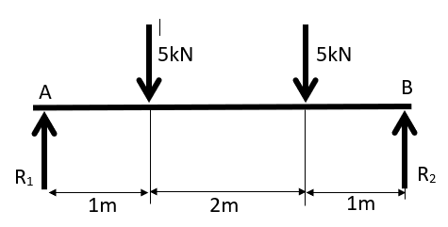

- Calculate both reactions using forces acting on fixed point B.

25kN
378kN
2m
4m
1m
B
A
R₂
R₁

Lesson 10 support materials

Concluding scenarios

Scenario one: Selection of materials based on weather data

An industrial developer has acquired sites throughout the country. The choice of buildings is mostly of the same design, although some features are changed to accommodate local conditions.

- Explain one way that weather and climatic data would affect the selection of materials in different parts of the country. (2)

- A proposal has been passed through a local planning authority to build a small, low-rise industrial development on a brownfield site. The site was previously a chemical works and as such it is expected that there will be a high level of ground contamination, particularly sulphur and heavy metals.

Explain how the presence of these types of chemicals will influence the materials chosen for the new project. (2)

- The site is in the north of England and is quite exposed. The area is known for rainfall throughout the year.

Using the weather data provided to support your responses, select construction materials to form the exterior shell of the structure, including walls, roof and any apertures within the structure. (9)

 | Min. temperature (°C) | Max. temperature (°C) | Rainfall (mm) | Humidity (%) | Rainy days (d) | Sun (hrs)
January | 1.5 | 6 | 70 | 88 | 10 | 3.3
February | 1.2 | 6.6 | 60 | 84 | 9 | 4
March | 2.1 | 8.8 | 62 | 80 | 9 | 4.7
April | 3.9 | 11.7 | 69 | 78 | 10 | 6.2
May | 7 | 14.6 | 69 | 76 | 10 | 7.5
June | 9.9 | 17.3 | 83 | 76 | 10 | 7.5
July | 12 | 19.4 | 80 | 75 | 10 | 8
August | 12 | 18.7 | 84 | 78 | 10 | 7.1
September | 10 | 16.6 | 68 | 80 | 8 | 5.6
October | 7.5 | 12.9 | 72 | 84 | 10 | 4.3
November | 4.1 | 8.8 | 73 | 87 | 10 | 3.6
December | 2.1 | 6.4 | 74 | 88 | 10 | 3.4

Scenario one: Selection of materials based on weather data

Notes for tutor
There is a difference of 24mm of precipitation between the driest and wettest months. Throughout the year, temperatures vary by 12°C.
The month with the highest relative humidity is January (87.69%). The month with the lowest relative humidity is July (75.43%). There is high humidity throughout the year.
The wettest month is January (13.8 days). The driest month is September (11.03 days), but it rains all year on average.
From this we can surmise that the environment is predominantly damp with high rainfall and humidity, and as such materials that are not susceptible to deterioration caused by contact with moisture would be preferable.
The ground is contaminated and poses a risk of acid exposure so materials that do not react easily would be recommended.

Scenario two: Steel selection for a load-bearing bridge component

Select a steel for use as a structural component in a bridge. The component needs to be lightweight yet strong as it will be load-bearing. The component will be on the external face of the bridge and exposed to the weather so needs to be corrosion-resistant and not susceptible to varying weather conditions. Using the data generated in lesson 4 for mild steel, stainless steel and high-strength steel, plot stress-strain graphs for each and describe the properties that each one displays. Use this information to justify your specification.

Insert graph here.

Scenario three: Bridge design analysis

Using the rules of equilibrium, determine the shear force at point A on the beam bridge and required reaction forces R₁ and R₂ to maintain equilibrium.

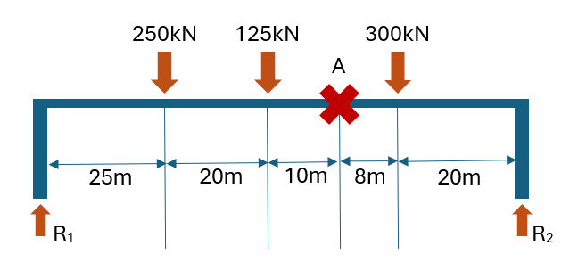


FUNDED BY
PRODUCED BY

This programme is funded by
the Department for Education
Ruth Brown of Leeds College of Building has produced this resource on behalf of the Education and Training Foundation

