
Support holistic delivery of Core Content and Occupational Specialism content: Digital infrastructure
ET-FOUNDATION.CO.UK
T LEVEL IN DIGITAL SUPPORT SERVICES (Part 1)

INTRODUCTION
These resources have been developed to be used to support learners studying the T Level in Digital support services. The materials focus on how to deliver a holistic approach, linking aspects of Core Content and the Occupational Specialism of digital infrastructure.
The overarching aim of the resources is to engage and motivate learners to complete the two years of study required to complete the T Level successfully. The resources aim to do this by giving the learner an initial overview of the content of the T Level. This gives them the opportunity, from early in the course, to develop the skills and knowledge they will use in the workplace. This is done by picking key areas of the requirements which will allow learners to engage with digital content early in the course.

Rationale
The aim of the lessons in this resource is to feed elements of the Core Content into the Occupational Specialism. This is to enrich learners with knowledge and skills to communicate network information clearly to both technical and non-technical audiences early enough in their pursuit of the Industry Placement. Learners will also gain skills that underpin the required level of competence in digital infrastructure.
It is suggested that these lessons are delivered early in the T Level course. This will motivate learners, as they perceive what is achievable by the end of the course. The 10 lessons in this resource will prepare the learner for further in-depth study. The structure of the 10 lessons enables delivery of knowledge that facilitates the development of the skills required to build a network of increasing complexity that meets network architectural principles.
Homework is not an aspect of all lessons as learners will not have access to the software when not in class. However, in the lessons, learners are instructed to research aspects of the required knowledge between lessons.

Required prior learning
Free online courses. Self-paced learning and certification-aligned pathways in Networking and Cybersecurity. Please visit netacad.com.

Technical skills development
The technical skills to be developed during the 10 lessons are:
- S2.1: Explain the fundamentals of network infrastructure
- S2.3: Install, configure and test physical and virtual networks – focus on: install and configure virtual networks
- S2.4: Maintain the effective functioning of physical or virtual networks (no coverage of physical).

This resource has three sections:

Framework for Learning
The resource includes a Framework for Learning (FfL). This covers 20 hours of learning, and there is a diagram to show how the content of those hours has been sequenced and scaffolded. There is also a narrative that explains the sequencing and scaffolding in more detail.

Lesson plans
There is a lesson plan for each stage in the sequencing and scaffolding of learning in the FfL. Lesson plans include details of the support materials that are required to support delivery, including those found in this resource.

Support materials
The support materials identified in the lesson plans are also available towards the end of this document.

NOTE:
There is a separate slide deck to be used with the lessons.

SECTION 1: FRAMEWORK FOR LEARNING

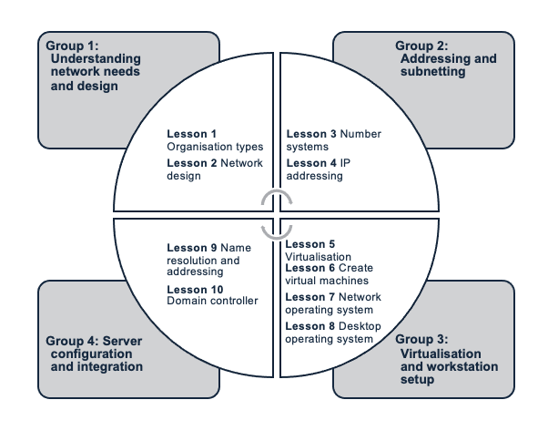
This Framework for Learning (FfL) sets out one approach to scaffolding and sequencing the holistic delivery of Core Content and the Occupational Specialism component of digital infrastructure for the T Level in Digital support services.
The specific areas of Core Content which are focused on are: Route Core Element 1 (RCE1): Business context; and Route Core Element 5 (RCE5): Digital environments. These provide a variety of knowledge and skills relevant to the Occupational Specialism components in the T Level in Digital support services.
Specific areas of Occupational Specialism components which are focused on are Digital Infrastructure – Performance Outcome 2 (PO2): Explain, install, configure, test and manage both physical and virtual infrastructure.
Route Core Elements
RCE1: Business context
RCE1.1: Types of organisations and stakeholders in the business environment – focus on organisation types
RCE 5: Digital environments
RCE5.2: Types and applications of networks, hardware and software, and the functions of internet of things – focus on: types and applications of networks; hardware and software
RCE5.3: The types and applications of protocols used to create networks and network referencing models
RCE5.4: The components and benefits of virtual computing systems
RCE5.5: The types, services and benefits of cloud computing
Occupational Specialism: Digital infrastructure
The Performance Outcome that is being used to holistically deliver content is elements of PO2: Explain, install, configure, test and manage both physical and virtual infrastructure. Emphasis is on install and configure virtual infrastructure. These elements cover both knowledge and skills.
Knowledge:
K2.1: The principles of network and infrastructure design
K2.3: The elements of infrastructure and associated technologies: network devices and end user devices (EUDs)
K2.6: The advantages and limitations of physical servers
K2.7: The advantages and limitations of self-hosted and cloud-hosted virtual servers
K2.8: The advantages and limitation of containers
K2.9: The types, benefits, similarities and differences of operation systems (OSs) and their application within digital infrastructure
K2.10: Service functions and their application in a client-server network environment – focus on active directory (AD DS), domain name systems (DNS) and Dynamic Host Configuration Protocol (DHCP)
K2.20: The concepts of virtualisation and the areas of application within digital infrastructure
Skills:
S2.1: Explain the fundamentals of network infrastructure
S2.3: Install, configure and test physical and virtual networks – focus on: install and configure component parts of virtual networks (virtual server, desktop and operating systems)
S2.4: Maintain the effective functioning of physical or virtual networks: virtual server and network-based services (DNS and DHCP)

The learning is split into 10 lessons.
This sequence is designed to ensure that learners build their skills in a logical and coherent manner. Each lesson serves as a building block, reinforcing and expanding on the knowledge gained in previous lessons. By progressing in this structured way, learners develop the confidence and competence needed to tackle complex networking and IT infrastructure challenges in the real world.
Group 1: Understanding network needs and design (lessons 1–2)
Lesson 1: Organisation types
The first lesson focuses on understanding the different types of organisations (e.g. small office or home office vs medium/large organisations). Learners explore how these differences influence the design of a network. The lesson sets the stage for tailoring network design to the specific requirements of a business.
Lesson 2: Network design
Building on the first lesson, learners are introduced to network architecture principles such as fault tolerance, scalability, Quality of Service (QoS) and security. This lesson emphasises how networks are structured to support business operations, Open Systems Interconnection (OSI) and Transmission Control Protocol / Internet Protocol (TCP/IP) models, with practical activities using Packet Tracer to simulate the models and design network topologies.
Group 2: Addressing and subnetting (lessons 3–4)
Lesson 3: Number systems
This lesson covers number systems, fundamentals to IPv4 addressing, helping learners understand how devices communicate within a network. Key concepts such as binary and decimal conversion are introduced, setting up the foundation for understanding data routing and addressing.
Lesson 4: IP addressing
In this lesson, learners move from basic addressing to more complex concepts such as subnetting and Classless Inter-Domain Routing (CIDR). The lesson explores the use of routable and non-routable addresses and provides learners with the skills to efficiently manage and segment IP addresses in a network.
Group 3: Virtualisation and workstation set-up (lessons 5–8)
Lesson 5: Virtualisation
This lesson introduces virtualisation, explaining how platforms like VirtualBox and Hyper-V are used to create and manage virtual machines (VMs). Learners learn about the fundamental principles of virtualisation, laying the groundwork for later skill activities.
Lesson 6: Create virtual machines
Learners apply their virtualisation knowledge by creating VMs and allocating resources. This lesson gives learners practical experience in setting up virtual environments, which is essential for managing server and network infrastructures.
Lesson 7: Network operating system
With VMs in place, learners proceed to install and configure network operating systems. This lesson teaches learners to make informed decisions about which network operating system to install, based on the requirements of the network and organisation.
Lesson 8: Desktop operating system
Learners explore the differences between home and professional workstations. The lesson also covers licensing considerations, teaching learners how to choose and implement the right workstation solutions for a business environment.
Group 4: Server configuration and integration (lessons 9–10)
Lesson 9: Name resolution and addressing
In this lesson, learners configure essential network services, such as DNS and DHCP, on their servers. Learners revisit IP addressing and subnetting concepts to ensure proper configuration and connectivity, enabling effective resource allocation across the network.
Lesson 10: Domain controller
The final lesson brings everything together. Active Directory Domain Services (AD DS) is implemented, requiring learners to join their systems to the domain. This capstone project integrates knowledge from all previous lessons, allowing learners to demonstrate their understanding of network design, virtualisation, server configuration and system integration.

SECTION 2: LESSON PLANS
This section includes 10 lesson plans. The lesson plans follow the Framework for Learning. The lesson plans include the:
- lesson title
- targeted specification content coverage
- lesson number in the sequence
- total amount of time required to deliver the lesson
- teacher and learner activities to be undertaken throughout the lesson
- resources needed to deliver the lesson (see Note below)
- details of how the lesson supports the development of English, maths and / or digital skills (where appropriate)
- details of how the lesson can be adapted to meet learners with specific needs
- next steps in learning, such as homework activities and links to the next lesson.
Note:
There is an assumption that the learning environment will include the following:
- whiteboard/smartboard or similar
- materials to take notes – e.g. pens, paper, audio recorder, digital device and software
- equipment to present a slide deck and video – e.g. projector, smartboard
- digital devices (e.g. laptop, tablet) for all learners
- Windows Server images (ISO), Windows 10 images (ISO) and Ubuntu
- Oracle VirtualBox, VMware and Hyper-V
- internet access
- learner access to word-processing, spreadsheet and presentation software
- Packet Tracer version 8.22
Packet Tracer comes with installation files for 32-bit and 64-bit platforms. Download the package with tutorial; it comes with installation video and activity wizard – resources. There is a separate pack for accessibility in Cisco Packet Tracer resources.
Cisco Packet Tracer free learning is available at netacad.com/courses/getting-started-cisco-packet-tracer?courseLang=en-US.
Self-paced online.

Lesson 1
Title: Organisation types
Targeted content reference:
Route Core Elements:
RCE1: Business context
RCE1.1: Types of organisations and stakeholders in the business environment
RCE5: Digital environments
RCE5.2: Types and applications of networks, hardware and software, and the functions of internet of things – focus on hardware and software
Occupational Specialism:
K2.3: The elements of infrastructure and associated technologies: network devices and end user devices (EUDs)
Lesson sequence number: 1
Timing: 2 hours
Prior learning:
Knowledge of basic networks.
Free online courses. Self-paced online learning. Please visit netacad.com.
Learn networking basics at netacad.com/courses/networking-basics?courseLang=en-US.
Learning environment:
Packet Tracer and Visio or another diagramming tool needs to be installed prior to the lesson.
Timing | Teacher activity | Learner activity | Support materials
10 minutes | Take register. | Answer questions as directed. | Slide deck  Activity: Identification of organisations  Activity: Create an organisation chart for your college  Microsoft Visio  Activity: Devices used to facilitate communications in an organisation  Activity: Network devices commonly used in an organisation  Packet Tracer activity: Network device representation  Cisco Packet Tracer
10 minutes | Framework for Learning on the slide deck used to give an outline of the learning objectives of the next 10 lessons. | Listen and take notes.
10 minutes | Learning objectives of lesson 1 outlined. | Listen to and clarify the requirements of this and the following 9 lessons.
10 minutes | Ask: Why do we need to know about different types of organisation?  Presentation – describe the types of organisation.  Hand out Activity: Identification of organisations sheet.  Support learners to complete Activity: Identification of organisations sheet.  Ask individual learners to give examples from the activity to the rest of the class. | Give ideas.  Listen and take notes.  Complete Activity: Identification of organisations.
10 minutes | Explain organisation chart.  Activity: Create an organisation chart for your college can be used to illustrate the hierarchical structure of an organisation.  Hand out Activity: Create an organisation chart for your college sheet.  Ask individual learners to give feedback to rest of the class. | Listen and take notes.  Complete Activity: Create an organisation chart for your college.  Provide oral feedback to rest of the class.
10 minutes | Outline the operational flow of communication that the network supports. | Use Microsoft Visio to create an organisation chart relevant to the department.
20 minutes | Presentation on how to identify devices used to facilitate communications in an organisation. | Listen and take notes.
20 minutes | Hand out Activity: Devices used to facilitate communications in an organisation. | Research and complete the table in Activity: Devices used to facilitate communications in an organisation.
30 minutes | Presentation covering network devices commonly used in an organisation. | Listen and take notes.
30 minutes | Hand out Activity: Network devices commonly used in an organisation.  Instruct learners to draw a diagram explaining how network devices are commonly used in an organisation. | Complete Activity: Network devices commonly used in an organisation using a flipchart diagram or smartboard.
30 minutes | Give feedback on diagrams, highlighting key points. | Listen and amend diagrams.
50 minutes | Demonstration of Packet Tracer as a tool to design and configure network infrastructure.  Direct learners to use Activity: Network devices commonly used in an organisation (Packet Tracer activity: Network device representation). | Follows activity instructions for Packet Tracer activity: Network device representation in Activity: Network devices commonly used in an organisation.
50 minutes | Provide instructions for Activity: Network devices commonly used in an organisation. | Identify EUDs, intermediary devices and media as represented in Packet Tracer.
Other:
English: This is linked to development of English skills via the use of correct vocabulary. Vocabulary to use for potential clients.
Adaptation:
SEND: Adjustments in terms of time to process knowledge. Microsoft software to help with dyslexic learners. Accessibility function used for slide deck.
Some learners may find a glossary of terms supportive with the introduction of new terms and vocabulary.
Next steps in learning:
Describe network design principles such as fault tolerance, scalability, quality of service and security.

Lesson 2
Title: Network design
Targeted content reference:
Route Core Element:
RCE 5.3: The types and applications of protocols used to create networks and network referencing models: Open Systems Interconnection (OSI); Transmission Control Protocol, Internet Protocol and User Datagram Protocol (TCP/IP/UDP)
Occupational Specialism:
K2.1: The principles of network and infrastructure design
S2.1: Explain the fundamentals of network infrastructure
Lesson sequence number: 2
Timing: 2 hours
Prior learning:
Learners have been introduced to elements of infrastructure, associated technologies and Packet Tracer in lesson 1.
Timing | Teacher activity | Learner activity | Support materials
5 minutes | Take register. |  | Slide deck  Packet Tracer  Packet Tracer activity  Activity: Create a LAN – Part 1: Connect network devices and hosts  Activity: Create a LAN – Part 2: Configure devices with IPv4 addressing  Activity: Create a LAN – Part 3: Verify the end device configuration and connectivity  Activity: Create a LAN – Part 4: Use networking commands to view host information  Packet Tracer: Investigate the TCP/IP and OSI models – Part 1: Examine HTTP web traffic  Packet Tracer: Investigate the TCP/IP and OSI models – Part 2: Display elements of the TCP/IP protocol suite
5 minutes | Outline the learning objectives. | Listen.
5 minutes | Explain the concept of fault tolerance. | Listen and take notes.
15 minutes | Present principles of network design. | Listen, ask questions and take notes.
60 minutes |  | Listen and ask questions.
60 minutes | Share Activity: Create a LAN parts 1, 2, 3 and 4 to create a local area network (LAN) with the learners. | Create a LAN.
60 minutes | Support learners to complete Packet Tracer activity.  Learners who finish early should be encouraged to attempt the extension questions on the activity sheet, which are available as they work through the activity. | Complete Packet Tracer activity.
20 minutes | Present information on hierarchical network design. | Listen, take notes and ask questions.
20 minutes | Present information on network reference and protocol models. | Listen, take notes and ask questions.
20 minutes | Present question on slide deck.  Circulate, support, stretch and challenge learners as they work. | Answer question.
20 minutes | Recap/summarise main points of the lesson.  Ask learners to consider a small office that has a LAN like the one they have created.  Ask individual learners to share what are the biggest facilities challenge in setting up the network in a new location.  Set homework activities. | Listen and take notes.  Make notes and prepare to share with rest of the class.  Answer questions when asked and make notes on classmates’ responses.
Other:
English: Learners to develop technical note-taking skills in this lesson.
Adaptation:
SEND: Provide learners with feedback sentence starters to assist with developing empathetic yet constructive feedback.
Extension: In the activities, there is a selection of extension questions that learners should complete if they have completed the activity.
Next steps in learning:
Learners to complete the following activities before the next lesson:
- Packet Tracer: Investigate the TCP/IP and OSI models – Part 1: Examine HTTP web traffic
- Packet Tracer: Investigate the TCP/IP and OSI models – Part 2: Display elements of the TCP/IP protocol suite.

Lesson 3
Title: Number systems
Targeted content reference:
Route Core Element: Check new specification for references to IP addressing.
Occupational Specialism:
K2.1 The principles of network and infrastructure design (number systems – applied for subnetting and IP addressing)
Lesson sequence number: 3
Timing: 2 hours
Prior learning:
Lessons 1 and 2.
Next steps in learning from lesson 2.
Timing | Teacher activity | Learner activity | Support materials
5 minutes | Take register. |  | Slide deck  Activity: Binary to decimal conversions  Activity: Convert decimal to binary  Activity: Convert binary to dotted decimal notation  Activity: Convert IPv4 dotted decimal notation to binary  Activity: Binary game  Activity: Converting from hexadecimal to decimal  Activity: IPv4 address structure
5 minutes | Talk through the learning objectives. | Listen and make notes.
20 minutes | Presentation: Binary number system. | Listen and take notes.
20 minutes | Distribute Activity: Binary to decimal conversions. | Work through the Activity: Binary to decimal conversions.
20 minutes | Distribute Activity: Convert decimal to binary. | Work through the Activity: Convert decimal to binary.
25 minutes | Using the slide deck, explain IPv4 address – 32 bits – 4 octets. | Listen and take notes.
25 minutes | Distribute Activity: Convert IPv4 dotted decimal notation to binary. | Work through the Activity: Convert IPv4 dotted decimal notation to binary.
20 minutes | Distribute Activity: Binary game. | Work through the Activity: Binary game.
20 minutes | Presentation using the slide deck relating to the hexadecimal number system. | Listen, take notes and ask questions to clarify understanding.
20 minutes | Distribute Activity: Converting from hexadecimal to decimal. | Work through the Activity: Converting from hexadecimal to decimal.
20 minutes | Present fundamentals of IPv4 addressing as per the slide deck. | Listen, take notes and ask questions to clarify understanding.
20 minutes | Distribute Activity: IPv4 address structure. | Work through the Activity: IPv4 address structure.
1 minutes | Plenary: exit card questions as per slide deck. | Answer questions as directed.
Other:
Maths: Learners develop the understanding of binary, denary and hexadecimal in this lesson.
Adaptation:
SEND: Use a glossary throughout the lessons.
Next steps in learning:
Apply the use of binary in IP addressing.

Lesson 4
Title: IP addressing
Targeted content reference:
Occupational Specialism:
K2.1: The principles of network and infrastructure design (number systems – applied for subnetting and IP addressing)
Lesson sequence number: 4
Timing: 2 hours
Prior learning:
Learners need an understanding of binary.
Timing | Teacher activity | Learner activity | Support materials
5 minutes | Take register. |  | Slide deck  Packet Tracer  Activity: Subnet within octet boundary /16  Activity: /16 usable hosts  Activity: Subnet network 10.0.0.0/8 using a /24 prefix  Activity: Packet Tracer: Subnet an IPv4 network
5 minutes | Talk through the learning objectives. | Listen, make notes and ask questions to clarify understanding.
10 minutes | Presentation: IPv4 unicast, broadcast and multicast to Network segmentation. | Listen, take notes, ask questions.
60 minutes | Distribute Activity: Subnet within octet boundary /16. | Complete the table in Activity: Subnet within octet boundary /16.
60 minutes | Instruct learners to complete the table for the octet boundary /16. | Review answers with peers.
60 minutes | Circulate.  Allocate learners into pairs to discuss and respond to the activity. | Discuss collectively in the pair and obtain consensus on a response to be given.
60 minutes | Distribute Activity: /16 usable hosts.  Instruct learners to complete the table for first and last usable host. | Complete the table for first and last usable host.
60 minutes | Circulate.
60 minutes | Distribute Activity: Subnet network 10.0.0.0/8 using a /24 prefix. | Complete the Activity: Subnet network 10.0.0.0/8 using a /24 prefix.
40 minutes | Present: Packet Tracer: Subnetting an IPv4 network. | Listen, take notes, ask questions.
40 minutes | Outline how to apply the magic number concept. | Listen and take notes.
40 minutes | Distribute Activity: Packet Tracer: Subnet an IPv4 network. (NB teacher to remove answers from the resource before handing out, as appropriate). | Complete the Activity: Packet Tracer: Subnet an IPv4 network.
5 minutes | Exit questions as per Packet Tracer. | Answer questions.
Next steps in learning:
Learners complete all activities in order to be able to apply their skills in the following lessons.

Lesson 5
Title: Virtualisation
Targeted content reference:
Route Core Element:
RCE5.4: The components and benefits of virtual computing systems
Occupational Specialism:
K2.20: The concepts of virtualisation and the areas of application within digital infrastructure
S2.3: Install, configure and test physical and virtual networks – focus on: install and configure virtual networks
Lesson sequence number: 5
Timing: 2 hours
Prior learning:
Lessons 2, 3 and 4.
Timing | Teacher activity | Learner activity | Support materials
10 minutes | Take register. |  | Slide deck  Activity: Enable Hyper-V on Windows  Activity: Create a virtual machine  Sticky notes
10 minutes | Present the learning objectives. | Listen, make notes and ask questions to clarify understanding.
10 minutes | Draw out existing knowledge. Confirm understanding through questioning. | Answer questions if asked by the teacher.
20 minutes | Presentation: Virtualisation – types and benefits. | Listen, take notes, ask questions to clarify understanding. Highlight key points.
20 minutes | Presentation: Hypervisors. | Listen, take notes, ask questions.
25 minutes | Distribute Activity: Enable Hyper-V on Windows. | Read Activity: Enable Hyper-V on Windows.
25 minutes | Provide instructions for activity. (10 minutes) | Complete the Activity: Enable Hyper-V on Windows. Ask questions to clarify if needed.
25 minutes | Circulate, support, stretch and challenge learners as they work. (15 minutes) | Ask for support if needed.
60 minutes | Distribute Activity: Create a virtual machine. | Navigate through the instructions.
60 minutes | Circulate to ensure learners are clear about the activity requirements. | Complete the Activity: Create a virtual machine.
60 minutes | Ask learners to compare their sheet with a peer’s. | Compare both Activity sheets with a peer. Discuss differences and note any remaining questions to feed back to class.
60 minutes | Ask for activity feedback from each learner. Record and discuss misconceptions. | Share feedback when asked. Listen to explanation of misconceptions and make amendments on Activity: Create virtual a machine.
5 minutes | Recap main points of the lesson. | Listen.
5 minutes | Ask learners to note one question that they still have on a sticky note and stick to the board. | Write one question that they still have and stick on the board.
Adaptation:
SEND: A step-by-step guide with screenshots has been included in the activity sheets to support learners when enabling Hyper-V and creating a virtual machine.
A screen-recorded walkthrough video with subtitles could be used to reinforce instructions and support learners who benefit from visual modelling.
Extension: Learners research one real-world example of how virtualisation is used in large-scale digital infrastructure (e.g. in data centres, cloud platforms or virtual desktop infrastructure).
Next steps in learning:
Teacher activity:
Complete activities in this lesson to provision platform for server and desktop virtual machines.
Review the sticky notes to identify questions and prepare answers for the start of lesson 6.

Lesson 6
Title: Create virtual machines
Targeted content reference:
Route Core Element:
RCE5.4: The components and benefits of virtual computing systems
Occupational Specialism:
S2.3: Install, configure and test physical and virtual networks (no coverage of ‘test physical’)
S2.4: Maintain the effective functioning of physical or virtual networks (no coverage of physical)
Lesson sequence number: 6
Timing: 2 hours
Prior learning:
Lessons 1 to 5.
Lesson environment:
Prepare environment to use Hyper-V or Oracle VirtualBox.
Timing | Teacher activity | Learner activity | Support materials
5 minutes | Register |  | Slide deck  Activity: Create Server VM using Hyper-V Manager  Activity: Create Server VM using Oracle VirtualBox  Activity: Create Desktop VM using Oracle VirtualBox  Activity: Create Desktop VM using Hyper-V Manager  Feedback sheet
5 minutes | Present the learning objectives. | Listen, make notes and ask questions to clarify understanding.
5 minutes | Answer questions that were shared in lesson 5. | Listen, make notes and ask questions to clarify understanding.
45 minutes | Distribute Activity: Create Server VM using Hyper-V Manager or Activity: Create Server VM using Oracle VirtualBox. | Navigate through the instructions.
45 minutes | Provide instructions for activity. | Note instructions.
45 minutes | Circulate, support, stretch and challenge learners as they work. | Complete Activity: Create Server VM using Hyper-V Manager or Activity: Create Server VM using Oracle VirtualBox. Ask for support where needed.
45 minutes | Distribute Activity: Create Desktop VM using Oracle VirtualBox or Activity: Create Desktop VM using Hyper-V Manager. | Navigate through the instructions.
45 minutes | Provide instructions for activity. | Complete Activity: Create Desktop VM using Oracle VirtualBox or Activity: Create Desktop VM using Hyper-V Manager.
25 minutes | Distribute Feedback sheet. And ask learners to swap places with a peer so they are at a different computer. | Move to a different computer.
25 minutes | Provide instructions for activity. | Review peers Desktop VM using the Feedback sheet.
25 minutes | Ask learners to share feedback with peer. | Share and receive feedback from peer. Identify areas for improvement if applicable.
25 minutes | Ask learners to write one area of improvement they have identified onto a shared collaborative platform such as Teams. | If applicable, share one area of improvement onto a shared collaborative platform.
Adaptation:
SEND: A step-by-step activity sheet with instructions and screenshots has been provided for each VM installation task.
Learners could be paired using a driver–navigator approach to support communication and confidence.
Extension: Learners investigate the difference between full virtualisation and paravirtualisation, summarising each with examples.
Next steps in learning:
Teacher activity:
Review areas of improvement. Prepare suggestions for improvement and share on shared learning platform.

Lesson 7
Title: Network operating system
Targeted content reference:
Route Core Element:
RCE5.4: The components and benefits of virtual computing systems
RCE5.5: The types, services and benefits of cloud computing
Occupational Specialism:
K2.9: The types, benefits, similarities and differences of operating systems (OSs) and their application within digital infrastructure
S2.4: Maintain the effective functioning of physical or virtual networks (no coverage of physical)
Lesson sequence number: 7
Timing: 2 hours
Prior learning:
Lessons 1 to 6.
Timing | Teacher activity | Learner activity | Support materials
5 minutes | Take register. |  | Slide deck  Activity: Download Windows Server 2019 ISO  Hyper-V Manager  Activity: Install Windows Server 2019 on Server VM using VirtualBox  Activity: Initial configuration of Windows Server 2019  Activity: Confirm initial configuration
5 minutes | Present the learning objectives. | Listen, make notes and ask questions to clarify understanding.
15 minutes | Distribute Activity: Download Windows Server 2019 ISO.
15 minutes | Provide instructions for activity. | Listen, make notes and ask questions to clarify understanding.
15 minutes | Circulate, support, stretch and challenge learners as they work. | Complete Activity: Download Windows Server 2019 ISO. Ask for support if needed.
40 minutes | Move into pairs to work together on this activity. | Move into pairs.
40 minutes | Distribute Activity: Install Windows Server 2019 on Server VM using VirtualBox. | Navigate through the instructions. Discuss configuration steps in pair.
40 minutes | Provide instructions for activity. Share technical guidance and highlight key steps. | Listen, make notes and ask questions to clarify understanding.
40 minutes | Circulate and address technical difficulties. | Complete Activity: Install Windows Server 2019 on Server VM using VirtualBox. Ask for clarification where needed.
40 minutes | Ask learners to confirm where they have got to in the installation process. Ensure all learners have completed the server installation prior to moving on to the next activity. | Let the teacher know when the activity is complete.
15 minutes | Distribute Activity: Initial configuration of Windows Server 2019. | Remain in pairs for this activity.
15 minutes | Provide instructions for activity. Share technical guidance and highlight key steps. | Listen, make notes and ask questions to clarify understanding.
15 minutes | Circulate and address technical difficulties. | Follow activity instructions. Configure Windows Server using the provided steps. Note any issues or queries. Ask for support if needed.
40 minutes | Distribute Activity: Confirm initial configuration. | Remain in pairs for this activity.
40 minutes | Provide instructions for activity. Share scenarios to check network visibility or system roles. | Listen, make notes and ask questions to clarify understanding.
40 minutes | Ask each learner to share one observation. | Complete Activity: Confirm initial configuration. Share one test outcome with the class. Reflect on configuration success and record improvements needed.
5 minutes | Recap main points of lesson. | Listen, make notes and ask questions to clarify understanding.
5 minutes | Ask learners to submit testing sheets. | Submit testing sheets for review.
Adaptation:
SEND: A step-by-step guide with visuals has been provided in each activity sheet to support download, installation and configuration.
Learners have been paired strategically for peer support throughout installation and testing tasks.
Extension: Learners investigate the differences between Windows Server and a Linux-based server OS (e.g. Ubuntu Server) and record the information in a table.
Next steps in learning:
Teacher activity:
Review test sheets to identify gaps in understanding, particularly in network set-up.

Lesson 8
Title: Desktop operating system
Targeted content reference:
Occupational Specialism:
K2.9: The types, benefits, similarities and differences of operating systems (OSs) and their application within digital infrastructure
Lesson sequence number: 8
Timing: 2 hours
Prior learning:
Lessons 1 to 7.
Lesson environment:
Ensure each learner has access to an empty virtual machine called Desktop VM.
Timing | Teacher activity | Learner activity | Support materials
5 minutes | Take register. |  | Slide deck  Activity: Download Windows 10 Pro ISO  Activity: Install Windows 10 Pro on Desktop VM  Activity: Initial configuration of Windows 10 Pro  Activity: Confirm configuration of Windows 10 Pro  Feedback sheet
5 minutes | Talk through the learning objectives. | Listen, make notes and ask questions to clarify understanding.
5 minutes | Present details of Windows desktop versions. Confirm understanding through questioning. | Listen, make notes and ask questions to clarify understanding. Answer questions.
15 minutes | Distribute Activity: Download Windows 10 Pro ISO.
15 minutes | Provide instructions for activity. | Listen, make notes and ask questions to clarify understanding.
15 minutes | Circulate to ensure learners have a copy of Windows 10 Pro. | Follow activity instructions to download the Windows 10 Pro ISO file.
40 minutes | Distribute Activity: Install Windows 10 Pro on Desktop VM.
40 minutes | Provide instructions for activity. | Listen, make notes and ask questions to clarify understanding.
40 minutes | Circulate and address technical difficulties. | Complete Activity: Install Windows 10 Pro on Desktop VM. Note any issues or queries. Ask for support if needed.
40 minutes | Ask learners to confirm where they have got to in the installation process. Ensure all learners have completed the desktop installation prior to moving onto the next activity. | Let the teacher know when the activity is complete.
40 minutes | Distribute Activity: Initial configuration of Windows 10 Pro.
40 minutes | Provide instructions for activity. | Listen, make notes and ask questions to clarify understanding.
40 minutes | Circulate and address technical difficulties. | Complete Activity: Initial configuration of Windows 10 Pro. Note any issues or queries. Ask for support if needed.
40 minutes | Ask learners to confirm where they have got to in the installation process. Ensure all learners have completed the desktop installation prior to moving onto the next activity. | Let the teacher know when the activity is complete.
20 minutes | Distribute Activity: Confirm configuration of Windows 10 Pro and Feedback sheet.
20 minutes | Provide instructions for activity. | Listen, make notes and ask questions to clarify understanding.
20 minutes | Circulate and ask questions about installation and configuration process. | Complete Activity: Confirm configuration of Windows 10 Pro. Individually, review own installation using the Feedback sheet.
20 minutes | Ask learners to write a short reflection on the similarities and differences between installing Windows Server 2019 and Windows 10 Pro for their homework. | Listen, make notes and ask questions to clarify understanding.
Adaptation:
SEND: A step-by-step installation guide has been provided with annotated screenshots to support navigation through the Windows 10 Pro set-up process.
Key terms have been simplified or explained verbally during the activity briefing, with visual icons used to support comprehension.
Extension: Learners should research one Windows 10 Pro feature that supports virtualisation and prepare a brief summary to upload to the shared collaborative space.
Next steps in learning:
Learner activity:
Homework: Write a short reflection on the similarities and differences between installing Windows Server 2019 and Windows 10 Pro.

Lesson 9
Title: Name resolution and addressing
Targeted content reference:
Occupational Specialism:
K2.10: Service functions and their application in a client-server network environment:
- Domain Name System (DNS) – for the translation of hostnames to IP addresses.
- Dynamic Host Configuration Protocol (DHCP) – to assign IP addresses to network client devices.
Lesson sequence number: 9
Timing: 2 hours
Prior learning:
Lessons 1 to 8.
Timing | Teacher activity | Learner activity | Support materials
5 minutes | Take register. |  | Slide deck  Activity: Review IPv4 addressing  Activity: Install and configure Dynamic Host Configuration Protocol (DHCP) role on Server VM from lesson 7  Activity: Install the domain name system (DNS) role on Server VM from lesson 7  Check the Server VM has a static IP address
5 minutes | Present the learning objectives and recap key concepts from the previous lesson. Confirm understanding through questioning. | Listen, make notes and ask questions to clarify understanding.
20 minutes | Distribute Activity: Review IPv4 addressing.
20 minutes | Provide instructions for activity. | Listen, make notes and ask questions to clarify understanding.
20 minutes | Circulate and support learners as they complete the task. Ask probing questions to identify misconceptions. | Complete Activity: Review IPv4 addressing independently. Ask questions for clarification.
40 minutes | Present overview of Dynamic Host Configuration Protocol (DHCP). | Listen. Take notes and ask questions for clarification.
40 minutes | Distribute Activity: Install and configure Dynamic Host Configuration Protocol (DHCP) role on Server VM from lesson 7.
40 minutes | Provide instructions for activity. | Listen, make notes and ask questions to clarify understanding.
40 minutes | Circulate and observe learner progress. Confirm understanding through questioning. | Complete Activity: Install and configure Dynamic Host Configuration Protocol (DHCP) role on Server VM from lesson 7. Note any issues or queries. Ask for support if needed.
40 minutes | Ask learners to confirm where they have got to in the installation process. Ensure all learners have completed the desktop installation prior to moving onto the next activity. | Let the teacher know when the activity is complete.
10 minutes  40 minutes | Present overview of domain name system (DNS). | Listen, make notes and ask questions to clarify understanding.
10 minutes  40 minutes | Distribute Activity: Install the domain name systems (DNS) role on Server VM from lesson 7.
10 minutes  40 minutes | Provide instructions for activity. | Listen, make notes and ask questions to clarify understanding.
10 minutes  40 minutes | Circulate and observe learner progress. Confirm understanding through questioning. | Complete Activity: Install the domain name systems (DNS) role on Server VM from lesson 7.
10 minutes  40 minutes | Ask learners to confirm where they have got to in the installation process. Ensure all learners have completed the desktop installation prior to moving onto the next activity. | Let the teacher know when the activity is complete.
5 minutes | Recap main learning points from DHCP and DNS activities. Ask targeted questions to reinforce understanding.  Set homework activity | Answer questions and contribute to summary discussion.
Adaptation:
SEND: Screenshots of expected server settings have been included in the printed instructions for learners with memory or sequencing challenges.
Extension: Learners should compare DHCP and static IP address assignment, identifying three key differences and giving examples of when each method would be used in industry.
Next steps in learning:
Learners write a 150-word response explaining why DNS and DHCP are often installed on separate servers in large networks.

Lesson 10
Title: Domain controller
Targeted content reference:
Occupational Specialism:
PO2: Explain, install, configure, test and manage both physical and virtual infrastructure – focus is on installation and configuration of virtual infrastructure.
K2.10: Service functions and their application in a client-server network environment
Active Directory Domain Services (AD DS):
Active directory – provides functionality to centrally manage and organise user and device accounts, security groups and distribution lists, contained in organisational units (OUs).
Lesson sequence number: 10
Timing: 2 hours
Prior learning:
Lessons 1 to 9.
Setting up the learning environment:
Launch the Server and Desktop VMs configured in lessons 6–8.
Timing | Teacher activity | Learner activity | Support materials
25 minutes | Take register. |  | Slide deck  Activity: Perform domain configuration prerequisites  Activity: Configure server as a domain controller  Activity: Join the domain  Activity: Installation peer review checklist
25 minutes | Outline learning objectives. | Listen. Ask questions for clarification.
25 minutes | Explain active directory. | Listen. Ask questions for clarification.
45 minutes | Present explanation of how to deploy Active Directory Domain Services (AD DS). | Listen. Take notes and ask questions for clarification.
45 minutes | Hand out Activity: Perform domain configuration prerequisites. | Complete the table in Activity: Perform domain configuration prerequisites.
45 minutes | Instruct learners to work individually.  Hand out Activity: Configure server as a domain controller.  Instruct learners to deploy AD DS.  Remind learners of location of previously configured virtual machines. Ensure learners can access virtual machines.  Circulate, observe how learners are engaging with the task. Ask probing questions to confirm understanding. | Work as individuals using the handout Activity: Configure server as a domain controller to install AD DS on server that will be the primary domain controller.
30 minutes | Distribute the Activity: Join the domain and explain that the learners should now join the second server and client to domain. | Ask questions for clarification and work through the Activity: Join the domain.
20 minutes | Distribute Activity: Installation peer review checklist.  Instruct learners to review a peer using the checklist.  Instruct learners to view their peer’s review of their own work and consider the following reflective questions:  What error did you find in the installation and configuration?  How did you resolve it? Set Homework activity | Complete for one other learner the Activity: Installation peer review checklist to confirm both virtual machines have been correctly joined to domain.  Review own Installation peer review checklist with feedback.
Adaptation:
SEND: Allow learners opportunity to individually review case study material ahead of the lesson.
Next steps in learning:
Investigate how to add in Group Policy Objects for managing passwords and mapping network drives that follow the user.

SECTION 3: LESSON SUPPORT MATERIALS
The support materials follow a list of those required for each lesson.
This section includes the handouts and worksheets referred to in the Support materials section of each lesson plan.
Note that some activities are on the slide deck

The following materials relate to lesson 1: Organisation types
Activity: Identification of organisations
Activity: Create an organisation chart for your college
Activity: Devices used to facilitate communications in an organisation
Activity: Network devices commonly used in an organisation
Packet Tracer activity: Network device representation
Challenge activity

Activity: Identification of organisations
Research and identify one of each of the following organisation types and complete the table.
Type | Examples | Services
Public sector

Private sector
Public limited company (PLC)

Private limited company (Ltd)

Partnership

Sole trader
Third sector
Voluntary/charity/social enterprise

What type of organisation is your college?

Activity: Create an organisation chart for your college
- Identify key roles and departments.
- Determine the hierarchical structure.
- Use Microsoft Visio to illustrate reporting relationships.
- Review and revise the chart for accuracy.
- Share it with stakeholders for feedback.
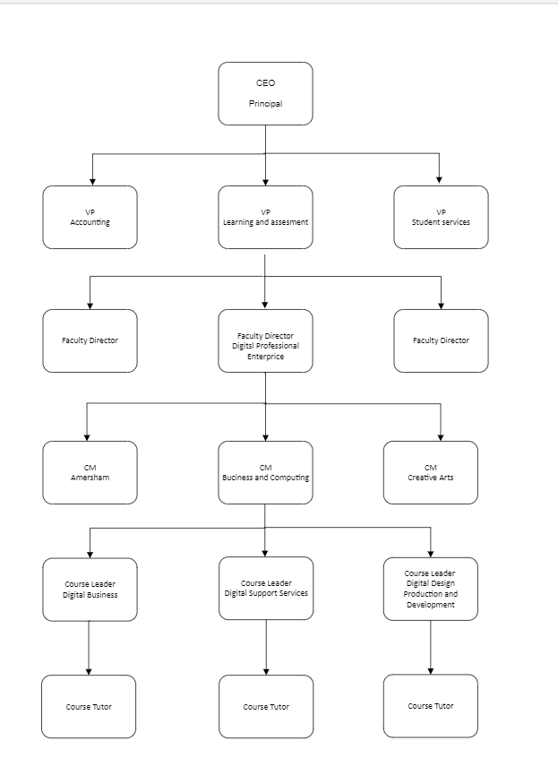

Activity: Devices used to facilitate communications in an organisation
Communication devices enable effective and efficient information exchange among employees, departments and teams. Research devices and populate the table with more examples, grouping them into the following categories:
- communication devices
- collaboration tools
- information-sharing tools.
Category | Device | Function
Communication devices | E.g. telephones | Direct voice communication
Collaboration tools | E.g. video conferencing equipment | Virtual meetings and remote working set-up
Information-sharing tools | E.g. smartboards | Real-time interaction and sharing of ideas

Activity: Network devices commonly used in an organisation
Network devices enable the operations performed by an organisation by facilitating communication, data transfer and connectivity across the network.
Network diagrams, or topology diagrams, use symbols to represent devices within a network. These devices can be categorised into two types – end devices and intermediary devices – based on their role and the network media they use.
An end device is where a message originates from or where it is received. Examples include desktop computer, laptop, server, printer and IP phone.
An intermediary device interconnects end devices and manages data as it flows through the network. Examples include switches, wireless access points, routers and firewalls.
A network medium allows a message to travel across a network from source to destination. Examples include copper, fibre optics and wireless.

Packet Tracer activity: Network device representation
Part 1: Identify end devices, intermediary devices and media as represented in Packet Tracer
The icon toolbar at the bottom-left has networking component categories: intermediary devices, end devices and media. The Connections category (with the lightning bolt icon) represents Packet Tracer’s networking media.
List the end device categories.
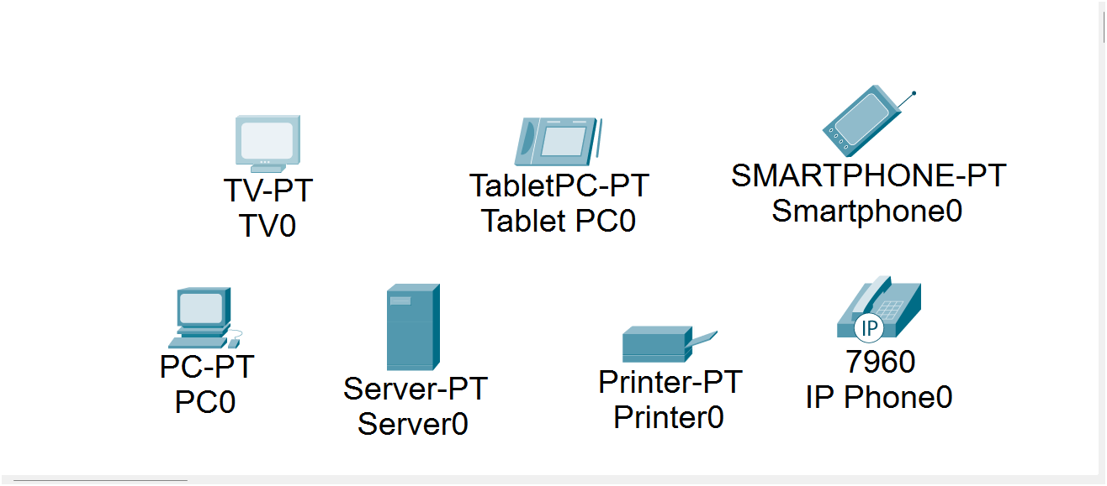

List the intermediary device categories.
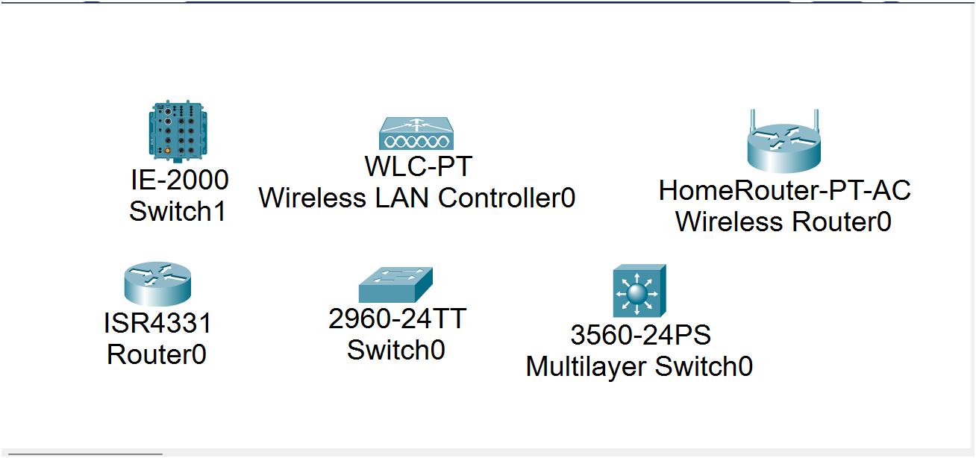

List the different types of media categories.
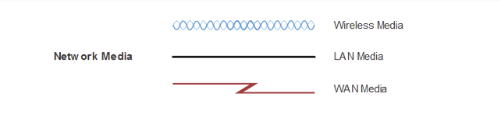

Part 2: Explain the function of the devices
In Packet Tracer, only the Server-PT device can act as a server. Desktop or laptop PCs cannot act as a server.
List the functions of servers and clients. Both are end devices. What determines their roles?
Servers are hosts that have software installed that enables them to provide information and services, like email or web pages, to other hosts on the network.
Clients are hosts that have software installed that enables them to request and display the information obtained from the server.
Software installed on the host determines the role it plays on the network.
A client could also be configured as a server simply by installing server software.
List at least two functions of intermediary devices.
Regenerate and retransmit data signals; maintain information about the available pathways through the network and internetwork; notify other devices of errors and communication failures; redirect data along alternative pathways when a link is compromised; classify and direct messages according to QoS priorities; control the flow of data based on security settings.
List at least two criteria for choosing a network media type.
The distance the media can successfully carry a signal; the environment in which the media is to be installed; the amount of data and the speed at which it must be transmitted; the cost of the media and installation.

Challenge activity
  - Open a new instance of Packet Tracer.
  - Create a new network with at least four end devices, an intermediary device and a media-type connection.
  - What else is needed for the end devices to send data to each other?
  - Verify connectivity between the devices.
  - Save the Packet Tracer file.

The following materials relate to lesson 2: Network design
Activity: Create a LAN – Part 1: Connect network devices and hosts
Activity: Create a LAN – Part 2: Configure devices with IPv4 addressing
Activity: Create a LAN – Part 3: Verify the end device configuration and connectivity
Activity: Create a LAN – Part 4: Use networking commands to view host information
Packet Tracer: Investigate the TCP/IP and OSI models – Part 1: Examine HTTP web traffic
Packet Tracer: Investigate the TCP/IP and OSI models – Part 2: Display elements of the TCP/IP protocol suite

Activity: Create a LAN – Part 1: Connect network devices and hosts
Instructions
Complete the steps of the activity when instructed.
If you have completed the activity, please attempt the extension questions.

Step 1: Power on the end devices and Office Router.

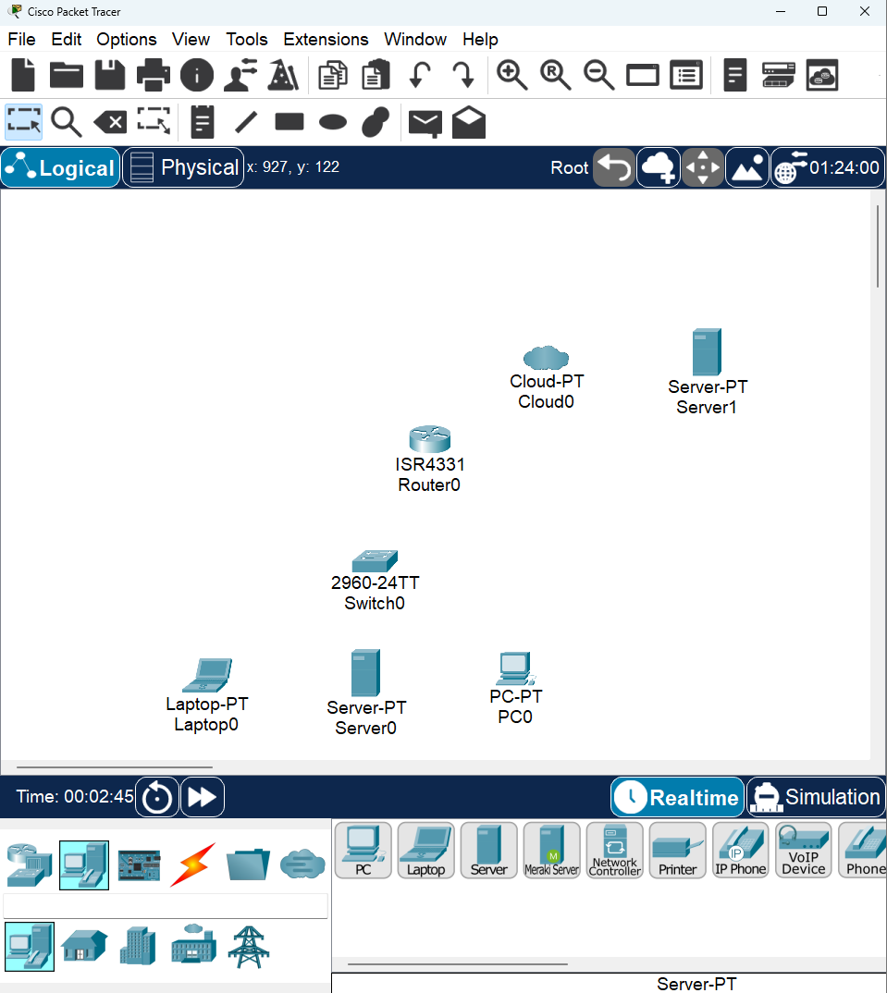
Click each device and open its Physical tab. Note: There is no power switch on the switch model used in this activity.
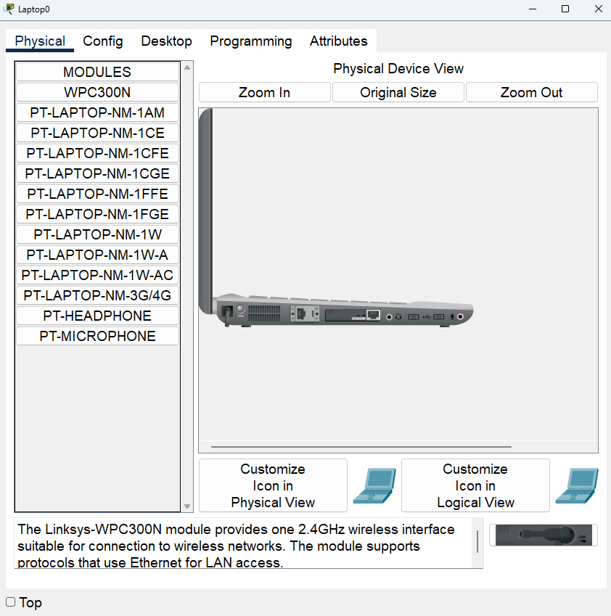

Step 2: Connect the end devices.
Use the table and instructions to connect the network devices and hosts to create the physical network.
Connections table
Device | Interface | Connected to device | Connection interface
PC0 | FastEthernet0 | Switch0 | FastEthernet0/4
Laptop0 | FastEthernet0 | Switch0 | FastEthernet0/5
Server0 | FastEthernet0 | Switch0 | FastEthernet0/6
Router0 | GigabitEthernet0/0/1 | Switch0 | GigabitEthernet0/1
Router0 | Serial0/1/0 | Cloud0 | Serial0
ISP | FastEthernet0 | Ethernet6

Connect the networking devices according to the information in the Connections table using Ethernet copper straight-through cables. For the internet to Router0 connection, select the device and port from the drop-down menus that appear when you click the cloud with connections tool selected.
Connect the PC0, Laptop0 and Server0 to the Switch according to the information in the Connections table. Use copper straight-through cables.
You should see green link lights on all connections after a brief delay.

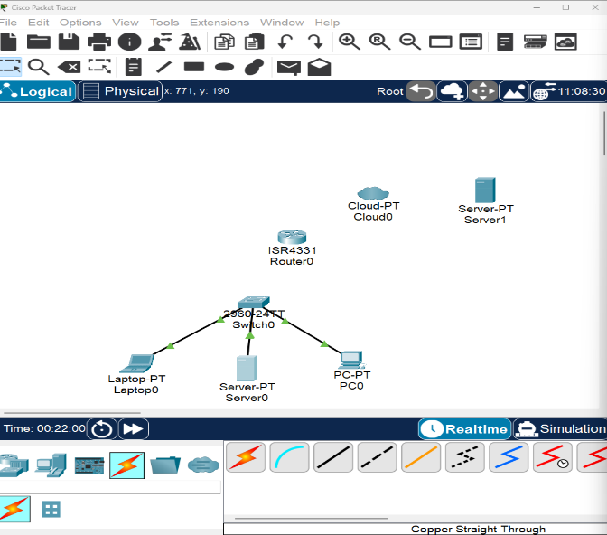

Activity: Create a LAN – Part 2: Configure devices with IPv4 addressing
Addressing table
Device | Port | IPv4 address | Subnet mask
PC0 | NIC | DHCP | N/A
Laptop0 | NIC | DHCP | N/A
Server0 | NIC | 192.168.1.1 | 255.255.255.0
ISP | NIC | 209.165.200.225 | N/A
Router0 | GigabitEthernet0/0/1 | 192.168.1.254 | 255.255.255.0

Step 1: Configure the hosts with addressing information
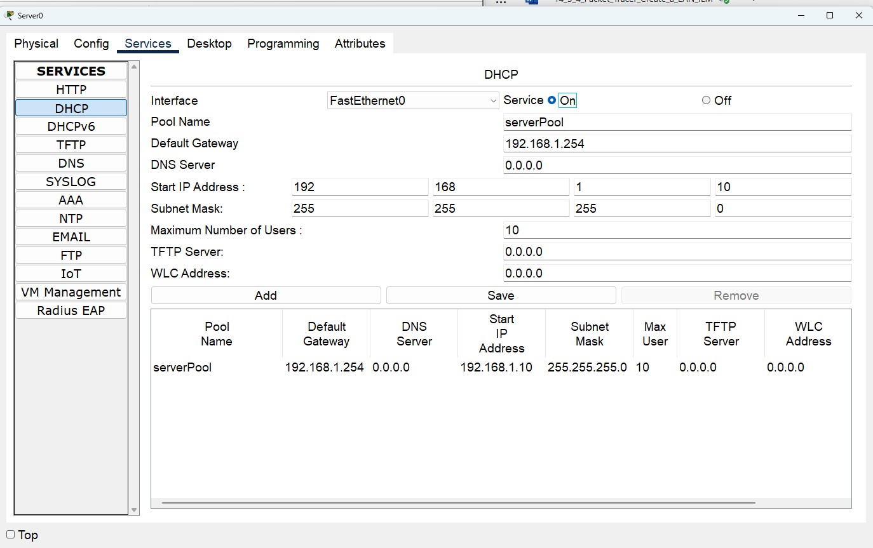Server0 has been configured to supply IP addresses to hosts on the LAN.

The PC0 and Laptop0 should receive their IP addressing information from DHCP. Click the PCs and go to the Desktop tab on each PC.

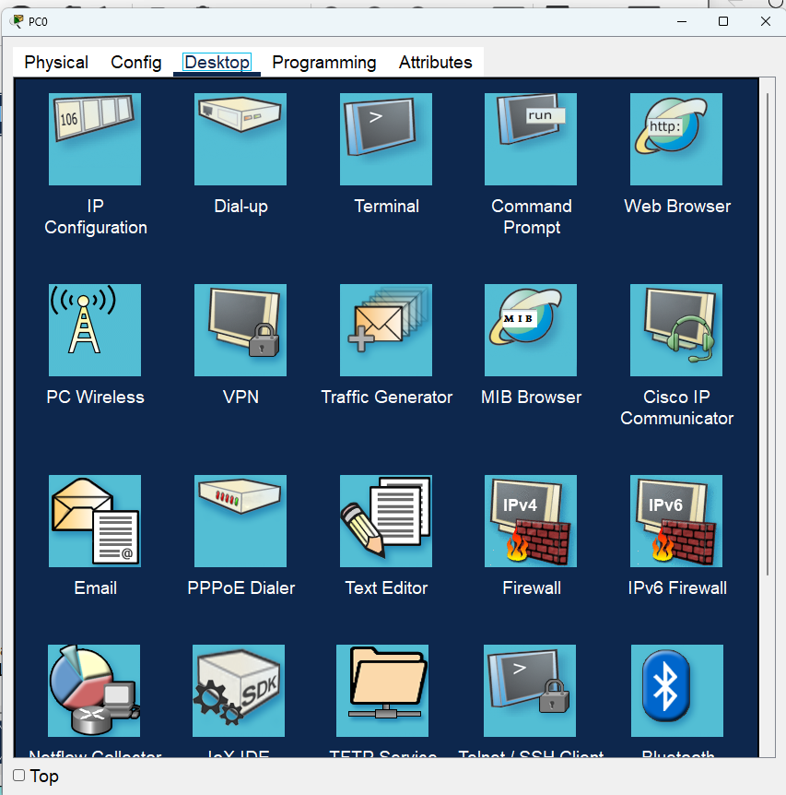

Open the IP Configuration application and configure the PCs to receive their IP addresses dynamically.
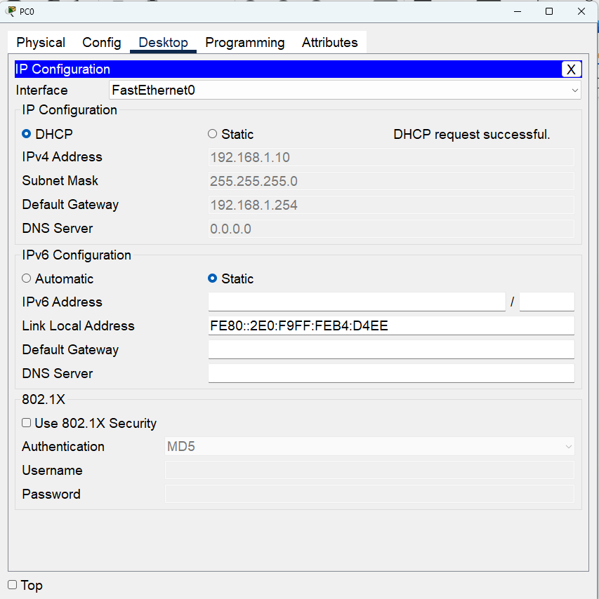

Laptop0
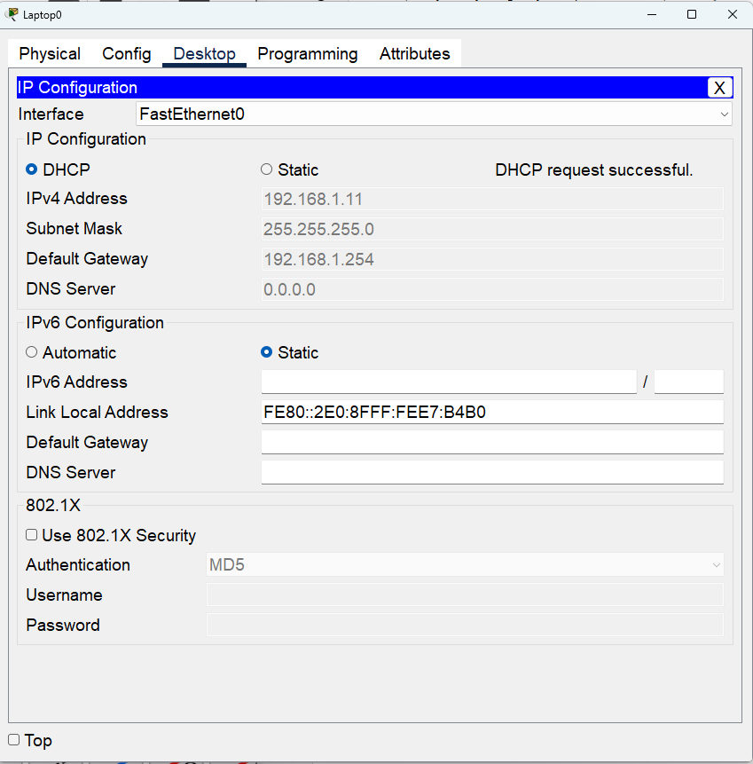
Server0 and Router0 are often manually configured with addressing because other devices on the network are configured to access them using IP addresses. Manual configuration with a static address will ensure that the IP addresses of these devices do not change.

Click Router0 and open the Config tab. Enter the addressing information from the Addressing table.

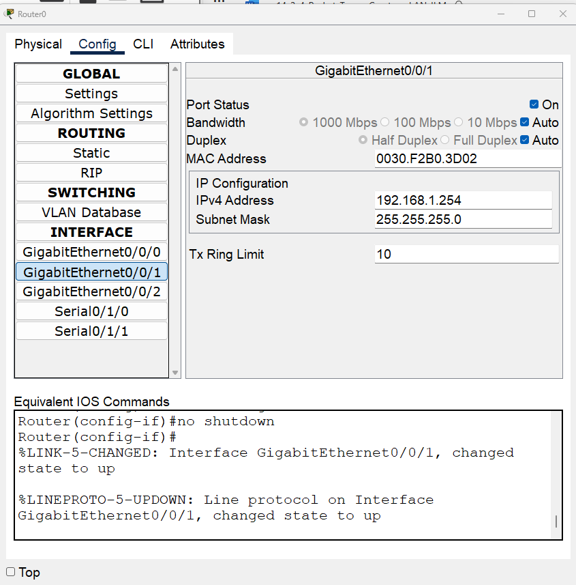

Extension question
Why do you think the IPv4 addresses are different, but the subnet masks and default gateways are the same?

Activity: Create a LAN – Part 3: Verify the end device configuration and connectivity
Step 1: Verify connectivity between the two PCs.
From the command prompt on PC0, ping the IP address of Laptop0. Repeat this process for Server0. You should see successful pings for each. This verifies that PC0, Laptop0 and Server0 are powered on and correctly connected and addressed.

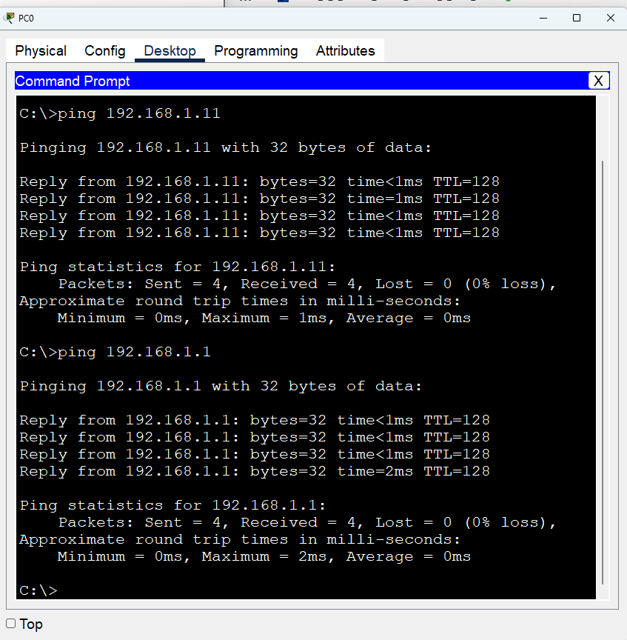

Activity: Create a LAN – Part 4: Use networking commands to view host information
The networking commands that are available from command prompt on PC0 are very similar to those that are available in Windows. In this part of the activity, you will use ipconfig to learn more about the LAN.
Using the ipconfig command
The ipconfig command displays details about the addressing that is configured on a host.
Open a command prompt on Laptop0 and enter the ipconfig command. Make note of the information that is returned.
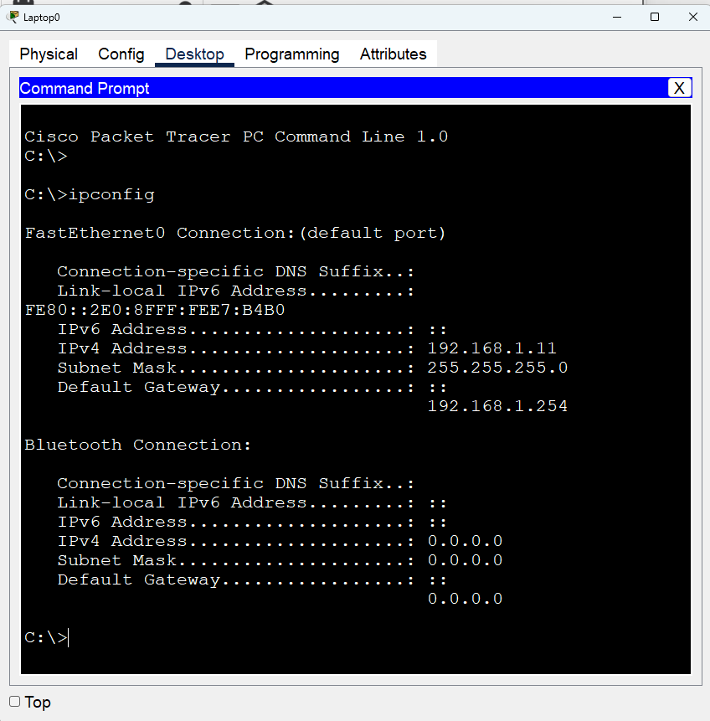

Now enter the ipconfig /all command. What additional information is displayed?
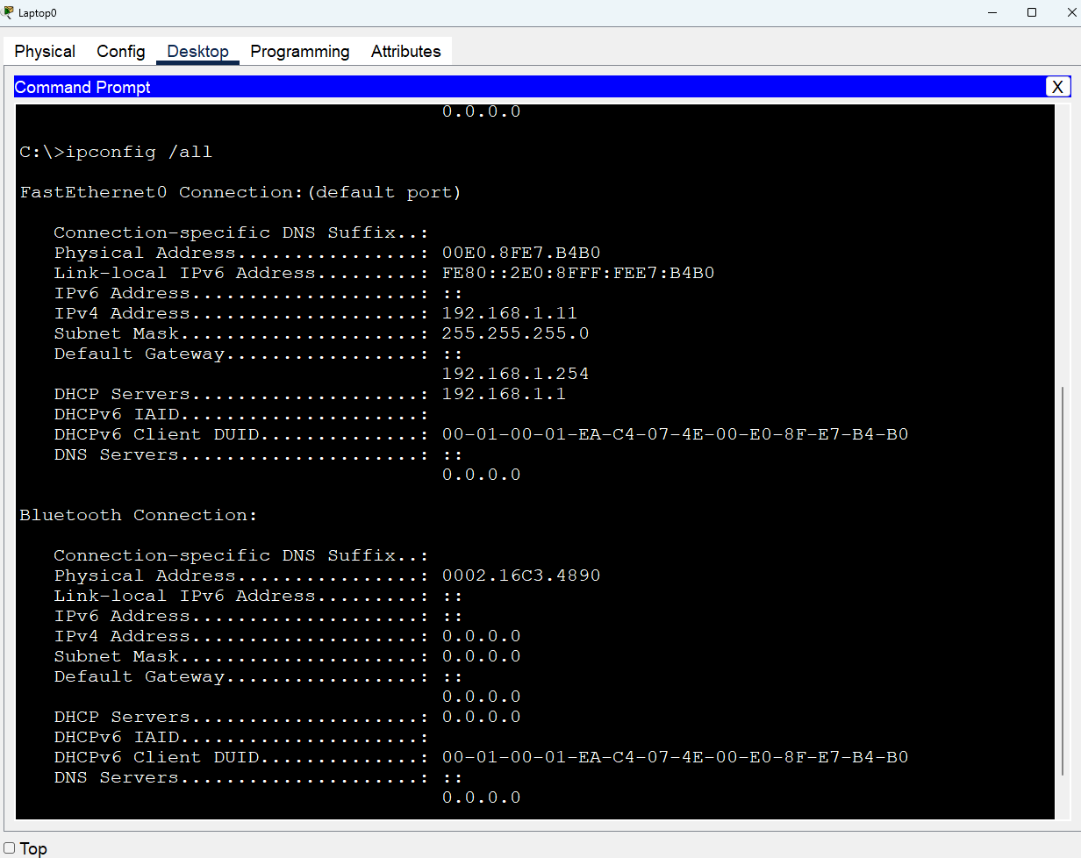

Packet Tracer: Investigate the TCP/IP and OSI models – Part 1: Examine HTTP web traffic
Instructions
In Part 1 of this activity, you will use Packet Tracer simulation mode to generate web traffic and examine HTTP.
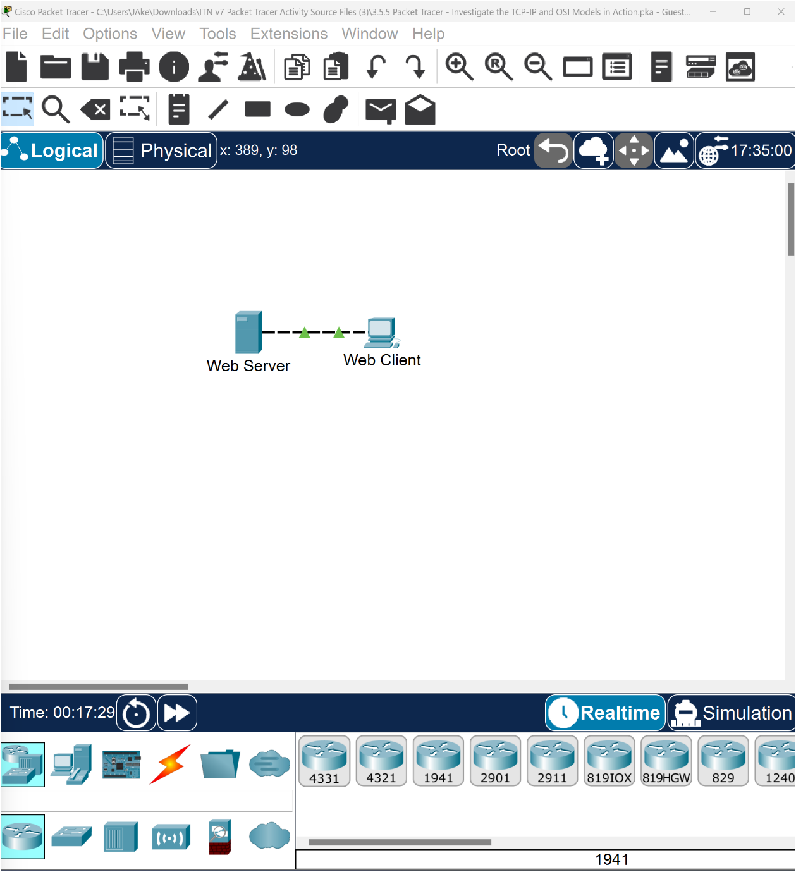

Step 1: Switch from Realtime to Simulation mode.
In the lower-right corner of the Packet Tracer interface are buttons that toggle between Realtime and Simulation mode. Packet Tracer always starts in Realtime mode, in which networking protocols operate with realistic timings. However, a powerful feature of Packet Tracer allows the user to ‘stop time’ by switching to Simulation mode. In Simulation mode, packets are displayed as animated envelopes, time is event driven and the user can step through networking events. Click the Simulation mode icon to switch from Realtime mode to Simulation mode.
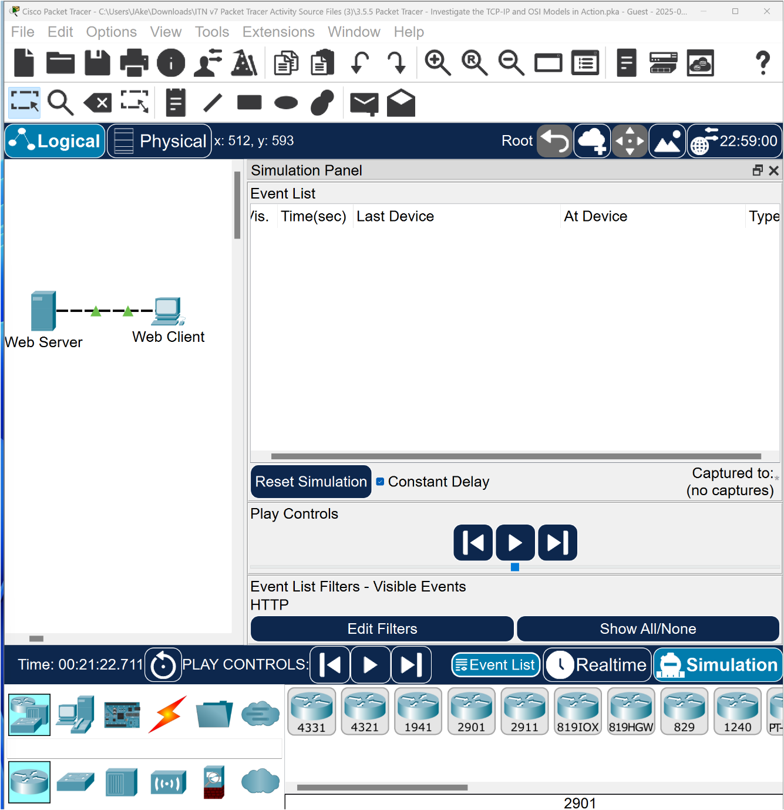
Select HTTP from the Event List Filters.
HTTP may already be the only visible event. If necessary, click the Edit Filters button at the bottom of the Simulation Panel to display the available visible events. Toggle the Show All/None check box and notice how the check boxes switch from unchecked to checked or checked to unchecked, depending on the current state.
Click the Show All/None check box until all boxes are cleared, and then select HTTP from the Misc tab of the Edit Filters window. 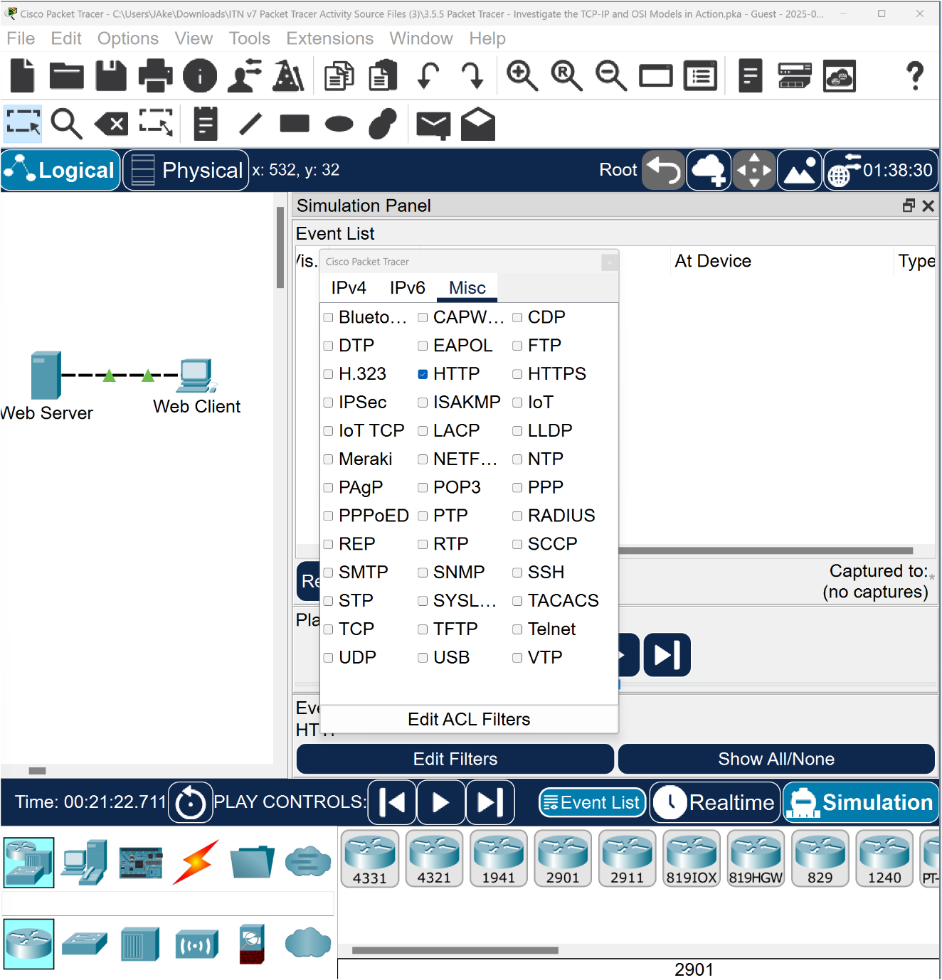
Click the X in the upper-right corner of the window to close the Edit Filters window. The Visible Events should now only display HTTP.

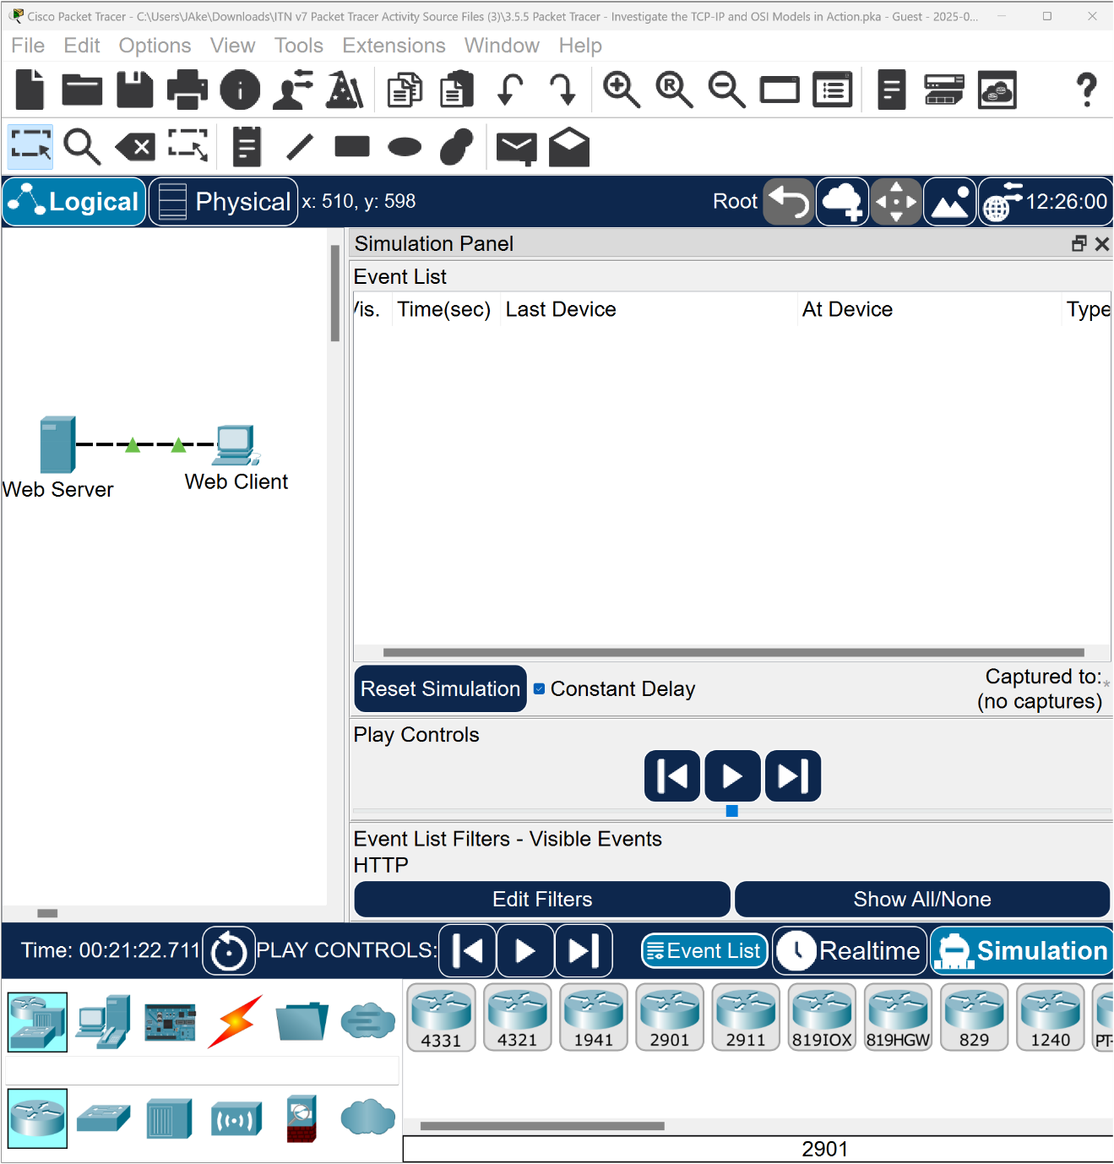
Step 2: Generate web (HTTP) traffic.
Currently the Simulation Panel is empty. There are five columns listed across the top of the Event List within the Simulation Panel. As traffic is generated and stepped through, events appear in the list.

a. Click Web Client in the far-left pane.
b. Click the Desktop tab and click the Web Browser icon to open it.
c. In the URL field, enter “www.osi.local” and click Go.

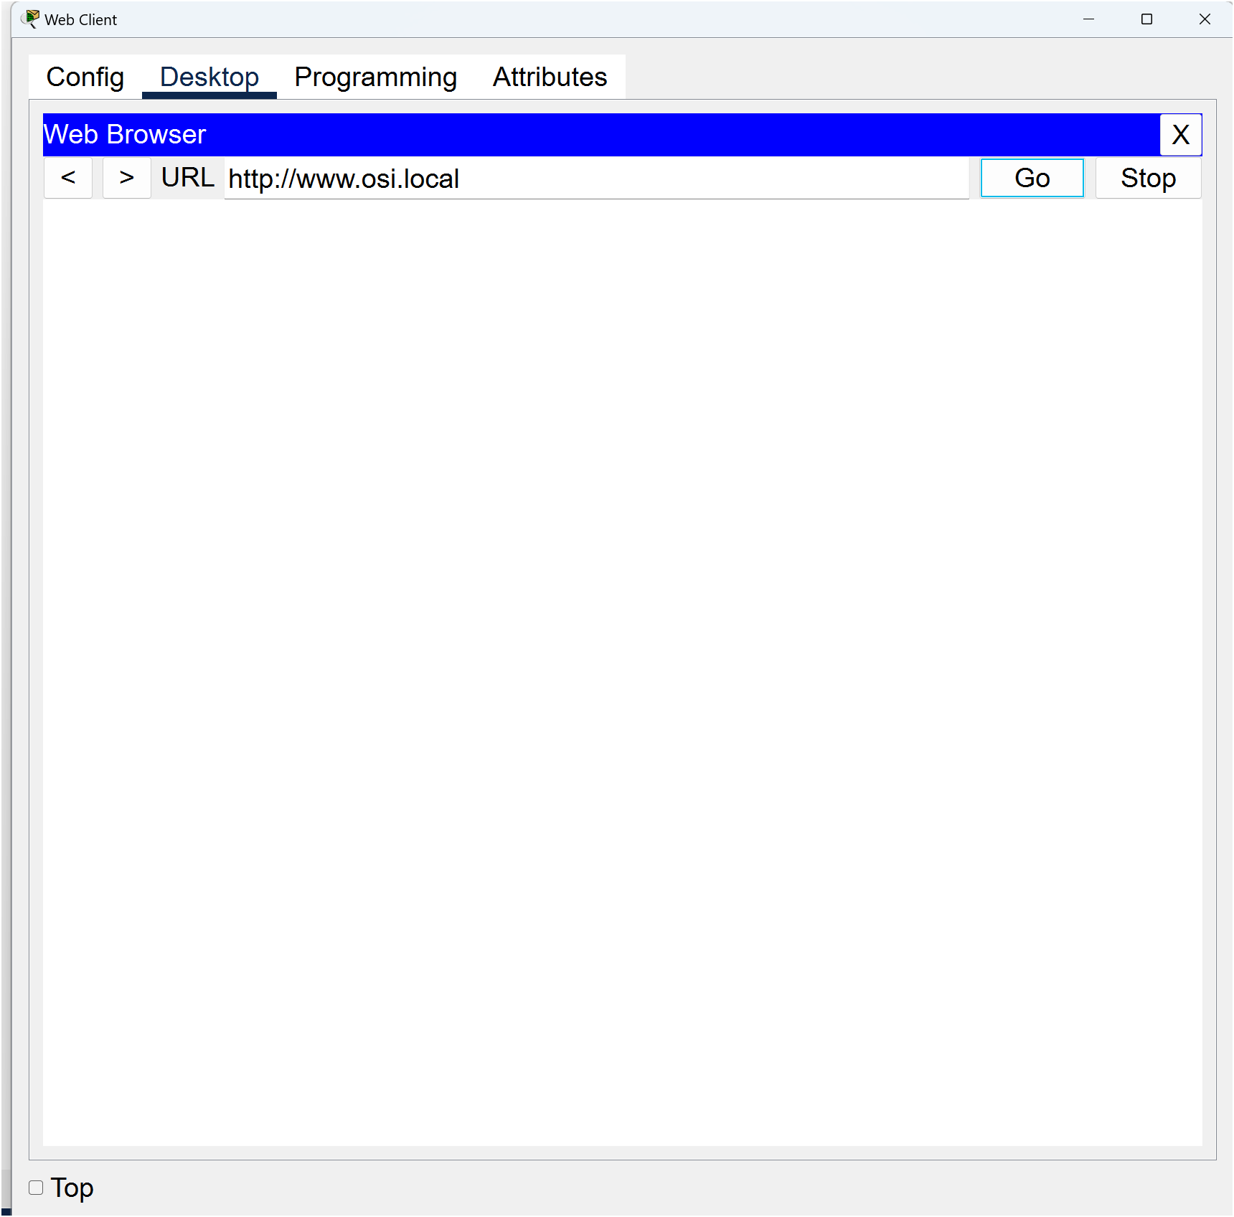
Because time in Simulation mode is event driven, you must use the Capture/Forward button to display network events. The Capture/Forward button is located at the left-hand side of the blue band that is below the topology window. Of the three buttons there, it is the one on the right.
Click Capture/Forward four times. There should be four events in the Event List.

Question to consider while working on the simulator:
Look at the Web Client web browser page. Did anything change?

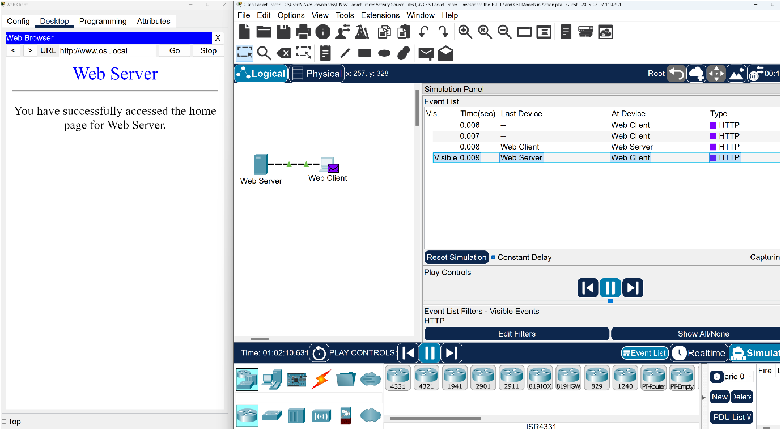
Click the first coloured square box under the Event List > Type column. It may be necessary to expand the Simulation Panel or use the scroll bar directly below the Event List.

The PDU Information at Device: Web Client window displays. In this window, there are only two tabs (OSI Model and Outbound PDU Details) because this is the start of the transmission. As more events are examined, there will be three tabs displayed, adding a tab for Inbound PDU Details. When an event is the last event in the stream of traffic, only the OSI Model and Inbound PDU Details tabs are displayed.
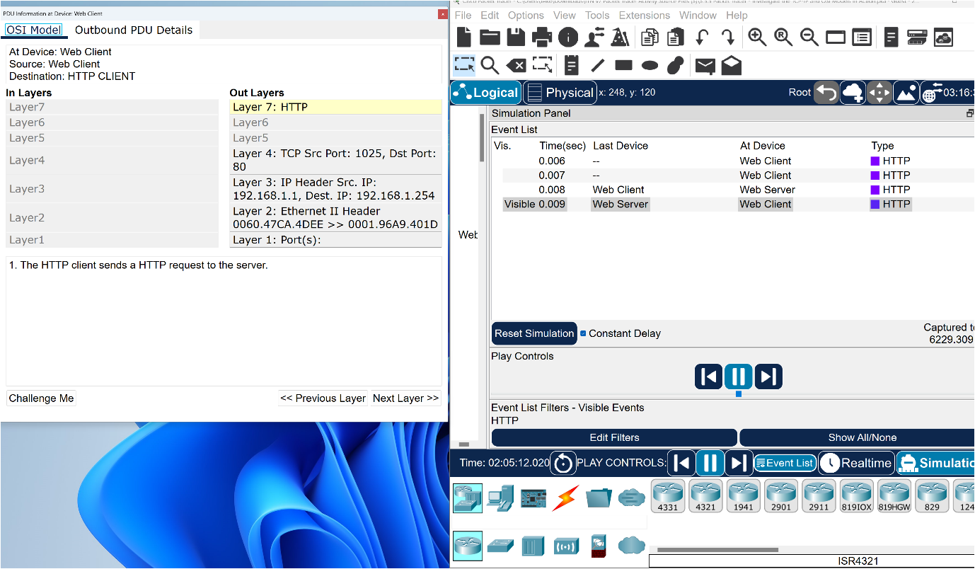
Ensure that the OSI Model tab is selected.

Under the Out Layers column, click Layer 7.

Questions:
What information is listed in the numbered steps directly below the In Layers and Out Layers columnsor Layer 7?

What is the Dest. Port value for Layer 4 under the Out Layers column?

What is the Dest. IP value for Layer 3 under the Out Layers column?

What information is displayed at Layer 2 under the Out Layers column?

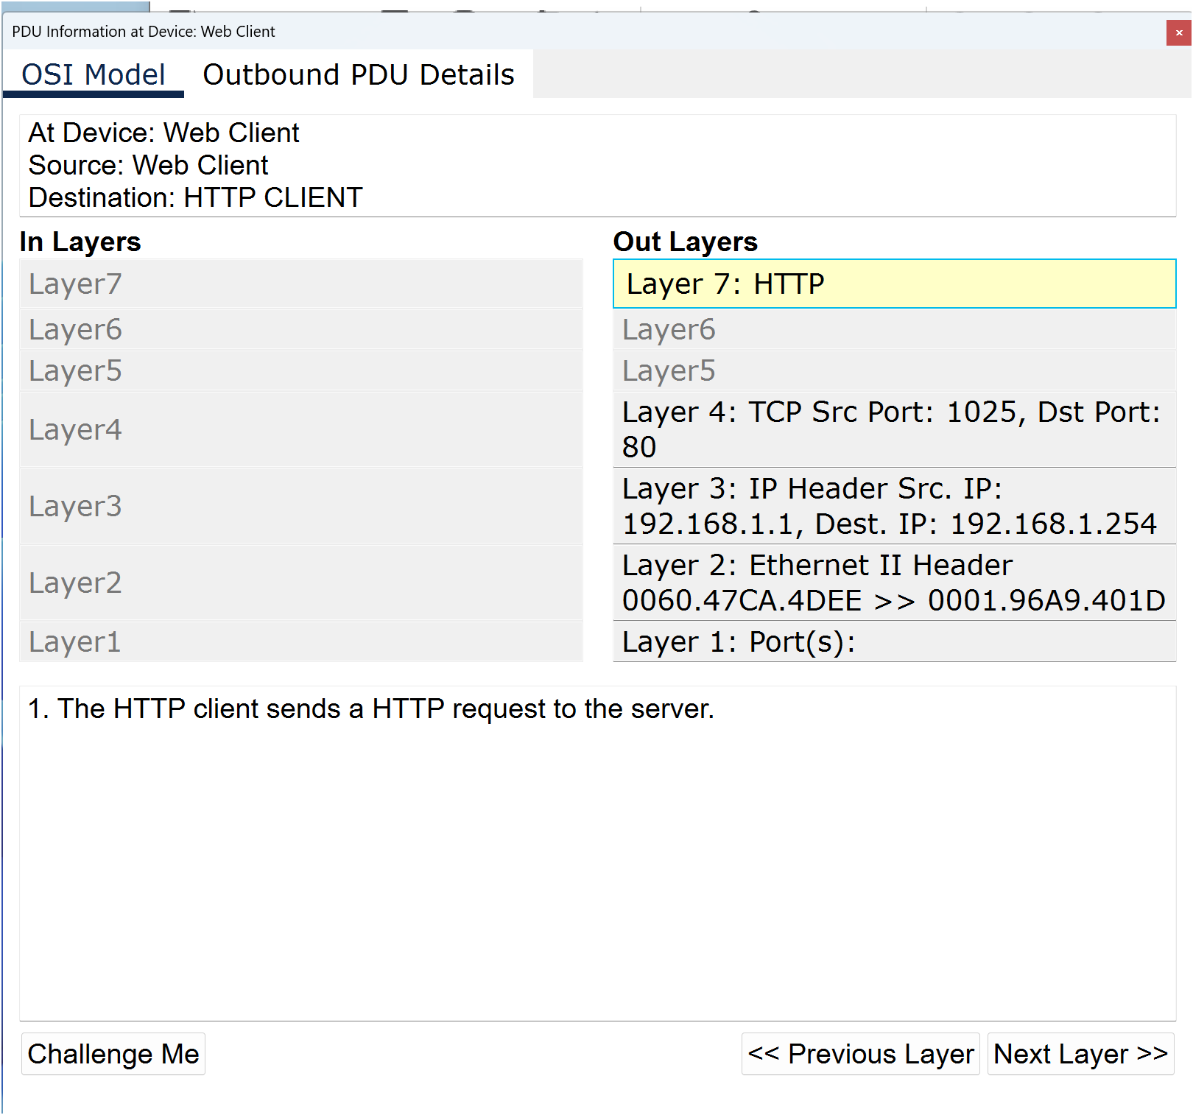
Click the Outbound PDU Details tab.

Information listed under the PDU Formats is reflective of the layers within the TCP/IP model.

Note: The information listed under the Ethernet II section of the Outbound PDU Details tab provides even more detailed information than is listed under Layer 2 on the OSI Model tab. The Outbound PDU Details provides more descriptive and detailed information. The values under DEST MAC and SRC MAC within the Ethernet II section of the Outbound PDU Details appear on the OSI Model tab under Layer 2, but are not identified as such.

Questions:

What is the common information listed under the IP section of Outbound PDU Details as compared to the information listed under the OSI Model tab? With which layer is it associated?

What is the common information listed under the TCP section of Outbound PDU Details, as compared to the information listed under the OSI Model tab, and with which layer is it associated?

What is the Host listed under the HTTP section of the Outbound PDU Details? What layer would this information be associated with under the OSI Model tab?

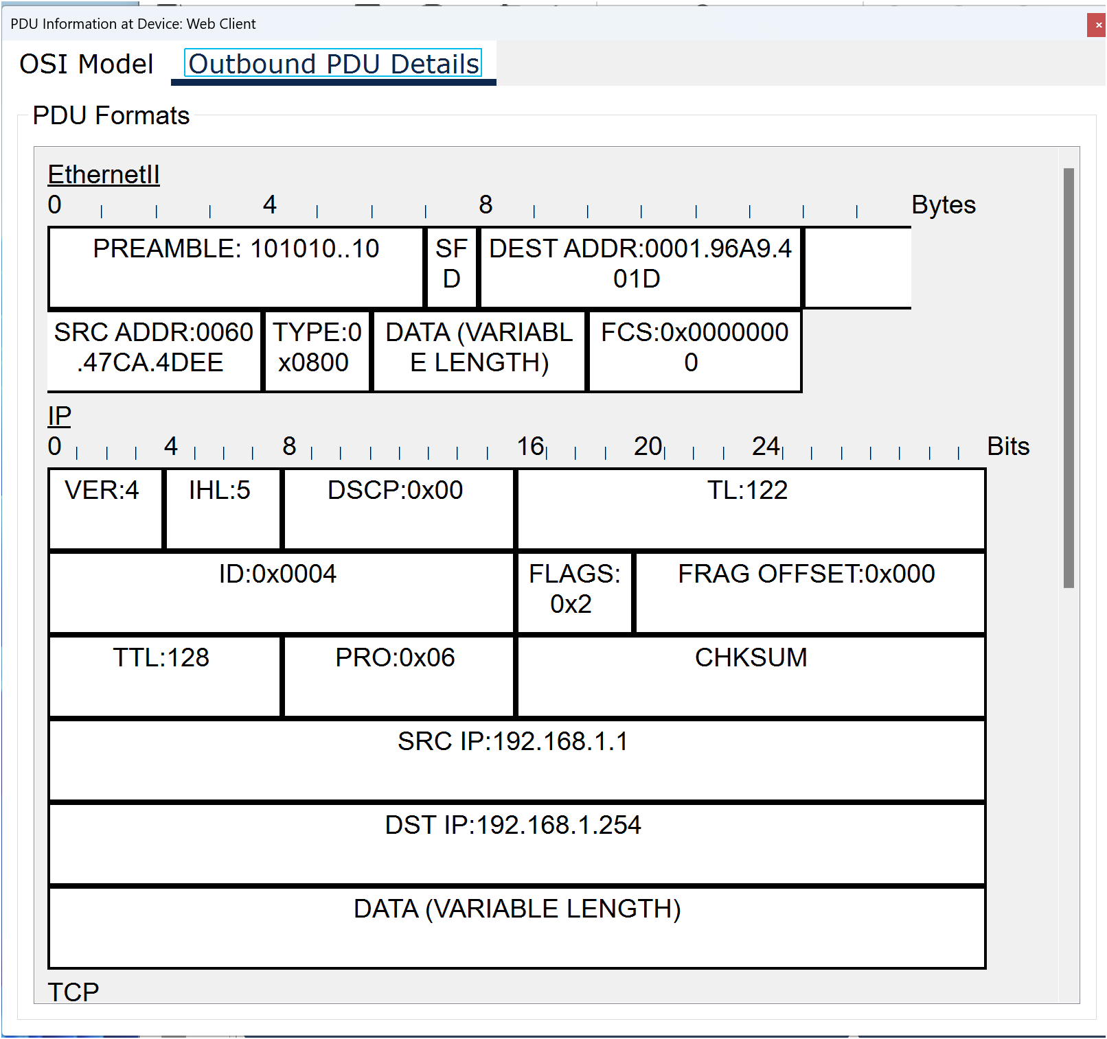
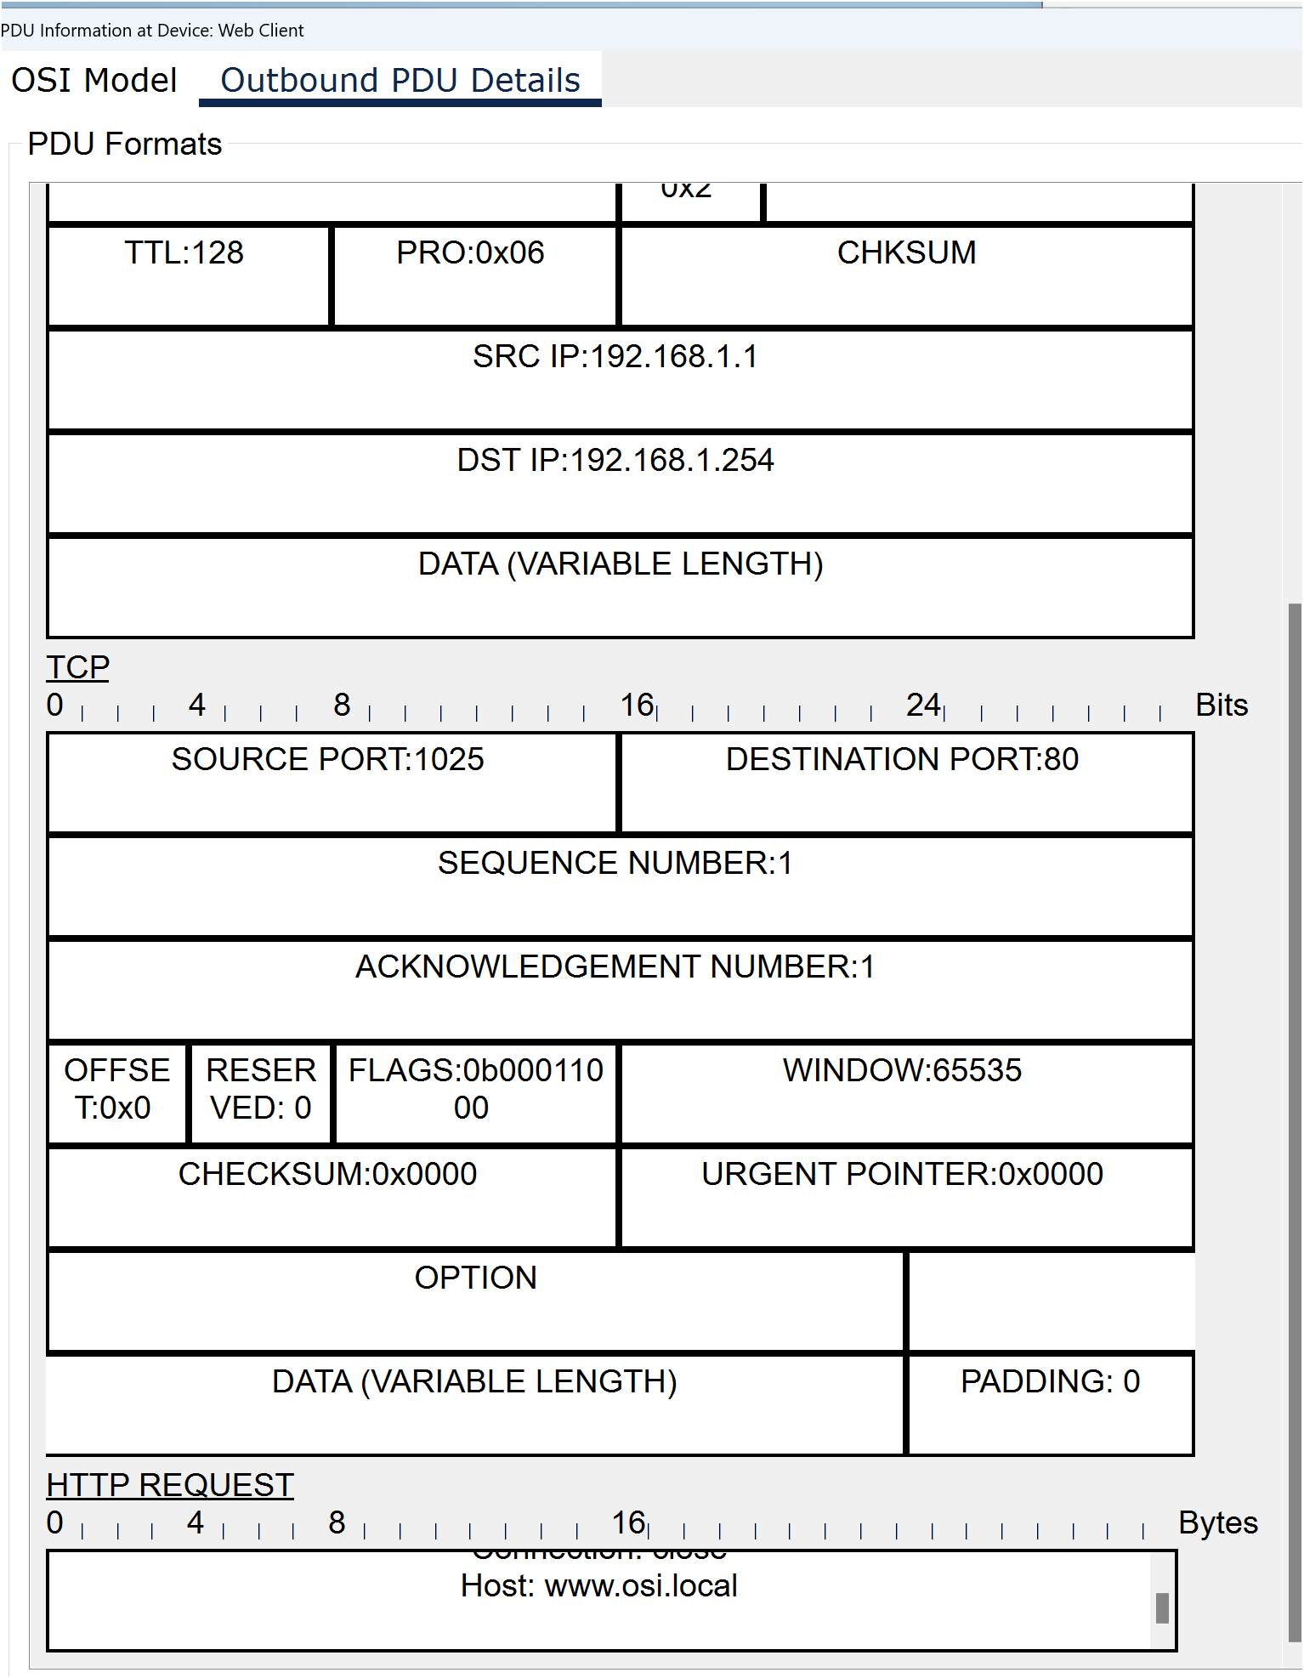

Click the next coloured square box under the Event List > Type column. Only Layer 1 is active (not greyed out). The device is moving the frame from the buffer and placing it on to the network.
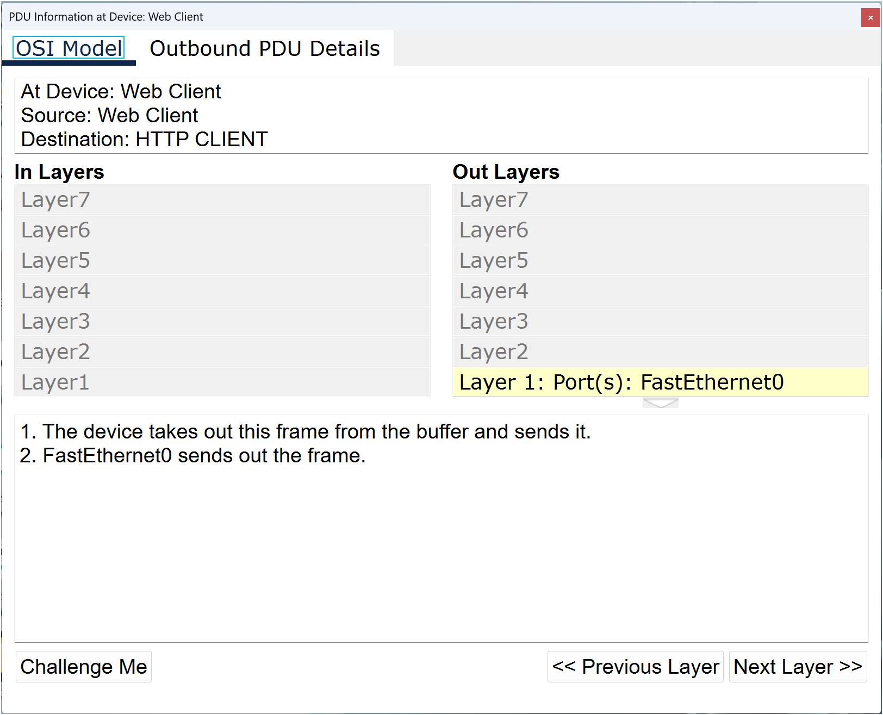
Advance to the next HTTP Type box within the Event List and click the coloured square box. This window contains both In Layers and Out Layers. Notice the direction of the arrow directly under the In Layers column: it is pointing upward, indicating the direction the data is travelling. Scroll through these layers, making note of the items previously viewed. At the top of the column, the arrow points to the right. This denotes that the server is now sending the information back to the client.

Comparing the information displayed in the In Layers column with that of the Out Layers column, what are the major differences?
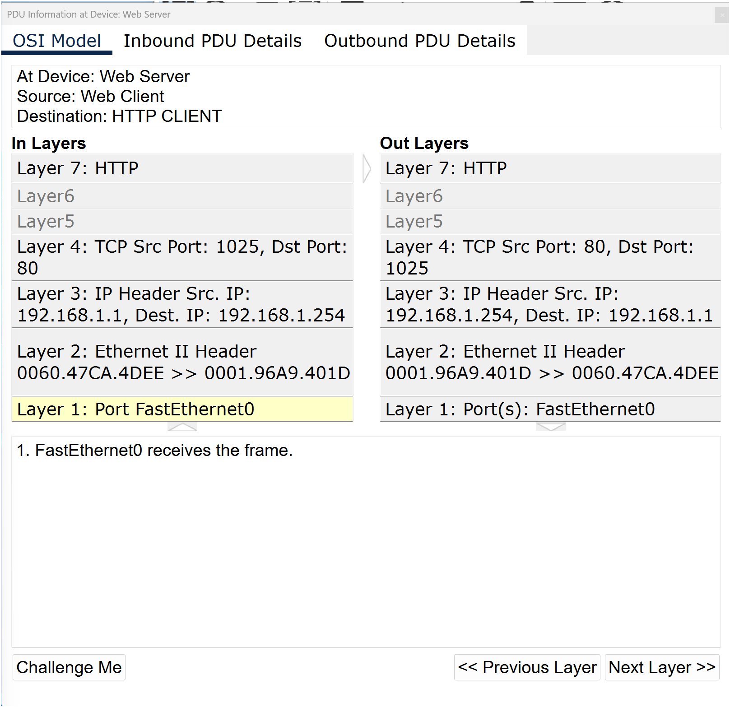
Click the Inbound and Outbound PDU Details tabs. Review the PDU details.

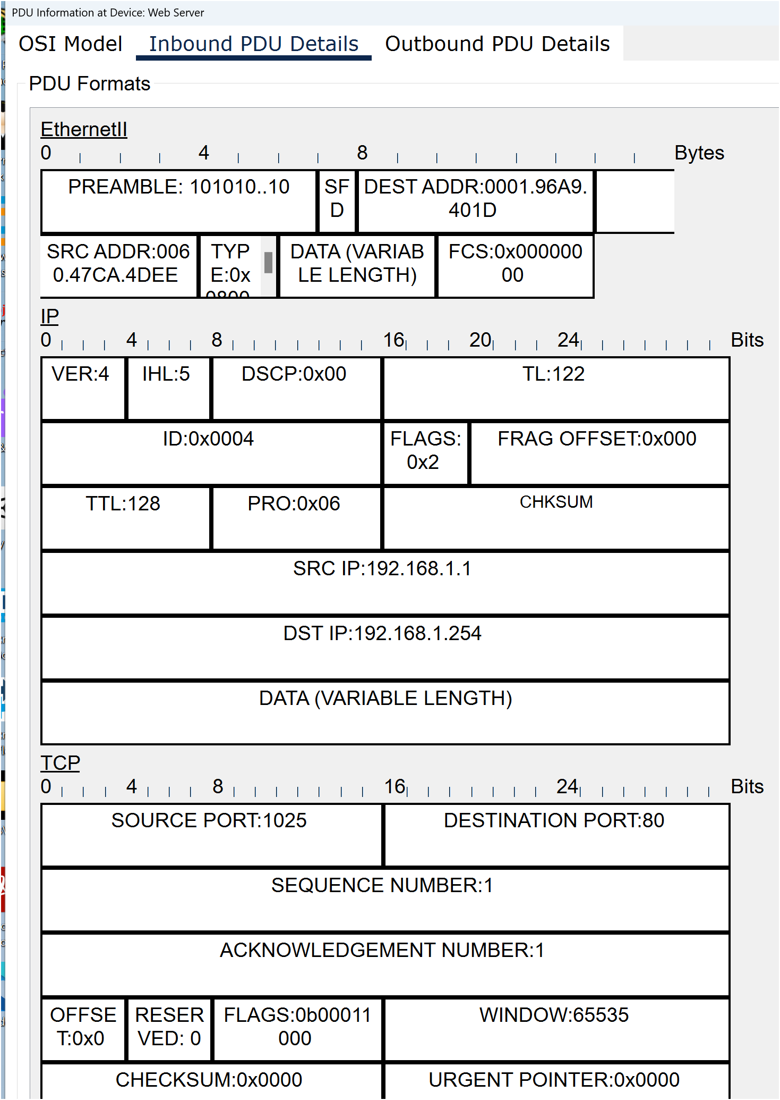

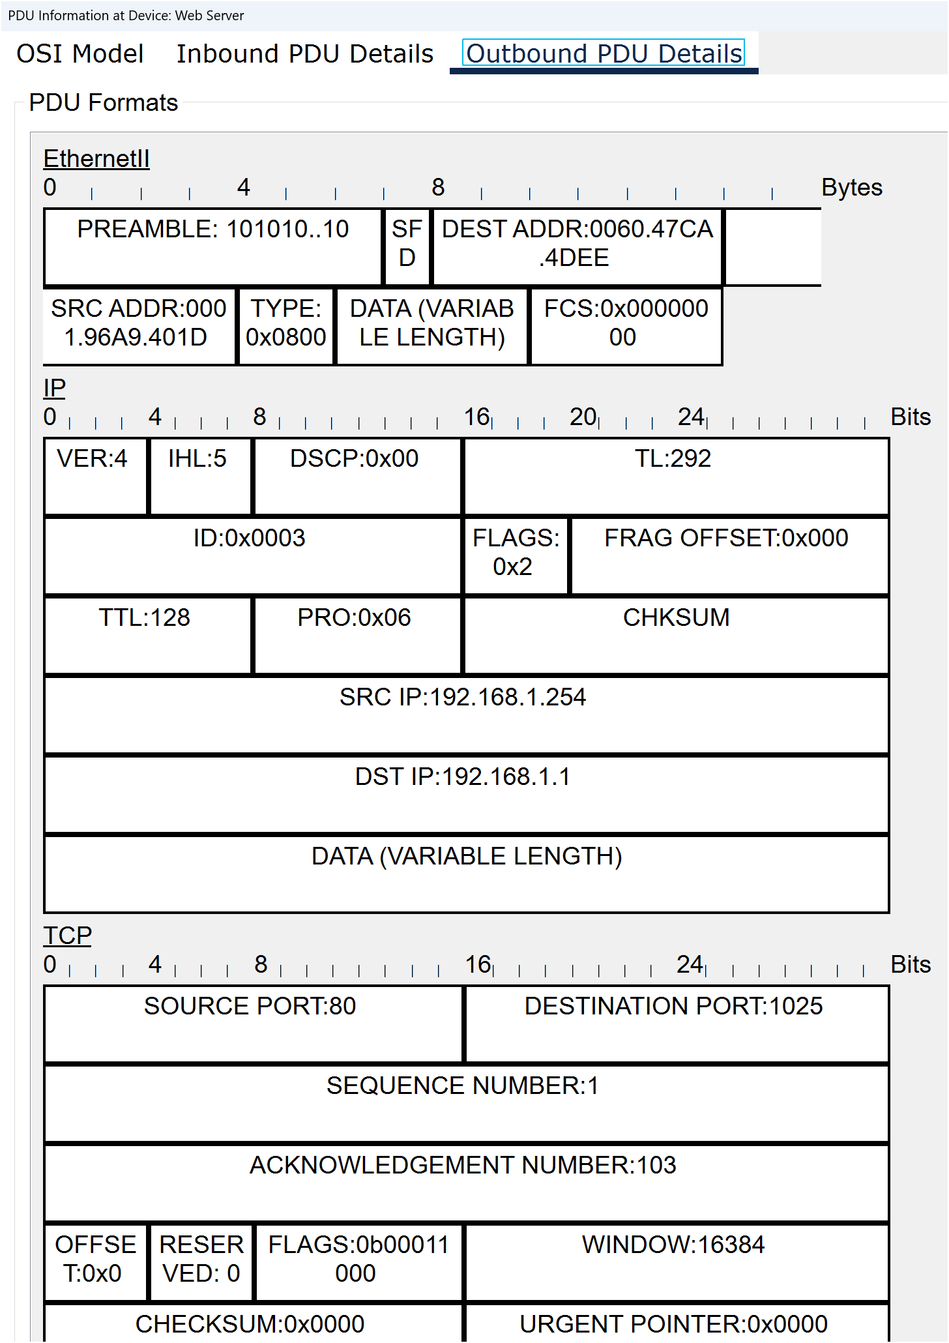
Click the last coloured square box under the Info column.
Question:
How many tabs are displayed with this event? Explain.
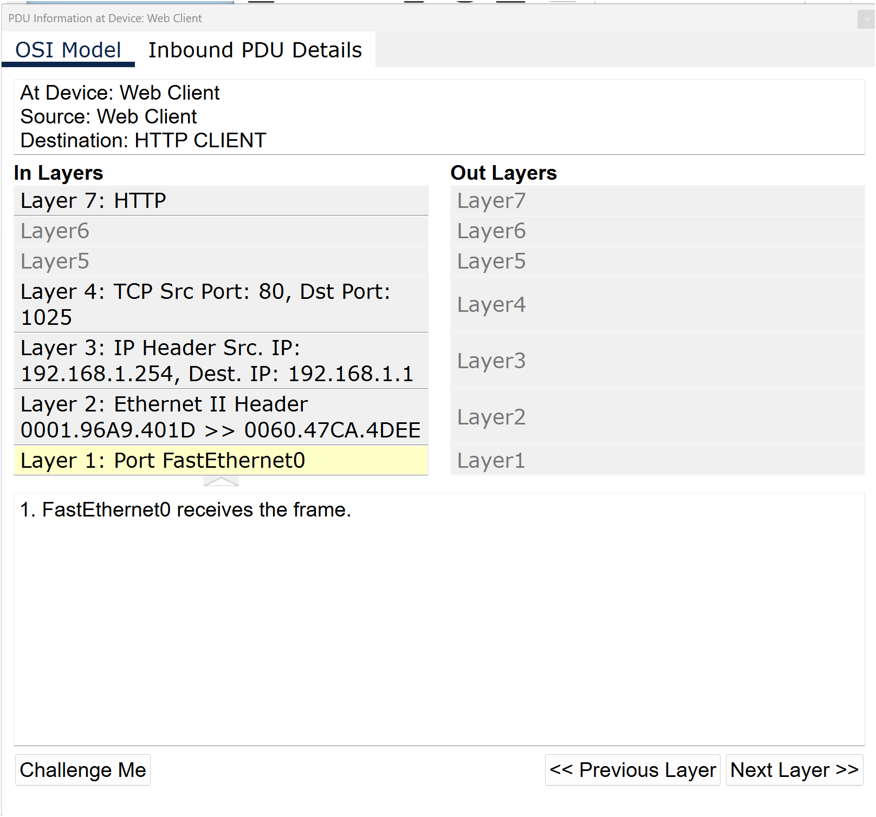

Packet Tracer: Investigate the TCP/IP and OSI Models – Part 2: Display elements of the TCP/IP protocol suite
In Part 2 of this activity, you will use the Packet Tracer Simulation mode to view and examine some of the other protocols comprising of TCP/IP suite.

Step 1: View additional events:
a. Close any open PDU information windows.
b. In the Event List Filters > Visible Events section, click Show All/None.

Question:
What additional event types are displayed?

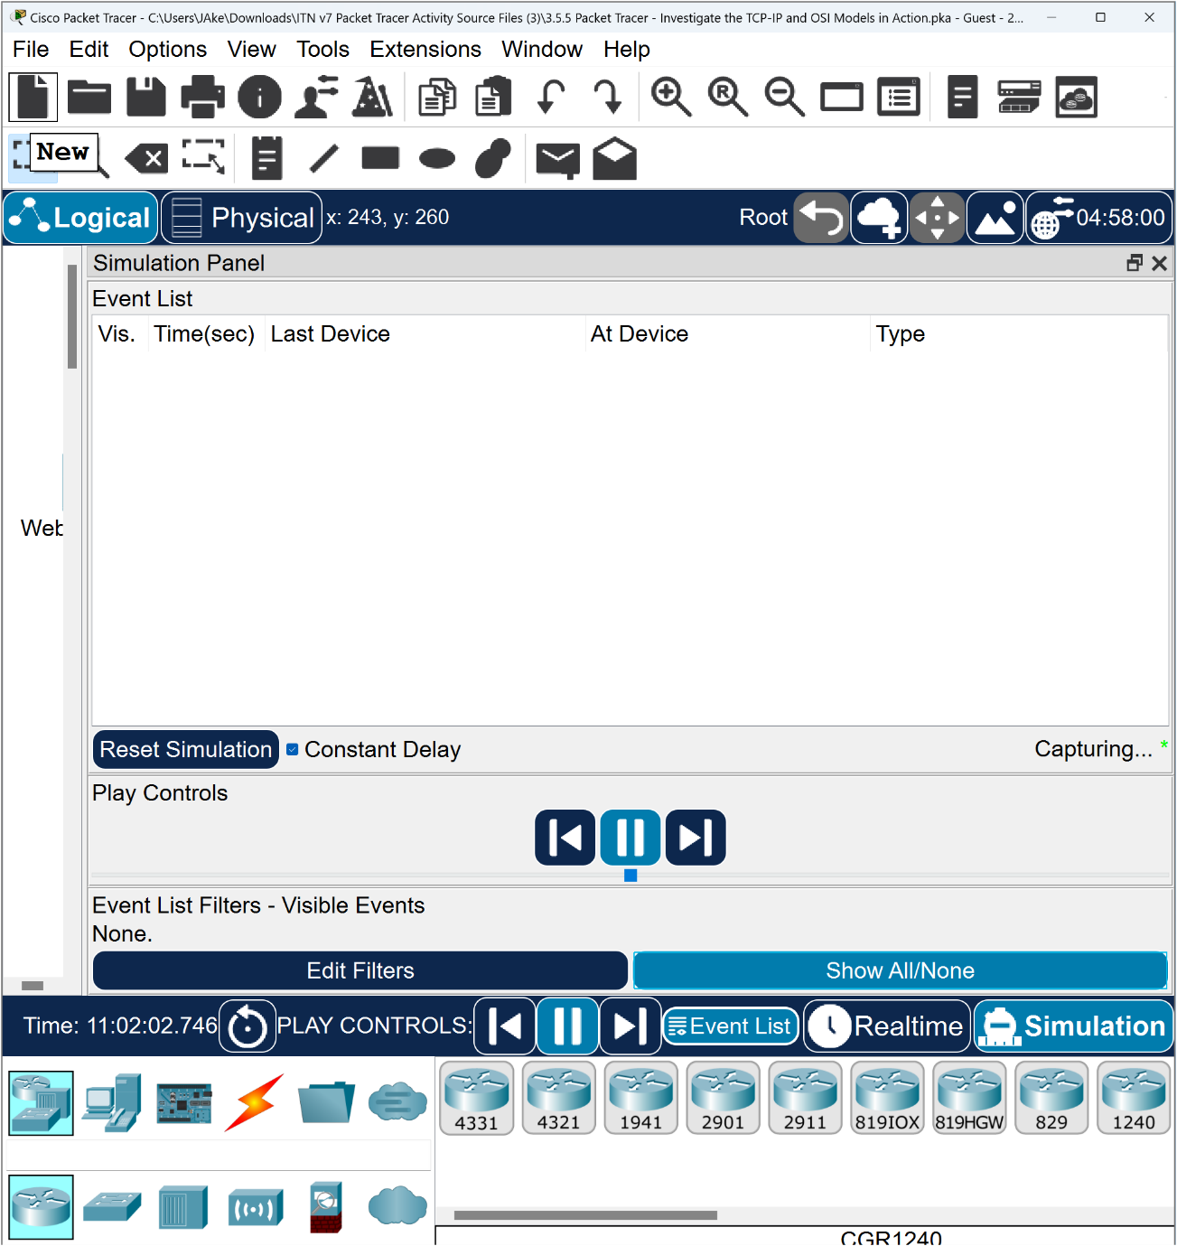

These extra entries play various roles within the TCP/IP suite. Address Resolution Protocol (ARP) requests MAC addresses for destination hosts. DNS is responsible for converting a name (e.g. www.osi.local) to an IP address. The additional TCP events are responsible for connecting, agreeing on communication parameters and disconnecting the communications sessions between the devices. These protocols have been mentioned previously and will be further discussed as the course progresses. Currently there are over 35 possible protocols (event types) available for capture within Packet Tracer.

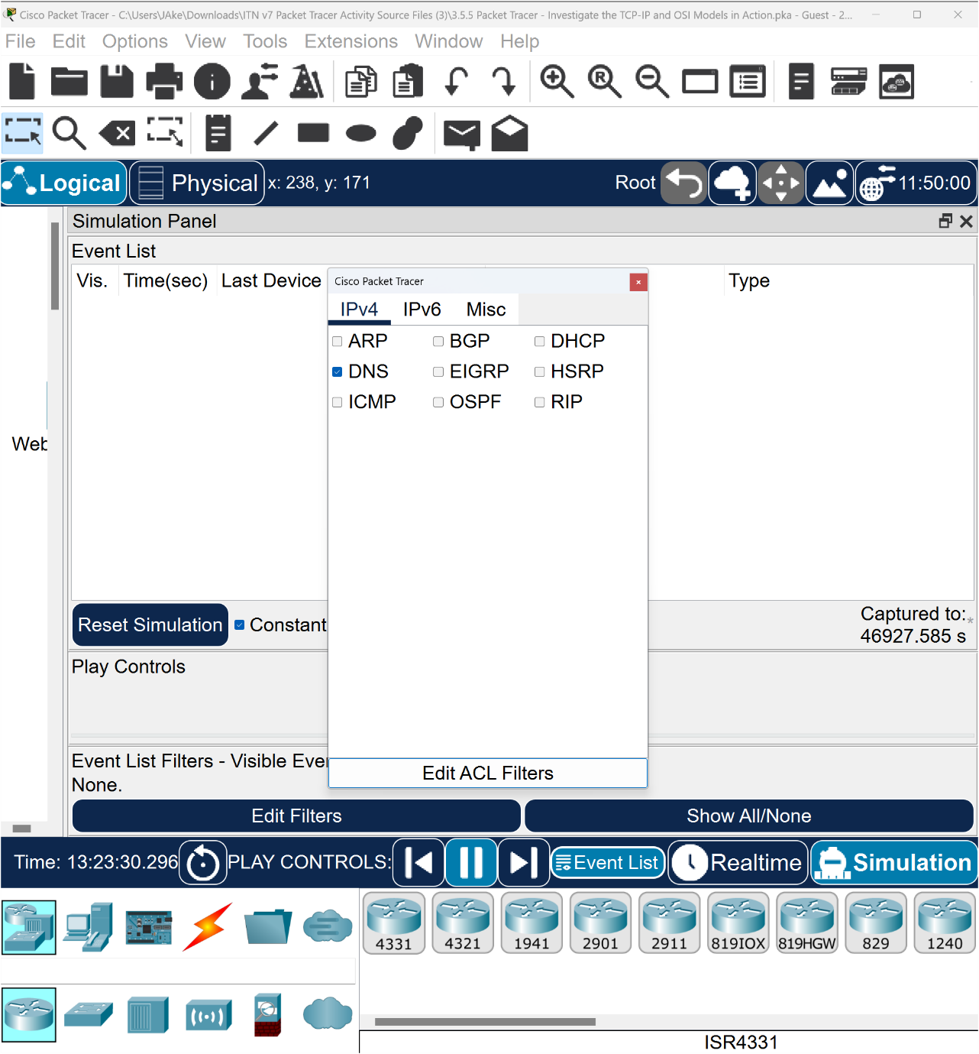

Click the first DNS event in the Type column. Explore the OSI Model and Outbound PDU Detail tabs and note the encapsulation process. As you look at the OSI Model tab with Layer 7 highlighted, a description of what is occurring is listed directly below the In Layers and Out Layers (“1. The DNS client sends a DNS query to the DNS server.”). This is very useful information to help understand what is occurring during the communication process.

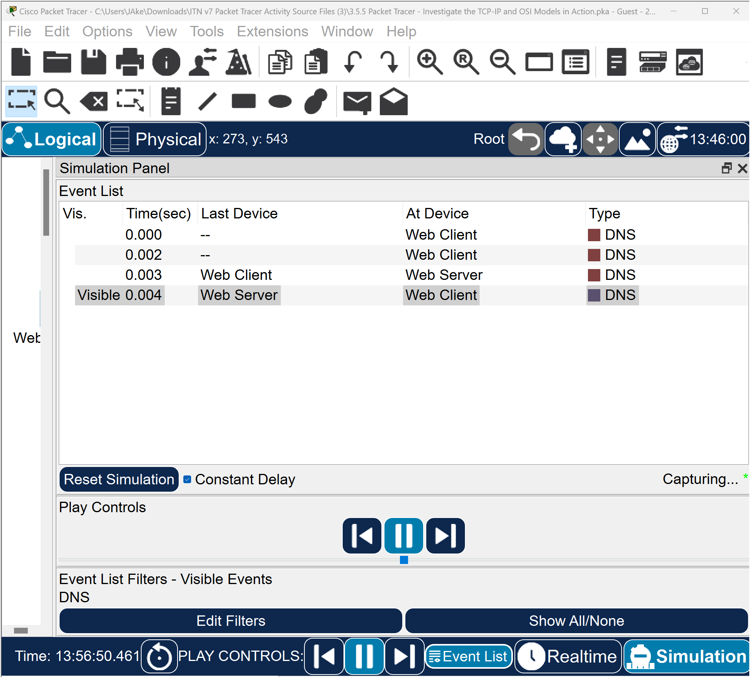
d. Click the Outbound PDU Details tab.
Question:
What information is listed in the NAME field in the DNS QUERY section?
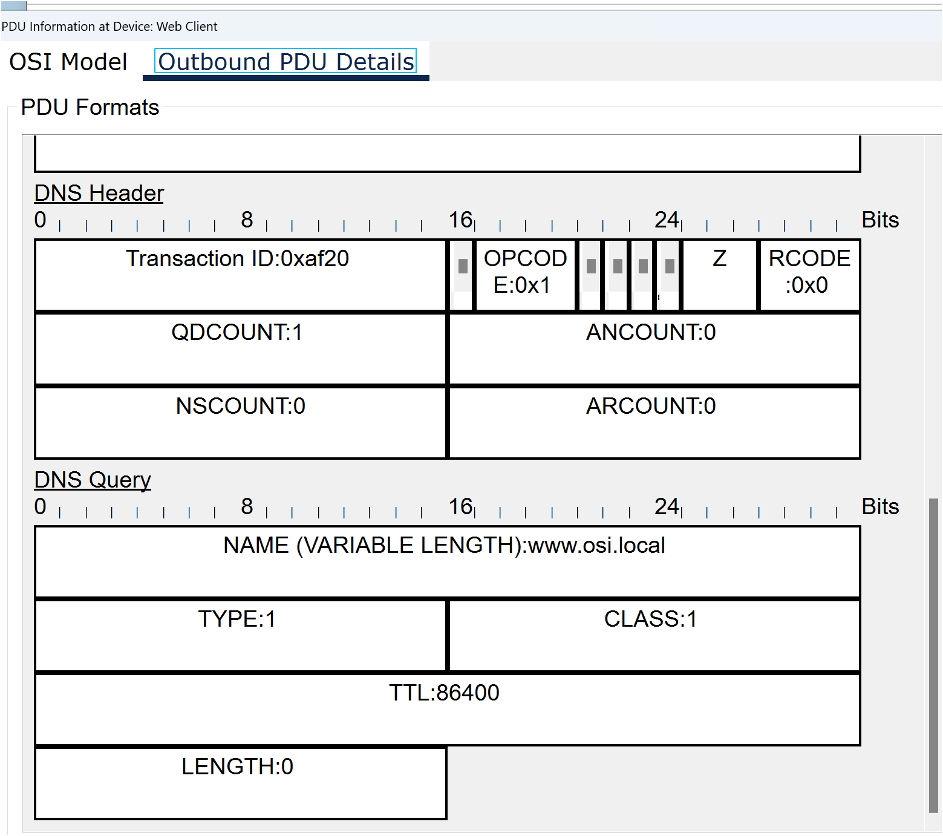
e. Click the last DNS Info coloured square box in the event list.

Questions:
At which device was the PDU captured?

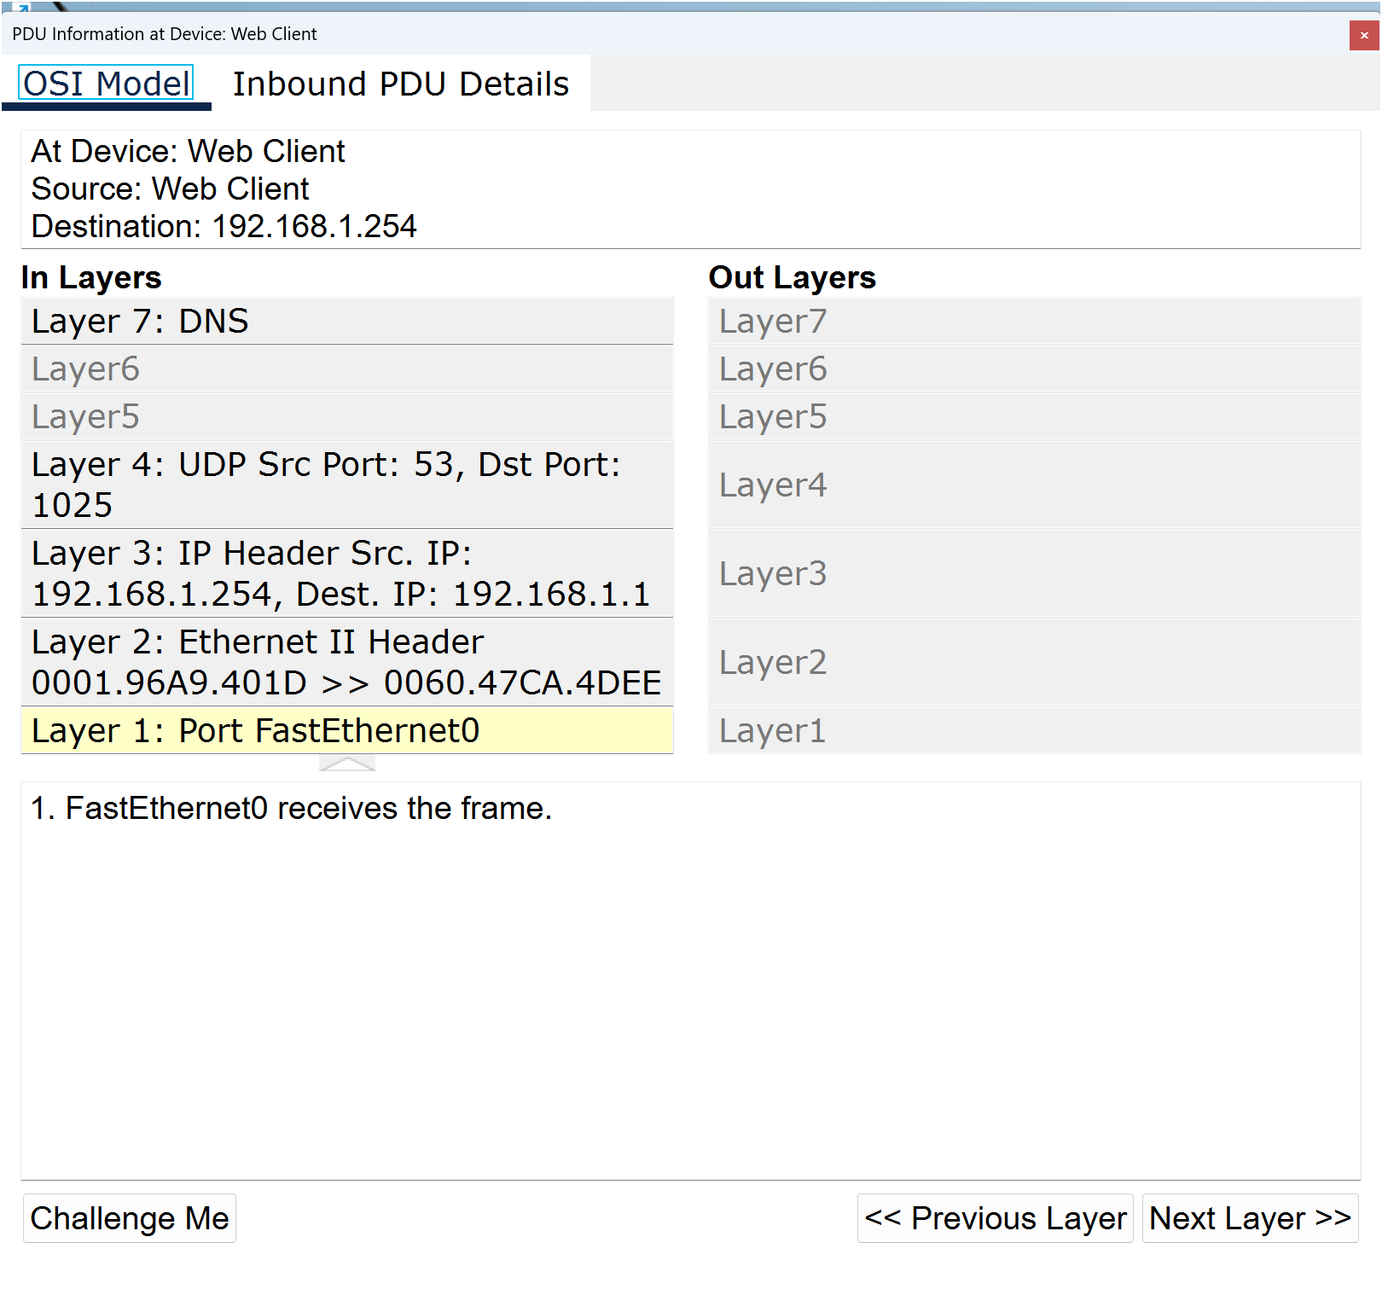
What is the value listed next to ADDRESS in the DNS Answer section of the Inbound PDU Details?

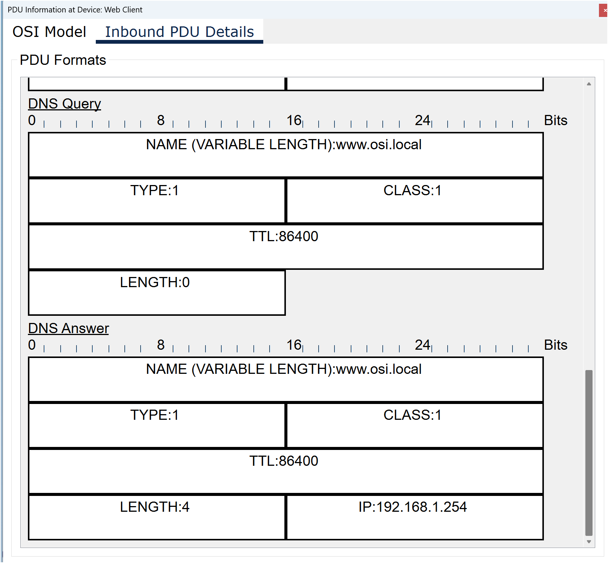

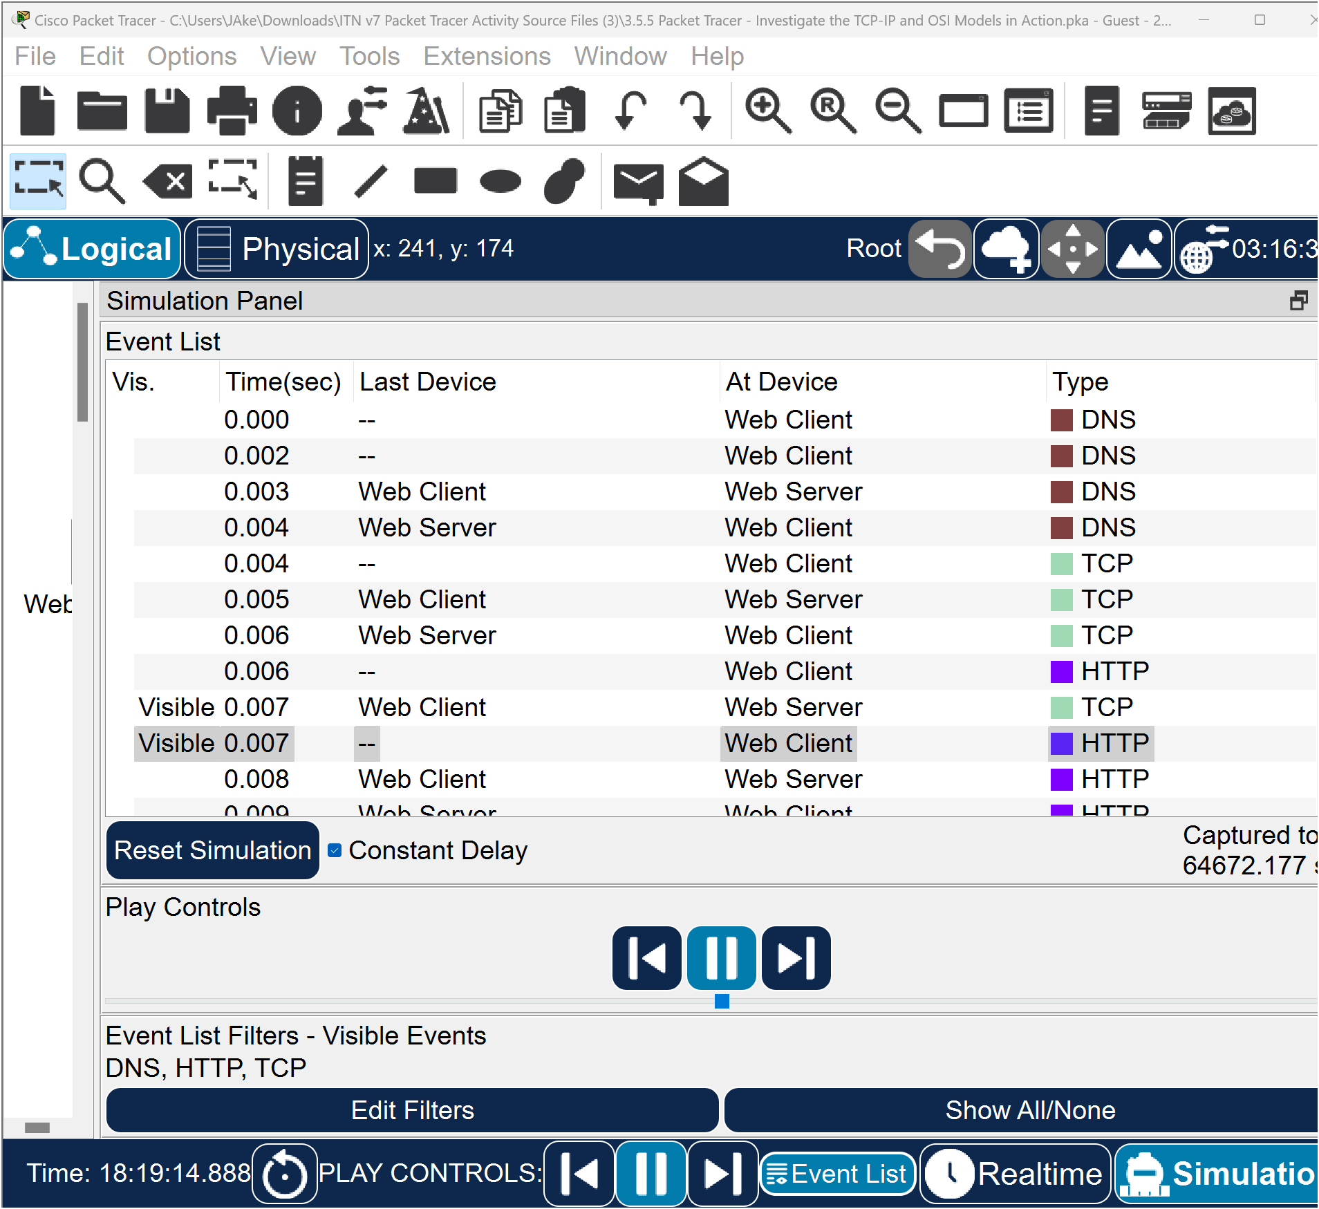

f. Find the first HTTP event in the list and click the coloured square box of the TCP event immediately following this event. Highlight Layer 4 in the OSI Model tab.

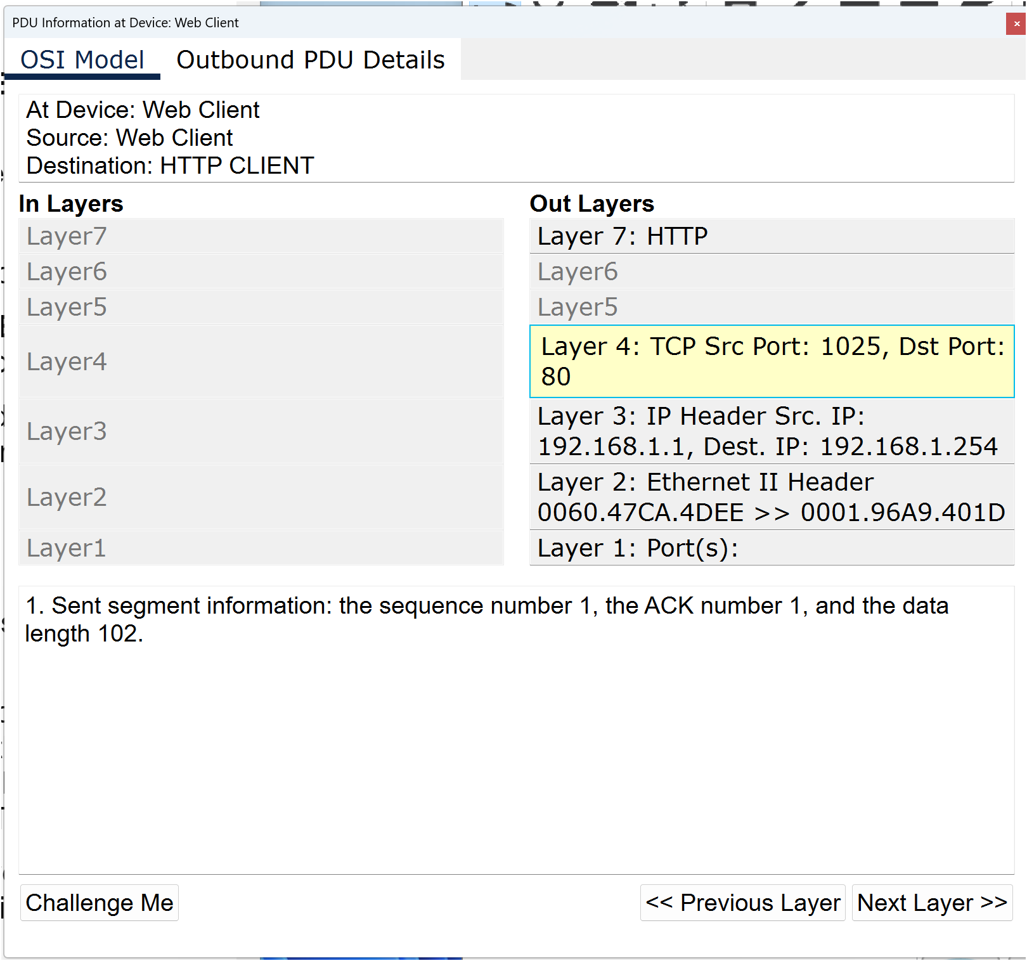
Question:
In the numbered list directly below the In Layers and Out Layers, what is the information displayed under items 4 and 5?

TCP manages the connecting and disconnecting of the communications channel along with other responsibilities. This particular event shows that the communication channel has been ESTABLISHED.

g. Click the last TCP event. Highlight Layer 4 in the OSI Model tab. Examine the steps listed directly below In Layers and Out Layers.

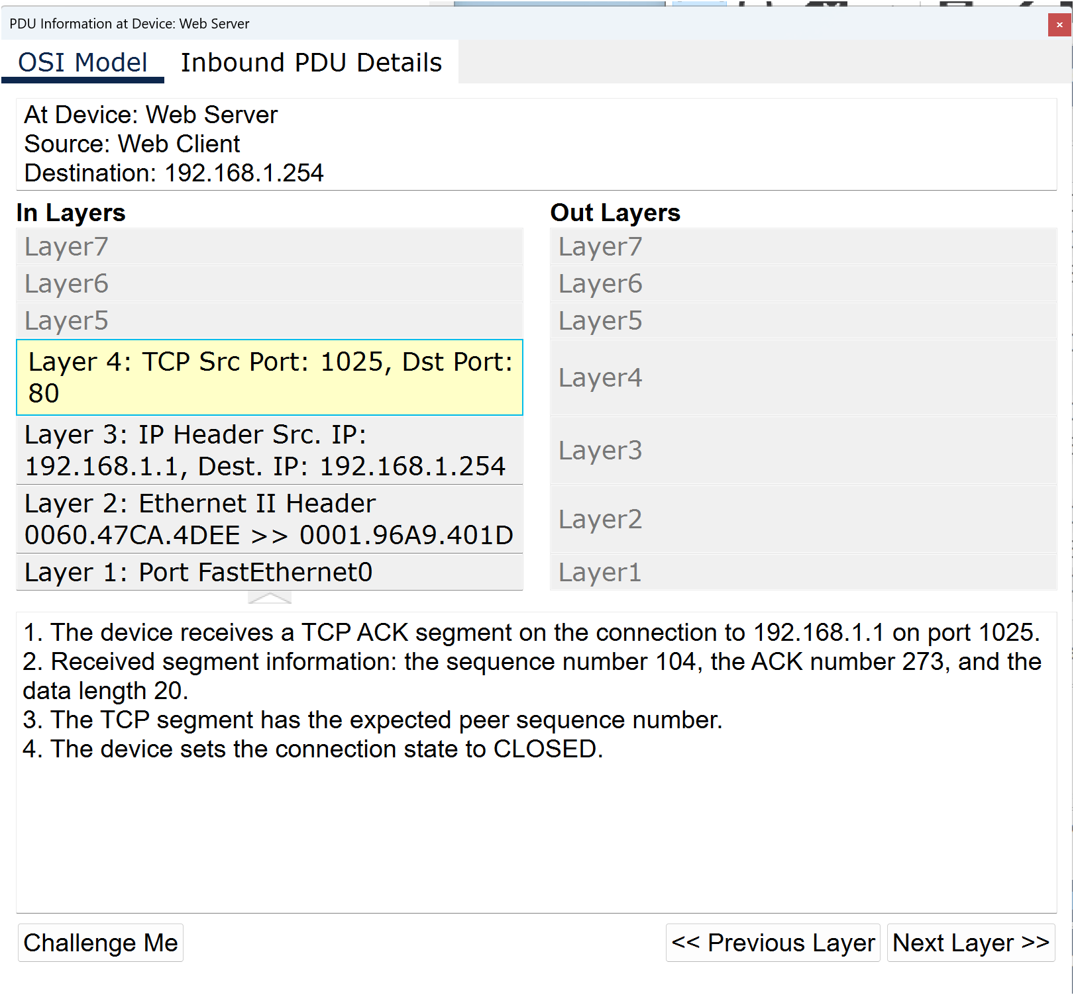
Question:
What is the purpose of this event, based on the information provided in the last item in the list (should be item 4)?

Challenge questions:
This simulation provided an example of a web session between a client and a server on a LAN. The client makes requests to specific services running on the server. The server must be set up to listen on specific ports for a client request. (Hint: Look at Layer 4 in the OSI Model tab for port information.)
Based on the information that was inspected during the Packet Tracer capture, what port number is the Web Server listening on for the web request?
What port is the Web Server listening on for a DNS request?

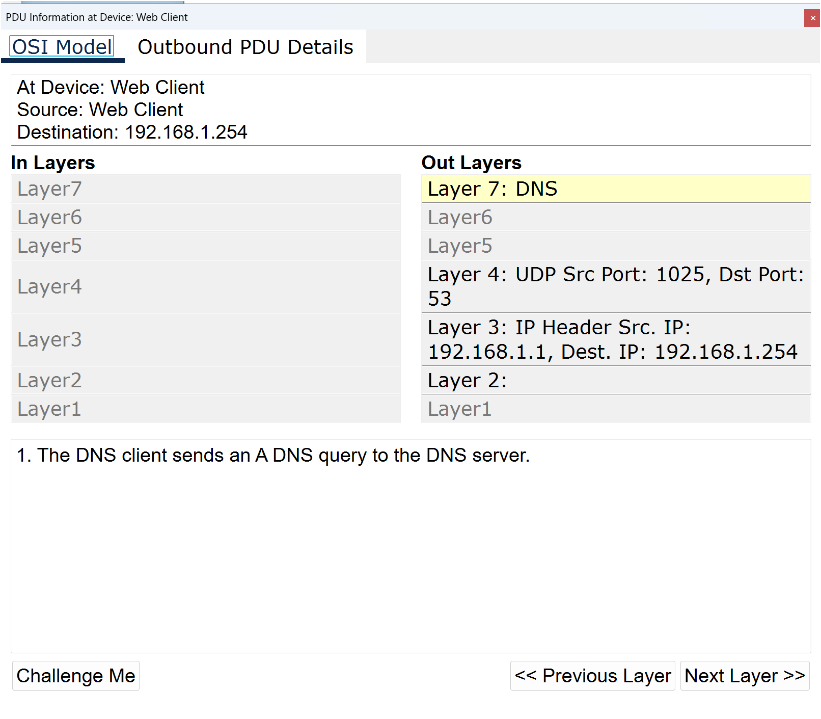

The following materials relate to lesson 3: Number systems
Activity: Binary to decimal conversions
Activity: Convert decimal to binary
Activity: Convert binary to dotted decimal notation
Activity: Convert IPv4 dotted decimal notation to binary
Activity: Binary game
Activity: Converting from hexadecimal to decimal
Activity: IPv4 address structure

Activity: Binary to decimal conversions
Use the table to convert the binary in table to decimal.
2⁷ | 2⁶ | 2⁵ | 2⁴ | 2³ | 2² | 2¹ | 2⁰
128 | 64 | 32 | 16 | 8 | 4 | 2 | 1
1 | 0 | 0 | 0 | 1 | 0 | 0 | 1
0 | 0 | 0 | 1 | 1 | 0 | 1 | 1
1 | 1 | 1 | 0 | 0 | 1 | 1 | 1
1 | 1 | 1 | 1 | 0 | 0 | 0 | 0
0 | 0 | 0 | 0 | 0 | 0 | 1 | 0
1 | 1 | 1 | 1 | 1 | 1 | 0 | 0
1 | 1 | 1 | 1 | 1 | 1 | 1 | 0
1 | 1 | 0 | 0 | 1 | 0 | 1 | 1
1 | 1 | 1 | 1 | 1 | 1 | 0 | 1
1 | 1 | 1 | 1 | 1 | 1 | 1 | 1

Activity: Convert decimal to binary
Use the table to convert decimal to binary.
As an example, convert 75 to binary is done for you.
Complete the table for the following decimals 69, 82, 114, 206, 255, 7, 45, 160, 11 and 0.
2⁷ | 2⁶ | 2⁵ | 2⁴ | 2³ | 2² | 2¹ | 2⁰ | Decimal
128 | 64 | 32 | 16 | 8 | 4 | 2 | 1
0 | 1 | 0 | 0 | 1 | 0 | 1 | 1 | 75
 |  |  |  |  |  |  |  | 69
 |  |  |  |  |  |  |  | 82
 |  |  |  |  |  |  |  | 114
 |  |  |  |  |  |  |  | 206
 |  |  |  |  |  |  |  | 255
 |  |  |  |  |  |  |  | 7
 |  |  |  |  |  |  |  | 45
 |  |  |  |  |  |  |  | 160
 |  |  |  |  |  |  |  | 11
 |  |  |  |  |  |  |  | 0

Activity: Convert binary to dotted decimal notation
Use the table to convert the octates to dotted decimal notation.
2⁷ | 2⁶ | 2⁵ | 2⁴ | 2³ | 2² | 2¹ | 2⁰
128 | 64 | 32 | 16 | 8 | 4 | 2 | 1

00001010 | 00001010 | 00001010 | 00000001
10 | 10 | 10 | 1

11000000 | 10101000 | 00000001 | 00000001

10101100 | 00001100 | 00000001 | 00001010

11000000 | 10101000 | 00001010 | 11111010

01111111 | 00000000 | 00000000 | 00000001

11010001 | 00101011 | 00001111 | 00000111

Activity: Convert IPv4 dotted decimal notation to binary
Complete the table.
10 | . | 10 | . | 10 | . | 1
00001010 |  | 00001010 |  | 00001010 |  | 00000001
126 | . | 50 | . | 10 | . | 10
172 | . | 16 | . | 1 | . | 100
192 | . | 168 | . | 0 | . | 72
209 | . | 100 | . | 35 | . | 15
191 | . | 250 | . | 130 | . | 5

Activity: Binary game
Game link: https://learningnetwork.cisco.com/docs/DOC-1803.
Challenge your peer!

Activity: Converting from hexadecimal to decimal
Use the table to convert hexadecimal to decimal: 1A is done for you.
16³ | 16² | 16¹ | 16⁰ |  | Decimal
4096 | 256 | 16 | 1
 |  | 1 | A | [1 x 16 =16]  +  [10 x 1 =10] | 26
 | 2 | 0 | F
 |  | A | B
1 | 0 | C | 5
 | 7 | A | D
 | 1 | 1 | F

Activity: IPv4 address structure
- Host-X has the IPv4 address and subnet mask 10.10.10.10 255.255.255.0. What is the network address of Host-X?
- Host-Y has the IPv4 address and subnet mask 172.12.2.1 255.255.0.0. What is the network address of Host-Y
- Host-X has the IPv4 address and subnet mask 192.168.1.4. 255.255.255.0.
List five IPv4 addresses that would be on the same network as Host-X.
- Host-Y has the IPv4 address and subnet mask 172.16.4.100 255.255.0.0. Suggest the broadcast address for the network.
- Host-X has the IPv4 address and subnet mask 192.168.1.50 255.255.255.0. What is the network address and broadcast address.

The following materials relate to lesson 4: IP addressing
Activity: Subnet within octet boundary /16
Activity: /16 usable hosts
Activity: Subnet network 10.0.0.0/8 using a /24 prefix
Activity: Packet Tracer: Subnet an IPv4 network (teacher to remove answers before handing out, as appropriate).

Activity: Subnet within octet boundary /16
Complete the table.
N | N | H | H | Decimal
00001010 | 00000110 | 00000000 | 00000000 | 10.6.0.0
00001010 |  |  |  | 10.7.0.0
00001010 |  |  |  | 10.8.0.0
00001010 |  |  |  | 10.9.0.0
00001010 | 00111100 |  |  | 10.60.0.0
00001010 |  |  |  | 10.100.0.0
00001010 | 11000000 |  |  | 10.192.0.0
00001010 |  |  |  | 10.224.0.0
00001010 |  |  |  | 10.254.0.0

Activity: /16 usable hosts
Complete the table for first and last usable host.
N | N | H | H | Decimal
00001010 | 00000000 | 00000000 | 00000001 | 10.0.0.1
00001010 | 00000000 | 11111111 | 11111110 | 10.0.255.254
00001010 | 00000011 | 00000000 | 00000001 | 10.3.0.1
00001010 | 00000011 | 11111111 | 11111110 | 10.3.255.254
00001010 |  | 00000000 | 00000001 | 10.9.0.1
00001010 |  | 11111111
 |  |  |  | 10.64.0.1
 |  | 11111111 |  | 10.64.255.
 |  | 00000000 |  | 10.192.0.1
00001010 | 11000000 |  | 11111110
 |  |  |  | 10.254.0.1
 |  |  |  | 10.254.255.254

Activity: Subnet network 10.0.0.0/8 using a /24 prefix
Subnet address | Host range |  | Broadcast
10.0.0.0 | 10.0.0.1 | 10.0.0.254 | 10.0.0.255
10.0.1.0 | 10.0.1.1 | 10.0.1.254 | 10.0.1.255
10.0.10.0
10.0.224.0
10.1.0.0 | 10.1.0.1
10.10.0.0 |  |  | 10.10.0.255
10.255.254.0

Activity: Packet Tracer: Subnet an IPv4 network
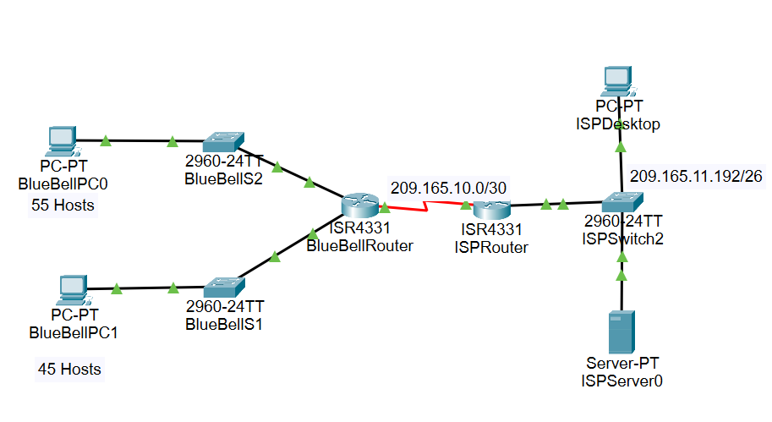
Part A: Subnet the assigned network
In this activity, you will subnet the BlueBell network into multiple subnets. The subnet scheme should be based on the number of host computers required in each subnet and future network host expansion.
Step 1: Create a subnetting scheme that meets the required number of subnets and required number of host addresses.
In this scenario, you are a network technician assigned to install a new network for a customer. You must create multiple subnets out of the 192.168.1.0/24 network address space to meet the following requirements:
- The first subnet is the LAN-A network. You need a minimum of 55 host IP addresses.
- The second subnet is the LAN-B network. You need a minimum of 45 host IP addresses.
- You also need at least two additional unused subnets for future network expansion.
Answer the following questions to help create a subnetting scheme that meets the stated network requirements.

How many host addresses are needed in the largest required subnet?
Answer: 55

What is the minimum number of subnets required?
Answer: 4
The network that you are tasked to subnet is 192.168.1.0/24. What is the /24 subnet mask in binary?
Answer:
11111111.11111111.11111111.00000000

The subnet mask is made up of two portions: the network portion and the host portion. This is represented in the binary by the ones and the zeros in the subnet mask.

Questions:
In the network mask, what do the ones represent?
Answer:
Network portion
In the network mask, what do the zeros represent?
Answer:
Host portion
The number of host bits (to the power of 2) defines the number of hosts per subnet (minus 2), and the number of subnet bits (to the power of 2) defines the number of subnets.
The subnet bits (shown in bold) are the bits that have been borrowed beyond the original network mask of /24. The /24 is the prefix notation and corresponds to a dotted decimal mask of 255.255.255.0.
Prefix length | N | N | N | H | Dotted decimal subnet mask
/25 | 11111111 | 11111111 | 11111111 | 10000000 | 255.255.255.128

Number of subnets?
Answer: 2¹ = 2
Number of hosts?
Answer: 2⁷ – 2 = 126

Prefix length | N | N | N | H | Dotted decimal subnet mask
/26 | 11111111 | 11111111 | 11111111 | 11000000 | 255.255.255.192

Number of subnets?
Answer: 2² = 4
Number of hosts?
Answer: 2⁶ – 2 = 62

Prefix length | N | N | N | H | Dotted decimal subnet mask
/27 | 11111111 | 11111111 | 11111111 | 11100000 | 255.255.255.224

Number of subnets?
Answer: 2³ = 8
Number of hosts?
Answer: 2⁵ – 2 = 30

Considering your answers above, which subnet mask meets both the minimum number of hosts required and the minimum number of subnets required?
/26 - Number of subnets?
Answer: 2² = 4
Number of hosts?
Answer: 2⁶ – 2 = 62
When you have determined which subnet mask meets all of the stated network requirements, derive each of the subnets. List the subnets from first to last in the table. Remember that the first subnet is 192.168.1.0 with the chosen subnet mask.
Identify the magic number
Answer: 64

Subnet mask
Answer: 255.255.255.192
Complete the table.
Subnet number | Subnet address | Prefix | Subnet mask
0
1 | 192.168.1.64
2
3

Answer:
Subnet address | Prefix | Subnet mask
192.168.1.0 | /26 | 255.255.255.192
192.168.1.64 | /26 | 255.255.255.192
192.168.1.128 | /26 | 255.255.255.192
192.168.1.192 | /26 | 255.255.255.192

Part B: Design the BlueBell logical topology and assign the calculated subnets

Network | Subnet address | First usable address | Last usable address | Broadcast address
LAN A | 192.168.1.0 | 192.168.1.1 | 192.168.1.62 | 192.168.1.63
LAN B | 192.168.1.64 | 192.168.1.65 | 192.168.1.126 | 192.168.1.127

Address table
Router | Gigabitethernet0/0/0 | 192.168.1.1 | 192.168.1.192
 | Gigabitethernet0/0/1 | 192.168.1.65 | 192.168.1.192
BlueBellPC0 | FastEthernet | 192.168.1.62 | 192.168.1.192
BlueBellPC1 | FastEthernet | 192.168.1.126 | 192.168.1.192

Assign the IPv4 address.

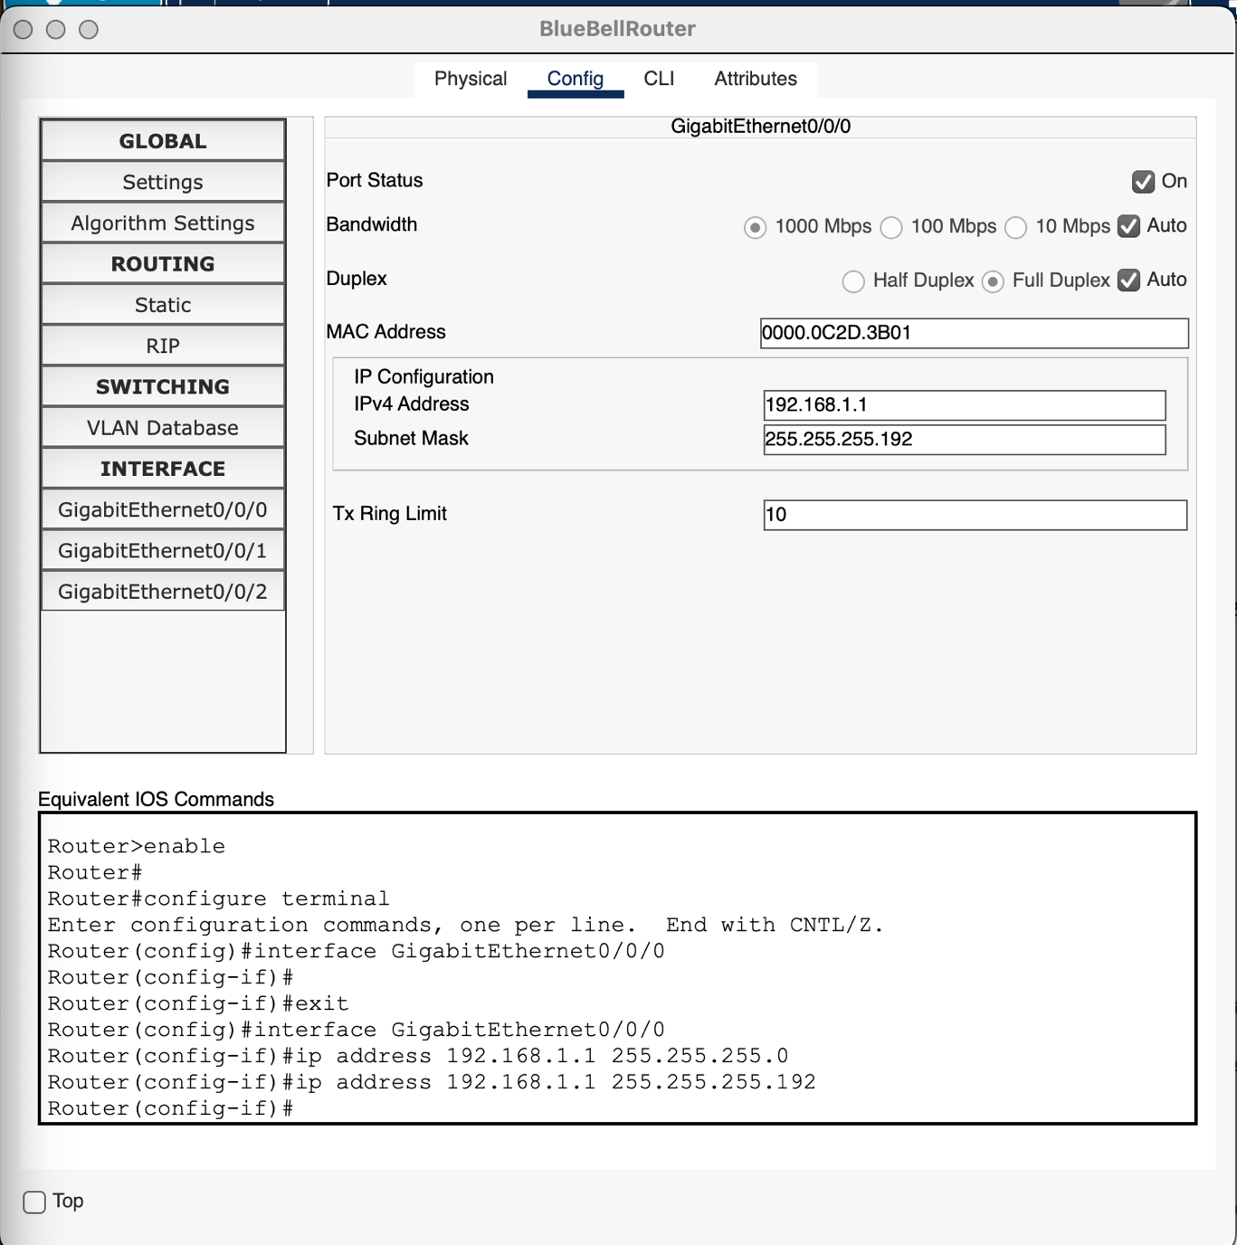

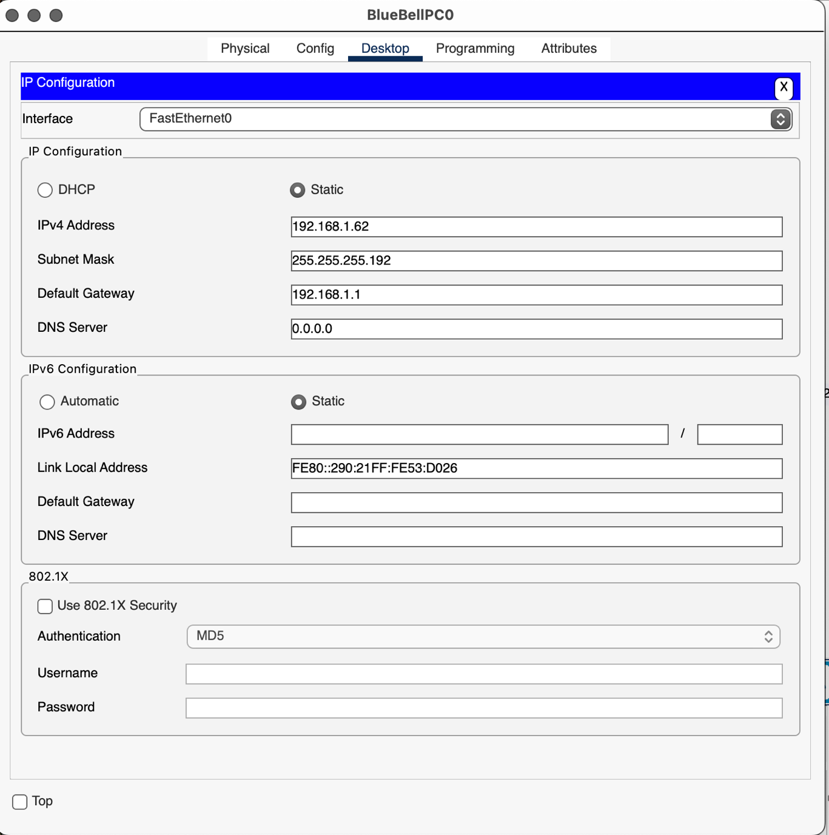
Test connectivity – use the ping tool.
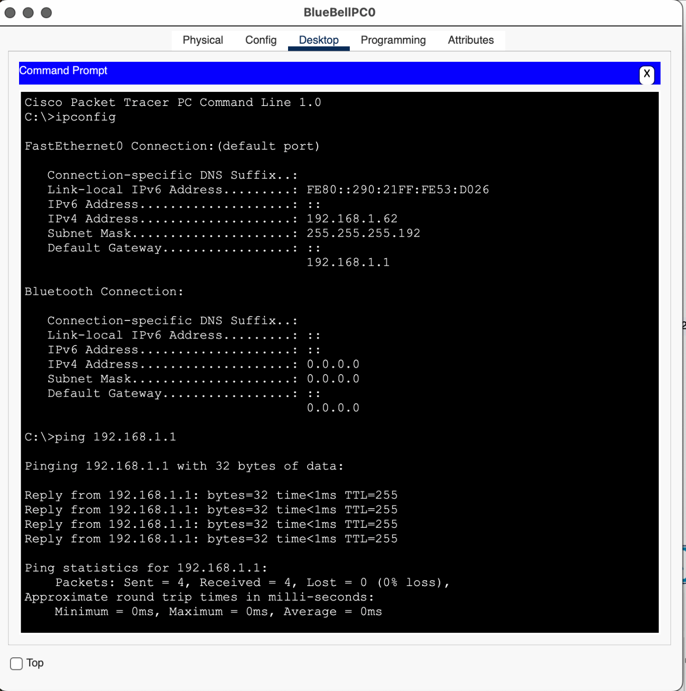

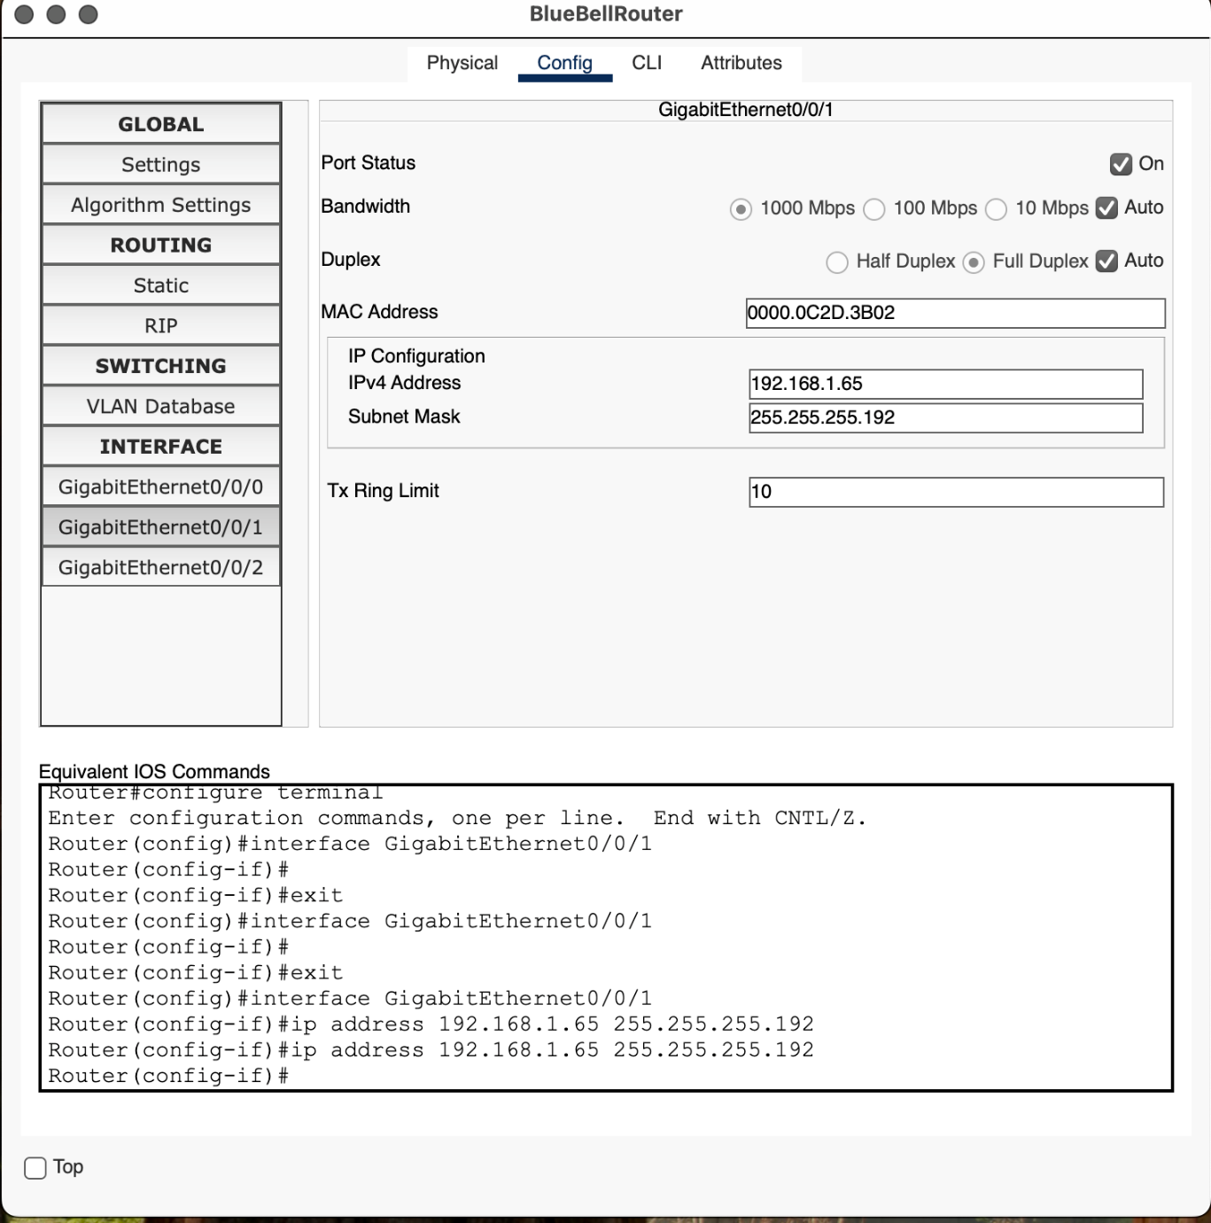
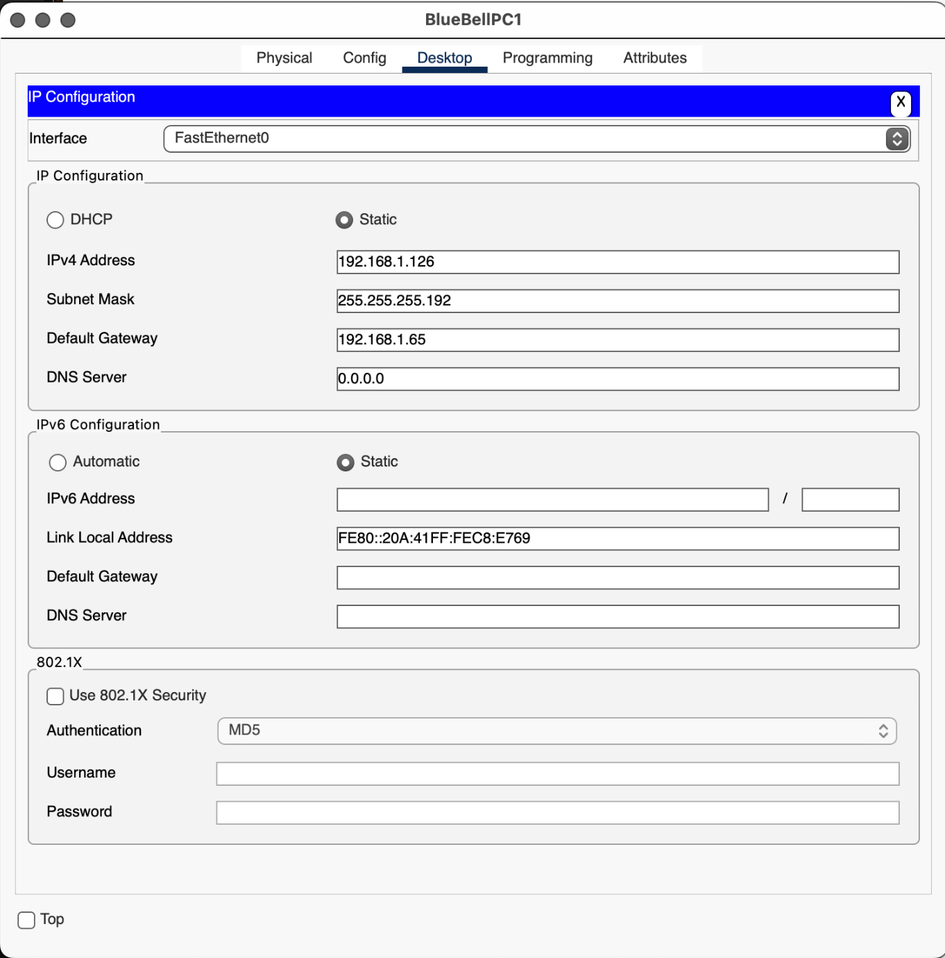

Test connectivity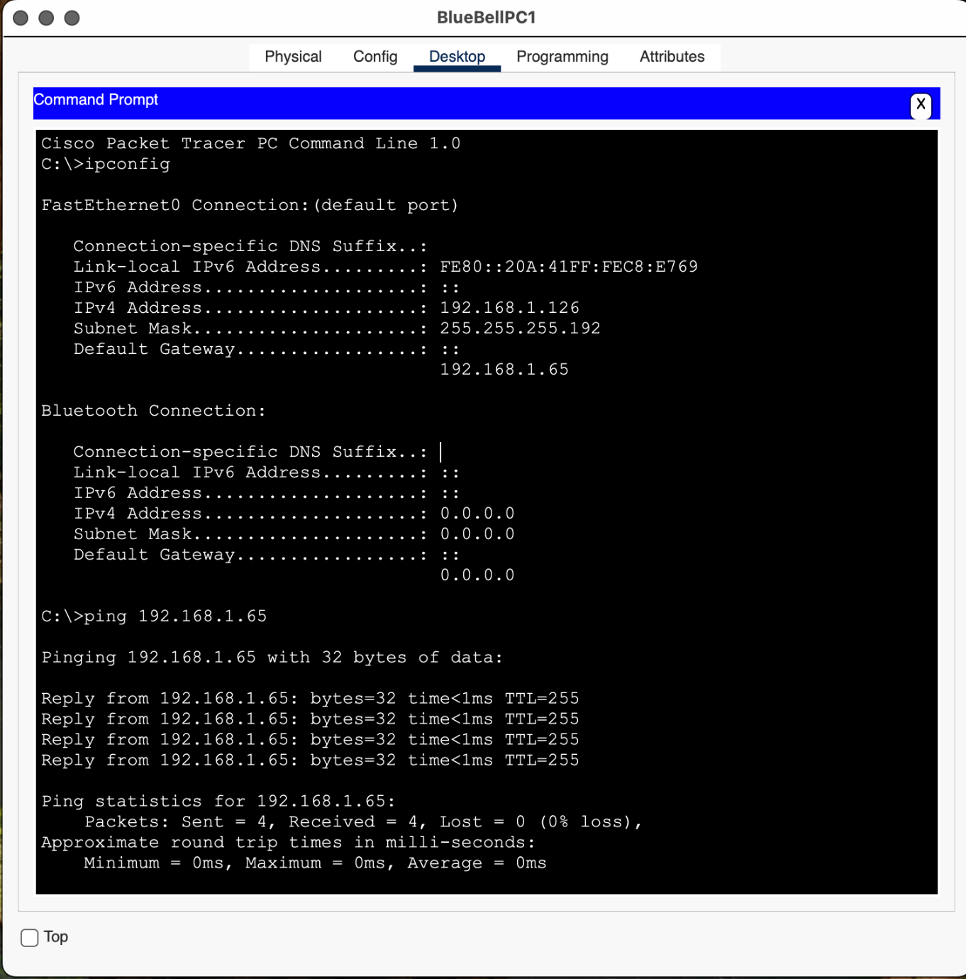

Logical topology
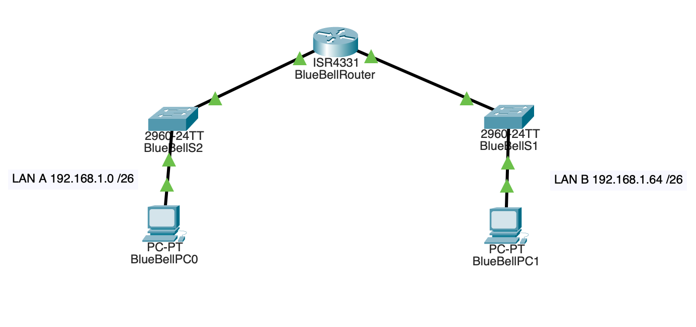

The following materials relate to lesson 5: Virtualisation
Activity: Enable Hyper-V on Windows
Activity: Create a virtual machine

Activity: Enable Hyper-V on Windows
Hyper-V is an optional feature on Windows 10 (Pro or Enterprise) and Windows 11 (Pro or Enterprise).
As a standalone product, it is called Microsoft Hyper-V Server.
The physical hardware must have Central Processing Unit (CPU) support for VM Monitor Mode Extension.
At least 4GB memory is required.

Instructions
Navigate to Settings then Control panel.
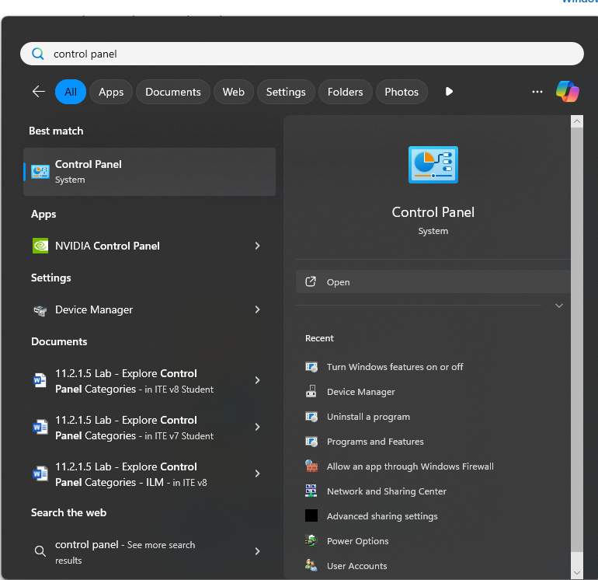

Select Programs.
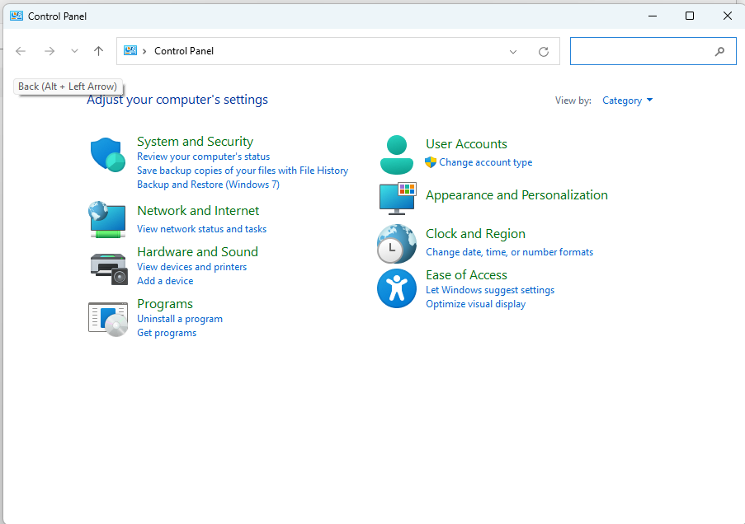
Click Programs and Features.
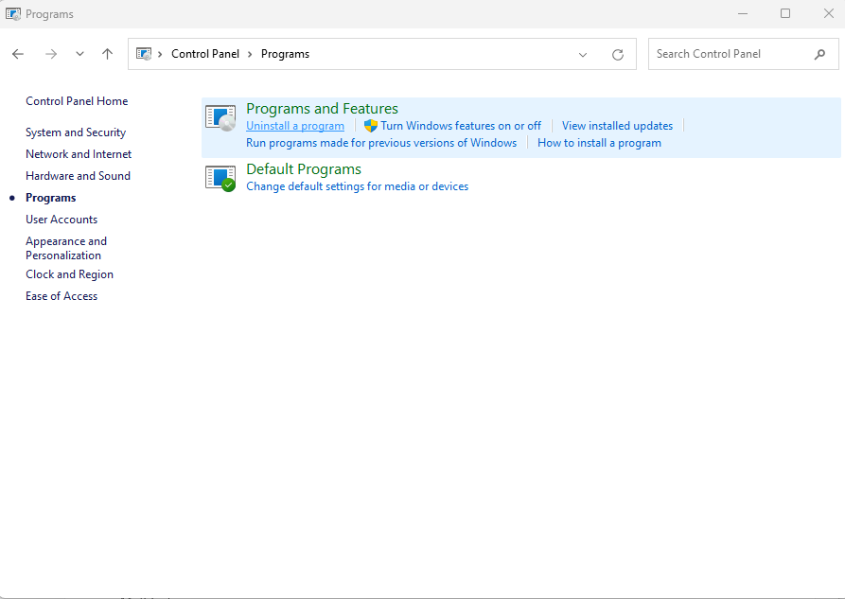
Select Turn Windows features on or off.

Select Hyper-V and choose OK.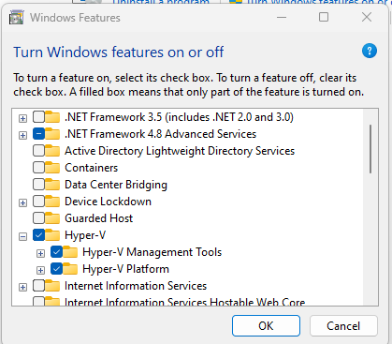
Restart the PC.

Activity: Create a virtual machine
Instructions
Load the Hyper-V Manager.
Click Action and select New, then choose Virtual Machines.

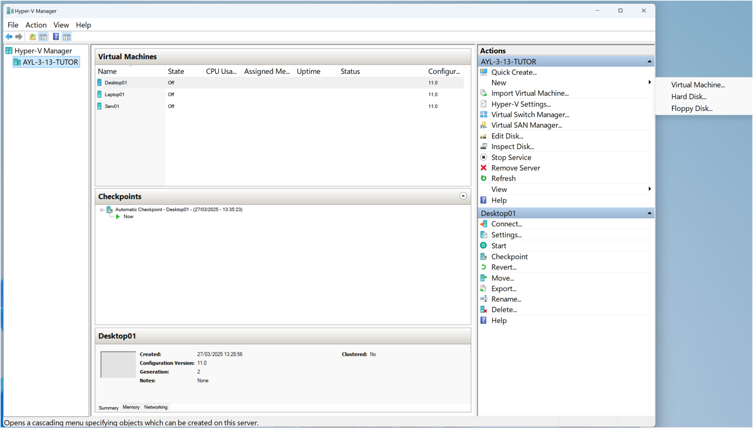
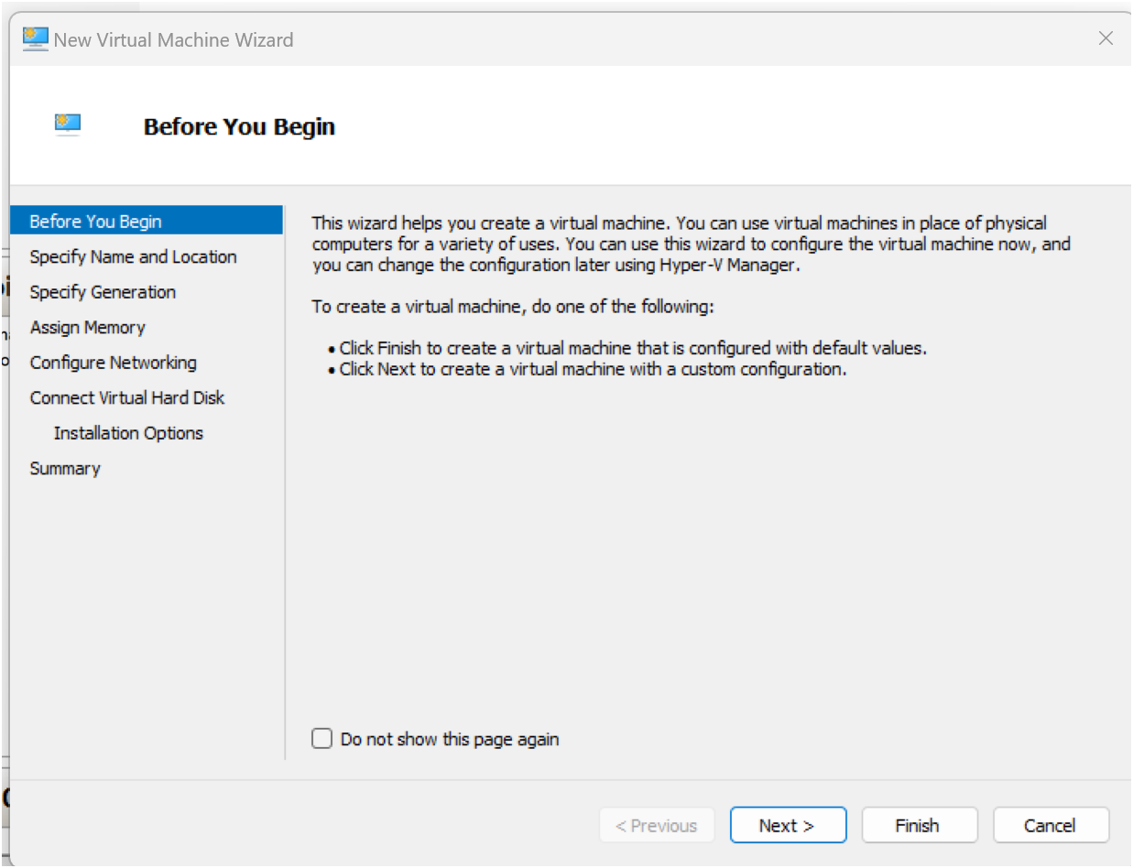
Click Next.

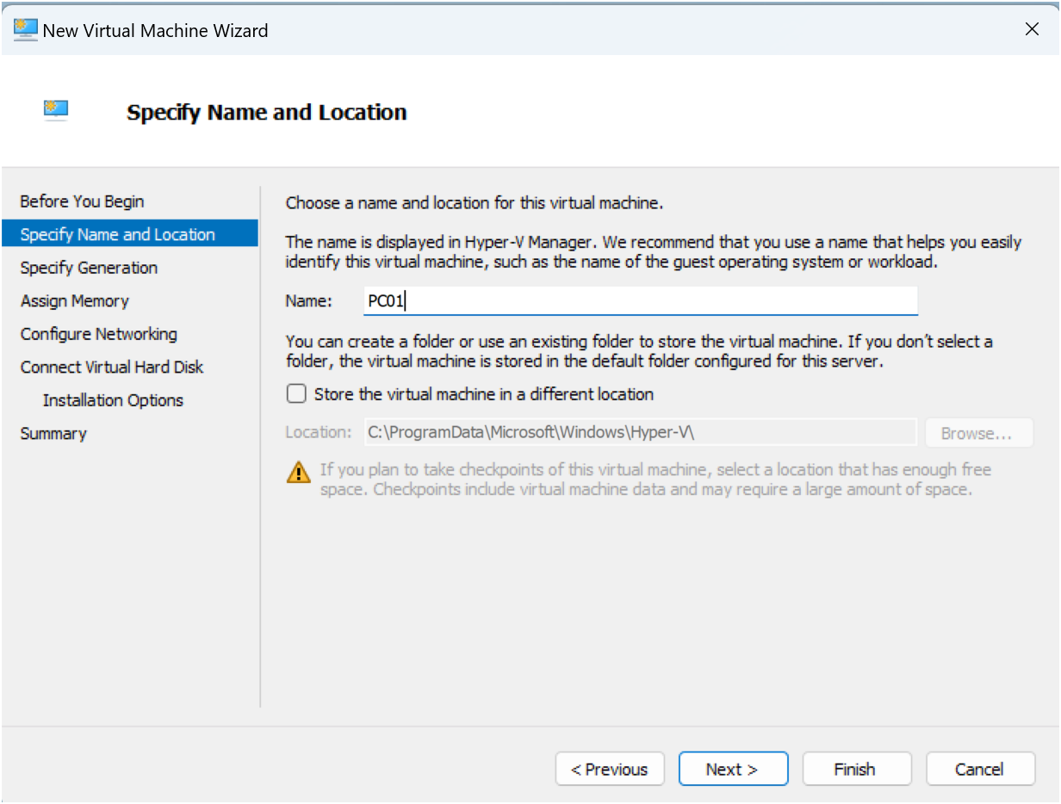
Choose storage location or accept the default.

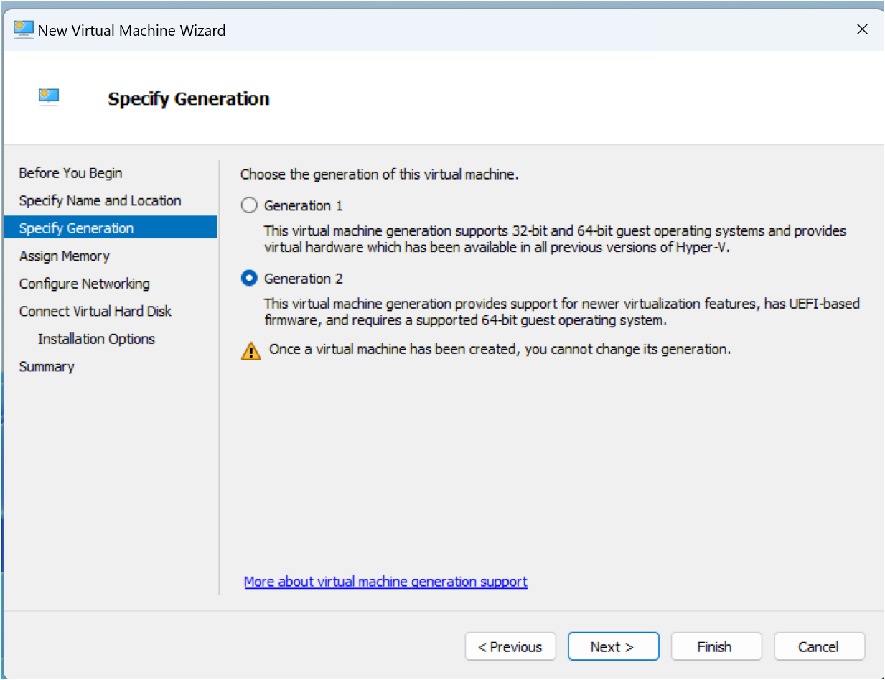
Click Next and allocate startup memory.

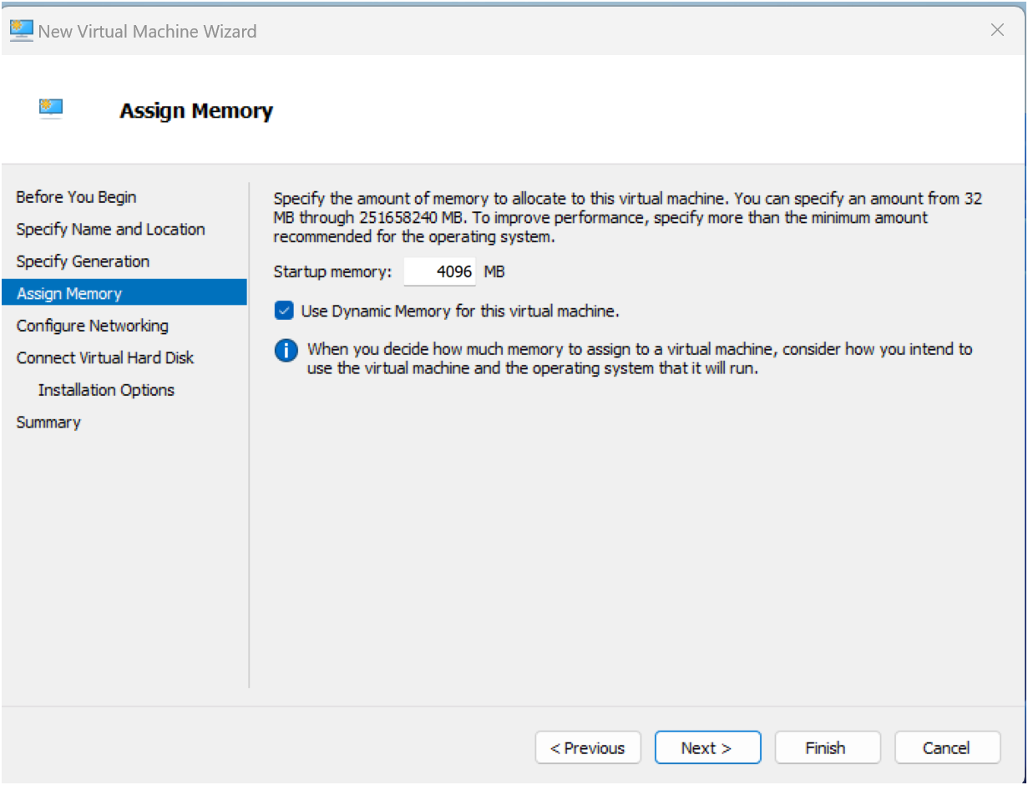
Click Next and Configure Networking – select switch.

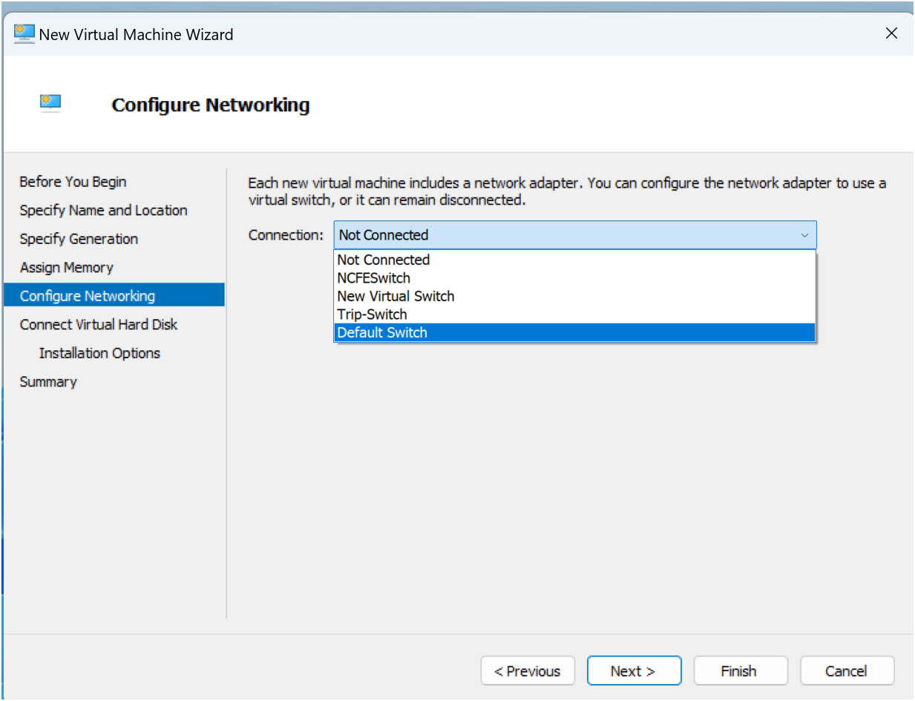
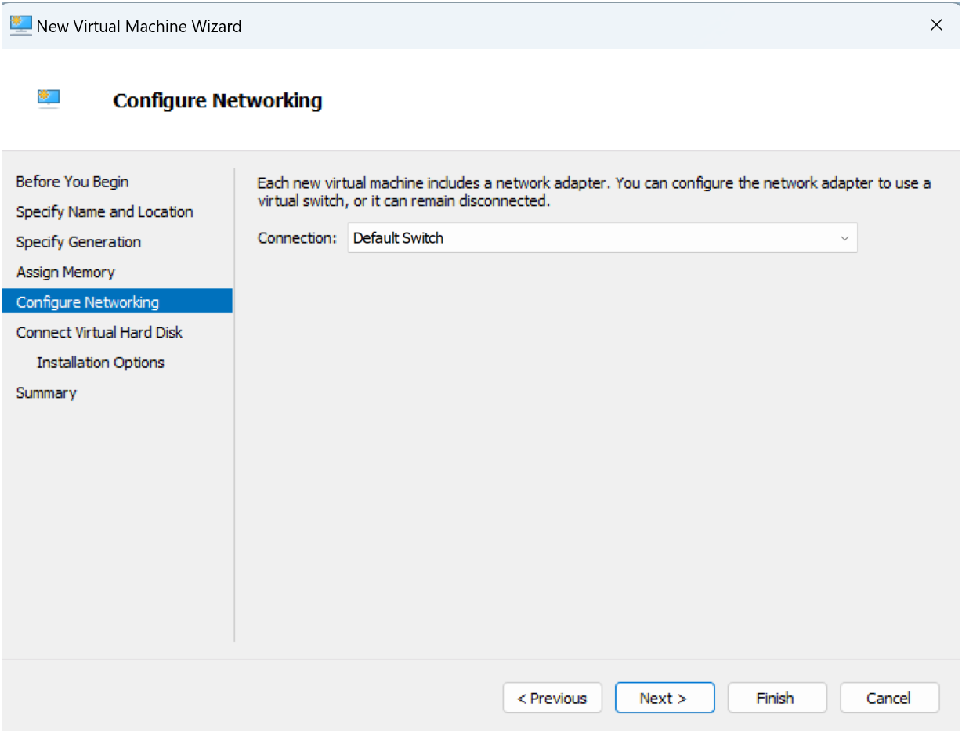
Connect Virtual Hard Disk – accept default size up to a maximum of 64TB.

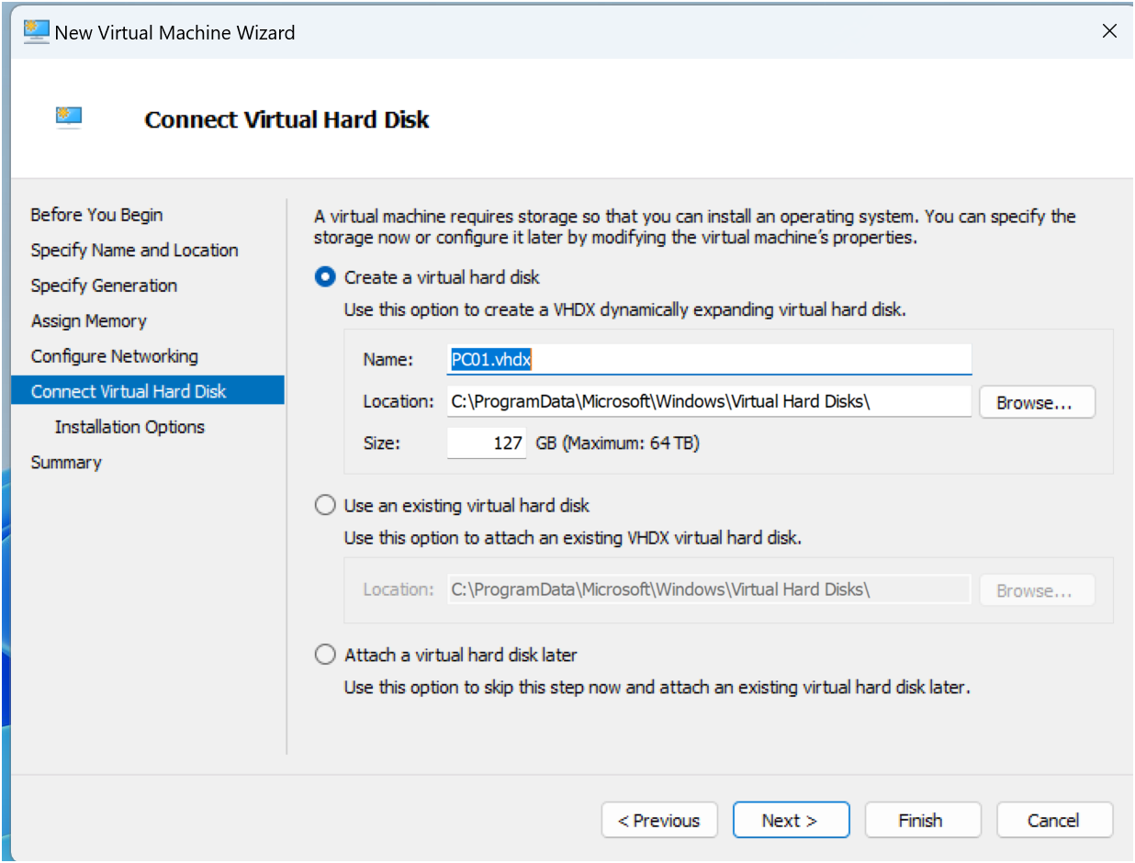
Click Next for options to install operating system.

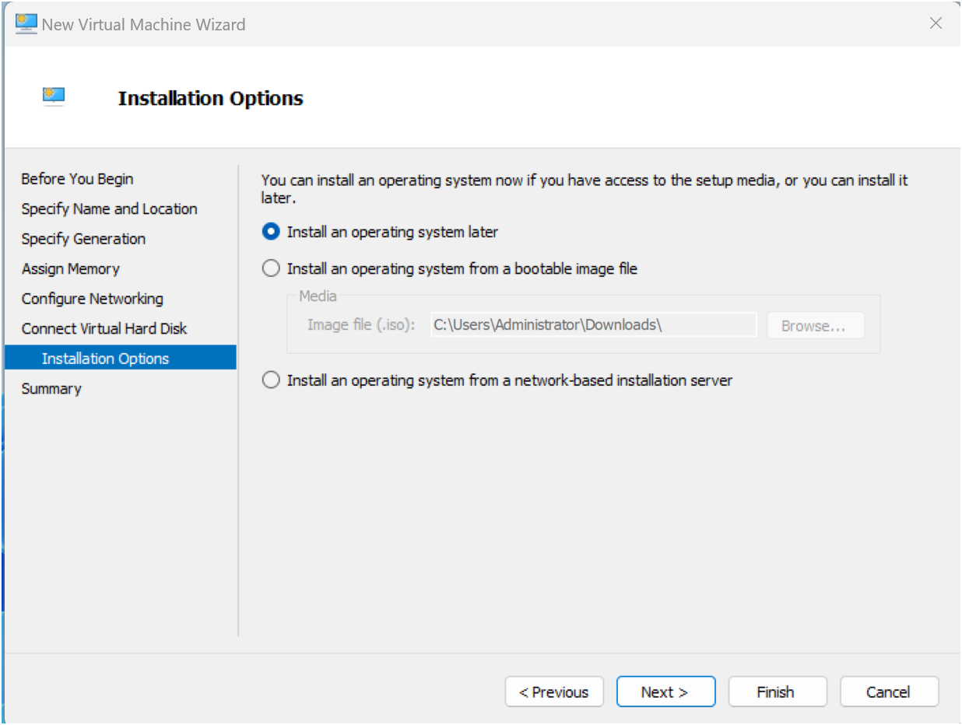
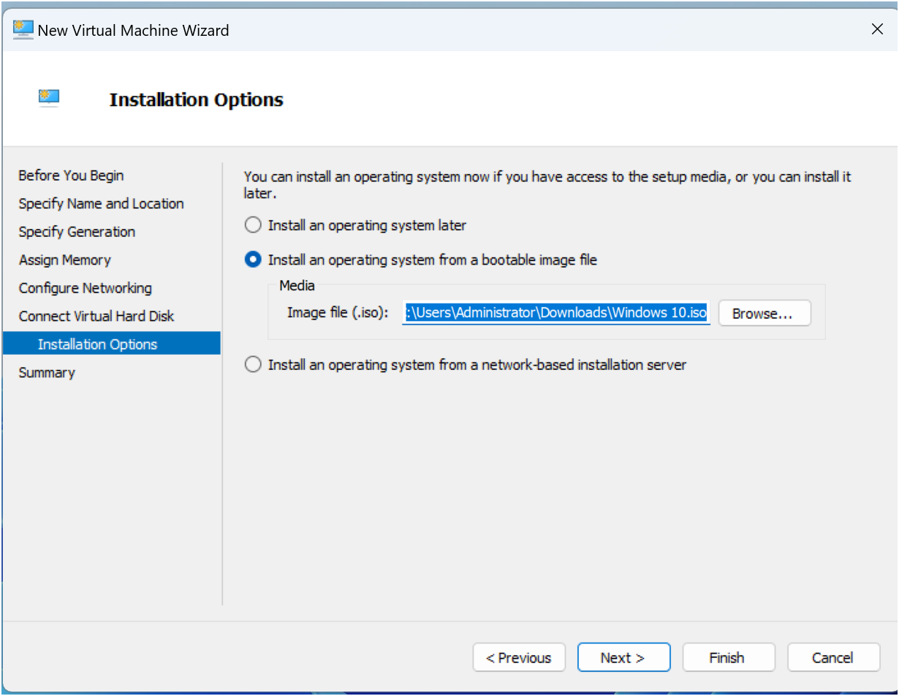
Click Next.
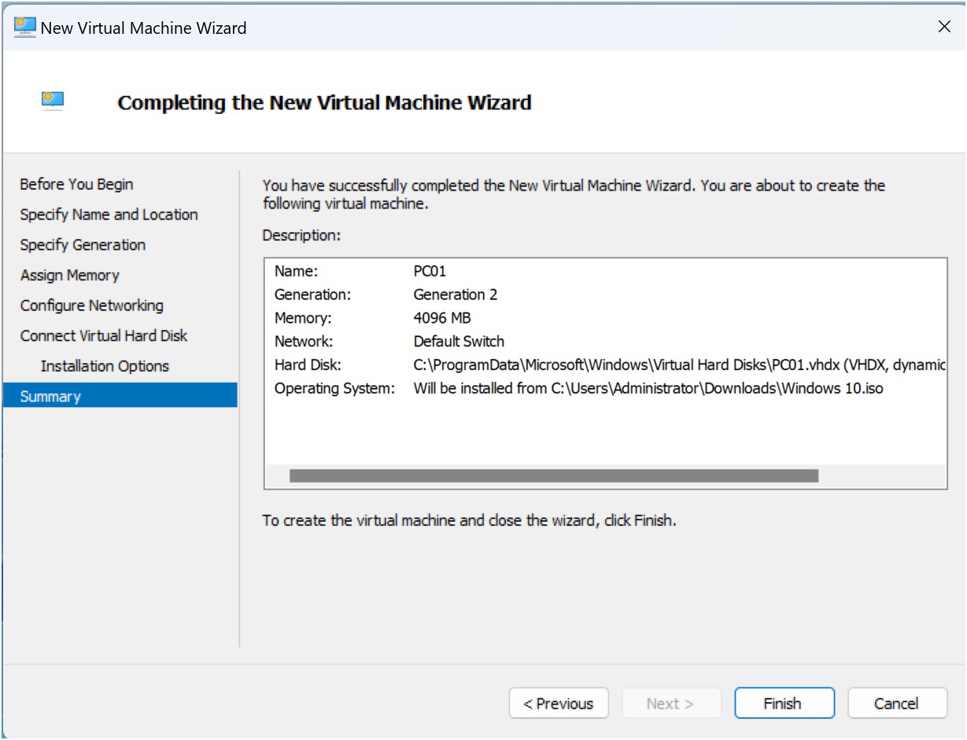
Click Finish.
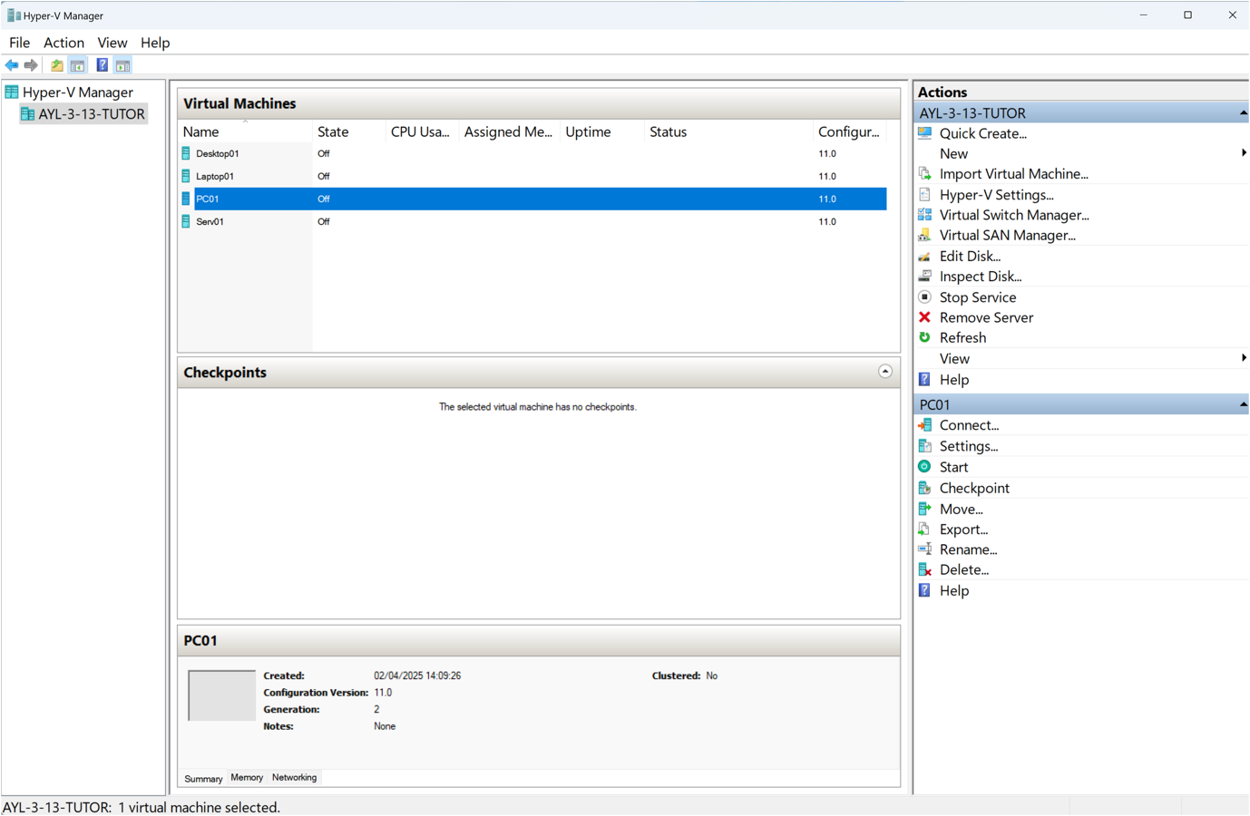

The following materials relate to lesson 6: Create virtual machines
Activity: Create Server VM using Hyper-V Manager
Activity: Create Server VM using Oracle VirtualBox
Activity: Create Desktop VM using Oracle VirtualBox
Activity: Create Desktop VM using Hyper-V Manager
Feedback sheet

Activity: Create Server VM using Hyper-V Manager

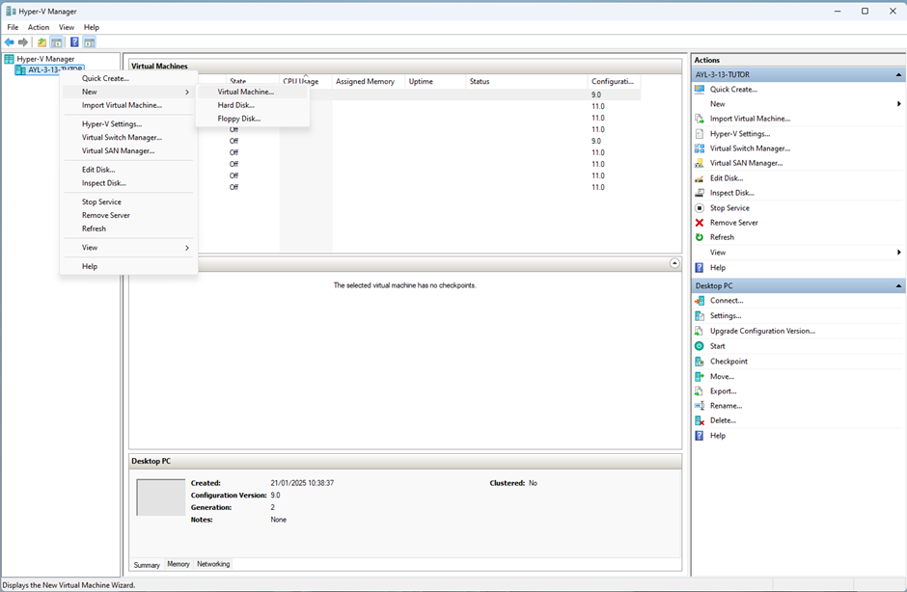

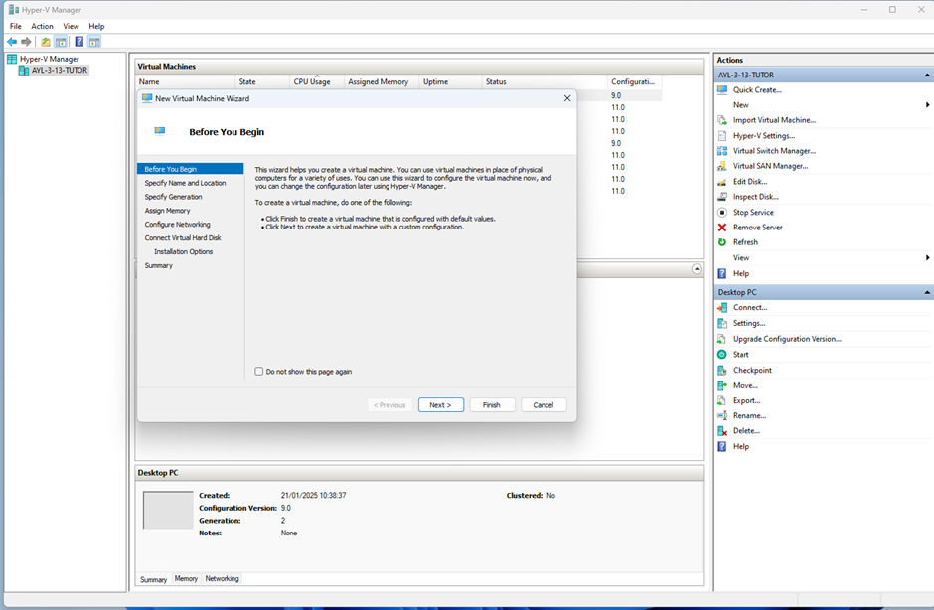

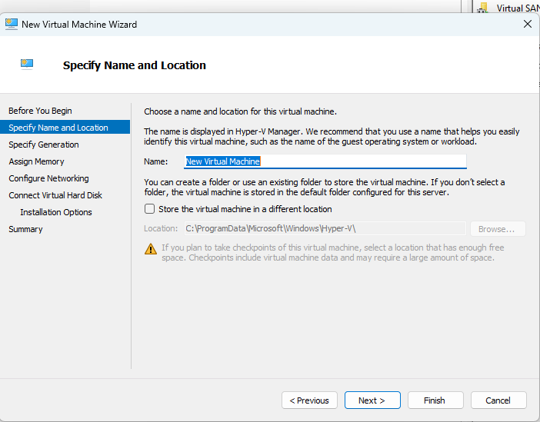

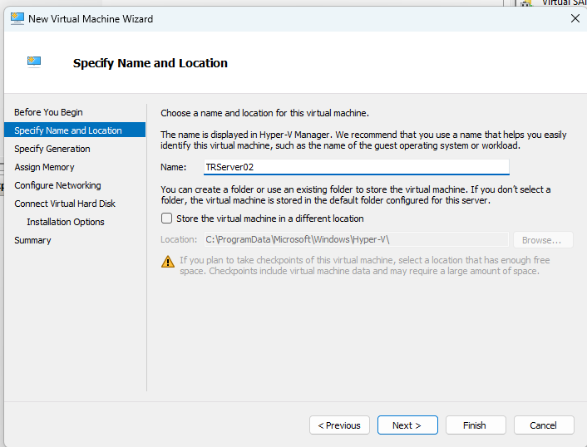

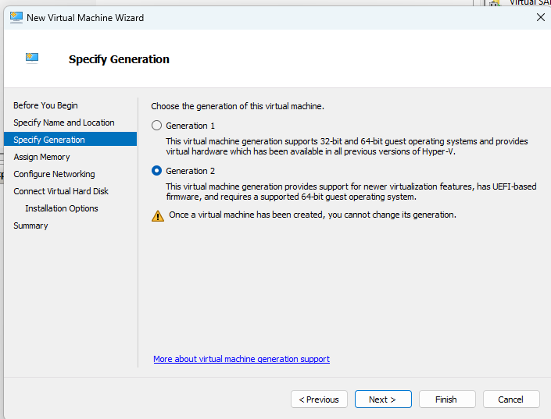

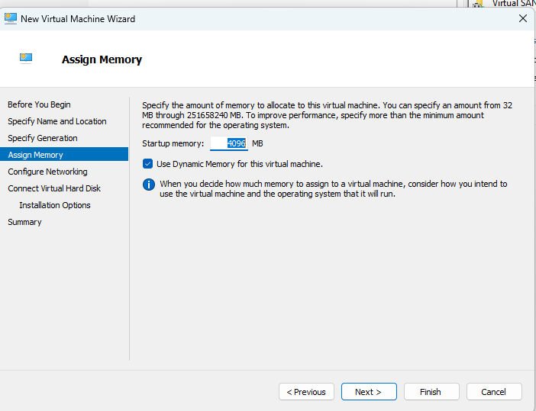

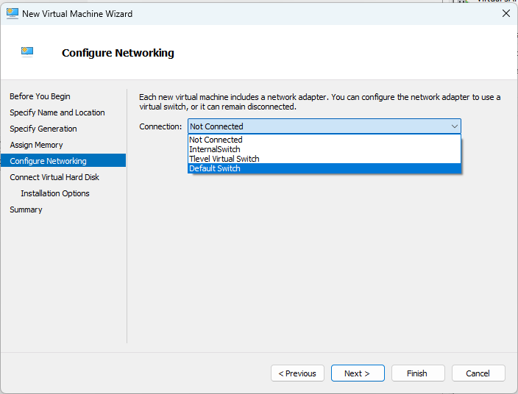

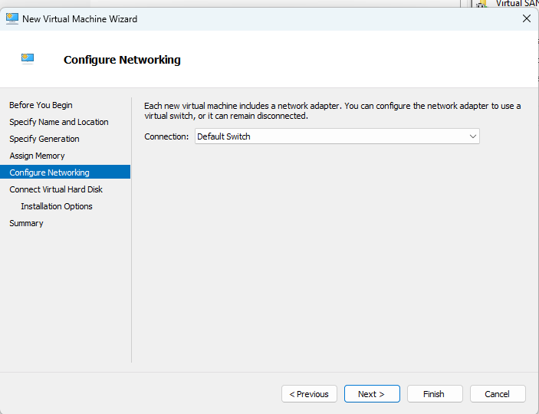

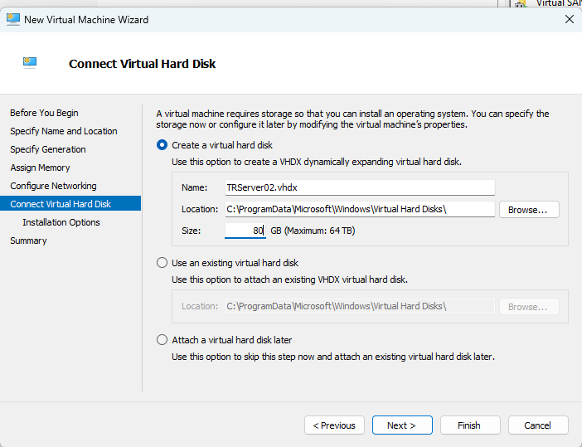

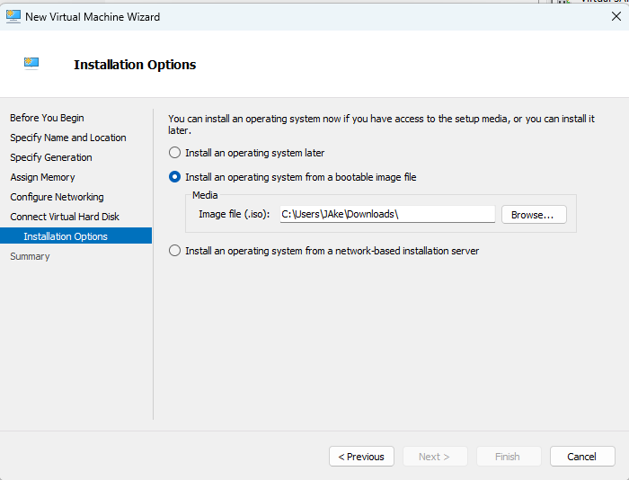

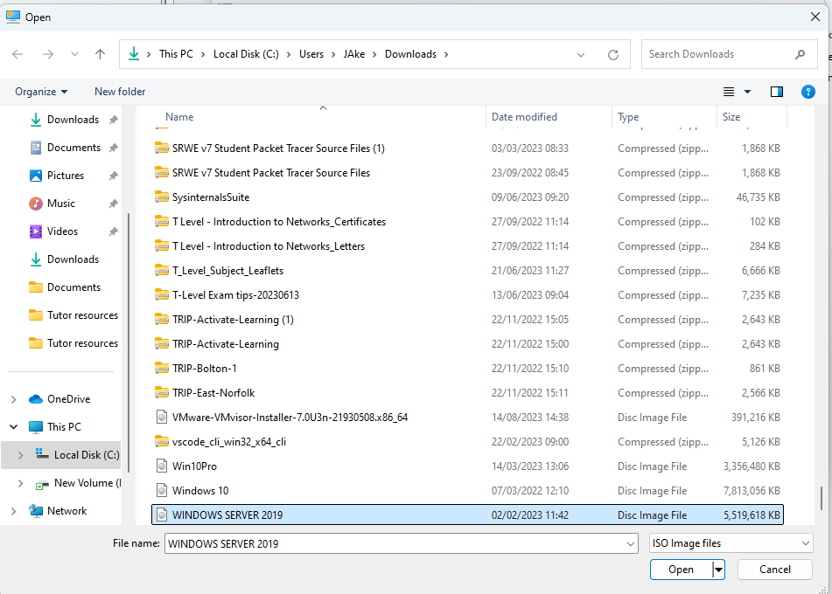

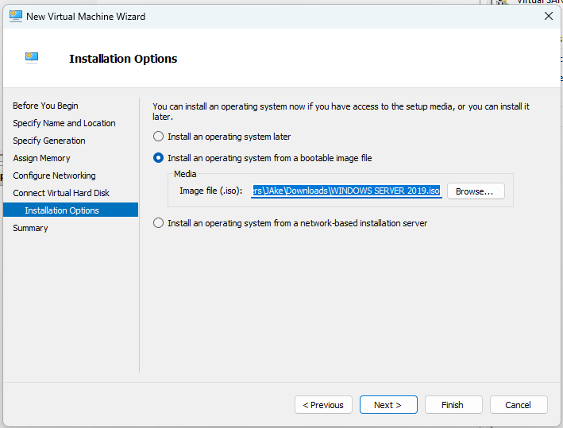

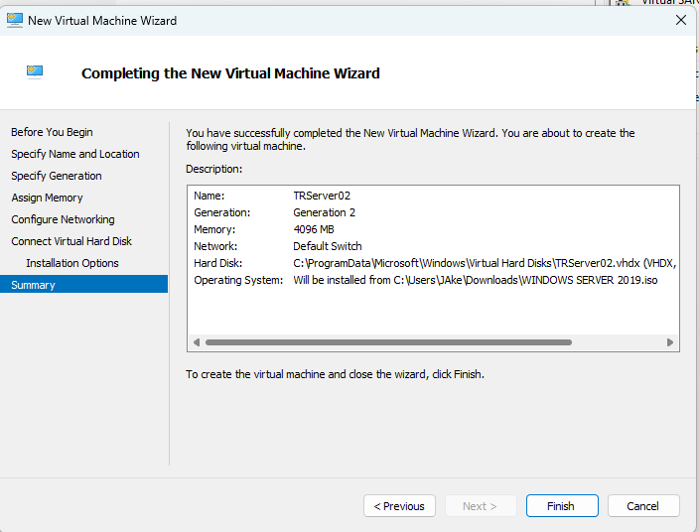

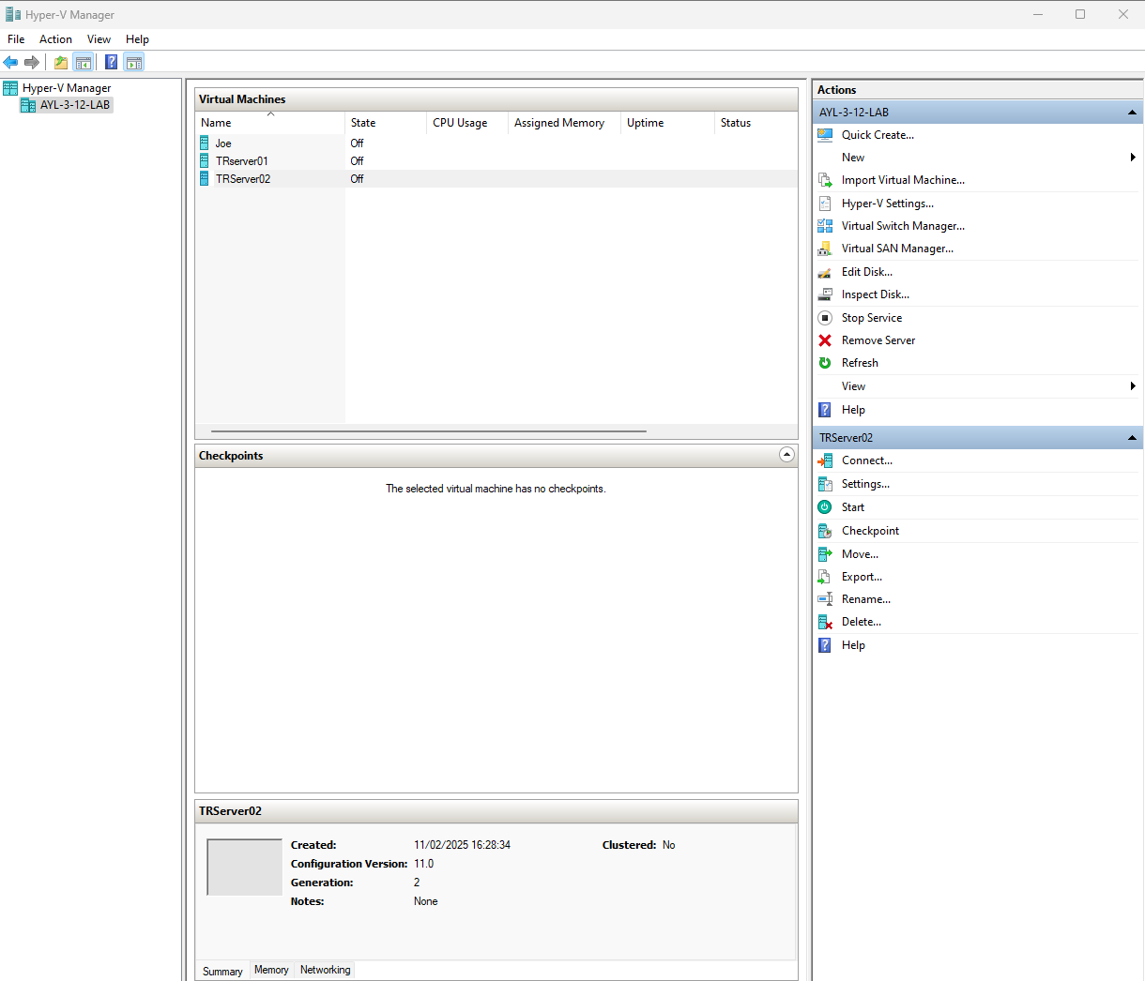

Activity: Create Server VM using Oracle VirtualBox

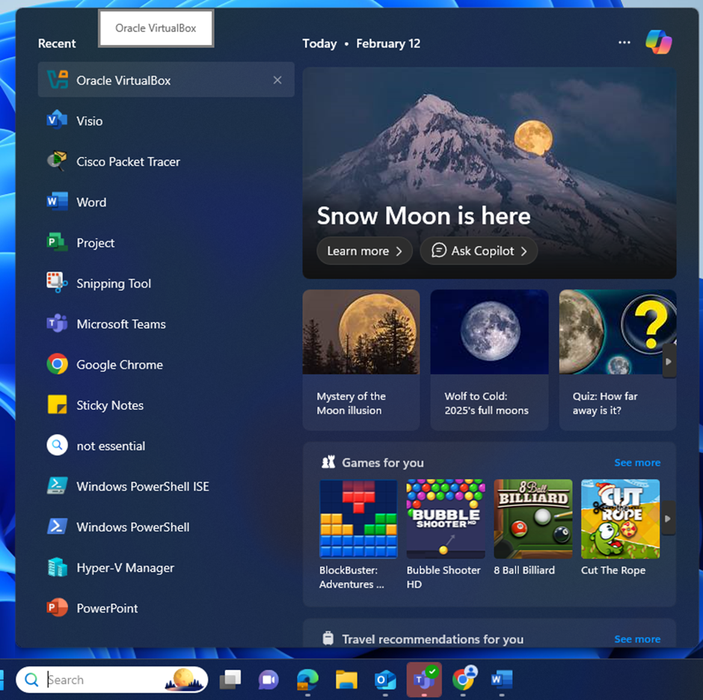

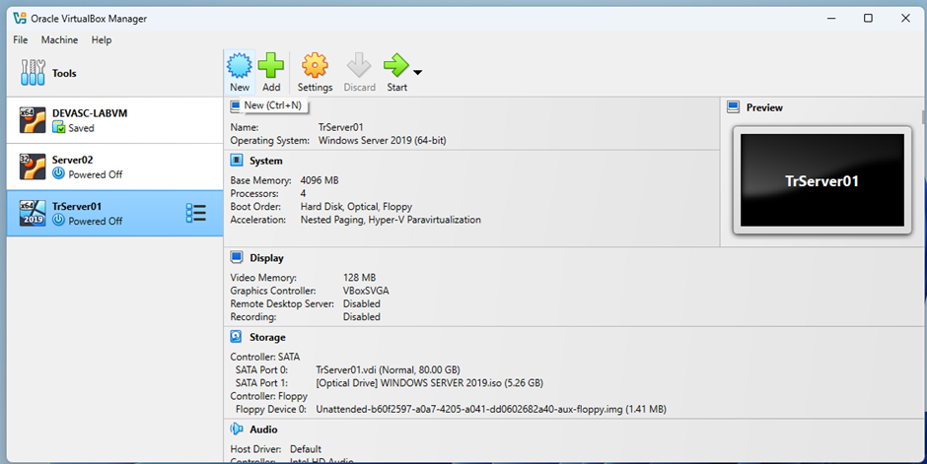

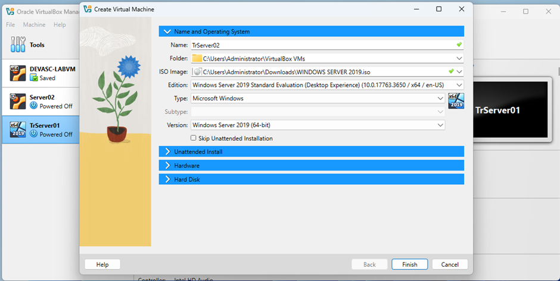

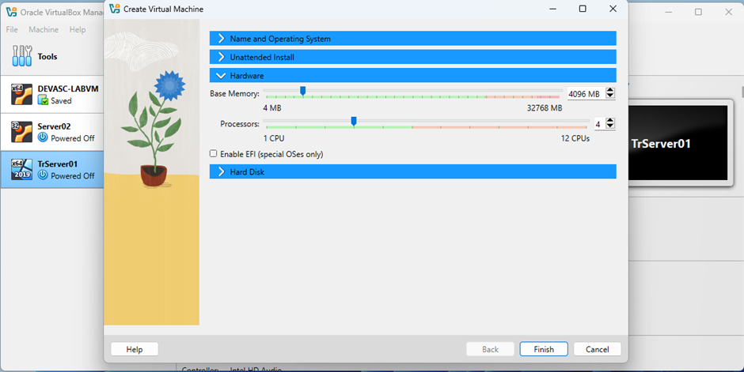

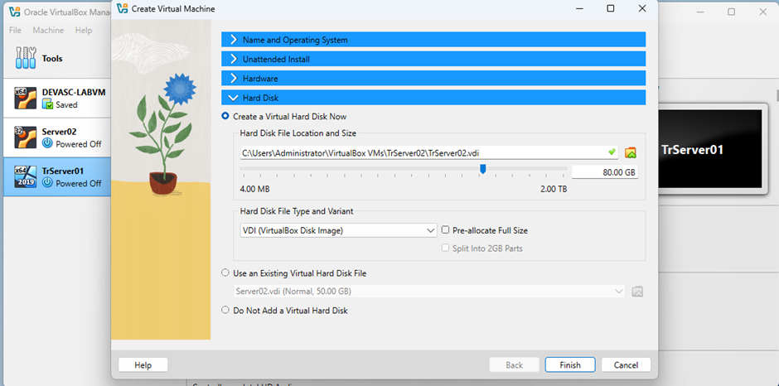

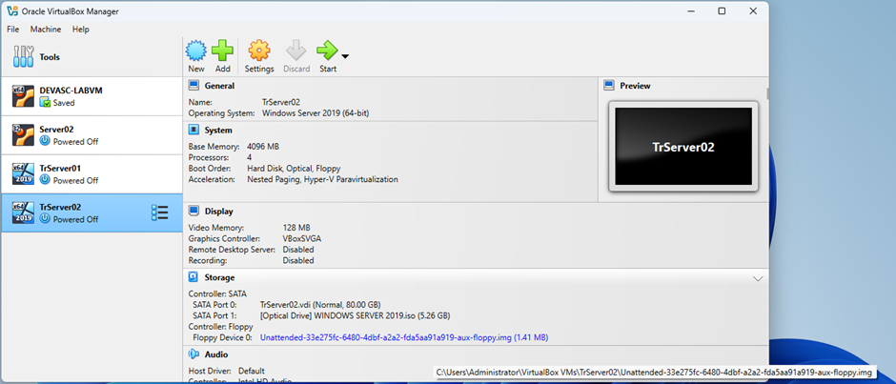

Activity: Create Desktop VM using Oracle VirtualBox
On the host computer, start Oracle VirtualBox.
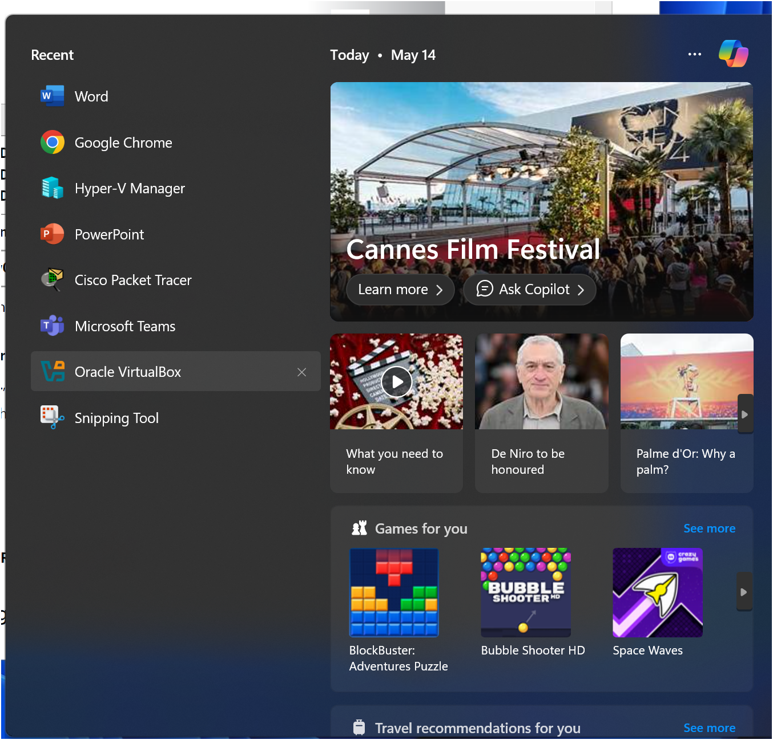
Click New, name the Desktop VM TrPC01 and navigate to the location of ISO Image – Windows.

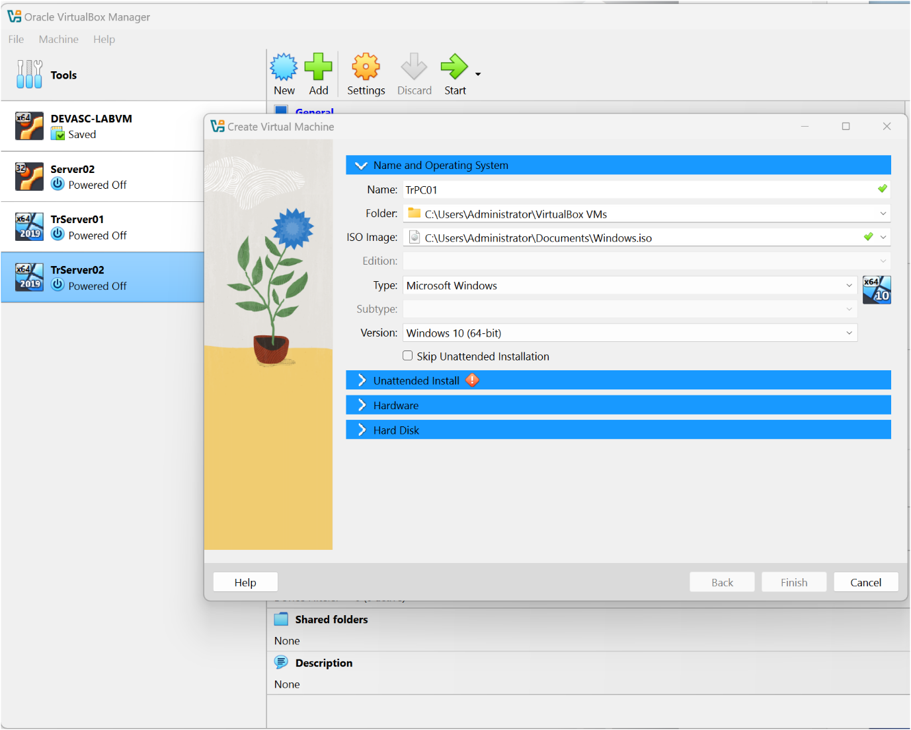
In Hardware, allocate Base Memory and Processors.
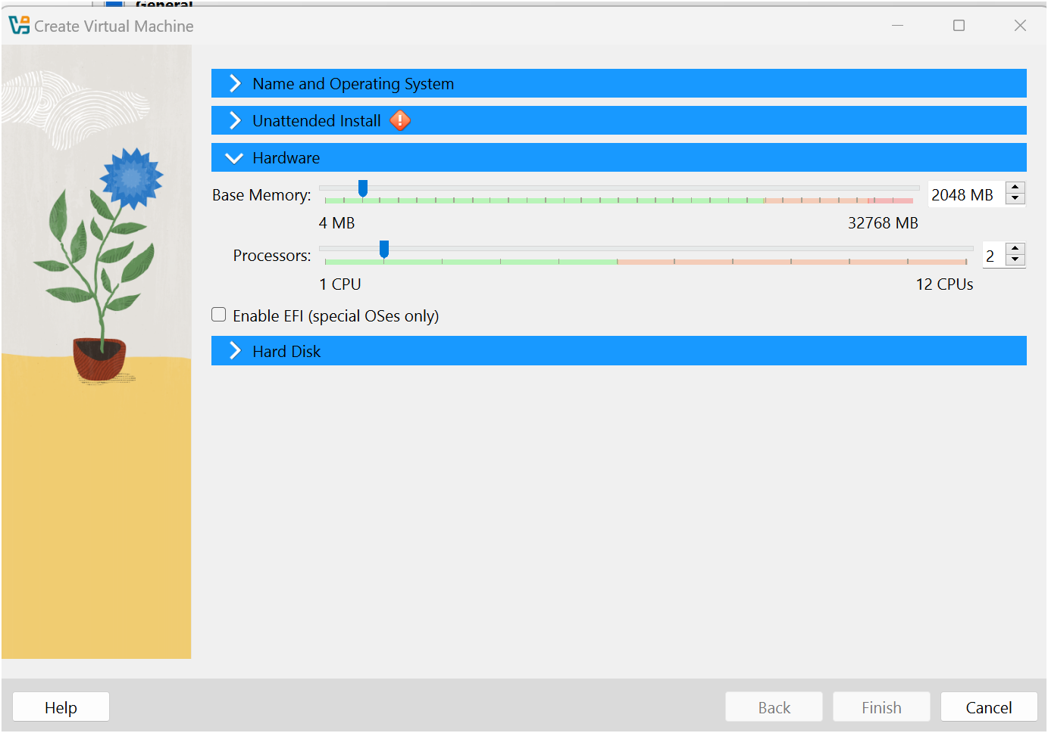
Click Hard Disk.
Navigate to Hard Disk File Location and Size and allocate size.
Choose Hard Disk File Type and Variant.

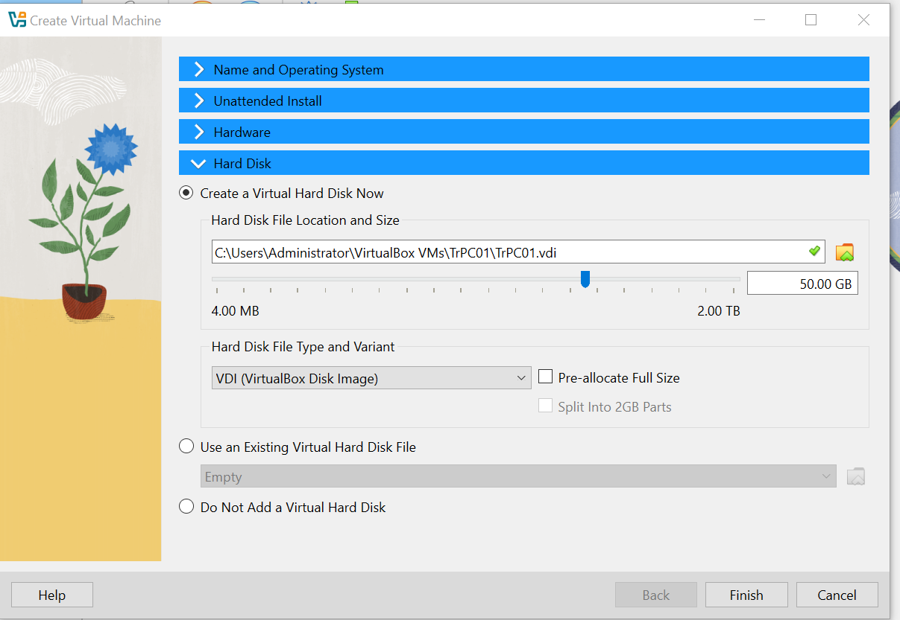
Click Finish.
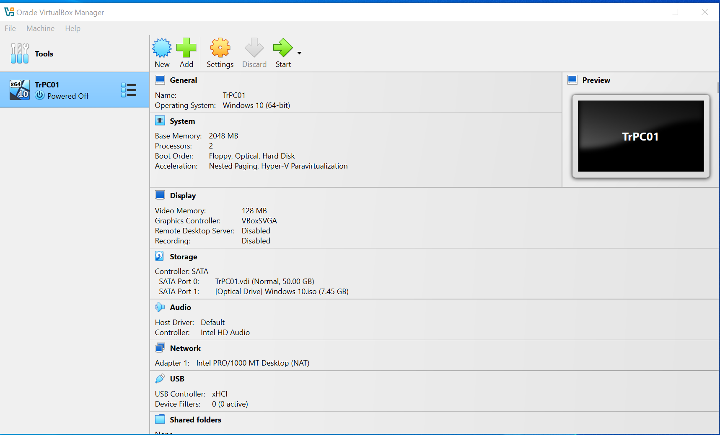

Activity: Create Desktop VM using Hyper-V Manager
On host computer, start Hyper-V Manager.
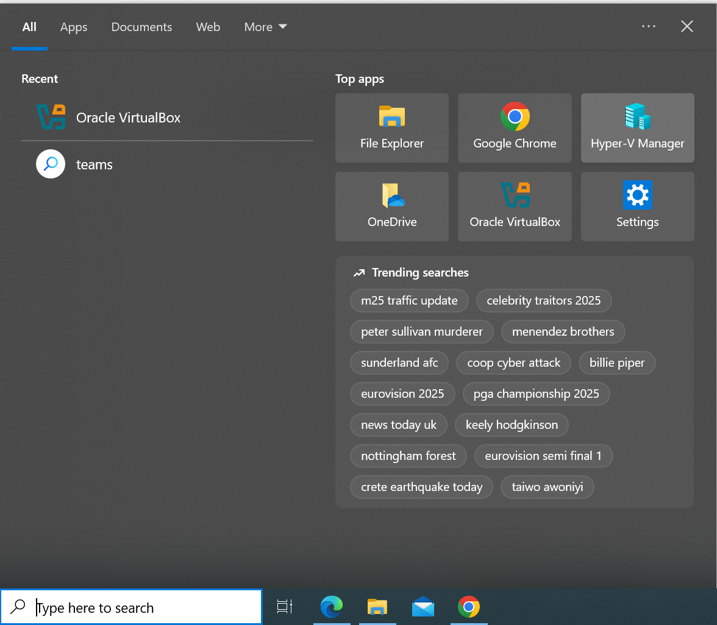

Click New and select Virtual Machines.
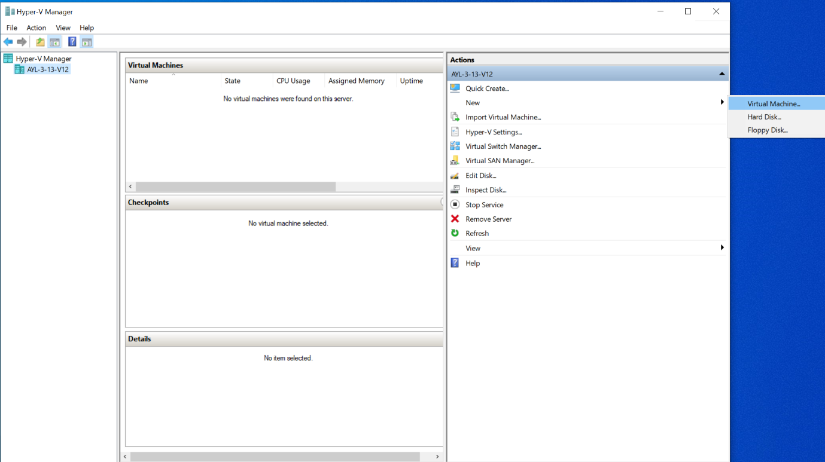
Navigate through the wizard.
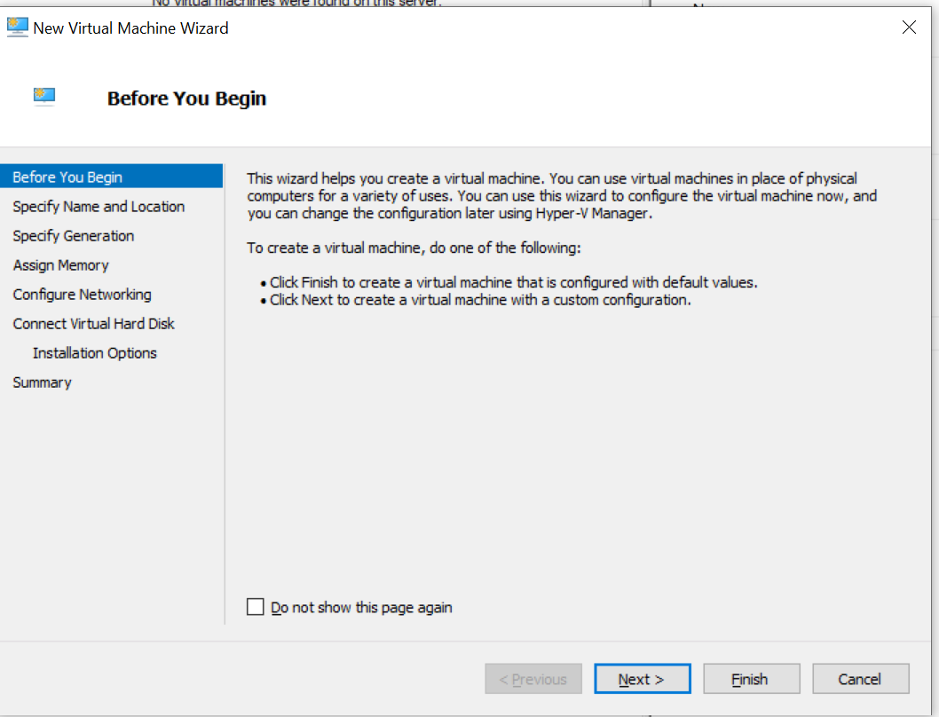
Click Next and specify Name and Location for the Desktop VM.
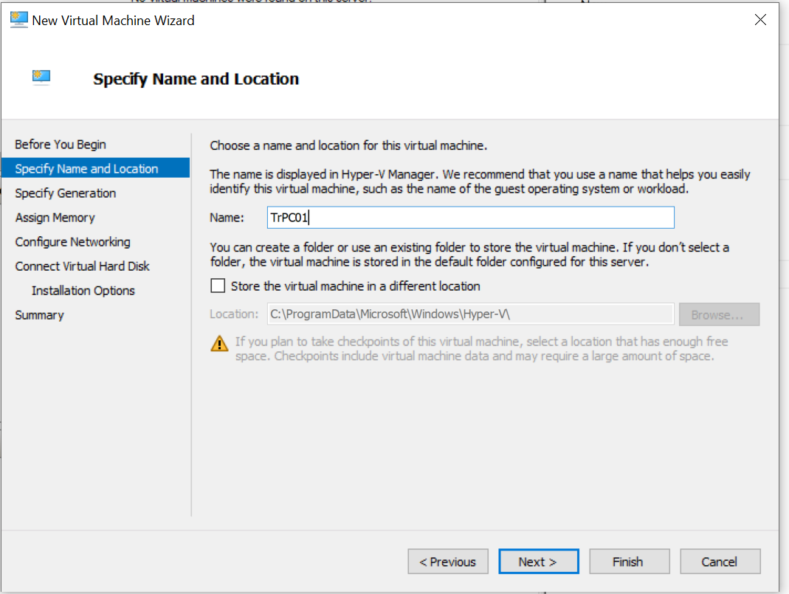
Click Next and Specify Generation.
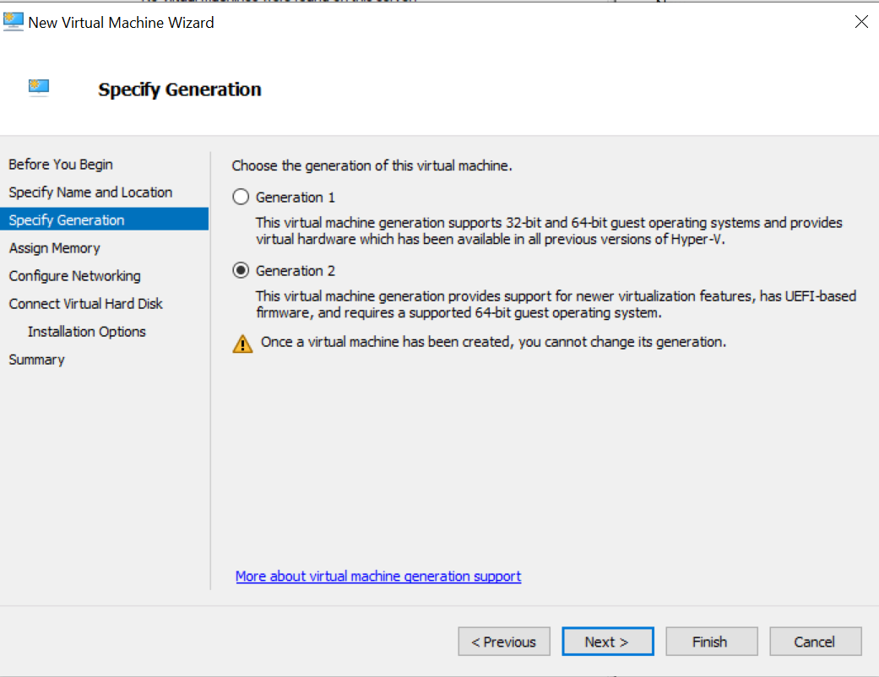
Click Next and Assign Memory.
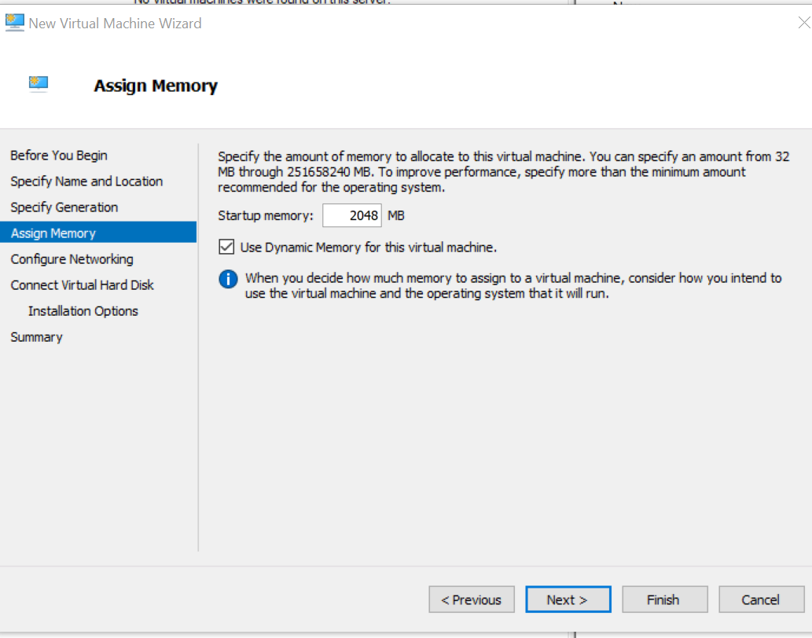
Click Next to Configure Networking.
Connection – select Default Switch.
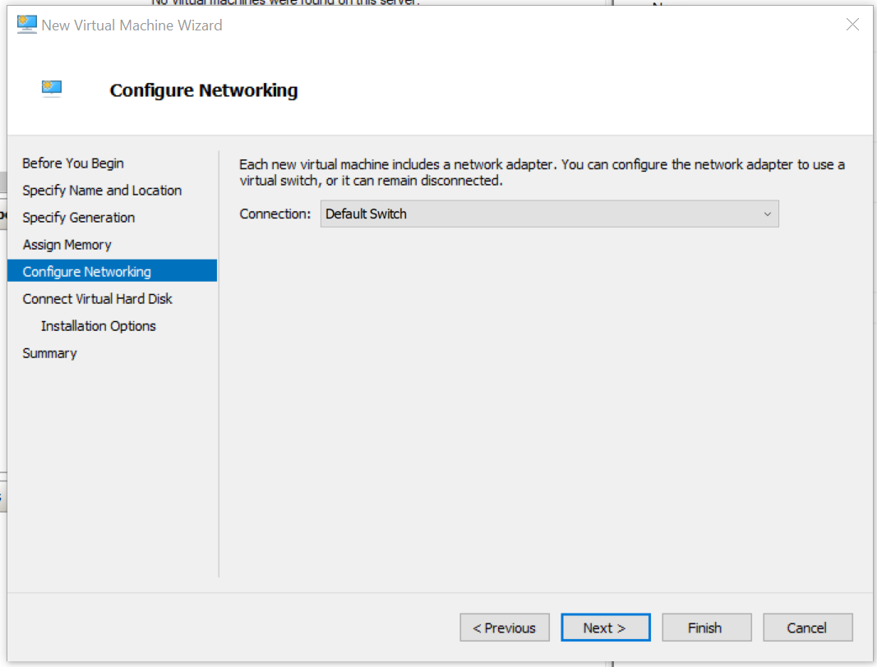
Click Next to Connect Virtual Hard Disk.
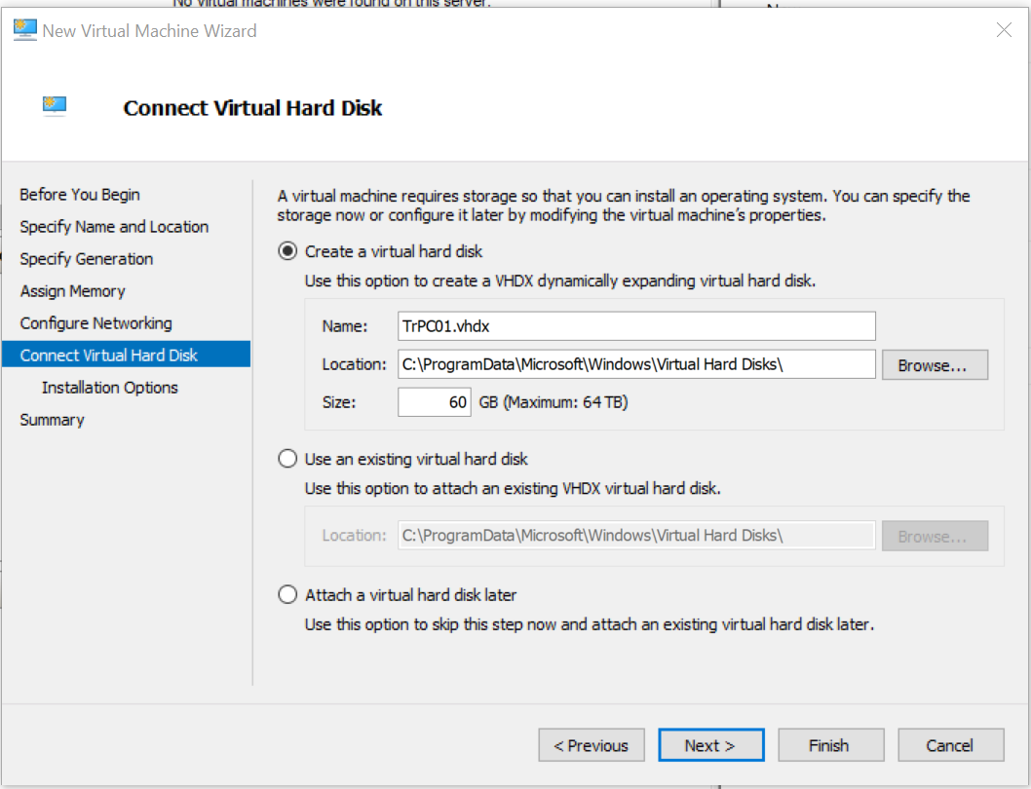
Click Next to Choose operating system Installation Options.

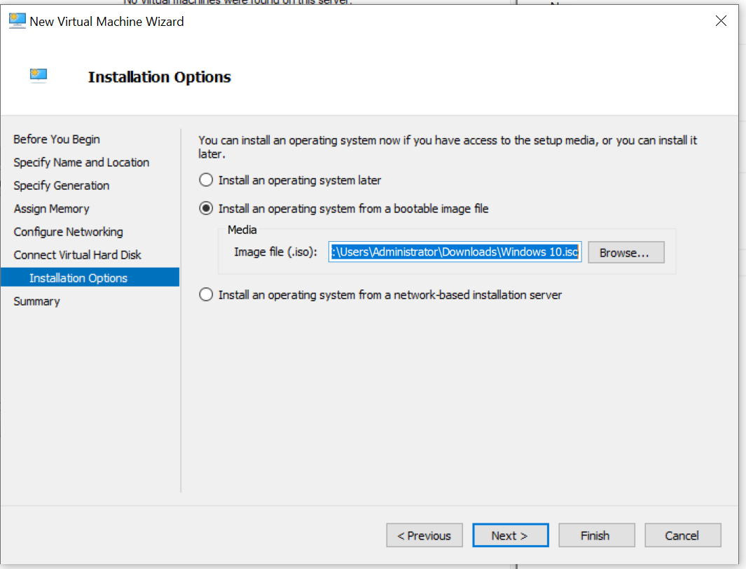
Agree to the summary of the resource’s allocation by clicking Finish.
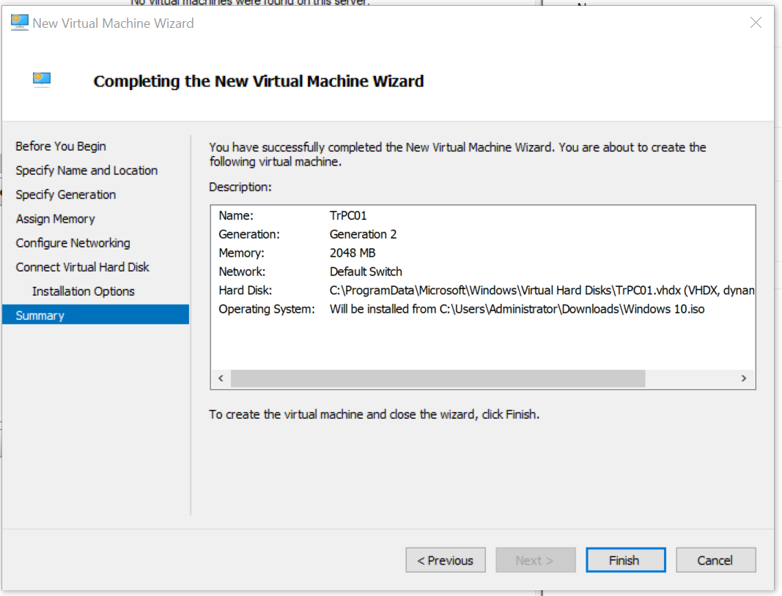
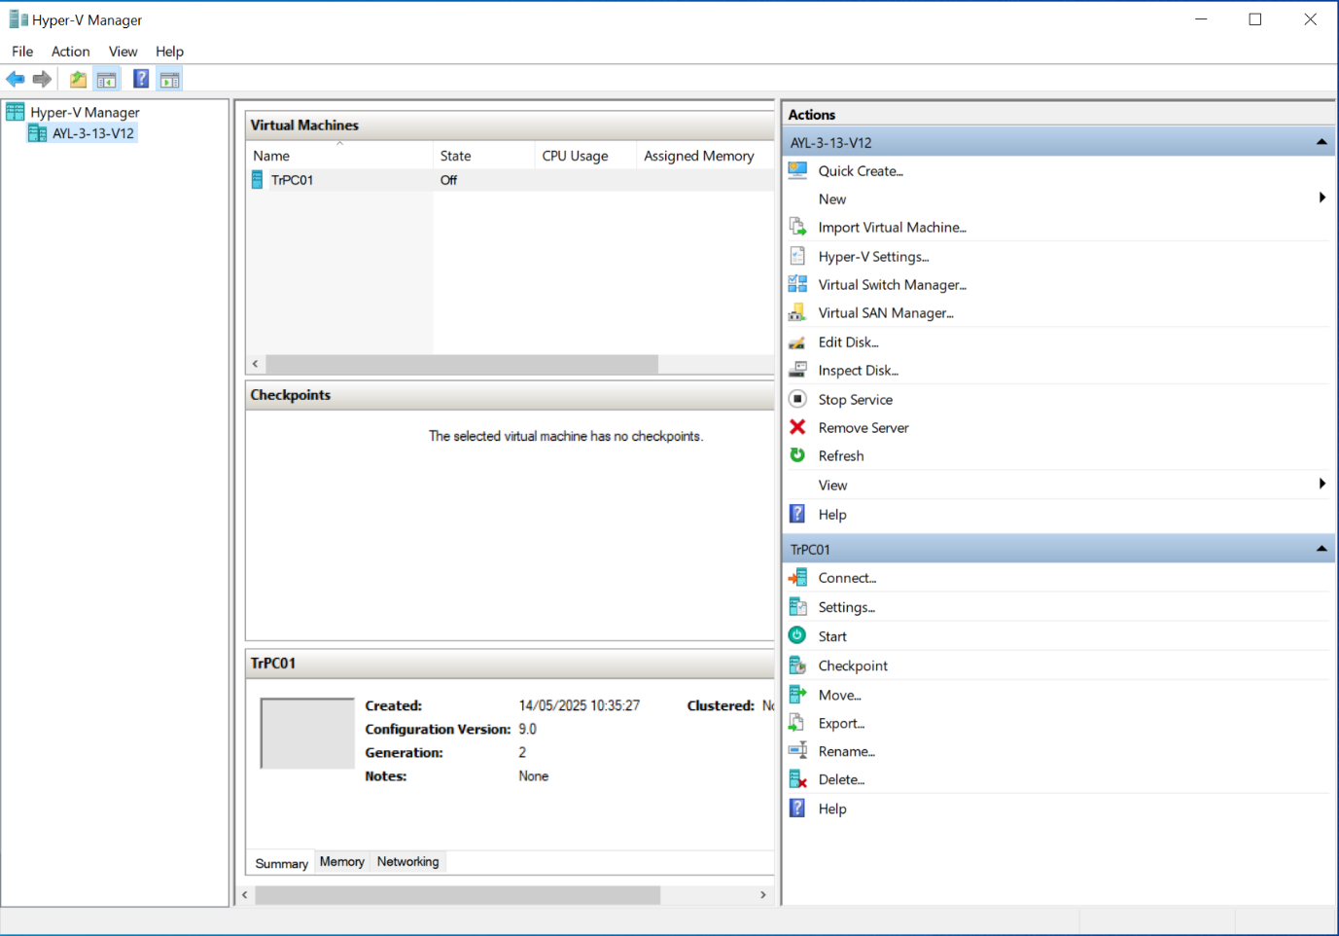

Feedback sheet
Learner being reviewed: __________________________
Reviewer name: __________________________
Date: __________________________

Aspect | Yes/No/Partially | Comments
The VM was created successfully and is operational. | ☐ Yes  ☐ No  ☐ Partially
Correct configuration settings were used (RAM, storage, OS version, etc.). | ☐ Yes  ☐ No  ☐ Partially
The VM boots without errors and shows a desktop environment. | ☐ Yes  ☐ No  ☐ Partially
The set-up process followed the activity instructions accurately. | ☐ Yes  ☐ No  ☐ Partially
The VM is labelled or named clearly and appropriately. | ☐ Yes  ☐ No  ☐ Partially
Any issues during installation were recorded or explained. | ☐ Yes  ☐ No  ☐ Partially

What worked well?
(Write one short comment about something your peer did well.)

What could be improved?
(Write one constructive suggestion to improve the VM set-up.)


FUNDED BY

This programme is funded by the Department for Education

Buckinghamshire College Group has produced this resource on behalf of the Education and Training Foundation

