Education for Sustainable Development (ESD)

Curriculum Audit for ESOL Practitioners

A tool to identify how ESD is already incorporated into the ESOL curriculum, as well as identify further opportunities to embed ESD.

DELIVERED BY | 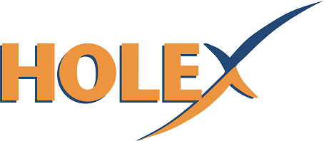 | DEVELOPED BY | 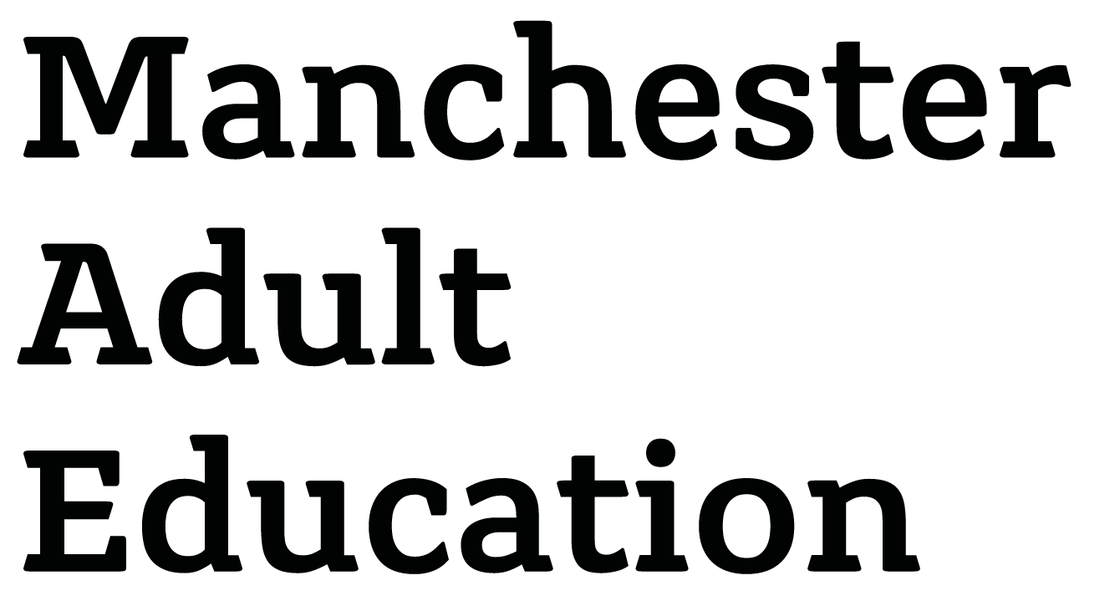

CONTENTS 1
FOREWORD 2
ABOUT THE CURRICULUM AUDIT TOOL 3
Audience 3
Purpose 3
Structure of the audit tool 3
Suggested process 3
Step one: learning about the goals 3
Step two: identifying what you already do 4
Step three: identifying what you could start doing 4
Step four: developing a plan of action 4
EDUCATION FOR SUSTAINABILITY CURRICULUM AUDIT 5
EDUCATION FOR SUSTAINABILITY ACTION PLAN 10

FOREWORD
This audit tool has been developed by Manchester Adult Education Service as part of a project commissioned by the Education and Training Foundation and delivered by HOLEX to identify effective practice and develop resources around Education for Sustainable Development in ESOL.

Education for Sustainable Development is defined by UNESCO as:

“[empowering] learners with knowledge, skills, values and attitudes to take informed decisions and make responsible actions for environmental integrity, economic viability and a just society.

Education for Sustainable Development is a lifelong learning process and is an integral part of quality education.”

In recognition that many ESOL practitioners already incorporate opportunities for learners to further develop their understanding of sustainability, including environmental, social and economic issues, this audit tool will enable ESOL leads to work with practitioners to highlight and share existing effective practice and ideas, as well as identify opportunities for further development.
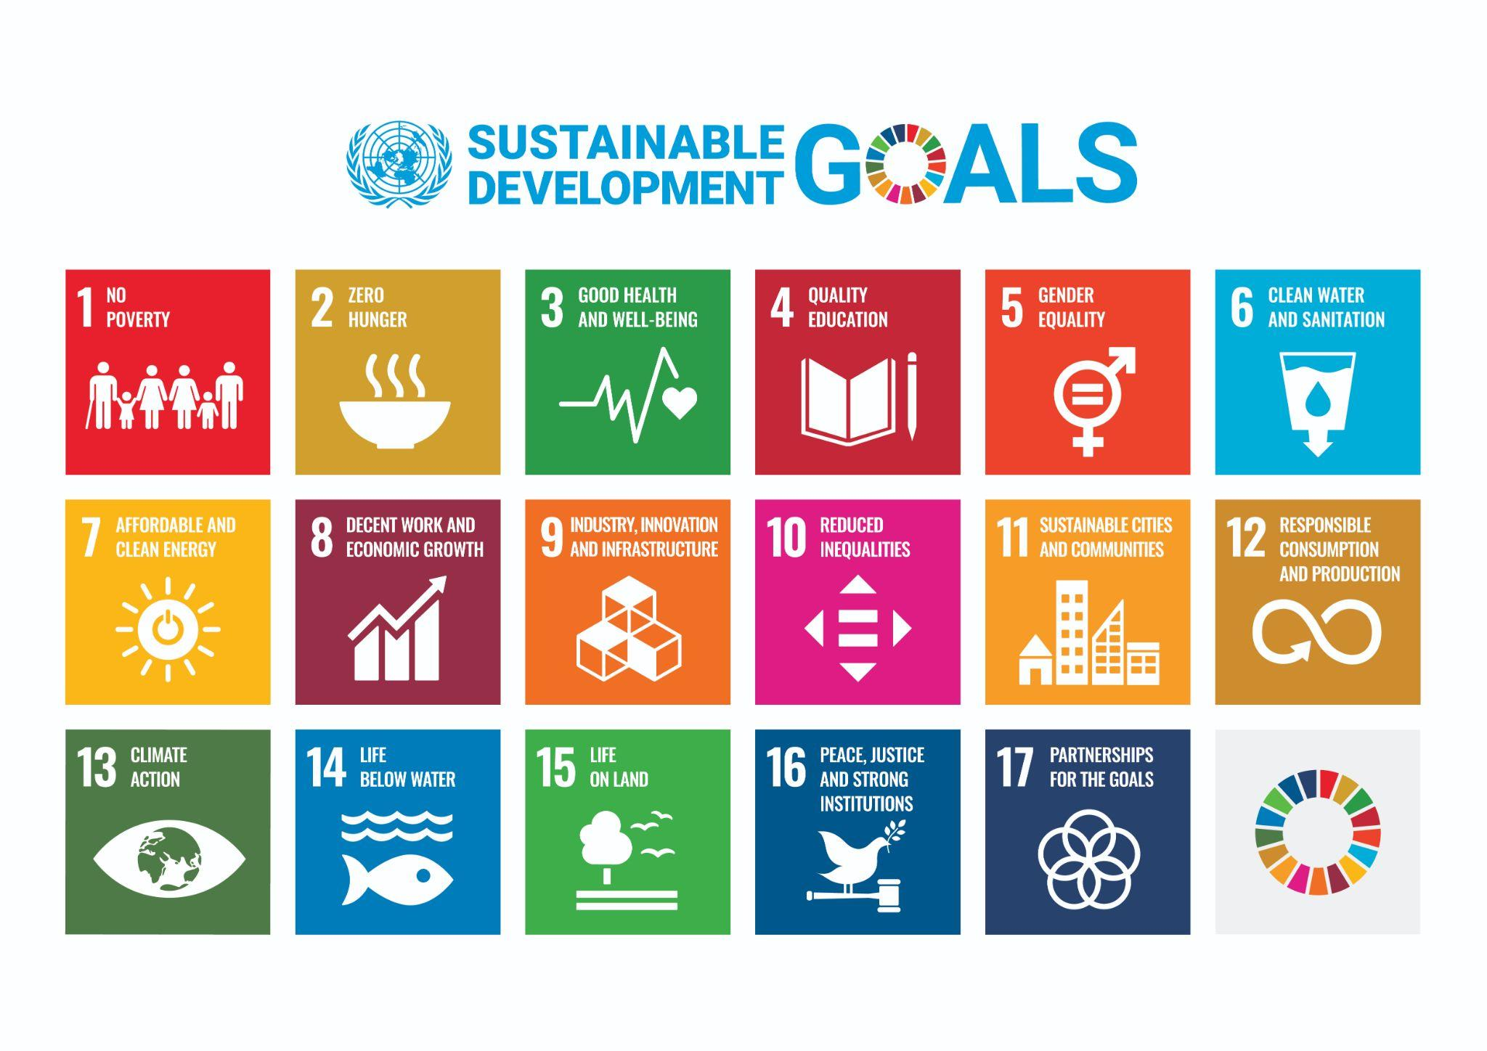
This tool is based on the United Nations’ Sustainable Development Goals.

The Goals are a universal call to action to end poverty, protect the planet and improve the lives and prospects of everyone, everywhere by 2030. The goals are interconnected and address the global challenges we face and identify the steps and actions needed to achieve them.

“For the goals to be reached, everyone needs to do their part: governments, the private sector, civil society and people like you.”
United Nations, 2015

Find out more about the United Nations’ Sustainable Development Goals.

ABOUT THE CURRICULUM AUDIT TOOL

Audience
This audit tool has been developed for ESOL leads to engage their ESOL teams in a professional dialogue on embedding education for sustainable development in ESOL provision.

Purpose
Using the Sustainable Development Goals as an entry point, this tool will help you to identify what you already do in terms of education for sustainable development (ESD) with learners, as well as identify further opportunities to integrate ESD in the curriculum.

By carrying out this audit, you will become more aware of the Sustainable Development Goals and start to identify how you can integrate sustainability issues into the ESOL curriculum, supporting learners to further develop their skills, knowledge, attitudes and values to take informed decisions and responsible actions for environmental integrity, economic viability and a just society.

Structure of the audit tool
For each goal, there is:
- a short description and link to further information specific to the goal
- an area in which to record what you already do in relation to the goal
- an area in which you can record what you could include in your provision in relation to the goal.

As the goals are interconnected, there may be some repetition in the evidence for what you already do and ideas for future developments.

Suggested process

Step one: learning about the goals
Familiarise yourself with the Sustainable Development Goals. Here are some suggestions to get you started:

United Nations’ Sustainable Development Goals
The UN website introduces each goal and presents facts and figures, targets and links for each.

The Sustainable Development Goals by Yak
An e-booklet introducing the 17 Sustainable Development Goals simply and succinctly.

Act Now
Act Now is the UN’s campaign for individual action on climate change and sustainability, including a mobile app which supports users to “make the shift to a more sustainable lifestyle”.

Good Life Goals
The Good Life Goals lay out 85 ways people can support the Sustainable Development Goals.

SDG Planning Calendar
The UN’s SDG Planning Calendar identifies key events during the year that are related to the goals, like International Women’s Day, World Environment Day and Human Rights Day.

Step two: identifying what you already do
Reflect on your ESOL curriculum and identify what you already do in relation to the goals. Organise your evidence in the most appropriate way for you and your colleagues - for example, by course type and/or level. As the goals are interconnected, you may find you are doing something that addresses more than one goal.

Step three: identifying what you could start doing
Identify what you could start doing in relation to the goals. This might be building on existing practice or new initiatives, for example by offering discrete modules or a series of events or workshops relating to one or more of the goals or embed regular activities to raise awareness of and explore the sustainable development agenda. The Education and Training Foundation’s ESD webpage has a host of information to help further develop your professional practice in this area.

Here is an example for goal 3, Good Health and Well-Being:
Goals |  | What do we already do? | What else can we do?
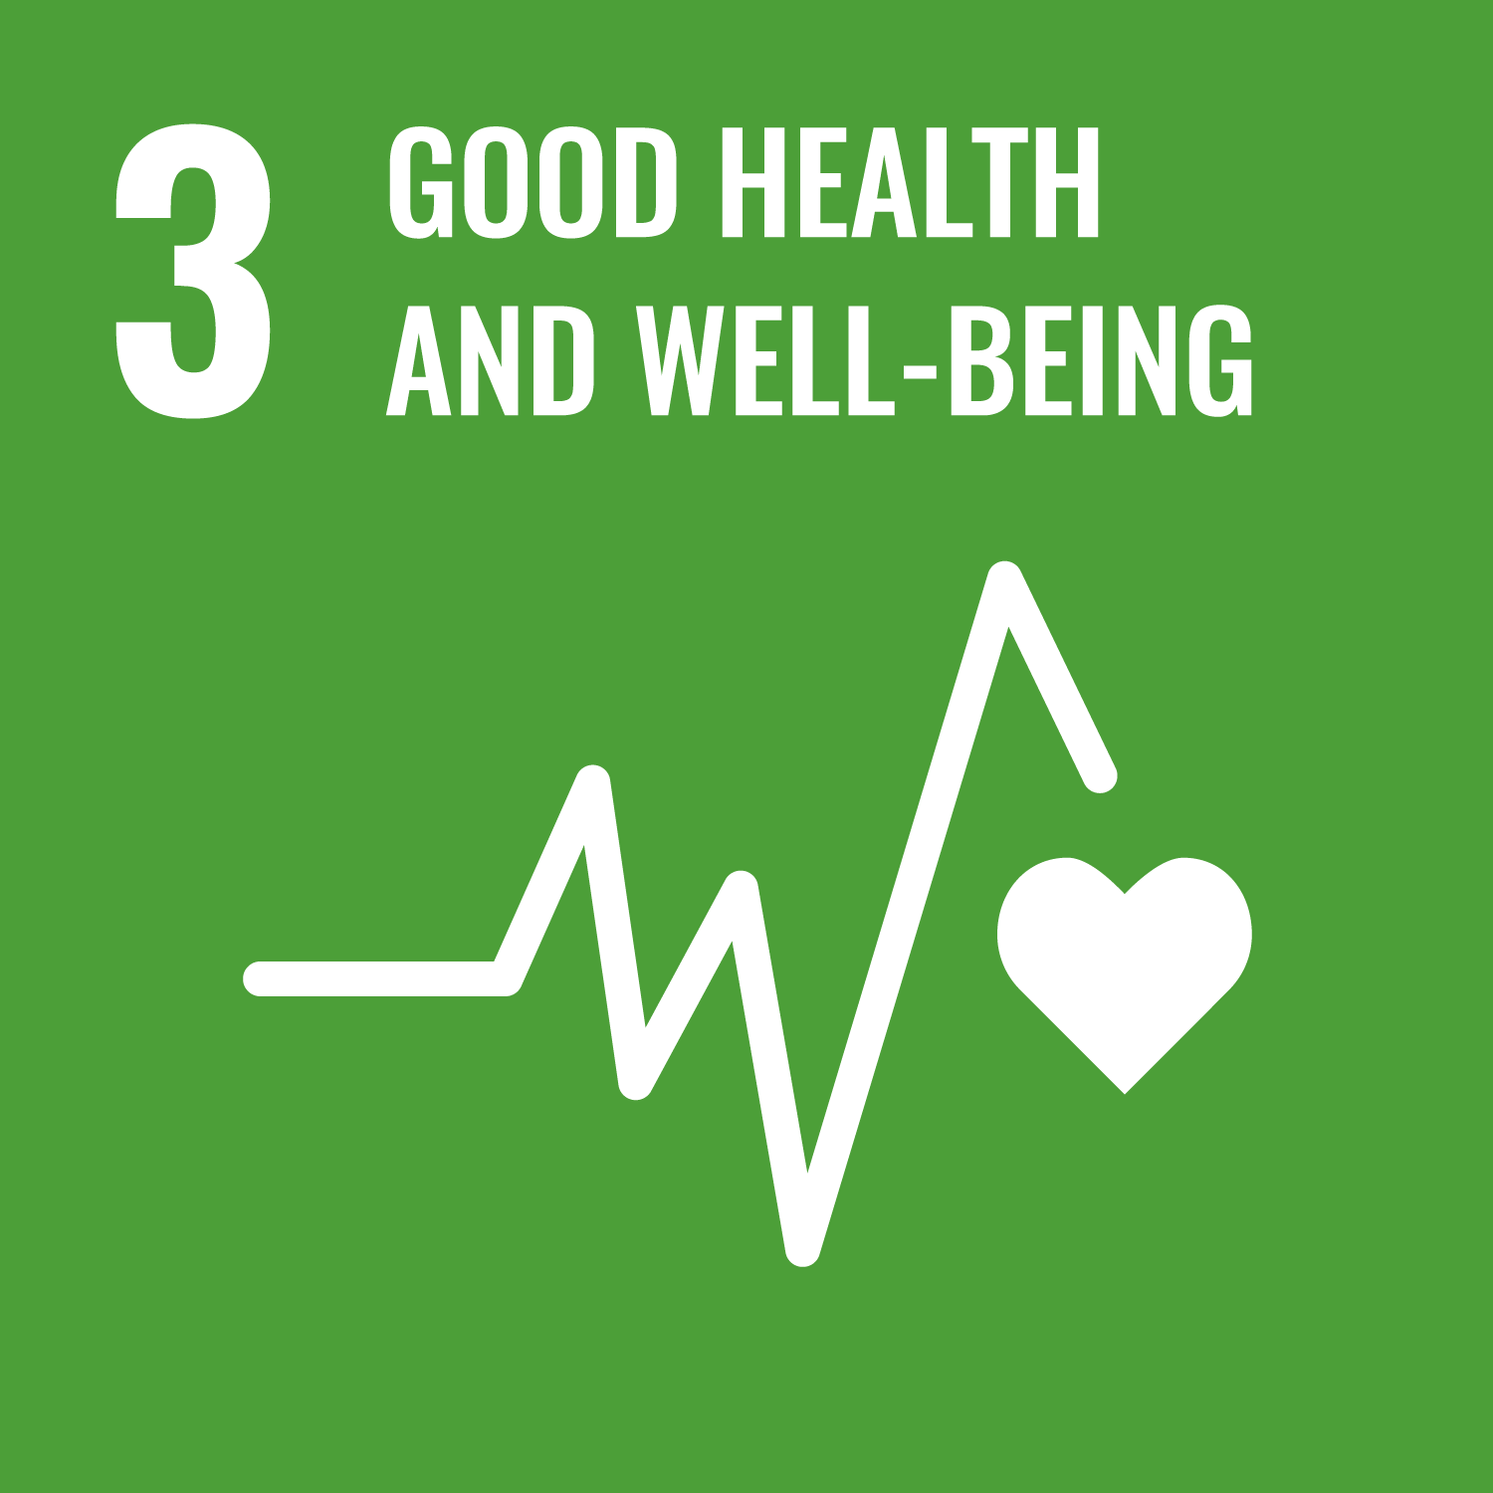 | 3 Good Health and Well-Being  Ensure healthy lives and promote well-being for all at all ages. | - Discrete modules on health at all levels covering functional language needed to access healthcare in the UK and lead healthier lives  - Embedding of the 5 ways to wellbeing in some courses  - Opportunities to participate in health walks for learners in some centres  - Visits from healthcare professionals arranged for some classes | - Review health modules to ensure that they are up to date and information and content is localised  - Share good practice in embedding the five ways to well-being for all learners.  - Widen opportunities for learners to participate in health walks in their local area  - Further develop partnerships with population health and the health and well-being service to widen access to services and information

Step four: developing a plan of action
Use the action plan to identify the actions you will take to highlight and develop education for sustainable development opportunities for learners.

EDUCATION FOR SUSTAINABILITY CURRICULUM AUDIT
Completed by |  | Completion date
Course(s) |  | Review date

Goals |  | What do we already do? | What else can we do?
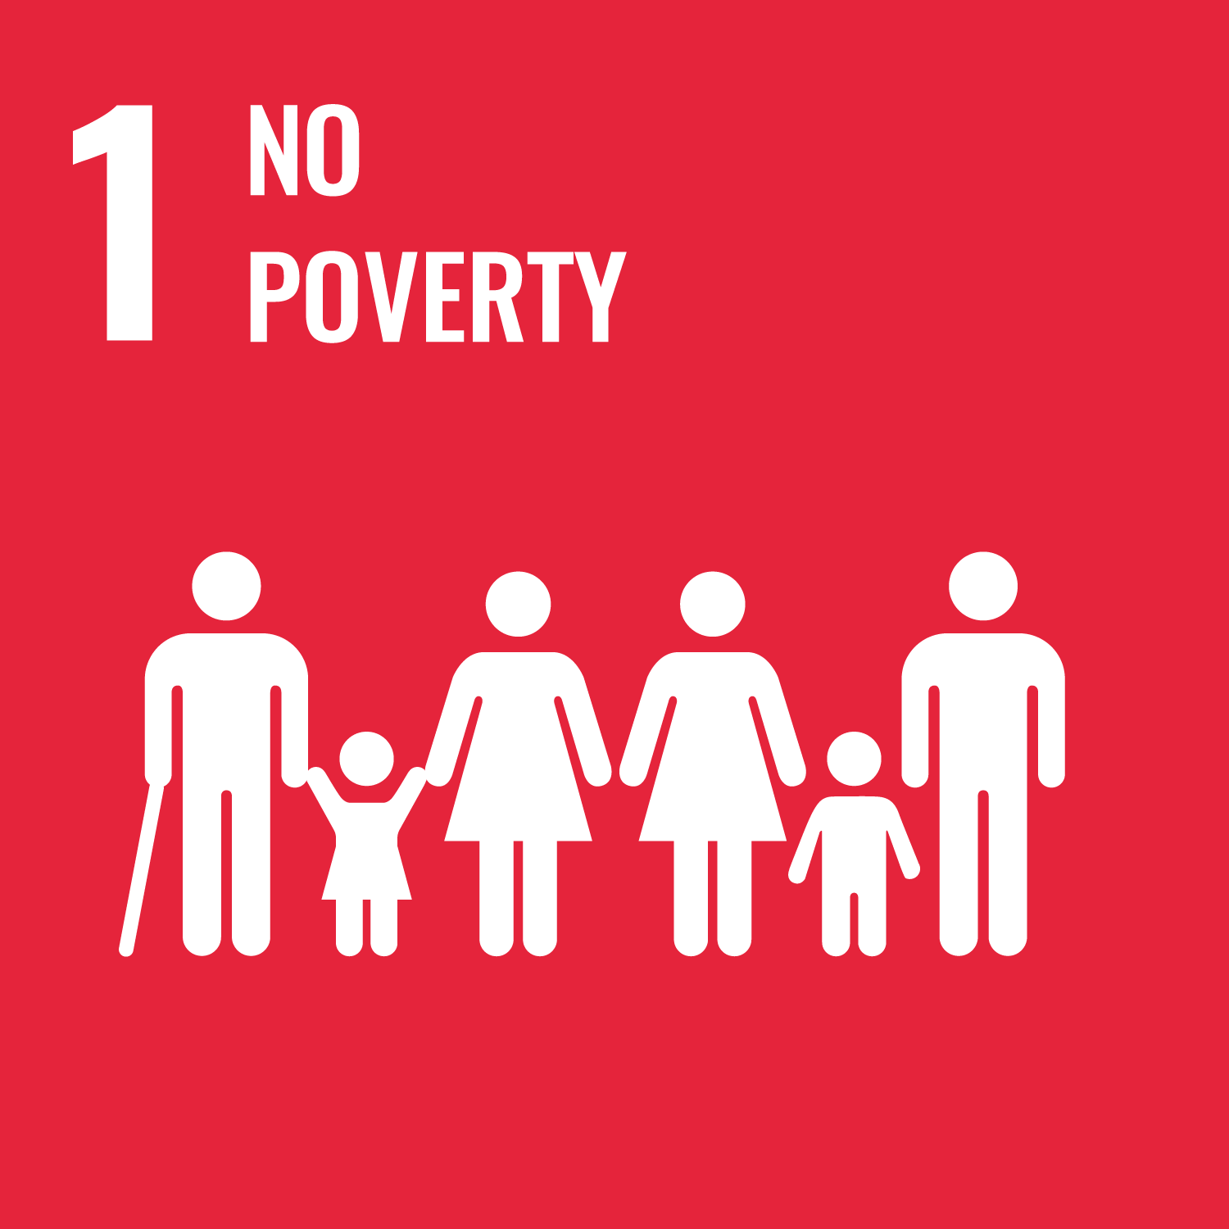 | 1 No Poverty  Ensure everyone has access to food, shelter clothing, healthcare and education so they can fully participate in society.
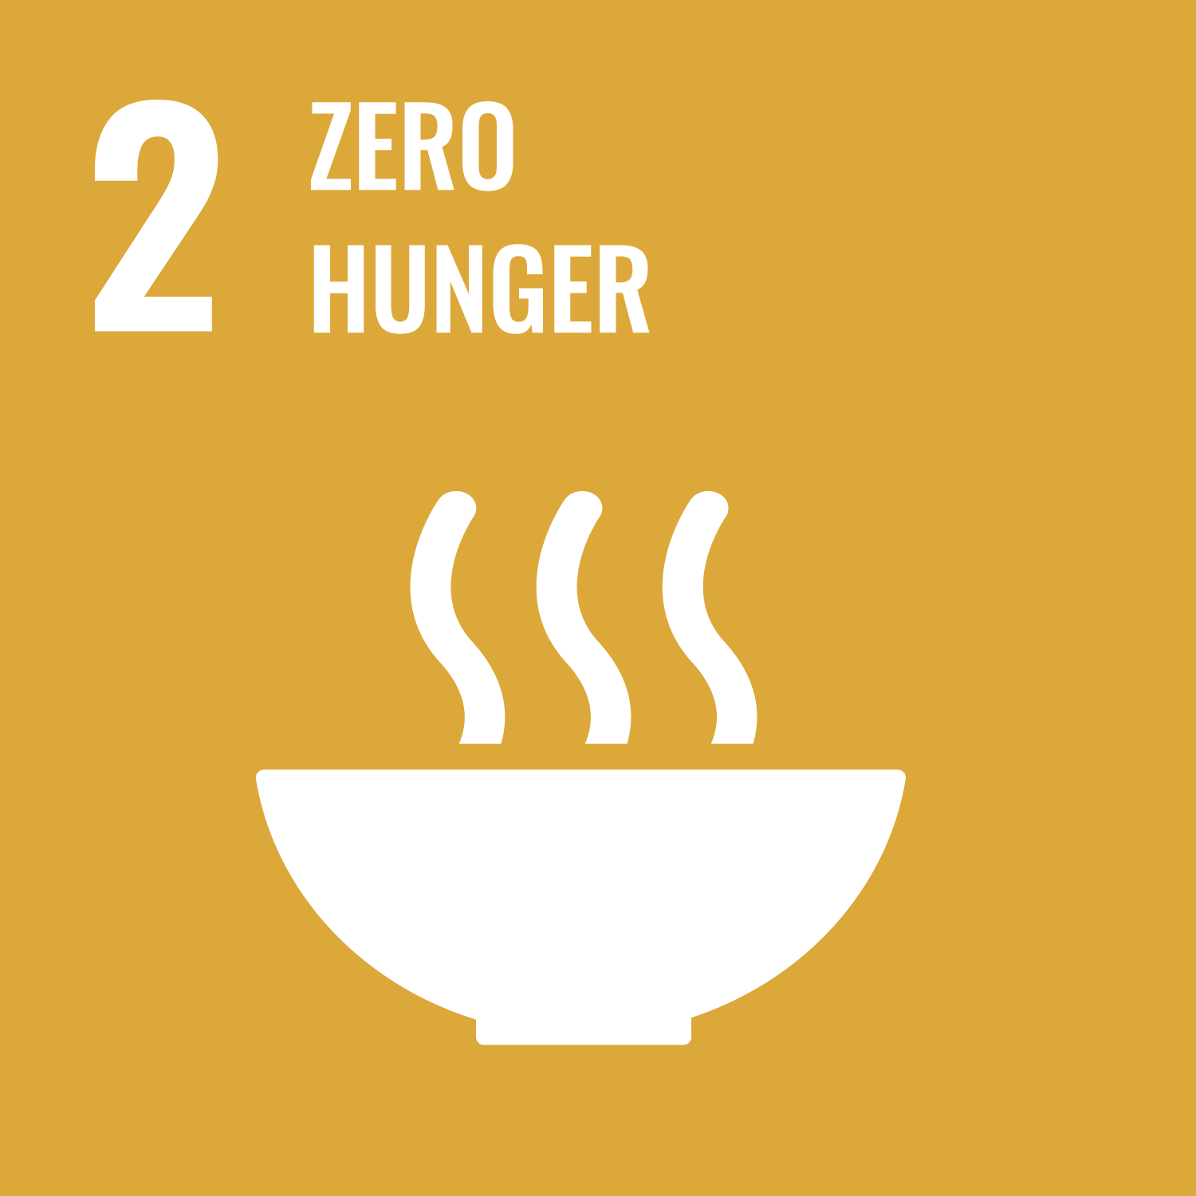 | 2 Zero Hunger  Address poor agricultural practices, food waste and environment degradation to ensure no one goes hungry.
3 Good Health and Well-Being
Ensure healthy lives and promote well-being for all at all ages.
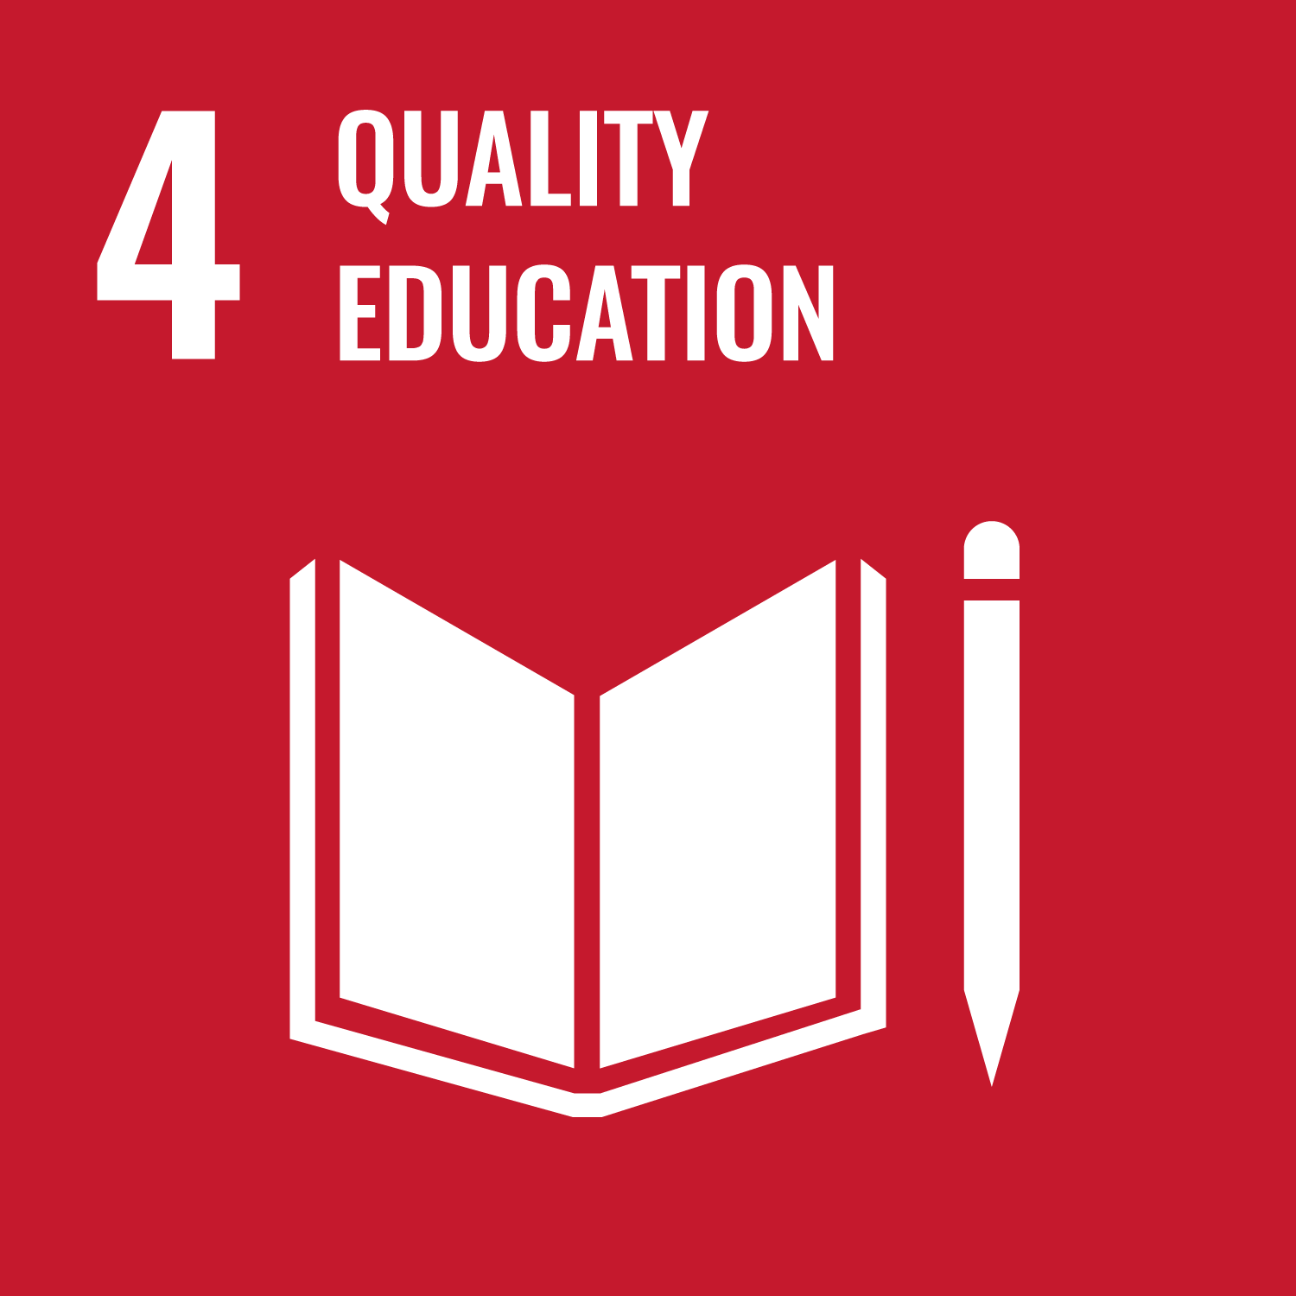 | 4 Quality Education  Ensure inclusive and quality education for all and promote lifelong learning for everyone, no matter who they are or where they are.
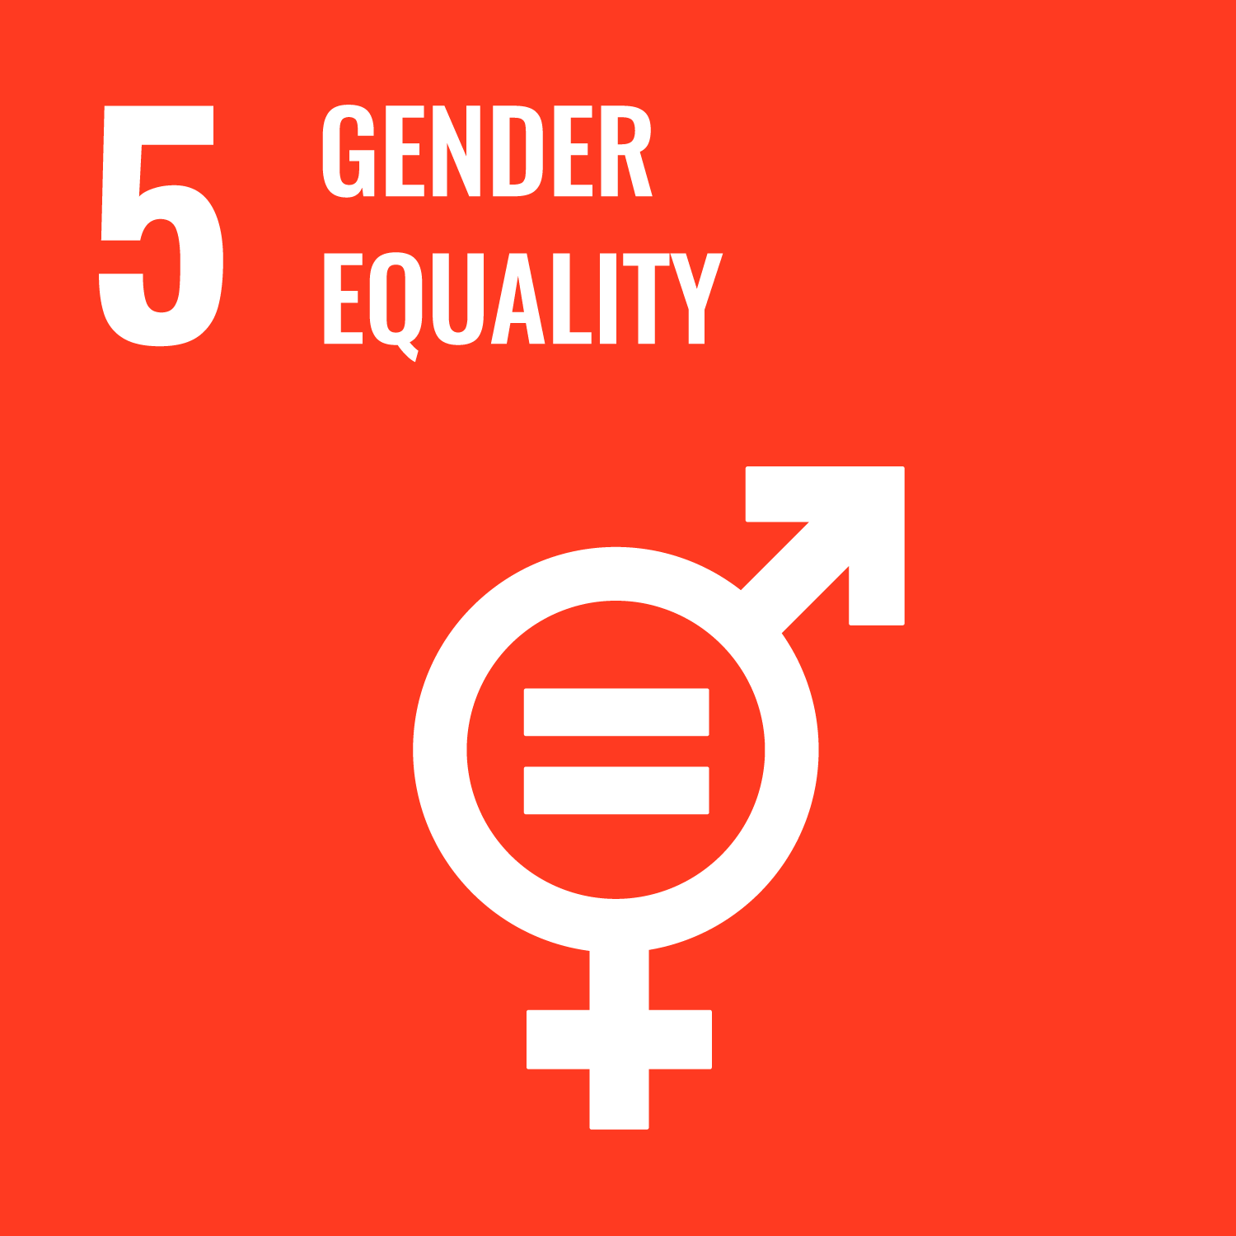 | 5 Gender Equality  Ensure equal access to education, health care and decent work for women and girls. End discrimination and violence against women and girls everywhere.
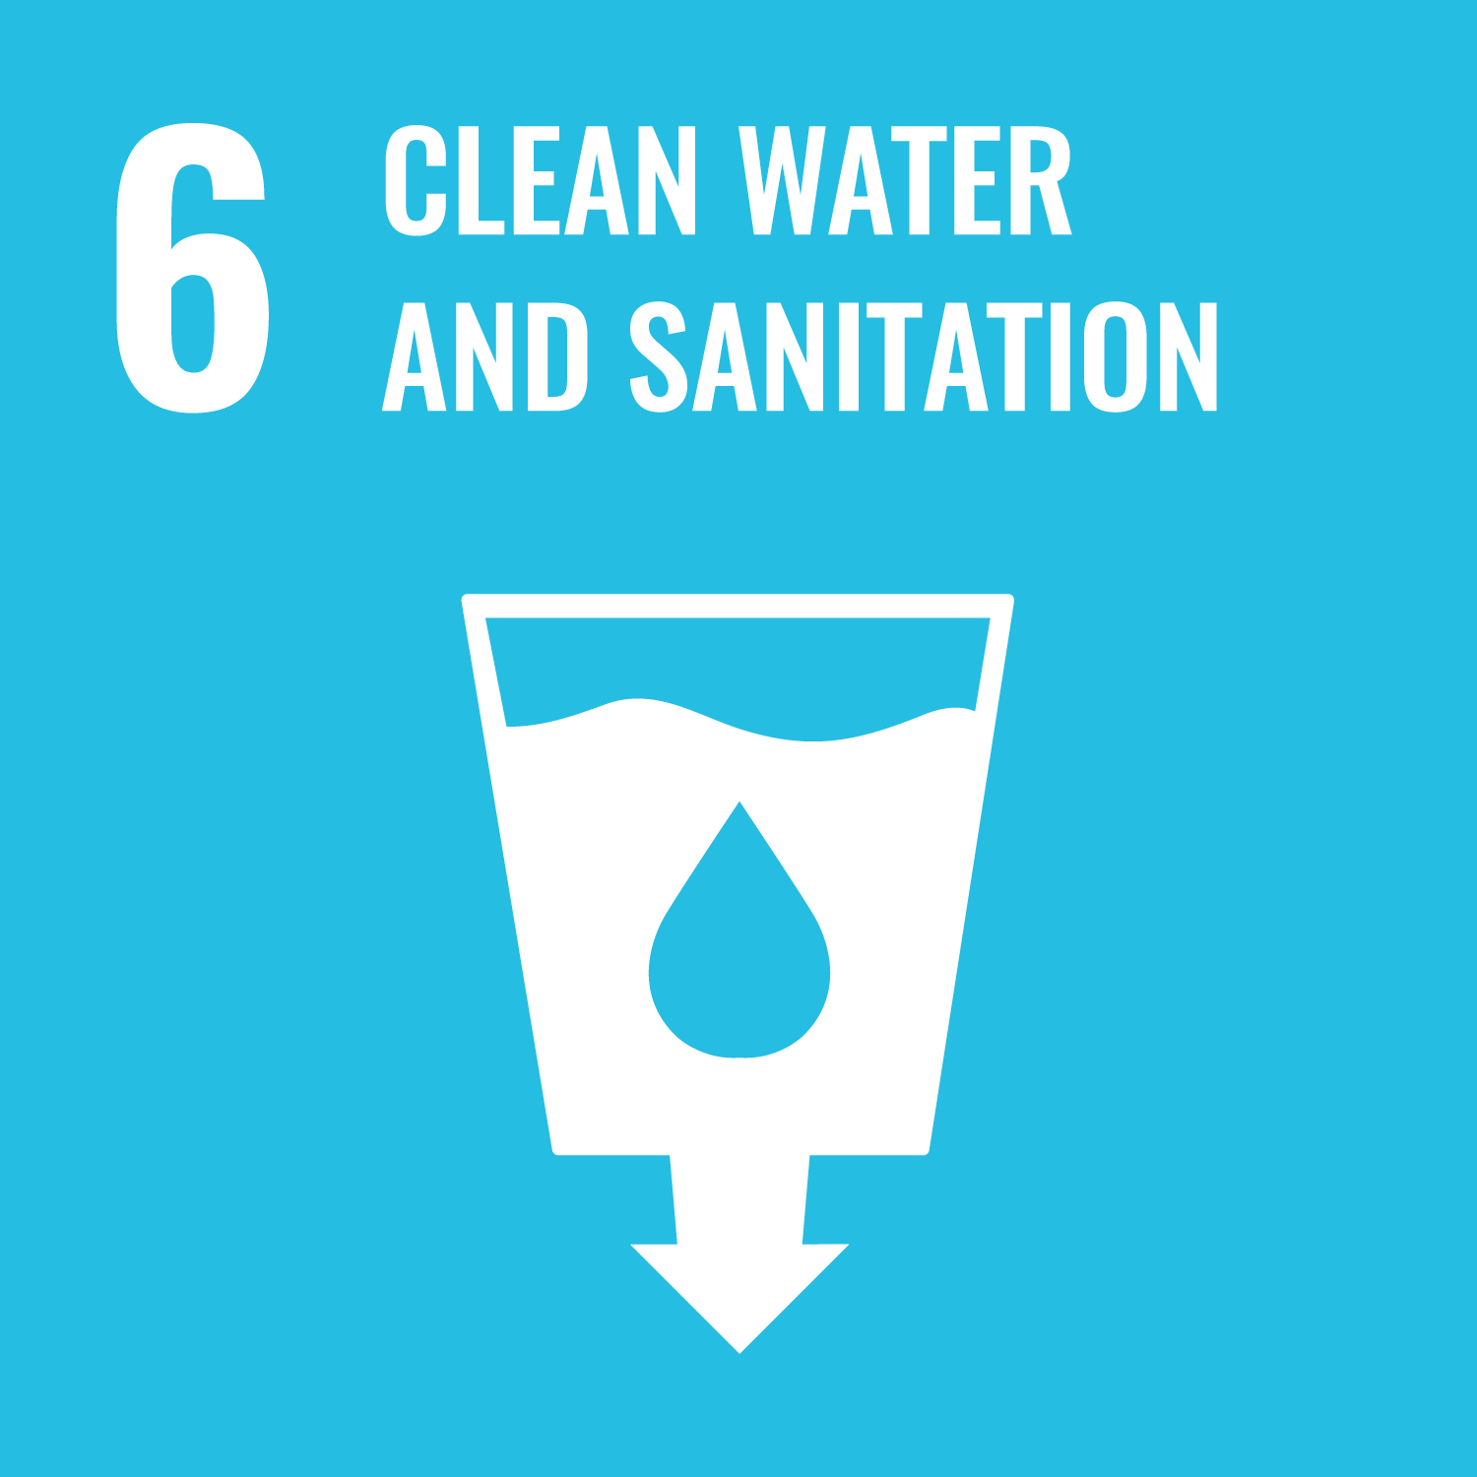 | 6 Clean Water and Sanitation  Ensure access to clean water and toilets for everyone. Value, protect and restore sources of water.
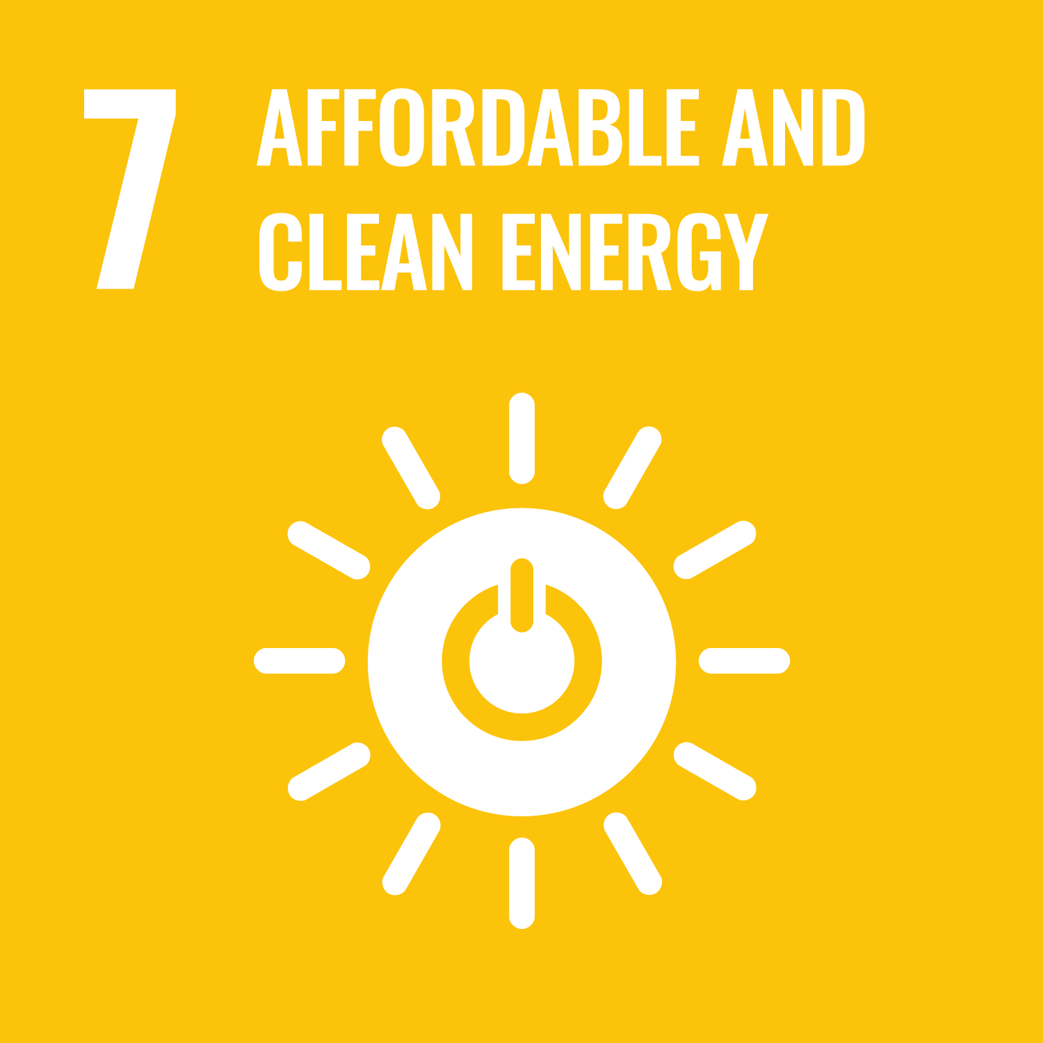 | 7 Affordable and Clean Energy  Enable everyone to access affordable, reliable, sustainable and modern energy that is clean and renewable.
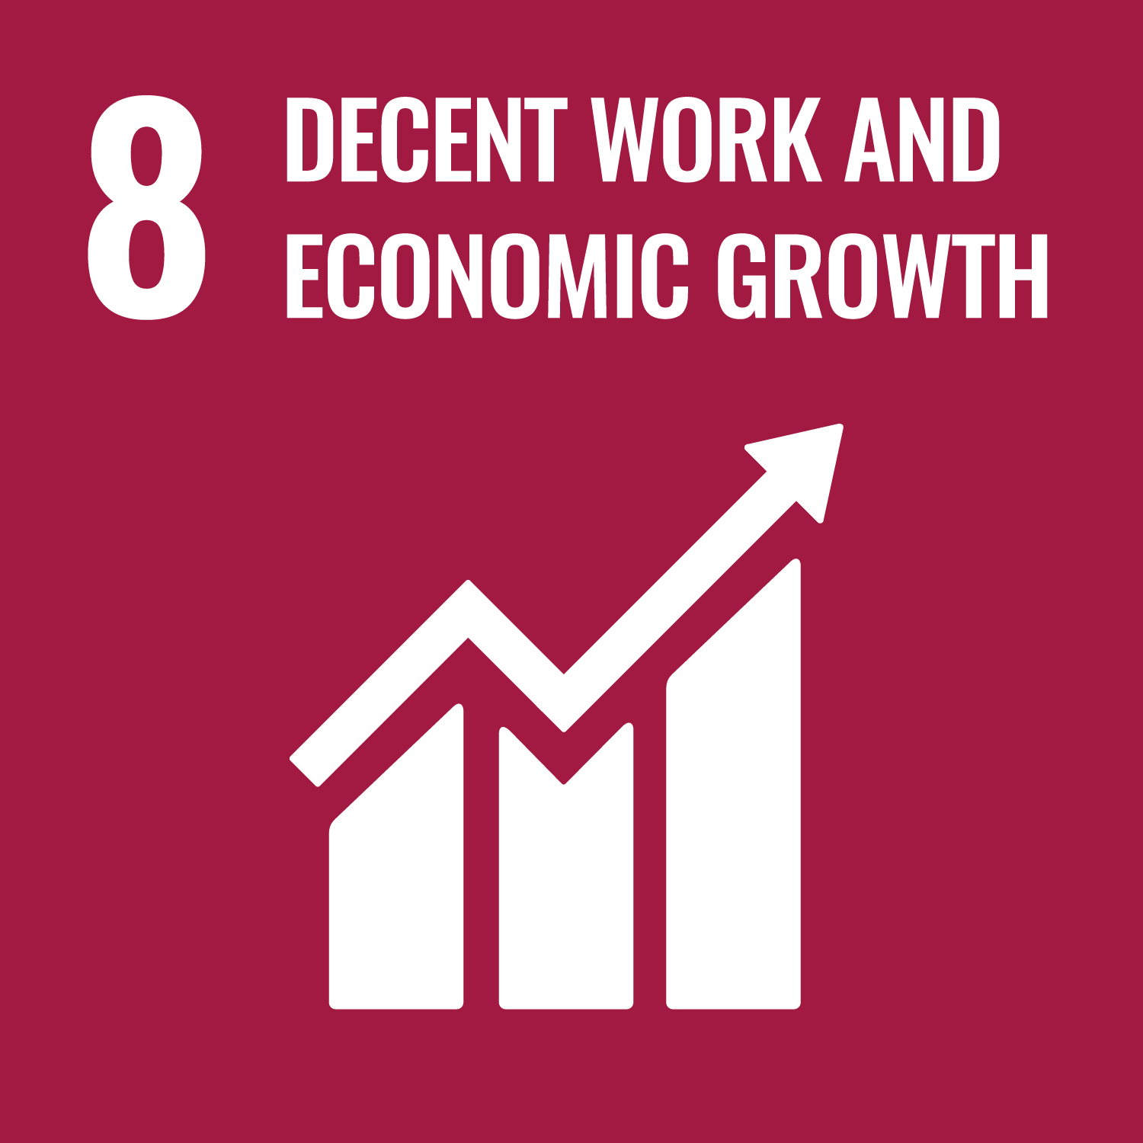 | 8 Decent Work and Economic Growth  Promote inclusive and sustainable economic growth and create employment opportunities and decent work for all.
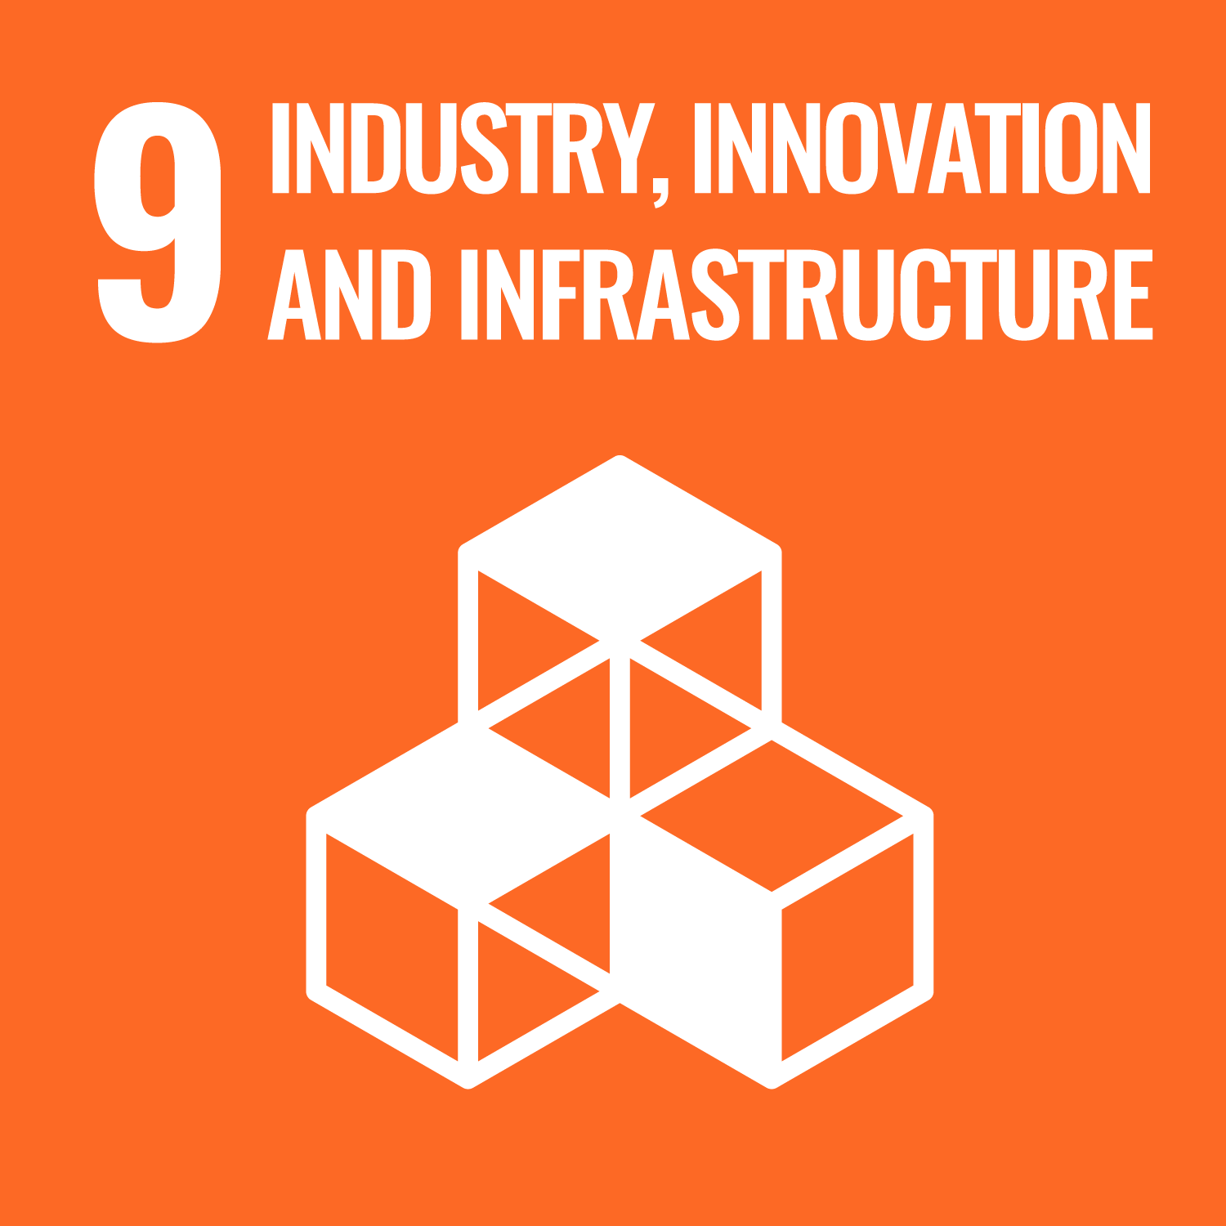 | 9 Industry, Innovation and Infrastructure  Encourage industries that bring opportunities to everyone while protecting the environment, supported by resilient infrastructure such as reliable transport and technological innovation.
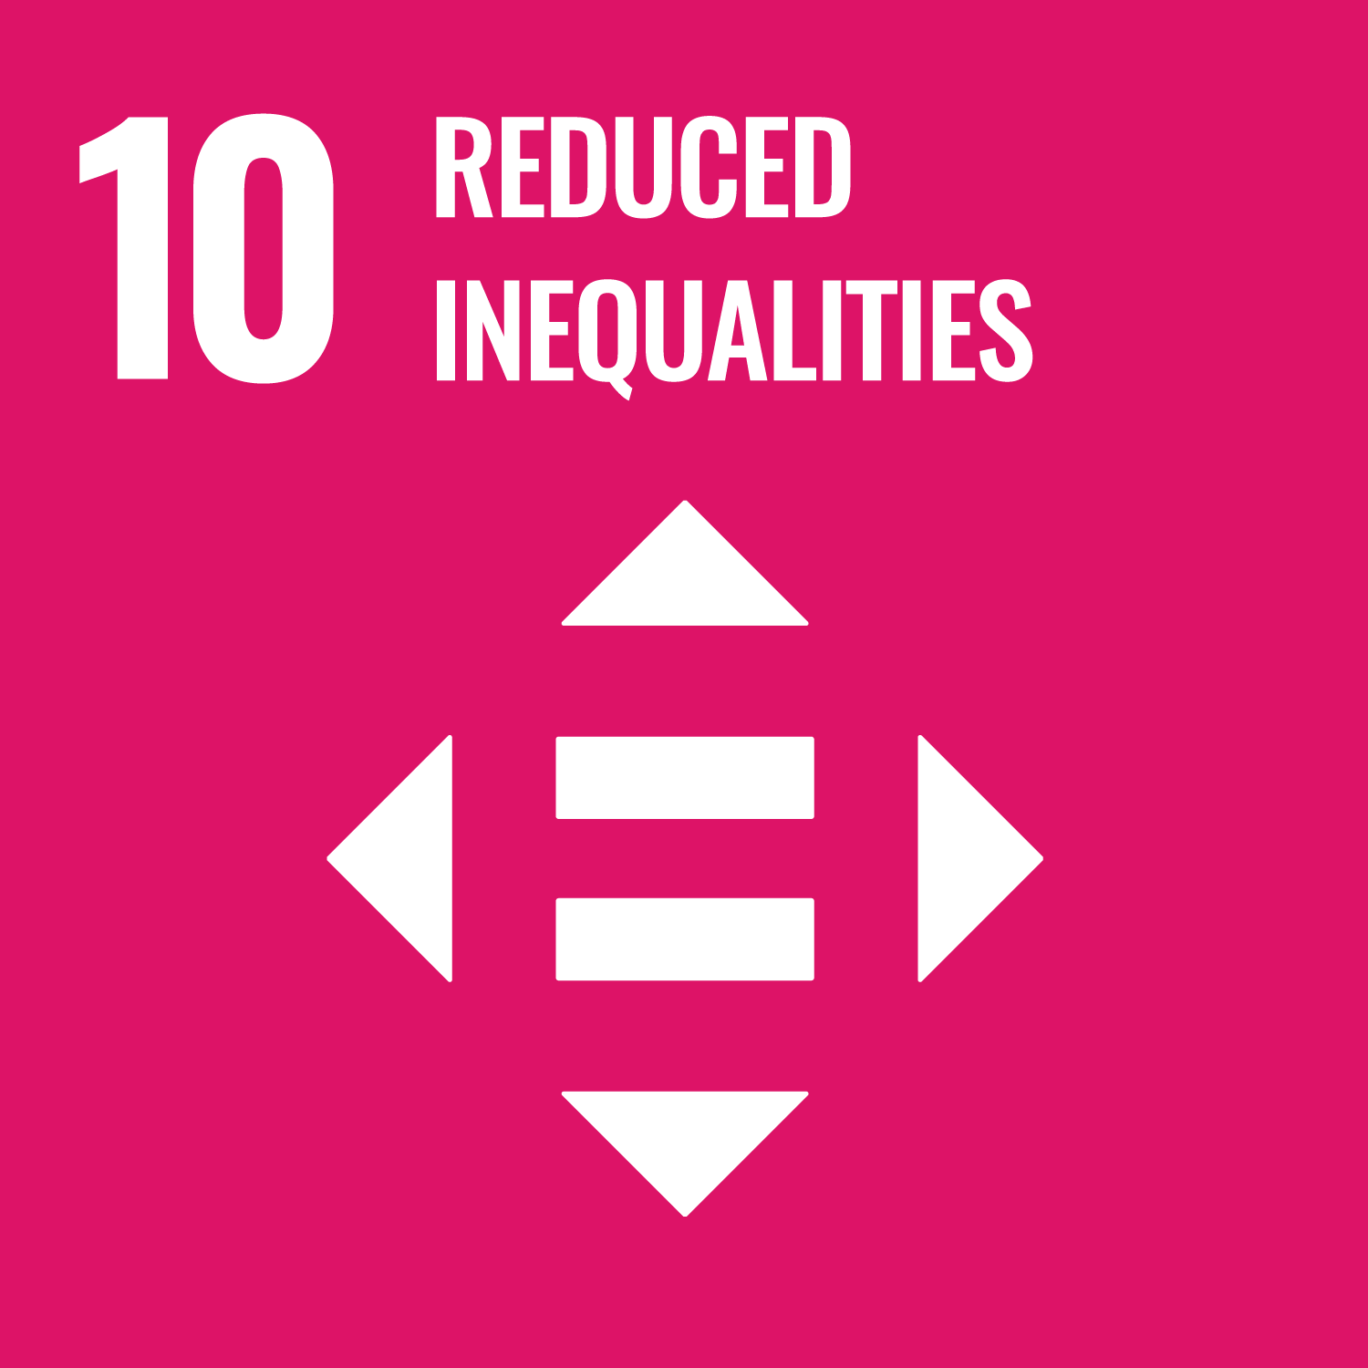 | 10 Reduced Inequalities  Reduce inequalities between rich and poor people and countries and make sure that everyone everywhere has a chance to live a healthy and happy life.
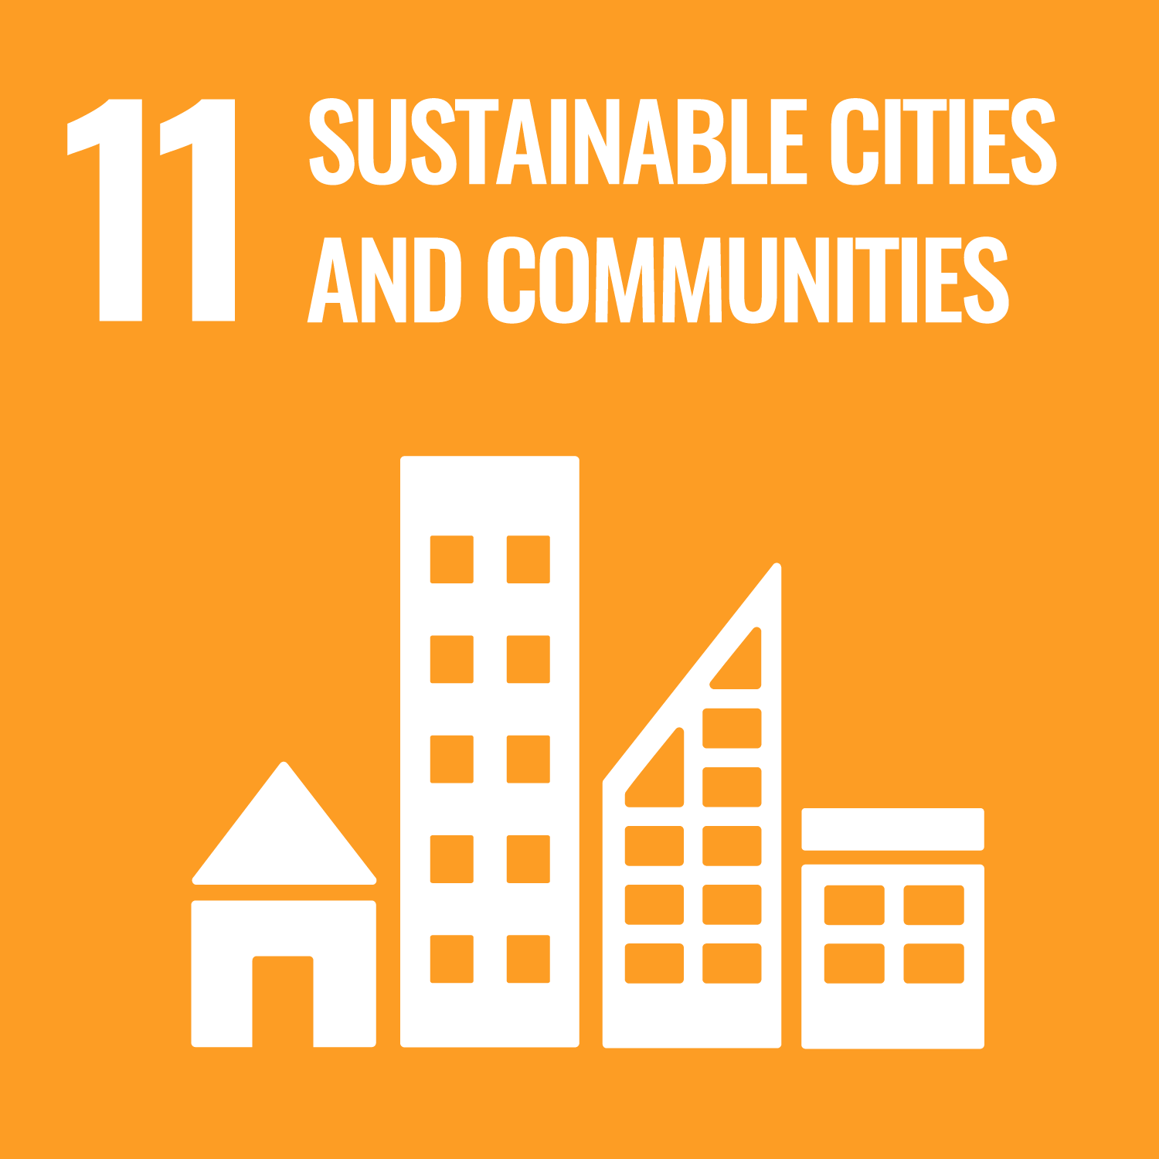 | 11 Sustainable Cities and Communities  Ensure cities and communities are clean, safe and sustainable, with good housing and services, as well as clean transport systems and green spaces for everyone.
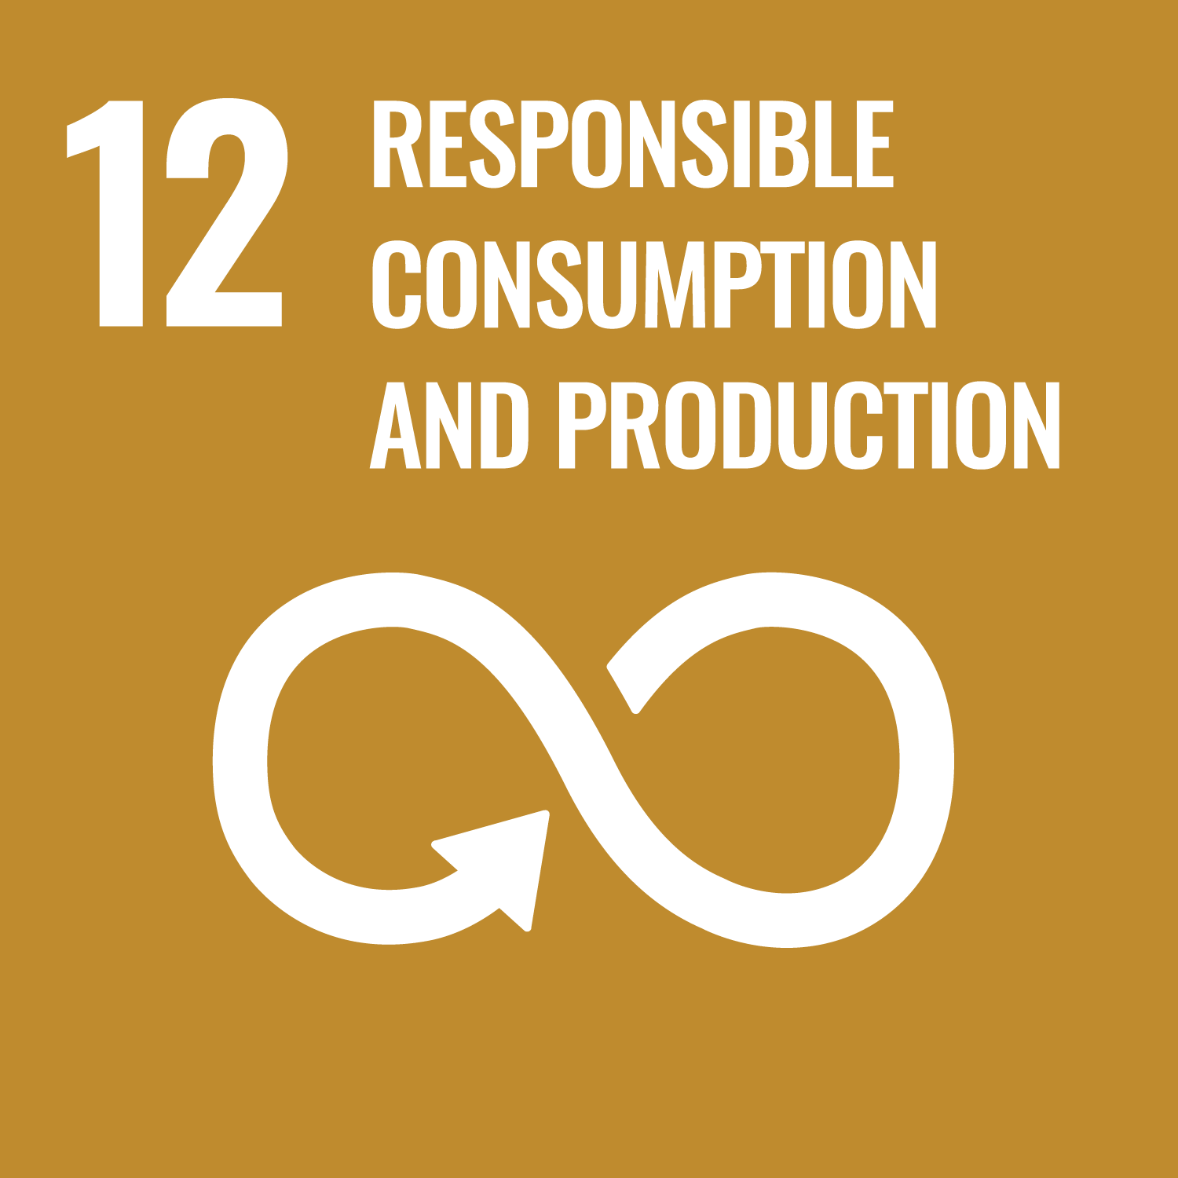 | 12 Responsible Consumption and Production  Encourage individuals, companies and governments to think about the things we produce and use and the waste we create in order to take more sustainable actions and reduce the impact on the planet.
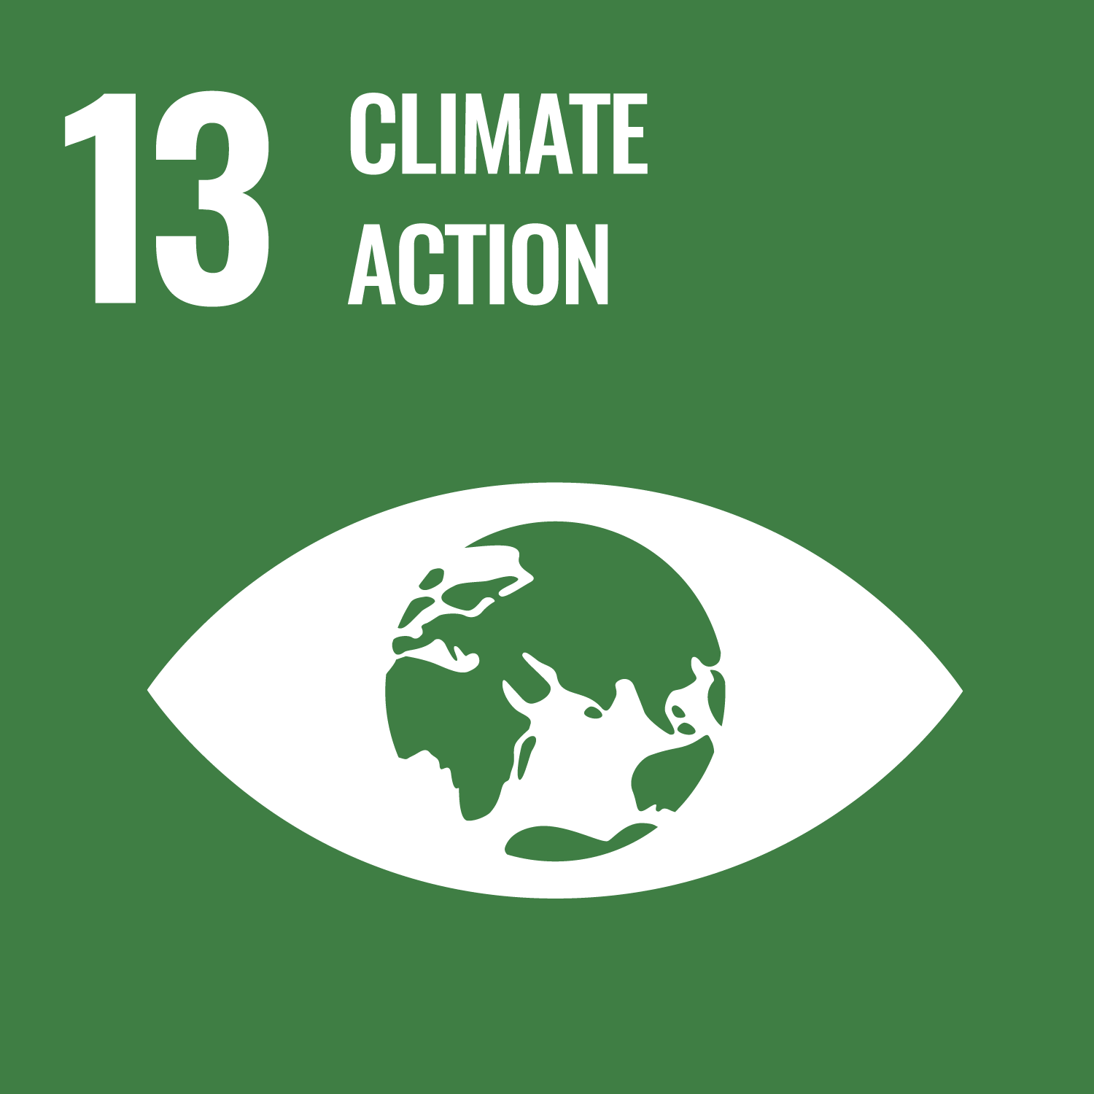 | 13 Climate Action  Take urgent action to combat climate change and change its impact.
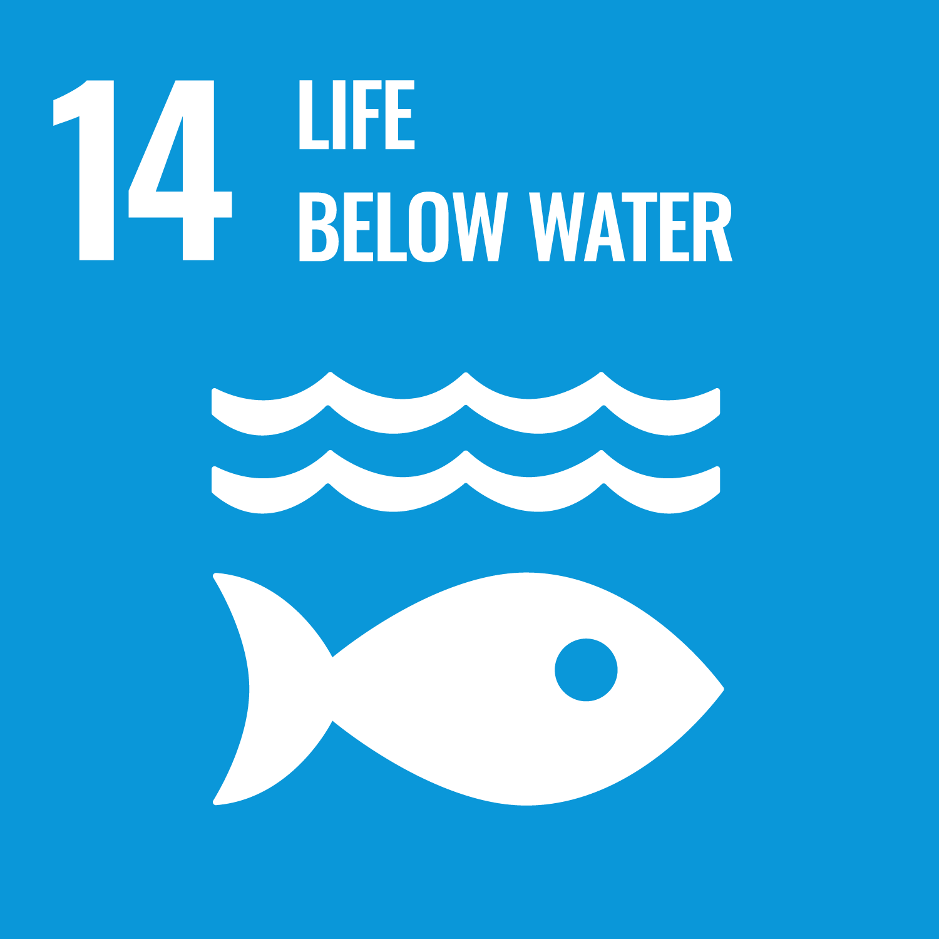 | 14 Life Below Water  Conserve and sustainably use the oceans, seas and marine resources.
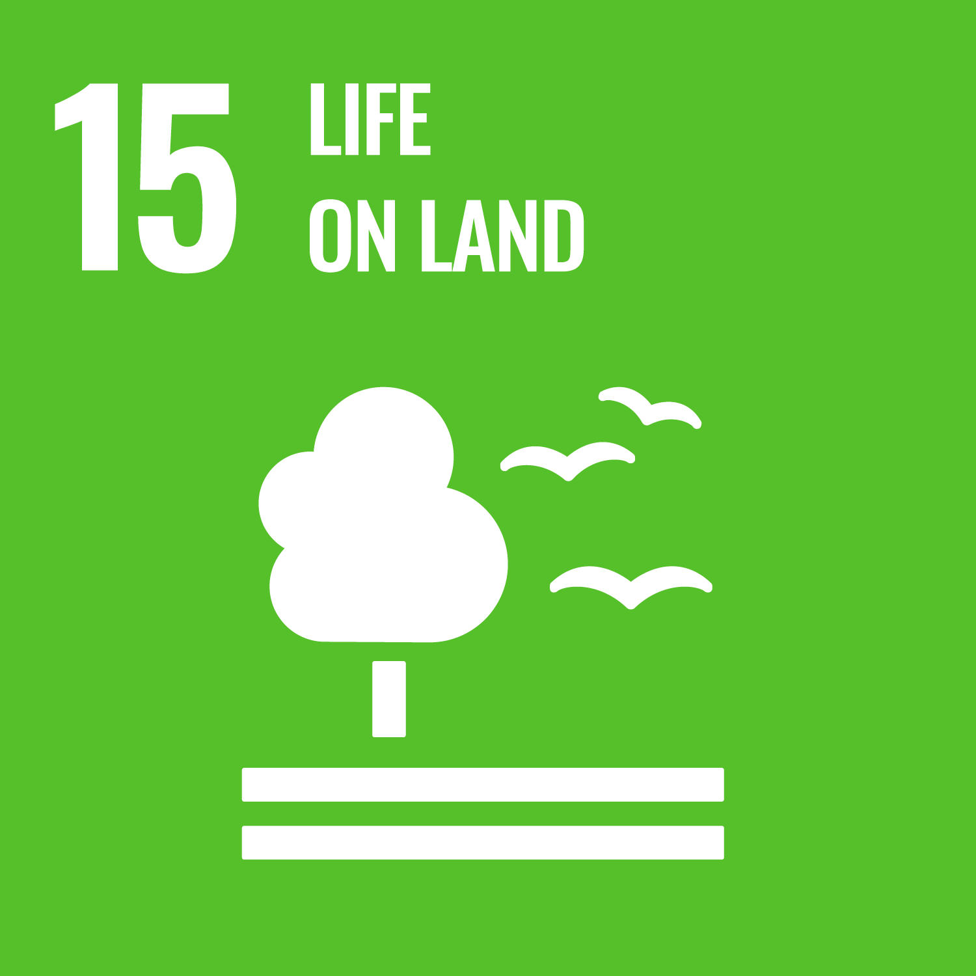 | 15 Life on Land  Stop activities that threaten our global home, including deforestation, land degradation and loss of animal and plant species.
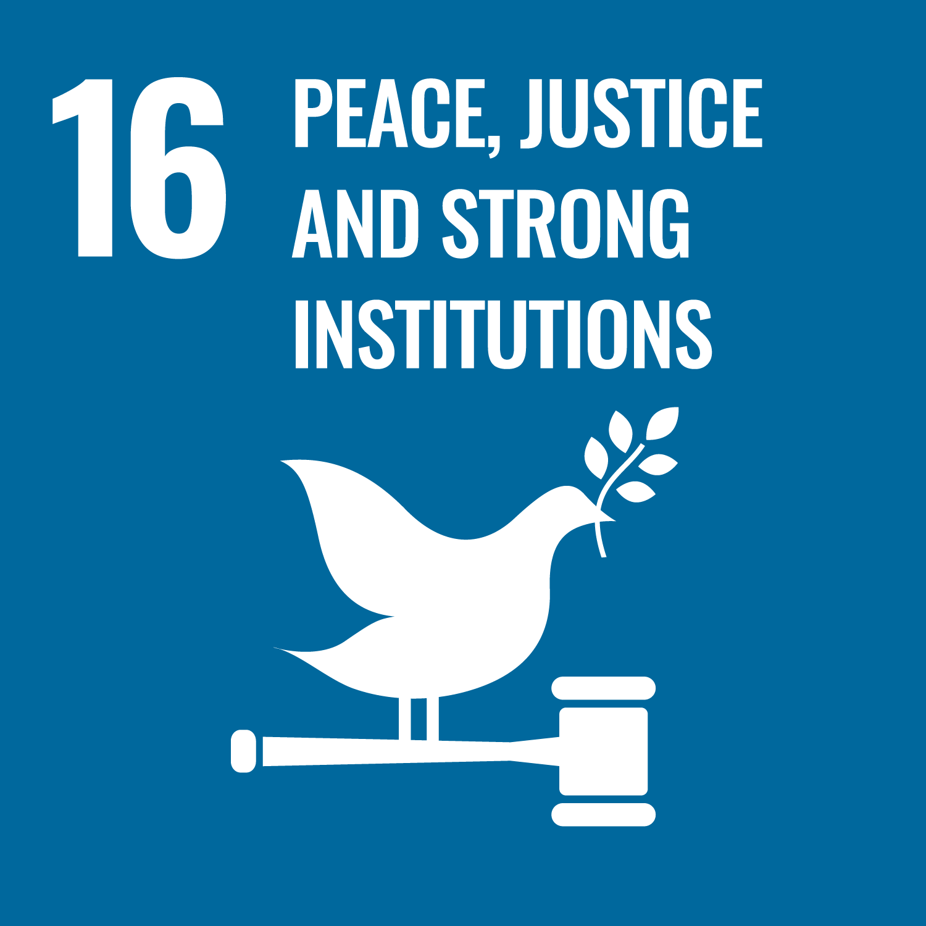 | 16 Peace, Justice and Strong Institutions  Ensure that everyone can live in a peaceful society, where they can have access to justice and don’t have to live in fear. Encourage everyone to participate in the public life of their countries.
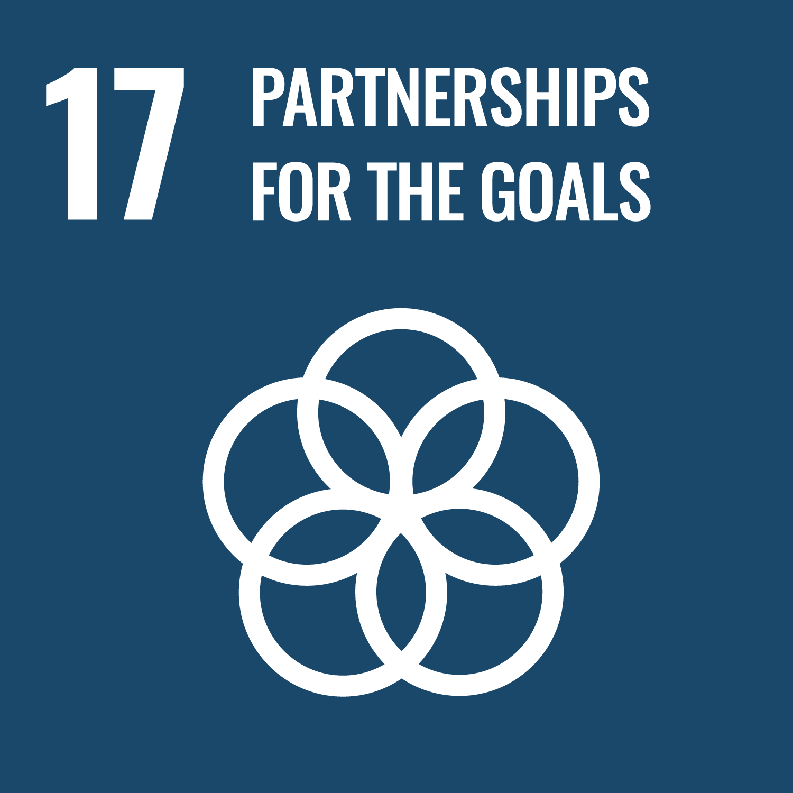 | 17 Partnerships for the Goals  Encourage governments, the private sector, civil society and individuals to work together to reach the goals.

EDUCATION FOR SUSTAINABILITY ACTION PLAN
Use this action plan to identify the actions you will take to highlight and develop education for sustainable development opportunities for learners.

Action | Relevant goals | By who | By when | Expected impact | Review and reflections
Example: Update SoWs to identify where we embed sustainable development. | All goals | A Teacher | Dec 2021 | Build staff and learner awareness of ESD

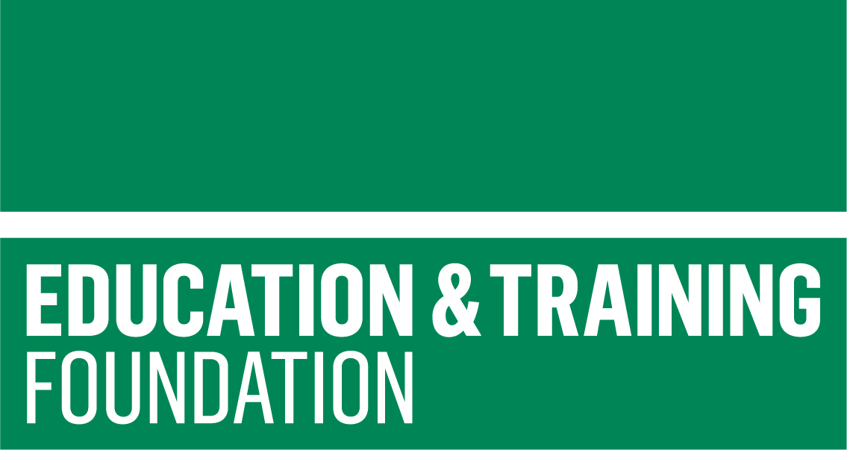

DELIVERED BY | DEVELOPED BY |  | FUNDED BY
 |  |  | 