
Education for Sustainable Development:
ESOL Resources
A Green Week event toolkit for organisations to plan and organise their own sustainability events or activities for ESOL learners




contents
contents 1
FOREWORD 2
How TO USE THE TOOLKIT 3
Partner Mapping guide 4
LOCAL AUTHORITIES 4
LONDON BASED ORGANISATIONS 5
UK BASED ORGANISATIONS 6
INTERNATIONAL ORGANISATIONS 7
APPS AND SEARCH ENGINES 7
resources 8
LESSON OVERVIEW: AIR POLLUTION 8
Appendix 1: Causes and effect cut up cards 10
Appendix 2: Effects of air pollution cut up cards 11
Appendix 3: Causes of indoor air pollution cut up cards 12
LESSON OVERVIEW: FOOD WASTE 13
Appendix 1: Food Waste in Numbers 15
Appendix 2: “Too Good to Go” Quiz 16
LESSON OVERVIEW: REDUCING AND REUSING – FAST FASHION 17
LESSON OVERVIEW: PLASTIC POLLUTION 20
Workshop ideas 23
WORKSHOP OVERVIEW: MAKE YOUR OWN PRODUCTS 23
Appendix 1: Disclaimer example 26
Appendix 2: Template risk assessment 27
Appendix 3: Small vocabulary cards 30
Appendix 4: Poster cards 31
Appendix 5: Product carousel place cards 34
Appendix 6: Instructions for homemade bag and recipes 38
Workshop Ideas 45
WORKSHOP OVERVIEW: UPCYCLING 45
Appendix 1: Instructions for making a cushion cover 47
AcknowledGments 49

FOREWORD
Welcome to our Green Week event toolkit. This toolkit has been developed by Idea Store Learning at Tower Hamlets Council as part of a project commissioned by the Education and Training Foundation and delivered by HOLEX to identify effective practice and develop resources around Education for Sustainable Development in ESOL.
In this toolkit you will find ideas on how to hold your own large scale or small-scale sustainability event with learners in your organisation based on Tower Hamlets’ experiences of holding events over the past two years. Our Green Week video, available at www.youtube.com/watch?v=h4FHxrHZ3o4 provides inspiration.
Green Week came about after a discussion with the ESOL team about wanting to bring learners’ voices into the conversation about climate change and to start taking some positive action on issues that are affecting the learners in their local area.
The aims of Green Week were to:
- Enhance the knowledge of the public and our learners of recycling, climate change and pollution in the local area
- Encourage and support participants in adopting a green, sustainable lifestyle by employing knowledge gained during the week
- Record a pledge on our Green Week Tree exhibition
- Bring ESOL learners voices into conversations about the climate crisis and the efforts to mitigate it.
Workshops were held over the course of Green Week for English, Maths, ESOL and Employability learners. Tutors were encouraged to embed the theme of climate change into their lessons with the help of English for Action who provided invaluable support with adapting resources, making them accessible to learners whose first language is not English.
The week ended with a large-scale event initially in store and then online the following year.
There were guest speakers and stall holders from external organisations along with various council departments, all brought together in one place to provide information to local residents. This included information regarding sustainability, recycling, composting, sustainable travel, reducing emissions, the impact of pollution on children’s lungs, low waste living, energy saving and reducing plastic usage including plastic free menstrual products.
It was also an opportunity to showcase an exhibition of learners’ work incorporating Tower Hamlets Council’s 3 Rs: reuse, reduce and recycle. The centrepiece of this being a giant tree made of recycled materials whereby learners and members of the public could add their own personal, environmental pledge throughout the month.
We have put this toolkit together to try and bring you some of the knowledge, contacts and resources we have gained over the past two years to hopefully inspire more organisations to embed sustainability within their curriculum. We didn’t have a massive budget, but we did gain the support of our senior management team. You could also investigate community funding initiatives in your local area to get started.

How TO USE THE TOOLKIT
This toolkit has been designed so that you can either use a standalone lesson or workshop to embed into your curriculum or you can use all the toolkit across one or two weeks in a Green Week style event.
We have included the following:
- A network mapping guide
- Resources
- Workshop ideas.
Network Mapping:
We have included organisations that either supported us by attending our events or inspired us to make resources. There is also an interactive map of the UK accessible via the education for sustainable development (ESD) pages of the ETF website with this list of organisations. We would love to grow this list to include more organisations across all the UK so please add suggestions that you know of. We spent a long time researching our local area and the different council departments and emailing people to see if they would be interested in attending our event or providing us with “freebies”. For example, we managed to get free reusable cups if each learner signed an anti-idling pledge, a recycling interactive robot, vegan snacks and composting materials.
Resources:
In the resource section we have included an overview of each lesson(s) to show:
- An overview of the content
- A link to the relevant UN Sustainable Development Goals
- Speaking and listening skills
- Reading and writing skills
- Language points (including Functional Skills adaptations)
- Links to PowerPoint materials
- Links to external resources.
The overview is then followed by a suggested lesson plan with adaptations for different levels and references to corresponding PowerPoint materials. In some cases, there’s also appendices to cut out materials/ worksheets. These materials can be adapted to suit your classes over a series of lessons. The lessons can either be taught online or in the classroom.
Workshops:
We have included two suggested workshops that have been tried and tested and received positive feedback from learners. One is regarding making your own products and the other is how to upcycle. There are adaptations for sessional tutors to show how it can still be done but within a sessional tutors’ hours.

Partner Mapping guide
This partner mapping guide has been designed to help providers of adult education build links and relationships that will help them deliver education relating to the UN’s Sustainable Development Goals. Many of these organisations participated in our Green Week events or have inspired our teaching materials. Please also see our interactive map of the UK on the education for sustainable development (ESD) pages of the ETF website.

LOCAL AUTHORITIES
Local councils and authorities will have teams set up to help with environmental and sustainability issues. Please contact your local authority to find out what support is available in your area. Here is a suggested list of council departments (there may be regional variations in the name of these departments).
Communications Team
This team can help spread the word amongst your community of any campaigns, events or work you are doing with your learners. They also arranged a litter pick with our learners.
Community Engagement Team
This team may be able to help supply you with resources for recycling and reusing and engage ESOL groups in ESD workshops.
Active Travel Team
This team can help inform on local cycling and walking campaigns and facilities.

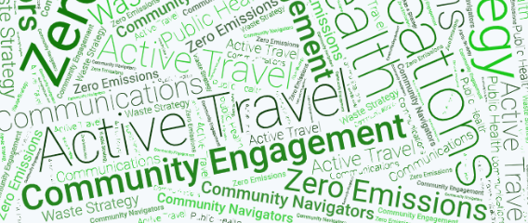
Zero Emissions Team
ZEN provides free access to tailored advice, exclusive services, and discounted deals to reduce air pollution that causes more than 4,000 premature deaths in London each year.
Waste Strategy Team
This team can provide information on recycling, garden waste, bulky item collection wormeries and composting initiatives and discounts.
Public Health/ Community Navigators
This team provides important health information for your local area including information on the impact of air quality on children’s health.

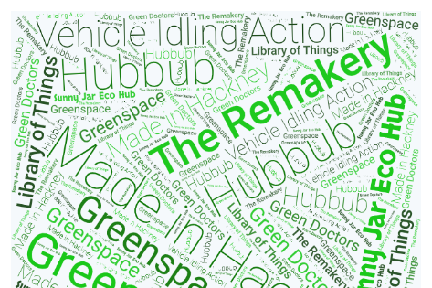
LONDON BASED ORGANISATIONS

Green Doctors - GroundWork London
Mobilising practical community action on poverty and the environment. Building community skills, confidence and making new friends, helping people reduce their use of resources to save money and become part of the movement battling the climate crisis.
Go to groundwork.org.uk/hubs/london
Made in Hackney
Is the UK’s first fully vegan community cookery school and charity. They collaborate with communities to showcase and develop skills, knowledge, and inspiration to grow, cook and eat more plants.
Go to madeinhackney.org
Sunny Jar Eco Hub
Is a social enterprise on a mission to make sustainable and eco-friendly living easy and accessible to all. Based in London they offer workshops focused on craft, upcycling, and wellbeing.
Go to sunnyjarecohub.com
Vehicle Idling Action
Vehicle Idling Action is a London-wide behaviour change campaign which is helping to reduce localised air pollution caused by motorists leaving their engines running when parked. There is many anti idling, downloadable resources.
Go to idlingaction.london

Greenspace Information for Greater London CIC
This is the capital’s environmental records centre where you can submit species records and it will help inform decisions in London to protect and improve biodiversity and geodiversity.
Go to gigl.org.uk
Hubbub
Campaign designers for environmental change to inspire ways of living that are good for the environment. With practical and realistic solutions that help cut waste, make clothes last longer, save money and create cleaner spaces to live and work in.
Go to hubbub.org.uk
Library of Things
The Library of Things is an organisation based in London that allows you to borrow items rather than buy them new.
Go to libraryofthings.co.uk
The Remakery

Co-working space and studios run workshops about upcycling and recycling.

Go to remakery.org

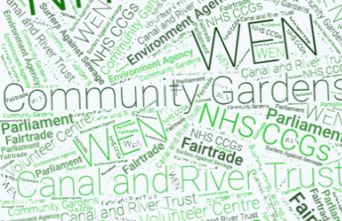
UK BASED ORGANISATIONS

Women’s Environmental Network (WEN)
WEN is a small organisation working towards achieving equality and justice on many issues including air equality, toxic free living, nature for wellbeing, women’s climate action, sustainable food and environmenstrual awareness – promoting plastic free menstrual products.
Go to wen.org.uk
NHS Clinical Commissioning Groups
Clinical Commissioning Groups decide what services are needed for diverse local populations and ensuring they are provided.
Go to england.nhs.uk/ccgs
Community Gardens
Community gardens offer access to green spaces and opportunities to learn more about the natural world.
Go to rhs.org.uk
Department for Business, Energy, and Industrial Strategy
This department is working to tackle climate change and support business and innovation.
Go to gov.uk
Environment Agency
The Environment Agency works to create better spaces for people and wildlife and support sustainability.
Go to gov.uk/government/organisations/environment-agency

Canal and River Trust
The Canal and River Trust manage 2,000 miles of waterways in the UK.
Go to canalrivertrust.org.uk
Fairtrade
Each year Fairtrade hold a fashion revolution event encouraging each of us to ask our favourite brands “who made my clothes?” to demand a fairer, more transparent industry.
Go to fairtrade.org.uk
Surfers Against Sewage
Surfers Against Sewage is an environmental charity working to tackle plastic pollution and protect the UK’s coastlines.
Go to sas.org.uk
UK Parliament Outreach Teams
Every area in the UK has a member of parliament who represents that area in the Houses of Parliament.
Go to learning.parliament.uk
Volunteer Centre
Volunteer Centres exist to provide support and expertise to volunteers and local organisations.
Go to ncvo.org.uk

INTERNATIONAL ORGANISATIONS

UN Sustainable Development Goals Knowledge Platform
This platform has been set up to help you find out more about the Sustainable Development Goals.
Go to sustainabledevelopment.un.org
Friends of the Earth
They are part of an international community dedicated to protecting the natural world and the wellbeing of everyone in it.
Go to friendsoftheearth.uk

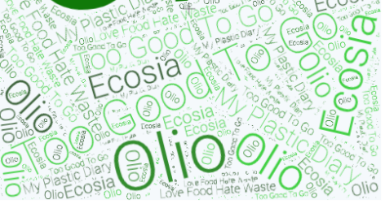

APPS AND SEARCH ENGINES

Olio
Olio is a Food App that helps people to give away food and household items to their neighbours.
Go to olioex.com

Too Good to Go
Too Good to Go is an anti-waste food app.
Go to toogoodtogo.org

Love Food Hate Waste
Leftover food recipes and money saving tips for your shopping.
Go to lovefoodhatewaste.com

My Plastic Diary App
Track and reduce your plastic footprint.
Go to myplasticdiary.co.uk

Ecosia
Ecosia is a search engine that plants trees.
Go to ecosia.org

resources

LESSON OVERVIEW: AIR POLLUTION
Overview | - This lesson can be used as a series of lessons as it covers a lot of subject matter  - Learners will learn about air pollution’s causes and effects  - Learners will discuss possible solutions for air pollution and make a pledge
Relevant Sustainable Development Goals |   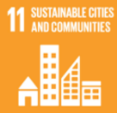  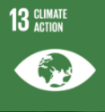    - Goal 3: Ensure healthy lives and promote well-being for all ages  - Goal 7: Ensure access to affordable, reliable, sustainable, and modern energy for all  - Goal 11: Make cities and human settlements inclusive, safe resilient, and sustainable  - Goal 13: Climate change is a global challenge that affects everyone, everywhere and needs to be tackled collectively
Skills: Speaking and listening | Entry level 1/2:  - Take part in discussions on the topic of air pollution and inequality  - Answer open and closed questions with short and extended answers  - Give and ask for opinions in groups and individually  Functional Skills L1/L2:  - Research and discuss this topic:  - What do you think we should do to improve air quality?  - Plan a short talk or a presentation on air pollution in your local area  (research local facts)
Skills: Reading and writing | Entry level 1/2:  - Read and answer comprehension questions about different types of text  - Read a table  - Recognise and read key words about air pollution and climate change  Functional Skills L1/L2:  - Read an article about air pollution: www.bbc.co.uk/news/uk-38990192  - Task 1: Discuss the meaning of the text. Task 2: In pairs identify the language and organisational features.  - Write a letter to your local MP or Councillor asking them to act on Air Pollution (150 – 250 words)
Language points | - Vocabulary (verbs, nouns and adjectives) relating to air pollution and climate change (reduce, respiratory illnesses, lung capacity, pollution, wildfires, contaminated soil, smog, birth defects, etc)  - Discussion language:  - I think… in my opinion…  - What do you think? I agree/ I don’t agree because…  - Future simple for pledges: I will reduce my car journeys; I will cycle or walk to school
Link to PowerPoint | https://www.et-foundation.co.uk/wp-content/uploads/2021/09/Green-week-toolkit-lesson-plan-slide-deck-1-air-pollution-2.pptx
Links to external resources | Go to towerhamlets.gov.uk  london.gov.uk

Lesson plan: Air pollution

Warm up

- Ask learners the questions on slide 3 and 4 allow them to discuss as a group than feedback to the rest of the class. Go through the definition in slide 5 of air pollution.
Activity 1: Causes and effects of air pollution

- In pairs, learners try to name what they can see in the pictures and whether they are causes or effects/ natural or caused by human behaviour slides 5 and 6. Learners then label pictures slide 7 or can make it a cut up and matching activity (see appendix 1).
- After showing learners the causes of air pollution, ask learners to discuss in groups, how does air pollution affect our bodies? Ask learners to write down answers on an A3 sheet and present their answers to the rest of the class.
- Discuss what they can see in the pictures slide 9. Explain that these represent the effects of air pollution. Learners then label the pictures slide 9 or can make it a cut up and matching activity (see appendix 2). Answers on slide 10.
- Use slide 11 to write down the answers that the learners provide/ in groups.

- Show learners slides 12, 13 and 14, discuss as a group and ask learners to take notes on key important figures. Show learners slide 15 asking learners to complete the comprehension questions and then feedback as a group.
Activity 2: A look at indoor air pollution
Slides 13 and 14 can be adapted to have information about your local area or as an extension activity learners’ can research the statistics about their local area and present it to class/ compare them to London.
- Ask learners what they do at home that may contribute to indoor air pollution and may be harmful to them. Allow learners to discuss in small groups then feedback slide 16.
- Discuss what they can see in the pictures slide 17. Explain that these represent the causes of indoor of air pollution. Label the pictures slide 18 or make it a cut up and matching activity (see appendix 3)
- During feedback, show slides 19 to learners.
- Discuss slides 21 and 22.
- Ask learners to write down answers on large A3 page on each table than present their answers to the class. During feedback show learners slides 23 and 24

Activity 3: Pledge time

- Ask learners to think about possible pledges they can make to reduce air pollution slides 25 and 26. Show example of pledges from slides 27 and 28.
- EXTRA ACTIVITY: Planting trees, if time available, see slides 29-34 and discuss with learners.

Appendix 1: Causes and effect cut up cards

 | 
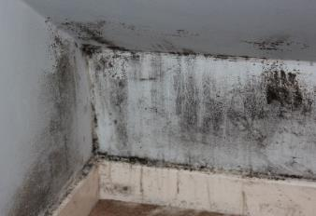 | 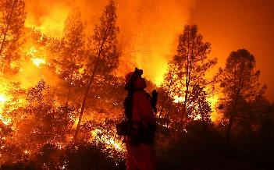
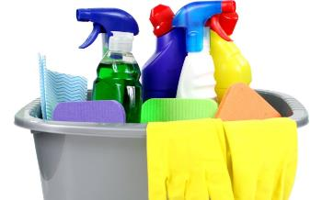 | 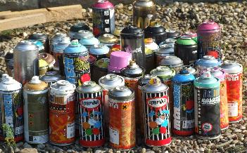
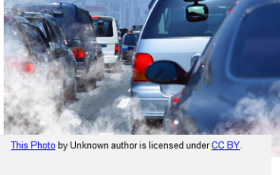 | 

Appendix 2: Effects of air pollution cut up cards

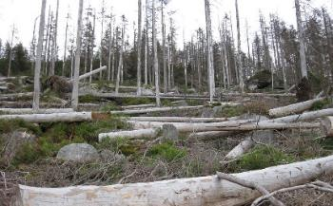 | 
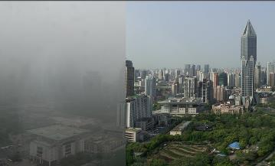 | 
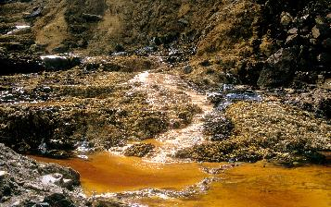 | 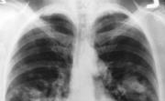
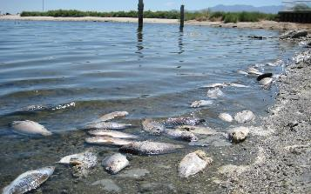 | 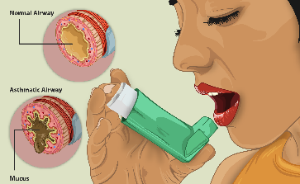

Appendix 3: Causes of indoor air pollution cut up cards
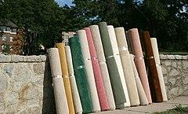 | 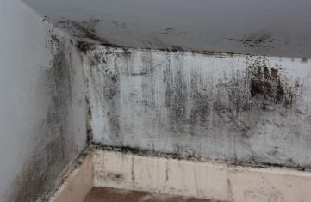
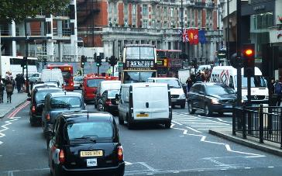 | 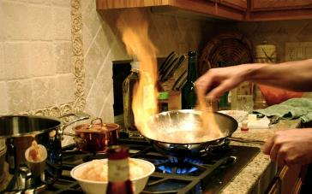
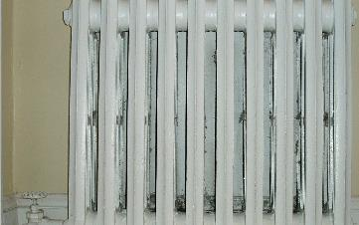 | 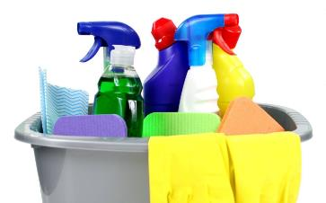


LESSON OVERVIEW: FOOD WASTE
Overview | - Learners will learn about food waste and its effects  - Learners will discuss possible solutions addressing food waste
Relevant Sustainable Development Goals | 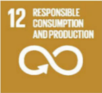  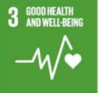  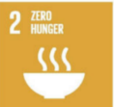  - Goal 2: The food and agriculture sector offer key solutions for development, and is central for hunger and poverty eradication  - Goal 3: Ensure healthy lives and promote well-being for all ages  - Goal 12: Ensure sustainable consumption and production patterns
Skills: Speaking and listening | Entry Level 1/2:  - Take part in a discussion about shopping habits and food waste  - Make comparisons - use comparatives or superlatives  - Discuss solutions - language of suggestions and proposals  - Talk about shopping habits, compare your shopping lists  Functional Skills L1/L2:  - In pairs, create a list of appropriate phrases you can use to interject or move the conversation on  - In small groups discuss what we could do to reduce food waste
Skills: Reading and writing | Entry Level 1/2:  - Write a food shopping list  - Read to understand facts and information about food waste  - Read to understand a recipe - Love Food Hate Waste website  Functional Skills L1/ L2:  - Work in pairs or small groups to create a list of information you could put on a newsletter. Think about the organisational features you might use  - Create a newsletter informing people what they can do to prevent food waste
Digital skills | - Look up food apps - Too Good to Go and Olio  - Research local food banks  - Look up recipes on “Love Food Hate Waste” website
Language points | - Vocabulary (verbs, nouns and adjectives): food waste, recycle, production, etc  - Question form - the auxiliary verb (present simple questions)  - Comparative and superlative forms of adjectives Olio is better than …  - Language of suggestion and proposals (for how to reduce food waste) I think we should…  - Use the present simple to discuss shopping habits I go to… I buy…
Link to PowerPoint | https://www.et-foundation.co.uk/wp-content/uploads/2021/09/Green-week-toolkit-lesson-plan-slide-deck-2-food-waste.pptx
Links to external resources | Go to cheaperwaste.co.uk  cleanstreets.westminster.gov.uk  toogoodtogo.org/en  holioex.com  bhf.org.uk  lovefoodhatewaste.com

Lesson plan: Food waste solutions
Warm up

- Look at the UN Sustainable Development Goals and match the meanings to the goals slide 2.
- Write a list of 5-10 food items that they buy on separate post it notes and follow the instructions on slide 5.
- Compare lists and answer the three questions on slide 6. Variation: if teaching online then discuss the questions in break out rooms.
- Put the titles in slide 7 on display/ on the screen as headings. Learners to place their responses under the correct heading based on their discussions.
Activity 1: Discussion about food waste

- Complete the gaps in the questions on slide 9.
- Draw a food waste bin & make a list of the food that goes into this bin slides 10 and 11.
- Compare their list with a partner.
Activity 2: Food waste in numbers

- Show learners three multiple choice questions slides 13 and 14.
- Write their answers on mini whiteboards or on a piece of paper and hold them up.
- Show them a video cleanstreets.westminster.gov.uk and complete the gap fill slides 15 and 16/ Appendix 1.
Activity 3: Food waste solutions

- Discuss with learners about ideas they have to reduce or stop food waste. Ask them to think about what they may do already and give one suggestion each slide 18.
- Show them the websites of two apps which are available nationally on slide 19.
- Watch the video demonstrating how the Too Good to Go app works youtube.com. Answer questions about video slide 20 and 21 /Appendix 2.
- Look at the list on slide 22 and 23. Discuss with learners if ideas are all true/ false. Then ask them to choose two to try.
- Talk about recipes for food waste as well as think about local food banks slide 24: lovefoodhatewaste.com.
Activity 4: Take action!
- Show learners a list of possible actions they can take slide 26.
- Ask them to choose one-two that they can practice over the next month.
- Ask them to tell someone else to keep them accountable!
- Encourage learners to use these example sentences to feedback their choices:
“I want to…”, “I am going to…” or “I will…”

Appendix 1: Food Waste in Numbers

Answer these questions

- Each year a third of _____ the world produces is lost or wasted.
- 28% of the worlds agricultural land produces _____ that are wasted.
- The _____ that is wasted from growing crops covers all the household water needs.
- The final message is: “Let’s do something about _____”.
Extension: Can you order the natural resources that are wasted?

___ Marketing ___ Processing ___Transporting

Growing ___ Packaging

Go to https://cleanstreets.westminster.gov.uk/food-waste-what-you-need-to-know/

Appendix 2: “Too Good to Go” Quiz

Answer these questions from the video:
- What is their first meal?
- lunch B) dinner C) brunch

- Where is the food from?
A) a shop B) a hotel C) a gym

- How much is their lunch in total?
A) £3 B) £5 C) £2

- Name two types of food in the lunch bag:

- ______________________ 2) _________________________

- What kind of cake is she hoping for?
A) chocolate cake B) cheesecake C) vanilla cake

- What will they get from the supermarket?
A) cheap bag B) magic bag C) food bag

- How much in pounds was the supermarket bag?
- £3 B) £5 C) £7

Go to https://www.youtube.com/watch?v=wARtqz2GP7Q

LESSON OVERVIEW: REDUCING AND REUSING – FAST FASHION

Overview | - Talk about fast fashion and develop related vocabulary  - Learners will learn about fast fashion, reducing clothing waste, and reusing  - They’ll take part in a discussion and make suggestions as well as plan and organise a clothing swap event
Relevant Sustainable Development Goals | 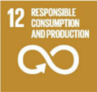  - Goal 12: Ensure sustainable consumption and production patterns
Skills: Speaking and listening | All levels:  - Take part in a discussion on the topic of fast fashion  - Ask and respond to simple questions  - Make suggestions  - Listen for specific information  Entry Level 3+:  - Give and explain ideas using complex structures  - Make suggestions using a range of language  Functional Skills L1/L2:  - Have a 10–15-minute discussion on what kind of clothes you like to wear and why and what items you could bring to a clothes swap  - Prepare a short talk 3-5 minutes to persuade another class that it is a good idea for them to get involved in the clothes swap
Skills: Reading and writing | Entry Level:  - Read a short text and answer questions  - Write simple and compound sentences  Entry Level 3+:  - Write a short paragraph using a range of discourse markers  - Plan and write longer texts for a specific purpose (see extension activity)  Functional Skills L1/ L2:  - Complete the extension activity to write an email organising a clothes swap (250 – 350 words). Teacher could include additional activities on the features of an email, creating a draft plan and structuring an email.  - In pairs learners read each other’s emails and check for use of clear paragraphs and correct spelling and grammar
Digital skills | - Use the internet to search for definitions  - Access a website to find specific information
Language points | - Vocabulary relating to fast fashion  - Modal verb - can: I can… We can…  - Making suggestions: How about we… Maybe I/we could…I think I/we should…  - Making a pledge: I will…
Link to PowerPoint | https://www.et-foundation.co.uk/wp-content/uploads/2021/09/Green-week-toolkit-lesson-plan-slide-deck-3-reducing-and-reusing-fast-fashion.pptx
Links to External Resources | Go to youtube.com  westlondonwaste.gov.uk

Lesson plan: Reducing and reusing

Warm up

- Organise learners into small groups to discuss questions on slide 3 for about 5 minutes.
- Learners report back and agree on a definition for fast fashion.
Activity 1: Fast Fashion

- Tell learners they are going to read the definition of fast fashion. Display slide 4.
- Provide varying levels of support regarding highlighted vocabulary dependent upon level.
- Ask learners if they think this is a good definition. Would they change or add anything?
Activity 2: The Cost of Fast Fashion

- Check comprehension of vocabulary on slide 5 and go through questions on slide 6.
- Play the video and give time for learners to discuss answers and opinions in groups.
- Allow time for whole group feedback and discussion.
Higher levels:
Could include work on discourse markers used in text for them to write their own definition of fast fashion or paragraph expressing their opinions after completing Activity 2.

Activity 3: Clothes in landfill

- Discuss meaning of biodegrade / decompose slide 7.
- Ask learners how long they think it takes for clothes to biodegrade slide 8. Elicit guesses.
- Go through activity on slides 9 – 13 where learners are shown an item of clothing and guess how long they take to decompose before revealing the answer.
- Ask learners if there were any surprises and how they feel about throwing away clothes.
Activity 4: Discussion and action

- Put learners into small groups to talk about what they have learned about fast fashion and consider actions they themselves can take slide 14.
- Introduce/review language for making suggestions. Give examples.
- Bring learners back together as a class to share ideas.
Lower levels could concentrate on producing sentences using ‘I can…’ or ‘We can…’ instead of using examples given.
Higher levels could form more complex sentences using conditionals. For example: ‘If we learn how to repair our clothes, we won’t have to keep buying new ones.’

Activity 5: Pledge writing

- Elicit meaning of making a pledge.
- Ask learners to work on their own to pledge to take two actions regarding fast fashion using the language on slide 15.
- Learners share their pledges with the class.
Activity 6: Swishing

- Depending on level of group, learners work with varying degrees of independence to find out what ‘swishing’ is and discuss questions in small groups slide 16.
- Review ‘swishing’ as a whole class.
Activity 7: Planning a swishing event

- Elicit from class things they need to consider when planning an event slides 17 and 18.
- Organise learners into small groups to plan a swishing event at their college, this could be imaginary or real.
- Review language from Activity 4 and tell learners they have 10-15 minutes to plan the event and then feedback their ideas to the rest of the class.
- After some general feedback try to arrive at some form of consensus regarding a plan for a clothes swapping event.
Possible extension activities:
- Design a poster advertising the event or write invitations.
- Write an email to head of department concerning the possibility of organising a clothes swap.
- Produce a leaflet or short video to share with other learners about fast fashion.
- Organise a sewing workshop.

Answers to Activity 3 ‘The cost of fast fashion’
- 80 billion
- Africa and Dubai
- 300,000 tonnes
- borrow clothes (for 4 – 8 days)
- They encourage customers to mend their clothes.

LESSON OVERVIEW: PLASTIC POLLUTION

Overview | Entry level: E2-E3  - This lesson can be used as a series of lessons as it covers a lot of subject matter  - Learners learn about plastic pollution and develop related vocabulary. They take part in discussions to consider this topic and make suggestions on possible actions they can take.
Relevant Sustainable Development Goals | 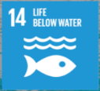  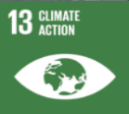  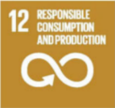  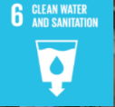  - Goal 6: Clean, accessible water for all is an essential part of the world we want to live in  - Goal 12: Ensure sustainable consumption and production patterns  - Goal 13: Climate change is a global challenge that affects everyone, everywhere and needs to be tackled collectively  - Goal 14: Careful management of this essential global resource is a key feature of a sustainable future
Skills: Speaking and listening | Entry level E2-E3:  - Talking about the problems of plastic  - Discussion plastic statistics and possible solutions  - Talking about what plastic items they have in their houses  - Discussing and comparing in groups.  - Listening to one another and practising discussion skills including body language / not interrupting etc.  Functional Skills L1/ L2:  - Have a 10 – 15-minute discussion on the following topic: ‘how can we use less plastic?’
Skills: Reading and writing | Entry level E2-E3:  - Write a list of the plastic items in their houses  - Completing a quiz and table  - Writing a pledge
Digital skills | - Researching alternatives to single use plastics
Language points | Climate change lexis – eco-system, extinct, pollution etc. Present and future simple grammar forms for the pledges
Link to PowerPoint | https://www.et-foundation.co.uk/wp-content/uploads/2021/09/Green-week-toolkit-lesson-plan-slide-deck-4-plastic-pollution.pptx

- Set up classroom tables to be suitable for group work
Preparation
Lesson Plan: Plastic pollution
- Make your own pledge as an example

Resources needed:
- Recycled paper
- Scissors
- Colourful pens
Warm up
- Elicit ‘’planet earth’ from the picture slide 2.
- Learners to discuss the questions on slide 2.
- Check understanding of ‘climate change’ through group discussion.
- Place any key vocabulary from the discussion on the board.
Activity 1: Water predictions

- Work in pairs / groups and discuss the questions on slide 3

Activity 2: Ocean images

- Look at unspoilt ocean images compared with plastic-polluted ocean images slides 4-16.
- Class discussion on what they think / how they feel.
- Introduce emotive language.
Activity 3: Plastic in the water discussion

- Discuss: how do you think plastic gets into water? Slide 17
- Check understanding of ‘sewage works’.
- Discuss: Why is plastic in oceans / rivers a problem? Slide 18
- Check understanding of ‘ecosystem’.
Activity 4: Biodegrading quiz

- Guess how long each item takes to biodegrade. Slides 19-21
- Class discussion / feedback.
Activity 5: Plastic in your house

- Discuss: Which plastic items do you have in your house? Slide 22
- Concept check ‘single use’ and ‘multiple use’ plastics. Slide 23
- Discuss, and make a list of, what plastic items are in their houses.
- Put items under ‘single use’ or ‘multiple use’.
- Think about which are worse ‘single use’ or ‘multiple use’. Slide 24
- The whole class to go through reasons of why ‘single use’ plastics are bad
Differentiation / extension activity:
- Make a list, or take photos, of their plastic items prior to coming to class – monitor the impact over the course of the programme

Activity 6: Single use plastics

- Discuss: How can we reduce our single use plastics? Slide 25
Activity 7: Pledge time

- Copy and cut out a leaf shape. Slides 26 and 27
- Model an example of a pledge to reduce single use plastics e.g., ‘I pledge to not buy fruit and vegetables in plastic.’
- Write pledges and share them with the class.

Differentiation / extension activity:

Discuss:
- Do you live near a pond, river, or beach?
- Is there a problem with rubbish?
- Is there anything you could do to help?
- Are there any charities that could help? Could your local authority or your MP help?
- Research, join and organise events
Create a short talk or presentation (3-5 minutes) persuading your audience to stop using single use plastic (bags, straws, etc).
Write a complaint for a council webform explaining that there is a lot of plastic pollution in your local area (200 words)

Read this article and write down what it suggests we can do to reduce plastic waste: https://www.bbc.co.uk/news/science-environment-53521001
Researching litter pick-ups and other initiatives in their areas

Workshop ideas

WORKSHOP OVERVIEW: MAKE YOUR OWN PRODUCTS
Overview | - This is a workshop open to learners from different classes (max 30 learners) or it can be used in one class only.  - Suitable for all levels.  - Learners will make their own toothpaste, natural deodorant, all-purpose cleaner, glass cleaner, window cleaner, toilet cleaner and a no sew tote bag.  - Learners will discuss the consequences of plastic pollution and make their own plastic free products.
Relevant Sustainable Development Goals | 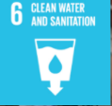  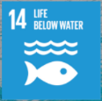  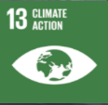  - Goal 6: Clean, accessible water for all is an essential part of the world we want to live in.  - Goal 12: Ensure sustainable consumption and production patterns  - Goal 13: Climate change is a global challenge that affects everyone, everywhere and needs to be tackled collectively  - Goal 14: Careful management of this essential global resource is a key feature of a sustainable future.
Skills: Speaking and listening | All levels:  - Take part in a discussion on the topic of plastic pollution and climate change.  - Ask for and provide personal information.  - Answer open and closed questions with short and extended answers.  - Give and receive instructions on how to make your own product.
Skills: Reading and writing | All levels:  - Read and follow instructions on how to make your own product.  - Recognise and read key words from a recipe text.
Language points | - Vocabulary (nouns and adjectives) relating to plastic pollution and climate change. (recycle, reuse, upcycle, zero waste, pollution, endangered etc)  - Discussion language:  - I think… in my opinion…  - What do you think? I agree/ I don’t agree because…  - Give instructions: verbs + noun + preposition soften the coconut oil in hot water
Link to PowerPoint | https://www.et-foundation.co.uk/wp-content/uploads/2021/09/Green-week-toolkit-workshop-plan-slide-deck-1-make-your-own-products.pptx
Links to external resources | Go to youtube.com  mommypotamus.com

Preparation
Workshop plan: Make your own products
- Learners will need to bring their own containers and old t-shirts.
- Get learners to complete and sign a disclaimer before coming to the workshop (see disclaimer example Appendix 1).
- Complete a risk assessment prior to the session for approval (see risk assessment example Appendix 2).
- Cut up small vocabulary cards (Appendix 3).
- Place poster cards on the wall around the room (Appendix 4).
- Either place slides 5 and 6 on your interactive whiteboard or place on the wall next to each poster card.
You will also need to prepare the make your own product workstations:
- Label ingredient containers clearly
- Divide up ingredients
- Prepare labels for the workstations (Appendix 5)
- Print out recipes and instructions (Appendix 6)

Sessional tutor adaptation:
- Check if your management team has the budget to pay for additional hours
- Ask a full-time member of staff to help with the preparation
- Select one activity rather than a carousel
- Ask learners to bring the listed ingredients for one recipe
- Check if your management team has a budget for materials
- Utilise volunteers

Ingredients / resources needed:
- White Vinegar  - Bicarbonate of Soda  - Coconut Oil  - Corn Starch  - Tea-tree, lavender and peppermint oil  - Water  Warm up | - Material scissors  - Spoons  - Bowls  - Pens  - Rulers

- Introduce yourself and other tutors and/or volunteers.
- Distribute cards amongst learners and then ask if they know what the terms (recycle, reuse, reduce, upcycle, zero waste) mean. Tables discuss. (Appendix 3)
- Explain that around the room there are poster words matching their cards and they should go to them. (Slide 4, Appendix 4)
- Ideally there should be 5 groups of 4 – 5 students each. Adjust groups accordingly.
Activity 1

- In their newly formed groups learners ask and answer question prompts.
- Volunteers and/or tutors join in discussions.

Activity 2

- Learners go back to their tables
- In small groups they discuss picture prompts Slide 8 (Answer: they are all made of plastic) and Slide 9. Feedback as a whole class.
- Watch the film about plastic (link in Slide 10): youtube.com
- First learners discuss question prompts in pairs Slide 11 and then as a whole class (you could print the slide for every 2/3 students or leave on display)
- Go over slides 12-14 and discuss as a whole class.
Activity 3

- Give learners a short break and prepare the make your own products workstations.
- Divide tutors and/or volunteers between stations.
- Display Slide 16 with workshop outline.
- Follow instructions on recipes and make your own DIY product (Appendix 6).
Extension reading task:
Remove the step numbers, cut up a recipe and learners need to place in the correct order or/ learners can match the pictures to the steps

- Learners move between stations making their own products.
- Give a time for learners to complete a task before moving to the next station. (guide time 15 minutes per station)

Appendix 1: Disclaimer example

Disclaimer

Please carefully read the list of ingredients that we will be using when making our own cleaning products.

Answer the questions.

Are you allergic to any of these ingredients? (circle answer)

1 | White vinegar | Yes | No
2 | Bicarbonate of soda | Yes | No
3 | Coconut oil | Yes | No
4 | Corn Starch | Yes | No
5 | Tea tree oil | Yes | No
6 | Lavender oil | Yes | No
7 | Peppermint oil | Yes | No

If you answered yes to any of these questions, talk to your tutor.
If you have any reactions after using these products, please talk to your doctor immediately. [Insert organisation] accepts no responsibility for any injury, accident or damage suffered in, or by reason of, the [insert workshop], however such may be caused.
Name
Signature
Date

Description of Activity | Make your own products workshop
Location | Click here to enter text.
Completed by
Date of Assessment | Click here to enter text. | Review Date | Click here to enter text.

Appendix 2: Template risk assessment
What are the hazards? | Who and how might someone be harmed? | What are you currently doing to control risks? | Risk Rating  L / M / H | What else do you need to do  (if applicable)? | Action by who / when? | Date Completed
Lack of Course / Session Management: General | Learners / Tutor | - Course Management:  - Tutor-led Induction e.g., welfare arrangements, workshop structure and what to wear etc.  - Tutor prepares a workshop Lesson Plan appropriate to level and learner needs (available on the day)  - Tutor has qualification relevant to class format (held with Programme Manager) | LOW |  | Tutor (prior to workshop)
Course / Session Management:  Too many learners per class | Learners and Tutor  Accidental collision with other learners, physical injury | - Workshop participants will be divided into groups during the session and activities managed by the tutors | LOW |  | Tutors (each workshop)
Manual Handling: Room set-up; class preparation pre/post session | Tutor  Physical injury | - Tutor to use good handling technique.  - Minimal manual handling done by staff.  - Tutors leave the room clean at the end of workshop  - Learners to read and sign disclaimer form. | LOW |  | Tutor (each class)  learners
Lone Working: Room set-up; class preparation pre/post session | Tutor  Physical injury; individual health concerns | - Tutor required to sign into each Centre  - Administrative / Facilities staff based in the reception area  - Daily schedule of classrooms in use maintained and held at reception and timetables outside of each room | LOW |  | Tutors  Administrative staff
Participation in DIY activities, E.g., Use of:  Handling of ingredients  Handling of containers  Handling of recycled containers | Tutor and Learners  Musculoskeletal injury; cuts and puncture wounds | - Class session delivered in line with programme, level etc.  - Learners are always supervised by tutor  - All equipment used according to manufacturer’s instructions  - First Aid boxes located in the room  - Learners always required to use equipment according to tutors’ instructions | LOW | - Tutor to give a safety briefing at the beginning of each workshop | Tutor (each workshop)
Disruptive / aggressive behaviour of learners | Tutor / Learners  Verbal or physical assault | - Learners are required to comply with normal classroom code of conduct  - Tutor to inform Programme Manager | LOW
Defective electrical equipment: domestic and industrial sewing machines, pressing system | Learners / Tutor  Physical injury, electric shocks, burns | - Tutor to check (visual) for defects conditions of connecting cables; Tutor to remove or refrain from use, if defective  - Tutor to inform Programme Manager  - All equipment is serviced once a year  - All electrical equipment is PAT tested once a year  - Defective equipment is either repaired by professionals or replaced with new ones | LOW |  | Tutors
Delay in First Aid assistance | Learners / Tutor  Deterioration of condition / injury | - Building First Aiders identified on-site (refer to signage in building)  - First aid boxes located in the room  - Some Individual Tutors are qualified in First Aid (held with Programme Manager)  - ‘What to do in an emergency’ information contained in Course Folder for Tutors.  - Tutor to inform Programme and Centre Managers of any Incident | LOW |  | Tutors
Fire Safety: Delay in Emergency Evacuation | Learners / Tutor  Smoke inhalation, burns or fatality | - Fire Safety Risk Assessment is in place with the Facilities Management team.  - Tutor to inform Learners of evacuation procedures including muster point at start of workshop  - Learners who need assistance have individual PEEP, recorded in Course Folder  - ‘What to do in an emergency’ information contained in Course Folder for Tutors | LOW | Tutor to notify Centre staff that someone requires assistance with emergency evacuation | Tutors (each workshop)
Defective or identified Building equipment or hazards e.g., slips/trips; electrical equipment | Learners / Tutor  Physical injury; electric shocks | - Hazards Identification form in Course Folder for Tutors to report issues  - Individual electrical items e.g., power tools visually inspected by tutor before use and serviced once a year  - No trailing extension cables or wires in the crafts room. | LOW | Tutor to notify Programme Manager of any hazard  Portable appliances to be maintained and periodically tested as required | Tutors  Your Service

Overall Residual Risk for Activity (L / M / H): | LOW

Leve of Risk | Suggested Action
LOW | Control measures are adequate but continue to monitor and review; ensure that they remain satisfactory and appropriate.
MEDIUM | Control measures need to be introduced within a specified time; continue to monitor and review.
HIGH | Unless control measures can be immediately introduced to reduce the risk so far as is reasonably practicable, the task or activity should be suspended.

recycle | reuse | reduce | upcycle | zero waste
recycle | reuse | reduce | upcycle | zero waste
recycle | reuse | reduce | upcycle | zero waste
recycle | reuse | reduce | upcycle | zero waste
recycle | reuse | reduce | upcycle | zero waste

Appendix 3: Small vocabulary cards

Appendix 4: Poster cards
Reduce
Recycle

Reuse

Zero waste

Upcycle

Appendix 5: Product carousel place cards

Natural toothpaste and deodorant

Window and glass cleaner
All-purpose cleaner and glass cleaner

No sew tote bag

Appendix 6: Instructions for homemade bag and recipes

How to make a no sew t-shirt tote bag
Supplies:
- Old t-shirt – The thicker the fabric, the sturdier the bag
- Sharp scissors, preferably fabric scissors
- Washable marker (optional)

Step 1: Cut the sleeves off  Top tip: fold the t-shirt in half so that you can cut both sleeves at the same time. | 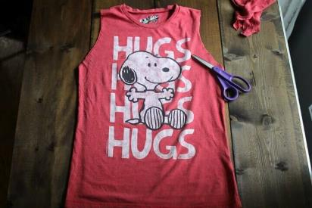
Step 2: Cut the neckline area  Turn the shirt inside out and use a bowl and a pen to make an oval shape.  Cut the shape. | 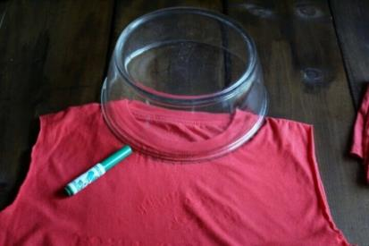
Step 3: Decide how deep you want the bag to be  Draw a line at the bottom of the shirt using a ruler or the edge of a book to decide how deep you want your bag to be. | 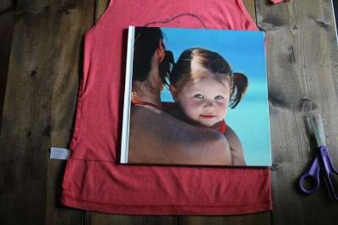
Step 4 Cut the fringe  Cut slits from the bottom of the shirt up to the line marking the bottom of your bag.  Cut both the front and back layers together because they need to match up for the next step.  I cut my slits about 3/4 to 1 inch apart. | 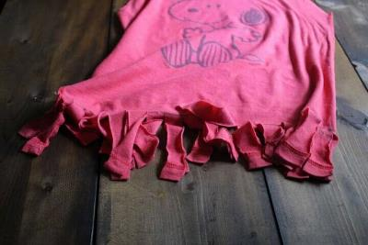

Step 5: Tie the fringe  Take your first pair of fringe pieces and tie them into a knot, then tie two more pairs. | 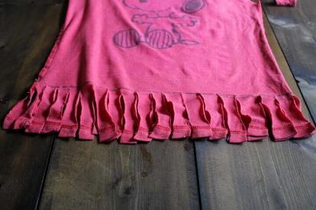
In this photo you see three sets of fringe pieces that have been tied in knots.  What I do next is grab one strand from the middle set (the one with the arrow pointing left) and tie it in a knot with one of the strands on the left set. | 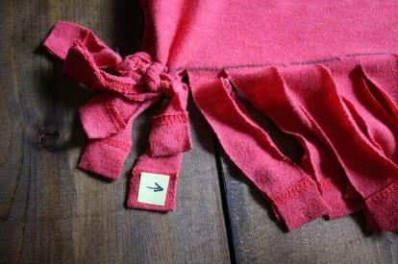
Then take the other strand from the middle set (the one with the arrow pointing right) and tie it in a knot with one of the strands on the right set.  Take the remaining strand on the right set and tie it to the next set of strands, and so on and so forth until all the strands are tied.  Now turn your t-shirt right side out again and you’re done! | 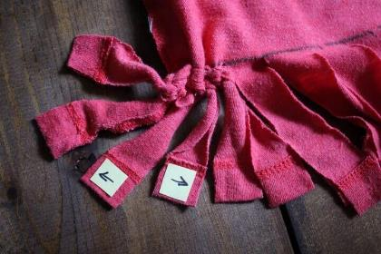
A couple of fun variations . . .  Turn the bag right side out when tying the fringe.  Tie the straps in knots, or tie bits of t-shirt scrap to the top as embellishments | 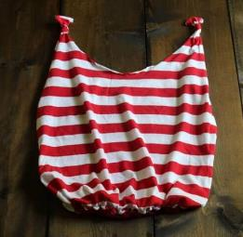  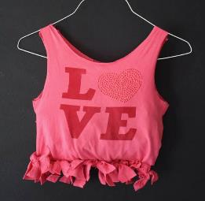

.
.

Source: mommypotamus.com

How to make natural toothpaste

The combination of coconut oil and baking soda make a great natural toothpaste.
It can help:
- Cure bad breath
- Get rid of bacteria and fungi
- Whiten teeth
- Lessen oral acid



Ingredients:

- 2 teaspoons of coconut oil
- 2 teaspoons of baking soda
- 1 drop of peppermint oil

Method:

1. Soften the coconut oil in hot water.
2. Mix all the ingredients together.
3. Use it to brush your teeth.

How to make natural deodorant

Ingredients:

- 1 teaspoon of coconut oil
- 1 teaspoon of corn flour
- 1 teaspoon of bicarbonate soda
- 1 drop of essential oil (lavender, tea tree or orange)

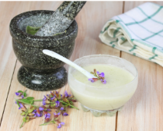

Method:

1. Mix all ingredients in a glass jar and keep at room temperature.
2. The mixture may get hard in the cold temperature.

Tips:

- Apply the deodorant with your fingers.
- Be careful of greasy stains on your clothes, mostly on silky fabric.
- If you feel any stinging stop using it and lessen the amount of bicarbonate in your mix.

How to make general all-purpose cleaner

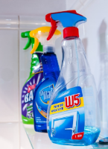

Ingredients:
- 250ml water
- 2 teaspoons bicarbonate of soda
- 1 tablespoon white vinegar

Method:
- Mix all ingredients in a bucket of water.
- Pour into a spray bottle.
- Store and keep.

Tips:
Use this to clean:
- Tiles
- Bathroom panels
- Mirrors
- Windows
- Hard bathroom and kitchen surfaces

Option 1: How to make glass cleaner
Ingredients:
- 250 ml warm water
- 1 tablespoon white vinegar

Method
- Combine the white vinegar and warm water in a spray bottle.

- Use to clean glass or mirrors with a dry cloth or piece of newspaper.



------------------------------------------------------------------------------------------------------------------------------

Option 2: How to make glass cleaner
Ingredients:
- 150ml warm water
- 1 tablespoon white vinegar
- 1 teaspoon cornflour
Method:
- Mix all ingredients together in a glass bottle.

How to make toilet cleaner

Ingredients:
- 4 tablespoons baking soda
- 4 tablespoons white vinegar
- 3 drops of tea tree oil
- 3 drops of lavender oil

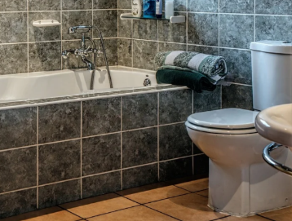

Method:

- Mix all ingredients together in a container.
- Store somewhere safe.

Tips:
- This cleaner smells lovely and really scrubs even the most limescale stained toilet bowls clean.
- As an added tip, pouring oil around the bowl after cleaning can help prevent “things” from sticking.

Workshop Ideas

WORKSHOP OVERVIEW: UPCYCLING
Overview | - This is a workshop open to learners for different classes (max 25 learners) or it can be used in one class only.  - Suitable for all levels.  - It’s an opportunity for learners to meet other learners from different groups and to share skills and ideas.  - During this workshop learners will discuss the meaning of upcycling and find out about opportunities to upcycle in their local area.  - Learners will follow a set of instructions to make a cushion cover out of a sari.  - If possible, learners to bring in their own materials and sewing kits if they have them.
Relevant Sustainable Development Goals | 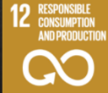  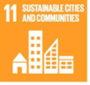  - Goal 11: Make cities and human settlements inclusive, safe resilient, and sustainable  - Goal 12: Ensure sustainable consumption and production patterns
Skills: Speaking and listening | All levels:  - Take part in a discussion on “upcycling”. Have they tried it? What ideas do they have already?  - Learners to ask for and provide information about what they do with surplus household materials.  - Give and receive instructions on how to make a cushion cover.
Skills: Reading and writing | All levels:  - Read and follow instructions on how to make a cushion cover from a sari.
Language points | - Vocabulary (nouns, verbs & adjectives) related to sewing (cotton, silk, needle, thread, cut, fold, measure, stitch, sew, shiny, stretchy)  - Language of suggestion:  - I like to… Have you tried? I would recommend that…  - Giving instructions: verb + noun + preposition turn the material out  - Sequence markers: first, next, then…  - Discussion language about the meaning and use of upcycling:  - I think… in my opinion…  - Present perfect:  - I have tried… I have made…
Link to PowerPoint | https://www.et-foundation.co.uk/wp-content/uploads/2021/09/Green-week-toolkit-workshop-plan-slide-deck-2-upcycling.pptx
Links to external resources | Go to youtube.com What is upcycling?  youtube.com Example video on how to use a sari to make cushion cover.  youtube.com Another example video on how to make cushion covers

Workshop plan: Upcycling

Preparation

- Learners to bring/ teacher to supply: an old sari or other patterned material, an old cushion insert, a needle and thread, scissors, measuring tape
Warm up

- Discuss with each other what upcycling is and give any ideas or examples
- Question ideas for discussion:
- What do you do with old saris, clothes, or bedding?
- Have you made anything new from them?
- Do you give them away or give them to charity shops?
- Share them with the group Slide 4
Activity 1

- Watch video Slide 6 of an example of upcycling and listen for the following:
- What does the man make?
- What things can we upcycle?
- Why is upcycling a good thing?
Activity 2

- Learners to show the materials they have brought in Slide 7
- Explain the history of the material e.g., a sari- I wore this to my sister’s wedding

Activity 3: Reading instructions

- Learners check they have the correct resources for making a cushion cover Slide 9
- Go through the instructions for making your own cushion cover Appendix 1 / Slides 10-17
- Start making!
Ask learners to present and share what they have made (even if it is unfinished)
Ask them what they could do next, something else they could make or use from their home to do a similar thing?
10
mins
Activity 5
Extension activity: Research other local upcycling workshops in the area.
Activity 4: Presentation

- Ask learners to present and share what they have made (even if it is unfinished) Slide 19
- Ask them what upcycling project they could do next. What could they remake?
Activity 5: Research (extension activity)

- Extension activity: Research other local upcycling workshops in the area Slide 20

Appendix 1: Instructions for making a cushion cover

Instructions for upcycling

Preparation  Lay the equipment you need on the table: | 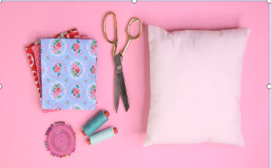
Step 1:  - Measure the width of the cushion  - Add 5cm each side | 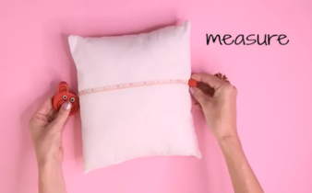
Step 2:  - Use the measurement to cut your material to size  - Put the material on the table with the pattern facing down onto the table  - Lay it length ways | 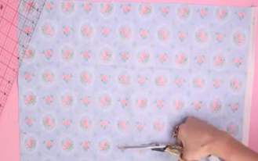
Step 3:  - Fold in the left and right side by 1cm  - Stitch the 2 sides | 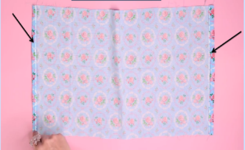
Step 4:  - Fold over the left side (leave a flap) | 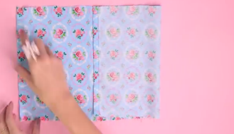

Step 5:  - Fold over the flap  - Stitch along the top and bottom  - Leave the flap open (unstitched) | 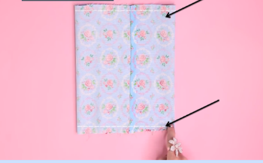
Step 6:  - Turn the cushion cover pattern side out | 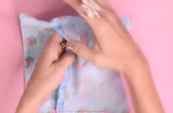  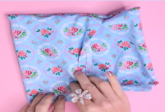
Step 7:  - Insert the cushion into the cushion cover | 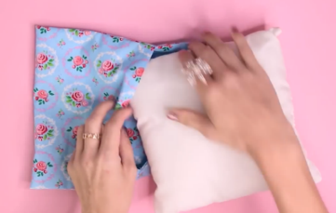

Source: youtube.com

AcknowledGments

Many thanks to the contributors of this toolkit and accompanying resources. They were tried, tested, and put together by the following team of talented teachers and staff at Idea Store Learning:

Ellen Garner-Bacon
Charlotte Latimer
Lucilia Branco
Rachel Bate
Saad Benaissa
Shah Ahmed
Shahida Aktar
Victoria Holmes

With many thanks for the time and energy spent conducting research and putting together these resources and the tutors’ commitment to embedding sustainability into the curriculum.




Our Partners Funded by

Thank you

