




INCLUSIVE EMPLOYER INDUCTION TOOLKIT

for employers of learner placements / apprentices

CITY COLLEGE NORWICH SHARING EFFECTIVE PRACTICE

CONTENTS

INCLUSIVE INDUCTION TOOLKIT
Contents 2
Introduction and inclusive culture 4
Using the toolkit 6
RESOURCES
Toolkit 1 Recruitment advice 8
Toolkit 2 Employer induction 11
Toolkit 3 Collaborative working 12
Toolkit 4 Mentoring principles 14
Toolkit 5 Questioning techniques 17
Toolkit 6 Setting SMART goals 19
Toolkit 7 SOAR model 21
Toolkit 8 The GROW model 23
Toolkit 9 Common issues 25
Toolkit 10 Inclusive guide toolkit 27
Toolkit 11 Welfare and Wellbeing 28



INTRODUCTION

Our learners and apprentices are the workforce of the future and these young people who see the world in a different way can bring so many benefits to a business and the wider community. This interactive workshop will share our current practices in delivering induction
activities to employers of placements / apprentices which promote and support an inclusive environment. We’ll share how we’ve developed the involvement of employers within the placement / apprenticeship induction processes.

What you can expect:
- developing an inclusive approach to recruitment
- the expectations of the partnership between employer, the college and the learner / apprentice
- practical examples of how to support the learner
/ apprentices with barriers to learning to develop knowledge, skills and behaviours to become a member of staff who can add value to the business
- how all staff within an organisation has responsibility to
take an inclusive approach
- access to resources including inclusive digital guide

A culture of inclusivity
For a successful learner / apprentice completing their programme, there needs to be a culture of inclusivity in meeting the needs across the organisation or company. Employers will be confident and ensure inclusion is everyone’s responsibility across the whole organisation/ company.

The toolkit will support and share best practices both within organisations and across the broader employer landscape.



Using the tools

These tools and techniques are derived from tried and tested tools that have been used extensively with employers.

Each tool has a generic description and can be adapted by you in accordance with the requirements of the organisation.

The tools can be adapted for use with different audiences and purposes, such as to generate opportunities, energise, inspire support and challenge to embed a culture of inclusivity.



Examples of competency-based questions
- Describe a time when you have worked as part of a team. Talk me through how you decided roles; what went well; what would you change?
- Tell me about a time where you had to change someone’s mind. Talk me through what the situation was, what you wanted to get out of it and how you went about changing their mind.
- Describe your biggest setback.
- Tell me about a time when you did not succeed first time with something. Talk me through what happened, what you did and how you overcame any challenges.
- Tell me about a time when you have had to persevere with something.
- Describe a time where you have had to ask for help.
- Explain to us about a time where your communication skills
made a difference in a situation.
- Tell me about a time when your communication didn’t work and what you did about it.

Examples of hypothetical questions
- What would you do if a customer was rude to you?
- How would you deal with feeling under pressure in the workplace?
- What approach would you take if you felt you weren’t getting on with your team?
- How would you go about giving someone excellent customer service?
- What would you do to turn around a customer’s previously bad experience?

Additional Questions
- What is interesting to you about the job role/the industry/an apprenticeship?
- How do you think you will organise yourself while you are studying and working full time?

Toolkit 1
Employer Guide to recruiting a successful apprentice

We are keen to help you appoint the right apprentice for your company. This tool kit has been designed to help you with the interview and recruitment process.

Everyone involved in the recruitment and selection of staff has a responsibility to ensure that candidates are treated fairly, that decisions are made objectively, and they are aware of the commitment to completing the apprenticeship.

Entry Requirements
With the introduction of the new apprenticeship standards, we expect that all our L3 apprentices have achieved at least Grade 4 (GCSE C) in Maths and English. If these levels have not been achieved the candidates may be expected to attend college on another delivery day to undertake maths /or and English.

All our apprenticeships have set entry requirements that are written on the front of the individual apprenticeship course sheet. If these levels have not been achieved the candidates may be expected to attend college delivery on another day.

Interview Questions - Competency Based Questions
Competency bases questions give you an opportunity to probe for someone’s experience of a situation. As you may be recruiting someone new to the working world, these might need to be more generic but can still give employers useful insight into how people work. Some examples of these are highlighted opposite

Hypothetical Questions
These can be useful when interviewing a candidate who does not have extensive experience to draw on. However, they should be used sparingly as people often know what they should say! They are good for revealing approaches or styles an individual uses in their day to day life.

Toolkit 2
The employer induction checklist

*TICK IF RELEVENT PLACEMENT APPRENTICE COMMENTS / NOTES

Delivery Framework Standards Guidance
Statement-terms & conditions
PDP-professional development plan Course requirements
Tasks in workplace

What to expect from each other
Learning provider Employer

Mentor Assessor Learner

Off the job training Placement plan / hours

Company procedures
Structure Hours of work

Work tour people & places
IT Log on
Health and Safety Car parking Breaks and lunch
Leave and absence
Safeguarding / security

Learner / Apprentice support Welfare and wellbeing Safeguarding disclosures Learning disabilities and difficulties Support advice

*tick areas relevant and covered at induction

Toolkit 3
Defining Inclusive Collaborative Working

Purpose
This activity explains how to put collaborative working into practice to ensure the highest creative consensus decision is reached, rather than the lowest common denominator to keep someone happy.

This will only be achieved if everyone is involved including learner / apprentices and they put the needs of the organisation or business ahead of their own wishes and needs.

Process
Define collaborative working by forming the highest creative
consensus: -
- Demonstrate good examples of collaborative working. Ask the team to make a note of the collaborative behaviour they witness.
- Give each staff member with a copy of the Six Definitions - Highest Creative Consensus detailed below and ask them to look at the features of forming the highest creative consensus and highlight any they particularly like. Ask if there are any comments they don’t understand.
- Use ‘defining inclusive collaborative working’ toolkit and explain
what collaborative working means in practice:
- Build consensus.
- Consult and involve.
- Support your team.
- Get and use diverse experience.
- Focus on process as well as outcome.

Hints and tips
Visit the inclusive guide before defining collaborative working, as
this enables an inclusive approach

Typical Duration
30 minutes

Toolkit 3
Defining - Highest Creative Consensus
Inclusive Collaborative Working


Cabinet responsibility
Once the decision is made, all members of the team support it.

Consensus decision making
Reaching for the highest creative denominator rather than the lowest common denominator to keep someone happy.

Using diversity
Getting different experiences and points of view into the mix – diverse teams make better decisions.

Business-wide interest
- the whole is more significant than
the parts
The wider interest of the organisation is more important than local interest i.e. this decision or action is better for me and/or my team.

Responsibility and authority
Responsibility and authority in equal measure i.e. senior roles in the room do not ‘trump’ others.

Opinion and evidence
Evidence and collective anecdote rather than assertion i.e. always evidence or give reason in relation to your viewpoint.

Toolkit 4
10 Principles of Mentoring

- Mentoring requires a trusting, confidential relationship based
on mutual respect.

- Mentoring relationships must involve clear boundaries.

- Mentoring involves a definite time commitment.

- Mentoring is intended for enhancing specific growth goals of a mentee, not for organisational requirements (such as employee evaluation).

- The purpose of mentoring must be mutually established by
the mentor and mentee with clearly defined goals/outcomes.

- Mentors should be an effective role-model.

- Performance assessments to be of high quality.

- Mentees must be encouraged to “raise the bar” for themselves as their insights and skills increase.

- The relationship ends when the mentee is able to operate independently.

- Give value to the mentee without receiving extrinsic reward.

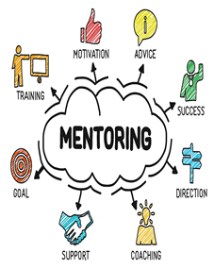
Toolkit 4
Mentoring approach and benefits

The roles of the person undertaking mentoring use skills such as active listening, questioning, guiding and supporting.

Mentors should consider
- Likely challenges and how to face them
- Boundaries and issues of confidentiality
- Active listening and communication skills
- The skills and qualities required
- An outline of the process and expectations for the learner / apprentice

Unique selling points
- Help to develop and promote talent
- Positive impact on the personal and professional development
- Increased self-reflection or critical reflection of their own practice.
- Support for progression, enabling the learner / apprentice to develop their practice.
- An effective mechanism for supporting
- challenge.
- Mentoring can be an appropriate response to support an individual to address significant issues that might inhibit progress.
- Alternatively, it might be used to accelerate the development of a learner apprentice deemed to have significant potential

The role boundaries of a mentor
It is important to establish boundaries that you both feel comfortable with. These could include:
- Operating within limits of own competence
- Respecting each other’s time and responsibilities
- Establishing a non-exploitative relationship
- Examining a mechanism for resolving problems
- Deciding what you, the learner / apprentice is prepared to talk about
- Not intruding into areas, the learner / apprentice wishes to keep private
- Working within the law and the Data Protection Act

Hints and tips
- Plan in advance potential areas to be covered
- Be prepared to be flexible and agree a
win-win
- Refer to the inclusive guide

Typical Duration
30 minutes to 1 hour

Toolkit 5
Questioning Techniques



Open Questions
Allow more expression and open up the conversation
T - Tell me... (an example of that?)
E - Explain to me... (why you did that?)
D - Describe to me... (how you tried to do that?)

Closed questions
Help you ‘close’ off conversation, by limiting the
response to yes or no (or a very short answer)

Reflective questions
Used to reflect what you have heard & offers the opportunity to check your understanding. Very useful when lots of information has been shared or you have been listening for some time.

Hints and tips
Use the inclusive guide to help consider and prepare your approach

Typical duration
15 - 30-minute discussion

Toolkit 6
Setting SMART Goals
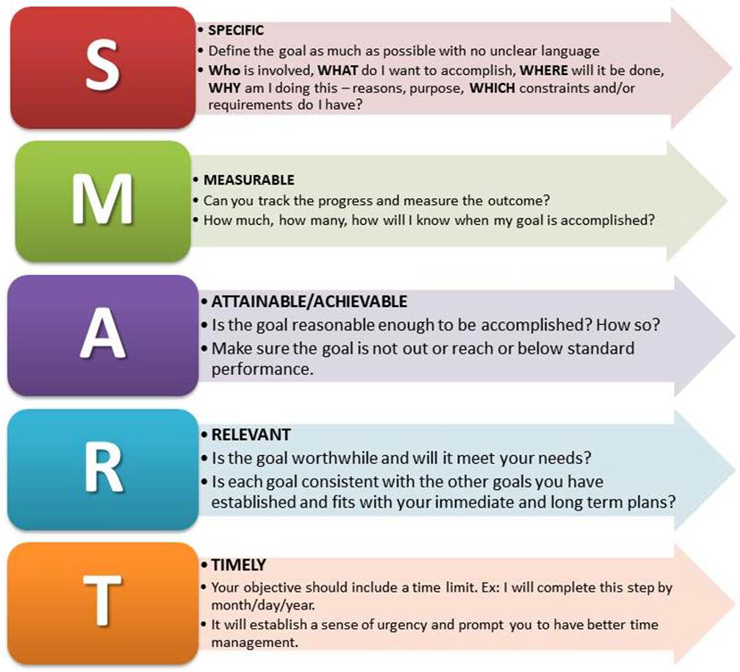

Purpose
SMART goals clarify ideas, focus efforts, and use time and resources productively. They help define what is needed to achieve.

Process
Discuss potential actions, the time frame and what is required. Gain agreement from the apprentice.

Hints and tips
- Plan in advance potential targets
- Be prepared to be flexible and if this isn’t possible, prepare your approach
- Refer to the inclusive guide

Typical Duration
30 minutes to 1 hour

Toolkit 7
Learner / Apprentice Personal Development Plan SOAR analysis (Strengths Opportunities Aspirations and Results)


Overview
The SOAR method is a “positively re- framed SWOT analysis”. SOAR is biased towards what a learner / apprentices can do rather than consider what areas they should avoid. In the context of SWOT, highlighting someone’s weaknesses for personal development isn’t the best tool and therefore SOAR is a better fit.
SOAR

Purpose
For the learner / apprentice to take responsibility for their own personal development plan and to identify short, medium long terms goals.

Activity
The Line manager should set out the expectation and talk to the learner
/ apprentice about the benefits of
undertaking the SOAR activity. The learner
/ apprentice should complete the SOAR to encourage ownership.

Process
- Meet with the learner / apprentice and to talk about the progress they have made in the role
- Discuss what strengths, opportunities and aspirations they have
- Share the SOAR personal development plan and ask the learner / apprentice to complete
- Give the learner / apprentice time to complete and decide of when you will meet them to review their PDP SOAR

Hints and tips
- Highlight one or two apprentices’ strengths, opportunities and potential aspiration
- Encourage them to reflect and engage
- Encourage ‘blue sky thinking’
- Refer to the inclusive guide

Typical Duration
15 - 30-minute discussion and 1 hour for learner / apprentice to complete.


Toolkit 8
Mentoring using the GROW model (Goal, Reality, Options, Way forward)

Helping learner / apprentices with their thinking

Goal - Your role is to help the learner / apprentice to clarify the goal.

Ask questions to help determine:
- What issue/area they want to focus on.
- What they want to achieve out of the session.

Reality - Your role is to help the learner / apprentice understand what is happening now and gain insight.

Ask questions to:
- Clarify the current situation
- Determine the current impact
- Determine future implications
- Invite self-assessment

Options - Your goal is to help the learner /
apprentice find out what is possible.

Generate Options:
- How would you make that happen?
- What else could you try?
- What else…?
- Assess Options:
- What is the best/worst thing about that?
- What are the advantages and disadvantages?
Way Forward - Your role is to help the learner / apprentice find a way forward and commit to best actions.

Ask questions such as:
- Which option do you think will work best?
- What is the next step?
- What will you do? When?
- What might get in the way? How might you overcome that?
- What support might you need?
- How might we follow up?

Hints and tips
- Refer to the inclusive guide

Typical Duration
30 minutes to 1 hour

Toolkit 9
Common issues with a learner / apprentices

Common issue 1
Behaviour seen - the learner / apprentice keeps forgetting to come in for meetings Behaviour expected – perhaps the expectations are too high

Behaviour agreed -

Common issue 2
Behaviour seen – the learner / apprentice is not used to formal way of communicating in business
Behaviour expected - the learner / apprentice expected to understand the NVQ terminology

Behaviour agreed -

Common issue 3
Behaviour seen – the learner / apprentice forgets instructions for tasks and duties
Behaviour expected – the learner / apprentice to apricate and understand that some aspects of the work can be repetitive and mundane

Behaviours agreed -

Common issue 4
Behaviours seen – the learner / apprentice keeps using mobile phone when on duty at work
Behaviours expected – the learner / apprentice is focused on areas of work Behaviours agreed -




Common issue 5
Behaviours seen – the learner / apprentice is struggling with the NVQ / written work
Behaviours expected - the learner / apprentice to do well in all areas of the work

Behaviours agreed -

Hints and tips
- Plan what you want to cover
- Be prepared to agree behaviours and what you need from the learner / apprentice
- Refer to the inclusive guide as some of the issues might be related to a learning difference or disability.

Toolkit 10
Learning Difficulties and Disabilities – Inclusive Toolkit

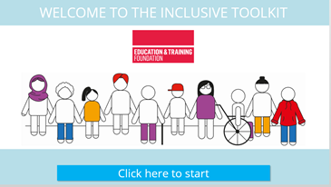
Purpose

This resource is designed to create a culture of inclusivity across the organisation or company. It will help
inform and support all staff and employers when working with a learner / apprentice who may have a learning difficulty and/or disability.

It will give an overview and strategies to
support those learners / apprentices
in their course activities and around the
work environment.

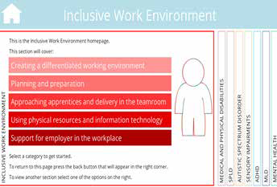
Activity
Click on link and access the inclusive toolkit where staff and employers can navigate their way around different types of disability and strategies to the support learner / apprentice in the workplace.
The staff member or employer can return to the inclusive toolkit at any point and resume where they left last time.

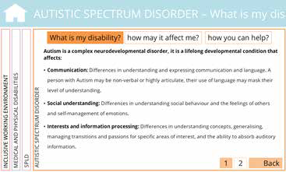
Hints and Tips
- click on each of the sections or a specific
disability;
- click on the sections to find out about the
disability;
- how it affects the learner / apprentice;
- how you can help;
- use the guide to support other tools in this kit

Typical Duration
30 minutes to 2 hours

https://www.ccn.ac.uk/inclusive-toolkit/story_html5.html

Toolkit 11

Welfare and Wellbeing

Wellbeing
- We understand the importance of a healthy and productive workforce, particularly with young learners / apprentices.
- We can signpost you and your learner / apprentice to a free service to help them overcome any difficulties they are experiencing at work due to stress, anxiety or depression, so they can remain a valuable asset to your company.

Safeguarding

If a learner / apprentice tells you about possible abuse or harm:
- Listen carefully and stay calm.
- Reassure them that by telling you, they have done the right thing.
- Inform the learner /apprentice that you must pass the information on, but that only those that need to know about it will be told. Inform them of whom you will report the matter to.
- Note the main points carefully.
- Do not investigate concerns or allegations yourself, but report them immediately to your point of contact at college who will alert the Safeguarding Officer at college

Prevent Duty
- Prevent is about safeguarding people and communities from the threat of terrorism. Prevent is the Government’s counter-terrorism strategy. It aims to stop people becoming terrorists or supporting terrorism.
- The following sources may also be useful for further information:
https://www.gov.uk/government/publications/prevent-duty-guidance
- Let’s Talk About It http://ltai.info/what-is-prevent

Radicalisation
“The process by which a person comes to support terrorism or forms of extremism that support terrorism”
- Are you worried about a learner / apprentice who might be showing a hatred for people from other faiths, ethnicities, people groups or countries? Worried about what they might do?
- Talk to our Safeguarding Team
- You can also get help and advice from http://www.ltai.info/

E- Safety
- Is your learner / apprentice being trolled or harassed online?
- Are their pictures and posts private?
- Did you know Facebook can change security settings without telling you?
- Does your apprentice really know who they are talking to online?
- Are their passwords and logons secure?
- If your learner / apprentice needs some help to keep safe online talk to your tutor/assessor.

Employer support for learner / apprentices
- Getting advice on simple adjustments
- Helping you to understand what support you are able to offer
- Getting advice on creating a support plan to get the apprentice back on track
- To access the free service contact:
- Remploy Limited: 0300 456 8210
apprentices@remploy.co.uk
https://www.remploy.co.uk/employers/skills-and-apprentices/mental-health-support-for- apprentices

https://www.ccn.ac.uk/support-and-advice/employers/

Inclusive Guide

https://www.ccn.ac.uk/inclusive-toolkit/story_html5.html

Education training Foundation – support for employers


Create an ETF account and log in to online learning
https://www.foundationonline.org.uk/login/index.php

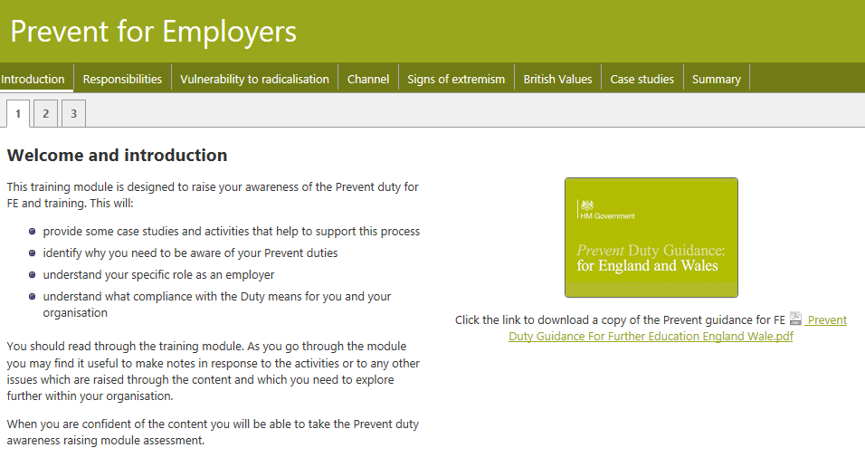

name of contact:

.............................................................
T: add telephone number
M: add mobile number
E: add email
W: add web address

Talk to our Safeguarding Team call/txt add mobile number
E: add email

