

SUPPORTING HOLISTIC DELIVERY OF CORE CONTENT AND OCCUPATIONAL SPECIALISM CONTENT
ET-FOUNDATION.CO.UK
T LEVEL IN DESIGN, SURVEYING AND PLANNING FOR CONSTRUCTION

INTRODUCTION
This Framework for Learning (FfL) provides a series of lessons that will develop learners’ knowledge and skills of construction planning techniques. The lessons combine knowledge and skills from the Core Content and Occupational Specialism to help bridge the gap between these elements of the T Level in design, surveying and planning for construction. The FfL builds on prior knowledge and scaffolds activities through a variety of construction contexts to help learners understand the complexities of construction planning.
Planning of construction projects is a fundamental skill that the construction industry relies on for the efficient delivery of projects. The evolution of the construction industry requires technicians with the skills to respond to increasing demands placed on contractors and developers to meet deadlines effectively. This resource will help learners develop the skills to effectively select, produce, synthesise and evaluate planning techniques and tools commonly used in the construction industry. These skills are assessed during both the Employer-set project and the Occupational Specialism assessments.
The sessions provide a variety of activities and learning experiences to help build the confidence of learners in the production of planning tools for construction projects. A wide range of planning tools are used within the industry and these lessons primarily look at three of the most common ones:
- Gantt charts
- line of balance
- critical path analysis.
While undertaking the lessons, learners will complete a range of tasks that will help develop skills in:
- digital production of tools
- collaboration
- synthesising information
- evaluation.
This resource has three sections:
Framework for learning
The resource includes a FfL. This covers 20 hours of learning and there is a diagram to show how the content has been sequenced and scaffolded across these hours. There is also a narrative that explains the sequencing and scaffolding in more detail.
Lesson plans
There is a lesson plan for each stage in the sequencing and scaffolding of learning in the FfL. Lesson plans include details of the support materials that are required to support delivery, including those found in this resource.
Support materials
The support materials identified in the lesson plans are also available at the end of this document.
NOTE:
There is a separate slide deck that can be used with the lessons.

SECTION 1: FRAMEWORK FOR LEARNING
This FfL sets out one approach to scaffolding and sequencing the development of planning and analytical skills in a range of construction contexts. The resource is designed to provide a holistic approach to learning, integrating Core Content with a Performance Outcome. This resource specifically supports the development of the following:
Occupational specialism: Design, surveying and planning for construction
Performance Outcome 2: Analyse the built environment
- 2.1 Analysis of construction process
  - S2.2 Analyse information available to determine requirements of the task.
- 2.2 Production of planning documentation for the construction process
  - S2.1 Sequence and prioritise tasks.
Core Content area 1: Health and safety
1.4.3 The benefits of undertaking safety reviews, including:
- reduction in costs
- improved reputation of the company
- improved employee morale
- improved performance in terms of production.
Core Content area 13: Project management
- 13.1.2 Principles of project management – goals, objectives, milestones.
- 13.3.2 Interpretation and production of project management tools and documentation; planning and management tools.
This resource will specifically focus on the development of planning skills using Gantt charts, critical path analysis and line of balance planning and management tools.
Sequencing and scaffolding
The FfL is based on four phases of learning which are designed to integrate understanding of project management with the development of analytical and planning skills in the context of construction. The applied purpose is to be able to effectively plan construction projects using project tools.
There are 10 two-hour lessons, which are designed to be delivered in order.

There are four phases of learning as follows:
Phase 1
This phase introduces the concept of planning and the reasons why planning is critical to success within construction. This phase introduces the key areas of project management and starts to develop analytical skills by looking at project information linked to the construction of buildings and the factors that affect the success of planning projects. There are three lessons in this phase.
Phase 2
This builds on Phase 1, bringing in complex construction building project requirements to support the development of planning and analytical skills. The information in these lessons is more detailed to support the skill of effectively analysing information. This phase develops logical thinking skills, building on the knowledge of planning activities involved in construction and extending the thinking to include sequencing of project activities. This phase also considers the interaction between activities, where there is potential overlap. This is designed to extend learners’ thinking about the sequencing of planning activities. This phase introduces planning and management tools. Learners will learn how to use Gantt charts, line of balance tools and critical path analysis for given case studies. There are three lessons in this phase.
Phase 3
Learners will build on the learning developed in phases 1 and 2. This phase will apply understanding of the merits of Gantt charts, line of balance tools and critical path analysis so that learners select the correct planning and management tool rather than being directed which tool to use. Learners will develop evaluative skills through reviewing the effectiveness of planning and management tools used for specific projects and learn how to convert plans between different tools. The use of more complex case studies will further develop analytical skills. There are three lessons in this phase.
Phase 4
This is the final phase, which has been designed as the formative assessment lesson bringing together all the learning stages. This phase is designed to check that learners can effectively plan construction projects using project tools. There is one lesson in this final phase.
Framework for Learning
The following diagram shows how the development of analytical and planning skills will be sequenced and scaffolded through this FfL. The diagram shows a visual image of the four stages of learning.

Framework for Learning: Development of planning skills for construction projects
Planning skills Effective planning skills
Analysing skills Critical analysis skills
Phase 4
Lesson 10
Planning a health and wellbeing centre

Lesson 9
Converting between different planning tools
Lesson 8
Analysing the effectiveness of planning techniques
Lesson 7
Selecting the appropriate tool for different projects
Phase 3
Phase 2
Lesson 6
Producing a critical path analysis

Lesson 4
Producing a Gantt chart
Lesson 5
Producing a line of balance
Lesson 3
Programme planning techniques

Lesson 1
The concept of planning in construction
Lesson 2
Considerations for programme planning in construction
Phase 1

Prior core learning

SECTION 2: LESSON PLANS
This section includes 10 lesson plans. The lesson plans follow the FfL. The lesson plans include the:
- lesson title
- targeted specification content coverage
- lesson number in the sequence
- total amount of time required to deliver the lesson
- teacher and learner activities to be undertaken throughout the lesson
- resources needed to deliver the lesson (see Note below)
- details of how the lesson supports the development of English, maths and / or digital skills (where appropriate)
- details of how the lesson can be adapted to meet students with specific needs
- next steps in learning such as homework activities and links to the next lesson.
Note:
There is an assumption that the learning environment will include the following:
- whiteboard/smartboard or similar
- materials to take notes, e.g. pens, paper, audio recorder, digital device and software
- equipment to present a slide deck and video, e.g. projector, smartboard
- digital devices (e.g. laptop, tablet) for all learners
- internet access
- learner access to word-processing, spreadsheet and presentation software.
Note to teacher:
Some of the resources have examples of planning tool formats shown in landscape. It would be advisable to print these on A3 paper.

Lesson 1
Title: The concept of planning in construction
Targeted content reference:
4.1.1 On-site construction methods and 4.1.2 Off-site construction methods – in context of construction planning.
12.6.1 Key performance indicators (KPIs) overview including their use with target setting.
13.1.2 Principles of project management – milestones.
13.3.1 Stages of the project management life cycle: planning – establishing project requirements (deliverables, delivery dates), resources and risk analysis.
S2.2 Analyse information available to determine requirements of the task.
Lesson sequence number: 1
Timing: 2 hours
Prior learning:
- Awareness of 4.1.1 On-site construction methods and 4.1.2 Off-site construction methods.
- Sequencing of construction activities for residential, commercial and industrial buildings.
- Difference between auger replacement piles and driven precast piles.
Timing | Teacher activity | Learner activity | Support materials
15 minutes | Set lesson overview and requirements of the starter task: Superstructure construction methods. Allocate class into pairs and allocate each pair one of the following construction methods:  - brick and block  - timber frame  - skeletal steel frame  - reinforced in-situ concrete  - modular construction.  Provide each pair with flipchart paper and pens. | Listen, take notes and ask clarification questions if required. | Presentation slides  Construction project scenarios  Residential construction  Commercial construction  Sticky notes  Mobile phone with camera  Plenary questions  Plenary question answers
15 minutes | Circulate, observe and ask probing questions to identify understanding. | Move into allocated pairs. Use flipchart paper to record outcomes of discussion for allocated construction method.
15 minutes | Facilitate class feedback, asking probing questions to check understanding and address misconceptions. | Share feedback with other groups, highlighting key aspects of their construction method.
30 minutes | Explain the requirements of Task: Construction project scenario. Split the class into five groups. Distribute Construction project scenarios handout, allocating each group a different scenario. | Listen, take notes and ask clarification questions if required.
30 minutes | Circulate, observe and ask probing questions to identify understanding. | Move into allocated group and undertake Task: Construction project scenario. Individually, read the Construction project scenarios. As a group, discuss the issue(s) and impacts that it has to the timeline.
30 minutes | Invite a group at a time to present their discussion points to the rest of the class. Note key points on a flipchart/whiteboard. | Provide feedback the key issue and impacts to the timeline to the rest of the class.
30 minutes | Facilitate class discussion, highlighting the points relating to overrunning of timelines. Ask probing questions to check understanding of the impact of deadline overruns. | Contribute to class discussion. Answer questions and take notes.
30 minutes | Present slides on planning construction projects and respective considerations. Provide examples and ask probing questions about the impact to the timeline of projects to check understanding of considerations for planning construction projects. Highlight that the considerations make good planning. | Listen and make notes. Respond to probing questions.
30 minutes | Organise class into small groups and set task. Distribute Residential construction handout and sticky notes. | Move into allocated group. Listen and take notes.
30 minutes | Circulate, observe and ask probing questions to identify understanding. Place flipchart paper around the room, each with a separate title as follows:  - operatives  - plant and equipment  - material storage. | Look at Residential construction images. Discuss what elements of the project will ensure a successful outcome. Write considerations on sticky notes.
30 minutes | Ask learners to place sticky notes on the correct flipchart located around the room. | Place sticky notes with considerations on relevant flipchart.
30 minutes | Ask learners to circulate around each flip chart. Facilitate a class discussion about the considerations noted on each flipchart, asking probing questions to check understanding and address misconceptions. | Discuss reasons for the considerations given. Answer questions asked. Take photo of each flipchart.
30 minutes | Photograph each flipchart. Share with learners at the end of the lesson.
30 minutes | Present slides on setting milestones in construction projects and KPIs. Ask probing questions to check understanding. | Listen and make notes. Respond to probing questions.
30 minutes | Organise class into pairs and set task. Distribute Commercial construction handout. Set the requirements of the task (parts 1 and 2). | Listen, take notes and ask clarification questions if required.
30 minutes | Circulate, observe and ask probing questions to identify understanding. | Read Residential construction. Individually, email allocated peer suggestions for three milestones and two KPIs for the commercial construction project.
30 minutes | Circulate, observe and ask probing questions to identify understanding. | Review peer email content.
30 minutes | Advise learners to respond to the email, providing improvements to the suggested project approach to milestone and KPIs (task part 3). | Listen, take notes and ask clarification questions if required.
30 minutes | Circulate, observe and ask probing questions to identify understanding. | Send an updated email to peer, adding improvements to the approach of milestones and KPIs.
15 minutes | Set plenary task. Distribute Plenary questions. | Listen, take notes and ask clarification questions if required.
15 minutes | Circulate, observe and ask probing questions to identify understanding. | Individually, complete Plenary questions.
15 minutes | Organise class to peer mark questions. | Swap question answers with peer.
15 minutes | Distribute model Plenary question answers for marking and go through expected answers with learners. Ask probing questions to check understanding and challenge misconceptions. | Mark peer answers.
15 minutes | Set next steps: Project planning research. | Listen, take notes and ask clarification questions if required.
Adaptation:
SEND: For the tasks that involve working in pairs and small groups, incorporate flexible grouping so that learners are grouped with non-SEND learners to help them to learn from their peers. For learners with vision impairments, an audio description of the project could be provided.
Extension: Additional milestones and KPIs could be added to the commercial construction email activity.
Next steps in learning:
Teacher: Share copies of the flipchart photos linked to the Construction project scenarios task
Learner homework: Project planning research covering the key considerations of planning a construction project.

Lesson 2
Title: Considerations for programme planning in construction
Targeted content reference:
4.2.2 Foundations: strip (traditional, deep, narrow, wide, stepped, reinforced), raft (edge thickening, edge beams, reinforced), pad (isolated, combined, reinforced), pile (driven, cast in situ, end bearing, friction).
4.2.3 Superstructures: frames (timber, steel, concrete, portal), roofs, floors, internal and external walls, windows and doors.
4.2.4 Internal and external walls: types (solid masonry, cavity walls, curtain walls, infill walls, structural insulated panels (SIPs), stud), openings, insulation, damp proofing, weather tightness.
13.3.1 Stages of the project management life cycle: planning – establishing project requirements (deliverables, delivery dates), resources and risk analysis.
S2.2 Analyse information available to determine requirements of the task.
Lesson sequence number: 2
Timing: 2 hours
Prior learning:
Lesson 1, plus:
- 4.2.2 Foundations: strip (traditional, deep, narrow, wide, stepped, reinforced), raft (edge thickening, edge beams, reinforced), pad (isolated, combined, reinforced), pile (driven, cast in situ, end bearing, friction).
- 4.2.3 Superstructures: frames (timber, steel, concrete, portal), roofs, floors, internal and external walls, windows and doors.
- 4.2.4 Internal and external walls: types (solid masonry, cavity walls, curtain walls, infill walls, structural insulated panels (SIPs), stud), openings, insulation, damp proofing, weather tightness.
Timing | Teacher activity | Learner activity | Support materials
15 minutes | Set lesson overview and requirements of the starter task. Organise class into pairs and ask learners to use their research from the homework task. | Listen, take notes and ask clarification questions if required. | Presentation slides  Notes from lesson 1 homework task  Teacher instruction: Linking superstructure and substructure techniques  Reasons for superstructure and substructure foundations  Sequencing of activities  Teacher instruction: Ordering of construction project activities  Group A cards  Group A scenario  Group B cards  Group B scenario  Factors affecting planning
15 minutes | Circulate, observe and ask probing questions to identify understanding. | Present feedback to peer on the appropriateness of:  - milestones  - operatives required  - activities undertaken  - plant and equipment required  - materials needed for the project  Repeat and suggest any improvements to peer.
45 minutes | Present substructure techniques. | Listen, take notes and ask clarification questions if required.
45 minutes | Organise class into pairs and set task. Refer to Teacher instruction: Linking superstructure and substructure techniques. Hand out cards to each pair. | Listen, take notes and ask clarification questions if required.
45 minutes | Circulate, observe and ask probing questions to identify understanding. | In allocated pair, complete the card sort, linking possible foundation types that are suitable for use with different superstructure techniques. Discuss choices and make notes.
45 minutes | Allocate each pair with another pair. Advise learners to present card choice matches to peer pair and then compare similarities and differences. | Listen, take notes and ask clarification questions if required.
45 minutes | Circulate, observe and ask probing questions to identify understanding. | Present reasons for choice of card sort to allocated paired group.  Listen to pair feedback. Compare choices and discuss reasons for differences.
45 minutes | Distribute Reasons for superstructure and substructure foundations. Explain task. Advise that this is an individual task, and it needs to be submitted once complete. Advise that it will be marked by the teacher and handed back next lesson. | Listen, take notes and ask clarification questions if required.
45 minutes | Circulate, observe and ask probing questions to identify understanding. | Complete the Reasons for superstructure and substructure foundations handout.  Hand it in to the teacher for marking.
45 minutes | Present slides on sequencing of construction activities and order of activities. | Listen, take notes and ask clarification questions if required.
45 minutes | Distribute Sequencing of activities handout. | Read handout.
45 minutes | Organise class into two groups and set task. Refer to Teacher instruction: Ordering of construction project activities. Distribute the Group A cards and Group A scenario to one group and the Group B cards and Group B scenario to the other group. | Listen, take notes and ask clarification questions if required. Move to allocated group.
45 minutes | Circulate, observe and ask probing questions to identify understanding. | As a group, discuss the activities within the allocated scenario. Decide on a sequence of activities and arrange the cards in a line accordingly. Place line on table.
45 minutes | Facilitate one group at a time to explain their reasons for their chosen sequence. | Listen, take notes and ask clarification questions if required.
45 minutes | Ask probing questions as required. | Explain the sequence, giving reasons for choice of the order of the construction line activities.  Take notes of any differences when the other group explains their sequence.
45 minutes | Present other factors that affect sequence. Distribute Factors affecting planning. Summarise key points. | Listen, take notes and ask clarification questions if required.  Read the Factors affecting planning handout.
15 minutes | Set the requirements of the plenary exam-style question. | Listen, take notes and ask clarification questions if required.
15 minutes | Circulate, observe and ask probing questions to identify understanding. | Individually, answer the exam-style question.
15 minutes | Ask learners to swap exam-style answer with a peer and mark it using the model answer. Ask learners to add how it could be improved. | Swap response to question with peer.
15 minutes | Circulate, observe and ask probing questions to identify understanding. | Mark response, adding comments which support an improvement to the answer.  Hand back to peer and answer any peer questions relating to the improvements.
15 minutes | Set next steps. | Listen, take notes and ask clarification questions if required.
Adaptation:
SEND: For dyslexic learners who find sequencing difficult, an adapted set of cards can be given. The cards can be divided into four subsets of five cards rather than 20 cards to help with organisation skills.
Extension: The Sequencing of activities task could be differentiated so that stronger learners have more cards to organise and present. This task could also allow learners to explain other aspects, such as trades or storage required.
Next steps in learning:
Teacher: Mark Reasons for superstructure and substructure foundations and provide feedback.
Learner homework: Produce a job advert that requests an employee to undertake project planning for construction. Identify the essential and desirable qualities that this person will need to be effective in the role. Advise learners to take notes as these will be used in the next lesson.

Lesson 3
Title: Programme planning techniques
Targeted content reference:
13.3.1 Stages of the project management life cycle.
13.3.2 Interpretation and production of project management tools and documentation; planning and management tools – Gantt charts, bar charts, critical path analysis, line of balance and suitable planning software.
S2.1 Sequence and prioritise tasks. Learners will plan and programme construction activities for small and medium-sized developments using the following: long- and short-term programmes, types of reporting: critical path, activity lists, Gantt charts, activity lists, schedules.
S3.1 Identify information and data required to complete the task. Learners will understand how designs are prepared, including design briefs, work stages, schedules, specifications, recommendations and programs. Key considerations: programmes.
Lesson sequence number: 3
Timing: 2 hours
Prior learning:
Lessons 1 and 2.
Timing | Teacher activity | Learner activity | Support materials
15 minutes | Set lesson overview and recap findings from homework activity. | Listen, take notes and ask clarification questions if required. | Presentation slides  Use a Gantt chart to plan a construction project  Use a line of balance to plan a construction project  Use a critical path analysis to plan a construction project
15 minutes | Conduct whole-class discussion and ask learners to summarise essential and desirable qualities. Summarise learner key points discussed on a whiteboard/flipchart. | Contribute to class discussion and provide feedback on essential and desirable qualities.  Make notes.
15 minutes | Ask learners to hand in job advert to be marked. | Hand in job adverts.
15 minutes | Ask learners which personal planning techniques they use. Summarise on whiteboard/flipchart. | Contribute to class discussion on planning techniques used.  Make notes.
30 minutes | Present slides on programme planning techniques used for construction projects. Explain that these are the common forms used. Provide example using Gantt. | Listen, take notes and ask clarification questions if required.
30 minutes | Organise class into small groups and set task. Distribute Use a Gantt chart to plan a construction project. | Listen, take notes and ask clarification questions if required. Move to allocated group.
30 minutes | Circulate, observe and ask probing questions to identify understanding. | In allocated group, complete task related to Use a Gantt chart to plan a construction project.
30 minutes | Invite a group at a time to present their discussion points to the rest of the class. Note key points on a flipchart/whiteboard. | Provide feedback on the discussion points to the rest of the class.  Take notes.
30 minutes | Present line of balance slides. | Listen, take notes and ask clarification questions if required.
30 minutes | Organise class into new groups and set task: Using a line of balance to plan a construction project. Distribute Use a line of balance to plan a construction project. | Listen, take notes and ask clarification questions if required.
30 minutes | Circulate, observe and ask probing questions to identify understanding. | In allocated group, complete task related to Use a line of balance to plan a construction project.
30 minutes | Invite a group at a time to present their discussion points to the rest of the class. Note key points on a flipchart/whiteboard. | Provide feedback on the discussion points to the rest of the class.  Take notes.
30 minutes | Present critical path analysis slides. | Listen, take notes and ask clarification questions if required
30 minutes | Organise class into new groups and set task: Use a critical path analysis to plan a construction project. Distribute Use a critical path analysis to plan a construction project. | Listen, take notes and ask clarification questions if required.
30 minutes | Circulate, observe and ask probing questions to identify understanding. | In allocated group, complete task Use a critical path analysis to plan a construction project. Provide feedback on the key issues and impacts to the timeline to the rest of the class.
30 minutes | Invite a group at a time to present their discussion points to the rest of the class. Note key points on a flipchart/whiteboard. | Provide feedback on the discussion points to the rest of the class.  Take notes.
15 minutes | Summarise the key points of all three planning techniques.  Present use of planning techniques used in construction slides. | Listen, take notes and ask clarification questions if required.
15 minutes | Set plenary exam-style question. | Listen, take notes and ask clarification questions if required.
15 minutes | Circulate, observe and ask probing questions to identify understanding. | Answer question. Hand in to teacher to be marked once complete.
15 minutes | Set next steps. | Listen, take notes and ask clarification questions if required.
Adaptation:
SEND: For learners with visual impairments, changes could be made to the format of the programming tool layout examples, e.g. using braille, large print or audio descriptions. Consider using braille representations of the Gantt, line of balance and critical path analysis.
Extension: For the Gantt activity, learners could explain how the Gantt chart can be used to organise the operatives and materials required.
Next steps in learning:
Teacher: Mark the job adverts and provide feedback.
Learner homework:
Individually, research planning programme techniques used for construction projects.
Identify alternative techniques to Gantt charts, line of balance and critical path analysis.

Lesson 4
Title: Producing a Gantt chart
Targeted content reference:
13.3.1 Stages of the project management life cycle: planning – establishing project requirements (deliverables, delivery dates), resources and risk analysis.
13.3.2 Interpretation and production of project management tools and documentation; planning and management tool – Gantt charts, bar charts and suitable planning software.
S2.1 Sequence and prioritise tasks – plan and programme construction activities for medium-sized developments using Gantt charts.
S3.1 Identify information and data required to complete the task – how designs are prepared, including design briefs, work stages, specifications, recommendations and programmes.
Lesson sequence number: 4
Timing: 2 hours
Prior learning:
- Lessons 1–3.
- 11.1.1 Types of stakeholders – client, construction team, community and end user.
Timing | Teacher activity | Learner activity | Support materials
15 minutes | Set lesson overview and recap findings from homework task. | Listen, take notes and ask clarification questions if required. | Presentation slides  Guided production of a Gantt chart for a construction project  Producing a Gantt chart for a construction project
15 minutes | Ask learners what alternative techniques to Gantt charts, line of balance and critical path analysis they found. | Advise what alternative techniques were found through research.
15 minutes | Summarise key features of alternative techniques on a flipchart/whiteboard. | Listen, take notes and ask clarification questions if required.
15 minutes | Distribute mini whiteboards. Set the starter task. Advise the learners that they have two minutes to draw the Gantt chart sketch. | Listen, take notes and ask clarification questions if required.
15 minutes | Circulate, observe and ask probing questions to identify understanding. | Use mini whiteboards to produce a sketch of a Gantt chart, labelling the key features.
15 minutes | Facilitate sharing of Gantt chart sketches. Ask probing questions on features identified. | Show sketches produced and respond to questioning.
45 minutes | Present slide about what needs to be on a Gantt chart. Show Gantt chart slide with examples and point out the key inclusions. Explain how tasks interact with each other and hence why a specific arrow cannot be specifically shown.  Present well-designed Gantt chart considerations. | Listen, take notes and ask clarification questions if required.
45 minutes | Ask learners to move to computers and log into the Gantt software. Distribute Guided production of a Gantt chart for a construction project. | Log in to access Gantt chart software.
45 minutes | Advise learners that they will be individually producing a Gantt chart. Model to learners how to produce a Gantt chart. Provide step-by-step instructions, asking learners to copy each stage as instructed. Refer to Guided production of a Gantt chart for a construction project for stages. | Listen, follow teacher instructions and produce a Gantt chart. Refer to Guided production of a Gantt chart for a construction project. Ask clarification questions if required.
45 minutes | Facilitate class discussion. Ask learners what makes an effective Gantt chart. Record key points raised on a flipchart/whiteboard. | Participate in whole-class discussion.  Make notes, asking clarification questions if required.
45 minutes | Distribute Producing a Gantt chart for a construction project. Set the requirements of the individual task. | Listen, take notes and ask clarification questions if required.
45 minutes | Circulate, observe and ask probing questions to identify understanding. | Read Producing a Gantt chart for a construction project. Produce a Gantt chart for the halls of residence project.
45 minutes | Present communication and collaboration slides. Ask probing questions to check understanding. | Listen, take notes and answer questions as directed.
45 minutes | Allocate pairs to work together. Set the requirements of the task – to peer review the Gantt charts produced. | Listen, take notes and ask clarification questions if required.  Move into allocated pair.
45 minutes | Circulate, observe and ask probing questions to identify understanding. | In allocated groups, review peers’ Gantt chart. Provide feedback against key considerations.
15 minutes | Set the requirements of the plenary task. | Listen, take notes and ask clarification questions if required.
15 minutes | Circulate, observe and ask probing questions. | Compare both Gantt charts produced. Update extension to the halls of residence project Gantt chart.  Email to teacher for review.
15 minutes | Set next steps. Allocate pairs. Advise learners that they are required to share their reasons for choice in the next lesson. | Listen, take notes and ask clarification questions if required.
Other:
English: How to communicate using Gantt charts and collaborating with stakeholders.
Digital: Designing and creating documents and digital media through the demonstration and modelling of Gantt chart for the university lecture hall. Learners design and create own Gantt chart following modelling.
Adaptation:
SEND: Ensure Gantt chart software is accessible, including options for screen readers, closed captions, adjustable fonts and colour contrast. Use assistive technologies like text-to-speech software, digital note taking aids and dyslexia-friendly fonts.
Extension: Learners could be guided to add milestones for distinct phases of the project when modelling the university lecture hall. Learners could then apply this as an extension when completing the Producing a Gantt chart for a construction project task.
Next steps in learning:
Teacher: Mark the Gantt charts produced and extension to the halls of residence project Gantt chart. Provide feedback.
Learner homework: Research different software products available for producing Gantt charts. Identify what Gantt software product looks the best for construction projects.

Lesson 5
Title: Producing a line of balance
Targeted content reference:
13.3.1 Stages of the project management life cycle: planning – establishing project requirements (deliverables, delivery dates), resources and risk analysis.
13.3.2 Interpretation and production of project management tools and documentation; planning and management tool – line of balance and suitable planning software.
S2.1 Sequence and prioritise tasks – plan and programme construction activities for medium-sized developments using line of balance.
S3.1 Identify information and data required to complete the task – how designs are prepared, including design briefs, work stages, specifications, recommendations and programmes.
Lesson sequence number: 5
Timing: 2 hours
Prior learning:
Lessons 1–4.
Timing | Teacher activity | Learner activity | Support materials
15 minutes | Set lesson overview and recap findings from homework task. | Listen, take notes and ask clarification questions if required. | Presentation slides  Guided production of a line of balance for a construction project  Producing a line of balance for a construction project
15 minutes | Facilitate class discussion. Ask each pair to share preferred software product to produce Gantt charts in construction. | Share with the rest of the class the software product which appears the best for producing Gantt charts in construction, giving reasons for choice.
15 minutes | Summarise key features of software that can produce Gantt charts suitable for construction projects on a flipchart/whiteboard. | Listen, take notes and ask clarification questions if required.
45 minutes | Ask learners to individually define the term ‘plot’ in the context of construction. | Listen, take notes and ask clarification questions if required.
45 minutes | Circulate, observe and ask probing questions. | Define the term ‘plot’.
45 minutes | Share slide with definition of ‘plot’. Facilitate class discussion, asking learners to share their own definitions. | Compare with own definition. Make notes.
45 minutes | Present slide about what needs to be on a line of balance.  Present advantages of using line of balance. | Listen, take notes and ask clarification questions if required.
45 minutes | Ask learners to move to computers and log into the line of balance software. Distribute Guided production of a line of balance for a construction project. | Log in to access line of balance software.
45 minutes | Advise learners that they will be individually producing a line of balance. Model to learners how to produce a line of balance. Include an example of how to edit software to determine lines for each task and interaction between lines. Provide step-by-step instructions, asking learners to copy each stage as instructed. Refer to Guided production of a line of balance for a construction project for stages. | Listen, follow teacher instructions and produce a line of balance. Refer to Guided production of a line of balance for a construction project. Ask clarification questions if required.
45 minutes | Facilitate class discussion. Ask learners what makes an effective line of balance. Record key points raised a flipchart/whiteboard. | Participate in whole-class discussion.  Make notes, asking clarification questions if required.
45 minutes | Distribute Producing a line of balance for a construction project. Set the requirements of the individual task. | Listen, take notes and ask clarification questions if required.
45 minutes | Circulate, observe and ask probing questions to identify understanding. | Read Producing a line of balance for a construction project. Produce a line of balance for the fruit and vegetable producer’s eight new storage units.
45 minutes | Organise class into small groups. Set the requirements of the peer review task. | Listen, take notes and ask clarification questions if required.  Move into allocated group
45 minutes | Circulate, observe and ask probing questions to identify understanding. | Discuss own line of balance with peers in allocated group.  Provide peer feedback about peer line of balances against key considerations.
15 minutes | Set the requirements of the plenary task. | Listen, take notes and ask clarification questions if required.
15 minutes | Circulate, observe and ask probing questions. | Update line of balance for the fruit and vegetable producer’s eight new storage units.  Email to teacher for review.
15 minutes | Set next steps. Explain it is an individual task. | Listen, take notes and ask clarification questions if required.
Other:
Digital: Developing skills to design, create and edit documents and digital media through the demonstration and modelling of line of line of balance. Learners design and create own line of balance following modelling and then edit the line of balance as part of the plenary task.
Adaptation:
SEND: Provide physical blank layouts of line of balance and coloured pens for learners to practise and visualise skill development before moving on to digital format. Pair with stronger learners to provide peer support for digital development.
Extension: Learners could produce the line of balance using an alternative format (e.g. format 1 as shown in the presentation).
Next steps in learning:
Teacher: Mark line of balance for the fruit and vegetable producer’s eight new storage units and provide feedback.
Learner homework: Research the limitations of using line of balance for construction projects.

Lesson 6
Title: Producing a critical path analysis
Targeted content reference:
13.3.1 Stages of the project management life cycle: planning – establishing project requirements (deliverables, delivery dates), resources and risk analysis.
13.3.2 Interpretation and production of project management tools and documentation; planning and management tool – critical path analysis and suitable planning software.
S2.1 Sequence and prioritise tasks – plan and programme construction activities for medium-sized developments using critical path analysis.
S3.1 Identify information and data required to complete the task – how designs are prepared, including design briefs, work stages, specifications, recommendations and programmes.
Lesson sequence number: 6
Timing: 2 hours
Prior learning:
Lessons 1–5.
Timing | Teacher activity | Learner activity | Support materials
15 minutes | Set lesson overview. Organise class into small groups and ask learners to discuss findings from homework activity. Learners to discuss the limitations of the line of balance for construction projects. | Listen, take notes and ask clarification questions if required.  Move into allocated groups. | Presentation slides  What Is Critical Path Analysis? (YouTube)  Guided production of a critical path analysis for a construction project  Producing a critical path analysis for a construction project  A3 paper
15 minutes | Circulate, observe and ask probing questions to identify understanding. | Discuss limitations for use of line of balance for construction projects.
15 minutes | Facilitate feedback. Summarise key limitations for the use of line of balance for construction projects on a flipchart/whiteboard. | Listen, take notes and ask clarification questions if required.
45 minutes | Show learners video – What is critical path analysis (4.42 minutes). | Watch and take notes.
45 minutes | Present slides about what elements need to be included in a critical path analysis and the advantages of their selection for planning construction projects. | Listen, take notes and ask clarification questions if required.
45 minutes | Distribute Guided production of a critical path analysis for a construction project. Distribute A3 paper. Ask learners to complete stage 1 of the activity, where they arrange the tasks on a piece of A3 paper. | Listen, take notes and ask clarification questions if required.  Listen, follow teacher instructions and produce a sequence of activities for preparation of a critical path analysis by arranging the tasks on a piece of A3 paper. Refer to Guided production of a critical path analysis for a construction project. Ask clarification questions if required.
45 minutes | Ask learners to move to computers and log into the critical path analysis software. Advise learners that they will be individually producing a critical path analysis. Demonstrate to learners stages 2 and 3 of the task in Guided production of a critical path analysis for a construction project. Model to learners how to produce a critical path analysis. Provide step-by-step instructions, asking learners to copy each stage as instructed. Refer to Guided production of a critical path analysis for a construction project for stages. | Log in to access the critical path analysis software. Listen, follow teacher instructions and produce a critical path analysis. Ask clarification questions if required.
45 minutes | Facilitate class discussion. Ask learners what makes an effective critical path analysis. Record key points raised on a flipchart/whiteboard. | Participate in whole-class discussion.  Make notes, asking clarification questions if required.
45 minutes | Distribute Producing a critical path analysis for a construction project. Set the requirements of the individual task. Distribute A3 paper. | Listen, take notes and ask clarification questions if required.
45 minutes | Circulate, observe and ask probing questions to identify understanding. | Refer to Producing a critical path analysis for a construction project handout. Produce a critical path analysis for the construction of a new road bridge over a river.
45 minutes | Organise class into small groups. Set the requirements of the peer review task. | Listen, take notes and ask clarification questions if required.  Move into allocated group.
45 minutes | Circulate, observe and ask probing questions to identify understanding. | Discuss own critical path analysis with peers in allocated group.  Provide peer feedback about their critical path analysis against key considerations.
15 minutes | Organise class into small groups. Set the requirements of the plenary edit critical path analysis task. | Listen, take notes and ask clarification questions if required.  Move into allocated group.
15 minutes | Circulate, observe and ask probing questions. | Discuss implications of the delay to the plan. Individually, make amendments to the critical path analysis to reflect the delay. Provide feedback to group members against key considerations.  Email to teacher for review.
15 minutes | Set next steps. Allocate class into pairs. | Listen, take notes and ask clarification questions if required.
Other:
Digital: Designing, creating and editing documents and digital media.
Adaptation:
SEND: Use differentiated critical path analysis formats to improve accessibility.
Extension: Learners could consider the addition of a toll booth and barrier into the construction of the bridge, identifying the activities involved and adding it into their critical path analysis.
Next steps in learning:
Teacher: Mark the updated critical analysis path and provide feedback.
Learner homework: Apply digital skills by producing a critical path analysis with an alternative software technique for the construction of the road bridge scenario used in this session.

Lesson 7
Title: Selecting the appropriate tool for different projects
Targeted content reference:
13.3.2 Interpretation and production of project management tools and documentation; planning and management tools – Gantt charts, bar charts, critical path analysis, line of balance and suitable planning software.
S2.3 How information is applied to a project in order to develop accurate plans and programmes of work – Project programmes.
S4.2 Interpret different types of information – Project schedules.
Lesson sequence number: 7
Timing: 2 hours
Prior learning:
Lessons 4–6.
Timing | Teacher activity | Learner activity | Support materials
15 minutes | Set lesson overview. Starter quiz. Distribute Starter quiz questions. | Listen, take notes and ask clarification questions if required. | Presentation slides  Starter quiz  Starter quiz answers  Selecting planning tools for different projects  Highlighter pens  Construction project case study 1  Construction project case study 2  Exit ticket
15 minutes | Circulate, observe and ask probing questions to identify understanding. | Individually, complete Starter quiz.
15 minutes | Organise class to peer mark questions. | Swap question answers with peer.
15 minutes | Distribute Starter quiz answers for marking and go through expected answers with learners. Ask probing questions to check understanding and challenge misconceptions. | Mark peer answers using Starter quiz answers.
30 minutes | Present slides on the factors that influence the selection of planning tools for different construction projects. The slide goes up to critical path analysis. | Listen, take notes and ask clarification questions if required.
30 minutes | Present slide on tool selection ranking technique. | Listen, take notes and ask clarification questions if required.
30 minutes | Organise class into pairs. | Move into allocated pair.
30 minutes | Distribute Selecting planning tools for different projects. Set requirements of the task. | Listen, take notes and ask clarification questions if required.
30 minutes | Circulate, observe and ask probing questions to identify understanding. | In allocated pair, complete the Selecting planning tools for different projects handout. Write the reasons for choice.
30 minutes | Invite a pair at a time to present their selections and reasons for choice to the rest of the class. Note key points on a flipchart/whiteboard. | Provide feedback on the selections made to the rest of the class.  Take notes.  Hand in completed Selecting planning tools for different projects.
30 minutes | Present slide on summarising texts for key points.
30 minutes | Distribute Construction project case study 1. Set requirements of task detailed in the handout. Organise class into small groups. Distribute highlighter pens. Advise learners how to skim and scan a document. Go through the first paragraph as an example and show how to summarise salient points. | Listen, take notes and ask clarification questions if required. Individually, skim and scan Construction project case study 1 paragraph one with the teacher using a highlighter pen.  Move into allocated group.
30 minutes | Circulate, observe and ask probing questions to identify understanding. | Read remaining Construction project case study 1. In allocated group, summarise the case study and select and justify the use of planning tools. Use skimming and scanning techniques to identify key content and highlight salient points.
30 minutes | Invite a group at a time to present their summarising of the case study, the planning tool selected and justification of this. Provide feedback on learners’ summary skills. | Provide feedback on the selections made to the rest of the class.  Take notes.
30 minutes | Distribute Construction project case study 2. Set requirements of task detailed in the handout. Allocate small groups. | Listen, take notes and ask clarification questions if required.
30 minutes | Circulate, observe and ask probing questions to identify understanding. | Move into allocated group.  Individually, read Construction project case study 2.  In allocated groups, complete task. Summarise the use of a planning tools, justifying decisions.
30 minutes | Invite a group at a time to present their summarising of the case study, the planning tool selected and justification of this. | Provide feedback on the selections made to the rest of the class.  Take notes.
15 minutes | Set plenary Exit ticket task. Distribute Exit ticket. Set task requirements detailed in the handout. | Listen, take notes and ask clarification questions if required.
15 minutes | Circulate, observe and ask probing questions to identify understanding. | Individually, complete the Exit ticket.
15 minutes | Allocate learners to share answers. | Provide feedback to class on project and planning tool selected with reasoning for choice.
15 minutes | Set next steps. | Listen, take notes and ask clarification questions if required.
Other:
English: Learners can develop skills in summarising information/ideas from larger bodies of text and highlighting the salient points.
Adaptation:
SEND: To support summarising activities, images could be provided with scenarios to help visualisation of information. Promote use of mind maps and chunking to break down text content.
Extension: Learners could identify alternative project scenarios and select the most appropriate planning tool for each one.
Next steps in learning:
Teacher: Mark completed Selecting planning tools for different projects document and provide feedback.
Learner homework: Produce a simple guide to highlight the appropriate uses of Gantt charts, line of balance and critical path analysis for differing project types. Identify a minimum of three construction project types per planning tool with a summary justification for each tool.

Lesson 8
Title: Analysing the effectiveness of planning techniques
Targeted content reference:
13.3.2 Interpretation and production of project management tools and documentation; planning and management tools – Gantt charts, bar charts, critical path analysis, line of balance and suitable planning software.
S2.3 How information is applied to a project in order to develop accurate plans and programmes of work – Project programmes.
S4.2 Interpret different types of information – Project schedules.
Lesson sequence number: 8
Timing: 2 hours
Prior learning:
Lessons 1–7.
Timing | Teacher activity | Learner activity | Support materials
15 minutes | Set lesson overview. Organise class into pairs and ask learners to discuss findings from homework task. | Listen, take notes and ask clarification questions if required.  Move into allocated pair. | Presentation slides  Evaluate the effectiveness of a planning tool  Improving the effectiveness of a planning tool
15 minutes | Circulate, observe and ask probing questions to identify understanding. | Discuss appropriate uses of Gantt charts, line of balance and critical path analysis for different construction projects.
15 minutes | Summarise key appropriate uses for Gantt charts, line of balance and critical path analysis for different construction projects on a flipchart/whiteboard. | Listen, take notes and ask clarification questions if required.
45 minutes | Present two slides on considerations used to assess the effectiveness of planning tools for construction projects. | Listen, take notes and ask clarification questions if required.
45 minutes | Distribute Evaluate the effectiveness of a planning tool. Organise class into two groups – A and B. Explain the requirements of the task scenario, planning tool and tool rating pro forma. The task is detailed in the handout. Give half of the class task A (Gantt chart for motor vehicle workshop), and the other half of the class task B (Line of balance for industrial units). | Listen, take notes and ask clarification questions if required.  Move into allocated group.
45 minutes | Circulate, observe and ask probing questions to identify understanding. | Read the allocated scenario and task for the Evaluate the effectiveness of a planning tool task. In allocated group, evaluate the given planning tool against criteria, making notes on the pro forma provided.
45 minutes | Invite a group at a time to present their evaluation of the planning tool reviewed. Use nominated questioning to check understanding. Record key points raised a flipchart/whiteboard. | Provide feedback on the evaluations made to the rest of the class.  Take notes.
45 minutes | Reorganise class into two new groups. | Move into allocated groups.
45 minutes | Distribute Improving the effectiveness of a planning tool. Organise class into two groups – A and B. Explain the requirements of the task scenario, planning tool and tool rating pro forma. The task is detailed in the handout. Give half of the class task A (Critical path analysis for a sports hall) and the other half of the class task B (Gantt chart for hotel). | Listen, take notes and ask clarification questions if required.  Read Improving the effectiveness of a planning tool. In allocated group, evaluate the given planning tool against criteria, making notes on the pro forma provided.
45 minutes | Invite a group at a time to present their evaluation of the planning tool and improvements. | Provide feedback to the rest of the class on the evaluation made and suggested improvements for the planning tool.  Take notes.  Hand in to teacher for review.
15 minutes | Organise class into pairs. Set the requirements of the plenary task. Allocate small groups. | Listen, take notes and ask clarification questions if required.  Move into allocated group.
15 minutes | Circulate, observe and ask probing questions. | Create a set of 10 flashcards.  Provide feedback to group members against key considerations.
15 minutes | Set next steps. | Listen, take notes and ask clarification questions if required.
Adaptation:
SEND: To support the evaluation of planning tools activities, learners could be provided with sentence starters to support formation of evaluation statements. Learners could also be provided with a glossary of key terms.
Extension: Learners can complete both scenarios (rather than just one) in each of the tasks for evaluating the effectiveness of a planning tool or improving the effectiveness of a planning tool.
Next steps in learning:
Teacher: Mark Improving the effectiveness of a planning tool. Provide feedback.
Learner homework: Conduct research using AI on the feasibility of using more than one tool for a project in construction. Explain why more than one planning tool may or may not be used.

Lesson 9
Title: Converting between different planning tools
Targeted content reference:
13.3.2 Interpretation and production of project management tools and documentation; planning and management tools.
S2.3 How information is applied to a project in order to develop accurate plans and programmes of work – Project programmes.
S4.2 Interpret different types of information – Project schedules.
S2.2 Analyse information available to determine requirements of the task.
S2.1 Sequence and prioritise tasks.
Lesson sequence number: 9
Timing: 2 hours
Prior learning:
Lessons 1–8.
Timing | Teacher activity | Learner activity | Support materials
15 minutes | Set lesson overview. Organise class into pairs and ask learners to discuss findings from homework activity. | Listen, take notes and ask clarification questions if required.  Move into allocated pairs. | Presentation slides  Guided conversion between planning tools  Process guide for converting between planning tools  Converting between planning tools for a construction project  Exam-style question
15 minutes | Circulate, observe and ask probing questions to identify understanding. | Discuss considerations for using multiple planning tools for construction projects.
15 minutes | Summarise key considerations for using multiple planning tools for construction projects on a flipchart or whiteboard. | Listen, take notes and ask clarification questions if required.
45 minutes | Present slides on converting between planning tools and considerations. | Listen, take notes and ask clarification questions if required.
45 minutes | Ask learners to move to computers and log into the Gantt chart software. Distribute Guided conversion between planning tools. Advise learners to read the handout. | Log in to access Gantt chart software.
45 minutes | Circulate, observe and ask probing questions to identify understanding. | Read Guided conversion between planning tools.
45 minutes | Advise learners that they will be individually converting between planning tools. Model to learners the use of software to convert a critical path analysis to a Gantt chart. Show how to design and create documents and digital media through the example. Instruct learners to make notes at each stage of the process. | Listen, follow teacher instructions and produce a Gantt chart from the given critical path analysis. Ask clarification questions if required.  Make notes.
45 minutes | Distribute Process guide for converting between planning tools. Ask learners to complete the guide from the notes they made when the conversion between tools was being modelled. Advise that it is an individual task. | Listen, take notes and ask clarification questions if required.  Move into allocated pair.
45 minutes | Circulate, observe and ask probing questions to identify understanding. | Individually, complete the Process guide for converting between planning tools using the notes made during the demonstration.
45 minutes | Allocate small group. | Move into allocated group.
45 minutes | Instruct groups to compare answers and combine them to produce a group guide. | Listen, take notes and ask clarification questions if required.
45 minutes | Circulate, observe and ask probing questions to identify understanding. | In allocated group, compare guides produced and formulate a combined guide.
45 minutes | Conduct whole-class discussion and ask learners to summarise steps to formulate a whole-class guide. Use nominated questioning to check understanding. Summarise learner steps discussed on a whiteboard or flipchart. Show how to edit the documents. Ask learners to make an edit. | Contribute to class discussion, provide feedback on steps formulated and justify selections made.  Make notes.  Edit Gantt chart.
45 minutes | Distribute Converting between planning tools for a construction project. Set the requirements of the individual task detailed in the handout. | Listen, take notes and ask clarification questions if required.
45 minutes | Circulate, observe and ask probing questions to identify understanding. | Read Converting between planning tools for a construction project. Produce a Gantt chart for a motor showroom and garage.
45 minutes | Organise class into small groups. Set the requirements of the peer review task. | Listen, take notes and ask clarification questions if required.  Move into allocated group.
45 minutes | Circulate, observe and ask probing questions to identify understanding. | Present Gantt chart to allocated group. Provide peer feedback to group members against key considerations.
15 minutes | Set plenary task. Distribute Exam-style question. | Listen, take notes and ask clarification questions if required.
15 minutes | Circulate, observe and ask probing questions to identify understanding. | Answer Exam-style question. Hand in to teacher to be marked once complete.
15 minutes | Set next steps. | Listen, take notes and ask clarification questions if required.
Other:
Digital: Through the modelling of Gantt charts and the summary at the end of the task, learners will develop the skills to design, create and edit documents and digital media.
Adaptation:
SEND: When converting from one planning tool to another, learners could have additional paper copies of formats and layouts used to develop and visualise their ideas.
Extension: When converting from one tool to another, learners could consider using an alternative tool, e.g. line of balance.
Next steps in learning:
Learner homework: Revise lessons 1–9 in preparation for the formative lesson 10.

Lesson 10
Title: Planning a health and wellbeing centre
Targeted content reference:
S2.2 Analyse information available to determine requirements of the task.
S2.1 Sequence and prioritise tasks.
13.1.2 Principles of project management – milestones.
13.3.2 Interpretation and production of project management tools and documentation; planning and management tools.
Lesson sequence number: 10
Timing: 2 hours
Prior learning:
Lessons 1–9.
Timing | Teacher activity | Learner activity | Support materials
20 minutes | Set lesson overview and requirements of the task. Distribute Case study: Health and wellbeing centre. Explain it is an individual task. | Listen, take notes and ask clarification questions if required. | Presentation slides  Case study: Health and wellbeing centre  Client and project brief: Health and wellbeing centre  Planning tool  Peer review feedback criteria sheet  Exam-style question  Model answer
20 minutes | Circulate, observe and ask probing questions to identify understanding. Advise learners who complete the task early of the extension task. | Individually, read Case study: Health and wellbeing centre. Identify on-site construction activities within the project.
20 minutes | Circulate, observe and ask probing questions to identify understanding. | Individually, sequence the construction activities for the building of a health and wellbeing centre.
20 minutes | Facilitate feedback from learners. Note the on-site construction activities as a list on a flipchart or whiteboard. | Provide feedback to the class, listen and ask questions.
50 minutes | Distribute Client and project brief: Health and wellbeing centre. Explain the requirements of the task detailed in the handout. | Listen, take notes and ask clarification questions if required.
50 minutes | Circulate, observe and ask probing questions to identify understanding and tackle misconceptions. | Read Client and project brief: Health and wellbeing centre. Individually, select an appropriate planning tool.  Produce a plan for the construction of a health and wellbeing centre (Phase 3).
30 minutes | Organise class into pairs and set task: peer review. Distribute Peer review feedback criteria sheet. | Listen, take notes and ask clarification questions if required. Move into allocated pair.
30 minutes | Circulate, observe and ask probing questions to prompt salient feedback. | Individually, review peer’s project programme plan using the Peer review feedback criteria sheet.
30 minutes | Circulate to ensure learners are clear about the requirements of the task. | Read peer feedback and clarify any questions relating to peer feedback.
30 minutes | Organise the class into small groups. Allocate two pairs together. Explain the requirements of the peer review task. | Listen, take notes and ask clarification questions if required. Move to be with new allocated pair.
30 minutes | Circulate, observe and ask probing questions to prompt salient feedback. | Discuss feedback as a group, comparing approaches and suitability of each project programme plan. Select the most effective plan and discuss reasons for choice.
30 minutes | Facilitate class discussion about the effectiveness of the plans. Ask probing questions about the ordering, interaction of activities and consideration of factors identified in the scenario. | Contribute to class discussion. Answer questions.  Hand in completed Gantt chart to teacher.
20 minutes | Set plenary and distribute Exam-style question. Advise learners that this will be completed independently. | Listen, take notes and ask clarification questions if required.
20 minutes | Circulate to ensure learners are clear about the requirements of the task. | Answer Exam-style question.
20 minutes | Allocate class into pairs. Distribute Model answer. Ask pair to swap answers and then mark their peer response, adding improvements. | Mark peer response and add any improvements using Model answer. Give peer marked answer.
20 minutes | Highlight what would make a good response. | Listen, take notes and ask clarification questions if required.
20 minutes | Summarise the learning and next steps. | Listen, take notes and ask clarification questions if required.
Adaptation:
SEND: For the peer review task, incorporate flexible grouping so that learners are grouped with non-SEND learners to help them to learn from their peers.
When learners are using the planning and management tools to develop a plan, consider magnification tools to enlarge text on the screen for better visibility, especially as some planning tools have a lot of information which can be difficult to read.
Extension: During the starter task, ask learners to consider a further five activities linked to the Case study: Health and wellbeing centre.
Next steps in learning:
Teacher: Mark the Gantt chart and provide feedback.
Learner homework: Produce a personal plan to further improve construction planning skills.

SECTION 3: LESSON SUPPORT MATERIALS
This section includes the handouts, worksheets, templates and case study materials referred to in the Support materials section of each lesson plan.
It is recommended that the landscape images of planning tools are printed on A3 paper to ensure that they are easy to read.

The following materials relate to lesson 1: The concept of planning in construction

Construction project scenarios
Scenario 1
A contractor has been selected to undertake the construction of a new railway station for a major town. During the substructure phase, parts of the site have ground conditions that vary from the ground survey conducted during the design phase of the project. Areas of weaker loose sand and silt have been found during excavation. The architect and structural engineer have observed these issues and have decided on a redesign of the substructure foundations for the whole project. This now involves using auger replacement piles instead of driven precast piles. These will be drilled to a much greater depth to a stratum below the weaker soil identified.
Scenario 2
A large housing developer has acquired a plot of ground where they have planned to build 90 homes, including detached and semi-detached houses for rental and private sale. The company exclusively employ subcontracted operatives to undertake all the construction work. During the 12-month project, there has been a significant upturn in the financial climate and many more housing developments have started in the area.
Scenario 3
A contractor has undertaken a bespoke project for a discerning client for the construction of a large residential property. Despite full plans and specifications being produced at the start of the project, the client is regularly making alterations to the design and specification.
Scenario 4
A developer has won a contract for a large inner-city office space development. The site is located in between two existing office blocks. Access is restricted to a narrow lane and parking is only available on the main road outside the site boundary. There are restrictions on the times when deliveries can be made. There will be no exterior space available once the development starts.
Scenario 5
A contractor had begun work on a refurbishment project for a large office block. The contract includes internal alterations to office spaces, fitting of new demountable partitions, internal doors and glazing, services and new floors. The work is to be undertaken while the office building is occupied and will involve relocating occupants into other offices while the work is carried out. Limited number of operatives are allowed on site at any one time.

Residential construction
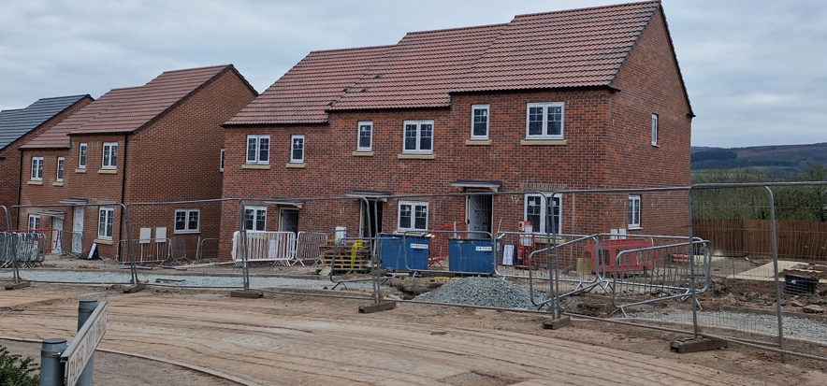
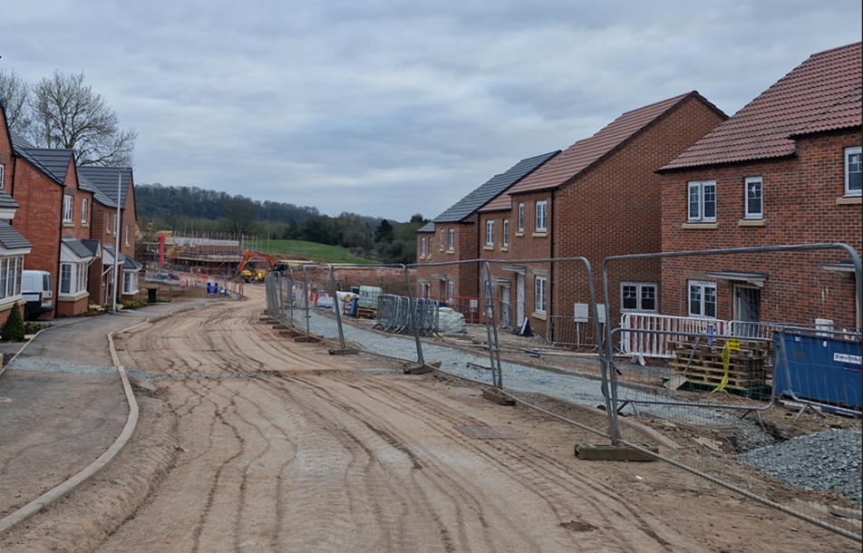
Source: Author

Commercial construction
A contractor has won a tender to build a new arena in a city centre. The planned deadline for construction is 12 months. The arena has a test event scheduled and other concerts and sports events bookings within one month of the construction deadline.
The concerts are high-profile performers who have booked the new arena as it has been sold as a state-of-the-art venue.
The first sports event to be held is an international event. The arena development was a factor in the success of the bid to host the international sporting event.
The arena will be of steel frame construction. It will be rectangular and accommodate an indoor running track and seating for up to 20,000.
The structure of the façade will be of a composite panel. The building features will include:
- enclosed space with walls and a roof
- a central area with primary space for events
- tiered seating that surrounds the central area, allowing for good visibility
- advanced lighting and sound systems to enhance the event experience
- other areas including restrooms, food and beverage service areas, a merchandise shopping area, office space, two corporate and hospitality suites and backstage changing areas.

Plenary questions
Question 1
Explain why storage needs to be considered when planning the construction of a residential housing project.
Question 2
Explain two possible factors that could cause a pre-school classroom extension block to run past its deadline.
Question 3
A large contractor is building a new critical care wing at a local hospital.
Suggest five milestone phases which could be used for the onsite construction of the project.
Propose one input KPI that could be used to effectively manage the project.

Plenary question answers
Question 1
Explain why storage needs to be considered when planning the construction of a residential housing project.
Answer:
Residential housing construction will require a lot of differing materials during the construction phase so the space available needs to be carefully planned because they could get damaged. Some materials are prone to damage from poor storage because the weather can affect them. For example, water ingress or frost damage can set cement if it is stored incorrectly. As some materials are expensive, they can be prone to being stolen from a site if it is left unsecured.
Question 2
Explain two possible factors that could cause a pre-school classroom extension block to run past its deadline.
Answer:
Weather: extreme cold weather can delay working, including work involving concrete and mortar as it will not set in freezing conditions.
Other examples could include lack of operatives, lack of materials, lack of plant and equipment, lack of information (drawings and specification), accidents and substructure issues (problems with ground conditions, hidden services, etc.).
Question 3
A large contractor is building a new critical care wing at a local hospital.

Suggest five milestone phases which could be used for the onsite construction of the project.

Propose one input KPI that could be used to effectively manage the project.
Answer:
Milestone examples:
Substructure (excavation, drainages and foundations), main superstructure (steel frame, brick and block, etc.), roof, internal fitting out, services, decorating and finishing, external works (roads, pavements, landscaping, etc.).
KPI examples:
Resource requirements (operatives, plant and equipment, materials), additional resource, e.g. training for operatives.

The following materials relate to lesson 2: Considerations for programme planning in construction

Teacher instruction: Linking superstructure and substructure techniques
For each pair: cut into individual cards. Give each pair one set of the superstructure type cards and six sets of the foundation type cards. Pairs then select foundations options for each superstructure type.
Superstructure type | Foundation type
Brick and block construction | Strip foundation
Timber frame construction | Reinforced strip foundation (wide strip)
Steel skeletal frame construction | Pile foundation
Steel portal frame construction | Pad foundation
Reinforced concrete (in-situ) | Raft foundation
Modular and pod

Reasons for superstructure and substructure foundations
Brick and block construction
Suitable foundation types | Reasons for selection

Timber frame construction
Foundation type/s suitable | Reasons for selection

Steel skeletal frame construction
Foundation type/s suitable | Reasons for selection

Steel portal frame construction
Foundation type/s suitable | Reasons for selection

Reinforced concrete (in-situ)
Foundation type/s suitable | Reasons for selection

Modular and pod
Foundation type/s suitable | Reasons for selection

Sequencing of activities
Sequencing activities in construction projects helps achieve timely and safe completion of projects.
Site set-up
The priority here is to set up the site to be safe and efficient. The first element is security fencing to prevent illegal access and keep members of the public safe. This will then be followed by the site offices and welfare facilities. Designated walkways and vehicle routes will be set out for efficient and safe manoeuvring around the site. Locations for storage will be set up that suit the site access, transport routes and locations for construction activities.
Setting out
The next stage of a project is to set out the position of the buildings being constructed. This will accurately identify where the substructure activities will be undertaken.
Substructure
This stage will involve the excavation and installation of the selected foundation for the project and the buried services, including gas, water supply and drainage, that will serve the building.
Superstructure
Once the substructure element is completed, work will start on the superstructure. The first objective is to form the structural framework of the building with the selected construction method. If a separate construction technique is selected for the roof, then this will be the next phase of the project.
Once the roof covering and external doors and windows are completed, this will achieve a ‘dry envelope’, a relatively watertight building where internal activities can now begin.
Internal activities
Depending on the designs, there will be a multitude of activities that will be undertaken inside buildings. Floors and internal walls are considered first, but these will have to be combined with services that need to be hidden. These will include plumbing, electrical and telecommunication systems. These activities are usually deemed to be ‘first fix’ as they need to be done before being covered up. These services are then hidden under floor coverings and behind wall coverings. This is common in residential buildings to ensure neatness, but other projects, such as commercial buildings, may incorporate false ceilings that can be easily accessed for maintenance. Some builds now leave services on show to cut costs. Stairs are also installed first to allow easier access to upper levels.
Where coverings are used, the subsequent activities are deemed ‘second fix’. These will be the elements visible in the finished building, such as sanitary ware, sockets, doors, architrave, skirting, units and fitments.
The last part of the internal work will be finishing elements such as floor coverings, tiling and decoration for walls and ceilings. These will begin when most of the larger tasks have been completed to prevent damage to these finishes.
External works
This will relate to activities such as landscaping, roads and paths. These will take place towards the end of the contract, when most other activities have been completed. Large plant and other resources, such as scaffolding and skips, will now be removed from the site. The storage spaces can then be removed and landscaped.
Handover
This stage is the end of the project, where final checks will be made on the conformity and quality of the project. Defects will be corrected, and testing and commissioning of systems will be undertaken. Final certification will be obtained from external bodies such as the Local Authority Planning and Building Regulations Control, private inspector or National Housing Building Council (NHBC).

Teacher instruction: Ordering of construction project activities
Cut up cards below before lesson. Separate class into two groups and issue a set of cards to each group. Ask learners to organise them into a logical sequence for the given project.
For feedback, each group forms a line with an equal number of cards. Each learner explains the sequencing of the cards they hold and their interaction with other members of the group. Learners can also explain how the order will impact on the relevant feature of the scenario (organising materials or plant/equipment resources).

Group A cards
Set up site | First fix plumbing
Excavate foundations | First fix electrical
Pour concrete | First fix carpentry
Brick and block up to DPC | Plasterboard and skim
Installation of timber frame | Second fix plumbing
Roof trusses | Second fix electrical
Felt, batten and tile | Second fix carpentry
Brickwork | Painting and decorating
External doors and windows | Landscaping
Stairs | Handover

Group A scenario
You are assisting a project manager in the planning of a residential project. The project is to be constructed using timber frame construction with a strip foundation. The project is of two-storey construction and will have standard services and carpentry throughout, with a driveway and garden externally. In a project planning meeting, the relevant activities for the project have been decided. Your task is to arrange these into the correct order for the project so that the organisation of materials deliveries and storage can be effectively planned.

Group B cards
Set up site | Install reinforcement for first floor beams
Set out building | Concrete for first floor beams
Excavate ground for pile caps  and ground beams | Erect formwork for first floor columns
Position piles for foundation | Install reinforcement for  first floor columns
Install steel reinforcement for  pile caps and ground beams | Concrete for level first floor columns
Concrete for pile caps  and ground beams | Erect formwork for roof beams
Erect formwork for ground floor columns | Install reinforcement for roof beams
Install reinforcement for  ground floor columns | Concrete for roof beams
Concrete for ground floor columns | Beam and block floor and roof
Erect formwork for first floor beams | Handover

Group B scenario
You are assisting a project manager in the planning of a commercial project. The project is to be constructed using in-situ concrete construction with a pile foundation. The project is of two-storey construction and will have reinforced concrete pile caps, ground beams, and superstructure columns and beams. In a project planning meeting, the relevant activities for the project have been decided. Your task is to arrange these into the correct order for the project so that clear organisation of the plant and equipment can be effectively planned.

Factors affecting planning
Factors affecting the planning of labour
 | Directly employed | Subcontracted
Advantages | - Can control availability.  - Understand skills/speed.  - Easier communication. | - Flexibility of workforce size.  - Fewer additional costs.
Disadvantages | - Limited size of workforce.  - More costs to cover, e.g. holidays and sickness. | - May not always be available.  - Skills/speed harder to regulate.  - Rapport will need developing.

Factors affecting the planning of plant/equipment
 | Owning plant/equipment | Hiring plant/equipment
Advantages | - Will always be available.  - Directly employed operatives will be familiar with it.  - Can be cheaper than hiring over a longer period. | - Can be returned when not in use.  - No initial purchase cost.  - No additional costs for maintenance and repairs.
Disadvantages | - Needs storage space when not being used.  - High initial cost to purchase.  - Additional costs to maintain and repair. | - May not always be available.  - Flexibility of workforce size.  - Fewer additional costs.  - Can be more expensive over a longer period.

Factors affecting the planning of materials
 | Off-the-shelf | Purpose-made
Advantages | - Readily available.  - Choice of suppliers. | - Will meet project requirements.
Disadvantages | - May be a ‘best fit’ –  not specific. | - May need to wait for supply (lead-in times).  - Limited choice of suppliers.

The following materials relate to lesson 3: Programme planning techniques

Use a Gantt chart to plan a construction project
A contractor has won a bid to subcontract several tasks for a main contractor. The project is the construction of a two-storey office block for a private client. The office block will be constructed using traditional brick and block construction. The main contractor has provided a Gantt chart for the project (see Gantt chart below) and the company director has asked this to be reviewed to assist with the company’s planning of the project. The company will subcontract the work for the bricklaying, roof construction, first and second fix carpentry and painting/decorating.
In your allocated group:
- identify the tasks that the subcontractor has been asked to undertake
- identify the milestones shown in the Gantt chart
- discuss the appropriateness of each milestone
- discuss how the Gantt chart is used to track the timeline of the project
- assess how well the Gantt chart shows the subcontractor what tasks should have been completed before the subcontractor tasks commence.

Gantt chart for a two-storey office block for a private client
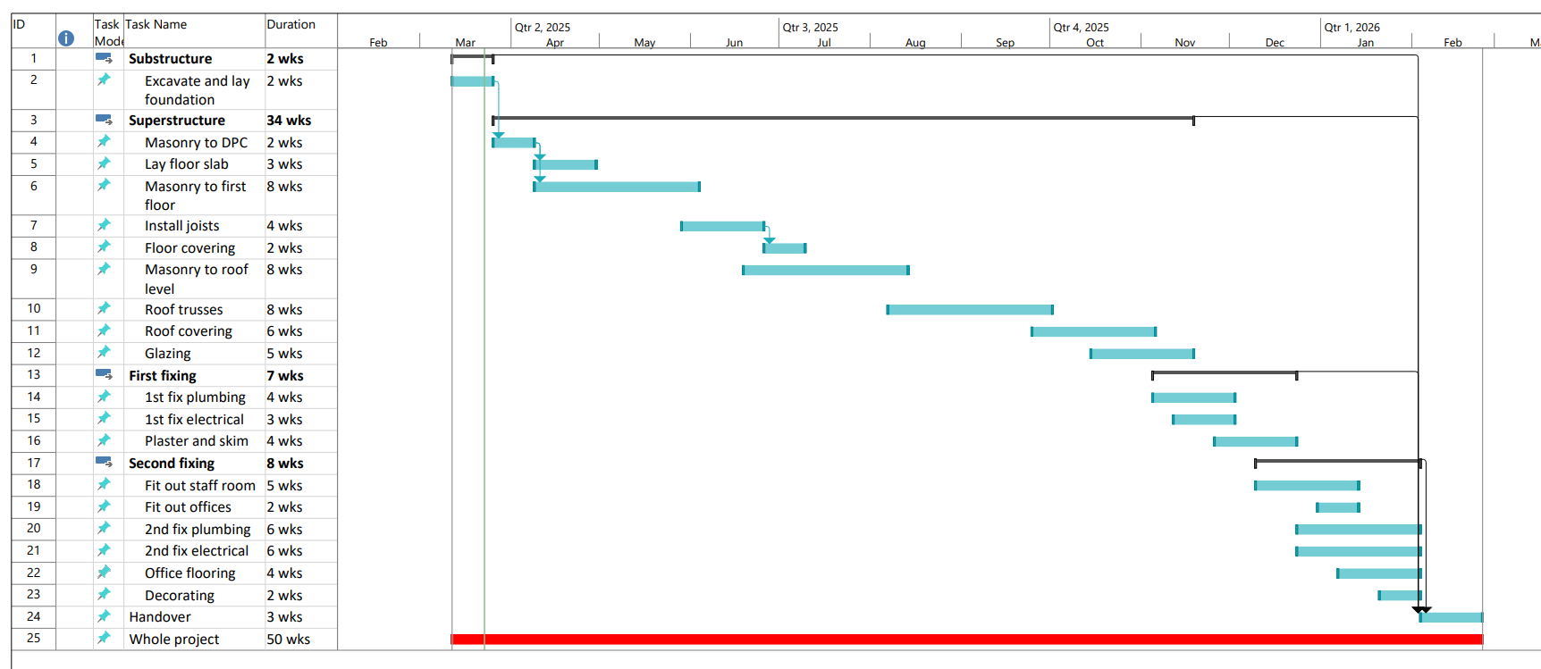
Source: Author

Use a line of balance to plan a construction project
A developer has gained planning permission to build a housing development on a plot of land it has acquired. The project will undertake the construction of 20 plots and timber frame construction will be the method of construction. The design of each plot is identical apart from a change of symmetry in their layout.
The project manager has been provided with a line of balance to plan the project and organise the resources required for the activities (see line of balance chart below). The project manager is working with a new site manager and has asked for clarification about the use of a line of balance.
In your allocated group:
- evaluate how well the line of balance will help the site manager plan repetitive activities in this project
- describe how the line of balance will show potential bottlenecks in the timeline of activities
- describe how the line of balance can be used to organise the operatives and materials required for each of the tasks.

Line of balance for a housing project
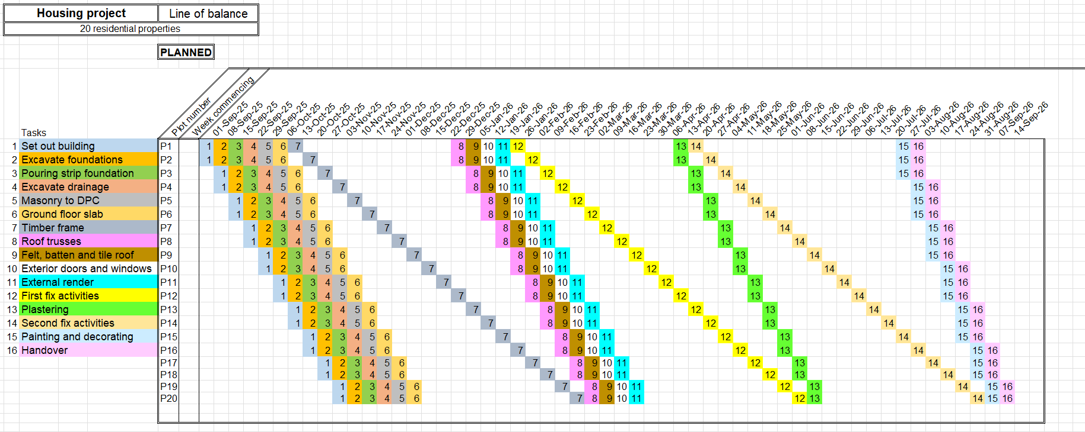
Source: Author

Use a critical path analysis to plan a construction project
A company has been selected as the main contractor to construct a new hospital for a large expanding town. This is the largest project the company has ever undertaken and it plans to use a lot of subcontracted specialists owing to the number of activities involved. The new hospital will have complex foundations combining with a variety of superstructure techniques, including reinforced concrete, steel frame and SIPS panels.
To help plan the project the contractor has employed a project management consultant. The consultant has provided the main contractor with a proposed critical path analysis planning tool to help them manage the project (see critical path analysis below). The company directors have not used this method before.
Provide feedback on the following aspects of critical path analysis which could help the company directors understand how critical path is used.
In your allocated group:
- identify the critical path for the project
- explain how the critical path can help the site manager plan unique activities in this project
- describe how the critical path can be used to organise the operatives and materials for each of the tasks that will be undertaken
- evaluate how well the timescales of float support the project.
Critical path analysis for a new hospital: Table of activities
To be used in conjunction with the Critical path analysis for a new hospital image.
Task name | Preceding tasks | Estimated duration
A - Set out buildings |  | 15 days
B - Pile foundation | A | 30 days
C - Pad foundation | A | 25 days
D - Strip foundation | A | 15 days
E - Reinforced concrete frame | B | 30 days
F - Steel frame | C | 25 days
G - Brick and block | D | 40 days
H - Lightweight block | E | 30 days
I - Cladding | F | 45 days
J - SIPS | G | 15 days
K - Windows and doors | H, I, J | 20 days
L - Offices and storage | K | 35 days
M - Waiting rooms | L | 30 days
N - Operating theatres | K | 40 days
O - Wards fit-out | N | 60 days

Critical path analysis for a new hospital

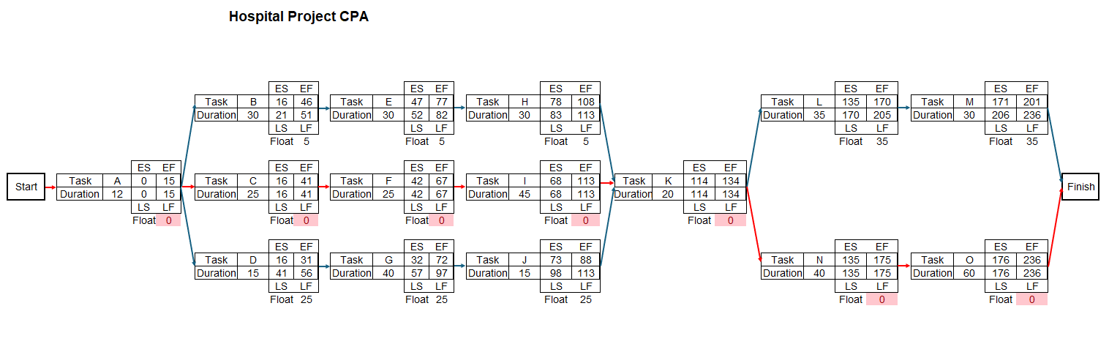
Source: Author

Key
ES – Early start
EF – Early finish
LS – Latest start
LF – Latest finish

The following materials relate to lesson 4: Producing a Gantt chart

Guided production of a Gantt chart for a construction project
A contractor has been selected to undertake the construction of a new lecture theatre for a university. The project is going to be constructed with timber glulam beams that will provide a pleasing aesthetic aspect to the building. This will be combined with smart glass windows and a striking façade using sandwich panels, incorporating the university’s logo and branding colours. These will be built onto low-level masonry walls. The theatre will include some additional study rooms and two offices for lecturers to use. There will also be toilet facilities provided in the project.
The total timeline for the project is 50 weeks.
Task
Form the activities below into a logical sequence for the programme planning of the project.
Stage 1
- Install toilet facilities (1 week).
- Install sandwich panel cladding to roof level (6 weeks).
- Handover (2 weeks).
- Construct masonry walls to low level (6 weeks).
- Install lighting and electrics (4 weeks).
- Fit out study rooms and lecturers’ office (9 weeks).
- Fit out lecture theatre with seating and lecture area (7 weeks).
- Install pitched roof structure onto glulam frame (3 weeks).
- Landscaping (6 weeks).
- Install roof coverings (5 weeks).
- Install internal walls (4 weeks).
- Excavate foundations (4 weeks).
- Install glazing (6 weeks).
- Install glulam frame (4 weeks).
- Install solid ground floor (2 weeks).
- Place concrete in foundations (2 weeks).
Stage 2
- Follow teacher demonstration to set up the format of a Gantt chart using software.
- Input activities in the logical sequence on the vertical axis.
- Identify timeline to be used on the horizontal axis (weeks).
- Plot overall timeline for the project.
Stage 3
- Follow teacher demonstration to create the complete Gantt chart.
- Input set times for individual tasks.
- Locate tasks to interact with each other.
- Locate tasks to finish within the deadline.

Producing a Gantt chart for a construction project
After successfully completing the previous contract to provide a new lecture theatre, the contractor has been successful in bidding for a new project for the university. The second project is the construction of an extension to the university halls of residence building. This is a much larger project, and it has been separated into three packages of work: one for the substructure, one for the superstructure frame and one for the building façade and fitting out to create the accommodation in the project.
The contractor has been successful in bidding for the fitting out of the building. This project will again use sandwich panel cladding on the external façade and installation of a flat roof covering to the frame. The internal fit-out will include all the walling to create rooms and the associated fixtures and fittings.
The timeline for the project is 37 weeks.
- Second fix electrics (7 weeks).
- Fit external sandwich panels (8 weeks).
- Painting and decorating (6 weeks).
- Floor coverings (3 weeks).
- Fit external doors (2 weeks).
- Fit external glazing (5 weeks).
- Electrical first fix (6 weeks).
- Install flat roof structure (3 weeks).
- Fit flat roof covering (2 weeks).
- Fit internal doors, skirting and architrave (6 weeks).
- Electrical second fix (9 weeks).
- Install metal stud partition walls (8 weeks).
- Footpaths and landscaping (6 weeks).
- Plumbing second fix (8 weeks).
- Handover (2 weeks).
- Fit reception area (3 weeks).
- Plumbing first fix (8 weeks).
- Fit out accommodation rooms (8 weeks).

The following materials relate to lesson 5: Producing a line of balance

Guided production of a line of balance for a construction project
A contractor has acquired a contract to provide new bathrooms and kitchens in a residential estate of existing properties. The client is a housing association that manages these properties, and it has commissioned the update of these properties to improve the standard of accommodation. There are 10 properties, and they are all to be occupied during the works. The client has stated that the bathrooms work must be completed first for all 10 properties as it is to provide temporary facilities on the estate for the occupants to use. The same procedure will then happen with the kitchen refurbishment. The company plans to use a line of balance to project how long the project will take to complete.
Stage 1
Form the activities below into a logical sequence for the programme planning of the project.
- New bathroom flooring (0.5 days per bathroom).
- Fitting new shower / heated towel rail / lighting (0.5 days per bathroom).
- Fit new bathroom suite (2 days per bathroom).
- Tile and paint bathroom (1 day per bathroom).
- Remove old bathroom (1 day per bathroom).
- Remove existing kitchen (1 day per kitchen).
- Fit new kitchen units (2 days per kitchen).
- Fit kitchen appliances / electrics (1 day per kitchen).
- Paint and tile kitchen (1 day per kitchen).
- Fit new kitchen flooring (0.5 days per kitchen).
- Handover (1 day per property).
Stage 2
Follow teacher demonstration to set up the format of a line of balance using software.
- Input activities in the logical sequence into the software
- Input the number of plots that the project contains.
- Identify timeline to be used on the horizontal axis (weeks).
- Plot overall timeline for the project.
Stage 3
Follow teacher demonstration to create the complete line of balance.
- Input set times for individual tasks.
- Locate tasks to link to the relative plots of the project.
- Locate tasks to finish within the deadline.

Producing a line of balance for a construction project
A contractor has been selected to construct eight storage units for a large fruit and vegetable producer. The units will all be identical and are to be constructed using steel portal frames with pad foundations. The frames will have a coated steel cladding for the walls and roof and large sliding doors on one gable end. The floor in each unit will be a reinforced concrete slab.
The fruit and vegetable client has specified that it only wants a small number of contractor operatives on site at any one time owing to the potential impact on its existing activities. This means the contractor can only have a small team of employees on site.
The company has asked for a line of balance to show the interaction of activities for the whole project. The activities include:
- Fitting sliding doors (0.5 days per unit).
- Roof cladding (2 days per unit).
- Pouring concrete floor (2 days per unit).
- External wall cladding (3 days per unit).
- Excavating of the foundation (1 day per unit).
- Erecting portal frame (2 days per unit).
- Fitting rainwater goods (0.5 days per unit).
- Pouring pad foundations (1 day per unit).
Task
Produce a line of balance for the project.

The following materials relate to lesson 6: Producing a critical path analysis

Guided production of a critical path analysis for a construction project
A developer has planned a project to construct a three-storey office building. The proposed office block building is designed to be built on pile foundations and have a ground floor parking area, reinforced with an in-situ concrete structural frame, external cladding and glazing systems, MEP (mechanical, electrical, plumbing) systems and interior finishing. The plans also include the fitting of a smoke/fire detection system and associated sprinklers to the offices.
This development is much larger than any previously undertaken. The developer is concerned that the project is more complex that those previously completed as the project will require numerous subcontractors. The developer has decided that a critical analysis will be produced to plan the project timeline.
Stage 1
Form the activities below into a logical sequence for the programme planning of the project. Write these separately on sticky notes. On an A3 piece of paper, create a draft critical path analysis diagram, creating the appropriate paths of tasks involved in the project.
- Ground floor slab (1 week).
- Handover (1 week).
- External wall construction (2 weeks).
- Exterior landscaping and paving (2 weeks).
- Pile foundation (3 weeks).
- External doors and windows (1 week).
- Underground utilities and drainage (2 weeks).
- MEP first fix (HVAC, electrical, plumbing – floors 1 to 3) (3 weeks).
- Structural frame – columns and beams (all floors) (4 weeks).
- Fire suppression and safety system installation (2 weeks).
- MEP system testing and commissioning (1 week).
- Site preparation and setting out building (2 weeks).
- Internal partitions and drywall (2 weeks).
- Roof slab and structural completion (2 weeks).
- Flooring and ceiling installation (2 weeks).
- Interior doors (1 week).
- Office fixtures and fit-out (3 weeks).
- Painting and decorating (2 weeks).
- MEP second fix (install switches, lights, AC units, etc.) (2 weeks).
Stage 2
Follow teacher demonstration to set up the format of critical path analysis using software.
- Input activities in the logically sequenced paths into the software.
- Input the data for each task, i.e. its duration.
Stage 3
Follow teacher demonstration to create the complete critical path analysis.
- Work forwards through each path from the start, identifying the earliest start time for each task on each path.
- Work backwards from the end, identifying the latest finish time for each task on each path.
- Complete each node point with latest start and earliest finish.
- Complete each node point with appropriate float time and critical path.

Producing a critical path analysis for a construction project
A contractor has been selected to build a new road bridge over a river. The bridge will be constructed using reinforced concrete and this will be cast in situ. The bridge will be supported on pile foundations with abutments where the bridge joins the existing embankment on each side. The project will incorporate additional elements that will improve the existing embankments surrounding the bridge, as well as improvement works along the river course to prevent erosion and provide better drainage.
- Final cleaning, handover and demobilisation (1 week).
- Piling and foundation works (piers and abutments) (4 weeks).
- Pier and abutment construction (4 weeks).
- Utility relocation and coordination (3 weeks).
- Concrete pouring and curing of deck (2 weeks).
- Installation of parapets and expansion joints (1 week).
- Earthworks for embankments (2 weeks).
- Site clearing and access road construction (2 weeks).
- Subgrade preparation and compaction (1 week).
- Stormwater drainage installation (2 weeks).
- Road pavement construction (asphalt or concrete) (3 weeks).
- Guardrails, signage and road markings (1 week).
- Bridge load testing and certification (1 week).
- Temporary river diversion / cofferdam installation (3 weeks).
- Final road inspection and approval (1 week).
- Environmental protection measures (silt fences, erosion control) (1 week).
- Riverbank stabilisation and landscaping (2 weeks).
- Lighting and power supply installation (2 weeks).
- Bridge deck formwork and reinforcement (2 weeks).
Task
Produce a critical path analysis for the project.

The following materials relate to lesson 7: Selecting the appropriate tool for different projects

Starter quiz
1. What is the primary purpose of a Gantt chart?
A. to calculate the budget of a project
B. to visualise task dependencies using nodes and arrows
C. to display the schedule and duration of tasks over time
D. to assess risk levels in a project
2. In a Gantt chart, what does the horizontal bar represent?

3. Which of the following best describes the line of balance method?
A. a budgeting technique
B. a schedule format for repetitive work
C. a resource optimisation tool
D. a method to calculate critical activities
4. In what type of projects is the line of balance chart most effectively used?

5. What is the ‘critical path’ in critical path analysis?
A. the path where the most expensive tasks will take place
B. the path that determines the shortest possible project duration
C. the path which will require the largest number of operatives
D. the path where all the high-risk tasks will take place

6. Explain why identifying the critical path is important.

7. Which of the following project planning tools best shows task dependencies?
A. Gantt chart
B. pie chart
C. critical path analysis
D. line of balance chart
8. Describe what happens if a non-critical task is delayed beyond its float time.

9. How can line of balance charts improve productivity in repetitive operations?
A. by visualising bottlenecks and adjusting crew flow
B. by breaking tasks into unrelated units
C. by removing dependencies
D. by removing scheduling
10. Define what ‘float’ or ‘slack’ means in the context of critical path analysis.

Starter quiz answers
1. What is the primary purpose of a Gantt chart?
✅ Answer: C
2. In a Gantt chart, what does the horizontal bar represent?
Answer:
The horizontal bar represents the duration of a task across a timeline.
3. Which of the following best describes the line of balance method?
✅ Answer: B
4. In what type of projects is the line of balance chart most effectively used?
Answer:
Projects with repetitive tasks across units, such as construction of multiple housing units or manufacturing.
5. What is the ‘critical path’ in critical path analysis?
✅ Answer: B
6. Explain why identifying the critical path is important.
Answer:
Because any delay in the critical path directly delays the overall project, so it helps prioritise tasks and allocate resources effectively.
7. Which of the following project planning tools best shows task dependencies?
✅ Answer: C
8. Describe what happens if a non-critical task is delayed beyond its float time.
Answer:
It can cause a delay in the overall project, potentially turning it into a critical task.
9. How can line of balance charts improve productivity in repetitive operations?
✅ Answer: A
10. Define what ‘float’ or ‘slack’ means in the context of critical path analysis.
Answer:
Float is the amount of time a task can be delayed without affecting the project’s completion date.

Selecting planning tools for different projects
In groups, discuss the projects below. Then rank the use of different planning tools for each project. Provide a statement to support each decision.
One – not suitable for the project.
Two – has some suitability for the project.
Three – most suitable for the project.
Project 1
A residential development of 30 identical detached houses. These will be two-storey three-bedroom homes with integral garages. The houses will be built using timber frame construction with a brick outer skin and pithed tiled roofs.
Planning tool | Rank rating | Justification statement
Gantt chart
Line of balance chart
Critical path analysis

Project 2
A redevelopment of a large town centre with new façades to existing shop fronts, demolition of some buildings and a new-build cinema and museum. Structures will be built using steel and cross laminated timber (CLT). The project has extensive external works to the roads and streets linking the building on the site.
Planning tool | Rank rating | Justification statement
Gantt chart
Line of balance chart
Critical path analysis

Project 3
A new office block development which will be two-storey and constructed using an in-site reinforced concrete frame. Foundations will be formed with pads and the external façade will be composite panels.
Planning tool | Rank rating | Justification statement
Gantt chart
Line of balance chart
Critical path analysis

Project 4
A development for a large new amusement park. The project will include multiple rides for a variety of visitors, a large hotel, offices, indoor areas with activities for younger children and multiple food, snack and merchandise outlets.
Planning tool | Rank rating | Justification statement
Gantt chart
Line of balance chart
Critical path analysis

Project 5
A retirement home for 25 residents. It will contain separate bedrooms, communal dining and lounge area, kitchen, staff office and linen store. The building will be two-storey and constructed using brick and block.
Planning tool | Rank rating | Justification statement
Gantt chart
Line of balance chart
Critical path analysis

Construction project case study 1
A contractor has been selected to undertake a project for an extension block for a sixth-form college. The college has been awarded a government grant to support the funding of the project. This is a prestige project for the college, the local area and the education authority that provided the grant.
The project will be a three-storey block that will include classrooms, IT suite, science laboratory, staff room and storage rooms. The design has planned to use standard construction techniques to keep costs as low as possible. The specification for the project is set to include:
- pile foundations with a reinforced ground beam to support the structural frame and infill walls
- steel frame construction with the components delivered in sections and bolted together on site
- concrete block construction to the ground floor with an external rendered finish
- curtain wall construction to the upper floors
- pre-cast concrete floor and roof panels
- suspended ceilings that will conceal services
- metal stud partitions with insulation and fire-resistant boarding.
The project plan is 12 months in duration, so most of the project will have to be undertaken while the rest of the college is in use. This means that the planning of the project activities is vital to reduce risks to health and safety. The final deadline is set to coincide with the start of the academic year, when the block will be timetabled for use. The designer has decided that off-site construction techniques will be used throughout the project to minimise the on-site construction activities. Storage space on site is very limited, and the contractor must organise deliveries of materials to align with their requirement during the construction phase.
Owing to the importance of the deadline date, the college has included a substantial penalty clause in the contract to heavily penalise the contractor if it runs over time.

Construction project case study 2
A country has been successful in its bid to host a major sports tournament. This tournament has the potential to enhance the international reputation of the country, depending on its success.
To be able to host the tournament, the country will need to be able to provide the appropriate facilities and these need to meet the relevant international standards. Additionally, they will all need to be ready for the event start date. This will include all construction, defect correction, standards compliance and test events.
After a review, the tournament management committee has decided that the project will require the following construction activities to be undertaken within the whole project:
- Redevelopment of three existing stadiums to increase attendance. This will be done by demolishing existing stands at each end and replacing them with new, larger-capacity stands.
- Construction of a new stadium to host the final of the tournament. This will be a state-of-the-art development that will be a beacon of sustainable development.
- Conversion of disused industrial buildings into accommodation for the tournament participants, coaches, support staff and dignitaries.
- Improvement of transportation, which will include the extension of a rail line from an existing station to the new stadium, where the final will be held. Additional improvement works will be undertaken in existing transport hubs to accommodate the expected increase in passengers.
- The committee has also identified a need for further work to improve the country’s infrastructure. This includes improvement works for water, sewage, electricity and telecommunications in areas where there will be the most impact from the tournament.
- Development of security infrastructure to support the tournament. This will include specialist resources, including control centres, CCTV, control gates and scanners.
The project has a six-year time frame to completion, and the amount of work planned means that most of it will be undertaken simultaneously. The tournament management committee are to be the project co-ordinators and will need to ensure that deadlines are met at each stage of the project.

Exit ticket
Lesson topic: Planning tool selection in construction projects
Name:
Date:
1. Project scenario (tick one):
☐ A) Building 100 identical housing units
☐ B) Constructing a unique suspension bridge
☐ C) Fitting out 10 retail stores with different layouts
2. Tool selection (circle one):
Which planning tool would you use for this project?
☐ Gantt chart ☐ Line of balance ☐ Critical path analysis
3. Justification (four sentences):
Why did you select this tool? Explain how it fits the project scenario and what advantages it provides.

4. Reflection:
What is one key point you have learned today about choosing the right planning tool?

The following materials relate to lesson 8: Analysing the effectiveness of planning techniques

Evaluate the effectiveness of a planning tool
Group A
Gantt chart for motor vehicle workshop
A contractor has been selected to be the main contractor for the construction of a motor vehicle service workshop. The project plans to construct a workshop that will be able to cater for private cars and larger vehicles, such as vans, buses, articulated lorry tractor units and rural vehicles, and there will be bespoke bays within the project to cater for these.
The project will incorporate a large steel portal frame unit to house the work bays. There will be an adjoining structure built in blockwork that will incorporate the offices, customer reception desk and storage facilities for tools, parts and materials.
The contractor plans to undertake most of the activities itself but will subcontract specialists for the steel portal frame erection, cladding and services.
Use the pro forma below to evaluate the effectiveness of the Gantt chart that the contractor has produced for the project.

Gantt chart for a motor vehicle workshop
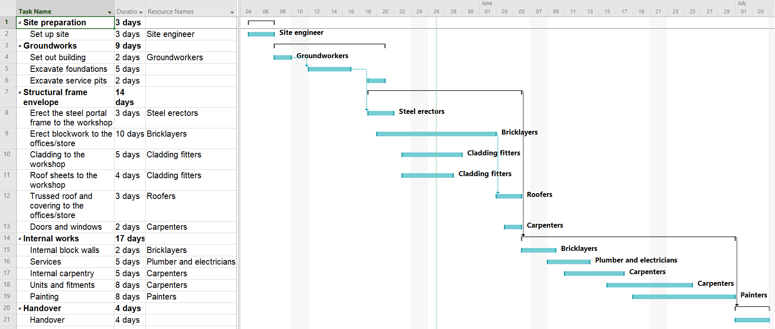
Source: Author
Task A
Evaluate the Gantt chart for a motor vehicle service workshop.
One – not suitable for the project.
Two – has some suitability for the project.
Three – most suitable for the project.
Evaluation criteria | Rank rating | Comments on effectiveness
Suitability for the project
(Is it the best tool for the project?)

Clarity of communication
(Are there clear timelines?)

Task dependency
(Are parallel and interdependent tasks clearly shown?)

Resource allocation
(Are these resources clearly defined throughout the project?)

Decision-making
(Does it identify bottlenecks or opportunities to catch up?)

Group B
Line of balance for industrial units
A developer has acquired a plot of land where it has been granted planning permission to construct an industrial development. The developer has conducted a feasibility study, which has identified a need for small units to be rented to start-up businesses.
The developer has produced designs for 10 identical units that it plans to construct. These will be constructed with cross-laminated timber (CLT). Each unit will be built on a raft foundation owing to the soil conditions. This work is quite specialised, and the developer will use mainly subcontracted specialists for the foundation and structural framework. Services will also be undertaken by subcontractors and the developer has realised that it needs to plan the project carefully to ensure it can coordinate the labour and materials effectively during the project. The developer has decided to use a line of balance planning tool to plan the project.
Early completion of some of the units is essential for the developer. It can then rent these out to recoup some of the financial outgoings used for their construction and reduce any risks from poor cash flow.
Line of balance for industrial units
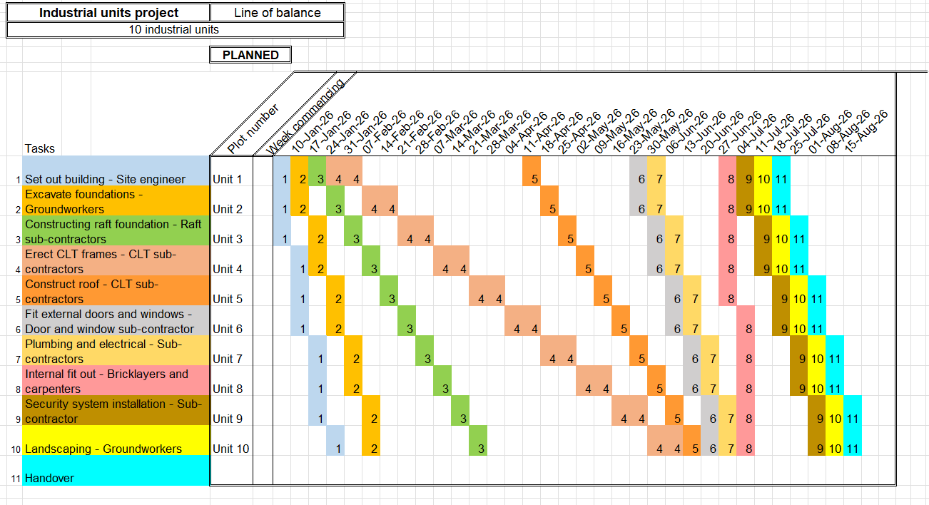

Task B
Evaluate the line of balance for the industrial development.
One – not suitable for the project.
Two – has some suitability for the project.
Three – most suitable for the project.
Evaluation criteria | Rank rating | Comments on effectiveness
Suitability for the project
(Is it the best tool for the project?)

Clarity of communication
(Are there clear timelines?)

Task dependency
(Are parallel and interdependent tasks clearly shown?)

Resource allocation
(Are these resources clearly defined throughout the project?)

Decision-making
(Does it identify bottlenecks or opportunities to catch up?)

Improving the effectiveness of a planning tool
Group A
Gantt chart for a hotel
A private client has tendered for a project to construct a two-storey hotel for a busy town centre. The building is to be constructed using pod construction for each of the hotel rooms, with external walls of composite panels. The substructure will be a pad foundation owing to the good soil conditions. The rooms will be linked by a reception area, restaurant and bar, office area and linen storage area, which will be built using timber frame construction with an external façade of brickwork to match neighbouring properties. This section of the build will have a strip foundation with trench blocks up to the timber frame.
The contractor who has won the bidding process is relatively inexperienced in constructing projects on this scale. Despite having a good reputation from previous contracts, the client has a slight concern about its ability to manage the project. The client has requested a plan of the construction activities to review how the construction phase will progress towards the deadline given.
The contractor has provided the Gantt chart shown and has assured the client that this has been sufficient for the projects it has previously worked on. Use the table to highlight the effectiveness of the Gantt chart and then propose alterations to the chart to improve its effectiveness.

Gantt chart for a hotel
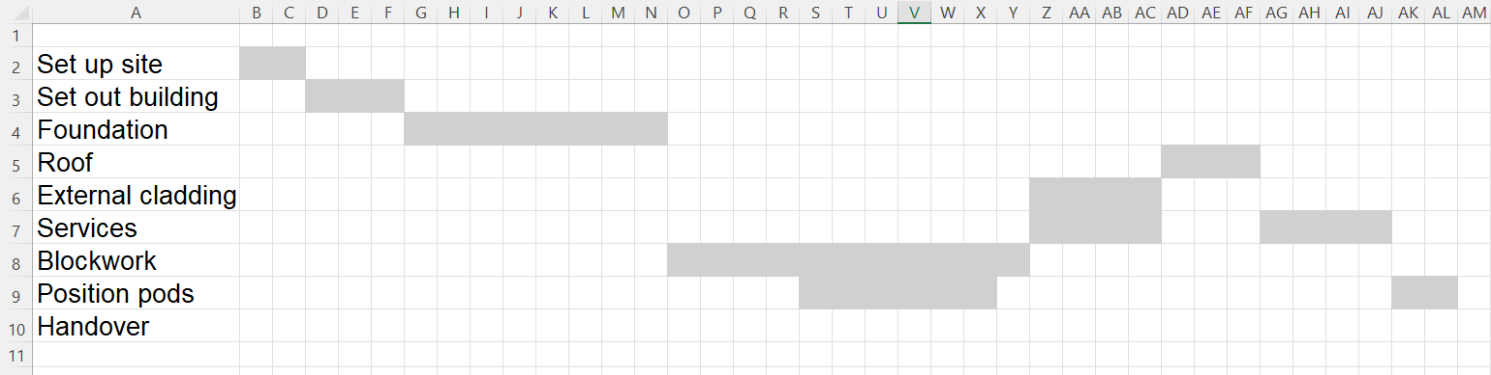

Task
Evaluate the use of the Gantt chart for the hotel.
One – not suitable for the project.
Two – has some suitability for the project.
Three – most suitable for the project.
Evaluation criteria | Rank rating | Comments on effectiveness
Suitability for the project
(Is it the best tool for the project?)

Clarity of communication
(Are there clear timelines?)

Task dependency
(Are parallel and interdependent tasks clearly shown?)

Resource allocation
(Are these resources clearly defined throughout the project?)

Decision-making
(Does it identify bottlenecks or opportunities to catch up?)

Group B
Critical path analysis for a sports hall
A client has acquired a plot of land and has gained planning permission to develop a sports centre on the site. The project will include the provision of a swimming pool, indoor multi-use sports hall, gym, changing rooms, café, a room that can be hired out and a reception area. The project is to be constructed using portal frame construction, with fair-faced blockwork forming the exterior and dividing walls. The building will have pad foundations to support the portal frames and strip foundations to the block walls.
The client has employed a consultant to project-manage the new development and asked them to produce a timeline of the construction phase so that they can see an overview of the activities and times for the on-site construction. They would like to share the timeline with the main contractor they have selected for the project.
The project manager has provided the following planning documentation and selected a critical path analysis for the project.
Task code | Activity description | Task duration | Dependencies
A | Site preparation. | 3 weeks
B | Foundations. | 4 weeks | A
C | Structural frame. | 4 weeks | B
D | Interior works. | 10 weeks | C
E | Electrical and plumbing. | 5 weeks | C
F | Landscaping. | 3 weeks | A
G | Final finishes. | 2 weeks | E
H | Handover. | 1 week | F, G

Critical path analysis for a sports hall

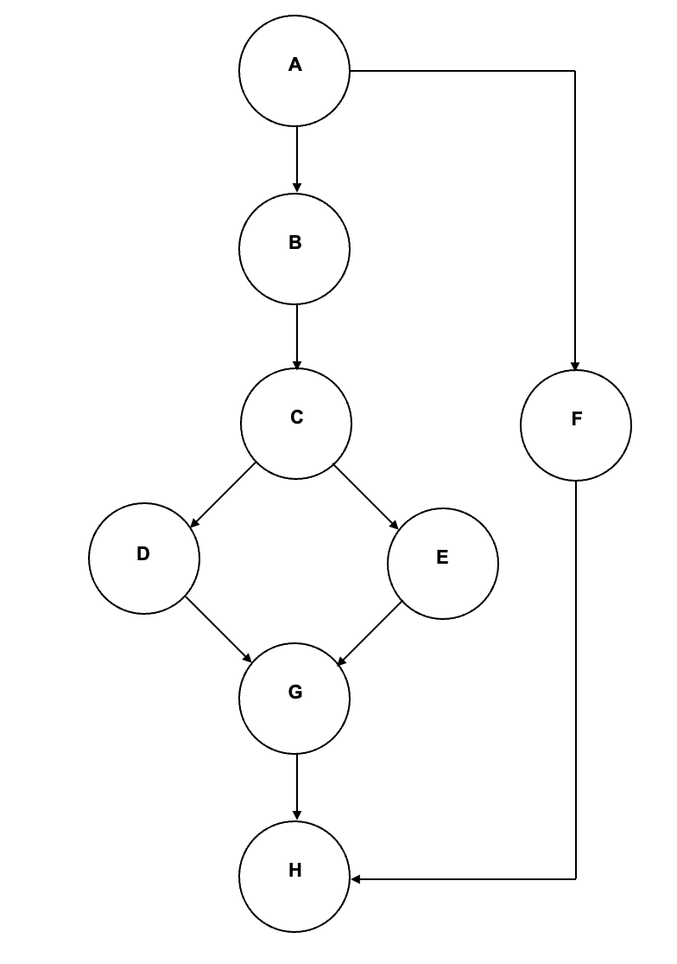
Task
Evaluate the use of the critical path analysis for the sports hall.
One – not suitable for the project.
Two – has some suitability for the project.
Three – most suitable for the project.
Evaluation criteria | Rank rating | Comments on effectiveness
Suitability for the project
(Is it the best tool for the project?)
Clarity of communication
(Are there clear timelines?)
Task dependency
(Are parallel and interdependent tasks clearly shown?)
Resource allocation
(Are these resources clearly defined throughout the project?)
Decision-making
(Does it identify bottlenecks or opportunities to catch up?)

The following materials relate to lesson 9: Converting between different planning tools

Guided conversion between planning tools
A contractor has been selected to be the main contractor for the construction of a new nursing home. The building is to be constructed using traditional construction techniques to match the area it is being constructed in.
The main contractor is experienced in working on larger complex projects and has used a critical path analysis planning tool to plan this project. However, the new subcontractors and suppliers it will work with have identified that they are not used to using critical path analysis and are much more experienced in using Gantt charts. The contractor has agreed to convert the existing critical path analysis plan into a Gantt chart to ensure the subcontractors understand it and are able to execute their activities effectively.

Critical path analysis for a nursing home: Table of activities
To be used in conjunction with the Critical path analysis for a nursing home image.
Activity reference | Activity description | Activity duration
A | Setting up site. | 1 week
B | Set out, excavate and install foundation. | 2 weeks
C | External cavity walls. | 8 weeks
D | Trussed rafter roof. | 2 weeks
E | Felt, batten and tile roof. | 2 weeks
F | Ground floor slab. | 1 week
G | External doors and windows. | 1 week
H | First fix carpentry and services. | 5 weeks
I | Plastering. | 3 weeks
J | Second fix carpentry and services. | 5 weeks
K | Painting and decorating. | 4 weeks
L | Landscaping. | 2 weeks
M | Handover. | 1 week

Critical path analysis for a nursing home
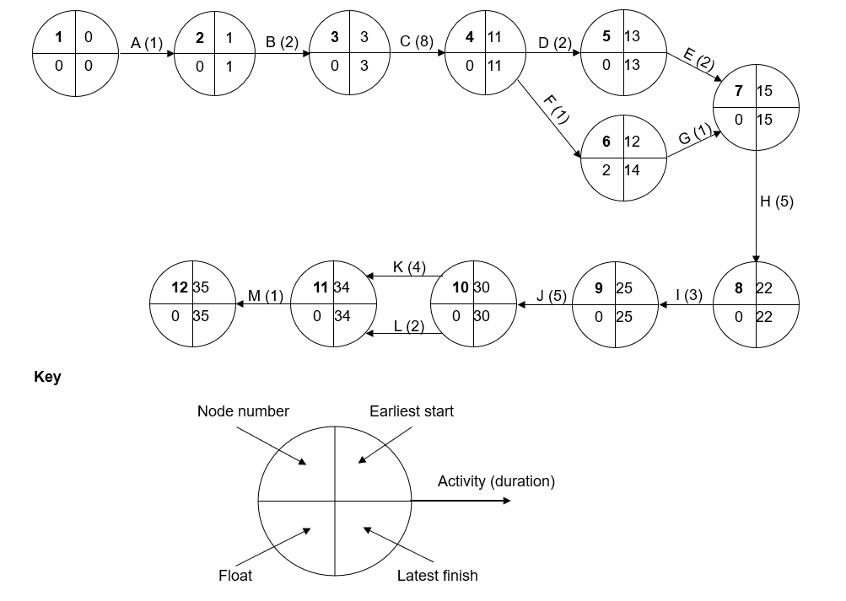Source: Author

Process guide for converting between planning tools
Task
Write an instruction for each step of the process for converting between planning tools.
Step | Instruction
Step 1
Step 2
Step 3
Step 4
Step 5
Step 6
Step 7
Step 8

Converting between planning tools for a construction project
A large motor vehicle company has appointed a contractor to construct a prestigious new showroom and garage on the outskirts of a major city. The company has undergone significant expansion in recent years, and this is one of several projects it has undertaken for new outlets in or near major towns or cities.
To improve its public standing, the company has decided to employ local contractors to undertake each project and has appointed a senior executive to project-manage each of the developments.
The project includes the construction of a two-storey showroom for new vehicles with office space above. There will be a staff room and kitchen on the upper floor area and a customer reception area in the showroom on the ground floor. This building will be steel frame construction with external cladding. There will be a second detached building which will contain workshops for servicing and MOT testing. The external works will have extensive areas to display new and second-hand vehicles and will have sustainable urban drainage incorporated into the design.
The project manager has produced a critical path analysis of each project so that the company directors can see the planned construction phases. However, the contractor selected for the project is not conversant with these and would prefer to work from a Gantt chart.

Motor vehicle showroom and garage: Table of activities
To be used in conjunction with the Motor vehicle showroom and garage image.
Activity reference | Activity description | Activity duration
A | Setting up site. | 5 days
B | Set out, excavate and install foundation for the showroom. | 5 days
C | Set out, excavate and install foundation for the garage. | 3 days
D | Showroom steel frame and flat roof. | 10 days
E | Garage blockwork and flat roof. | 20 days
F | Showroom cladding. | 20 days
G | Garage service pits. | 10 days
H | External doors and windows. | 15 days
I | Showroom offices fit-out. | 25 days
J | Garage fit-out. | 25 days
K | Showroom reception area. | 10 days
L | Installation of sustainable urban drainage. | 25 days
M | Paving. | 15 days
N | Tarmacadam roads and parking area. | 5 days

Motor vehicle showroom and garage

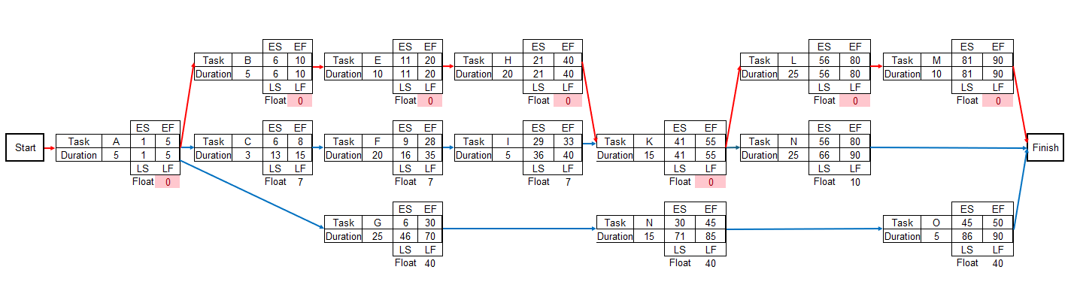

Source: Author

Exam-style question
A contractor has taken on a large project to construct an eco-park on the edge of a large town. The client has been granted planning for several buildings which will be used as offices for rent, with smaller units for start-up businesses and larger units for industrial use. As part of the planning consent there is a requirement to construct a further building which will be for local authority use, containing their planning department.
The project is to be constructed using a variety of construction forms, including portal frame, timber frame and cross-laminated timber The contractor will require the services of many subcontractors and suppliers to complete the project.
At a construction planning meeting, the contractor has decided to use a combination of two planning tools. It is going to use a Gantt chart and a critical path analysis.
- Discuss the advantages and disadvantages of using both planning tools for the project.
- Evaluate the contractor’s decision to use a combination of both a Gantt chart and critical path analysis for the project.

The following materials relate to lesson 10: Planning a health and wellbeing centre

Case study: Health and wellbeing centre
A construction organisation has been selected for Phase 3 of a development on the edge of a large industrial town.
The project is part of a larger urban regeneration scheme to provide residential accommodation and amenities to a deprived area. The project is divided into three phases:
Phase 1 – sports hall and gym
Phase 2 – residential buildings
Phase 3 – health and wellbeing centre.
The site is located on the outskirts of a town which was formerly a centre for heavy industry and manufacturing. The project involves the development of a health and wellbeing centre on a 1.5-hectare site which was previously used for industrial purposes. The site will be repurposed to accommodate a modern facility offering medical, therapeutic and community services to promote public health and wellbeing.
The development site is located near existing commercial and residential areas. The site is bordered by a former mill, and careful planning must be considered in the design of the health and wellbeing centre.
There is a derelict industrial building on the site and this building was used for the manufacture of herbicide and pesticide products in the 1960s and 1970s. This site has been derelict since the 1980s and, since then, has been blighted with antisocial issues, such as squatting, vandalism and illegal substance use.
The site is served by roads to the south and west and a canal runs alongside the north boundary.
General specification and guidance substructures
Single-storey structure in timber frame construction with a tiled pitched roof.
Foundations
Concrete strip foundations, minimum 600mm width and 300mm deep. Concrete mix to conform to BS EN 206-1 and BS 8500-2. Underside of foundation to be minimum 1000mm below external ground level, constructed on ground with a minimum safe bearing pressure of 100kN/m².
Below-ground blockwork built up in 440mm by 215mm by 300mm 7N trench block.
Underground services
100mm soil pipes to be installed to give a falloff of 1:40 and laid to comply with BS EN 1401-1.
75mm ducting installed to take 25mm Medium Density Polyethylene (MDPE) water main.
Ground floor construction
To meet min U-value required of 0.13 W/m²K.
Solid ground floor to consist of 150mm consolidated well-rammed hardcore. Blinded with 50mm sand blinding. Provide 100mm ST2 or Gen2 ground-bearing slab concrete mix to conform to BS 8500-2 over a 1200-gauge polythene DPM. DPM to be lapped in with DPC in walls. Floor to be insulated over slab and DPM with min 125mm PIR insulation
Superstructure
Walls to achieve minimum U-value of 0.18W/m²K. Roof to achieve U-value of 0.16 W/m²K.
Sole plate for timber frame installed and fixed to brickwork a minimum of 150mm above external ground level. Timber frame installed using crane onto prepared ground floor. Timber frame will be pre-insulated with vapour barrier.
Timber frame to have render finish applied in three coats to comply with BS EN 13914-1.
Internal walls and ceilings to be boarded with 12.5mm tapered-edge plasterboard with joints taped and filled ready for decoration.
Trussed rafter roof installed to manufacturer’s specification. Synthetic slate roof covering fixed to 50mm × 25mm treated timber battens with breathable felt underlay. 225mm UPVC fascia and soffit, with ventilation.
Windows and external doors
Window energy rating to be Band A or better and to achieve U-value of 1.4 W/m²K. Glazed doors to achieve U-value of 1.2 W/m²K.
Double-glazed with low emissivity argon-filled glass in prefinished hardwood frames fixed to propriety cavity closers. Front and rear composite doors supplied fully finished in hardwood frames. All glazing in doors will comply to Part K, BS 6206.
Services
Wall-hung toilets and basins to all toilets.
All electrical work to follow Part P and will be issued with a BS 7671 certification on completion.
Smoke alarms should be mains-operated and conform to BS 5446 components of automatic fire alarm systems for residential premises, Part 1 specification for self-contained smoke alarms and point-type smoke detectors.
They may have a secondary power supply such as a battery (rechargeable or replaceable).
Guttering will be 100mm half-round plastic with 65mm circular downpipes, connecting to a 100mm storm sewer.
Joinery and internal finishes
Bathrooms and toilets to be fully tiled.
Floors to have a durable linoleum covering throughout.

Client and project brief: Health and wellbeing centre
- Produce a plan for the construction of the health and wellbeing centre.
- Select an appropriate planning tool.
- Plan an effective timeline that includes all on-site activities.
- The plan must show clear interaction between on-site construction activities.
- Milestones must be clear.
Tasks, durations and number of operatives required
Roof trusses  4 days  five operatives | External render  8 days  four operatives | Felt and batten roof  6 days  five operatives
Excavate foundations  7 days  four operatives | External doors and windows  12 days  five operatives | Pouring strip foundations  5 days  four operatives
Roof tiles  8 days  four operatives | Clear site  4 days  four operatives | Second fix plumbing  12 days  six operatives
Excavation of drainage  2 days  four operatives | Painting and decorating  8 days  three operatives | Timber frame  10 days  six operatives
Masonry up to DPC*  8 days  six operatives | First fix electrical  20 days  six operatives | Floor coverings  8 days  three operatives
Second fix carpentry  25 days  eight operatives | Plastering  10 days  six operatives | Second fix electrical  15 days  six operatives
First fix plumbing  25 days  five operatives | First fix carpentry  15 days  six operatives | Ground floor slab  4 days  four operatives
*DPC: damp proof course

Peer review feedback criteria sheet
Overall timeline: | Has the work presented clearly shown the project being completed in the timeline constraint given? If not, which areas of the programme could have been adjusted to achieve the required outcome?
Feedback:

Logical flow of activities: | Is there an appropriate flow to the presented activities in the plan? Are activities in an appropriate order?
Feedback:

Interaction of activities: | Does the plan have appropriate interaction of activities where they are dependent on each other or where there are overlapping or simultaneous activities taking place?
Feedback:

Milestones: | Are milestones identifiable and appropriate for the project?  Is the plan easy to understand? Do the milestones allow a review of several phases?
Feedback:

Exam-style question
A development contractor has been selected as the main contractor for a large development project. The development is a regeneration of a town centre. The project will include building new commercial shop outlets, offices and development of the streets interlinking them.
This is the largest project that this company has undertaken, and the company directors have decided to use project planning tools to programme the construction activities for this project. The developer has selected critical path analysis as its planning tool.
Discuss the effectiveness of the developer using the critical path analysis for the regeneration development.

Model answer
Critical path analysis is an effective choice as the planning of this project is complex involving a range of activities from building shops to linking the footpaths. There will be several operatives and subcontractors, and the contractor will pay them for their time on site, so it is important to know when the resources are needed on site. If the contractor does not plan, it could have sub-contractors on site when their part of the development work isn’t needed. Since the contractors will still need to be paid, this will cost the overall contractor money
This project is complicated as there will be several activities running at the same time. Having a critical path allows the contractor to track priorities and the dependency of activities on each other. It helps the developer to know what activities cannot move and allows the activities to be closely tracked. If there is a delay in the critical path, the contractor will be able to know at key points if deadlines are affected. This is good as the contractor will be able to live-track the project and put in early interventions if required.
Other points that could be included:
- Organisation of the correct labour, plant and equipment to be available on site for each activity and the durations of time they are required for.
- Planning the ordering and delivery of materials to suit the progress of the project. This will aid efficiency and avoid damage to materials.
- Ability to make alterations during the project to meet the needs of the client and contractor.


FUNDED BY
PRODUCED BY

This programme is funded by the Department for Education
Shrewsbury Colleges Group has produced this resource on behalf of the Education and Training Foundation

