
Support holistic delivery of Core Content and Occupational Specialism content: Digital infrastructure
ET-FOUNDATION.CO.UK
T LEVEL IN DIGITAL SUPPORT SERVICES (Part 3)

The following materials relate to lesson 9: Name resolution and addressing
Activity: Review IPv4 addressing
Activity: Install and configure Dynamic Host Configuration Protocol (DHCP) role on Server VM from lesson 7
Activity: Install the domain name systems (DNS) role on Server VM from lesson 7
Check the Server VM has a static IP address

Activity: Review IPv4 addressing
Scenario
The network for a branch office is 192.168.1.0/24. This network needs to be subdivided into three subnets that meet the following requirements:
- one subnet with at least 100 IP addresses for clients
- one subnet with at least 10 IP addresses for servers
- one subnet with at least 40 IP addresses for future expansion.

Task 1: Calculate the bits required to support the hosts on each subnet.
Complete the table.
Hosts | Hostsbits required to support client subnets | Subnet mask bits
100 | 7 bits are required (2⁷ – 2 = 126, 2⁶ – 2 = 62) | 32 – 7 = 25
10 | 4 bits are required (2⁴ – 2 = 14, 2³ – 2 = 6) | 32 – 4 = 28
40 | 6 bits are required (2⁶ – 2 = 62, 2⁵ – 2 = 30) | 32 – 6 = 26
25 | 5 bits are required (2⁵ – 2 = 30, 2⁴ – 2 = 14) | 32 – 5 = 27

Which feature allows a single network to be divided into subnets of varying sizes?
Variable length subnet masking!
Task 2: Calculate the subnet mask in binary and decimal.
Subnet mask bits | Binary | Decimal
27 | 11111111 11111111 11111111 11100000 | 255.255.255.224
28 | 11111111 11111111 11111111 11110000 | 255.255.255.240
26 | 11111111 11111111 11111111 11000000 | 255.255.255.192
25 | 11111111 11111111 11111111 10000000 | 255.255.255.128

For the client subnet, define the network ID, first available host, last available host and broadcast address. Assume that the client subnet is the first subnet allocated from the available address pool. Calculate the decimal and binary version of each address.
The bits in bold are part of the network ID.
Description | Decimal | Binary
Network ID | 192.168.1.0 | 11000000.10101000.00000001.00000000
First host | 192.168.1.1 | 11000000.10101000.00000001.00000001
Last host | 192.168.1.126 | 11000000.10101000.00000001.01111110
Broadcast | 192.168.1.127 | 11000000.10101000.00000001.01111111

For the server subnet, define the network ID, first available host, last available host and broadcast address. Assume that the server subnet is the second subnet allocated from the available address pool. Calculate the decimal and binary versions of each address.
The bits in bold are part of the network ID.
Description | Decimal | Binary
Network ID | 192.168.1.128 | 11000000.10101000.00000001.10000000
First host | 192.168.1.129 | 11000000.10101000.00000001.10000001
Last host | 192.168.1.190 | 11000000.10101000.00000001.10111110
Broadcast | 192.168.1.191 | 11000000.10101000.00000001.10111111

For the future allocation subnet, define the network ID, first available host, last available host and broadcast address. Assume that the future allocation subnet is the third subnet allocated from the available address pool. Calculate the decimal and binary versions of each address.
The bits in bold are part of the network ID.
Description | Decimal | Binary
Network ID | 192.168.1.192 | 11000000.10101000.00000001.11000000
First host | 192.168.1.193 | 11000000.10101000.00000001.11000001
Last host | 192.168.1.254 | 11000000.10101000.00000001.11111110
Broadcast | 192.168.1.255 | 11000000.10101000.00000001.11111111

Activity: Install and configure Dynamic Host Configuration Protocol (DHCP) role on Server VM from lesson 7
Scenario
Install and configure a DHCP server that will provide IP addresses and configuration to the client computers at the branch office. Servers are configured with static IP addresses and usually do not use DHCP for obtaining IP addresses.

Tasks:
- Install the DHCP server role
- Configure the DHCP scope and options
- Configure the client VM to use DHCP and then test the configuration

Task 1: Install the DHCP server role
Open Hyper-V Manager, Start TrServer01.
Open Server Manager and then install the DHCP Server role.

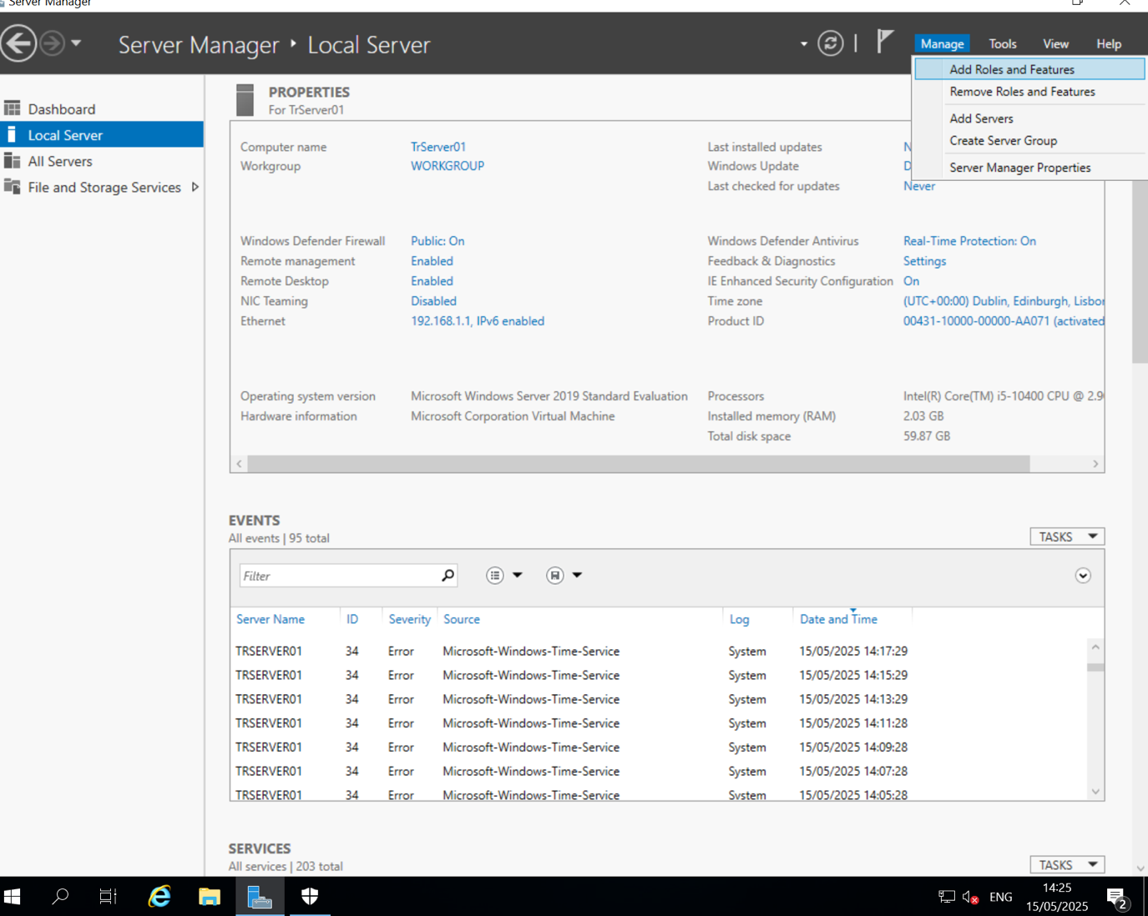
In the Add Roles and Features Wizard, accept all defaults.
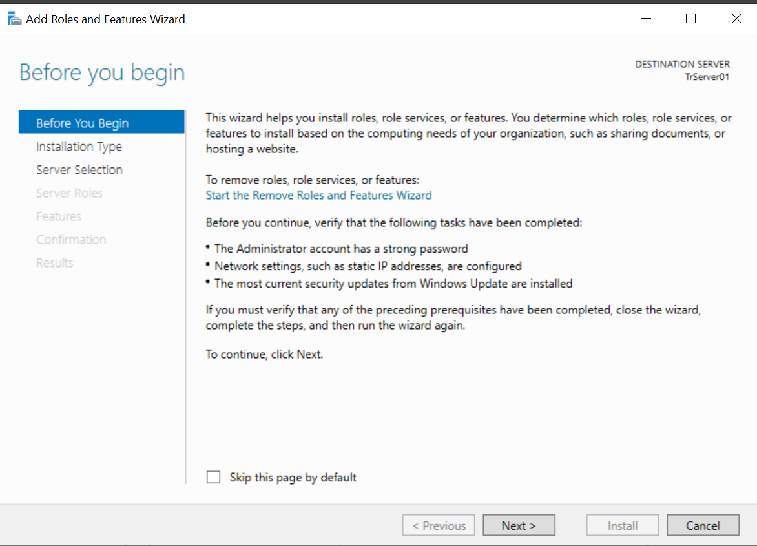
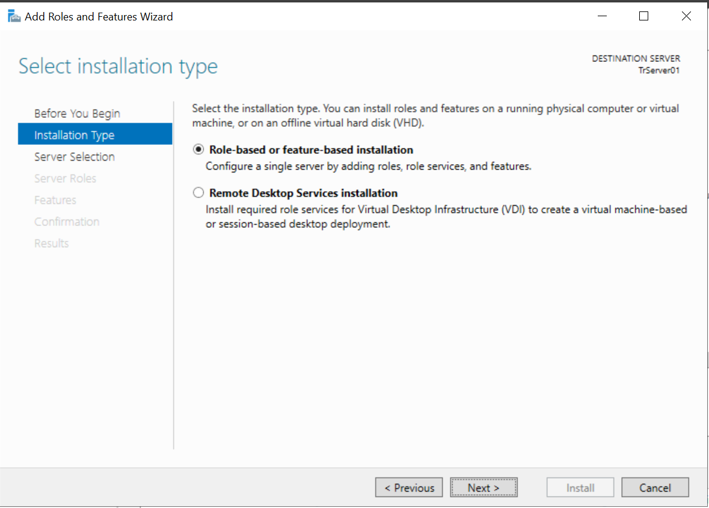
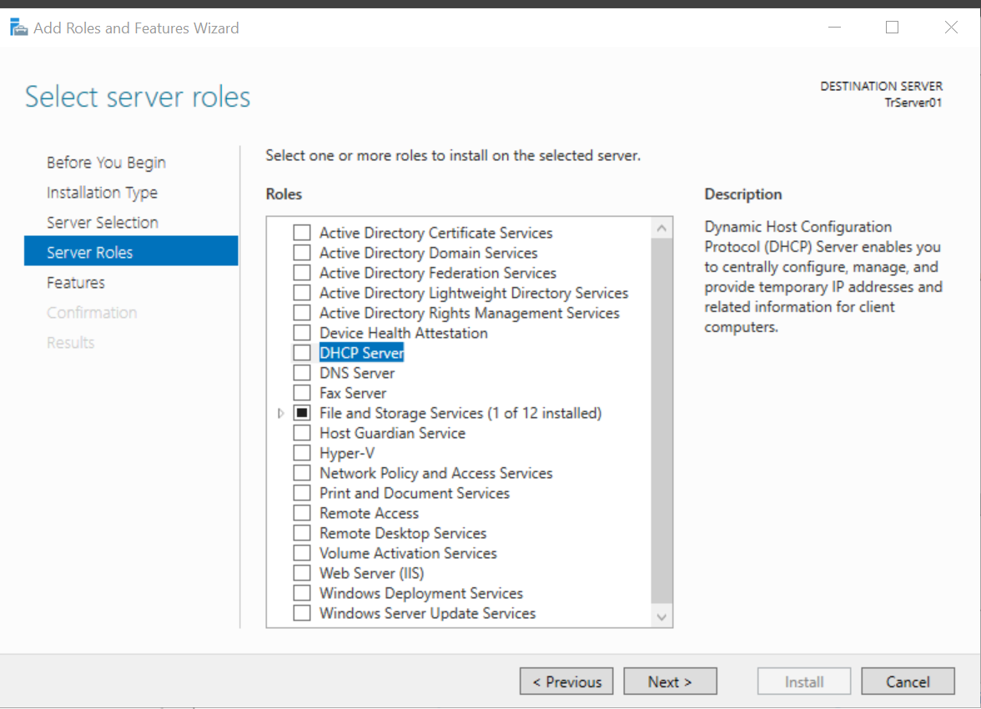
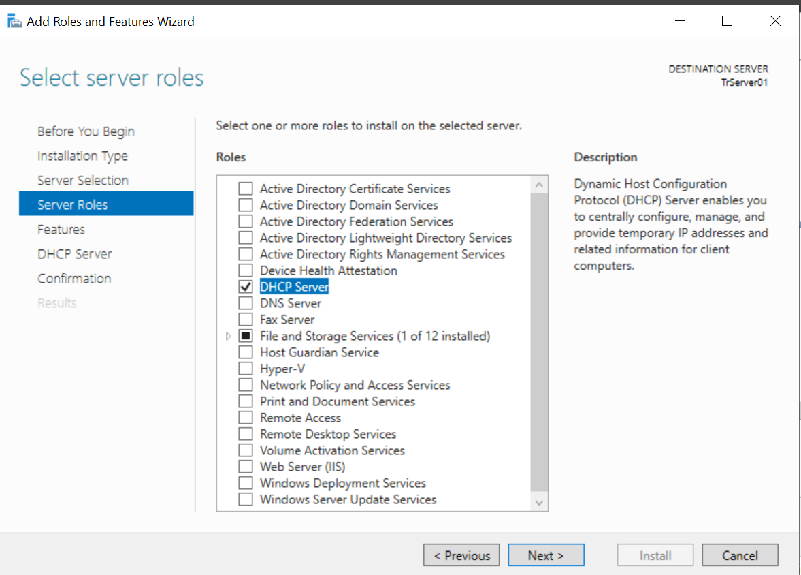
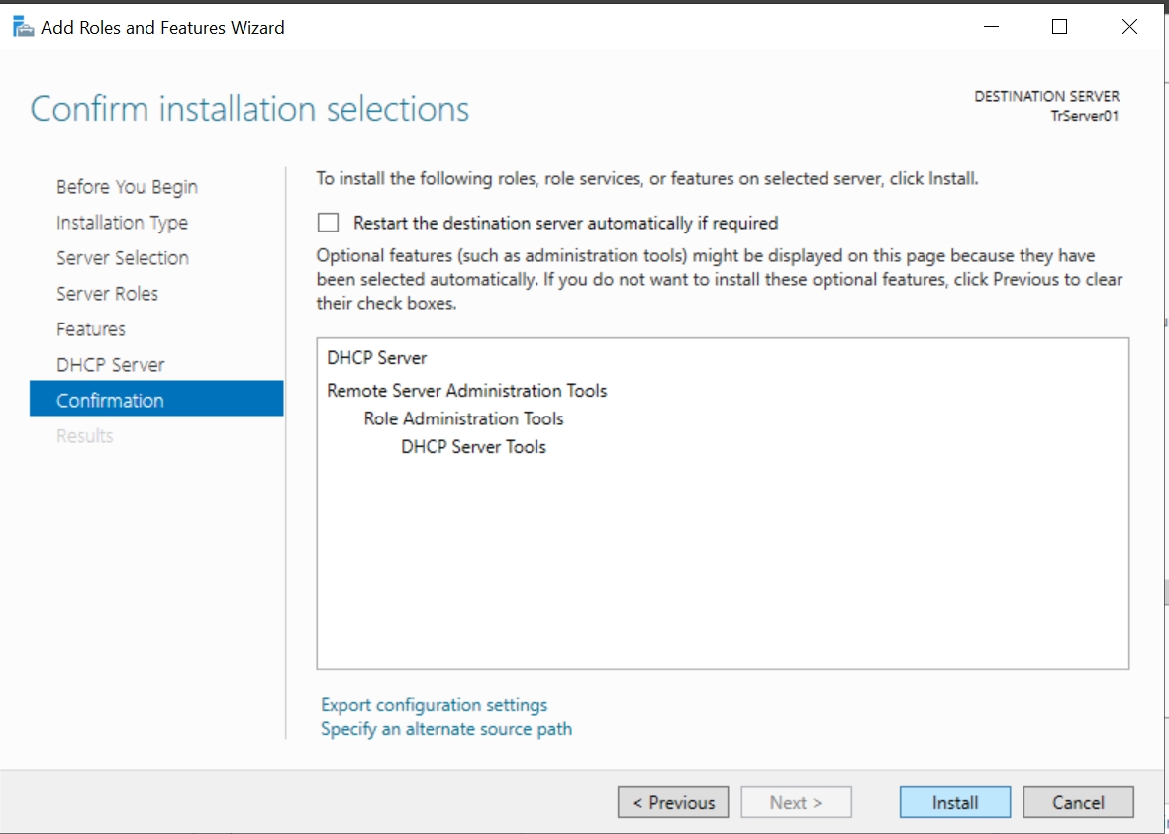
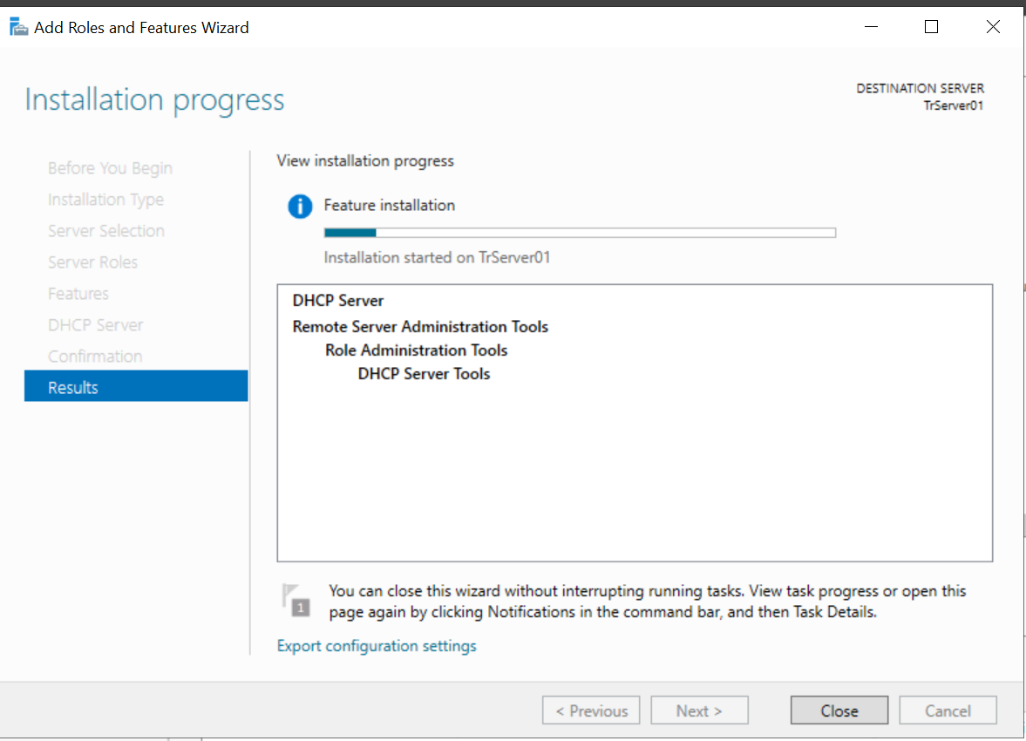
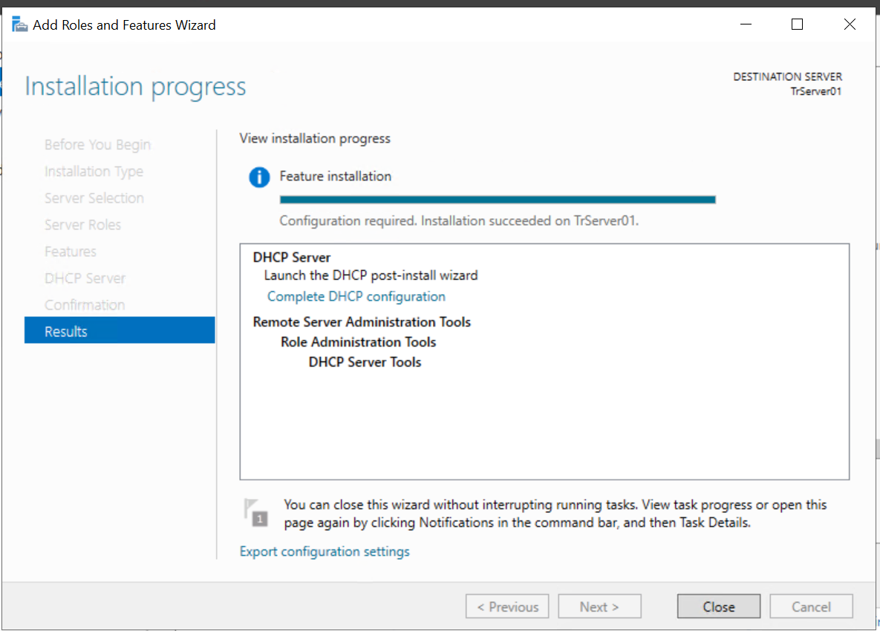
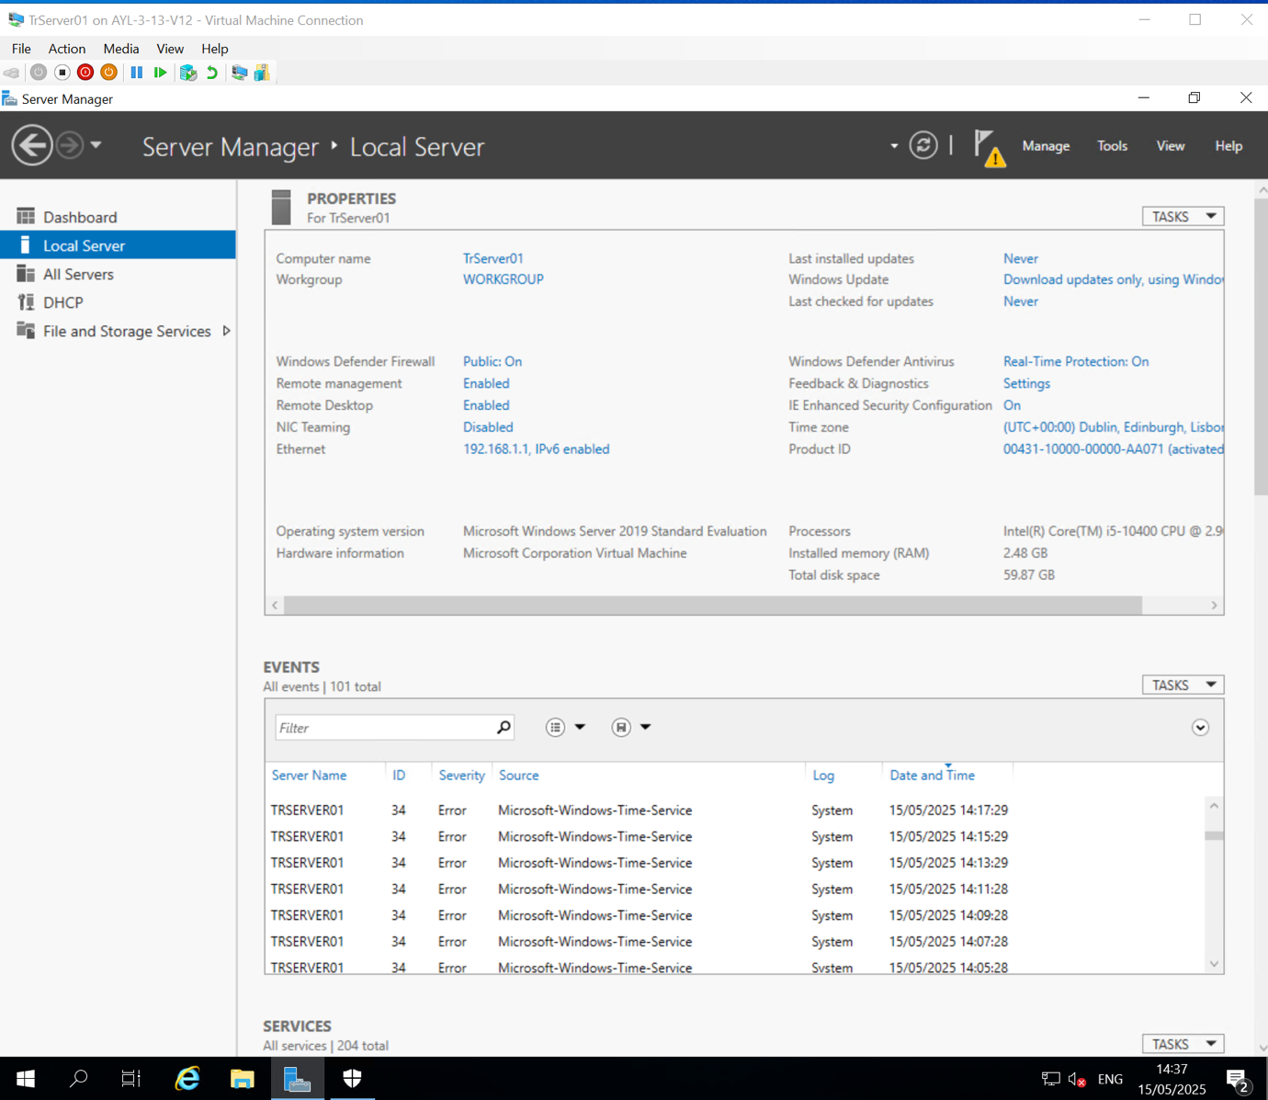
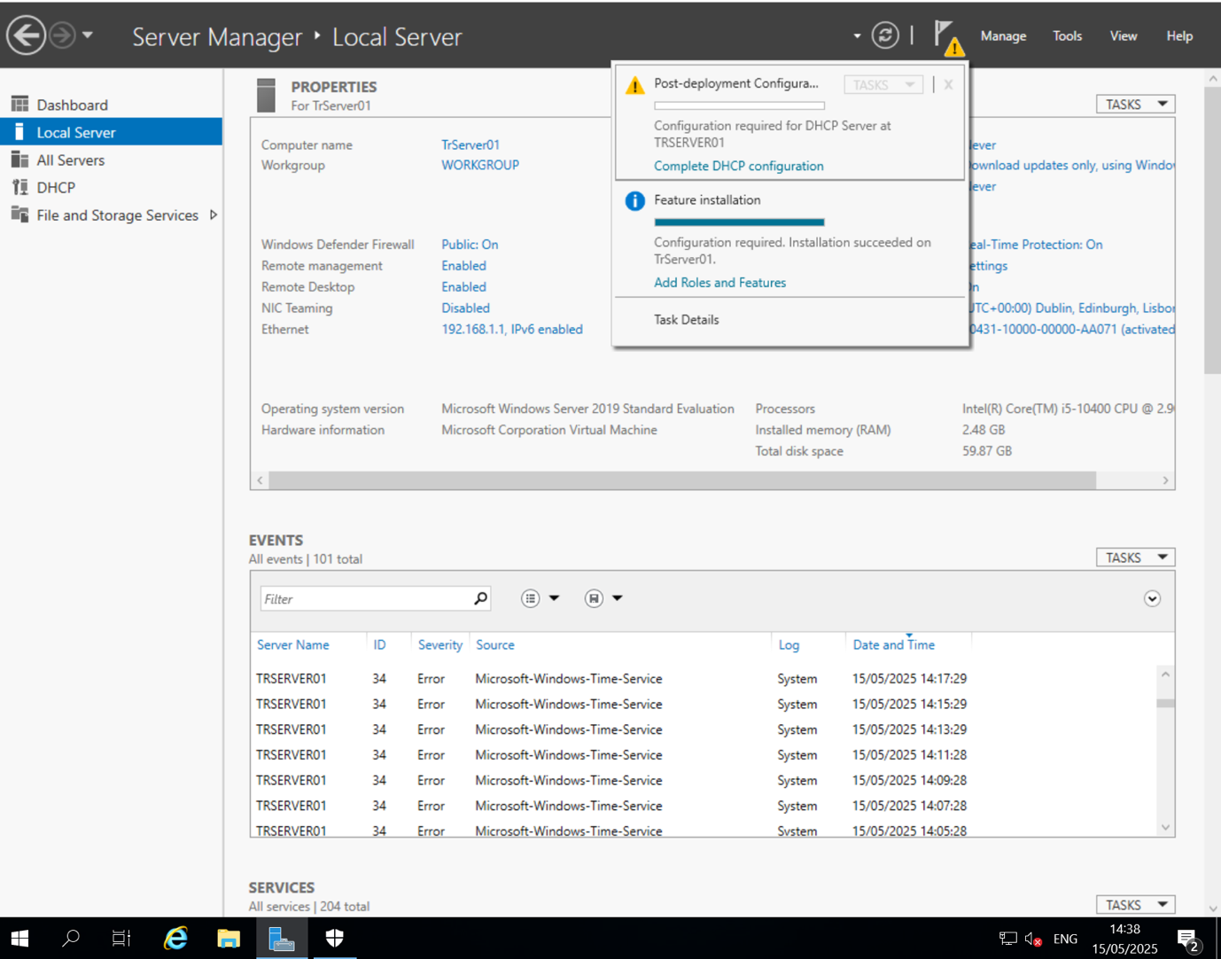
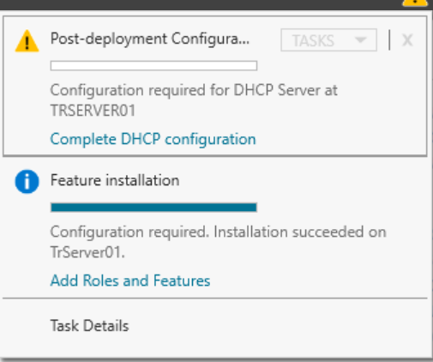

Task 2: Configure the DHCP scope and options

In Server Manager, open the DHCP console.
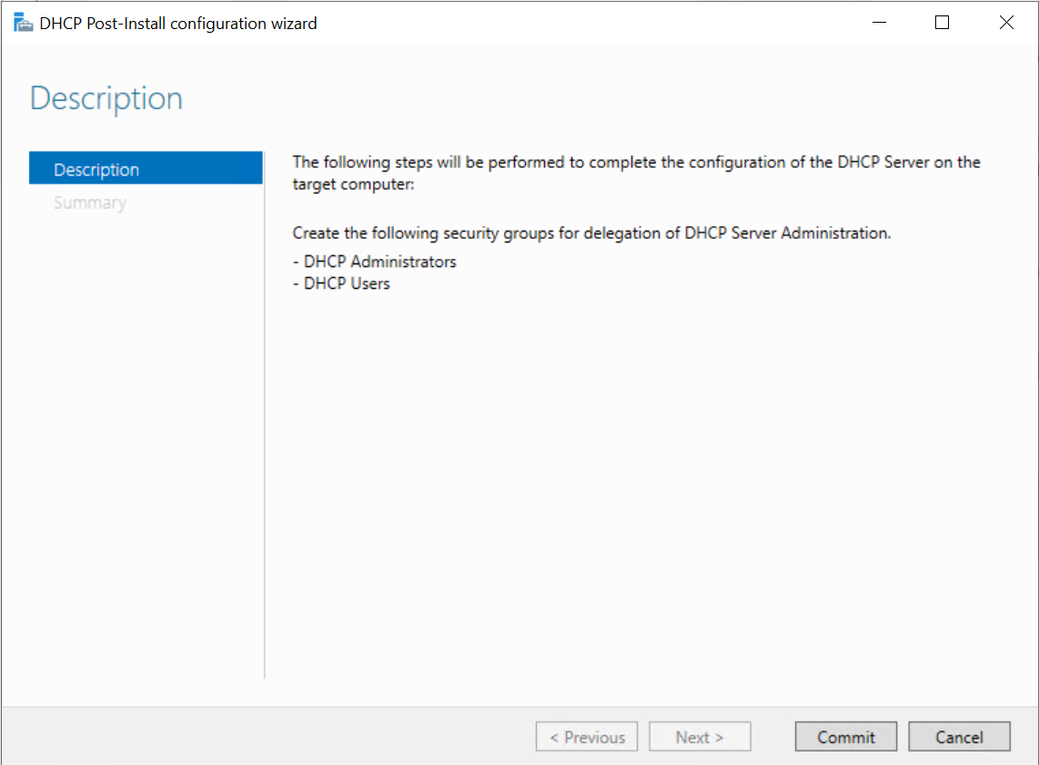

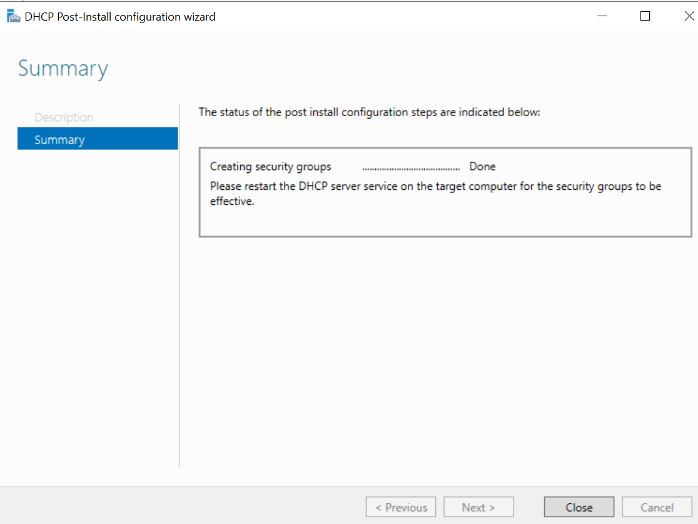
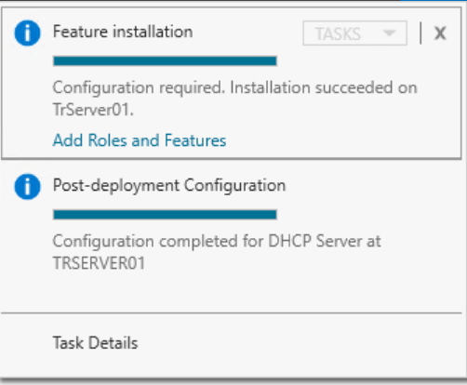
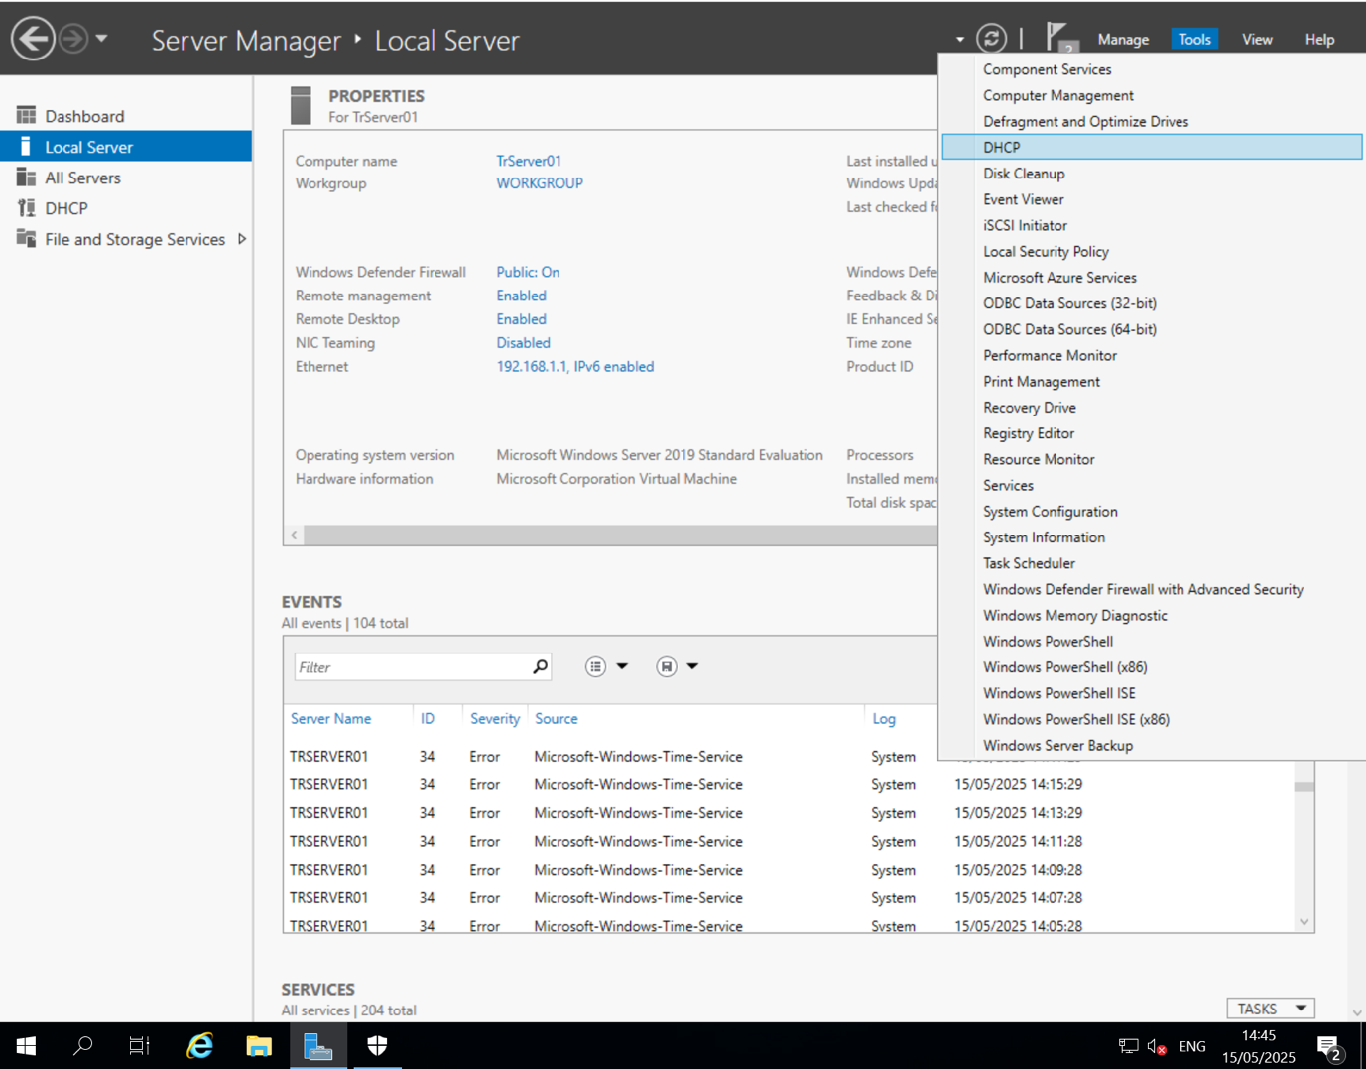

In DHCP, in the navigation pane, browse to IPv4, right-click IPv4 and then click New Scope.

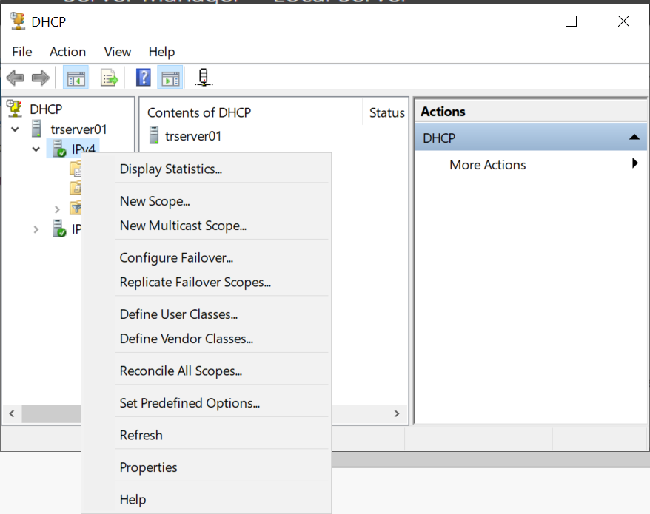

Create a new scope with the following properties:
- Name: Branch Office
- IP Address Range: 192.168.1.10-192.168.1.120
- Length: 25
- Subnet mask: 255.255.255.128
- Exclusions: 192.168.1.100-192.168.1.120
- Configure options for router: 192.168.1.126
- For all other settings, use default values.
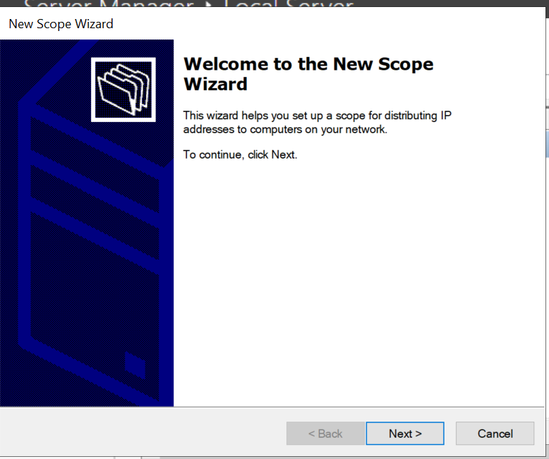

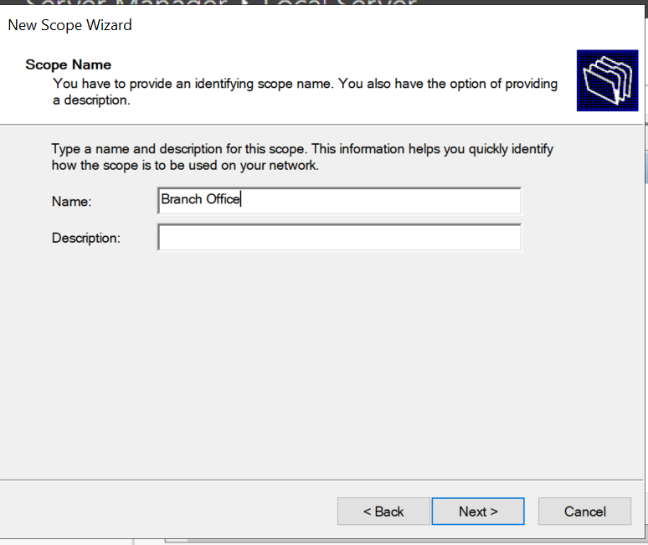
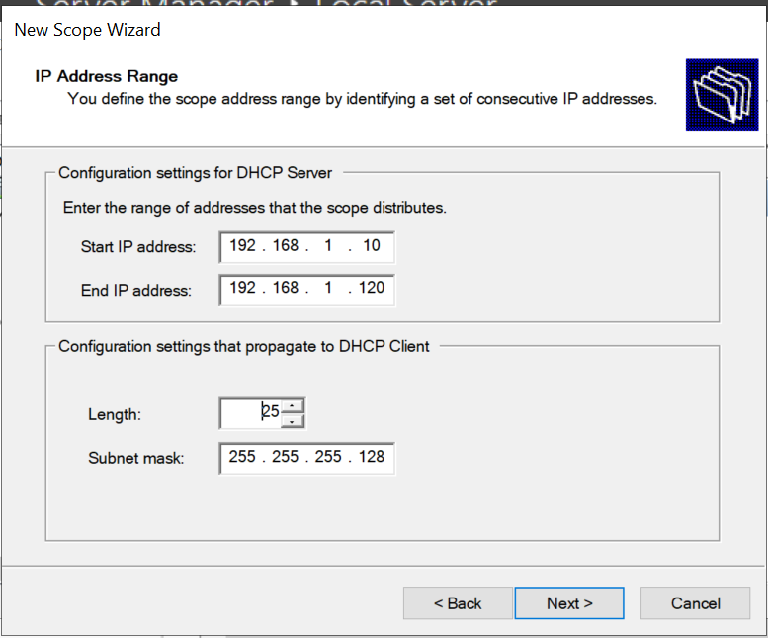

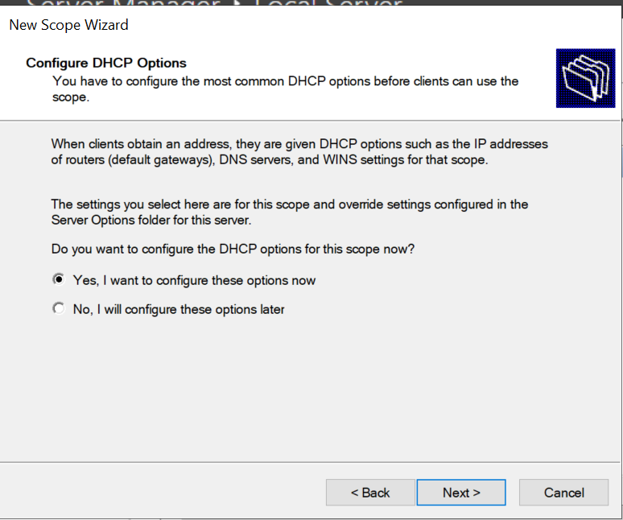
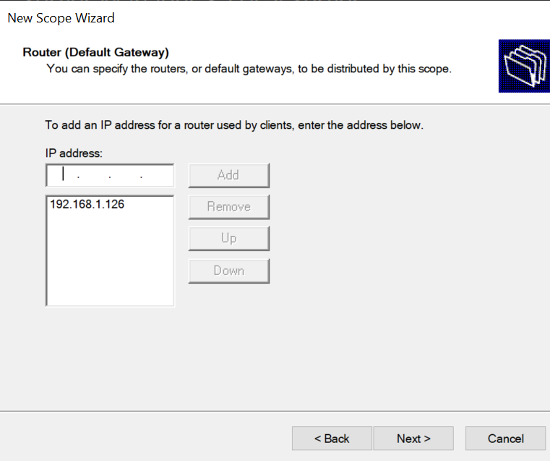

Activate the scope.
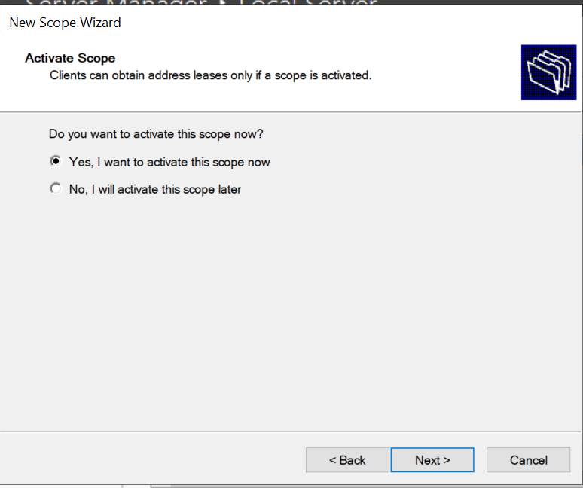
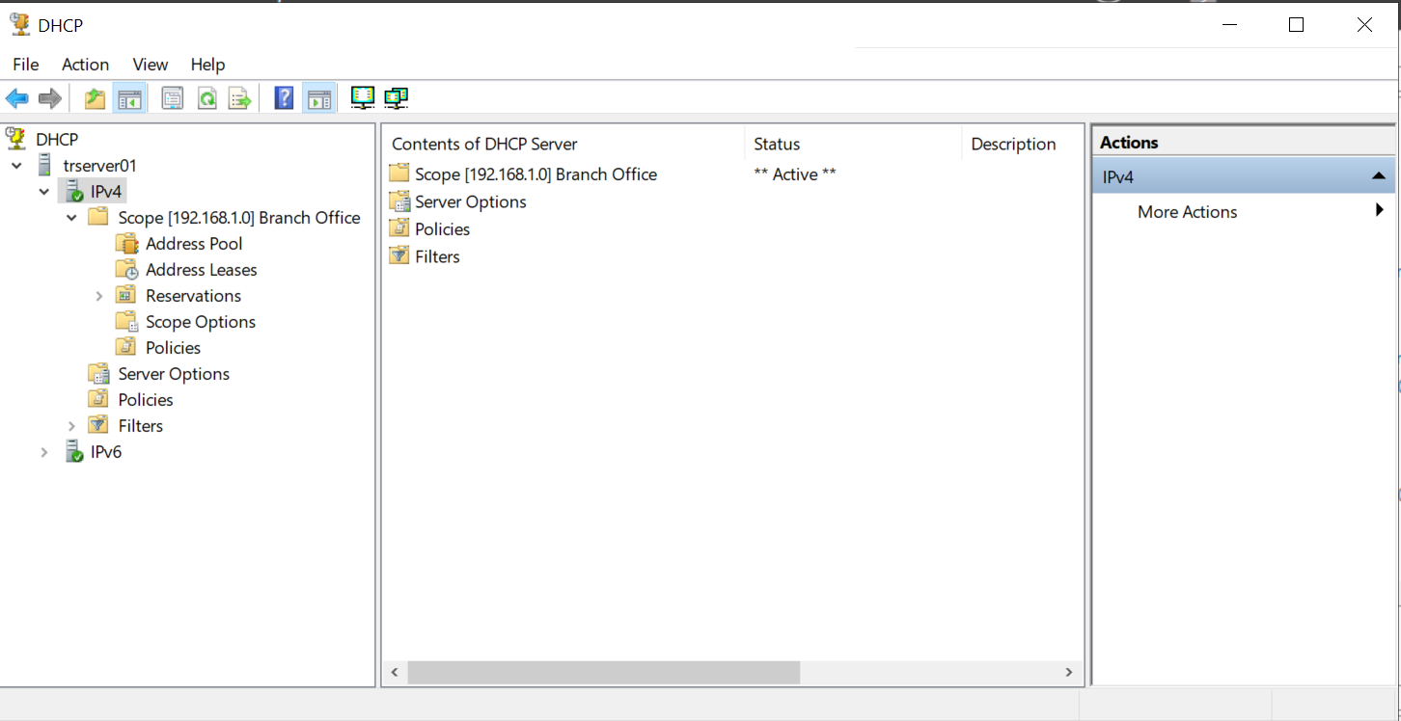

Task 3: Configure the Client VM to use DHCP, and then test the configuration
Start the Client VM.
Reconfigure the Ethernet connection using the following information:
- Configure – Internet Protocol Version 4 (TCP/IPv4)
- Obtain an IP address automatically
- Obtain DNS server address automatically

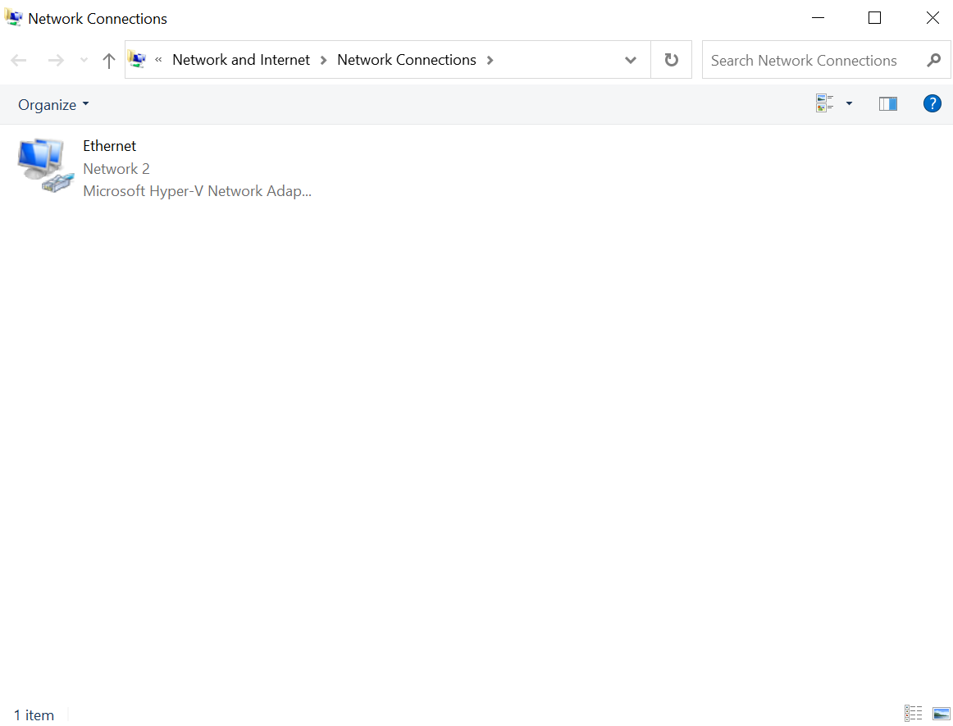
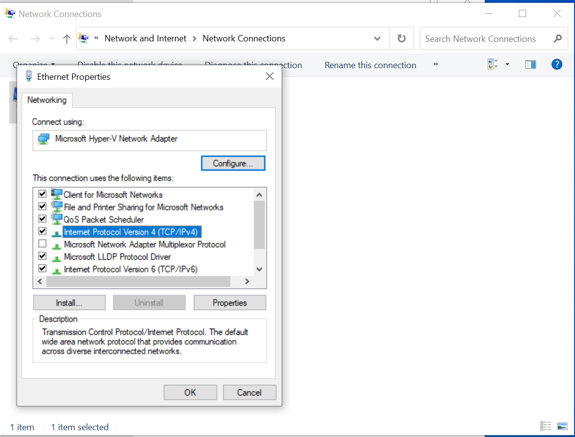
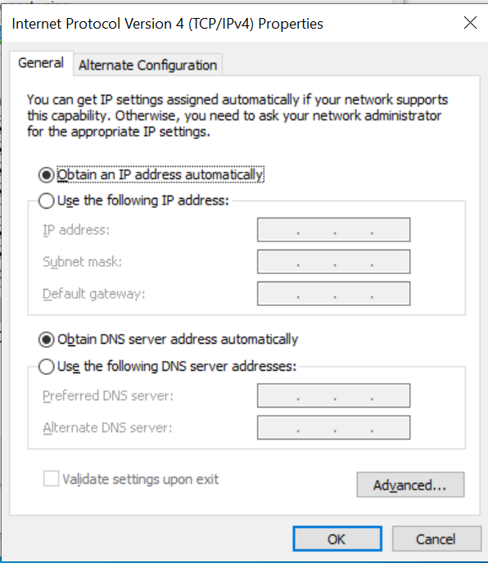
Open the Command Prompt window and then initiate the DHCP process using the ipconfig /renew command.
To test the configuration, verify that Client VM has received an IP address from the DHCP scope by typing ipconfig /all in the Command Prompt window.
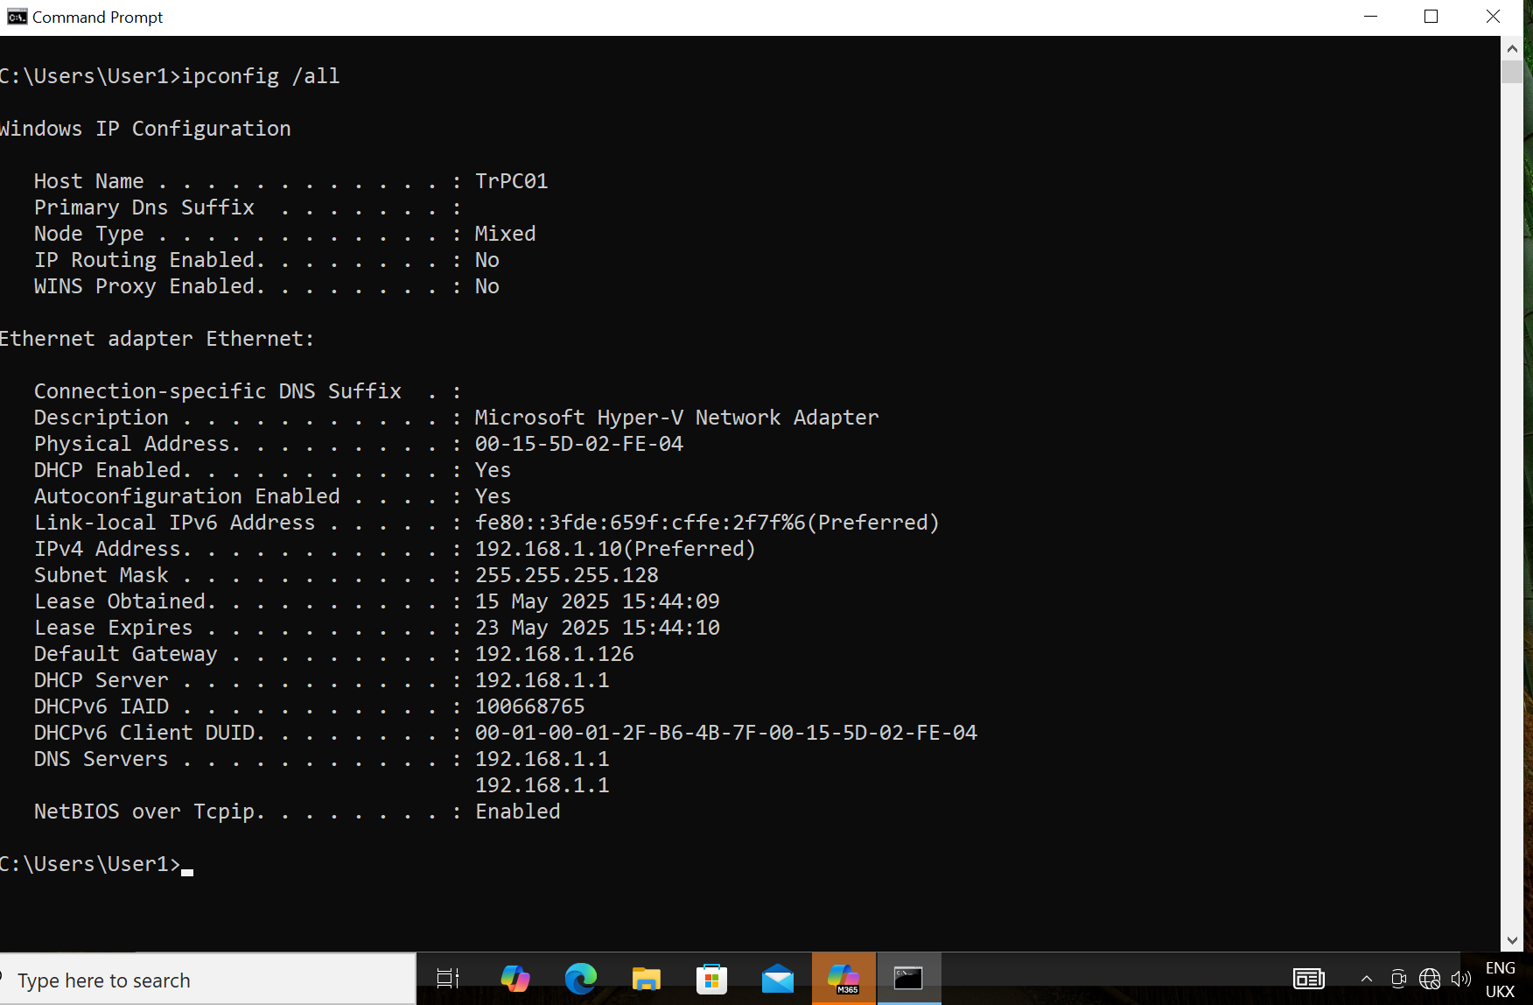

This command returns information such as IP address, subnet mask and DHCP Enabled status, which should be Yes.

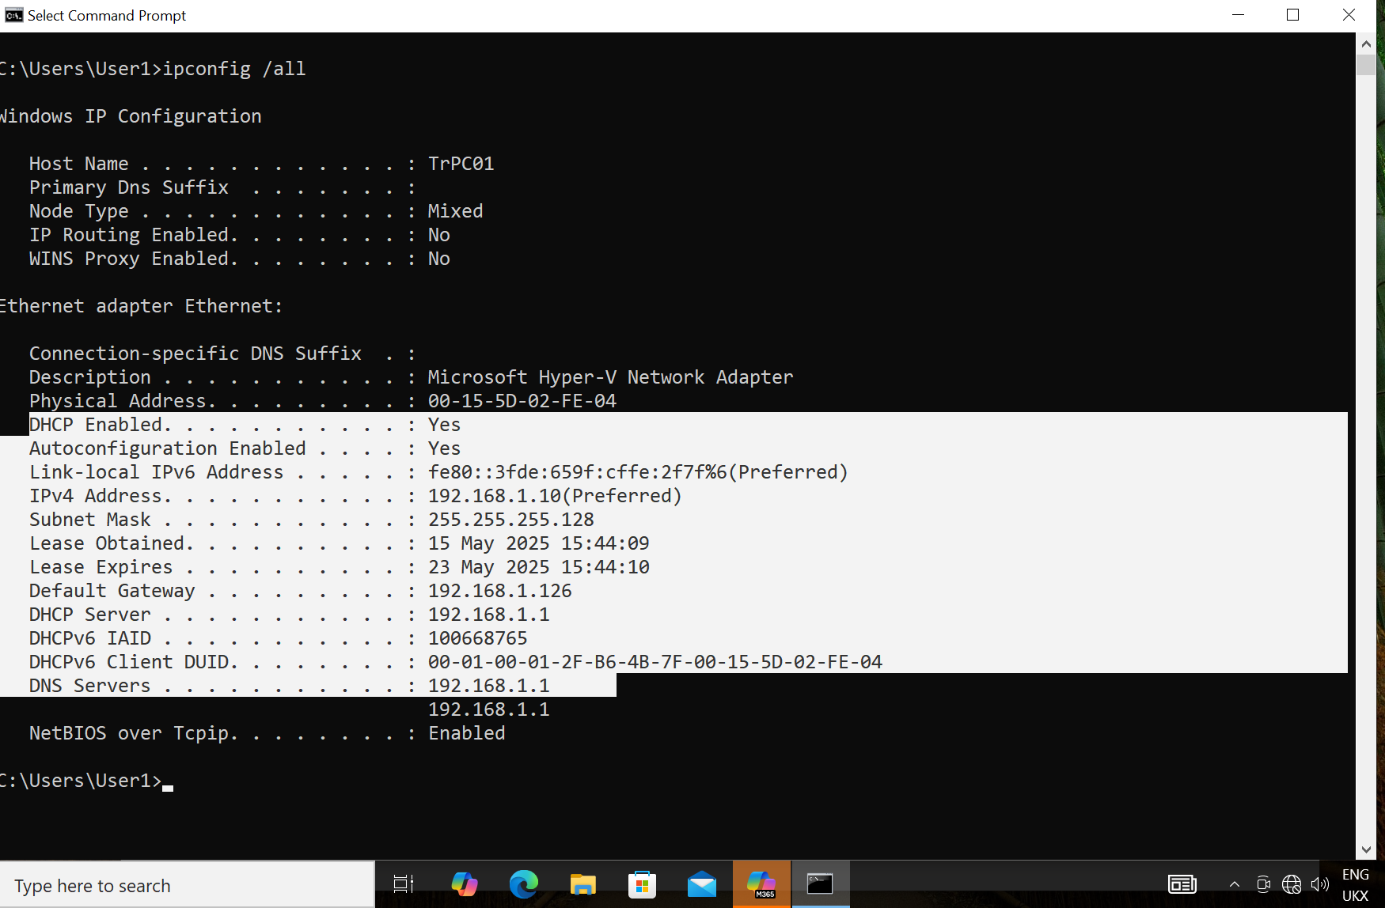

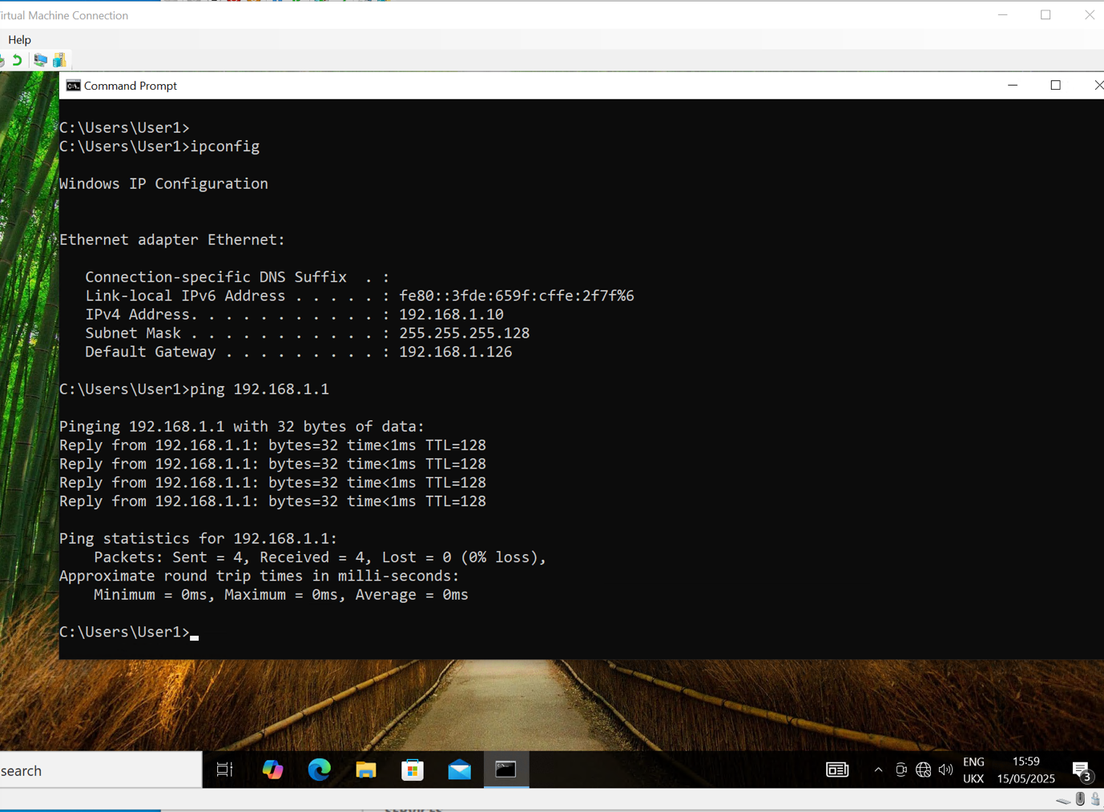

Activity: Install the domain name systems (DNS) role on Server VM from lesson 7
DNS server role can install alone or install as part of the configuration tasks during AD DS install. Check the Server VM has a static IP address (Why?). A warning comes up, though installation continues. Clients could lose connection to the server if the IP address changes.
Scenario
As part of configuring the infrastructure for a new branch office, you are required to configure a DNS server that provides name resolution for the branch office.
Tasks:
- Install DNS
- Configure DNS
- Create host records in DNS

Check the Server VM has a static IP address
Instructions
- Log into the Server VM.
- Start the Server VM used in previous lessons.
- Log in using your administrator credentials.
- Open the Network Settings.
- Click the Start menu.
- Type Control Panel and open it.
- Select Network and Sharing Center.
- Click Change adapter settings on the left-hand menu.
- Open Adapter Properties.
- Right-click the active Ethernet adapter (or similar) and choose Properties.
- In the list, click Internet Protocol Version 4 (TCP/IPv4) and then click Properties.
- Check IP Settings.
- Look at the current configuration:
  - If Obtain an IP address automatically is selected, the server is using dynamic (DHCP) addressing.
  - If Use the following IP address is selected, the server is using a static IP address.
  - Switch to Static (if needed).
- If it is currently automatic, change it to:
  - IP address: 192.168.1.1 (or another value if provided by your teacher)
  - Subnet mask: 255.255.255.128
  - Default gateway: 192.168.1.126
  - Preferred DNS server: 192.168.1.1 (or another if specified).
- Click OK to save and close all open windows.
- Test the Connection.
- Open Command Prompt (type cmd in the Start menu).
- Type: ipconfig and press Enter.
- Check that the IP address listed matches what you entered.
- Optionally, type ping 192.168.1.1 to test the connection to your default gateway.
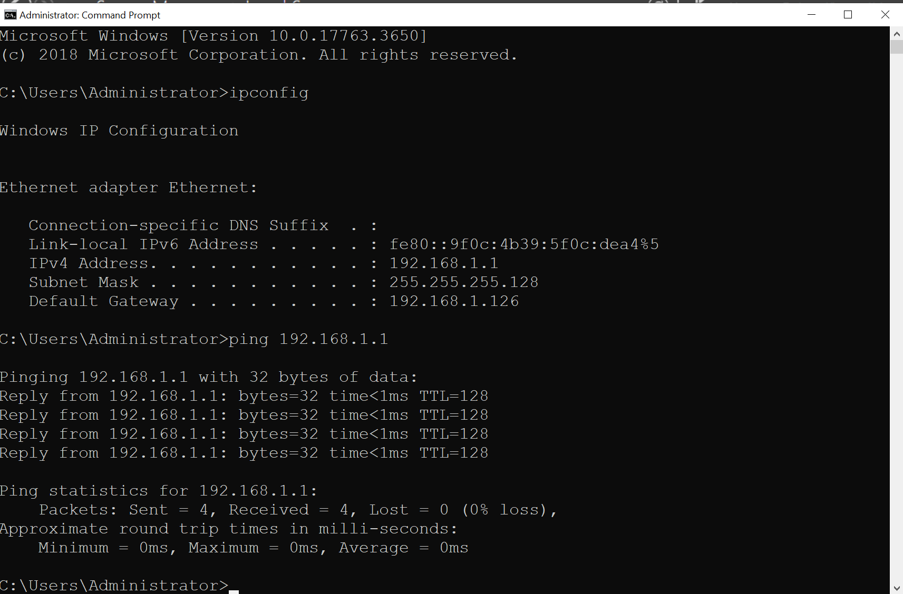

Checklist:
- Server VM started and logged in.
- IP settings viewed and confirmed as static.
- IP address manually set if needed.
- Settings tested using ipconfig and ping.

Task:
Install DNS.

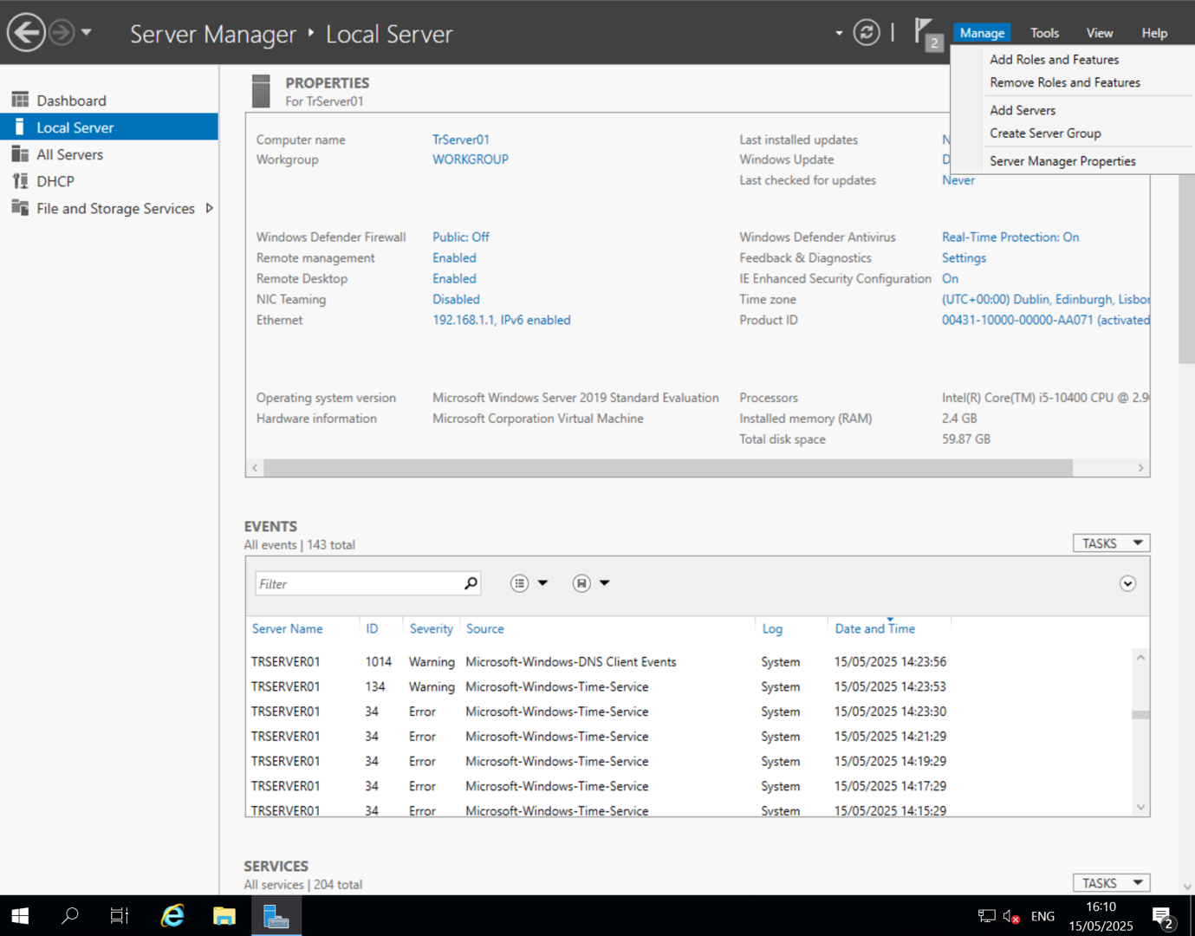
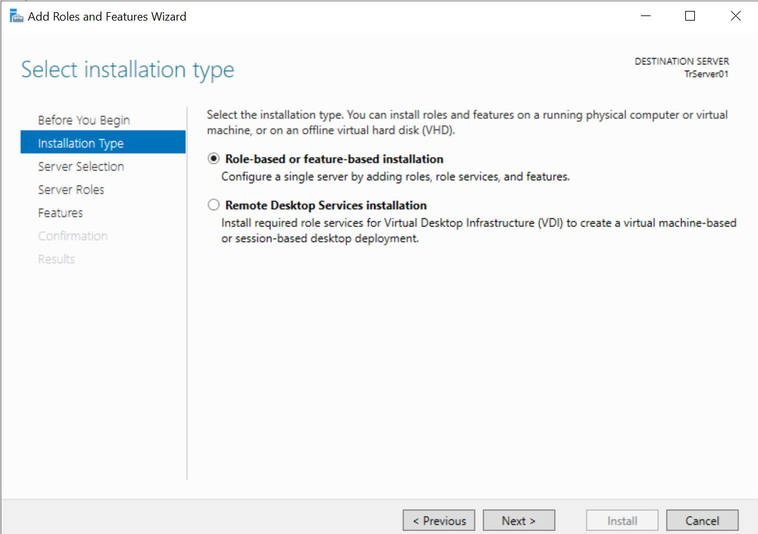
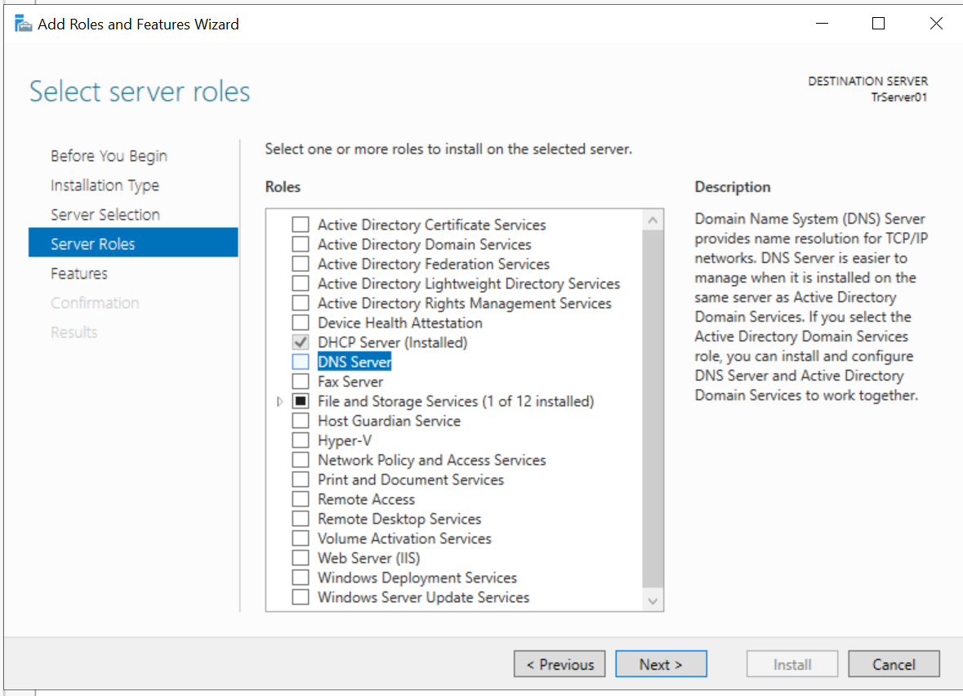
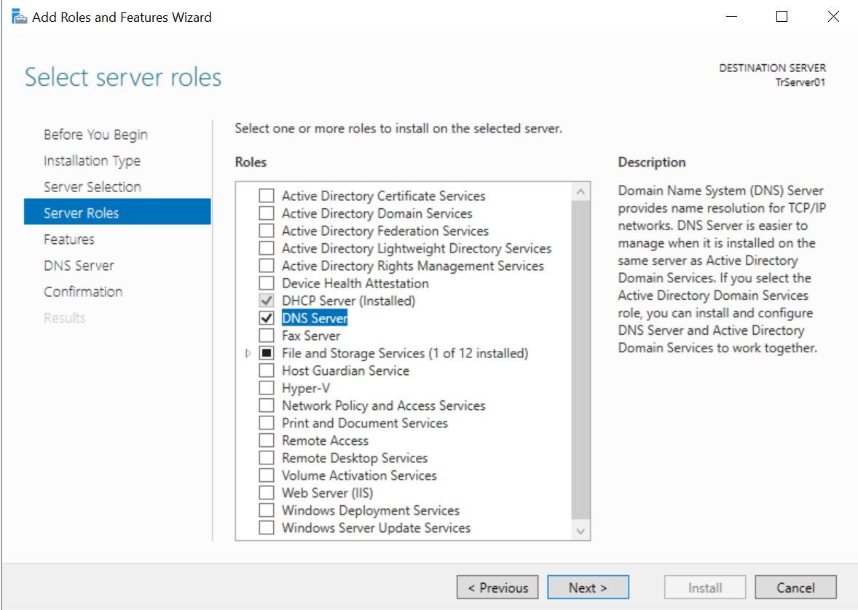
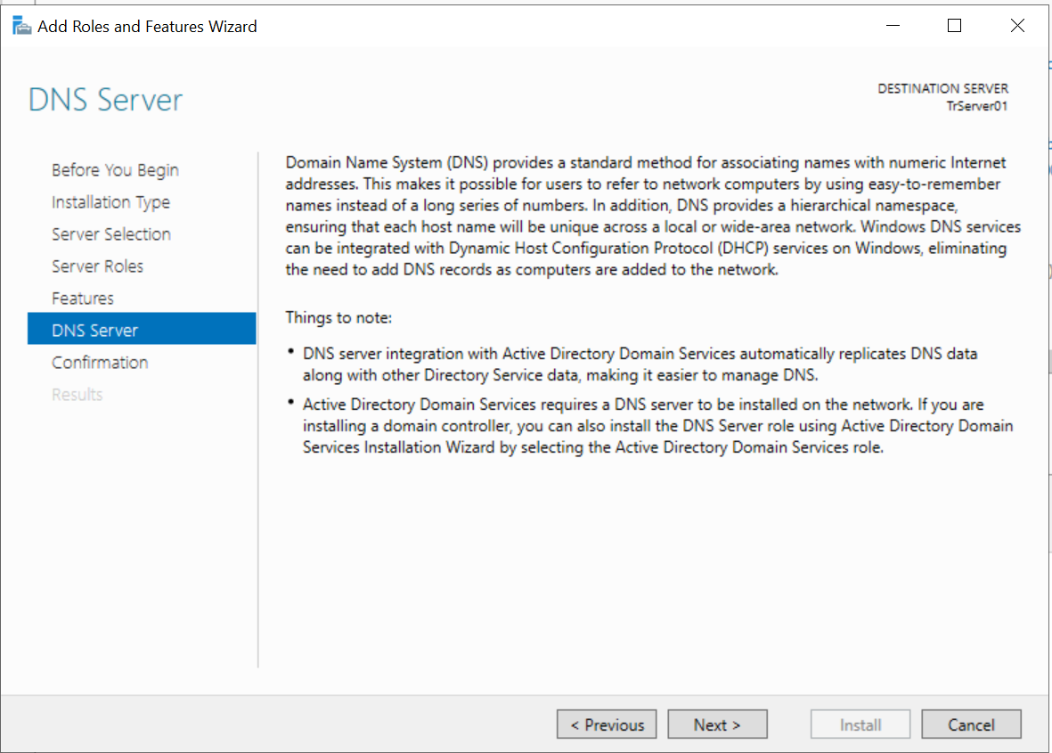
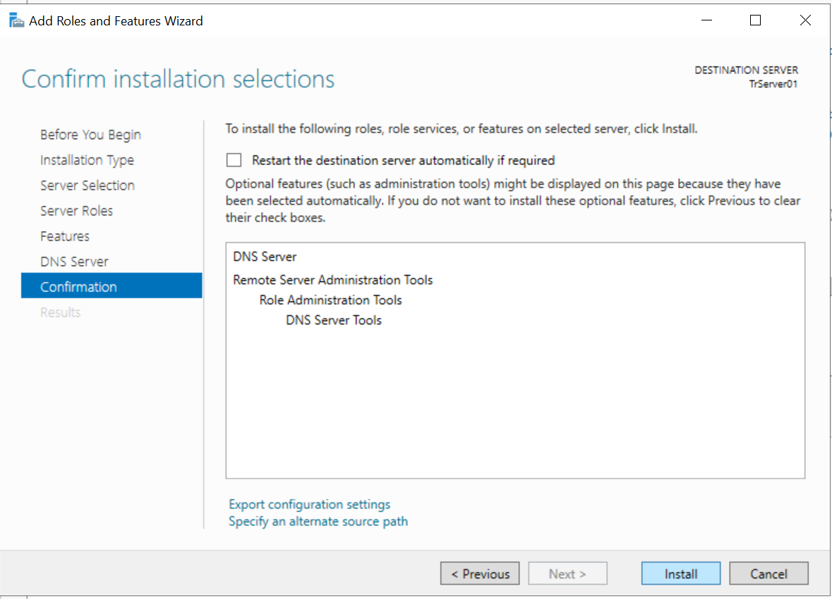
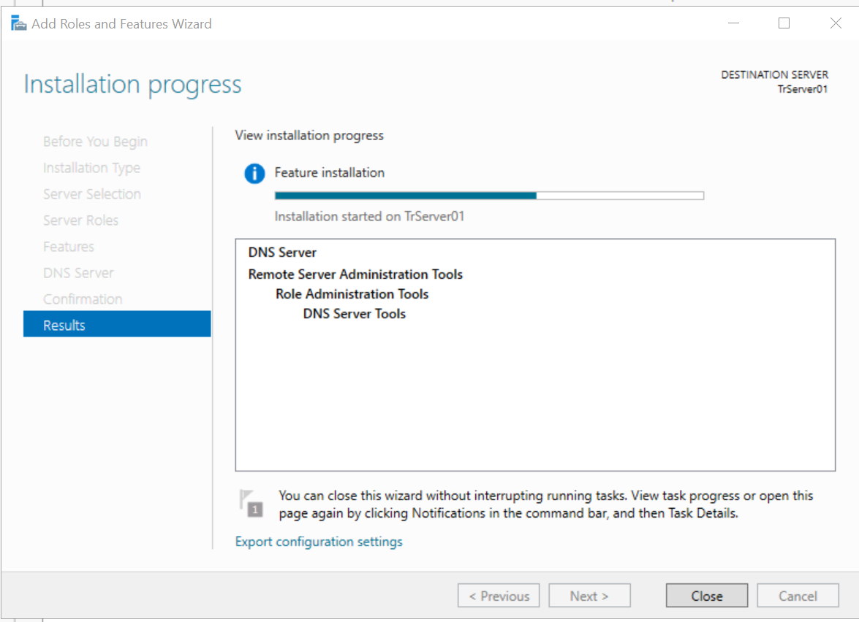

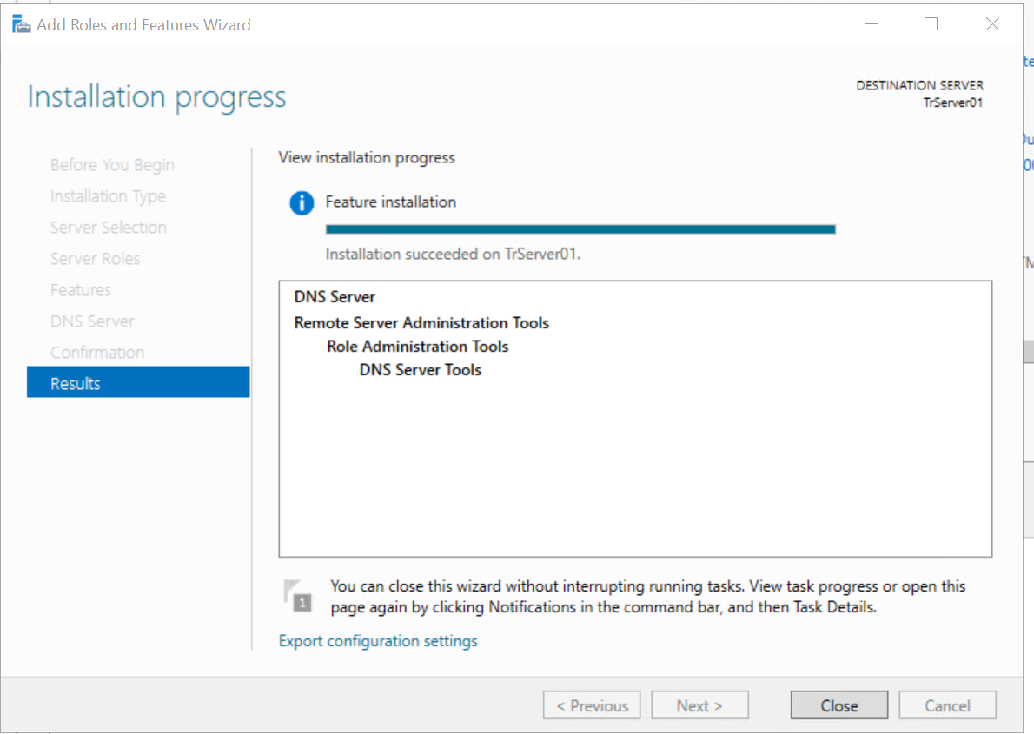
2 Configure Domain System
From Server Manager, click Tools and then click DNS.

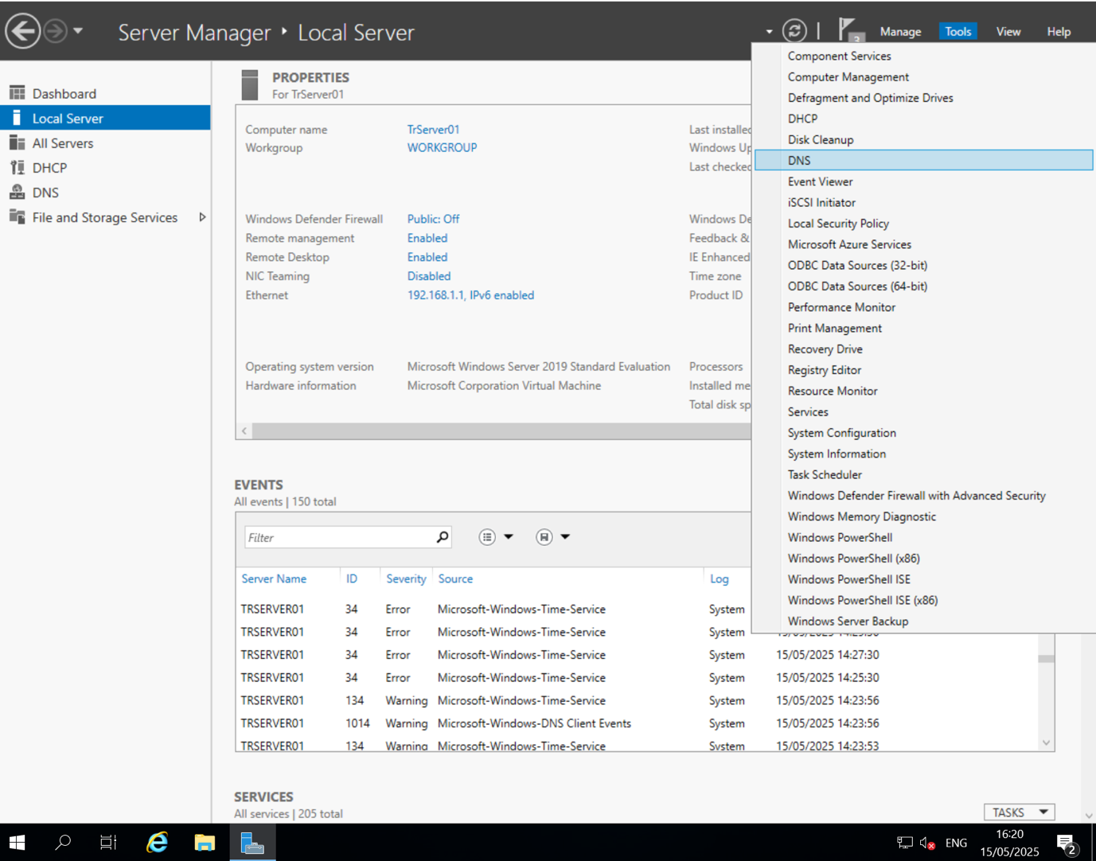
Click the arrow next to your server’s name to expand your options.
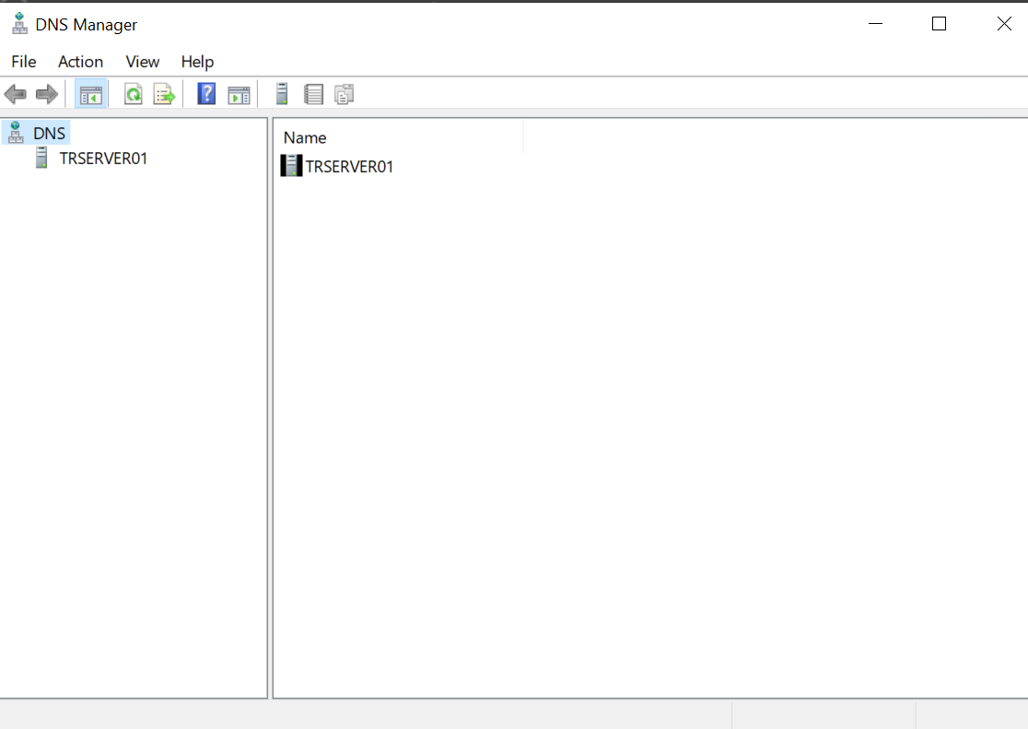
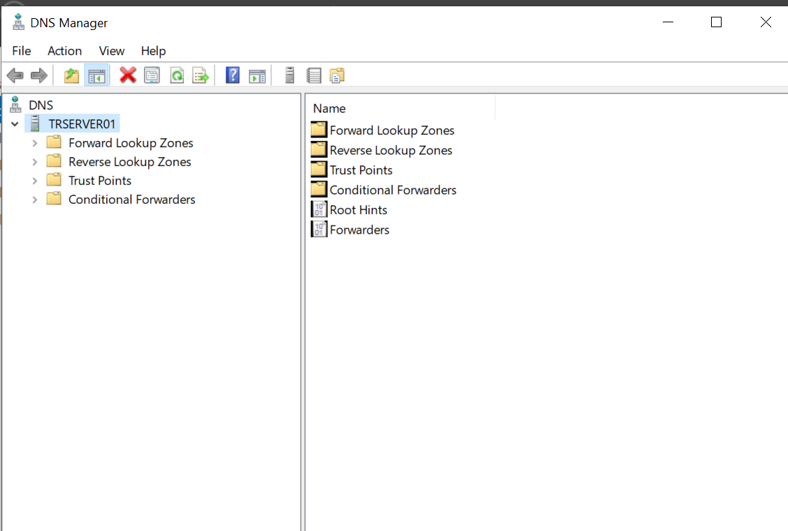

Right-click Forward Lookup Zones, and select New Zone.
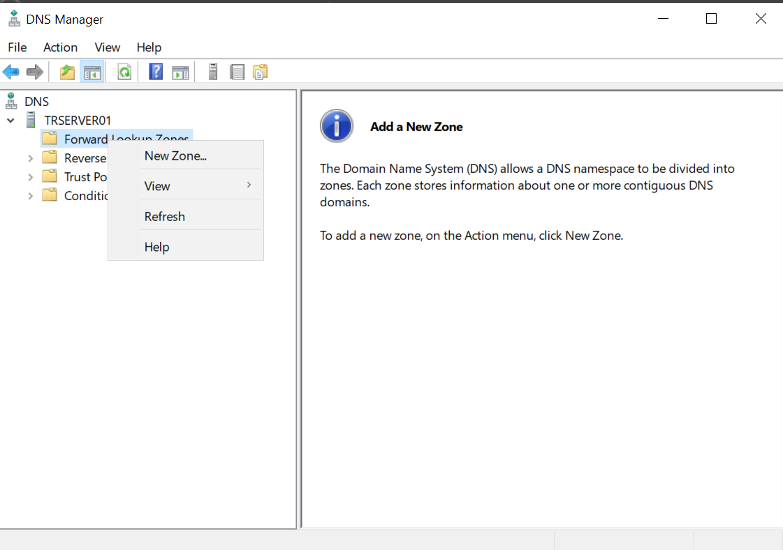
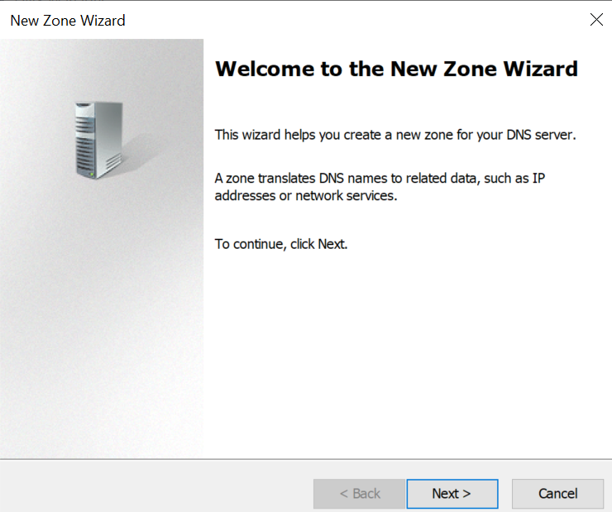
In the Welcome to the New Zone Wizard, click Next.
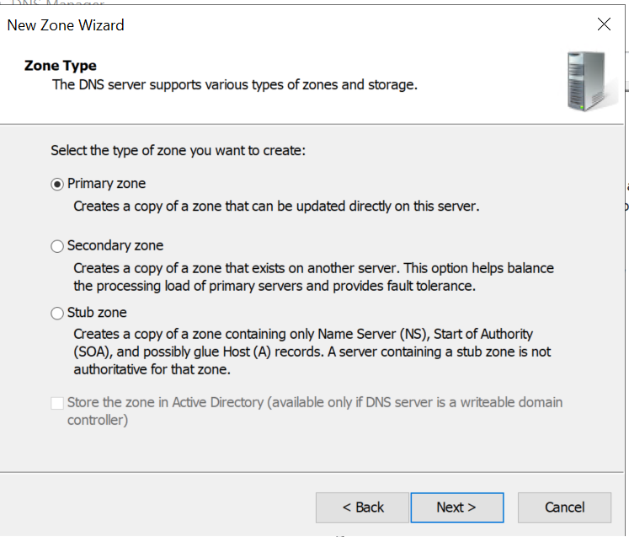
On the Zone Type screen, leave Primary Zone selected and click Next.
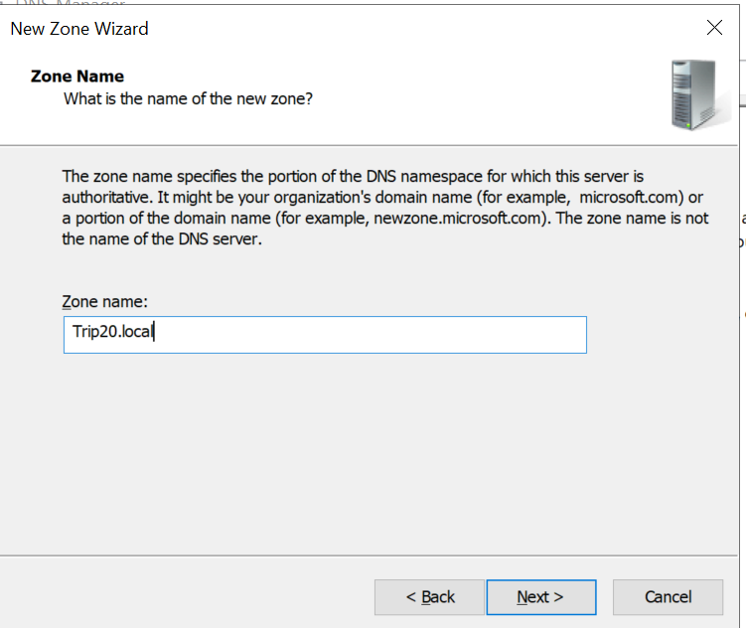
On the Zone Name screen, enter the zone name.

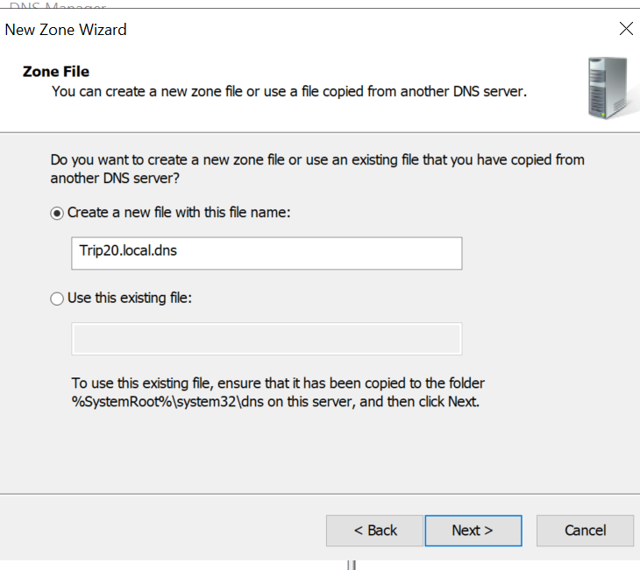

On the Zone File screen, leave the selection on Create a new file with this file name, and click Next.

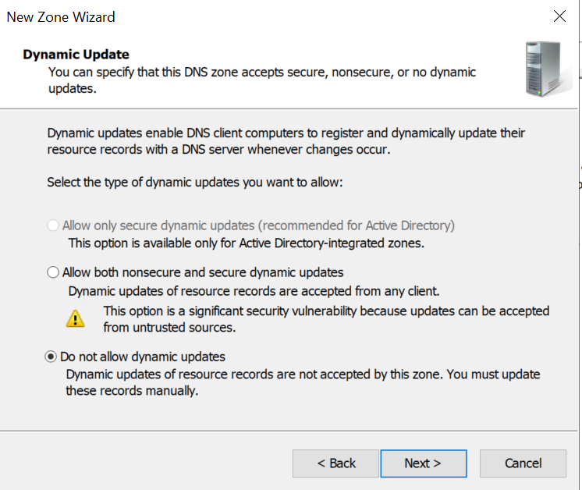
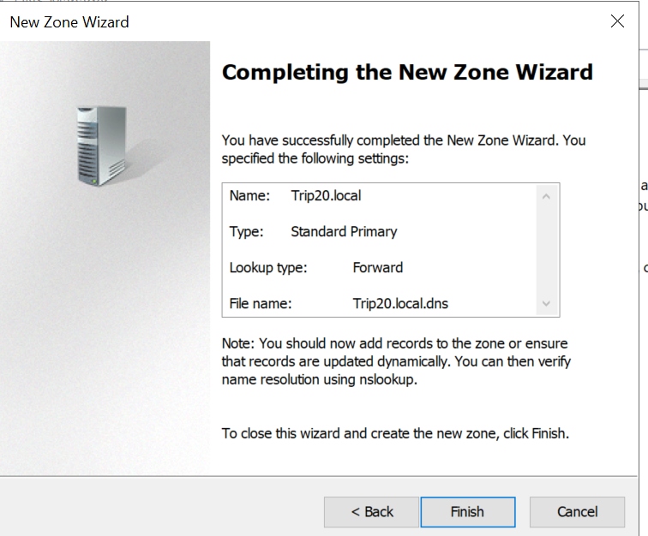
Click Finish.
Right-click Reverse Lookup Zones and select New Zone.

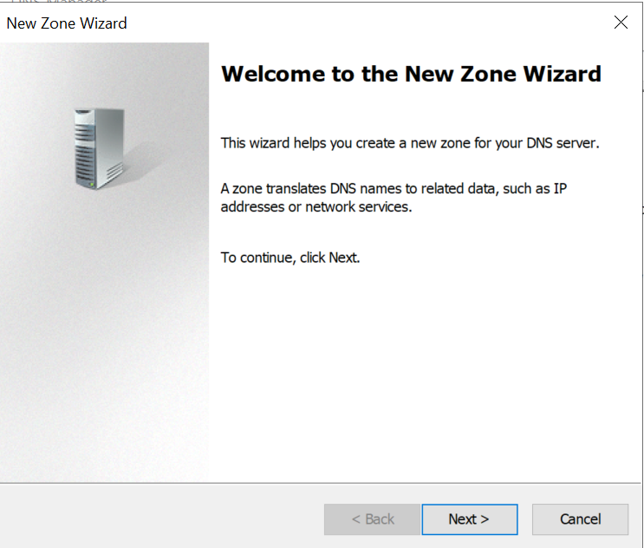

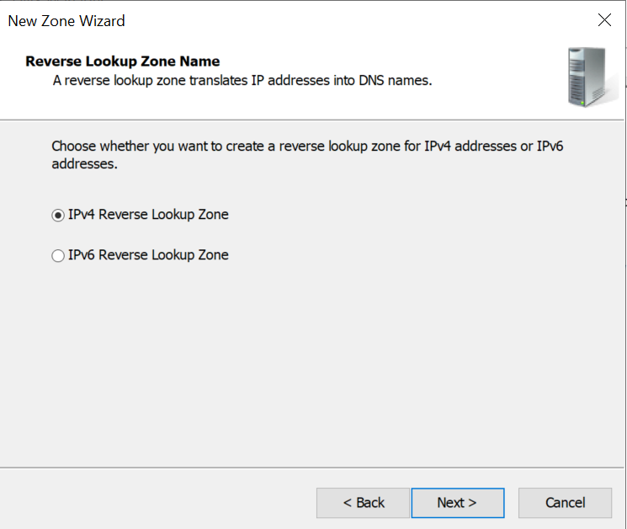

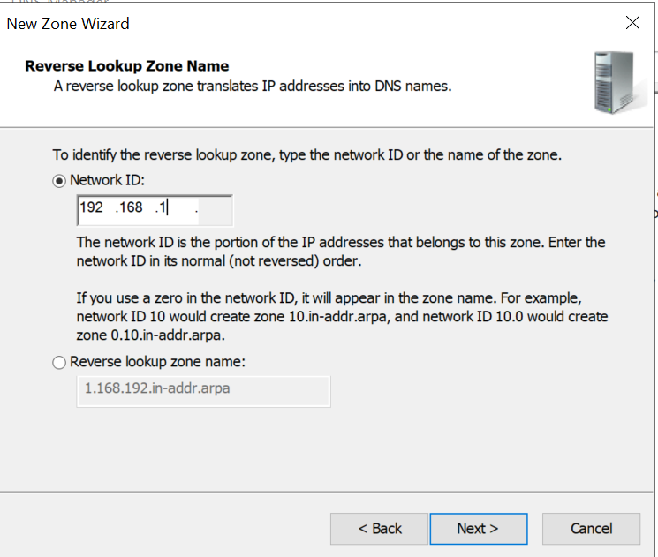

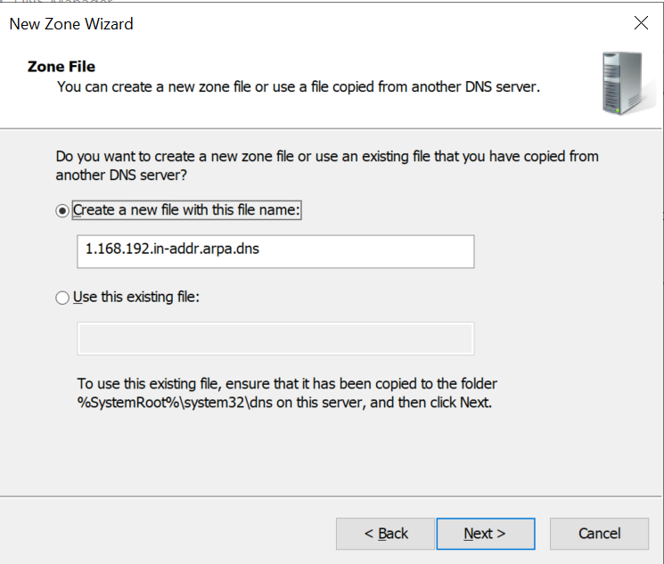

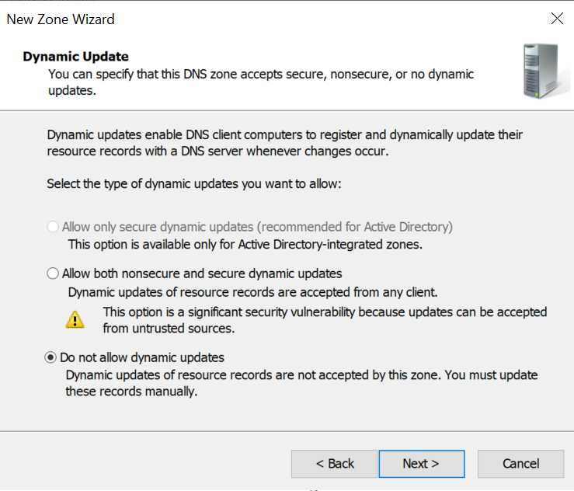

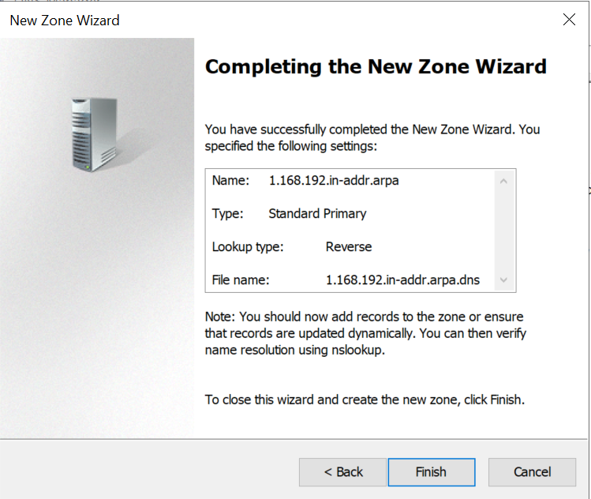

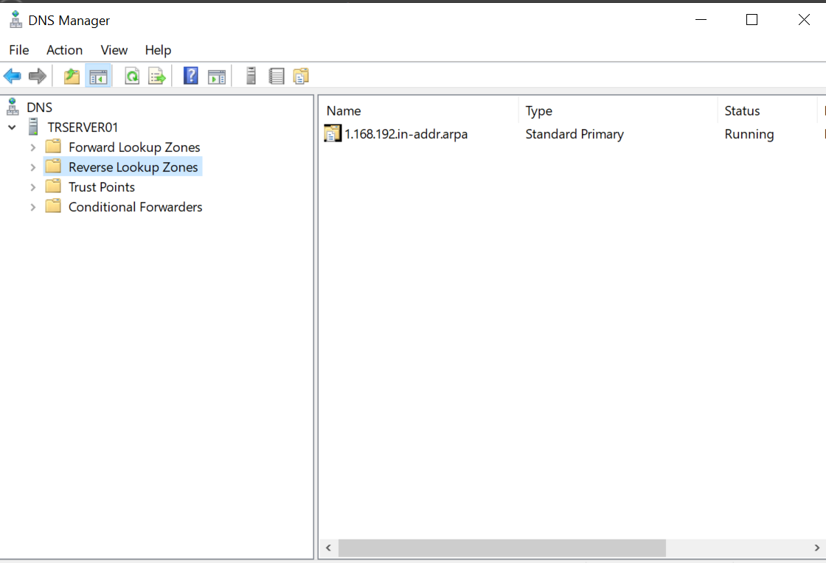

The following materials relate to lesson 10: Domain controller
Activity: Perform domain configuration prerequisites
Activity: Configure server as a domain controller
Activity: Join the domain
Activity: Installation peer review checklist

Activity: Perform domain configuration prerequisites
Link to lesson 9 – please complete activities in lesson before you start lesson 10.
Perform the following tests:

Test | Devices | Expected outcome | Actual outcome
IPCONFIG | Server1 VM
IPCONFIG | Server2 VM
IPCONFIG | Desktop VM
Ping from Server1 VM | Server2 VM
Ping from Server1 VM | Desktop VM
NSLOOKUP | Server2 VM
NSLOOKUP | Desktop VM

Activity: Configure server as a domain controller
Install Active Directory Domain Services
- From the Server Manager Local Server window
- Click Manage and then select Add Roles and Features

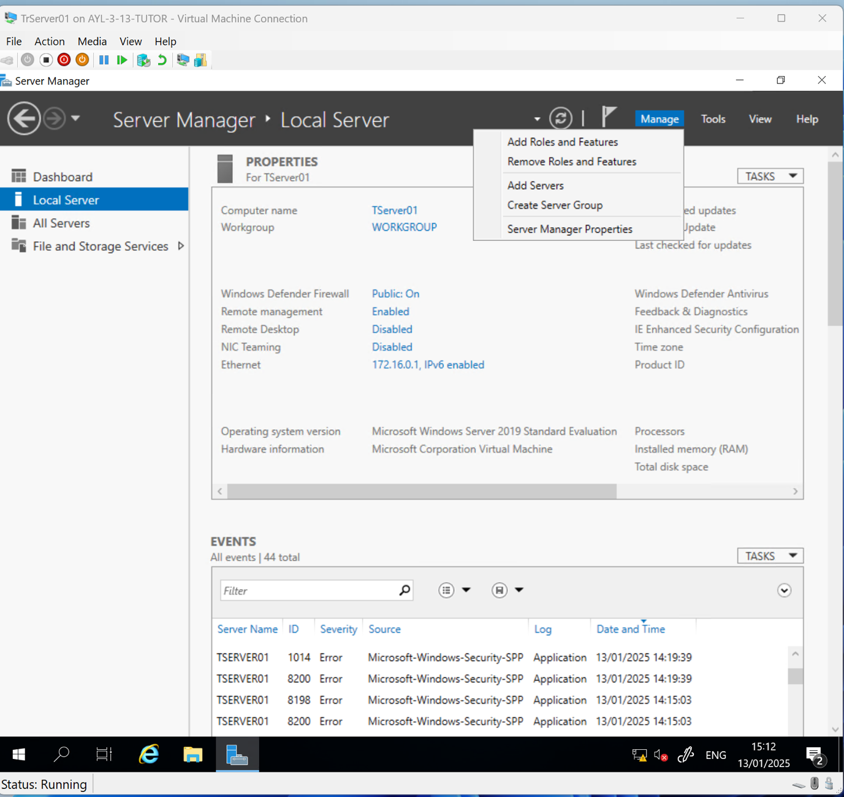

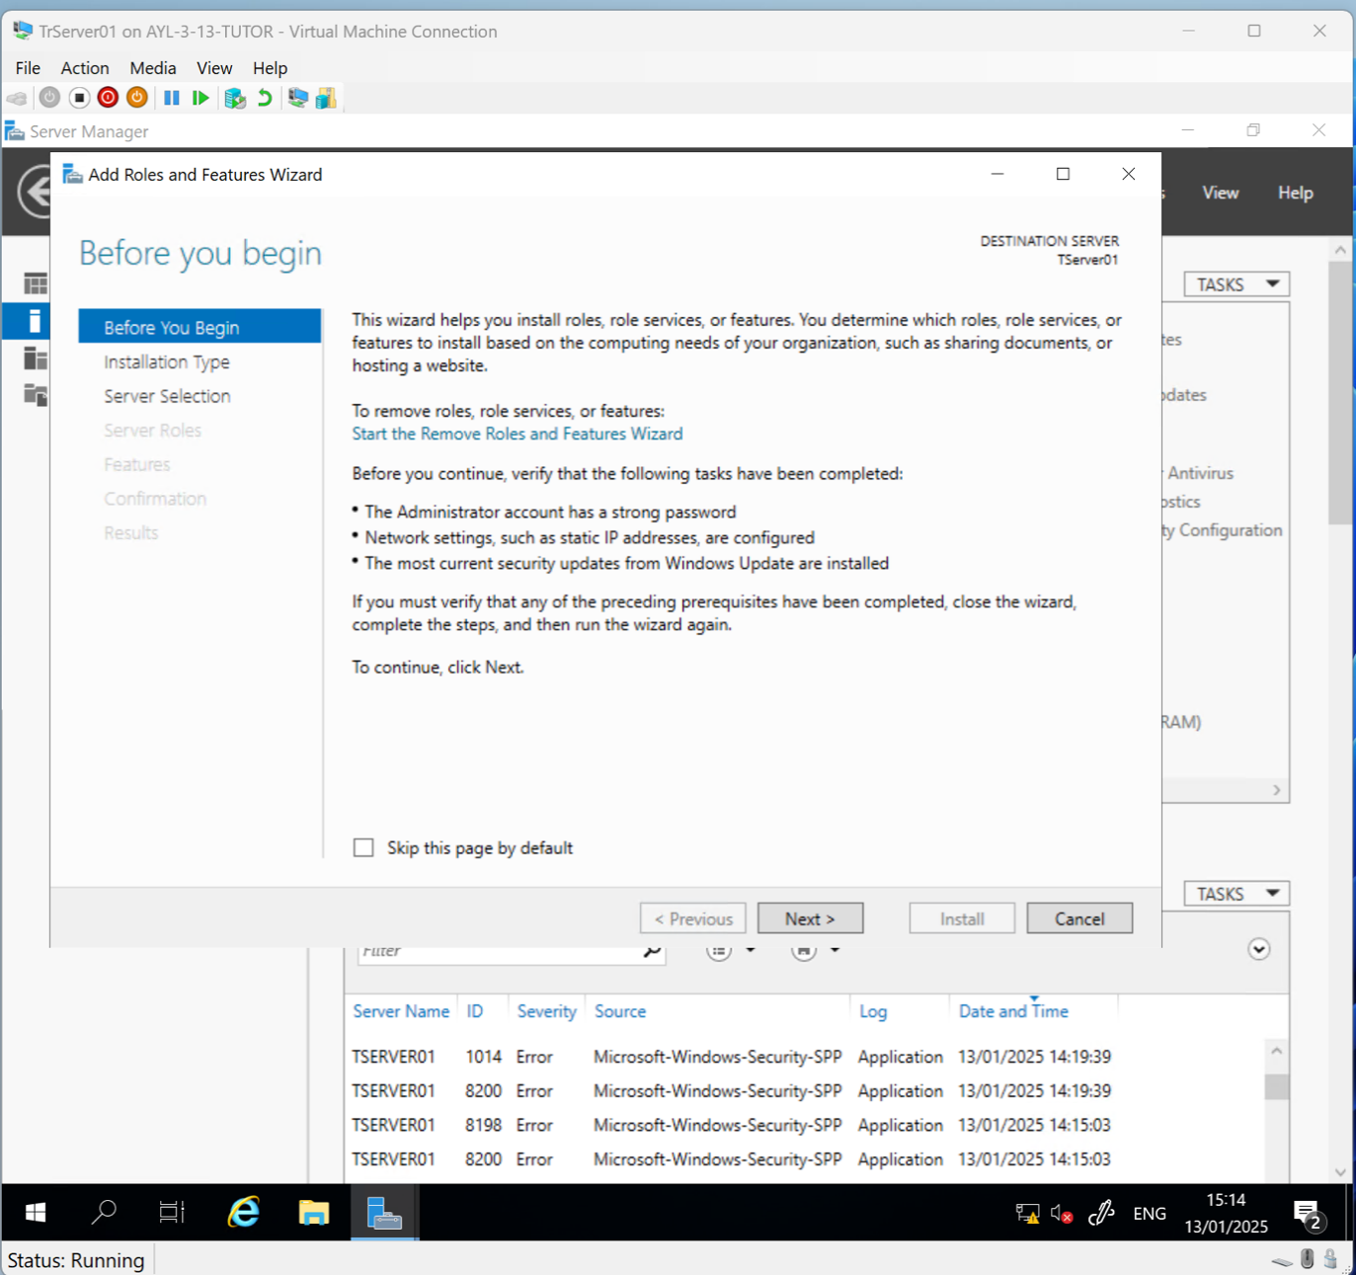Click Next.

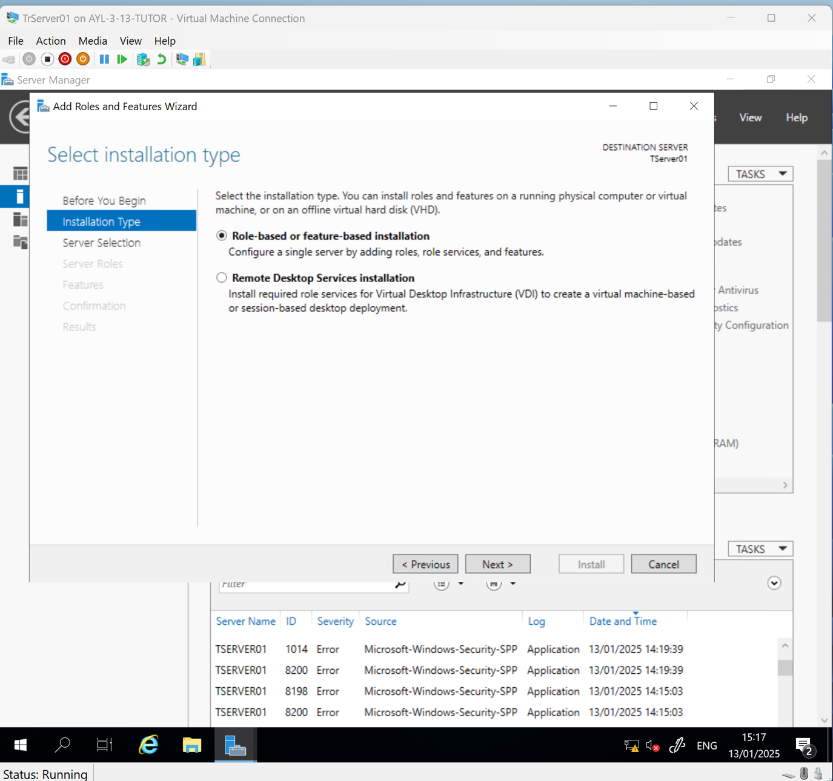Click Next.
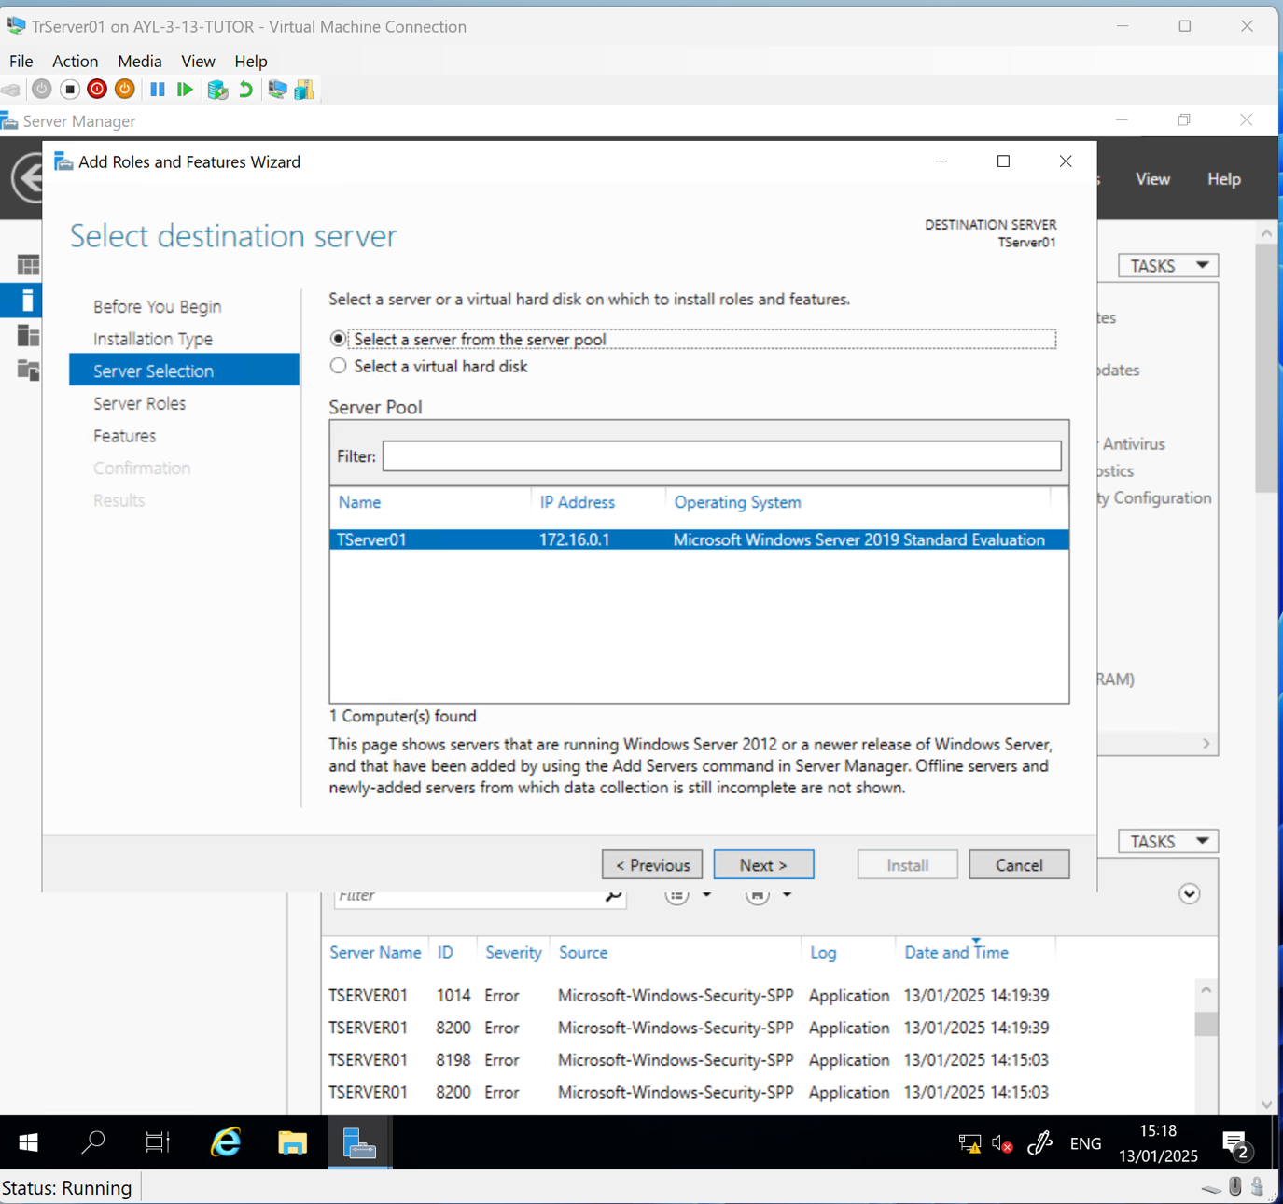Click Next.

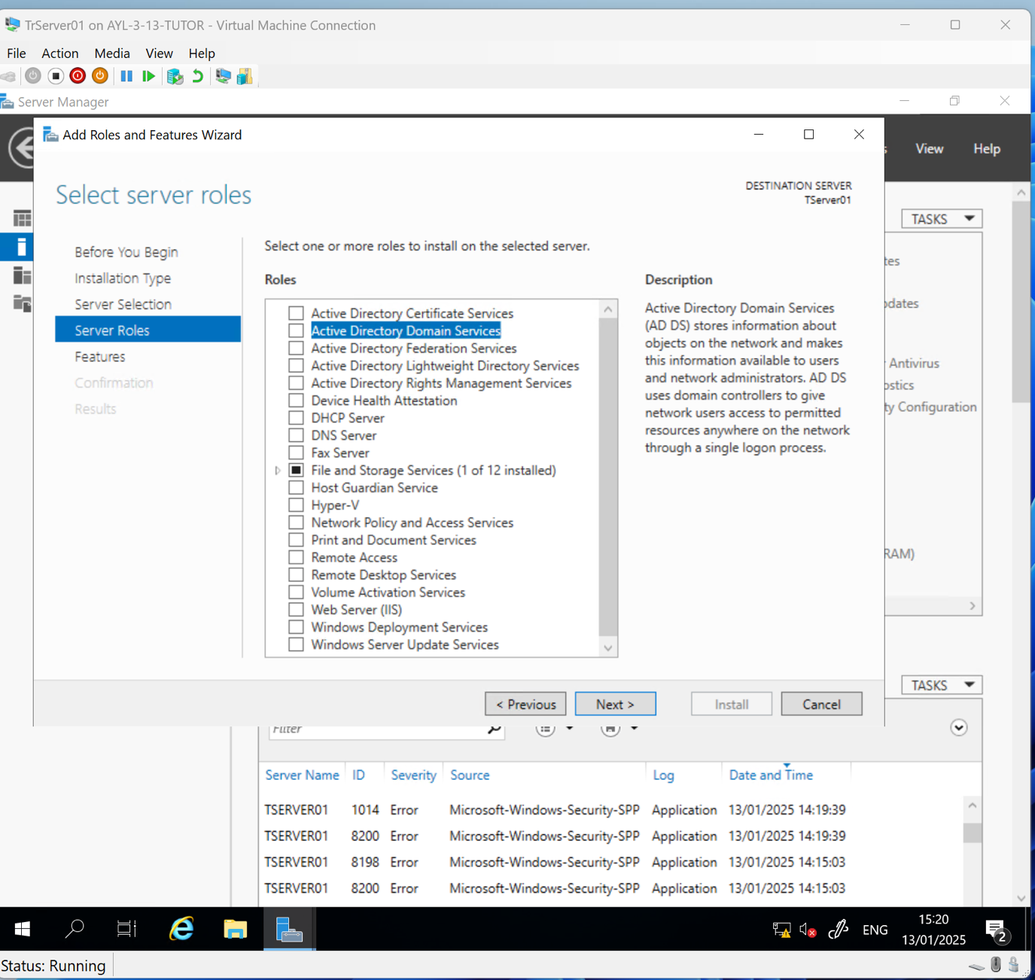Select Active Directory Domain Services.

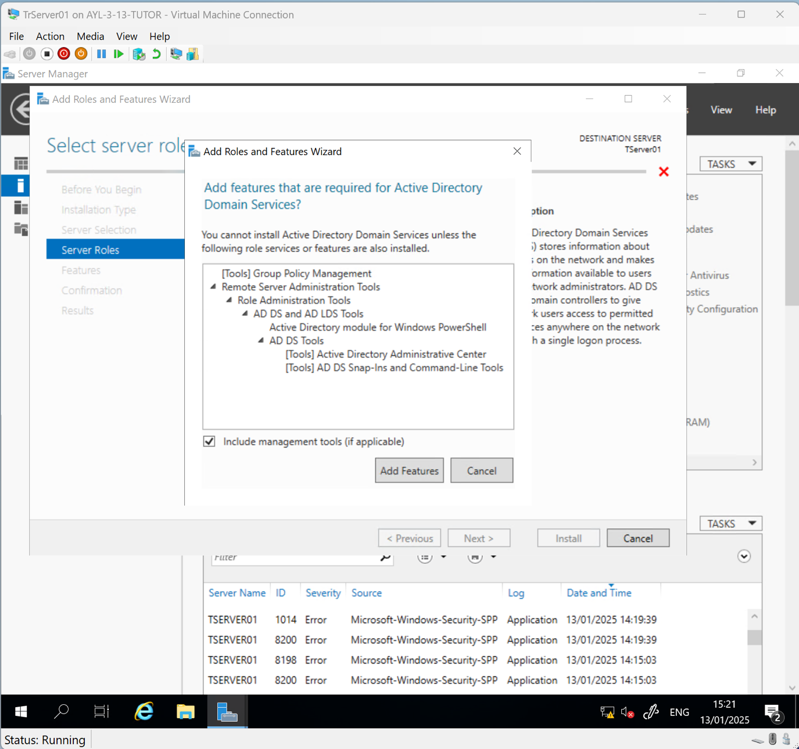Click Add Features.

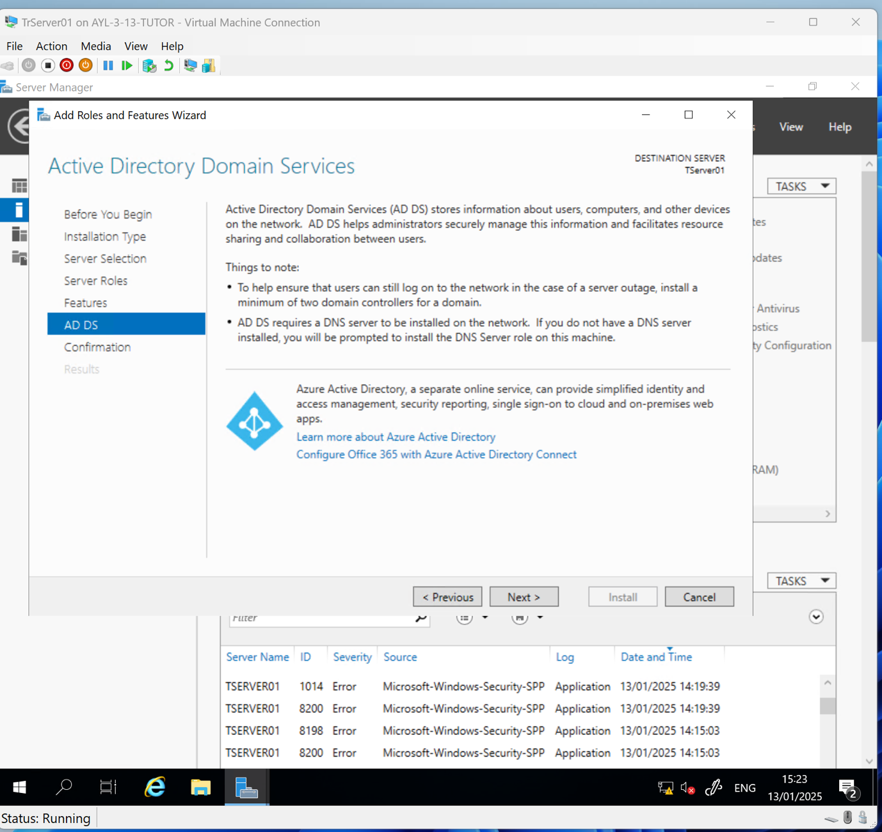Click Next.
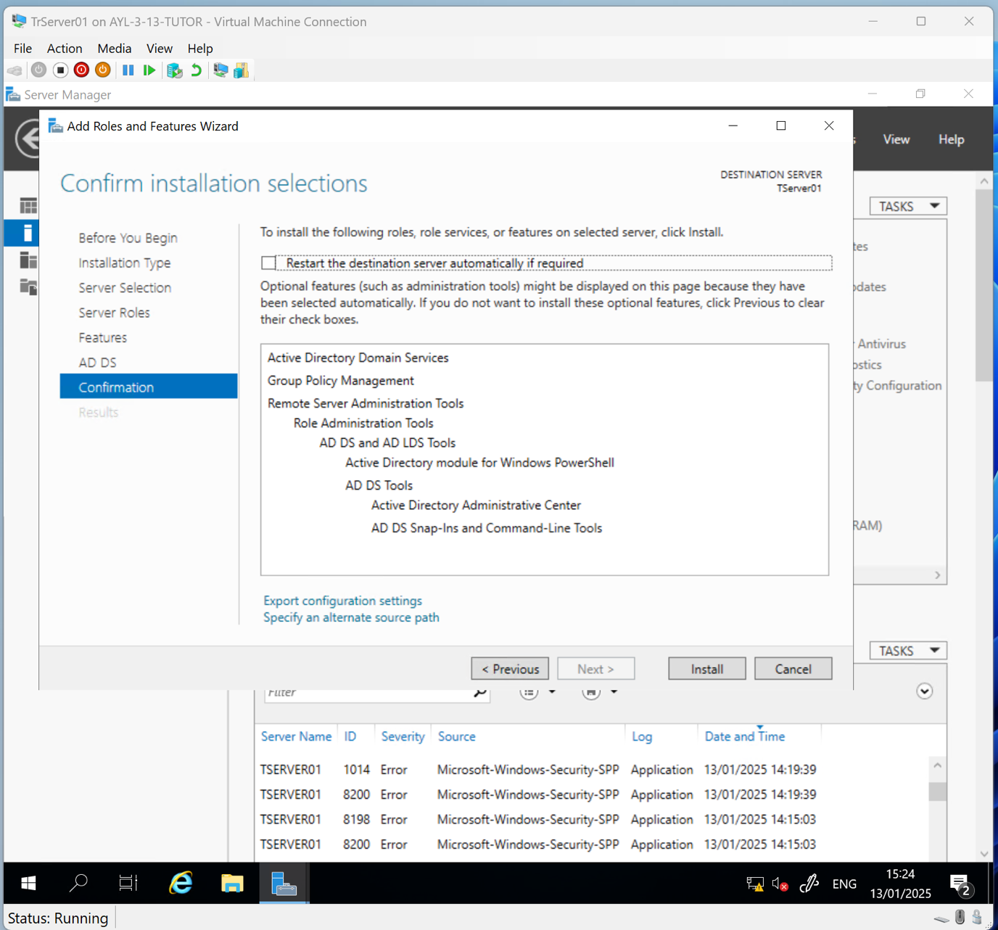Click Install.

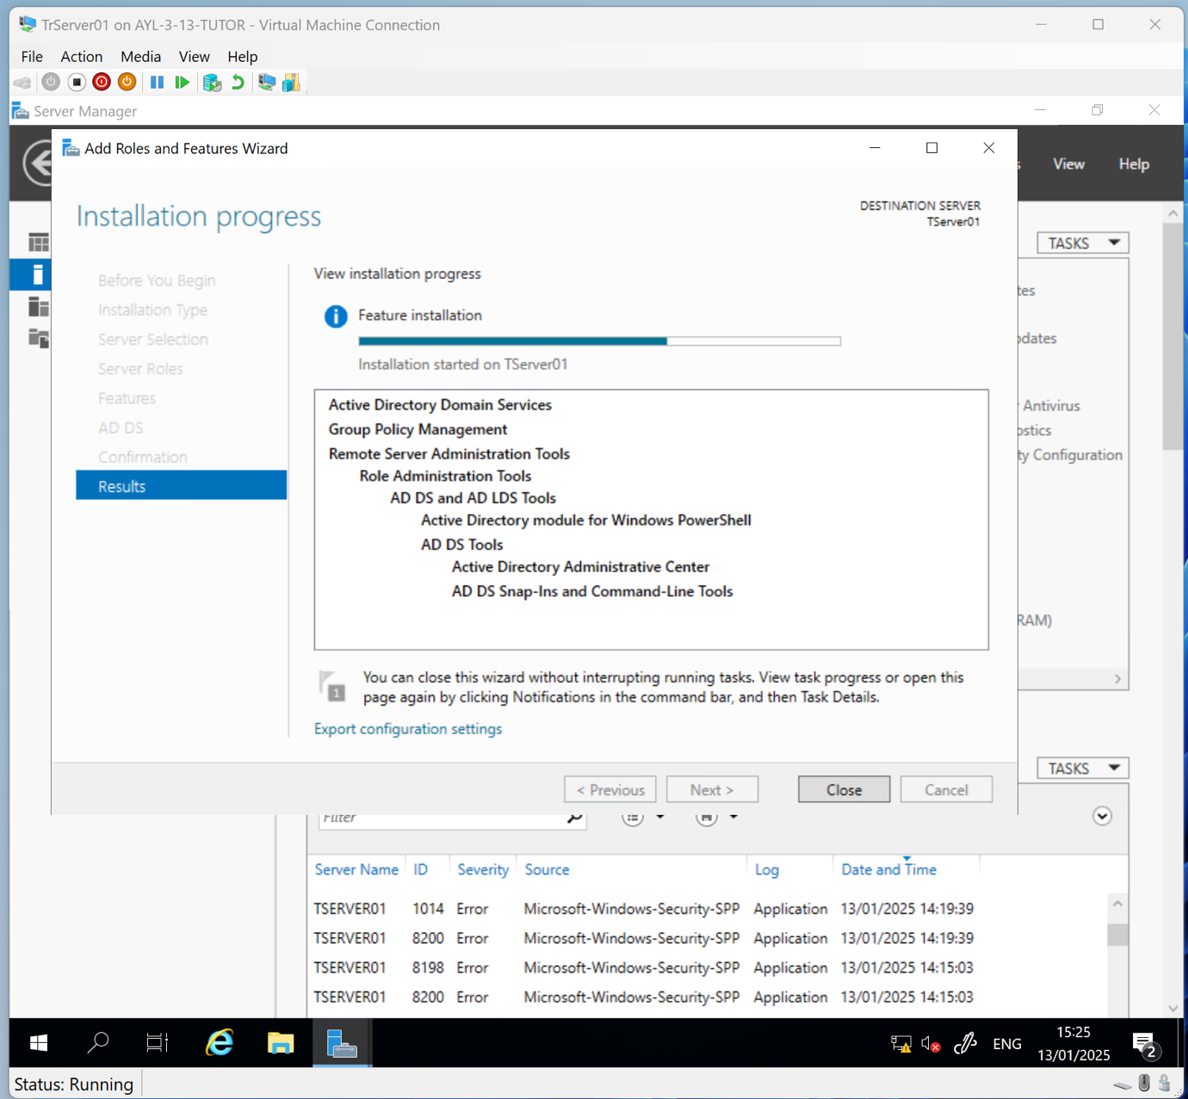Click Close after the installation is complete.

Configure Active Directory Domain Services

From Server Manager, click the flag, and then click Promote This Server to a Domain Controller, as shown below:
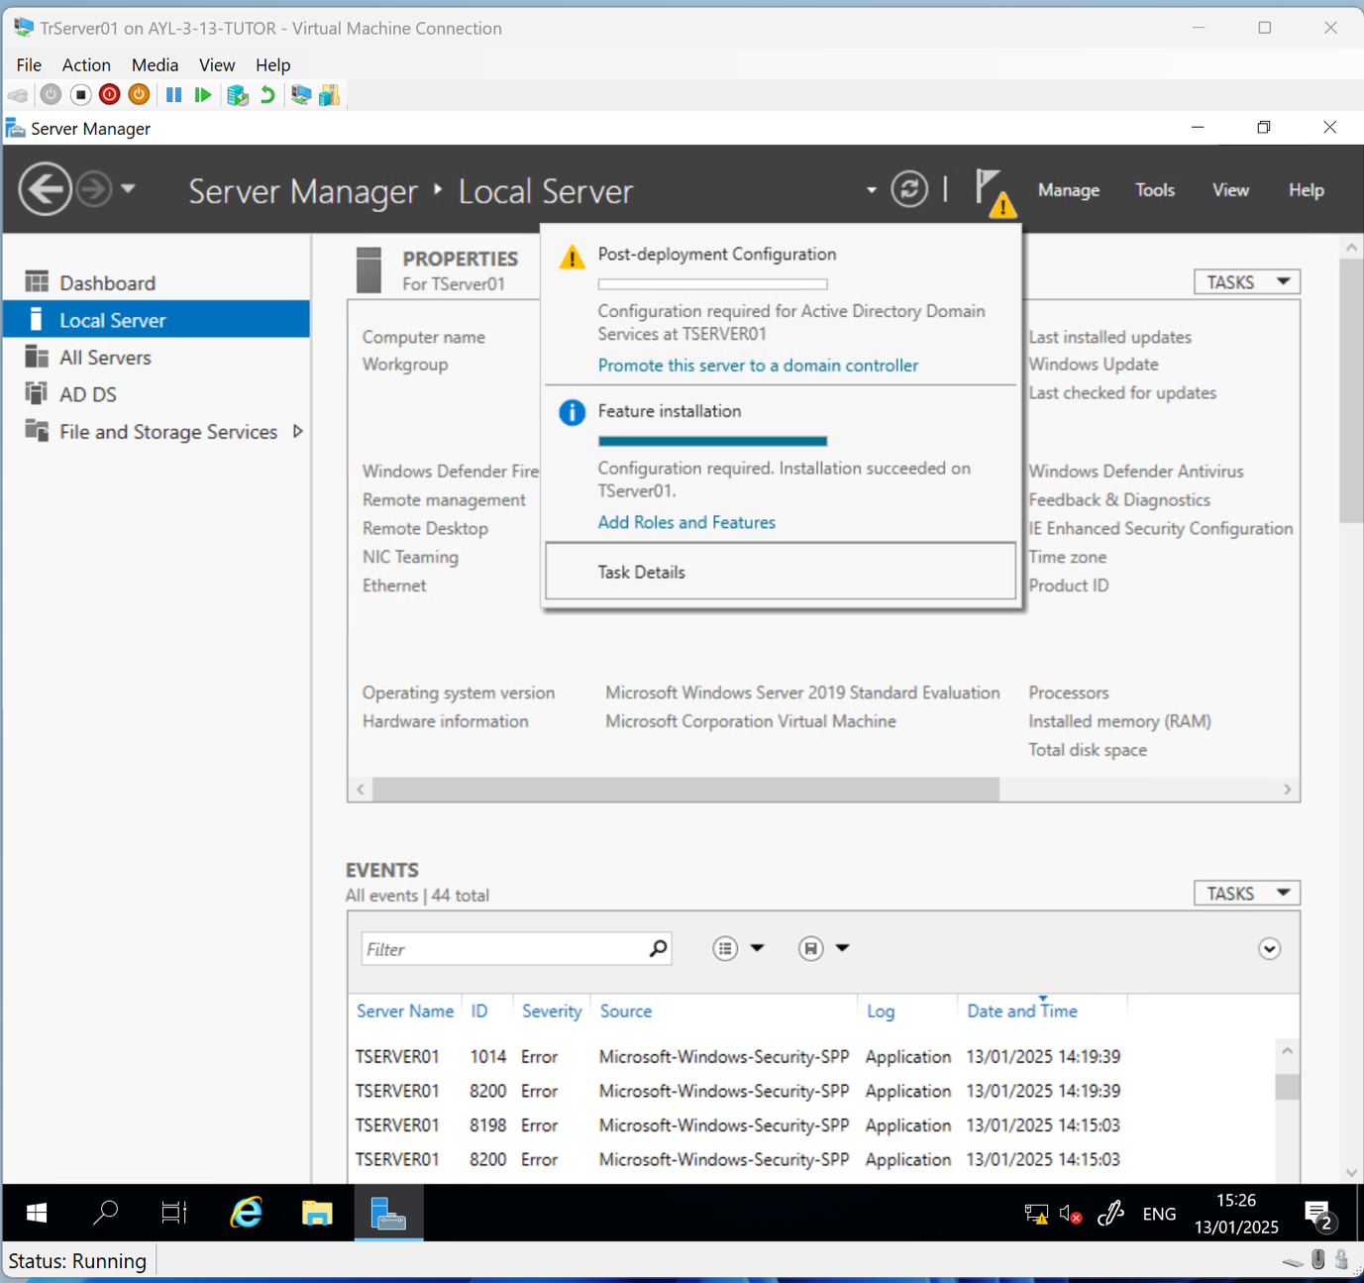

Deployment configuration
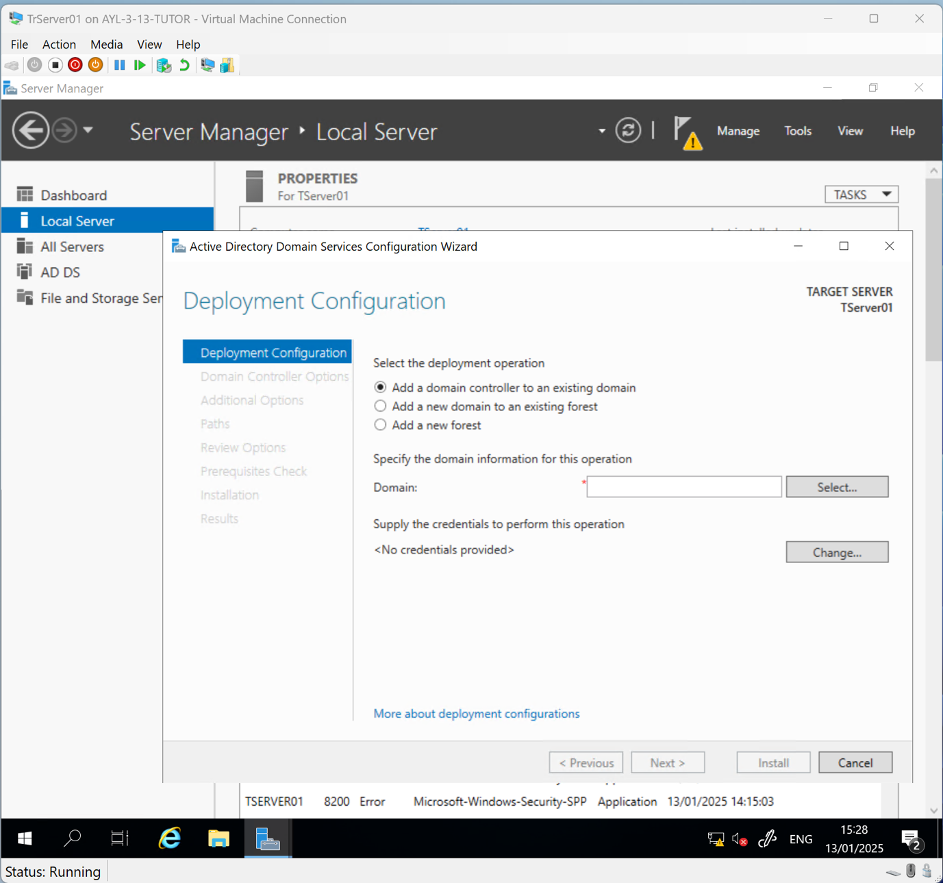Select Add a New Forest.

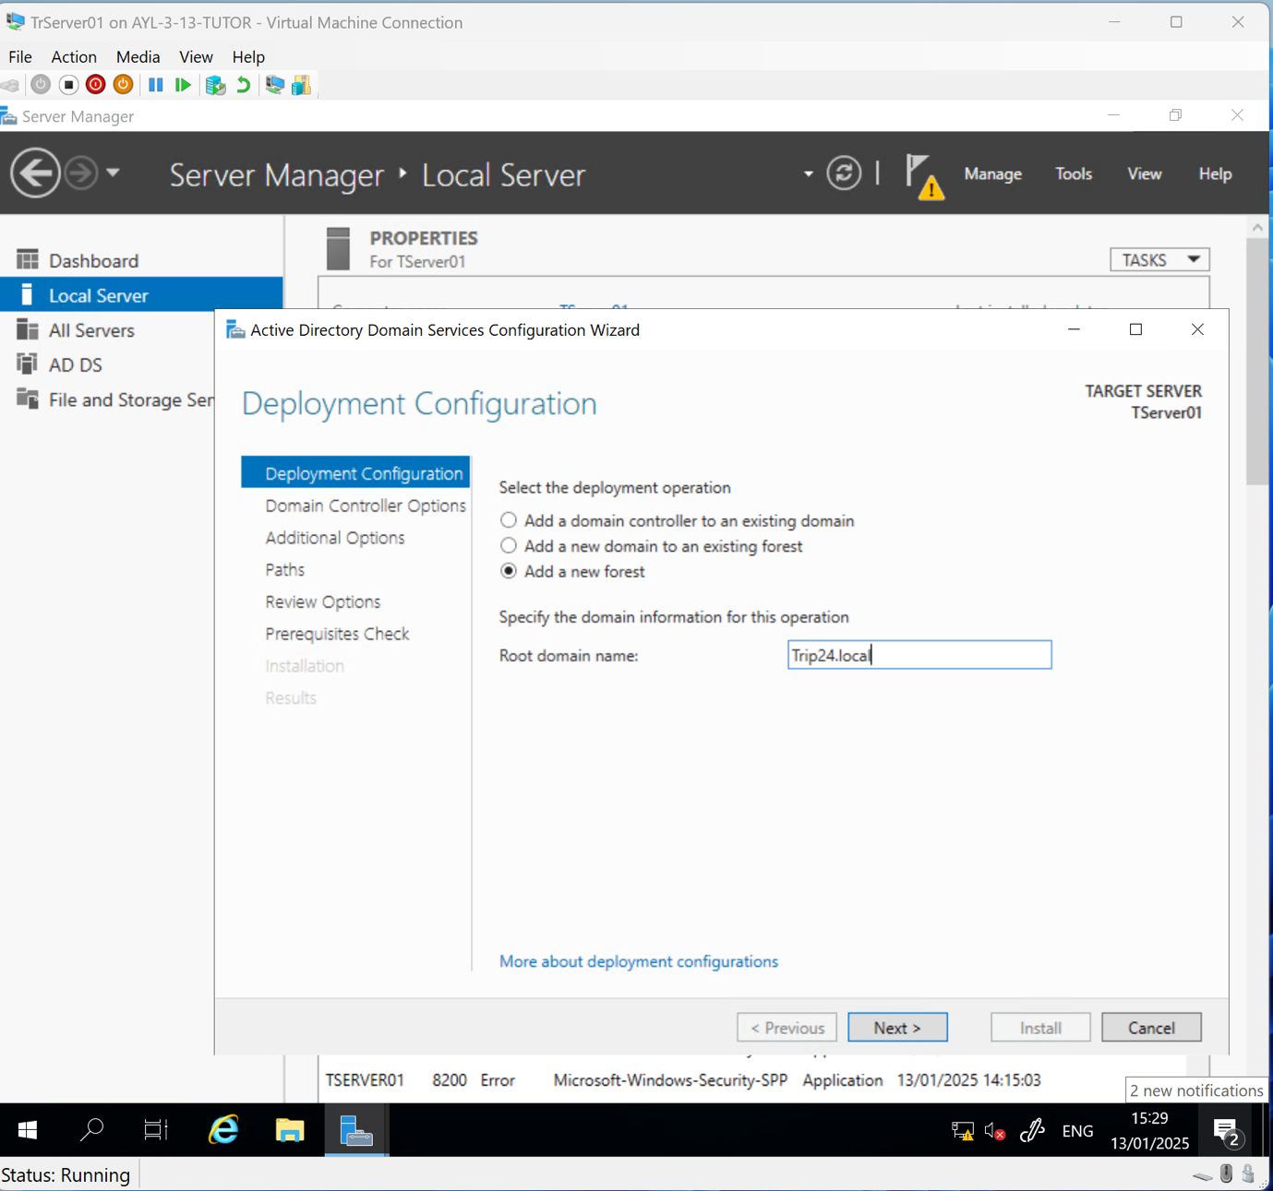Enter the root domain name “Trip24.local”.

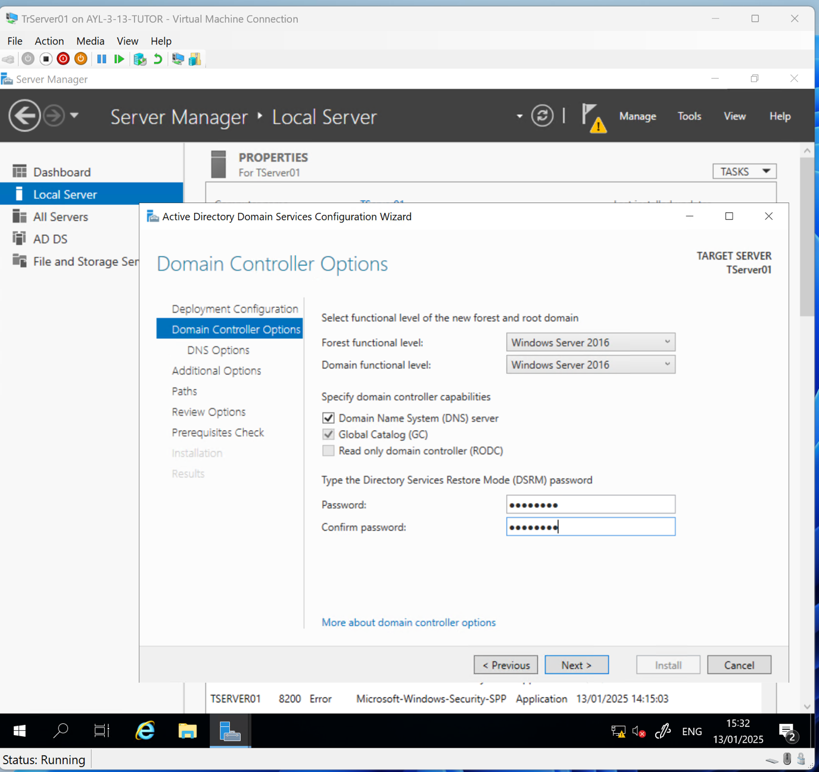Click Next.
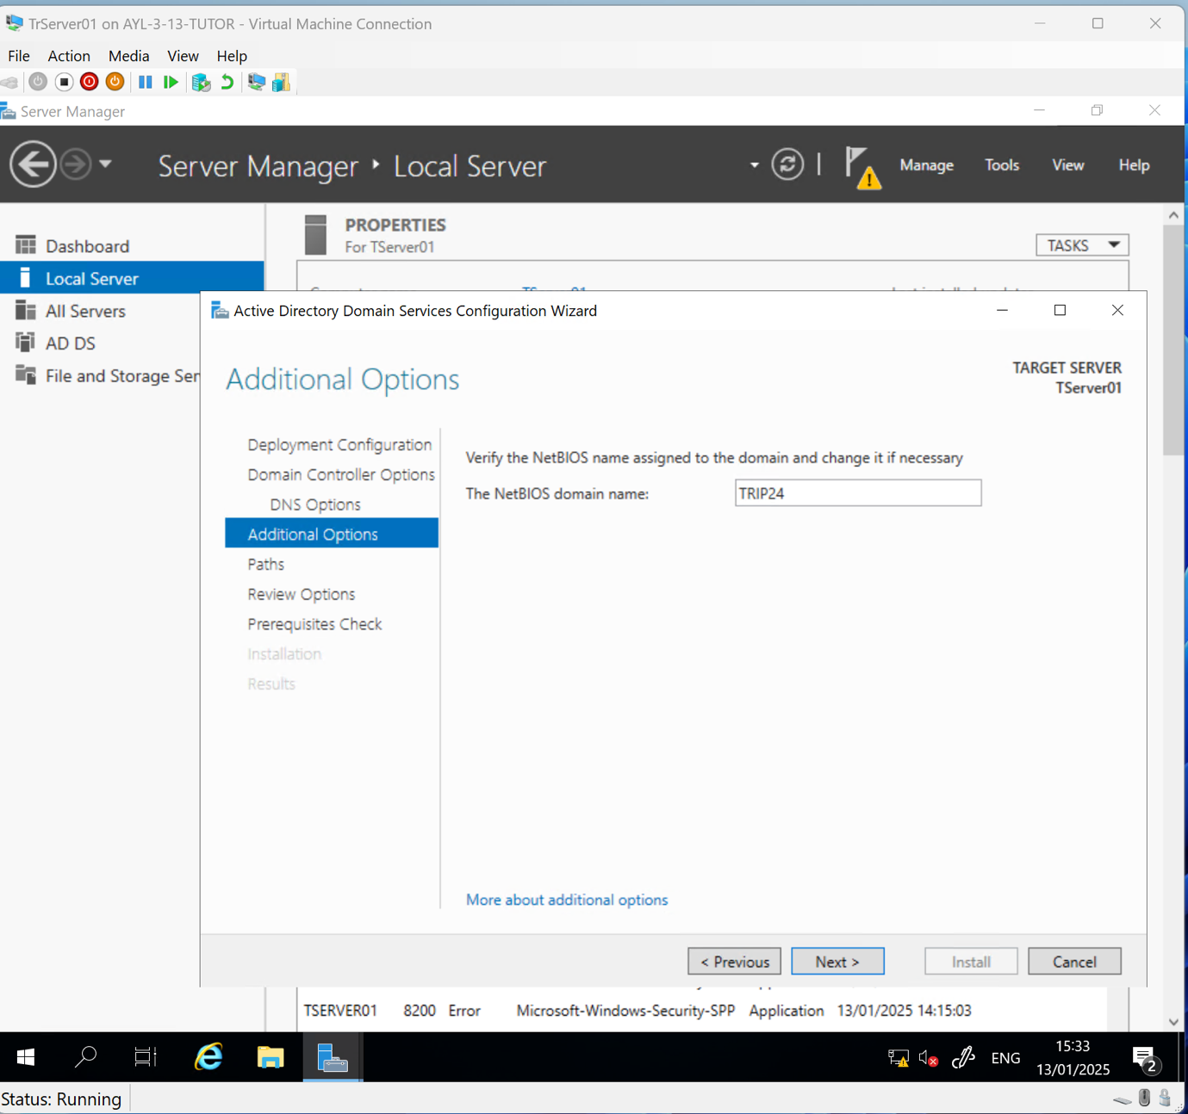Click Next.
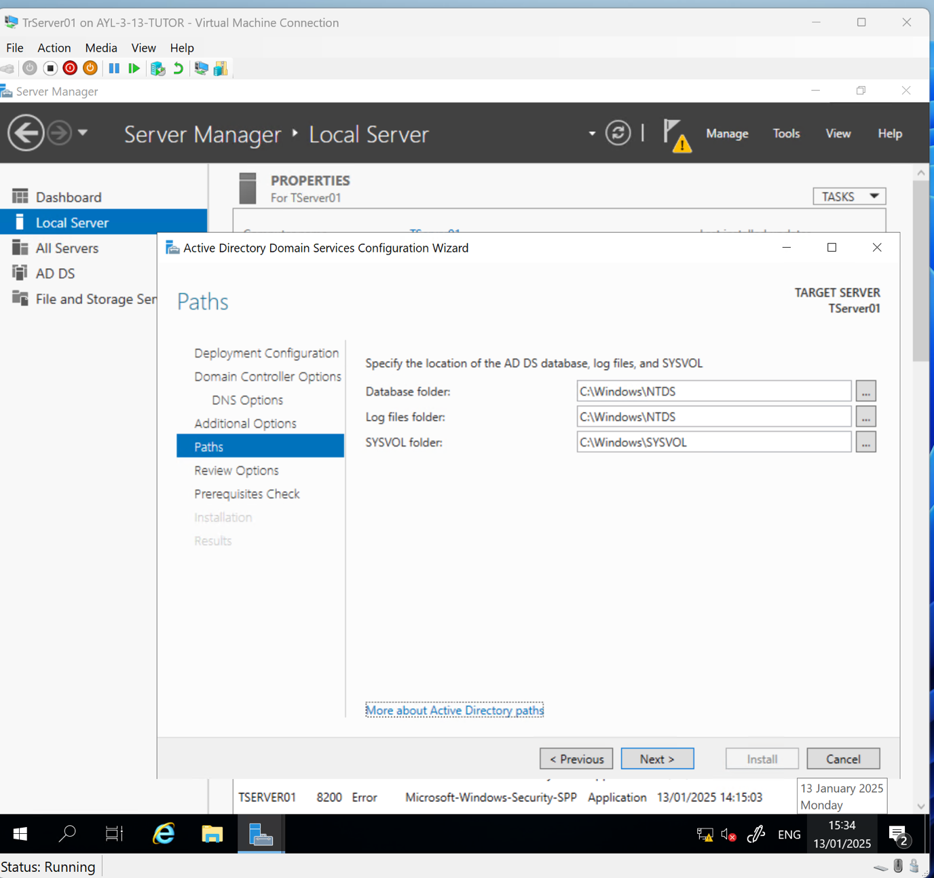Click Next.

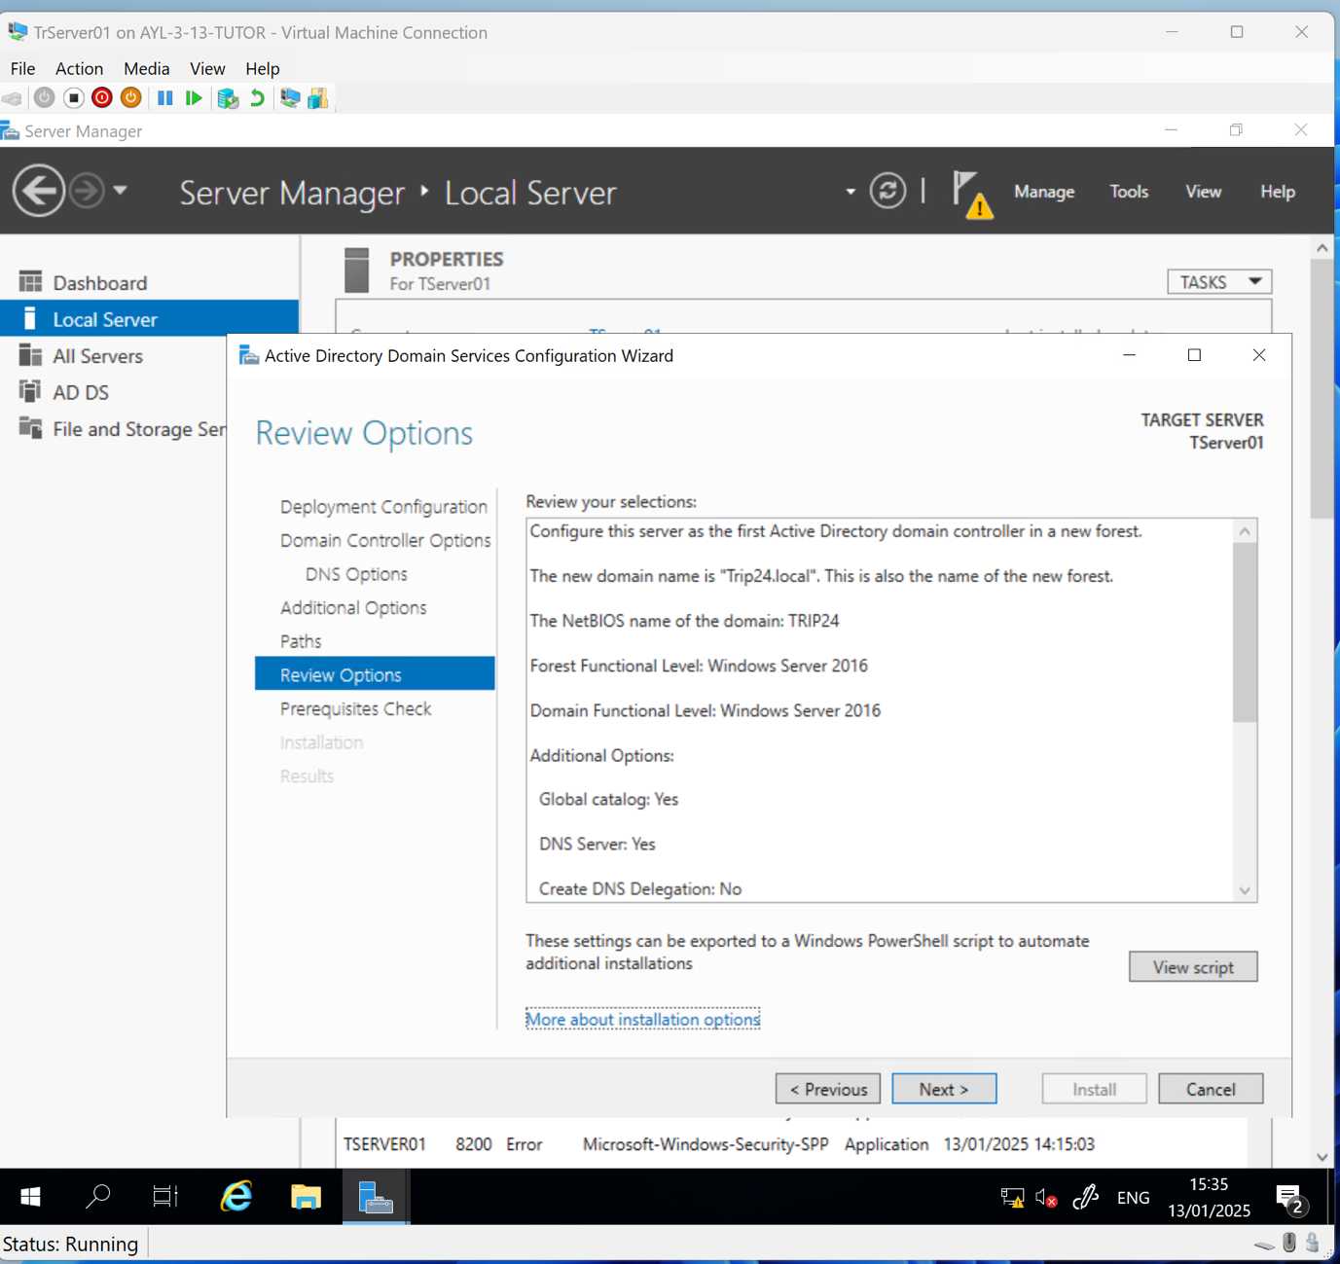Click Next.

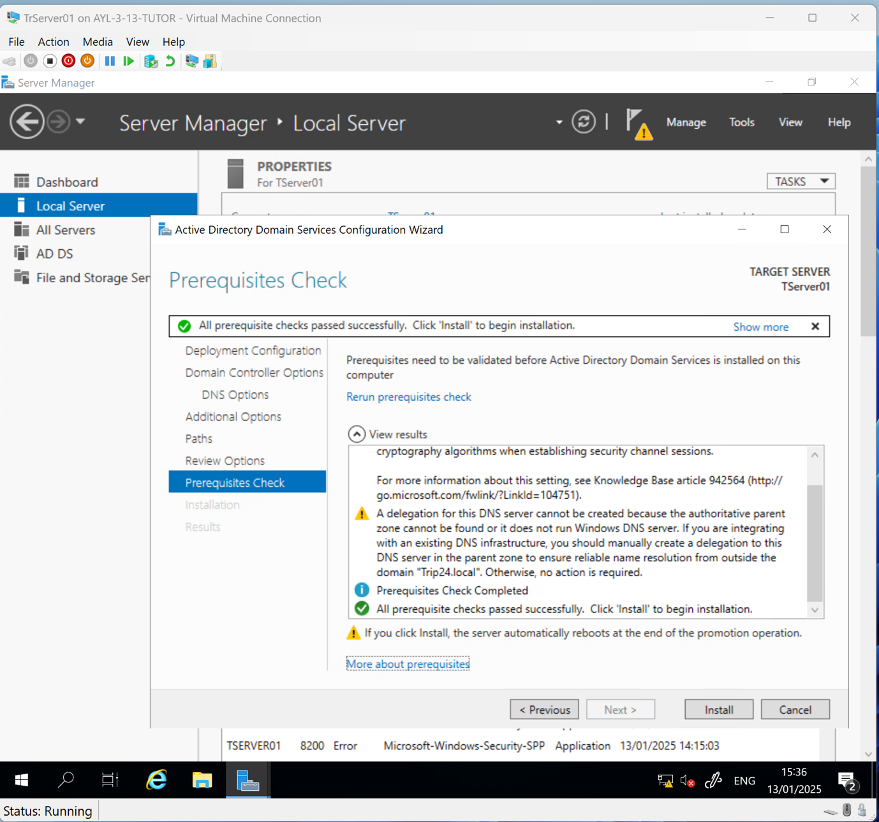Click Install.

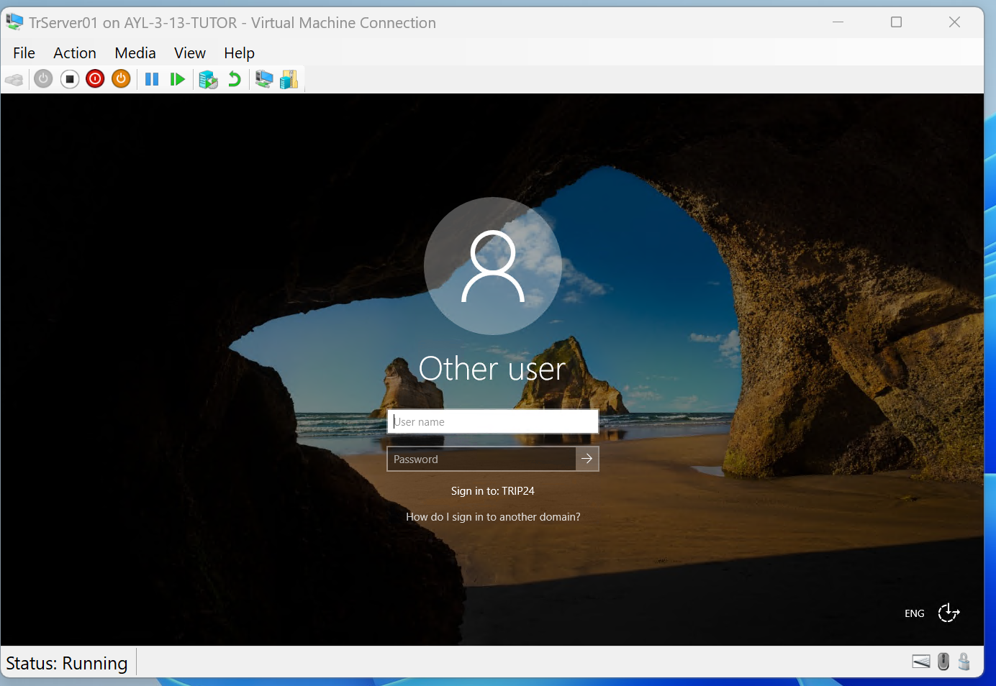Domain Trip24.local created. Log in as domain administrator.

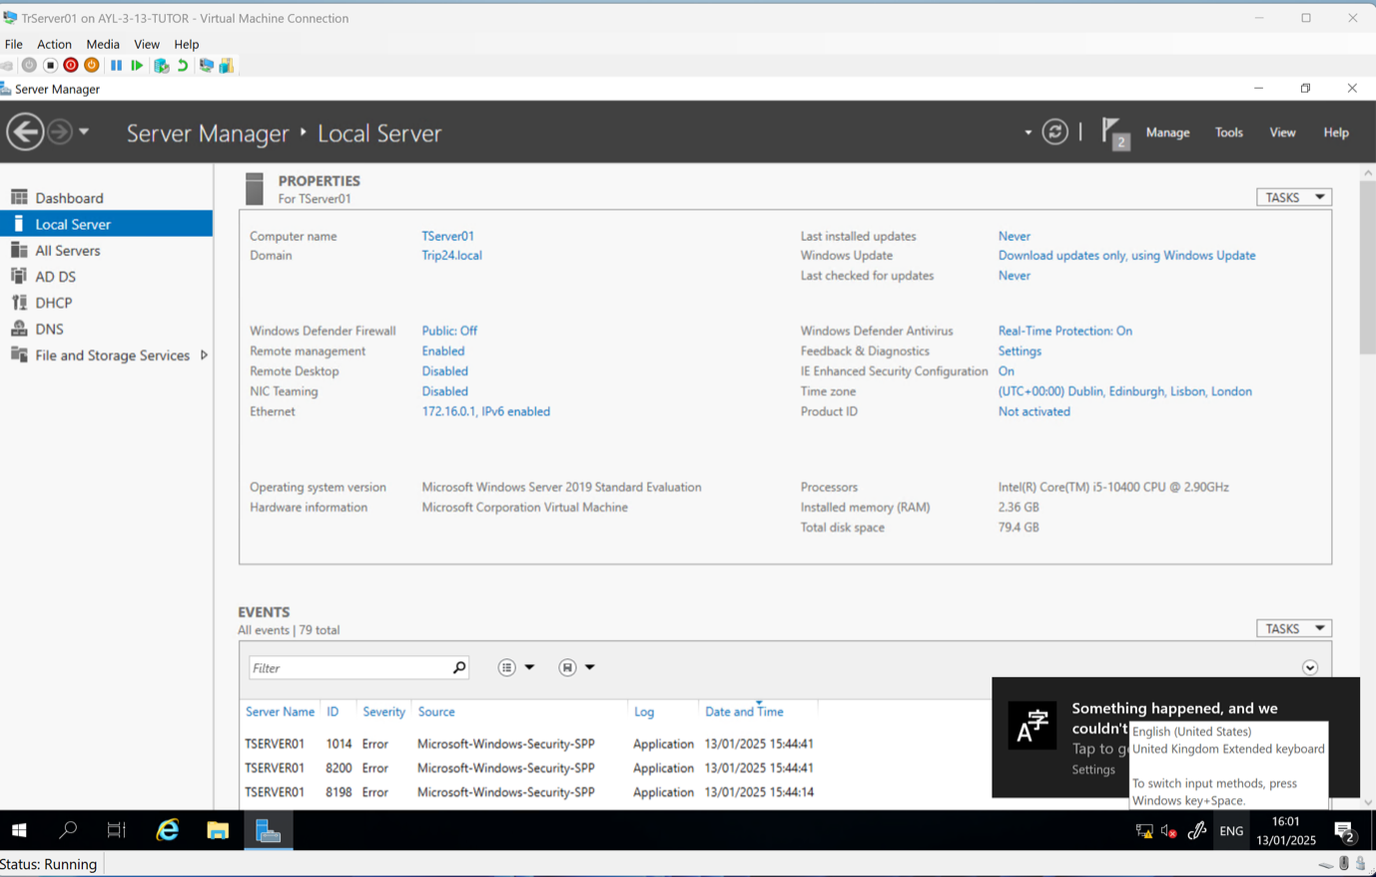Tserver01 in Trip24.local

Activity: Join the domain
Join Server2 VM and Desktop VM from lessons 7 and 8 to Trip24.local
Join Server VM to Trip24.local

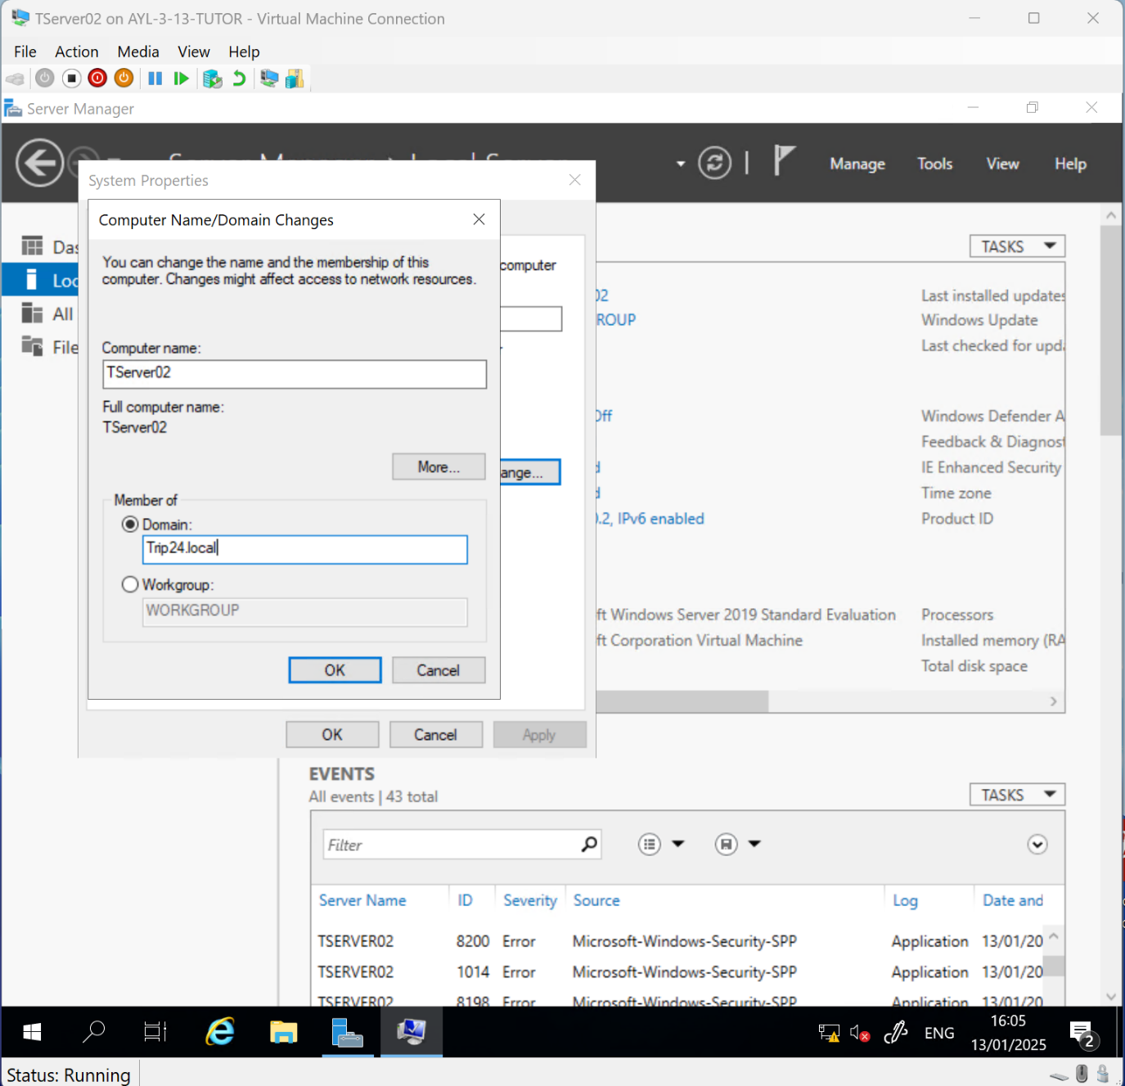Click OK.
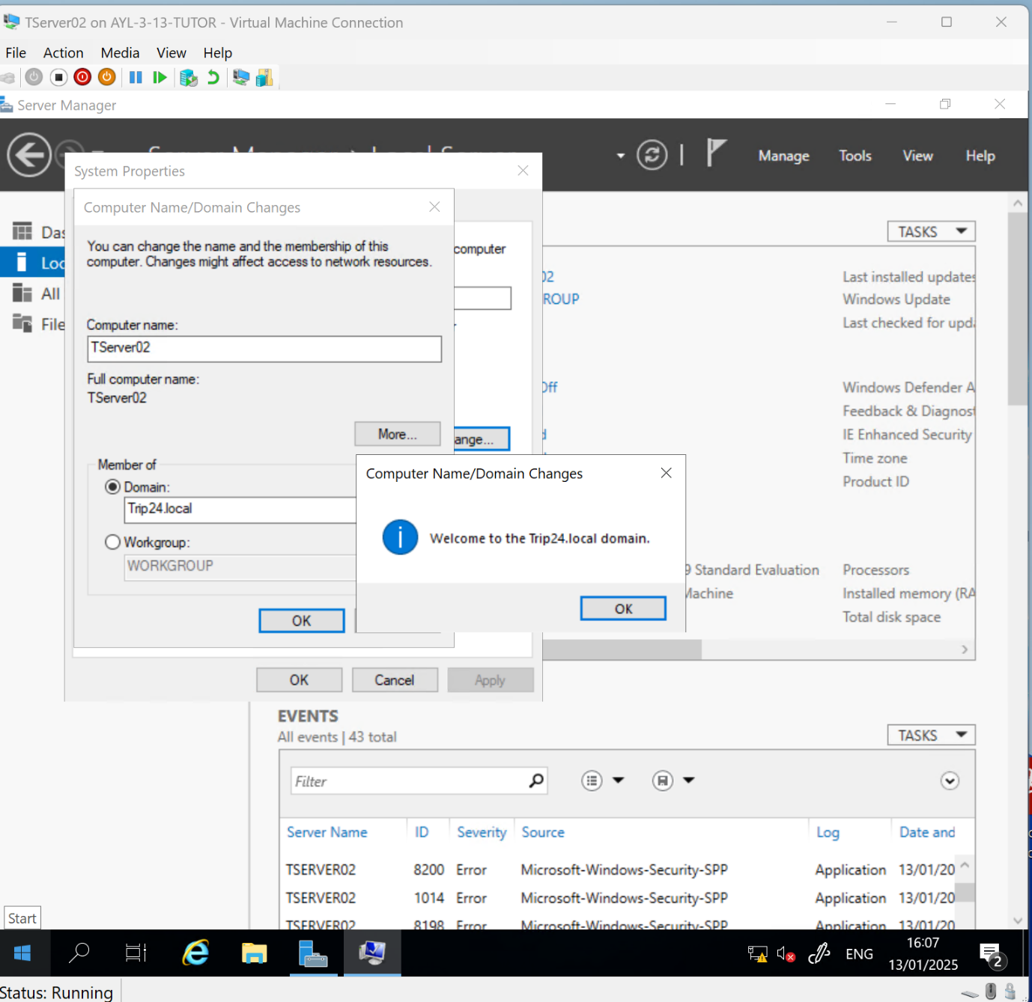Tserver02 joined Trip24.local

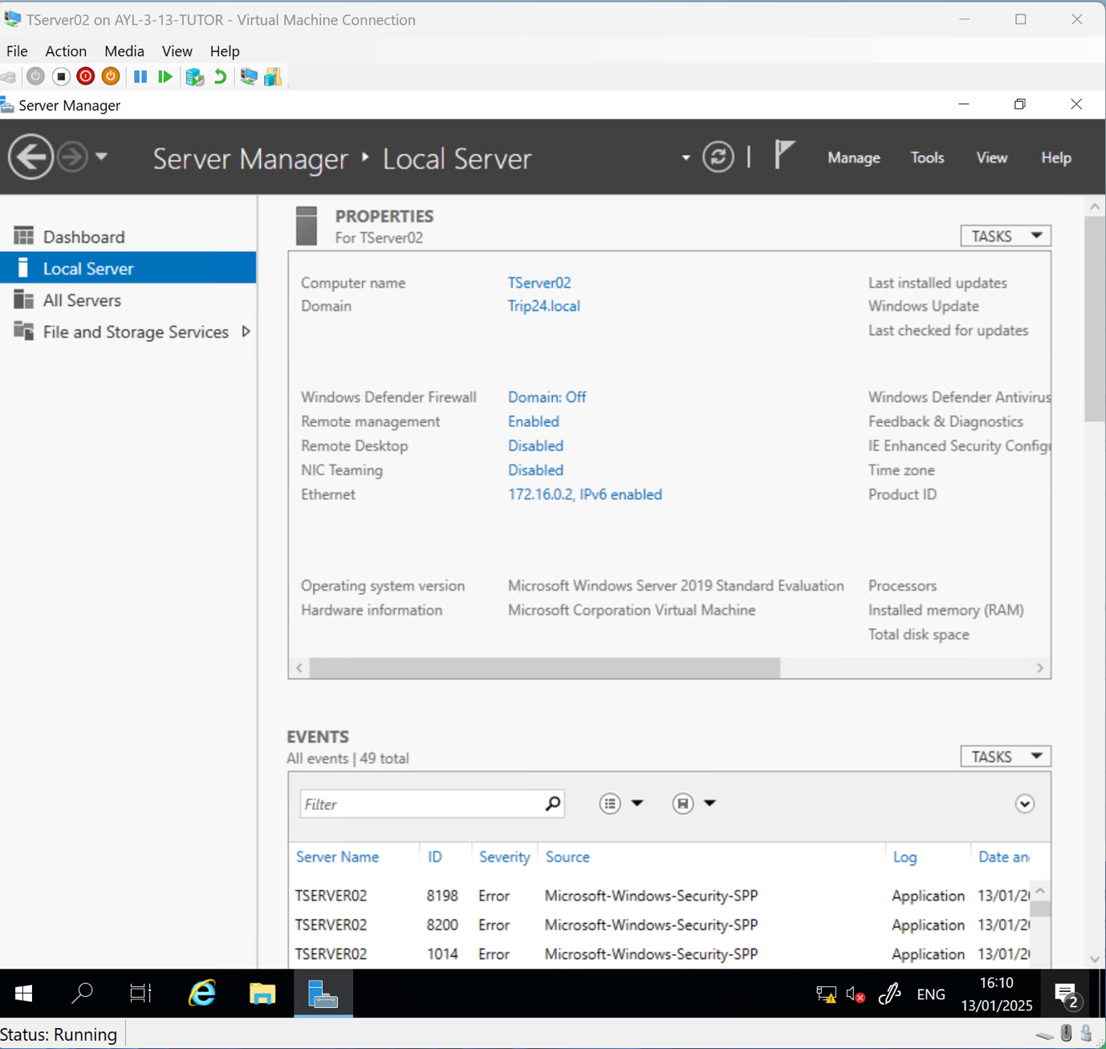Tserver01 in Trip24.local

Join Desktop VM to Trip24.local

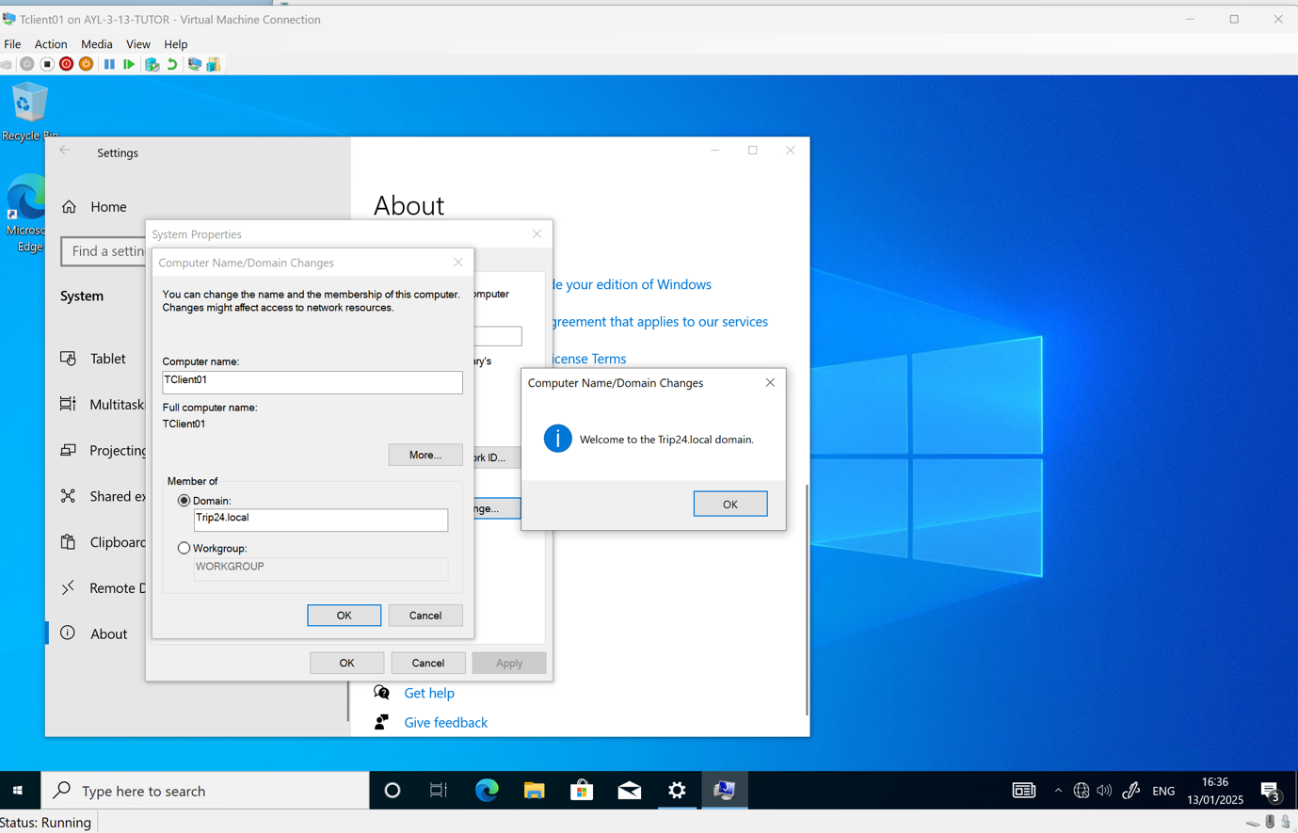Join TClient01 to Trip24.local

Activity: Installation peer review checklist

Prerequisites test – expected outcome and actual outcome match
Static IP address assigned to the server
DNS server role configured
Evidence network connectivity
AD DS installed
Server promoted to domain controller
Domain listed in Active Directory Users and Computers
Client machines successfully joined to the domain


FUNDED BY

This programme is funded by the Department for Education

Buckinghamshire College Group has produced this resource on behalf of the Education and Training Foundation

