T LEVEL IN DESIGN, SURVEYING AND PLANNING
  - Supporting holistic delivery of Core Content and Occupational Specialism Content
  - ET-FOUNDATION.CO.UK

INTRODUCTION
Inclusivity
This resource has been developed with inclusion-first principles. It has been designed to demonstrate how lessons can be designed to support learners with Special Educational Needs and Disabilities (SEND). The resource embeds the principles of Universal Design for Learning (UDL) and so supports inclusivity while at the same time addressing the diverse needs of neurodiverse learners and those with physical and/or sensory impairments. The focus is on high-quality, accessible materials to help learners to create an inclusive pitch.
Barriers to learning are explicitly addressed through the incorporation of UDL principles with differentiated activities, flexible resources, and scaffolding techniques. By integrating UDL principles throughout the learning journey, the lessons provide an accessible, engaging, and inclusive experience for all learners, regardless of their starting point or individual needs.
This inclusive approach ensures all learners have an equitable opportunity to engage with the content and develop their skills, fostering confidence and independence.
Framework for learning
The resource includes a Framework for learning (Ffl). This covers 20 hours of learning. There is a diagram to show how the content of those hours has been sequenced and scaffolded. There is also a narrative that explains the sequencing and scaffolding in more detail.
Lesson plans
There is a two-hour lesson plan for each stage in the sequencing and scaffolding of learning in the Ffl. Lesson plans include details of the resources that are required to support delivery, including those developed specifically for this TRIP.
Support materials
The support materials identified in the lesson plans are also available towards the end of this document.
Note:
There is a separate slide deck for use with the lessons. There are no slides for Lesson 4, which is conducted externally on-site.

SECTION 1: FRAMEWORK FOR LEARNING
This Framework for learning (FfL) sets out one approach to scaffolding and sequencing a holistic approach to learning, integrating Core Content with a Performance Outcome. This resource specifically supports the T Level in Design, surveying and planning and in particular development of the following:
- Core Content Area 3: Measurement
- Core Content Area 7: Construction mathematical techniques
- Performance Outcome 1: Measure the built environment.
This resource focuses on accurate measurement and data validation within the built environment.
The FfL comprises 20 hours of guided learning, structured into 10 lessons of two hours each.
The lessons adopt a practical, hands-on approach, enabling learners to build understanding using real measuring instruments. Learners will engage in quality assurance and validation of measurements to consolidate their learning. Additionally, they will analyse case studies to develop the skills and knowledge required for measuring this aspect of the built environment.
The lessons aim to help learners connect classroom learning to real-world applications and appreciate the impact of inaccuracies in measuring the built environment to support the application of that learning.
Predominantly, learners will be using the total station as the main measurement tool. This will involve learners working both inside and outside of a normal classroom environment. Providers will need to ensure that appropriate health and safety and safeguarding checks are carried out. Providers will also need to adapt some of the support materials that are provided as they will need to relate to their own built environment.
Sequencing and scaffolding
The content is designed using Bloom’s hierarchical framework to progressively develop higher order thinking skills from Lesson 1 through to Lesson 9. The final lesson provides a formative assessment, requiring learners to apply their acquired knowledge and skills by responding to a client brief.
Remember
The initial lessons have a clear focus, presenting familiar ideas of perimeter, area and volume and reviewing learners’ prior knowledge. The focus is on basic measurement and the importance of accuracy and tolerance in construction.
Understand and apply
The next phase focuses on understanding and application, spanning lessons 3 to 5. Learners will recognise situations where objects to be measured are beyond the range of basic tools and require specialist instruments. They will be introduced to setting up and taking measurements of building elements above ground level. Instruction will include how to set up and operate a total station to achieve accurate measurements. Learners will repeat these activities to consolidate their skills and ensure proficiency with the equipment. Health and safety considerations (CK1) related to using the total station will also be reviewed. The concept of quality assurance is also incorporated into this phase.
As Ffl progresses, the lessons become increasingly complex, incorporating case studies that may involve unfamiliar contexts. These later lessons require learners to apply higher order thinking to address issues, solve problems, and make informed decisions.
Analyse
This next phase aligns with the ‘Analyse’ phase of Bloom’s taxonomy. Learners will work with case studies to determine what needs to be measured, how it should be measured, whether specialised instruments are required, and what factors could negatively impact the process. After completing their analysis, learners will carry out the necessary measurement activities. To resolve problems, learners will use trigonometry techniques
Create
Lesson 10 is designed as a formative assessment, bringing together all stages of learning. This phase ensures that learners can accurately measure aspects of the built environment using the appropriate tools and techniques.

Framework for learning diagram
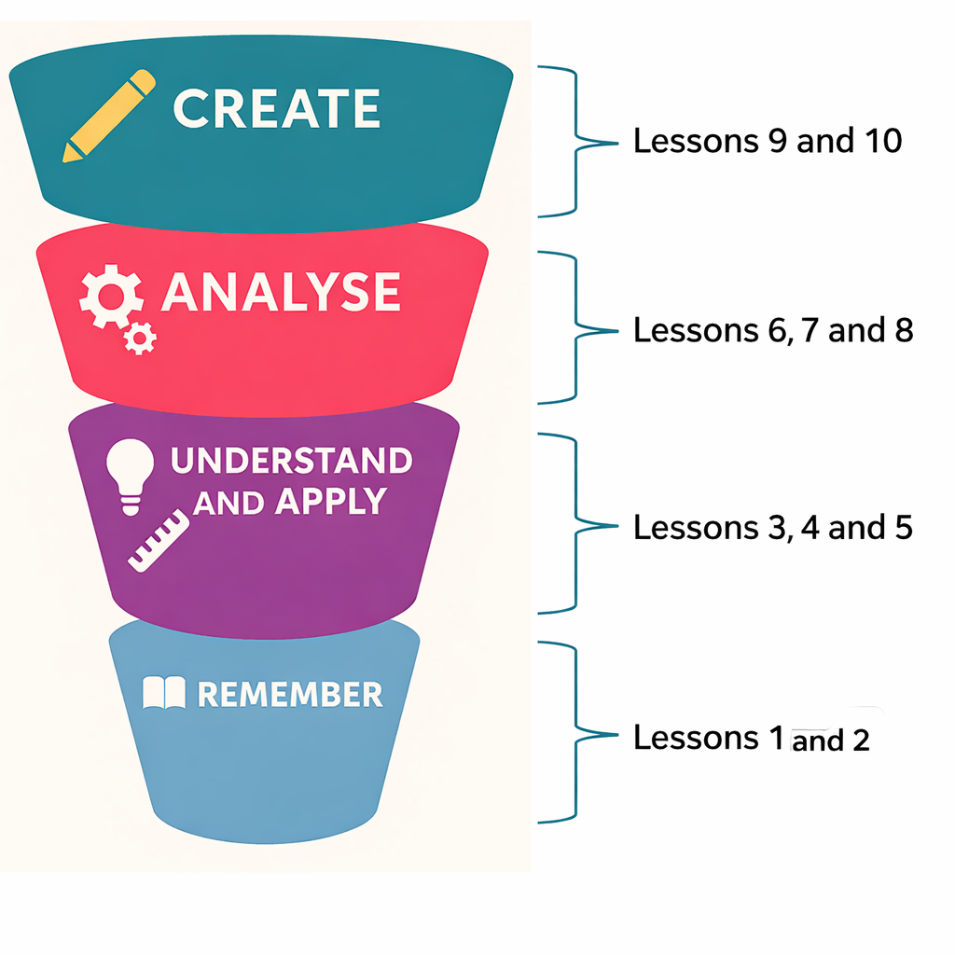

SECTION 2: LESSON PLANS
This section includes 10 lesson plans. The lesson plans follow the Framework for learning. The lesson plans include the:
- lesson number in the sequence
- lesson title
- total amount of time required to deliver the lesson
- targeted specification content coverage
- resources needed to deliver the lesson (see Note below)
- teacher and learner activities to be undertaken throughout the lesson
- details of how the lesson supports the development of English, maths and/or digital skills (where appropriate)
- details of how the lesson supports students with specific needs, applying the principles of UDL
- next steps for teachers and/or learners, such as homework activities and providing feedback to learners.
Note:
There is an assumption that the learning environment will include the following:
- whiteboard/smartboard or similar
- materials to take notes, e.g. pens, paper, audio recorder, digital device and software
- equipment to present a slide deck and video, e.g. projector, smartboard
- mini whiteboards
- digital devices (e.g. laptop, tablet) for all learners
- internet access
- learner access to word-processing, spreadsheet and presentation software.
The lesson may refer to resources that are freely accessible online. These will be presented with the title as indicated on the relevant website with a hyperlink to the resource. The hyperlink was correct at the time of producing this resource, but the Education and Training Foundation (ETF) has no control over third-party links.
Learners may need access to the following to support their specific needs:
- screen readers
- audio recording applications
- video recording applications
- quiet working areas
- text magnifiers
- alternative formats.
Other requirements will be specified at the start of each lesson plan.

Lesson 1
Lesson title: Measuring dimensions
Lesson time: 2 hours
Targeted content: CK3.1, CK3.2, CK7.1, SDK1.5, SDK1.7, SDS1.5, SDS1.10
Teacher preparation:
The room needs to be set up so that the measuring equipment and resources to be measured are all available on the desks for the start of the lesson. There should be sufficient measuring equipment for each pair of learners to access. Each ‘resource’ to be measured for the starter activity will need to be measured in advance to provide comparative data.
Resources needed:
- Support materials
  - Template to record measurement.
- Equipment
  - Steel rule.
  - Ruler (plastic).
  - Tape measure.
  - String.
  - Resources to be measured – dimensions below 30cm, such as a brick or rectangular block of wood. These resources can be of different sizes.
  - Calculator.
Learning activities included in this lesson to develop English, maths and digital (EMD) skills:
Maths: Learners are reminded of the process and formulae needed to calculate perimeter, area and volume and carry out calculations to reinforce learning.
SEND support:
Learners work in pairs to ensure support from their peers, particularly for those with fine dexterity impairments, which may limit their potential to measure relatively small objects. Learners are given autonomy to select who they work with. Templates are provided to record data to remind learners of the units of measurement and key measurement requirements. The teacher provides input on perimeter, area and volume to support learners who may be experiencing skills fade to recall processes.

Timing | Teacher activity | Learner activity
15 minutes | Introduce the learning aims. Give an overview of the lesson content. | Listen.
 | Explain the activity. Highlight each piece of equipment to be measured and each piece of measuring equipment that is available to the learners. Give out the Template to record measurement. Allocate pairs based on seating location. | Listen. Ask questions for clarification. Identify equipment as they are referred to by the teacher.
 | Circulate and support where required. | In pairs, measure the piece of equipment provided using both the steel rule and the plastic ruler. Note the measurements on the Template to record measurement. Pass the piece of equipment to the next pair. Carry out the same activity on the new piece of equipment.
 | Ask learners for their data. Record the data on a whiteboard. Add data recorded by the teacher. | Give the teacher the data as requested. Note the data from other pairs on the Template to record measurement.
 | Lead a discussion, asking questions of learners related to the measuring activity, identifying misconceptions and differences in data. | Contribute to the discussion, answering questions from the teacher if asked.
40 minutes | Explain the activity. Highlight each piece of measuring equipment that is available. Allow learners to select another learner to work with. Point out different parts of the learning environment that have three dimensions, e.g. smartboard, desk, cupboard, and windows. Allocate each pair one of these. Note any health and safety issues that may need to be considered. | Listen. Ask questions for clarification. Identify parts of the learning environment as they are referred to by the teacher. Select a partner to work with.
 | Circulate and support where required. | In pairs, measure the part of the learning environment that has been allocated. Note the measurements on the Template to record measurement.
 | Ask learners for their data. Record the data on a whiteboard. | Give the teacher the data as requested.
 | Remind learners how to calculate perimeter using the slide deck. Explain the perimeter activity. | Listen. Take notes. Ask questions for clarification.
 | Circulate and support where required. | Individually calculate the perimeters using collected data. Put the calculation on a mini whiteboard.
 | Correct any misconceptions. | Show the mini whiteboard to the teacher when prompted.
 | Remind learners how to calculate area. Explain the area activity. | Listen. Take notes. Ask questions for clarification.
 | Circulate and support where required. | Individually calculate the areas using the collected data. Put the calculation on a mini whiteboard.
 | Correct any misconceptions. | Show the mini whiteboard to the teacher when prompted.
 | Remind learners how to calculate volume. Explain the volume activity. | Listen. Take notes. Ask questions.
 | Circulate and support where required. | Individually calculate the volumes using collected data. Put the calculation on a mini whiteboard.
 | Correct any misconceptions. | Show the mini whiteboard to the teacher when prompted.
 | Explain the activity. Ask learners to select a part of the learning environment to be measured. | Listen. Ask questions for clarification.
 | Circulate and support where required. | Individually produce clear and precise instructions for what needs to be measured.
 | Explain the activity. Allow learners to select a peer to work with. | Listen. Ask questions for clarification. Move into pairs.
 | Circulate and support as required. | Pass the completed instructions to a peer. The peer reviews and annotates if there is any lack of clarity.
 | Ask learners to highlight key learning points regarding the importance of clear instructions. | Listen. Take notes. Ask questions for clarification.
45 minutes | Explain the activity. Learners continue to work in their pairs. Refer learners to the measuring equipment that has been provided. Allocate pairs to measure either the length or the width of the room. Provide each pair with string. | Listen. Check resources.
 | Circulate and support where required. Monitor health and safety and logistics of the activity. | In pairs, measure the width or length of the room, as allocated, using a piece of string.
 | Model how to use arm lengths to estimate measurements in imperial. Explain the activity. | Listen and observe the teacher’s demonstration.
 | Circulate and support where required. Monitor health and safety and logistics of the activity. | Individually, estimate the measurement of the width or length of the room, using the armlengths method. Record in the Template to record measurement.
 | Use the slide deck to show the relationship between imperial and metric units. | Listen. Take notes. Ask questions for clarification.
 | Explain the activity. | Listen.
 | Circulate and support where required. | Individually, convert the arm lengths imperial estimate for width or length to metric. Update the Template to record measurement.
 | Explain the activity. Refer learners to the tape measure available. | Listen. Ask questions for clarification.
 | Circulate and support where appropriate. Monitor health and safety and logistics. | Working in pairs, measure the length or width as allocated using a tape measure. Record in the Template to record measurement.
 | Circulate and support where required. | Compare the estimated measurement with the actual measurement. Note on the Template to record measurement.
 | Facilitate a class discussion on using estimation rather than accuracy. Encourage wide participation. | Contribute to the class discussion. Provide examples where appropriate, ask questions, and respond to questions when asked.
 | Present a summary of key implications. | Listen. Take notes. Ask questions for clarification.
15 minutes | Present the exam-style question on the slide deck. | Listen.
 | Circulate and support where required. | Individually answer the question shown on the slide deck. Write the answer in a notebook.
 | Present answers to the question using the slide deck. | Self-assess their answer against the model answer presented.
 | Collect the answers. | Hand in completed and marked answers.
 | Next steps: Review answers from all learners. Determine any common misconceptions, misunderstandings and/or errors to address in the next lesson. Provide individual feedback to each learner prior to the next lesson.

Lesson 2
Lesson title: Accuracy and tolerance in measurement
Lesson time: 2 hours
Targeted content: CK3.1, CK3.2, CK7.1, SDS1.3, SDK1.5, SDK1.7, SDK1.3, SDS1.5, SDS1.10
Teacher preparation:
Produce a slide deck with sufficient slides for each pair of learners in the class. Each slide is blank, but with a layout for a title and content. The slide deck should be available in the provider’s shared area for learners to access.
Resources needed:
- Support materials
  - Construction tolerance calculations.
  - Compound error calculations.
  - Error calculations activity.
  - Error calculations activity answers.
  - Measurement tools research findings table.
  - What if we get it wrong? activity.
- Web links
  - Collaborative wall application
Learning activities included in this lesson to develop EMD skills:
English: Learners will develop their written English skills by summarising their research findings to include in the content of one presentation slide.
Maths: Learners will apply their mathematical understanding and skills to complete calculations related to perimeter, area and volume.
Digital: Learners will use digital skills to conduct online research into the different measurement tools. They will also use their skills to produce a presentation slide.
SEND support:
In this lesson, the teacher uses a range of techniques as a means of providing feedback to encourage learners to contribute and to support inclusion. The use of mini whiteboards and an online collaborative wall allows learners to contribute anonymously, giving them confidence to share their views and findings, whilst also ensuring that they have the value of peer input to broaden their own perspectives. Learners complete a range of mathematical calculation activities. These are presented in a structured way to build their understanding and skills of mathematical processes.

Timing | Teacher activity | Learner activity
15 minutes | Introduce the learning aims. Give an overview of the lesson content. | Listen.
 | Present images of construction issues using the slide deck. With each image, explore with learners what they see, asking questions such as:  What can you see?  What is the issue here?  What are the potential consequences?  How much of a difference is acceptable?  Engage as many learners as possible across all three images. Ask for learners to contribute initially, but those who are not contributing, use prompts and probing questions that build on what a previous learner has contributed. | View the images. Contribute answers to questions posed by the teacher. Add to the comments made by other learners. Take notes.
 | Present information on the terms accuracy, precision, tolerance, and reliability. | Listen. Take notes. Ask questions for clarification if needed.
50 minutes | Explain the activity. Distribute the Construction tolerance calculations. | Listen.
 | Circulate and support where required. | Individually complete the Construction tolerance calculations.
 | Explain the activity. | Listen.
 | Review the answers shown on mini whiteboards. Select learners to contribute based on the answers shown. Start with a learner who got an incorrect answer and ask them the first stage in their calculation. Ask other learners to comment on whether they started in the same way. Ask a learner with the correct answer how they progressed. Ask another with the right answer for their answer. Do this for each calculation to engage as many learners as possible. Write the range of answers on the whiteboard. | Enter the three answers to the calculations on a mini whiteboard. Show the mini whiteboard when requested. Provide information on the process followed when asked. Take notes.
 | Use the answers on the whiteboard to facilitate a discussion with learners on ‘small errors’ and how these can compound over a project. | Listen. Take notes. Ask questions for clarification. Contribute to the discussion.
 | Explain the activity. Distribute the Compound error calculations. | Listen.
 | Circulate and support where required. | Individually complete the Compound error calculations.
 | Explain the activity. Direct learners to the Collaborative wall application. | Listen.
 | Circulate and support, including technical support where required. | As directed by the teacher, enter the results of each calculation into the Collaborative wall application..
 | Show the results of the collaborative wall for each question separately. Highlight what is shown, which may include differences in answers. Ask specific learners to go through how they achieved their answers. Address any errors and misconceptions. | Listen. Take notes. Respond to teacher requests for details of calculations made.
 | Present information on the consequences of inaccurate measurements. | Listen. Take notes. Ask questions for clarification.
 | Explain the activity. Distribute the Error calculations activity. | Listen.
 | Circulate and support if required. | Individually complete the Error calculations activity.
 | Explain the activity. Distribute the Error calculations activity answers. | Listen.
 | Circulate and support if required. | Review completed answers to the Error calculations activity against the Error calculations activity answers. Note on a mini whiteboard the number of the exercise that was incorrect. If no answers were incorrect, write ‘0’.
 | Review the mini whiteboards and the numbers where there were errors. Use this to target learners to explain the process they followed to calculate their answers. Address misconceptions and errors in approach as they arise. | Listen. Show mini whiteboards when requested. Give details of calculations and the process followed when requested. Ask questions for clarification. Take notes.
 | Present information on different types of errors and how to reduce errors using the slide deck. | Listen. Take notes. Ask questions for clarification.
40 minutes | Present information on different types of measurement tools. | Listen. Take notes. Ask questions for clarification.
 | Explain the activity. Ask learners to select a partner to work with. Ask each pair to select one of the measurement tools to research. Aim to cover all measurement tools listed. Distribute the Measurement tools research findings table. | Listen. Move into pairs.
 | Circulate and support if required. | Carry out research into the selected measurement tool. Complete the Measurement tools research findings table.
 | Explain the activity. Give each learner a slide number. Give them details of where the slide deck can be found. | Listen.
 | Circulate and support if required. | Produce a one-slide summary of findings. Enter the information into the allocated slide. Put the measurement tool as the heading.
 | Explain the activity. Direct learners to the prepared slide deck in the shared area. | Listen.
 | Circulate and support if required | Download the created slide deck. Select the most appropriate measuring tool for the situation shown on the slide deck shown by the teacher.
 | Facilitate learners to provide feedback on their selections. Go through each situation on the slide deck. Ask one pair of learners which measurement tool they chose. Ask another pair to give reasons why this would be suitable or unsuitable. Ask if anyone selected a different tool. Ask another pair whether they agree it was suitable and why. Use this approach to engage as many pairs as possible, going through each situation on the slide deck. | Listen. Respond to questions when asked by the teacher. Take notes. Ask questions for clarification.
 | Present information on why surveyors use precise instruments.
15 minutes | Explain the activity. Ask learners to select a new partner to work with. Distribute the What if we get it wrong? activity. | Listen. Move into pairs.
 | Circulate and support if required. | Complete the What if we get it wrong? activity.
 | Explain the activity. Allocate peer reviewers for each pair. | Listen. Pass the completed What if we get it wrong? activity to the allocated pair.
 | Circulate and support if required. | Review the information provided. Highlight any misconceptions or errors and add comments to the document. Return the annotated version to the original pair.
 | Ask learners to give examples of any issues highlighted as a result of peer review. Select a pair for the first example, and when they give the example, ask another pair to explain why this may have happened and ask another pair how it could be corrected. Select a range of learners to highlight the issues. Write issues on the whiteboard. Review the content of the whiteboard at the end. | Listen. Contribute and respond to questions when asked. Ask questions for clarification. Take notes.

Lesson 3
Lesson title: Precision measurement using a total station
Lesson time: 2 hours
Targeted content: CK3.1,1, CK3.2.1, SDK1.4, SDK1.6, SDS1.8, SDS1.9, SDS1.11.
Teacher preparation:
An appropriate site should be selected. An online satellite map of the site will need to be provided for learners.
Resources needed:
- Support materials
  - Checklist for setting up and levelling a total station.
  - Template to record survey measurements.
  - Model answers to exam-style questions.
- Equipment
  - Manual total stations.
  - Tripods.
  - Personal Protective Equipment (PPE).
    - Hi-Vis jacket.
    - Safety boots
Learning activities included in this lesson to develop English, maths and digital (EMD) skills:
Maths: Learners will be recoding data collected through measurement.
SEND support:
Learners are able to work in pairs and groups, which supports them in broadening their perspectives on actions and issues. Allowing learners to select who they work with gives them some autonomy in the activities and confidence to work with those with whom they are comfortable. The learning activities are scaffolded with the teacher modelling the approach to be taken so that learners can experience it and follow guidance from the teacher, before they are then asked to apply what they have seen and heard. Working in pairs for practical activities allows learners to share responsibilities. Although each learner must engage in each role, they can take responsibility for one role if preferred. Pair working provides learners who may have mobility difficulties with direct support from their peer rather than relying on the teacher. Guidance notes and templates are provided to give structure and for reference by learners.

Timing | Teacher activity | Learner activity
20 minutes | Introduce the learning aim. Give an overview of the lesson content. | Listen.
 | Explain the activity. Ask learners to select a partner to work in pairs. Distribute flip chart paper and marker pens. | Listen. Move into pairs.
 | Circulate and support where required. | Create a mind map to show factors to consider when carrying out measurements on a construction site.
 | Explain the activity. Ask learners to select another pair to work with to form a group. | Listen. Move into groups.
 | Circulate and support where required. | Share the mind maps on the flip chart paper. Discuss where there are differences. Add to each mind map where any gaps are identified.
 | Ask each group to give examples of factors to consider. Write them on the whiteboard. Group or classify them as they are given. Ask probing questions for the details of each and the reasons for inclusion. Address any misconceptions if they arise. | Listen. Contribute when asked. Take notes.
30 minutes | Explain the activity. Direct learners to an online map of a potential construction site. Continue to work in groups. | Listen.
 | Circulate and support where required. | Access the online map as directed. Discuss the specific factors to consider for carrying out a boundary survey on the land identified for a specific day. Update the mind map on the flip chart with a different coloured marker pen.
 | Explain the activity. Ask learners to select another group for peer review. | Listen. Pass completed considerations to another group for peer review.
 | Circulate and support where required. Prepare for feedback by writing the factor headings on a whiteboard. | Review the considerations on the mind map. Annotate the mind map with a different coloured marker pen. Give a tick where there is valid content. Write a comment if there are any queries or issues.
 | Facilitate learners to give feedback. Ask each group to contribute factors to consider and write each on the whiteboard if it is valid under the relevant heading. If the suggestion is not valid, address errors and misconceptions. Ask each group to give an example of an annotated comment indicating an error or misconception. Ask another group to address the error or misconception. | Listen. Contribute feedback when asked. Address misconceptions when asked. Take notes.
 | Summarise key factors to consider when carrying out measurements on a construction site. Make explicit reference to health and safety requirements. | Listen. Take notes. Ask questions for clarification.
15 minutes | Present information on the total station, including health and safety requirements. | Listen. Take notes. Ask questions for clarification.
 | Model how to set up the total station, including health and safety requirements at each stage. Distribute the Checklist for setting up and levelling a total station. Ask learners to select a partner to work with. On completion, model to learners how to shut down the total station. | Observe the teacher modelling. In pairs, follow the process to set up the total station. Ask questions for clarification. Write notes if required. Shut down the total station.
 | Explain the activity. | Listen.
 | Circulate and support where required. | In turn, set up the total station, implementing each step modelled by the teacher. One partner sets up the total station whilst the other takes a health and safety role, ensuring each stage is secured before moving to the next stage. Shut it down after the first learner and then swap roles. Refer to the Checklist for setting up and levelling a total station if needed.
 | Present information on the importance of the correct set-up and levelling. | Listen. Take notes. Ask questions for clarification.
45 minutes | Model how to take a measurement to a specific window corner. Learners to continue to work in the same pairs. Distribute the Template to record survey measurements. | Observe and ask questions for clarification. Take notes.
 | Explain the activity. | Listen. Ask questions for clarification.
 | Circulate and support where required. Monitor for health and safety. | Take turns to measure and record the distance to a specific window corner until all corners are measured. Record the measurements on the Template to record survey measurements.
 | Model how to safely pack away the equipment. | Observe and ask questions for clarification. Take notes.
 | Ask each group to give a measurement and add to the whiteboard. As each measurement is added, ask another group if they got the same measurement. Note on the whiteboard as a difference. Ask another group for reasons why they may be different. Use prompts related to human error, tool use, precision, recording error, etc. Build up a picture of the range of measurements taken. Summarise, highlighting key issues with measurement and error and how to minimise errors in future. | Listen. Take notes. Contribute when asked. Ask questions for clarification if needed.
10 minutes | Present information on the next lesson and use of a total station in an external environment. | Listen. Take notes. Ask questions for clarification.

Lesson 4
Lesson title: Measuring the built environment with a total station
Lesson time: 2 hours
Targeted content: CK3.1,1, CK3.2.1, SDK1.4, SDK1.6, SDS1.8, SDS1.9, SDS1.11.
Resources needed:
- Support materials
  - Template to record survey measurements (from Lesson 3).
  - Checklist for setting up and levelling a total station (from Lesson 3).
- Equipment
  - Total station.
  - Tripod.
  - Personal protective equipment.
    - Hi-Vis jacket.
    - Safety boots.
Teacher preparation
A suitably built environment and building needs to be selected. The building should have a number of windows and at least one door. The side of the building, one window and the door will need to be measured. Note that the data from the measurements collected in this lesson will be used as the basis for calculations in the next lesson.
To prepare for Lesson 5, the teacher will need data for the same measurements.
SEND support:
This lesson is conducted entirely in an external environment. Support will have been provided by the teacher, checking the site is safe, completing a risk assessment and providing guidance to learners on maintaining safety when carrying out tasks. Learners work in pairs, enabling peer support. Learners each take different roles to experience each aspect of the learning, but they are allowed to focus on a specific role if it supports their needs. It is recommended that where learners have mobility impairments, they can work in groups of three so that there is increased peer support. All learners should engage in all activities at least once to aid their understanding of the process and implications of using a total station in an external environment.

Timing | Teacher activity | Learner activity
10 minutes | Remind learners of health and safety risks and controls in place. Point out any potentially hazardous points on the site. Check that learners are wearing PPE. | Listen. Carry out a visual check of the environment for potential hazards.
 | Refer learners to the Checklist for setting up and levelling a total station, and provide copies to those learners who don’t have them. | Read through the Checklist for setting up and levelling a total station. Ask questions if anything is unclear.
 | Ask learners to organise into groups of two or three. Highlight the different roles that each will take. | Listen. Ask questions if unclear. Move into groups.
40 minutes | Explain the activity. Direct learners to the first area to be measured (the side of the building). Remind learners of the process and the Checklist for setting up and levelling a total station. Distribute the Template to record survey measurements. | Listen. Ask questions for clarification if needed.
 | Circulate and support where needed. | In groups, one learner sketches the environment and building to be measured in their notebook. Discuss the data points that need to be measured within the group, and one learner adds these to the sketch.
 | Explain the activity. | Listen.
 | Circulate and support where needed. Adopt a quality assurance role, sampling the recording and measuring of groups and correcting any errors observed as they occur. | In groups, set up the total station. Refer to the Checklist for setting up and levelling a total station if required. In turn, take different roles. One role is to use the total station to measure the data point. A second role is to verify that the total station has been correctly calibrated and to record the data collected on the Template to record survey measurements. If there is a third person, there can be a recording role and a verifying role. Each learner should take each role for a similar number of data points, where possible. Learners can focus on a particular role if required.
 | Review with learners any points to consider from the measurement activity. | Ask questions for clarification if needed.
30 minutes | Explain the activity. Direct learners to the next area to be measured – a window. Remind learners of the process and any health and safety issues to be applied. | Listen.
 | Circulate and support where needed. Adopt a quality assurance role, sampling the recording and measuring of groups and correcting any errors observed as they occur. | In groups, discuss and agree on the data points to be collected to measure the window. One learner adds these to the sketch. Repeat the process followed for the previous area that was measured.
30 minutes | Explain the activity. Direct learners to the next area to be measured – a door. Remind learners of the process and any health and safety issues to be applied. | Listen.
 | Circulate and support where needed. Adopt a quality assurance role, sampling the recording and measuring of groups and correcting any errors observed as they occur. | In groups, discuss and agree on the data points to be collected to measure the window. One learner adds these to the sketch. Repeat the process followed for the previous area that was measured.
10 minutes | Remind learners how to pack away the total station. | Listen.
 | Circulate and support where required. | Pack away the total station.
 | Provide learners with details of the homework required. | Homework: In an Excel workbook, create a table and enter all the data recorded.

Lesson 5
Lesson title: Problem-solving using total station data
Lesson time: 2 hours
Targeted content: CK3.1,1, CK3.2.1, SDK1.4, SDK1.6, SDS1.8, SDS1.9, SDS1.11.
Resources needed:
- Web links
  - Collaborative wall application
  - Poll application
Teacher preparation
This lesson requires learners to use the data collected from the previous lesson in order to carry out the calculations. To enable modelling of the processes for calculations, the teacher will need data for the same measurements. The teacher will need to give details of the size of each cladding tile or sheet. The teacher will need to use the measurements to create a range of options (ideally five options) in the Poll application that are credible for learners to select from.
Learning activities included in this lesson to develop EMD skills:
Maths: Learners apply their understanding of mathematical techniques to solve a construction problem by calculating perimeter, area and volume.
SEND support:
Learners work independently in this lesson, which is structured to provide a clearly scaffolded approach to solving a construction problem. Scaffolding is also incorporated to support learners to process information, with the teacher modelling the approach to be taken. This enables learners to experience it and follow guidance from the teacher, before they are then asked to apply what they have seen and heard. A range of techniques are used to check learning and for learners to provide feedback on their achievements and understanding. There is the use of mini whiteboards, a collaborative wall and a poll. Each allows learners to contribute anonymously, giving them confidence to share their answers and approaches whilst also ensuring that they have the value of peer input to broaden their own perspectives. Learners complete a range of mathematical calculation activities. These are presented in a structured way to build their understanding and skills of mathematical processes.

Timing | Teacher activity | Learner activity
15 minutes | Introduce learning aim. Give an overview of the lesson content. | Listen.
 | Explain the activity. Direct learners to the Collaborative wall application. | Access the Collaborative wall application
 | Circulate and support, including technical support, where needed. | Individually write two difficulties encountered when using a total station in an external environment.
 | Share the results of the learner input to the Collaborative wall application. Use this as a prompt to ask learners to explain difficulties and give input on how to minimise difficulties for future measurements in the external environment. | Listen. Take notes. Contribute when asked by the teacher. Ask questions if required.
30 minutes | Model to learners how to use Excel to plot coordinates using the teacher’s coordinates taken in Lesson 4. | Open an Excel workbook. This can either be a new workbook or a new worksheet in the workbook created for homework. Follow the teacher modelling, inputting the same data as the teacher. Take notes. Ask questions if required.
 | Explain the activity using the slide deck. Explain how the lesson will follow a process to be able to solve the problem shown on the slide deck. | Listen.
 | Circulate and support where needed. Observe learner calculations when circulating. Note if any errors observed or incorrect techniques or processes being used. Use this to identify which learners to target for feedback, focusing on those following the correct approach. | Individually use the data entered into Excel based on their own measurements, plot the coordinates and calculate the perimeter of the building.
 | Select one learner to start the feedback, giving details of the first step taken and write this on the whiteboard. Ask the class if other learners did something different at the start. Explore the reasoning behind differences. If needed, add to the whiteboard. Continue to explore with different learners the approach taken, building the calculation on the whiteboard, but with prompts and probing questions to confirm understanding. Highlight on completion where any alternative approaches could be taken. | Listen. Contribute when asked. Take notes. Update own calculations if needed.
30 minutes | Remind learners of how to calculate area. Explain the activity. Give details of the cladding measurements. | Listen. Ask questions for clarification if needed.
 | Circulate and support where needed. | Individually complete the activity to calculate the area of the façade, one window and one door based on the data collected. Use this information to calculate the amount of cladding needed.
 | Explain the activity. Direct learners to the Poll application. | Listen. Access the Poll application.
 | Circulate and support, including technical support, where needed | Select the answer in the poll that is closest to the answer calculated.
 | Share the results of the learner input to the Poll application. Use this as a prompt to ask learners to explain why there may be differences in the answers selected. Address any misconceptions and answer learner queries. | Listen. Take notes. Contribute when asked by the teacher. Ask questions if required.
30 minutes | Remind learners of how to calculate volume. Explain the activity. | Listen. Ask questions for clarification if needed.
 | Circulate and support where needed. | Individually complete the activity to calculate the volume of space needed to store the cladding.
 | Explain the activity. | Listen.
 | Circulate and support where needed. | On a mini whiteboard, write the answer to the amount of space needed to store the cladding that was calculated.
 | Review the answers shown on mini whiteboards. Select learners to contribute based on the answers shown. Start with a learner who got an incorrect answer and ask them the first stage in their calculation. Ask other learners to comment on whether they started in the same way. Ask a learner with the correct answer how they progressed. Ask another with the right answer for their answer. Do this for each calculation to engage as many learners as possible. Write the range of answers on the whiteboard. | Show the answer on the mini whiteboard to the teacher. Listen. Take notes. Contribute when asked. Ask questions for clarification if needed.
15 minutes | Explain the activity. Ask learners to select a partner to work with. | Listen. Move into pairs.
 | Circulate and support, giving prompts if needed. | Discuss the question on the slide ‘How would the calculations be different if one corner of the building were slanted?’
 | Facilitate a class discussion on the question on the slide deck. Ask each pair to contribute. Start with one pair and use ‘bounce’ to ask another pair to comment on what the first pair contributed. Ask another pair if they agree with both previous pairs and give a reason why. Ask them to give another comment and follow the same process. Engage as many learners with directed prompts and probing questions as possible. | Listen. Contribute when asked. Take notes. Ask questions for clarification if needed.
 | Provide information to learners on the theme of the next set of lessons. | Listen.

Lesson 6
Lesson title: Site survey
Lesson time: 2 hours
Targeted content: CK1.1, CK3.1, SDK1.3, SDK1.4, SDS1.3, SDK1.5, SDK1.6 SDS1.9, SDS1.10,
Resources needed:
- Support materials
  - Trigonometry calculations worksheet.
  - Trigonometry calculations worksheet answers.
  - Physical site survey scenario.
  - Physical site survey sketch.
  - Checklist for setting up and levelling a total station (from Lesson 3),
  - Template to record survey measurements (from Lesson 3).
- Equipment
  - Mini whiteboards.
  - PPE appropriate for the site (teacher to determine based on actual site and completed risk assessment).
- Web links
  - Collaborative wall application
Teacher preparation:
This lesson requires learners to have some time in the external environment, carrying out measurements using a total station. The Physical site survey scenario and Physical site survey sketch have been produced based on a site available to the provider developing this resource. The teacher will need to produce equivalent resources to reflect the environment where the learners will be carrying out these measurements.
Learning activities included in this lesson to develop EMD skills:
Maths: There is a section in the lesson for input on trigonometry to support learner recall of prior learning and provide an opportunity to clarify understanding. There are specific exercises to apply their understanding. Learners then apply their understanding to make calculations to support problem-solving in construction.
Digital: Learners develop their skills working with spreadsheets as they practice and apply their skills to their own data obtained from a live site survey.
SEND support:
In this lesson, there is the use of a digital collaborative wall and mini whiteboards for learners to provide the teacher with feedback from the activities. These two approaches allow the teacher to ensure that all learners engage in giving feedback and gives the learner confidence in contributing as they do not feel that they are being targeted. This approach also allows the teacher to view all responses and use these to identify any class-based issues and/or individual issues. The teacher can then address these issues for all learners to reinforce concepts and secure understanding. Learners can be given specific prompts and probing questions appropriate to their responses. During the site survey, learners work in groups, enabling peer support. Learners each take different roles to experience each aspect of the learning, but they are allowed to focus on a specific role if it supports their needs.

Timing | Teacher activity | Learner activity
15 minutes | Introduce the learning aim. Give an overview of lesson content. | Listen.
 | Explain the activity. Direct learners to the Collaborative wall application. | Access the Collaborative wall application.
 | Circulate and support where required, including technical support. | Individually write three words associated with trigonometry.
 | Share the results of the learner input to the Collaborative wall application. Use this as a prompt to ask learners to explain what different terms mean and how they are used in trigonometry. Refer to other key terms if they are important and not included. | Listen. Take notes. Contribute when asked by the teacher. Ask questions if required.
30 minutes | Present details on trigonometry and how to use this to make calculations. | Listen. Take notes. Ask questions if required.
 | Explain the activity. Distribute the Trigonometry refresher. | Listen.
 | Circulate and support where required. | Individually complete the calculation exercises on the Trigonometry refresher.
 | Distribute the Trigonometry calculations worksheet answers. Explain the activity. | Listen.
 | Circulate and support where required. | Individually self-assess answers against those in the Trigonometry refresher answers. Note any differences in totals and compare the stages of the calculations to identify reasons for differences, if and where they apply.
 | Explain the activity. | Listen.
 | Observe the information on the mini whiteboards. If learners have indicated support is needed, ask another learner who doesn’t have that question on their mini whiteboard to answer any questions. Continue until all queries have been answered. | On a mini whiteboard, write the question number of any question that was incorrect or for which clarity is required from the teacher.
15 minutes | Explain the activity. Emphasise the importance of health and safety. Distribute the required PPE. Distribute the Physical site survey scenario. Ask learners to organise themselves into groups of three. If the class number is not divisible by three, allow groups of four. | Listen.
 | Lead learners to the survey site. | Move to the survey site.
 | Circulate and support where required. Monitor any health and safety issues. | Individually produce a sketch of the survey site so that each learner in the group has their own sketch. In groups, discuss the data points to be measured with a total station so that the boundary (perimeter) can be calculated. Individually note these on your own sketch. Compare sketches with data points to confirm that the agreed-upon points are noted on each correctly.
 | Distribute the Physical site survey sketch. Explain the activity. | Listen.
 | Circulate and support where required. Note issues and differences that any group has. | Review the content of the Physical site survey sketch. Compare with your own sketch. Make amendments to your own sketch if needed.
30 minutes | Distribute the Checklist for setting up and levelling a total station and the Template to record data. Explain the activity. | Listen. Ask questions if required.
 | Circulate and support where required. | In groups of three (or four) set up the total station. Refer to the Checklist for setting up and levelling a total station if required. In turn, take different roles. One role is to use the total station to measure the data point. A second role is to verify that the total station has been correctly calibrated and to record the data collected on the Template to record survey measurements. The final role is to hold the prism. Each learner should take each role for a similar number of data points, where possible. Learners can focus on a particular role if required.
 | Explain the activity. | Listen. Ask questions if required.
 | Circulate and support where required, including technical support. | Transfer the data from the total station to the shared area. Pack the total stations away securely. Go back to the classroom.
30 minutes | Demonstrate to learners the process to plot the boundary shape in Excel. Support learners where required. | Work individually. Create a new Excel Workbook and save it with an appropriate file name in the shared area. Follow the teacher demonstration, inputting measurement data into Excel as directed. The plotted shape should match the provided Physical site survey sketch.
 | Show learners the slide with the example outcome. Circulate and check for any plotted shapes that are significantly different to the one shown. Highlight to the class any issues identified and possible reasons. | Listen. Ask questions if one's own shape is significantly different to that shown on the slide deck.
 | Explain the activity. Present the slide showing the distance formula. Ask learners to now work in the same groups as previously. | Listen. Ask questions for clarification.
 | Circulate and support where required, including technical support. | Calculate the boundary (perimeter) of the site.
 | Ask each group to give their final answers. Write them on a whiteboard as they are given by the learner. | Give details of the calculated answer when asked. Note all answers from the whiteboard.
 | Use ‘bounce’ or a similar strategy to engage learners in a discussion of the results. Ask probing questions about any differences that may be apparent from the answers and possible reasons. If all answers are the same, target the groups with ‘what if?’ questions, asking about how different data would impact the result or how the wrong data would impact the result. | Contribute with reasoning when asked by the teacher.
 | Set homework. | Homework: Review the data and calculations in the Excel workbook. Identify any issues that require teacher clarification for the next lesson.

Lesson 7
Lesson title: Solving construction problems with trigonometry
Lesson time: 2 hours
Targeted content: CK3.1, CK7.1, SDK1.3, SDK1.4, SDK1.5, SDK1.6, SDS1.3, SDS1.9, SDS1.10,
Resources needed:
- Support materials
  - Total station data readings activity sheet.
  - Example trigonometry calculation for modelling – teacher resource.
  - Applying trigonometry to calculate area.
  - Applying trigonometry to calculate area answers.
  - Aerial view activity.
  - Aerial view activity answers.
  - Roofing activity.
  - Roofing activity answers – teacher resource.
- Equipment
  - Mini whiteboards.
Learning activities included in this lesson to develop EMD skills:
Maths: Learners continue to develop their understanding and skills, applying trigonometry to solve construction problems in new contexts.
SEND support:
The lesson is scaffolded for learners to build their understanding and skills by firstly having a process modelled, practising this through controlled and defined activities, working in groups with peer support to apply to a construction context, before working individually. Teacher modelling supports learner understanding as they can see, listen and have the opportunity to ask questions for clarification. Peer learning takes place through group work and peer assessment, with peers providing feedback. Where learners are working in groups, they have autonomy to select who they work with, ensuring they have confidence in the support of their peers.

Timing | Teacher activity | Learner activity
15 minutes | Introduce the learning aim. Give an overview of lesson content. | Listen.
 | Explain the activity. Distribute the Total station data readings activity sheet. | Listen.
 | Circulate and support where required. | Individually complete the exercises on the Total station data readings activity sheet.
 | Explain the activity. Ask learners to select a partner to work with. | Listen. Move into pairs.
 | Circulate and support where required.  Review the content of the whiteboards. Address any queries learners have identified. | Share the results of the completed Total station data readings activity sheet. Note any differences and discuss possible reasons for these differences.  On a mini whiteboard, write any differences that were not resolved through the paired discussion. Display mini whiteboards.
30 minutes | Present details on using trigonometry for calculations relating to area and perimeter. | Listen. Take notes. Ask questions if required.
 | Model how to use trigonometry to calculate values on the whiteboard, using the Example trigonometry calculation for modelling – teacher resource. | Follow the teacher modelling. Take notes. Ask questions if required.
 | Explain the activity. Distribute the Applying trigonometry to calculate area. | Listen.
 | Circulate and support where required. | Individually complete the calculation exercises on the Applying trigonometry to calculate area.
 | Distribute the Applying trigonometry to calculate area answers. Explain the activity. | Listen.
 | Circulate and support where required. | Individually self-assess answers against those in Applying trigonometry to calculate area answers. Note any differences in totals and compare the stages of the calculations to identify reasons for differences, if and where they apply.
 | Explain the activity. | Listen.
 | Observe the information on the mini whiteboards. If learners have indicated support is needed, ask another learner who does not have that question on their mini whiteboard to answer any questions. Continue until all queries have been answered. | On a mini whiteboard, write the question number of any question that was incorrect or for which clarity is required from the teacher.
30 minutes | Explain the activity. Distribute the Aerial view activity. Ask learners to organise into pairs or groups of three. | Listen. Organise into pairs or groups of three.
 | Circulate and support where required. | In groups, review the data on the Aerial view activity. Discuss the calculations needed and the process that needs to be followed. Work together to carry out the calculations specified.
 | Share the expected results of the calculation using the slide deck. Engage learners to contribute to explaining the process to be followed and the expected results. Target each group to respond. Respond to questions and clarify any misconceptions and misunderstandings. | Listen. Contribute when asked. Annotate own calculations if changes are needed. Ask questions for clarification if needed.
 | Explain the activity. Distribute the Aerial view activity answers. | Listen.
 | Circulate and support where required. | Use the results shared by the teacher. In groups, carry out the calculations needed to determine how many tipper trucks are required.
 | Share the expected results of the calculation using the slide deck. Engage learners to contribute to explaining the process to be followed and the expected results. Respond to questions and clarify any misconceptions and misunderstandings. | Listen. Contribute when asked. Annotate own calculations if changes are needed. Ask questions for clarification if needed.
30 minutes | Explain the activity. Distribute the Roofing activity. | Listen.
 | Circulate and support where required. | Individually review the information on the Roofing activity. Determine the amount of roofing materials needed. Hand in completed calculations to the teacher.
 | Next steps: Review the submitted calculations against the Roofing activity answers – teacher resource. Annotate each with feedback. Review all submissions and identify any common errors, misconceptions and misunderstandings. Produce a handout based on any issues observed and share this with learners to support them in responding to these issues.

Lesson 8
Lesson title: Measurement for a retrofit
Lesson time: 2 hours
Targeted content: S1.3, S1.4, S1.5, S1.6, S1.8, S1.10, K2, K3
Resources needed:
- Support materials
  - Risk assessment activity – teacher guide.
  - Risk assessment template.
  - Cladding scenario data.
  - Checklist for setting up and levelling a total station (from Lesson 3).
  - Template to record survey measurements (from Lesson 3).
- Equipment
  - Total station.
  - PPE.
- Web links
  - Collaborative wall application
Teacher preparation:
This lesson requires learners to have some time in the external environment, carrying out measurements using a total station. The teacher will need to identify a suitable building and environment where the learners can take measurements using a total station, and for that data to be used for the subsequent calculations.
The teacher will also need measurements so that they can create an alternative set of data which includes some values that are slightly out of tolerance. These values are then used by the teacher to calculate the materials required and shared with learners for the comparison task towards the end of the lesson.
Learning activities included in this lesson to develop EMD skills:
Maths: Learners further develop the maths skills introduced in previous lessons, applying measurement of area and the use of trigonometry. They determine the techniques needed to solve the construction problem.
Digital: Learners continue to develop their skills working with spreadsheets as they practice and apply their skills from previous lessons.
SEND support:
In this lesson, there is use of a digital collaborative wall for providing feedback. This is used to share results with learners, allowing them to compare their own results with their peers with confidence and not feeling targeted. During the site survey, learners work in groups, enabling peer support. Learners each take different roles to experience each aspect of the learning, but they are allowed to focus on a specific role if it supports their needs.

Timing | Teacher activity | Learner activity
15 minutes | Introduce the learning aim. Give an overview of lesson content. | Listen.
 | Present a recap on key terminology and the format of a risk assessment. | Listen.
 | Explain the activity. Distribute the Risk assessment template and go through the key headings. Share the risk assessment scenario from the slide deck. | Listen.
 | Ask learners to talk through the process of completing a risk assessment based on the scenario on the slide. Use the Risk assessment activity – teacher guide to provide prompts to enable learners to identify potential hazards, determine likelihood, determine severity, and propose controls. Engage as many learners as possible. Direct learners to complete the Risk assessment template as the content of the risk assessment scenario is explored. Answer questions from learners. Address any misconceptions from learners through the process. | Respond to the teacher’s questions and prompts when asked. Build up the Risk assessment template as directed by the teacher. Ask questions for clarification.
30 minutes | Explain the activity. Distribute the Cladding scenario data. | Listen.
 | Circulate and support where required. | Individually review the Cladding scenario data. Use Excel to calculate the amount of cladding materials to be ordered.
 | Explain the activity. Direct learners to the Collaborative wall application. | Access the Collaborative wall application.
 | Circulate and support where required, including technical support. | Enter the results of the calculation into the Collaborative wall application.
 | Share the results of the learner input to the Collaborative wall application. Use this as a prompt to explore the answers. If there are differences in answers, use prompts to enable learners to explain why the differences may have occurred. | Listen. Take notes. Contribute when asked by the teacher. Ask questions if required.
30 minutes | Explain the activity. Ask learners to organise themselves into groups of three. If the class number is not divisible by three, allow groups of four. | Listen. Move into groups.
 | Lead learners to the survey site. Provide required PPE. | Move to the selected survey site.
 | Circulate and support where required. Monitor any health and safety issues. | Produce a sketch of the survey site. In the groups, discuss the data points to be measured with a total station and add details to their own sketches.
 | Distribute the Checklist for setting up and levelling a total station and Template to record survey measurements. Explain the activity. | Listen. Ask questions if required.
 | Circulate and support where required. | In groups, set up the total station. Refer to the Checklist for setting up and levelling a total station if required. In turn, take different roles. One role is to use the total station to measure the data point. A second role is to verify that the total station has been correctly calibrated and to record the data collected on the Template to record survey measurements. The final role is to hold the prism. Each learner should take each role for a similar number of data points, where possible. Learners can focus on a particular role if required. Transfer the data from the total station to the shared area. Put total stations away. Go back to the classroom.
30 minutes | Explain the activity. | Listen.
 | Circulate and support if needed, including technical support. | Individually calculate the quantity of materials needed using Excel based on the data collected from the site survey.
15 minutes | Explain the activity. | Listen.
 | Circulate and support if needed. | Calculate the difference in the materials required based on the two sets of data.
 | Ask learners to give their differences and write each on the whiteboard. Use the data on the whiteboard to highlight the differences in calculations and the impact of inaccurate measurement on a construction project. | Listen. Give data when requested by the teacher. Take notes.
 | Collect in all calculations. | Hand in all calculations.
 | Next steps: Review the submitted calculations. Annotate each with feedback. Review all submissions and identify any common errors, misconceptions and misunderstandings. Provide a handout to support learners to respond to these issues.

Lesson 9
Lesson title: Using AI to support decision making
Lesson time: 2 hours
Targeted content: CK7.1.1, CK7.1.2, CK7.1.3, CK7.1.4, SDS1.7, SDK1.9
Resources needed:
- Support materials
  - AI prompts teacher guide.
  - Wind turbines case study.
  - Research log.
  - Wind turbine calculations answers.
- Web links
  - Collaborative wall
Learning activities included in this lesson to develop EMD skills:
English: Learners are taught how to produce a justification, including the use of key terms to extend their vocabulary.
Maths: Learners will be using geometry and trigonometry knowledge and skills to plan and carry out calculations to solve construction problems.
SEND support:
In this lesson, the teacher is modelling the processes to follow to enable the learner to experience and visualise the process they will be using. This supports them with their cognitive processing and organising time and activities. Learners are also supported by their peers through pair working so that they can discuss and explore a wider range of options. The use of the collaborative wall enables learners to contribute feedback confidently and so encourages all to participate. The teacher uses other techniques to engage all learners in providing feedback through targeted questioning. Learners have autonomy to select their own partner to work with and will benefit from peer support. They also benefit from peer support through peer review activities.

Timing | Teacher activity | Learner activity
10 minutes | Introduce the learning aims. Give an overview of lesson content. | Listen.
 | Pose the question from the slide deck ‘What is your experience of using AI?’ Ask learners to give examples on their mini whiteboards. | Listen. On mini whiteboards, give examples of experience in using AI.
 | Select a range of learners to contribute their examples from the mini whiteboards. Note on the whiteboard the examples given. Summarise key experiences from what is written on the whiteboard. Use information regarding which learners have experience to allocate peers for pair and group work. | Contribute examples when asked. Take notes.
40 minutes | Demonstrate to learners how to use AI to obtain a risk assessment for an excavation. | Listen. Follow the demonstration. If needed, input information into the AI following the teacher’s input.
 | Demonstrate to learners how to add prompts to refine an answer, considering a range of factors. Use the AI prompts teacher guide to assist. | Listen. Follow the demonstration. If needed, input information into the AI following the teacher’s input.
 | Present information on referencing sources, including AI, using the slide deck. | Listen. Take notes. Ask questions.
 | Explain the activity. Distribute the Wind turbines case study. Allocate learners initially so that those who have experience of using AI for research are working with those who have not. Allow learners to select their own partner if preferred. | Listen. Move into pairs.
 | Circulate and support where required. | Carry out research using AI to find out information on wind turbines and make a proposal to the farmer in response to the issues in the Wind turbines case study. Complete the Research log.
 | Use ‘cold calling’ to select learners to provide feedback on their findings. Select one learner to start, and when they give an example of findings, explore with another learner if they found the same information and the source used. Ask another learner the same question and what prompt they used. Ask if any other learner used the same prompt and then explore with them why they chose that prompt and what source they used. Continue to explore with as many learners as possible being involved. | Respond to teacher questions when asked. Ask questions to clarify understanding if needed. Take notes.
20 minutes | Present information on how to justify including the use of key terms. | Listen. Take notes. Ask questions.
 | Model the development of a justification for a proposal. | Listen. Take notes. Ask questions.
 | Explain the activity. | Listen.
 | Circulate and support if required. | Individually produce a justification for the proposal.
 | Direct learners to the Collaborative wall application. | Listen.
 | Circulate and support, including technical support if required. | Access the Collaborative wall application. Input the justification.
 | Share the results of the collaborative wall activity. Highlight key common points and themes. Select learners to comment by giving prompts and asking probing questions to confirm understanding. On the whiteboard, select from the examples on the collaborative wall to model an exemplar justification. | Contribute when asked by the teacher. Take notes. Ask questions for clarification if needed.
40 minutes | Explain the activity. Ask learners to select a partner to work with. | Listen. Ask questions if needed. Move into pairs.
 | Circulate and support where required. | Discuss the calculations that are needed to find an answer to the problem in the case study. Agree on the order in which the calculations should be completed.
 | Ask one pair of learners what they had as the first calculation and write this on the whiteboard. Ask another pair if they had that first. If not, ask what they had as the calculation before the one shown and add that to the whiteboard. If they had the same one first, then ask what comes next. Go round each pair asking for a calculation to be completed and the order until everyone has contributed. If all calculations are on the whiteboard before all pairs have contributed, ask other pairs for reasons why they are in the order they are and implications if they are completed in a different order. Keep the calculations and order on the whiteboard to support learners with the next activity. | Listen. Take notes. Contribute when asked.
 | Explain the activity. | Listen.
 | Circulate and support where required. | Individually complete the calculations as agreed on the whiteboard. Write in notebooks.
 | Explain the activity. Distribute the Wind turbine calculations answers. | Listen.
 | Circulate and support where required. | Review your own answers against those on the Wind turbine calculations answers. Note any errors.
 | Present learners with new information about the installation of the wind turbines using the slide deck. Explain the activity. Ask learners to move into their previous pairs. | Listen. Take notes. Ask questions. Move into pairs.
 | Circulate and support where required. | Complete the calculations related to the installation. Produce a report for the farmer. Justify the proposal.
 | Explain the activity. Allocate a pair for peer review. | Listen. Pass the completed report to the peer reviewers.
 | Circulate and support where required. | Review the justification. Annotate and provide constructive feedback.
 | Explain the activity. | Listen. Return the proposal and feedback to the original pair.
 | Circulate and support where required. | Review the feedback and note any changes that need to be made.
 | Facilitate a class discussion focusing firstly on what learners did well in their reports. Write positive points on the whiteboard. Then explore any misconceptions, errors and misunderstandings. Note these on the whiteboard, addressing these development needs as they are raised. Review the content of the whiteboard. | Contribute to class feedback when asked by the teacher. Ask questions for clarification. Take notes.
10 minutes | Explain the activity. Point out to the learners which part of the room is ‘good for the community in which they are located’, which part is ‘bad for the community in which they are located’ and where the undecided should go. Share the question using the slide deck. | Listen. Note the locations to go to.
 | Support learners to move to a location in the room. | Individually move to the relevant part of the room based on their own perspective.
 | Explore with learners the choices they made. Select a learner to start to give a reason for their choice. Ask a learner from the opposite side of the room to counter the argument. Ask an ‘undecided’ learner if either argument given was persuasive enough to move them and for them to give reasons why it was or wasn’t persuasive. Continue to explore with learners, considering different reasons. | Answer questions when posed by the teacher. Move to a different part of the room if appropriate, as directed by the teacher.
 | Provide an overview of the next lesson and any preparation that may be helpful. | Listen. Ask questions for clarification.

Lesson 10
Lesson title: Solar panel installation
Lesson time: 2 hours
Targeted content: CK7.1.1, CK7.1.2, CK7.1.3, CK7.1.4, SDS1.7, SDK1.9
Resources needed:
- Support materials
  - Solar panel installation case study.
  - Research log (from Lesson 9).
  - Planning template.
  - Template to record survey measurements (from Lesson 3).
  - Checklist for setting up and levelling a total station (from Lesson 3).
- Equipment
  - Total station.
  - Tripod
  - PPE – Hi-vis jackets and safety boots
Teacher preparation:
A building will need to be selected for this purpose. It should be in a location which can be measured by a total station. It should ideally be a building of at least 5 storeys and ideally with a flat roof. However, if there is no such building locally with a flat roof, the teacher will need to explain to learners that the roof is not relevant to the measurement. The length of each side should be approximately 10m, although they can be longer. Values for the lengths of each side should be taken.
Total stations will need to be in the appropriate environment to measure the building, ready for the learners to use. Alternatively, more time will be needed for learners to collect and take the total stations to the environment.
Learning activities included in this lesson to develop EMD skills:
English: Learners will use their written communication skills to justify a proposal.
Maths: Learners will use their mathematical understanding to determine the calculations needed to propose a solution. They will use geometry to calculate perimeter and area, and trigonometry to determine lengths. They will solve problems using different mathematical techniques.
SEND support:
This is a formative assessment lesson that holistically brings together learning from previous lessons. Learners are taking what they have learnt previously and applying it to a new context. The content is therefore familiar, and previous lessons have also introduced them to the processes to be followed. The learners have feedback from peers and can self-assess against the teacher’s ‘answers’ to assist them in their planning. Learners work individually, and this allows them to work at their own pace and reflect on any difficulties they may experience with time management. When working with the total station, they are in pairs as they need the physical support of a colleague to complete the task.

Timing | Teacher activity | Learner activity
10 minutes | Introduce the learning aims. Give an overview of lesson content. Distribute the Solar panel installation case study. Explain the activity. | Listen.
 | Circulate and support where required. Answer questions from learners. | Individually read the Solar panel installation case study. Highlight key points. Identify any terms that are not clear and ask for help from the teacher.
50 minutes | Set out the activity. Distribute the Research log and Planning template. | Listen.
 | Circulate and support where required. | Use AI to research solar panels and the information needed to assist in solving the problem. Complete the Research log. Use the information obtained to plan the measurements required and the stages to follow in order to propose a solution to the problem in the case study. Justify the plan. Complete the Planning template.
 | Set out the activity. Allocate a peer reviewer to each learner. | Listen. Pass the completed Planning template to the allocated peer reviewer.
 | Circulate and support where required. | Review the Planning template that is proposed. Highlight any issues. Annotate with constructive comments.
 | Set out the activity. | Listen. Return the Planning template to the original learner.
 | Circulate and support where required. | Review the feedback. Ask questions for clarification is unclear. Update your own Planning template.
30 minutes | Set out the activity and health and safety information. Ask learners to select a partner to work with. Remind learners of the Checklist for setting up and levelling a total station and make available if required. | Listen. Select a partner.
 | Lead learners to the survey site. Provide required PPE. | Move to the selected survey site.
 | Circulate and support where required. | Individually create a sketch of the site and the data points to be used for measurement. In pairs, set up the total station. Use the Checklist for setting up and levelling a total station if required. In turns, take different roles. One role is to use the total station to measure the data point. A second role is to verify that the total station has been correctly calibrated and to record the data collected on the Template to record survey measurements. Each learner should take each role for a similar number of data points, where possible. Learners can focus on a particular role if required. Transfer the data from the total station to the shared area. Put total stations away. Go back to the classroom.
30 minutes | Explain the activity. | Listen.
 | Circulate and support where required. | Individually carry out the calculations required, based on the data taken from the measurement of the building. Produce a short report to the owner of the building, justifying the proposal.
 | Collect in all outputs. | Submit all outputs to the teacher.
 | Next steps: Review the completed outputs. Note any common issues, misconceptions and misunderstandings. Provide a summary of key points. Annotate each output with feedback to each learner.

SECTION 3: LESSON SUPPORT MATERIALS
This section includes the support materials that have been developed for this resource, as indicated in the relevant lesson plan. You are free to change and adapt as needed to support your learners.
Note that there is also a separate slide deck.

The following materials relate to lesson 1:
- Template to record measurement.

Template to record measurement
Record the measurements taken in this document.
Item measured | Measurement equipment | Length (mm) | Width (mm) | Thickness (mm)

The following materials relate to lesson 2:
- Construction tolerance calculations.
- Compound error calculations.
- Error calculations activity.
- Error calculations activity answers.
- Measurement tools research findings table.
- What if we get it wrong? activity.

Construction tolerance calculations
- Concrete slab design: 8 m × 5 m
- Calculate the perimeter
- Apply a tolerance of ±10 mm per side and determine the acceptable perimeter range

- Rectangular footing: 7.5 m × 3.5 m
- Calculate the perimeter
- Apply a tolerance of ±20 mm per side and determine the acceptable range

Compound error calculations
Scenario: Site setting out check
The design dimensions and recorded measurements are shown below.
Element | Design value | Measured value
Length | 10,000 mm | 10,050 mm
Width | 6,000 mm | 5,970 mm
Height (slab level) | 150 mm | 165 mm
Tasks
- For each measurement, calculate the error using:
Error = measured value- design value
- State whether each error is:
- A positive error (too large).
- A negative error (too small).
- The allowable tolerance is ±20 mm.
- Decide whether each measurement is within tolerance.
- Identify which elements require correction.

Error calculations activity
- A foundation designed as 6 m × 4 m is built outside the tolerance range (too large).
Questions:
- What might happen to the building structure?
- What could this effect during construction?
- What are the cost implications?
- A foundation is built below the acceptable tolerance range.
Questions:
- What risks does this create for safety?
- How might this affect load distribution?
- What might happen over time?

Error calculations activity answers
Task 1
- Misalignment with walls.
- Wasted materials.
- Increased cost.
Task 2
- Structural instability.
- Cracks.
- Possible failure.

Measurement tools research findings table
Measurement tool researched:
Characteristics
Recommended applications
How it works
Benefits
Limitations
Sources used

What if we get it wrong? activity
1. The door that won’t fit
Scenario: A door is manufactured at 1981 mm × 762 mm. The frame on site measures 1976 mm × 760 mm.
- Will the door fit into the frame?
- Give two consequences for time, cost, or compliance.
2. Concrete pour miscalculation
Scenario: A slab is specified as 4.0 m × 3.0 m × 150 mm. The depth was measured incorrectly at 130 mm.
- Calculate the correct volume of concrete.
- Calculate the volume based on the incorrect measurement.
- What are the environmental impacts of over- or under-ordering concrete?
3. Pipe length error
Scenario: Two pipe runs are designed to meet in the centre of a wall. One pipe is cut 10 mm too short.
- What happens when the plumber tries to join the pipes?
- How might this affect water pressure or leak risk?
4. Out-of-square room
Scenario: A room is marked out as 3.0 m × 4.0 m, but one corner is 20 mm out of square.
- Predict what happens when fitting flooring.
- How will this affect skirting boards or fitted units?
5. Window reveal gap
Scenario: A window is 1200 mm wide. The opening is measured at 1208 mm instead of the required 1215 mm.
- Will the window fit correctly?
- What happens if the gap is too tight or too loose?
- How does this affect insulation, airtightness, and energy efficiency?

The following materials relate to lesson 3:
- Checklist for setting up and levelling a total station.
- Template to record survey measurements.
- Model answers to exam-style questions.

Checklist for setting up and levelling a total station
Step-by-step instructions:
- Select a stable location on firm ground, away from obstructions.
- Set up the tripod - spread legs evenly and adjust height to eye level.
- Attach the Total Station securely to the tripod using the tribrach clamp.
- Centre the instrument over the survey point using an optical or laser plummet.
- Roughly level the instrument by adjusting tripod legs.
- Fine level using foot screws and circular bubble.
- Check electronic level display (if available).
- Perform final stability and calibration checks before measurement.
Step | Completed
Select a stable location
Set up a tripod
Attach instrument
Centre over point
Rough level
Fine level
Check the electronic level
Final stability check
Take measurements of four points
Record measurement on the Template to record survey measurements
Checklist

Template to record survey measurements
Point number | Horizontal angle | Vertical angle | Horizontal distance | X coordinate | Y coordinate | Z coordinate | Remarks
E.g.,  Point 1 | 123°45'30" | 89°59'50" | 45m | 500.123m | 500.456m | 50.789m | Top left corner of the window

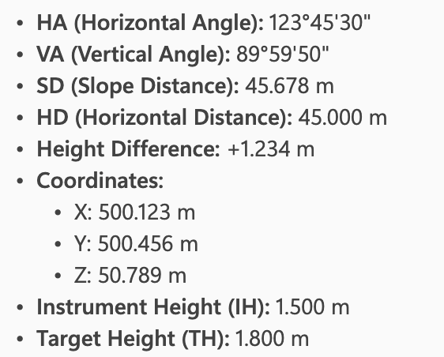
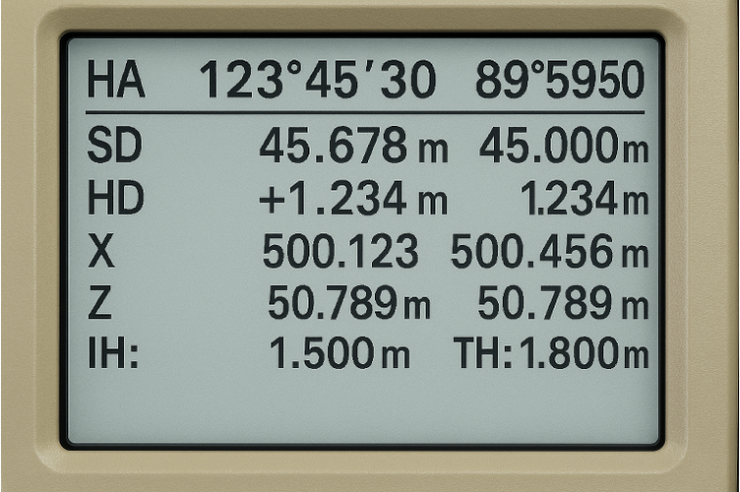

Model answers to exam-style questions
  - Explain why maintaining accuracy is critical when setting up a total station for measurement. ​
Maintaining accuracy and tolerance when setting up a total station is critical because even small errors can lead to significant measurement inaccuracies, resulting in incorrect positioning, construction faults, and increased costs.
  - Describe two main functions of a total station. ​
a) To measure both horizontal and vertical angles.
b) To calculate distances to determine precise positions of points on a site.
- List three safety measures that should be followed when using a total station on a construction site.
- Ensure the tripod is set up on stable, level ground.
- Keep the instrument secured and never leave it unattended.
- Be aware of surroundings, such as vehicle traffic and site hazards.

The following materials relate to lesson 4:
There are no new support materials required for this lesson.
Learners will need access to the Template to record survey measurements and the Checklist for setting up and levelling a total station from Lesson 3.

The following materials relate to lesson 5:
There are no support materials for this lesson.

The following materials relate to lesson 6:
- Trigonometry calculations worksheet.
- Trigonometry calculations worksheet answers.
- Physical site survey scenario.
- Physical site survey sketch.
Learners will also need access to the Checklist for setting up and levelling a total station and the Template to record survey measurements from Lesson 3.

Trigonometry calculations worksheet
Right-angle triangle
1a
45°
x
21 cm

Work out the value of x.

1b
x$°$
14 cm
12 cm

Work out the value of x.

Non-right-angled triangle
33°
12 cm
$$x$$
105°
2a

Work out the value of x. Give your answer to 1 decimal place.

2b
9 m
x $°$
16 m
50°

Work out the size of angle x. Give your answer to 3 significant figures.

2c
11 cm
14 cm
x cm
110°

Work out the value of x.
$$x°$$
16 cm
19 cm
17 cm
Give your answer to 1 decimal place.

2d

Work out the value of x. Give your answer to 3 significant figures.

Trigonometry calculations worksheet answers
1a
$sin(45)= \frac{21}{x}$
$$x= \frac{21}{\begin{aligned}sin(45) \\ =29.7 cm\end{aligned}}$$

1b
$tan x = \frac{14}{12}$
$$x= \tan^{-1} \frac{14}{12}$$
$$x=49.4°$$

2a
$\frac{x}{sin(33)}= \frac{12}{sin (105)}$
$x= \frac{12}{\sin\left(105\right)} × sin\left(33\right)$
$x=$6.8 $cm$

2b
$\frac{sin x }{9 }=\frac{sin 50 }{16 }$
$$sin x= \frac{sin 50 }{16 } × 9$$
$sin x=0.43089…$
$$x= \sin^{-1} \left(0.43089…\right)$$
$x=25.5°$

2c
$a^{2}=b^{2 }+ c^{2}-2bc cosA$
$$x^{2 }={14}^{2 }+ {11}^{2}-2\left(14\right)\left(11\right)cos 110$$
$$x^{2}=422.3422…$$
$$x=20.6 cm$$

2d
$cos A= \frac{b^{2}+ c^{2}- a^{2}}{2bc}$
$$cos x= \frac{{16}^{2 }+ {17}^{2}-{19}^{2}}{2(16)(17)}$$
$$cos x=\frac{23}{68}$$
$$x= \cos^{-1 } \frac{23}{68}$$
$$x= 70.2°$$

Physical site survey scenario
A school has plans to install an outdoor workshop canopy, storage containers, a shelter and seating areas. It has been given access to a grass field on its current site. Before planning can begin, a precise measurement of the field’s boundary(perimeter) is required to determine whether the planned installations fit within regulatory spacing and safety requirements.
The site has already been pegged out with six wooden stakes, labelled in clockwise order: P1 (bottom left), P2 (upper left), P3 (top right of the upper section), P4 (small vertical drop), P5 (mid-right horizontal), and P6 (sloping edge returning to P1). The shape matches the field sketch.
Task instructions:
- Draw your own sketch of the site. With your other team members, discuss where on the sketch the six measurement points would be located.
- Check your sketch with the Physical site survey sketch. Note any differences.
- In your group, set up the total station. You may need to refer to the Checklist for setting up and levelling a total station. Choose a station with visibility of all points.
- Take the measurements. In your group, you should have:
  - One person holding the prism.
  - One person taking the measurements.
  - One person verifying the total station has been correctly calibrated and recording the data.
Data should be recorded on the Template to record data.
Each learner should experience each role at least once.
- Transfer data to an Excel workbook.

Physical site survey sketch

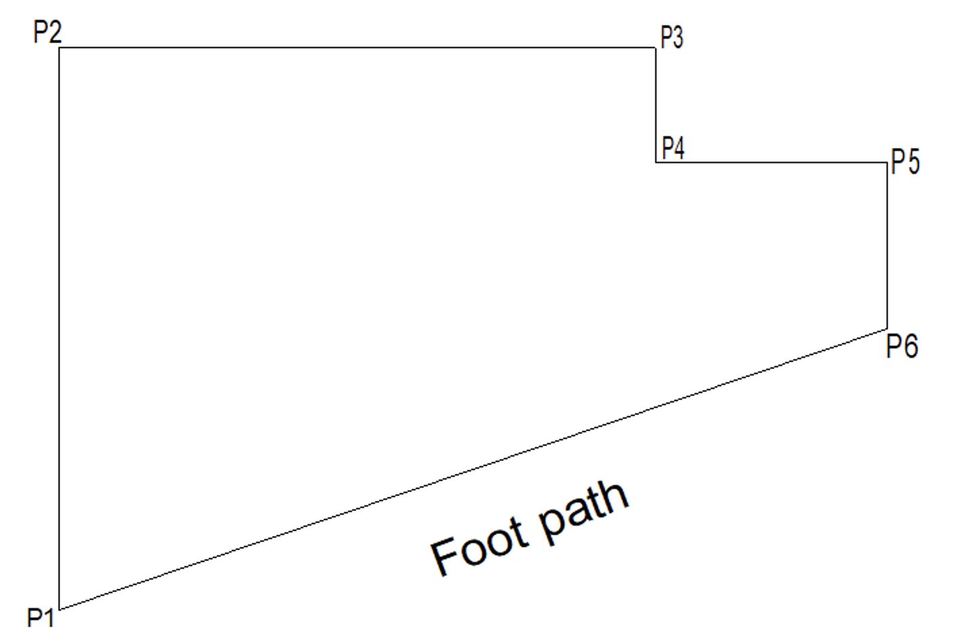
Source: Provider-created image

The following materials relate to lesson 7:
- Total station data readings activity sheet.
- Example trigonometry calculation for modelling – teacher resource.
- Applying trigonometry to calculate area.
- Applying trigonometry to calculate area answers.
- Aerial view activity.
- Aerial view activity answers.
- Roofing activity.
- Roofing activity answers – teacher resource.

Total station data readings activity sheet

A total station was used to measure a point on a window. Three measurements were taken.
- Enter the measurements into the table.
Easting | Northing
- Explain the significant of taking any of these measurements when making decisions about the window.
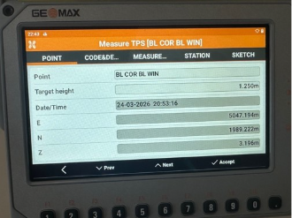

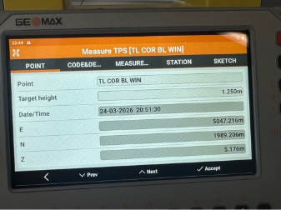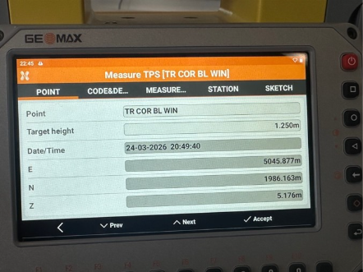
Example trigonometry calculation for modelling – teacher resource
A housing association has purchased a brownfield site. The site will be used for social housing intended for families.
The site will be enclosed using 8 m wide fencing panels.

Calculate the minimum number of fencing panels that will be needed.

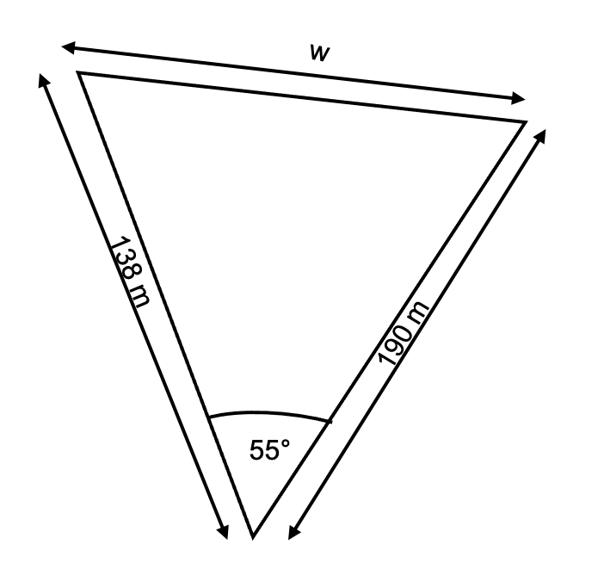

$$a^{2}= b^{2 }+c^{2}-2bccos{A}$$
$a^{2 }={138}^{2 }+ {190}^{2}-2 ×138 × 190×cos (55)$
$$a^{2}=25065.65168$$
$$a=158.32 m$$
Total length $=138+190+158.32$
Total length $=486.32 m$
Number of panels = $\frac{486.32}{8 }$
$=60.79$
Minimum number of panels = 61

Applying trigonometry to calculate area
A construction company is preparing to build a warehouse on a triangular plot of land. The plot is bordered by:
- a railway line on one side.
- a river on the other side.
- an access boundary forming the final side.
This is shown in Figure 1.
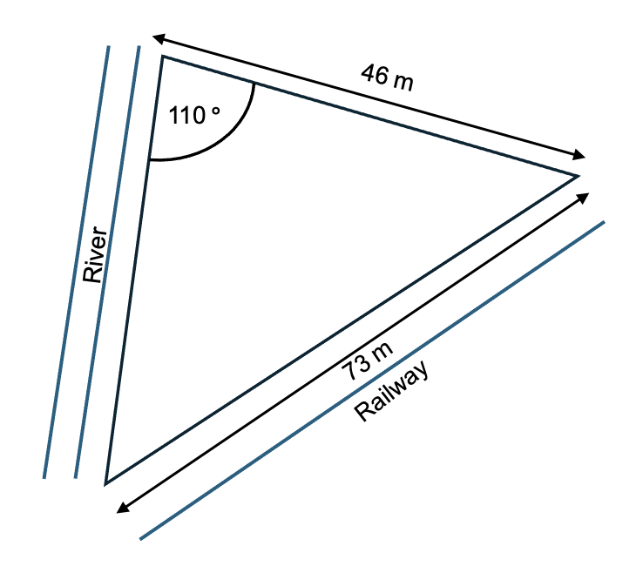
Figure 1
Task
Work in groups.
- Calculate the perimeter of fencing to secure the site.
- Calculate the area of the site.

Applying trigonometry to calculate area answers
  - Calculate the perimeter.
Use the cosine rule to find missing sides.
$${73}^{2}= x^{2}+ {46}^{2}-2(46)(x)cos⁡(110)$$
$$5329=x^{2}+2116+31.5x$$
Bring everything to one side and let it equal 0.
$x^{2}=31.5x+2116-5329$
$$x^{2}+31.5x-3213=0$$
Use the quadratic formula:
a= 1
b= 31.5
c= -3213
$$x=\frac{-31.5±\sqrt{{(31.5)}^{2}-4(1)(-3213)}}{2(1)}$$
$$x=43.1 or x= -74.6$$
Ignore negative length.
$$x=43.1 m$$
Perimeter = 43.1+73+46
Perimeter = 162.1 m
  - Calculate the area.
$Area= \frac{1}{2}absin(c)$
$Area=\frac{1}{2}×43.1×46×\sin{110}$
$$Area=931.5 m^{2}$$

Aerial view activity
The topsoil within the marked area A–A is to be excavated to a depth of 3 metres in preparation for basement construction. The topsoil will need to be removed and taken to a landfill site. A company will need to be contracted to remove the topsoil.
Tasks
Calculate the number of tipper trucks to be contracted to remove the soil. Use the information on the next page.
Complete the following calculations.
- Calculate the area of the marked section A–A (in m²).
- Using your answer, calculate the total volume of soil to be excavated.
Volume = Area × Depth
- A medium tipper truck (8–18 tonne) can carry 12 m³ of material. Determine how many truckloads (runs) will be required to remove all the excavated soil to a landfill site. Round up your answer to the nearest whole number.

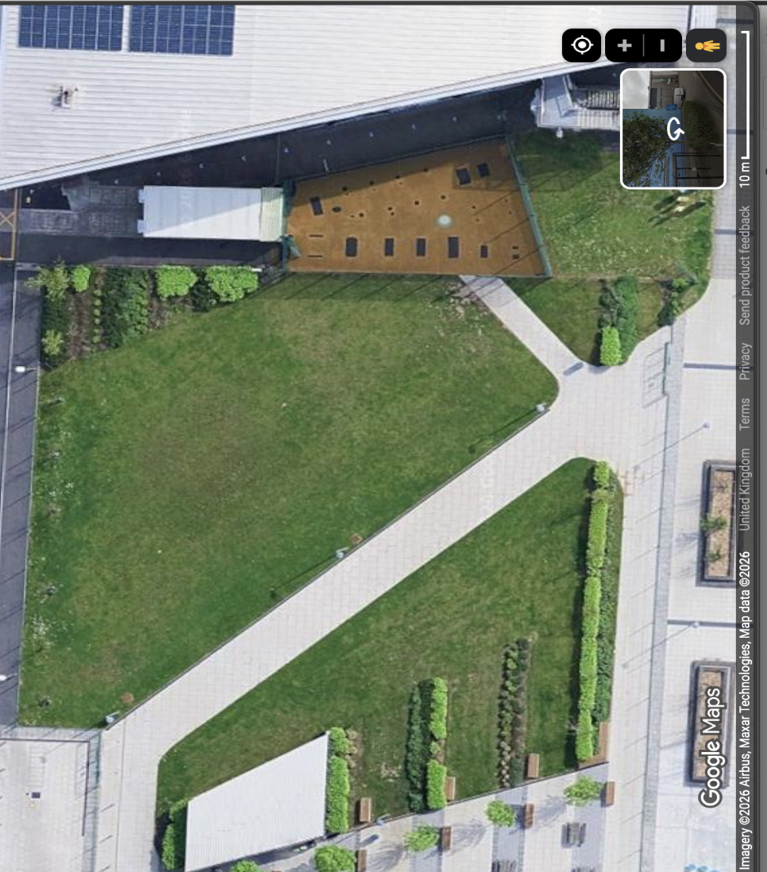
95°
105°
Area A-A
7m
2m
6m
1m
6
The shape has been split to help with area and volume calculation. You may need to split it further.
4m
Area A-A
Source: Google Maps (2026) Available at: https://maps.goog.com
Sketch not to scale

Aerial view activity answers
Split shape like so
Triangle 2
95°
105°
Area A-A
7m
2m
6m
1m
6
Triangle 1
3m

Area of rectangle
$$Area=6 × 1=6m^{2}$$

Area of triangle 1
$$Area= \frac{1}{2}absinC$$
$$Area=\frac{1}{2} ×6 × 3×\sin{(95°)}$$
$$Area=9 × 0.996=8.97m^{2}$$

Area of triangle 2
$$Area= \frac{1}{2} ×7 × 2×\sin\left(105°\right)$$
$$Area=7 × 0.966=6.76 m^{2}$$
$$Total area=6+8.96+6.76$$
$$=21.72 m^{2}$$
Volume
$$Volume=area × depth$$
$$Volume=21.72 × 3=65.16 m^{3}$$

Number of truck loads
$$Loads= \frac{65.16 }{12}=5.43$$
$$Truck loads=6$$

Roofing activity
Scenario:
A company is preparing to re-roof a domestic property. Before ordering materials, the number of tiles required needs to be determined.
Task 1
Record the following dimensions from the images below into this table:
Measurement needed | Value | Unit
Building length excluding flat roof section
Building width
Rafter length
Slate size | 500 x 250 | mm

Brick walls

Boiler
13 m
First Floor
Cast iron
roof truss
With timber and slate
coverings
32.0 m Ridge
17.00 m
27.00 m Eaves

4m
Roof ridge
Roof ridge
13m
11m
13m
Access road
Flat roof
Edge of dock
5m
4m
The Dock
Site
Boundary
4m
4.6m
13m
2m
Task 2
Calculate the roof surface area using the process below.

Calculate slope length
Show your calculation:

Slope length: __________________ m

Area of one roof slope
Show your calculation:

Area of one slope: __________________ m²

Total roof area: ____________________ m²

Task 3
Calculate the number of roofing tiles needed
Coverage rate: __________ tiles per m²

Tiles needed = total roof area × tiles per m²
Tiles needed (no waste): __________________ tiles.

Add 10% waste allowance
Final quantity = tiles needed × 1.10

Final tiles to order: __________________ tiles.

Roofing activity answers – teacher resource
Task 1
Measurement needed | Value | Unit
Building height excluding the flat roof section | 32 | m
Building width | 13 | m
Rafter length | 8.2 | m
Slate size | 500 x 250 | mm

Roof geometry and given data based on the provided drawings and measurements:
Building width: 13 m
Roof rise (eaves 27 m to ridge 32 m): 5 m
Half-span: $\frac{13 }{2 }$ = 6.5 m
Roof pitch:
$$\tan{θ= \frac{5}{6.5}}$$
$$θ=37.6°$$

Slope length (rafter) calculated using Pythagoras
Using Pythagoras theorem:
slope length = √ (rise² + run²)
= √ (5² + 6.5²)
= √ (25 + 42.25)
= √67.25 = 8.2 m

Task 2
Calculate slope length (Rafter length)
Using Pythagoras theorem:
slope length = √ (rise² + run²)
= √ (5² + 6.5²)
= √ (25 + 42.25)
= √67.25 = 8.2 m

Calculate pitched roof surface area
Area of one roof slope:
area = slope length × building length
area = 8.2 m × 13 m = 106.6 m²

Each block has 2 slopes:
Area-per-block = 2 × 106.6 = 213.2 m²

There are 2 identical roof blocks:
Total pitched area = 2 × 213.2 = 426.4 m²

Task 3
Slate quantity calculations
Slate size: 500 mm × 250 mm = 0.5 m × 0.25 m = 0.125 m² nominal area
Option A – Theoretical quantity (No overlap)
slates = roof area ÷ slate area
slates = 426.4÷ 0.125 = 3411.2 slates

Adding 10% waste:
Final total = 3411.2 x 1.10 = 3,753 slates

Option B – Practical roofing coverage (recommended)
Typical coverage for 500×250 slate: 22 slates per m²
slates = 426.4 × 22 = 9,381 slates
Adding 10% waste:
final total = 9,381 × 1.10 = 10,319.1
10,320 slates

Final recommended figures
Total pitched roof area (excluding flat roof): 426.4 m²
Recommended total slates (with overlap & waste): 10,320 slates

The following materials relate to lesson 8:
- Risk assessment activity – teacher guide.
- Risk assessment template.
- Cladding scenario data.
Learners will also need access to the Checklist for setting up and levelling a total station and the Template to record survey measurements from Lesson 3.

Risk assessment activity – teacher guide
Example Hazards
- Working at height on pitched roof surfaces.
- Falls from unprotected roof edges or through fragile elements.
- Slips/trips due to wet, mossy, or uneven roof surfaces.
- Ladder failure/misuse (incorrect angle, unsecured, overreaching).
- Proximity to dock water (drowning risk) and slippery quayside.
- Adverse weather: wind, rain, ice, low light reducing visibility.
- Moving vehicles on the access road and plant interface.
- Manual handling of equipment (muscle strain, awkward access).
- Falling objects (dropped tools or materials striking people below).
- Electrical hazards (overhead lines, temporary power leads).
Risks/potential harm (examples)
Hazard | Risk/potential harm
Working at height on pitched roof surfaces. | Loss of footing leads to a fall from height, causing serious injury or fatality.
Unprotected roof edges/fragile elements. | Fall through/over edge, causing major trauma; may also damage the structure.
Wet or uneven surfaces. | Slip/trip resulting in sprains, fractures, or secondary falls from height.
Ladder misuse/failure. | Fall from ladder (~2–6 m), leading to fractures/head injury.
Control measures (aligned to hierarchy)
Hazard | Control measures
Working at height on a pitched roof. | Plan from the ground where possible using laser devices and long-range inclinometers. Use scaffold access with guardrails and toe boards; install temporary edge protection. Use designated roof ladders/crawling boards; maintain three points of contact.
Unprotected edges/fragile elements. | Fit guardrails or temporary barriers; mark and cover fragile areas; set exclusion zones below; use fall-arrest (harness, lifeline) only as a last resort with trained users and a rescue plan.
Wet/uneven surfaces. | Check the weather forecast; postpone in high wind/rain/ice. Wear non-slip footwear. Clear loose debris/moss where safe to do so. Keep the work area tidy to avoid trip hazards.
Ladder misuse/failure. | Use industrial-grade inspected ladders; set 75° (4:1) angle; tie/secure at top and foot; extend 1 m above landing; do not overreach (belt buckle rule); maintain three points of contact; maximum 15–30 minutes tasks from ladders only.

Risk assessment template
Risk assessment for:  (Process/activity) |  |  |  | Date of assessment
What is the hazard?  (The potential to cause harm) | Who is at risk?  (e.g. operator,  other learners or staff) | What existing control measures are in place? | Probability (P) | Severity (S) | Risk rating (=P x S) | Are there any additional control measures required?

Cladding scenario data
Project background
A commercial warehouse built in the 1970s is scheduled for a cladding retrofit to improve weather protection and meet modern insulation standards. A technician has produced an initial set of façade measurements using historic drawings and partial on-site notes.
Technician's original measurements (potentially incorrect)
Elevation | Width (m) | Height (m) | Notes
North | 28.02 | 7.96 | Technician confident.
South | 27.88 | 8.42 | Height suspected to be incorrect.
East | 41.32 | 7.48 | Possible overestimation.
West | 40.12 | 7.49 | Likely correct.

Openings (opening type) | Quantity | Width (m) | Height (m)
Roller shutter | 1 | 4.0 | 4.0
Standard door | 2 | 1.1 | 2.1
Windows | 6 | 2.0 | 1.5
Task
- Enter all measurements into a spreadsheet under appropriate headings.
- Calculate gross wall area for each elevation using: Area = Width × Height.
- Calculate opening areas and deduct them from each elevation’s gross area.
- Produce net cladding area values for ordering retrofit materials.

The following materials relate to lesson 9:
- AI prompts teacher guide.
- Wind turbines case study.
- Research log.
- Wind turbine calculations answers.

AI prompts teacher guide
Note to teacher: You may want to use this to support the modelling of using prompts to create a detailed and applied risk assessment for an excavation.
Scenario
A construction company has been asked to excavate a trench to install a new underground water supply pipe for a small commercial building. The work will take place on a mixed-use site that includes vehicle access, nearby buildings and pedestrian routes.
1. Basic prompt (broad research)
- What are the main hazards involved in excavation work on construction sites?
2. Add task details
- What hazards should be considered when excavating a trench for underground services such as water pipes?
3. Add site context
- What additional risks should be considered when excavating a trench on a mixed-use site with vehicle access, nearby buildings and pedestrian routes?
4. Add people and equipment
- Identify hazards and control measures for trench excavation involving workers, excavators and delivery vehicles on a live site.
5. Add time and conditions
- How does the duration of an open trench and changing weather conditions affect excavation risks, and what controls should be used?
6. Full risk assessment prompt
- Produce a risk assessment for excavating a trench to install a new underground water supply pipe for a small commercial building on a mixed-use site with vehicle access, nearby buildings and pedestrian routes. Include hazards, who may be harmed, risk levels and suitable control measures.

Wind turbines case study
A farmer owns a 607,029 m² dairy farm located on the outskirts of a rural town in the UK. The farm primarily supports grazing cattle and produces milk for regional processing.
Recently, an electricity provider approached the farmer with a proposal to install several wind turbines on part of his land as part of the government's initiative for the UK to be a fully green country by 2050. The company believes the site is suitable due to strong, consistent wind speeds and good access for construction and maintenance.
Site Context:
Figure 1 shows the farm site. The site includes several important surrounding features:
- Active dairy farmland with grazing cattle.
- A nearby village approximately 800m from the proposed turbine area.
- An area of woodland, possibly designated as a protected habitat.
- A dual carriageway running along one edge of the property.
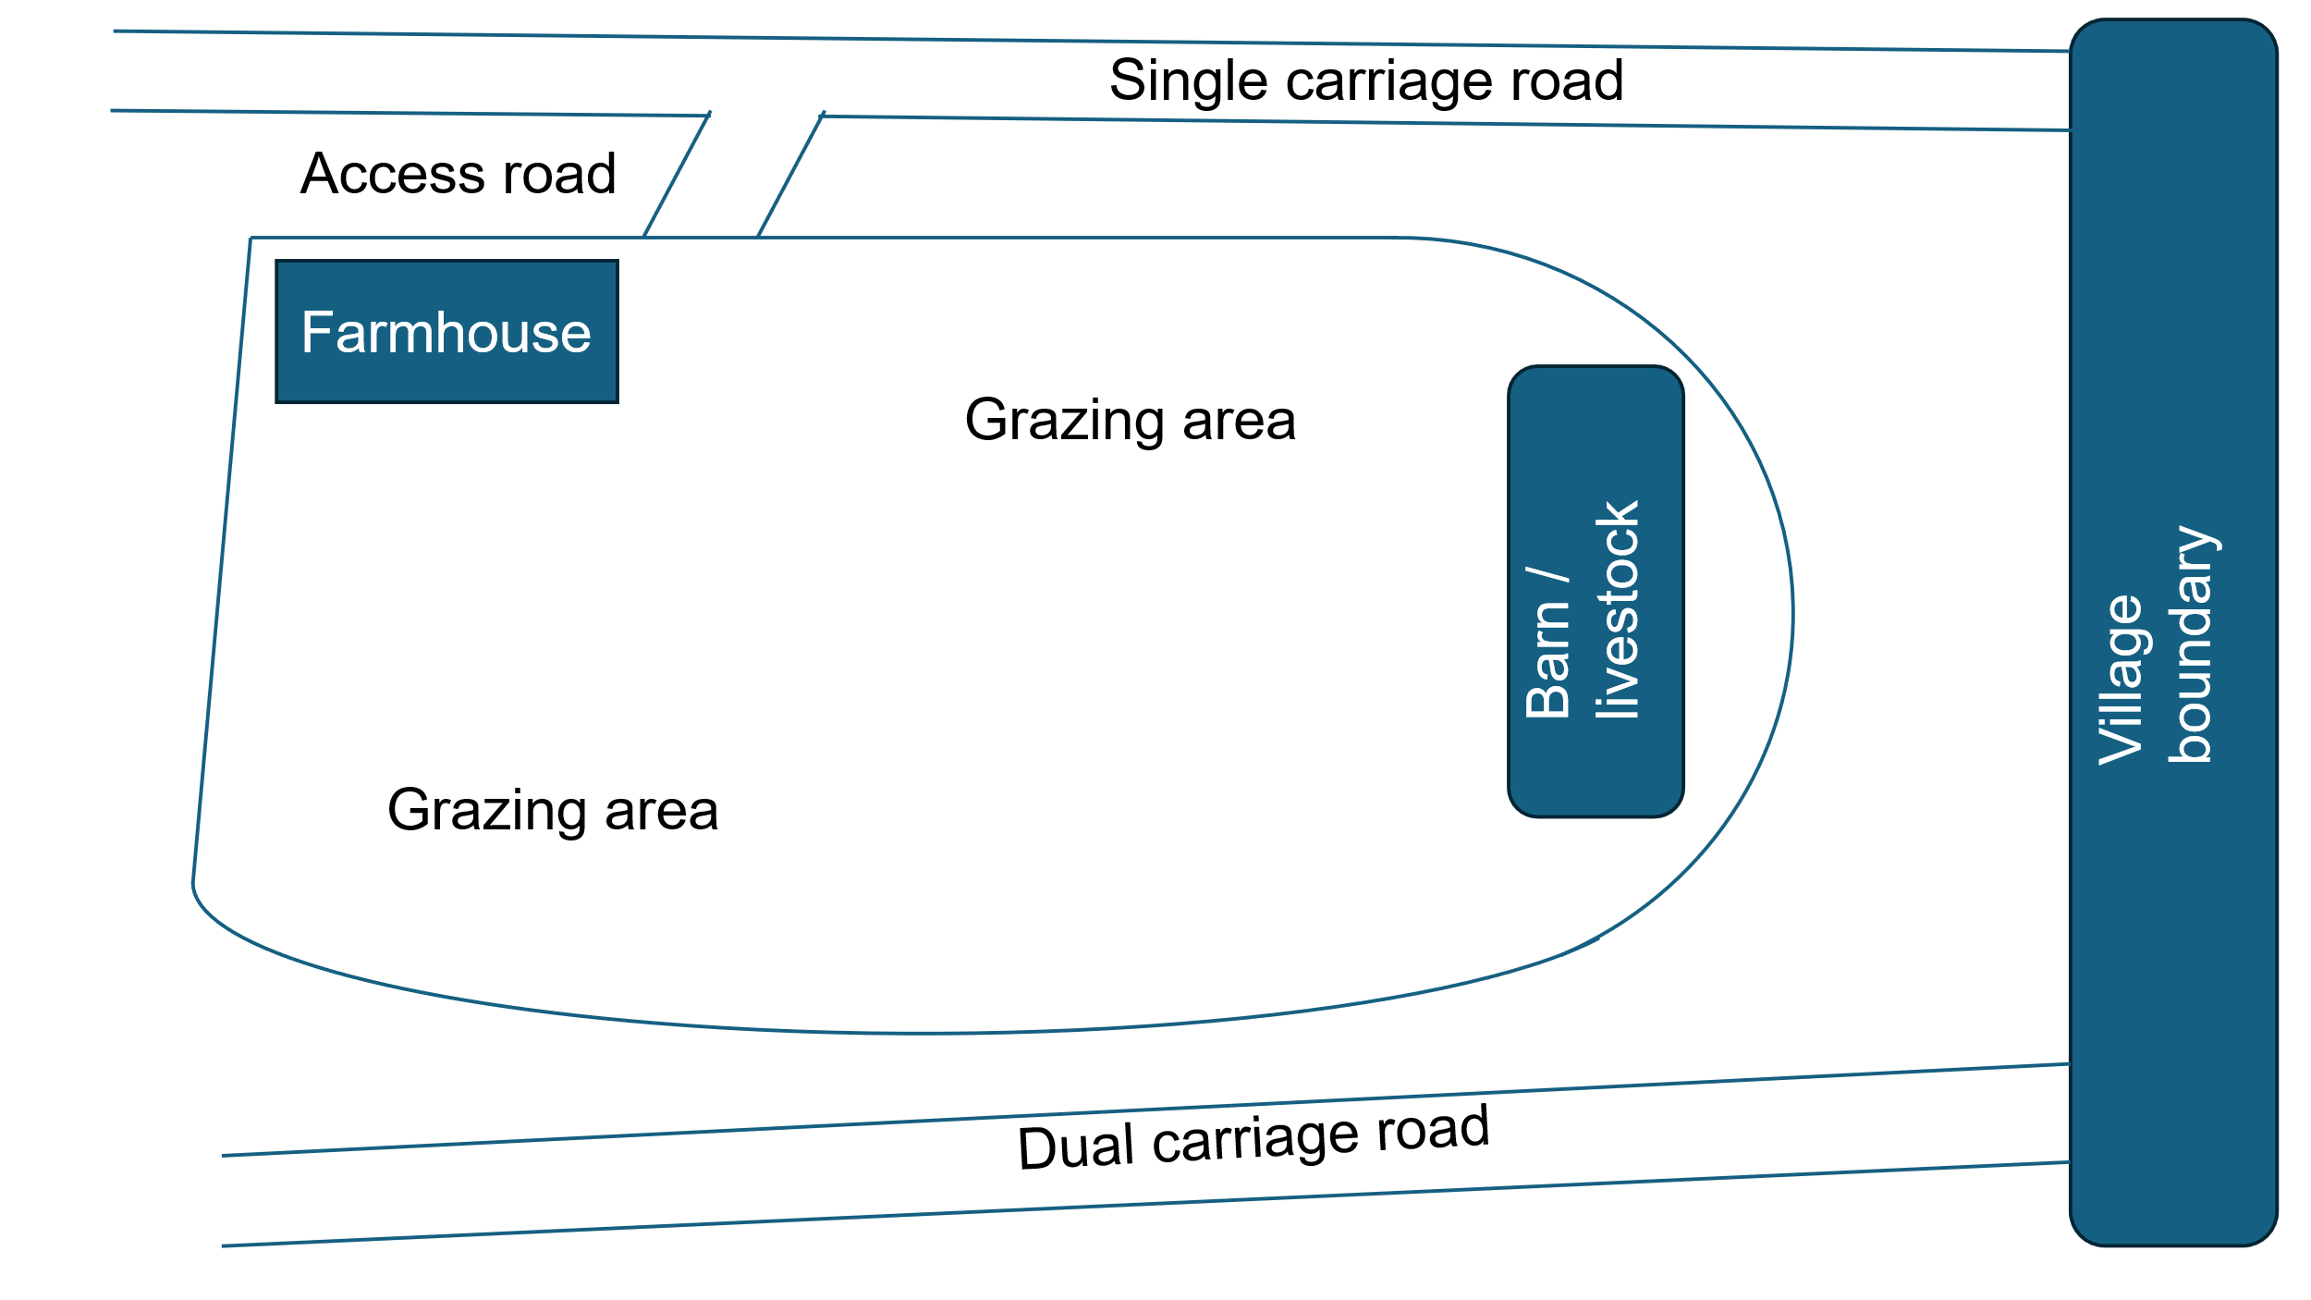
Figure 1: Plan to show the farmer’s field and the environment
Client Objectives
The farmer is considering the proposal, but has key priorities:
- Maintain safe grazing conditions for livestock.
- Continue normal farm operations.
- Generate additional income through land leasing.
- Avoid disruption to local residents and the environment.

Research log
Research question and prompt(s) used | Findings | Sources (including references)

Wind turbine calculations answers
Length of support cable
$$Sin\left(53\right)=\frac{80}{x}$$

Rearrange
$$x=\frac{80}{sin⁡(53)}$$

$$x=\frac{80}{0.7986}$$

$x=100.2 m$
Length of support cable = 100.2m
Distance from the base
$$\tan\left(53\right)=\frac{80}{x}$$

$$x=\frac{80}{tan⁡(53)}$$

$x=60.3$ m

The cable should be anchored approximately 60.3 m from the base of the turbine.

The following materials relate to lesson 10:
- Solar panel installation case study.
- Planning template.

Learners will also need access to the Checklist for setting up and levelling a total station and the Template to record survey measurements from Lesson 3 and the Research log from Lesson 9.

Solar panel installation case study
A property developer has proposed installing solar panels on the roof of a 15-storey residential building located in an urban UK environment.
The aim is to reduce carbon emissions, lower energy costs for residents, and contribute to the UK’s net zero targets.
Site conditions
• Building height: 45–50 metres.
• Wind speeds up to 23 mph at roof level.
• Surrounded by tall buildings, roads, and pedestrian areas.
The roof is enclosed by a parapet boundary wall with a thickness of 230 mm.
Research standard solar panel dimensions and use this information to inform your calculations. Measure the building footprint to determine the total roof surface area.
Using this area, calculate how many solar panels can be installed, allowing for a 1 m clearance around the roof perimeter for maintenance access, as well as accounting for the thickness of the parapet wall.

Planning template

Purpose of the survey
Location of the survey
Health and safety
Hazard | Who might be harmed? | Control measure
Equipment required
Equipment | Purpose
Measurements required

Sketch to show data points to be collected

Calculations needed (give them in sequence)

Acknowledgements

PRODUCED BY
FUNDED BY

London Design & Engineering UTC has produced this resource on behalf of the Education and Training Foundation.
This programme is funded by the Department for Education.

