
Employer-set project


Qualification | T-Level in  Laboratory  Science (Level 3) | Topic | Employer set project | Delivery | 4 sessions  (Each session is 2  hours
Learning Aims
The purpose of the employer-set project (ESP) is to ensure that students are given the opportunity to apply core knowledge and skills to develop a substantial piece of work in response to an employer-set brief. The brief and tasks are contextualised around an occupational area, requiring students to plan a scientific project. The following lesson plans have been designed to prepare students for the ESP, specifically Tasks 4a and 4b. These resources will provide more understanding of the tasks to ensure that staff and students are prepared for the assessment.
Employer set project: Task 4a and 4b
(Presentation of outcome and conclusions)
Assessment objectives
AO2: Apply core knowledge and skills to the development of a scientific project (12 marks)
AO3: Select relevant techniques and resources to meet the brief (6 marks)
AO4: Use English, mathematics and digital skills as appropriate (4 marks)
AO5: Realise a project outcome and review how well the outcome meets the brief (6 marks)
Core skills
CS4: Creativity, innovation
CS6: Communication (written and verbal)
CS7: Reflective evaluation
Prior knowledge needed before beginning this set of lessons (these are covered in task 3 of the ESP):
Ability to use statistical techniques (for example, standard deviation, t-tests, spearman’s rank.
Ability to use Excel or Google sheets to create digital tables and graphs in addition to creating tables and graphs in a written format. Ability to look at graphs to explain trends and patterns.
The employer set project is a series of 6 tasks, each task will build the students’ skills in order to complete the next. Techniques and skills gained in task 3 will help the students with data presentation on their posters.
Example research topics that can be used for this task
(This scheme of learning is written generically so that any topic chosen by staff or student can be applied):
  - Antibiotic resistance (over prescription of medicines or superbugs).
  - Climate change (effects on the environment, temperature changes).
  - Fossil fuels (effects on the environment, compare fossil fuels to renewable energy sources).
  - Overfishing (effects of trawling on the environment).

 | Learning intentions | Key learning activities  (This includes student tasks and teacher guidance) | Assessment focus (These include both assessment objectives and core skills) | Accompanying PowerPoint slides
  Lesson Number
1  What makes a good  scientific poster? | Learning intentions:  To be able to identify and discuss what a good scientific poster looks like.  To explain what makes a good scientific poster.  To be able to draft a scientific poster. | Starter  Students to discuss in pairs, the types of scientific posters that they have seen previously and think about what sections are the most important to include. Examples of discussion points when talking about a ‘good’ scientific poster: Hypothesis or abstract, method (if research was conducted, how was this done?), results, presentation of results (these should be reader friendly- tables/graphs etc), discussion, conclusion and further areas of development.  It’s important that students are aware of what a scientific poster should look like so that they can plan their own. This discussion will lead onto the main student task for this lesson.  Student tasks  Look through a series of professional scientific posters and discuss what makes a good poster; what are the important aspects? Links on student worksheet (Appendix 1: Analysis of scientific posters)  Extract what the different sections of a poster should include then decide which of these sections will be relevant to the ESP.  Students to create their own checklist of what they should be including on their scientific poster.  Students to then discuss in groups, where the information that they will collect from Tasks 1-3 will be condensed and placed on their posters.  Teacher guidance and additional resources  Print or give students online access to the scientific posters provided. (Appendix 1: Analysis of scientific posters)  Print student worksheet (Appendix 1: Analysis of scientific posters)  Homework  Prepare a 3 minute presentation on a given topic | AO3  Here the students will be selecting relevant resources which will meet the brief, ensuring that they cover what is needed for the task.  AO1 and AO3  Students will realise what the project outcome is: a scientific poster. They will then plan how to achieve this outcome. | 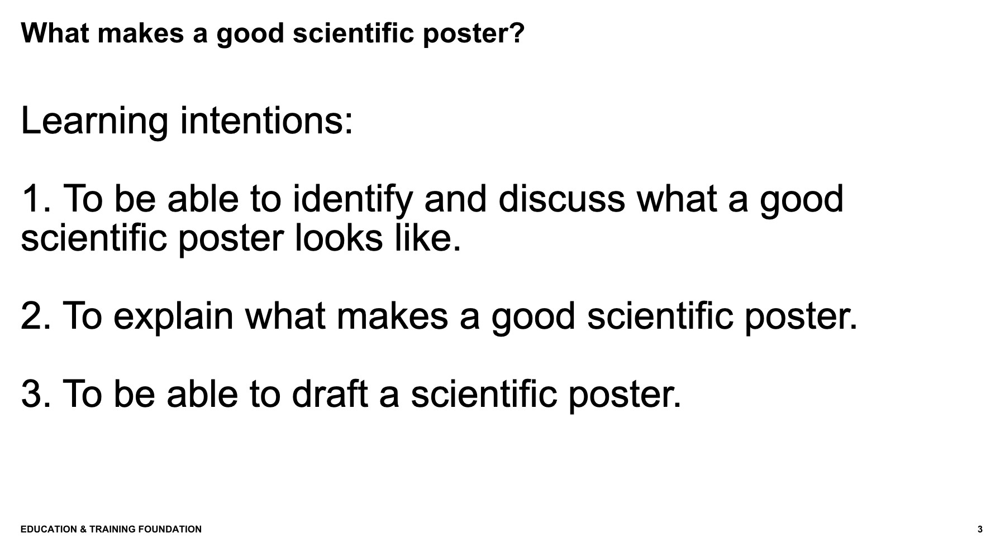  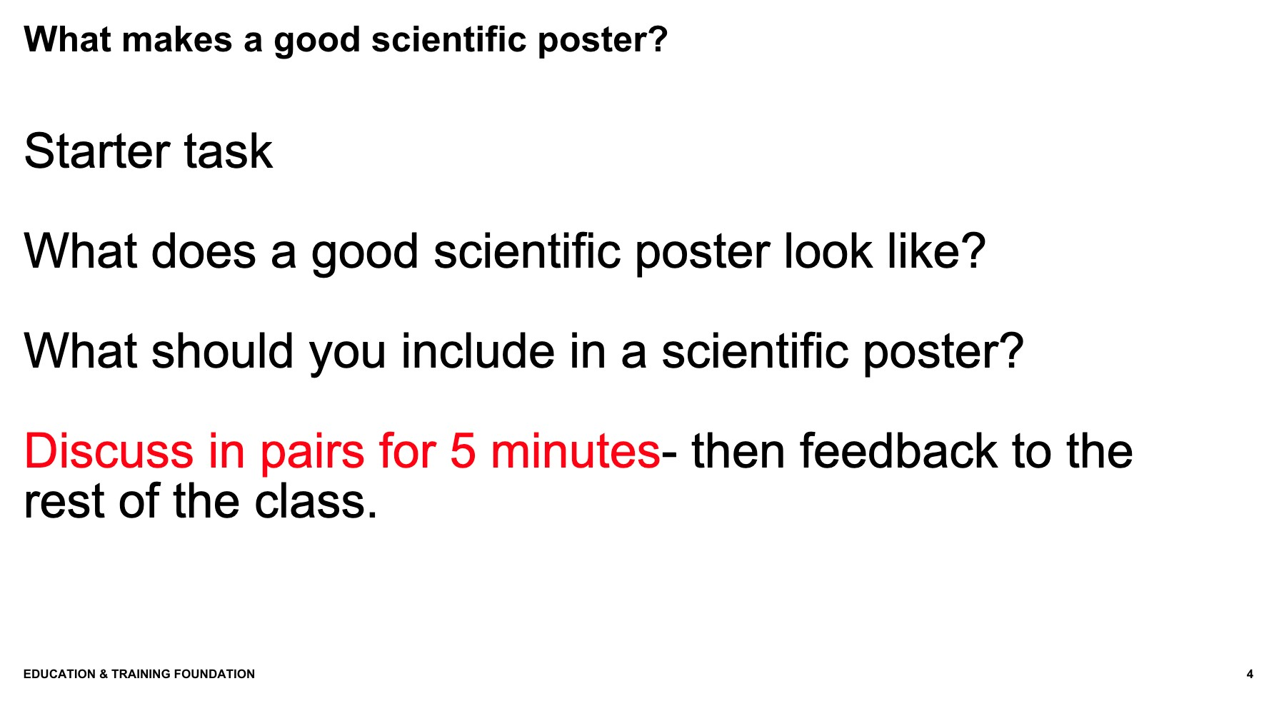  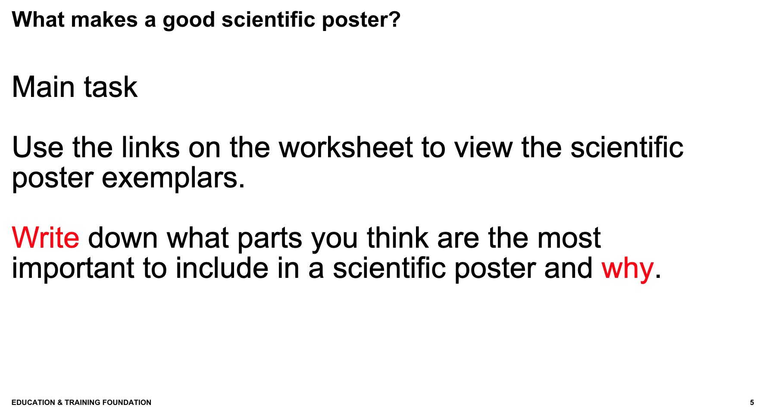  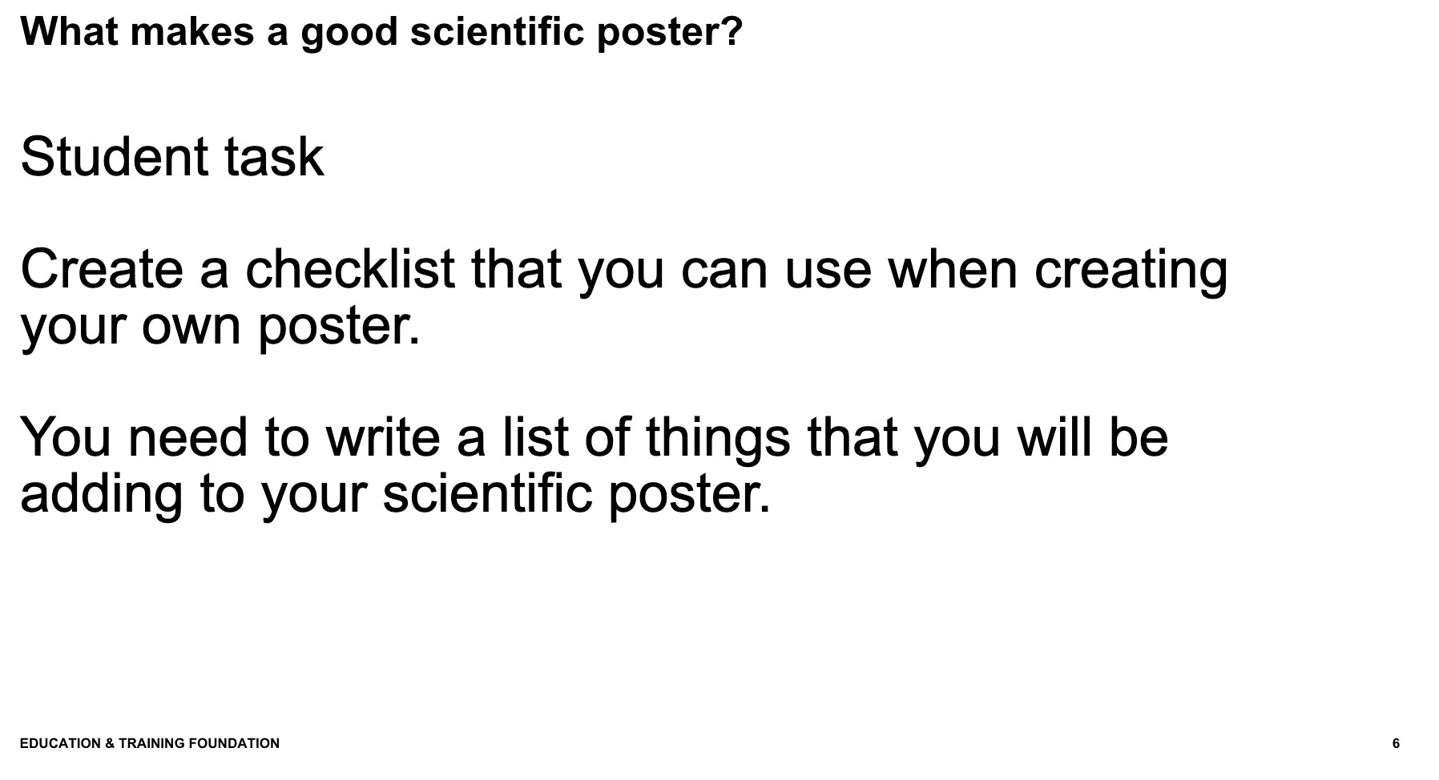

2  How to create an effective  scientific poster.  How to deliver an effective presentation  (Can be done  over two lessons, 4 hours in total) | Learning intentions:  To be able to plan a scientific poster.  To research and consolidate information that will be presented on the poster.  To review data and  choose an appropriate format to present in. | Scientific posters  Starter  Teacher to lead a discussion in class to come up with some data that the students can use for the task. Students will then decide what kind of graph/table they want to present their data in and produce this using online software.  Discussion examples to collect data: shoe sizes, temperature of different rooms in the school/college, hair colour.  Student tasks  Students to each use an A3 piece of paper to plan where each section of their poster will be placed and organise their structure. This will help when creating the poster as students won’t need to spend time trying to fit everything in. Ensure that work is presented in a way which reflects the project outcome well.  Research information that will be going onto the scientific poster: the students can use some of the ideas which have been posted in the information section of this document.  Consolidate this into what is relevant for the topic that has been chosen and meets the needs of the brief.  The purpose of this task is that students can use secondary data which they can research based on the topic they have chosen.  For example, If a student chooses the climate change topic they can research which countries produce the most pollution, then break this down to sectors/industries. The data can then be presented in a graph which the student produces digitally.  Teacher guidance  Support students in their digital skills to ensure that they are including this as part of their presentation.  TOP TIP: Examiners are looking for evidence of digital skills used on the poster, students can either create the whole poster digitally on a computer (On software such as Microsoft power point or Google slides) and then print out and glue onto their A2 posters. Students may also wish to fully create their poster digitally; this is also acceptable.  Presentations  Discuss what makes an effective presentation.  Students to present the topic they have prepared.  Teacher Guidance  Individual discussion on presentation while others work on posters | AO4  Students will use their digital skills in order to produce a graph using online software. English writing skills are also used here.  AO1, AO3 and AO5 Students will work towards the outcome and plan how to achieve this. Students are developing their research skills.  AO4  Students will use digital and maths skills to ensure that data is presented in an appropriate graph. | 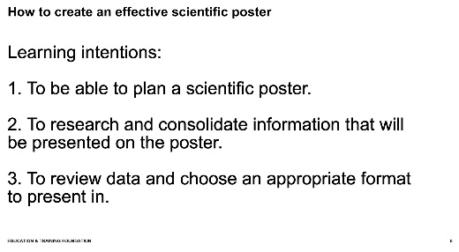  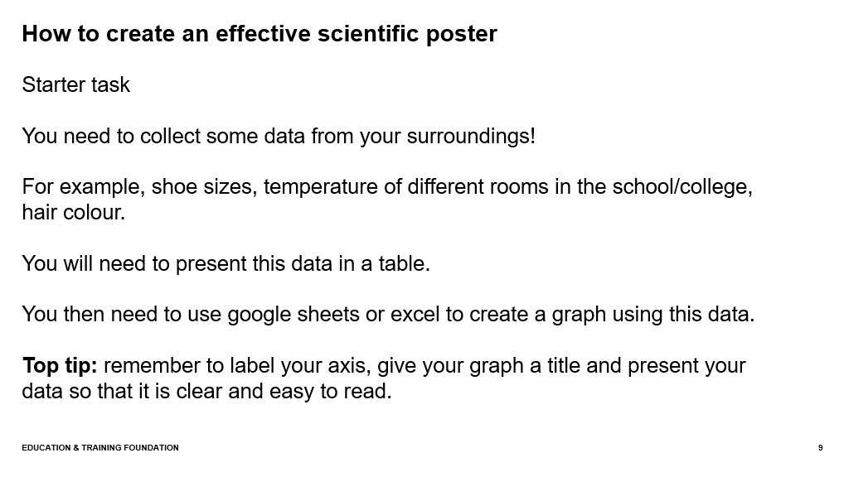  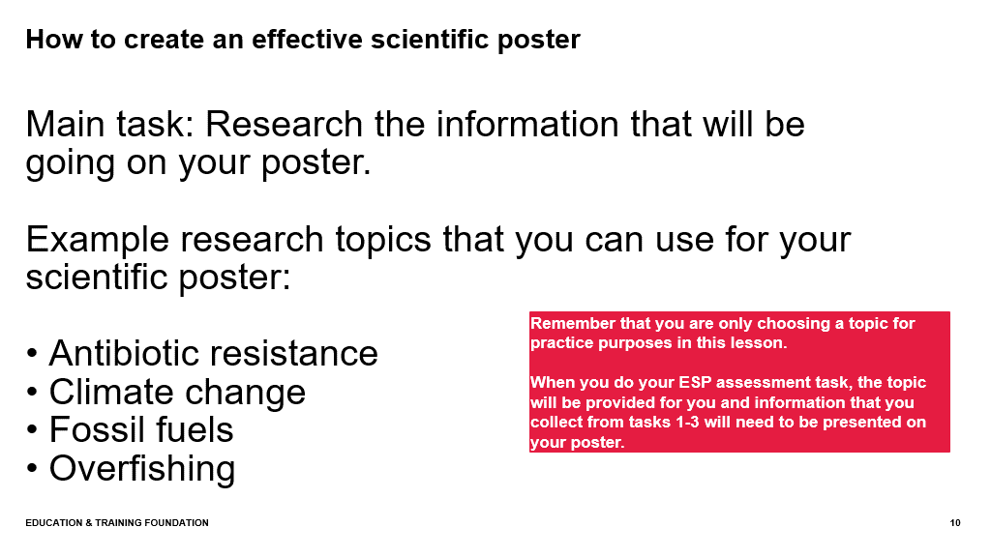  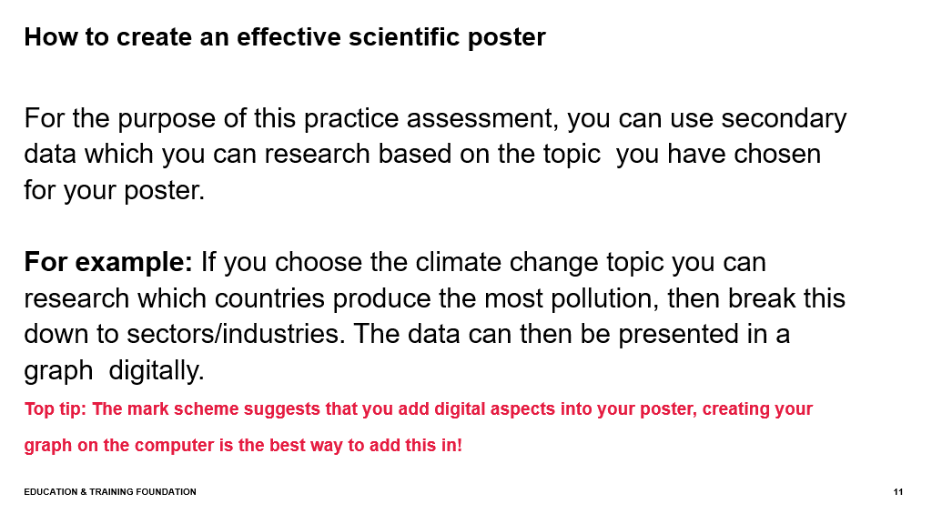

3  Creating a  scientific poster  Practising presentation skills  (Can be done  over two lessons, 4 hours in total) | Learning intentions:  To create a scientific poster using relevant techniques and resources. | Student tasks  Students will have this lesson time to prepare their A2 posters.  Computers or laptops should be available for students as well as access to a printer. This is so that they can digitally present some of their information and then print, cut and stick onto their posters.  Students have the option to create their poster fully digitally on a computer or they can do parts of it digitally, print these out and then add to their posters.  TOP TIP: Ensure that students leave enough space for each section on their posters, they could use a pencil on their poster to map out where each section will go.  Time will be allocated for students to  Teacher guidance and resources required  Ensure that students have all resources required (A2 paper, pens, coloured paper, glue, scissors etc).  Provide students with the checklist to ensure that they have covered all aspects that should be included on a scientific poster. (Appendix 2: Checklist for poster)  TOP TIP: When doing the ESP assessment, if students have done a physical poster, pictures will need to be taken and uploaded online for the examiner to mark . Students will need to write neatly, have clear headings and use colours/fonts that are clear to see when pictures of the work are taken. | AO2, AO3, AO4 and AO5  Students will create their posters, working towards meeting the project outcome.  CS4  Students will ensure that the posters are eye catching and include all the relevant information required.  CS7  Students will use skills of reflective evaluation when using this checklist. | 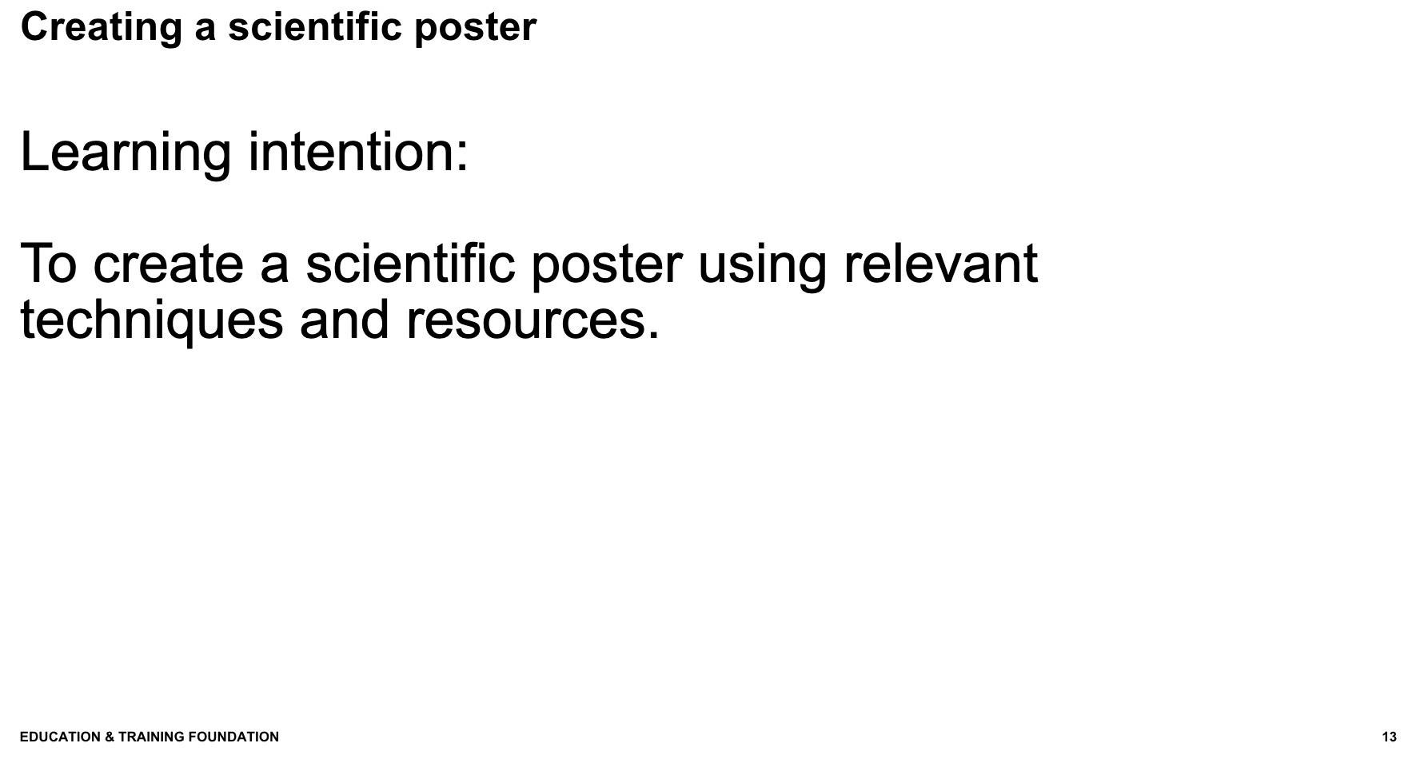  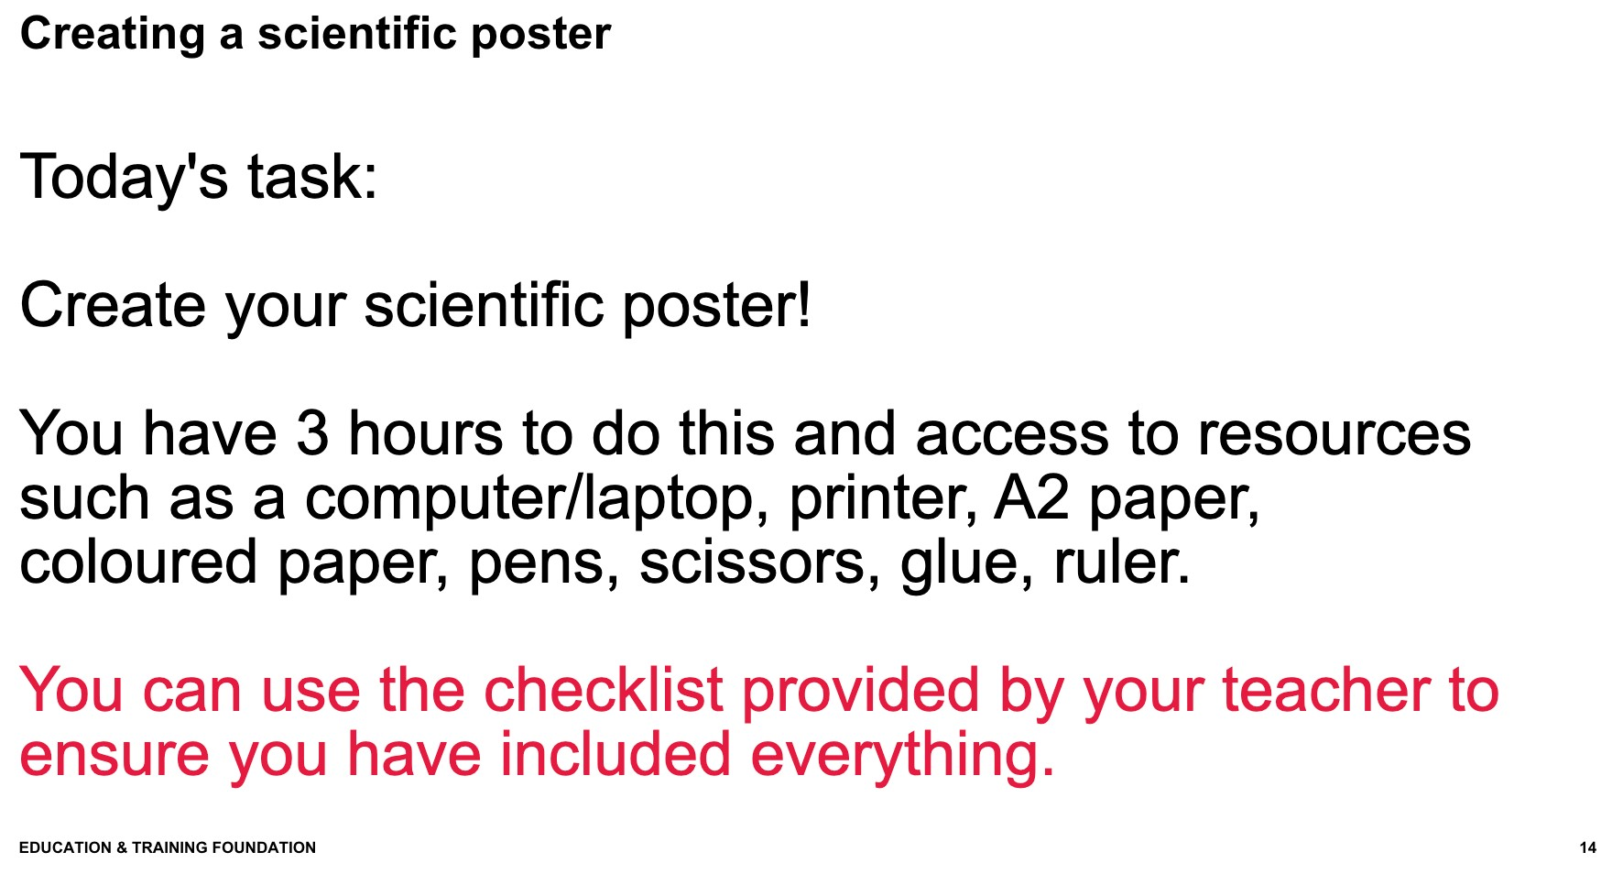

4  Presenta tion and  evaluatio n/  feedback session | Learning intentions:  To present their scientific poster to their peers.  To evaluate their own presentations.  Feedback to their peers about the presentations and posters. | Starter  Give students 10-15 mins to prepare for their presentations. They can revisit information so that they know what they will be presenting.  Student tasks  Students will work in groups of 4-5, they will each take turns to present their posters to the rest of their small group.  The peers watching the presentation will fill out an evaluation/ feedback sheet for each person after they have finished presenting and can also ask them questions based on any information they have missed in their presentation or if they would like more information on any aspects. (Appendix 3: Feedback and evaluation forms)  After everyone in the class has presented, students should leave their posters on the desk for the students to circulate the room and share ideas with their peers.  Teacher guidance and additional resources  Support students in ensuring that they don’t spend more than 10 minutes presenting.  Make sure students fill out an evaluation form for each person in their group. (Appendix 3: Feedback and evaluation forms)  During the last student task, teachers can also go around the class to view student posters and leave them some feedback on what was done well and which sections they can improve on. | CS6 and CS7  AO5  Students will communicate, during  their verbal presentations when showcasing their posters.  Skills gained: presentation skills, public speaking, confidence.  Students will also have a chance to feedback to their peers in order to improve their work. | 