

Supporting holistic delivery of Core Content and Occupational Specialism content:
Animal management and behaviour
ET-FOUNDATION.CO.UK
T LEVEL IN ANIMAL CARE AND MANAGEMENT

INTRODUCTION
Unit 407 is part of the Occupational Specialism Animal Management and Behaviour within the T Level in Animal Care and Management. This unit is part of wider topics that are assessed in Year 2 as part of an externally set synoptic assignment. The lessons provided here can be used in the second year of the course or there is an option to use these in Year 1 to support learners with preparation for the Employer Set Project (ESP). Another option would be to pick some of the lessons out and link them with other units throughout the Occupational Specialism such as Animal Health and Welfare.
The purpose of this Occupational Specialism is for learners to learn about, and undertake, the design and development processes required when working in animal management and behaviour environments.
Learners will have the opportunity to plan, perform and evaluate their work using a range of techniques, methods and resources, and develop knowledge and skills in:
- optimising the health and welfare of animals
- understanding the impact the environment can have on animals and how it can best be optimised
- optimising animal health and welfare
- applying techniques to influence animal behaviour positively.
Unit content will continually be assessed and monitored within lessons, with a formative design assessment in the final lesson which reflects the final summative assessment.
Learners will be completing an Industry Placement which will feed into the lessons and teachers should draw upon this knowledge during teaching.
This resource has been developed to enable teachers to plan for and develop the learners’ peer assessment and evaluation skills. These are needed as they progress in their T Level studies and engage in their Industry Placement and particularly as they complete their ESP and synoptic assignment.
This resource has three sections:

Framework for Learning
The resource includes a Framework for Learning (FfL). This covers 20 hours of learning and there is a diagram to show how the content of those hours has been sequenced and scaffolded. There is also a narrative that explains the sequencing and scaffolding in more detail.

Lesson plans
There is a lesson plan for each stage in the sequencing and scaffolding of learning in the FfL. Lesson plans include details of the support materials that are required to support delivery, including those found within this resource.

Support materials
The support materials identified in the lesson plans are also available at the end of this document.

NOTE:
There is a separate slide deck that should be used with the lessons.

SECTION 1: FRAMEWORK FOR LEARNING
The FfL sets out one approach to scaffolding and sequencing the holistic delivery of Core Content from the Core Pathway coverage Animal Management and Occupational Specialism Animal Management and Behaviour, with a focus on the content of Performance Outcome (PO) 2 (optimise animal environments to meet their needs).

Sequencing and scaffolding
The Technical Qualification is made up of two components, each of which needs to be achieved.
The Common Core component is made up of the Common Core and the Core Pathway. The Common Core Content is designed to offer sufficient breadth of knowledge for the learner to apply it in a variety of contexts related to the agriculture, environmental and animal care industry and those Occupational Specialisms linked to this T Level.
The Common Core Content is the building block of knowledge and skills that will give a learner a broad understanding of the industry and job roles. At the same time, it will develop the Core Skills they will need to apply when working in the industry.
The Core Pathway is designed to offer sufficient breadth of knowledge for the learner to understand contexts related to animal management and behaviour.
Occupational Specialisms develop the knowledge, skills and behaviours necessary to achieve threshold competence in an occupation. Threshold competence is defined as when a learner’s attainment against the knowledge, skills and behaviours is of a standard for them to enter the occupation and industry. They must also demonstrate the ability to achieve occupational competence over time with the correct support and training.
Within the Occupational Specialism, learners will have the opportunity to plan, perform and evaluate their work using a range of techniques, methods and resources.
The learners will develop their knowledge and skills in optimising the health and welfare of animals. They will also build their understanding of the impact the environment can have on animals and how it can best optimised.
Within the Occupational Specialism PO2, learners develop knowledge about a range of mammals, birds, herptiles, aquatics and invertebrates. Learners can monitor and determine animal needs and current behaviours through a range of formats. The following 10 lessons are there to support the learners with their decision-making regarding the environment required for each animal. Learners will develop skills needed to optimise the animal’s environment to maximise animal health and welfare.
The lessons have been designed to support learners to develop a holistic understanding of both the Core Pathway and the Occupational Specialism as this reflects the animal welfare industry and how they will be assessed in the synoptic assignment.
The materials have been designed around a ‘wall of learning’, which includes 10 blocks of learning, i.e. 10 lessons. The top capping of the wall can only be achieved if all lower blocks (courses) of learning are complete. The courses (lower blocks) can be delivered in any sequence. However, the resource is recommended to be delivered in four phases as follows:
Phase 1: Foundation
This phase includes three lessons:
- introduction to animal environments
- factors affecting design
- legislation related to enclosure design.
This phase introduces different aspects of enclosure design so that learners can start to think practically and empathetically around enclosure design. It will develop empathy skills in understanding the requirements of enclosure design and how this can impact the animal’s overall health and wellbeing. This phase introduces different mediums of information so that learners understand the legislation requirements when developing enclosures for a range of species. This phase is the foundation for the development of critical evaluation and collaborative learning.
Phase 2: Production
This phase includes two lessons:
- practice design (formative assessment)
- methods of review (evaluation practice).
This phase assesses learning and enhances development by using a range of information for different designs and validating the authenticity of learner work. This phase includes reflecting on the content of information used to develop critical thinking skills. At the end of this phase, learners should show more confidence in their evaluation skills and be able to show empathy towards animal care and management.
Phase 3: Refinement
This phase includes four lessons:
- enrichment design
- health and safety considerations
- stakeholders 1
- stakeholders 2.
This phase builds on phase 1 and 2. This phase develops learners’ understanding of the relevance of animal behaviour, audience perception and practicality when designing enclosures. The phase develops knowledge and understanding so that learners understand the impact of various audiences on appropriate design. At the end of this phase, learners should be able to consider all aspects of animal management when designing animal enclosures for a range of species.

Phase 4: Quality assurance
This phase includes one lesson:
- design and produce an accommodation design (formative assessment).
The final stage addresses the quality checks that would form part of the accommodation design process in the context of learners’ own designs. Learners should be confident to evaluate and assure that their design and the process to develop the design of the required standard as required by the animal, legislation and stakeholders. This phase replicates this concept. This final phase requires that the learner applies all learning from phases 1 to 3. It includes evaluative practice to quality assure the design process.

The following diagram shows how the development of enclosure design will be sequenced and scaffolded through this FfL.

SECTION 2: LESSON PLANS
This section includes 10 lesson plans. The lesson plans follow the FfL. The lesson plans include:
- lesson title
- targeted specification content coverage
- lesson number in the sequence
- total amount of time required to deliver the lesson
- teacher and learner activities to be undertaken throughout the lesson
- resources needed to deliver the lesson (see Note below)
- details of how the lesson supports the development of English, maths and digital skills (where appropriate)
- details of how the lesson can be adapted to meet learners’ specific needs
- next steps in learning such as homework activities and links to the next lesson.
Note:
There is an assumption that the learning environment will include the following:
- whiteboard/smartboard or similar
- materials to take notes, e.g. pens, paper, audio recorder, digital device and software
- equipment to present a slide deck
- digital devices (e.g. laptop, tablet) for all learners
- internet access
- learner access to word-processing, spreadsheet and presentation software.

Lesson 1
Title: Introduction to animal environments
Targeted content reference:
- Core Pathway: 1. Health and safety; 3. Biosecurity; 7. Animal health.
- Occupational Specialism: 2.5 How the natural habitats influence requirements for captive animal environments.
Lesson sequence number: 1
Timing: 2 hours
Prior learning: Critical evaluation skills gained from the Core Pathway and Common Core.
Timing | Teacher activity | Learner activity | Support materials
20 minutes | Briefly introduce the purpose of the lesson: evaluating variations in animal enclosures and their importance in animal management.  Outline learning objectives and structure of the lesson. | Listen and ask questions as required. | Slide deck  Worksheet: Example enclosures  Case studies: Enclosure design  Animal enclosure evaluation sheet
20 minutes | Give presentation explaining why enclosure designs vary. | Listen and take notes.
20 minutes | Hand out Worksheet: Example enclosures.  Instruct learners to look at the images of three contrasting enclosure designs.  Ask learners the questions found on the slide deck. | Look at the Worksheet: Example enclosures and answer the questions on the slide deck.
40 minutes | Divide learners into small groups (three or four per group).  Hand out Case studies: Enclosure design.  Instruct learners to evaluate three varied enclosure designs as per the case studies using the evaluation criteria on the slide deck. | Working in groups of three or four, evaluate three varied enclosure designs in the Case study: Enclosure design using the evaluation criteria on the slide deck (group analysis of enclosure design).
40 minutes | Hand out Animal enclosure evaluation sheet.  Instruct groups to score using the Animal enclosure evaluation sheet. | Groups discuss and score each enclosure based on the criteria provided on the Animal enclosure evaluation sheet.
40 minutes | Give verbal feedback on Animal enclosure evaluation sheet responses.  Advise learners to retain the Animal enclosure evaluation sheet as it will be useful in future lessons. | Take notes and amend Animal enclosure evaluation sheet.
40 minutes | Give instruction to choose one of the designs from the case study and discuss key weaknesses and areas for improvement. | Groups identify key weaknesses and areas for improvement.
40 minutes | Give instruction to modify one of the evaluated enclosure designs to improve it. | Use the guided questions on slide deck to modify the group’s design.
40 minutes | Facilitate presentations from the small groups covering proposed changes and provide justifications based on the evaluation criteria. | Groups prepare presentations.  Each group briefly presents their redesign to the class
20 minutes | Recap key points using the questions on the slide deck. | Listen and take notes.
20 minutes | Facilitate a class discussion regarding the presentations and what they have learnt, as per the slide deck. | Participate in the discussion.
Other:
English: Learners should have developed presentation skills across their programme of study. Taking notes is a skill learners will have developed across their programme of study.
Adaptation:
SEND: Allow learners to individually review case study material ahead of the lesson. Offer a quiet working area for learners who may struggle with sensory overload during collaborative activities. Consider using a glossary throughout the lessons.
Extension: Research an innovative animal enclosure and write a short report about its strengths and weaknesses.
Next steps in learning:
The next lesson promotes engagement, collaborative learning, and application of theory through case studies while ensuring all key points are covered when looking at animal accommodation.

Lesson 2
Title: Factors affecting design
Targeted content reference:
- Core Pathway: 7. Animal health.
- Occupational Specialism: 2.10 Factors affecting the design of animal accommodation and environment.
Lesson sequence number: 2
Timing: 2 hours
Prior learning: Skills such as collaborative learning would have been developed during Industry Placement around accommodation design and as part of the core specialism.
Timing | Teacher activity | Learner activity | Support materials
10 minutes | Outline the learning objectives of the lesson as per the slide deck. | Listen and make notes. | Case study 1: Designing accommodation for a leopard gecko  Case study 2: Designing a kennel for two dogs  Case study 3: Designing a stable for a horse  Case study 4: Designing a rabbit enclosure  Flipchart paper  Marker pens
15 minutes | Put learners into groups of four or five.  Facilitate a discussion by asking the questions as per the slide deck. | In groups of four or five, discuss the questions as per the slide deck.
15 minutes | Outline the following accommodation with the learners; kennel for a dog, stable for a horse, zoo enclosure (tiger, bush dog) and aquarium (as per the slide deck). | Listen and take notes.
15 minutes | Ask the learners to work in the same groups of four or five to discuss the questions on the slide deck and list their ideas in two columns on flipchart paper. | In same groups of four or five, discuss the questions on the slide deck and list ideas in two columns on flipchart paper.
30 minutes | Allocate learners to groups of three or four. Outline some examples of the key factors that affect the design of animal accommodation (as per the slide deck). | Get into groups of three or four. Listen and take notes
30 minutes | For each factor, ask groups to suggest examples for different animals (e.g. What does a rabbit need compared to a horse?). | Discuss each factor and note responses.
30 minutes | Instruct each group in turn to note their answers on the board to share with the class. | Note responses on the board.
30 minutes | Give feedback regarding any examples the learners have added. | Ask questions to clarify.
40 minutes | Hand out laptops. Put learners into pairs.  Hand out one of the four case studies to each pair of learners. Depending on the number of learners, there may need to be more than one copy of each case study. | Read the case study. In pairs, sketch design as per the slide deck instructions.
40 minutes | Facilitate the learners’ designs, giving feedback as appropriate. | Amend the sketch in line with teacher feedback.
40 minutes | Using the slide deck, ask learners to review their designs. | Amend designs in light of the questions on the slide deck.
25 minutes | Recap the main factors influencing animal accommodation design. | Listen to the teacher and ask any clarifying questions
25 minutes | Reinforce key concepts with quick-fire questions:  - Why is ventilation important?  - What does ‘enrichment’ mean for an animal?  - How does species affect design choices? | Answer the quick-fire questions.
25 minutes | Instruct learners about the homework noted on the slide deck.  Ask learners to observe or research an animal enclosure (e.g. at a pet shop, farm or zoo) and identify what works well or could be improved. | Make notes and ask any questions for clarification.
Other:
English: Learners will need to develop speaking and listening skills in order to participate fully in discussions.
Adaptation:
SEND: Provide prompts and scaffolding for learners needing more support during case studies activity.
Next steps in learning:
Consideration of how legislation links to designing enclosures based on animal health and animal behaviour.

Lesson 3
Title: Legislation related to enclosure design
Targeted content reference:
- Core Pathway: 1. Health and safety; 3. Biosecurity; 7. Animal health.
- Occupational Specialism: 2.2 Hazards, risks and control measures associated when optimising animal environments; 2.7 How the animal welfare frameworks promote animal health and welfare within the environment; 2.10 Factors affecting the design of animal accommodation and environment.
Lesson sequence number: 3
Timing: 2 hours
Prior learning: Learners should have covered legislation in the Core Pathway and Occupational Specialism units, such as Animal Health (Unit 305), or during practical lessons and Industry Placement. Skills of short report writing developed across the Core Pathway.
Timing | Teacher activity | Learner activity | Support materials
15 minutes | Outline the learning objectives of the lesson as per the slide deck. | Listen and take notes. | Slide deck  Sticky notes
15 minutes | Recap: facilitate a discussion around the factors affecting designs of enclosures from the previous lesson. | Participate in the recap activity by asking and answering questions. | Slide deck  Sticky notes
15 minutes | Ask learners the following questions (write them on the board):  - What responsibilities do humans have towards animals, farms, rescue centres and zoos?  - What laws might exist to ensure animal welfare in these contexts? | Individually, write down responses to the two questions. | Slide deck  Sticky notes
15 minutes | Run a question-and-answer session round the room to check understanding and misconceptions. | . Representative of each group feeds answers back to rest of class. | Slide deck  Sticky notes
15 minutes | Facilitate a discussion around topics raised by the answers. | Join in class discussion. | Slide deck  Sticky notes
15 minutes | Briefly introduce the key legislations as listed on the slide deck. | Copy the key pieces of legislation to be discussed within the lesson as per the slide deck. | Slide deck  Sticky notes
55 minutes | Divide learners into groups of three or four. Instruct learners to read through the scenarios as per slide deck. | In groups of three or four, read the scenarios as per slide deck. | Slide deck  Sticky notes
55 minutes | Instruct the groups to consider the three questions on the slide deck. | Groups discuss the three questions on the slide deck. | Slide deck  Sticky notes
55 minutes | Instruct groups to prepare a short presentation of their findings. | Present findings (five minutes per group). | Slide deck  Sticky notes
55 minutes | Give feedback during the presentation, highlighting the links between different scenarios and their associated legislation. | Individuals take notes from each presentation. | Slide deck  Sticky notes
20 minutes | Facilitate a class discussion as per the topic on the slide deck by asking each learner to write on two separate sticky notes one point that supports the notion that animal welfare laws are effective and one point that supports the notion that they are not effective. | On separate sticky notes, write down one point which supports the notion that animal welfare laws are effective and one point that supports the notion that they are not effective. | Slide deck  Sticky notes
20 minutes | Instruct learners to place their sticky notes on the board. On the left, place points which suggest the laws are effective. On the right, place points which suggest the laws are not effective. | Put sticky notes on the board.
20 minutes | Summarise the points made on the sticky notes and add any that might be missing. Encourage learners to add more points to both sides. | Take notes of the points made on the sticky notes.
Adaptation:
SEND: Provide an opportunity for learners to discuss action points with the teacher before committing these to paper.
Next steps in learning:
Formative assessment of knowledge and understanding from lessons 1–3. Opportunity to address any misconceptions or gaps in knowledge.

Lesson 4
Title: Practice design (formative assessment)
Targeted content reference:
- Core Pathway: 1. Health and safety; 3. Biosecurity; 7. Animal health.
- Occupational Specialism: 2.10 Factors affecting the design of animal accommodation and environment; 2.12 Suitability of environments for different animals; 2.13 Information and data relating to environmental design; 2.17 Produce an accommodation design.
Lesson sequence number: 4
Timing: 2 hours
Prior learning: Learners will need to have successfully completed lessons 1 to 3 in order to have the skills and knowledge to attempt the formative assessment.
Timing | Teacher activity | Learner activity | Support materials
15 minutes | Outline the learning objectives of the lesson as per the slide deck. | Participate in the lesson and listen to the teacher. | Slide deck  Enclosure design planning worksheet  Animal enclosure design quick quiz  Answer sheet guide
15 minutes | Recap prior learning: facilitate a discussion using the whiteboard. | Participate and take notes in the recap session.
35 minutes | Present the theory and explanation of enclosure design as per slide deck. | Write down the discussion points using the slide deck.
35 minutes | Facilitate a class discussion about the topics on the slide deck. | Participate in class discussion.
50 minutes | Divide learners into groups of four.  Allocate to each group an animal as listed on the slide deck.  Hand out Enclosure design planning worksheet.  Facilitate learning by circling the classroom and asking direct questions. | Work in groups of four to design enclosures.  Complete designs in groups.  Note responses on Enclosure design planning worksheet.
20 minutes | Hand out the Animal enclosure design quick quiz. | Individuals complete the Animal enclosure design quick quiz.
20 minutes | Hand out Answer sheet guide.  Use the recap Animal enclosure design quick quiz to check learners’ understanding via peer marking. | Peer mark quiz using Answer sheet guide.
20 minutes | Teacher to collect the quiz form to record progress. | Hand in quiz.
Next steps in learning:
Learners will now consider evaluating their own enclosure design and implement any changes to then improve the designs. This encourages learners to think critically about their work and make improvements.

Lesson 5
Title: Methods of review (evaluation practice)
Targeted content reference:
- Core Pathway: 1. Health and safety; 3. Biosecurity; 7. Animal health.
- Occupational Specialism: 2.10 Factors affecting the design of animal accommodation and environment; 2.12 Suitability of environments for different animals; 2.13 Information and data relating to environmental design; 2.17 Produce an accommodation design.

Lesson sequence number: 5
Timing: 2 hours
Prior learning: The formative assessment in lesson 4 will support learners to begin to think critically about their work in preparation for lesson 5. Evaluation practice will have taken place through the Common Core.
Timing | Teacher activity | Learner activity | Support materials
10 minutes | Introduce the lesson objectives. | Listen and take notes. | Slide deck  Lesson 4 learner designs  Rubric evaluation sheet
10 minutes | Ask the learners:  - What is performance evaluation?  - Why is it important?  Make notes on whiteboard of the learners’ ideas. | Consider the two questions and make notes.  Share ideas with the class.
10 minutes | Give presentation to introduce evaluation of the industry and build upon the learners’ ideas. | Listen and take notes.
30 minutes | Define evaluation criteria as per the slide deck.  Outline the key aspects to evaluate. | Take notes from the slide deck and teacher comments.
30 minutes | . Elicit from learners aspects that they could evaluate.  Present the examples of what to consider given on the slide deck. | Answer questions when prompted
30 minutes | Explain how specific, measurable, achievable, relevant and time-bound (SMART) goals can be used to support the evaluations. | Individually, set a SMART target around their personal challenge.  Take notes and ask questions.
30 minutes | Talk through the types of evaluation methods on the slide deck and approaches to providing effective feedback. | Take notes from the slide deck.
35 minutes | Hand out Rubric evaluation sheet.  Supervise the learners evaluating the designs from lesson 4 using the Rubric evaluation sheet. | Use the Rubric evaluation sheet to evaluate their own enclosure design from the previous lesson.
35 minutes | Pose questions on slide deck to individual learners. | Answer the questions on the slide deck as directed to support evaluation.
15 minutes | Present the key takeaways as per the slide deck. | Consider the key takeaways from the lesson. Take notes from the slide deck.
Adaptation:
SEND: Provide learners with feedback sentence starters to assist with developing empathetic yet constructive feedback.
Next steps in learning:
Learners will develop their creativity and enhance problem-solving. This supports them in reinforcing their understanding of how providing the correct enrichment can enhance animal welfare.

Lesson 6
Title: Enrichment design
Targeted content reference:
- Core Pathway: 1. Health and safety; 7. Animal health.
- Occupational Specialism: 2.6 Encouraging natural behaviour within a captive environment; 2.16 Enrichment in accommodation.
Lesson sequence number: 6
Timing: 2 hours
Prior learning: Prior knowledge of animal enrichment from the practical lessons and Industry Placement.
Timing | Teacher activity | Learner activity | Support materials
10 minutes | Introduce the learning objectives as per slide deck. | Listen and take notes. | Slide deck  Enrichment examples  Images of animals engaging with enrichment
15 minutes | Ask learners to individually consider the questions on the slide deck. | Individuals write down their responses to the questions.
15 minutes | Put learners into pairs.  In pairs, discuss examples of enrichment they have seen in zoos, farms or homes. | Share responses with partner.  Participate in a paired discussion.  Prepare to share their examples.
15 minutes | Instruct pairs to share their examples with the class on the whiteboard. | Pairs share their examples on the whiteboard.
45 minutes | Use the slide deck to outline the five types of enrichment. | Listen and take notes.
45 minutes | Divide learners into groups of three.  Distribute images of animals engaging with enrichment. | In groups of three, discuss how enrichment affects the animals’ behaviour.
45 minutes | Instruct groups to discuss the five types of enrichment as per the slide deck, for each of the images.  Instruct groups to consider how enrichment develops positive or negative behaviour and come up with examples for each.  Instruct individual learners to make notes of their group’s examples. | Consider how enrichment develops positive or negative behaviour and individually write down examples for each.
40 minutes | Guide the groups to design a one-week enrichment schedule for the given animal (see slide deck), ensuring variety and safety. | In the same groups, design a schedule for a given animal to implement enrichment.
40 minutes | Circulate to facilitate groups’ designs. | Ask questions to clarify understanding.
40 minutes | Swap designs across groups and instruct groups to peer assess their colleagues’ designs by highlighting three pros and three cons. | Evaluate/peer assess each other’s designs.  Make notes of the three pros and three cons and give the design and notes to their colleagues.  On receipt of feedback, make any changes to own design based upon the advice given.
10 minutes | Wrap up the lesson by highlighting the key takeaways as per the slide deck. | Reflect on the key takeaways from the lesson.  Note the key takeaways and answer the key questions on the slide deck in own notes.
Next steps in learning: Allow the learner to show understanding and the application of health and safety protocols when designing and working around animal accommodation.

Lesson 7
Title: Health and safety considerations
Targeted content reference:
- Core Pathway: 1. Health and safety.
- Occupational Specialism: 2.2 Hazards, risks and control measures associated when optimising animal environments.
Lesson sequence number: 7
Timing: 2 hours
Prior learning: Learners will have addressed health and safety along with biosecurity within the Core, Core Pathway and Industry Placement.
Timing | Teacher activity | Learner activity | Support materials
15 minutes | Introduce the topic.  Talk through the lesson objectives. | Listen and take notes. | Slide deck  Health and safety regulations summary sheet  Case study scenario  Hierarchy of controls  Regulation sheet  Risk assessment scenarios  Risk assessment worksheet  Zoonotic diseases fact sheet
15 minutes | Talk through why health and safety is important when working with animals in various animal environments.  Hand out the Health and safety regulations summary sheet to support learners in taking notes. | Listen and take notes, using the Health and safety regulations summary sheet to support their note taking (and the following activity).
15 minutes | Facilitate learners to consider the environments on the slide deck. | Participate in the exercise, taking notes and asking questions to clarify understanding.
30 minutes | Hand out the Case study scenario. | Individually, read through the Case study scenario and ask any questions for clarification.
30 minutes | Put learners into groups of three.  Hand out Hierarchy of controls sheet.  Explain the case study task of identifying hazards and how to use the hierarchy of control as per the slide deck.  Support learners throughout the task and facilitate learning. | In groups of three, identify the hazards present and how the hierarchy of control could be used in this situation.
30 minutes | Introduce legislation from the slide deck and ask the learners to identify the employer and employee responsibilities. | Take notes and identify the employer and employee responsibilities.
30 minutes | Talk through common hazards in animal environments.  Divide learners into groups of three.  Hand out the Risk assessment scenarios and Risk assessment worksheet.  Instruct groups to carry out a risk assessment for the scenario noted on the Risk assessment worksheet. | In groups of three, complete Risk assessment worksheet.
30 minutes | Ask the learners to identify the different types of personal protective equipment (PPE) available for different animal environments. | Identify types of PPE for different animal environments.
30 minutes | Introduce zoonotic diseases and highlight some common ones to the learners.  Handout the Zoonotic diseases fact sheet.  Ask learners to share their definitions. | Individually, come up with a definition of an example of zoonotic disease (e.g. rabies, ringworm, leptospirosis).  Share this definition with the rest of the group.
30 minutes | Guide learners to discuss biosecurity measures. | In groups, discuss how to implement biosecurity measures in different settings.
30 minutes | Guide learners through the reflective task. | Reflect on how they would apply what they have learnt today in real-life scenarios.
Adaptation:
SEND: Offer individual activity for those that find groupwork overwhelming.
Next steps in learning:
This phase develops knowledge and understanding of the impact of various audiences on appropriate design. At the end of this phase, learners should be able to consider all aspects of animal management when designing animal enclosures for a range of species.

Lesson 8
Title: Stakeholders 1
Targeted content reference:
- Core Pathway: 1. Health and safety; 3. Biosecurity; 7. Animal health.
- Occupational Specialism: 2.13 Information and data relating to environmental design.
Lesson sequence number: 8
Timing: 2 hours
Prior learning: Learners will have addressed stakeholders and information and data within the Core, Core Pathway and Industry Placement.
Timing | Teacher activity | Learner activity | Support materials
15 minutes | Introduce the topic.  Talk through the lesson objectives. | Listen and take notes. | Slide deck  Zoo stakeholder environmental data worksheet
20 minutes | Split learners into groups of four. | In groups of four, brainstorm stakeholders in a zoo (e.g. visitors, vets, employers, employees, owners, licensing officers, colleagues). | Slide deck  Zoo stakeholder environmental data worksheet
20 minutes | Guide learners to discuss stakeholders that they may find working alongside zoo collections.  Support learners throughout the task and facilitate learning. | Individually, create a quick word map showing what each stakeholder might care about in terms of animal environment (temperature, humidity, noise, cleanliness, etc.). | Slide deck  Zoo stakeholder environmental data worksheet
20 minutes | Talk through the types of environmental data from the slide deck. | Listen and take individual notes. | Slide deck  Zoo stakeholder environmental data worksheet
20 minutes | Talk through methods of data collection as per the slide deck. | Listen and take individual notes. | Slide deck  Zoo stakeholder environmental data worksheet
45 minutes | Assign learners to groups of three.  Hand out the Zoo stakeholder environmental data worksheet.  Facilitate learners looking through and consider the stakeholders that they have been given. | Each group to be given a stakeholder (e.g. vets, licensing officers, zookeepers).  Answer questions on the slide deck.  Complete Zoo stakeholder environmental data worksheet. | Slide deck  Zoo stakeholder environmental data worksheet
20 minutes | Inform the groups that they will need the Zoo stakeholder environmental data worksheet for the next lesson as they will start by feeding back to the rest of the group. | Groups to ensure they have completed the worksheet ready to feed back in the following lesson. | Slide deck  Zoo stakeholder environmental data worksheet
Adaptation:
SEND: Provide an opportunity for learners to discuss action points with the teacher before committing these to paper.
Next steps in learning:
This phase develops knowledge and understanding of the impact of various stakeholders when designing enclosures. At the end of this phase, learners should be able to consider the information and data various stakeholders will need to support the day-to-day running of a zoo.

Lesson 9
Title: Stakeholders 2
Targeted content reference:
- Core Pathway: 1 Health and safety; 3. Biosecurity; 7. Animal health.
- Occupational Specialism: 2.13 Information and data relating to environmental design.
Lesson sequence number: 9
Timing: 2 hours
Prior learning: Learners will have addressed stakeholders and information and data within the Core, Core Pathway and Industry Placement.
Timing | Teacher activity | Learner activity | Support materials
10 minutes | Talk through the lesson objectives. | Listen and take notes. | Zoo stakeholder environmental data worksheet (completed by learners in the previous lesson)  Slide deck  Zoo stakeholder role-play scenario cards
10 minutes | Introduce the topic, which builds on the previous lesson on stakeholders.
20 minutes | Facilitate the learners feeding back the information they collected from the previous stakeholders lesson using the Zoo stakeholder environmental data worksheet.  Time the learners (two minutes per group) as they verbally feed back using the worksheet. | Provide feedback to other groups using the worksheet from the previous lesson.
60 minutes | Put learners into pairs.  Assign learners roles from the Zoo stakeholder role-play scenario cards.  Facilitate the role-play and encourage use of vocabulary: ‘data log’, ‘humidity levels’, ‘daily enrichment report’, etc. | In pairs, act out short role-play interactions to explore how environmental data is discussed/shared between stakeholders.
30 minutes | Support learners to answer the questions from the reflection task.  Circle the classroom to ensure learning is taking place. | Answer questions from the slide deck individually.
Next steps in learning:
The next lesson will bring all information and data together into real-life scenarios and explore how this can affect the overall running of a zoological collection.

Lesson 10
Title: Produce an accommodation design (formative assessment)
Targeted content reference:
- Core Pathway: 1. Health and safety, 3. Biosecurity 7. Animal health
- Occupational Specialism:
  - 2.1 Effect of accommodation on biosecurity measures.
  - 2.2 Hazards, risks and control measures associated when optimising animal environments
  - 2.5 How the natural habitats influence requirements for captive animal environments.
  - 2.6 Encouraging natural behaviour within a captive environment.
  - 2.7 How the animal welfare frameworks promote animal health and welfare within the environment.
  - 2.10 Factors affecting the design of animal accommodation and environment.
  - 2.12 Suitability of environments for different animals.
  - 2.13 Information and data relating to environmental design.
  - 2.16 Enrichment in accommodation.
  - 2.17 Produce an accommodation design.
Lesson sequence number: 10
Timing: 2 hours
Prior learning: Evaluation practice, peer assessment, legislation and health and safety, practical animal lessons, using laptops to design enclosures (skills supported throughout and in formative assessment, lesson 4).
Timing | Teacher activity | Learner activity | Support materials
10 minutes | Introduce the lesson on enclosure design. | Listen and ask questions. | Slide deck  Case study 1: Mammal enclosure design – lion exhibit in a zoo  Case study 2: Bird enclosure design – grey crowned crane  Case study 3: Reptile enclosure design – bearded dragon  Case study 4: Fish enclosure design – sustainable aquaculture  Case study 5: Invertebrate enclosure design – tarantula  Worksheet: Peer assessment form for evaluation
10 minutes | Facilitate learners to review their notes to remind them of the work they have done on enclosure design. | Participate in discussions based on the prior learning.
60 minutes | Distribute Case studies 1–5. | Individually, read Case studies 1–5.
60 minutes | Circulate, asking questions about the learners’ designs and any possible adverse effects on the animals.  Give prompts to improve designs and point them in the right direction where necessary.  Considerations should be made using the points on the slide deck. | Use a digital device to create the enclosure design.
30 minutes | Divide learners into pairs. | Display or share their work with partner
30 minutes | Distribute Worksheet: Peer assessment form for evaluation. | Review partner’s work and listen to their explanation.
30 minutes | Observe and support the peer assessment process. | Complete Worksheet: Peer assessment form for evaluation for partner.
15 minutes | Facilitate feedback lesson.  Suggest improvements where appropriate. | Provide written or verbal feedback to their peer, noting what is on the slide deck.
5 minutes | Share insights or key learnings with the class on the whiteboard. | Reflect on the feedback they have received and identify one specific action they will take to improve their work.
Other:
Maths: Calculating the size of the enclosures based on the case study the learner has been given. Calculating stocking density based on the species.
Digital: Learner should have prior experience of digital devices.
Adaptation:
Extension: Higher-level learners may consider costing implications to the enclosure designs.
Next steps in learning:
Applying all previous learning on the Impact that accommodation design can have on animal health and welfare.

SECTION 3: LESSON SUPPORT MATERIALS
This section includes the handouts, worksheets, templates and case study materials referred to in the Support materials section of each lesson plan.

The following materials relate to lesson 1: Introduction to animal environments
Worksheet: Example enclosures
Case studies: Enclosure design
Animal enclosure evaluation sheet

Worksheet: Example enclosures
Three contrasting images which include an elephant enclosure, a domestic rabbit pen and a rehabilitation enclosure for mallard ducks.

Image 1: Elephant enclosure
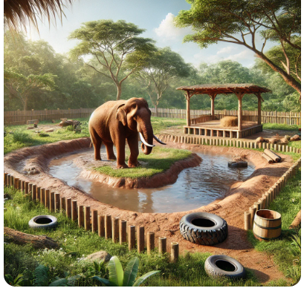
Image source: AI-generated using ChatGPT.

Worksheet: Example enclosures (continued)
Image 2: Domestic rabbit pen
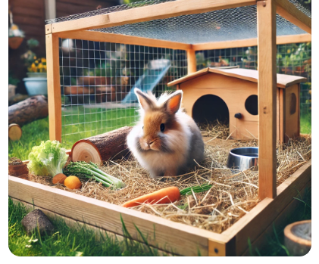
Image source: AI-generated using ChatGPT.

Worksheet: Example enclosures (continued)
Image 3: Rehabilitation enclosure for mallard ducks
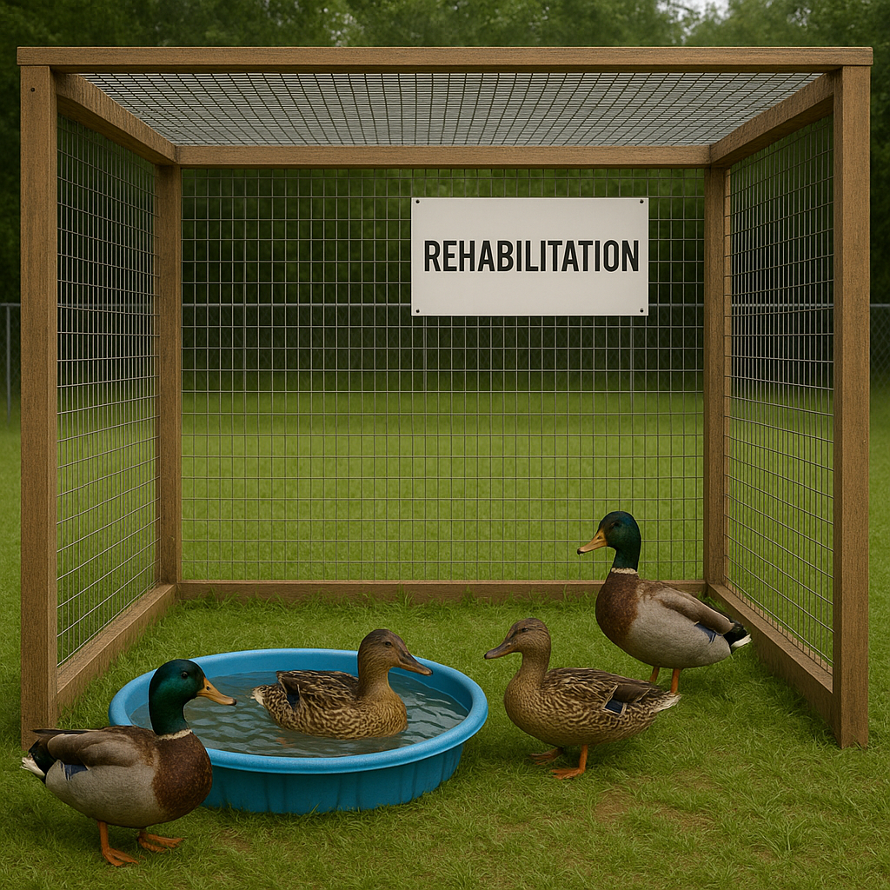
Image source: AI-generated using ChatGPT.

Case studies: Enclosure design
Habitat layout for lions

Total area:
- Minimum 10 acres (40,000m²) to allow for natural behaviours like stalking, running and resting.
Zones:
  - Open grasslands: ~60% of the area, planted with native grasses like Bermuda grass and Rhodes grass.
  - Rocky outcrops: ~15% of the area, with elevated rocks for basking, lookout points and resting.
  - Wooded areas: ~20% of the area, shaded with acacia and baobab trees for resting and cooling.
  - Water features: ~5% of the area, including a large pond or stream for drinking and cooling off.
Perimeter:
A secure, reinforced fence with a double-layered system (10–12 feet high) and a
4-foot overhang to prevent escapes.

Key features:
Natural terrain
- Grassy areas for open exploration.
- Dirt pathways and soft soil areas for walking and marking territory.
- Sandpits for grooming and rolling.
Rocky outcrops
- Artificial kopjes with varying heights (3–8 feet).
- Constructed using durable, weather-resistant materials.
- Incorporates shaded nooks and crannies for privacy.
Water features
- A natural-looking pond (~30 x 50 feet) with gradual slopes for safe entry/exit.
- A small waterfall or fountain for aeration and visual interest.
- Shallow sections (1–2 feet deep) and deeper zones (4–6 feet deep) for drinking and cooling off.
Vegetation
- Native grasses and shrubs, ensuring minimal toxicity.
- Dense clusters of trees (~20–30 trees per acre).
- Bushy vegetation near fence lines to encourage territorial behaviours.
Shelters
- Underground dens or shaded shelters made from durable materials.
- Temperature-controlled zones for extreme weather conditions.
Enrichment features
- Hanging logs, ropes and large tyres for climbing.
- Rotating carcass feeders to simulate hunting.
- Buried scents and scattered food to encourage foraging.

Dimensions:
Overall habitat:
  - Length: ~660 feet (200m).
  - Width: ~660 feet (200m).
Water feature: ~30 x 50 feet (900 square feet).
Rocky outcrops: 5–6 areas, each ~300-400 square feet.
Shelters: ~200 square feet per den (4–6 dens).
Walking paths (staff use): 5-foot-wide gravel paths.

Operational features:
Observation points:
  - Elevated, hidden platforms for staff and visitors.
  - Minimal disruption to the lions.
Access gates:
  - Double-door entry points for safety.
  - Large enough for vehicles to enter during emergencies or maintenance.
Drainage system:
  - Designed to prevent flooding near water features and shelters.
Solar panels:
  - Power for pumps, temperature control and night lights.
Waste management:
  - Compost pits for organic waste and water filtration systems for the pond.

Case studies: Enclosure design
Habitat layout and dimensions for an arboreal enclosure for parrots

Dimensions:
Height: 8–10 feet (minimum) to allow flight and climbing opportunities.
Width: 6–12 feet, depending on the number and size of parrots.
Depth: 6–10 feet to provide sufficient space for movement and enrichment items.
These dimensions work well for medium-sized parrots like African greys, Amazons and macaws. Adjustments can be made for smaller species like budgerigars or larger ones like hyacinth macaws.

Layout description:
Zones:
  - Perching zone: Located at varying heights to encourage climbing and flying.
  - Feeding zone: Ground-level or mid-level, away from perching areas to avoid contamination.
  - Play zone: Includes hanging toys, swings and ropes.
  - Privacy zone: Enclosed corners or covered perches for rest and retreat.
Access points:
  - A secure, lockable door for human access.
  - Smaller, bird-sized doors for easy entry to specific sections.
Lighting:
  - Natural light with UVB exposure.
  - Artificial lighting that mimics sunlight if outdoors is not feasible.

Materials
Frame: Galvanised steel or powder-coated metal to prevent rust and chewing.
Mesh: Stainless steel mesh with ½-inch spacing for smaller parrots and 1-inch spacing for larger parrots.
Flooring:
- Permeable materials like sand, gravel or natural turf for outdoor enclosures.
- Easy-to-clean surfaces for indoor set-ups (e.g. non-slip tiles or linoleum).
Perches:
- Natural wood branches (safe species include manzanita, java wood or apple).
- Rope perches for variety.
- Toys: Non-toxic, durable materials like untreated wood, leather or acrylic.

Vegetation
Incorporate live, non-toxic plants such as:
  - spider plants
  - bamboo
  - areca palms
  - parrot-safe herbs (basil, parsley)
Avoid toxic plants like oleander, philodendron or avocado.

Ventilation and safety
Ventilation: Ensure good airflow but protect from strong draughts or
extreme weather.

Safety features:
- Secure latches to prevent escape.
- Rounded edges and no sharp objects.
- Avoiding toxic paints, metals or treated wood.

Enrichment
- Climbing structures: Ropes, ladders and natural vines.
- Foraging opportunities: Puzzle feeders, hidden food compartments.
- Water features: Small fountains or misting systems for play and hydration.
- Nest boxes: For breeding pairs or rest areas.

Location
Outdoor enclosures:
- Choose a sheltered location to provide shade and protect from rain.
- Install predator-proof barriers if in a wildlife-prone area.
Indoor enclosures:
Place in a well-lit, ventilated area away from loud noises and kitchen fumes.

Case studies: Enclosure design
Semi-aquatic tank design for otters

Tank dimensions:
Overall dimensions: Minimum 25 feet x 15 feet x 8 feet (length x width x height). This provides adequate space for swimming, playing and land activities.
Water section: At least 15 feet x 10 feet x 5 feet deep, ensuring space for diving
and swimming.
Land section: At least 10 feet x 10 feet, including varied terrain for resting, nesting and playing.

Layout:
Aquatic zone (water section):
- Depth variation: Include a slope from 1-foot-deep shallow area to 5-foot-deep area for wading and diving.
- Water features: Incorporate waterfalls, currents or fountains for enrichment and oxygenation.
- Substrate: Use smooth, non-toxic materials like river rocks and sand.
Avoid sharp edges.
Terrestrial zone (land section):
- Dry nesting areas: Provide a den or hideout made from natural materials
for privacy.
- Varied terrain: Include sand, soil and grassy patches.
- Climbing structures: Add logs, rocks or platforms for climbing and exploration.
- Drainage system: Ensure proper drainage to avoid waterlogging.
Transition zone:
- Ramp or platform: Non-slip ramps for easy movement between water and land.
- Beach-like slope: Gradual incline from water to land.

Enrichment features:
- Toys: Floating balls, tunnels and ropes.
- Vegetation: Native aquatic and terrestrial plants for shade, hiding spots and natural aesthetics.
- Food delivery systems: Floating feeding platforms or hidden food puzzles.

Materials:
- Viewing panels: Durable, scratch-resistant tempered glass for viewing areas.
- Tank walls: Reinforced concrete or fibreglass for water containment.
- Fencing: Overhead netting or glass panels to prevent escape.
- Waterproof coating: Non-toxic sealants for water features.

Filtration and maintenance:
- Water filtration: High-capacity biological and mechanical filtration system to manage waste.
- UV sterilisers: To reduce harmful bacteria and algae.
- Drainage system: Easy water change and cleaning access.
- Access points: Secure, human-friendly hatches for regular cleaning and feeding.

Lighting and temperature:
- Lighting: Natural sunlight is best. Use UVB lighting to simulate daylight.
- Temperature control:
  - Water temperature: Maintain between 68°F to 75°F.
  - Land temperature: Provide basking spots with heat lamps if necessary.

Safety and accessibility:
- Animal safety: Avoid small gaps, sharp edges or toxic materials.
- Caregiver accessibility: Include secure walkways and removable panels for access.
- Emergency protocols: Design escape-proof areas and secure perimeters.

Sample dimensions and layout:
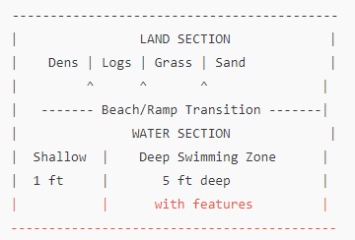

Animal enclosure evaluation sheet
Evaluator name: _______________________
Date: ______________
Location: ____________________________

Animal welfare
Space
  - Adequate size for the species?
☐ Excellent ☐ Good ☐ Fair ☐ Poor
  - Sufficient space for movement, resting and exercise?
☐ Excellent ☐ Good ☐ Fair ☐ Poor
Enrichment
  - Availability of enrichment items (e.g. toys, climbing structures)?
☐ Excellent ☐ Good ☐ Fair ☐ Poor
  - Rotated or updated regularly?
☐ Yes ☐ No
Natural behaviours
  - Does the enclosure allow for species-specific behaviours (e.g., climbing,
digging, flying)?
☐ Excellent ☐ Good ☐ Fair ☐ Poor
  - Provides opportunities for social interactions (if applicable)?
☐ Yes ☐ No
Comments:

Practicality
Cleaning
  - Ease of access for regular cleaning?
☐ Excellent ☐ Good ☐ Fair ☐ Poor
  - Appropriate drainage and waste management?
☐ Excellent ☐ Good ☐ Fair ☐ Poor
Feeding
  - Accessible and safe feeding areas?
☐ Excellent ☐ Good ☐ Fair ☐ Poor
  - Prevents food contamination?
☐ Yes ☐ No
Safety for keepers and animals
  - Secure barriers to prevent escapes?
☐ Excellent ☐ Good ☐ Fair ☐ Poor
  - Minimised keeper–animal direct interactions (when appropriate)?
☐ Yes ☐ No
Comments:

Sustainability
Materials
  - Use of sustainable or recycled materials?
☐ Yes ☐ No
  - Long-lasting and durable?
☐ Yes ☐ No
Energy efficiency
  - Use of energy-efficient lighting or systems?
☐ Excellent ☐ Good ☐ Fair ☐ Poor
Water use
  - Efficient water use for cleaning and animal needs?
☐ Excellent ☐ Good ☐ Fair ☐ Poor
  - Recycling or rainwater collection systems?
☐ Yes ☐ No
Comments:

Visitor experience
Visibility
  - Clear viewing areas for visitors?
☐ Excellent ☐ Good ☐ Fair ☐ Poor
Educational value
  - Are there signs or information about the animals and conservation?
☐ Yes ☐ No
Accessibility
  - Is the enclosure easily accessible for all visitors (e.g., pathways, ramps)?
☐ Yes ☐ No
CommentsOverall rating
☐ Excellent ☐ Good. ☐ Fair ☐ Poor
Additional comments

The following materials relate to lesson 2: Factors affecting design
Case study 1: Designing accommodation for a leopard gecko
Case study 2: Designing a kennel for two dogs
Case study 3: Designing a stable for a horse
Case study 4: Designing a rabbit enclosure

Case study 1: Designing accommodation for a leopard gecko

Scenario:
You are a reptile enthusiast planning to adopt a leopard gecko. Your task is to design and set up a suitable vivarium to ensure the gecko’s health, comfort and wellbeing.
Use the following guidelines to plan the enclosure and address potential challenges.

Key information:
Leopard geckos are small, terrestrial reptiles native to arid regions of Asia. They are nocturnal and thrive in warm, dry environments. A healthy leopard gecko requires a properly maintained habitat to replicate its natural environment.

Requirements for the vivarium:
- Size:
    - A minimum of 20 gallons for one gecko (larger if housing more than one).
    - Consider extra space for enrichment and accessories.
- Temperature and heating:
    - A thermal gradient is crucial: 88–92°F (31–33°C) on the warm side and 75–80°F (24–27°C) on the cool side.
    - Use a heat mat under one side of the vivarium or a ceramic heat emitter. Avoid heat lamps that can overheat or harm the gecko.
- Lighting:
    - Leopard geckos are nocturnal and do not require UVB lighting, but it can enhance their health.
    - Provide a light cycle of 12 hours of light and 12 hours of darkness.
- Substrate:
Choose safe substrates such as reptile carpet, paper towels or slate tiles.
Avoid loose substrates like sand, which can cause impaction if ingested.
- Hides:
Provide at least three hides:
- a warm hide on the hot side
- a cool hide on the cooler side
- a humid hide to assist with shedding.
- Diet:
Feed a variety of live insects, such as crickets, mealworms and dubia roaches, dusted with calcium and vitamin D3 supplements.

- Water and humidity:
- Provide fresh water in a shallow dish.
- Maintain humidity levels at around 30–40%.

Challenges:
- Maintaining temperature:
How will you ensure a stable thermal gradient? What equipment will you use to monitor temperature?
- Ensuring safety:
How will you avoid risks like impaction or injuries caused by unsafe decor?
- Behaviour monitoring:
How will you recognise signs of stress, illness or discomfort in your gecko?
- Long-term maintenance:
What is your plan for cleaning, monitoring and updating the vivarium as the gecko grows?

Case study 2: Designing a kennel for two dogs

Scenario:
You are tasked with designing and constructing a kennel for two medium-sized dogs (e.g. Labrador Retrievers). The kennel must provide shelter, safety and comfort for the dogs while also being practical and easy to maintain for their owners.
Consider the following requirements and constraints:

Key requirements:
- Space:
Each dog requires its own space to relax comfortably. The kennel should offer:
- enough space for each dog to lie down, stretch and turn around
- a shared area for play and interaction.
- Materials:
The kennel must be constructed from durable, weather-resistant materials that
are easy to clean. Suitable options include treated wood, metal frames and waterproof covers.
- Ventilation and insulation:
- The kennel should have proper airflow to prevent overheating in summer.
- Insulation is required to keep the dogs warm in colder months.
- Safety features:
- The enclosure should be secure to prevent the dogs from escaping.
- No sharp edges or hazardous materials that could harm the dogs.
- Accessibility:
- Owners need easy access for feeding, cleaning and interacting with the dogs.
- Consider a gate or door with a secure locking mechanism.

Scenario details:
- Location:
The kennel will be placed outdoors in a backyard that experiences moderate weather conditions all year round. Occasional rain and mild winters are typical in the area.
- Behavioural considerations:
- One of the dogs is very energetic and needs space to move.
- The other dog is more reserved and enjoys having a quiet space.

Case study 3: Designing a stable for a horse

Scenario:
You are a stable manager tasked with designing a new stable for a horse named Shadow, a five-year-old thoroughbred gelding. Shadow is primarily used for show jumping and requires a comfortable, safe and functional living space.

Key considerations:
- Size of the stable:
Horses need ample space to move around comfortably. The recommended size for Shadow’s stable is at least 12 feet by 12 feet – the standard for most horses. Larger sizes, like 12 feet by 14 feet, might be preferred for thoroughbreds.
- Flooring:
Shadow’s stable should have safe, non-slip flooring. Options include:
- rubber mats for cushioning and ease of cleaning
- a drainage system to keep the stall dry.
- Bedding:
Bedding ensures comfort and absorbs moisture. Options include:
- straw (traditional but may require more upkeep)
- wood shavings (good for absorbency and cleanliness).
- Ventilation:
Proper airflow is critical to maintain Shadow’s respiratory health. The stable should have windows or vents to allow fresh air and avoid draughts to keep Shadow warm in colder weather.
- Lighting:
Good lighting is essential for Shadow’s safety and comfort.
- Use natural light wherever possible, with windows.
- Install safe, well-placed overhead lights for night-time care.
- Feeding and watering facilities:
Shadow’s stable must include:
- a hay rack or hay net at an appropriate height
- an automatic waterer or clean bucket system to ensure fresh water is
always available.
- Security and safety:
- Ensure the stable door is at least 4 feet wide, solid and secure.
- Avoid any sharp edges or protrusions inside the stall.
- Access to turnout area:
Horses need regular exercise. The stable design should allow easy access to a paddock or turnout area where Shadow can move freely.

Case study 4: Designing a rabbit enclosure

Scenario:
You are tasked with designing an outdoor enclosure for a group of pet rabbits. The owner wants a safe, comfortable and stimulating environment for their rabbits to live in. The enclosure will be placed in a backyard, and the rabbits will have access to the enclosure for most of the day.
Your goal is to create an ideal habitat for the rabbits while considering their physical, emotional and social needs.
Key considerations:
    - Enclosure size and space requirements: What is the minimum size of
the enclosure?
Rabbits need enough space to hop, stretch and exercise. Consider the number of rabbits, their size and how much space they should have.
    - Safety and security: How will you ensure the rabbits are safe from predators?
Rabbits are prey animals, so it is important to keep them safe from potential predators such as foxes or neighbourhood dogs. The enclosure should have secure fencing, a solid floor to prevent digging and no gaps large enough for the rabbits to squeeze through.
    - Shelter and comfort: What kind of shelter should be provided?
Rabbits need a sheltered area to protect them from the elements, such as rain, wind and extreme temperatures. The shelter should be large enough for the rabbits to move around but not so large that it leaves them feeling insecure.
    - Environmental enrichment: How will you provide mental and physical stimulation for the rabbits?
Rabbits are intelligent and curious animals, and they need plenty of enrichment to keep them active and mentally engaged. This can include toys, tunnels and space for them to dig, hop and explore.
    - Maintenance and cleanliness: How will the enclosure be cleaned and maintained?
An outdoor enclosure should be easy to clean to ensure the rabbits stay healthy. You must consider how to manage waste, remove soiled bedding and clean surfaces.

The following materials relate to lesson 3: Legislation related to enclosure design

There are no materials for this lesson. All information for learners is on the
slide deck.

The following materials relate to lesson 4: Practice design (formative assessment)
Enclosure design planning worksheet
Animal enclosure design quick quiz
Answer sheet guide

Enclosure design planning worksheet
Learner name: _______________________
Group members: ______________________
Animal assigned: _____________________

Section 1: Basic enclosure details
- Species: _______________
- Enclosure size (approximate): _______________
- Indoor, outdoor or both? _______________

Section 2: Key zones
- Sleeping area: describe size, bedding, shelter type.
- Feeding area: consider location, hygiene considerations.
- Exercise and enrichment zones: provide opportunities for climbing, digging, swimming, etc.
- Visitor viewing area: consider safe distance, signage.

Section 3: Safety and welfare
- Fencing/barrier type: _______________
- Drainage and temperature control: _______________
- Escape prevention features: _______________

Section 4: Sustainability considerations
- Eco-friendly materials, energy-efficient lighting/heating.

Animal enclosure design quick quiz
(10 questions; mix of multiple-choice and short-answer)

Multiple-choice questions (1 mark each)
- Which of the following is NOT one of the Five Freedoms?
a) Freedom from discomfort
b) Freedom to roam anywhere
c) Freedom from hunger and thirst
d) Freedom from fear and distress

- Why is enrichment important in an enclosure?
a) It makes the enclosure look nice.
b) It prevents the animal from getting bored or stressed.
c) It helps the zookeeper feed the animal easily.
d) It reduces the need for medical care.

- What is the primary purpose of a safety barrier in an enclosure?
a) To prevent animals from escaping.
b) To make the enclosure look professional.
c) To provide shade for the animals.
d) To help with feeding routines.

- Which of these is a key consideration when designing an enclosure for a burrowing animal?
a) High climbing structures
b) Deep substrate for digging
c) Bright artificial lighting
d) Minimal hiding spaces

- Sustainable enclosure design includes:
a) using energy-efficient heating and lighting.
b) providing unlimited food to animals.
c) keeping the enclosure as small as possible.
d) avoiding any interaction with the animals.

Short-answer questions (2 marks each)
- Name two safety features you would include in an enclosure for a large predator.

- Describe one example of how an enclosure can support an animal’s natural behaviour.

- Why is drainage important in enclosure design?

- If designing an enclosure for a bird species, what are two important features you should include?

- Give one example of how an enclosure design can consider public safety.

Scoring guide:
Total marks: 15
- 5 multiple-choice questions (1 mark each)
- 5 short-answer questions (2 marks each)

Answer sheet guide
Animal enclosure design quick quiz: answer key
Multiple-choice qestions (1 mark each)
- b) Freedom to roam anywhere. (This is not one of the Five Freedoms.)
- b) It prevents the animal from getting bored or stressed. (Enrichment encourages natural behaviours and mental stimulation.)
- a) To prevent animals from escaping. (Safety barriers protect both the animals and the public.)
- b) Deep substrate for digging. (Burrowing animals need loose, deep material to exhibit natural digging behaviours.)
- a) Using energy-efficient heating and lighting. (Sustainable design reduces environmental impact and operating costs.)

Short-answer questions (2 marks each)
- Two safety features for a large predator enclosure:
  - Strong, escape-proof fencing or glass barriers.
  - Double-door entry system (airlock) to prevent accidental escapes.
- Example of supporting natural behaviour:
Providing climbing structures for primates to encourage foraging, climbing and social interaction.
- Importance of drainage:
Proper drainage prevents waterlogging, keeps bedding dry and reduces the risk of bacteria build-up.
- Two important bird enclosure features:
  - Perches at varying heights for roosting and exercise.
  - Netting or aviary walls to prevent escape while allowing flight.
- Example of public safety consideration:
Viewing platforms or barriers set at a safe distance from the enclosure.

Scoring guide:
Total marks: 15
- Multiple-choice questions: 1 mark each (5 marks total)
- Short-answer questions: 2 marks each (10 marks total)

The following materials relate to lesson 5: Methods of review (evaluation practice)
Rubric evaluation sheet

Rubric evaluation sheet

Category | Excellent  (5) | Good  (4) | Satisfactory (3) | Needs improvement (2) | Incomplete (1)
Layout and design | Clear zones, logical flow | Mostly clear zones | Basic zones, minor gaps | Zones unclear | No layout provided
Animal welfare | All five welfare needs met | Most welfare needs met | Some welfare needs met | Few welfare aspects | Not addressed
Enrichment features | Creative, species- specific | Basic features present | Few enrichment elements | Minimal enrichment | None included
Safety considerations | Comprehensive and practical | Adequate safety | Basic safety measures | Safety gaps present | No safety addressed
Presentation and justifications | Clear, confident and practical | Mostly clear, with some gaps | Basic explanation | Poorly explained | Not present

Total: / 25

The following materials relate to lesson 6: Enrichment design
Enrichment examples
Images of animals engaging with enrichment

Enrichment examples
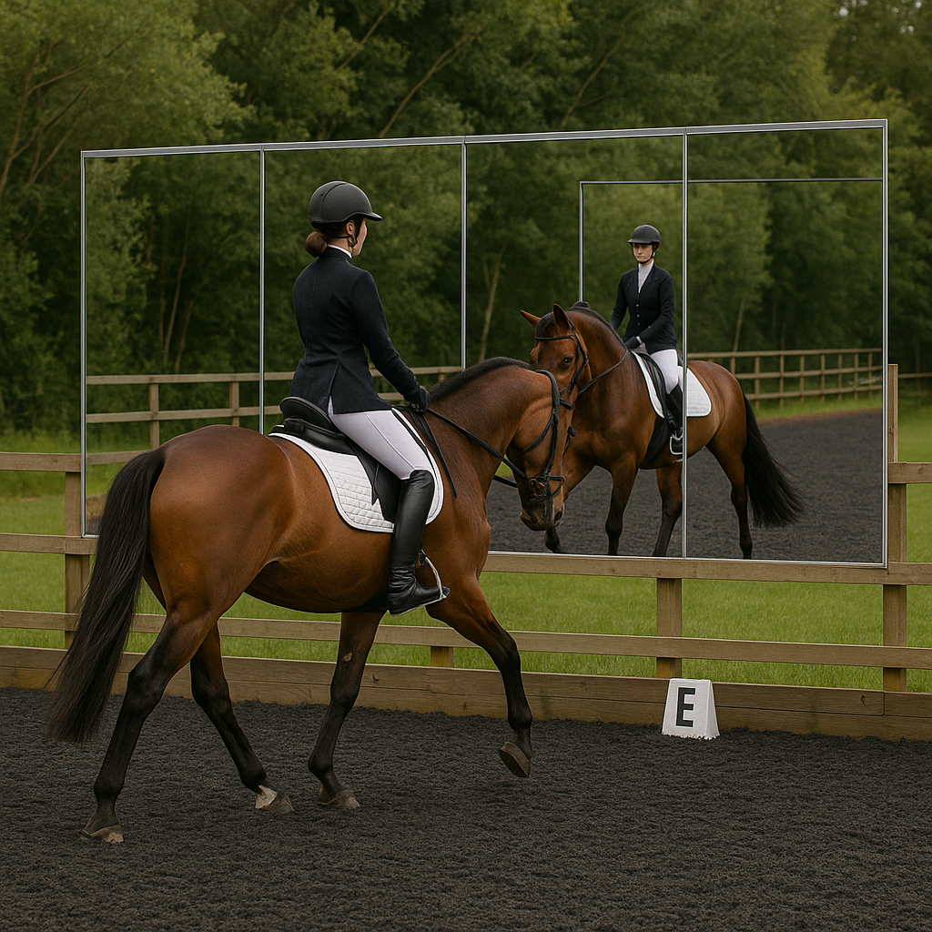
Image source: AI-generated using ChatGPT.

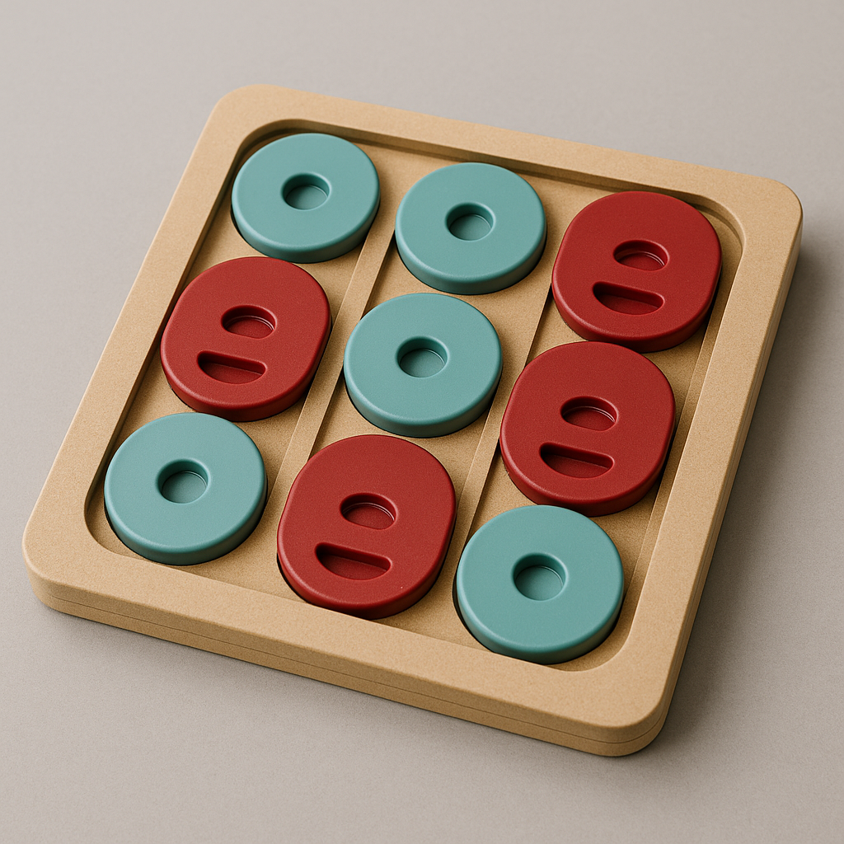
Image source: AI-generated using ChatGPT.

Images of animals engaging with enrichment

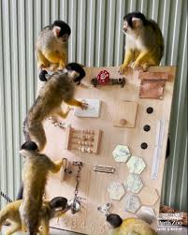
Image source: AI-generated using ChatGPT.

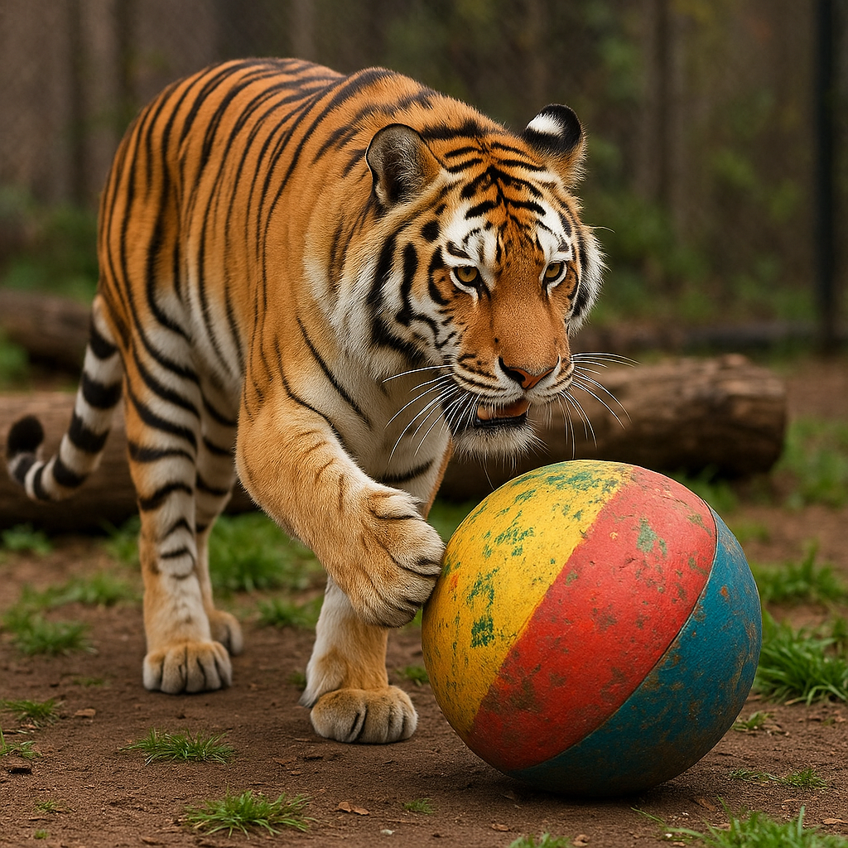
Image source: AI-generated using ChatGPT.

The following materials relate to lesson 7: Health and safety considerations

Case study scenario
Hierarchy of controls
Regulation sheet
Risk assessment worksheet
Zoonotic diseases fact sheet
Risk assessment scenarios
Health and safety regulations summary sheet

Case study scenario

Background:
You are a health and safety officer at a large livestock farm that raises cattle and poultry. The farm uses deep litter bedding in the barns to absorb animal waste, and this bedding decomposes over time, producing ammonia gas as a byproduct. Ammonia gas can be harmful to both animals and farm workers, causing respiratory issues and eye irritation when exposure levels become too high. The farm has ammonia detectors, but they are not regularly checked, and the ventilation system in some barns is inadequate.

Scenario:
One morning, a worker named Jack enters the poultry barn to begin his routine duties, including feeding the birds and cleaning the area. The barn has not been ventilated properly for several days, as the exhaust fan system has been malfunctioning for a few weeks. The litter in the barn is also deeper than usual, as the regular cleaning schedule has been delayed owing to staff shortages.
As Jack works, he begins to notice a strong ammonia smell in the air. Initially, he assumes it is just the normal odour in the barn. However, after a few minutes, he starts to feel a burning sensation in his eyes and throat and feels increasingly lightheaded and dizzy. Jack decides to leave the barn, and once outside, he feels relief from his symptoms.
He informs his supervisor, Emily, about the situation, and she immediately checks the ammonia levels using the barn’s ammonia detectors. The readings show ammonia concentrations well above the safe threshold for both workers and animals.
Meanwhile, in the cattle barn, another worker, Sarah, is feeding the cattle. The barn has similar ventilation issues, and the ammonia levels have also reached dangerous levels. However, Sarah has not reported any symptoms because the ammonia concentration has not yet caused her immediate discomfort, and she is unaware of the risk.

Hierarchy of controls

Elimination: physically remove the hazard (most effective)

Substitution: replace the hazard

Engineering control: isolate people from the hazard

Admin control: change the way people work

PPE: protect the worker with personal protective equipment (least effective)

Regulation sheet

1. Elimination (most effective)
Action: Remove the source of ammonia build-up by improving the farm’s waste management practices. This includes increasing the frequency of cleaning the barns to reduce the amount of manure and bedding that decomposes and produces ammonia.
Outcome: By reducing the build-up of manure and bedding, ammonia levels can be kept under control, eliminating the hazard at its source.

2. Substitution (less effective)
Action: Switch to a different type of bedding material that produces lower levels of ammonia when decomposed, such as sand or hemp bedding, which has been shown to reduce ammonia emissions.
Outcome: Substituting materials with lower ammonia production helps reduce the hazard, though it does not completely eliminate the need for ventilation and monitoring.

3. Engineering controls
Action: Repair and maintain the barn’s ventilation system to ensure proper airflow and reduce the concentration of ammonia in the air. This could include installing additional exhaust fans, improving airflow design and adding ventilation that draws fresh air from outside.
Outcome: Improved ventilation reduces ammonia levels in the barns, effectively controlling the exposure risk and protecting both workers and animals from harmful concentrations.
Action: Install ammonia gas detectors and alarms that are regularly calibrated and checked to ensure they function properly.
Outcome: These devices will alert workers if ammonia levels exceed the safe limit, enabling them to take action quickly to avoid harmful exposure.

4. Administrative controls
Action: Establish and enforce a maintenance schedule for the barn’s ventilation system to ensure it is working efficiently at all times. This should include regular checks of the ammonia detectors, ventilation systems and barn conditions.
Outcome: Administrative controls help ensure that systems are regularly checked and maintained, reducing the likelihood of system malfunctions that could lead to unsafe ammonia levels.
Action: Train workers to recognise the signs and symptoms of ammonia exposure (e.g. eye irritation, coughing, dizziness) and emphasise the importance of reporting unsafe conditions immediately. Create a clear procedure for evacuating the barn if ammonia levels become dangerous.
Outcome: Training workers to identify ammonia exposure symptoms ensures they can take immediate action to protect their health and alert supervisors to potential hazards.

5. Personal protective equipment (PPE) (least effective)
Action: Provide workers with PPE, such as respirators or masks that protect against ammonia inhalation, as well as protective eyewear to prevent eye irritation.
Outcome: While PPE will help protect workers from exposure in the short term, it does not address the root cause of the problem – ammonia build-up – and is therefore the least effective method.

Health and safety regulations summary sheet
Key laws and regulations

Health and Safety at Work Act 1974
- Employers must ensure the health, safety and welfare of employees and others.
- Employees must take care of their own and others’ safety.
Control of Substances Hazardous to Health (COSHH) Regulations 2002
- Employers must assess and control exposure to hazardous substances.
- Proper storage, handling and disposal procedures must be in place.
Animal Welfare Act 2006
- Ensures the welfare of animals under human care.
- Requires provision of suitable living conditions, diet and veterinary care.
Employer responsibilities
- Conduct risk assessments.
- Provide training and PPE (personal protective equipment).
- Maintain a safe working environment.
- Ensure emergency procedures are in place.
Employee responsibilities
- Follow health and safety guidelines.
- Use PPE correctly.
- Report hazards and accidents.
- Ensure their own safety and that of others.

Risk assessment worksheet

Activity | Hazard | Who is at risk? | Risk level (low/  medium/ high) | Control measures | Review date
Example: cleaning a stable | Slipping on wet floor | Worker  Animals | Medium | Use warning signs, wear non-slip boots | Monthly
Working in a veterinary clinic | Exposure to animal bites | Staff  Clients | High | Use protective gloves  Proper handling techniques | Biannual

Risk assessment scenarios
- Cleaning a stable: risks include slipping, exposure to animal waste, lifting injuries.
- Working in a veterinary clinic: risks include exposure to zoonotic diseases, animal bites, handling sharps.
- Handling chemicals (e.g. disinfectants): risks include inhalation, skin irritation, accidental spills.

Definition:
Zoonotic diseases are infections that can be transmitted between animals and humans. They can be caused by bacteria, viruses, fungi or parasites.
Examples:
- Rabies: a viral disease affecting the nervous system, usually transmitted through bites.
- Ringworm: a fungal infection that spreads through direct contact with infected animals or surfaces.
- Leptospirosis: a bacterial infection transmitted through contaminated water, urine, or soil.
Routes of transmission:
- Direct contact: handling infected animals or bodily fluids.
- Indirect contact: touching contaminated surfaces (e.g. bedding, food bowls).
- Vector-borne: transmission through bites from infected fleas, ticks or mosquitoes.
- Airborne: breathing in droplets from sneezing or coughing animals.
- Foodborne: consuming contaminated animal products.
Prevention strategies:
- Wear appropriate PPE (gloves, masks, protective clothing).
- Wash hands thoroughly after handling animals.
- Regularly disinfect work areas and equipment.
- Vaccinate animals against common zoonotic diseases.
- Implement biosecurity measures to prevent disease spread.

The following materials relate to lesson 8: Stakeholders 1
Zoo stakeholder environmental data worksheet

Zoo stakeholder environmental data worksheet
Group name:

Your assigned stakeholder:
🔍 ____________________________________________________

TASK 1: What data does your stakeholder need?
Fill in the table below based on your stakeholder’s perspective.
Type of environmental data | Why do they need it? | How often? (daily, weekly, etc.) | How is it used?
e.g. temperature | Ensure reptile enclosure stays within safe range. | Daily | Adjust heating system if needed.

TASK 2: Prioritisation
From the data types above, list the top three that are most important for your stakeholder and explain why.

✔ Why? ____________________________________________________

✔ Why? ____________________________________________________

✔ Why? ____________________________________________________

TASK 3: Communication example
Write a short example of something your stakeholder might say to another person in the zoo about environmental data (e.g. a vet speaking to a zookeeper or an inspector asking for a report).

The following materials relate to lesson 9: Stakeholders 2
Zoo stakeholder role-play scenarios

Zoo stakeholder role-play scenarios cards
1. Vet and zookeeper  The vet asks the zookeeper for the temperature logs of the reptile house for the past three days.  Discuss what the readings are and if there have been any issues. | 2. Licensing officer and zoo manager  The licensing officer is conducting an inspection. They want to know how often humidity and lighting levels are checked in the tropical bird enclosure.  The manager explains the process and shows a sample data record.
3. Animal keeper and colleague  One keeper is going off shift and updates the next keeper about noise levels being too high near the primate enclosure today.  Discuss what actions were taken and if enrichment was adjusted. | 4. Visitor and information staff  A curious visitor asks how the zoo ensures the penguin habitat stays cool during summer.  The staff member explains the use of environmental monitoring and cooling systems.
5. Zookeeper and manager  A zookeeper reports that the air quality monitor in the nocturnal house keeps flashing a warning.  The manager asks for data logs and plans a response. | 6. Vet and licensing officer  A vet is explaining to a licensing officer how data from recent health checks correlates with poor humidity levels in a snake enclosure.  They discuss improving environmental monitoring.

7. Education officer and keeper  An education officer is preparing a tour and wants accurate recent data on temperature and feeding times for the meerkats to share with students.  The keeper provides the details and explains the routine. | 8. Maintenance worker and keeper  The keeper notices the heating system in the amphibian enclosure is fluctuating.  They explain the temperature logs to the maintenance worker, who diagnoses the issue.
9. Zookeeper and owner  The zookeeper is requesting a new enrichment log system to help track environmental stimulation for the lions.  The owner asks why this data is important and how it will help animal welfare. | 10. Inspector and keeper  The inspector wants to see records of how often the enclosure water features are cleaned and checked for quality.  The keeper shows the logs and explains the process.

The following materials relate to lesson 10: Produce an accommodation design (formative assessment)

Case study 1: Mammal enclosure design – lion exhibit within a zoo
Case study 2: Bird enclosure design – grey crowned crane
Case study 3: Reptile enclosure design – bearded dragon
Case study 4: Fish enclosure design – sustainable aquaculture
Case study 5: Invertebrate enclosure design – tarantulas
Worksheet: Peer assessment form for evaluation

Case study 1: Mammal enclosure design – lion exhibit within a zoo

Design objectives:
- Animal welfare: provide a stimulating and comfortable environment that mimics the lions’ natural savanna habitat.
- Visitor experience: offer unobstructed views while maintaining safety.
- Educational opportunities: incorporate features that inform visitors about lion behaviour and conservation.
- Sustainability: use eco-friendly materials and systems for long-term maintenance.

Case study 2: Bird enclosure design – grey crowned crane

- Objective: create a habitat that mimics the natural environment of tropical birds while enabling immersive visitor experiences.
- Design philosophy: blend aesthetics with functionality, ensuring birds’ wellbeing, ecological education and a seamless visitor experience.

Case study 3: Reptile enclosure design - bearded dragon

Design objective: create a functional, safe and aesthetically pleasing enclosure for a bearded dragon that supports its health and mimics its natural habitat.
Species-specific needs:
- Native to arid, semi-desert regions of Australia, requiring a warm, dry environment.
- Requires UVB lighting for calcium metabolism and a heat gradient for thermoregulation.
- Diet consists of insects and leafy greens, necessitating an easily cleanable environment.

Case study 4: Fish enclosure design - sustainable aquaculture

Design objective: design and implement a fish enclosure that optimises water quality, fish health and production efficiency while minimising environmental impact.
- Sustainability: reduce ecological footprint through eco-friendly materials and practices.
- Efficiency: enhance fish growth rates and overall yield using advanced technologies.
- Cost-effectiveness: minimise construction and maintenance costs.
- Durability: ensure longevity in saline and freshwater conditions.

Case study 5: Invertebrate enclosure design - tarantula

Design objective: design an enclosure for the Chilean Rose tarantula, a terrestrial species native to arid and semi-arid regions of South America.
- Replicate natural habitat: ensure the tarantula feels secure and stress-free.
- Maintain health: provide an environment that supports the tarantula’s physical wellbeing.
- Ease of maintenance: ensure the enclosure is easy to clean and manage.
- Visibility: allow the owner to observe the tarantula without disturbing it.

Worksheet: Peer assessment form for evaluation

Peer assessment form
Evaluator’s name: ______________________
Date: ______________________
Peer’s name (work being assessed): ______________________

Assessment criteria
- Content accuracy (5 points)
  - Guiding question: Is the information accurate and supported by evidence?
  - Comments:

  - Score (0–5): ______

- Clarity of presentation (5 points)
  - Guiding question: Is the explanation clear and easy to understand?
  - Comments:

  - Score (0–5): ______

- Practical relevance (5 points)
  - Guiding question: Does the work demonstrate understanding of practical applications in animal care?
  - Comments:

  - Score (0–5): ______
- Creativity and innovation (5 points)
  - Guiding question: Are there unique or creative elements in the work?
  - Comments:

  - Score (0–5): ______

Overall comments
Please provide any additional feedback or suggestions for improvement:

Final total score (out of 20): ______

Evaluator’s signature: ______________________


FUNDED BY
PRODUCED BY

This programme is funded by the Department for Education
the Department for Education
Reaseheath College has produced this resource on behalf of the Education and Training Foundation

