
SUPPORTING THE DEVELOPMENT OF CONTEXTUALISED CORE SKILLS – COMMUNICATION
ET-FOUNDATION.CO.UK
T LEVEL IN DESIGN, SURVEYING AND PLANNING FOR CONSTRUCTION

INTRODUCTION
Effective communication is an essential life skill and is also needed by learners to be successful in their T Level studies.
In each T Level, there are embedded communication requirements, based on the General English Competencies. Learners studying the T Level in Design, surveying and planning for construction are expected to demonstrate a range of communication skills. This resource focuses on one of the key competencies, EC1 Convey technical information to different audiences.
Communication also features as a Core Skill in the T Level in Design, surveying and planning for construction specification. Core Skill 1 (CS1): Communication. Core Skills are assessed through the employer-set project (ESP) assessment.
Communication involves reading, writing, listening and speaking – i.e. oral and written communication skills. This resource has been developed to support providers in planning and delivering structured opportunities for learners to develop their presentation and oral communication skills. The aim is to enhance learners’ readiness for the ESP as well as to prepare them for successful engagement in their Industry Placement and future progression into employment or further training.
Although designed with the T Level in Design, surveying and planning for construction in mind, the principles and framework of this resource are broadly transferable across other T Level routes in which communication plays a central role, such as:
- Media, broadcast and production
- Digital production, design and development
- Design and development for engineering and manufacturing
- Maintenance, installation and repair for engineering and manufacturing
- Health, healthcare science
- Accounting, finance
- Legal services
- Education and early years
- Management and administration
Where applied outside of construction, contextual adaptation of lesson tasks and scenarios will be necessary to ensure relevance and sector-specific focus.
This resource has three sections:
Framework for learning
The resource includes a Framework for Learning (FfL). This covers 20 hours of learning. There is a diagram to show how the content of those hours has been sequenced and scaffolded. There is also a narrative that explains the sequencing and scaffolding in more detail.

Lesson plans
There is a lesson plan for each stage in the sequencing and scaffolding of learning in the FfL. Lesson plans include details of the support materials that are required to support delivery, including those found in this resource.
Support materials
The support materials identified in the lesson plans are also available towards the end of this document.
NOTE:
There is a separate slide deck that can be used with the lessons. At the end of the slide deck, there are some learner slides linked to lesson 10.

SECTION 1: FRAMEWORK FOR LEARNING
The Framework for Learning (FfL) sets out one approach to scaffolding and sequencing the development of communication skills. It will specifically focus on the development of oral communication skills. This resource concentrates on the contextualisation of Core Skill 1 (CS1), Communication and focuses on the development of oral communication.
The context for this resource links to Design, surveying and planning for construction. However, the learning can be adapted to any area in the Construction and the built environment route as it develops transferable skills.
The learning involves a series of building blocks. Learners will be exposed to a range of different contexts involving different stakeholders to develop their communication skills. This will bring together learning across a range of areas of the specification.
Sequencing and scaffolding
This resource has been designed around a wall of learning which includes 10 blocks of learning, or 10 lessons. Phases one to three represent the building process from foundation to refinement, developing the knowledge and skills required to deliver effective oral presentations. Each phase must be complete before laying the next course. The top of the wall is the fourth phase, quality assurance, which is represented by the capping. This phase allows learners to put in to practice the knowledge and skills developed through phases one to three.
The intention is for the lessons to be delivered in sequence from lesson 1 through to lesson 10.
This TRIP resource is recommended to be delivered in phases as follows:
Phase one: foundation
This phase includes three lessons:
- Thinking like a stakeholder
- Accuracy of information
- Supporting delivery.
This phase introduces different audiences so that learners can start ‘Thinking like a stakeholder’. It will develop oral communication skills used to deliver effective presentations and the skills to empathise and adapt communication to different stakeholders. This phase considers accuracy of information and its authenticity so that learners can select, verify and use accurate information when communicating. This phase introduces different visual aids so that learners can effectively present to the design, surveying and planning sectors of construction. This phase develops the use of communication for different purposes and audiences through a range of situations.
This phase is the starting foundation for the development of oral communication skills.

Phase two: production
This phase includes two lessons:
- Methods of review
- Delivering a solution.
This phase builds on the foundation knowledge and further develops communication skills started in phase one. It applies learning to different design, surveying and planning for construction situations and develops learners’ use of a range of information for different audiences, validating the authenticity. This phase develops the ability to communicate effectively with different stakeholders. This phase includes reflecting on the content of information used to develop targeted communication. At the end of this phase, learners should show more confidence in their communication skills.
Phase three: refinement
This phase includes three lessons:
- Removing distractions
- The audience journey
- Planning a presentation.
This phase builds on phases one and two. It develops understanding of the relevance of information communicated and the importance of removing distractions. The phase develops the skill to communicate in a sequential and appropriate order to capture audiences. This phase includes ways in which communication can be supported and or enhanced. At the end of this phase, learners’ communication skills should be clear, logical and concise.
Phase four: quality assurance
This phase includes two lessons:
- Record and produce
- The stakeholder panel.
The final stage links to the quality checks that would be used in Design, surveying and planning for construction to evaluate and assure that a process is of a sufficient standard. This phase replicates this concept. The phase applies all learning from phases one to three. It includes evaluative practice to quality assure the communication skills which learners will apply in a stakeholder meeting scenario. The context is based on the feasibility of a new development linked to design, surveying and planning. The overall outcome of learning from this resource is to be able to effectively present solutions to different audiences, which is demonstrated in the final lesson.
The following diagram shows how the development of communication skills will be sequenced and scaffolded through this FfL.

Developing effective oral communication skills
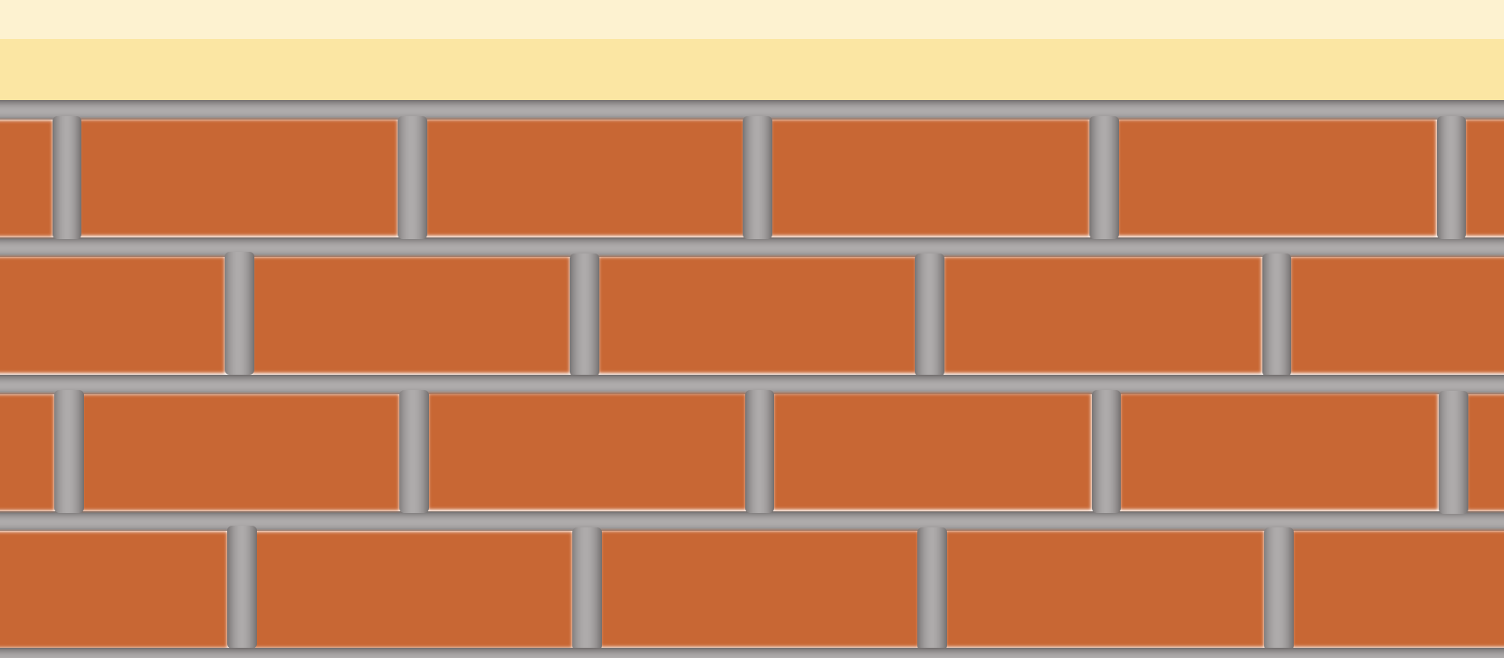
Record and produce
The stakeholder panel
Removing distractions
The audience journey
Planning a presentation
Methods of review
Delivering a solution
Thinking like a stakeholder
Accuracy of information
Supporting delivery
Phase one
Phase two
Phase three
Phase four

The damp-proof course (black line) represents the boundary between the prior learning and the content of this resource. All required prior learning needs to be taught in advance of Phase one.

SECTION 2: LESSON PLANS
This section includes 10 lesson plans. The lesson plans follow the Framework for Learning. The lesson plans include the:
- lesson title
- targeted specification content coverage
- lesson number in the sequence
- total amount of time required to deliver the lesson
- teacher and learner activities to be undertaken throughout the lesson
- resources needed to deliver the lesson (see Note below)
- details of how the lesson supports the development of English, maths and/or digital skills (where appropriate)
- details of how the lesson can be adapted to meet learners with specific needs
- next steps in learning, such as homework activities and links to the next lesson.
Note:
There is an assumption that the learning environment will include the following:
- whiteboard/smartboard or similar
- materials to take notes – e.g. pens, paper, audio recorder, digital device and software
- equipment to present a slide deck and video – e.g. projector, smartboard
- digital devices (e.g. laptop, tablet) for all learners
- internet access
- learner access to word-processing, spreadsheet and presentation software.

Lesson 1
Title: Thinking like a stakeholder
Targeted content reference: CS1 Synthesise information from given case studies, construction projects or site visits.
Lesson sequence number: 1
Timing: 2 hours
Prior learning:
How to write an email.
Timing | Teacher activity | Learner activity | Support materials
15 minutes | Introduction: provide an overview of the 20 hours of learning and the focus of the lesson. | Listen and take notes. Ask clarification questions as required. | Presentation slides  Use of a digital collaborative wall  Teacher instructions: stakeholder card sort  Stakeholder case studies  Stakeholder case study summaries  Teacher script: positive and negative language  Leisure centre case study  Email response
15 minutes | Set starter task requirements. Ask class: Who is a stakeholder for a construction project? Ask learners to individually write answers on a digital collaborative wall. | Listen, take notes and write stakeholders on a digital collaborative wall.
15 minutes | Summarise key stakeholders from the list on the collaborative wall. | Listen and take notes. Ask clarification questions as required.
30 minutes | Set task requirements for stakeholder card sort as detailed in Teacher instructions: stakeholder card sort. Allocate learners into small groups. Advise learners that the task relates to the development of a bypass of a small village. Distribute stakeholder sort cards. | Listen and take notes. Ask clarification questions as required.
30 minutes | Circulate asking probing questions, correcting misconceptions. | Move into allocated group. Use the stakeholder sort cards to match types of stakeholders to their vested interest in construction projects.
30 minutes | Facilitate class discussion. Summarise correct answers to stakeholder card sort. | Contribute to class discussion and reflect on correct answers to those that the group completed.
30 minutes | Set task requirements. Allocate learners into new small groups. Distribute Stakeholder case studies. Allocate each group a different case study. | Listen and take notes. Ask clarification questions as required.
30 minutes | Circulate asking probing questions, correcting misconceptions. | Move into allocated group. Review the allocated case study information. Identify key stakeholders for the construction project and their vested interest in the project.
30 minutes | Facilitate feedback from each group. Ask a group at a time to introduce their case study and identify the stakeholders. Ask probing questions to check understanding. | Feed back details of case study and results of group work to the rest of the class, as directed by the teacher.
30 minutes | Distribute the Stakeholder case study summaries. Summarise key points from the case study task, referring to the handouts. Ask learners to annotate the handout with notes. | Ask clarification questions. Annotate the four Stakeholder case study summaries.
30 minutes | Use Teacher script: positive and negative language. Read information in the script to learners. | Listen for examples of positive and negative examples used.
30 minutes | Present slides about conveying confidence, avoiding negative tone, terminology and how to be persuasive. Focus on oral presentation. Following the presentation, re-read the script, emphasising the words in bold. | Listen and take notes. Ask clarification questions as required.
30 minutes | Set requirements of the task. Advise learners that the communication can be from a positive or negative viewpoint depending upon the development. Learners should be advised that they should be confident in either approach. | Listen and take notes. Ask clarification questions as required.
30 minutes | Circulate asking probing questions, correcting misconceptions. | Individually, write a review about a nearby construction development.
30 minutes | Allocate pairs. Advise learners to swap written reviews. | Swap their written review with allocated partner.
30 minutes | Circulate asking probing questions, correcting misconceptions. | Highlight the positive or negative terms in the review. Return the review to the partner. Discuss the terminology used by each.
30 minutes | Present slides on prior to and when delivering a presentation and covering presentation considerations. Highlight the importance of empathy and the inclusion and effect of language (non-technical, technical), tone, style, etc. Discuss technical vs non-technical. Ask probing questions throughout. | Listen and take notes. Answer questions as directed.
30 minutes | Set requirements of the task. Distribute Leisure centre case study. Split the class in two. Allocate stakeholder 1 to half of the class and stakeholder 2 to the rest of the class.  Stakeholder 1: Gym competitor, constructive tone.  Stakeholder 2: Main contractor, assertive tone. | Listen and take notes. Ask clarification questions as required.
30 minutes | Circulate asking probing questions, correcting misconceptions. | Individually, read and review the Leisure centre case study. Produce a short statement presenting details of the leisure centre positively for allocated stakeholder.
30 minutes | Allocate a stakeholder 1 with a stakeholder 2. Set requirements of the task. | Listen and take notes. Ask clarification questions as required. Move to allocated pair.
30 minutes | Circulate asking probing questions, correcting misconceptions. Take notes. | Read out the statement to partner.  Give partner oral feedback on how positive the statement is, key positive terms observed and any improvements that could be made.
30 minutes | Summarise key points from observation while circulating. | Listen and take notes. Ask clarification questions as required.
15 minutes | Set requirements of task. Distribute Email response. | Listen and take notes. Ask clarification questions as required.
15 minutes | Circulate asking probing questions, correcting misconceptions. | Individually, read and review Email response information. Respond to the email using appropriate language, style and tone to meet the stakeholder needs.
15 minutes | Collect completed statements. Review in preparation for lesson 2. | Hand in to the teacher on completion.
15 minutes | Set next steps. | Listen and take notes. Ask clarification questions as required.
Other:
English: Writing a review about a nearby construction development and responding to the email is developing learners’ skills in conveying confidence, using a positive tone and persuasive language skills in writing. Reading the statement to a partner is orally developing these skills. The lesson develops positive oral communication skills.
Adaptation:
SEND: For task relating to case studies, SEND learners could be provided with the stakeholders without their vested interest to provide a scaffold. For the leisure centre task, pairs could work together to read and review the case study or a reader could be provided.
Extension: Learners could complete more than one case study.
Next steps in learning
Teacher: Assess the email and provide feedback to learners on the use of appropriate language, style and tone to meet the stakeholder needs.
Learner homework: Find a television programme relating to construction. Watch the programme and summarise the use of positive tone used in the programme. Compare this to notes taken in class.

Lesson 2
Title: Accuracy of information
Targeted content reference: CS1 Synthesise information from given case studies, construction projects or site visits.
Lesson sequence number: 2
Timing: 2 hours
Prior learning:
Lesson 1 and know how to email an attachment.
Timing | Teacher activity | Learner activity | Support materials
15 minutes | Introduce the lesson focus. Split class into three groups. Set the starter task.  Allocate each group a different topic detailed on the slide. Set requirements of the task: discussion on the implications of false advertisement, the effects on the stakeholder and the repercussions for the company. | Listen and take notes. Ask clarification questions as required. Move to allocated group. | Presentation slides  Accuracy handout  Recording device  Recall adverts
15 minutes | Circulate asking probing questions, correcting misconceptions. | Participate in allocated group discussion about the provided topic. Note key points discussed.
15 minutes | Facilitate class feedback. Ask for one key point from each group. | Feed back key points discussed to the rest of the class. Make notes of key points from other groups.
30 minutes | Present the first two truths one lie slide and go through this with the class. Provide information to guide where it exaggerates (use of the word all). Explain misinformation. Also point out that damp-proof course is often referred to as DPC. | Listen and take notes. Ask clarification questions as required.
30 minutes | Allocate pairs. Ask learners to discuss the Two truths one lie: energy slide. | Listen and take notes. Ask clarification questions as required.
30 minutes | Circulate asking probing questions, correcting misconceptions. | Discuss statements and identify which statement is a lie.
30 minutes | Ask learners which statement is a lie. Facilitate class discussion on reasons for choice and show correct answer. Also point out that Energy Performance Certificate is often referred to as EPC. | Indicate which statement is a lie when asked. Explain reasons for choice.
30 minutes | Present the Two truths one lie: tree slides. Ask learners to identify the lie. | Discuss statements and identify which statement is a lie.
30 minutes | Ask learners which statement is a lie. Facilitate class discussion on reasons for choice. Also point out that tree preservation order is often referred to as TPO. | Indicate which statement is a lie when asked. Explain reasons for choice.
30 minutes | Summarise task, reinforcing the use of words that exaggerate and misinform. Provide examples. | Listen and take notes. Ask clarification questions as required.
45 minutes | Present slides on misinformation. | Listen and take notes. Ask clarification questions as required.
45 minutes | Present the requirements of the task. Distribute the Accuracy handout. | Listen and take notes. Ask clarification questions as required.
45 minutes | Circulate class and provide clarification where necessary. | Individually, read the information presented in the provided Accuracy handout. Identify misinformation or exaggerations and rewrite the statement so that the information is accurate.  Plan to present a recording of an accurate statement.
45 minutes | Provide learners with guidance on the equipment to be used for audio capture. Provide instruction on how to record an oral presentation on a digital device. | Listen and take notes. Ask clarification questions as required.
45 minutes | Circulate class and provide support with audio recordings as required. | Record on a digital device the updated information, listen back and self-evaluate presentation skills used.
45 minutes | Present: What could cause misinformation? Ask probing questions. Summarise using examples of the misinformation and exaggerations in the Accuracy handout, e.g. rust forming immediately is an exaggeration. Ask learners to share what they found most challenging about the task. Explain what would happen if the learner had sent the email as a professional. | Listen, take notes and contribute to feedback as directed.
20 minutes | Explain the requirements of the recall advertisement task. Allocate pairs. Distribute Recall adverts. Give one handout which includes two adverts per pair. | Listen and take notes. Ask clarification questions as required.
20 minutes | Circulate class and provide support with audio recordings as required. | Review Recall adverts. Discuss which is the corrected version of the two adverts and reasons for choice. Discuss the reasons why the advert was recalled.
20 minutes | Facilitate feedback as class discussion.  Summarise key points on whiteboard or flipchart. | Contribute to class discussion about which is the correct version of the advert and the reasons why the advert was recalled.
10 minutes | Set next steps. Allocate pairs. Ask learners to email a partner a copy of the voice recording completed in the lesson. | Listen and take notes. Ask clarification questions as required.
10 minutes | Circulate class and provide support with emailing attachments. | Email recording to partner.
Other:
English: The two truths and one lie task supports the development of misconceptions used in language. Learners develop the use of correct terminology to be used through the recording of an advert.
Digital: How to produce a voice recording on digital device.
Adaptation:
SEND: For the accuracy task, learners could work with another learner who could support with reading the Accuracy handout. SEND learners could use artificial intelligence (AI) to help assess the accuracy of the handout. They could be given key statements from the handout and use AI to find out if the statement is accurate.
Extension: Select two pieces of misinformation or exaggerations in the Accuracy handout statement. Explain why the selected misinformation or exaggerations would affect the Bridge over troubled water LTD.
Next steps in learning:
Teacher: Assess the peer feedback email and provide feedback prior to the next lesson.
Learner homework: Review partner voice recording. Assess the accuracy of the information. Provide feedback to partner in an email prior to lesson 3 and copy in the teacher.

Lesson 3
Title: Supporting delivery
Targeted content reference: CS1 Present ideas and concepts for design proposals as part of a group to stakeholders.
Lesson sequence number: 3
Timing: 2 hours
Prior learning:
Learners need a basic understanding what computer-aided design, critical path analysis, Gantt charts and graphical conventions are.
Timing | Teacher activity | Learner activity | Support materials
15 minutes | Introduce the lesson focus. Split class into four groups. Explain the requirements of the task. Give each group a different topic (see handout Lesson 3: topics) and ask learners to consider the benefits of using the medium for their construction situation. | Listen and take notes. Ask clarification questions as required. | Presentation slides  Lesson 3: topics  Retaining wall  Brick and block cavity wall  Streetlight installation critical path  Streetlight infographic
15 minutes | Circulate asking probing questions, correcting misconceptions. | Discuss the topic and provide reasons why it is appropriate for the situation. Take notes during discussion.
15 minutes | Facilitate class feedback, taking examples from each group. Ask class questions throughout to check understanding. | Feed back example reasons why it is appropriate for the situation. Contribute to class discussion. Take notes relating to other topics.
30 minutes | Present overview of using visual aids to support presentations and examples. Note: the lesson will focus support using visual aids when presenting information.  Distribute Retaining wall image to half of the class and Brick and block cavity wall image to the other half. Set the requirements of the first part of the task. Advise learners to use the internet to research where their allocated wall is used and the terms provided alongside the image. This will be used to deliver the information effectively in the second part of the task. | Listen and take notes. Ask clarification questions as required.
30 minutes | Circulate asking probing questions, correcting misconceptions. | Research allocated wall and key terms. Prepare presentation.
30 minutes | Allocate pairs. Explain the requirement of the second part of the task, learners will need to present their assigned wall to a partner who will then present their assigned wall. | Listen and take notes. Ask clarification questions as required.
30 minutes | Circulate asking probing questions, correcting misconceptions. | Using the image, present the information to partner.  Review partner presentation, taking notes.
30 minutes | Advise learners to provide feedback to partner. | Listen and take notes. Ask clarification questions as required.
30 minutes | Circulate asking probing questions, correcting misconceptions. | Provide partner with feedback on how well the image was used to present information.
30 minutes | Present: What to consider when using visual aids? Ask learners to share what they did. | Listen and take notes. Ask clarification questions as required. Share examples demonstrated in the task as directed by teacher.
30 minutes | Distribute Streetlight installation critical path. Explain what the image includes and the stages. Set the context; explain it is street lighting that has been agreed and is at the implementation stage. Explain that there is a stakeholder meeting planned to convey the impact of the lighting on the local area. It will be held at the town hall.  Ask learners what stakeholders the critical path image is suitable for. | Listen and take notes. Ask clarification questions as required.  Look at the Streetlight installation critical path. Identify stakeholders.
30 minutes | Present: Streetlight infographic. Advise learners that the image is to be used at the stakeholder meeting and that residents will be present. Explain why the image is not appropriate for certain stakeholders. | Listen and take notes. Ask questions as directed.
30 minutes | Explain the requirements of the task. | Listen and take notes. Ask questions as directed.
30 minutes | Circulate asking probing questions, correcting misconceptions. | Individually, create a draft version of the infographic using annotations.
30 minutes | Allocate pairs. Explain the requirements of the task. Advise learners to select one of the three stakeholders in attendance at the meeting. Learner to tell partner their choice of stakeholder. Distribute Streetlight infographic. Partner to use Streetlight infographic to present the information targeted to the stakeholder. | Listen and take notes. Ask questions as directed.
30 minutes | Circulate asking probing questions, correcting misconceptions. | Select stakeholder and advise partner of choice. Present to partner using Streetlight infographic.
30 minutes | Ask learners to feed back on how well their partner targeted the presentation to the selected stakeholder. | Listen and take notes. Ask clarification questions as required.
30 minutes | Circulate asking probing questions, correcting misconceptions. | Feed back to partner, providing improvements as required.
30 minutes | Present information about targeting information, simplicity and finding the level. Ask probing questions throughout. | Listen and take notes. Respond to questions as directed by teacher.
30 minutes | Set the requirements of the project plan task. | Listen and take notes. Ask clarification questions as required.
30 minutes | Advise learners to remain in the same group. Explain the requirements of the task. | Individually, produce a draft flyer.
30 minutes | Mark before next lesson. | Hand in draft flyer to teacher.
15 minutes | Set plenary task to produce a flow chart. | Listen and take notes. Ask clarification questions as required.
15 minutes | Circulate asking probing questions, correcting misconceptions. | Individually, produce a flow chart that explains how to use a visual aid in a presentation.
15 minutes | Set next steps. Advise learners to bring the presentation recording to the next lesson. | Listen and take notes. Ask clarification questions as required.
Other:
English: The lesson develops using visual aids when communicating. Learners develop persuasive writing in the project plan task.
Adaptation:
SEND: Provide SEND learners with a speaker note template to use to produce speaker notes to deliver the streetlight task.
Extension: Refine the design of the infographic to improve the effect of the visual stimulus. Suggest improved layout for the Streetlight infographic.
Next steps in learning:
Teacher: Assess the draft flyer and provide feedback prior to the next lesson.
Learner homework: Produce a visual aid which could be used to present information about the structure of a truss for a roof style of the learner’s choice. Prepare a short presentation which includes the use of the visual aid. Using a digital device, record the presentation.

Lesson 4
Title: Methods of review
Targeted content reference: CS1 Participate in group and class discussions to examine concepts and approaches to produce solutions to construction problems.
Lesson sequence number: 4
Timing: 2 hours
Prior learning:
Lessons 1 to 3 and Excel formulas.
Timing | Teacher activity | Learner activity | Support materials
20 minutes | Introduce the lesson focus and present overview of feedback.  Explain the requirements of the task.  Allocate pairs for the starter task. Distribute Pond design. Advise learners that this is in a local park area at the boundary to an existing woodland. The pond is near a road which has localised flooding because of a dip in the road. Present the requirements of the task. | Listen and take notes. Ask clarification questions as required. | Presentation slides  Pond design  Use of a digital collaborative wall  Drainage work handout  Pricing sheet  Sticky notes
20 minutes | Circulate asking probing questions, correcting misconceptions. | Move to allocated pair, review the Pond design and discuss the aesthetics of the design with partner.
20 minutes | Facilitate feedback from the task. On a flipchart/whiteboard, sort the feedback into two columns.  Column 1: feed back where the learner has clearly provided actions, e.g. the local trees could drain the water supply, so consider the location.  Column 2: feedback that does not provide sufficient information, e.g. ‘yes’.  Ask questions throughout to check understanding.  Identify why the feedback would and would not be actionable, and provide guidance on how it can be adapted to become actionable. | Contribute to class discussion. Provide feedback and answer questions as directed by teacher. Take notes.
30 minutes | Ask learners to list on a collaborative wall what types of feedback they have undertaken and received. | Listen and take notes. Ask clarification questions as required.
30 minutes | Host collaborative wall. | List examples of feedback on collaborative wall.
30 minutes | Summarise key examples shared. Ask learners which feedback they preferred and reasons for choice. | Answer questions as directed.
30 minutes | Present: Types of feedback. Provide examples of the lessons where they have received each type of feedback and why it was appropriate to that situation.  Present: Methods of feedback in construction. Provide examples of different methods used in construction. | Listen and take notes. Answer questions as directed by teacher.
30 minutes | Present: Formative review. Ask questions to clarify understanding. | Listen and take notes. Answer questions as directed by teacher.
30 minutes | Explain the requirements of the formative feedback task. | Listen and take notes. Ask clarification questions as required.
30 minutes | Circulate asking probing questions, correcting misconceptions. | Write formative feedback on the local pond design to ensure that the design is safe for its purpose and how it can be integrated into drainage.
30 minutes | Facilitate class feedback. Ask each learner to share one formative feedback suggestion. | Share feedback as directed by teacher.
30 minutes | Present: Constructive feedback. Explain the key points and provide an example. Ask probing questions to check understanding. | Listen and take notes. Ask clarification questions as required. Answer questions as directed by teacher.
30 minutes | Present: Peer feedback. | Listen and take notes. Ask clarification questions as required.
30 minutes | Explain the requirements of the task. Distribute Drainage work handout. | Listen and take notes. Ask clarification questions as required.
30 minutes | Circulate asking probing questions, correcting misconceptions. | Individually, read the Drainage work handout, then complete the drainage map for the piece of land provided (task part 1).
30 minutes | Allocate pairs. Distribute sticky notes. Advise learners to complete parts 2 and 3. | Move next to assigned partner.
30 minutes | Circulate asking probing questions, correcting misconceptions and check sticky notes for accuracy. | Peer review drainage map, and provide notes for oral feedback on sticky notes.  Provide oral constructive feedback to partner.
30 minutes | Explain the requirements of the task. Distribute Pricing sheet. Advise learners to make use of trade sites to identify costs per unit for the required materials. Assign pairs for peer review. Advise learners that the peer review will take place at regular intervals during the completion of the pricing task. Go through an example of how to work out a sum total. | Listen and take notes. Ask clarification questions as required.
30 minutes | Circulate asking probing questions, correcting misconceptions. | Move into pairs in preparation for the review.  Complete Pricing sheet.  Peer review partner’s Pricing sheet task every 5 minutes, providing oral feedback to partner.  Action the feedback received before continuing.
30 minutes | Explain that a review of the completed Pricing sheet is important. Facilitate a class discussion as to the limitations and drawbacks of the Pricing sheet for the size of the development listed. | Listen, take notes on the limitations and drawbacks, identify and contribute the potential oversights of the pricing sheet in relation to the project.
30 minutes | Present information on self-review. Explain the key points and example. Ask probing questions to check understanding. | Listen and take notes. Ask clarification questions as required. Answer questions as directed by teacher.
10 minutes | Set plenary task, produce three notes of improvements that could be made to the method used for identifying materials required for each room of the development. Ask learners to add them to the collaborative wall. | Listen and take notes. Ask clarification questions as required.
10 minutes | Host collaborative wall. Circulate to assist with the creation of three points as required. | Produce three bullet pointed notes for improvements that could be used for the pricing task completed. Add to collaborative wall.
10 minutes | Summarise notes added on the collaborative wall. | Listen and take notes. Ask clarification questions as required.
10 minutes | Set next steps. Advise learners to consider wires, plugs and lighting. | Listen and take notes. Ask clarification questions as required.
Other:
English: How to present actionable feedback. How to provide written and oral constructive feedback.
Maths: Calculations of how to work out a sum total.
Adaptation:
SEND: Provide learners with pricing information for the pricing task to aid them in completing the work in the time frame provided.
Extension: Remove pricing information or provide variations to the sheet for learners to comment on the implication of this change. For the pond review task, learners can work on potential improvements as sketches.
Next steps in learning:
Learner homework: Produce a materials list to rewire your kitchen at home; collect feedback from the clients (family) as to what would be required and what would be desired in the space.

Lesson 5
Title: Delivering a solution
Targeted content reference: CS1 Present ideas and concepts for design proposals as part of a group to stakeholders.
Lesson sequence number: 5
Timing: 2 hours
Prior learning:
Lessons 1 to 4. Use of design software to produce posters.
Timing | Teacher activity | Learner activity | Support materials
15 minutes | Introduce lesson focus. Present: Overview: delivering a solution.  Explain starter task. Distribute Site office annotated, Site office dimensioned and Temporary office solution high-definition images. These are created for the site office for a development of 60 homes. Advise learners they are to independently identify information that would be required to deliver the design effectively. Guidance can be provided to facilitate the review. | Listen and take notes, ask clarification questions as required. | Presentation slides  Site office annotated  Site office dimensioned  Temporary office solution high-definition images  Site office requirements sheet  Road improvement task  Road improvement case study  Kitchen diner extension task  Checklist template
15 minutes | Circulate asking probing questions, correcting misconceptions. | Review the images of the site office for the development. Identify the information needed to deliver a successful pitch.
15 minutes | Facilitate a class discussion on the required information for the site office design. Summarise key points. | Contribute to class discussion on the required information for an effective presentation.
45 minutes | Distribute the Site office requirements sheet. Explain the requirements of the task. Advise learners that they should check whether the Site office requirements sheet provides all the information discussed in the starter task. | Listen and take notes, ask clarification questions as required.
45 minutes | Circulate asking probing questions, correcting misconceptions. | Review the Site office requirements sheet. Identify any gaps.
45 minutes | Facilitate feedback, asking if any information is missing. | Contribute to class discussion.
45 minutes | Summarise the task, explaining to learners that information for designs and projects is rarely truly exhaustive and conversations between clients and contractors are usually required to address this. | Listen and take notes, ask clarification questions as required.
45 minutes | Present slides on effective layout, detailed views and ordering information. | Listen and take notes, ask clarification questions as required.
45 minutes | Distribute Road improvement task and Road improvement case study. Explain the requirements of the task. Learners are to produce a presentation that details the benefits and impact of the provided solution given the Road improvement case study. Advise learners that this is an individual task.
45 minutes | Circulate asking probing questions, correcting misconceptions. | Individually, read Road improvement case study.  Produce a six-slide presentation that outlines the project’s scope and benefits to the residents of the improved road layout, referring to the provided case study.  Produce speaker notes to accompany slides.
45 minutes | Allocate pairs. Advise learners that they are to review partner’s presentation and speaker notes. | Listen and take notes, ask clarification questions as required.
45 minutes | Circulate asking probing questions, correcting misconceptions. | Review partner’s speaker notes and presentation slides. Note written constructive feedback.  Give partner feedback, answering any queries.
45 minutes | Deliver slides on presentation skills. Ask probing questions at the end of each slide about why this was important in an effective delivery. | Listen and take notes, ask clarification questions as required. Answer questions as directed by teacher.
45 minutes | Distribute Kitchen diner extension task. Explain the task requires learners to make use of the design descriptors and the images of the pre-extension kitchen diner and extended kitchen diner with the mood board to produce an effective slide deck presentation. Advise that it is an individual task. | Listen and take notes, ask clarification questions as required.
45 minutes | Circulate asking probing questions, correcting misconceptions. | Read Kitchen diner extension task. Produce presentation slides and associated speaker notes that can be used to effectively deliver the design to the homeowner.
45 minutes | Allocate pairs. Explain to learners that they are required to present the presentation to their partner. The learner is to use their own presentation slides and associated speaker notes. The partner is to review the presentation against the requirements in the Kitchen diner extension task. | Listen and take notes, ask clarification questions as required.
45 minutes | Circulate asking probing questions, correcting misconceptions. | Present to partner. Note feedback while partner presents.  Provide constructive feedback post presentation to partner.
10 minutes | Distribute Checklist template. Explain the requirements of the plenary task. Advise learners that they should populate the checklist with criteria that can be used to quality check that the presentation produced is ready for delivery. | Listen and make notes, ask clarification questions as required.
10 minutes | Circulate asking probing questions, correcting misconceptions. | Complete the Checklist template.
10 minutes | Set next steps. Advise learners that they will need to refer to the Site office annotated, Site office dimensioned and Temporary office solution high-definition images. | Listen and make notes, ask clarification questions as required.
Other:
English: Developing oral presentation communication skills.
Adaptation:
SEND: Presentation produced for the road improvement task can be reduced in slide number from six to five slides. Kitchen diner extension task presentation could include pairing that is selective to group similar outputs as required.
Extension: Further imagery can be produced to support the delivery of the Kitchen diner extension task.
Next steps in learning:
Learner homework: Using the images from the starter task, produce a poster that outlines the suitability of the design. Suggest improvements to the design in terms of the office fit-out.

Lesson 6
Title: Removing distractions
Targeted content reference: CS1 Present ideas and concepts for design proposals as part of a group to stakeholders. Core Content Area 4.1: Learners must understand construction methods used in residential, commercial and industrial construction contexts and be able to discriminate between methods and select appropriately.
Lesson sequence number: 6
Timing: 2 hours
Prior learning:
Lessons 1–5. Use of presentation software; an understanding of construction material properties and life cycle analysis.
Timing | Teacher activity | Learner activity | Support materials
15 minutes | Introduce the lesson focus and set requirements of starter task. Allocate pairs. | Listen and take notes, ask clarification questions as required. | Presentation slides  Use of a digital collaborative wall  Balcony task  Simplify to clarify
15 minutes | Circulate asking probing questions, correcting misconceptions. | Discuss with partner what would draw attention away from the presentation.
15 minutes | Facilitate class discussion using collaborative board. | Listen to instructions and write answers on the collaborative wall.
- minutes | Present: Reasons to remove distractions; Equipment noise; Environmental noise; and Room chat and side conversations. Ask probing questions and facilitate discussions per slide to identify possible causes of noise and methods to address these. | Listen and take notes, ask clarification questions as required. Contribute to class discussion as directed by teacher.
- minutes | Present: Noise discussion. Ask the class to consider what would they do if the noise was to appear part way through a live presentation. Gather in responses and summarise once complete. | Contribute to class discussion.
- minutes | Choose some of the responses to the class discussion and provide possible solutions to the response. E.g. if learners provided the response ‘people talking during a presentation online’, you could provide the option of setting up different controls for the audience to the presenter and having restricted access, such as disabled microphone use. The presenter can then unmute participants after a hand-raise has been used to indicate they would like to talk. | Listen and take notes, ask clarification questions as required.
30 minutes | Present: Stick to a layout. Show the portal frame construction. Explain that the images should only be used if they have a purpose. Explain the purpose of the images for this slide is to illustrate a comparison of a concrete and steel frame. Advise that this could be used if showing customers different designs when delivering a pitch. Advise learners that this is an example of a slide that is presented as right justified.  Present: Benefits of steel portal frame. Explain the benefits of both frames. Advise that the image in the background is an example of a distractor and should always be avoided as it does not have a purpose for the slide. | Listen and take notes, ask clarification questions as required.
30 minutes | Facilitate group discussion. Ask learners whether the information was easy to follow between the portal frame construction slide and benefits of steel portal frame slide. Show slides again. | Participate in group discussion.
30 minutes | Present: Overcrowded slides and provide the example using steel vs concrete. Ask learners what is essential and what could be removed from the example. | Listen and take notes, ask clarification questions as required.  Suggest what is essential and what could be removed.
30 minutes | Present: Cost-effectiveness. Discuss the content. Ask learners whether the information all needed to be on one slide. | Listen and take notes, ask clarification questions as required. Answer questions as directed by teacher.
30 minutes | Present: Durability. Advise that the slide is an example where information is summarised and a presenter would elaborate on each point. | Listen and take notes, ask clarification questions as required.
30 minutes | Present: Strength. Explain that the example provides a comparison. Highlight the font is too small (font 20) and that there is too much information.  Present: Image selection. Explain the best use of images, when they should be used and the quality. | Listen and take notes, ask clarification questions as required.
30 minutes | Show the design versatility slide. Explain that this is a poor example. Ask why it is a poor example. | Identify why the slide is poor quality.
30 minutes | Present: Clear and accurate placement of information; Managing your own noise; Simplifying complex ideas; and Preparing for the unexpected. Ask probing questions throughout. | Listen and take notes, ask clarification questions as required. Answer questions as directed by teacher.
30 minutes | Allocate small groups. Advise learners to discuss the slides. | Listen and take notes, ask clarification questions as required.
30 minutes | Distribute Balcony task. Explain the requirements of the task. The task focuses on the design for a new outdoor seating area for a thriving restaurant overlooking a lake. Advise learners that the information was all planned for display on an A2 board for a client presentation. Learners are to, individually, simplify the content and group the information, applying learning about what a good slide should look like. Demonstrate how to set slide size to A2 to produce a poster. | Listen and take notes, ask clarification questions as required.
30 minutes | Circulate asking probing questions, correcting misconceptions as required. | Produce an A2 poster, using the image of the balcony and the provided information, to present to the end client, the restaurant owner.
30 minutes | Advise learners to email the poster to the teacher. | Email completed A2 poster to teacher.
15 minutes | Deliver final thoughts slide and set plenary task. Distribute Simplify to clarify and highlighter pens. | Listen and take notes, ask clarification questions as required.
15 minutes | Circulate asking probing questions, correcting misconceptions as required. | Individually read the Simplify to clarify document.  Highlight the key information required for a client. List five slide titles.
15 minutes | Set next steps. Explain that learners are to use Simplify to clarify to complete the task. Advise learners to email presentation slides to teacher. | Listen and take notes, ask clarification questions as required.
Other:
English: How to communicate effectively when presenting slides.
Digital: How to set slide size to A2 to produce a poster on PowerPoint. How to produce an effective presentation.
Adaptation:
SEND: Provide SEND learners with three less paragraphs for the Balcony task to reduce workload. For the Simplify to clarify task, learners can make use of artificial intelligence or a thesaurus to simplify the content.
Extension: Learners can produce a floorplan of the balcony area for the Balcony task to further develop their poster.
Next steps in learning:
Teacher: Assess completed A2 poster and homework slides, and provide feedback.
Learner homework: Produce presentation slides which highlight the benefits of replacing halogen lighting with LED lighting.

Lesson 7
Title: The audience journey
Targeted content reference: CS1 Participate in group and class discussions to examine concepts and approaches to produce solutions to construction problems.
Lesson sequence number: 7
Timing: 2 hours
Prior learning:
Lessons 1–6. Use of design software to produce a storyboard template. Drafting techniques.
Timing | Teacher activity | Learner activity | Support materials
10 minutes | Explain starter task. Allocate small groups. Advise learners to reflect on the question and then discuss in allocated small group. | Listen and take notes, ask clarification questions as required. | Presentation slides  Use of a digital collaborative wall  Example playground  Sticky notes  Flash cards  Footbridge planning task
10 minutes | Circulate and ask probing questions, correcting misconceptions as required. | Personally reflect on the question.  Discuss with peers and identify the common foundations of the presentations.
10 minutes | Advise learners to submit feedback on a collaborative wall titled: What makes a targeted presentation? (This will need setting up prior to the lesson.) | Listen to instructions and write points discussed on the collaborative wall.
10 minutes | Introduce the lesson focus by delivering: What is the audience journey? | Listen and take notes, ask clarification questions as required.
40 minutes | Present: Why empathy matters; and considering the secondary audience. | Listen and take notes, ask clarification questions as required.
40 minutes | Explain the requirements of: Task: playground design. Remind learners that they should consider why empathy matters. Advise learners that the design is for presentation to the local community planning officer, but other stakeholders may need considering. Advise it is an individual task. | Listen and take notes, ask clarification questions as required.
40 minutes | Circulate asking probing questions, correcting misconceptions as required. Prompt learners to expand on the secondary audience (children, parents, users of the recreational space). | Complete playground design task considering all audiences for the project.
40 minutes | Present: Four-stage journey; and Council presentation. | Listen and take notes, ask clarification questions as required.
40 minutes | Explain the requirements of Task: plan your audience journey. Advise learners to plan, in rough draft form, for the delivery of their design to the local council community planning officer. Advise learners to produce no more than three sentences per stage. Distribute Example playground, advise learners that this is to guide their design not replace it. Advise that this is an individual task. | Listen and take notes, ask clarification questions as required.
40 minutes | Circulate asking probing questions, correcting misconceptions as required. | Look at the Example playground. Produce three sentences for each stage of the four-stage journey on how to produce the presentation for the playground design knowing what the council cares about.
40 minutes | Allocate small groups. Advise learners to circulate and review the four-stage draft plans produced by their peers in their allocated groups. Distribute sticky notes and advise learners to provide constructive feedback using the sticky notes. | Listen and take notes, ask clarification questions as required.
40 minutes | Circulate asking probing questions, correcting misconceptions as required. | Review draft four-stage journey plans for those in allocated group. Provide feedback on a sticky note as applicable.  Review feedback and make notes as required.
40 minutes | Summarise the key points observed on the sticky notes as circulating. | Listen and take notes, ask clarification questions as required.
30 minutes | Present: Research for reach; and Methods to gather information. | Listen and take notes, ask clarification questions as required.
30 minutes | Distribute Footbridge planning task. Explain the requirements of the footbridge planning task. Allocate pairs. | Listen and take notes, ask clarification questions as required.
30 minutes | Circulate asking probing questions, correcting misconceptions as required. | Read Footbridge planning task.  In pairs, discuss the potential audience for a footbridge connecting a housing estate to a retail park over a bypass. Identify stakeholder interests, priorities and any potential conflicting viewpoints.  Produce a flash card with stakeholder and conflicting viewpoint on one side and a solution on the other.
30 minutes | Facilitate class feedback on the identified stakeholder for the project and their viewpoint. Ask learners to share flash card. | Feed back on flash card example. Make notes of other examples.
30 minutes | Present: Thinking emotion; Storyboarding is…; Presentation storyboard; and Benefits of a storyboard. | Listen and take notes, ask clarification questions as required.
30 minutes | Present: Bakery design brief. Explain the requirements of: Bakery design task. Advise learners that they should make use of a storyboard layout, such as the one covered earlier, and the methods covered so far (four-stage journey, research for reach and storyboarding) to produce an effective storyboard for the presentation of the design to the intended audience (potential bakery renter). Advise the learners that the task does not require a design; the focus is on selling the concept of running a bakery at a forest escape resort. | Listen and take notes, ask clarification questions as required.
30 minutes | Circulate asking probing questions, correcting misconceptions as required. | Individually produce a storyboard for how you would deliver the design of a new bakery layout for the potential bakery renter.
30 minutes | Present slide on self-review. Advise learners to complete this on the storyboard produced for the bakery, and advise that they will submit this to the teacher via an email. | Listen and take notes, ask clarification questions as required.
30 minutes | Circulate asking probing questions, correcting misconceptions as required. | Complete a self-review of storyboard for the presentation of a bakery in a forest escape resort.  Email storyboard and self-review to teacher.
10 minutes | Present: Final points.  Set quiz. Allocate the class into two. | Listen and take notes, ask clarification questions as required.
10 minutes | Facilitate quiz. Read questions and then answers. | Answer questions as a group. Swap answers and mark the answers of the other group.
10 minutes | Set next steps. | Listen and take notes, ask clarification questions as required.
Other:
English: How to use empathy in communication.
Adaptation:
SEND: For the playground design task, provide SEND learners guidance on the size of common playground equipment and benching for parents. Reduce age range of children for simplicity. For the footbridge task, provide learners with road users who will face construction delays and truck drivers who will have to consider height restrictions, as an example.
Extension: Storyboard layout can be designed from scratch for the bakery design. Learners can then produce an image of the outside design of an in-keeping forest escape resort bakery, given that it is in the central plaza.
Next steps in learning:
Teacher: Assess the storyboard and provide feedback.
Learner homework: Choose a construction-based project out of the three options provided; identify the primary audience and list two secondary audience members. Produce a storyboard covering the four-stage journey for the presentation to your identified primary audience.

Lesson 8
Title: Planning a presentation
Targeted content reference: CS1 Participate in question-and-answer sessions and respond to questions from a range of different types of stakeholders.
Lesson sequence number: 8
Timing: 2 hours
Prior learning:
Lessons 1–7. Research techniques.
Timing | Teacher activity | Learner activity | Support materials
15 minutes | Introduce the lesson focus. Introduce starter task: What is wrong with this set-up? Advise learners that they are to discuss with peers in a small group the set-up in the image, suggesting improvements for a more effective delivery. Allocate small groups. | Listen and take notes, ask clarification questions as required. | Presentation slides  Final practice topics  Topic information
15 minutes | Circulate asking probing questions, correcting misconceptions as required. | Discuss the image with peers, identifying issues with the set-up and suggesting corrections that should be made to correct them.
15 minutes | Facilitate a quick roundup of feedback. Ask each group to suggest one improvement for the set-up. | Contribute to class feedback providing one improvement to the current set-up.
45 minutes | Present: The four key areas of focus; and slides relating to questions. | Listen and take notes, ask clarification questions as required.
45 minutes | Explain the requirements of the question task. Allocate pair and topic. Allocate topics. Advise that the first part of task is to be completed independently. Advise learners that the research is a brief activity and that they are allocated 15 minutes in total to complete the research and prepare some notes to assist an oral presentation to a peer. | Listen and take notes, ask clarification questions as required.
45 minutes | Circulate asking probing questions, correcting misconceptions as required. | Research topic and produce notes to assist an oral presentation to a peer.
45 minutes | Advise learners to email their research and notes to their partner. The partner will have 10 minutes to produce questions to ask of the partner. The questions should be in one of the styles covered in the slide deck:  - clarifying  - challenging  - off-topic  - open-ended. | Listen and take notes, ask clarification questions as required.
45 minutes | Circulate asking probing questions, correcting misconceptions as required. Check questions. | Email partner research. Complete a review of the information provided and produce questions in a minimum of two forms covered. This should then be emailed to the partner in response.
45 minutes | Advise learners to sit next to allocated partner and take turns asking the questions written to the partner. | Listen and take notes, ask clarification questions as required.
45 minutes | Circulate asking probing questions, correcting misconceptions as required. | Question partner on their notes and research, and provide feedback on their preparedness. Answer questions asked, considering the effectiveness of your response method.
45 minutes | Present: Reading body language; and Body language cues. Ask learners how they would show the emotional states of bored, confused, intrigued using body language. | Listen and take notes, ask clarification questions as required.  Answer questions as directed by teacher.
45 minutes | Present: Providing time for digestion through to Management techniques.  Ask questions throughout to check understanding. | Listen and take notes, ask clarification questions as required.  Answer questions as directed by teacher.
45 minutes | Introduce final practice task. Allocate topics. Distribute Final practice topics. Give half of the class one topic and the other half the second topic. Advise learners that they are to research their chosen topic; they have 10 minutes to find additional information to add to the given information. They will then present this (orally) to their partner and make use of pauses and control whole-body energy manifestations. Assign pairs for presentations. Ensure pairs have different topics. | Listen and take notes, ask clarification questions as required.
45 minutes | Circulate asking probing questions, correcting misconceptions as required. | Move next to partner, choose between the two topics, which one each of the pair will research and deliver.  Research topic and prepare additional information for a presentation to partner.
45 minutes | Advise learners to take it in turn to present their information to their partner. The partner should look for whole-body energy manifestations and the strategic use of pauses. | Listen and take notes, ask clarification questions as required.
45 minutes | Circulate asking probing questions, correcting misconceptions as required. | Present your information to your partner, making use of pauses and control whole-body energy manifestations appropriately.  Provide feedback to partner on the use of pauses and controlling their energy during the presentation.
15 minutes | Present: Summary. Ask learners one key fact / new knowledge they have learnt from the tasks.  Set the requirements of the plenary task. | Listen and take notes, ask clarification questions as required. Contribute to summary of new knowledge learnt.
15 minutes | Circulate asking probing questions, correcting misconceptions as required. | List three techniques you want to improve on, and set a measurable goal of how you would know this has been achieved.
15 minutes | Set requirements of next steps body language task. Distribute Topic information and allocate topics to learners. Advise learners that they will take it in turn to orally present the information provided to a partner, who will only use body language to influence the delivery. Advise the learner when listening to the presenter they should select and use one positive and one negative cue. The peer should make a note as to whether the presenter adjusted their presentation accordingly. Allocate one topic to each pair.  Advise learners to email a personal evaluation which incorporates feedback provided by partner. | Listen and take notes, ask clarification questions as required.
Other:
English: Developing the ability to engage in deeper, more flexible conversations through asking and answering clarifying, challenging, off-topic and open-ended questions.
Adaptation:
SEND: Provide SEND learners with Topic information to allow for more time practising delivery, rather than reviewing the information. Provide a brief overview of the topic assigned for questioning task to assist research.
Extension: For topic assigned to research, encourage learners to look for another alternative with similar properties to compare to.
Next steps in learning:
Teacher: Review learner personal evaluations and provide feedback.
Learner homework: Practise body language. Present to peer, adjusting communication skills according to partner’s body language. Email evaluation to teacher.

Lesson 9
Title: Record and produce
Targeted content reference: CS1 Produce reports and presentations for construction professionals, clients or non-technical audiences such as the public. Participate in question-and-answer sessions and respond to questions from a range of different types of stakeholders.
Lesson sequence number: 9
Timing: 2 hours
Prior learning:
Lessons 1–8. Know how to record a presentation.
Timing |  | Teacher activity |  | Learner activity |  | Support materials
15 minutes | Introduce the lesson focus. Present starter slide, advise learners that they should consider the questions that are on the board and discuss in allocated group. Allocate small groups. |  | Listen and take notes, ask clarification questions as required. |  | Presentation slides  Coffee shop case study  Coffee shop site plan  Stakeholder roles  Two highlighter pens per learner (different colours)
15 minutes | Circulate asking probing questions, correcting misconceptions as required. |  | Discuss the starter task, identifying the needs of a coffee shop opening nearby.
15 minutes | Facilitate class feedback, retrieve one piece of feedback per group and write on the whiteboard. |  | Contribute to class feedback, provide a justification as to why you have come to that conclusion.
45 minutes | Present: Overview reminder. |  | Listen and take notes, ask clarification questions as required.
45 minutes | Explain the requirements of the Thinking like a stakeholder discussion point. Allocate small groups. Advise learners that they have 3 minutes to discuss what a parent would want for a playground designed for 4- to 7-year-olds. |  | Listen and take notes, ask clarification questions as required.
45 minutes | Circulate asking probing questions, correcting misconceptions as required. |  | Discuss the wants of a parent for the playground designed for 4- to 7-year-olds.
45 minutes | Gather feedback on discussion point, one point per group. |  | Contribute a point from the group. Take notes.
45 minutes | Present: Accuracy of information. In the same groups, ask learners to discuss what would be confusing about the statement provided. Allocate similar time. |  | Listen and take notes, ask clarification questions as required.
45 minutes | Circulate asking probing questions, correcting misconceptions as required. |  | Discuss the statement identifying the area of confusion.
45 minutes | Identify the area of confusion over the use of the term pedestrianised, as this could be fully pedestrianised or pedestrian crossings and walkways. |  | Listen and take notes, ask clarification questions as required.
45 minutes | Present: Supporting a delivery. Facilitate a class discussion about how an image could support a presentation. |  | Listen and take notes, ask clarification questions as required.  Contribute to class discussion.
45 minutes | Present: Methods of review; and delivering a solution. Allocate new small groups. Explain the scenario and discussion task. |  | Listen and take notes, ask clarification questions as required.
45 minutes | Circulate asking probing questions, correcting misconceptions as required. |  | Discuss the point in allocated group, allowing all members to contribute to discussion.
45 minutes | Gather feedback on discussion points, one point group. |  | Contribute a point to class feedback. Take notes.
45 minutes | Present: Removing the noise; Audience journey; and Planning a presentation.  Recap on the learning from earlier lessons. Ask questions throughout to check understanding. |  | Listen and take notes, ask clarification questions as required. Answer questions as directed.
45 minutes | Explain the requirements of the task.  Distribute the Coffee shop case study, Coffee shop site plan and Stakeholder roles handouts.  Distribute two highlighter pens per learner. Advise learners that they are to review the Coffee shop case study twice using the two colours of highlighter provided. They should highlight local area in one colour and economic benefits in another colour.  Allocate pairs. |  | Listen and take notes, ask clarification questions as required.
45 minutes | Circulate asking probing questions, correcting misconceptions as required. |  | Individually, read the roll allocated in Stakeholder roles and the Coffee shop case study and Coffee shop site plan handouts.  In pairs, discuss the information. Highlight information on the local area and produce a list of project requirements.  Highlight information on the economics and finances of the project, and produce a summary for the feasibility of the potential project.
45 minutes | Facilitate class feedback. Ask for one example per pair. |  | Provide one example. Take notes.
45 minutes | As detailed in TRetail Park expansion plans task, advise learners to complete part three: prepare a presentation. Allocate the stakeholder roles to each learner. Make sure that there is an even distribution of roles between the class. Advise learners to work in pairs but to individually produce a presentation. |  | Listen and take notes, ask clarification questions as required.
45 minutes | Circulate asking probing questions, correcting misconceptions as required. |  | Produce a presentation targeted at the selected stakeholder. Produce speaker notes to assist your delivery.
45 minutes | Explain the requirements of the coffee shop presentation task. Partner learners with presentations which target different stakeholders. Advise when taking the role of the stakeholder to refer to the Stakeholder roles. Advise learners that they are to present using partner’s prepared slides and notes. |  | Listen and take notes, ask clarification questions as required.
45 minutes | Circulate asking probing questions, correcting misconceptions as required. |  | Swap presentation slides and notes. Present your presentation to your partner.
45 minutes | Circulate asking probing questions, correcting misconceptions as required. |  | Provide oral feedback to your partner on their presentation, providing potential improvements to the presentation.
15 minutes | Set the requirements of the individual plenary task. |  | Listen and take notes. Ask clarification questions as required.
15 minutes | Circulate asking probing questions, correcting misconceptions as required. |  | Reflect on delivering a presentation prepared by others. Email teacher the reflection for marking.
15 minutes | Set next steps. Allocate new pairs for peer review in lesson 10. Advise of a designated area to upload the video. Advise that the recording is of their original presentation. |  | Listen and take notes. Ask clarification questions as required.
Other:
English: Analysing and organising information to communicate purposefully and appropriately for a specific audience. Presenting information prepared by others.
Adaptation:
SEND: Provide SEND learners with a reduced version of the Coffee shop case study, removing some of the economic information. Learners could present the slides that they are familiar with.
Extension: Learners can produce a presentation which has more detail.
Next steps in learning:
Teacher: Assess the personal reflections of the presentation prepared by others, and send some feedback on learners’ self-evaluative skills. Review the self-reviews of the video, providing feedback.
Learner homework: Record a final delivery of the presentation for use as a pre-recorded presentation. Self-review the video, highlighting areas that can be improved, and provide to teacher before lesson 10.

Lesson 10
Title: The stakeholder panel
Targeted content reference: CS1 Generate reports that consider the feasibility of a new development or refurbishment project.
Lesson sequence number: 10
Timing: 2 hours
Prior learning:
Lessons 1–9. Knowledge of the tendering process. Roles of staff involved in planning and staff involved in finance decisions.
Timing | Teacher activity | Learner activity | Support materials
15 minutes | Introduce the lesson focus. Present starter slide: advise learners to review the recorded presentations of their partner assigned in lesson 9 and produce feedback to provide to the partner. Advise learners that they should consider the stakeholder description in the Stakeholder roles while reviewing the video. | Listen and take notes. Ask clarification questions as required. | Presentation slides  TRetail Park tender presentation slides  Access to lesson 9 Stakeholder roles and homework learner videos  Teacher instructions: TRetail Park expansion plans  TRetail Park expansion plans task  Highlighter pens  Flashcards  Case study: TRetail Park expansion plans  Stakeholder panel members  Personal evaluation form
15 minutes | Circulate asking probing questions, correcting misconceptions as required. | Review partners pre-recorded presentation.  Provide feedback to partner on the effectiveness of the presentation and the physical cues to be aware of if relevant.
20 minutes | Explain the requirements of the task. Refer to Teacher instructions: TRetail Park expansion plans task. Distribute TRetail Park expansion plans task. Explain how the task is broken down into several tasks. | Listen and take notes.  Read the TRetail Park expansion plans task.
20 minutes | Distribute Case study: TRetail Park expansion plans and show learners how to access the learner TRetail Park tender presentation slides at the end of the teacher presentation slide deck. Give out highlighter pens. Instruct learners to make use of the flashcards to produce notes to support a presentation. | Listen and take notes. Ask clarification questions as required. Log on computer to locate TRetail Park tender presentation slides.
20 minutes | Circulate to ensure learners are clear about the requirements of the task. | Individually, read the case study and highlight key points. Prepare to deliver a presentation.
25 minutes | Explain the requirements of Task: present to stakeholders, detailed in the Teacher instructions: TRetail Park expansion plans task. Advise learners that when they take the role of the stakeholder, they should take notes about the effectiveness of the communication skills demonstrated. Allocate class into pairs. | Listen and take notes. Ask clarification questions as required. Move to be with allocated pair.
25 minutes | Circulate to ensure learners are clear about the requirements of the task. Let learners know when 5 minutes is up and advise learners to ask three questions they have thought of during the presentation. After a further 5 minutes, advise learners to swap roles. | In pairs, present to partner; then swap roles and repeat. Take notes about partner communication skills.
20 minutes | Set out the requirements of the presenting feedback task, detailed in the Teacher instructions: TRetail Park expansion plans task. | Listen and take notes. Ask clarification questions as required.
20 minutes | Circulate to ensure learners are clear about the requirements of the task. | Plan the feedback that will be provided to the presenter; the feedback should be clear and allow the presenter to improve on future deliveries.  Provide oral feedback to partner about the communication skills demonstrated. Suggest areas for improvement.  Clarify any questions asked about the feedback.
25 minutes | Explain the requirements of Task: presenting to new stakeholders, detailed in the Teacher instructions: TRetail Park expansion plans task. Advise learners that when they take the role of the stakeholder, they should take notes about the effectiveness of the communication skills demonstrated. Advise learners to remain in the same pair. | Listen and take notes. Ask clarification questions as required.
25 minutes | Circulate to ensure learners are clear about the requirements of the task. Let learners know when 5 minutes is up and advise learners to ask three questions. After 10 minutes, advise learners to swap roles. | In pairs, present to partner, then swap roles and repeat. Take notes about partner communication skills.
25 minutes | Set out the requirements of Task: presenting to new stakeholders, detailed in the Teacher instructions: TRetail Park expansion plans task. | Listen and take notes. Ask clarification questions as required.
25 minutes | Circulate to ensure learners are clear about the requirements of the task. | Individually, prepare to deliver a presentation.
15 minutes | Set the requirements of Task: the critical review. Distribute Personal evaluation form. | Listen and take notes. Ask clarification questions as required.
15 minutes | Circulate to ensure learners are clear about the requirements of the starter task. | Individually, complete a Personal evaluation form.
15 minutes | Present next steps. Advise learners to observe someone of choice. This could be a teacher, someone in their Placement or someone on the television. | Listen and take notes. Ask clarification questions as required.
Other:
English: Strategically communicating a project by selecting, organising and presenting information effectively and appropriately for a specific audience.
Adaptation:
SEND: Provide SEND learners with a simplified version of the TRetail park case study, and advise learners that the costing is not required in their presentation to the stakeholder panel.
Extension: Additional questions can be asked as part of tasks Present to stakeholders and Presenting to new stakeholders. This would be their own questions in relation to the stakeholders that they are representing.
Next steps in learning
Teacher: Review the evaluations and provide feedback.
Learner homework: Observe oral communication skills demonstrated. Compare the oral communication skills demonstrated with your own communication skills. Identify any areas for improvement. Devise a plan for how you can further improve your oral communication skills.

SECTION 3: LESSON SUPPORT MATERIALS
This section includes the handouts, worksheets, templates and case study materials referred to in the Support materials section of each lesson plan.

The following materials relate to lesson 1: Thinking like a stakeholder

Teacher instructions: stakeholder card sort
Print stakeholder cards – one set of sort cards per group. One set of sort cards at a time, cut up the stakeholders and vested interest descriptions. Distribute all stakeholders and mixed-up vested interest descriptions to each group.
Stakeholder sort cards
Stakeholders | Vested interest descriptions
Local resident | Vested interests  - Quality of life: concern about increased noise, pollution and loss of scenic views or green spaces; alternatively, reduced traffic and congestion in the area might be welcomed  - Property value: concern that the construction could devalue property or negatively affect the aesthetics of the area  - Access and safety: concern about how the bypass will affect local roads, access and pedestrian safety
Project manager | Vested interests  - Project completion: concern about ensuring the bypass is completed on time and within budget, managing resources and coordinating stakeholders  - Reputation: interest in a successful project, which boosts career and reputation  - Risk management: focus on addressing challenges like political opposition, environmental concerns and logistical hurdles while keeping costs and timelines in check

Highways agency | Vested interests  - Improved infrastructure: interest in enhancing the national road network, reducing congestion and improving traffic flow  - Efficiency and safety: focus on creating a safer and more efficient road system, reducing accidents, delays and wear on existing infrastructure  - Public relations: interest in ensuring the project gains public support, particularly among residents and environmentalists, to avoid backlash or legal challenges
Delivery drivers | Vested interests  - Efficiency: interest in reducing delays caused by traffic, which leads to faster deliveries and reduced operational costs  - Fuel savings: interest in shorter and faster routes, meaning less fuel consumption, which is crucial for cost-effective operations  - On-time deliveries: interest in a reliable, congestion-free route that ensures deliveries are made on time, improving customer satisfaction
Commuter | Vested interests  - Time-saving: interest in reducing travel time, avoiding congestion and providing a quicker route through or around the area  - Cost-effectiveness: interest in reducing travel time as it can lower fuel costs and wear on vehicles  - Convenience and reliability: interest in a more direct route, improving the overall convenience of daily travel

Water services | Vested interests  - Infrastructure impact: concern about how the bypass will affect water infrastructure, including pipes and reservoirs along the planned route  - Environmental concerns: interest in ensuring that the project does not disrupt water supply or sewage systems, and focus on addressing any potential impacts on water sources or drainage  - Regulatory compliance: interest in ensuring that the construction meets environmental regulations and does not result in contamination or resource depletion
Local landowner | Vested interests:  - Compensation: concern about securing fair compensation for land taken for the bypass route  - Land use: concern about how the bypass might affect the usability or value of remaining land, including the potential for future development or farming  - Long-term impacts: interest in how the project will affect the environmental value of the land or its potential for future sale or use

Stakeholder case studies
Teacher note: Distribute one case study to each group.
Case study 1: Installation of streetlights on a cul-de-sac
A new project is being planned to install energy-efficient streetlights across a housing estate to improve safety and visibility for residents. The project will be carried out in phases, with efforts to keep disruption minimal while ensuring all stakeholders’ concerns are considered.

Case study 2: Installation of a playground on the local playing field
A new playground is set to be installed on the local playing field to provide a safe and engaging space for children and families to enjoy. The project aims to encourage outdoor play, promote physical activity and enhance the community’s recreational facilities.
Case study 3: Traffic control system project
A project is underway to replace an existing roundabout with a permanent four-way traffic control system to improve road safety and traffic flow. The new system will feature signal-controlled junctions to reduce congestion and enhance pedestrian and cyclist crossings. Construction will be carried out in phases to minimise disruption, with temporary diversions in place where needed. Advanced traffic management technology will be integrated to optimise signal timings and reduce vehicle emissions. Once completed, the new system will create a safer, more efficient and more sustainable transport solution for the area.
Case study 4: Pedestrian footbridge project
A new pedestrian footbridge is planned over a busy A road to improve safety and accessibility for pedestrians. The bridge will provide a dedicated crossing point, reducing the risk of accidents and easing congestion caused by frequent pedestrian crossings. Construction will be phased to minimise disruption to both road users and residents. The design will ensure accessibility for all by including ramps and other inclusive features. Once completed, the footbridge will create a safer, more efficient and more sustainable crossing solution for the community.

Stakeholder case study summaries
Case study 1: Installation of streetlights on a cul-de-sac summary
A new project is being planned to install energy-efficient streetlights across a housing estate to improve safety and visibility for residents. The project will be carried out in phases, with efforts to keep disruption minimal while ensuring all stakeholders’ concerns are considered.
Vested interest stakeholders
- Residents: They want well-lit streets for increased safety, security and ease of movement at night. Some may be concerned about light pollution or disruption during installation.
- Local council: They are responsible for funding and ensuring the project meets public safety standards and environmental regulations. Interested in cost-effective and sustainable solutions.
- Housing developers: They may support the project to enhance the estate’s appeal and property value.
- Electricity providers: They are responsible for supplying power and ensuring the new streetlights are efficiently connected to the grid.
- Environmental groups: They are interested in minimising light pollution, protecting local wildlife and ensuring the use of energy-efficient lighting.
- Contractors and construction workers: They are tasked with installing the lights efficiently while maintaining safety and minimising disruption to the community.

Case study 2: Installation of a playground on the local playing field summary
A new playground is set to be installed on the local playing field to provide a safe and engaging space for children and families to enjoy. The project aims to encourage outdoor play, promote physical activity and enhance the community’s recreational facilities.
Vested interest stakeholders
- Residents and families: They are interested in having a safe, accessible and engaging play area for children. Some may be concerned about noise levels, increased foot traffic or potential maintenance issues.
- Local council: They are responsible for funding, planning permissions and ensuring the playground meets safety and accessibility regulations. They are keen to provide community benefits while managing costs and addressing public concerns.
- Schools and community groups: They may use the playground for outdoor activities to encourage children to engage in active play as part of their development.
- Local sports teams: They are concerned about the reduction of playing field space, which could affect training and match schedules. They may seek alternative arrangements to maintain access to recreational facilities.
- Playground equipment suppliers and contractors: They are tasked with designing, manufacturing and installing the equipment while ensuring compliance with safety standards and environmental guidelines.
- Environmental groups: They are focused on minimising the impact on green spaces, ensuring responsible material use and preserving existing natural features such as trees and wildlife habitats.
- Health and safety regulators: They oversee that the playground adheres to legal safety standards, ensuring it is a secure and accessible space for children of all abilities.
- Local businesses: Nearby shops or cafes may see an increase in foot traffic and potential customers, making them supportive of the project, while others may have concerns about parking and congestion.

Case study 3: Traffic control system project summary
A project is underway to replace an existing roundabout with a permanent four-way traffic control system to improve road safety and traffic flow. The new system will feature signal-controlled junctions to reduce congestion and enhance pedestrian and cyclist crossings. Construction will be carried out in phases to minimise disruption, with temporary diversions in place where needed. Advanced traffic management technology will be integrated to optimise signal timings and reduce vehicle emissions. Once completed, the new system will create a safer, more efficient and more sustainable transport solution for the area.
Vested interest stakeholders
- Residents: They are interested in reduced congestion, improved road safety and minimal disruption during construction. Some may be concerned about noise, pollution and access to their homes.
- Commuters and road users: They seek smoother traffic flow, reduced journey times and improved safety at the junction. They may be affected by temporary diversions during construction.
- Local businesses: They are concerned about access for customers and suppliers during construction, but may benefit from improved traffic conditions once the project is completed.
- Local council and transport authorities: They are responsible for funding, planning and ensuring the system meets road safety and efficiency goals while minimising long-term maintenance costs.
- Emergency services (police, fire, ambulance): They require a reliable and quick-response route through the area and will be interested in how the new system affects emergency response times.
- Pedestrians and cyclists: They are interested in safer crossings and improved accessibility in the new system, ensuring their routes remain clear and convenient.
- Public transport operators: They are concerned about potential delays to bus routes during construction and how the new system will affect service efficiency.
- Construction contractors and engineers: They are tasked with implementing the project efficiently while managing costs, timelines and safety regulations.
- Environmental groups: They are focused on reducing pollution, noise and the environmental impact of construction and long-term vehicle emissions.
- Highways and planning authorities: They are responsible for ensuring the new system complies with national road safety standards and integrates with the wider transport network.

Case study 4: Pedestrian footbridge project summary
A new pedestrian footbridge is planned over a busy A road to improve safety and accessibility for pedestrians. The bridge will provide a dedicated crossing point, reducing the risk of accidents and easing congestion caused by frequent pedestrian crossings. Construction will be phased to minimise disruption to both road users and residents. The design will ensure accessibility for all by including ramps and other inclusive features. Once completed, the footbridge will create a safer, more efficient and more sustainable crossing solution for the community.
Vested interest stakeholders
- Local government/authorities: They are concerned with ensuring public safety, improving traffic management and meeting urban planning goals while staying within budget.
- Pedestrians: They are interested in a safe and convenient crossing to avoid traffic risks, with easy access and reduced wait times.
- Motorists and road users: They are focused on maintaining smooth traffic flow without significant disruptions or congestion from the footbridge installation.
- Transport/traffic engineers and consultants: They are concerned with ensuring the bridge design is structurally sound, functional and integrates well with existing transportation systems.
- Emergency services: They are focused on ensuring the bridge does not obstruct emergency access and helps improve overall safety for responders.
- Construction contractors and suppliers: They are concerned with completing the project efficiently within budget while meeting all design, safety and regulatory standards.
- Environmental groups: They are interested in minimising environmental impact, promoting sustainable construction and encouraging walking to reduce traffic-related pollution.

Teacher script: positive and negative language
The words that are in bold are to be emphasised when read through for the second time.
Positive example: excited and warm tone
Capital investment in a development project provides a significant opportunity to drive long-term growth and success. It enables the creation of new infrastructure, increases operational efficiency and can generate substantial returns in the form of increased productivity, improved services or higher property values. This investment fosters innovation, attracting skilled labour, technology and expertise, ultimately contributing to the broader economic development of the community. A well-planned development project backed by capital investment can have a ripple effect, creating jobs, enhancing local amenities and boosting the overall quality of life for residents.
Negative example: nervous and apprehensive tone
While capital investment in a development project may offer short-term benefits, it often comes with considerable risks and challenges. The initial costs can be prohibitively high, leading to financial strain and potentially diverting funds from other critical areas. Unforeseen delays, budget overruns or economic shifts can undermine the project’s long-term viability, leaving stakeholders with an underperforming asset. Moreover, the reliance on external investors or debt financing can lead to further complications, such as reduced control over the project or long-term financial obligations that may outweigh the anticipated benefits.

Leisure centre case study
Overview
A new gym is looking to open on an industrial estate. The gym will occupy three units which have been knocked through to allow for multiple areas within the space.
There will be the following zones:
- cardio
- studio
- powerlifting
- weight-lifting.
The gym will offer personal training sessions.
Location
The estate is located near to a large town (70,000 at past census) and has new-build developments within one mile. The developments are currently on phase 2 of 7, with talks of a potential 500 more homes over the next five phases. There are four other gyms within two miles. The four gyms are comprised of a CrossFit specialised gym, a bodybuilding specialised gym and two chain gyms.
The gym
The three units combined will have a floor space of 600m², split equally between the units. The units are single story. A list of equipment per unit is provided below:
Unit 1: Cardio | Unit 2: Resistance | Unit 3: Free weights
5 x treadmills | 2 x dual cable | 2 x squat racks
3 rowing machines | 1 x lat pulldown | 1 x deadlift platform
3 upright bikes | 1 x seated row | Incline, flat, decline bench
2 StairMasters | Assisted pull-up | Smith machine
2 SkiErgs | Leg press | Dumbbell rack 2.5–60kg
 | Leg curl | Leg press
 | Leg extension | Assortment of plates
 | Shoulder press | 3 benches

Financial
The renovation of the units into a gym has been priced at £200,000. The membership cost will be £28.00 per month, and a day pass at £6.00 would be offered. The monthly running costs will be £2,400; this covers all costs, including staffing.
Final points
There are male, female and accessible changing rooms and toilets. The kitchen area is for staff use and includes a sink unit with fridge, dishwasher and blender bar.
The kitchen will serve smoothies and fitness shakes for the clients.

Email response
You have received the following email from the main contractor about the refurbishment of a hospital:
Dear Mr Medical,
I hope this message finds you well. I wanted to take a moment to revisit the floor treatment choice for Ward 11 of the hospital’s ongoing refurbishment. While we have discussed the option of resin coating, after carefully considering the project’s long-term goals and budget, I would like to suggest exploring the possibility of using a painted surface instead.
There are several compelling reasons why a high-quality painted finish might be a more advantageous solution for this application:
- Cost-effectiveness: A painted surface can often be more budget-friendly, especially when factoring in both material and installation costs. This could allow for potential savings that could be better allocated to other areas of the project.
- Faster installation: Compared to resin coating, which can require longer curing times and specific environmental conditions, a painted surface typically offers a quicker turnaround. This means less downtime and faster project completion.
- Maintenance flexibility: Painted surfaces are generally easier to repair and touch up, offering flexibility if any areas need attention in the future. This could provide greater convenience in maintaining the floor’s appearance over time.
- Aesthetic options: Modern paints offer a wide range of colours and finishes, allowing us to achieve the desired aesthetic effect while ensuring the floor is both durable and visually appealing. This option can often mimic the look of resin without some of the long-term commitments.
- Durability: Advances in industrial-grade paints have made them highly resistant to wear, chemicals and heavy traffic, making them a reliable and long-lasting option for high-use areas.
Of course, we are committed to ensuring the best outcome for the project and will guide you in making the decision that aligns with both your goals and your budget. If you would like, we can arrange a meeting to discuss the pros and cons of both options in more detail or provide samples to help with your decision-making.
Please let me know if you would like to explore this further or if you have any other questions. We are here to ensure the project proceeds smoothly and meets your expectations.
Looking forward to hearing your thoughts.
Best regards,
Brick Steel

The following materials relate to lesson 2: Accuracy of information

Accuracy handout
Subject: Delay in completion of harbour bridge construction
Dear Dave Dock,
I am writing to inform you that, regrettably, the construction of the new opening bridge over the harbour will not be completed by the previously agreed-upon deadline. Several unforeseen circumstances have affected our timeline, making it impossible to meet the initial schedule.
Firstly, the unexpected weather conditions have significantly delayed progress. The region has experienced an unusual number of rainy days, which has made it impossible for our teams to continue working safely. Even light rain has completely halted all construction activities, including the internal fit-out of the control room, as moisture affects electrical components before installation. Additionally, high winds, which are not typical for this area, have further slowed down crane operations, causing major setbacks. Since the bridge is designed to open and close, we cannot install the mechanical lifting mechanisms during wet weather because of concerns about rust forming immediately.
Secondly, we have encountered delays in material delivery. The steel beams required for the bridge structure were supposed to arrive on-site months ago, but because of logistical errors and international shipping restrictions, they were significantly delayed. Unfortunately, the only supplier of suitable materials is overseas, and no alternative sources exist. Additionally, some of the materials we received turned out to be incompatible with our design, requiring extensive modifications and testing before they could be used. Further complicating matters, the aluminium reinforcement for the concrete was also delayed, forcing us to postpone crucial structural work. No suitable alternative material was available at the required price point, meaning we had no choice but to wait for the aluminium shipment to arrive.
Furthermore, issues have arisen with the concrete setting process. We initially anticipated that the concrete foundations for the bridge supports would set within 24 hours, allowing us to proceed immediately with heavy load-bearing structures. However, delays have occurred as the concrete is taking far longer than expected to cure. This has significantly affected our ability to continue with the scheduled phases of construction. We are currently exploring ways to accelerate the curing process, including using industrial heaters and chemical additives to force the concrete to harden more quickly.
Finally, while our workforce is highly skilled, we have faced unavoidable challenges with labour availability. Several of our key engineers and skilled workers have taken unexpected leave with only three weeks’ notice, leaving critical aspects of the project without oversight. Their replacements, although qualified, have struggled to complete the complex work of a project of this size because of lack of experience. Additionally, because of budget constraints, we have not been able to employ additional workers to compensate for these absences.
This has particularly affected the installation of the hydraulic system, as only a handful of specialists can handle such intricate work. Additionally, we are using a sustainable mineral oil for the hydraulic system, which has introduced further delays because of sourcing challenges and additional testing requirements to ensure compatibility with our compressors and valves.
Despite these setbacks, we assure you that our team is working diligently to mitigate further delays and expedite the remaining phases of the project. We are committed to delivering a structurally sound and high-quality bridge as soon as possible.
We appreciate your understanding and cooperation in this matter. Please let us know if you require any further information or wish to discuss this issue in more detail.
Sincerely,
Bridge over troubled water Ltd

Recall adverts
Advert 1
Self-cleaning glass advert | Self-cleaning glass advert
Narrator (enthusiastic, confident tone):  “Introducing Effortless glass’ revolutionary self-cleaning glass – the future of effortless cleanliness! Say goodbye to window cleaning forever!”  Narrator (excited tone):  “With our self-cleaning technology, your windows stay spotless, rain or shine. No more scrubbing, no more streaks. It is like having windows that clean themselves – automatically!”  Narrator (smooth, persuasive tone):  “Experience the magic of self-cleaning glass that practically maintains itself. Enjoy crystal-clear views without the hassle, all year round.”  Narrator (calm, assured tone):  “Effortless glass – the glass that does the work for you. Find out more at www.Effortless-glass.org.ac.”  [Soft music fades out]  [End] | Narrator (calm, reassuring tone):  “Introducing Effortless glass’ advanced self-cleaning glass – designed to make your windows easier to maintain than ever before.”  Narrator (enthusiastic tone):  “With innovative technology, our self-cleaning glass helps reduce dirt build-up and makes cleaning quicker and easier, so you can enjoy clearer views for longer.”  Narrator (smooth, confident tone):  “While no glass is completely maintenance-free, our self-cleaning solution minimises the need for frequent cleaning – giving you more time to enjoy your space.”  Narrator (calm, assured tone):  “Effortless glass – making window maintenance simpler, cleaner and more efficient. Discover more at www.Effortless-glass.org.ac.”  [Soft music fades out]  [End]

Advert 2
Replacement windows and doors advert | Replacement windows and doors advert
Narrator (excited, confident tone):  “Ever wondered how strong your windows really are? We’ve taken strength to the next level!”  Narrator (dramatic tone):  “Introducing the Super-Strength Window from Tougher UPVC. Watch as a 200-pound wrecking ball... bounces off with no damage at all!”  Narrator (energetic tone):  “With these windows, you don’t have to worry about storms, accidents or even the most extreme impacts. They are practically indestructible. The ultimate in strength and security!”  Narrator (confident tone):  “Protect your home with Super-Strength Windows. Built to withstand anything, no matter the force. Visit our website www.Tougher-UPVC.org.ac to find out more.”  [Music fades out]  [End] | Narrator (calm, reassuring tone):  “Introducing the Super-Strength Window. While no window is completely indestructible, our advanced technology is designed to make your windows more resistant to damage from everyday impacts.”  Narrator (clear, informative tone):  “With enhanced durability, our windows help protect your home against common accidents and the wear and tear of daily life, reducing the need for repairs.”  Narrator (confident tone):  “While extreme forces like heavy impact or storms can still cause damage, our Super-Strength Windows offer added security and peace of mind. Built to last, with the strength you can rely on.”  Narrator (calm tone):  “Learn more about our windows and how they can help safeguard your home at www.Tougher-UPVC.org.ac to find out more.”  [Music fades out]  [End]

The following materials relate to lesson 3: Supporting delivery

Teacher note: The Streetlight installation critical path needs to be printed on an A3 sheet.

Lesson 3: topics
Topic 1
Focus: Use of computer-aided design for development brochures for new-build housing estates.
Topic 2
Focus: Use of critical path analysis for the construction phase to identify potential risks to a project timeline.
Topic 3
Focus: Use of Gantt charts for project managers to track progress and organise teams on-site.
Topic 4
Focus: Use of graphical conventions in engineering drawings to convey information to trade professionals.

Retaining wall
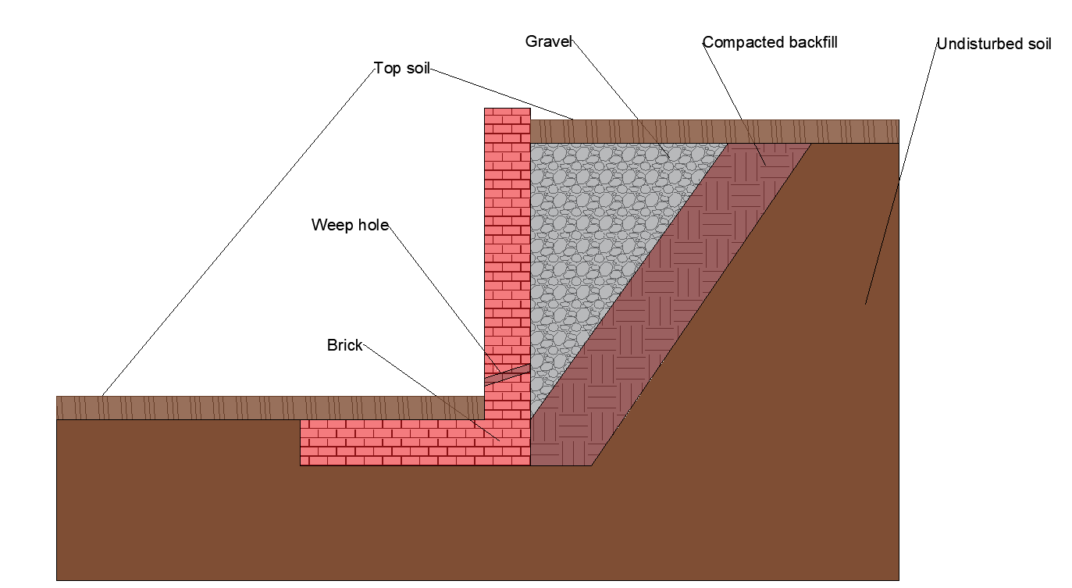
Topsoil
Source: Author

Brick and block cavity wall
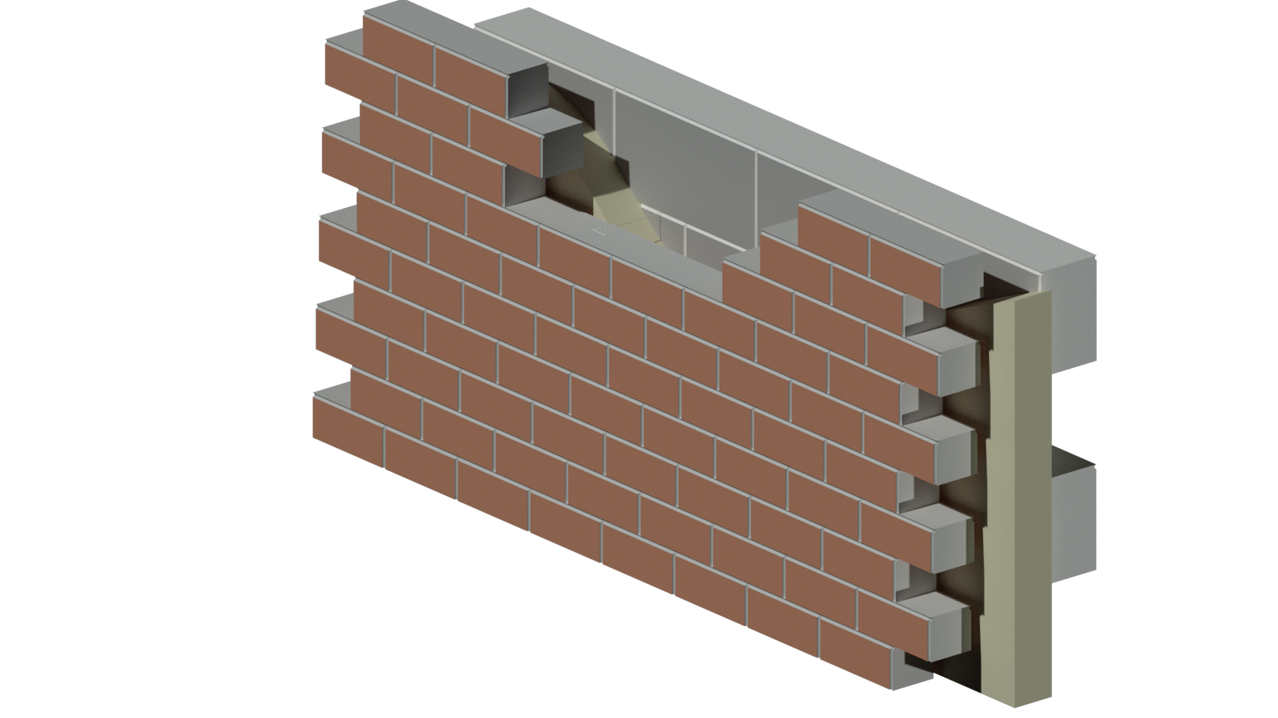
Brick
Block
Insulation
Wall tie
Mortar

Source: Author

Streetlight installation critical path
Critical path

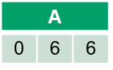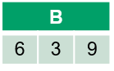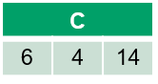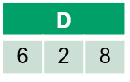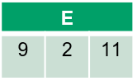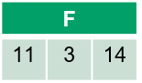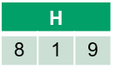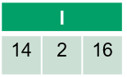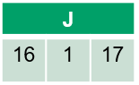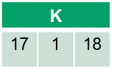Source: Author

Critical path activities
Activity | Description | Activity | Description
A | Apply for permits from local council for works. | G | Secure a storage area with surveillance systems.
B | Order plant equipment required for the installation of lighting and welfare unit. | H | Clear storage area of growth and level.
C | Order streetlights to specification provided by client. | I | Install streetlights in specified location along roadside.
D | Contact traffic control to install traffic management system. | J | Connect streetlighting to the grid and test.
E | Install welfare unit on sectioned-off piece of road. | K | Remove equipment and welfare unit from site; traffic control to remove traffic management systems.
F | Move reinforcement bars and cabling to site.

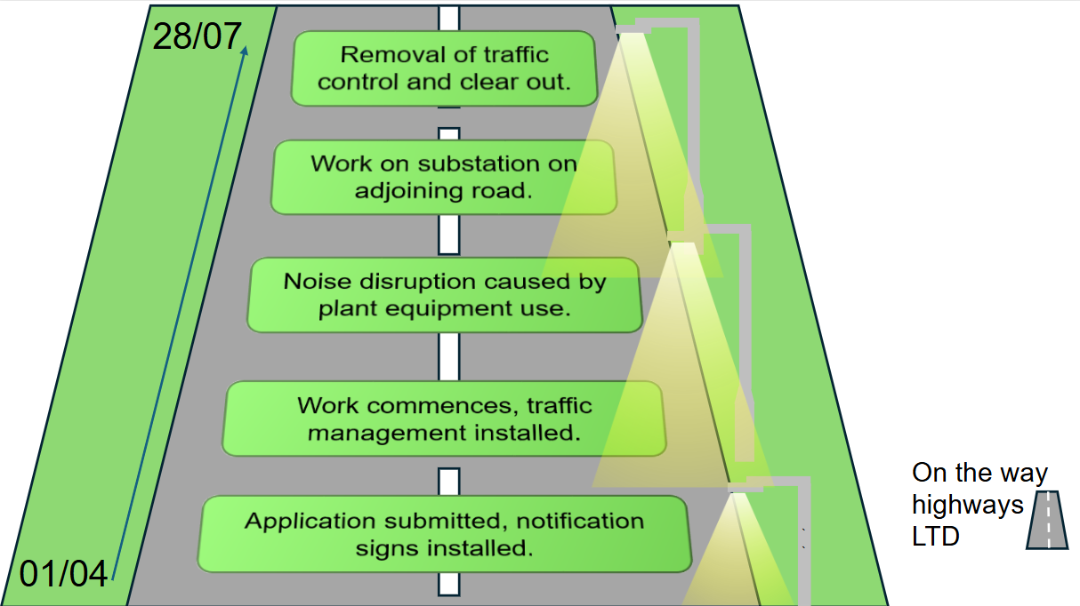
Streetlight infographic
Source: Author

The following materials relate to lesson 4: Methods of review

Pond design
View in situ

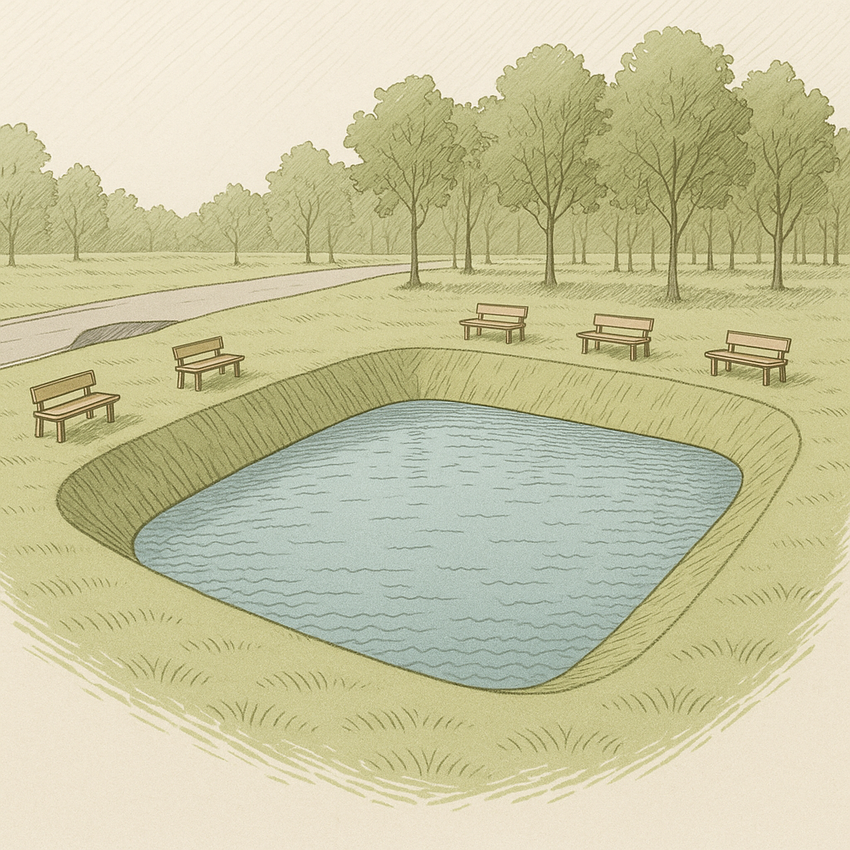
Source: ChatGPT

Pond slice view

Source: ChatGPT

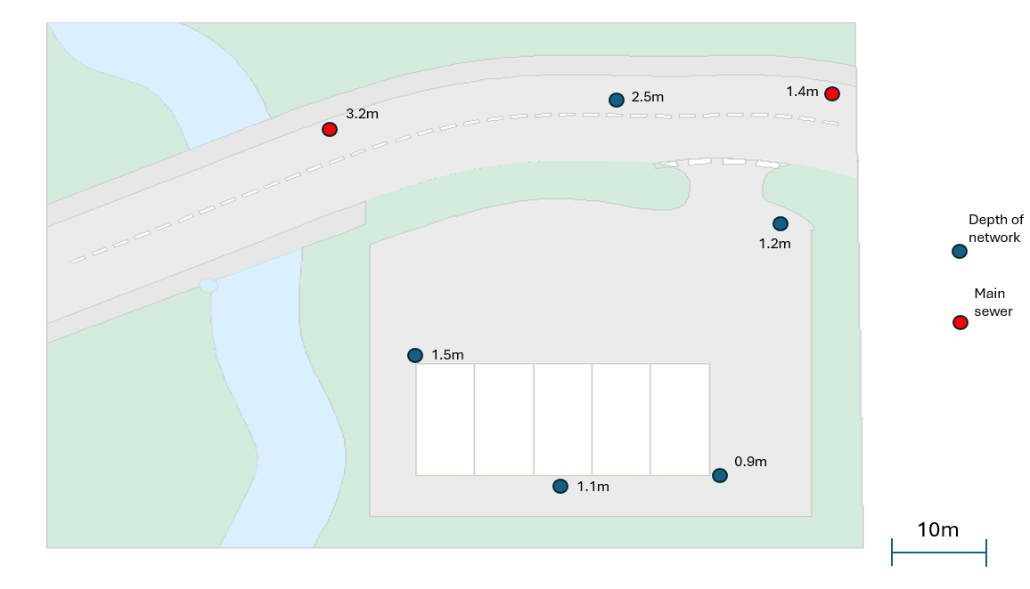
Drainage work handout
Source: Author

Pricing sheet
Project details
- Project type: multi-use commercial development
- Building size: 10,000 square feet
- Number of floors: three floors
- Purpose of rooms: development includes a mix of office spaces, meeting rooms, conference halls, kitchenettes, restrooms and utility rooms.
Each room will require specific electrical wiring and installations based on its intended use. The office spaces will have standard power outlets, while meeting rooms and conference halls will require additional outlets and interactive boards. The kitchenettes will require fused spurs for kitchen appliances, and restrooms will have lighting with isolators to ensure safety. Utility rooms will have additional sockets and dedicated circuits for machinery and equipment.
Extent of work
The rewiring work will include the following key components:
Sockets:
- 2G sockets in the office areas and larger rooms
- 1G sockets in utility and restroom areas.
Switches:
- 2G switches in larger rooms and areas requiring multiple lights or circuits
- 1G switches in smaller rooms or single-light areas.
Cabling:
- 1.5mm² twin and earth for standard power circuits
- 2.5mm² twin and earth for higher power circuits
- 10mm² cable for heavy-duty appliances or dedicated circuits.
Consumer unit:
- Replacement of the existing consumer unit to meet the needs of the newly designed electrical system.
Fused spur:
- Installation in kitchenettes for appliances such as fridges, microwaves and kettles.
Isolators:
- Installation in areas requiring high levels of safety for lighting and equipment.
Junction boxes:
- Used for safe and secure connections between different electrical circuits.
LED strip light:
- Installations for lighting fittings in all rooms.
Labour and consumables:
- The rewiring project will require skilled electricians to carry out the installations and ensure safety standards are met. Additionally, consumables such as cable ties, electrical boxes, screws and other small items will be needed to complete the work.
Research:
- Research the missing information using appropriate sites to find the missing unit prices.
Calculate the total cost of the rewiring for the current tender sheet.

Quantity estimates: a breakdown of the required quantities for given components are found in the table below:
Rewire tender

Component | Quantity | Unit price | Total cost
2G sockets | 50 | £6.85
1G sockets | 30 | £4.28
1G switches | 30 | £3.42
2G switches | 20 | £4.35
1.5mm² twin and earth (m) | 3,000
2.5mm² twin and earth (m) | 1,500
Fused spurs | 10 | £5.52
Isolator switches | 5 | £10.68
Consumer units | 1
10mm² Cable (m) | 500 | £4.22
60A junction boxes | 15 | 11.88
LED batten lights | 45
Labour (hours) | 900
Consumables |  |  | £500
Contingency (10%)
 |  | Subtotal
 |  | VAT (20%)
 |  | Total cost

The following materials relate to lesson 5: Delivering a solution

Site office annotated
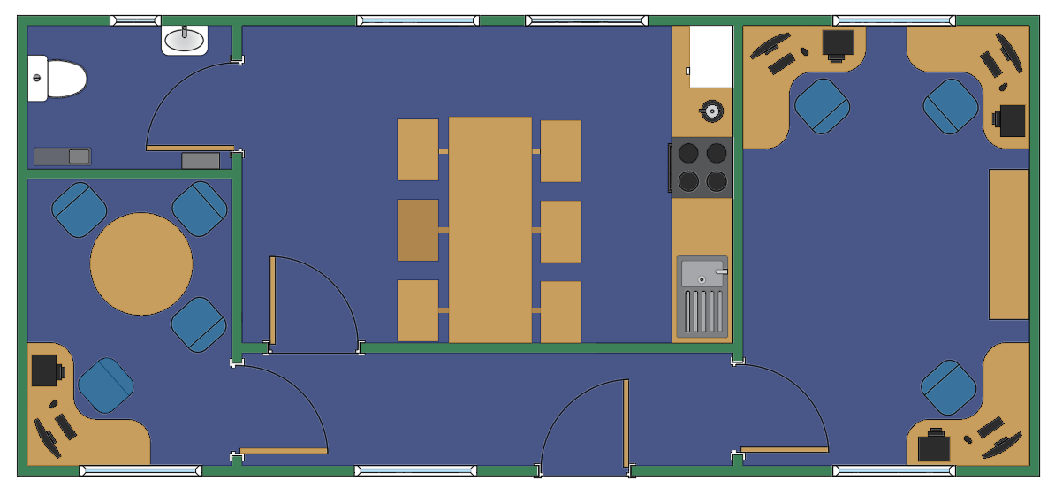Source: Author
Hallway
WC
Kitchen and dining space
Communal office
Single office

Site office dimensioned
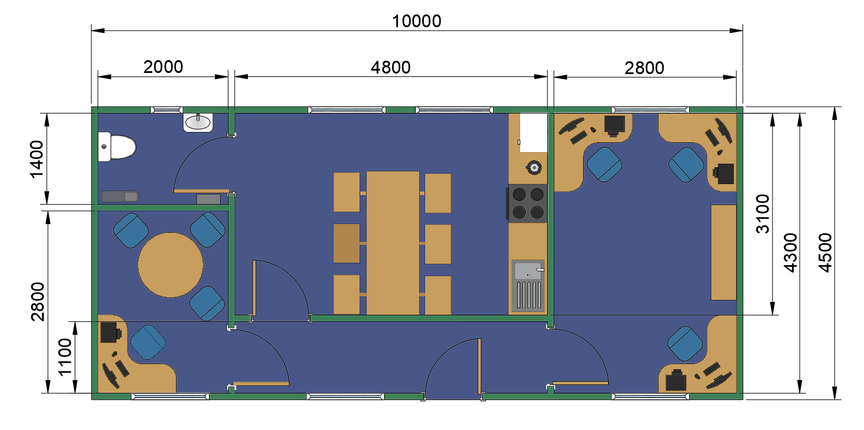
Source: Author

Temporary office solution high-definition images
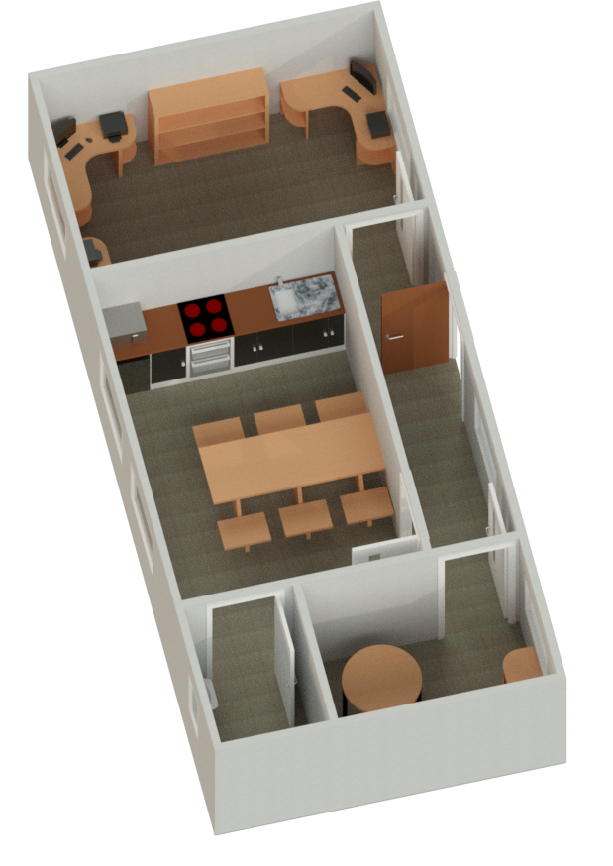

Source: Author
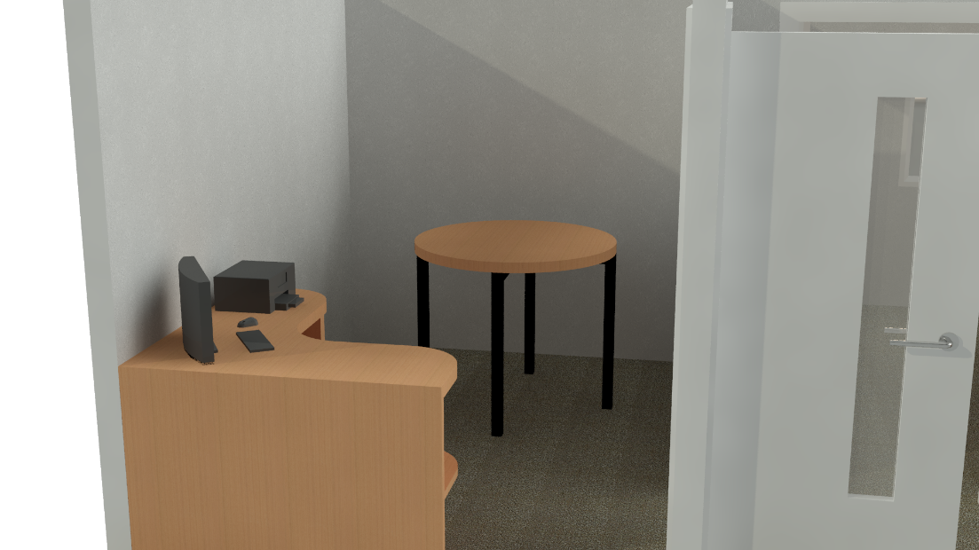
Component images
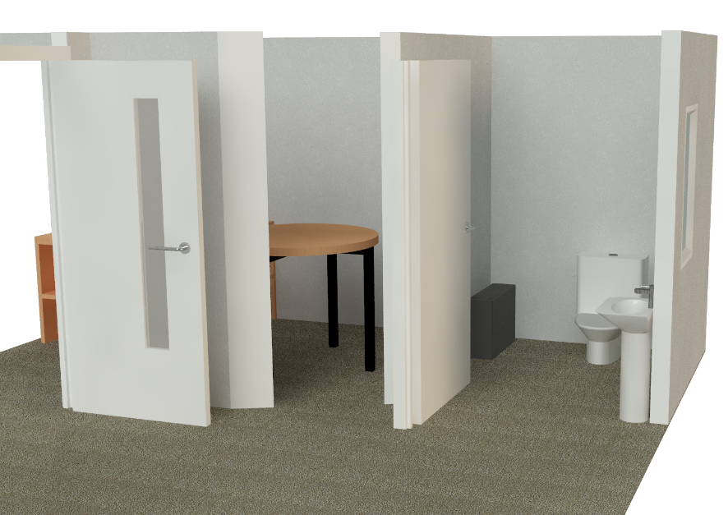

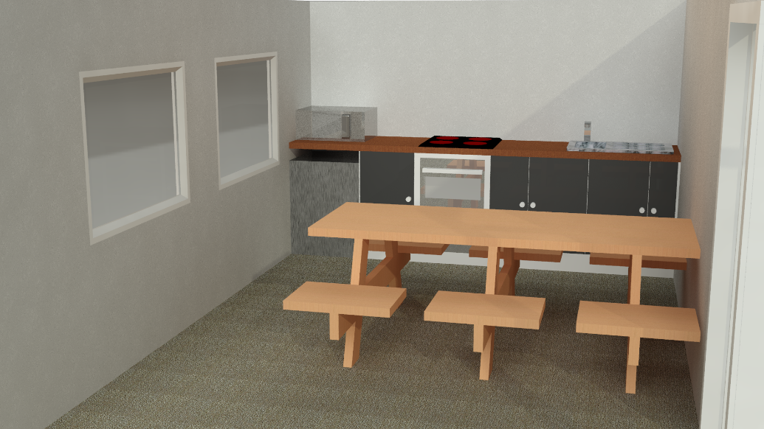
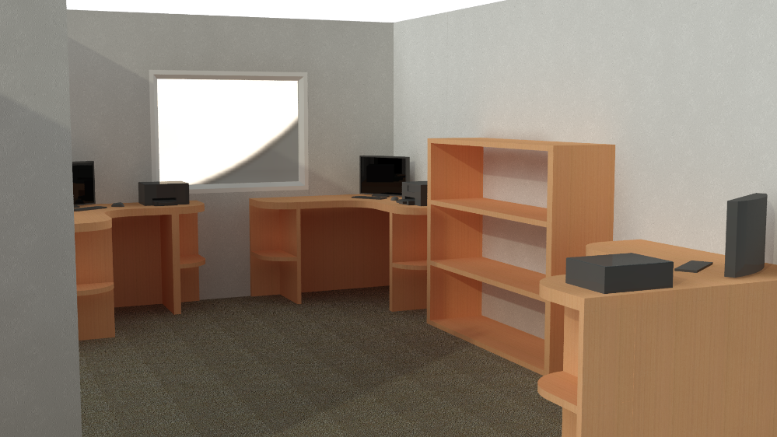
Source: Author

Site office requirements sheet
Shared office for foreman, civil engineer and quantity surveyor
A space with three desks, each equipped with seating, filing storage and necessary office equipment to facilitate collaborative work between the foreman, civil engineer and quantity surveyor.
Main office for project manager
A private office for the project manager, equipped with a desk, seating, storage, computer and communication facilities for managing project tasks and meetings.
Canteen with cooking facilities
A designated area for staff breaks, including tables and seating along with basic cooking facilities, such as a microwave, kettle, fridge and small stove for preparing meals.
Single toilet
A clean, well-maintained single toilet with necessary sanitation facilities, including soap dispensers, toilet paper and hand-drying options.

Road improvement task
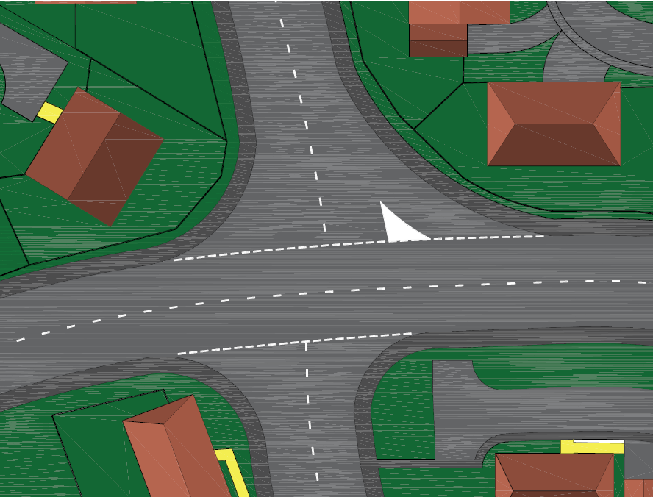
Pre-improvement image

Source: Author
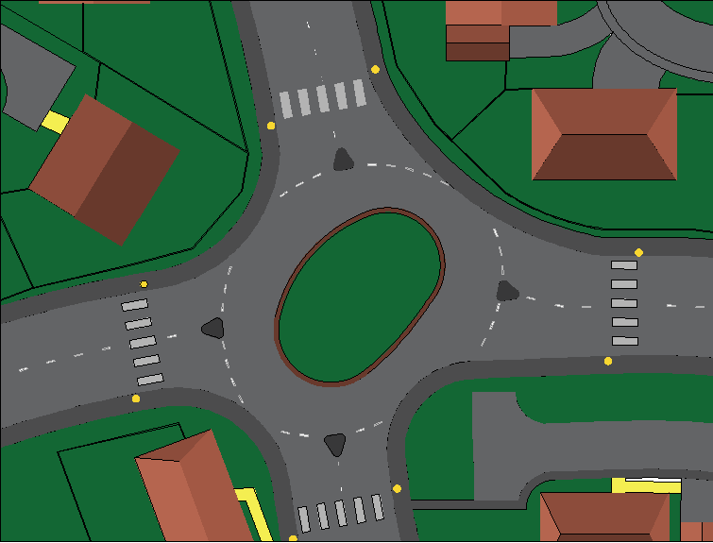
Planned improvement

Source: Author

Road improvement case study
The current four-way junction is located at the intersection of one B road and two adjoining roads, each serving busy housing estates. The junction experiences significant traffic congestion, particularly during peak hours, because of the high volume of vehicles entering and exiting the housing estates. The area is also known for pedestrian activity, with many residents walking to local amenities, schools and bus stops. Currently, there are no dedicated pedestrian crossings, and traffic flow is frequently disrupted, leading to safety concerns.
Reasons for change
- Traffic congestion:
The current junction experiences frequent bottlenecks, particularly during rush hour, leading to long waiting times for drivers and increased fuel consumption. With the growing population in the surrounding housing estates, traffic volumes have steadily increased, exacerbating these issues.
- Safety concerns:
There have been multiple reports of accidents at the junction, including rear-end collisions, side-impact accidents and pedestrian-related incidents. The lack of pedestrian crossings and the confusing nature of the intersection have contributed to this heightened risk. The current design does not effectively separate pedestrians from vehicular traffic, leading to hazardous situations.
- Inadequate pedestrian infrastructure:
Pedestrian safety is a major concern. There are no dedicated pedestrian crossings, which forces people to cross busy roads unpredictably, often in areas with limited visibility for both pedestrians and drivers. This increases the likelihood of accidents and discourages walking.
- Environmental impact:
The current traffic management system is inefficient, contributing to higher emissions because of idling and congestion. A more efficient traffic flow would not only reduce travel time but also lower vehicle emissions, promoting a cleaner environment.
The proposed solution: a roundabout
To address these issues, the installation of a roundabout is proposed, incorporating pedestrian crossings at each of the four exits and a landscaped centre. The roundabout will serve as a safer and more efficient alternative to the existing junction, providing numerous benefits for road users and the community.
Improvements for road users:
- Improved traffic flow:
A roundabout will help to maintain continuous traffic flow, reducing congestion by eliminating the need for traffic lights or stop signs. This will significantly reduce waiting times, particularly during peak hours, improving the overall efficiency of the junction.
- Increased safety:
Roundabouts have been proven to reduce the likelihood of accidents compared to traditional junctions. By slowing down vehicles as they enter and exit, roundabouts reduce the chances of high-speed collisions. The circular design also reduces the number of conflict points, making it safer for both vehicles and pedestrians. The addition of pedestrian crossings at each exit ensures that pedestrians can cross safely and predictably, with reduced crossing distances and improved visibility.
- Pedestrian accessibility:
The inclusion of pedestrian crossings at each exit will directly address the current safety concerns, providing safe passage for people on foot. These crossings will be clearly marked and located in areas of high pedestrian traffic, ensuring that pedestrians can move through the area without having to navigate through the vehicular flow.
- Environmental benefits:
With the improved traffic flow, vehicles will spend less time idling at the junction, leading to a reduction in fuel consumption and harmful emissions. This will contribute to a cleaner environment and promote sustainability in the local community.
- Aesthetic and community benefits:
The landscaped centre of the roundabout will not only improve the visual appeal of the junction but also enhance the local environment. A well-maintained roundabout with green space can serve as a focal point for the community, contributing to a sense of pride and connection among residents.
Conclusion
The installation of a roundabout at this busy four-way junction is a crucial step towards improving both road safety and traffic flow in the area. By addressing the current issues of congestion, safety and pedestrian access, the roundabout will provide significant benefits to all road users. With pedestrian crossings on each exit and a landscaped centre, the roundabout will not only create a safer and more efficient transportation hub but also enhance the local environment, making it a positive development for the community.

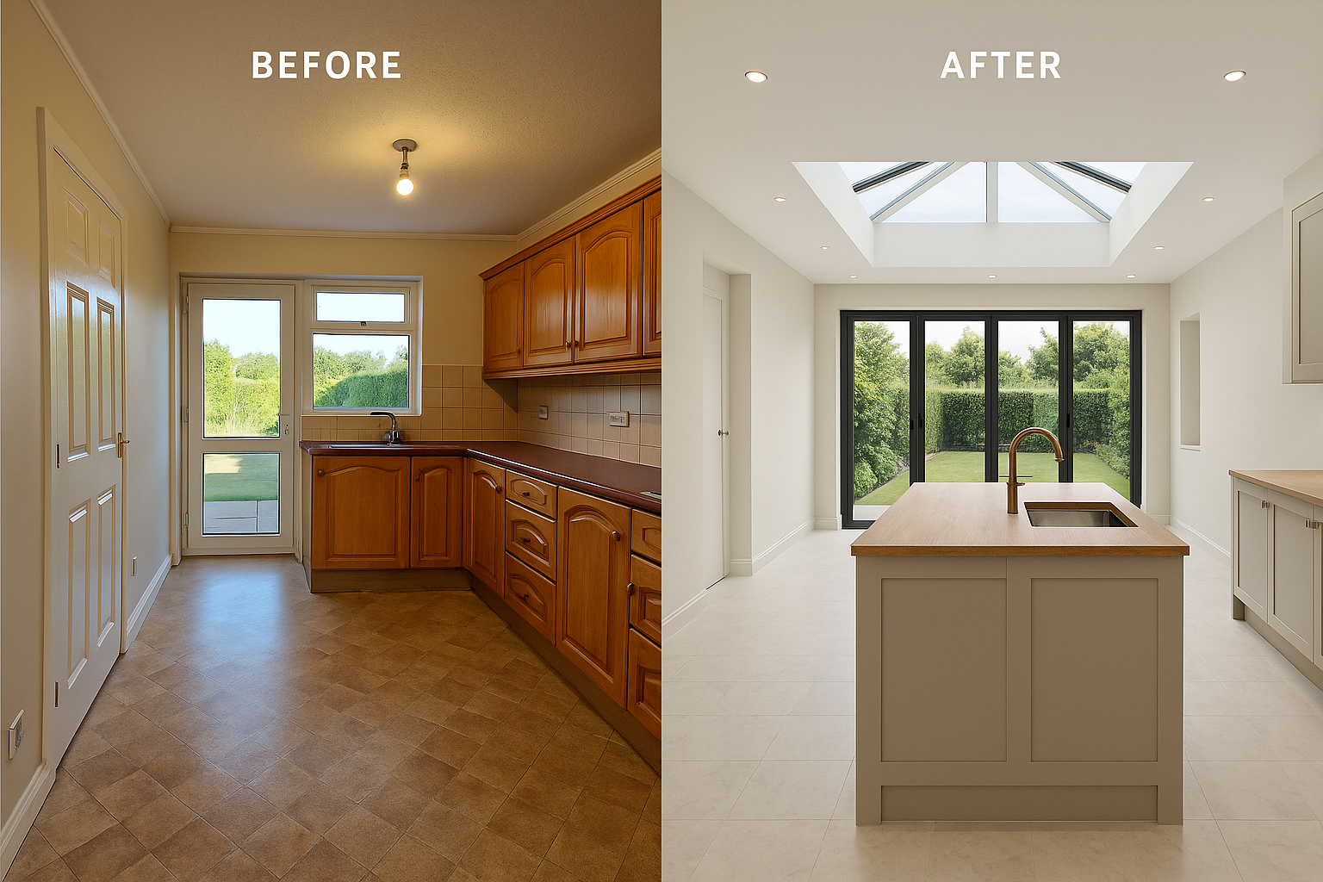
Kitchen diner extension task


Source: ChatGPT

Mood board for the kitchen extension

Checklist template
Name: _______________________
Presentation title: _______________________
Date: _______________________
List key criteria that can be used to check the quality of a presentation prior to delivery.
Key criteria | Completed (✓) | Notes

The following materials relate to lesson 6: Removing distractions

Balcony task
Scenario
An outdoor seating area for a lakeside restaurant has been designed (see image of lakeside restaurant). The design is part of a tender so the client must be convinced this is a suitable design for a thriving restaurant.
Image of lakeside restaurant
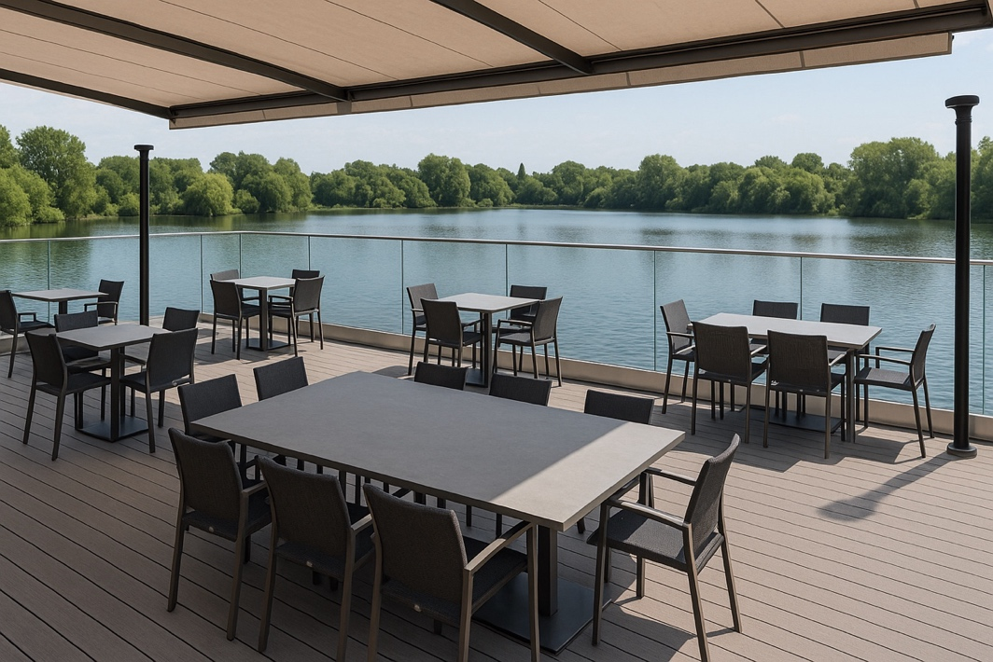

Source: ChatGPT
Outdoor seating area information
The outdoor seating area has been designed to offer a stylish and comfortable experience for up to 25 guests at a time, making it ideal for both casual diners and larger groups enjoying the stunning lakeside views.
Composite decking has been selected as the flooring material because of its excellent durability, low maintenance requirements and clean, contemporary appearance, which fits with the overall design theme. A modern glass balustrade surrounds the entire perimeter of the balcony, providing an unobstructed view of the lake while maintaining a strong sense of safety for all visitors, especially children and elderly guests. The seating arrangement includes a thoughtful mix of tables designed to accommodate different group sizes, ranging from intimate tables for two up to spacious tables that can seat parties of 10 people comfortably. Each table is paired with matching contemporary seating, with a focus on ergonomic design and weather-resistant materials to ensure comfort and durability throughout the seasons.
There is a fully retractable canopy installed above the balcony space, allowing the restaurant to adapt quickly to changing weather conditions and provide shade from the sun or shelter from light rain when needed. The canopy material is a high-quality, UV-resistant fabric in a neutral colour, selected to complement the natural tones of the decking and the surrounding environment, ensuring a harmonious overall look.
The layout has been carefully planned to maintain smooth movement between tables, allowing both diners and staff to move easily through the space without feeling cramped or restricted. Space efficiency was a key consideration during the planning stage, ensuring that while 25 guests can be accommodated, no table feels squeezed in or too close to neighbouring parties.
Discreet outdoor heating units are strategically placed around the perimeter and in the seating area, providing gentle warmth to guests during cooler evenings and extending the usability of the outdoor space throughout the year.
Subtle, low-level lighting has been integrated into the decking and around the balustrade, creating a welcoming and intimate atmosphere after dark without overpowering the natural setting of the lake.
Planting features have been incorporated into the design at key points, adding greenery without cluttering the space and helping to soften the modern lines of the decking and balustrade.
Tables for two are positioned nearest the edge of the balcony to maximise the romantic impact of the lakeside view, while larger tables are situated slightly closer to the building for ease of service. Furniture styles are coordinated across all table sizes, with sleek, minimalist designs that tie the entire balcony together visually, reinforcing the restaurant’s modern branding.
Overall, the balcony design aims to balance functionality with style, offering guests a comfortable, visually pleasing outdoor dining experience while making the most of the beautiful natural surroundings.
Task
The outdoor seating area information was planned for display on an A2 board for a client presentation.
  - Simplify the content and group the information, applying learning about what a good slide should look like.
  - Produce an A2 poster using the image of the balcony and the information provided. The poster should be suitable for the client, the restaurant owner, to understand.
  - The poster should cover all the benefits of the balcony and specific information relevant to the business, such as the low maintenance design and efficient use of space to accommodate 25 people.

Simplify to clarify

Retail superstructure

Source: ChatGPT

Application and performance review of LED lighting integration in a retail superstructure
Overview
The subject premises, a multi-zone commercial superstore, has undergone a comprehensive luminaire retrofit involving the deployment of LED (light-emitting diode) arrays in lieu of legacy fluorescent and halide fittings. This strategic upgrade serves multiple operational and environmental objectives, including load optimisation, luminous efficacy enhancement and regulatory compliance pursuant to Part L of the Building Regulations and BS EN 12464-1.
System specification
The installed LED infrastructure comprises variable-output, addressable luminaires interfaced via a DALI (Digital Addressable Lighting Interface) topology, with centralised controls enabling zonal dimming, ambient compensation and failure diagnostics. Power factor correction exceeds 0.95, with THD (total harmonic distortion) levels maintained below 15% in accordance with IEC 61000-3-2 standards. Lumen packages range from 3,000lm to 9,500lm per unit, depending on locational illuminance requirements and mounting height variance.
Illumination strategy
Lighting levels across key retail areas conform to a target lux threshold of 750lx (±10%), verified through photometric calculations and on-site luxmeter validation. The CRI (colour rendering index) of the selected diodes exceeds 85Ra, supporting high-fidelity product visualisation, especially in fresh produce and apparel departments. Corridor and egress zones operate under PIR (Passive Infrared sensor)-activated task lighting logic, reducing non-essential draw during inactive periods.
Energy and maintenance profile
Preliminary sub-metering indicates a net energy consumption reduction of 38.4% over the previous scheme, with anticipated ROI (return on investment) realised in 22–26 operational months. MTBF (mean time between failures) for luminaires is specified at >50,000 hours at Ta ≤ 35°C, reducing frequency of relamping cycles and associated working-at-height hazards.
Regulatory compliance and integration
The system meets all stipulations under CIBSE LG7 for commercial retail environments, while also aligning with Section 6 of the Building Services Compliance Guide (Non-Domestic). Emergency luminaires integrated with the UPS (Uninterruptible Power Supply) are tested via automatic self-diagnostic protocols (EN 50172 compliant), reporting via BMS (building management system).

The following materials relate to lesson 7: The audience journey

Example playgrounds

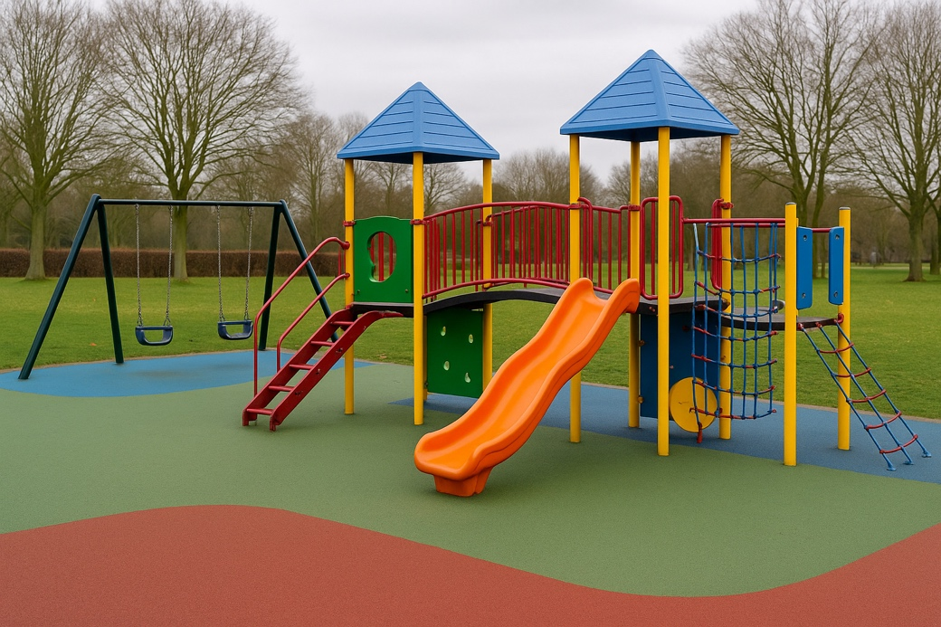

Source: ChatGPT

Footbridge planning task
Brief
Persuade Highways England that a pedestrian footbridge is essential across a busy bypass leading to a retail park.
Highways England cares about:
- public safety and accident prevention
- traffic flow and disruption minimisation
- justifiable investment and cost-effectiveness
- evidence of clear need (data, public concern).
Highways England plans to hold a meeting to discuss the concerns of the stakeholders.
Task
- Discuss who would be affected by the installation of a pedestrian footbridge across the bypass.
- Identify their interests, priorities and any potential conflicting viewpoints.
- Produce a flash card with a conflicting viewpoint on one side and a solution on the other.

The following materials relate to lesson 8: Planning a presentation

Topic information
Topic 1: Benefits of glulam beams for a ski resort
What is glulam?
Glulam (glue-laminated timber) is made by layering and bonding strips of timber with strong, moisture-resistant adhesives.
It allows for long spans and curved shapes not possible with solid timber.
Why glulam suits ski resorts:
- Strength and structural versatility:
- can span wide areas for open spaces like ski lodges, dining areas or atriums without needing lots of support columns
- strong enough to support heavy snow loads on roofs.
- Weather performance:
- factory-treated glulam resists shrinking and warping from snow and cold
- works well with other insulating materials.
- Sustainability:
- uses smaller timber sections (reduces deforestation pressure)
- stores carbon and has a lower embodied energy than steel or concrete.
- Aesthetic integration:
- provides a natural, warm interior look that fits the alpine environment
- allows visible structures with architectural impact.

Topic 2: Theodolites vs total stations
Surveying tools like total stations and theodolites are vital for accurately setting out buildings, roads and landscapes. Knowing when to use each one can affect the precision, cost and speed of a construction project.
Theodolites:
- designed to measure horizontal and vertical angles
- traditionally used with measuring tapes or chains to determine distances
- require manual calculations and record-keeping
- often used in education, basic fieldwork and as back-up equipment
Advantages:
- cheaper to buy and maintain
- simpler to use in basic situations
- lightweight and robust.
Disadvantages:
- slower process; needs manual maths
- does not measure distance automatically
- more prone to human error.
Total stations:
- integrates a theodolite with electronic distance measurement
- most have internal memory, some use Bluetooth, USB or cloud upload
- can autocorrect for tilt, measure height differences and interface with site plans
- widely used in civil engineering, large infrastructure and digital construction workflows.
Advantages:
- extremely accurate measurements
- fast data collection and storage
- minimises error and reduces labour cost.
Disadvantages:
- more expensive and complex
- needs training and regular calibration
- can be affected by battery life or digital faults.
Use cases:
- A theodolite can be used to set fence posts on a small site.
- A total station can be used to align pillars for a bridge or to manage levels on a large housing site.

Topic 3: Concrete render vs lime render
Render protects buildings from the elements and defines the exterior look. The choice between concrete and lime render relates to breathability, longevity, aesthetics and suitability for old or new buildings.
Concrete render:
- made from cement, sand and water
- often includes polymers for improved bonding and strength
- creates a hard, smooth finish.
Pros:
- tough and long-lasting when applied correctly
- provides a clean, modern appearance
- lower maintenance once cured.
Cons:
- not breathable – traps moisture inside walls
- can crack if walls move slightly or if applied on old substrates
- higher carbon footprint because of cement.
Best for: new builds, exposed locations modern aesthetics.
Lime render:
- made from lime, sand and water
- more flexible and breathable than cement-based render
- ideal for heritage buildings and soft bricks.
Pros:
- allows moisture to escape, reducing damp risk
- more tolerant to small movements in old walls
- naturally antibacterial and environmentally lower impact.
Cons:
- needs more care in mixing and application
- slower curing process
- more regular maintenance in exposed settings.
Best for: listed buildings, barns or older properties with breathable materials.
Use cases:
- A Victorian terrace being refurbished would need lime render.
- A newly built garden wall may suit concrete render for sharp edges.

Topic 4: Use of Corten steel for cladding
Corten steel (also called weathering steel) is a modern material used in architecture and construction for its durability and striking rusty appearance.
What is it?
- It is a group of steel alloys that form a stable, self-protecting layer of rust.
- The rust seals the surface and prevents deeper corrosion.
- No paint or coating is needed.
Benefits:
- Durable: It withstands most environments for decades.
- Low maintenance: No repainting or coating is required.
- Visual appeal: It has an earthy, industrial appearance that suits modern and natural settings.
- Sustainability: It has a long lifespan and no chemical coatings.
Risks and limitations:
- Run-off: Rainwater may carry rust and stain concrete or other surfaces.
- Coastal unsuitability: Saltwater accelerates corrosion and prevents the protective layer from forming.
- Detailing needed: It requires careful drainage design and weathering knowledge.
Common applications:
- External wall cladding for museums, galleries and offices
- Garden walls or facades where a natural look is desired
- Sculptural or signage uses in public spaces.

Topic 5: Use of existing services in a repurposed building
Repurposing buildings (e.g. turning a factory into flats) is increasingly popular. Reusing existing services – like pipework, cables and ventilation – can be a smart way to save time, money and resources.
What are ‘services?
- Electrical: power, lighting, data cabling
- Mechanical: heating, cooling and ventilation (HVAC)
- Plumbing: water supply, drainage, waste systems
Advantages:
- Lower cost: Reusing ductwork, wiring or water mains reduces materials and labour.
- Faster programme: There is less demolition and fewer delays.
- Sustainable: It reduces waste and embodied carbon.
Challenges:
- Compliance: Old services may not meet modern regulations (e.g. fire safety, efficiency).
- Condition: Existing pipes and cables may be hidden and damaged.
- Inflexibility: Services may be in the wrong location for the new layout.
Examples:
- A church converted into a co-working space may reuse heating ducts.
- A 1960s office converted to housing might reconfigure bathrooms using existing stacks.
Good practice:
- Conduct a thorough survey of systems.
- Decide whether to retain, upgrade or replace each part.
- Coordinate service reuse with structural and design needs.

Final practice topics
Topic 1: Heating, ventilation and air conditioning (HVAC)
HVAC stands for heating, ventilation and air conditioning. It refers to systems used to control indoor temperature, air quality and airflow.
- Heating keeps spaces warm in cold weather.
- Ventilation provides fresh air and removes pollutants.
- Air conditioning cools spaces during hot weather.
HVAC systems improve comfort, air quality and energy efficiency by managing temperature, humidity and airflow. Key components include thermostats, air filters, ducts and vents. These systems are important in maintaining a healthy and comfortable indoor environment, especially in extreme climates.
Topic 2: Mechanical ventilation with heat recovery (MVHR)
MVHR stands for mechanical ventilation with heat recovery. It is a system designed to provide fresh air to a building while recovering heat from the outgoing stale air.
- Function: MVHR systems extract warm, stale air from inside the building and use that heat to warm the incoming fresh, cold air from outside.
- Efficiency: It helps maintain a comfortable indoor temperature without wasting energy, as it reduces the need for additional heating.
- Health: MVHR improves indoor air quality by continuously bringing in fresh air and removing pollutants, moisture and odours.
In summary, MVHR systems are energy-efficient and help improve air quality while reducing heating costs. They are commonly used in well-insulated homes and buildings to ensure ventilation without losing heat.

The following materials relate to lesson 9: Record and produce

Coffee shop case study
A coffee shop has been invited to tender for a new site on the edge of a retail park. The retail park is investigating the feasibility of a food and drink outlet in an established retail park. The prospective site is close to a commuter route for a large city 60 miles away. The retail park in question is within three miles of a smaller city that has park-and-ride facilities located on the opposite side of a minor road heading into the city.
A national coffee chain has other establishments in the small city centre, 2.8 miles away. The new food and drink establishment will have the unique selling points of a drive-thru and extended opening hours.
The retail park units currently have the following tenants:
- a vehicle mechanic offering MOTs and servicing
- a furniture store
- a clothing store
- a veterinary practice
- a pet shop with a dog groomer
- two recently vacated small units.
Many of the units have wait times, and they have asked for the food and drink outlet to try to make these wait times more attractive to customers, who at the minute go elsewhere or look around shops and then wait in the car or waiting areas in respective units.
The park-and-ride site’s first bus to the city departs at 6.00am, with the final bus returning passengers to the facility by 8.00pm. The site has parking for 400 cars.
The proposed site for the new coffee shop is in the top-left corner of the retail park. The site currently has no food and drink facilities other than vending machines at the mechanic and veterinary practice sites. The plan is to attach to the required facilities in the car park of the retail park.
The design and size of the coffee shop have not been finalised but should include:
- outdoor seating
- accessible parking spots.
The retail park car park can be used by all other retail customers, and a new zebra crossing will be installed by the retail park owner to serve the coffee shop.
The land has been inspected and deemed suitable for the load-bearing requirements of a single-storey development. The construction method is yet to be determined but will make use of strip foundations.
The coffee shop will operate with shift patterns to accommodate opening hours between 6.00am and 8.00pm, with busier periods expected during weekends. The store will hire locally and train staff internally.

The roles available include:
- baristas
- cleaners
- store managers
- cashiers.
The quantity of each role will depend on the size of the development and its popularity. The site should be designed to operate for 10 years before requiring refurbishment or redesign. The coffee shop aims for the development to recoup its costs within five years.
The car park is equipped with security systems, including automated number plate recognition to enforce a strict 2.5-hour parking limit. The site is also well-lit using LED light poles.
The lease for the land has been agreed at £2,500 per calendar month. The agreement stipulates that all construction costs will be borne by the new tenants. The lease is a 20-year contract.
For comparison purposes, the cost of a regular latte at the coffee chain in the city is £3.80. The average order total at the city centre store, including food and drink, is £10.60. The cost of a machine-dispensed regular latte at the fast-food chain is £2.00. The sandwich shop operates between 10.00am and 6.00pm, while the burger chain operates 24 hours a day.
Currently, there are three sites within 0.7 miles seeking permission for large housing developments, targeting commuters for the large city. These developments include some affordable housing, a community hub and a play area as part of their applications.
Coffee shop site plan
Site overview
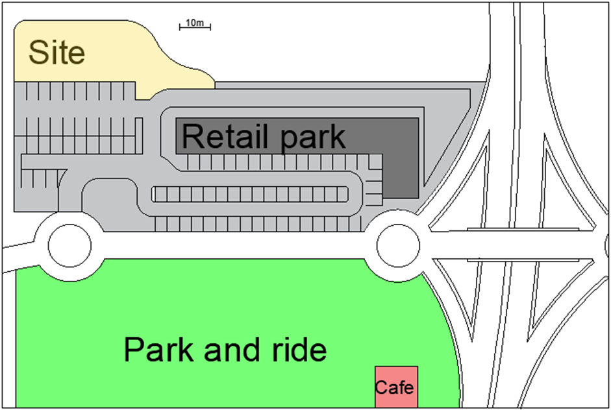Source: Author

Site plan
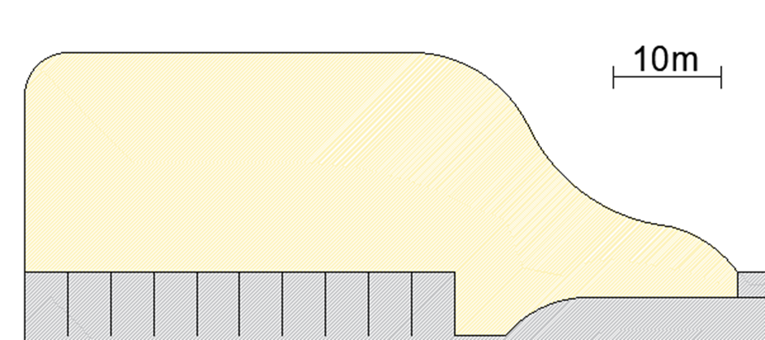
Source: Author
Potential layout
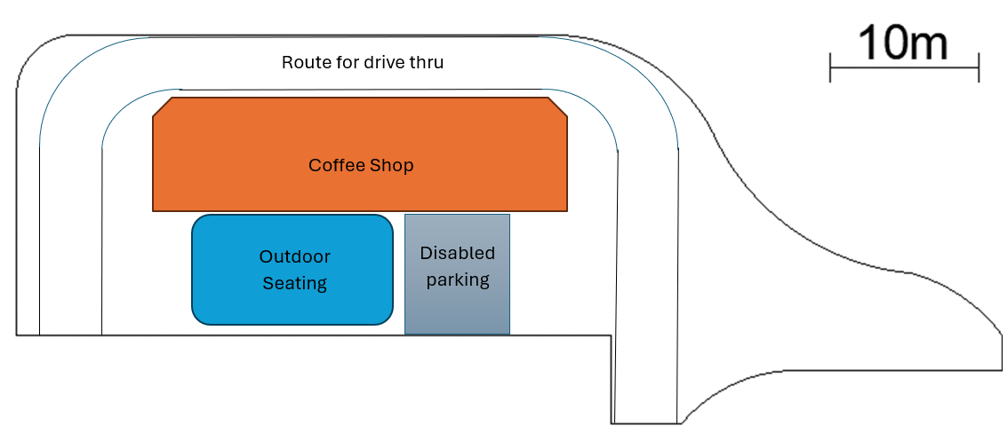
Coffee shop
Outdoor seating
Route for drive-thru
Source: Author

Stakeholder roles
Role | Descriptor
Finance director for the retail site | The finance director asks questions associated with the finances of the coffee shop. They want to know that the coffee shop will be long-lasting and will boost the profits and rentability of the retail outlets.
Potential investor | The potential investor asks questions associated with the finances of the coffee shop. They want to be assured that the coffee shop is profitable as a business in all aspects (takeaway food and drinks, eat-in facilities).
Retailer | The owner and manager of one of the stores in the retail park asks questions on how the coffee shop will potentially boost trade and add to the retail park.
Planning expert for the retail park’s owners | The planning expert has knowledge of the planning process and asks questions about the suitability of building layouts and parking.

The following materials relate to lesson 10: The stakeholder panel

Teacher instructions: TRetail Park expansion plans
Resources to be distributed:
- TRetail Park expansion plans task
- Case study: TRetail Park expansion plans
- TRetail Park tender presentation slides
- Highlighter pens.
Provide learners with an overall explanation of the tasks that they will be completing. Advise learners that they are provided with one slide deck presentation which is to be used to present solutions to two audiences. Advise learners to use the case study to establish information about each audience and the proposed extension plans. Learners must be advised that they are not to change the presentation slides. Learners are to emphasise and use the relevant information in the slide deck presentation for each audience presentation. The slides are designed as a visual support to their presentations and to provide the content to be communicated. It is the communication skills demonstrated that are key to this lesson.
Learners are to take the role of a regional manager of a national coffee shop who is bidding for the tender. The tender relates to the opening of a food and drink outlet which has been identified as a solution to help increase footfall at the retail outlet.
Audience 1 is the national coffee chain’s operations director.
Audience 2 is the public relations manager from the national coffee chain.
The learning sequence for this task is:
- Present to audience 1
- Swap roles and repeat
- Present partner feedback
- Prepare for audience 2, considering partner feedback
- Present to audience 2
- Swap roles and repeat
- Present partner feedback, identifying improvements observed.
The specific task details are as follows:
Task: Prepare a presentation (20 minutes)
This is an individual task. All learners need access to the slide deck presentation and the case study. This task is the preparation of the presentation for audience 1.
Learners are to plan how to use the information provided in the slide deck presentation for the audience. Learners need to plan how they will use good communication skills when presenting to audience 1.
Five minutes has been allocated to set up the task.
Task: Present to stakeholders (25 minutes)
Learners need to be allocated a pair. One learner is to take the role of the regional manager of a national coffee shop. The other learner is to take the role of a representative from audience 1. The learner taking on the role of the audience should produce three questions – using the question styles covered in lesson 8 – based on the Stakeholder panel members information.
Once complete, the roles should be swapped.
Task: Presenting feedback (20 minutes)
Leaners should be given 10 minutes to reflect on the communication skills demonstrated by their partner and prepare to provide oral feedback. Learners should then be given 5 minutes each to present the feedback to their partner. Guidance on timings should be given to ensure that each learner has 5 minutes.
Task: Presenting to new stakeholders (25 minutes)
This is a repeat of the second task but to a new audience – audience 2. Ten minutes should be allocated at the start of the task to allow learners to plan the communication for the new audience. Each presentation is 10 minutes, including time for three questions.

TRetail Park expansion plans task
Situation
You are a regional manager of the national coffee shop tendering to build and open a coffee shop at TRetail Park. You have been asked to represent the organisation and present at two stakeholder meetings. The organisation has prepared your presentation slides, which focus on solutions to increase footfall to the retail park.
The first stakeholder meeting where you need to present is with the operations director of the national coffee chain. The second meeting where you need to present is with the public relations manager of the national coffee chain.
Task: Prepare a presentation
This is an individual task.
- Read Case study: TRetail Park expansion plans.
- Look through the TRetail Park tender presentation slides.
- Prepare for a 5-minute presentation to the financial director and a planning expert commissioned by the retail park.
Task: Present to stakeholders
In pairs, one person takes the role of the regional manager and the other a stakeholder attending the meeting. Once the task is complete, swap roles and repeat.
Regional manager:
- Present the solutions to the operations director.
- The presentation should last 5 minutes. Following the presentation, you are required to respond to three stakeholder questions.
Stakeholder:
- Listen to the presentation.
- Ask the Regional Manager three questions
- Taking notes throughout about the effectiveness of the communication skills demonstrated by the Regional Manager.
Task: Present feedback
- Individually, reflect on the communication skills demonstrated by your partner and prepare to provide oral feedback.
- Give a 5-minute oral presentation to your partner, presenting your observations and highlighting areas of improvement.
- In your pairs, clarify any questions asked about your feedback.
Task: Present to new stakeholders
In pairs, one person takes the role of the regional manager and the other is the public relations manager of the national coffee chain. Once the task is complete, swap roles and repeat.
Regional manager:
- Present the solutions to a group of retailers from the retail park.
- The presentation should last 5 minutes. Following the presentation, you are required to respond to three stakeholder questions.
Stakeholder:
- Listen to the presentation.
- Ask the regional manager three questions.
- Take notes throughout about the effectiveness of the communication skills demonstrated by the regional manager.

Case study: TRetail Park expansion plans
A coffee shop has been invited to tender for a new site on the edge of a retail park. The retail park is investigating the feasibility of a food and drink outlet in an established retail park. The prospective site is close to a commuter route for a large city 60 miles away. The retail park in question is within three miles of a smaller city that has park-and-ride facilities located on the opposite side of a minor road heading into the city.
A national coffee chain has other establishments in the small city centre, 2.8 miles away. The new food and drink establishment will have the unique selling points of a drive-thru and extended opening hours.
The retail park units currently have the following tenants:
- a vehicle mechanic offering MOTs and servicing
- a furniture store
- a clothing store
- a veterinary practice
- a pet shop with a dog groomer
- two recently vacated small units.
Many of the units have wait times, and they have asked for the food and drink outlet to try to make these wait times more attractive to customers, who at the minute go elsewhere or look around shops and then wait in the car or waiting areas in respective units.
The park-and-ride site’s first bus to the city departs at 6.00am, with the final bus returning passengers to the facility by 8.00pm. The site has parking for 400 cars.
The proposed site for the new coffee shop is in the top-left corner of the retail park. The site currently has no food and drink facilities other than vending machines in the mechanic and veterinary practice sites. The plan is to attach to the required facilities in the car park of the retail park.
The design and size of the coffee shop have not been finalised but should include:
- outdoor seating
- accessible parking spots.
The retail park car park can be used by all other retail customers, and a new zebra crossing will be installed by the retail park owner to serve the coffee shop.
The land has been inspected and deemed suitable for the load-bearing requirements of a single-storey development. The construction method is yet to be determined but will make use of strip foundations.
The coffee shop will operate with shift patterns to accommodate opening hours between 6.00am and 8.00pm, with busier periods expected during weekends. The store will hire locally and train staff internally.

The roles available include:
- baristas
- cleaners
- store managers
- cashiers.
The quantity of each role will depend on the size of the development and its popularity. The site should be designed to operate for 10 years before requiring refurbishment or redesign. The coffee shop aims for the development to recoup its costs within five years.
The car park is equipped with security systems, including automated number plate recognition to enforce a strict 2.5-hour parking limit. The site is also well-lit using LED light poles.
The lease for the land has been agreed at £2,500 per calendar month. The agreement stipulates that all construction costs will be borne by the new tenants. The lease is a 20-year contract.
For comparison purposes, the cost of a regular latte at the coffee chain in the city is £3.80. The average order total at the city centre store, including food and drink, is £10.60. The cost of a machine-dispensed regular latte at the fast-food chain is £2.00. The sandwich shop operates between 10.00am and 6.00pm, while the burger chain operates 24 hours a day.
Currently, there are three sites within 0.7 miles seeking permission for large housing developments targeting commuters for the large city. These developments include some affordable housing, a community hub and a play area as part of their applications.

Site overview
Source: Author

Stakeholder panel members
Operations director
The vested interest of a national coffee chain’s operations director in the development of a new site would be focused on ensuring that the new location contributes positively to the overall operational success of the business. Specifically, their interests would include:
- Operational efficiency: ensuring the site’s layout, equipment and processes support smooth, efficient day-to-day operations
- Brand standards compliance: making certain that the site adheres to brand guidelines in terms of service quality, visual appearance and the overall customer experience
- Staffing and training: confirming that staffing requirements are met and that employees are appropriately trained to maintain consistent service standards from the outset
- Cost control and profitability: overseeing that the site is developed within budget and has strong potential for early profitability
- Customer experience: ensuring the new site offers a welcoming, convenient and consistent customer experience that aligns with the brand’s values
- Location viability: assessing footfall, accessibility and local demographics to ensure the location is likely to be commercially successful.
Public relations manager
The public relations manager’s vested interest in the development of a new site lies in ensuring the launch enhances the coffee chain’s reputation, attracts positive public attention and strengthens its relationship with the local community. Specifically, their interests may include:
- Positive brand exposure: ensuring the site opening is positioned as a success story, reinforcing the chain’s values and commitment to quality and customer satisfaction
- Media and public engagement: coordinating media coverage, press releases, launch events and social media tasks to maximise public interest and coverage
- Reputation management: anticipating and mitigating any potential negative perceptions (e.g. competition with local cafes, environmental concerns, etc.) and ensuring the brand responds appropriately to public feedback
- Community relations: highlighting the brand’s engagement with and contribution to the local area, such as job creation, sustainability initiatives or charity partnerships
- Consistency of messaging: ensuring all public communications regarding the new site align with the company’s brand tone, values and broader public relations strategy
- Crisis preparedness: being ready with a communication plan in the event of delays, protests or operational issues that may arise during or after launch.

Personal evaluation form
Personal evaluation
Name: _____________________________________
The evaluation form reviews both your recorded presentation and your boardroom session. You should seek feedback from those who reviewed your presentation and participated in the question-and-answer session.
Do you believe… | Answer  Yes/No | How could it have been completed better, if applicable?
the content was clearly conveyed?
the questions were answered clearly and concisely?
your use of space was effective?
the audience engagement was clear?
the visuals used to support your presentation were clear?
Action points for future presentations
1.

2.

3.


FUNDED BY
PRODUCED BY

East Norfolk Sixth Form College has produced this resource on behalf of the Education and Training Foundation
This programme is funded by the Department for Education

