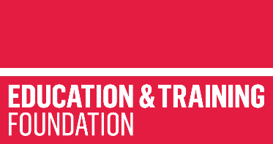

SUPPORT HOLISTIC DELIVERY OF CORE CONTENT AND OCCUPATIONAL SPECIALISM CONTENT
ET-FOUNDATION.CO.UK
T LEVEL IN CRAFT AND DESIGN

INTRODUCTION
Effective evaluation and iterative design are fundamental competencies in the field of Craft and Design, crucial for learner success in their T Level programme and subsequent industry roles. Embedded in the T Level in Craft and Design are requirements that align with both Core Competencies and Performance Outcomes, focusing on evaluative, analytical, creative and problem-solving skills.
This resource provides a structured framework designed to holistically integrate Core Content, Core Skills and Occupational Specialism content, specifically targeting Performance Outcome 2 (PO2): “Refine and communicate ideas for creative product development”. In this outcome, learners will develop skills such as reviewing and refining ideas based on their suitability for purpose.
The resource explicitly addresses Core Skill 2 (CS2): “Generating Ideas”. This will enable learners to effectively interpret and clarify design briefs, critically review ideas, select viable concepts for client presentation and accurately compare their designs against specified briefs.
Additionally, key Core Elements such as Audience and Equality, diversity and inclusion (EDI) are woven throughout the resource. Learners will explore how demographic, geographic and psychographic considerations affect customer needs and expectations, alongside recognising and addressing unconscious biases.
The Framework for Learning (FfL) outlined in this resource systematically sequences and scaffolds learning in three progressive stages:
- Stage 1: introduces foundational analytical skills in interpreting and assessing design briefs, establishing success criteria and integrating basic concepts of audience engagement and EDI
- Stage 2: builds upon initial evaluative skills, applying these to more complex scenarios and incorporating iterative feedback mechanisms to refine design outcomes with deeper exploration of audience diversity and EDI
- Stage 3: enhances evaluative proficiency, engaging learners in complex iterative design processes; this stage emphasises advanced demographic, geographic and psychographic considerations, preparing learners to effectively respond to sophisticated client briefs and professional industry standards.
Accompanying this structured learning journey are comprehensive lesson plans, support materials, presentations and targeted guidance to ensure a fully integrated and enriched learner experience.
This resource has three sections:
Framework for Learning
The resource includes a FfL. This covers 20 hours of learning, and there is a diagram to show how the content of those hours has been sequenced and scaffolded. There is also a narrative that explains the sequencing and scaffolding in more detail.
Lesson plans
There is a lesson plan for each stage in the sequencing and scaffolding of learning in the FfL. Lesson plans include details of the support materials that are required to support delivery, including those found in this resource.
Support materials
The support materials identified in the lesson plans are also available towards the end of this document.
NOTE:
There is a separate slide deck that should be used with the lessons.

SECTION 1: FRAMEWORK FOR LEARNING
The Framework for Learning (FfL) sets out one approach to scaffolding and sequencing the development of holistic delivery of Core Content and Occupational Specialism content relating to the T Level in Craft and Design. This resource focuses on the development of evaluative and iterative design skills in a range of textiles and fashion maker contexts. Customer requirement scenarios, case studies, mood boards, design briefs and product outcomes are used to develop these skills. The resource is designed to provide a holistic approach to learning, integrating Core Content and Core Skills with Performance Outcomes. This resource specifically supports the holistic development of:
- Performance Outcome 2 (PO2): Refine and communicate ideas for creative product development
  - TFS2.1: Review initial ideas for further development, assessing suitability of purpose
- Performance Outcome 5 (PO5): Review and evaluate the activities and development against the original brief or proposition to refine product(s)
  - TFS5.1: Evaluate the extent to which the finished product meets the design brief
- Core Skill 2 (CS2): Generating ideas:
  - Interpret the design brief and clarify expectations.
  - Review, refine and reject ideas.
  - Select proceedable ideas or series of ideas to present to client.
  - Compare ideas to the design brief.
- Core Element 4: Audience
  - CK4.2: Demographical and geographical considerations to support the diverse needs of audiences and customers
- Core Element 7: Equality, diversity and inclusion (EDI)
  - CK7.1.3: The presence of unconscious bias – stereotyped judgements made without conscious awareness
The overall outcome of learning from this resource is to be able to critically evaluate client briefs and to review and refine designs so that they fully meet given client briefs.
Sequencing and scaffolding
The sequencing is intentional, set out in three stages. The intention is for the stages to follow in sequence from lesson 1 through to lesson 10. The resource has been designed to be delivered in a block of learning. However, the resource can be adapted to be delivered using alternative models.
Stage 1 has four lessons, Stage 2 has four lessons, and Stage 3 has two lessons. Each lesson is two hours in length.
Stage 1: Understand how to analyse and interpret design briefs
This stage introduces learners to the success criteria used to evaluate finished design products. Learners will learn how to review design brief ideas and concepts to determine how well their ideas meet the requirements of design briefs. Through looking at different customer requirements and design briefs, learners will be developing basic evaluative skills as well as some knowledge of Core Content relating to audience and EDI. This stage includes evaluative and problem-solving skills.
Stage 2: Apply evaluative skills
This stage requires learners to work with a range of case studies which include more complex elements of the design cycle and professional standards. Learners will apply their knowledge of success criteria and learn how to use feedback to improve design product outcomes. This stage involves implementing the iterative design process. This stage builds on the concept of audience introduced earlier, deepening the focus through the lens of EDI. It introduces how demographic and geographic factors can influence the behaviours, needs and expectations of different customers and audience groups.
This stage builds on the development of evaluative skills and problem-solving.
Stage 3: Refine evaluative skills through iterative design
This stage includes complex elements of the design cycle, introducing new ideas and concepts which learners will evaluate. Learners will apply their learning from stages 1 and 2. This stage requires application of the iterative design process to refine design outcomes in line with professional standards. This stage builds on prior understanding of audience by exploring demographic, geographic and psychographic factors that influence customer needs, preferences and behaviours. The evaluative process considers more complex EDI considerations.
This stage culminates with a new case study and design brief. Learners will evaluate this and suggest refinements to fully meet the complex requirements of the client brief.
The following diagram shows a visual image of how this FfL will apply in the three stages outlined above. It shows the sequencing and scaffolding of learning.
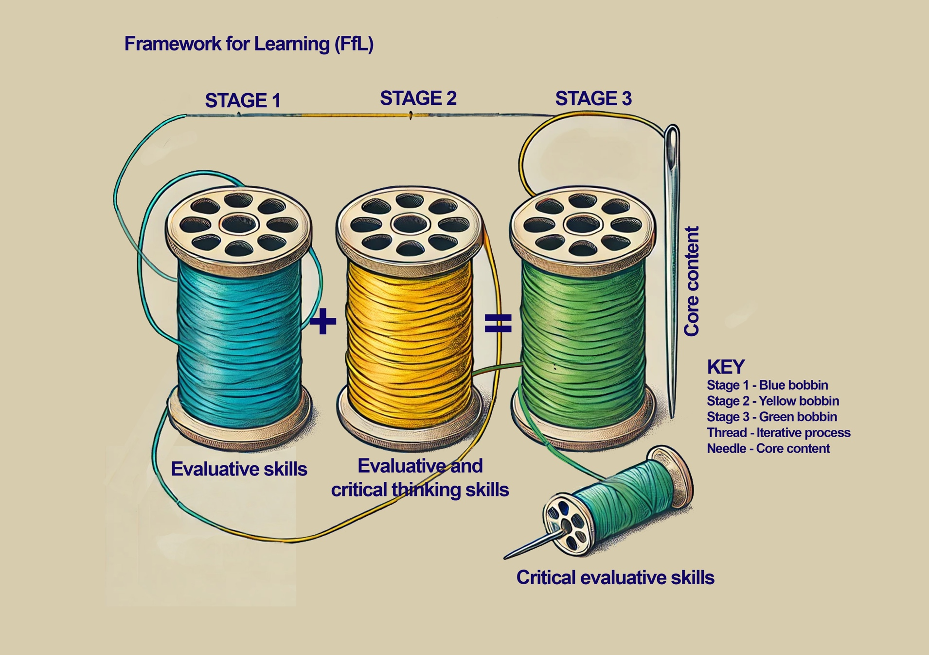

SECTION 2: LESSON PLANS
This section includes 10 lesson plans. The lesson plans follow the FfL. The lesson plans include the:
- lesson title
- targeted specification content coverage
- lesson number in the sequence
- total amount of time required to deliver the lesson
- teacher and learner activities to be undertaken throughout the lesson
- resources needed to deliver the lesson (see Note below)
- details of how the lesson supports the development of English, maths and/or digital skills (where appropriate)
- details of how the lesson can be adapted to meet learners with specific needs
- next steps in learning, such as homework activities and links to the next lesson.
Note:
There is an assumption that the learning environment will include the following:
- whiteboard/smartboard or similar
- materials to take notes; e.g. pens, paper, audio recorder, digital device and software
- equipment to present a slide deck and video; e.g. projector, smartboard
- digital devices (e.g. laptop, tablet) for all learners
- internet access
- learner access to word-processing, spreadsheet and presentation software.

Lesson 1
Title: Review, refine and reject ideas
Targeted content reference:
PO2: Refine and communicate ideas for creative product development; TFS2.1: Review initial ideas for further development, assessing suitability of purpose
CS2: Generating ideas: interpret the design brief and clarify expectations
CK4.2: Demographical considerations to support the diverse needs of audiences and customers: age, gender identity
Timing: 2 hours
Prior learning:
Understanding of the concept of a client brief
Knowledge of different fabrics
How to send an email
Timing | Teacher activity | Learner activity | Support materials
15 minutes | Introduction: set out what is going to be achieved from the lesson.  Set starter task. Distribute Self-evaluation handout. | Listen, take notes and ask questions as required. | Self-evaluation  Activewear client brief  Reusable adhesive  Sticky notes
15 minutes | Circulate to ensure learners are clear about the requirements of the starter task. | Individually, complete Self-evaluation handout.
30 minutes | Facilitate discussion about what a client brief is and what needs to be considered when reviewing a client brief. The questions are intended to establish the level of prior knowledge of this topic. | Contribute to class discussion.
30 minutes | Present slide: Client brief: printed shirt. Highlight to learners the client requirements. | Listen, take notes and ask questions as required.
30 minutes | Present slide: Client brief: printed shirt outcome. Highlight to learners why each of the elements listed in response to the client brief are not meeting the requirements. | Listen, take notes and ask questions as required.
30 minutes | Divide the class into four. Give each group a flipchart and pens. Allocate one client brief requirement to each group: one designs a shirt for daily wear, another a unisex style, etc. Ask each group to discuss how their allocated requirement could be met. | Listen, take notes and ask questions as required. Move to allocated group.
30 minutes | Circulate to ensure learners are clear about the requirements of the task. | In allocated group, list on a flipchart how the requirement could be met.
30 minutes | Facilitate class feedback. Invite each group to feedback key points discussed. Correct any spelling and grammar as required. | Feedback how the requirement can be met to the rest of the class.
30 minutes | Set the requirement of Activewear client brief task. Allocate class into pairs. Distribute Activewear client brief. | Listen, take notes and ask questions as required. Move to be with allocated pair.
30 minutes | Circulate to ensure learners are clear about the requirements of the task. | Read Activewear client brief. In pairs, evaluate how well the activewear solution meets the requirements of the client brief. Make notes.
30 minutes | Facilitate class feedback. Invite each pair to feedback a key point until all points have been addressed. | Feedback to class reasons why the client requirements have not been met.
30 minutes | Present the process to review, refine and reject ideas. | Listen, take notes and ask questions as required.
30 minutes | Set out the requirements of the task. Explain to learners that they are to apply the review, refine and reject ideas process. Learners to work with the same pair. Provide each pair with flipchart paper and pens. Advise learners to refer to the Activewear client brief. | Listen, take notes and ask questions as required.
30 minutes | Circulate to ensure learners are clear about the requirements of the task. | Refine the activewear solution so that it meets the requirements of the client brief. Write the solution on a flipchart.
30 minutes | Ask learners to display their flipchart paper. Correct any spelling and grammar as required. | Display flipchart paper.
30 minutes | Distribute sticky notes to learners. Advise learners that they are to score each of the other pairs’ refined activewear solution displayed on the flipchart paper. | Listen, take notes and ask questions as required.
30 minutes | Circulate to establish which solutions scored the highest. | Score other pairs’ activewear refined solutions. Place a sticky note on the flipchart.
30 minutes | Discuss with learners the reasons for the highest scoring pair(s). | Contribute to class discussion.
15 minutes | Set plenary exam-style question. Advise learners this will be completed independently. | Listen, take notes and ask questions as required.
15 minutes | Circulate to ensure learners are clear about the requirements of the task. | Answer question.
15 minutes | Ask learners to hand in response. To be marked and given back at the next lesson. | Hand in response.
15 minutes | Set the requirements for the next steps. | Listen, take notes and ask questions as required.
Other:
English: Oral communication development through contributing to group and class discussions and providing peer feedback. Written communication skills through completing self-evaluation forms, recording ideas on flipchart paper and responding to an exam-style question. The success criteria are linked to professional standards and support the development of punctuation, grammar and spelling.
Adaptation:
SEND: A simplified self-evaluation handout with sentence starters and visual prompts could be used to guide responses. Pair SEND learners with supportive peers during group tasks to ensure they clearly understand each requirement and can contribute effectively.
Extension: Learners can add justification for the score given for peers’ activewear refined solutions.
Next steps in learning:
Teacher: Review answers to exam-style question, providing feedback on the quality of responses. Forward feedback to learners.
Learner homework: Produce criteria which could be used to check if the requirements of a client brief have been successfully met.

Lesson 2
Title: Evaluative skills and reviewing concepts
Targeted content reference:
PO5: Review and evaluate the activities and development against the original brief or proposition to refine product(s); TFS5.1: Evaluate the extent to which the finished product meets the design brief
CS2: Generating ideas: undertake research to determine design influences; market and competitors; style and current trends; ethical sourcing
CK4.1.2: Importance of market and customer research; CK4.3: Methods that may be used to measure the impact of products, services or content on an audience or customer
Timing: 2 hours
Prior learning:
Lesson 1
Timing | Teacher activity | Learner activity | Support materials
15 minutes | Introduction: set out what is going to be achieved from the lesson. | Listen, take notes and ask questions as required. | Success criteria questions  Success criteria for answering a client brief  Design brief and concept  SWOT analysis template  Retail brand case studies  Plenary design brief
15 minutes | Set starter task. Who is the chair designed for? Facilitate class discussion using bounce questioning technique. Challenge learners to elaborate on answers as required. | Contribute to class discussion. Answer questions as directed.
15 minutes | Summarise who the chair is designed for. Present information from slide deck to extend class contribution, highlighting the key features. | Listen, take notes and ask questions as required.
45 minutes | Present success criteria list. | Listen, take notes and ask questions as required.
45 minutes | Distribute Success criteria questions and Success criteria for answering a client brief handout.  Facilitate class discussion about what success criteria are and what needs to be considered when reviewing a client brief. | Read Success criteria questions and Success criteria for answering a client brief handout and contribute to class discussion.
45 minutes | Distribute Design brief and concept. Ask learners to read the brief. | Listen, take notes and ask questions as required.
45 minutes | Circulate to ensure learners are clear about the requirements of the brief. | Individually read through Design brief and concept.
45 minutes | Explain the requirements of the task. Allocate pairs. Advise learners to research on the internet images of the Alexander McQueen’s Spring/Summer Plato’s Atlantis designs. | Listen, take notes and ask questions as required.
45 minutes | Circulate to ensure learners are clear about the requirements of the task. | Research images of the Alexander McQueen’s Spring/Summer Plato’s Atlantis designs.  In pairs, agree and score the Alexander McQueen designs.
45 minutes | Allocate small groups made up of the pairs. Ask learners to compare scores and discuss reasons for any differences. | Listen, take notes and ask questions as required.
45 minutes | Circulate to ensure learners are clear about the requirements of the task. | Discuss scores and reasons for any difference in scores with peers.
45 minutes | Present SWOT (strengths, weaknesses, opportunities, strengths) analysis diagram and explain how it can be used as an evaluative tool. Explain the image layout and how this can help to segment the analysis. | Listen, take notes and ask questions as required.
45 minutes | Explain the requirements of the task. Split class into four groups. Distribute the SWOT analysis template and Retail brand case studies. Allocate one case study retail brand to each group: Nike (sportswear), Gucci (luxury fashion), H&M (fast fashion) and Stella McCartney (sustainable fashion). Advise learners to discuss the questions as a group before completing a SWOT. | Listen and take notes and ask questions as required.
45 minutes | Circulate to ensure learners are clear about the requirements of the task. | Contribute to allocated group discussion. Complete SWOT analysis template for allocated fashion brand.
45 minutes | Facilitate feedback of SWOT from each group. Once complete, ask learners to place SWOT on table. | Present scenario and SWOT for allocated retail brand.
45 minutes | Facilitate a class walk-around for SWOTs, noting any similarities and differences. | Note similarities and differences.
45 minutes | Facilitate class discussion of SWOT similarities and differences for the different fashion brands. | Contribute to class discussion.
15 minutes | Set requirements of plenary task. Distribute Plenary design brief and new SWOT template. | Listen, take notes and ask questions as required.
15 minutes | Circulate to ensure learners are clear about the requirements of the task. | Individually, read Plenary design brief. Complete SWOT.
15 minutes |  | Once complete, hand in to the teacher.
15 minutes | Set the requirements for the next steps. | Listen, take notes and ask questions as required.
Other:
English: Oral communication development through peer comparisons and group analysis tasks, such as presenting and evaluating SWOTs. Written communication skills through producing a SWOT analysis individually and in groups. The success criteria are linked to professional standards and support the development of punctuation, grammar and spelling.
Adaptation:
SEND: For the SWOT activities, sentence starters could be given to help structure the task and provide confidence in the task. For the research task, SEND learners could be buddied up.
Extension: For the SWOT analysis, fashion brand task learners could answer the questions in writing and submit them to be marked.
Next steps in learning:
Teacher: Review SWOT, providing feedback on the quality and written communication skills. Forward feedback to learners.
Learner homework: Research the term inclusivity and think about what it means to you?

Lesson 3
Title: Inclusive designs
Targeted content reference:
PO5: Review and evaluate the activities and development against the original brief or proposition to refine product(s); TFS5.1: Evaluate the extent to which the finished product meets the design brief
CK6.2: Common ethical dilemmas individuals and organisations may face in the industry; CK2.2: Misleading information regarding a product, content or service; CK6.2.3: Inclusion of bias in a product, content or service; CK7.2: Equality, diversity and inclusion (EDI)
Timing: 2 hours
Prior learning:
Completion of lessons 1 and 2
Timing | Teacher activity | Learner activity | Support materials
15 minutes | Introduction: set out what is going to be achieved from the lesson.  Set starter task: What does the term inclusivity mean to you? Ask learners to write three words on a collaborative wall. | Listen, take notes and ask questions as required. | Access to collaborative wall  Inclusivity review worksheet  Hoodie two review questions  Inclusive designs  Learner personas  Inclusivity checklist
15 minutes | Circulate to ensure learners are clear about the requirements of the task. | Write three words on a collaborative wall.
15 minutes | Facilitate class discussion. Highlight the key terms that are most prominent. | Contribute to class discussion.
15 minutes | Present slide: What does inclusivity mean in design? Ask learners to individually write out the statement, filling in the gaps. | Listen.
15 minutes | Circulate to ensure learners are clear about the requirements of the task. | Write statement, filling in the missing words.
15 minutes | Present answers. | Listen and update statement as required.
45 minutes | Present information about EDI. Present how fashion designs can be inclusive. | Listen, take notes and ask questions as required.
45 minutes | Explain the requirements of the college hoodie brief task and present image one. Advise it is an individual task. Distribute Inclusivity review worksheet. | Listen, take notes and ask questions as required.
45 minutes | Circulate to ensure learners are clear about the requirements of the task. | Complete the Inclusivity review worksheet.
45 minutes | Facilitate class feedback. Ask learners to contribute answers in a class discussion. | Discuss key points as directed by teacher.
45 minutes | Present image of hoodie two. Explain the requirements of the task. Distribute Hoodie two review questions. | Listen, take notes and ask questions as required.
45 minutes | Circulate to ensure learners are clear about the requirements of the task. | Complete Hoodie two review questions.  Hand in completed answers for marking.
45 minutes | Present considerations to make designs inclusive for ceramics, jewellery, textiles/print and furniture. Discuss one at a time. Ask probing questions to check understanding. | Listen, take notes and ask questions as required.
45 minutes | Set the requirements of the inclusivity task. Split the class into four groups. Give each group one of the following creative specialisms:  - ceramics  - jewellery  - textiles/print  - furniture.  Distribute Inclusive designs. Allocate the design appropriate to the area allocated. Distribute flipchart paper and pens to each group. | Listen, take notes and ask questions as required. Move to allocated group.
45 minutes | Circulate to ensure learners are clear about the requirements of the task. | Complete inclusivity review. Note key points on flipchart paper.
45 minutes | Facilitate class presentation. | Present overview of design and judgement on inclusivity and recommendations.
45 minutes | Allocate sticky notes. Ask learners to display flipcharts. Ask learners to rotate around the room adding further recommendations or improvements. | Display flipcharts. Add sticky note comment to peer flipcharts.
15 minutes | Explain the requirements of the plenary task. Distribute Learner personas. | Listen, take notes and ask questions as required.
15 minutes | Circulate and support learners as they work. | Read Learner personas and answer questions.
15 minutes | Facilitate feedback discussion. Go through one question at a time, asking learners to share answers. | Answer questions as directed by teacher.
15 minutes | Set the requirements for the next steps. Distribute Inclusivity checklist. Advise learners that they can select any item of jewellery. | Listen, take notes and ask questions as required.
Other:
English: Oral communication development through collaborative discussion, group presentations and peer feedback. Written communication skills through completing worksheets, constructing inclusive design reviews and responding to persona questions. The success criteria are linked to professional standards and support the development of punctuation, grammar and spelling.
Digital: Digital literacy using a collaborative wall for sharing ideas and peer interaction, supporting engagement in virtual or hybrid classroom environments.
Adaptation:
SEND: Simplified inclusivity checklist could be given with sentence starters or bullet point prompts. Learners could also be paired to support understanding and build confidence during group activities.
Extension: Learners could select one of the inclusive design recommendations discussed and create a brief written justification explaining how their recommendation improves inclusivity.
Next steps in learning:
Teacher: Review Inclusivity review worksheet, providing feedback on the quality, professionalism and written communication skills. Forward feedback to learners.
Learner homework: Evaluate whether an item of jewellery is inclusive. Complete the Inclusivity checklist. Tick off each question as you reflect on how well it considers different people’s needs, identities and experiences.

Lesson 4
Title: Consolidating skills
Targeted content reference:
PO5: Review and evaluate the activities and development against the original brief or proposition to refine product(s); TFS5.1: Evaluate the extent to which the finished product meets the design brief
CK6.2: Common ethical dilemmas individuals and organisations may face in the industry; CK2.2: Misleading information regarding a product, content or service; CK6.2.3: Inclusion of bias in a product, content or service; CK7.2: Equality, diversity and inclusion
Timing: 2 hours
Prior learning:
Completion of lessons 1–3 and how to sew on a button
Timing | Teacher activity | Learner activity | Support materials
15 minutes | Introduction: set out what is going to be achieved from the lesson.  Set starter task: matching cards. Allocate pairs. Allocate each pair a set of Matching cards. | Listen, take notes and ask questions as required. | Matching cards  Wear your voice – mental health campaign brief  Needles  Thread  Buttons  Plenary quiz  Answers plenary quiz
15 minutes | Circulate to ensure learners are clear about the requirements of the task. | Work in pairs to match components to definitions.
15 minutes | Discuss answers with learners. Refer to uncut sheet for answers. | Check definitions are correct. Correct as required. Take notes.
15 minutes | Present recap. Remind learners of what makes a strong brief: audience clarity, inclusive language, defined outcomes and realistic constraints. | Listen, take notes and ask questions as required.
45 minutes | Present information about clarity. Ask probing questions to identify understanding. | Listen, take notes. Answer questions as directed.
45 minutes | Set the requirements of the script writing task (part one). Explain this is an individual task. Learners to be provided with access to the internet. Distribute Wear your voice – mental health campaign brief. | Listen, take notes and ask questions as required.
45 minutes | Circulate to support groups and ask probing questions. Check written communication and provide feedback as required. | Individually read the Wear your voice – mental health campaign brief and then produce a script promoting mental health awareness among young people aged 14–18.
45 minutes | Set the requirements of the task (part two). Allocate pairs. | Listen, take notes and ask questions as required.
45 minutes | Circulate to ensure learners are clear about the requirements of the task. | Review peer script for clarity and inclusivity. Provide feedback to peer.
45 minutes | Facilitate class reflection discussion. | Participate in class reflection discussion.
45 minutes | Present information how to record a voiceover presentation. Ask probing questions to identify understanding. | Listen, take notes and ask questions as required. Answer questions as directed.
45 minutes | Set the requirements of the voiceover script writing task part two. Allocate pairs. | Listen, take notes and ask questions as required.
45 minutes | Circulate to ensure learners are clear about the requirements of the task. | Plan a voiceover presentation with peer.  Record a voiceover presentation which demonstrates how to sew a button on material.
45 minutes | Set the requirements of the voiceover feedback task. Using the same pair as before, allocate two pairs to work together. | Review peer voiceover presentation for clarity, inclusivity and effectiveness.  Provide peer with feedback.
45 minutes | Highlight good examples observed from circulating around the class. | Listen, take notes and ask questions as required.
15 minutes | Explain the requirements of the plenary quiz. Allocate learners into small groups. Distribute Plenary quiz. | Listen, take notes and ask questions as required. Move to allocated group.
15 minutes | Read plenary questions. Manage answers: refer to Answers plenary quiz. Note scores throughout on a flipchart or whiteboard. | Answer questions as directed by teacher.
15 minutes | Recap key learning from the quiz answers. Celebrate effort and engagement. Present summary about clarity. | Listen, take notes and ask questions as required.
15 minutes | Set the requirements for the next steps. Advise learners to work with the same allocated pair. | Listen, take notes and ask questions as required.
Other:
English: Oral communication development through peer feedback, collaborative discussion and voiceover presentation planning. Written communication skills through scriptwriting for a mental health campaign and providing structured peer reviews. The success criteria are linked to professional standards and support the development of punctuation, grammar and spelling.
Digital: Digital literacy development with the use of the internet for researching, planning and producing a voiceover recording. Learners apply digital tools to scriptwriting, voice recording and playback for peer evaluation.
Adaptation:
SEND: Word banks or visual prompts could be given for matching activities, scripting and voiceover tasks to support learners’ understanding and communication.
Extension: Learners could produce a short reflection evaluating how effectively their script and voiceover met inclusivity and clarity criteria, suggesting specific improvements.
Next steps in learning:
Learner homework: In pairs, produce an updated voiceover presentation which demonstrates how to sew a button on material and takes account of feedback. Self-review the voiceover presentation for clarity, inclusivity and effectiveness.

Lesson 5
Title: Applying evaluative skills
Targeted content reference:
PO2: Refine and communicate ideas for creative product development; TFS2.1: Review initial ideas for further development, assessing suitability of purpose
CS2: Generating ideas: interpret the design brief and clarify expectations; review, refine and reject ideas; select proceedable ideas or series of ideas to present to client; compare ideas to the design brief
CK4.2 Demographical and geographical considerations to support the diverse needs of audiences and customers
Timing: 2 hours
Prior learning:
Completion of lessons 1–4
Timing | Teacher activity | Learner activity | Support materials
15 minutes | Introduction: set out what is going to be achieved from the lesson. | Listen, take notes and ask questions as required. | Smart wear brief for the sustainable commuter
15 minutes | Set starter activity. Present slide deck showing the two product images with no description or context. Show the images twice. | Observe and interpret the product images. | Smart wear brief for the sustainable commuter
15 minutes | Facilitate whole-class discussion based on learners’ observations. Use guided questions: “What do you think this is? Who is it for? And why?” | Discuss ideas. Share interpretations and reasoning with the class as directed by teacher. | Smart wear brief for the sustainable commuter
15 minutes | Present summary of interpretation and bias. | Listen, take notes and ask questions as required. | Smart wear brief for the sustainable commuter
40 minutes | Introduce the concept of evaluative judgement and making informed decisions based on criteria. Present information on different types of evaluation: analytical, comparative and critical. | Listen, take notes and ask questions as required. | Smart wear brief for the sustainable commuter
40 minutes | Present key terms: sustainability, usability and audience appropriateness. Facilitate discussion about the key terms. Summarise key points on whiteboard/flipchart. Ask learners to write a definition. | Participate in class discussion, providing meaning of key terms. Take notes. | Smart wear brief for the sustainable commuter
40 minutes | Ask learners to write a definition. Once complete, share with peer and improve if required. Circulate to check punctuation, spelling and grammar. Provide feedback as required. | Write a definition of sustainability, usability and audience appropriateness. | Smart wear brief for the sustainable commuter
40 minutes | Set the requirements of the comparative evaluation task, and present image of the two backpacks. Ask learners to compare the two backpacks using the key terms sustainability, usability and audience appropriateness. Allocate pairs and provide flipchart paper and pens. | Listen, take notes and ask questions as required. | Smart wear brief for the sustainable commuter
40 minutes | Circulate to ensure learners are clear about the requirements of the task. | Discuss the two back packs. Note comparisons on flipchart paper provided. | Smart wear brief for the sustainable commuter
40 minutes | Facilitate feedback from each pair about their comparative evaluation. Ask probing questions to check understanding. | Feedback comparative evaluation on the two backpacks to the class. | Smart wear brief for the sustainable commuter
45 minutes | Present evaluation guidance: analytical, comparative and critical evaluation.  Distribute Smart wear brief for the sustainable commuter. Explain the requirements of the task. Explain that all three types of evaluation should be used in evaluating the smart wear prototypes. Allocate small groups. | Listen, take notes and ask questions as required. | Smart wear brief for the sustainable commuter
45 minutes | Circulate to ensure learners are clear about the requirements of the task. | Individually, read through Smart wear brief for the sustainable commuter.  As a group, analyse the brief. Discuss how well each product matches the brief. Compare results of the analysis for each jacket, and decide which is the best or propose a new design. | Smart wear brief for the sustainable commuter
45 minutes | Facilitate group feedback to the rest of the class. Ask each group to share a key judgement and how they reached it, for each evaluative approach. | Feedback a key judgement and how the group reached the decision.  Take notes on other group judgements. | Smart wear brief for the sustainable commuter
20 minutes | Explain the requirements of the plenary task. Explain it is an individual task. | Listen, take notes and ask questions as required. | Smart wear brief for the sustainable commuter
20 minutes | Circulate to ensure learners are clear about the requirements of the task. | Answer questions. | Smart wear brief for the sustainable commuter
20 minutes | Ask learners to hand in answers to be marked. Set the requirements for the next steps. | Listen, take notes and ask questions as required. | Smart wear brief for the sustainable commuter
Other:
English: Oral communication development through class and peer discussions using guided questioning to explore interpretation, bias and evaluative judgement. Written communication skills through defining key terms, doing comparative evaluations and responding to individual plenary questions. The success criteria are linked to professional standards and support the development of punctuation, grammar and spelling.
Adaptation:
SEND: Structured templates with sentence starters could be used for each evaluative approach, breaking down the tasks into clear steps (e.g. “Describe a key feature”, “Compare two features”, “Recommend one based on…”). A checklist could be used to guide SEND learners through analytical, comparative and critical evaluations.
Extension: Learners could revisit their evaluation of the two smart wear concepts, comparing how effectively each meets the client’s needs for sustainability, usability and brand alignment. Learners could then recommend one concept for production, justifying their choice with evidence, and suggest one improvement.
Next steps in learning:
Teacher: Review answers to exam-style question, providing feedback on the quality of responses. Forward feedback to learners.
Learner homework: Review own design work and choose two key design decisions made. Explain how each decision links to the client brief and meets the needs of your target audience. Share your explanations with a peer. Get feedback on how clearly your design communicates the intended message and where it could be improved.

Lesson 6
Title: Using feedback to refine designs
Targeted content reference:
PO2: Refine and communicate ideas for creative product development; TFS2.1: Review initial ideas for further development, assessing suitability of purpose
CS2: Generating ideas: interpret the design brief and clarify expectations; review, refine and reject ideas; select proceedable ideas or series of ideas to present to client; compare ideas to the design brief
CK4.2 Demographical and geographical considerations to support the diverse needs of audiences and customers
Timing: 2 hours
Prior learning:
Completion of lessons 1–5
Timing | Teacher activity | Learner activity | Support materials
15 minutes | Introduction: set out what is going to be achieved from the lesson.  Set starter task: What makes feedback constructive? Ask learners to write three words on a collaborative wall. | Listen, take notes and ask questions as required. | Access to collaborative wall  The Good Earth Skincare brief  Structured feedback form  Refinement
15 minutes | Circulate to ensure learners are clear about the requirements of the task. | Write three words on collaborative wall.
15 minutes | Facilitate class discussion. | Contribute to class discussion.
15 minutes | Highlight keywords from collaborative wall. Present feedback on design, explaining what constructive feedback is and the purpose of feedback in design. | Listen, take notes and ask questions as required.
45 minutes | Present information about the three-part feedback model. | Listen, take notes and ask questions as required.
45 minutes | Present slide: What makes feedback helpful to the designer? Ask learners to write three words on a collaborative wall. | Write three words on collaborative wall.
45 minutes | Facilitate class discussion about what makes feedback helpful to the designer. Summarise key points on the collaborative wall. | Contribute to class discussion.
45 minutes | Set requirements of the task. Present Luna Bean Café logos, before and after. Lead a class discussion using the Luna Bean Café logos. Discuss the before and then the after image. Provide an example of effective feedback using the three-part feedback model. Start the discussion, highlighting that the first image has part of the logo cut. | Listen, take notes and ask questions as required.  Participate in class discussion as directed by the teacher, using the three-part feedback model.
45 minutes | Present the travel magazine cover design. Divide the class into two groups. Explain the task. Each group is to evaluate the travel magazine cover using the three-part feedback model. | Listen, take notes and ask questions as required.
45 minutes | Circulate to ensure learners are clear about the requirements of the task. | Evaluate the travel magazine cover using the three-part feedback model.
45 minutes | Facilitate class discussion and summarise key points on a whiteboard/flipchart. | Contribute to class discussion.
45 minutes | Distribute The Good Earth Skincare brief, Structured feedback form and Refinement. Explain the requirements of the individual task. | Listen, take notes and ask questions as required.
45 minutes | Circulate to ensure learners are clear on the requirements of the task. | Complete the Structured feedback form and Refinement document.
45 minutes | Allocate pairs. Advise learners to peer-review the refined The Good Earth Skincare product using the three-part feedback model. | Listen, take notes and ask questions as required.
45 minutes | Circulate to ensure learners are clear on the requirements of the task. Ask probing questions to check understanding. | Review peer’s refined The Good Earth Skincare product using the three-part feedback model.  Provide feedback to peer.  Update refined The Good Earth Skincare product based on peer feedback.
15 minutes | Explain the requirements of the reflective discussion plenary task. | Listen, take notes and ask questions as required.
15 minutes | Facilitate class reflective discussion. Record key points on flipchart paper/whiteboard. Reinforce how good feedback improves ideas, not just criticises them. | In groups, reflect on the activities and summarise the best feedback you heard today.
15 minutes | Set the requirements for the next steps. Explain to learners that they can use any design of interest to them. | Listen, take notes and ask questions as required.
Other:
English: Oral communication development through peer reviews, reflective discussions and structured class conversations using the three-part feedback model. Written communication skills through completing structured feedback and refinement documents and participating in collaborative wall tasks. The success criteria are linked to professional standards and support the development of punctuation, grammar and spelling.
Digital: Digital literacy development using a collaborative wall for sharing and reflecting on ideas, enhancing engagement and collective thinking.
Adaptation:
SEND: Visual aids and simplified templates could be given for the three-part evaluation model, with sentence starters to support written or verbal responses. For the individual reviewing of The Good Earth Skincare product, learners could be paired with another learner.
Extension: For an extension task, learners could create a social media post or promotional flyer that effectively communicates the sustainable and eco-conscious aspects of The Good Earth Skincare. They could use persuasive language and visuals that align with the brand’s values, reinforcing the key feedback points identified in the task.
Next steps in learning:
Learner homework: Review: Look at an existing design and consider how well it reflects the brand’s message. Feedback: Use the three-part feedback model to give constructive feedback: what works, what needs improving and a clear suggestion. Refine: Choose one design and suggest one change to better align it with the brand.

Lesson 7
Title: Demographic and geographic considerations in design
Targeted content reference:
PO2: Refine and communicate ideas for creative product development; TFS2.1: Review initial ideas for further development, assessing suitability of purpose
CS2: Generating ideas: interpret the design brief and clarify expectations; review, refine and reject ideas; select proceedable ideas or series of ideas to present to client
CK4.2: Demographical and geographical considerations to support the diverse needs of audiences and customers
Timing: 2 hours
Prior learning:
Completion of lessons 1–6
Timing | Teacher activity | Learner activity | Support materials
15 minutes | Introduction: set out what is going to be achieved from the lesson. | Listen, take notes and ask questions as required. | Access to collaborative wall  User profiles  Cycling bag  Feedback slips  Refined The Good Earth Skincare product from lesson 6
15 minutes | Facilitate class discussion on how furniture design might change for different groups. | Contribute to class discussion.
45 minutes | Present: What is the meaning of demographics? Ask learners to put three words on a collaborative wall. | Put three words on a collaborative wall.
45 minutes | Summarise the keywords listed on the collaborative wall and provide a definition. | Listen, take notes and ask questions as required.
45 minutes | Present demographics. Explain how demographics inform design. Ask for an example for each demographic. | Listen, take notes and ask questions as required. Give a demographic example as directed by teacher.
45 minutes | Explain the requirements of the user profile task. Allocate small groups. Distribute User profiles. Assign a different user profile to each group (four available). | Listen, take notes and ask questions as required.
45 minutes | Circulate to ensure learners are clear on the requirements of the task. Ask probing questions to check understanding. | Analyse the User profiles.  Write a design rationale.
45 minutes | Pair up groups and advise learners to present and justify their design rationale based on user profiles. Peer group to provide constructive feedback. | Listen, take notes and ask questions as required.
45 minutes | Circulate to ensure learners are clear on the requirements of the task. Ask probing questions to check understanding. | Provide constructive feedback.  Make notes on improvements.
45 minutes | Highlight key considerations and patterns across the different user needs in the user profiles. Emphasise how inclusive design adapts to global diversity. | Listen, take notes and ask questions as required.
45 minutes | Present slides on constructive feedback, including examples and benefits. | Listen, take notes and ask questions as required.
45 minutes | Explain the requirements of the task. Distribute Cycling bag.
45 minutes | Circulate to ensure learners are clear about the activity requirements. | Write constructive feedback about the Cycling bag.
45 minutes | Facilitate class feedback. Ask for one key statement from each learner. Highlight good examples of constructive feedback and suggest improvements as required. | Share one statement used in the feedback.
45 minutes | Distribute Feedback slips. Explain that the handout is to provide examples to support constructive feedback. Explain the requirements of the task. Allocate pairs. Advise learners to provide written constructive feedback for the refined The Good Earth Skincare product produced in lesson 6. | Listen, take notes and clarify the activity requirements as required.
45 minutes | Circulate to ensure learners are clear on the requirements of the task. Ask probing questions to check understanding. | Write constructive feedback for The Good Earth Skincare product produced in lesson 6.  Share feedback with peer.
45 minutes | Facilitate class feedback. Ask for one key statement from each learner. Highlight good examples of constructive feedback, and suggest improvements as required. | Share one statement used in the feedback.
15 minutes | Set plenary question. | Listen, take notes and clarify the activity requirements as required.
15 minutes | Circulate to ensure learners are clear about the activity requirements. | Answer question.
15 minutes | Ask learners to share answers. Highlight how constructive feedback contributes to effective design. | Share answer and make notes on any gaps.
15 minutes | Set the requirements for the next steps. Allocate pairs. | Listen, take notes and ask questions as required.
Other:
English: Oral communication development through group discussion, presentation and justification of design rationales and delivery of constructive peer feedback. Written communication skills through writing design rationales and structured feedback using slips. The success criteria are linked to professional standards and support the development of punctuation, grammar and spelling.
Digital: Digital literacy development using a collaborative wall for sharing demographic insights and feedback reflections, encouraging interactive and technology-enhanced learning.
Adaptation:
SEND: Simplified user profiles could be given with visual prompts and clearly structured worksheets to guide learners through demographic and geographic considerations. Sentence starters and key vocabulary banks could be given to assist with writing the design rationale.
Extension: Learners could research an additional profile independently (a person from a distinctly different geographic region) and briefly explain how their original fashion design could be adapted to suit this new user’s needs.
Next steps in learning:
Learner homework: Write a statement explaining why it is important for designers to think about who they are designing for and where that person lives.

Lesson 8
Title: Consolidating advanced evaluative skills
Targeted content reference:
PO2: Refine and communicate ideas for creative product development; TFS2.1: Review initial ideas for further development, assessing suitability of purpose
CS2: Generating ideas: interpret the design brief and clarify expectations; review, refine and reject ideas; select proceedable ideas or series of ideas to present to client
CK4.2: Demographical and geographical considerations to support the diverse needs of audiences and customers.
Timing: 2 hours
Prior learning:
Completion of lessons 1–7
Timing | Teacher activity | Learner activity | Support materials
15 minutes | Introduction: set out what is going to be achieved from the lesson. | Listen, take notes and ask questions as required. | Key terms matching quiz  Key terms matching quiz answers  Client brief: Verdant threads  Structured critique form  Client brief: Urban Nest Café  Reverse-engineering worksheet  Client brief: Trend Visionary
15 minutes | Set individual starter task: match key terms quiz to reinforce terminology. Distribute Key terms matching quiz.
15 minutes | Circulate to ensure learners are clear about the activity requirements. | Read Key terms matching quiz. Match key terms.
15 minutes | Facilitate a brief discussion of correct answers. Refer to Key terms matching quiz answers. Clarify misconceptions or complex terms. | Participate in discussion to confirm understanding. Note any errors.
45 minutes | Present information about what a critique is. | Listen, take notes and ask questions as required.
45 minutes | Explain the requirements of the task. Distribute Client brief: Verdant threads and the Structured critique form. Allocate small groups. Advise learners to use the Structured critique form to provide evaluative design feedback on the proposed concept. Explain to learners that they should include a method of evaluation from the previous lessons learning: SWOT; critical types of evaluation; three-part feedback model; review, reflect, refine. | Listen, take notes and ask questions as required.
45 minutes | Circulate to ensure learners are clear about the activity requirements. | Individually, read Client brief: Verdant threads.  Discuss brief with peers. Analyse brief. Record findings on Structured critique form.
45 minutes | Facilitate peer questioning to share group critiques. Ask one group to present key discussion points from task and one group to start the questioning. | Contribute to class discussion. Present findings. Engage with peer-to-peer questioning. Provide constructive feedback.
40 minutes | Present the definition of reverse-engineering.  Distribute Client brief: Urban Nest Café and Reverse-engineering worksheet. Explain the requirements of the task. Advise learners to use the Urban Nest Café image and client brief information to complete the Reverse-engineering worksheet. Learners are to identify design decisions and assess how well they align with the client objectives. Allocate small groups. | Listen, take notes and ask questions as required.
40 minutes | Circulate around the room to provide guidance and prompt deeper analysis. | Read the Client brief: Urban Nest Café. Review the design, noting key visual elements. Complete the Reverse-engineering worksheet. Suggest alternative design choices.
40 minutes | Facilitate class discussion. Ask learners to share one design decision that could be improved. | Share findings with peers, focusing on one design decision that could be improved.
40 minutes | Highlight connections between design elements and the intended brand message, sustainability focus or target audience. | Listen, take notes and ask questions as required.
20 minutes | Explain the requirements of the plenary task. All learners to provide individual written response. | Listen, take notes and ask questions as required.
20 minutes | Circulate to ensure learners are clear about the requirements of the task. Collect responses to inform future teaching focus. | Reflect on personal progress, and identify strengths and development areas.  Hand in to the teacher.
20 minutes | Set the requirements for the next steps. Distribute Client brief: Trend Visionary. | Listen, take notes and ask questions as required.
Other:
English: Oral communication development through peer critique discussions, questioning and class presentations. Written communication skills through completing structured critique and reverse-engineering forms and producing a written plenary reflection. The success criteria are linked to professional standards and support the development of punctuation, grammar and spelling.
Adaptation:
SEND: Provide a simplified critique checklist that breaks down each design element (e.g. colours, text, quick response (QR) code) with specific prompts, such as “What stands out the most?” and “How easy is it to read the main message?” Pair SEND learners with a supportive peer to discuss their observations before completing the worksheet.
Extension: Learners could be challenged to create a digital mock-up of a revised version of the Urban Nest Café poster, implementing their suggested improvements. They could annotate the design, explaining how each change enhances sustainability messaging, visual impact and brand alignment.
Next steps in learning:
Teacher: Review answers relating to reflection on personal progress. Forward feedback to learners.
Learner homework: Create a hand-drawn response to the Client brief: Trend Visionary, and prepare notes explaining design choices and intended outcomes.

Lesson 9
Title: Refining evaluative skills through iterative design
Targeted content reference:
PO1: Analyse, interpret and respond to a creative proposition or a given brief taking on board purpose and end user; TFS1.5: Generate ideas for initial concept to meet the design brief. PO2: Refine and communicate ideas for creative product development; TFS2.1: Review initial ideas for further development, assessing suitability of purpose
CS2: Generating ideas: interpret the design brief and clarify expectations; review, refine, reject ideas; select proceedable ideas or series of ideas to present to client
CS3: Communicating ideas: communicate and present initial ideas appropriately to meet the requirements of the group
CK6.1: The principles of professional codes and standards and how they are applied within the creative industries; CK6.1.3: Work etiquette
Timing: 2 hours
Prior learning:
Completion of lessons 1–8
Completion of homework task – hand-drawn response to the given brief
Timing | Teacher activity | Learner activity | Support materials
15 minutes | Introduction: set out what is going to be achieved from the lesson.  Set starter task: What does iteration mean in design? | Listen, take notes and ask questions as required. | Sticky notes  Professional conduct summary  Mock discussion review sheet  Client brief: Trend Visionary, given in lesson 8  Client brief review sheet  Exit ticket sheet  Peer evaluation sheet
15 minutes | Circulate to ensure learners are clear about the requirements of the task. | Individually, add three words to sticky notes.
15 minutes | Facilitate learner feedback, and record learner responses on whiteboard/flipchart. | Feed back on words as directed by teacher.
15 minutes | Summarise what iteration means in design. | Listen, take notes and ask questions as required.
30 minutes | Present information on professional conduct in the workplace. Distribute Professional conduct summary. Ask learners to individually read the handout. | Listen, take notes and ask questions as required.
30 minutes | Circulate to ensure learners are clear about the requirements of the task. | Read Professional conduct summary handout.
30 minutes | Distribute the Mock discussion review sheet. Provide instruction on how to use it.  Allocate pairs. Set requirements of the mock discussion task about fast fashion. | Listen, take notes and ask questions as required.
30 minutes | Circulate to ensure learners are clear about the requirements of the task. | Discuss the pros and cons of fast fashion. Complete Mock discussion review sheet. Provide oral feedback to peer on scores given.
30 minutes | Facilitate feedback. Ask for one point discussed from each pair. Summarise feedback on whiteboard or flipchart. | Provide one discussion point to the rest of the group.
30 minutes | Explain the requirements of the Client brief: Trend Visionary task. Provide instruction on how learners should prepare a short presentation. Explain the task will aid a role-play task to follow later in the lesson. Advise learners to use hand-drawn outcome completed for homework. | Listen, take notes and ask questions as required.
30 minutes | Circulate to ensure learners are clear about the requirements of the task. | Prepare a short presentation.
30 minutes | Explain the requirements of the role-play task. Advise learners to take turns to be the client and the designer in a role-play scenario. Remind learners about the expected professional standards when communicating. | Listen, take notes and ask questions as required.
30 minutes | Set timer for 10 minutes per presentation and professional discussion. Circulate to ensure learners are clear about the requirements of the task. | Role-play client and designer meeting. Present the outcome along with notes and hold professional discussion.
30 minutes | Distribute the Client brief review sheet. Provide instruction on how to use. | Listen, take notes and ask questions as required.
30 minutes | Circulate to ensure learners are clear about the requirements of the task. | Complete Client brief review sheet, and hand to peer.
30 minutes | Present task on refining the hand-drawn outcome using the feedback from the client review sheet. | Listen, take notes and ask questions as required.
30 minutes | Circulate to ensure learners are clear about the requirements of the task. | Refine design using feedback from Client brief review sheet. Present changes to peer, explaining refinements.  Swap and repeat. Provide oral feedback to peer based on refinements made.
30 minutes | Summarise reasons for iterations. | Listen, take notes and ask questions as required.
15 minutes | Explain requirements of the plenary task. Distribute Exit ticket sheet. | Listen, take notes and ask questions as required.
15 minutes | Circulate to ensure learners are clear about the requirements of the task. | Individually complete Exit ticket sheet. Hand in to teacher once complete.
15 minutes | Distribute Peer evaluation sheet. Advise how to complete the document and that it is to be completed individually. | Listen, take notes and ask questions as required.
15 minutes | Circulate to ensure learners are clear about the requirements of the task. | Complete Peer evaluation sheet. Hand in to teacher once complete.
15 minutes | Set the requirements for the next steps. | Listen, take notes and ask questions as required.
Other:
English: Oral communication development through structured role-play, peer discussions and professional dialogues simulating client-designer meetings. Written communication skills through completing review sheets, evaluation forms, exit tickets and feedback documentation. The success criteria are linked to professional standards and support the development of punctuation, grammar and spelling.
Adaptation:
SEND: Clear visual examples and simplified definitions of iteration could be given. Structured role-play prompts and peer-review templates with sentence starters for clarity and ease of participation could also be given.
Extension: Learners could: produce a short reflection explaining specifically how iterative feedback shaped their final design; and propose two additional refinements for future iterations.
Next steps in learning:
Teacher: Review exit ticket sheets and peer evaluations sheets. Provide feedback, including written communication. Forward feedback to learners.
Learner homework: Generate ideas for what could be included in an effective design iteration checklist.

Lesson 10
Title: Final evaluation and presentation
Targeted content reference:
PO2: Refine and communicate ideas for creative product development; TFS2.1: Review initial ideas for further development, assessing suitability of purpose
CS2: Generating ideas: interpret the design brief and clarify expectations; review, refine and reject ideas; select proceedable ideas or series of ideas to present to client
CK4.2: Demographical and geographical considerations to support the diverse needs of audiences and customers.
Timing: 2 hours
Prior learning:
Completion of lessons 1–9
Timing | Teacher activity | Learner activity | Support materials
10 minutes | Introduction: set out what is going to be achieved from the lesson.  Set starter task. Advise learners that this is a recap of the previous lessons. Allocate pairs. | Listen, take notes and ask questions as required. | Client brief: Bag doubles up as jacket  Success criteria  Reusable adhesive  Self-evaluation  Self-evaluation completed in lesson 1
10 minutes | Circulate to ensure learners are clear about the requirements of the starter task. | Discuss with peer what critical evaluation is.
10 minutes | Facilitate feedback from pairs. Ask for one point discussed from each pair. Summarise feedback on whiteboard or flipchart. | Provide one discussion point to the rest of the group.
45 minutes | Set the requirements of task: Bag doubles up as jacket. Distribute Client brief: Bag doubles up as jacket. | Listen, take notes and ask questions as required.
45 minutes | Advise learners to be seated at a computer. | Move to computer.
45 minutes | Circulate to ensure learners are clear about the requirements of the starter task. | Individually, read Client brief: Bag doubles up as jacket and complete task: Bag doubles up as jacket.
45 minutes | Ask learners to print their mood board and their written solution. | Print mood board and written solution.
30 minutes | Set the requirements of task: Refinement of bag doubles up as jacket. Advise learners that they have five minutes each to present their ideas - part (a) of the task. | Listen, take notes and ask questions as required.
30 minutes | Allocate pairs. Allocate an exhibition space in the classroom. | In allocated pair, display the two mood boards and respective written solutions completed in task: Bag doubles up as jacket.
30 minutes | Circulate to ensure learners are clear about the requirements of the task. After five minutes, tell learners to swap roles. | One learner in each pair, individually, presents ideas and mood board to peer. Change roles and repeat.
30 minutes | Distribute Success criteria. Advise learners they are now to complete part (b) of the task. | Listen, take notes and ask questions as required.
30 minutes | Circulate to ensure learners are clear about the requirements of the task. | Using Success criteria, evaluate peer’s mood board and written solution. Evaluate how well the mood board and written solution meet the requirements of the client brief.
30 minutes | Advise learners to complete part (c) of the task. Circulate to ensure learners are clear about the requirements of the task. | Provide oral constructive feedback to peer.
20 minutes | Set the requirements of task: Refinement of bag doubles up as jacket. | Listen, take notes and ask questions as required.
20 minutes | Circulate to ensure learners are clear about the requirements of the task. | Refine mood board and written solution based on feedback from peer.
20 minutes | Ask learners to share with the class how they have refined their solution to better meet the client brief requirements. | Share change made to mood board and written solution, explaining how it better meets the client brief.
15 minutes | Set plenary task and distribute Self-evaluation. Ask learners to review their Self-evaluation completed in lesson 1. | Listen, take notes and ask questions as required.
15 minutes | Circulate to ensure learners are clear about the requirements of the task. | Individually, complete Self-evaluation. Compare the evaluation to the self-evaluation in lesson 1. Hand in once complete.
15 minutes | Set the requirements of next steps. | Listen, take notes and ask questions as required.
Other:
English: Oral communication development through peer-to-peer critique, verbal presentations of design concepts and the delivery of constructive feedback. Written communication skills through producing written solutions, evaluating work against success criteria and completing self-evaluation forms. The success criteria are linked to professional standards and support the development of punctuation, grammar and spelling.
Digital: Digital literacy development using computers to research, design and produce mood boards and written responses, as well as printing and preparing digital materials for peer review.
Adaptation:
SEND: Additional time could be given to complete tasks, such as creating the mood board or refining their design. One-on-one support could be offered during key stages, such as reviewing the client brief or preparing their presentation. Simplify the success criteria to focus on key elements, such as functionality and aesthetics, and present them as a checklist with clear, easy-to-understand language. Pair SEND learners with supportive peers who can help clarify instructions and encourage participation during tasks and discussions. Provide prompts for the pairs, such as specific questions to discuss.
Extension: Learners could create a marketing pitch for their “bag doubles up as jacket” design, aimed at the target audience outlined in the client brief. They will work in pairs to develop a short presentation that highlights the key features, benefits and unique selling points of their design. Sentence starters, such as “Our product stands out because…” or “The key benefit of this design is…”, should be used to support their communication. For those who prefer smaller groups, learners can present within a peer group rather than to the whole class.
Next steps in learning:
Teacher: Review self-evaluations, comparing to the initial evaluation. Forward feedback to learners.
Learner homework: Evaluate and refine client briefs available during Placement. Learners to analyse client needs, align the brief with project specifications and incorporate sustainability and inclusivity principles. Learners to ensure the brief adheres to industry standards by considering factors such as target audience, functional requirements and aesthetic appeal. Learners to ask their mentor for feedback and apply the iterative process.

SECTION 3: LESSON SUPPORT MATERIALS
This section includes the handouts, worksheets, templates and case study materials referred to in the Support materials section of each lesson plan.

The following materials relate to lesson 1: Review, refine and reject ideas

Self-evaluation
Rate your level of confidence for each statement from 1 to 10.
1 = Not confident
10 = Very confident
How confident are you at: | Self-evaluation rating
- Identifying the main requirements of a design or project client brief.
- Judging whether a design or idea meets client requirements or criteria given in the brief.
- Identifying both the strengths and weaknesses of a design.
- Justifying why a design is successful or unsuccessful based on specific criteria.
- Considering alternative approaches or solutions when evaluating a design.
- Questioning the assumptions behind the design choices (e.g. material selection, usability).
- Recognising the impact of external factors (such as sustainability, social issues or trends) on the design.
- Suggesting improvements to design ideas.

Activewear client brief
Client requirements:
- Designed to target women 40+
- Suitable for the gym
- Design to include built-in support and concealed pocket
- Suitable for a mixed coloured wash
- Design needs to be made of breathable fabric
Activewear solution:
- The solution features bright pink floral gym bottoms made of wool.
- Gym bottoms are flared and extremely on trend for 20+ women who are urban gym goers.
- The design has a matching pink wool shirt with bell bottom long sleeves and a high-neck design.
- The top features a large, zipped pocket at the front.
- The top also includes a woollen belt to tie round the waist, with beaded detail on either end.
Task:
Evaluate how well the activewear solution meets the client brief requirements.

The following materials relate to lesson 2: Evaluative skills and reviewing concepts

Success criteria questions
1. Adherence to the client brief
Does the design fully meet the requirements outlined in the client brief?
2. Functionality and practicality
Is the design functional? Does it meet the intended use case?
3. Material choice
Does the material selected match the brief’s specifications?
4. Design aesthetics
Is the design visually appealing and appropriate for the target audience? Does it reflect the desired style?
5. Fit and comfort
How does the design consider fit and comfort for the intended purpose?
What factors influence the level of comfort in this design, and do they align with the brief?
6. Innovation and creativity
Does the design show originality and creativity while still adhering to the client brief?
7. Sustainability and ethical considerations
Does the design consider sustainability? Are eco-friendly materials or ethical production methods considered?
8. Market appropriateness
Is the design suitable for the mass market? Does it cater to the needs and preferences of a broad audience, as specified in the brief?
9. Ease of manufacture
Is the design easy to produce from a manufacturing standpoint?
10. Branding and identity
Does the design align with the branding and image of the client? Is the product cohesive with the client’s values and market position?

Success criteria for answering a client brief
When developing a product, service or solution in response to a brief, it is important to evaluate the work against key success criteria. Below is a 1 to 5 scale for assessing different aspects of the response to a brief.
Criteria | 1 | 2 | 3 | 4 | 5
Adherence to the client brief | Does not meet the brief at all | Partially meets the brief | Meets most of the brief | Meets all of the brief | Exceeds the brief
Functionality and practicality | Not functional at all | Limited functionality | Works but has minor issues | Mostly functional and effective | Highly functional and effective
Material choice | Inappropriate material selection | Partially suitable material selection | Adequate material selection | Good material selection | Excellent material selection
Design aesthetics | Unattractive or not aligned with the brief | Somewhat appealing but lacks refinement | Acceptable design | Visually pleasing and well-thought-out | Stunning design, perfectly suited to purpose
Fit and comfort | Uncomfortable or ill-fitting | Some fit issues | Adequate but not optimal | Good fit and comfort | Perfect fit and high comfort
Innovation and creativity | Very generic and uninspired | Some creativity but predictable | Shows originality in parts | Innovative with strong unique elements | Highly innovative and unique
Sustainability and ethical considerations | Not sustainable or ethical | Somewhat sustainable and/or ethical but not fully considered | Moderate sustainability and/or ethical efforts | Strong ethical and/or sustainability considerations | Fully sustainable and/or ethically sourced
Market appropriateness | Not suitable for the market | Somewhat aligned to market | Acceptable but could be improved | Well-suited to the market | Perfectly tailored to the market needs
Ease of manufacture | Difficult or too expensive to manufacture | Some feasibility issues | Can be produced but not efficiently | Mostly easy to manufacture | Easily manufactured a reasonable cost
Branding and identity | No connection to the brand identity | Limited alignment with branding | Some brand elements present | Strong brand alignment | Perfectly represents the brand identity
General comments:

Design brief and concept
Alexander McQueen Spring/Summer Plato’s Atlantis
For the Spring/Summer collection, Alexander McQueen was inspired by a vision of a futuristic world where climate change has forced humanity to adapt to life underwater. The collection, titled “Plato’s Atlantis”, showcased a merging of organic and digital aesthetics, pushing the boundaries of haute couture with cutting-edge fabrications and avant-garde tailoring.
A key haute couture dress from this collection was designed to embody the transformation of humans into amphibious creatures, with intricate textures mimicking scales and oceanic patterns.
The brief required:
- innovative fabrication: digitally printed silks resembling reptilian and marine life forms, reflecting an evolutionary shift
- structural mastery: sculptural, body-hugging silhouettes with exaggerated, otherworldly proportions
- conceptual depth: a dress that narrates the tension between nature and technology, showcasing biomimicry in textile design
- technical precision: complex draping, laser-cut detailing and seamless integration of form and function.

SWOT analysis template
Category | Your notes
Strengths
Weaknesses
Opportunities
Threats

Retail brand case studies
Teacher note: Allocate one retail brand case study to each group.

Nike (sportswear)
Overview:
Nike is a leading global sportswear brand known for its focus on athletic performance, innovation and iconic branding. It offers a wide range of footwear, apparel and equipment designed for athletes and everyday wear. Nike is also investing in sustainability initiatives and technological advancement.
Key features:
- Strong brand identity with global recognition
- High investment in research and development for performance-enhancing materials (e.g. Flyknit, Dri-FIT technology)
- Sustainability initiatives like “Move to Zero”, aiming to reduce carbon footprint
- Celebrity endorsements and sponsorships, including partnerships with top athletes and teams
- Expanding into digital retail and smart apparel with technology-driven innovations
Task:
- Research the following before completing a SWOT analysis:
- how Nike is a market leader
- ethical concerns related to Nike’s labour practices in supply chains
- impacts of large-scale mass production on the environment; consider how Nike can mitigate these.
- Complete a SWOT analysis.
Gucci (luxury fashion)
Overview:
Gucci is a renowned luxury fashion brand recognised for its high-end products, strong brand heritage and trend-setting designs. It caters to affluent customers seeking exclusivity, luxury materials and bold style statements. Gucci has also taken steps toward sustainability in recent years.
Key features:
- Heritage brand known for craftsmanship and exclusivity
- Strong presence in high fashion and pop culture
- Focus on premium materials, such as leather, silk and wool
- Sustainability efforts include carbon neutrality and sustainable sourcing of materials
- Expands into digital fashion, non-fungible tokens (NFTs) and collaborations with artists and designers
Task:
Research the following before completing a SWOT analysis:
- How does Gucci justify its high price points while remaining competitive in the luxury market?
- What impact does the counterfeit market have on Gucci’s brand exclusivity and how can it combat this issue?
- How can Gucci balance its heritage identity with modern trends to attract younger consumers?
Complete a SWOT analysis.

H&M (fast fashion)
Overview:
H&M is a global fast fashion retailer offering affordable, trend-led clothing for a wide audience. The brand is known for rapid product turnaround and high street accessibility. It has made efforts to improve sustainability through its conscious collection and garment recycling programmes.
H&M is a leader in fast fashion.
Key features:
- Affordable pricing and frequent new collections based on the latest trends
- Extensive global retail presence in high streets and online markets
- Conscious Collection promoting the use of organic cotton and recycled materials
- Clothing recycling programme to reduce fashion waste
- Collaborations with designers and influencers to attract younger customers
Task:
- Research the following before completing a SWOT analysis:
- Discuss how being a leader in fast fashion affects the environment.
- Explain how fast fashion organisation like H&M affect the environment.
- Discuss the effects of online-only retailers.
Complete a SWOT analysis.

Stella McCartney (sustainable fashion)
Overview:
Stella McCartney is a fashion brand with a strong focus on ethical and sustainable design. It promotes cruelty-free and environmentally responsible practices, using innovative materials and supporting circular fashion. It targets consumers who value luxury with a conscience.
Stella McCartney has a niche audience compared to mainstream luxury brands.
Key features:
- Pioneer in sustainable luxury fashion, using vegan leather and recycled fabrics
- Commitment to ethical production and cruelty-free materials
- Circular economy approach, promoting repair and resale of clothing
- Collaborations with eco-conscious brands and organisations
- Innovations in biodegradable and plant-based textiles
Task:
- Research the following before completing a SWOT analysis:
- Discuss how Stella McCartney manages high production costs associated with sustainable material sourcing.
- Discuss how the brand can expand its reach.
- Suggest strategies which could educate consumers about the benefits of sustainable fashion.
- Complete a SWOT analysis.

Plenary design brief
“Echoes in Fabric” – a couture response to abstract emotion
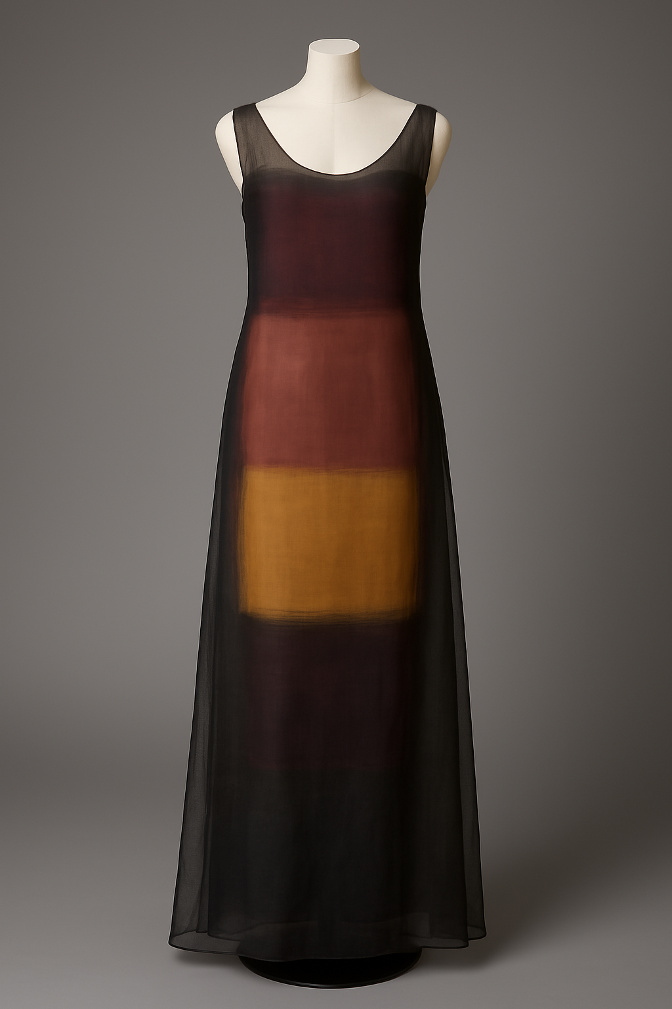
Image: ChatGPT
Fictional designer reference: Leora Dain
Collection title: Silent Radiance (1963)
Background and context:
During the early 1960s, fictional designer Leora Dain emerged as a pioneering figure in experimental fashion. Deeply influenced by emotional abstraction in contemporary art, Dain was known for translating raw, expressive brushstrokes into wearable silhouettes. Her most iconic piece from the Silent Radiance collection was the Echoes in Fabric gown – a softly structured evening dress inspired by the emotional tension and tonal harmony found in the colour-field paintings of her contemporaries.
Rather than replicating visual art, Dain sought to interpret mood and emotion through textile, drape and colour gradation, creating garments that communicated rather than decorated.
Design objective:
Create a modern couture dress inspired by Dain’s imagined Echoes in Fabric, using layering, tonal variation and fluid structure to evoke emotional depth. The outcome should feel painterly and immersive while remaining elegant, wearable and technically sophisticated.

Task
Complete a SWOT analysis on this brief.

The following materials relate to lesson 3: Inclusive designs

Inclusivity review worksheet
Question | Response
Who would be in attendance at the college open day?
Is the design gender-neutral?
Is this suitable for all body types?
Are colour choices accessible (e.g. for colour blindness)?
Could any part of the design be culturally insensitive?
Discuss improvements.

Hoodie two review questions
- Identify who might feel excluded from this design.
- Assess how inclusive the branding and messaging is.
- Suggest how this design could be more inclusive.

Inclusive designs
Teacher note:
Groups:
- ceramics – jug
- jewellery – necklace
- textiles/print – image of textile print
- furniture – stool.


Ceramic jug

Image: ChatGPT
Necklace
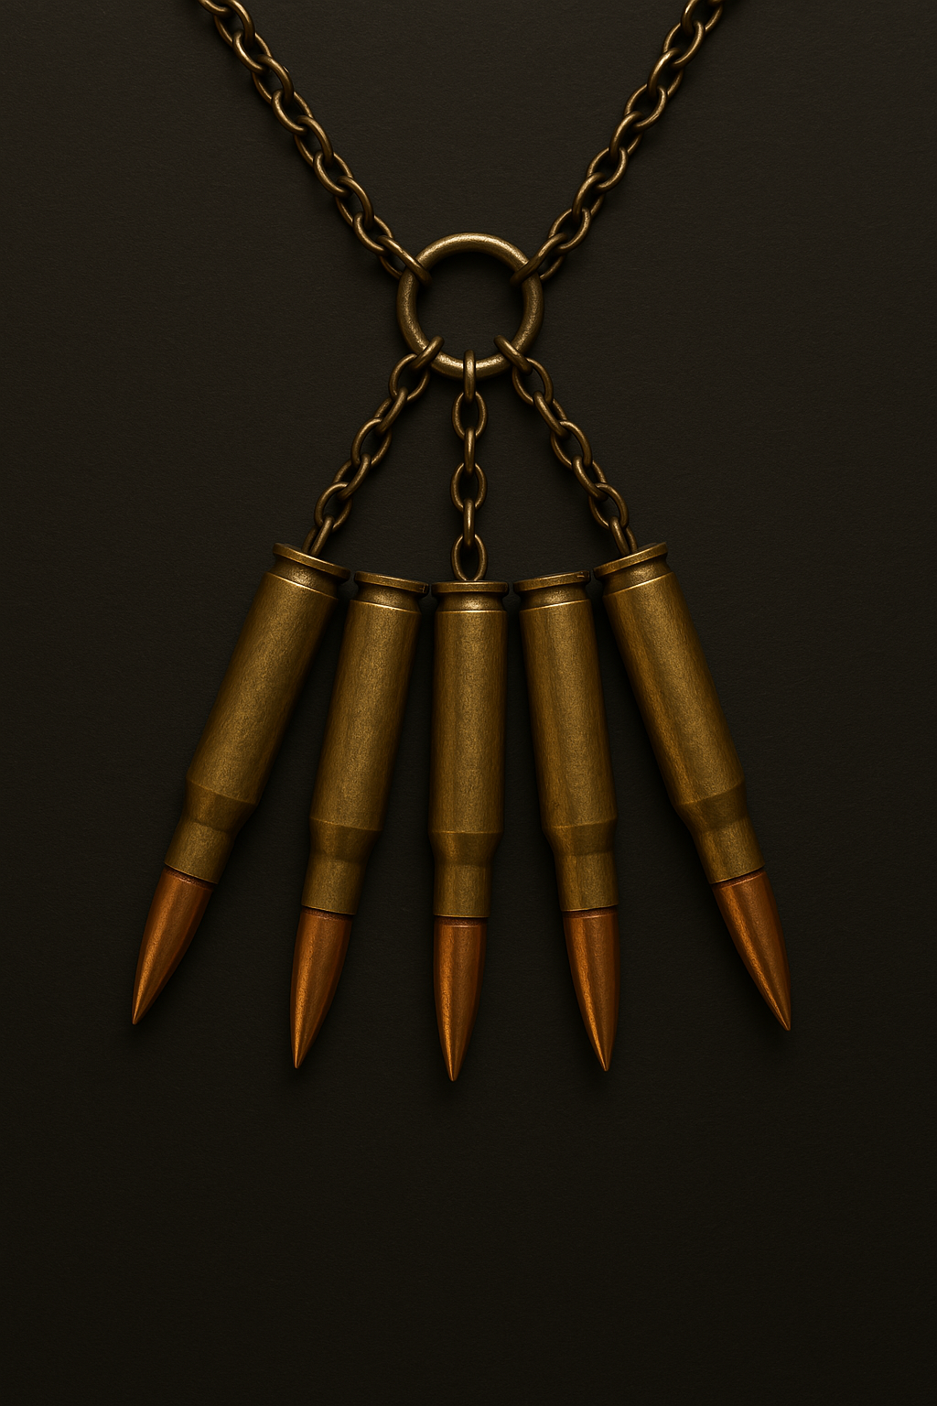
Image: ChatGPT

Textile print


Image: ChatGPT
Stool
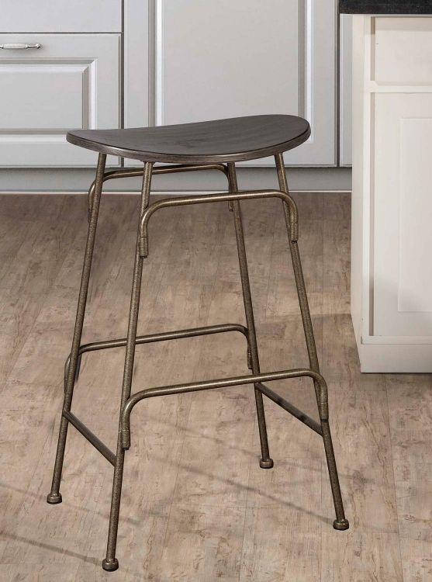
Image: ChatGPT

Learner personas
Hoodie images:
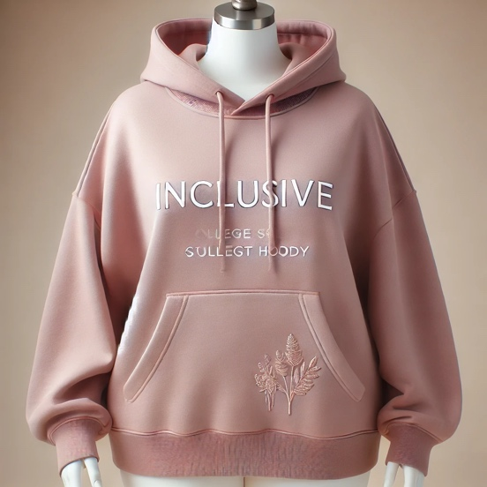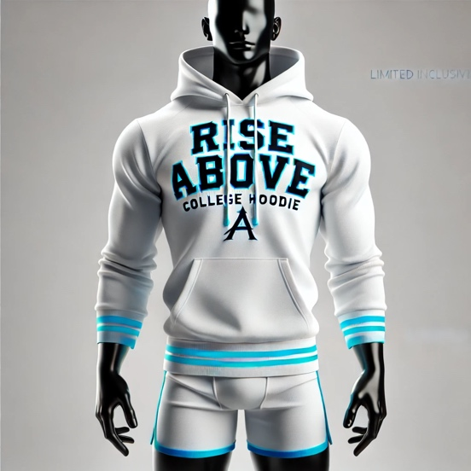
Images: ChatGPT

Taylor (they/them)
Taylor is non-binary and prefers clothing that avoids gender styles. They want to feel represented and comfortable in what they wear.
How inclusive is the design for Taylor?
How could the hoodie be improved for Taylor?
Amina (she/her)
Amina is Muslim and wears modest clothing, including long sleeves and loose fits. She values representation and comfort when choosing what to wear in public.
How inclusive is the design for Amina?
How could the hoodie be improved for Amina?
Liam (he/him)
Liam is a wheelchair user who finds it difficult to wear tight or awkwardly shaped clothing. Accessibility and ease of use are priorities for him.
How inclusive is the design for Liam
How could the hoodie be improved for Liam?
Maria (she/her)
Maria is a plus-size learner who often struggles to find college merchandise in her size. She wants to feel included in all learner events and branding.
How inclusive is the design for Maria?
How could the hoodie be improved for Maria?

Inclusivity checklist
Use this checklist to evaluate whether a jewellery product is inclusive. Tick off each question as you reflect on how well it considers different people’s needs, identities and experiences.
1. Gender inclusivity
☐ Does it avoid reinforcing gender stereotypes?
☐ Is it welcoming and accessible to people of all gender identities?
2. Size and body inclusiveness
☐ Does it consider a wide range of body types and physical needs?
☐ Is it comfortable or accessible for people of all sizes?
3. Cultural awareness and representation
☐ Are language, imagery and symbols used respectfully and appropriately?
☐ Does it acknowledge or represent cultural diversity in a thoughtful way?
☐ Are any cultural prints or references used in a respectful and informed manner?
☐ Have cultural elements been included in collaboration with or input from relevant communities?
4. Accessibility and usability
☐ Can people with disabilities engage with or use it without barriers?
☐ Are visual or physical design choices accessible to everyone?
5. Representation and visibility
☐ Does it reflect a diverse range of people or perspectives?
☐ Are different identities included in a respectful and visible way?
6. Language and communication
☐ Is the language inclusive, clear and respectful to all audiences?
☐ Could anything be misinterpreted or feel exclusive to certain groups?

The following materials relate to lesson 4: Consolidating skills

Matching cards
Teacher instructions: Print matching cards – one set of six cards per pair. Cut out the cards and shuffle. Learners to match each component of a design brief to its correct definition.

Card A: Purpose
Card B: The reason behind the project – what it aims to achieve

Card A: Target audience
Card B: The specific group of people the content is designed for

Card A: Deliverables
Card B: The final outputs or products that must be submitted

Card A: Constraints
Card B: The limitations, such as time, budget or resources

Card A: Timeline
Card B: The schedule, including key deadlines and milestones

Card A: Tone of voice
Card B: The style or mood of the communication; e.g. formal, friendly playful

Wear your voice – mental health campaign brief
Client: a national charity supporting young people’s mental health.
Audience: young people aged 14–18.
Project title: Wear your voice – a fashion-based mental health awareness campaign.
Scenario:
You have been commissioned by a national charity to design and create a textile-based awareness campaign that uses fashion as a communication tool to:
- encourage open conversations about mental health
- break the stigma surrounding mental health issues
- signpost young people to support services through creative design
- ensure all work is inclusive, accessible and reflective of a diverse audience, including different cultures, gender identities, abilities and neurotypes.

Plenary quiz
- What should you define before communicating to ensure your message has direction and focus?
- How can you make your language clearer and easier to understand?
- What will help your audience follow your message more easily?
- Why is it helpful to ask others for their thoughts on your message?
- What can you do to spot areas of confusion or information overload before finalising your work?
- In SWOT, what kind of things go under Opportunities?
- True or false: A good brief should include deliverables and a timeline.
- What might be a ‘threat’ when responding to a design brief?
- Why is it important to consider accessibility in a design brief?
- What is one way you could improve a vague or unclear brief?

Answers plenary quiz
- Answer: your purpose – know what you want to say and why
- Answer: use clear, concise words and avoid jargon
- Answer: structure information in a logical flow
- Answer: to check if your message is clear and easily understood
- Answer: review with fresh eyes or take a step back
- Answer: external factors that could benefit your project, such as emerging trends, market gaps, new technology or potential partnerships
- Answer: true
- Answer: anything that could negatively affect the success of the project, such as tight deadlines, budget constraints, strong competition or changing client requirements
- Answer: to ensure the final design can be used and understood by everyone, including people with disabilities or different needs, promoting inclusion and usability
- Answer: ask clarifying questions to the client or stakeholders, or suggest a clearer structure that includes purpose, target audience, deliverables, and timeline.

The following materials relate to lesson 5: Applying evaluative skills

Smart wear brief for the sustainable commuter
Client: AetherTech – a sustainable smart wear company.
Target market: Urban commuters aged 22 to 35.
Design values: Environmental responsibility, tech integration, comfort and style.
Scenario:
AetherTech is launching its first wearable product and needs an evaluation of the two concept prototypes.
Product concepts:
Concept A: smart temperature-regulating jacket
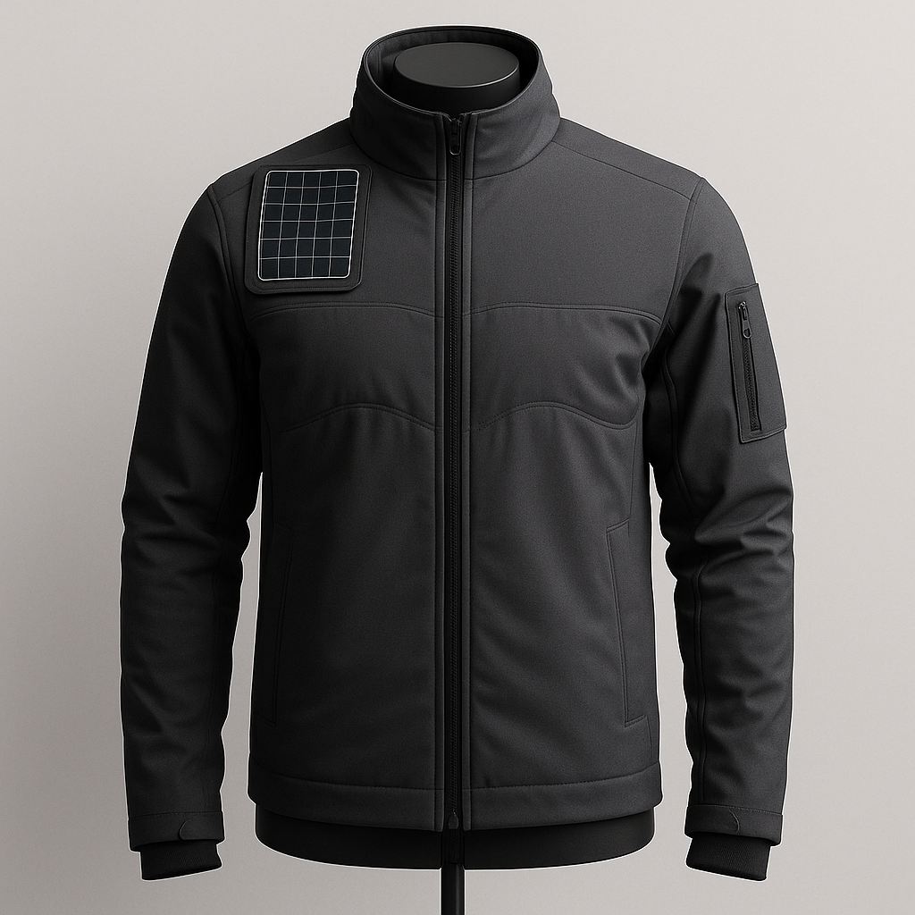
Image: ChatGPT
- Solar-powered mesh adjusts body temperature
- Biodegradable fibre blend construction
- Limited waterproofing; slightly bulky battery pack

Concept B: modular smart commuter cape
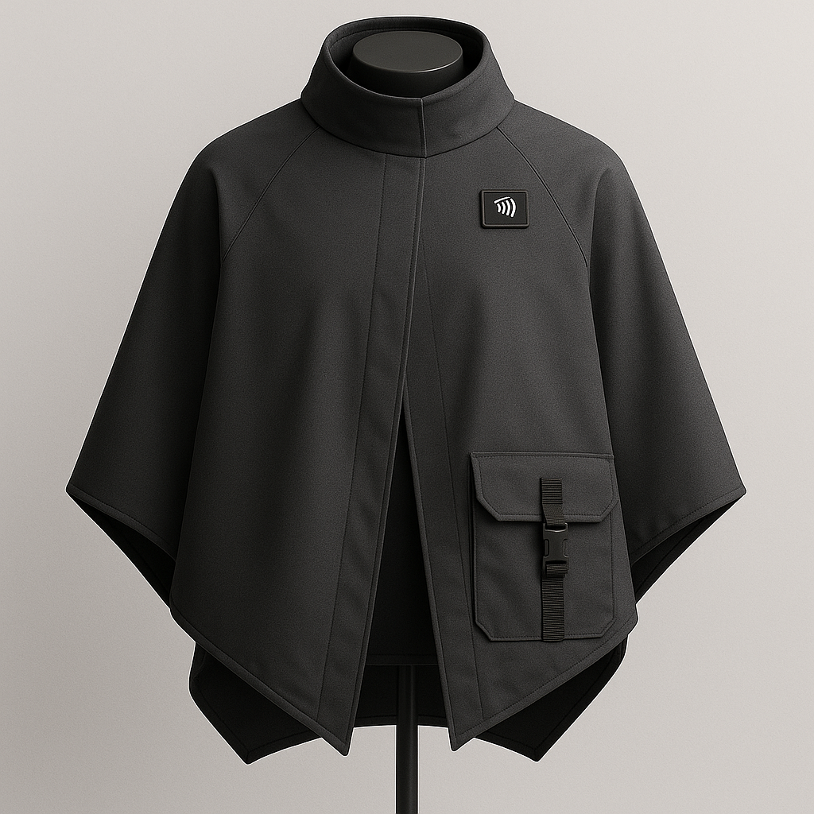
Image: ChatGPT
- Made from recycled marine plastic with a water-repellent coating
- Lightweight, foldable, includes near-field communication payment chip in collar
- No temperature regulation.
Task:
Working in your allocated group, use analytical evaluation to break down the design features. Use comparative evaluation to contrast their strengths and weaknesses, and use critical evaluation to decide which concept (or combination) better meets the brief.
- Discuss how well each jacket matches the client brief requirements.
- Compare the results of the analysis of each jacket.
- Decide which is the best jacket to meet the client brief or propose a new design or a hybrid solution.

The following materials relate to lesson 6: Using feedback to refine designs

The Good Earth Skincare brief
Client: The Good Earth Skincare
Background: The Good Earth Skincare is a mid-range, eco-conscious skincare brand that targets environmentally aware consumers aged 25–40. The brand is known for its use of sustainable, plant-based ingredients and minimalistic packaging.
Design objective:
The client wants to refresh the packaging of their best-selling moisturiser, Hydra-Lush, to better communicate their eco-friendly ethos and modernise the look for a younger demographic.
Requirements:
- Highlight sustainable ingredients and vegan certification prominently.
- Include quick response (QR) code for digital product information in order to reduce printed materials.
- Maintain earthy tones but incorporate a fresh, contemporary aesthetic.
- Packaging must use recyclable or compostable materials.
- Must stand out on retail shelves next to competitor products.
Current design:

Image: ChatGPT

Structured feedback form
Write your answers in the boxes provided.
What is the strongest visual aspect of the design? Why?
What is one area that could be improved?
How could the design better reflect the brand’s sustainability focus?
Is the QR code placement effective? Why or why not?
What changes would you recommend which will meet the requirements of the client brief?

Refinement
Write your answers in the boxes provided.
Proposed refinements:
How does the proposed change align with the client brief and target audience?
Provide a sketch of the refined The Good Earth Skincare product.

The following materials relate to lesson 7: Demographic and geographic considerations in design

User profiles
Teacher note: Allocate one profile to each group.

User profile one
A four-year-old child attending nursery in Reykjavik, Iceland:
- cold climate, lots of snow and rain
- needs mobility for play and safety outdoors
- likely to wear many layers.
Prompt: What kind of jacket or shoes would this child need for both comfort and safety?

User profile two
A 70-year-old grandmother living in a rural village in Kenya:
- warm, dry climate
- walking long distances on uneven terrain
- to incorporate modesty and traditional fabric
Prompt: How might footwear or clothing be designed to support comfort, mobility and cultural respect?

User profile three
A 25-year-old music producer in Seoul, South Korea:
- urban environment, busy social life
- trend-conscious and tech-savvy
- uses public transport daily.
Prompt: How could a bag or outerwear item reflect both practicality and fashion trends?

User profile four
A 30-year-old wheelchair user living in São Paulo, Brazil:
- hot, humid climate
- navigating a large, hilly and often crowded city
- prioritises comfort, cooling and ease of dressing.
Prompt: What features would a jacket or bag need to be inclusive, breathable and easy to use?

Cycling bag
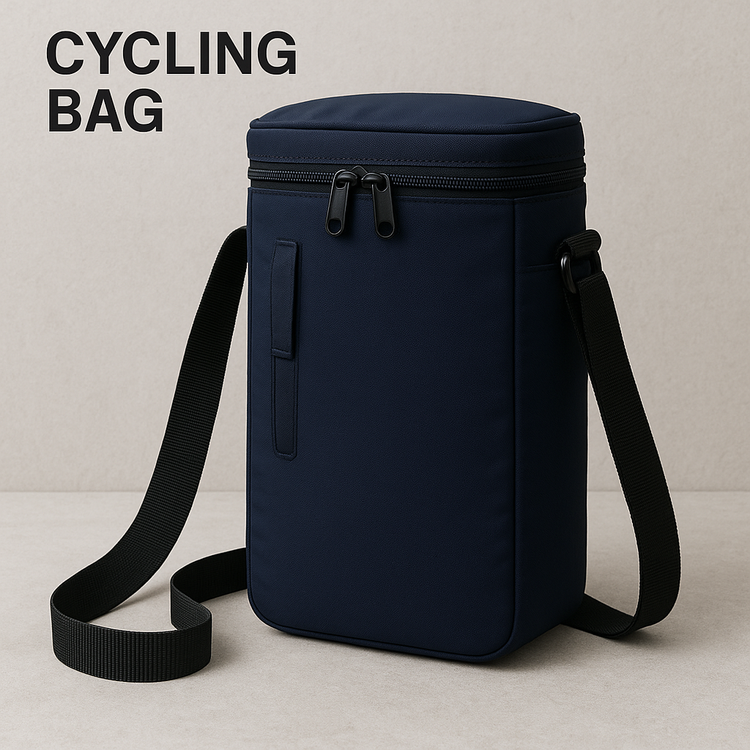
Image: ChatGPT
I am designing a waterproof cycling bag for a 22-year-old delivery cyclist in rainy London. The bag will be made from recycled waterproof canvas with reflective strips for visibility during darker winter months. It will have a padded strap for shoulder comfort and a roll-top closure to keep contents dry.
The cyclist needs something lightweight but durable for long hours outdoors. In London’s climate, sudden rain is common, so waterproofing is essential. The bag will include an internal sleeve for a phone and external clips for attaching a small light. This design supports both safety and function, while reflecting a practical, urban style. It also considers sustainability, which matters to many young urban professionals.

Feedback slips
Feedback slip one
• One thing I liked about your idea is...

• One suggestion I make to improve your design is…

• Your design suits the user because...

• You could think more about...
Feedback slip two
• One thing I liked about your idea is...

• One suggestion I make to improve your design is…

• Your design suits the user because...

• You could think more about...
Feedback slip three
• One thing I liked about your idea is...

• One suggestion I make to improve your design is…

• Your design suits the user because...

• You could think more about...

The following materials relate to lesson 8: Consolidating advanced evaluative skills

Key terms matching quiz
Match the key terms to their correct definitions.
Write the letter of the correct definition next to each term.
Match the following key terms with the correct definitions:
- Constraints
- Brand identity
- Accessibility
- Psychographics
- Demographics
- Inclusive design
- Quick response (QR) code
- Sustainability
- Visual hierarchy
- Target audience
Definitions:
- The characteristics, attitudes and values of a specific group of consumers.
- Limitations or restrictions that affect the design process, such as budget, materials or timeline.
- The specific group of people a design or product is intended to reach.
- The consistent visual and messaging style of a brand that distinguishes it from others.
- Designing products and services that minimise environmental impact.
- Ensuring that designs are usable by people with varying abilities or disabilities.
- The arrangement of elements to guide the viewer’s attention in a specific order.
- Creating products, services or experiences that are usable by all people, regardless of ability.
- Statistical data about a population, such as age, gender and income.
- A machine-readable code used to link physical products to digital information.

Key terms matching quiz answers
Psychographics – A. The characteristics, attitudes and values of a specific group of consumers.
Constraints – B. Limitations or restrictions that affect the design process, such as budget, materials or timeline.
Target audience – C. The specific group of people a design or product is intended to reach.
Brand identity – D. The consistent visual and messaging style of a brand that distinguishes it from others.
Sustainability – E. Designing products and services that minimise environmental impact.
Accessibility – F. Ensuring that designs are usable by people with varying abilities or disabilities.
Visual hierarchy – G. The arrangement of elements to guide the viewer’s attention in a specific order.
Inclusive design – H. Creating products, services or experiences that are usable by all people, regardless of ability.
Demographics – I. Statistical data about a population, such as age, gender and income.
QR code – J. A machine-readable code used to link physical products to digital information.

Client brief: Verdant threads
Background:
Verdant Threads is a sustainable fashion brand known for its use of organic, recycled and low-impact materials. The brand is relaunching its range with a focus on outerwear to attract a younger audience. Your task is to design a signature fashion item that reflects the brand’s eco-conscious values while appealing to trend-aware consumers aged 18–30.
Project objective:
Design a statement outerwear piece (e.g. jacket, coat or rainwear) that:
- represents the brand’s commitment to sustainability
- feels modern, stylish and wearable
- connects with young, urban consumers
- can be marketed both online and in-store
Target audience:
- 18- to 30-year-olds living in urban areas
- Fashion-conscious consumers who want style without environmental compromise
- People who value ethical production, sustainable materials and inclusivity
Key design considerations:
- Use recycled or organic materials (e.g. organic cotton, recycled canvas, biodegradable finishes).
- Reflect brand colours: forest green, earth brown and cream.
- Include practical features (e.g. roll-top hood, breathable lining, internal pockets).
- Ensure the item is gender-inclusive and designed with comfort and function.
- Avoid synthetic plastics, heavy branding or throwaway fashion aesthetics.
Client vision:
“We want a coat or jacket that is sustainable but stylish, something people are proud to wear, not just because it is ethical, but because it looks great. It should feel practical for urban life, be made for movement and echo our values: slow fashion, conscious design and creative impact.”

Current jacket design:
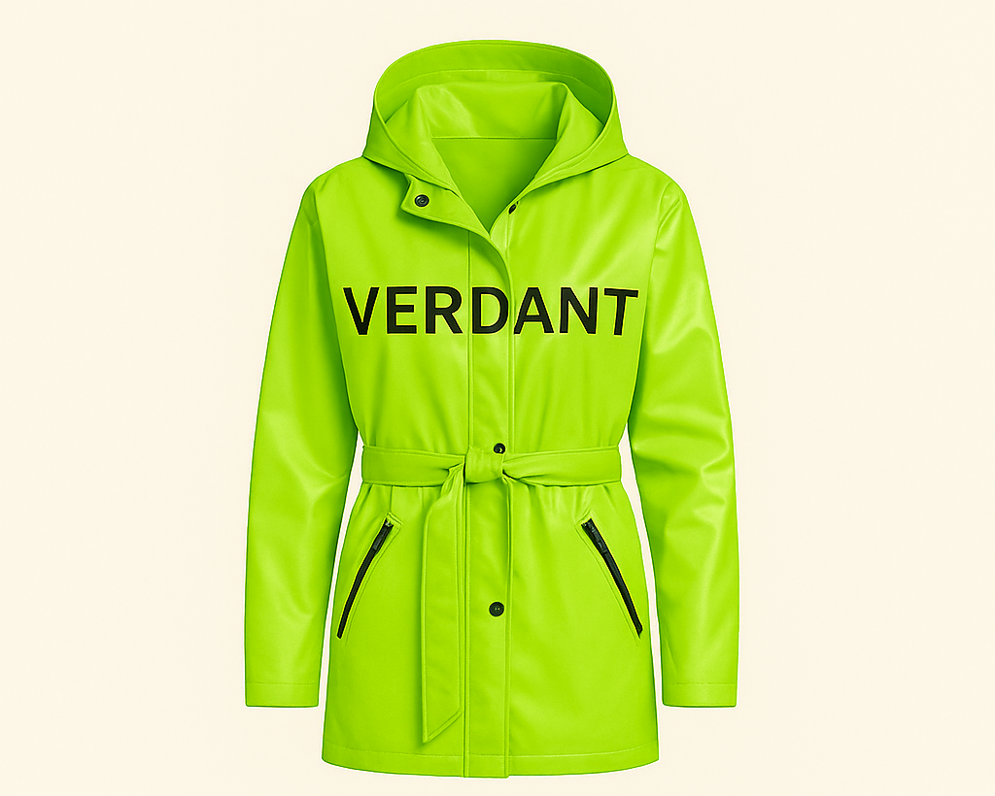
Image: ChatGPT

Structured critique form

Use this form to conduct a structured critique of the assigned design. Focus on the key areas of audience targeting, clarity of message, sustainability and inclusivity. Provide specific, actionable feedback and justify your suggestions.
Audience analysis:
Who is the intended audience for this design?
How well does the design align with the audience’s needs?
What adjustments could make the design more relevant to the target audience?

Clarity of message:
What is the main message of the design?
Is the message communicated clearly?
Suggest one way to enhance clarity without altering the main concept:
Sustainability and environmental impact:
Are sustainable elements clearly communicated in the design?
How could the design more effectively convey sustainability?

Suggest one practical change to enhance eco-consciousness:
Inclusivity and accessibility:
Are there any elements that may exclude certain audiences?
How can the design be adjusted to be more inclusive?
Suggest a change to make the design more accessible to a wider audience:
Overall recommendations:
Based on your critique, what is the most impactful change you would recommend?

Why do you believe this change would improve the overall effectiveness of the design?
Use one evaluative method from previous lessons learning to evaluate the design, and provide a reason for your choice.

Client brief: Urban Nest Café
Client: Urban Nest Café
Background:
Urban Nest Café is a popular café located in a busy, trendy area of the city. It caters to young professionals, learners and environmentally conscious consumers. Despite its sustainable practices, Urban Nest’s current branding is inconsistent and lacks visual impact. The café wants to establish itself as the go-to spot for eco-conscious, modern customers while maintaining its approachable, community-focused vibe.
Project objective:
Urban Nest Café wants to launch a new branding campaign to better communicate its eco-friendly values while attracting a younger, trend-conscious audience. The focus is on cohesive visual branding across all marketing materials, starting with an in-store poster that promotes sustainability initiatives.
Design deliverable: in-store poster (A2 size):
Promote Urban Nest’s key sustainable practices:
- Show that it uses reusable cups.
- Show that it uses locally sourced, fair-trade coffee beans.
- Show that it uses compostable packaging.
- Include the slogan: “Sip Sustainably” prominently.
- Integrate the café’s logo (a bird’s nest with a coffee cup) to maintain brand recognition.
- Include a Quick Response (QR) code that links to the café’s website for more information about its sustainability efforts.
- Maintain earthy, natural tones (greens, browns, neutrals) to align with the eco-friendly message.
- Ensure all text is legible and organised to clearly convey the key messages.
- Include a call to action, such as “Learn more about our sustainable practices”, below the QR code.

Design constraints:
- Must be visually impactful and eye-catching but maintain a minimalist, modern aesthetic.
- QR code must be clearly visible and easily scannable.
- Text hierarchy must be clear – primary focus on the slogan, followed by key sustainable practices.
- Must appeal to both the existing customer base and new, younger customers.
Current design:

Image: ChatGPT
- The poster uses a green and beige colour scheme but lacks visual contrast, making it difficult to read from a distance.
- The slogan is positioned too low, making it easy to miss.
- The QR code is small and located in the bottom corner, reducing its visibility.
- Text is densely packed, making it overwhelming to read.
- The coffee cup illustration is generic and does not align with Urban Nest’s brand identity.

Client feedback summary:
“The poster looks bland and uninspired – it does not grab attention.”
“Sustainability messaging is too subtle and gets lost among the text.”
“The QR code placement is ineffective – it needs to be more prominent.”
“The overall layout feels disjointed and lacks focus.”

Reverse-engineering worksheet
In this task, you will reverse-engineer a completed design to identify the key design decisions, their intended impact and areas for potential improvement.
Consider how each element contributes to the overall effectiveness of the design and how well it aligns with client objectives.
Design analysis worksheet
- Target audience:
Who do you think the design is intended for?
What elements suggest this audience?
- Design elements analysis:
Identify three key design elements (e.g. colour palette, typography, imagery) and their intended impact.
- Intended impact:
Suggested change:

- Message clarity:
What is the main message being communicated?
How effectively is this message conveyed? Why?
What specific change would make the message clearer?
- Brand alignment:
How well does the design reflect the brand’s values or objectives?
Suggest one way to improve brand alignment:
- Sustainability and inclusivity:
Are there any elements that communicate sustainability or inclusivity?
How could the design be adjusted to enhance these aspects?
- Overall recommendation:
What is the most impactful change you would recommend, and why?

Client brief: Trend Visionary
You have been commissioned by Trend Visionary, a cutting-edge fashion brand, to create an innovative fashion outcome for their upcoming Spring/Summer Collection. The collection focuses on sustainability, forward-thinking design and appealing to a contemporary target audience. Your task is to interpret the brief, extract key information and design an outcome that meets the brand’s aesthetic and functional requirements.
Target audience;
- Age group: 18–30
- Style-conscious, eco-aware consumers
- Interested in sustainable and ethical fashion
- Inspired by urban culture and futuristic influences
- Seek unique, limited-edition fashion pieces.
Design considerations:
Your outcome must:
- align with Trend Visionary’s contemporary, sustainable ethos
- be wearable and functional yet push creative boundaries
- incorporate innovative materials and construction techniques
- reflect a balance between high fashion and commercial appeal
- consider practicalities such as durability and comfort.
Materials and sustainability:
- Primary materials should be sustainable (organic cotton, recycled polyester, plant-based leather, etc.).
- Any synthetic elements should be biodegradable or recyclable.
- Use minimal waste-cutting techniques (zero-waste pattern cutting, modular design, etc.).
- Avoid harmful dyes or treatments.
- Sourcing from ethical manufacturers is encouraged.
Complexity of design:
- Consider details like fastenings, layering and versatility.
- It can include innovative embellishments (3D printing, upcycling, interactive elements).

Additional elements:
- Consider how your design may fit within a marketing campaign.
- Think about cultural and seasonal influences.
- Propose colour palettes and fabric textures.
- Reflect on the potential retail price and customer appeal.
Remember: This brief includes a lot of information, but not all of it may be essential to your design. It is your job to extract the most important elements and create a strong concept that meets the needs of the client.

The following materials relate to lesson 9: Refining evaluative skills through iterative design

Professional conduct summary
Why professional conduct matters:
Professional conduct is essential in any workplace. It shapes how others perceive you, fosters a positive work environment and enhances career opportunities. Employers expect employees to present themselves professionally through their behaviour, communication and appearance.
Key aspects of professional conduct:
1. Body language
- Maintain good posture to show confidence and attentiveness.
- Avoid crossing arms, as it may appear defensive or uninterested.
- Use open gestures and moderate hand movements when speaking.
- Nod occasionally to show active listening.
2. Dress code
- Dress appropriately for the industry; business casual or formal may be required.
- Ensure clothing is clean, neat and free from inappropriate logos.
- Wear appropriate footwear (e.g. closed-toe shoes in formal settings).
- Maintain good personal hygiene and grooming.
3. Eye contact
- Make regular eye contact to show confidence and engagement.
- Avoid staring, but do not look away too frequently, as it may indicate nervousness or dishonesty.
- In group discussions, shift eye contact naturally between individuals.
4. Communication skills
- Speak clearly and at a moderate pace.
- Use professional language; avoid slang and inappropriate humour.
- Listen actively by nodding and responding appropriately.
- Keep phone use to a minimum and avoid distractions.

5. Workplace etiquette
- Arrive on time and be prepared for meetings or tasks.
- Show respect to colleagues, supervisors and clients.
- Follow company policies and procedures.
- Keep your workspace tidy and respect shared spaces.
The impact of professional conduct:
Maintaining professional conduct helps build trust, fosters teamwork and ensures a productive and respectful work environment. By demonstrating these behaviours, you will be seen as reliable, competent and a valuable member of the workplace.
Remember: Professionalism is not just about appearance but also about how you interact with others and handle responsibilities. Strive to make a positive impression every day.

Mock discussion review sheet
Peer reviewer name: _____________________________________
Name of learner being reviewed: ___________________________
(Score how effectively the learner demonstrated professional conduct – circle one per category and provide a brief comment; 1 = Not at all demonstrated, 5 = Fully demonstrated.)
Professional conduct criteria | Score (1–5) | Comments
Body language | 1 • 2 • 3 • 4 • 5
Eye contact | 1 • 2 • 3 • 4 • 5
Communication skills | 1 • 2 • 3 • 4 • 5
Dress code | 1 • 2 • 3 • 4 • 5
Other comments:

Client brief review sheet
Peer reviewer name: _____________________________________
Name of learner being reviewed: ___________________________
Part 1: Professional conduct in presentation
(Score how effectively the learner demonstrated professional conduct – circle one per category; 1 = Not at all demonstrated, 5 = Fully demonstrated.)
Professional conduct criteria | Score (1–5) | Comments
Body language | 1 • 2 • 3 • 4 • 5
Eye contact | 1 • 2 • 3 • 4 • 5
Communication skills | 1 • 2 • 3 • 4 • 5

Part 2: Feedback on hand-drawn outcome
(Provide written feedback on the quality and effectiveness of the response to the client brief.)
Strengths of the outcome:
Areas for improvement and why:
Effectiveness of justifications given:
(How well did the learner explain their design choices?)

Exit ticket sheet
Name: _________________________
Date: _________________________

Exit ticket: quick summary
Reflect on the iteration process by answering the following questions:
- How did the iteration process improve your outcome?
- What would you do differently in further iterations?

Peer evaluation sheet
Learner name: ___________________________
Evaluator: _______________________________
Part 1: Mock discussion and presentation scoring
(Circle the appropriate score for each category; 1 = Not at all demonstrated, 5 = Fully demonstrated.)
Criteria | Mock discussion score | Presentation score
Body language | 1 • 2 • 3 • 4 • 5 | 1 • 2 • 3 • 4 • 5
Dress code | 1 • 2 • 3 • 4 • 5 | 1 • 2 • 3 • 4 • 5
Eye contact | 1 • 2 • 3 • 4 • 5 | 1 • 2 • 3 • 4 • 5
Communication skills | 1 • 2 • 3 • 4 • 5 | 1 • 2 • 3 • 4 • 5
Part 2: Design brief presentation feedback
(Circle the score that best reflects the learner’s performance in each area; 1 = Not at all demonstrated, 5 = Fully demonstrated.)
Criteria | Score (1–5)
Clear and creative ideas | 1 • 2 • 3 • 4 • 5
Persuasive and engaging | 1 • 2 • 3 • 4 • 5
Professional approach | 1 • 2 • 3 • 4 • 5
Client needs addressed | 1 • 2 • 3 • 4 • 5

Part 3: Written feedback
One strength in their performance:
One area for improvement:
Final comments:

The following materials relate to lesson 10: Final evaluation and presentation

Client brief: Bag doubles up as jacket
The client is a fashion-forward brand focused on sustainable, multifunctional designs. It is looking for an innovative solution that addresses both practicality and style for the modern consumer. The client brief requires the design of a bag that doubles up as a jacket, which can serve the needs of individuals who want versatility in their clothing and accessories. This design must seamlessly transition between the two functions without compromising on aesthetics, comfort or usability.
Design requirements:
- Functionality: the bag should easily transform into a jacket and back again into a bag, with clear, simple mechanisms that enable this transformation.
- Materials: the design should incorporate eco-friendly materials.
- Aesthetics: the design should cater to both gender-neutral and unisex preferences.
- Comfort: the jacket must be practical for daily use.
- Size and shape: the design needs to include a range of sizes and consider disability and impairment considerations.
- Sustainability: the design should reflect the brand’s commitment to the environment.
Target market:
- Young professionals and fashion-conscious individuals.
Deliverables:
- Initial concepts: provide a written solution that meets the client brief requirements of a bag-to-jacket design.
- Mood board: present a mood board that visually conveys the style, colours, materials and aesthetic qualities of the design.

Success criteria
Alignment with client brief:
- Does the mood board clearly reflect the client’s core requirements, including the transformation of the bag into a jacket?
- Are the eco-friendly materials and sustainability considerations appropriately represented?
- Is there a clear connection between the design elements (colour palette, textures and shapes) and the target market (fashion-forward, eco-conscious and inclusive)?
- Does the design address the accessibility needs mentioned in the brief (e.g. mechanisms that are easy to use for individuals who use a mobility aid or a wheelchair)?
Functionality and versatility:
- Does the mood board show designs that demonstrate the versatility of the product, effectively combining both the bag and jacket functions?
- Are the design solutions clear on how the bag-to-jacket transformation will work, considering ease of use for a wide range of consumers?
Aesthetic appeal:
- Is the overall look modern and stylish, adhering to the minimalist, gender-neutral and unisex styles requested?
- Are the selected colour palette and textures visually appealing and suitable for a broad audience, including urban professionals?
- Does the mood board effectively represent both the practical (bag) and wearable (jacket) elements without compromising on aesthetics?
Sustainability and material selection:
- Are the materials shown on the mood board aligned with the sustainability goals in the brief? (The materials are recycled fabrics, biodegradable materials and upcycled textiles.)
- Does the board convey innovative use of materials that are both practical and sustainable?

Innovative solutions:
- Does the mood board present any creative or innovative ideas that go beyond basic functional requirements?
- Are there thoughtful, inventive solutions that meet both the aesthetic and practical aspects of the design brief?
Inclusivity and accessibility:
- Are design elements (e.g. fastenings, adjustments, closures) included that accommodate users with varying abilities?
- Does the mood board address inclusivity not only in design but also in how the product will be used by people with disabilities?
Presentation and communication:
- Is the mood board professionally presented with attention to detail in the execution?
- Does it communicate the vision clearly, using visuals, colours and layouts that effectively represent the ideas to a client or peer audience?

Self-evaluation
Rate your level of confidence for each statement, from 1 to 10.
1 = Not confident
10 = Very confident
How confident are you at: | Self-evaluation rating
Identifying the main requirements of a design or project client brief.
Judging whether a design or idea meets client requirements or criteria given in the brief.
Identifying both the strengths and weaknesses of a design.
Justifying why a design is successful or unsuccessful based on specific criteria.
Considering alternative approaches or solutions when evaluating a design.
Questioning the assumptions behind the design choices (e.g. material selection, usability).
Recognising the impact of external factors (such as sustainability, social issues or trends) on the design.
Suggesting improvements to design ideas.


FUNDED BY
PRODUCED BY

This programme is funded by the Department for Education
Capital City College has produced this resource on behalf of the Education and Training Foundation

