
Support holistic delivery of Core Content and Occupational Specialism content: Digital infrastructure
ET-FOUNDATION.CO.UK
T LEVEL IN DIGITAL SUPPORT SERVICES (Part 2)

The following materials relate to lesson 7: Network operating system
Activity: Download Windows Server 2019 ISO
Hyper-V Manager
Activity: Install Windows Server 2019 on Server VM using VirtualBox
Activity: Initial configuration of Windows Server 2019
Activity: Confirm initial configuration

Activity: Download Windows Server 2019 ISO
Instructions
Download a copy of Windows Server 2019. In practice, you may use a USB drive or have it hosted locally for access.
microsoft.com/en-us/evalcenter/download-windows-server-2019

Hyper-V Manager
Install Windows Server 2019 on Server VM created in lesson 6.

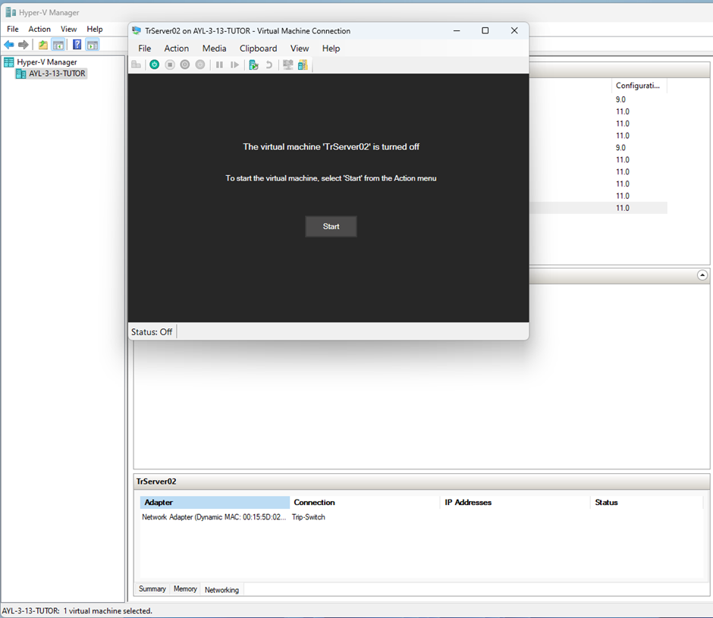

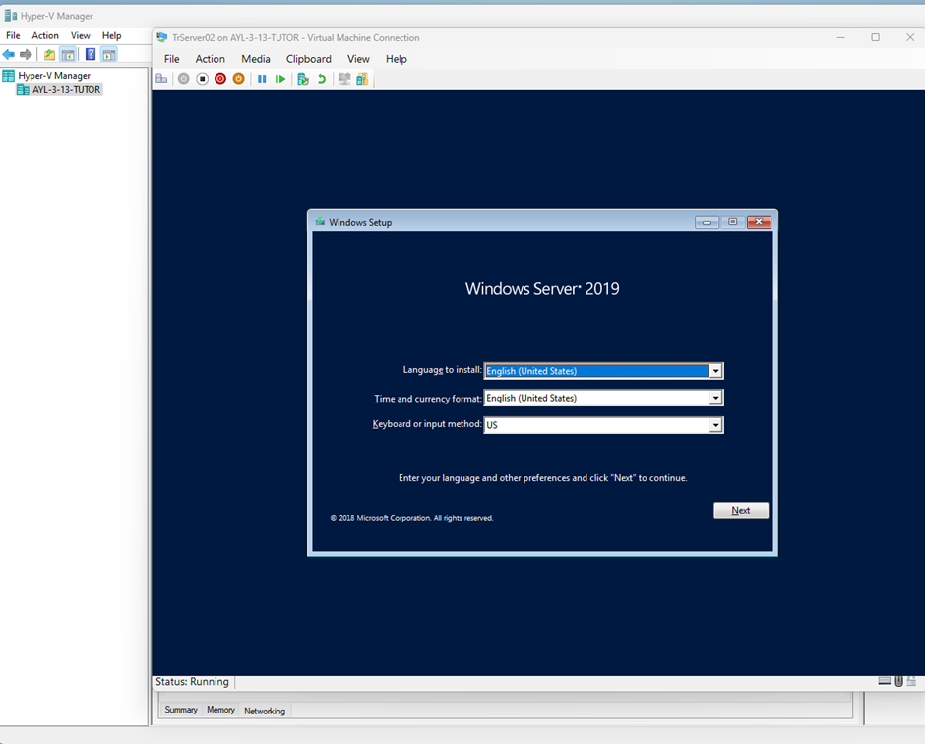

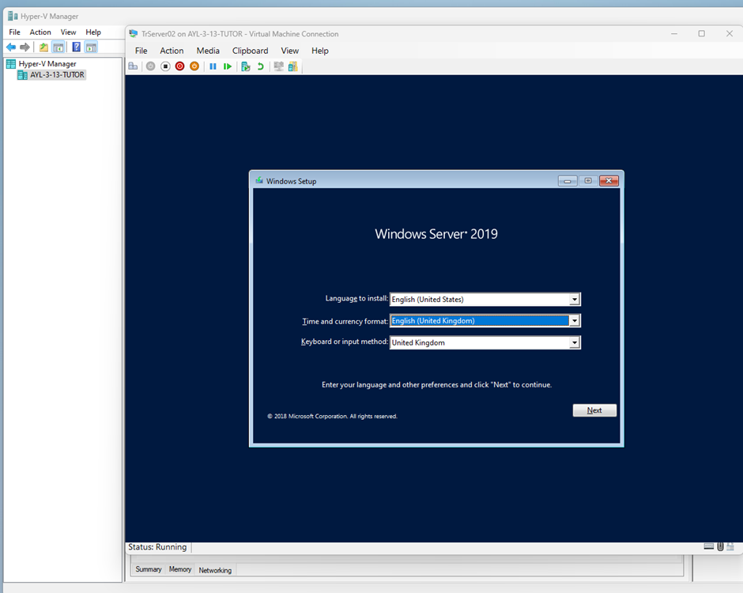

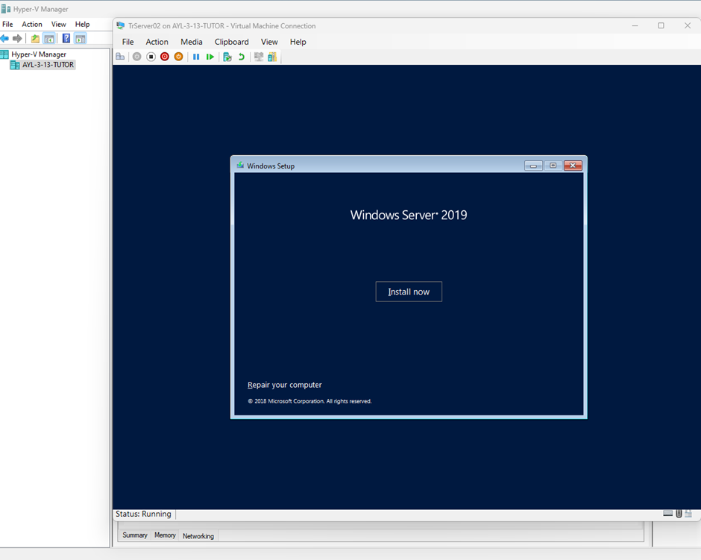

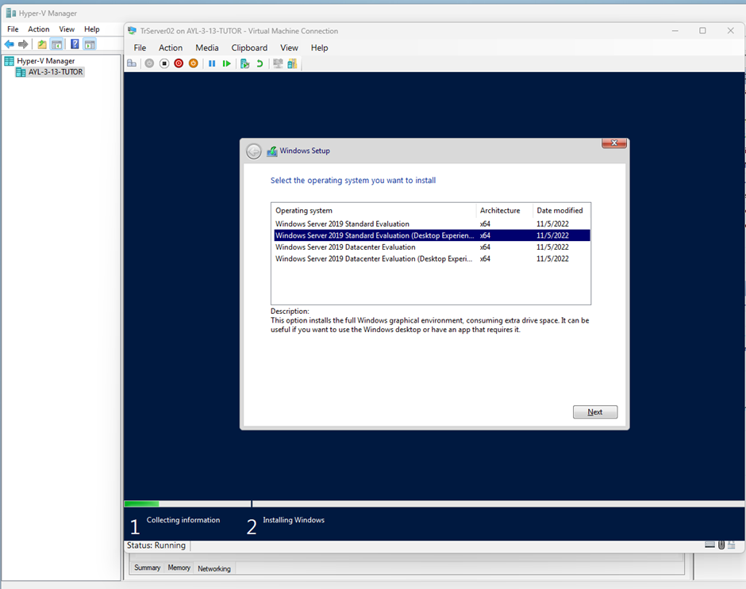

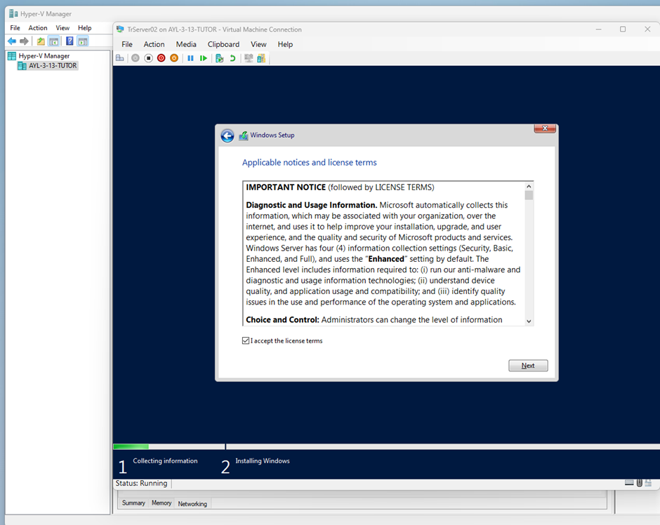

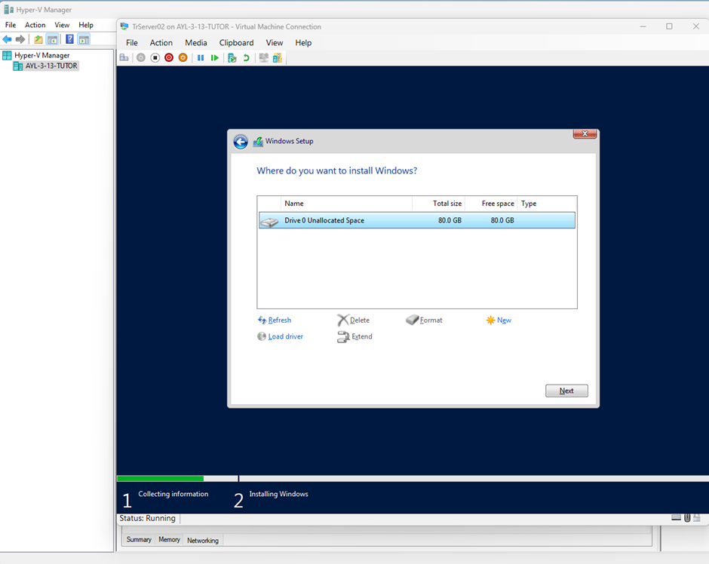

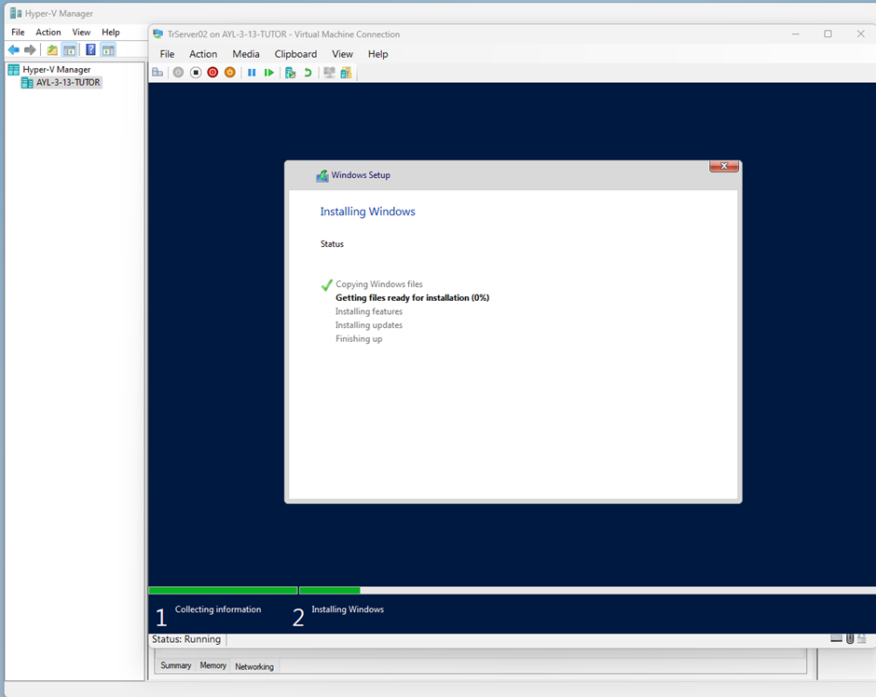

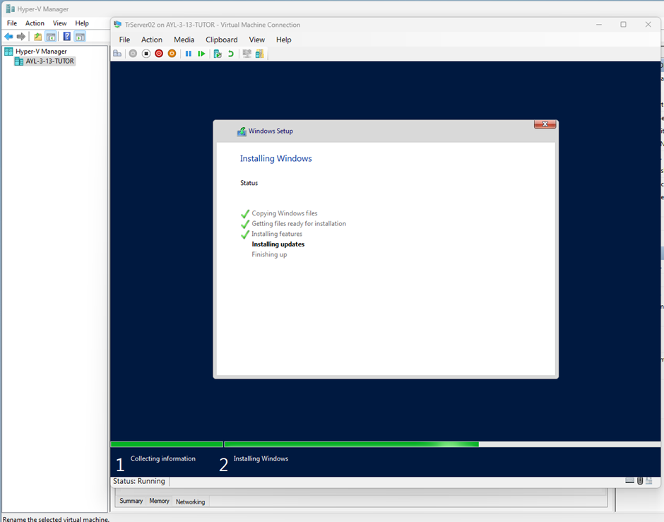

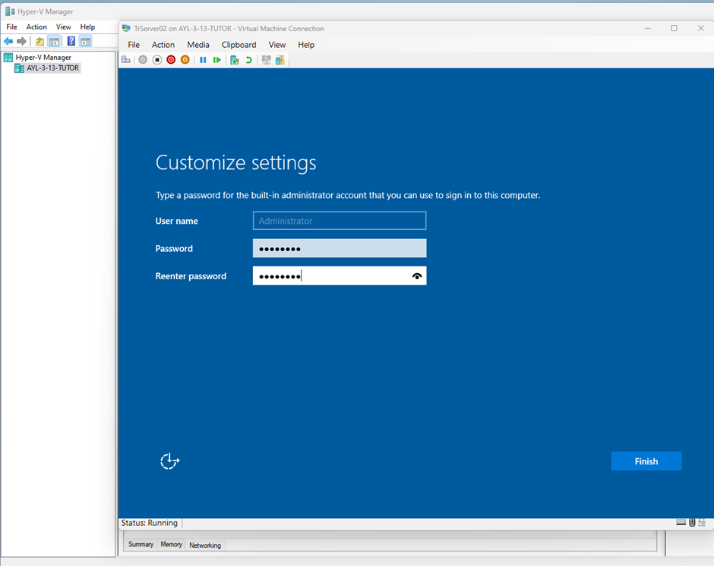

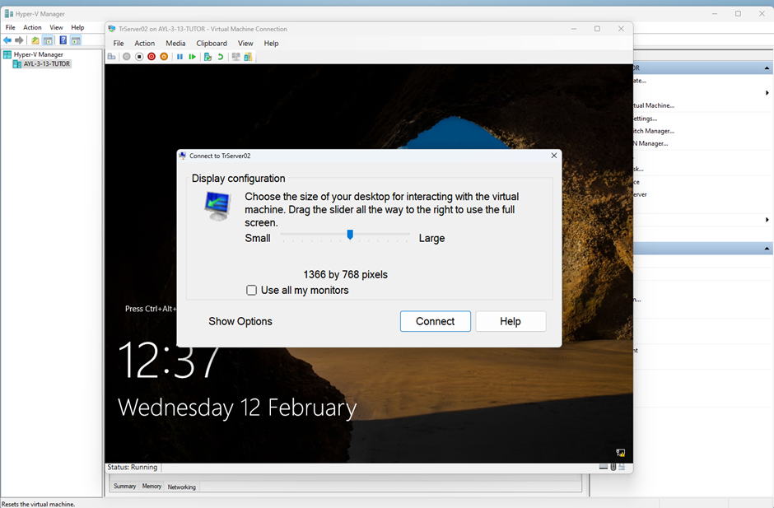
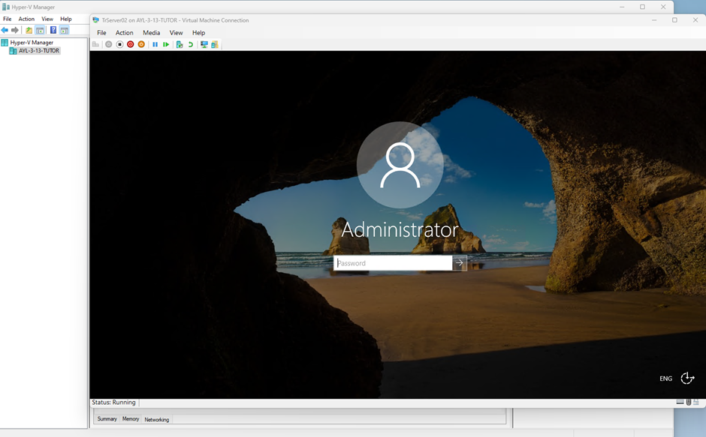

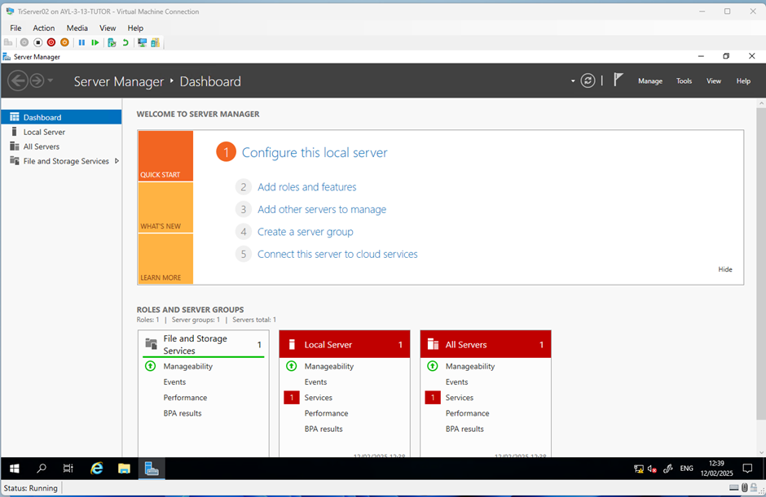

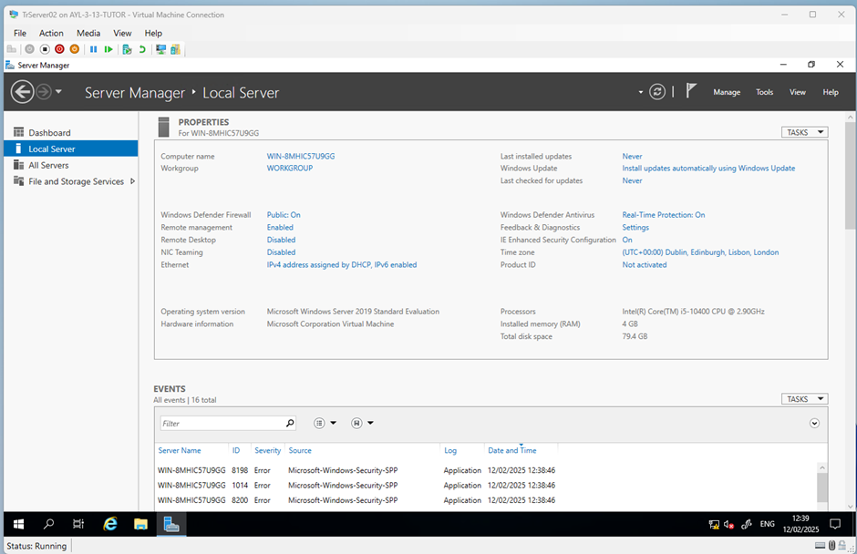

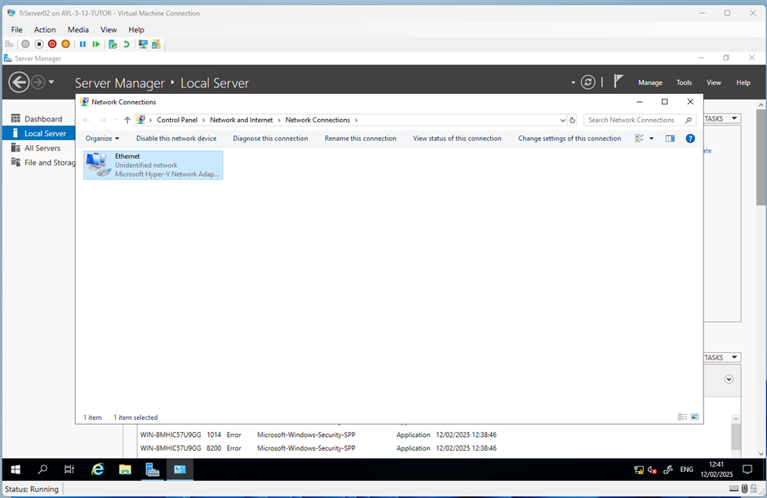

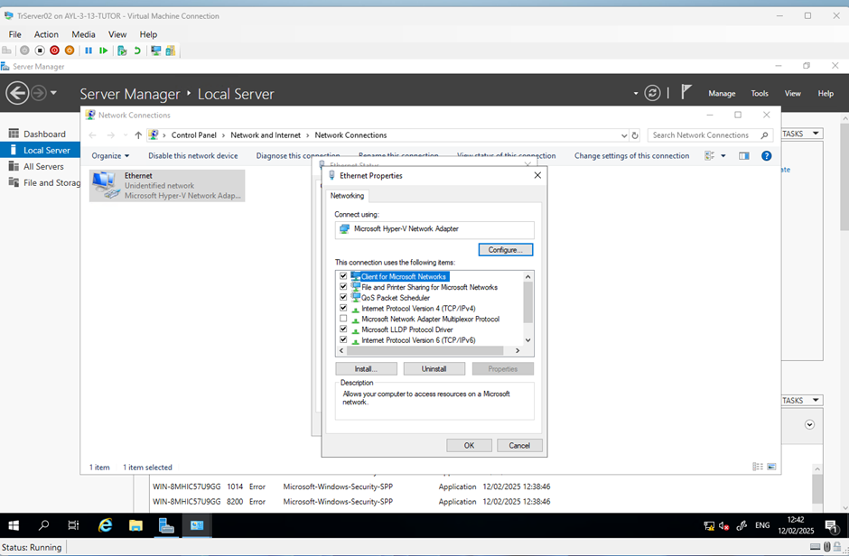

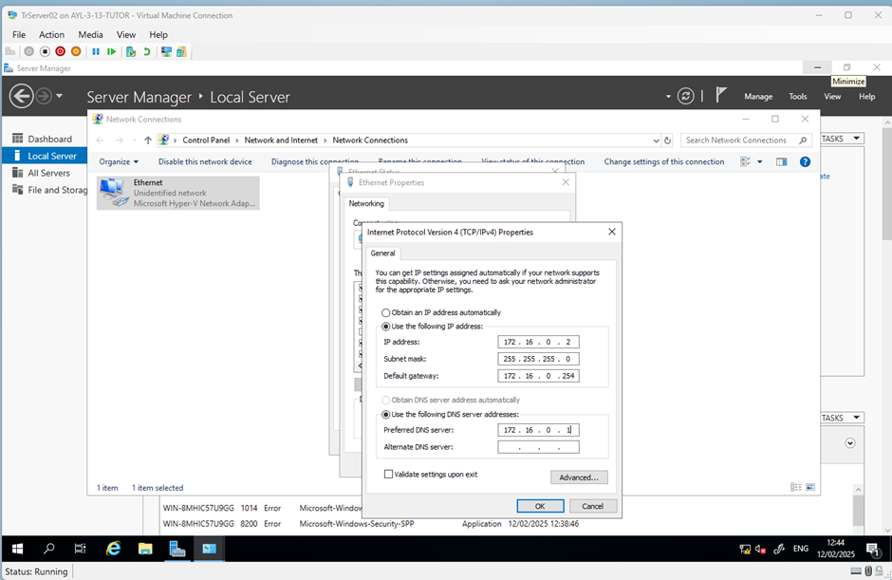

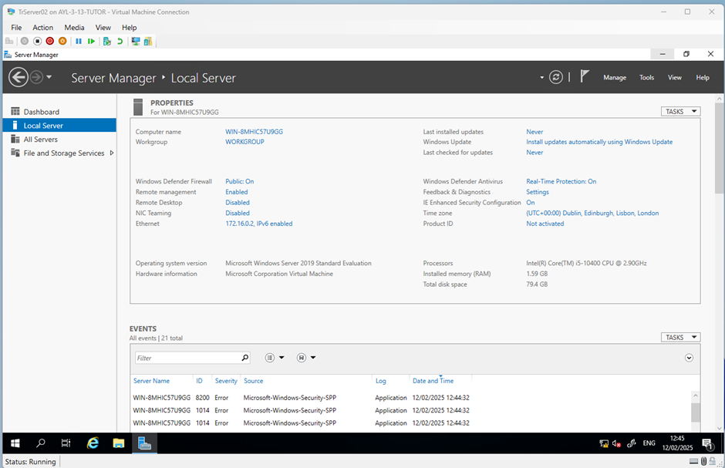

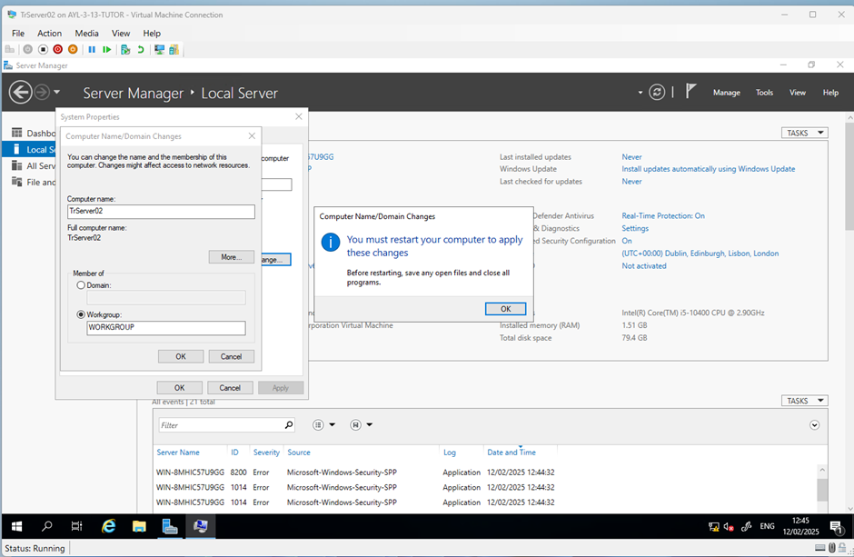

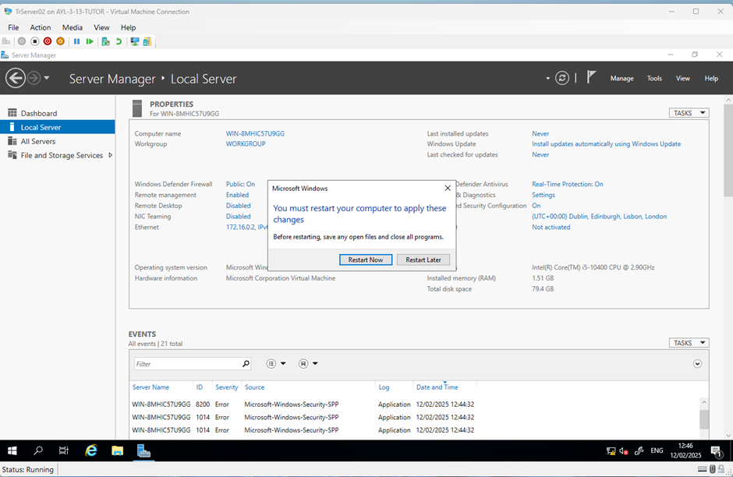

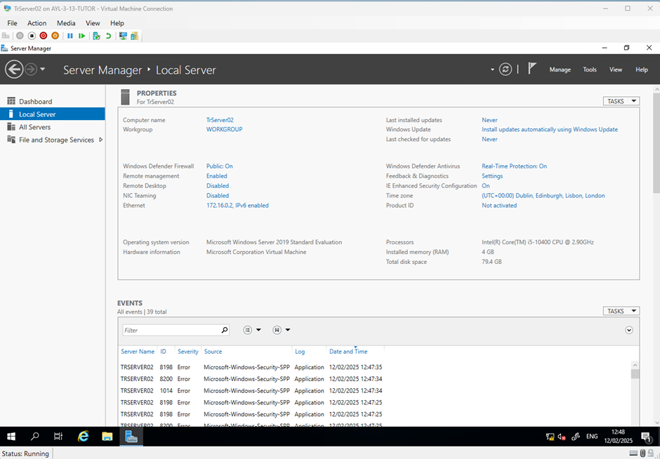

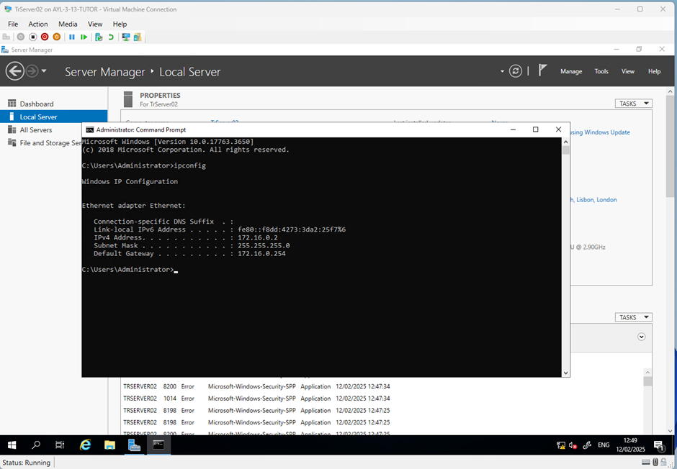
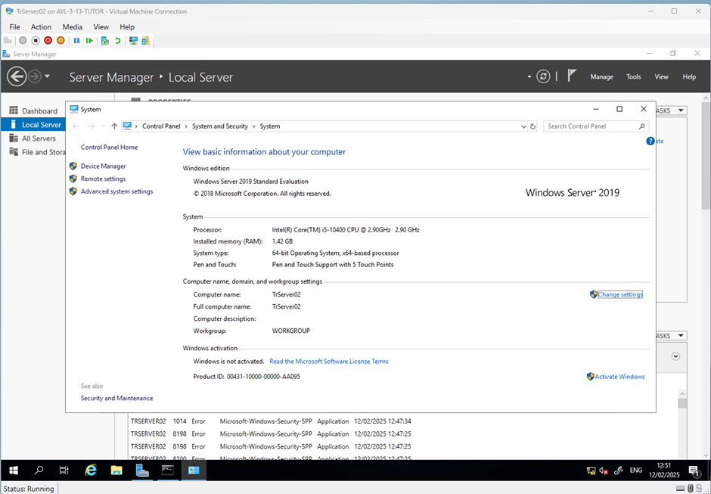

Activity: Install Windows Server 2019 on Server VM using VirtualBox

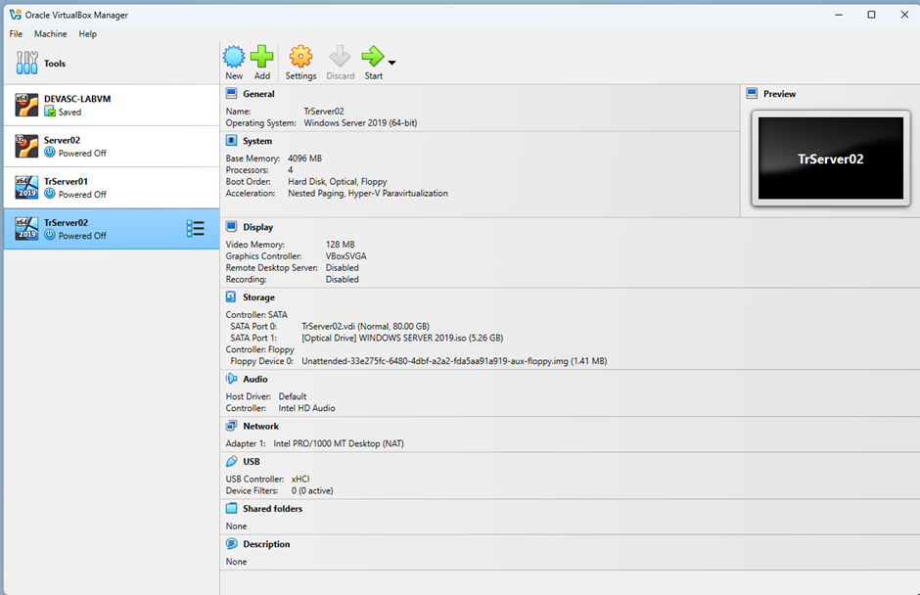

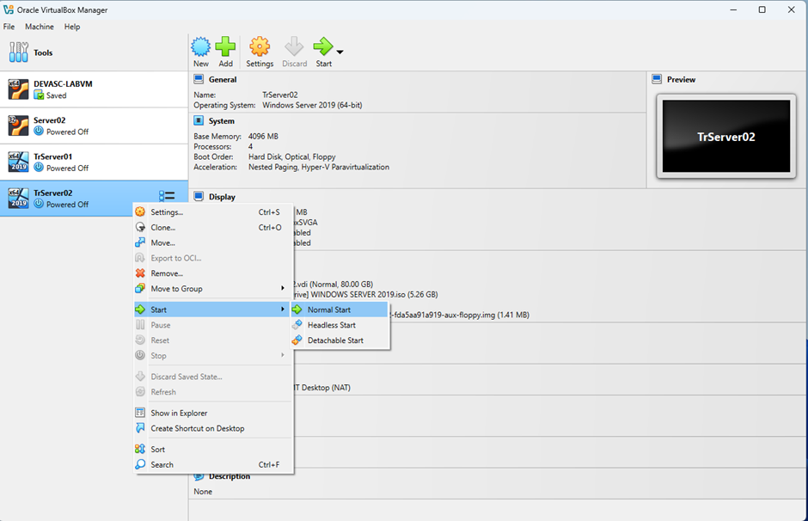
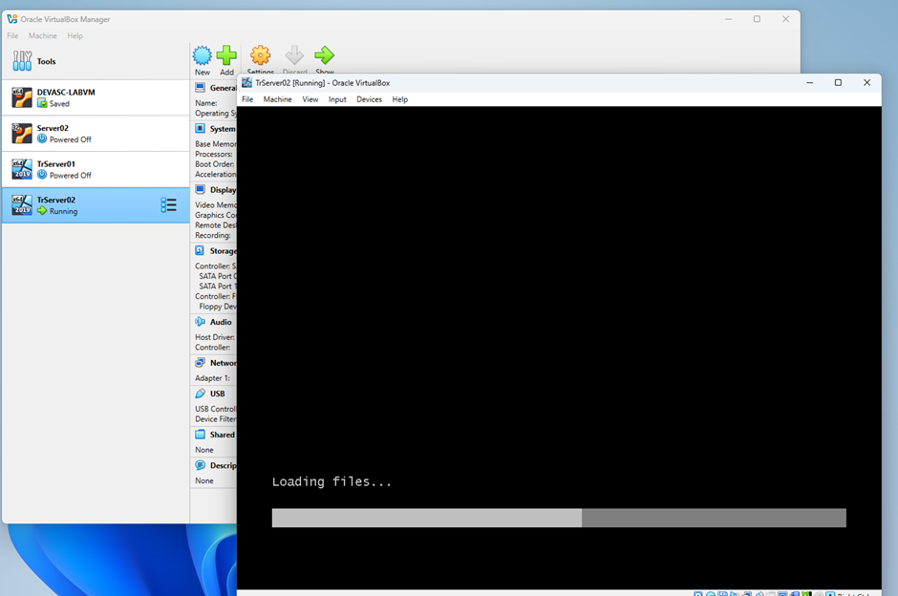

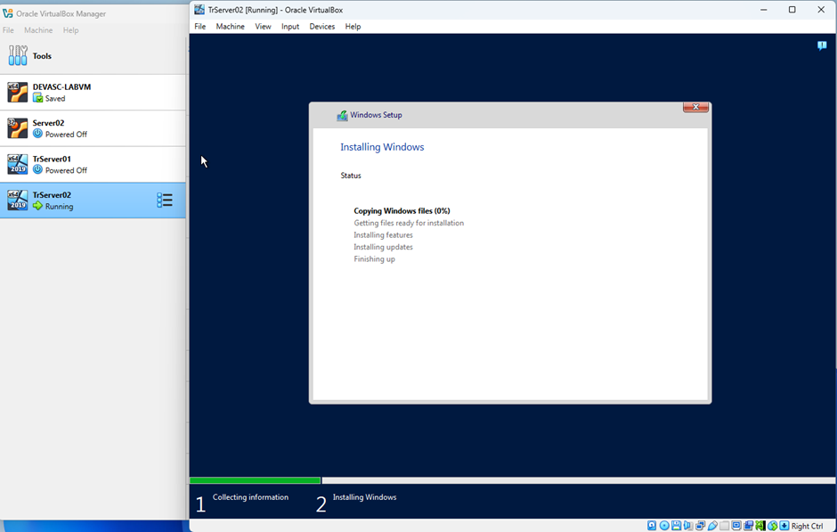

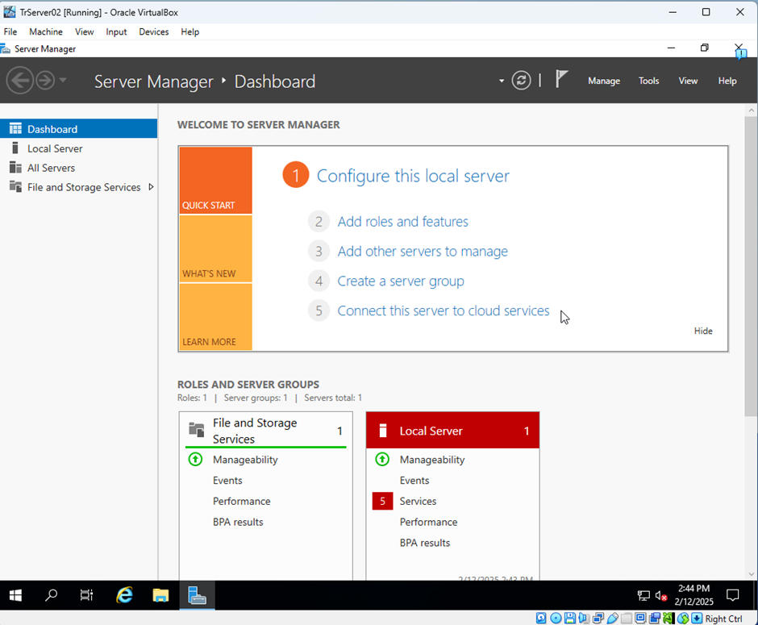

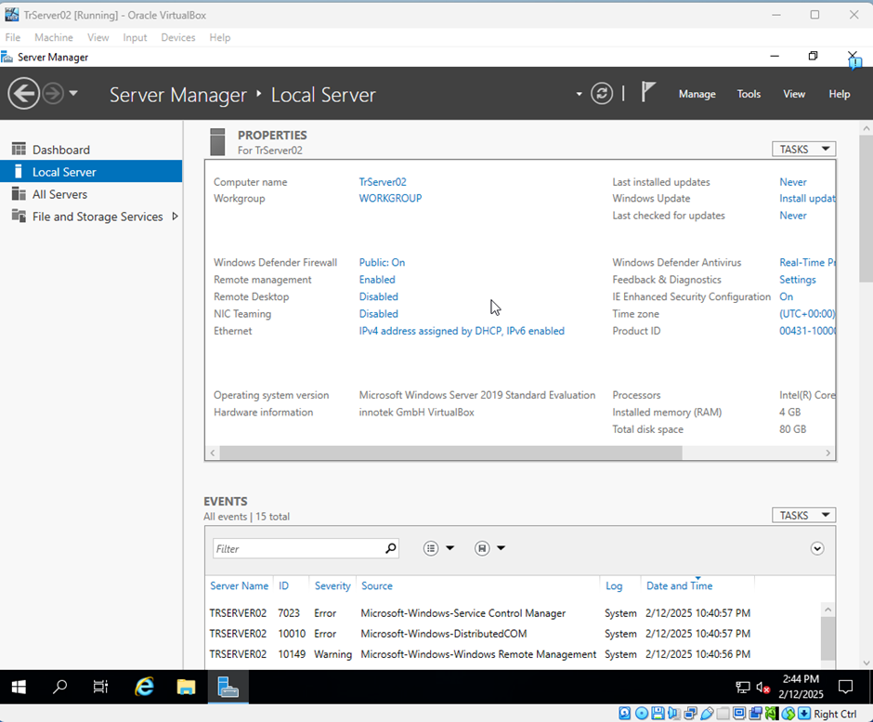

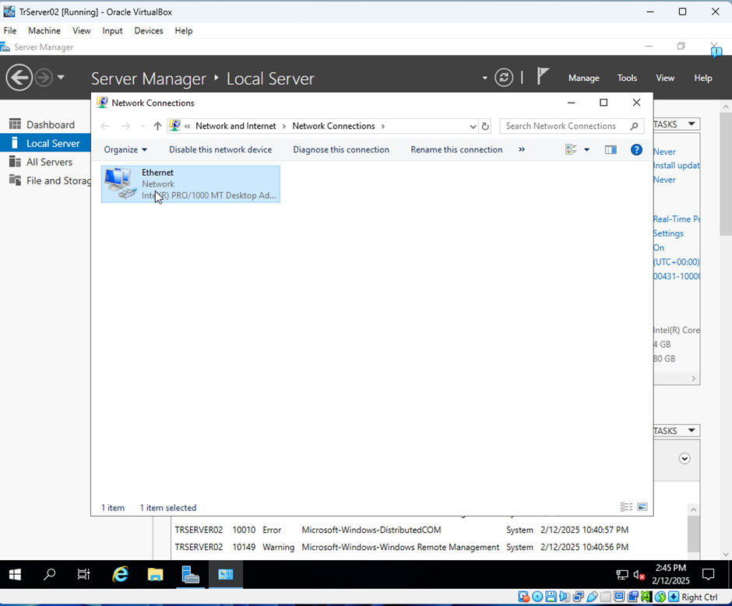

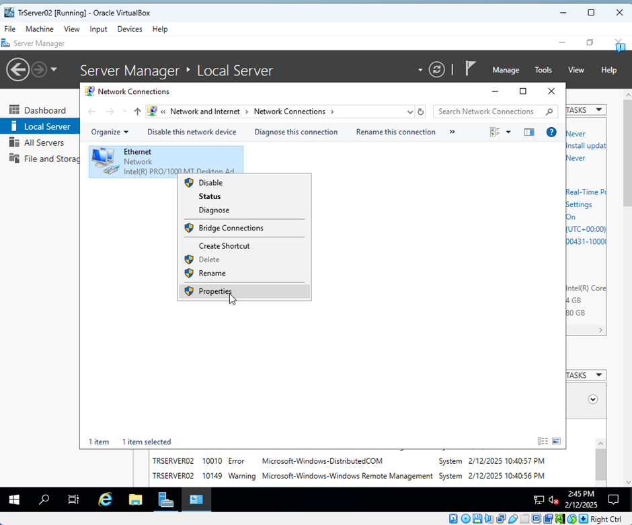

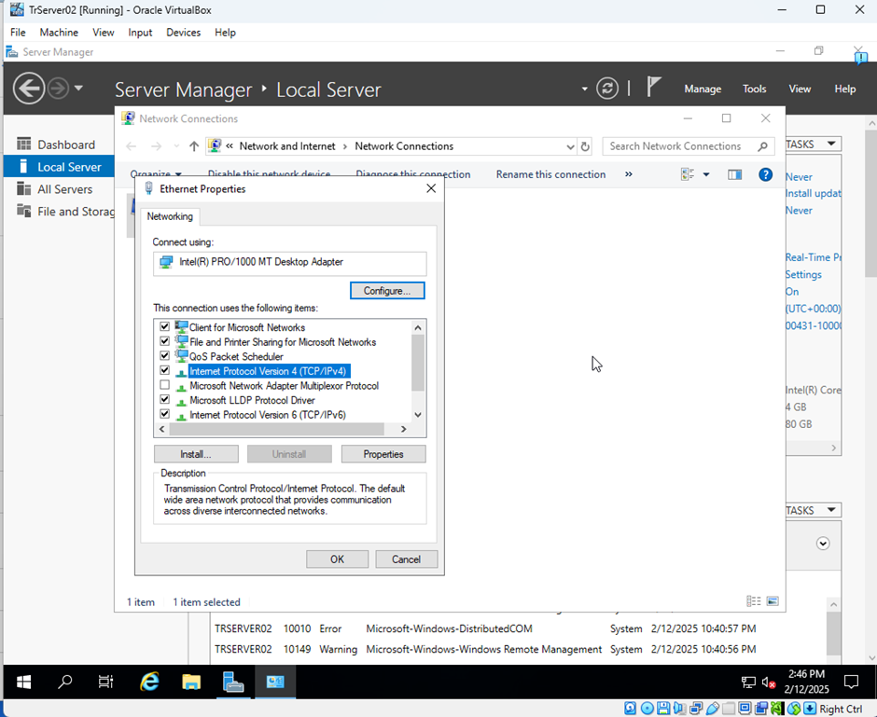

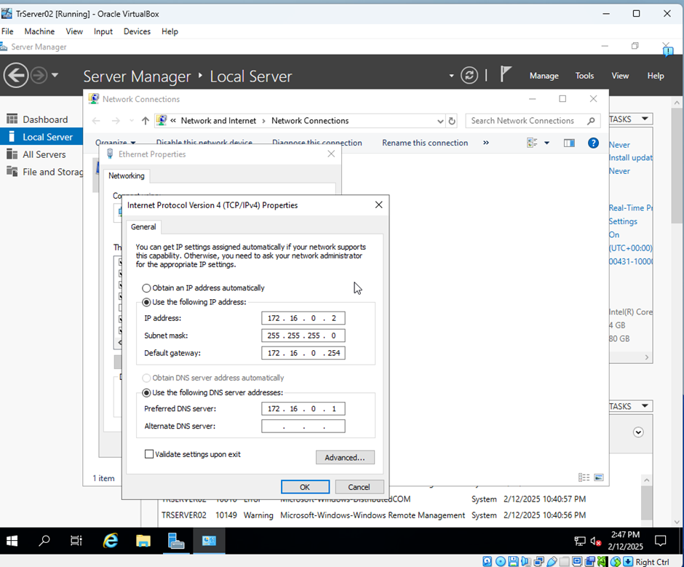

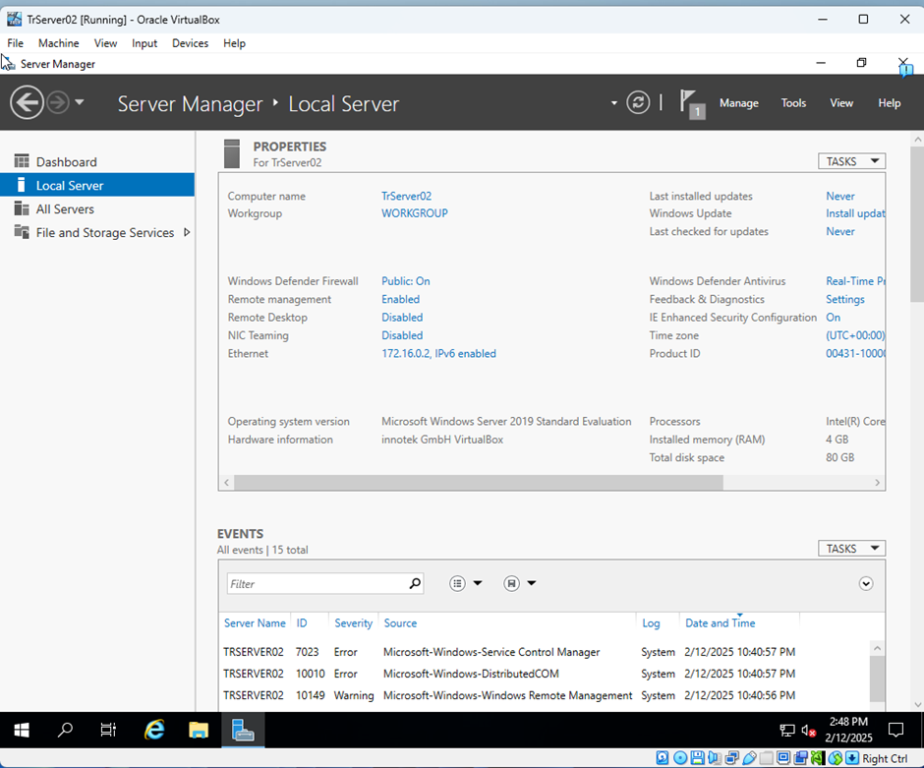

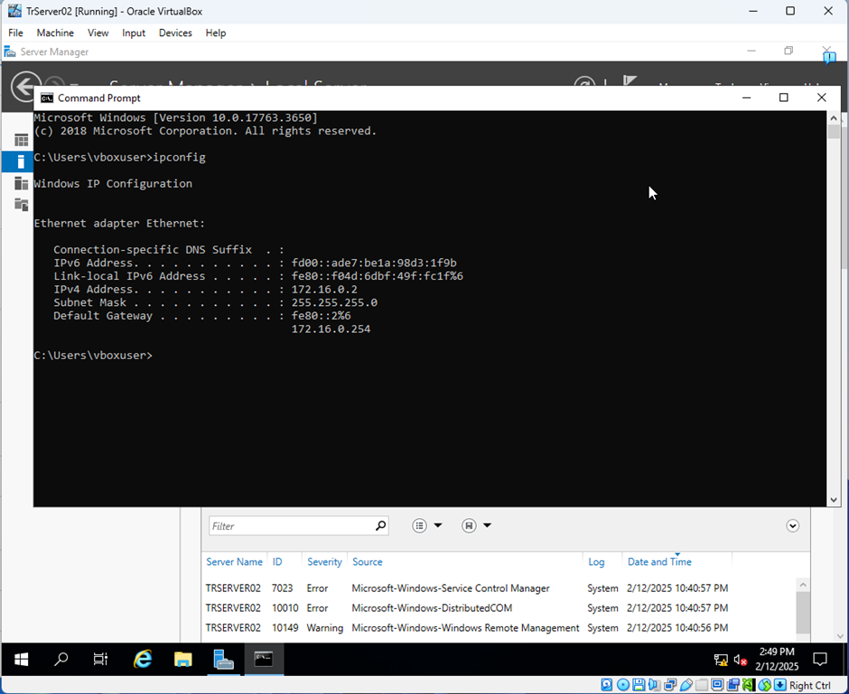

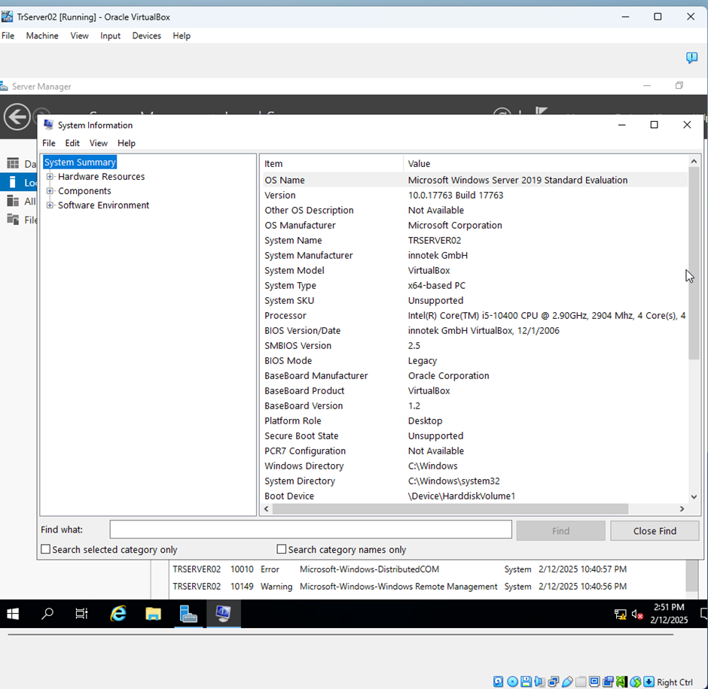

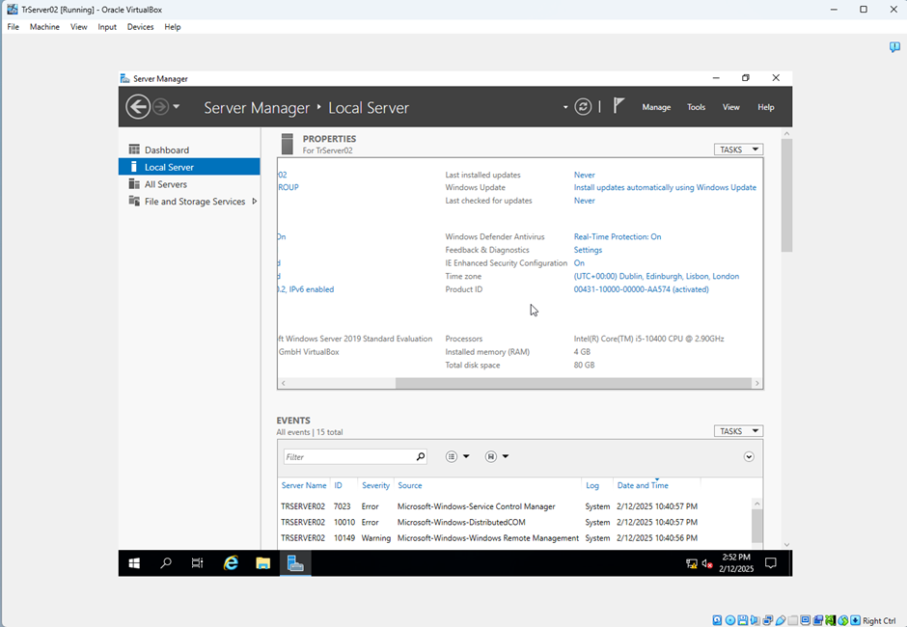

Activity: Initial configuration of Windows Server 2019
Open Hyper-V Manager.
Start TrServer01 VM.
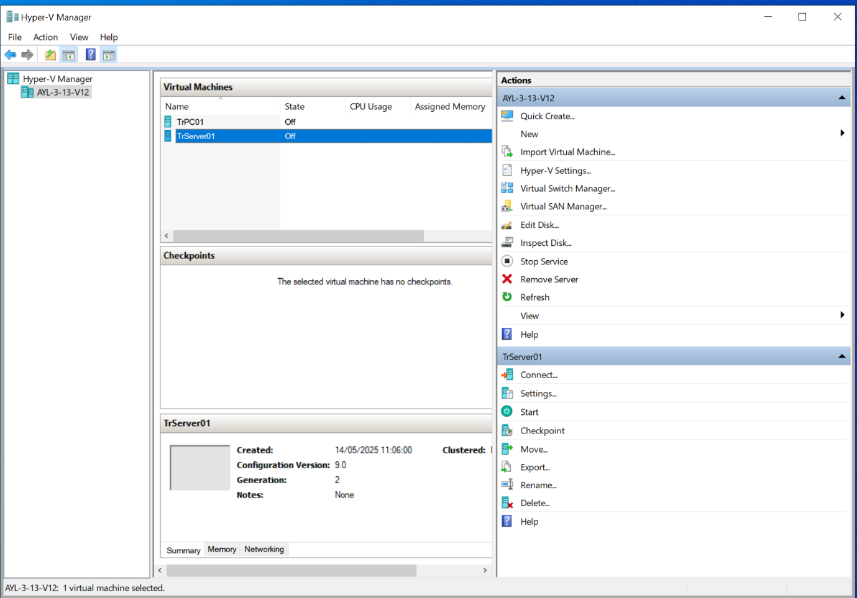
Start TrServer01 and enter the password
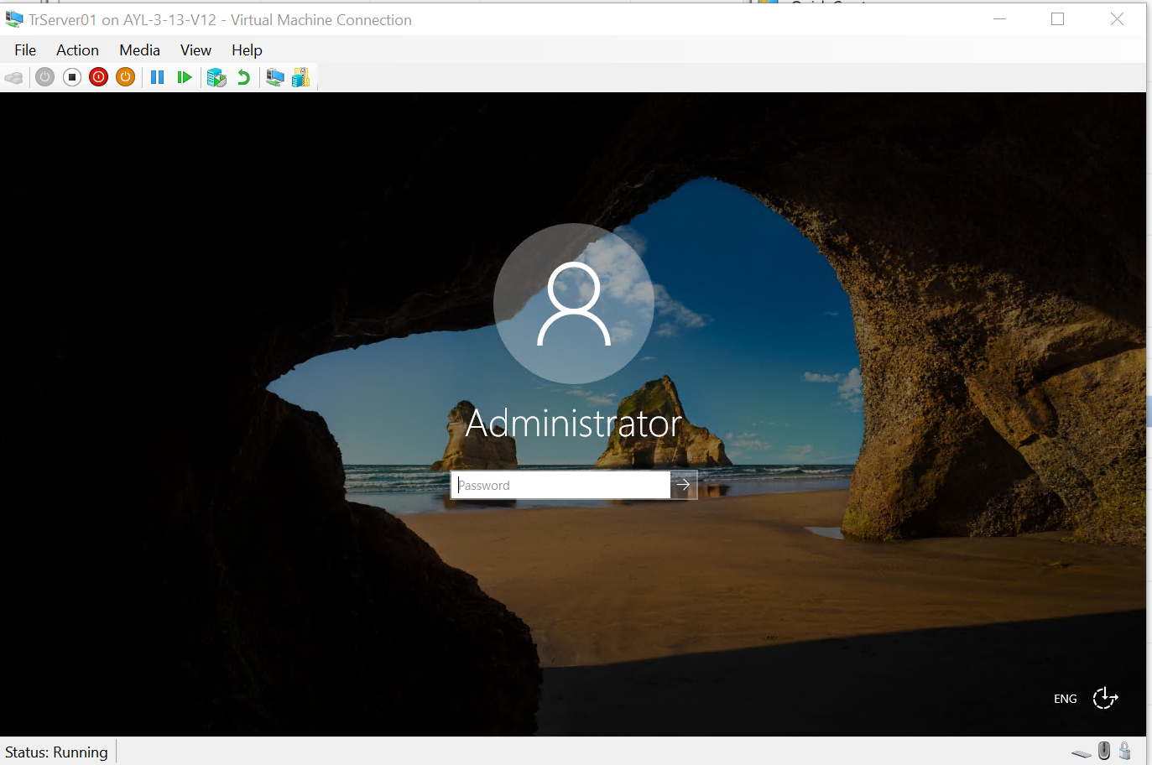
Enter the password.

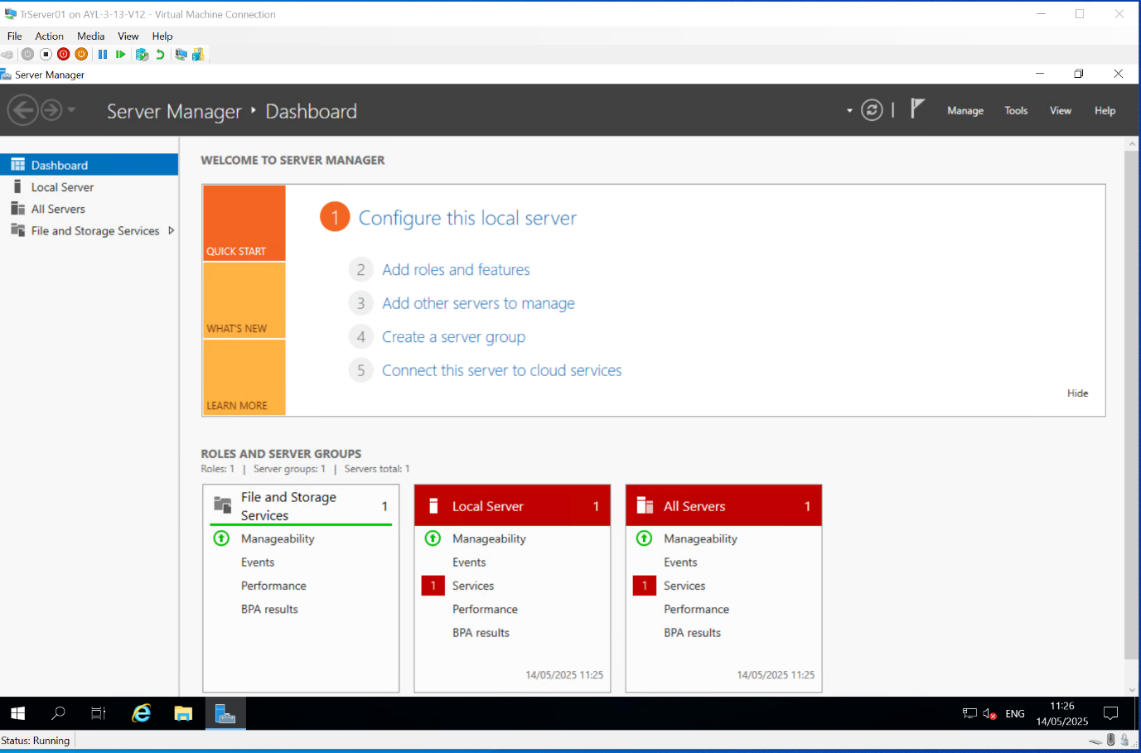
Open Server Manager and select Local Server.
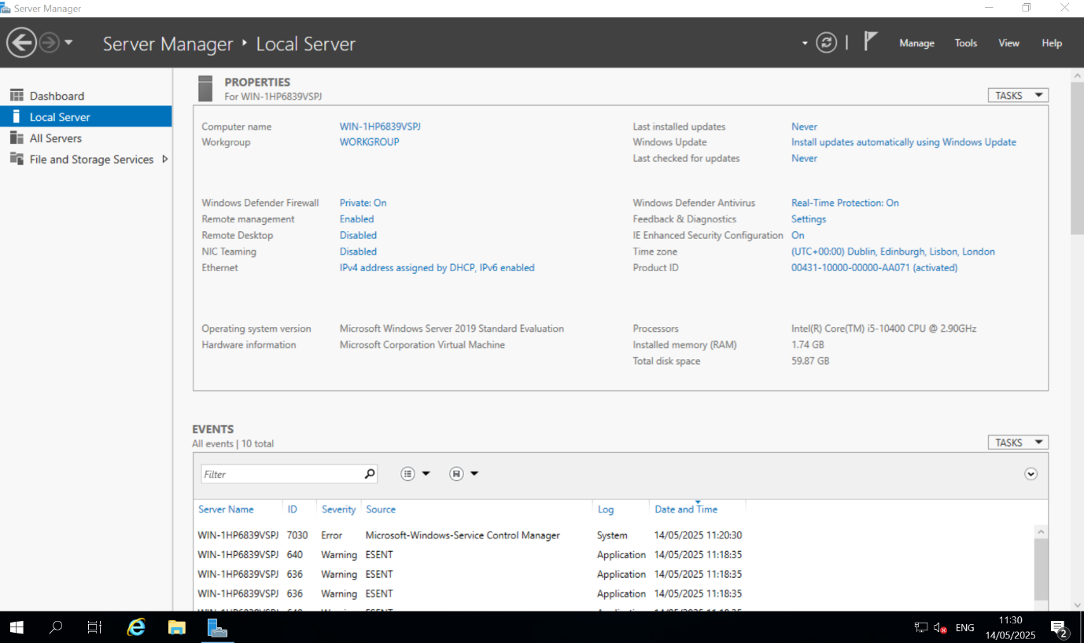
Set the date, time and time zone.
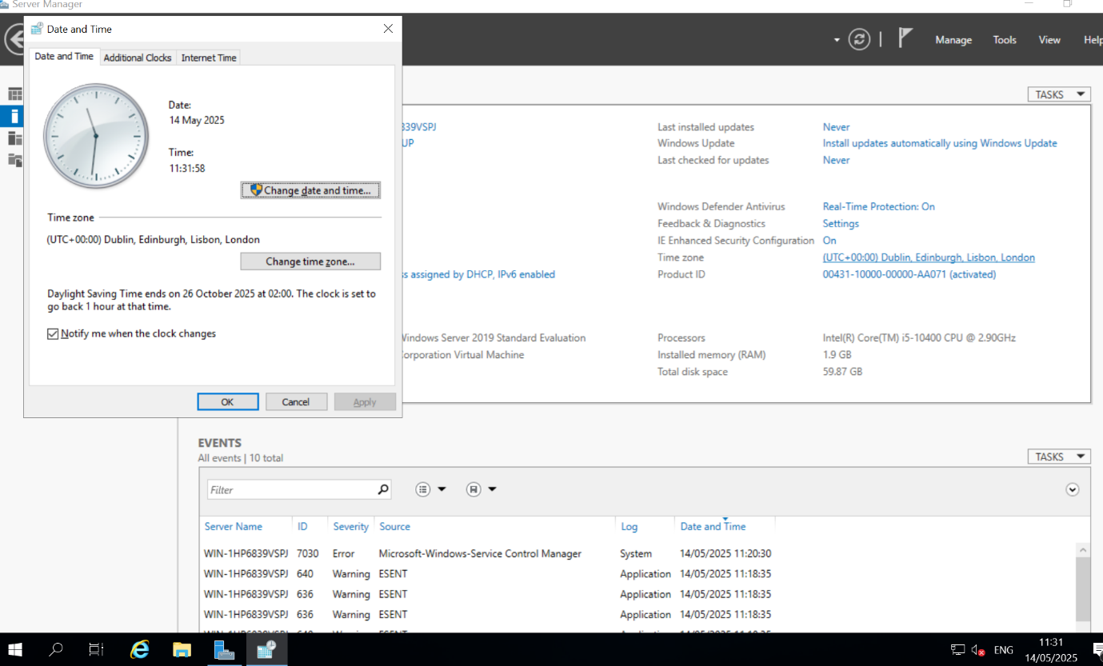

Change the computer name

Before:
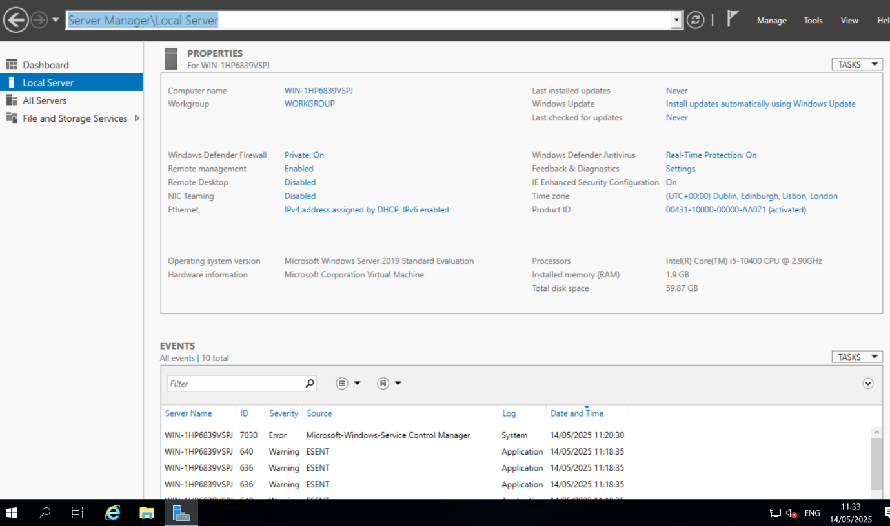
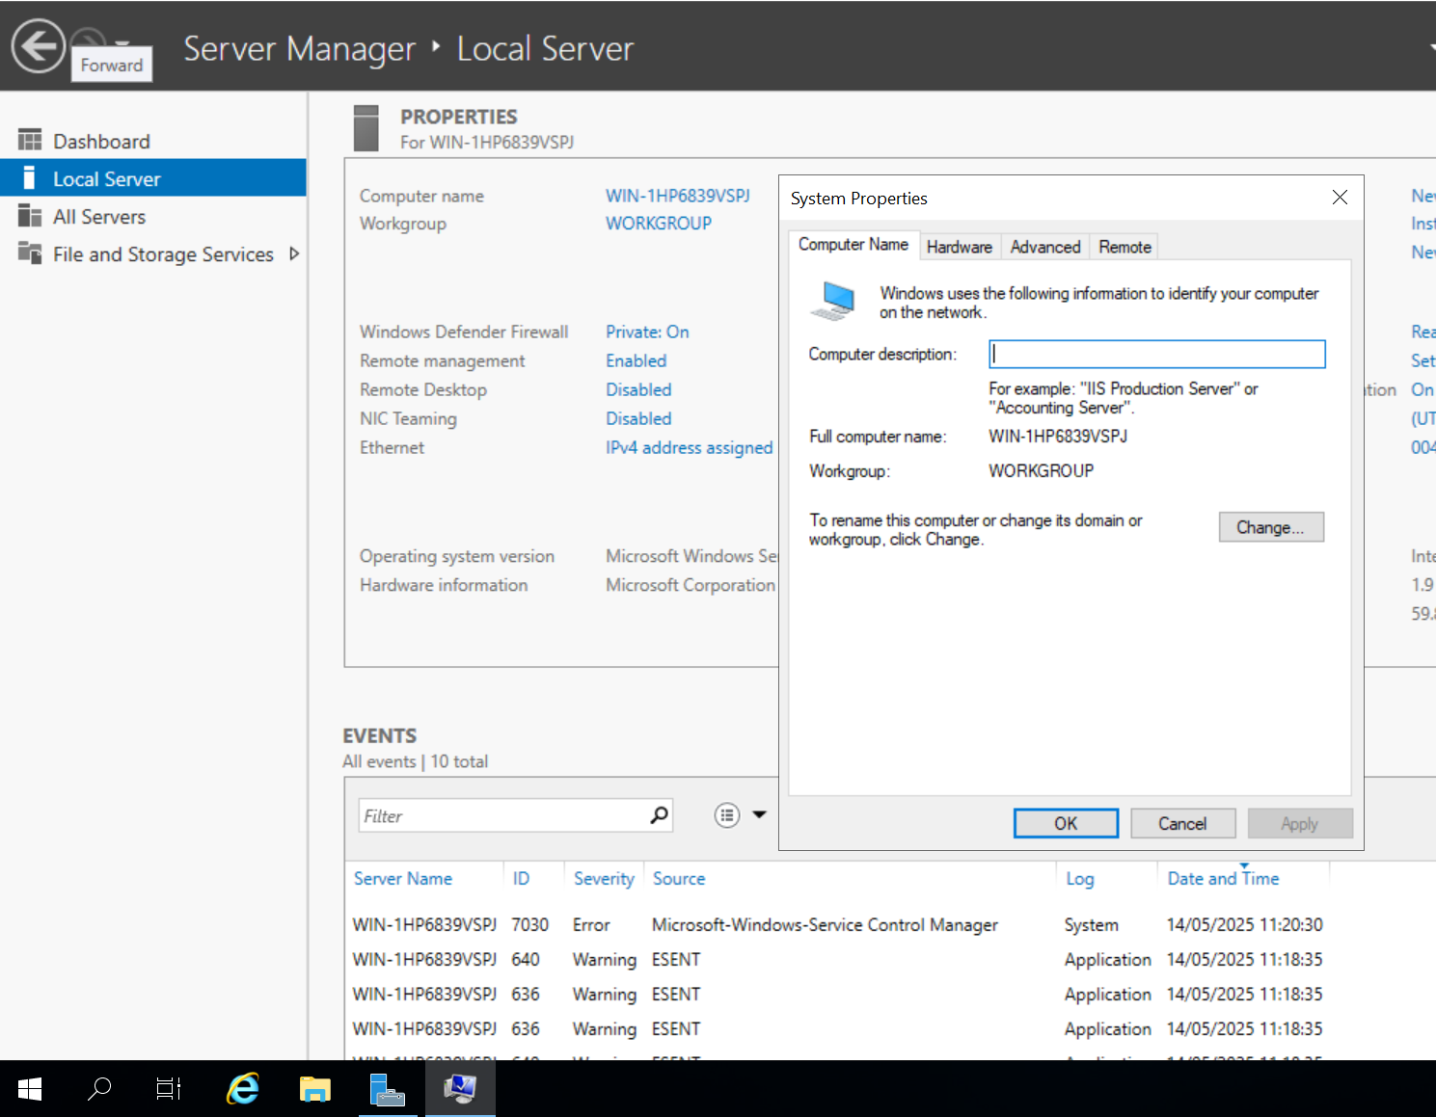
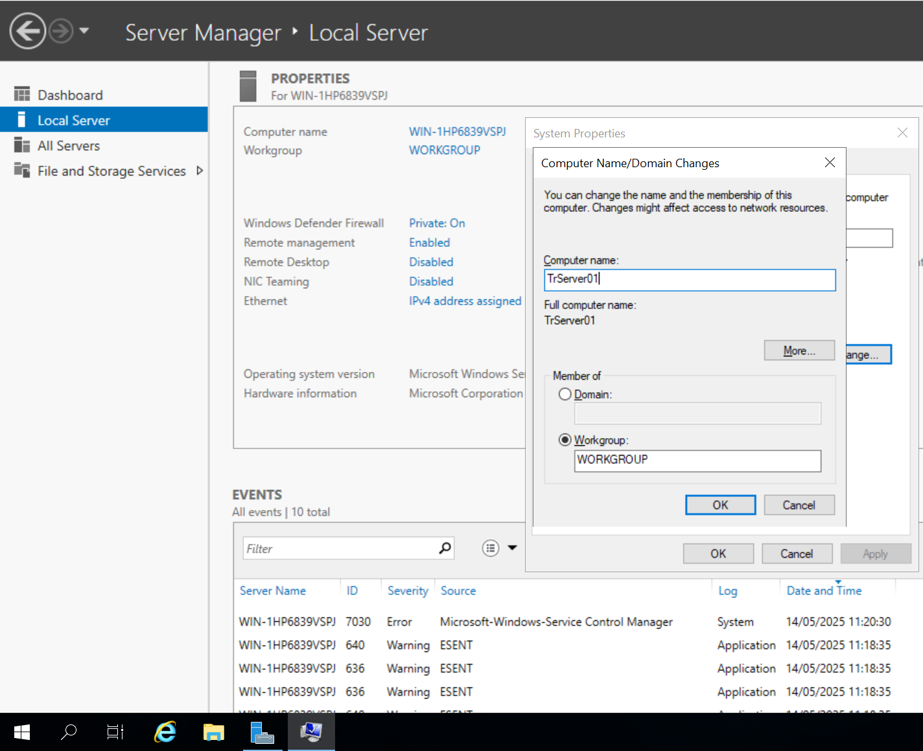
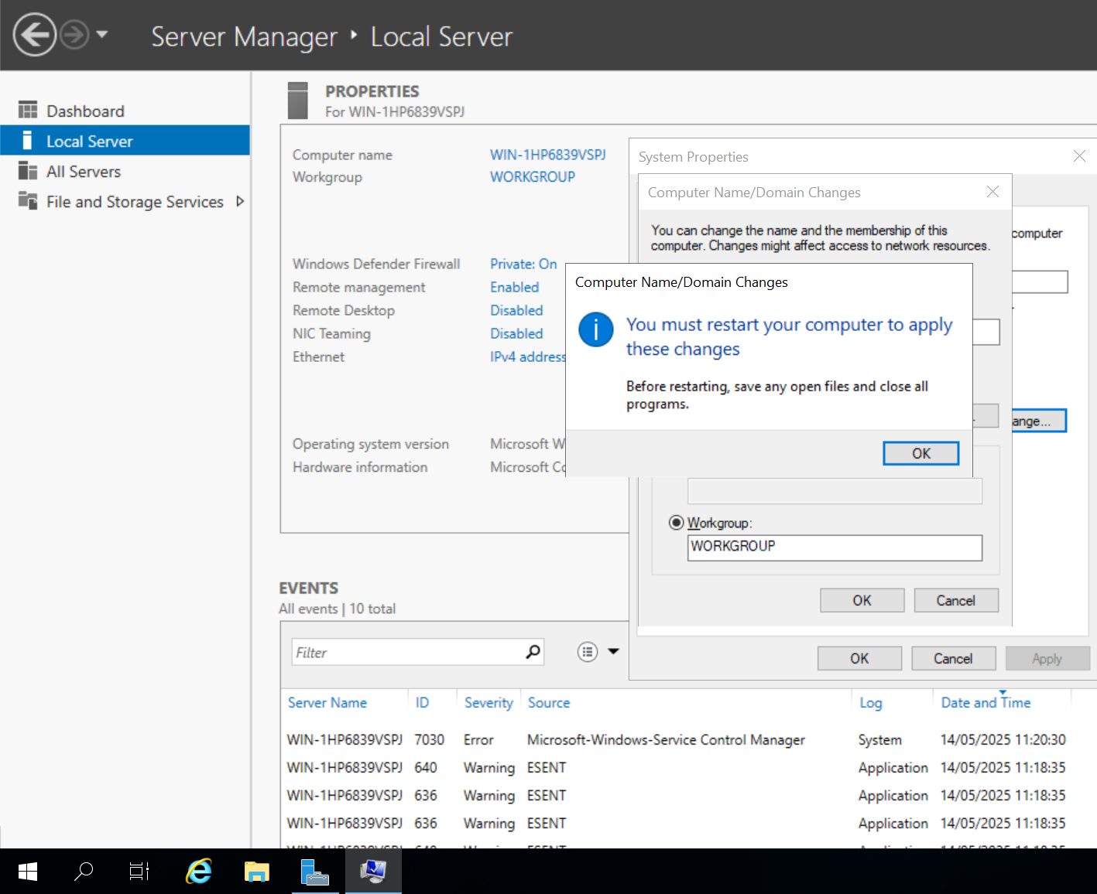
Click OK.
After:
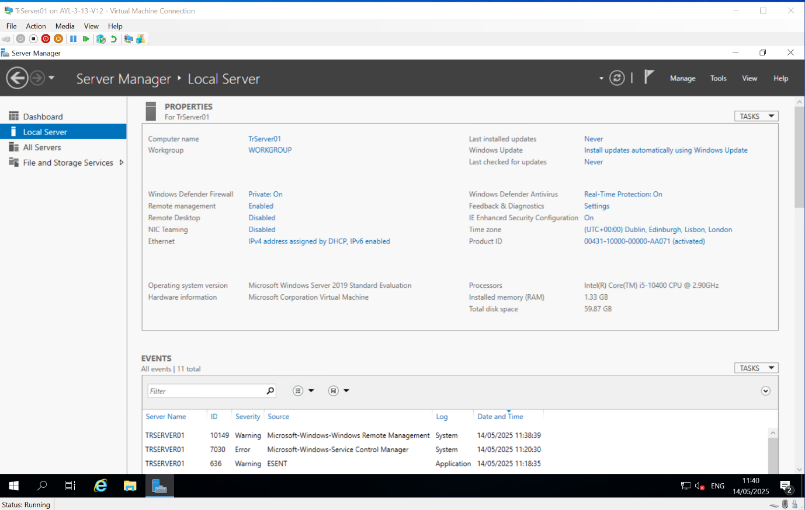
Configure the networking
From Local Server, click Ethernet.
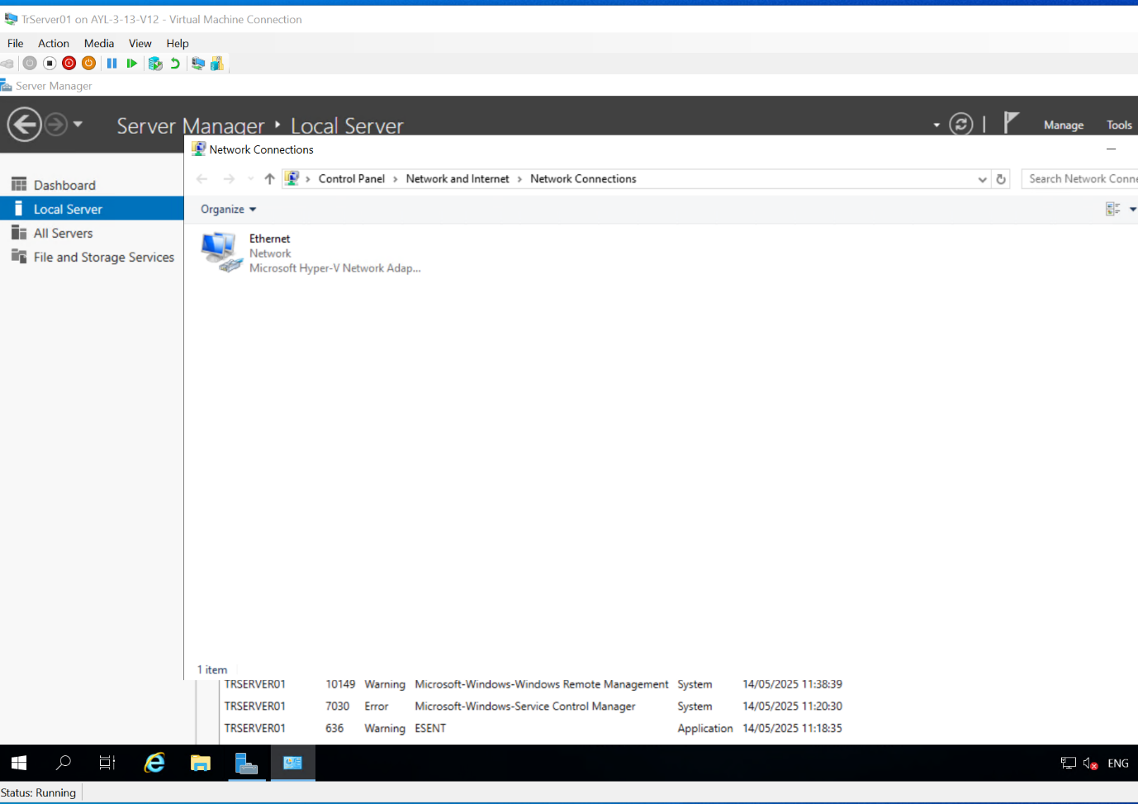
Right-click and choose properties.

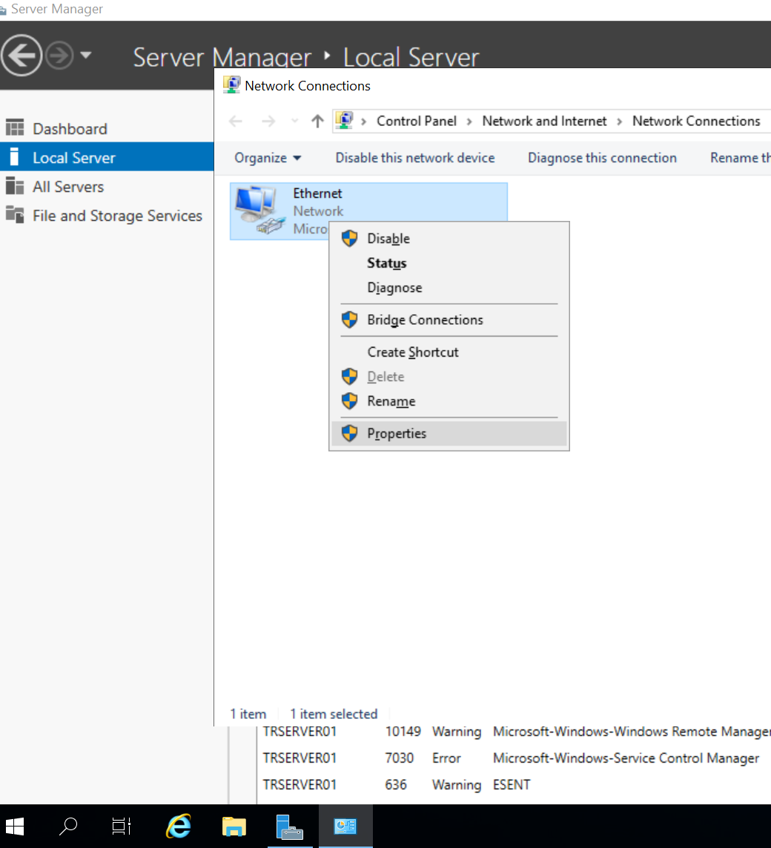
Select Internet Protocol Version 4 (TCP/IPv4).
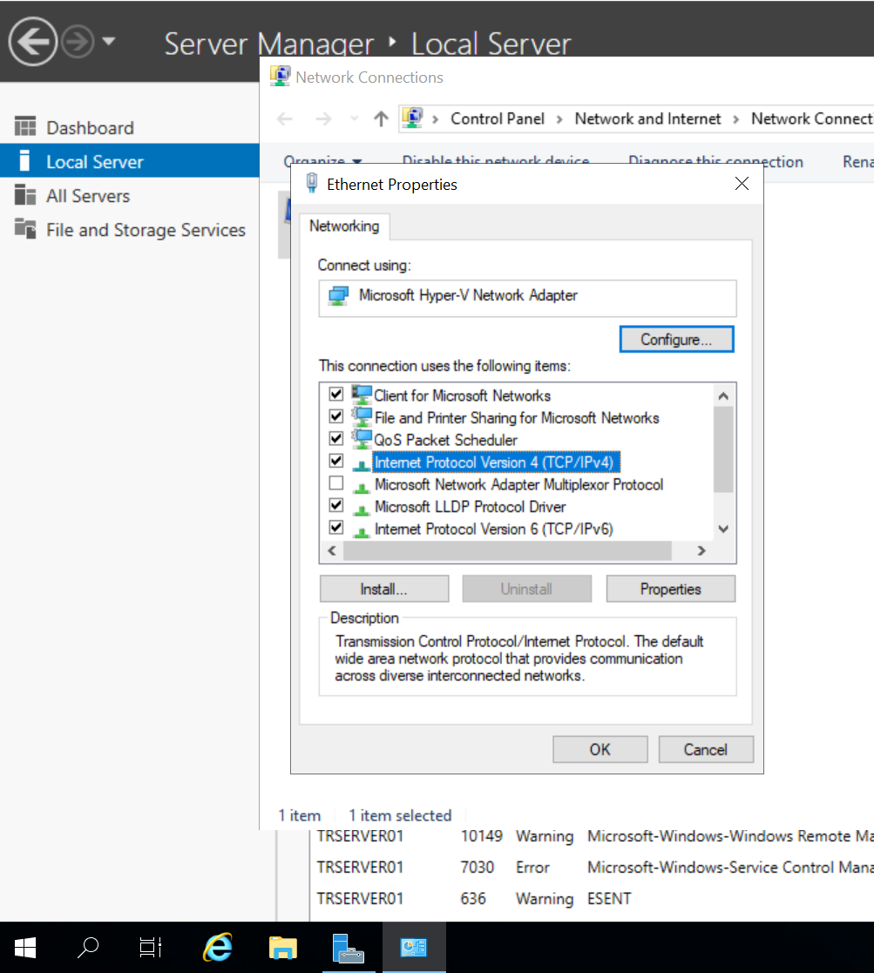
Click Properties to assign static IPv4 address.
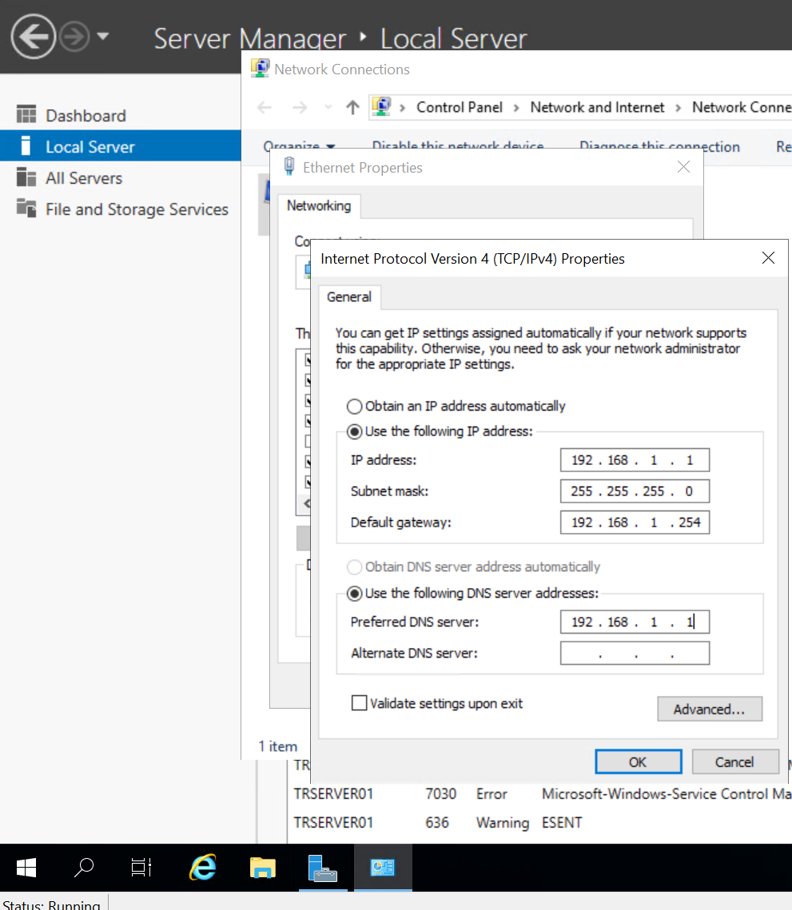
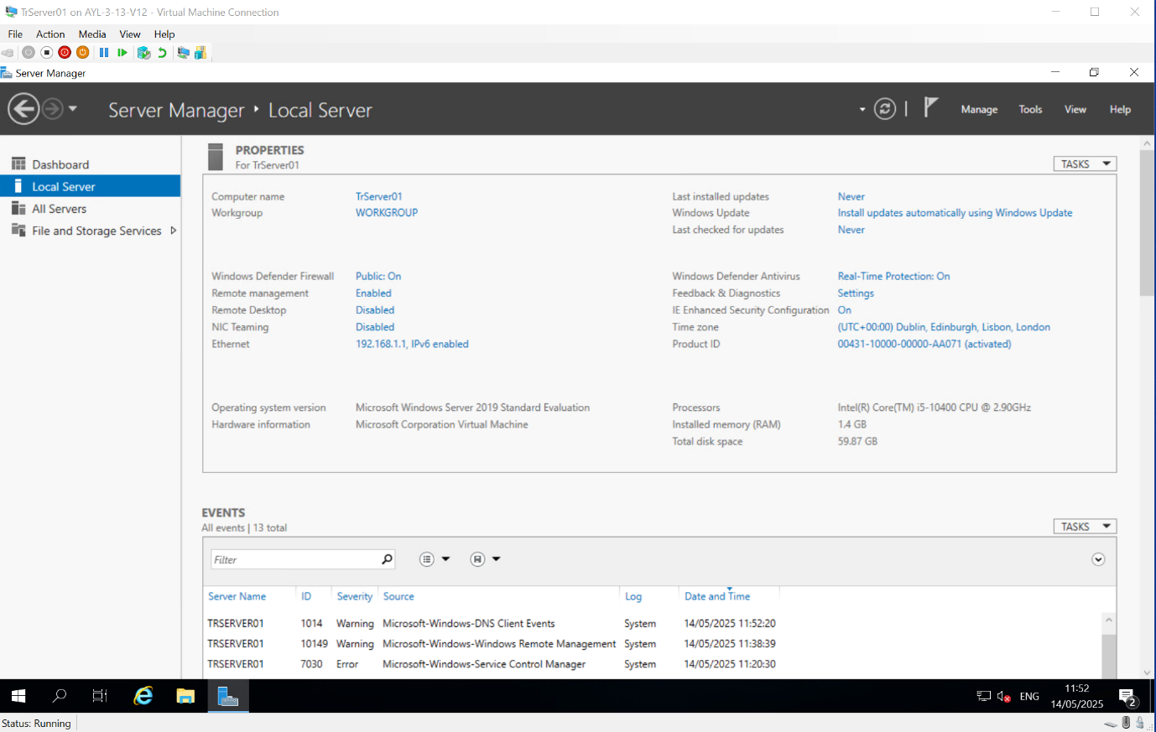
Configure the Windows Server firewall
From Server Manager, select Local Server.
Click the hyperlink Public: On, next to Windows Defender Firewall.
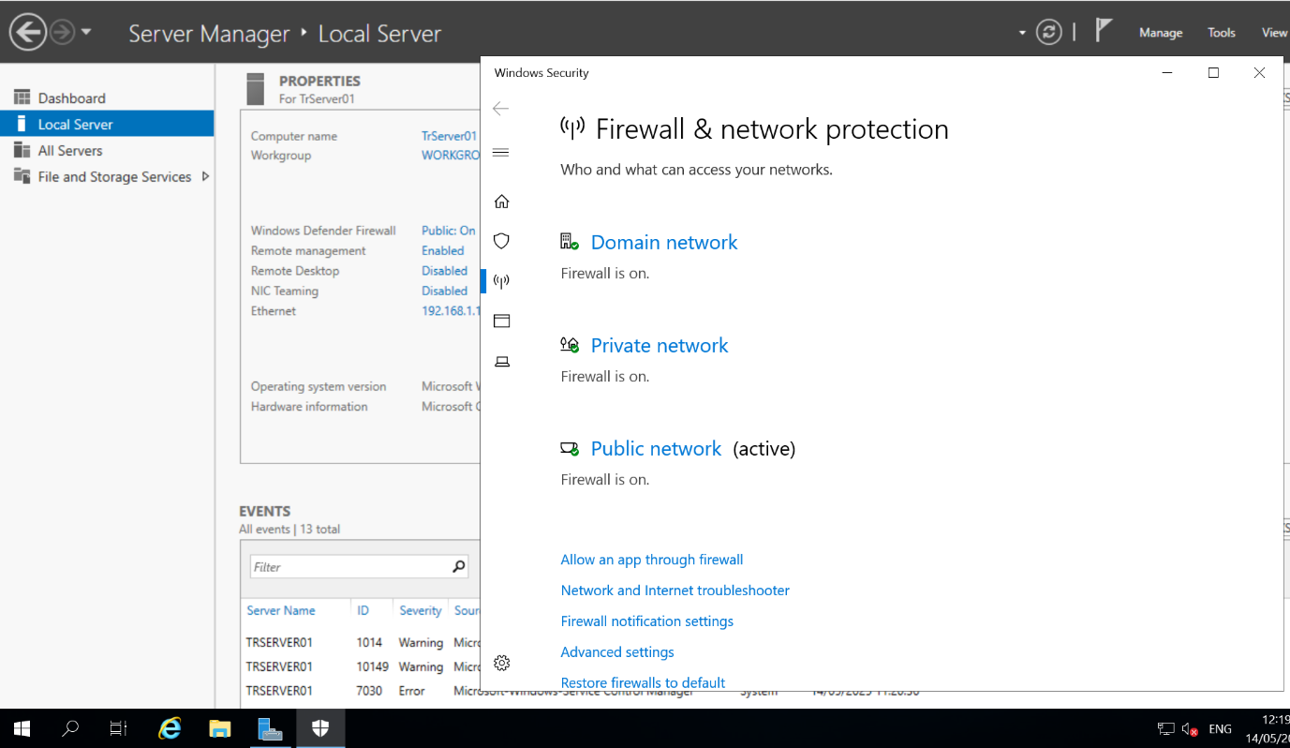
Click Allow an app through firewall.
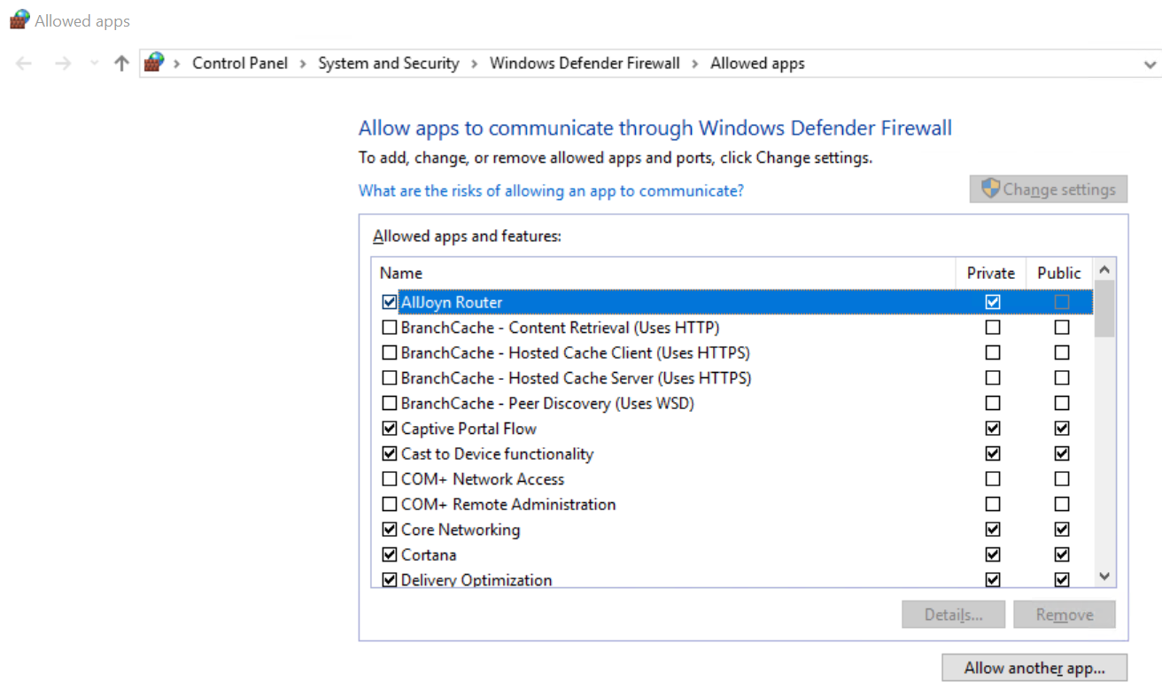
Select File and Printer Sharing and enable it for the Private profile by selecting the check box under Private.
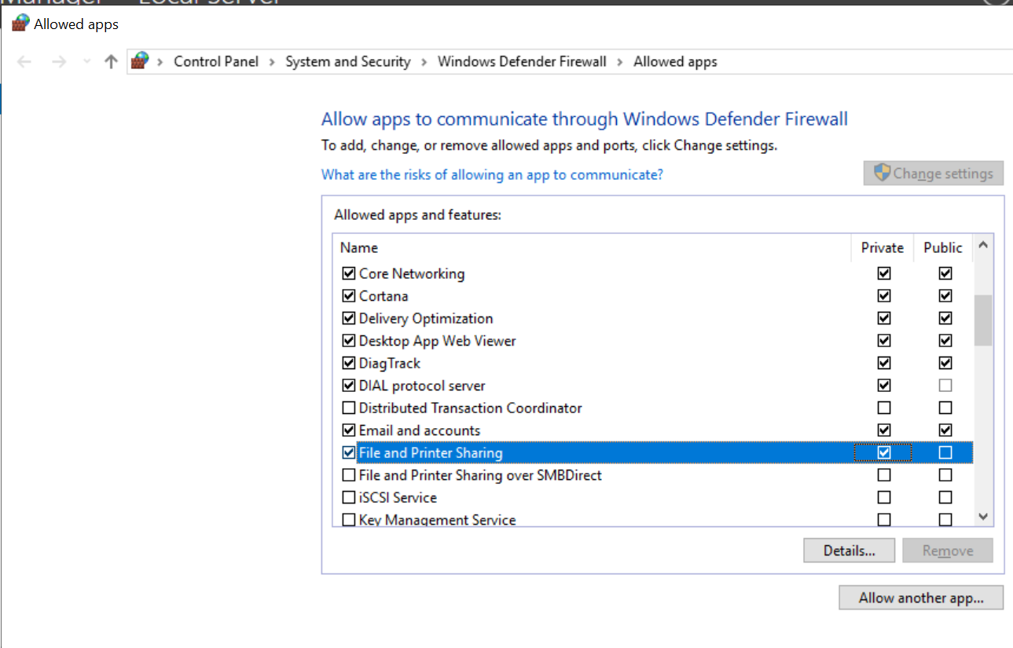

Click OK to save your changes.

Configure the server to receive Windows updates
Click the Start menu and type gpedit.msc.
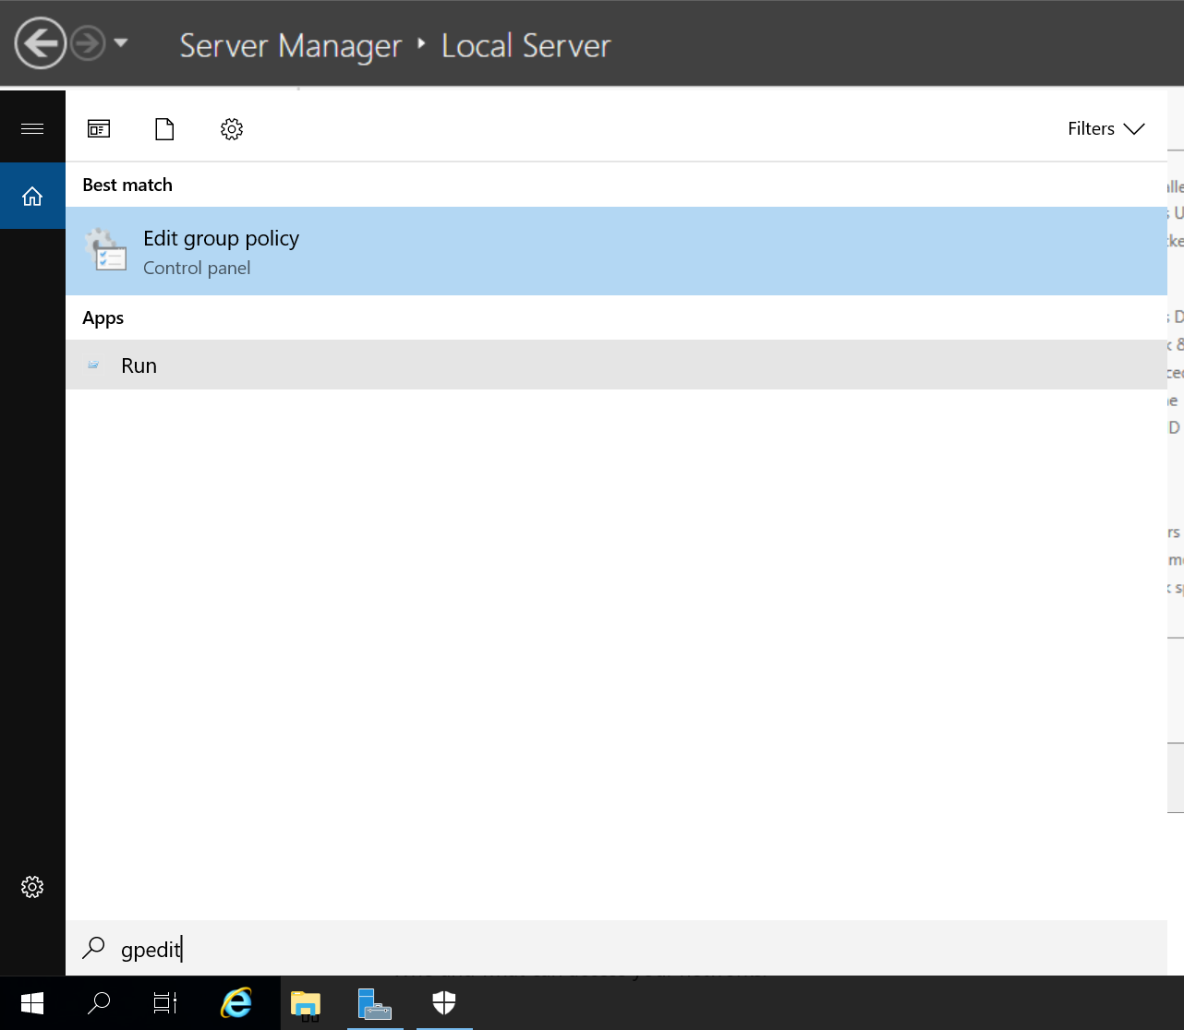
Navigate to the Windows Update section by clicking on Computer Configuration, then Administrative Templates, then Windows Components, and finally Windows Update.
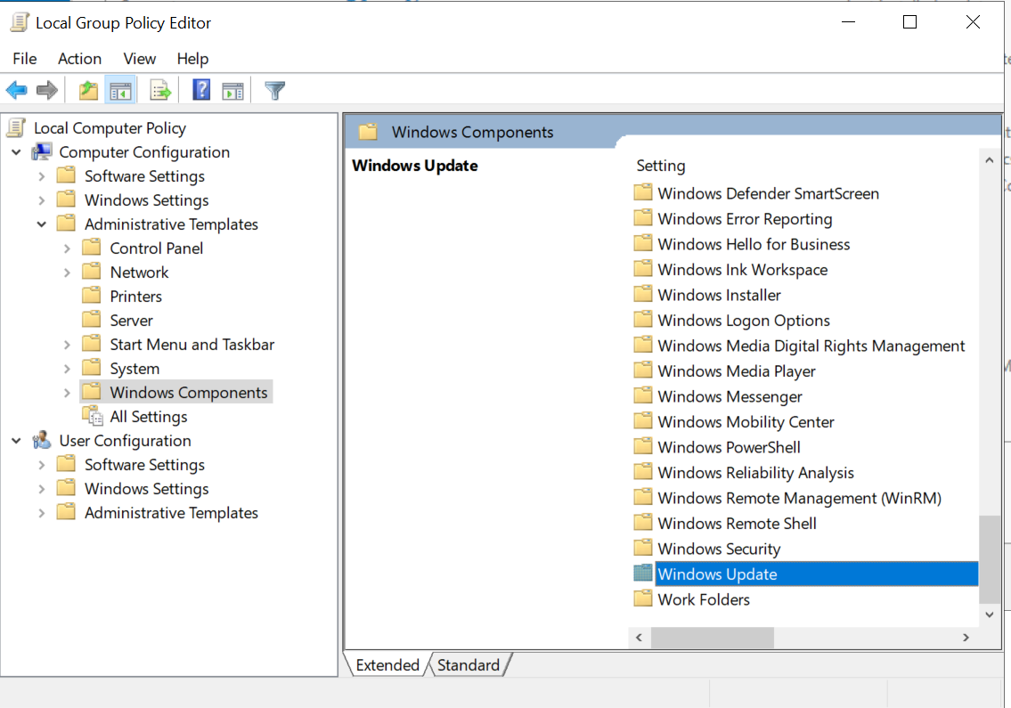
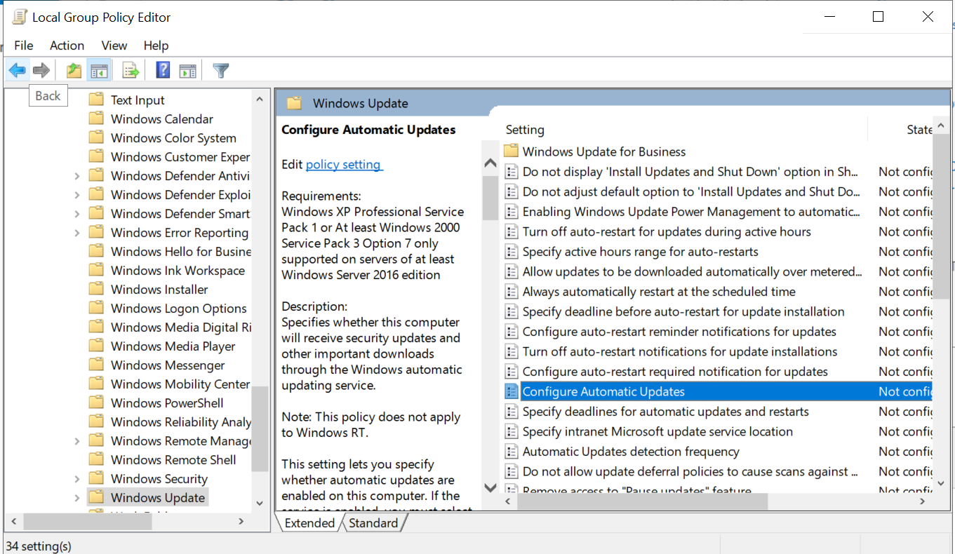
Double-click Configure Automatic Updates.
Select Enabled.
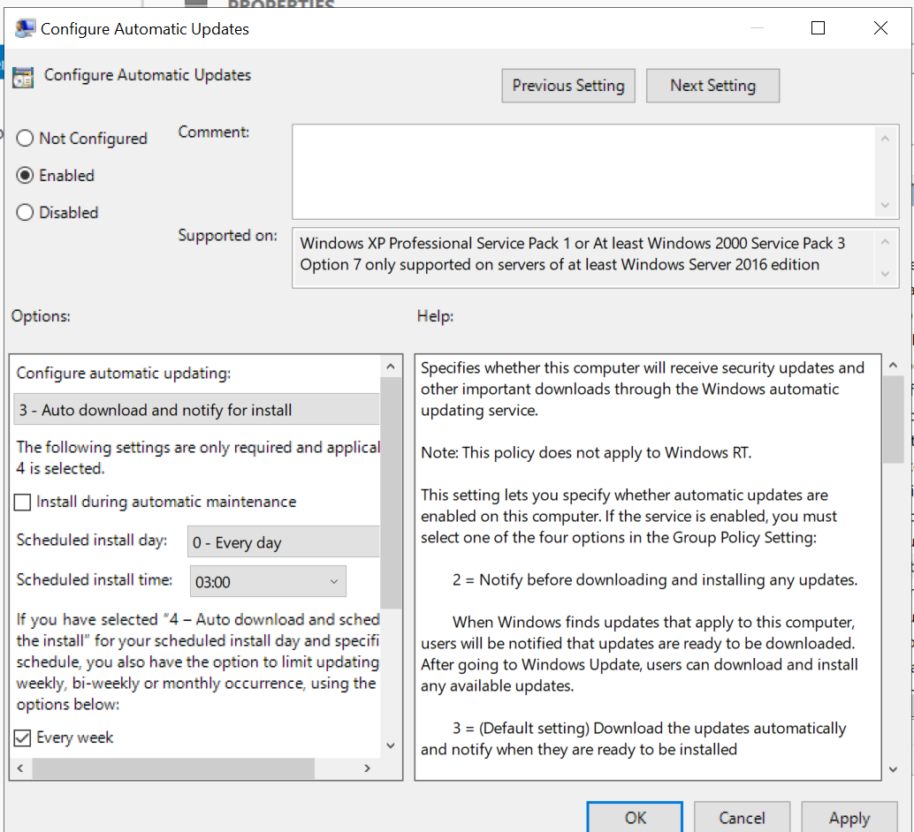
Click OK to save the change.
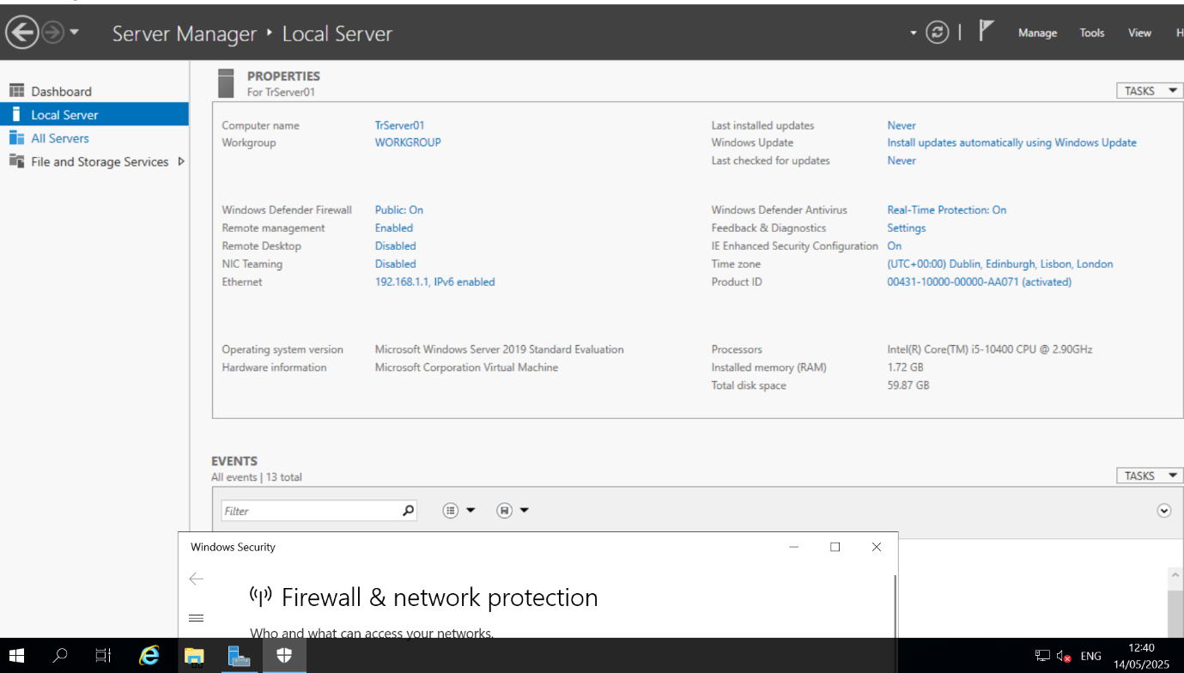
Add roles and features
Roles and features are added in Windows Server 2019 with Desktop Experience through Server Manager.
Open Server Manager.
Choose Manage⇒ Add Roles and Features.

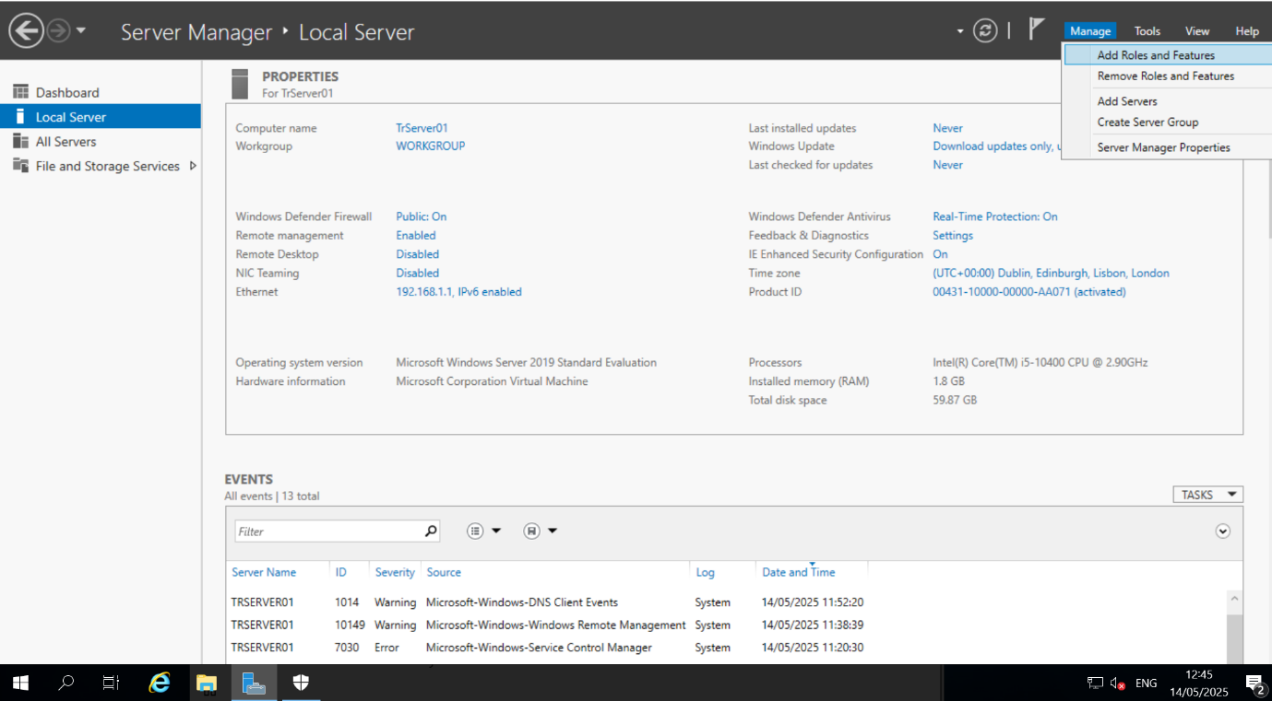

On the Before you begin page, click Next.
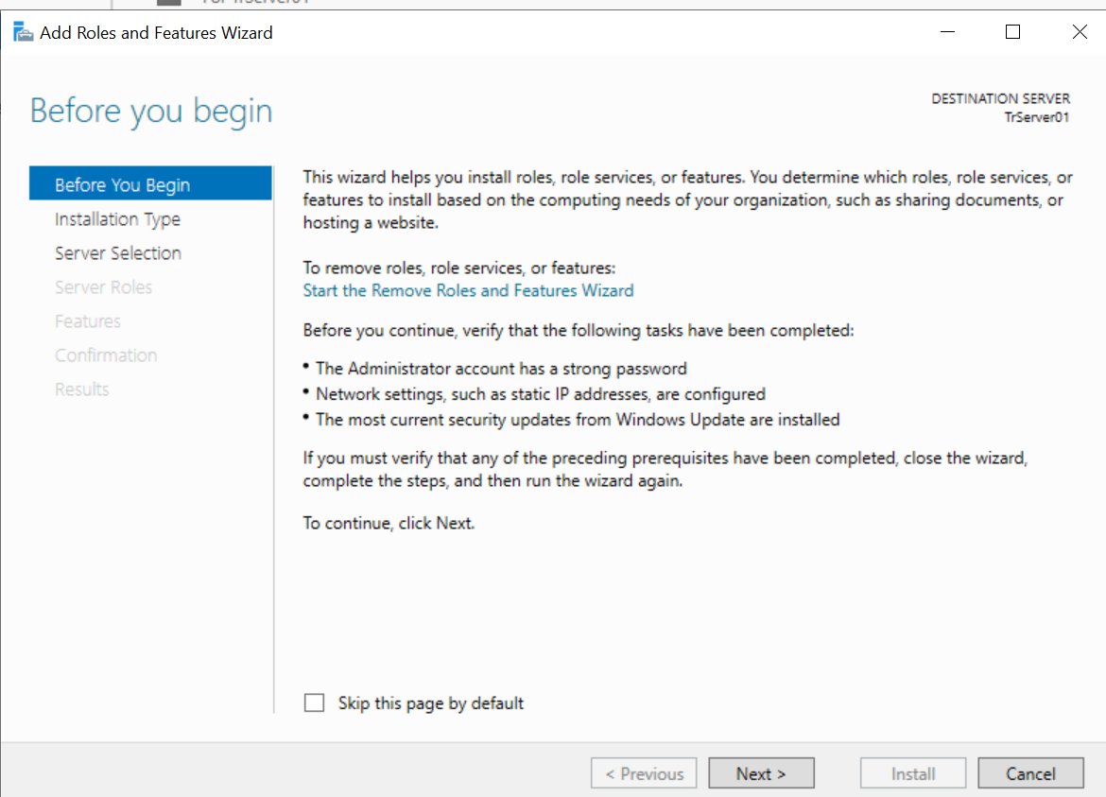
On the Select installation type page, click Next.
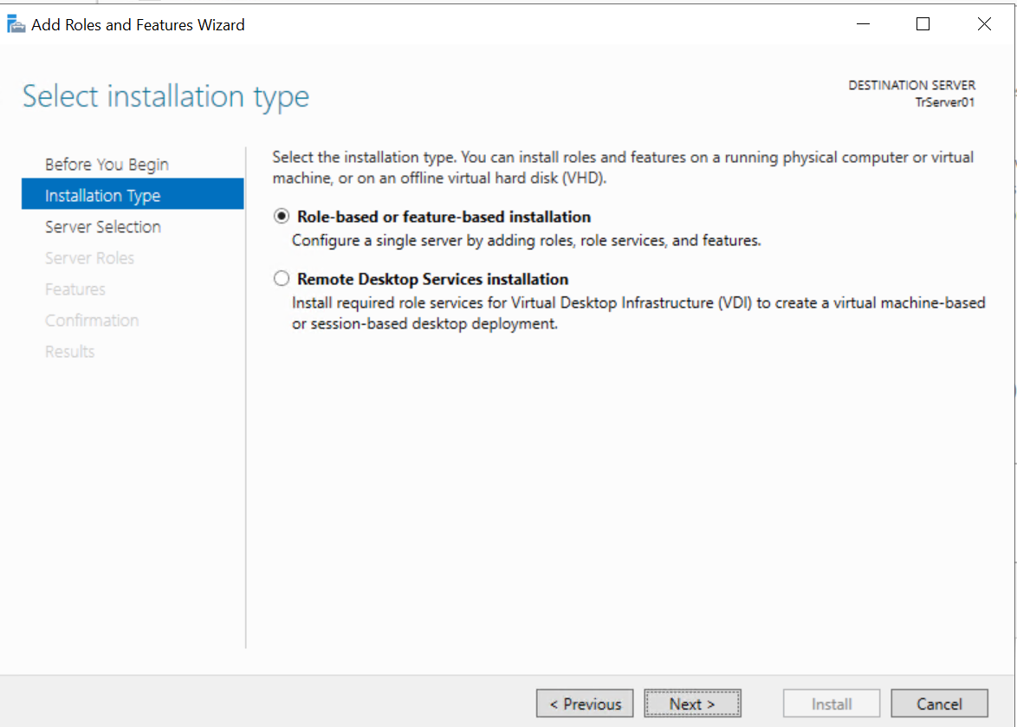
On the Select destination server page, click Next.
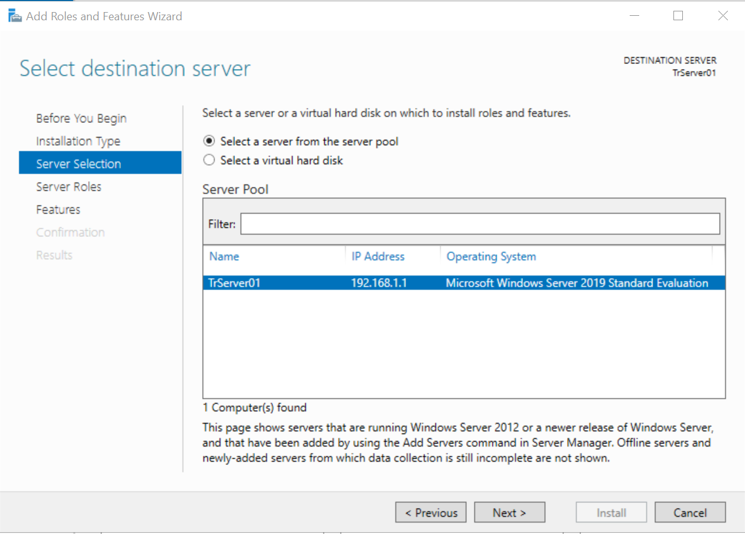
Check the check box next to the role that you want to install, and click Next.
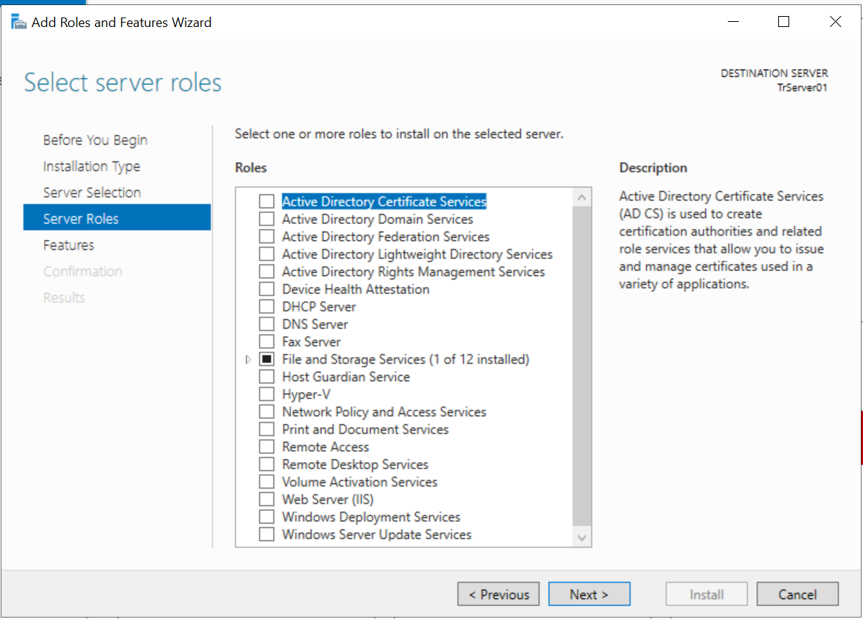
Click Install to install the roles and/or features you selected.
Setup the Windows Server OS for remote administration.
With Server Manager open, click Local Server.
Click the hyperlink next to Remote Desktop that says Disabled.

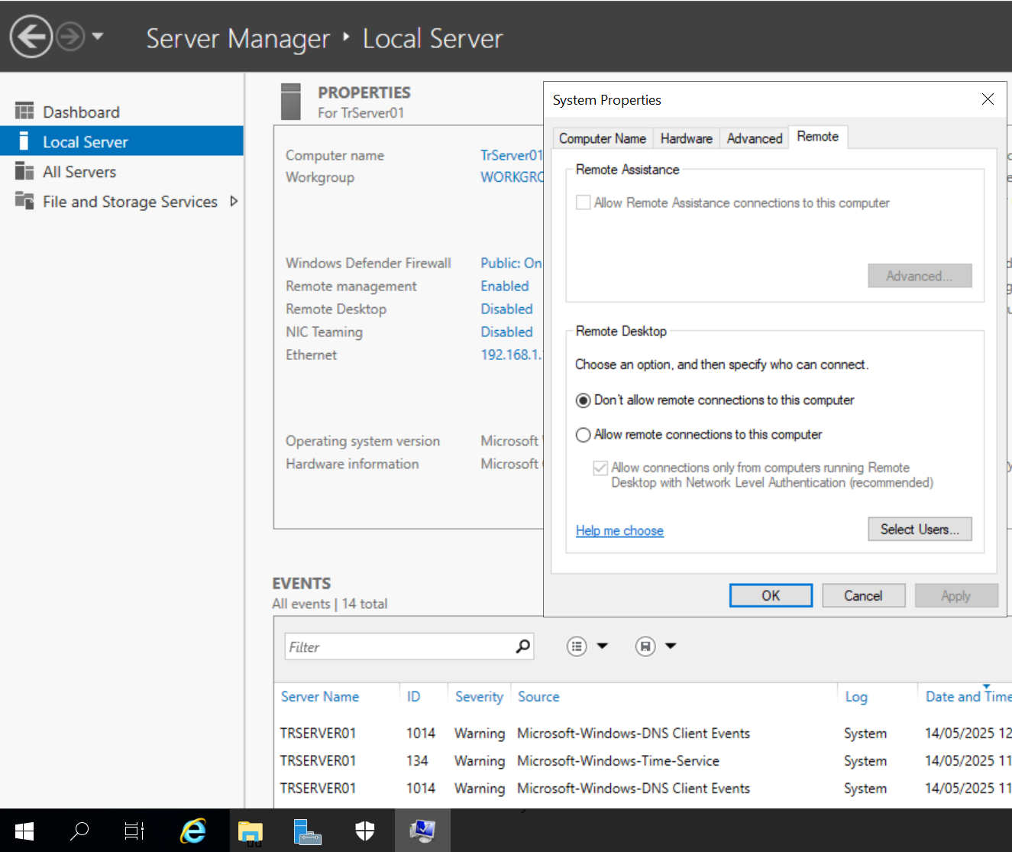
In the dialog box that appears, select Allow remote connections to this computer.
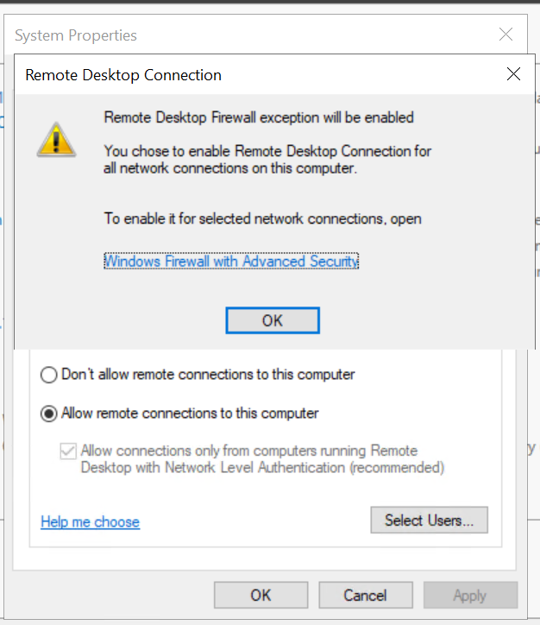
Click OK.
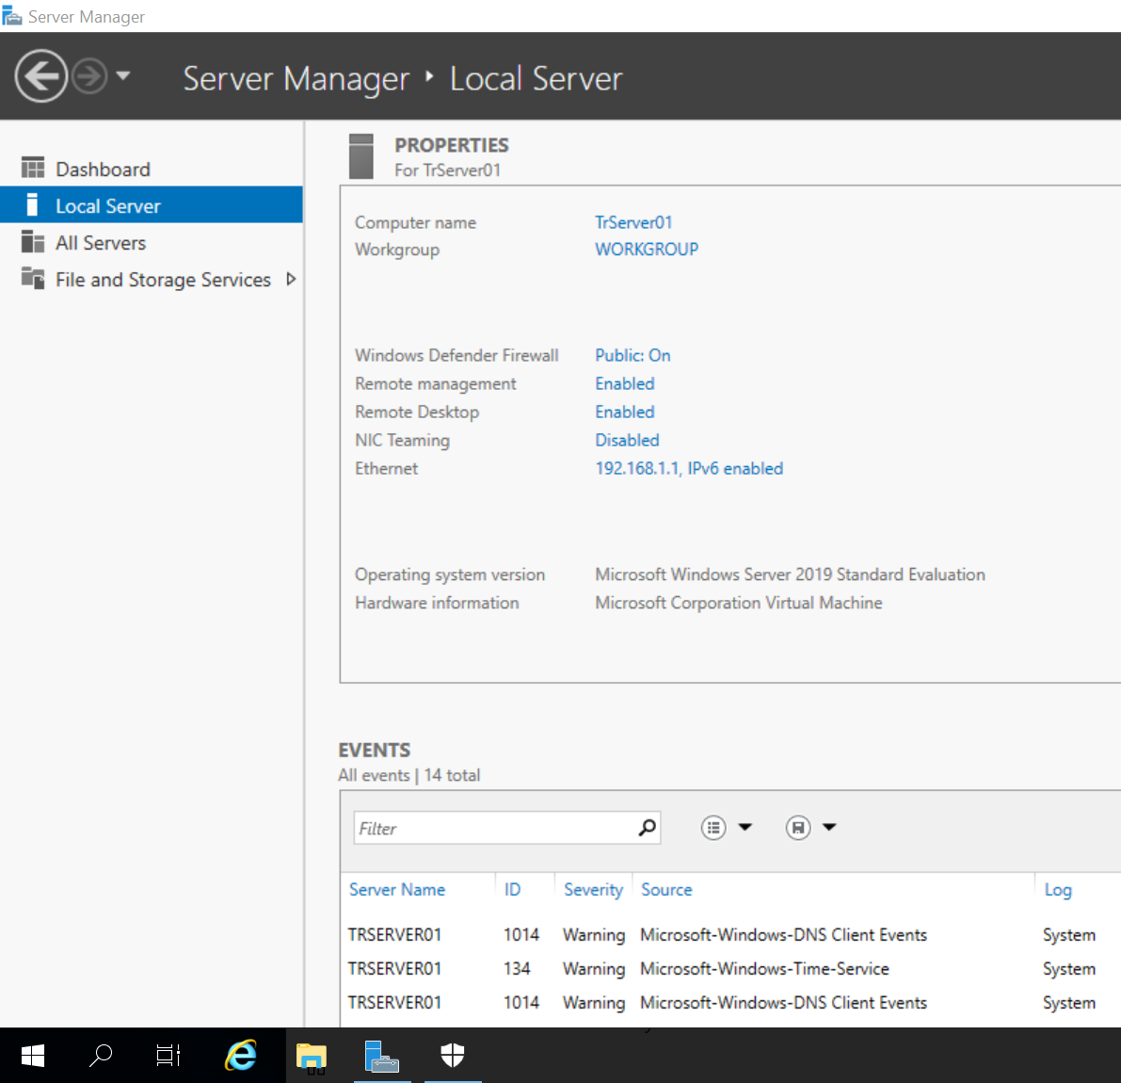

Activity: Confirm initial configuration
Use the following screenshot to confirm your settings are correct.
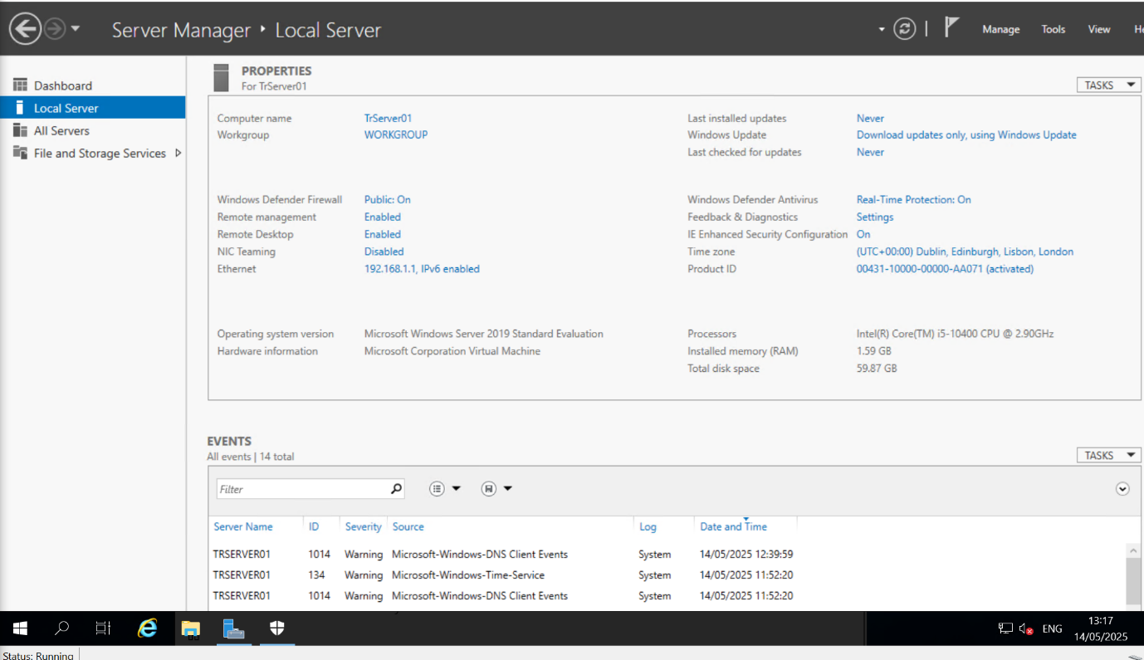

The following materials relate to lesson 8: Desktop operating system
Activity: Download Windows 10 Pro ISO
Activity: Install Windows 10 Pro on Desktop VM
Activity: Confirm configuration of Windows 10 Pro
Feedback sheet

Activity: Download Windows 10 Pro ISO

Instructions
Download a copy of Windows 10 Pro. In practice, you may use a USB drive or have it hosted locally for access.
microsoft.com/en-us/software-download/windows10

Activity: Install Windows 10 Pro on Desktop VM

Open Hyper-V Manager.
Start TrPC01 and install Windows Pro.
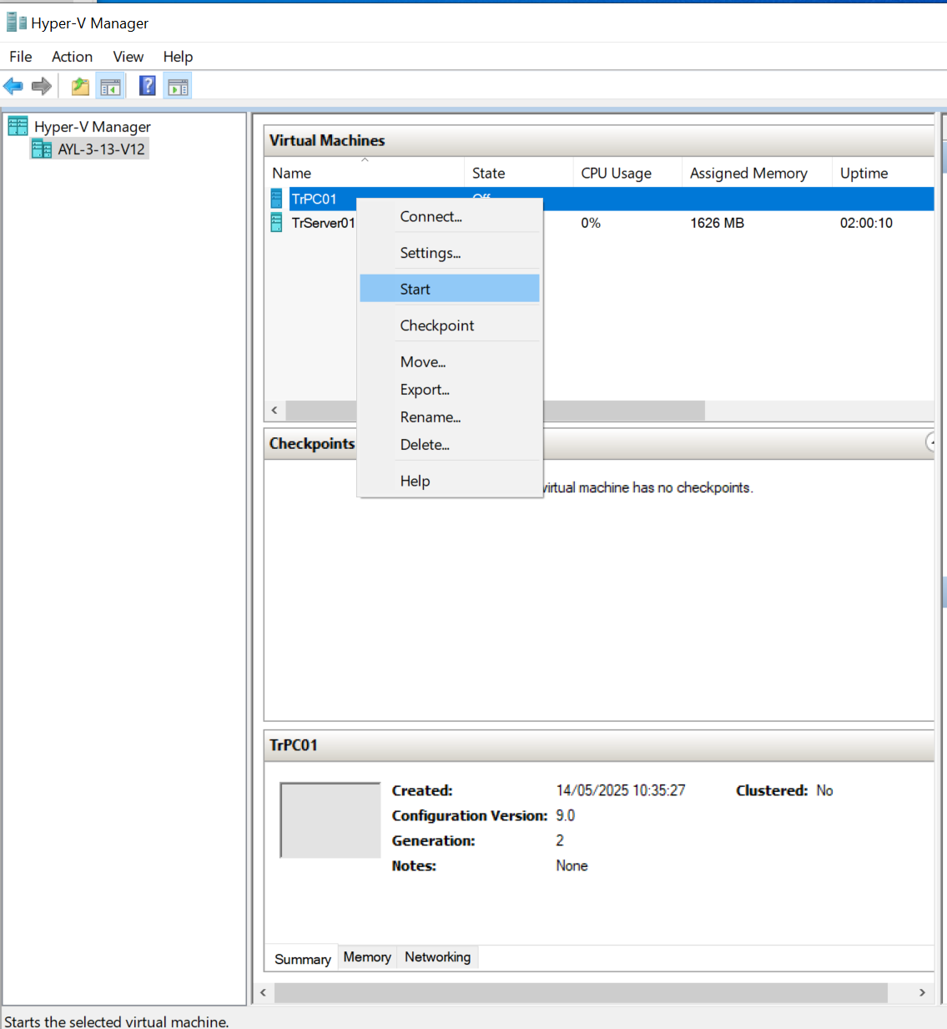
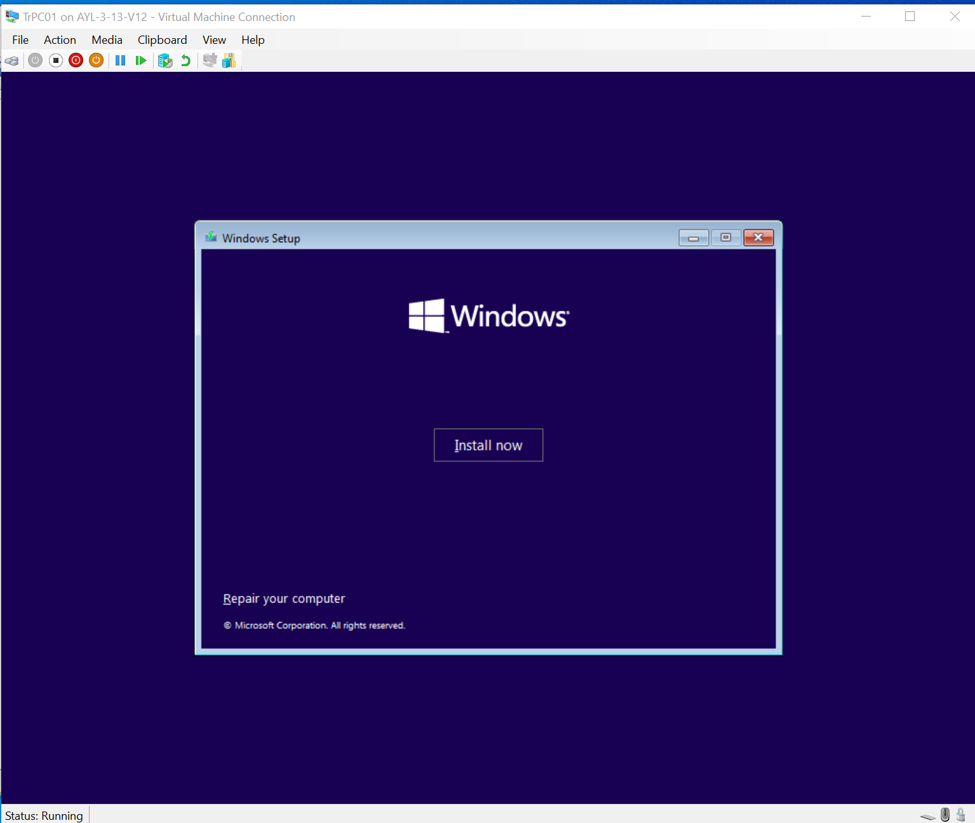

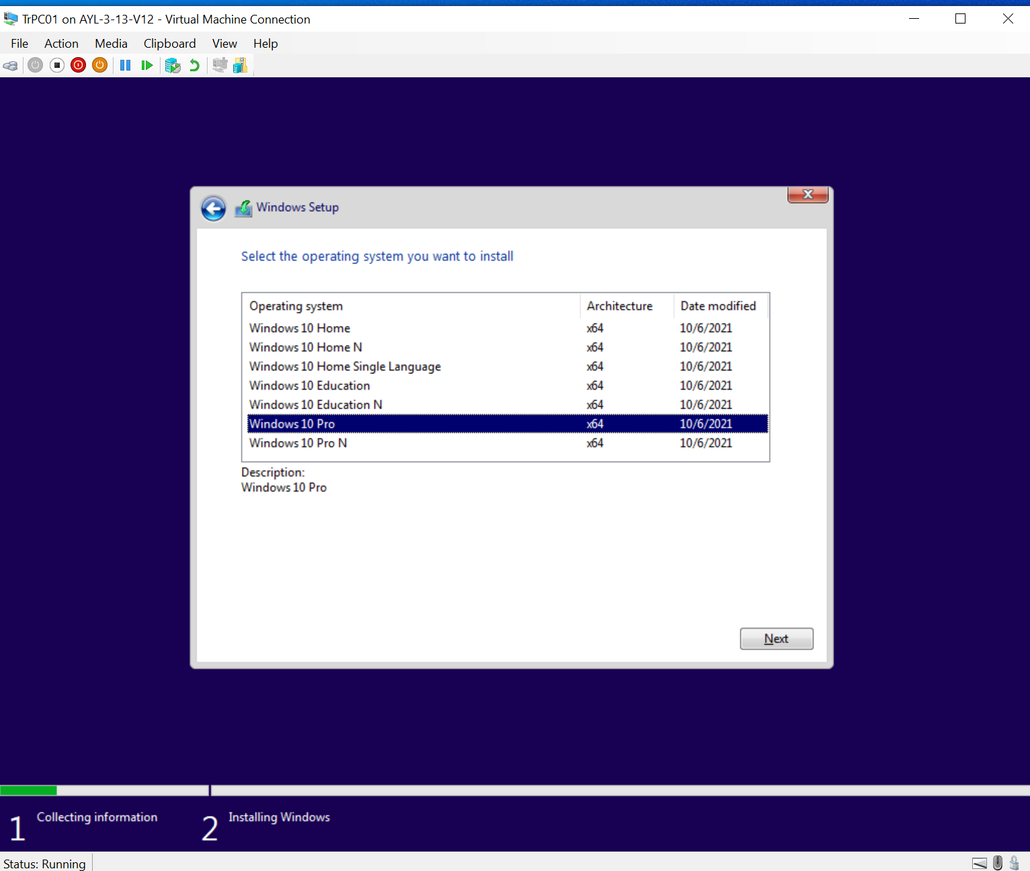
Click Next.
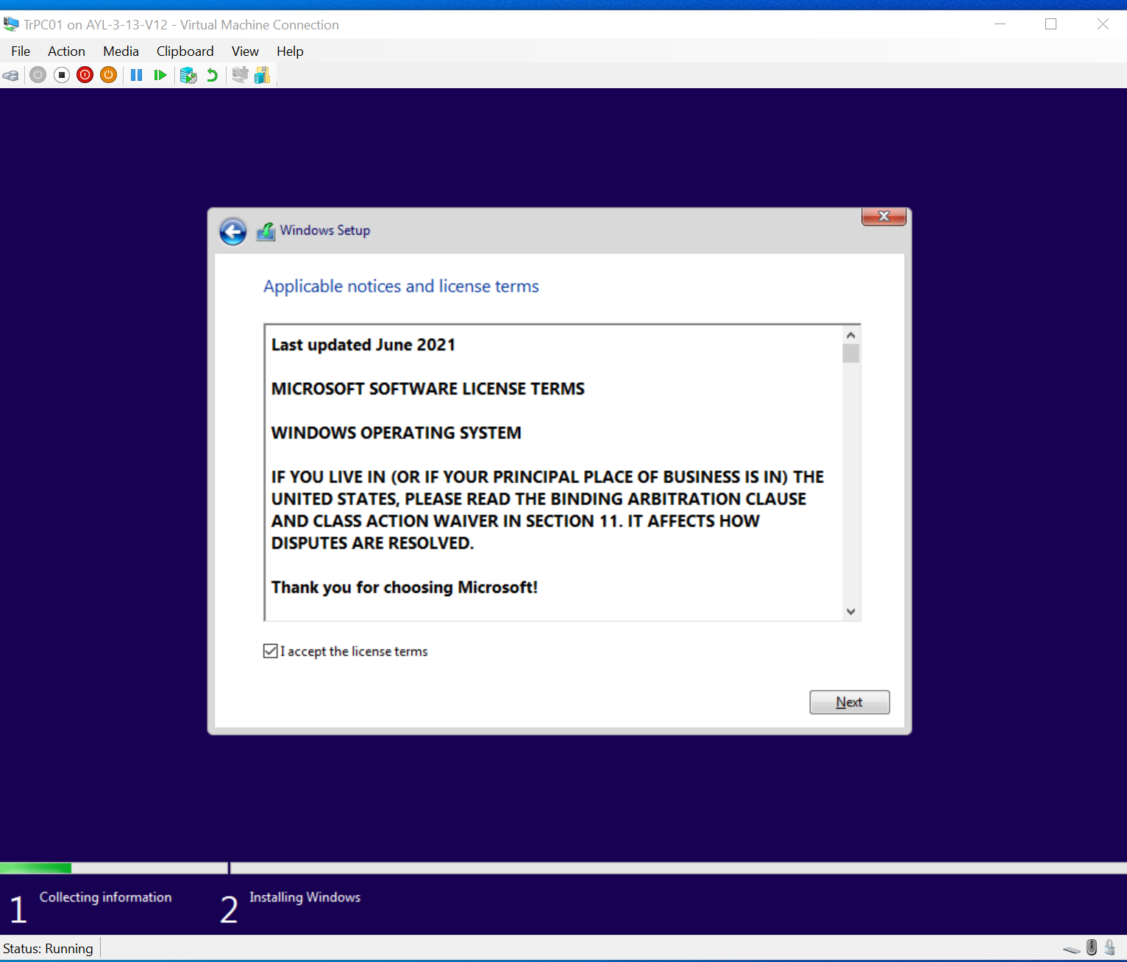
Click Next and select New.

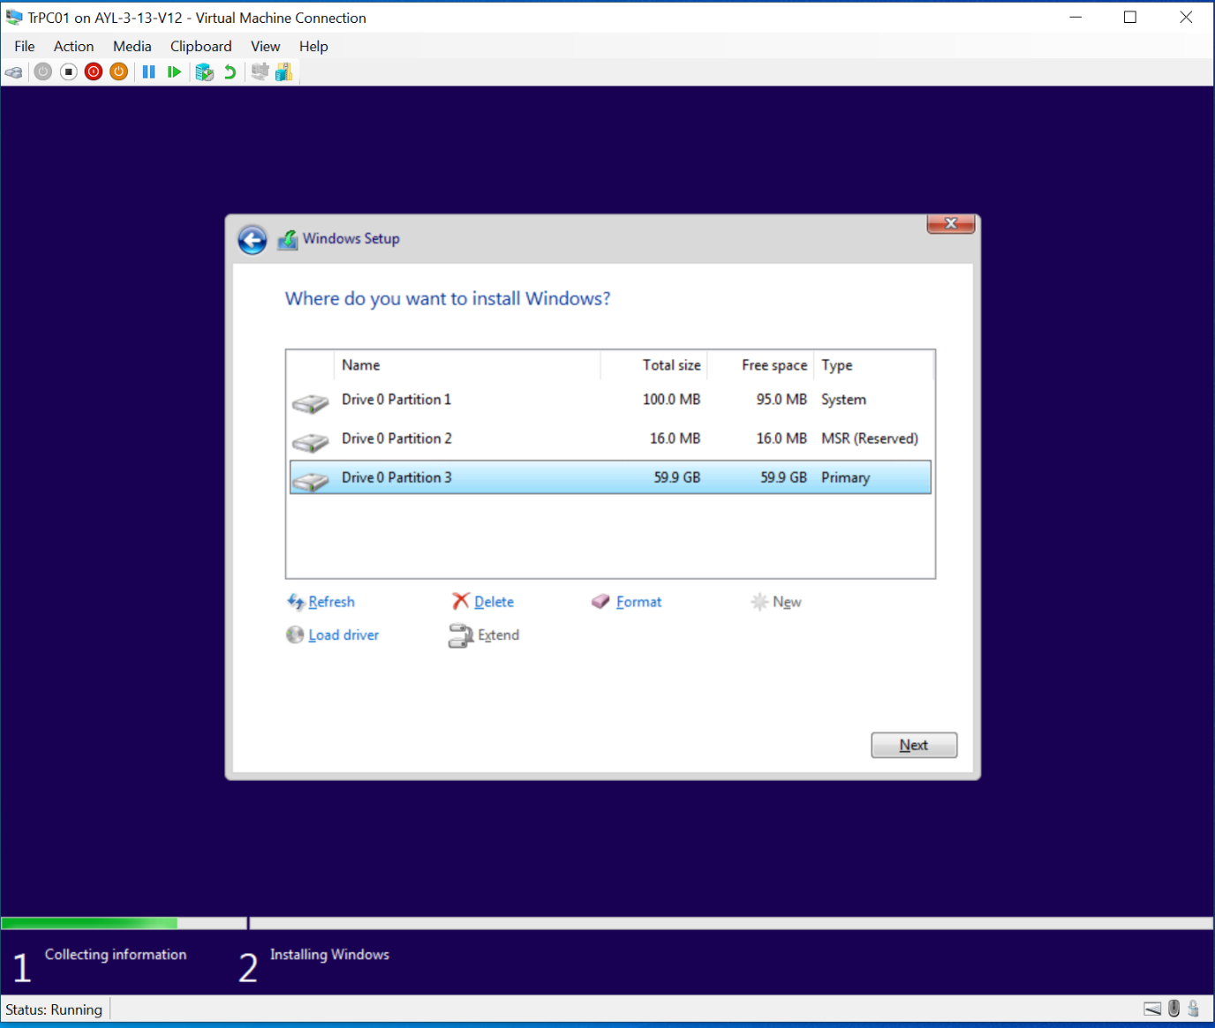
Click Next.
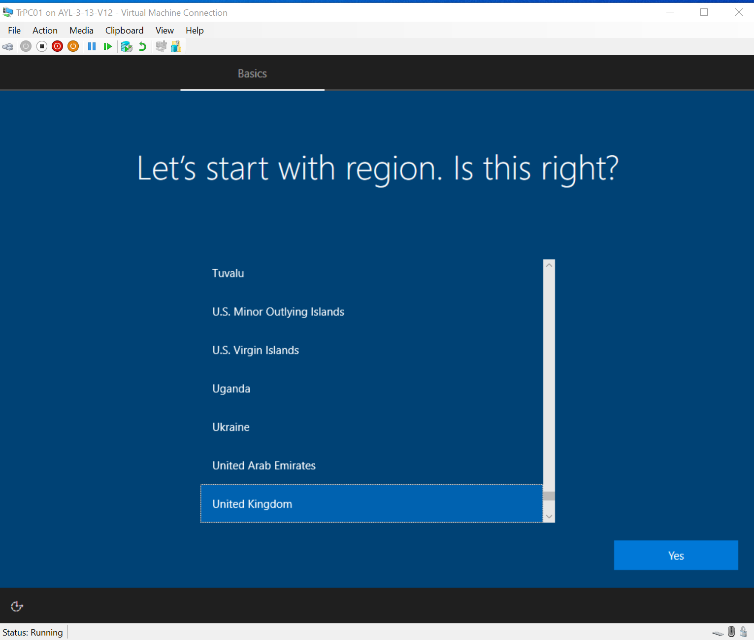

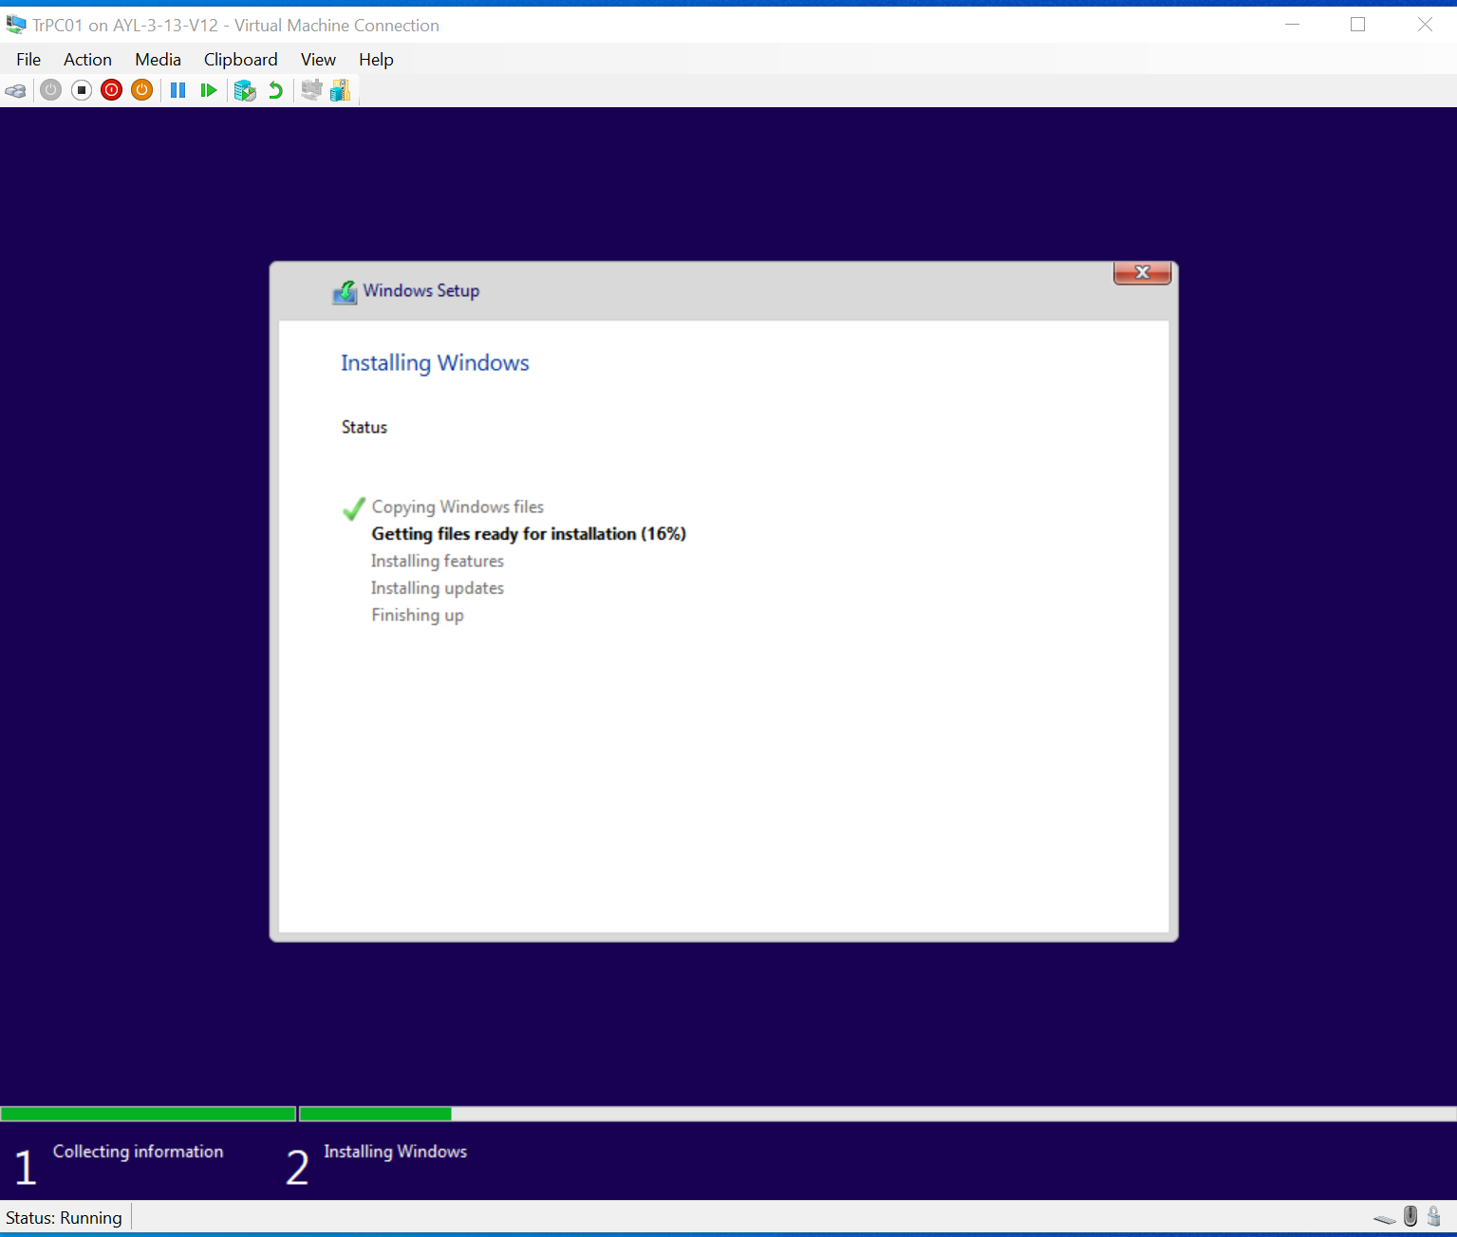

Activity: Confirm configuration of Windows 10 Pro

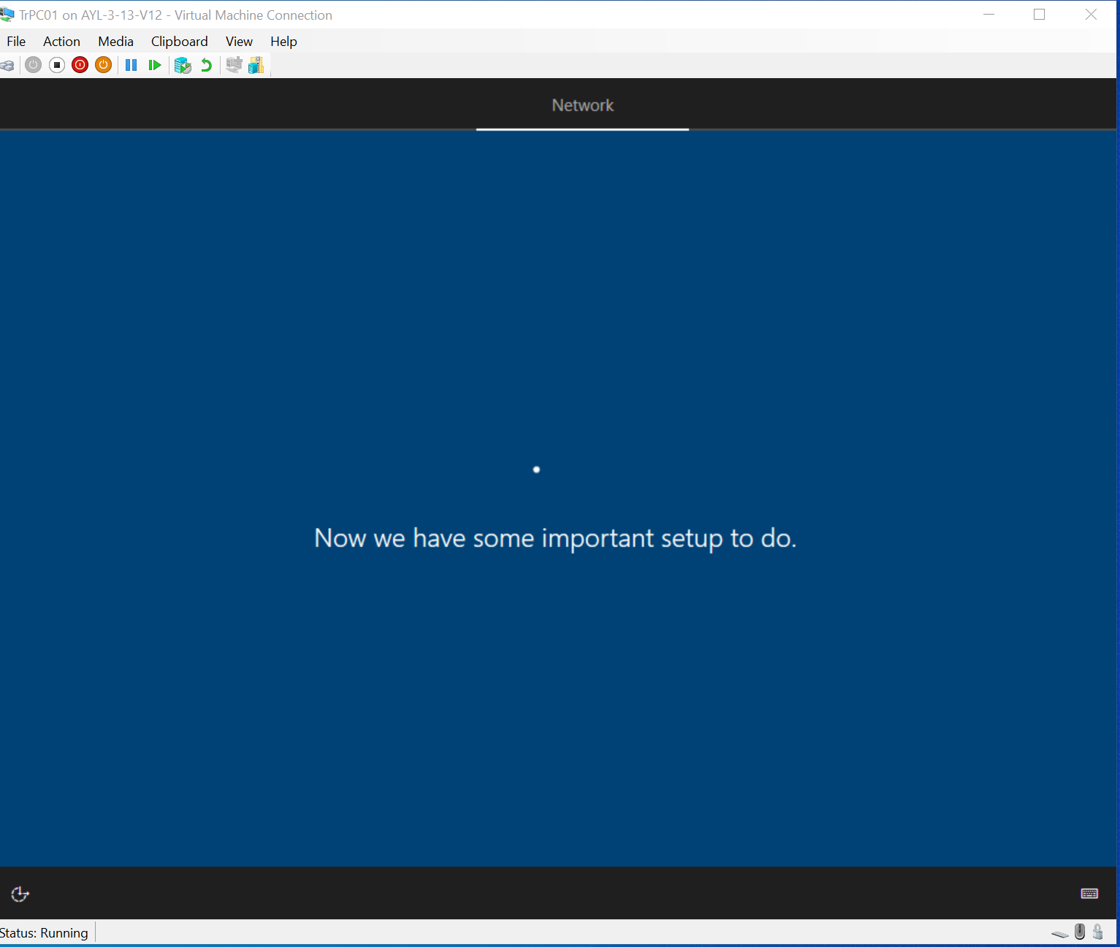
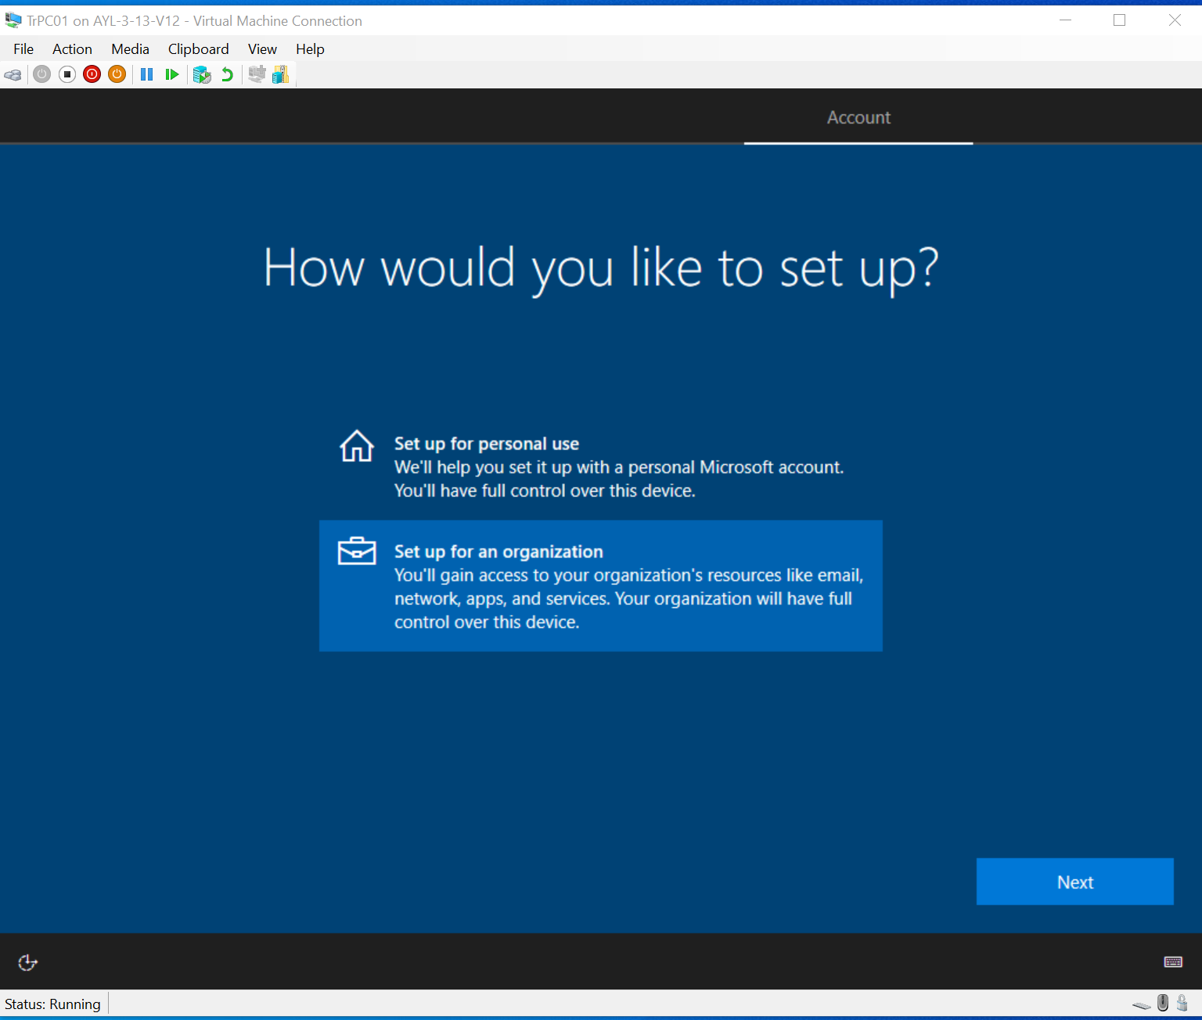
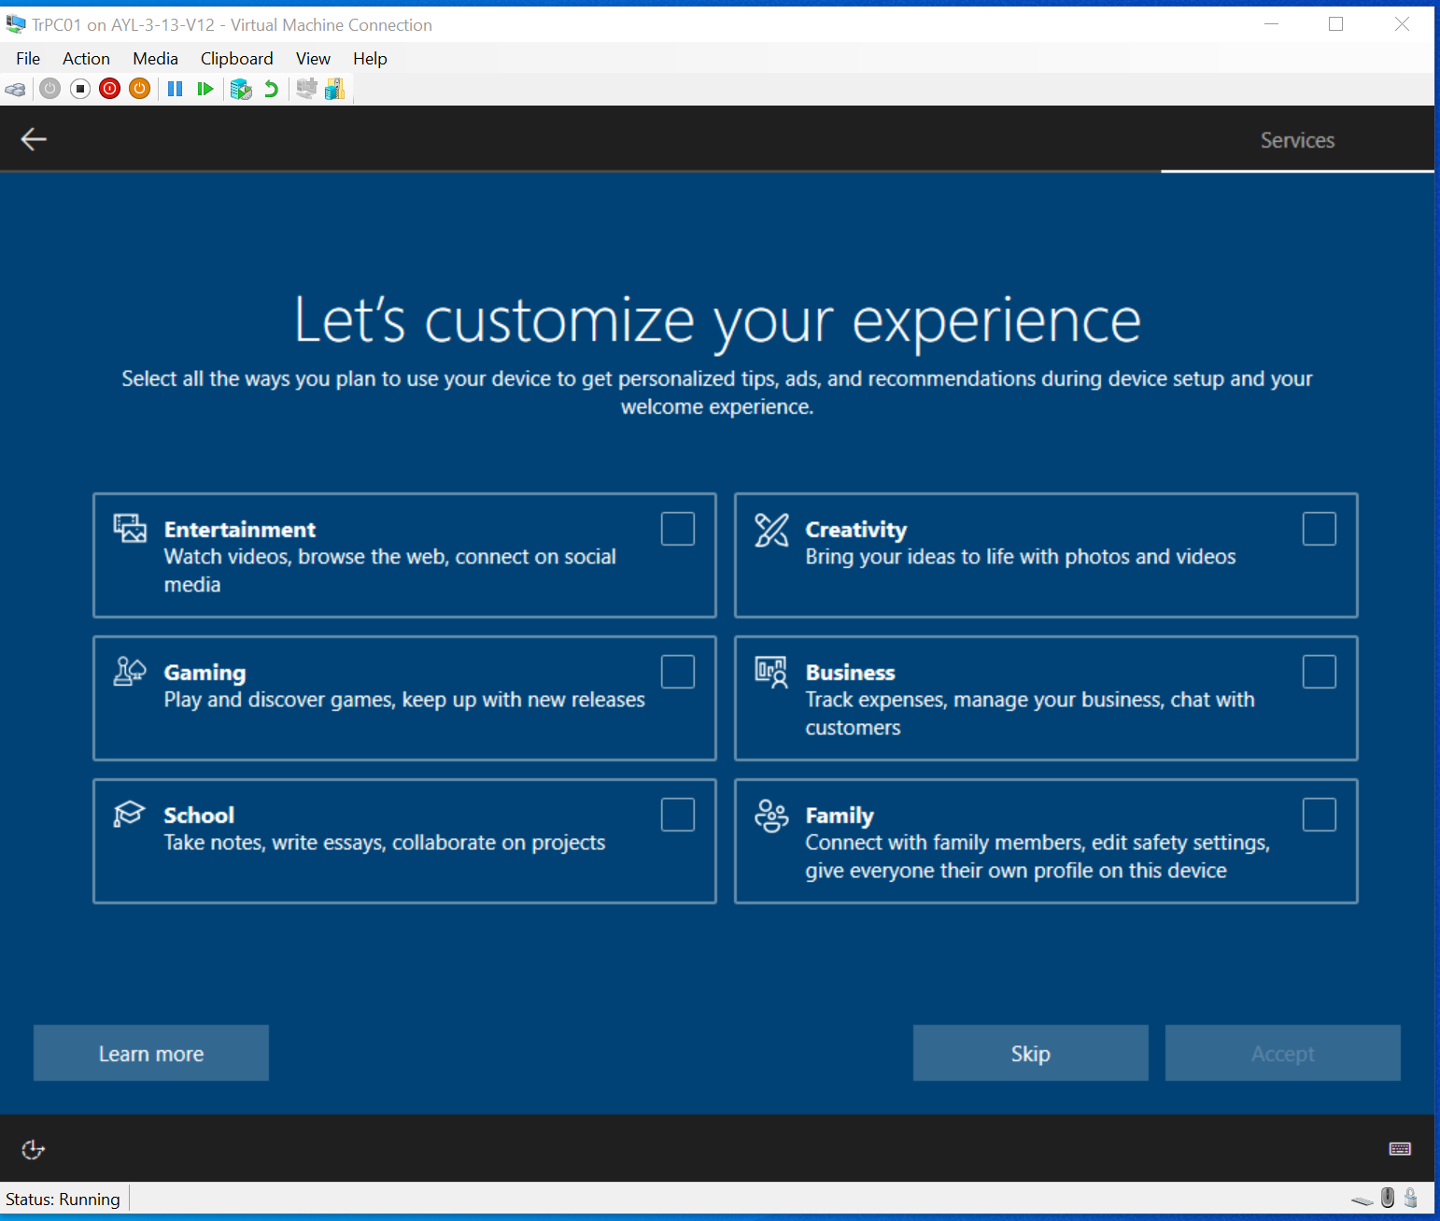

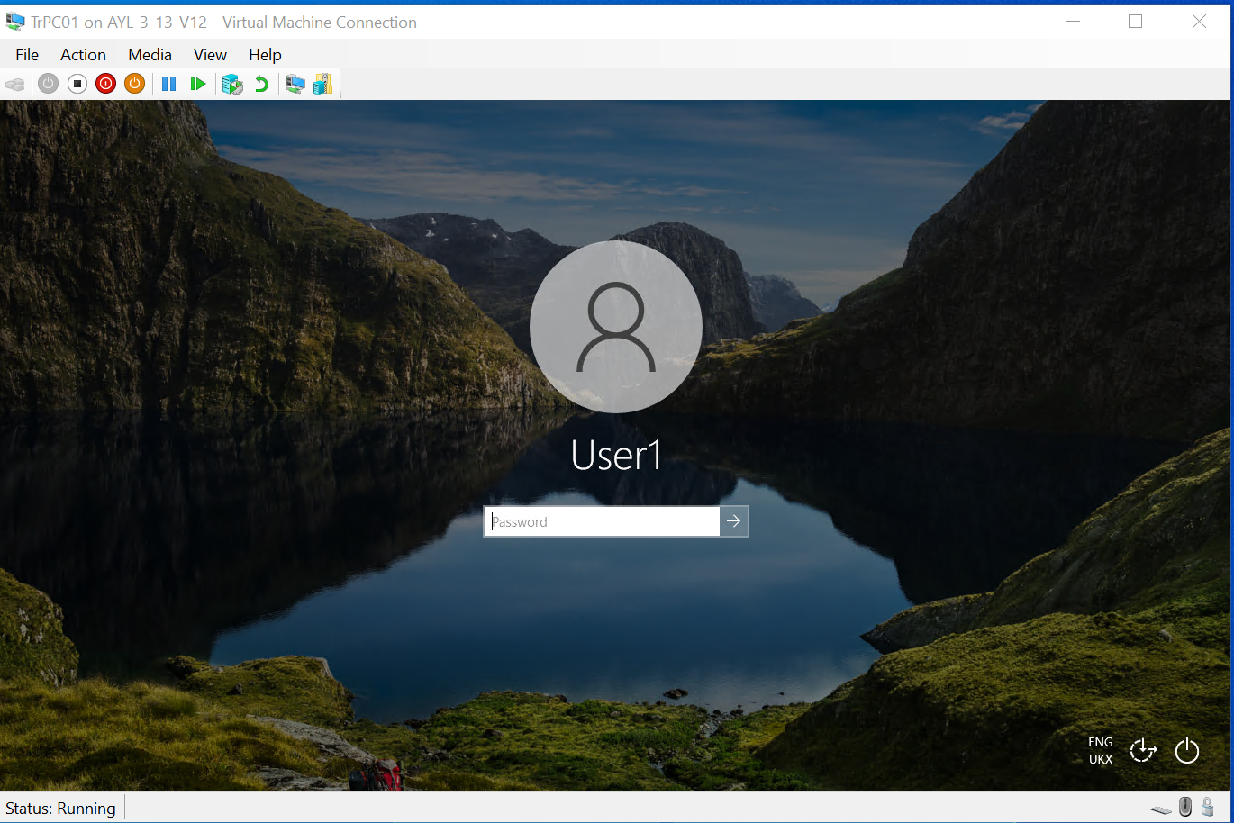

Settings

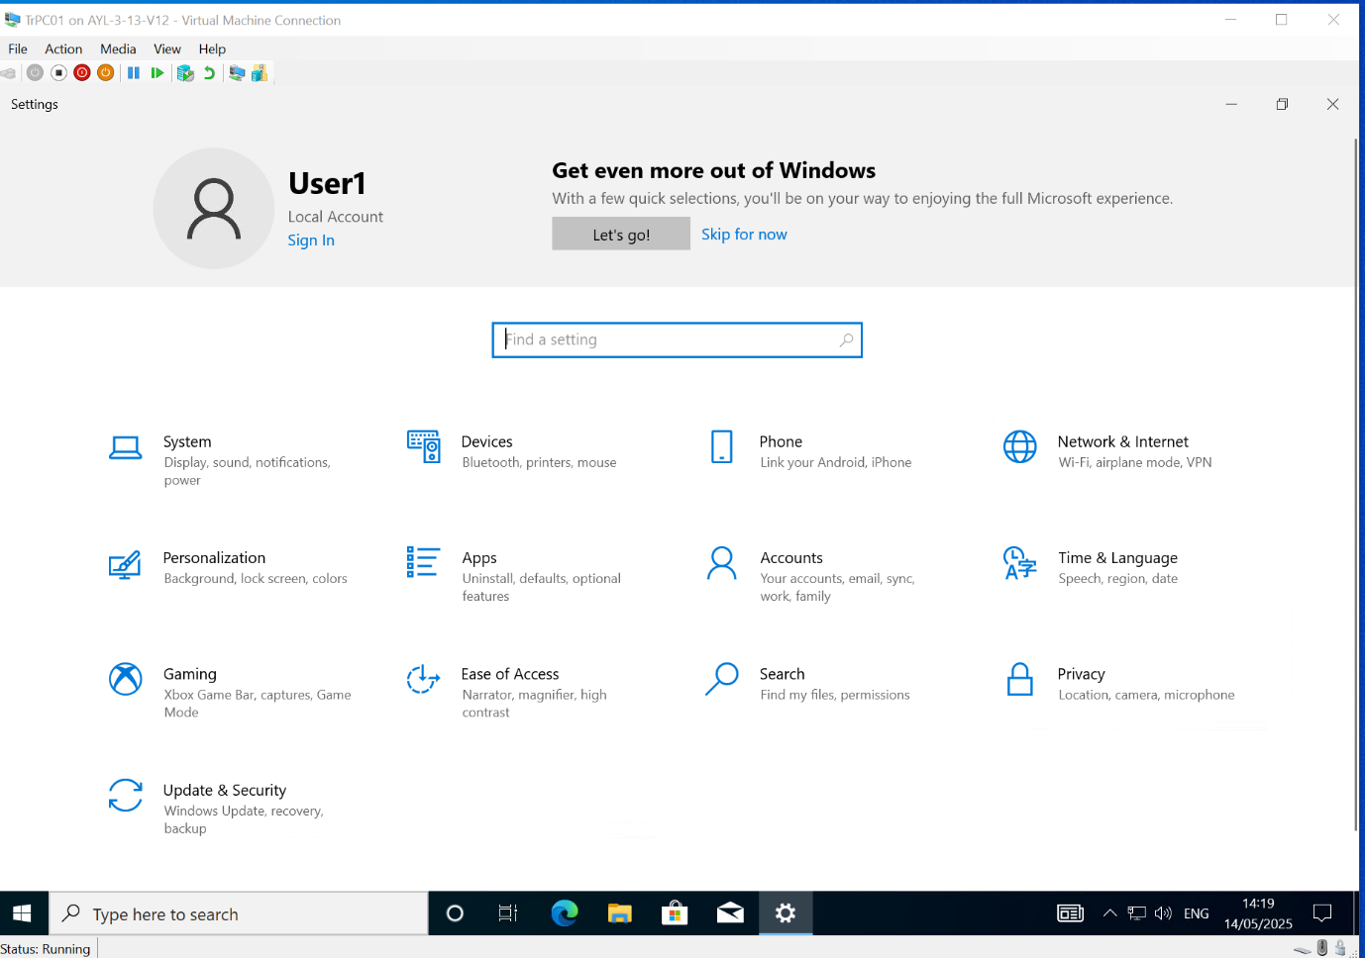
Network settings
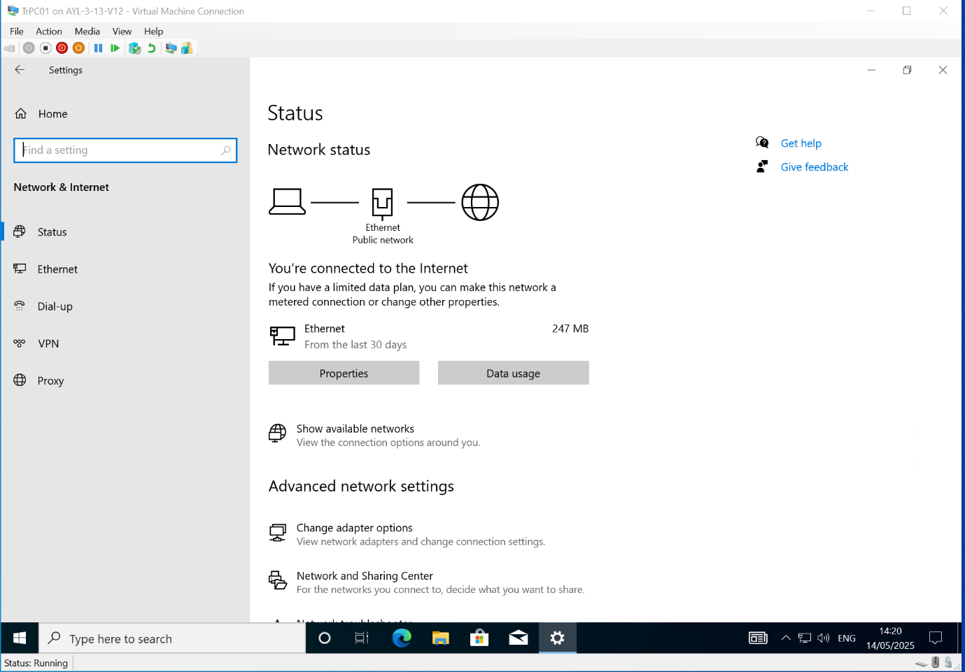
Test initial configuration.
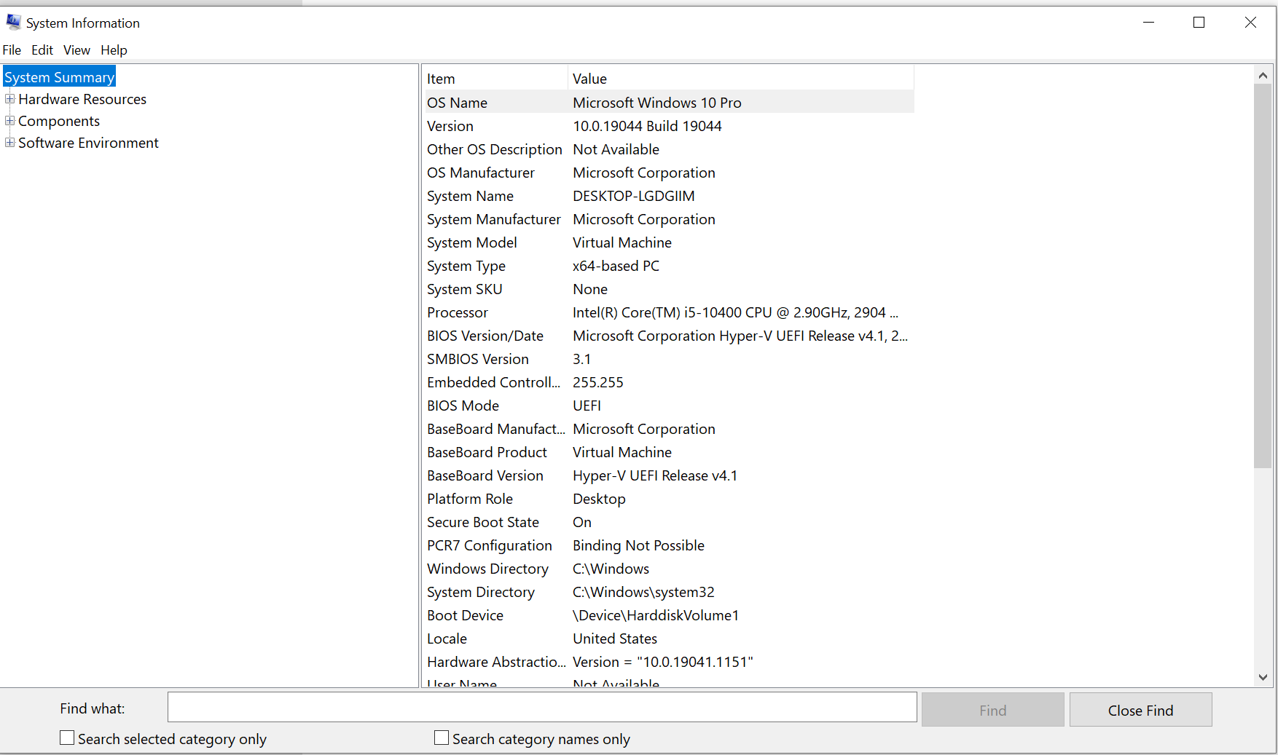

Network settings

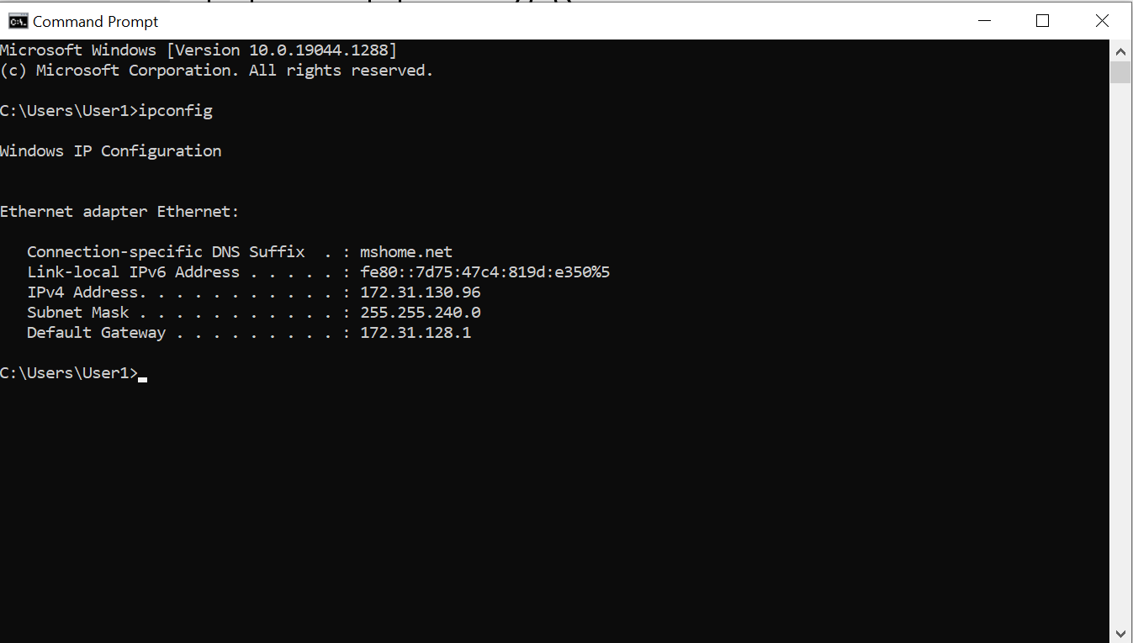
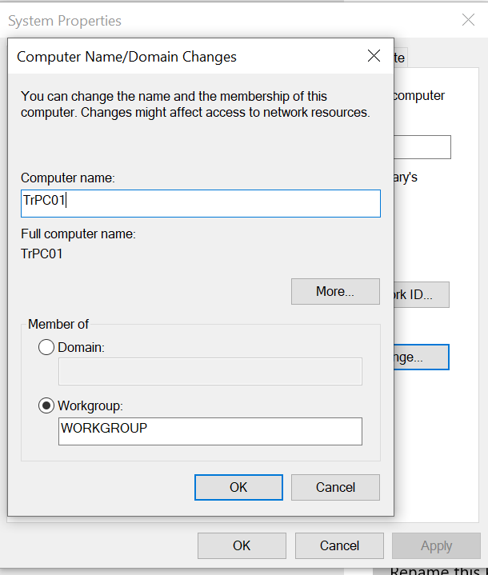

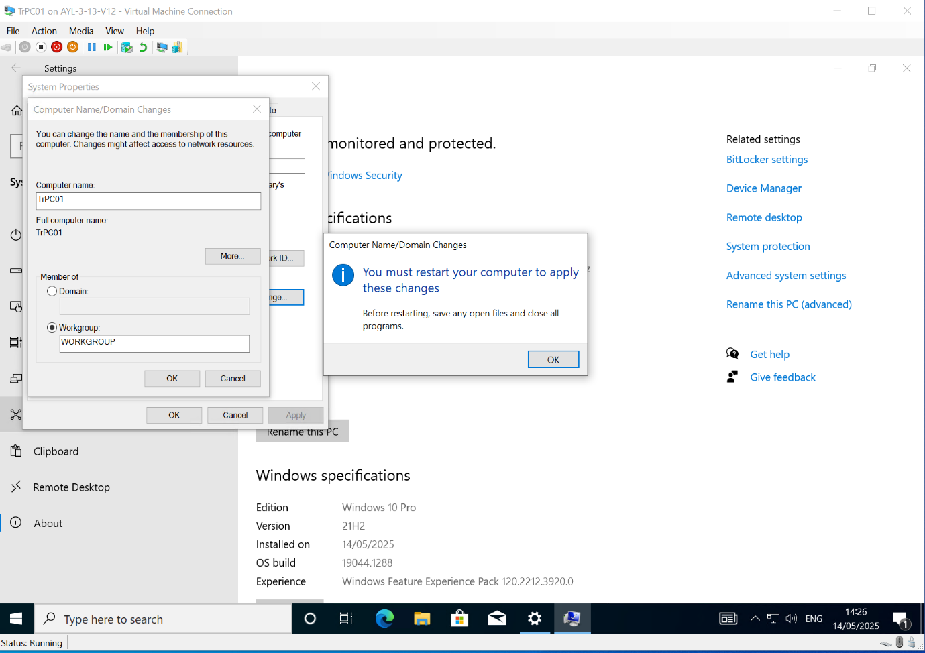
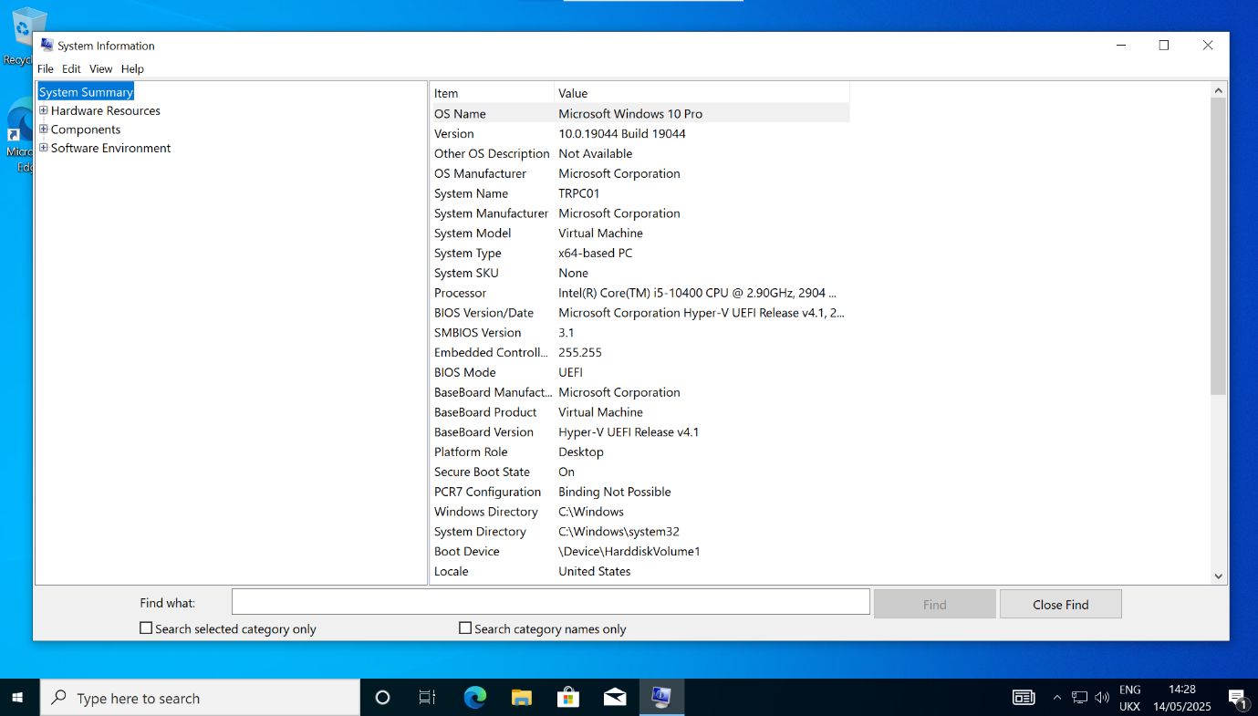

Feedback sheet
Learner being reviewed: __________________________
Reviewer name: __________________________
Date: __________________________
Aspect | Yes/No/Partially | Comments
The Windows 10 Pro ISO was correctly downloaded and mounted. | ☐ Yes ☐ No ☐ Partially
The Windows 10 Pro installation process was completed without errors. | ☐ Yes ☐ No ☐ Partially
Appropriate configuration options were selected (region, language, version). | ☐ Yes ☐ No ☐ Partially
Initial user set-up (username, password, PC name) was completed clearly. | ☐ Yes ☐ No ☐ Partially
Privacy and set-up preferences (updates, feedback, location) were customised logically. | ☐ Yes ☐ No ☐ Partially
The system boots to a working desktop and is functional. | ☐ Yes ☐ No ☐ Partially

What worked well?
(Write one short comment about something your peer did well.)

What could be improved?
(Write one constructive suggestion to improve the Windows 10 Pro set-up.)


FUNDED BY

This programme is funded by the Department for Education

Buckinghamshire College Group has produced this resource on behalf of the Education and Training Foundation

