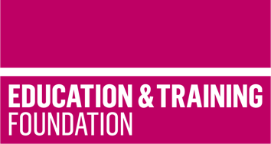


TRIP 15

Produce materials to support Occupational Specialism holistic delivery of the T Level in Education and early years

This T Level Resource Improvement Project (TRIP) has produced a range of learning materials, developed and peer reviewed by experienced T Level providers. These learning materials will support providers to holistically deliver Performance Outcome 3 of the Occupational Specialism Early years educator of the T Level in Education and early years.

Produced by Calderdale College and peer reviewed by Nottingham College, this TRIP provides an accessible framework for learning, lesson plans and supporting learning materials that will enable learners to hone and develop knowledge and skills for the Early years educator Occupational Specialism content of the T Level in Education and early years.

The resources include:
- a framework for learning to show how learning can be scaffolded and holistically sequenced to develop the required knowledge and skills.
- 14 lesson plans which cover 24 hours of learning to support the scaffolding of the knowledge and skills within the Occupational Specialism content
- learning materials to support each lesson which enables the delivery of the 24 hours of learning

The aim of this resource is to support the planning of an effective activity plan in early years settings, covering the prime areas of learning. The resource is based on a class size of 15-20 learners and has considered some adaptive teaching which is subject to change dependent upon the learners in the group. It focuses only on the prime areas of development that early years settings focus on, owing to the resource being only 24 hours long. The prime areas link to every lesson and are embedded in all learning opportunities, whereas the remaining four additional areas of learning may need specific activities.

The prime areas covered are:

- communication and language
- physical development
- personal, social and emotional development.

The additional areas that are not covered in this resource are:

- literacy
- mathematics
- understanding the world
- expressive arts and design.

The learning materials to support each lesson includes activities, case studies, research tasks, handouts and templates

There is a separate slide deck to support the lessons.

Downloadable resources

Word document including introduction, framework for learning, lesson plans and associated supporting resources | 1
PowerPoint to support lesson plans | 1

