

SUPPORT HOLISTIC DELIVERY OF CORE CONTENT AND OCCUPATIONAL SPECIALISM CONTENT
ET-FOUNDATION.CO.UK
T LEVEL IN IN ANIMAL CARE AND MANAGEMENT

INTRODUCTION
Understanding and applying appropriate techniques to influence positive animal behaviour is crucial. It promotes animal welfare, enhances human–animal interactions and facilitates effective conservation efforts. By understanding why animals behave the way they do, we can better protect the animals, manage their care and foster harmonious relationships with them.
This resource provides a Framework for Learning (FfL) linked to the T Level in Animal Care Management. The learning centres on Performance Outcome (PO) 3: Apply techniques to influence positive animal behaviour and the resource additionally draws on other content to provide a holistic approach.
The resource includes a variety of tasks, tools, videos and case studies designed to develop understanding and the skills to manage animals effectively when influencing animal behaviour.
The resource develops learners’ problem-solving and critical thinking skills through analysis and evaluation of animal behaviour. It requires learners to work with a range of animals so that they can better understand the similarities and differences between species’ behaviours and how techniques are adapted to suit a specific animal.
This resource has three sections:
Framework for Learning
The resource includes a Framework for Learning (FfL). This covers 20 hours of learning. There is a diagram to show how the content of those hours has been sequenced and scaffolded. There is also a narrative that explains the sequencing and scaffolding in more detail.
Lesson plans
There is a lesson plan for each stage in the sequencing and scaffolding of learning in the FfL. Lesson plans include details of the support materials that are required to support delivery, including those found within this resource.
Support materials
The support materials identified in the lesson plans are also available at the end of this document.
NOTE:
There is a separate slide deck that can be used with the lessons.

SECTION 1: FRAMEWORK FOR LEARNING
The FfL sets out one approach to scaffolding and sequencing the development of holistic delivery of Core Content and Occupational Specialism content relating to the T Level in Animal Care and Management. This resource focuses on PO3: Apply techniques to influence positive animal behaviour. The holistic approach combines the development of this PO with the relevant Core Content to develop understanding and skills required to influence positive animal behaviour. The resource incorporates the development of health and safety legislation, reporting of animal care and relationship management, including the roles of stakeholders and stakeholder communication. The activities within the lessons develop Core Skill B (CSB), Communication: reading, writing, listening and speaking using visual, oral and written methods.
This resource includes a range of animals including rabbits, guinea pigs and hamsters. Some animals, including degus, lemurs and rats, are used as examples to compare animal behaviour. Providers may want to adapt the lessons so they relate to the animals that are available to their own learners. It is expected that a significant amount of additional time will be spent delivering the content of PO3 beyond these 20 hours and that this will need to relate to other animal species.
Sequencing and scaffolding
The learning is based on four stages of learning, which are represented as a food web, illustrating the approach to holistic learning. The applied purpose and outcome of this learning is to propose solutions to influence positive animal behaviour.
The stages are as follows:
Soil stage
This stage represents the foundation of growth and includes understanding of the techniques used to influence positive animal behaviour. It introduces the theory of animal behaviour and plants the seeds of knowledge of health and safety legislation, reporting of animal care, and risk and incident reporting. Learners will apply ethologist theories to case study animal observations and, through these case studies, start to develop analytical skills. This stage also develops written communication skills and active listening skills.
This stage includes three lessons.
Vegetation stage
This represents the growth of the seeds of knowledge developed at the soil stage. Learners will apply theory and start to develop observation techniques used to identify factors affecting animal behaviour. This stage will develop a deeper understanding of animals and the links between behaviour, health and welfare. It will reference relationship management, including the roles of stakeholders and stakeholder communication. This stage introduces a level of complexity as learners will be introduced to animal health and need to consider different factors when identifying the underlying causes of animal behaviour. This stage also develops written communication skills and the skill of adapting communication to different stakeholders.
This stage includes three lessons.
Rabbit stage
This stage is outside of the resource’s 20 hours but within the sequence of learning. It requires learners to practically apply the knowledge and skills acquired from the soil and vegetation stages in a practical animal setting. This stage requires learners to observe and adapt to any environmental factors for an animal over a five-week period. They will need to carry out the task with the same animal, at the same time each week.
Fox stage
This stage develops strategies and techniques to implement permanent positive changes with animals. It develops problem-solving and critical analysis skills, extending the learners’ ability to propose solutions to influence positive animal behaviour. This stage draws on peer learning so that learners understand the range of behaviours of a variety of animals. Learners will then be able to identify animal welfare concerns relating to behaviour and propose suitable solutions.
This final stage includes four lessons, the last bringing all the learning together.
The following diagram shows how the development of skills to propose solutions to influence positive animal behaviour will be sequenced and scaffolded.
Framework for Learning diagram illustrating the development of skills to propose solutions to influence
positive animal behaviour
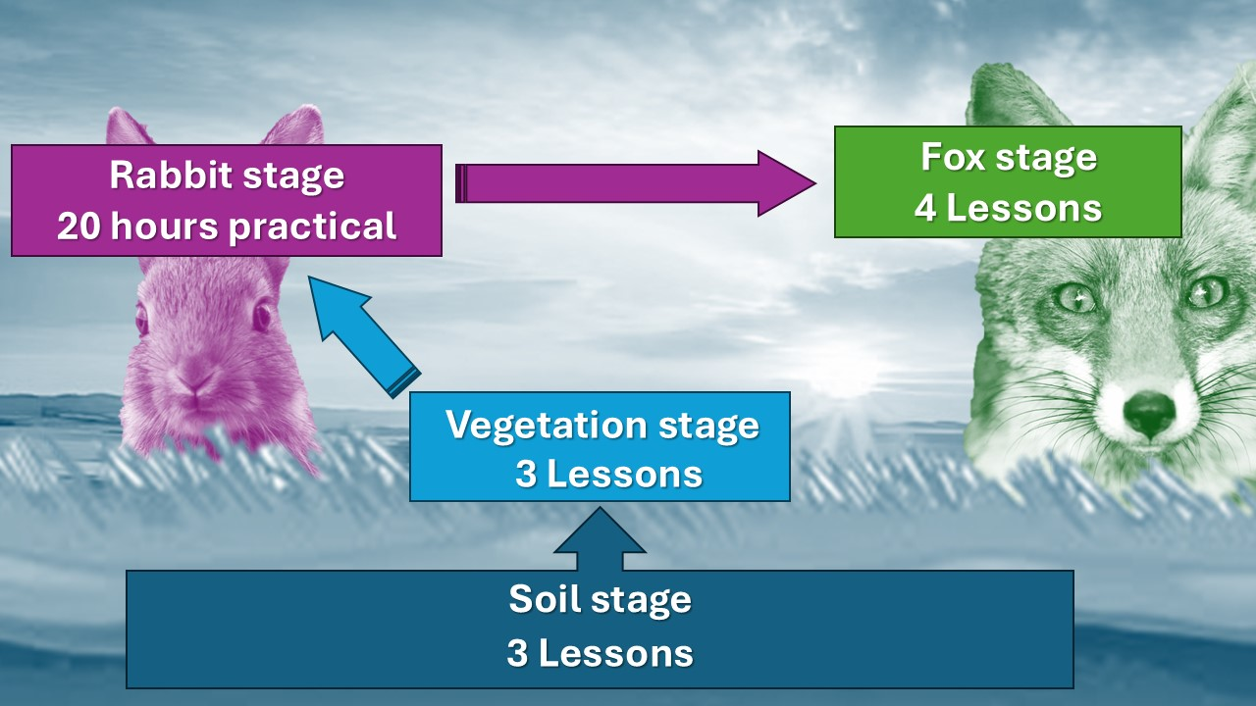

SECTION 2: LESSON PLANS
This section includes 10 lesson plans. The lesson plans follow the FfL. The lesson plans include the:
- lesson title
- targeted specification content coverage
- lesson number in the sequence
- total amount of time required to deliver the lesson
- teacher and learner activities to be undertaken throughout the lesson
- resources needed to deliver the lesson (see Note below)
- details of how the lesson supports the development of English, maths and / or digital skills (where appropriate)
- details of how the lesson can be adapted to meet learners with specific needs
- next steps in learning such as homework activities and links to the next lesson.
Note:
There is an assumption that the learning environment will include the following:
- whiteboard/smartboard or similar
- materials to take notes, e.g. pens, paper, audio recorder, digital device and software
- equipment to present a slide deck and video, e.g. projector, smartboard
- digital devices (e.g. laptop, tablet) for all learners
- internet access
- learner access to word-processing, spreadsheet and presentation software.

Lesson 1
Title: Why do we study animal behaviour?
Targeted content reference:
Core: 1.1 and 7.1.
OS: 3.4 and 3.8.
Lesson sequence number: 1
Timing: 2 hours
Prior learning:
Learners are required to understand the Animal Welfare Act 2006 (five needs) (Animal Core Pathway 3.1).
Learners should also have developed health and husbandry skills relating to working with small mammals such as rabbits, guinea pigs and hamsters.
Timing | Teacher activity | Learner activity | Support materials
15 minutes | Introduction: set out the sequence of learning. Explain what is going to be achieved from the lesson. Explain starter task. Distribute Animal behaviour confidence rating worksheet. | Listen, take notes and ask questions as required. | Slide deck  Animal behaviour confidence rating worksheet  Mini whiteboards  Flipchart paper and pens  Natural behaviours worksheet  Behaviour snap cards (teacher to cut out cards in advance)  Lesson 1 next steps worksheet
15 minutes | Circulate, observe and ask probing questions to identify understanding. | Individually, read and complete the Animal behaviour confidence rating worksheet. Calculate total score.
15 minutes | Invite learners to indicate total score. Make note of learners with a particularly high or low score for future reference. | Indicate total score using a mini whiteboard, sheet of paper or similar.
10 minutes | Give task requirements. | Listen, take notes and ask questions as required.
10 minutes |  | Individually, write a definition of the term ‘animal behaviour’.
10 minutes | Allocate learners to pairs. Give details of task. | Listen and clarify task requirements. Move to allocated pair.
10 minutes | Circulate, observe and ask probing questions to identify understanding. | Compare own definition with pair and agree a revised definition.
10 minutes | Facilitate class feedback. | Each pair to give their agreed definitions.
30 minutes | Explain what is meant by natural and atypical behaviour. | Listen, take notes and ask clarification questions as required.
30 minutes | Provide examples of natural and atypical behaviour. Talk through examples that learners will be familiar with from home/school/college or their Industry Placement. Ask learners questions about any of the behaviours that they have observed while going through each example. | Listen, take notes and provide examples of animal behaviours.
30 minutes | Explain the requirements of the task. Split the class into six groups. Allocate groups one animal species. Provide flipchart paper and pen to each group. | Listen, take notes and ask clarification questions as required.
30 minutes | Circulate, observe and ask probing questions to identify understanding. | Each group writes the name of one of the following animals on the flipchart paper, ensuring that each animal is represented: rabbit, guinea pig, hamster, chicken, bearded dragon and armadillo. The group discuss and write examples of both natural and atypical behaviours associated with the animal given on the flipchart paper. Each group moves to the next piece of flipchart paper and adds to the examples of natural and atypical behaviours. This continues until all learners have written examples for all animals.
30 minutes | Move around the room noting the key behaviours for each animal. Ask learners for specific reasons why they have noted specific behaviours and correct any misconceptions. | Answer questions when asked. Note any misconceptions.
25 minutes | Explain how animal behaviour is monitored. Go through the causes of atypical behaviour. Remind learners that to be able to perform natural behaviour is one of the five welfare needs. If the other four are not facilitated, this can contribute to atypical behaviour. | Listen, take notes and ask clarification questions as required.
25 minutes | Introduce examples of natural behaviours using a meerkat and elephant as examples. Provide examples of how each animal exhibits their natural behaviour and highlight the differences. | Listen, take notes and ask clarification questions as required.
25 minutes | Set the requirements of the task. Distribute Natural behaviours worksheet. Regroup learners into previously allocated groups. Ask them to refer to the flipchart paper. | Listen, take notes and ask clarification questions as required.
25 minutes | Circulate, observe and ask probing questions to identify understanding and correct any misconceptions. | Move into allocated groups and note allocated animal (rabbit, guinea pig, hamster, chicken, bearded dragon or armadillo). Discuss the requirements of the Natural behaviours worksheet. Complete the worksheet individually. Upload one copy of the completed Natural behaviours worksheet to a collaborative space for all learners to access.
20 minutes | Allocate new groups, which include a representative from each animal group. Give details of the second part of the task. | Listen and ask clarification questions if required. Move to allocated group.
20 minutes | Circulate, observe and ask probing questions to identify understanding. Rotate around each group. Observe and note any themes or misconceptions. | Each learner takes turns to give details of the content of the Natural behaviours worksheet for their allocated animal. Each group will discuss all six animals.
5 minutes | Allocate pairs. Set the requirements of the snap game. Distribute Behaviour snap cards. | Listen and ask clarification questions if required. Move to allocated pairs.
5 minutes | Monitor game playing. | Play snap with the Behaviour snap cards.
10 minutes | Set exam-style question: Why do we study animal behaviour? | Listen, take notes and ask questions as required.
10 minutes | Monitor writing of answer to exam-style question. | Write response to question.
10 minutes | Click onto the next slide to reveal an answer. Go through an expected answer. Answer clarification questions from learners. | Ask clarification questions where answer is not in line with presented answer. Update answer if required.
5 minutes | Set the requirements of next steps. Allocate to each learner one of four ethologists. Distribute Lesson 1 next steps worksheet. | Listen, take notes and ask clarification questions as required.
Other:
English: Reading and interpreting an exam-style question and producing a written response. Reviewing own answer against model answer given.
Adaptation:
SEND: For neurodiverse learners, the snap game can be played individually as a matching exercise.
Next steps in learning:
Homework: Complete Lesson 1 next steps worksheet. Prepare to discuss in the next lesson.

Lesson 2
Title: Understanding ethologists and observation techniques in animal behaviour
Targeted content reference:
Core: 7.1.
Animal Core Pathway: 5.1
OS: 3.1, 3.3, 3.4, 3.8 and 3.9.
Lesson sequence number: 2
Timing: 2 hours
Prior learning:
Lesson 1.
Timing | Teacher activity | Learner activity | Support materials
15 minutes | Explain what is going to be achieved from the lesson. Explain starter task. Split the learners into groups of four made up of a representative of each of the four ethologists. | Listen, take notes and ask questions as required. | Slide deck  Guinea pig behaviour video  Ethogram template  Safe working practice document for working with animals (provided by provider)
15 minutes | Circulate, observe and ask probing questions to identify understanding. | Present homework findings relating to ethologist researched to the rest of the group. Take notes about other ethologists.
15 minutes | Summarise key points observed from circulating around the room. | Listen, take notes and ask questions as required.
45 minutes | Present ethologist slides. Link theories to real-life animal behaviour examples. Ask probing questions, correcting misconceptions. | Listen, take notes and answer questions as directed by teacher.
45 minutes | Present observation techniques and types of animal observation. | Listen, take notes and ask questions as required.
45 minutes | Ask learners to watch the Guinea pig behaviour video individually. Choose one guinea pig to observe. Note observations on the collaborative wall. Advise that observations should be noted throughout the video. | Listen, take notes and ask questions as required.
45 minutes | Play first 10 minutes of the Guinea pig behaviour video. | Note any animal behaviour displayed in the video on the collaborative wall.
45 minutes | Facilitate class discussion about the behaviours observed in the video. Summarise key points. | Listen, take notes and ask questions as required.
45 minutes | Distribute Ethogram template. Explain what needs to be recorded on the template. Explain the requirements of the task. | Listen, take notes and ask questions as required.
45 minutes | Play next 20 minutes of the Guinea pig behaviour video. | Watch video and individually complete Ethogram template based on one guinea pig.
45 minutes | Present information about active listening skills. | Listen, take notes and ask questions as required.
45 minutes | Allocate pairs based on chosen guinea pig and explain the requirements of the task. Each pair to have observed the same guinea pig. Advise learners to practise active listening skills while completing the task. | Listen, take notes and ask questions as required.
45 minutes | Circulate, observe and ask probing questions to identify understanding. | In pairs, compare findings. Use this task to practise active listening.
45 minutes | Facilitate feedback on the findings and check for understanding by asking learners to identify potential inconsistencies in observations. | Listen, take notes and answer questions as directed by teacher.
15 minutes | Summarise key points of the lesson. Set plenary exam-style summary question. | Listen, take notes and ask questions as required.
15 minutes | Circulate, observe and ask probing questions to identify understanding. | Individually answer question. Hand in completed question to teacher for marking.
15 minutes | Distribute provider’s Safe working practice document for working with animals.  Advise learners of homework task. | Listen, take notes and ask questions as required.
Other:
English: Learners will practise active listening skills when comparing their ethogram templates.
Adaptation:
SEND: Video could be played for less time than suggested and allow for breaks to support learners with attention deficit hyperactivity disorder (ADHD). Alternatively, learners could have control of the video on their own device.
Extension: Assign independent research on additional ethologists and compare their observation techniques with one previously researched.
Next steps in learning:
Homework: Observe animals in an enclosure at own institution.

Lesson 3
Title: Health and safety in animal behaviour observations
Targeted content reference:
Core: 1.1, 1.2 and 1.3.
OS: 3.1, 3.3, 3.4, 3.8 and 3.9.
Lesson sequence number: 3
Timing: 2 hours
Prior learning: Lessons 1 and 2.
Learners should have completed Common Core Content 1: Health and safety.
Timing | Teacher activity | Learner activity | Support materials
15 minutes | Explain what is going to be achieved from the lesson. Explain starter task (to plan an observation for an allocated animal). Learners to be advised to refer to notes from the previous lesson and the provider’s Safe working practice document for working with animals. Split the learners into small groups. Allocate each group an animal. | Listen, take notes and ask questions as required. | Slide deck  Safe working practice document for working with animals (provided by provider)  Monitoring foxes case study  Animal risk assessment template  Observing male goat case study  Animal sanctuary case study  Incident report form template
15 minutes | Circulate, observe and ask probing questions to identify understanding. | Create a plan for allocated animal, making notes in a collaborative space.
15 minutes | Ask each group to present their plan of considerations. Summarise class considerations and similarities and differences between the animal plans. Present key health and safety considerations. | Listen, take notes and ask questions as required.
30 minutes | Distribute Monitoring foxes case study. Read out the case study and present key risks. | Listen, take notes and ask questions as required.
30 minutes | Allocate small groups. Distribute flipchart paper and pens to each group. Give details of task. | Listen, take notes and ask questions as required.
30 minutes | Circulate, observe and ask probing questions to identify understanding. | List hazards and control measures to mitigate risk on flipchart paper.
30 minutes | Present information about animal risk assessments. Explain what a risk assessment is, levels of severity and considerations to evaluate risk. Distribute Animal risk assessment template. | Listen, take notes and ask questions as required.
30 minutes | Guide learners as a group to complete the Animal risk assessment template. Ask probing questions to elicit key responses. Summarise key points of case study. | Complete Animal risk assessment template.
30 minutes | Present information on incident reporting, why incidents are reported and what should be recorded. | Listen, take notes and ask questions as required.
30 minutes | Distribute Observing male goat case study and Incident report form template. | Listen, take notes and ask questions as required.
30 minutes | Circulate to ensure learners are clear about the requirements of the task. Allocate pairs. | Individually, read the case study.  Move into pairs. Discuss the behaviours in the Observing male goat case study with peer. As a pair, complete Incident report form template.
30 minutes | Organise learners to partner each pair with another pair. | Listen, take notes and ask questions as required. Move to allocated pair.
30 minutes | Circulate, observe and ask probing questions to identify understanding. | Peer review peer-completed Incident report form template, adding improvements as required.  Give peers the reviewed Incident report form template.  Answer any questions relating to feedback.
30 minutes | Facilitate feedback from peer groups. Summarise key outcomes of the task. | Contribute to class feedback.
30 minutes | Distribute Animal sanctuary case study and Incident report form template. Explain the requirements of the task. | Listen, take notes and ask questions as required.
30 minutes | Circulate, observe and ask probing questions to identify understanding. | Individually, read the Animal sanctuary case study and complete Incident report form template.
30 minutes | Allocate pairs. Give details of task. | Listen, take notes and ask questions as required.
30 minutes |  | In allocated pairs, review the completed Incident report form template.
30 minutes | Summarise the key points of the task. Present effective communication in animal observations.
15 minutes | Set the requirements of the plenary task. Advise learners the email can relate to any Incident report form template completed in the lesson. | Listen, take notes and ask questions as required.
15 minutes | Circulate, observe and ask probing questions to identify understanding. | Write email and send to teacher to mark once complete.
15 minutes | Set the requirements of next steps. Give examples, e.g. rhino who charged at zookeeper, killer whale who killed trainer. | Listen, take notes and ask questions as required.
Adaptation:
SEND: Learners who may have difficulty with cognitive overload can work on only one additional case study.
Extension: The plenary task could expand to include different stakeholders and responses to both incident reports.
Next steps in learning:
Homework: Research an incident where an animal’s behaviour has caused significant harm to an individual. Use the information to complete an Incident report form template.

Lesson 4
Title: Developing and using ethograms
Targeted content reference:
Core: 7.1.
Animal Core Pathway: 5.1.
OS: 3.1, 3.3, 3.4, 3.8 and 3.9.
Lesson sequence number: 4
Timing: 2 hours
Prior learning:
Lessons 1–3.
Learners will need knowledge of degu behaviour.
Timing | Teacher activity | Learner activity | Support materials
15 minutes | Provide the Glossary worksheet. Give details of task. | Listen and take notes, ask clarification questions. | Slide deck  Glossary worksheet  Degu video  Chinchilla video  Mouse behaviour video  Rabbit behaviour video  Ethogram template (from Lesson 2)
15 minutes | Circulate, correct any misconceptions, provide information and guidance as required. | Review the terms in the Glossary worksheet and decide which ones would be best to describe anticipated degu behaviour. Write a definition for those identified behaviours.
15 minutes | Summarise outcomes before transitioning to the next task. | Review and refine notes, identify and discuss key behavioural terms. Listen and improve definitions.
40 minutes | Introduce the video, setting clear expectations on observation focus. Distribute the Ethogram template.  Provide guidance on what to look for. | Listen and take notes.
40 minutes | Play the Degu video. | Watch the video clip of degu behaviour and take preliminary notes on Ethogram template.
40 minutes | Summarise key behaviours before moving to discussion. Ask learners how difficult it was to observe the same degu throughout the clip. | Listen and ask clarification questions. Answer questions as directed by teacher.
10 minutes | Present details of task. Allocate learners into pairs. | Listen and ask clarification questions.
10 minutes | Circulate and respond to any clarification questions. | In pairs, compare notes and identify differences in observations and potential reasons.
10 minutes | Ask learners to share key findings regarding accuracy. Note any differences on a flipchart, whiteboard or similar. Point out why differences might apply and highlight important behaviours that may have been missed. | Give details of comparison. Make notes and ask clarification questions.
10 minutes | Reinforce correct terminology and summarise key points. | Listen, take notes and ask clarification questions.
40 minutes | Distribute Ethogram template. Allocate learners one of the videos to watch:  - Chinchilla video  - Mouse behaviour video  - Rabbit behaviour video.  Remind learners of the considerations for accuracy. | Access video on device.
40 minutes | Circulate to ensure learners are watching video. Answer clarification questions. | Watch the first 15 minutes of the video. Complete Ethogram template.
40 minutes | Give details of the task. Allocate learners into pairs that have watched the same video. | Listen, take notes and ask clarification questions.
40 minutes | Circulate and observe pair discussions. Answer clarification questions. | In pairs, compare notes and identify differences in observations and potential reasons.
40 minutes | Facilitate discussion on accuracy of findings. | Contribute to discussion on accuracy of findings.
15 minutes | Summarise key points of the lesson. Set exam-style question on rehomed rabbit. | Listen, take notes and ask questions as required.
15 minutes | Monitor writing of answer to exam-style question. | Individually answer question. Hand in completed question to teacher for marking.
15 minutes | Set the requirements of next steps. | Listen and take notes.
Other:
English: Learners will be interpreting observed behaviour and classifying these in terms of behaviours. Learners will be developing technical vocabulary through the Glossary task and worksheet.
Adaptation:
SEND: Learners can watch a shorter version of the video if they need to rewind and watch several times for clarity.
Extension: Learners could watch a shorter section of each video, covering all three animals, and draw behaviour comparisons.
Next steps in learning:
Teacher: Prepare feedback on learner responses to exam-style question and upload to internal communication system. Prepare a summary of common themes and misconceptions to be shared with learners.
Homework: Research job posts for working in an animal collection.

Lesson 5
Title: Working with animals over their life stages: Roles and responsibilities
Targeted content reference:
Core: 3.1 and 3.3.
OS: 3.1, 3.3, 3.4, 3.8 and 3.9.
Lesson sequence number: 5
Timing: 2 hours
Prior learning:
Lessons 1–4.
Learners should understand life stage variations and their impact on animal behaviour.
Timing | Teacher activity | Learner activity | Support materials
15 minutes | Explain what is going to be achieved from the lesson. Advise learners to refer to notes from the previous lesson and the provider’s Safe working practice document for working with animals. Allocate the learners into pairs. Give details of task. | Listen, take notes and ask questions as required. | Slide deck  Zookeeper job description and person specification  Safe working practice document for working with animals (provided by provider)
15 minutes | Circulate, observe and give prompts to assist learners. | Move into pairs. Create a list of tasks and responsibilities required of staff working at a zoo. Add to the collaborative space.
15 minutes | Summarise content from collaborative space and organise content into role types within a zoo setting e.g. administrative, customer-facing, animal care and welfare, management. | Listen, take notes and ask questions as required.
30 minutes | Distribute printed copies of the Zookeeper job description and person specification. Read out the first section, highlighting key content. Use this to model how to analyse content and extract what information is important and what is not so important. | Listen and follow the presentation on the Zookeeper job description and person specification, highlighting the content of the section being covered.
30 minutes | Allocate small groups. Assign each group either the job description or person specification of the Zookeeper job description and person specification. Give details of task. | Listen and ask clarification questions.
30 minutes | Circulate and ensure learners are engaged in the task. Provide guidance if required. | Move to allocated group. Discuss the allocated content and highlight the key points from the assigned section. Use the highlighted content to produce a short summary. Enter the summary on a collaborative space.
30 minutes | Review the summaries from the collaborative space. Facilitate discussion. | Listen, take notes and contribute to discussion.
15 minutes | Present details of what is normally seen in a job advert. Give details of task. | Listen, take notes and ask clarification questions if required.
15 minutes | Circulate and provide guidance to learners if required. | Use the summaries to produce a job advert for a zookeeper.
15 minutes | Allocate learners into pairs. Give details of the task. | Listen and ask clarification questions.
15 minutes | Circulate and provide guidance to learners if required. | Working in pairs, compare adverts and make improvements based on discussion with peer.
15 minutes | Facilitate discussion on key findings from the task. Point out to learners how they have learnt to analyse content, highlight key points and produce a summary. | Contribute to discussion. Take notes and ask clarification questions.
20 minutes | Present key life stages in animals. | Listen and ask clarification questions.
20 minutes | Present interview preparation task. | Listen and ask clarification questions.
20 minutes | Circulate and ensure learners are accessing appropriate information. | Carry out research for the task and make notes appropriate for an interview. Discuss these notes with peers.
25 minutes | Allocate learners into small groups to discuss their notes. Distribute flipchart paper and pens. | Move into groups.
25 minutes | Circulate and ask probing questions to support understanding. | Discuss animal behaviours. Summarise on the flipchart a response to the task. Provide a rationale for choices.
15 minutes | Summarise key points of the lesson. Set exam-style question on mammal life stages. | Listen, take notes and ask questions as required.
15 minutes | Circulate, observe and ask probing questions to identify understanding. | Individually answer question. Hand in completed question to teacher for marking.
15 minutes | Set the requirements of next steps. Advise learners to bring their Ethogram templates that they completed in lesson 4. | Listen, take notes and ask questions as required.
Other:
English: Learners are reading and summarising content in the Zookeeper job description and person specification to support reading and writing skills development.
Adaptation:
SEND: The job interview task could be split into shorter separate timed tasks (research and note taking, peer discussion, group collaboration) for learners who need support with time management.
Extension: Learners could explore the relationship between the job description and the person specification.
Next steps in learning:
Teacher: Provide feedback on completed response to the exam-style question using the provider internal communication system. This should include a summary of any key themes and misconceptions.
Homework: Research how nutritional needs of animals change over life stages: infant, juvenile, adult, senior (the same life stages identified in this lesson).

Lesson 6
Title: Preparation for behavioural observation
Targeted content reference:
OS: 3.1, 3.3, 3.4, 3.8 and 3.9.
Lesson sequence number: 6
Timing: 2 hours
Prior learning:
Lessons 1–5.
Timing | Teacher activity | Learner activity | Support materials
15 minutes | Give details of starter task. Provide learners with details of the word cloud access. Review the information regarding nutrition and life stages they have researched as part of homework. Ask learners to type three key terms per life stage. | Listen, take notes and ask questions as required. | Word cloud software  Slide deck  Lesson 6 rabbit stage worksheet  Ethogram template (from Lesson 4)
15 minutes | As learners input into the word cloud for the infant stage, display it on the board. | Access word cloud software. Insert three terms that best represent the nutritional requirements of the infant life stage.
15 minutes | Note key terms from word cloud on a flipchart, whiteboard or similar. | Take notes or an image of the flipchart or whiteboard.
15 minutes | Repeat word cloud task for the other three life stages. | Repeat word cloud task in relation to juvenile, adult and senior life stages.
15 minutes | Highlight key similarities and differences in nutritional requirements between the four life stages. | Listen, take notes and ask clarification questions.
15 minutes | Present macronutrients, cats, dogs, horses and rabbits. | Listen, take notes and ask clarification questions.
25 minutes | Present an overview of how to calculate percentages, going through each stage. Once complete, set the requirements of the calculation task. | Follow the demonstration, making notes, and ask questions.
25 minutes | Circulate and ensure learners are accessing appropriate information. | Individually calculate the 10 percentages.
25 minutes | Provide correct answers and ask learners to share answers. Go through any errors to clarify understanding. | Share answers and correct where necessary.
25 minutes | Present overview of how to calculate the percentage of occurrences. Give details of the task. | Follow the demonstration, making notes, and ask questions.
25 minutes | Circulate and ensure learners are accessing appropriate information. | Using one of the Ethogram templates completed in Lesson 4, individually calculate the percentages of the observed behaviours.
20 minutes | Present display data and the five steps for inputting data and creating pie charts in spreadsheet software. | Listen, take notes and ask clarification questions if required.
20 minutes | Give details of the task. | Listen, take notes and ask clarification questions if required.
20 minutes | Circulate and ensure learners are accessing appropriate information. | Using the percentages calculated, create pie charts.
20 minutes | Give learners details of task. Allocate learners into pairs. | Move into pairs.
20 minutes | Circulate and ensure learners are accessing appropriate information. | Working in pairs, review each set of data. For each set of data, write an observation summary. Write three sentences starting with:  The most observed behaviour was ___.  The least observed was ___.  This might suggest that ____.
 | Facilitate discussion on key findings from the task. | Contribute to discussion. Take notes and ask clarification questions.
45 minutes | Present overview of the rabbit stage and what learners will be observing over the next five weeks. | Listen and take notes. Ask clarification questions.
45 minutes | Distribute Lesson 6 rabbit stage worksheet. Ask learners to use the worksheet to create a plan template for their observations. | Listen and take notes. Ask clarification questions.
45 minutes | Circulate, checking plans and prompting learners to think about practicalities like handling or visibility. | Individually create a plan template, deciding the day, time and environmental factors to observe each week.
45 minutes | Facilitate feedback on template design and ask learners to write three actions they need to undertake. | Participate in class feedback. Write down three actions to be completed before the first observation.
15 minutes | Summarise key points of the lesson. Set exam-style question on behaviour monitoring. | Listen, take notes and ask questions as required.
15 minutes | Circulate, observe and ask probing questions to check understanding. | Individually answer question. Hand in to teacher.
15 minutes | Set the requirements of next steps. | Listen, take notes and ask questions as required.
Other:
Maths: Learners will analyse behaviour observation data, including creation of pie charts. Learners will interpret data when presenting summaries. Learners will calculate percentages from a range of data sources.
Digital: Learners will practise or develop skills inputting data into spreadsheet software and analyse and present data as pie charts.
Adaptation:
SEND: Teacher modelling of the process for analysing data using spreadsheets will support neurodiverse learners that have difficulty processing information.
Next steps in learning:
Teacher: Assess answers to exam-style question, providing feedback on the quality of responses. Forward feedback to learners.
Rabbit stage: Undertake requirements as set out in the Lesson 6 rabbit stage worksheet.

Lesson 7
Title: Applying learning theories to influence positive animal behaviour
Targeted content reference:
MC: 4.
OS: 3.1, 3.3, 3.4, 3.8 and 3.9.
Lesson sequence number: 7
Timing: 2 hours
Prior learning:
Lessons 1–6.
Learners should have had some experience of training animals.
Timing | Teacher activity | Learner activity | Support materials
10 minutes | Explain what is going to be achieved from the lesson. Allocate small groups and set starter quiz. | Listen, take notes and ask questions as required. | Slide deck  Behavioural challenge case studies  Hot and cold game teacher guidance  Rewards flashcards for hot and cold game  Pavlov’s dogs video
 | Ask and review each question in turn. Facilitate discussion on the answers from the quiz. Go through any errors to clarify understanding. | Participate in the quiz, providing answers to the questions. Contribute to the discussion. Make clarifying notes if required.
20 minutes | Ask learners to get out all their data from their observations. Split the learners into small groups. Present details of task. | Listen, take notes and ask questions as required. Move into groups.
20 minutes | Circulate and ensure learners are accessing appropriate information. | Discuss reflections and make notes.
20 minutes | Advise learners to select a spokesperson from each group to feed back. Summarise key points on a flipchart or whiteboard. | Select a spokesperson for the group to provide feedback. Listen to all feedback and make notes as appropriate.
40 minutes | Present an overview of classical and operant conditioning. | Listen, take notes and ask questions as required.
40 minutes | Facilitate a discussion on how animals learn. | Contribute to discussion about how animals learn, identifying examples of training and behaviour modification observed or experienced.
40 minutes | Present the four quadrants of operant conditioning (positive/negative reinforcement and punishment). | Listen, take notes and ask clarification questions.
40 minutes | Allocate pairs. Give details of task. Distribute Behavioural challenge case studies. Allocate each pair one of the case studies to review. | In pairs, review the allocated Behavioural challenge case studies. Identify training techniques that could be used to overcome the behavioural challenges displayed by the animals.
40 minutes | Organise the pairs to form larger groups. Each pair should have considered a different case study. Give details of task. | Listen, take notes and ask clarification questions. Organise into groups as allocated.
40 minutes | Circulate and ask questions. | Each pair shares their proposals for training techniques. Other pairs in the group challenge the ideas with probing questions.
40 minutes | Explain the rules of the hot and cold game, referring to Hot and cold game teacher guidance. Place learners into groups of three. Distribute Rewards flashcards for hot and cold game to each group. | Listen, take notes and ask clarification questions.
40 minutes | Circulate to ensure each group understands and is applying the rules. Observe and note feedback provided by learners. | Join a group. Using the Rewards flashcards for hot and cold game, participate in the game. Each learner takes turns to be the trainer, animal and observer, providing feedback after each turn.
40 minutes | Ask learners to contribute any key challenges from the task.  Summarise key points observed by groups. Highlight that this is the basis of operant conditioning. | Contribute to class feedback as appropriate. Take notes and ask clarification questions.
10 minutes | Summarise key points of the lesson. Set exam-style question on conditioning. | Listen, take notes and ask questions as required.
10 minutes | Circulate, observe and ask probing questions to check understanding. | Individually answer question. Hand in to teacher.
10 minutes | Set the requirements of next steps. | Listen, take notes and ask questions as required.
Other:
English: When learners are engaging in group tasks and asking probing questions, they are developing listening and oral communication skills.
Adaptation:
SEND: When engaging in the hot and cold game, neurodivergent learners could just take on the observer role, circulating among different groups.
Extension: Learners can engage with more than one of the Behavioural challenge case studies if they have time or for homework.
Next steps in learning:
Teacher: Review submitted answer to exam-style question. Send feedback to each learner through internal communication system. Note any common misconceptions, errors or key points to refer to in Lesson 8.
Homework: Watch a video about Pavlov’s dogs and make notes regarding its purpose and when it could be used to train animals.

Lesson 8
Title: Training plans using the S.P.I.D.E.R. framework
Targeted content reference:
CSB.
OS: 3.12, 3.13 and 3.16.
Lesson sequence number: 8
Timing: 2 hours
Prior learning:
Lessons 1–7.
Timing | Teacher activity | Learner activity | Support materials
15 minutes | Explain what is going to be achieved from the lesson. Highlight any misconceptions or key points arising from completion of exam-style question in lesson 7. Explain starter task. Distribute the Applying animal learning theory article extract. Give details of task. | Listen, take notes and ask questions as required. | Slide deck  Applying animal learning theory article extract  Oakwood Wildlife Park case study  Ring-tailed lemur case study  Asian elephant case study  Green iguana case study  Willowbrook Zoo case study  Meerkats case study  Flipchart paper and pens  A guide to training older dogs
15 minutes | Circulate, observe and respond to learner questions. | Individually, read the provided Applying animal learning theory article extract. Ask clarification questions of teacher if required. Highlight key points on the extract.
15 minutes | Allocate pairs. | Working in pairs, write a short summary of the extract. Put the summary on the collaborative wall.
15 minutes | Summarise key points from collaborative wall. Highlight the use of classical conditioning in ensuring animal safety in captive environments. | Listen, take notes and ask clarification questions.
20 minutes | Divide the class into small groups. Present details of task. Distribute Oakwood Wildlife Park case study. Explain that this is the first of six case studies, each with its own task related to it. | Listen, take notes and ask clarification questions. Move into groups.
20 minutes | Circulate, observe and ask probing questions to identify understanding. | Read the Oakwood Wildlife Park case study. Determine suitable training goals for the given animal scenario, as set out in the case study.
20 minutes | Distribute Ring-tailed lemur case study. Explain the requirements of the task. | Listen, take notes and ask clarification questions. Move into groups.
20 minutes | Circulate, observe and ask probing questions to identify understanding. | Read the Ring-tailed lemur case study. Collaboratively, create a sequence of training activities, as set out in the case study.
30 minutes | Distribute Asian elephant case study, Green iguana case study, Willowbrook Zoo case study and Meerkats case study. Suggest the time to be taken for each case study. | Listen, take notes and ask clarification questions.
30 minutes | Circulate, observe and ask probing questions to identify understanding. Provide updates on time that has been taken and time still available. | Read each case study. Complete the activities given in each case study before moving to the next case study.
10 minutes | Give details of the task. Provide flipchart paper and pens. Explain that the case studies form a framework. | Listen and ask clarification questions.
10 minutes | Circulate, observe and ask probing questions to identify understanding. Observe and note any issues or misconceptions. | Create a diagram of a framework that could be used to create and monitor animal training.
10 minutes | Present the S.P.I.D.E.R. framework for training animals. Set requirements of the task. | Listen, take notes and ask clarification questions.
10 minutes | Circulate, observe and ask probing questions to identify understanding. | Compare own diagram to the S.P.I.D.E.R. framework. Update diagram if required.
15 minutes | Summarise key points of the lesson. Set exam-style questions on training conditions. | Listen, take notes and ask questions as required.
15 minutes | Circulate, observe and ask probing questions to identify understanding. | Individually, answer questions. Hand in completed question to teacher for marking.
15 minutes | Set the requirements of next steps. Share blog post link with learners: Golden years growth: mastering how to retrain an older dog.  Advise learners to bring their rabbit stage observation data and pie charts to lesson 9. | Listen, take notes and ask questions as required.
Other:
English: Learners will summarise key information provided in the Applying animal learning theory article extract to develop their reading and summarising skills and reinforce this with the homework task.
Adaptation:
SEND: Learners with sight impairment will need to use assistive technologies to read the article and case studies.
Extension: Learners could read more of the Applying animal learning theory article extract. Learners could describe the importance of appropriate timing, frequency and duration of training sessions in achieving the desired behavioural outcomes.
Next steps in learning:
Teacher: Review answers to the exam-style question and provide feedback to learners. Review all answers to identify any themes or general misconceptions and provide guidance on developing understanding.
Homework: Read the blog post A guide to training older dogs Prepare a summary of key points related to adjusting training methods for different life stages.

Lesson 9
Title: Developing and proposing an animal training plan
Targeted content reference:
Core: 1.1, 4.1 and 7.1.
OS: 3.4, 3.8, 3.10 and 3.12.
Lesson sequence number: 9
Timing: 2 hours
Prior learning:
Lessons 1–8.
Data and behaviour observations from rabbit stage.
Conventions of letter writing.
Timing | Teacher activity | Learner activity | Support materials
20 minutes | Explain what is going to be achieved from the lesson. Explain starter task. Instruct learners to get into pairs. Distribute the Training adaptations hot and cold flashcards to each pair. Principle of the game play is the same as lesson 7, with the addition of scenario cards. | Listen and take notes. Ask clarification questions. Move into pairs.  In today’s version of the game, learners have to make training adaptations as if the animal is in an older life stage, as per the information collected from their next steps in lesson 8. | Slide deck  Training adaptations hot and cold flashcards  Data and behaviour observations (from rabbit stage)  Peer review pro forma
20 minutes | Facilitate the playing of the hot and cold game. Circulate and observe. | Use the Training adaptations hot and cold flashcards to play the Training adaptations hot and cold game. Apply the same rules but with trainer and animal roles only (no observer). Take turns to be the animal and the trainer. Feed back to each other what adaptations were made.
20 minutes | Discuss with learners what adaptations they made and why. Ask learners to highlight how the outcomes of the homework task were used to inform decisions. | Discuss and feed back to the class the adaptations made during the game.
50 minutes | Give details of the task. Ask learners to use their rabbit stage observations and data analysis to create a suitable training plan. | Listen and ask clarification questions. Collate the behaviour observations and data to carry out the task.
50 minutes | Circulate, observe and provide support as needed. | Individually, set one or more training goals and formulate a training plan based on the first two stages of the S.P.I.D.E.R. framework for the animal observed in the rabbit stage.
15 minutes | Allocate learners into pairs. Give details of the peer review task. Distribute a Peer review pro forma to each learner. | Listen and ask clarification questions if required.
15 minutes | Circulate, support and check feedback is constructive. | In pairs, complete the Peer review pro forma and provide constructive feedback.
15 minutes | Give details of task. | Clarify any points not clear in the Peer review pro forma.
20 minutes | Get learners to adjust their training as per the feedback received. | Listen and ask clarification questions if required.
20 minutes | Circulate and support where needed. | Adjust plan based on feedback.
15 minutes | Give learner details of the task. Give details of what should be included: summary of plan, justification for animal welfare, reference to observation data. Explain to the learners that they are now going to write an email to the collections manager explaining their training plan. | Listen and ask clarification questions if required.
15 minutes | Circulate, observe and ask probing questions to identify understanding. | Write an email to collections manager (the person responsible for the animals) of the facility where the animal was observed, including a training plan. The email should include a summary of their training plan, a justification in terms of the welfare benefits and how observation data has been used to develop the plan.
15 minutes |  | Submit email to teacher.
15 minutes | Provide details of next lesson and homework task. | Listen, take notes and ask clarification questions.
Other:
English: Learners will apply their knowledge of writing conventions to produce a email for a collections manager, based on their training proposals.
Adaptation:
SEND: To support learners in completing the four case studies within 30 minutes, the teacher should advise learners on how long to spend on each case study and provide timing prompts to support neurodiverse learners who have difficulty with time management.
Extension: Consider other aspects of the S.P.I.D.E.R. framework, such as implementation and documentation.
Teacher: Forward email to relevant member of staff. Review email to identify misconceptions and errors and any email writing, grammatical and spelling issues. Provide feedback for learners through internal communication systems. Summarise any common themes and misconceptions and circulate to all learners in advance of lesson 10.
Homework: Review materials from lessons 1–9. Prepare for lesson 10 by collating all materials and bringing to next lesson. Review feedback from teacher on email to collections manager.

Lesson 10
Title: Proposing solutions to influence positive animal behaviour
Targeted content reference:
Core: 1.1, 4.1 and 7.1.
OS: 3.4, 3.8, 3.10 and 3.12.
Lesson sequence number: 10
Timing: 2 hours
Prior learning:
- Completion of lesson 1–9.
- Atypical behaviours of rabbits and rodents.
- Common animal health disorders in rabbits and rodents and associated treatments.
Timing | Teacher activity | Learner activity | Support materials
15 minutes | Introduction: set out what is going to be achieved from the lesson. Set starter task. | Listen and take notes. | Slide deck  Exotic behaviours starter clip video  Dutch rabbit case study  Syrian hamster case study  Animal training plan template  Peer review pro forma (from lesson 4)  Animal behaviour confidence rating worksheet (from lesson 1)
15 minutes | Play Exotic behaviours starter clip video. Show it a second time to ensure all information is captured. | Watch Exotic behaviours starter clip video and list animal behaviours observed in the video.
15 minutes | Facilitate group discussion on what behaviours have been observed. Show slide with the full list of behaviours. | Contribute to class discussion and provide examples of animal behaviour.
15 minutes | Give details of task. Organise learners into small groups.
15 minutes | Circulate to ensure learners are clear about the requirements of the task. | In small groups, suggest two techniques to manage improved behaviours for one animal observed.
15 minutes | Facilitate feedback from the class. Capture feedback on a flipchart or whiteboard. | Contribute to class feedback. Provide examples of techniques that could be used to manage behaviour.
40 minutes | Set the requirements of task. Distribute the Dutch rabbit case study and the Syrian hamster case study. Provide learners with an Animal training plan template. Allocate each learner one of the case studies, ensuring equal distribution of the case studies. | Listen and take notes.
40 minutes | Circulate to ensure learners are clear about the requirements of the task. | Individually, read the allocated case study. Create a training plan proposing solutions to influence positive animal behaviour. Use the Animal training plan template.
30 minutes | Set the requirements of task: pair up a learner who has completed Dutch rabbit case study with a learner who has completed Syrian hamster case study. Distribute Peer review pro forma. | Listen and take notes. Ask clarification questions.
30 minutes | Circulate and monitor learner progress. Provide support, asking probing and prompting questions. | Read the case study that the learner has not seen previously.  Each learner spends five minutes preparing to present their training plan to one another. Present training plan to each other.  Once both steps are complete, learners complete Peer review pro forma.
20 minutes | Present details of task. | Listen and take notes.
20 minutes | Circulate around the room to offer support and ensure learners understand the task. | Read completed Peer review pro forma. Reflect on feedback and identify actions. Update Animal training plan in response to feedback.
20 minutes |  | Submit Animal training plan to the teacher.
15 minutes | Set the requirements of the plenary task. Distribute Animal behaviour confidence rating worksheet. | Listen and take notes.
15 minutes | Circulate to ensure learners are clear about the requirements of tasks. | Complete Animal behaviour confidence rating worksheet. Compare results to lesson 1.
15 minutes |  | Set SMART targets to further improve skills and knowledge related to techniques to influence positive animal behaviour. Submit to teacher.
15 minutes | Collect in targets.
15 minutes | Set the next steps task with the class. | Listen and take notes.
Adaptation:
SEND: Learners who may have difficulty in processing information could be provided with the case study in advance so that they are familiar with the information and can prepare clarification questions.
Extension: Learners can complete training plans for both case studies.
Next steps in learning:
Teacher: Review submitted training plans and targets and provide formative feedback.
Learner:
- Apply learning to influence positive animal behaviour to other animals.
- Observe other animals and use techniques to influence positive animal behaviour.
- Review and use formative feedback to improve future training plans.

SECTION 3: LESSON SUPPORT MATERIALS
This section includes the handouts, worksheets, templates and case study materials referred to in the Support materials section of each lesson plan.

The following materials relate to lesson 1: Why do we study animal behaviour?

Animal behaviour confidence rating worksheet
Instructions:
Use the table below to self-assess your level of confidence for each question by choosing a confidence rating.
1 = not confident; 2 = somewhat confident; 3 = completely confident.

Animal behaviours and their characteristics | 1 | 2 | 3
1. Can you identify different types of animal behaviours?
2. Could you describe the key characteristics of normal animal behaviours for the following species?
- rabbit
- mouse
- guinea pig
3. Would you be able to recognise signs of abnormal animal behaviours and their potential causes?
4. Could you identify how environmental factors influence animal behaviours?
5. Can you compare behaviours between domesticated and wild animals?
Methods of keeping records of animal behaviours
6. Do you understand the importance of accurate record-keeping in behaviour monitoring?
7. Are you able to identify different methods for recording animal behaviours?
8. Could you evaluate the effectiveness of various behavioural recording methods?
The impacts of nutrition and feeding on behaviour
9. Can you describe how nutritional deficiencies can affect animal behaviour?
10. Are you able to explain the relationship between feeding schedules and behaviour patterns?
11. Can you assess the impact of diet changes on an animal’s behaviour?
Factors influencing animals’ learning and behaviour | 1 | 2 | 3
12. Could you identify environmental factors that influence learning in animals?
13. Could you explain the role of genetics in shaping animal behaviour?
14. Do you understand the impact of social interactions on learning and behaviour?
Suitability of learning theories and training aids for training goals
15. Can you compare different learning theories?
16. Could you evaluate the suitability of various training aids for specific training goals?
Ethical considerations of training
17. Do you understand the ethical implications of using punishment in training?
18. Could you explain the importance of welfare in training methods?
Carrying out a behavioural assessment
19. Are you able to plan and conduct a behavioural assessment for an animal?
20. Are you able to interpret the results of a behavioural assessment to inform management decisions?
Total

Natural behaviours worksheet
Allocated animal:
Natural behaviour | Species specific description
Sleep/wake cycle
Feeding
Communication
Activity levels
Grooming
Sexual behaviour
Aggression
Play
Social interaction

Behaviour snap cards
Instructions:
1. Separate the picture and word cards.
2. Take one pile each.
3. Shuffle your cards.
4. Play snap (when the picture and the word match).

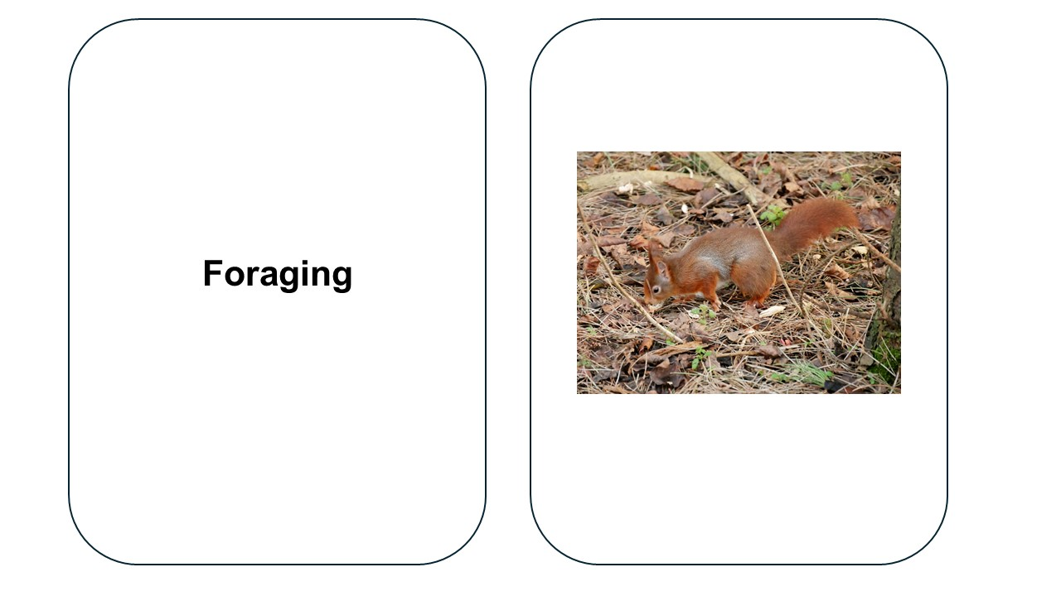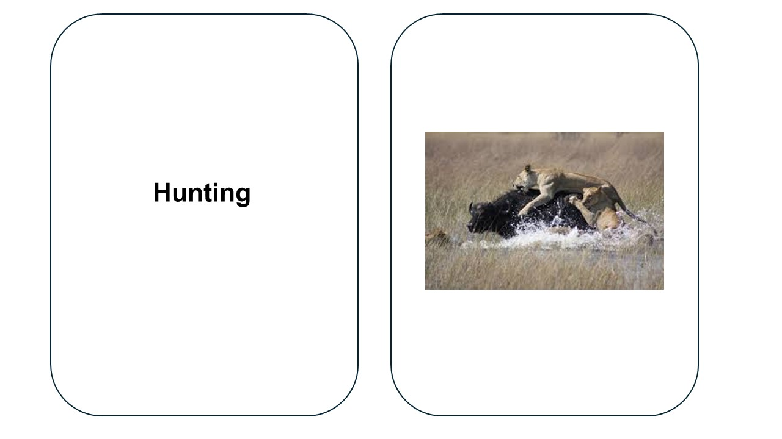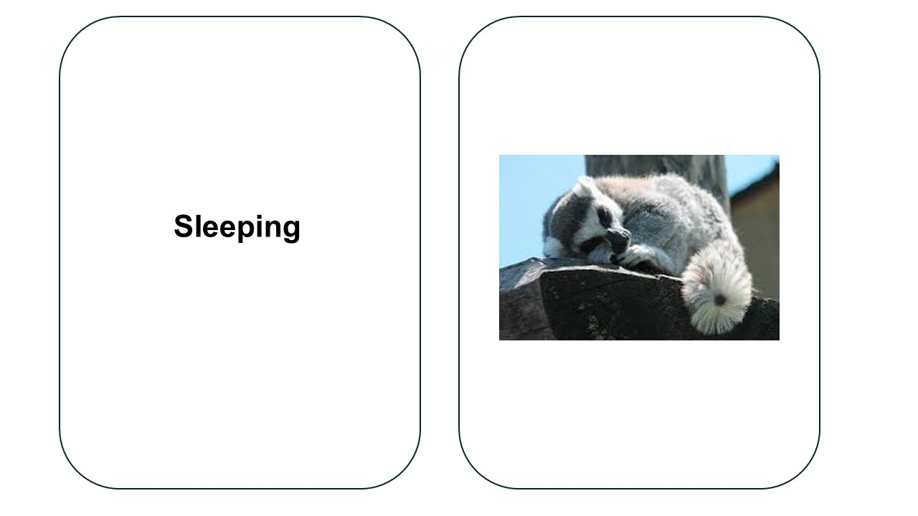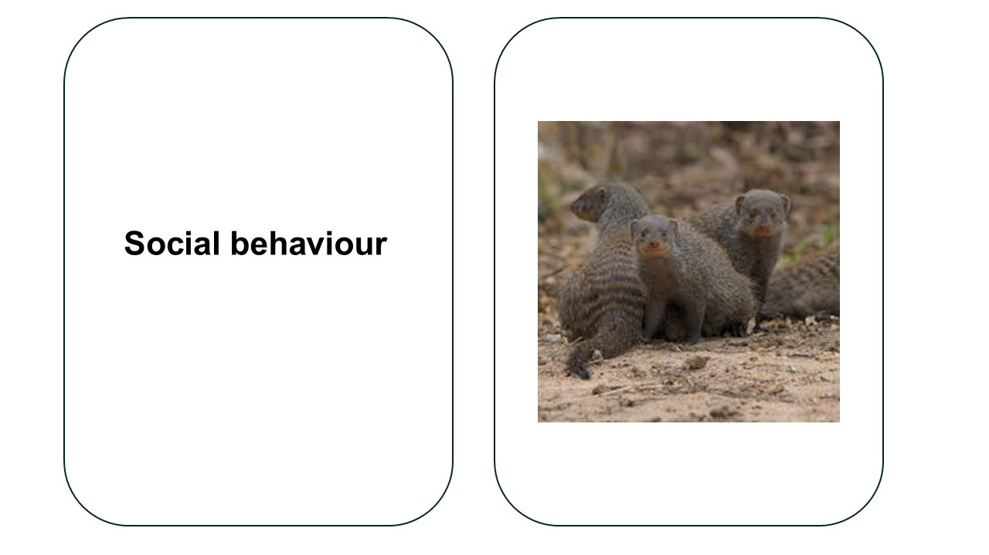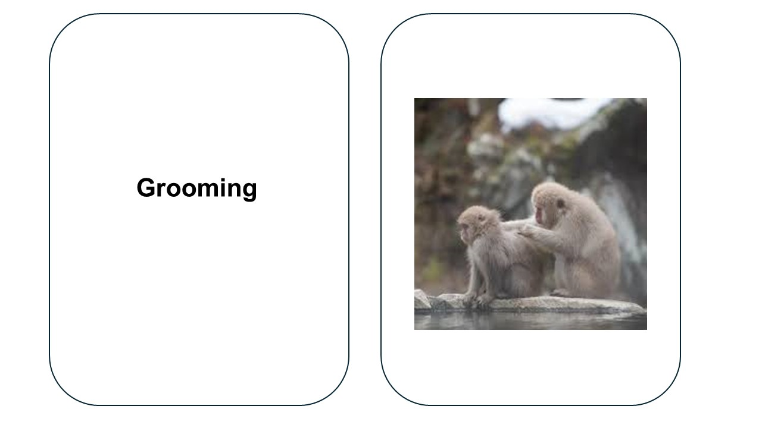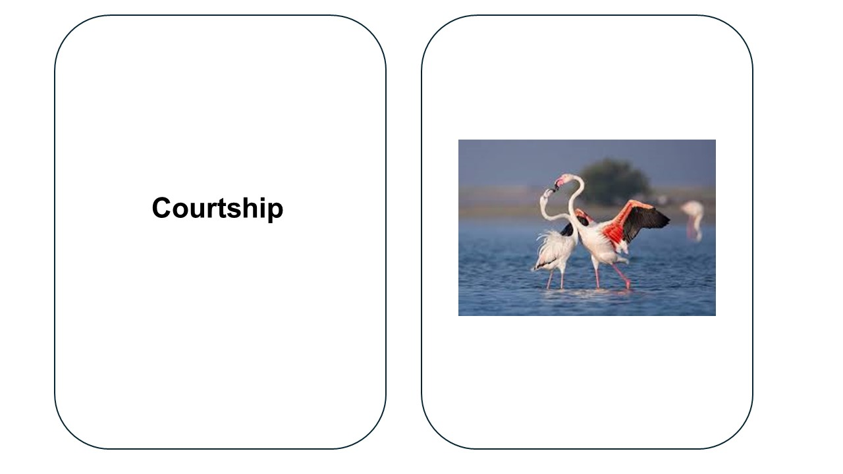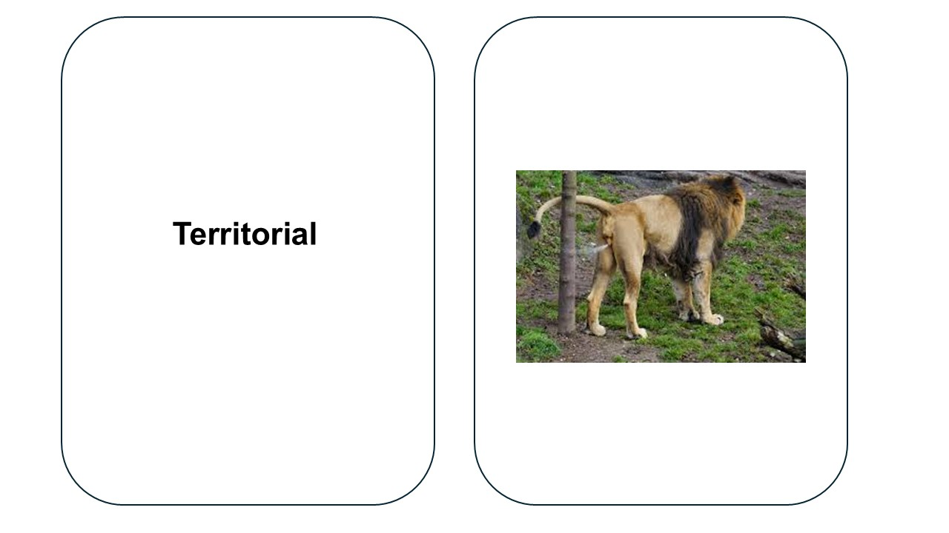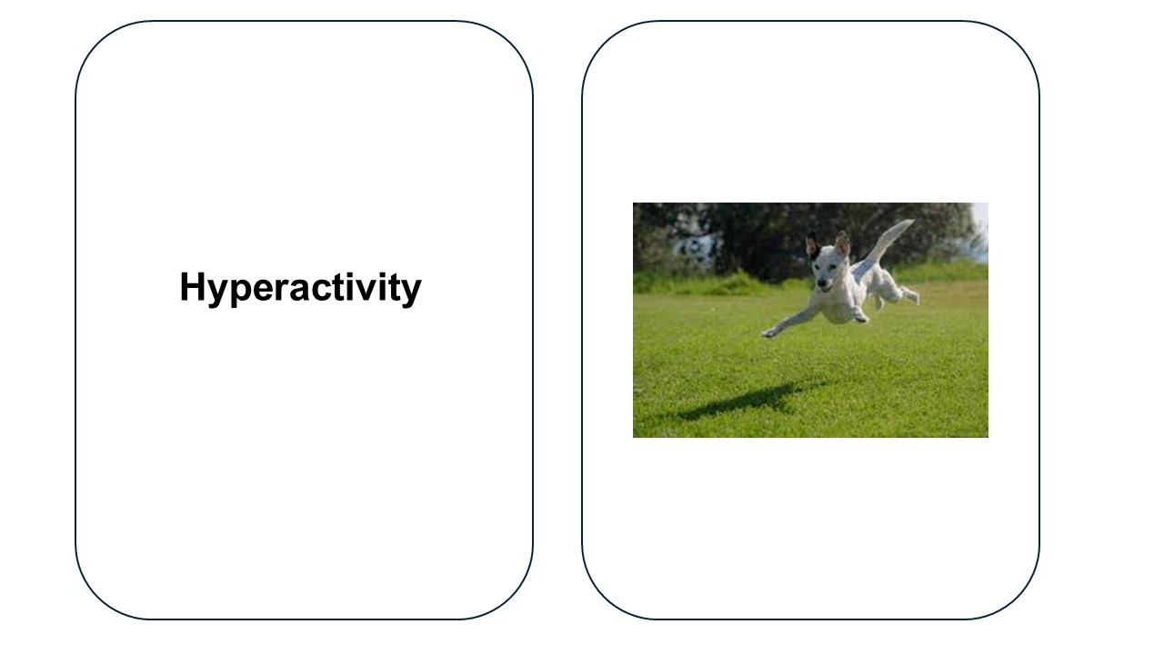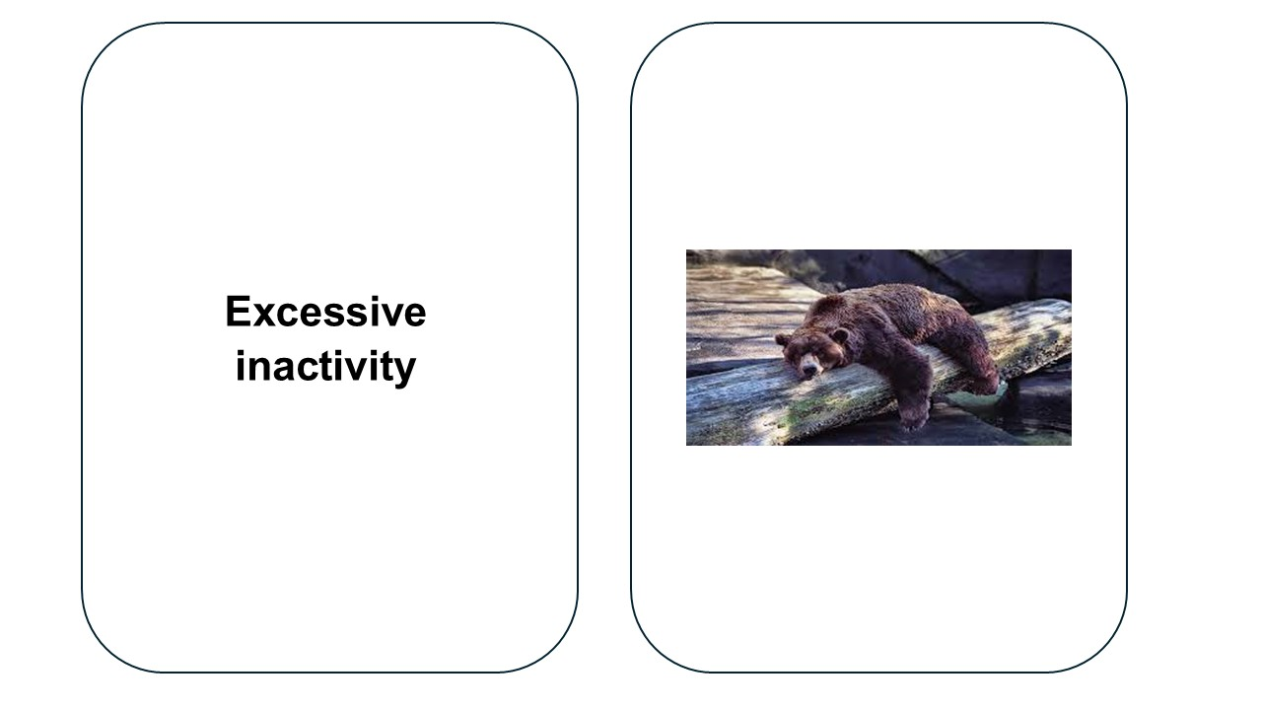

Sources:
- https://www.geograph.org.uk/photo/4828750
- https://upload.wikimedia.org/wikipedia/commons/thumb/1/14/Lions_hunting_Africa.jpg/300px-Lions_hunting_Africa.jpg
- https://pixabay.com/photos/lemur-sleep-animal-lemurs-nature-347543/
- South Staffordshire College
- https://pixabay.com/photos/snow-monkey-preen-preening-groom-4809480/
- https://commons.wikimedia.org/wiki/File:Lovely_kiss.jpg
- https://commons.wikimedia.org/wiki/File:Asiatic_lion_marking_its_territory.jpg
- https://cdn.shopify.com/s/files/1/0526/8740/5250/files/small-white-dog-invisible-fence.jpg?v=1639680336
- https://commons.wikimedia.org/wiki/File:Bear_Sleeping_(11842384304).jpg

Lesson 1 next steps worksheet
My ethologist is:
What did the ethologist research?

What was the conclusion of the ethologist’s research?

What animal species did the ethologist work with?

How has it helped people understand animal behaviour today?

The following materials relate to lesson 2: Understanding ethologists and observation techniques in animal behaviour
Learners will need a copy of the Safe working practice document for working with animals used by the provider.

Ethogram template
Data collection sheet for __________________________________________________________________
Date __________________ Time of observation ________________ Location ______________________________
Note what the animal is doing at the start of each minute. Only record ONE BEHAVIOUR by ticking the appropriate box.
Behaviour | 1 | 2 | 3 | 4 | 5 | 6 | 7 | 8 | 9 | 10 | 11 | 12 | 13 | 14 | 15 | 16 | 17 | 18 | 19 | 20 | T
Out of sight

The following materials relate to lesson 3: Health and safety in animal behaviour observations
Learners will also need a copy of the Safe working practice document for working with animals used by the provider.

Monitoring foxes case study
Scenario
You are a trainee animal behaviourist conducting an observation at a local wildlife rescue centre. You are monitoring a group of rescued foxes to assess their readiness for release. The observation is scheduled to last for 30 minutes, and you must remain undetected to ensure natural behaviour. During your observation, you notice one fox limping, another displaying repetitive pacing and one attempting to dig under the enclosure fence. The enclosure is surrounded by a wooden perimeter with an electric wire on the top. A staff member is working inside the enclosure but is not wearing any PPE.

Animal risk assessment template
Risk | Hazard | Likelihood | Severity | Control measure

Observing male goat case study
Scenario
You are working at a small petting zoo and are responsible for observing the behaviour of a new male goat that has recently joined a herd. The zoo’s policy states that all new animals must be closely monitored for signs of stress or aggression. During your observation, you notice that the new goat is frequently headbutting others, standing alone for long periods and vocalising loudly. One of the older goats is limping and appears to be avoiding interaction. Visitors, including young children, are standing close to the enclosure, watching the interactions.

Incident report form template
Date and time of incident: | Location:
Animal involved: | Species:
Handler/observer name: | Witnesses:

Incident description:
Summary of the event: [Detailed, objective description]

Immediate actions taken: [First aid, separation, environmental adjustments]

Potential causes: [Aggression, stress, handler error]

Recommendations for prevention: [Procedural changes, training needs]

Animal sanctuary case study
Scenario
You are an intern at a large animal sanctuary where primate rehabilitation takes place. During your observation session, you witness a staff member entering an enclosure alone, despite the facility’s lone-working policy. The staff member attempts to interact with a young macaque that has previously shown signs of aggression. Moments later, the macaque suddenly lunges, causing the staff member to trip and fall. They manage to exit safely but appear shaken. You later hear conflicting reports from different staff members about what happened.

The following materials relate to lesson 4: Developing and using ethograms
Learners will also need an Ethogram template from lesson 2 materials.

Glossary worksheet
Term | Definition | Notes/Examples
Behaviour
Ethology
Ethogram
Sample sheet
Natural behaviour
Atypical behaviour
Stereotypical behaviour
Displacement behaviour
Hyperactivity

Focal sampling
Scan sampling
‘Behaviour’ sampling
Instantaneous sampling
Continuous sampling
Ad lib sampling
Hereditary
Domestication
Adaptation
Instinctive behaviour

Learned behaviour
Trial and error
Habituation
Agnostic behaviour
Affiliative behaviour
Altruism
Monogamy
Polygamy

Polygyny
Polyandry
Courtship
Imprinting

The following materials relate to lesson 5: Working with animals over their life stages: Roles and responsibilities
Learners will also need a copy of the Safe working practice document for working with animals used by the provider.

Zookeeper job description and person specification
Responsible to: | Head keeper
Responsible for: | N/A
Grade of post: | Grade 3
Hours of work: | Permanent, 1:0 FTE, 37.5hrs/week
Work location: | A Zoo
Code: | HR123-456

Job purpose:
To provide a high standard of animal husbandry and care primarily within the
A Zoo. To work alongside the Head keeper and keeper team to complete general duties to include the daily husbandry and general maintenance of the Zoo collection and grounds.

Job description, key duties and responsibilities
1. Provide day-to-day animal husbandry for a range of animal species housed at the Zoo, including:
- daily feeding and monitoring of animals
- daily animal husbandry and maintenance, which may include sweeping, mucking out, mopping and other daily hygiene tasks
- enclosure maintenance, upkeep and development
- grounds maintenance, weeding, plant control
- assisting with breeding programmes
- environmental enrichment and animal training
- administering routine health care, in accordance with veterinary health plan
- stock control of feedstuffs and other sundries
- health and safety – risk management
- interpretive material development and maintenance
- keeper talks and the delivery of guest experiences
- record-keeping – section daybook, ZIMS records, etc.
- supervision of interns, work experience and volunteers – as required
- undertaking any other appropriate duties as requested by the management team.
2. Work safely and cooperatively as part of the animal keeper team, ensuring all animal welfare needs are met.
3. Drive Zoo vehicles to help with the effective running of the animal collection, e.g. vet visits, food pick-up, etc.
4. Assist or complete basic maintenance tasks as required.
5. Liaise with other zoo departments (Maintenance, Marketing, Guest Services, etc.) to ensure the fulfilment of the role.
Other duties and responsibilities
- To carry out all duties in accordance with the Zoo’s health and safety, safeguarding, equality and diversity policies and procedures, practices and procedures.
- To provide support, where appropriate, before and during Zoo inspections.
- To undertake such other duties as your Line Manager may, from time to time, determine in consultation with the post holder to ensure the continued existence, viability and progress of the Zoo.
Person specification
Communication – oral and written | - Maintain accurate records that are detailed by using internal record-keeping systems.  - Communicate effectively during team meetings, liaise with colleagues and ensure each system and procedure runs smoothly and methodically.  - Communicate with stakeholders/customers in an effective and timely manner.  - Actively promote equality and diversity/British values.
Teamwork and motivation | - To be aware of the Zoo’s commitment to the creation of a culture that encourages debate, rewards innovation and fosters inclusiveness and productive team working.  - Work with colleagues professionally and effectively to achieve targets set by Line Manager and/or Curator team.  - Support peers by sharing good practice.
Liaison and networking | - Work to strengthen supportive partnerships and alliances with local communities, stakeholders, the public, professional bodies and appropriate government departments.  - Work with fellow industry professionals to network, create and liaise to enhance the organisation’s working practices.  - Engage in networking opportunities with key stakeholders during events or CPD days.
Service delivery – customer is anyone receiving services | Maintain excellent standards of animal welfare  through:  - daily feeding and monitoring of animals  - daily animal husbandry and maintenance, which may include sweeping, mucking out, mopping and other daily hygiene tasks  - enclosure maintenance, upkeep and development  - grounds maintenance, weeding, plant control, etc.  - assisting with breeding programmes  - environmental enrichment and animal training  - administering routine health care in accordance with veterinary health plan  - stock control of feedstuffs and other sundries  - health and safety – risk management.  - interpretive material development and maintenance  - keeper talks and the delivery of guest experiences  - record-keeping – section daybook, ZIMS records, etc.  - supervision of interns, work experience and volunteers – as required  - undertaking any other appropriate duties as requested by the management team  - an adaptable and flexible work ethic, showing the same appetite for desirable and undesirable tasks  - ethical and moral awareness and sensitivity to issues such euthanasia.
Decision-making | - Show initiative and be willing to take part in making decisions within the role.
Planning and organising | - Work in line with the organisation’s policies and procedures and ensure goals are met.
Initiative and problem-solving | - Solve and use initiative in times of need.
Investigation and analysis | - Engage in continual research from peer-reviewed, industry-recognised sources (journals, conferences, webinars, etc.) to ensure you remain up to date with the latest animal welfare / keeping developments / industry updates.
Sensory and physical demands | - Be confident and competent with specialised equipment as per subject specialist area.  - Use Microsoft Office/Teams online and standard office equipment.  - Use ZIMS record-keeping system to input data or find information.
Work environment | - Comply and adhere to standard health and safety guidance in regard to self and others and report concerns to others for action.  - Complete mandatory health and safety training.
Team development | - Assist colleagues with day-to-day tasks and help new employees settle in.  - Participate in the Zoo’s induction/buddy/training process.  - Engage in activities to share good practice within teams.
Knowledge and experience | - Relevant industrial experience involving the management of animals in a recognised animal collection for ideally three years.  - A formal qualification at Level 6 – BSc in Zoo Animal Management, or a related subject, or other industry-approved qualification.

The following materials relate to lesson 6: Preparation for behavioural observation

Lesson 6 rabbit stage worksheet
Over a five-week period, you will conduct structured behavioural observations on the same animal at the same time each week, developing an in-depth understanding of its responses to environmental factors and interactions.
Key expectations:
- Complete 20 hours of structured observation over five weeks.
- Observe and document changes in behaviour, environmental influences and potential welfare concerns.
- Maintain a professional and ethical approach when working with animals.
Observation guidelines:
- Choose an animal:
- Select a rabbit, guinea pig, or hamster for your study.
- You must work with the same animal throughout the five-week period.
- Schedule weekly observations:
- Conduct your observation at the same time each week for consistency.
- Sessions should last 4 hours per week (20 hours total).
- Record behavioural data:
- Use an ethogram to log observed behaviours.
- Identify patterns in feeding, grooming, social interactions, resting, and activity levels.
- Note any atypical or stereotypical behaviours that could indicate welfare concerns.
- Environmental factors:
- Assess how changes in lighting, temperature, noise levels, or handling influence behaviour.
- Identify how enrichment or housing conditions impact natural behaviours.
Final project submission:
At the end of the five-week period, you will compile a detailed behaviour report, including:
- weekly observation logs with ethograms
- analysis of behavioural trends and environmental influences
- a proposed behaviour modification plan based on learning theories
- recommendations for improving welfare and training.

The following materials relate to lesson 7: Applying learning theories to influence positive animal behaviour

Behavioural challenge case studies
Case study 1: Reggie the Raccoon
Context:
Reggie is a four-year-old male raccoon living in a small wildlife centre. Staff have reported that Reggie becomes highly agitated during enclosure cleaning. He paces, growls and attempts to nip at keepers through the mesh. This makes it unsafe to clean while he is present.
Behavioural challenge:
Reggie shows fear and territorial aggression during enclosure cleaning.
Discussion prompts:
- What might be triggering this behaviour?
- How could classical conditioning help reduce his anxiety?
- How might you use positive reinforcement to encourage Reggie to move voluntarily to a shift area during cleaning?
Case study 2: Tilly the Tortoise
Context:
Tilly is a seven-year-old Sulcata tortoise in a college animal care collection. Recently, staff have struggled to get Tilly to accept oral medication. She retracts her head and refuses food for hours after an attempt.
Behavioural challenge:
Tilly associates human interaction with negative experiences, leading to avoidance.
Discussion prompts:
- How might you use desensitisation and counterconditioning to change Tilly’s response to medication time?
- What reinforcers could be used for a tortoise?
- Could shaping be used to train a target behaviour (e.g. approaching a target for food)?

Case study 3: Diesel the Dog
Context:
Diesel is a rescue German Shepherd living in a rehoming centre. He lunges and barks aggressively when approached by men, especially those wearing hats. This has made walking him difficult, and visitors are put off from viewing him for rehoming.
Behavioural challenge:
Diesel shows fear-based reactivity to certain people.
Discussion prompts:
- What might be the cause of this specific fear response?
- How might systematic desensitisation and positive reinforcement be used to build trust?
- Could you apply negative reinforcement in a way that avoids stress?

Rewards flashcards for hot and cold game
Hot and cold game teacher guidance
Follow the instructions below:
One learner will be the ‘animal’, one will be the ‘trainer’, one will be the observer.
Total amount of time given: 10 minutes.
The ‘trainer’ has one minute to hide their chosen ‘reward’ somewhere in the room. The ‘animal’ has five minutes to locate the ‘reward’.
The ‘trainer’ is only able to direct the ‘animal’ using the verbal cue of ‘hot’ or ‘cold’.
Once the ‘reward’ is found, or time is up, the ‘observer’ has four minutes to provide feedback (including feedback for the ‘trainer’ and ‘animal’).

Biscuits

Jelly sweets

The following materials relate to lesson 8: Training plans using the S.P.I.D.E.R. framework

Fizzy drinks

Chocolate

Social media

Phone

Ice cream

Cake

Applying animal learning theory article extract
Applying animal learning theory: Training captive animals to comply with veterinary and husbandry procedures
May 2004
Animal Welfare 13(2):225–232
DOI:10.1017/S0962728600026968
Authors: Robert John Young – University of Salford; Cynthia Cipreste – Belo Horizonte Zoo FPMZB
Link to full article: https://www.researchgate.net/publication/233510832_Applying_animal_learning_theory_Training_captive_animals_to_comply_with_veterinary_and_husbandry_procedures
Introduction
In all institutions that maintain animals in captivity throughout the world, an animal caregiver (e.g. zookeeper) is expected to visually inspect the health of the animals in their care at least once per day. Normally, a zookeeper achieves this by shaking his/her collection of keys near to the animal’s enclosure and soon after this signal (stimulus) is emitted, the animal usually appears. How does the animal know to appear and how does the caregiver know to do this? Usually, we discover that the caregiver has paired (associated) the sound of the rattling keys with the subsequent presentation of a reward such as food (positive reinforcer). Thus, the animal associates the sound of the keys with a food reward or with another positive reinforcer, such as comfort. What has occurred here is classical conditioning (Chance 1998). In terms of classical conditioning the animal has learnt that the key noise (stimulus) indicates that a food reward (positive reinforcer) has become available. Most caregivers know how to train animals in this way, although few would call it training (Lukas et al 1998). In many zoos, caregivers learn such methods from more experienced caregivers (i.e. social or observational learning) or develop the method themselves. If you were to ask caregivers to describe the aforementioned process in terms of animal learning theory, few of them would be able to (and, in our experience, many would argue that it is not animal training). In fact, the term ‘animal training’ has become so inextricably linked with animals performing ‘tricks’ for people’s amusement that many in the animal industries refer to veterinary or husbandry training as ‘behavioural management’ (which usually also includes environmental enrichment) to differentiate the situations (Bloomsmith et al 1994, 1998).
From the animal’s perspective, the performance of a ‘trick’ or of a behaviour to facilitate a veterinary procedure are the same: i.e. a behaviour is emitted upon a cue and a reward is subsequently received. The difference is in the human perception of the animal’s trained behaviour. We do not wish to discuss here the ethical value of animal training as this is a complex issue beyond the scope of this article.
Given that our caregiver has a legal obligation to visually inspect his animals every day, why else might we be interested in training zoo-housed animals? The simple answer is to improve their quality of life (i.e. animal welfare). Specifically, there are many times in a captive animal’s life when we need to manage some aspect of its well-being, most commonly its physical well-being (Mellen & Ellis1996). In the past, the treatment of physical well-being problems (e.g. injuries) or the monitoring of physical well-being (i.e. medical examination) required that the animal be either physically (e.g. in a crush cage) or chemically restrained (e.g. anaesthetised). Both processes normally cause some distress and danger both to the animal and to its caregiver (Pollard et al 1992; Grandin et al 1995; Phillips et al 1998). Additionally, in the case of chemical immobilisation, there is often a considerable health risk associated with the use of the chemicals. For example, approximately 35% of anaesthetised giraffes die from the effects of anaesthesia (Bush 1993, 1996), and other large mammal species such as elephants and rhinos face similarly high risks. With all species, but particularly with those of high conservation importance, such risks must be minimised, especially since the adverse effects both of physical and chemical restraint are accumulative on the physical and psychological well-being of the individuals concerned. It is well known for example that certain drugs used for immobilisation accumulate within the animal’s body. Thus, each subsequent chemical restraint/anaesthesia increases the risk of a physical health problem (Bush 1993, 1996). The physical well-being of trained animals is also improved since they are usually much easier to handle and manage (Grandin et al 1995), negating the need for the use of force to control their behaviour.
It was suggested by Hediger (1955) that the training of animals might be equated with occupational therapy. A number of studies have supported this suggestion regarding the positive effects of training on the psychological well-being of animals. For example, a general reduction in the performance of abnormal behaviour has been reported for animals undergoing behavioural training (Kastelein and Wiepkema 1988; Mellen and Ellis 1996; Laule and Desmond 1998). It has also been suggested that animals may derive pleasure from performing behaviour that results in them gaining a reward (Wiepkema and Koolhaas 1992). Thus, in terms of animal welfare, the behavioural training of animals is very important.
The purpose of this article is to explain clearly and simply the basics of training animals for husbandry and veterinary procedures, since outside North American zoos and laboratories knowledge of animal training is often lacking. By outlining the basic principles and pointing out potential pitfalls, we hope to guide institutions in the use of animal training to improve animal welfare. Our experience has shown us that badly designed and badly implemented behavioural training programmes usually result from a lack of knowledge. Attempts to train animals by people without a basic understanding of how animals learn, not only result in failure, but also frequently in a decrease in animal welfare. For example, many people still believe that punishment is an essential part of the animal learning process (see Monks of New Skete Staff 2002; and for discussions see Kiley-Worthington 1990; Stevenson 2002). Punishment not only reduces animal welfare but also increases the risk that the animal being trained will attack its trainer (see Chance 1998).

Oakwood Wildlife Park case study
Scenario
You have recently joined the carnivore team at Oakwood Wildlife Park. The park’s two-year-old male African lion, Simba, was rescued from a private owner and is not used to human interaction or training.
Simba is healthy but shows signs of anxiety when approached by unfamiliar keepers. He often paces near the enclosure barrier and growls when approached with equipment.
The veterinary team needs him to enter a holding crate voluntarily for future health checks. For now, the goal is to prepare him for vet visits within the next six months, using protected contact methods only (no free contact).
You have access to:
- a crate already positioned in an off-show holding area
- a food chute to deliver meat rewards safely
- daily 15-minute training opportunities.
Task
Write three SMART goals to achieve over six months.
Consider:
- age and limited human contact history
- the need to keep training stress-free
- the need to build trust and reduce fear.

Ring-tailed lemur case study
Scenario
At Riverside Wildlife Centre, the animal care team is preparing for a four-week enclosure renovation in the lemur walk-through area. There are four ring-tailed lemurs, aged three to five years, that need to be moved to an off-show holding pen each day for the builders to work safely.
Currently, the lemurs only enter the holding pen if enticed with fruit but quickly lose interest. You have observed that they are nervous of new objects, including unfamiliar keepers holding items.
The team has suggested using target stick training to encourage voluntary movement. You have been given four weeks to achieve reliable results before building work begins.
Resources available
- The lemurs’ favourite foods: banana, mango, mealworms.
- A safe holding pen connected by a short tunnel to the main enclosure.
- Daily 10-minute training sessions, Monday to Friday.
Task
Design a training plan covering:
- step-by-step desensitisation to the target stick
- rewards and reinforcers to use
- session frequency, timing and environment set-up
- strategies to minimise fear and stress
- safety measures for keepers.

Asian elephant case study
Scenario
At Hillside Zoo, a 12-year-old female Asian elephant named Maya has been trained over the past year to lift her front feet on cue for nail trimming.
Maya responds well to the regular Senior Keeper and lifts her foot promptly during morning sessions. A new Junior Keeper has been added to the team and is now trying to carry out the training.
The Junior Keeper reports that:
- in morning sessions, Maya lifts her foot 80% of the time for the senior keeper
- in afternoon sessions, Maya refuses to engage, walking away from the training wall
- both keepers are using the same verbal cue, food reward (fruit) and target stick
- both keepers are unsure if they should push for more attempts or stop early.
Task
Review the current training plan:
Focus area | Action
Relationship- building | Schedule non-training interactions between the keeper and Maya (e.g. calm feeding, grooming) to build trust.
Session timing | Trial earlier afternoon sessions or reduce afternoon training if Maya shows consistent fatigue.
Reward assessment | Use higher-value or novel rewards in afternoon sessions (e.g. banana, sweetcorn).
Session length | The Junior Keeper should keep sessions short and end on a positive behaviour – avoid pushing for multiple repetitions.
Consistency | The Junior Keeper should mimic the Senior Keeper’s approach exactly – tone, timing, cue delivery – and consider observing/recording the Senior Keeper’s sessions.
Record-keeping | Keep a behaviour log for each session (date, time, handler, response) to identify patterns.

New SMART goal
Specific: Maya will lift her foot on cue for the Junior Keeper in both morning and afternoon sessions.
Measurable: At least four out of five successful responses in both sessions.
Achievable: Achieved through modified rewards, adjusted timing and consistent handling.
Relevant: Builds reliability and resilience in behaviour across handlers and times.
Time-bound: Goal met consistently for one week within the next six weeks.
Decide:
- Is the plan suitable to continue without changes?
- What factors might explain Maya’s inconsistent behaviour?
- What adaptations might support better implementation?

Green iguana case study
Scenario
At Greenfields Reptile House, a five-year-old green iguana named Spike has been trained for voluntary crating to allow safe weighing every month.
The reptile keepers have been recording training sessions informally but now need formal documentation as the zoo moves towards meeting British and Irish Association of Zoos and Aquariums (BIAZA) best practice standards for animal training records.
The training has progressed well. Spike enters the crate consistently with food rewards and minimal stress.
The collection manager has asked you to recommend a documentation system to ensure training progress is monitored long term and can be audited by external inspectors.

Task
Create a list or template of at least four essential documents. Explain briefly why each document is needed and what it records.

Willowbrook Zoo case study
Scenario
At Willowbrook Zoo, a six-year-old male capuchin monkey named Chico has been undergoing training to present his arm for intramuscular injection.
The goal is to eliminate the need for manual restraint during annual vaccinations.
Observation records show that:
- with the regular keeper Chico presents his arm correctly 80% of the time
- with a new keeper Chico presents his arm correctly 50% of the time
- Chico sometimes displays lip-smacking and pacing when the new keeper approaches with the syringe prop
- training sessions are conducted three times a week for 10 minutes.

SMART goal for next six weeks:
Specific: Chico will present his arm calmly for the regular keeper using the syringe prop.
Measurable: 80% success rate across five consecutive sessions.
Achievable: Through increased desensitisation, consistency and trust building.
Relevant: Builds handler flexibility and reduces need for restraint during medical procedures.
Time-bound: Within six weeks from training plan revision.
Training programme
Week | Focus | Steps
1 | Trust-building with new keeper | New keeper gives food/enrichment daily outside training sessions. No training attempts.
2 | Cue and prop introduction | New keeper present during regular keeper-led training. Regular keeper holds prop but does not interact.
3 | Pair training | Regular keeper gives cue; new keeper delivers reward. Gradually introduce new keeper giving the cue.
4 | Desensitisation to syringe prop | New keeper holds prop during training. Gradually move prop closer during successful arm presentations.
5 | New keeper leads sessions with regular keeper present | New keeper gives cue and reward. Regular keeper present for reassurance.
6 | Independent new keeper-led sessions | New keeper runs sessions alone. Aim for 80% correct response over five consecutive sessions.
Each session: 10 minutes, three times per week. End session after a successful attempt to build confidence.
Task
Write a short evaluation of the training programme so far.
Consider:
- success of the programme
- any concerns (behavioural, procedural)
- recommendations for next steps.

Meerkats case study
Scenario
At Sunnydale Zoo, a group of eight meerkats have been trained to voluntarily enter a shift box to allow keepers to clean the enclosure safely.
An evaluation report shows that:
- the meerkats enter the shift box reliably in the morning
- in the afternoon, they only enter the box 60% of the time
- keepers report the meerkats become distracted by visitors and by feeding time in nearby enclosures
- keepers sometimes vary who delivers the training session.
Task
Based on the evaluation, suggest at least two adjustments to improve the training outcome.
Explain how these adjustments could help improve results.

The following materials relate to lesson 9: Developing and proposing an animal training plan
Learners will additionally need the behavioural data from the rabbit stage.

Training adaptations hot and cold flashcards

Senior animal tiring quickly
Your animal starts slow but shows signs of fatigue after a few minutes.

Older dog with limited hearing
Your animal doesn’t respond well to normal vocal cues.

Easily distracted puppy
Your animal gets distracted by noises outside the room and stops searching for the reward.

Experienced dog with previous training
Your animal seems to expect the reward too quickly and stops searching after one attempt.

Peer review pro forma
Peer review name:

Questions | Feedback
How well do the solutions address atypical animal behaviours?
How well structured and easy to follow is the Animal training plan?
How attainable are the solutions?
How ethical and species-appropriate are the techniques used?

The following materials relate to lesson 10: Proposing solutions to influence positive animal behaviour
Learners will also need the following materials:
- Peer review pro forma from lesson 9.
- Animal behaviour confidence rating worksheet from lesson 1.

Dutch rabbit case study
Rabbit profile
Name: Thumper Age: two years
Breed: Dutch rabbit Gender: male
Health status:
- fully vaccinated
- diagnosed with Malocclusion
- otherwise healthy.
Temperament:
Thumper is an outgoing and curious rabbit, often seeking human interaction and exploring his environment. However, he has recently become less interactive and more irritable.
Living conditions:
Thumper is housed alone in a small indoor enclosure measuring 90 x 60cm with solid run flooring with newspaper substrate and minimal bedding.
Diet:
Thumper’s diet consists of commercial rabbit pellets with occasional vegetables. Hay is provided sporadically but is of low quality.
Duration of conditions:
These conditions have persisted for approximately six months.
Ethogram for Thumper:
Behaviour | Frequency | Duration
Feeding | Rare | <15 min/day
Gnawing fixtures and fittings | Frequent | 5 min/hour
Pacing | Moderate | 3 min/hour
Resting | Frequent | 60 min/hour
Digging | Rare | <1 min/day
Grooming | Moderate | 10 min/hour
Nipping when handled | Occasional | <1 min

Syrian hamster case study
Hamster profile
Name: Nibbles Age: 10 months
Species: Syrian hamster Gender: female
Health status:
- no history of illnesses
- physically healthy but displaying signs of stress-related behaviours.
Temperament:
Nibbles is aturally curious and explorative but has become defensive and human aggressive.
Living conditions:
Nibbles is housed in a small wire cage measuring 40 x 30 x 30cm. The cage has minimal sawdust substrate (2cm). Ceramic bowl, plastic water bottle and small wire wheel on a stand are the only internal furniture.
Handling frequency:
Nibbles is handled multiple times daily by different family members, often for prolonged periods.
Duration of conditions:
These conditions have persisted for approximately three months.
Ethogram for Nibbles:
Behaviour | Frequency | Duration
Feeding | Frequent | 10 min/day
Drinking | Adequate | 5 min/day
Self-grooming | Moderate | 5 min/hour
Gnawing on cage bars | Frequent | 10 min/hour
Running on a wheel | Not observed | N/A
Burrowing attempts | Frequent | 5 min/hour
Food scattering | Moderate | 3 min/hour
Nesting | Rare | <1 min/day
Aggressive behaviour when handled | Frequent | <1 min/interaction
Increased daytime activity | Frequent | 10 min/hour

Animal training plan template
Behaviour objective:

Species and individual identified:

Training objectives:

Training location and frequency:

Equipment required:

Techniques to be used:

Cue/bridge/reward:

Preliminary steps:

Training plan steps:

Evaluation:


FUNDED BY
PRODUCED BY

This programme is funded by the Department for Education
South Staffordshire College has produced this resource on behalf of the Education and Training Foundation

