
Apprenticeship Workforce Development Programme
USING THE TEMPLATE APPRENTICESHIP TRAINING PLAN
Resource demonstrating best practice use
for the template

July 2024 (v1 draft)
CREATED BY



Introduction
This resource is designed to support both the AWD live sessions, including topics such as "Working Successfully with Employers," planning effective curriculum design, and "Integrating On-the-Job and Off-the-Job Learning/Training." It is also intended to support the Apprenticeship Action Groups (AAGs).
This tool focuses on improving apprenticeship outcomes through an impactful training plan, allowing AAG members to refine their processes and enhance the quality of their apprentices’ training plans.

Purpose of this resource
Adopting and implementing a successful training plan is vital to the success of apprenticeships within your organisation.
Training plans are an essential part of delivering effective apprenticeships and have both quality and compliance impact. They must be agreed between the apprentice, provider and employer and show the journey ahead, establishing expectations of what is going to be delivered within the programme.

How to use this resource
This document is a guide to using the suggested training plan sourced from direct.gov.uk.
It equips you to complete the spreadsheet accurately and make informed decisions that will enhance the overall apprenticeship experience.
Use this resource as a reference to ensure that the key aspects of the training plan process are understood and implemented effectively.


Best practice guidance on using the non-mandatory DfE template training plan (2023/24 template v1)

Training plans
The key objectives of a training plan are to:
- Identify relevant stakeholders within the programme
- Identify planned training content, including functional skills where required, assessment and end point assessment
- Explain the method of delivery including off-the-job (OTJ) training and other activities considering any reasonable adjustments necessary under the Equality Act 2010
- Agree the objectives and the method
- Allow for the re-agreement of material changes to the training plan.

Providers will often design their ‘own’ training plans and integrate them with learning management tools. Although there are minimum expectations of what the plan must include from a compliance perspective, it is common practice to enhance a training plan to provide greater transparency of the planned programme and set clearer expectations for employers and apprentices. There is a template training plan made available by the Department for Education, which is used by many providers as a baseline to meet the funding rules and establish quality fundamentals.
This guide is designed to supplement the guidance within the template and gives users the confidence to use it effectively and make enhancements where they wish to.
The non-mandatory template available from the ESFA
The template, available here is updated at least annually and is formed of four sections shown within a Microsoft Excel spreadsheet.
- A cover sheet that shows the stakeholders within the apprenticeship and their signatures to demonstrate agreement.
- A list of key policies relevant to the stakeholders.
- Commitments to the programme.
- A plan of training that shows the content of the programme and method of delivery.

The template is editable using excel including the ability to add or remove content and/or personalise the template to the provider’s own policies and approaches.
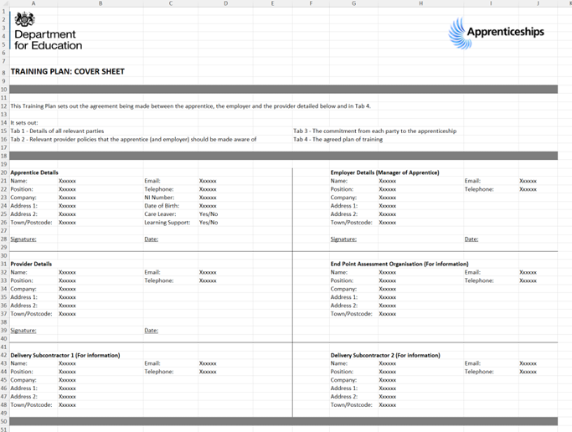
Fig 1-3 – Extracts from the spreadsheet
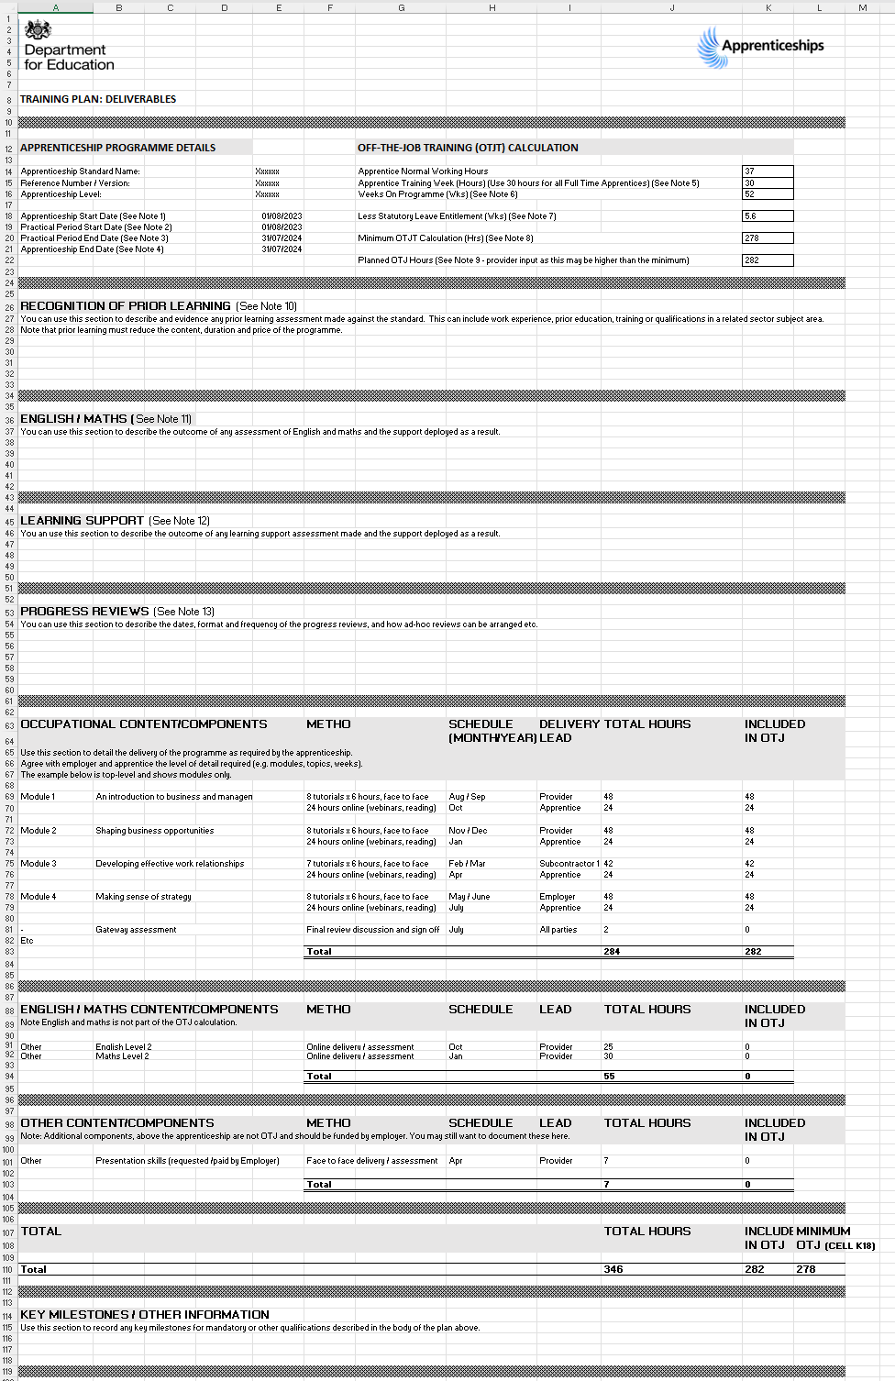
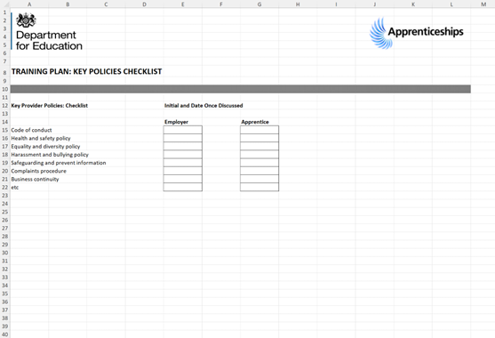
The sections of the template
Tab 0: Notes
The purpose of this tab is to give advice on how to complete the tabs of the sheet and relevant notes for fields of the tab to help the provider record the right information.

Fig 4: The notes tab
The notes will be updated based on the version of the template that is used. The link where the spreadsheet is held on .gov will only show the latest version of the sheet.
These notes are referenced in the other tabs and we will address these in the individual sections below.

Possible enhancements:
- If you add content to the template, you will always benefit from giving user guidance for those completing the form. If you add content or sections to the template, then consider additional notes explaining how to complete the additional components.

Tab 1: Cover Sheet
The purpose of this tab is to detail the named parties to the agreement: the apprentice, the employer and the provider.
The provider may choose to add logos or additional information here if required.
Note: the provider is responsible for the relationship with the employer and the development of the training plan, even if the training is contracted out to a sub-contractor.

Fig 4 – Cover sheet tab
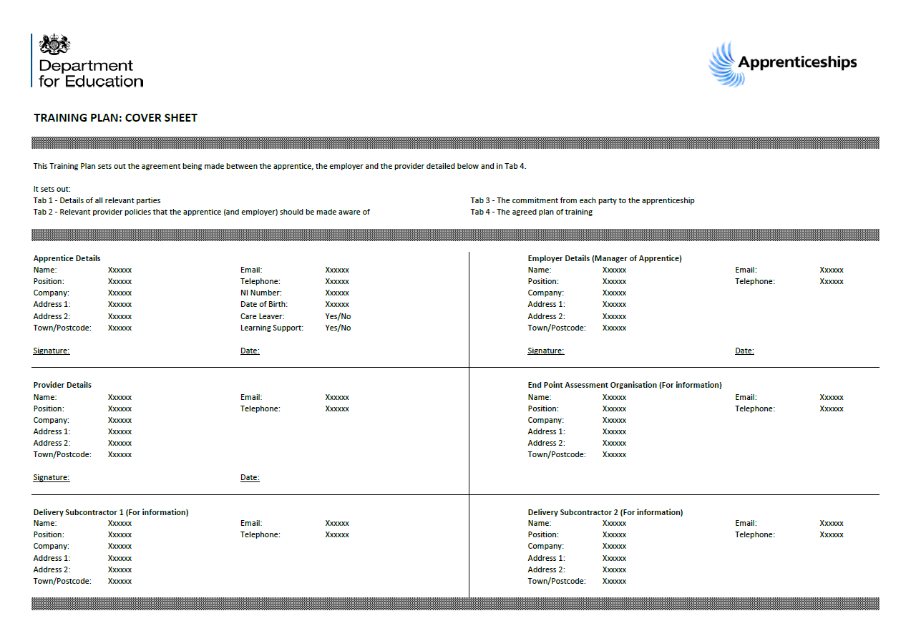
Critical components:
- It is essential that the apprentice, provider and employer sign this plan. Without signatures on your training plan then your funding would be at risk.
- If details of any stakeholders are not known at the start you would be expected to add these and ensure the parties of the plan are aware of the change.
- If the apprentice does not consent to the employer knowing about their care leaver status or learning support status, then ensure you do not include this in the apprentice details section or anything in sight of the employer.
- All parties should receive a copy of the plan and any agreed updates.
Key benefits:
- The benefits of capturing all key details are to ensure that on the front sheet of the plan, you can easily find and reach any individual relevant to the service you are providing, this could include service recovery if things are not going well.
- Keeping a copy of the latest version allows you to know what has been agreed upon and what the current plan is.
Possible enhancements:
- It is good practice with any signature field to have a declaration of what is being agreed to within the signature. You could consider adding a line to signature fields like “I agree to the content of this training plan”.
- If learning support or reasonable adjustments are being provided, if the apprentice has consented to the employer knowing then you could consider the addition of this stakeholder to the sheet. If you do not use subcontractors, you could replace the delivery subcontractor fields (it is possible to overwrite onto the sheet).
- The addition of a version number and date to the plan is a good idea, it makes it easier to know which is the latest version when completing compliance checks.

Tab 2: Key Policies
The purpose of this tab is to allow the provider to cover any pertinent information that the apprentice and the employer need to be aware of. It is important to consider that the training plan is usually the main document that all the key parties of an apprenticeship agree to, so the awareness of this information can be confirmed robustly by addressing it in the plan. It is not the means to solely deliver awareness of key policies, it is the place where they are confirmed as known.
Fig 5 – Key Policies tab
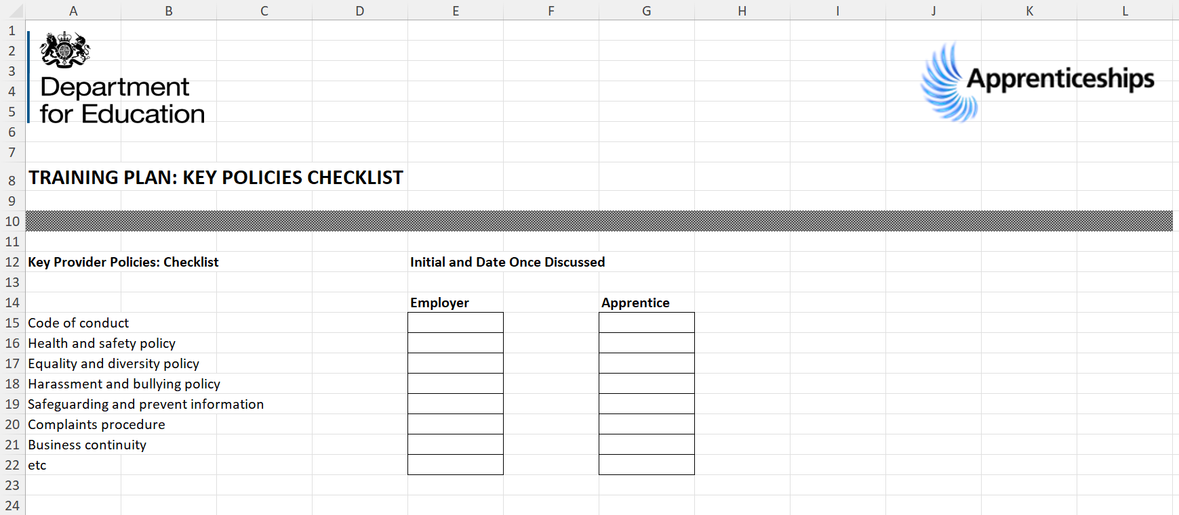

This might include policies such as safeguarding, health and safety and the complaints procedure that the apprentice and employer can use.
This tab can be adapted as required and hyperlinks to policies are encouraged so that everything is available in one place.
Relevant employer policies should have been discussed on entry to employment (between the employer and apprentice) but it may be appropriate to recap information here if relevant to apprenticeship (e.g. time off for study).
It is not common for apprentices to have access to the contract for services between a provider and employer, so many key terms, conditions and contractual requirements as well as key policies may not be known. Many of these carry a real significance day to day, including safeguarding arrangements and the application of health and safety.

Critical components:
- Ensure that apprentices and employers are aware of the policies you choose to feature here.
- If you do not use hyperlinks to policies, ensure it is clear where they can be accessed.

Key benefits:
- With the training plan being signed as agreed you can confirm that all parties are aware of the key policies that apply to them.
- If hyperlinks are used, then individuals have easy access to the policies and gives parties a better understanding of their rights within the programme. Likewise ensuring you have access to the most up-to-date version.

Possible enhancements:
Consider the policies you want parties to be aware of and update the template accordingly. These will naturally feature in your onboarding/induction processes.
Consider adding the version number or date of the policy.
Many providers will also detail the arrangements and confirmation of delivery of the other elements of their programme induction elements within their training plan, or merge content from apprentice or employer handbooks into their training plan directly.
With key policies, however, it should be considered whether policy elements such as your approach to explaining the requirement to release for all OTJ training or defining what would be a withdrawal, may be better included in the plan’s commitments or agreements to the programme.
Consider adding your policies on: “Providing reasonable adjustments for individuals with disabilities or special educational needs”, “Participation and attendance” and “Break in learning and programme transfer”.
It is good practice to ensure that sufficient time is given in the onboarding process to ensure these policies are clearly explained and understood.

Tab 3: Commitment to the programme (roles and responsibilities)
The purpose of this tab is to outline the commitment being made by each party - this should be discussed during the initial assessment /onboarding but can be documented here as part of the training plan if preferred.
The template does identify the following passage: “The lines inserted are requirements of the apprenticeship funding rules. These must not be edited”, however, if the funding rules have been updated following the production of the current live template version then you may need to update these terms.
The parties may choose to add additional requirements/commitments on a separate sheet e.g. around punctual attendance, and behaviour. Note that these are not required by the Apprenticeship Funding Rules.

Fig 6 – Commitment to programme tab provider obligations
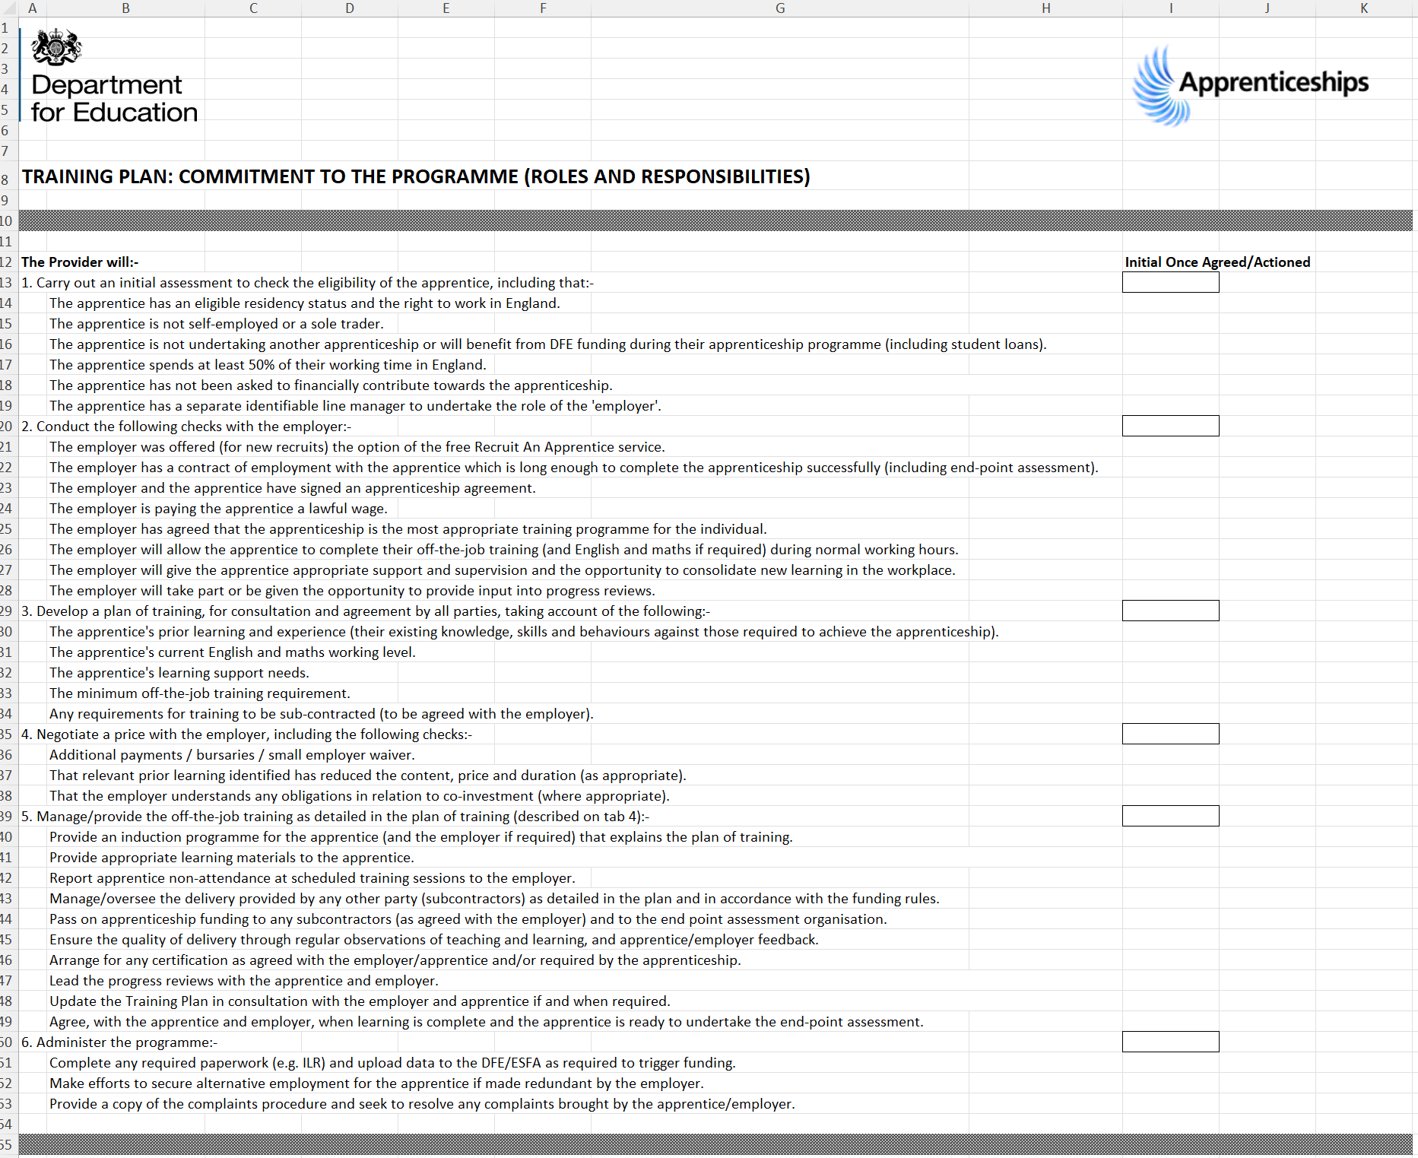
Critical components:
- The declarations should be initialled or confirmed to ensure you meet the relevant funding rules at the time.
- The initial should occur only when the element asked about has been actioned.
- The sections are broken down into provider obligations, employer obligations and apprentice obligations, the initial should ideally be that of the relevant party.

Fig 7 – Commitment to programme tab employer obligations
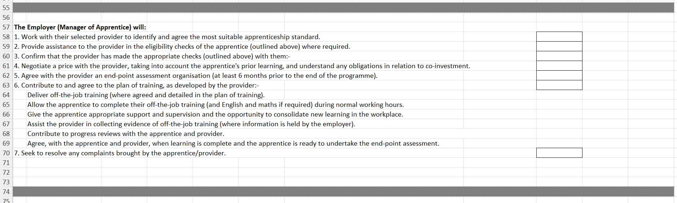

Fig 8 – Commitment to programme tab apprentice obligations


Key benefits:
- The initials can provide evidence that key funding rule terms have been met, though in some cases additional evidence or declaration may give you greater assurance of meeting the rules.
- The employer initials give you confirmation of employer agreement to key terms such as agreeing to the volume of OTJ training and release for maths and English delivery where required.

Possible enhancements:
Though the terms are linked to funding rules, rather than use the ‘initial once agreed / actioned’ function, some providers amend the terms to confirmatory statements that the element has been checked with fewer confirmatory initials.
It is advisable to supplement these commitments with additional “agreements” to specific policy elements that are important to your programme, for example,
- what you would define as automatic withdrawal,
- the expectations relating to active learning,
- the process for changing employer and its potential impact on the programme,
- clarification that the apprentice is aware of minimum wage laws and is lawfully paid (with a hyperlink to relevant guidance),
- that self-employment would necessitate withdrawal.

Tab 4: Plan of training
The purpose of this tab is to outline the plan of training. It is the central and most critical part of the spreadsheet (alongside signatures). If the plan of training changes, then a new tab 4 should be signed by, and distributed to all parties. The original training plan should be kept on file for reference purposes.
Sections can be expanded by adding lines to personalise the training plan.
A useful example is pre-set in the form but should be overwritten with your programme details.
Fig 9 – The Plan of Training in full
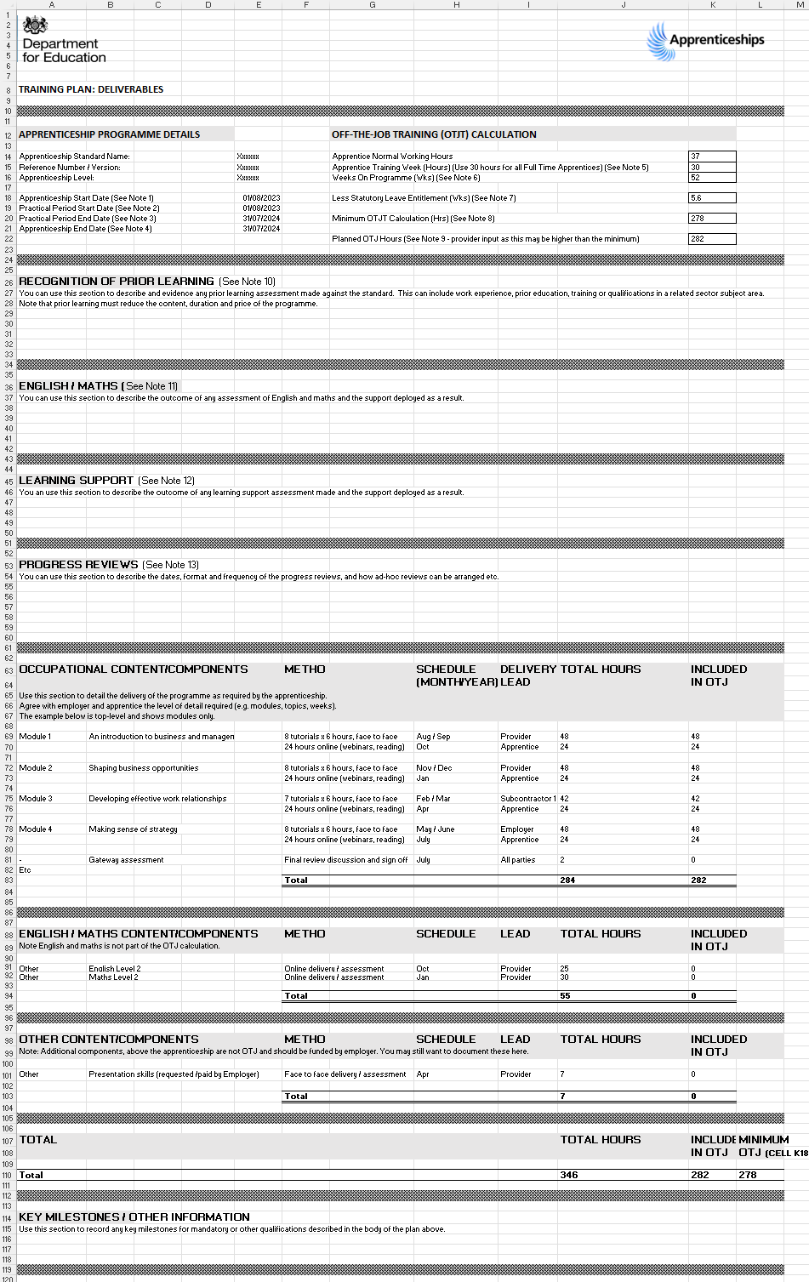

Key benefits:
- The content of the plan of training sets up how you will evidence the delivery of OTJ training which is critical to supporting funding claims.

Each section of this tab is addressed below:

Programme details and off-the-job training (OTJT) calculation
Fig 10 – The Plan of Training – Programme details and off-the-job training (OTJT) calculation
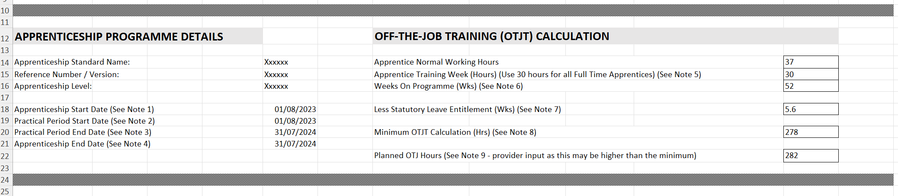

Critical components:
- The programme details section must be consistent with your ILR and apprenticeship agreement, noting that the apprenticeship end date field would be the expected end of end-point assessment, and this may vary depending on your standard.
- The OTJ calculation section will show the minimum hours but note that it also shows the planned. It is the plan that would be agreed within the apprenticeship agreement and ILR
- Take account of the relevant notes in this area:
- Understanding the planned OTJ is a key component of effective curriculum design, it will be consistent with the ‘occupational content/components’ later in the section showing the plan of training.

Possible enhancements:
- Best practice is to explain the minimum OTJ hours in the OTJ section is the minimum volume of hours required if you are a faster learner but that the planned hours are the hours necessary to complete the curriculum for most learners.

Recognition of prior learning and English/Maths
Fig 11 – The Plan of Training – Recognition of prior learning and English and Maths sections
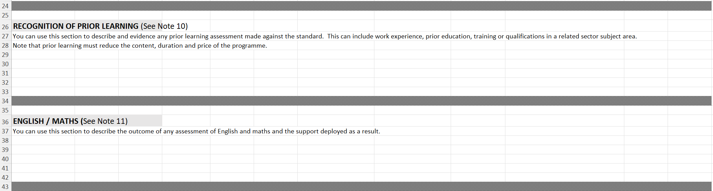
Critical components:
- Take account of the relevant notes in this area:
- The plan should clarify how prior learning has been applied following the initial assessment and should show at least the original programme total of off the job and total hours, then the chapters, units, modules or tasks removed, and the quantity of hours removed as well as any change in duration, e.g. “8 weeks removed from original full duration”. This will help support your calculations of funding reductions.
- The English and Maths section should supplement the ‘occupational content/components’ section, so will commonly show the results of the initial assessment but should not duplicate what would be in the occupational content section.

Other Possible enhancements:
- Some providers will include the calculation of funding based on prior learning within their training plan though this can, and usually is separate in the evidence pack.

Learning Support and Progress Reviews
Fig 12 – The Plan of Training – Learning Support and Progress Reviews
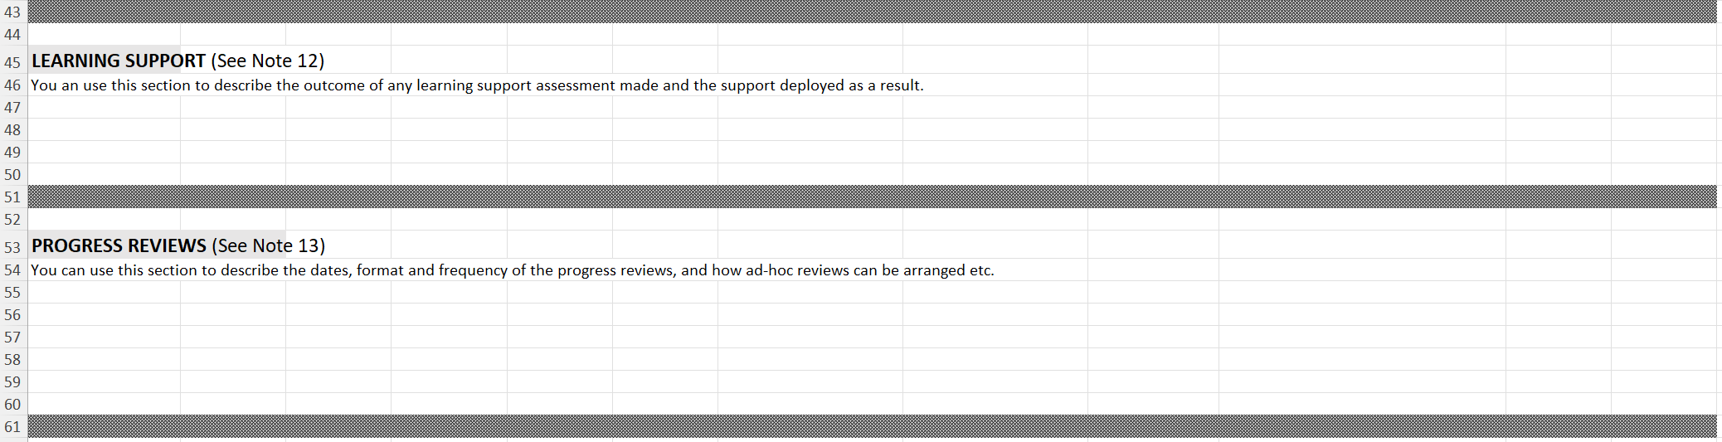
Critical components:
- Take account of the relevant notes in this area though note from 1st August the progress review requirement changes from every 12 weeks to every three months but can still be four times a year:
- If apprentices have not consented to an employer knowing about any learning support needs then this section should not be completed and instead you use a confidential plan shared only with the necessary officers of the training provider.

Other Possible enhancements:
- With the explanation of progress reviews, some providers will include them as a component in the table of planned training so that their timing and importance are enhanced, this increases ‘buy-in’.
- With learning support the use of a separate learning support plan is best practice as sufficient space can be afforded to the strategies and adjustments occurring to the specific methods of delivery rather than condensed into the wider training plan template. Ideally, the original training plan template would reference that there is a separate support plan.

Occupational Content / Components
Fig 13 – The Plan of Training – Occupational Content / Components
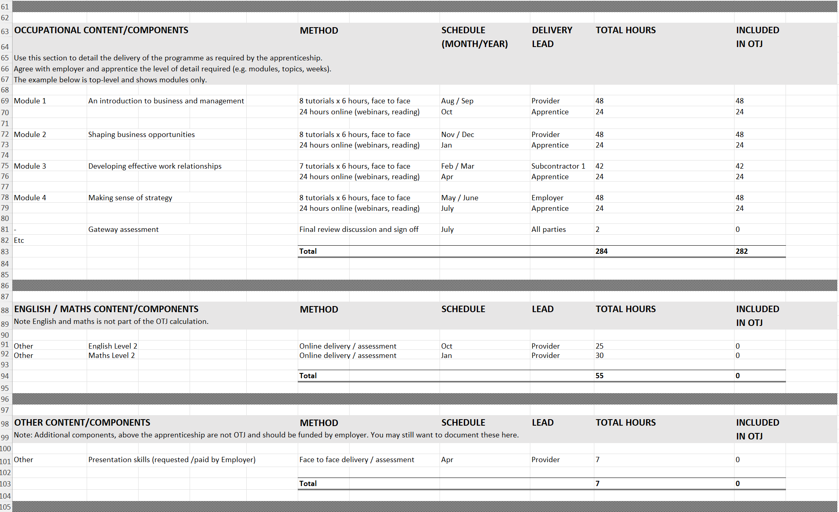

Critical components:
- There is example content here that should be overwritten.
- This should be your curriculum and clearly show the activities necessary and the total hours be the total hours of that component and the ‘included in OTJ’ section show these, how many count as OTJ training.
- You can show this like the example as ‘module’ or ‘unit’ or ‘chapter’ but it could also be your activities as individual lines.
- The ‘method’ section must quantify the hours included as OTJ training. It is essential for compliance purposes and your curriculum should be transparent. So, where it says for module 1 in the example ‘8 tutorials x 6 hours’ it is clear how much time is planned.
- Some activities in a plan will not count as OTJ hours but will be necessary for the programme (e.g. progress reviews, on-programme assessments and examinations” but are timebound and should be clear in the ‘total hours’ volume but would not be in the ‘included in OTJ’ column.
- Where subcontractors are used it should be clear where they are involved, you can see in the example that module 3 has delivery by the subcontractor.
- Generally, be clear on how the apprenticeship is possible within the working environment and is in paid time.
- The time you expect for maths and English functional skills should be shown here, this will be different for each provider based upon their curriculum model.
- If you have content in your programme that is not part of the apprenticeship, then you can use the ‘other content’ section.
- The table will automatically total up the hours of the programme and those included as OTJ, these will then appear on the top of the form in the OTJ section.

Possible enhancements:
- The method could be broken down in further detail to show activities like assignments, examination, shadowing, mentoring and the other categories of learning activity, being careful to identify those that count as OTJ and those that do not. This will make compliance activities of reconciling OTJ much easier but critically will give apprentices the information of what they should be recording as OTJ in each module/ unit or chapter.
- Many providers will supplement this tab with a graphical representation of the journey showing month-by-month or week-by-week.
- Illustrate the maths / English curriculum clearly, and make it obvious how this can be achieved
- If you are using other learning management platforms then add a section and explain how these are accessed.
- The training plan is designed to meet funding rules and show the practical training period, but it does not, and ideally would show, the expected activity, expectations and timescales for endpoint assessment. This would help show the full commitment to the programme.
- The sequence of the programme should match how you intend to deliver and ideally be consistent with how you construct your programmes in any other learning management platforms.

Occupational Content / Components
Fig 14 – The Plan of Training – Key milestones

Critical components:
- This is subjective and for a provider to use how they wish.

Possible enhancements:
- This could be where a provider shows their delivery timetable or semester pattern but also the components and timing for endpoint assessment.
- Graphic visualisations are useful here.
- A good provider will personalise the training plan with individual milestones based upon the apprentice’s targeted objectives, e.g. not simply achieving the qualification but what grades should be targeted based upon their entry position.
General Recommendations relevant to the training plan
- You must ensure the training plan is signed as agreed by the apprentice and employer, this should be before the actual start of training and should be the result of pre-enrolment processes including initial assessment, you can, however, continue to refine and update training plans following enrolment if changes are agreed.
- Regularly check for updates to the template and integrate training plans as a key part of your quality improvement cycle.
- Ensure you regularly check for updates to the apprenticeship funding rules in the section of “the training plan” to ensure these components are included in the format you are using and update your template where necessary.
- Ensure the latest copy of the training plan is readily available for your delivery and compliance teams, it should be easily findable within your data storage systems.
- Ensure you maintain data integrity and confidentiality where it applies, access to personal data should be limited to those who require access, manage this in your data use policies.

Useful links
The training plan template https://www.gov.uk/government/publications/apprenticeships-off-the-job-training
23/24 version 1: https://assets.publishing.service.gov.uk/media/653145c20b5392000da92a22/2023_10_Training_Plan_Template_-_23_24_Rules_v1.0.xlsx
Apprenticeship Funding Rules https://www.gov.uk/guidance/apprenticeship-funding-rules
Apprenticeship workforce development https://www.et-foundation.co.uk/professional-development/apprenticeships/
AWD Programme Brochure: https://www.et-foundation.co.uk/wp-content/uploads/2024/02/AWD-Programme_Brochure_Online_Asynchronous.pdf



Delivered by:

If a training plan does contain details of learning difficulties, disabilities and the presence of any learning support or reasonable adjustments then the apprentice should have consented to this. If there is not consent, then details of any support or adjustments should be in a separate document – See Funding Rules 24/25
The training plan template can be found within the Apprenticeships: off the job training guidance documents available on .gov https://www.gov.uk/government/publications/apprenticeships-off-the-job-training

