
SUPPORTING DELIVERY OF THE T LEVEL FOUNDATION YEAR
ET-FOUNDATION.CO.UK
T LEVEL FOUNDATION YEAR IN AGRICULTURE, ENVIRONMENTAL AND ANIMAL CARE

INTRODUCTION
This resource supports the delivery of the T Level Foundation Year and specifically draws upon the national technical outcomes (NTOs) for the T Level Foundation Year in agriculture, environmental and animal care. The NTO it focuses on is Outcome 3A: Maintain the health and welfare of animals.
The specific knowledge and skills being taught and developed from Outcome 3A are referenced throughout this resource.
This resource has three sections:
Framework for Learning
The resource includes a Framework for Learning (FfL). This covers 20 hours of learning and there is a diagram to show how the content of those hours has been sequenced and scaffolded. There is also a narrative that explains the sequencing and scaffolding in more detail.
Lesson plans
There is a lesson plan for each stage in the sequencing and scaffolding of learning in the FfL. Lesson plans include details of the support materials that are required to support delivery, including those found within this resource.
Support materials
The support materials identified in the lesson plans are also available at the end of this document.
NOTE:
There is a separate slide deck that can be used with the lessons.
There are also separate videos that can be used with the lessons.
There is a separate guidance document for use with learners.

SECTION 1: FRAMEWORK FOR LEARNING
The FfL diagram shows one approach to scaffolding and sequencing learning which is designed to meet some of Outcome 3A: Maintain the health and welfare of animals, from the T Level Foundation Year NTOs: Agriculture, environmental and animal care route.
The following rationale provides more information about how the content is sequenced and scaffolded.
Rationale
The FfL is structured into 10 two-hour lessons. Each lesson includes an introduction that provides a brief overview of the lesson’s topic(s) and content.
Outcome 3A focuses on the technical skills that can be applied when working in the animal care sector. It also states that the development of technical skills is underpinned with technical knowledge which ultimately supports learners to make appropriate decisions regarding their choice of actions about animal care and welfare. As such, lessons 1 to 8 of the teaching sequence target specific aspects of animal health and welfare, from understanding animal needs and biosecurity issues to creating suitable environments and ensuring the safety of animals and people.
This content delivery in lessons 1 to 8 (supported by examples and case studies) is accompanied by lesson activities which are intended to engage learners and enhance their technical skills by affording them the opportunity to apply their knowledge and understanding. It is recommended that these sessions are also supported by a visit to a local animal establishment where learners would be able to evaluate practices taking place within the industry. This is shown in the centre of the FfL diagram.
Formative assessments, including quizzes, presentations or practical tasks, evaluate the learners’ grasp of the material and their ability to apply it. The teaching sequence then culminates in a practical task in lessons 9 and 10 whereby learners design their own animal building and enclosures, thus demonstrating the skills and knowledge they have learnt throughout previous lessons. Learners are also expected to provide a rationale for their design. This will act as a justification for the decisions they make and provide evidence of their ability to apply the underpinning knowledge and skills they have acquired regarding animal health and welfare.
During these final lessons, learners will also review designs produced by their peers. To do this, they will need to draw upon the skills and knowledge acquired in previous lessons. Learners will then adapt and refine their designs in response to the peer feedback they receive, thereby also developing skills from Outcome 3A in self-managing and self-reflecting.
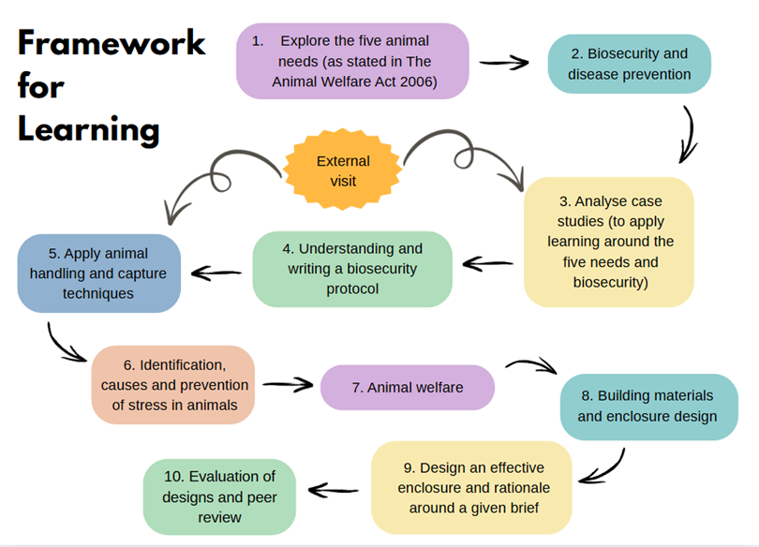

SECTION 2: LESSON PLANS
This section includes 10 lesson plans. The lesson plans follow the FfL. The lesson plans include the:
- lesson title
- targeted specification content coverage
- lesson number in the sequence
- total amount of time required to deliver the lesson
- teacher and learner activities to be undertaken throughout the lesson
- resources needed to deliver the lesson (see Note below)
- details of how the lesson supports the development of English, maths and / or digital skills (where appropriate)
- details of how the lesson can be adapted to meet learners’ specific needs
- next steps in learning such as homework activities and links to the next lesson.
Note:
There is an assumption that the learning environment will include the following:
- whiteboard/smartboard or similar
- materials to take notes, e.g. pens, paper, audio recorder, digital device and software
- equipment to present a slide deck and video, e.g. projector, smartboard
- digital devices (e.g. laptop, tablet) for all learners
- internet access
- learner access to word-processing, spreadsheet and presentation software.

Lesson 1
Title: Explore the five animal needs (as stated in the Animal Welfare Act 2006)
Targeted content reference: Outcome 3A: Maintain the health and welfare of animals:
Knowledge:
Animal health and welfare:
- Animal welfare frameworks: needs, domains and best practice in ensuring they are implemented.
Communication:
- Listening techniques: active and deep.
Lesson sequence number: 1
Timing: 2 hours
Prior learning: None required.
Timing | Teacher activity | Learner activity | Support materials
10 minutes | Give an overview of the lesson ahead. | Listen. | Slide deck  Flipchart paper  Adhesive putty  Whiteboard markers
10 minutes | Introduce the principles of listening actively and what it means and how they will need to do it in the next activity. | Listen actively and take notes.
10 minutes | Present an overview of the Animal Welfare Act 2006 using the slides. | Listen and take notes.
5 minutes | Quick-fire activity: learners to create a list of everything they think animals need with the person next to them. | In pairs, create list of everything an animal needs.
5 minutes | Circulate and discuss with learners their lists. | Ask and answer questions and add to lists.
15 minutes | Present the five needs. | Listen and take notes.
15 minutes | Split learners into five small groups. Allocate one of the five animal needs from the Welfare Act to each group. Ask them to write down on flipchart paper everything they should consider regarding their allocated need. | Write onto flipchart paper what should be considered for their group’s allocated need when looking after animals.
15 minutes | Stick flipchart paper onto the wall to refer to throughout the rest of the session. | Hand flipchart paper to tutor to stick to the wall.
10 minutes | Present the need for a suitable environment. | Listen and take notes.
10 minutes | Facilitate a discussion on substrates. Refer to learners’ flipchart paper from the first activity about the five needs and address any missing points. | Discuss different substrates they have worked with, which animals use them and how easy they are to clean.
15 minutes | Present the need for a suitable diet. | Listen and take notes.
15 minutes | Create a list on the board of responses of different feeding patterns. Make sure learners understand the new terminology given for different feeding methods and how to spell them accurately by modelling the difficult parts of words and discussing strategies for remembering these parts. | In pairs, complete a list of different feeding patterns for animals.
15 minutes | Facilitate discussion on how best to feed the animals named on the slide. Refer to learners’ flipchart paper from the first activity about the five needs and address any missing points. | Contribute to the whole-class discussion about how best to feed animals.
20 minutes | Introduce the topic of the need to be able to exhibit normal behaviour patterns. | Listen and take notes.
20 minutes | Divide the whiteboard into three sections and title them ‘dog’, ‘bird’ and ‘rabbit’. Make board pens available to learners to be able to write their ideas on the board. | Discuss, within pairs, the normal behaviour of animals and then write ideas on the classroom whiteboard under relevant heading.
20 minutes | Lead class discussion about things they have written on the board. Refer to learners’ flipchart paper from the first activity about the five needs and address any missing points. | Take notes and join in discussion.
20 minutes | Present the remaining slides, allowing discussion and ongoing examples throughout. | Take notes and join in discussion.
20 minutes | Present the need to be protected from pain, injury, suffering and disease. | Listen and take notes.
20 minutes | Set up and facilitate a paired task where learners research and produce a list of routine healthcare for one of the species identified on the slide. | Separate into pairs and research and produce a list of routine healthcare for one of the species identified.
20 minutes | Lead a class discussion to explore the things they have written on the board and refer to learners’ flipchart paper from the first activity about the five needs and address any missing points. | Take notes and join in the discussion.
20 minutes | Discuss the routine healthcare learners have identified. | Listen and take notes.
20 minutes | Ask learners to get back into the groups they worked in at the start of the lesson when they were looking at one of the five animal needs. Explain that they will now evaluate how this need is met for both the barn owl and the wildcat. | In groups, discuss whether the need is met for both the barn owl and the wildcat.
20 minutes | Lead a discussion on the five needs by going to each of the groups and asking them to explain how their allocated need would be met for both the barn owl and the wildcat. | Contribute to the discussion by explaining their group’s thoughts on whether the identified need has been met for the barn owl and wildcat.
5 minutes | Lead a plenary discussion to draw the learning together around the five needs and how they should be applied to different species. | Join in the discussion.
Other:
English: Teach learners the principles of active listening and give them the opportunity to apply these techniques when they listen to the presentation by the teacher about the Animal Welfare Act 2006.
Support development and use of subject-specific terminology such as ‘omnivore’, ‘carnivore’, ‘herbivore’, ‘insectivore’ and ‘frugivore’. Model how to spell these words by focusing on the difficult parts of the word and how to remember the spelling of these parts in particular.
Adaptation:
SEND: Allow learners to choose the specific species they discuss during the discussion about how best to feed animals.
Extension: Allocate less familiar species to learners who need to be stretched and challenged.
Next steps in learning: Biosecurity and disease prevention.

Lesson 2
Title: Biosecurity and disease prevention
Targeted content reference: Outcome 3A: Maintain the health and welfare of animals
Animal health and welfare:
- Animal welfare frameworks: needs, domains and best practice in ensuring they are implemented.
Biosecurity:
- Biosecurity: risk factors in different types of animal environments; measures to prevent and control biosecurity risks.
Lesson sequence number: 2
Timing: 2 hours
Prior learning: Lesson 1.
Timing | Teacher activity | Learner activity | Support materials
10 minutes | Recap on the key points from lesson 1 by leading a class discussion around the questions on the slide. | Listen and respond to questions. | Slide deck  Animal diseases, transmission and biosecurity measures  Whiteboard pens  Link to digital egg timer
10 minutes | Give an overview of the lesson ahead using the slide. | Listen and ask questions.
15 minutes | Ask learners to work in pairs and look up online definitions for key terms. Allocate 2 minutes for the task and set up the online egg timer. Explain and model how to conduct suitable research on their own devices. | Use own devices to work in pairs and look up definitions for key terms.
15 minutes | Ask pairs to list as many modes of disease transmission as they can think of. | In pairs make a list of modes of disease transmission.
15 minutes | Prepare the class whiteboard with the title ‘disease transmission’ and invite pairs to come and write a mode of transmission onto the whiteboard until no suggestions remain. | Contribute to the class activity by writing modes of disease transmission onto the class whiteboard.
15 minutes | Outline and explain all modes of disease transmission using the slides. Refer to key points and questions raised in the previous activity. | Listen, take notes and ask questions.
15 minutes | Ask learners to work in the same pairs as before and write down what they understand by the term ‘biosecurity’. | Write notes on what they understand by the term ‘biosecurity’.
15 minutes | Take responses from the pairs and then explain biosecurity using the slides. | Listen, take notes and ask questions.
10 minutes | Ask learners to work in their pairs and write a list of as many biosecurity measures as they can think of. Make the activity into a kind of competition and use the timer on the slide. Support the development of subject-specific terminology and its accurate use and spelling by modelling how to spell the difficult parts of key words and discussing strategies for remembering them. | In pairs, write a list of as many biosecurity measures as they can think of.
10 minutes | Take learners’ ideas and compile a class list on the whiteboard (or similar). | Contribute suggestions for the whole-class list.
10 minutes | Explain biosecurity measures and refer to the previous activity and learner suggestions. Support the use of accurate subject-specific terminology through modelling, including spelling strategies. | Listen, take notes and ask questions.
20 minutes | Split the class into four groups. Explain the group task and how to use the Species-specific biosecurity handout (one per group). Give learners 15 minutes to do the first phase of the task (three columns). | Work in a group to research and complete the first three columns of the handout.
15 minutes | Set learners working on phase two of the activity by asking each group to swap their handouts with another and then complete columns four and five. | Swap handouts with another group and research and complete columns four and five.
10 minutes | Ask learners to swap handouts with another group, as indicated by the slides, and evaluate the suggestions for preventing disease by using certain biosecurity methods. | Work in groups to evaluate suggestions made on another group’s handout. Make changes or adaptations to the handout.
10 minutes | Lead a plenary discussion by asking learners to stand up or sit down in response to the questions on the slides. Clarify any misconceptions or misunderstanding. | Contribute to the plenary discussion and stand up or sit down accordingly.
Other:
English: Support development and use of subject-specific terminology (such as ‘biosecurity’, ‘pathogen’, ‘aetiology’, ‘epidemiology’, ‘zoonotic’, ‘notifiable’, etc.) during the paired activity where learners write a list of as many biosecurity measures as they can think of. Discuss and model which parts of words in particular are difficult / common mistakes. Discuss how to spell them and strategies for remembering them.
Digital: Support learners to conduct appropriate research on their own devices when completing the Species-specific biosecurity handout.
Adaptation:
SEND: Learners with specific reading difficulties could be given the names of diseases for the handout. Allow learners to choose the species they work with in the activity where they look at biosecurity measures and complete sections of the handout. Give learners with reading difficulties or attention challenges (such as ADHD) specific websites to look at to conduct the research on biosecurity and complete the sections of the handout.
Next steps in learning:
Analyse case studies (to apply learning around the five needs and biosecurity).

Lesson 3
Title: Analyse case studies (to apply learning around the five needs and biosecurity)
Targeted content reference: Outcome 3A: Maintain the health and welfare of animals
Animal health and welfare:
- Animal welfare frameworks: needs, domains and best practice in ensuring they are implemented.
Biosecurity:
- Biosecurity: risk factors in different types of animal environments; measures to prevent and control biosecurity risks.
Lesson sequence number: 3
Timing: 2 hours
Prior learning: Lessons 1 and 2.
Timing | Teacher activity | Learner activity | Support materials
10 minutes | Set up the recap activity using the slide. | Listen and ask questions. | Slide deck  Biosecurity measures and the five animal needs  Case study 1: A bird park with an outbreak of avian influenza  Case study 2: A rescue kennel with an outbreak of Bordetella bronchiseptica (kennel cough)  Whiteboard markers
10 minutes | Observe the pairs asking and answering questions. | In pairs, ask questions of each other, following the instructions on the slide.
10 minutes | Feed back key points from the activity and correct any common misconceptions or misunderstandings. | Listen to key points.
10 minutes | Outline the lesson ahead. | Listen and ask questions.
15 minutes | Ask learners to get into pairs and explain the mind-mapping task. | Listen and ask questions.
15 minutes | Travel the room and make sure pairs are including relevant information in their mind maps. | In pairs, create a mind map of enclosure features that will affect biosecurity measures.
15 minutes | Prepare the class whiteboard with the title ‘enclosure features and their impact on biosecurity’ and invite pairs to come and write suggestions onto the whiteboard until no suggestions remain. | Contribute to the class activity by writing suggestions onto the class whiteboard.
20 minutes | Distribute the handout Biosecurity measures and the five animal needs. Explain the activity about animal needs, biosecurity measures and the impact of the biosecurity measures on the animals’ needs. Show learners the example table on the slide. | Listen and ask questions.
20 minutes | Circulate among the pairs of learners and support the activity. Support development of subject-specific terminology and its accurate use and spelling by stopping learners at appropriate times to interject with a brief discussion about a key word you have observed learners struggling with. Discuss its meaning, the difficult part(s) of the word to spell and strategies for remembering the spelling. | Complete the table on the handout in pairs.
60 minutes | Go through each of the case studies in brief. Take questions. Explain the section of Case study 1 where animals are listed and how the notation works in animal keeping (i.e. 2.0 geese denotes two male geese and no female) and that the two numbers need to be added together to find the total number of animals to be housed in the individual enclosures. Focus on any new vocabulary which the case studies introduce (e.g. ‘diagnostic’, ‘culled’).  Emphasise terminology they have already seen in the previous lessons and check understanding through targeted questioning. | Listen and ask questions.
60 minutes | Split learners into groups and allocate each group one of the two case studies. Explain the activity. Model and explain how they might go about conducting the necessary research using the internet. | Move to form groups and read the allocated case study.
60 minutes | Circulate among groups and support the research and design task, including the correct use of subject-specific terminology. | In groups, research and begin designing species-specific temporary enclosures based on the allocated case study, considering necessary biosecurity measures.
15 minutes | Lead a class discussion to share some of the groups’ initial ideas. Draw out key learning around the five needs, biosecurity measures and their application to specific species. | Contribute to the class discussion and share initial design ideas and justifications for them.
Other:
English: Support development of subject-specific terminology (‘diagnostic’, ‘culled’, ‘zoonotic’, ‘notifiable’, etc.) and its accurate use during the activity when learners complete the Biosecurity measures and the five animal needs handout. Pause the activity at appropriate times with a brief discussion about a key word you have observed learners struggling with. Discuss its meaning, the difficult part(s) of the word to spell and strategies for remembering the spelling.
Maths: Explain the ratios when looking at Case study 1 with learners and support the use of simple addition skills to ensure learners plan for enclosures to house the correct number of animals.
Adaptation:
SEND: Allocate specific case studies to learners with SLD to cater for their reading and comprehension levels, personal interests, etc. (Case study 1 is more challenging than 2 so the allocation of the case studies can be differentiated to meet learner needs.)
Extension: Use biosecurity examples from the learners’ own provider for added relevance.
Next steps in learning:
Understanding and writing a biosecurity protocol.

Lesson 4
Title: Understanding and writing a biosecurity protocol
Targeted content reference: Outcome 3A: Maintain the health and welfare of animals
Biosecurity:
- Biosecurity: risk factors in different types of animal environments; measures to prevent and control biosecurity risks.
Lesson sequence number: 4
Timing: 2 hours
Prior learning: Lessons 1–3.
Timing | Teacher activity | Learner activity | Support materials
10 minutes | Outline the lesson ahead. | Listen and ask questions. | Slide deck  Personal protective equipment  Sample biosecurity protocol for children’s petting farm  Professional and business writing tips video  Transcript of professional and business writing tips video
10 minutes | Use the slides to explain biosecurity considerations and key components of a biosecurity protocol. | Listen and ask questions.
5 minutes | Explain control of access in animal buildings. | Listen and ask questions.
10 minutes | Use the slide to explain the activity and the Personal protective equipment handout.  Put learners into pairs for the activity. | In pairs, discuss and complete the Personal protective equipment handout.
10 minutes | Discuss the handout and what the pairs have written. | Contribute to the discussion and share what has been written on the handout.
5 minutes | Explain cleaning and disinfection, expanding on the bullet points from the slide. | Listen, take notes and ask questions.
5 minutes | Explain the principles of animal movement, using the slides. | Listen, take notes and ask questions.
10 minutes | Explain the principles of health monitoring and record keeping. | Listen, take notes and ask questions.
10 minutes | Ask learners to get into small groups to discuss records kept in the animal centres they have experience of. | Discuss records kept in the animal centres they have experienced, in small groups.
10 minutes | Conduct a brief discussion where learners share their experiences of the records kept with the rest of the room. | Share their experiences of the records kept in the animal centres they have experienced with the rest of the class. Listen and ask questions.
5 minutes | Explain training and awareness using the slides. | Listen, take notes and ask questions.
20 minutes | Explain the SMART approach using the slide. | Listen and ask questions.
20 minutes | Hand out the Biosecurity protocol for a children’s petting farm for learners to read. Explain that they will be evaluating its suitability for purpose using the SMART approach. | Individually, evaluate the Biosecurity protocol for a children’s petting farm using the SMART approach.
20 minutes | Ask learners to collaborate with the person next to them and share their evaluations of the Biosecurity protocol for a children’s petting farm. | Share evaluations and ideas.
10 minutes | Play the Professional and business writing tips video. | Watch the video.
10 minutes | Discuss the key points from the video. | Contribute to the discussion about the key writing tips.
10 minutes | Explain how artificial intelligence (AI) can be used for writing and use the slide to outline how. | Listen and ask questions.
10 minutes | Model one component of a protocol (i.e. PPE) using AI and following the stages and tips on the slide, taking special care to make adaptations to the AI suggestions to ensure the writing fits audience and purpose. Explain that the standard to aim for is below 20% of content to be generated by AI but, on their first attempt, they will be permitted to go up to 50%. | Listen and ask questions.
15 minutes | Explain the task, using the slide, to write a biosecurity protocol about the case study they looked at in lesson 3 (bird park or kennels). | Use AI assistance to write a biosecurity protocol about the case study they looked at in lesson 3.
5 minutes | Draw the lesson to a close. Give any immediate feedback on the writing they have begun and set the homework task. | Listen and ask and answer questions.
Other:
English and digital: Support learners to understand how to use AI assistance to produce writing by explaining the principles and then modelling them before asking learners to write their own biosecurity protocol.
Adaptation:
SEND: Organisations like Lion Learners and Zoo2U specialise in creating tailored animal-handling sessions for SEND learners so could be approached for the next steps in learning (see below).
Next steps in learning:
Apply animal handling and capture techniques. It is recommended that in advance of the next lesson, learners can visit a zoo or other animal establishment. The visit would ideally include a talk about capture and handling of more exotic animal species, especially those which might require chemical restraint. Where this is not possible, a member of the educational organisation’s staff might be able to provide this or someone from a local establishment might be willing to visit learners in the classroom and give a talk.
Homework: Complete the biosecurity protocol, aiming for less than 50% content to be AI-generated.

Lesson 5
Title: Apply animal handling and capture techniques
Targeted content reference: Outcome 3A: Maintain the health and welfare of animals
Animal health and welfare:
- Animal welfare frameworks: needs, domains and best practice in ensuring they are implemented.
- Animal handling: techniques for safe and welfare-orientated animal handling capture and restraint.
Lesson sequence number: 5
Timing: 2 hours
Prior learning: Lessons 1–4. Learners also need to have visited a zoo or other animal establishment and received a talk on the handling and capture of animals.
Timing | Teacher activity | Learner activity | Support materials
10 minutes | Give an overview of the lesson ahead. | Listen. | Slide deck  Sticky notes
10 minutes | Hand out a sticky note to each learner and ask them to answer the question from the slide. | Write down one consideration for handling animals and stick it to the board. | Slide deck  Sticky notes
15 minutes | Present information on considerations for handling animals and discuss the learners’ sticky note responses. | Listen and take notes and explain sticky note responses. | Slide deck  Sticky notes
15 minutes | Hand out more sticky notes and ask learners to give reasons why we may need to handle animals. | Write down one reason we may need to handle animals and stick to the board. | Slide deck  Sticky notes
15 minutes | Lead a class discussion about their responses on all the sticky notes. | Listen and contribute to the class discussion. | Slide deck  Sticky notes
15 minutes | Explain the task from the slide and refer to the zoo visit (or visit to another establishment or talk given within the educational setting). | Listen to the task instructions and ask any questions to clarify understanding. | Slide deck  Sticky notes
15 minutes | Circulate the room, helping learners to remember the zoo/other visit. Prompt learners to use the zoo’s website to jog their memory. | Write down answers to the questions on the slide by thinking of a specific animal enclosure. | Slide deck  Sticky notes
60 minutes | Take learners to the onsite animal facilities and model animal handling and how enclosure design can facilitate this. Go through the questions and model answers for one animal species. | Observe demonstration and ask any questions to clarify understanding. | Slide deck  Sticky notes
60 minutes | Circulate among learners to support task completion. | Complete the task shown on the slide, by choosing animals from three different taxa. | Slide deck  Sticky notes
20 minutes | Return to the classroom and go through the enclosures learners have chosen and discuss with the whole group their answers to the questions.  Refer to the five needs and pose the question: Do the enclosures meet the five needs? | Feed back on chosen enclosures. Contribute to the discussion about suitability, how their choices assist handling and capture and whether the enclosures meet the five needs. | Slide deck  Sticky notes
Adaptation:
SEND: Allocate more familiar species to learners with specific difficulties. Ensure that careful thought is given to the animal handling activities by taking account of individual needs and putting support in place accordingly, e.g.:
- extra supervision by trained staff to ensure safety of learners and animals
- introducing animals with different textures gradually to learners with sensory sensitivities.
Extension: Look at how the design of the observed enclosure(s) could be improved to facilitate ease of handling and/or capture.
Next steps in learning:
Identification, causes and prevention of stress in animals.

Lesson 6
Title: Identification, causes and prevention of stress in animals
Targeted content reference: Outcome 3A: Maintain the health and welfare of animals
Animal health and welfare:
- Animal welfare frameworks: needs, domains and best practice in ensuring they are implemented.
- Animal stress: techniques to protect an animal from stress, personal behaviour and how these are applied.
Lesson sequence number: 6
Timing: 2 hours
Prior learning: Lessons 1–5.
Timing | Teacher activity | Learner activity | Support materials
5 minutes | Give an overview of the lesson ahead. | Listen to the overview. | Slide deck  Sticky notes  Graph examples 1 to 5  Species and enrichment cards  Animal enrichment video  Transcript of the animal enrichment video
5 minutes | Give each learner two sticky notes. Ask them to use one to respond to the first question on the slides. | Write down, on a sticky note, a definition of ‘stress’ by thinking about what the word means to them.
10 minutes | Go through learners’ definitions and discuss as a group what stress means to them. Determine which definition the group feels fits best. | Listen and participate in the group discussion.
10 minutes | Use the slides and the three explanations of stress to sum up the discussion. | Listen, make notes and ask questions.
20 minutes | Present slides about causes, prevention and identification of stress. Include examples from own experience and knowledge, and prompt learners to do the same. | Take notes, ask questions and participate in the discussion.
20 minutes | Ask learners to write on another sticky note a sign they have seen of an animal in stress and stick it to the board. | Write an example of a sign of stress in an animal on sticky notes. Stick these examples to the board.
15 minutes | Use the slide to explain recording and measuring stress and how graphs can be used to illustrate stress-related behaviours. | Listen and ask questions.
15 minutes | Talk through the graph and model analysing and explaining what it shows. | Listen and ask questions.
30 minutes | Put learners into five groups. Give each group one of the example graphs and ask them to discuss what the graph shows. | In groups, discuss what the allocated graph shows.
30 minutes | Lead a discussion, aided by each group, about the five sample graphs and what they show. Support learners to use subject-specific vocabulary correctly during this discussion by modelling, prompting and correcting learner language use. | Contribute to the discussion and share the group’s ideas about the graph they analysed.
10 minutes | Show the video about animal enrichment. | Watch the video, listen and make notes.
20 minutes | Present the class with the Species and enrichment cards in two separate containers. Ask each learner to take a card from each pot and use this to design a specified form of enrichment for a specified species. | Select a species and an enrichment type from the Species and enrichment cards. Design enrichment according to the selected cards.
10 minutes | Ask selected learners to hold up their designs and explain why they have chosen to do it in that way. | Explain their design if/when prompted.
10 minutes | Draw out key learning around animal enrichment and make links with stress reduction. | Listen and contribute to the discussion.
Other:
English: Prompt the correct use of subject-specific vocabulary (e.g. ‘stereotypical behaviour’, ‘stressors’) during the follow-up discussions on the graph analysis by modelling, prompting and correcting learner language.
Maths: Support learners to read and analyse data represented on the sample graphs by discussing patterns, trends and correlation.
Adaptation:
SEND: The five sample graphs are written to allow for differentiation: graphs 1 and 2 are the simplest to interpret, graph 5 is more challenging and 3 and 4 are of average difficulty. YouTube closed captions can be enabled for hearing impaired learners when playing the video about animal enrichment. There is also a transcript of the animal enrichment video available.
Extension: Add additional species to the cards for the animal enrichment design task to suit particular groups of learners, their interests and their experiences.
Next steps in learning:
Animal welfare.

Lesson 7
Title: Animal welfare
Targeted content reference: Outcome 3A: Maintain the health and welfare of animals
Animal health and welfare:
- Physical and behavioural signs of good and poor animal health and welfare.
Lesson sequence number: 7
Timing: 2 hours
Prior learning: Lessons 1–6.
Timing | Teacher activity | Learner activity | Support materials
10 minutes | Give an outline of the lesson ahead. | Listen. | Slide deck  Sticky notes
10 minutes | Ask learners to use a sticky note to write down what the word ‘welfare’ means to them. | Write what the word ‘welfare’ means to them on a sticky note. | Slide deck  Sticky notes
10 minutes | Use the sticky notes to lead a discussion about their ideas. Use the definition on the slide to sum up the discussion. | Listen and contribute to the discussion. | Slide deck  Sticky notes
15 minutes | Put the learners into small groups to discuss the three welfare questions on the slide. | In groups, discuss the three questions. | Slide deck  Sticky notes
15 minutes | Lead a discussion and take answers from the groups around the three questions. | Contribute to the class discussion. | Slide deck  Sticky notes
15 minutes | Explain the table on the slide showing signs of good welfare. | Listen, make notes and ask questions. | Slide deck  Sticky notes
15 minutes | Ask learners to create, on paper, a similar table to the slide to identify signs of poor welfare. Circulate while learners are writing to ensure their responses are correct and to correct any misconceptions. | Create a table showing the signs of poor welfare. | Slide deck  Sticky notes
5 minutes | Explain monitoring welfare using the slide. | Listen, make notes and ask questions. | Slide deck  Sticky notes
5 minutes | Lead a discussion about what we use to monitor and record physical and behavioural health and welfare. Make a list of key ideas on the whiteboard (or similar). | Listen and contribute ideas. | Slide deck  Sticky notes
30 minutes | Use the slide to explain how to create good PowerPoint presentations which inform and explain. | Listen, make notes and ask questions. | Slide deck  Sticky notes
30 minutes | Explain the task: in pairs, write a five-minute presentation on signs of good and poor welfare in a specific animal, including physical and behavioural indicators. Allocate an animal to each pair. | Listen and ask questions to clarify the task. | Slide deck  Sticky notes
30 minutes | Circulate among pairs to keep them on task and support the use of PowerPoint. | Work in pairs to create a PowerPoint presentation on signs of good and poor welfare in a specific animal, including physical and behavioural indicators. | Slide deck  Sticky notes
30 minutes | Invite each group to present their PowerPoint. | Listen and ask questions in response to other groups’ presentations. Present their group’s PowerPoint. | Slide deck  Sticky notes
Other:
Digital: Explain what makes a good PowerPoint presentation and discuss these features with learners before asking them to work in groups to create their own presentation.
Adaptation:
SEND: For learners with specific learning difficulties, teachers might want to allocate animals on which to base their presentation, depending on individual interests and experience. If any learners are hearing impaired, ask learners to enable closed captions in their PowerPoint presentations.
Extension: Some learners may need to be challenged to think about a different animal from those they have focused on in previous lessons.
Next steps in learning:
Building materials and enclosure design.

Lesson 8
Title: Building materials and enclosure design
Targeted content reference: Outcome 3A: Maintain the health and welfare of animals
Materials:
- Factors affecting choice of materials: sustainability, cost, availability, durability, form and suitability for purpose.
Lesson sequence number: 8
Timing: 2 hours
Prior learning: Lessons 1–7.
Timing | Teacher activity | Learner activity | Support materials
10 minutes | Outline the lesson ahead. | Listen. | Slide deck  Building materials handout  Flipchart paper  Glue sticks
10 minutes | Present the picture of an enclosure on the slide. Ask learners to evaluate the picture on their own and make some notes about how the enclosure meets the five needs they have been learning about. | Make evaluative notes about the picture of the enclosure.
50 minutes | Introduce the task and distribute a copy of the Building materials handout to each learner. Put learners into seven groups and allocate one building material per group. | Listen and ask questions.
50 minutes | Circulate among groups to keep them on task, ask prompting questions and ensure misconceptions are corrected. | Get into groups and complete the section of the Building materials handout for their allocated building material.
50 minutes | Organise learners into new groups of seven, each with one representative from each of the original groups represented (thereby having an ‘expert’ from each type of building material represented in these new groups.) Instruct each member of the new group to explain their ideas on their allocated building material to the rest of their new group while the others make notes and complete the corresponding section of their Building materials handout. | Share ideas about the allocated building material with the rest of the newly formed group. Listen to other groups’ ideas about their allocated building materials and complete the relevant parts of the Building materials handout.
10 minutes | Explain that they will be drawing a bird’s eye view of an enclosure. Use the slide to show learners how to measure their enclosure and calculate area. If needed, show learners the different sides to the tape measure (inches/centimetres) and explain that they will be taking measurements in centimetres. Model this process and perform the calculation using an object in the room. | Listen, make notes and ask questions.
10 minutes | Ask learners to work in pairs to measure and calculate the area of the table at which they are currently sitting. | Work in pairs to measure and calculate the area of the table at which they are currently sitting.
30 minutes | Take learners to the animal facilities and ask them to choose one enclosure, in pairs. | Listen to instructions and choose an animal enclosure.
30 minutes | Instruct learners to draw a bird’s eye view of their chosen enclosure. | Draw a bird’s eye view of their chosen enclosure.
30 minutes | Return with learners to the classroom. | Return to the classroom.
15 minutes | Instruct learners to stick their bird’s eye plan to the centre of a sheet of flipchart paper and annotate it using the headings on the slide. | Listen and ask questions to clarify the task.
15 minutes | Circulate among the pairs and ensure learners are on task, following the headings from the slide and annotating with the correct information. | Stick the bird’s eye plan to the centre of a sheet of flipchart paper and annotate it using the headings on the slide.
5 minutes | Explain the homework task to learners. | Listen and ask questions.
Other:
Maths: Show learners how to measure their enclosure and calculate area. If needed, show learners the tape measures, explaining how they work and what is on the different sides. Model this process and calculation using an object in the room (not the same table they will use in the following task).
Adaptation:
SEND: If any learners have physical disabilities, make sure measures are in place for them to access the animal facilities.
Next steps in learning:
Design an effective enclosure and rationale around a given brief.

Lesson 9
Title: Design an effective enclosure and rationale around a given brief
Targeted content reference: Outcome 3A: Maintain the health and welfare of animals
Animal health and welfare:
- Animal welfare frameworks: needs, domains and best practice in ensuring they are implemented
- Animal handling: techniques for safe and welfare-orientated animal handling capture and restraint
- Animal stress: techniques to protect an animal from stress, personal behaviour and how these are applied
Biosecurity:
- Biosecurity: risk factors in different types of animal environments; measures to prevent and control biosecurity risks
Lesson sequence number: 9
Timing: 2 hours
Prior learning:
- Learners need to have completed some practical work with rabbits, guinea pigs and ferrets, or other species of small animals held in the provider’s collection (as outlined in lessons 1–8).
- Learners need to know how to work out floor space in buildings for animals.
- Learners need to have been taught some research skills.
Timing | Teacher activity | Learner activity | Support materials
20 minutes | Give an overview of the lesson ahead. | Listen. | Design brief  Flipchart (A1) paper  Marker pens  Slide deck  Rulers  Peer review form
20 minutes | Demonstrate the task by modelling, on a whiteboard or similar, designing another building to house animals. (Pick an animal which is different from the learners’ brief.) Model the thought processes and how to apply the underpinning skills and knowledge learners have gained from previous lessons. Also model subject-specific vocabulary (e.g. ‘husbandry’, ‘zoonosis’, ‘biosecurity’ and ‘caecotrophs’). | Observe the process of modelling, asking questions to clarify and taking notes on the process of design.
20 minutes | After a period of modelling, become the scribe and ask learners for suggestions to develop the design further. Add learners’ ideas to the design displayed on the whiteboard. Demonstrate to learners how to add appropriate labels and justifications to a design. Through the modelling and scribing, ensure decisions which demonstrate the technical skills and knowledge taught in previous lessons have been explored. | Contribute suggestions to develop the design further.
5 minutes | Separate learners into groups of three to four and provide the design brief. Outline key points and take questions. | Move into allocated groups. Listen to the explanation of the design brief and ask questions.
5 minutes | Demonstrate how learners can work out the floor space of the building and size of the enclosures within it to ensure design elements can fit. | Listen and respond to the demonstration.
10 minutes | Travel around the room to monitor progress, ensuring the appropriate subject-specific words are used when speaking to groups, e.g. ‘How are they considering biosecurity?’, ‘What may caecotrophs need?’ | Research the animals named on the brief, using the internet and digital devices.
45 minutes | Provide large (A1/flipchart) paper, rulers and pens of a variety of colours for learners to use. Travel around the room to monitor progress and ensure equal collaboration from all learners. | Work together to design a building and enclosures to meet the design brief. Continue researching as and when needed.
45 minutes | Support learners, where needed, to calculate the floor space of the building and size of the enclosures within to ensure design elements can fit. | Calculate floor space of the building and size of enclosures.
30 minutes | Explain that learners will be rotating around the room to review and evaluate one other group’s design work using the Peer review form. | Listen and take notes.
30 minutes | Go through the checklist on the Peer review form and remind learners what they should be looking for. Explain that they might be tempted to put the same point in more than one section but should not feel they need to repeat themselves; as long as the point is written somewhere on the form, it is fine. | Listen and take notes.
30 minutes | Ensure learners use the Peer review form to provide feedback and that it is constructive. Set a timer to allow students to complete the review at the same time. | Review the design from one other group using the Peer review form.
5 minutes | Explain that learners should hand their Peer review forms to the relevant group and then return to their own design and read their feedback. Tell learners that they will have time to make amendments in the following lesson, based on the peer feedback they have received. | Hand Peer review form to the relevant group and then return to own design and read feedback.
5 minutes | Ensure all groups are working. Check that feedback is received as it was intended and considered constructively, for the purpose of making improvements. Ensure all designs are kept. Make learners aware that they will continue refining their designs in the next lesson. | Begin considering what changes they might want to make in the next lesson.
5 minutes | Share and review key feedback points from the peer reviewing activities. | Make suggestions about things they have learnt from designing their animal buildings and from doing and receiving the peer reviews.
Other: English: Support the use of subject-specific vocabulary, e.g. ‘husbandry’, ‘zoonosis’, ‘biosecurity’, ‘caecotrophs’.
Maths: Teach and support learners to calculate the floor space of the building and size of the enclosures to ensure design elements can fit.
Adaptation:
SEND: Learners with specific difficulties may need higher levels of teacher intervention during some of the group tasks and more scaffolded templates and guidance of what is to be included within the design of the building and enclosures within it. Provide websites where they could complete research (as opposed to them finding their own).
Extension: Learners could apply scale to their designs. Other animal species could be used in the design brief. Enclosures could be designed on computer software.
Next steps in learning:
Evaluation of designs and peer review.

Lesson 10
Title: Evaluation of designs and peer review
Targeted content reference: Outcome 3A: Maintain the health and welfare of animals
Animal health and welfare:
- Animal welfare frameworks: needs, domains and best practice in ensuring they are implemented.
- Animal handling: techniques for safe and welfare-orientated animal handling capture and restraint.
- Animal stress: techniques to protect an animal from stress, personal behaviour and how these are applied.
Biosecurity
- Biosecurity: risk factors in different types of animal environments; measures to prevent and control biosecurity risks.
Lesson sequence number: 10
Timing: 2 hours
Prior learning: Lessons 1–9.
Timing | Teacher activity | Learner activity | Support materials
10 minutes | Give an overview of the lesson ahead. | Listen and ask questions. | Design brief (from lesson 9)  Dice (or a digital dice such as the one available from https://classroomscreen.com/)  Slide deck
10 minutes | Recap on the project and design brief and the work they started last lesson. | Listen and ask questions.
10 minutes | Direct learners to get back into their groups from the previous lesson. | Get back into their groups from lesson 9.
65 minutes | Explain to learners that they are now creating their final design for the animal building and the enclosures within it. Encourage them to add finishing touches and ensure designs are appropriately annotated with their justifications. | Listen and ask questions.
65 minutes | Circulate the room and ensure the correct subject-specific terminology is being used and address misunderstandings and spelling issues. | Contribute to design work. Ensure the design is appropriately annotated.
30 minutes | Lead a discussion on the amendments the learners have made to their designs. Ask learners what they have changed or adapted and why. | Contribute to the discussion and feed back on designs and design choices and how feedback from others helped.
15 minutes | Conduct a plenary to review learning throughout the task. | Ask and answer questions to contribute to class discussion.
15 minutes | Explain the dice activity to learners and that its purpose is to review learning throughout this task. Load dice onto screen or give physical dice to learners. | Individually, throw a dice once to determine which question from the PowerPoint slide they will answer. Answer the reflective question.
Other:
English: Develop subject-specific vocabulary, e.g. ‘husbandry’, ‘zoonosis’, ‘biosecurity’, ‘caecotrophs’.
Adaptation:
Extension: Learners could apply scale to their designs to further develop and embed maths.
Next steps in learning: Continue Outcome 3A and develop breadth through ‘People’ descriptor (p24): Roles and responsibilities of different occupations involved in maintaining health and welfare of animals’.

SECTION 3: LESSON SUPPORT MATERIALS
This section includes the handouts, worksheets, templates and case study materials referred to in the Support materials section of each lesson plan.

The following materials relate to lesson 1: Explore the five animal needs (as stated in the Animal Welfare Act 2006).
No additional materials are required for this lesson.

The following materials relate to lesson 2: Biosecurity and disease prevention.

Animal diseases, transmission and biosecurity measures
Establishment type: |  |  | Animal species:
Name of disease | Transmission details  (Infectious? Contagious? Zoonotic? Notifiable? Include all that apply) | Transmission mode |  | Prevention  (Is there a vaccine or other assistive preventative treatment, e.g. antiparasitic treatment?) | Biosecurity methods

The following materials relate to lesson 3: Analyse case studies (to apply learning around the five needs and biosecurity).

Biosecurity measures and the five animal needs
Need | Biosecurity measure | Impact

Case study 1: A bird park with an outbreak of avian influenza
Key details:
- One bird has been confirmed via diagnostic testing to have avian influenza (AI).
- That individual and the 11 birds it shared an enclosure with have been ordered by APHA to be culled. This pen is labelled ‘Pen 1’ in the basic diagram below.
- There is one other enclosure on the same water source as the confirmed AI bird. It is an open-topped pen exposed to wild birds; the pond is supplied by a stream from the nearby canal. This pen is labelled ‘Pen 2’ in the diagram.
- The enclosure contains the following:
  - 2.0 maned geese (grazers)
  - 3.1 Australian white-eyed ducks (diving ducks)
  - 1.2 plumed whistling ducks (perching, diving ducks)
  - 1.1 Pacific black ducks (dabbling ducks).
- The 11 birds in this enclosure have tested negative for AI and have to be tested again in 90 days. If they test negative in 90 days, they will not be ordered to be culled.
Task: Design a temporary enclosure, or multiple temporary enclosures, to house the 11 birds for the 90-day period between diagnostic testings.
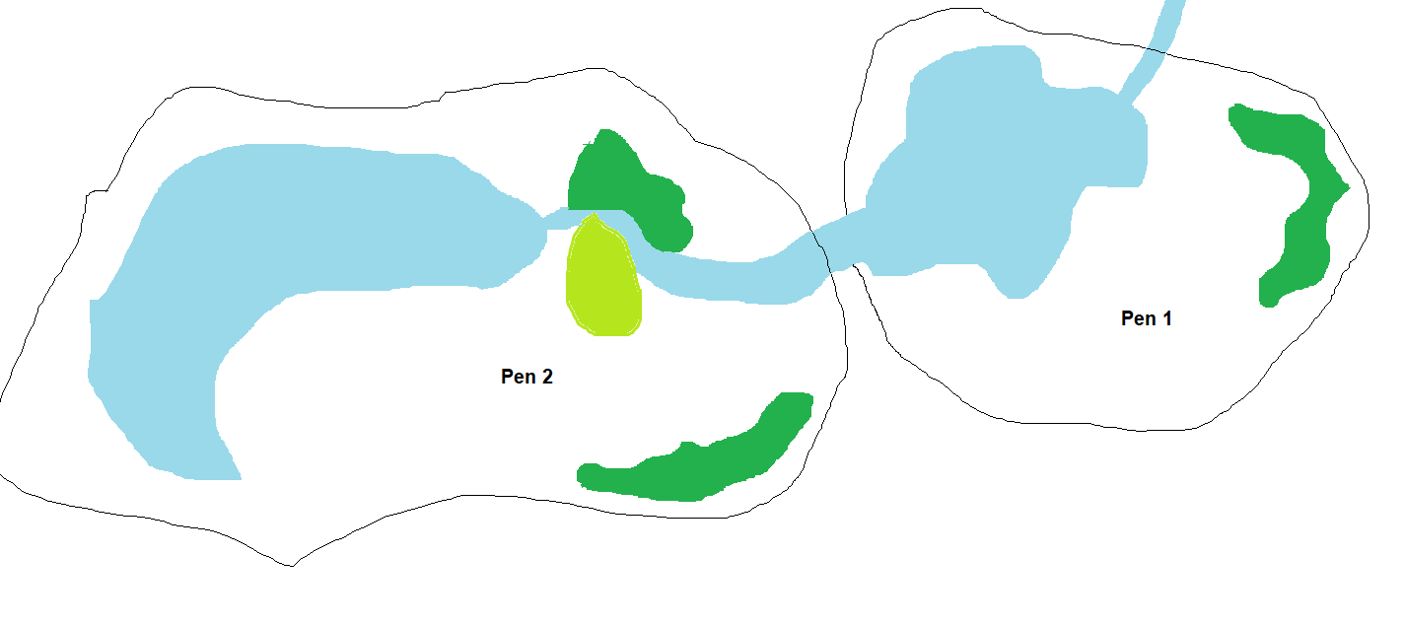

Case study 2: A rescue kennel with an outbreak of Bordetella bronchiseptica (kennel cough)
Key details:
- A vet has confirmed that a dog that was brought to the rescue centre two days earlier has Bordetella bronchiseptica (kennel cough).
- There are currently six other dogs housed in separate kennels at the centre.
- The infected dog (housed in Kennel 4) was socialised in the exercise paddock with the dog from Kennel 2 yesterday; it has had no contact with any other dogs from the facility.
- There is one isolation kennel, in a separate part of the building; it is only big enough to house one dog.
- The dogs from Kennels 2 and 4 are in Block 1, which is separated by a kitchen area from Block 2. There is also a dog in Kennel 3 and a further four dogs in Kennels 6, 7, 9 and 10.
- A basic plan of the facility can be seen below.
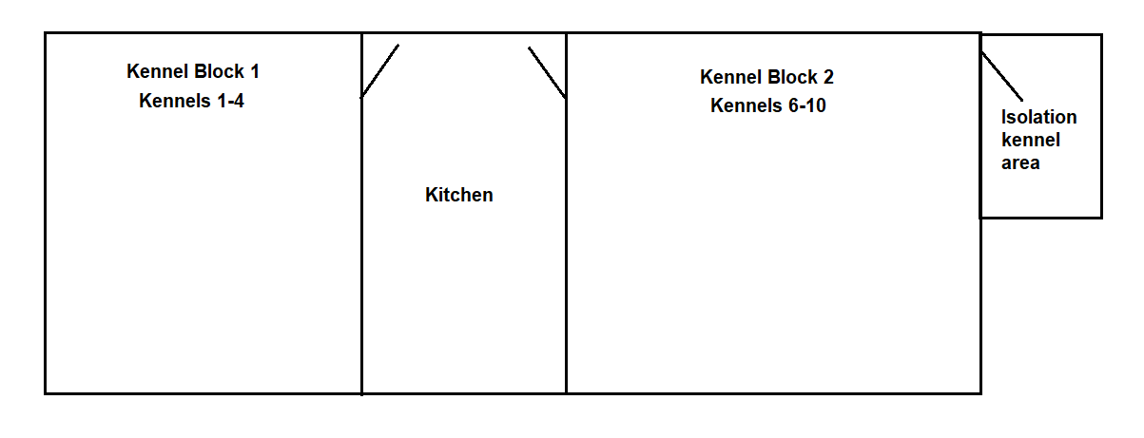
Task: Suggest the best temporary housing approach.

The following materials relate to lesson 4: Understanding and writing a biosecurity protocol.

Personal protective equipment
PPE | Purpose

Sample biosecurity protocol for children’s petting farm
Purpose:
The purpose of this biosecurity protocol is to minimise the risk of disease transmission between animals, visitors and staff on the children’s petting farm. This protocol ensures a safe and healthy environment for all visitors, particularly children, while protecting the welfare of the animals.

1. General guidelines
- Visitor education:
Clearly communicate the importance of hygiene and biosecurity to all visitors through signs, brochures and staff interactions. Ensure visitors know how to wash their hands, avoid touching faces and follow all safety instructions.
- Staff training:
All staff members must receive biosecurity training during induction and regularly thereafter. Training should cover hygiene practices, animal health monitoring, emergency procedures and visitor safety.

2. Animal health management
- Veterinary care:
Ensure that all animals are regularly checked by a licensed veterinarian, including before being introduced to the petting farm. Any sick animals should be immediately isolated, and proper treatment should be administered.
- Health monitoring:
Daily health checks for all animals should be conducted, and any signs of illness should be recorded and reported to the veterinarian. Symptoms to look for include lethargy, changes in eating habits, unusual discharges or visible wounds.
- Quarantine of new animals:
New animals should be quarantined before being allowed to interact with other animals on the farm to monitor for signs of contagious diseases.

3. Visitor management
- Visitor entry protocol:
Visitors should be required to wash their hands upon entry to the petting farm and after each interaction with animals. Hand-sanitising stations should be available throughout the farm, particularly near animal areas.

- Age restrictions:
Children under three years of age should not be allowed to touch certain high-risk animals unless supervised by an adult, as they are more susceptible to zoonotic diseases.
- Supervision requirements:
Children must be accompanied by an adult at all times. Ensure that staff or volunteers monitor animal handling to ensure proper hygiene and that no one feeds or handles animals improperly.

4. Animal interaction procedures
- Animal handling:
Only designated and trained staff or volunteers should handle sick or injured animals. Visitors may be allowed to pet or feed animals under supervision. Each animal should have clear signage to indicate whether they are safe for interaction.
- Feeding guidelines:
Visitors should be provided with animal-safe food only, and they should be instructed to feed the animals directly from provided containers. Visitors should not bring outside food or treats into the animal areas.
- Cleaning and disinfection:
High-touch surfaces, including animal pens, feeding stations and gates, should be regularly cleaned and disinfected throughout the day. Areas where children and animals interact should be sanitised between visitor groups.

5. Hygiene protocols
- Handwashing stations:
Handwashing stations with soap, water and paper towels should be placed at multiple points around the farm, particularly near animal enclosures, feeding areas and restrooms.
- Staff hygiene:
Staff should wash their hands between shifts and whenever handling animals. They should wear gloves when handling animals that are sick or during any cleaning procedures. Disposable gloves should be discarded after use, and staff should wash their hands immediately.
- Protective equipment:
Depending on the type of animals, staff may be required to wear additional protective equipment such as masks, gloves and aprons.

6. Farm hygiene
- Facility cleaning:
The farm should be thoroughly cleaned and disinfected at least once a day, focusing on high-risk areas such as animal pens, barns and restrooms. Floors, feeding stations, and petting areas should be sanitised regularly.
- Animal waste removal:
Animal waste should be removed promptly and disposed of in a safe manner to prevent contamination of surfaces. Special attention should be given to cleaning areas where children might be in direct contact with animals.
- Waste disposal:
All waste, including animal bedding and waste, should be disposed of in a manner that prevents exposure to other animals or visitors. Bins should be closed and emptied regularly.

7. Disease outbreak response
- Disease detection and reporting:
Any signs of illness in animals or staff should be reported immediately. If an outbreak occurs, the petting farm may need to close temporarily, and animals that are symptomatic should be isolated.
- Emergency protocols:
In the case of a serious disease outbreak (e.g. avian influenza, salmonella), the petting farm should have an emergency response plan in place that includes notifying health authorities.

8. Visitor signage and communication
- Clear signage:
Signs should be displayed throughout the farm detailing hygiene protocols, animal handling rules and restricted areas. Signs should also provide information on the symptoms of common zoonotic diseases (e.g. E. coli, salmonella).
- Visitor consent form:
Upon entry, all visitors should sign a consent form that includes a disclaimer about the potential risks of interacting with animals and acknowledges the biosecurity measures in place.

9. Record keeping and audits
- Health and hygiene records:
All animal health checks, visitor interactions and cleaning schedules should be logged. Regular audits should be conducted to ensure biosecurity measures are being adhered to.
- Visitor logs:
Maintain records of visitors to ensure that any potential exposure to disease can be traced in the event of an outbreak.

10. Regular review and updates
- Protocol review:
This biosecurity protocol should be reviewed regularly or as required. Updates should be made to address new risks and improve practices.

Conclusion:
This biosecurity protocol is designed to protect both visitors and animals at the petting farm. Strict adherence to these procedures will help prevent the spread of zoonotic diseases and ensure a fun and safe experience for all involved.

Transcript of professional and business writing tips video
Business writing is any written communication used in a professional setting, including emails, memos and reports. It’s direct, clear and designed to be read easily, and with practice, you can become an effective business writer. So whenever you’re writing a business document, get to the point quickly. Tell your readers what they need to know up front so they don’t have to hunt for it. Make every sentence short and direct while keeping your paragraphs brief. Doing this will add focus while making your document easy to read and remember.
Most business writing needs a call to action, which is information that instructs and encourages a response from your readers. It lets them know what they should do, where to go and so on. In addition to being professional, keep your writing polite. Consider using a brief greeting or conclusion and remember that offering courtesies like ‘please’ and ‘thank you’ go a long way. Revision is a key part of good writing, so after you finish your first draft, read it over and figure out what works and what doesn’t. Clarify sentences, simplify word choices and organise the structure until everything flows in a logical order. As part of your revision process, try reading your work aloud, or ask someone to give you feedback. Both of these methods can help you discover new perspectives and ideas. With so much to read and rewrite, don’t be surprised if it takes a few revisions before your document is polished and ready to go. Remember, business writing is a skill that takes a lot of practice to develop, but as you improve, you will possess an incredibly valuable job skill.

The following materials relate to lesson 5: Apply animal handling and capture techniques.
No additional materials are required for this lesson.

The following materials relate to lesson 6: Identification, causes and prevention of stress in animals.

Graph example 1
Jacobson, S.L., Ross, S.R. & Bloomsmith, M.A., 2016. ‘Characterizing abnormal behaviour in a large population of zoo-housed chimpanzees: prevalence and potential influencing factors.’ Peer J, 4, e2225. Available at: https://doi.org/10.7717/peerj.2225 [Accessed 8 May 2025].
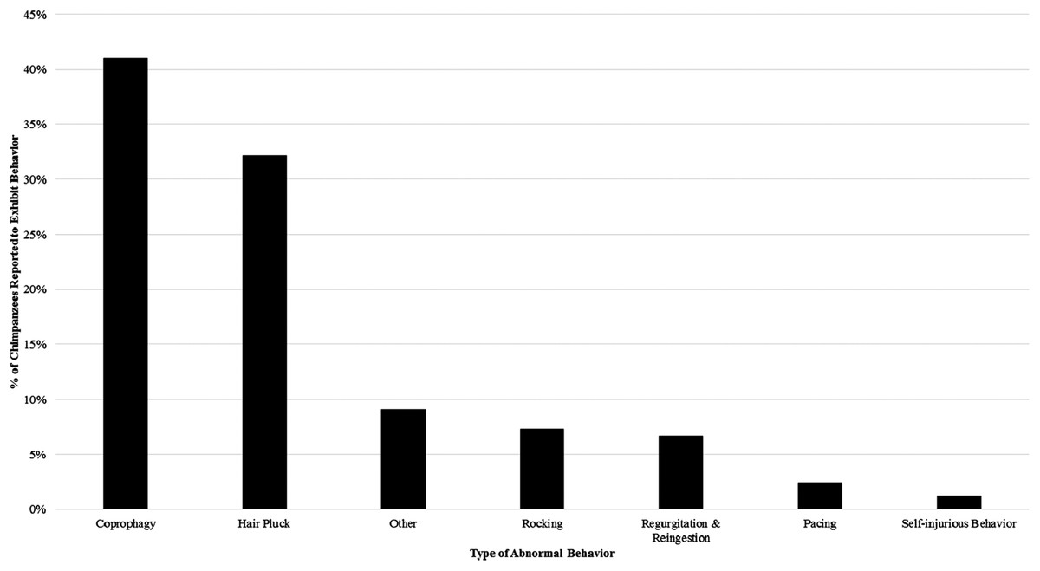
Figure 1: The percentage of the study sample reported to engage in each category of abnormal behaviour at least once from 2011 to 2013.
Summarise what the graph shows.

Graph example 2
Mason, G., Clubb, R., Latham, N. & Vickery, S. (2007) ‘Why and how should we use environmental enrichment to tackle stereotypic behaviour?’, Applied Animal Behaviour Science, 102(3–4), pp. 163–188.

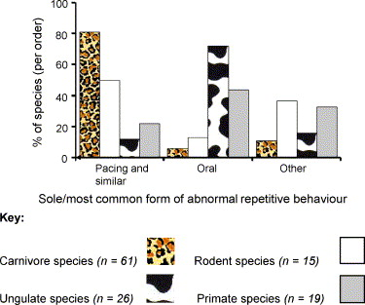

Summarise what the graph shows

Graph example 3
Abdul-Mawah, S.S., Chor-Wai, L., Jasnie, F., Norma-Rashid, Y. and Ramli, R. (2022) ‘Effects of environmental enrichment on behaviours and faecal glucocorticoid levels in captive sun bear (Helarctos malayanus)’

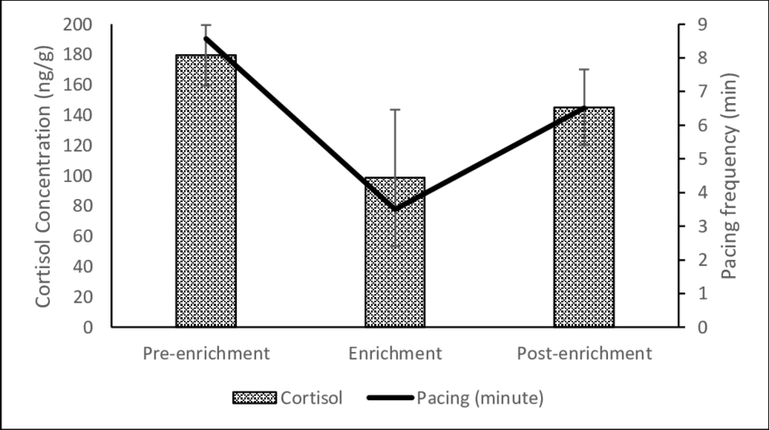
Summarise what the graph shows.

Graph example 4
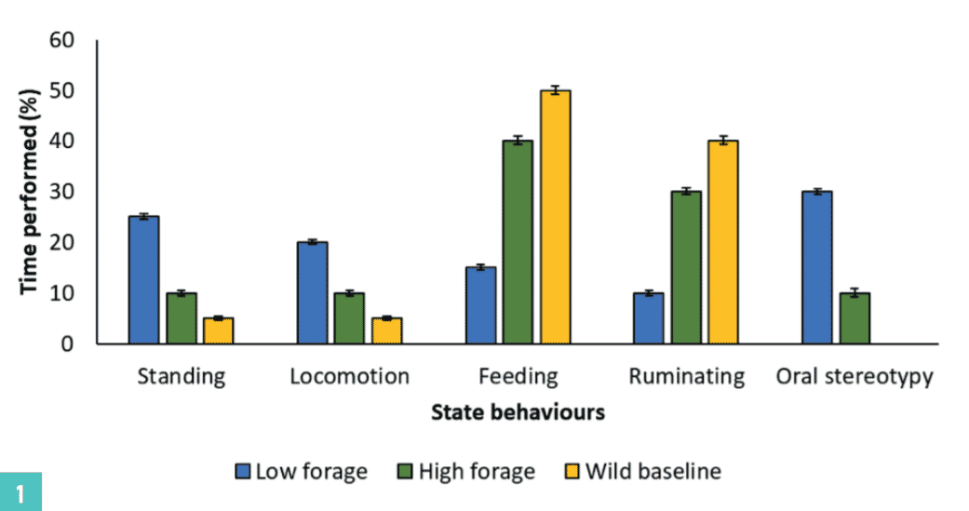

FIGURE (1) An example with fictitious behavioural data showing the mean activity budget of cows fed on a low forage-high concentrate diet (blue bars), cows fed on a high forage-low concentrate diet (green bars) and baseline for wild buffalo (yellow bars)
Summarise what the graph shows.

Graph example 5
Fureix, C., Benhajali, H., Henry, S. et al. (2013) ‘Plasma cortisol and faecal cortisol metabolites concentrations in stereotypic and non-stereotypic horses: do stereotypic horses cope better with poor environmental conditions?’, BMC Veterinary Research, 9(3), p.3. doi: 10.1186/1746-6148-9-3.
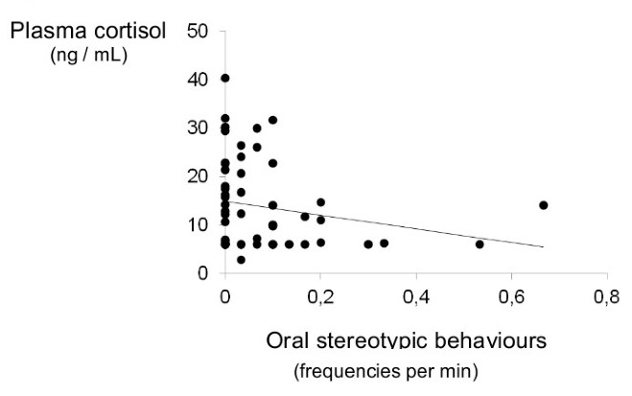
Summarise what the graph shows.

Species and enrichment cards
Cat | Sensory
Dog | Feeding
Rabbit | Cognitive
Goat | Physical
Tortoise | Sensory
Guinea pig | Feeding
Chicken | Cognitive
Snake | Physical

Transcript of the animal enrichment video
0:36
Good, Ozzy, good.
0:40
Put it up here, Oz.
0:41
Enrichment, in its most basic sense, is simply improving, enhancing, enriching the animal’s life.
0:48
And you hear it called animal enrichment, environmental enrichment, behavioural enrichment, it’s all the same.
0:53
It’s all looking for opportunities to improve the animal’s wellbeing by adding elements to its environment.
1:04
Basically, environmental enrichment is all about providing for the psychological wellbeing of the animals in the collection.
1:10
You know, we cater for their physical wellbeing, we have great veterinary care, we treat their diseases.
1:16
But animals need more than that.
1:17
They need to be psychologically healthy just like humans.
1:20
And different animals need different things.
1:22
And we use environmental enrichment as a way of addressing those needs by changing the environment to satisfy those psychological needs.
1:33
What we try to do is understand what it is about the animal’s environment and the animal’s experiences that are critically important in terms of which species and which individual animal we’re talking about.
1:44
And then we look for ways to try to reintroduce those critical elements and give animals opportunities to do the things that they’re supposed to do.
1:51
For example, for a river otter, we can give them live fish and actually allow them to have that predatory experience.
1:57
But for other larger carnivores, there are ethical and logistical issues about giving them live food.
2:03
So what we want to do is understand what are the critical elements of the experience of being a predator, and how can we reintroduce those opportunities?
2:10
So we think about how do they find their food?
2:13
How do they stock and kill, dismember and drag away the food item that they’ve caught?
2:18
And so we can actually recreate those experiences, even if we might not be doing it in the exact way they would experience it in the wild.
2:29
Polar bears are extremely intelligent, curious animals.
2:34
They spend a lot of time investigating their environment in the wild so they can find seals.
2:38
We can provide things to put in their zoo environment that make it more interesting for them.
2:42
And one obvious example is giving them piles of ice or snow, which, believe it or not, polar bears seem to like a lot, especially if there’s pieces of food hidden in it.
2:53
We also give them ice blocks with a number of different sorts of food treats hidden in them.
2:56
And that does a couple of things.
2:58
It provides them with their food, but it provides it in a more challenging way because they have to break into the ice blocks and they never know quite what’s in the ice blocks and they have to explore and search around the exhibits to get it.
3:08
So it just makes things a little more interesting and requires a little bit more from the polar bears than a more traditional way of just putting their food on the floor in front of them.
3:17
We also give polar bears plastic toys.
3:20
And actually, polar bears are very playful and they will make up games to play with plastic toys.
3:24
Now, you might not think that’s very natural, and that’s true, but a natural ability or natural characteristic of polar bears is to be very curious and to explore and manipulate their environment.
3:33
So giving them an artificial plastic toy does actually satisfy that need in polar bears.
3:38
And people have seen polar bears playing with plastic toys in the wild.
3:51
So welcome to, for many of you, your first enrichment activity here at the zoo.
3:57
And one of the things we do for our animals every day is providing with enrichment.
4:02
And the whole idea of enrichment is to make the animals think.
4:06
One part of enrichment is what we call functional naturalism.
4:09
It means that we use something that doesn’t look natural, but it has the same function.
4:15
The Volunteer Enrichment Committee formed because it was a concern.
4:20
There wasn’t a mechanism to help the keepers with providing enrichment for the animals.
4:24
It’s something they do every day, but sometimes they don’t have time to make the big-ticket items.
4:29
So we gathered together a group of, at that time, about 20 people and it’s grown to over 100 people.
4:35
And our purpose is to give the keepers whatever help they need to provide enrichment for the animals, something that may change the animal’s day, change something in their exhibit, give them a chance to do something they might do out in the wild just to change your lives.
4:52
So we may do something as small as make ice treats for some of the animals or gather wild edible flowers and herbs for them to eat, or we’ve done bigger things.
5:05
So whatever the keepers would like in terms of enrichment, we help with.
5:14
The Volunteer Enrichment Team is a group of volunteers who are committed to this idea of animal enrichment.
5:19
They work with us to understand what it is we’re trying to accomplish for the animals.
5:23
They undertake projects that are a little more complex or difficult than we would necessarily have time or ability to do. Some of the things that they’ve been able to do for us—
5:31
—simple things like making piñatas and complex ice treats to offer to the animals, but some really innovative things too.
5:37
We’ve done Polar Bear Snow Day, where they actually go up to an ice rink with a pickup truck and they pick up all the Zamboni shavings and bring them up to the zoo and cart them wheelbarrow by wheelbarrow into the exhibit so the animals get an opportunity to be on snow.
5:49
We did Polar Bear Snow Day in July.
5:51
It was a big hit with the public and it was really cool to see polar bears being polar bears.
5:56
We’re going to do it the easy way.
5:59
The Volunteer Enrichment Team sometimes takes enrichment a step further.
6:03
One thing that the team has done is to create a paper mâché deer for the tigers – life-size, about four feet tall.
6:12
The first time we put one of these deer in there, the female tiger actually attacked at first, brought it down, and then the male came in, they tore it apart.
6:21
They rolled it around, took turns pulling at it as they would do out in the wild with a kill, provide a lot of exercise for the animals because they did chase each other around, got into a little arguments once in a while, and then the other one would sneak in and take a haunch of it and go across the exhibit.
6:43
The Oregon Zoo has a very prominent history in terms of environmental enrichment.
6:47
Hal Markowitz is often thought to be the father of environmental enrichment, the guy who first really brought it to prominence.
6:52
He was at the Oregon Zoo in the 80s and we have continued that history of doing research on environmental enrichment and advocating for more environmental enrichment in the zoo community.
7:15
What we’re hoping for the future of enrichment at the Oregon Zoo is to do more of what we’re doing now and to do it better, and to do it more efficiently, and to plan environmental enrichment into all our new exhibits.
7:26
It’s a constantly moving goal post.
7:28
It’s really only limited by the creativity and imagination of the keepers that are doing it.
7:32
And if we do our jobs right with respect to environmental enrichment, we may find that we don’t need to use the term in the future.
7:39
It’ll just be good animal care.

The following materials relate to lesson 7: Animal welfare.
No additional materials are required for this lesson.

The following materials relate to lesson 8: Building materials and enclosure design.

Building materials handout
Building material | Pros | Cons
Wood
Metal
Mesh
Glass
Acrylic
UPVC
Concrete

The following materials relate to lesson 9: Design an effective enclosure and rationale around a given brief.

Design brief
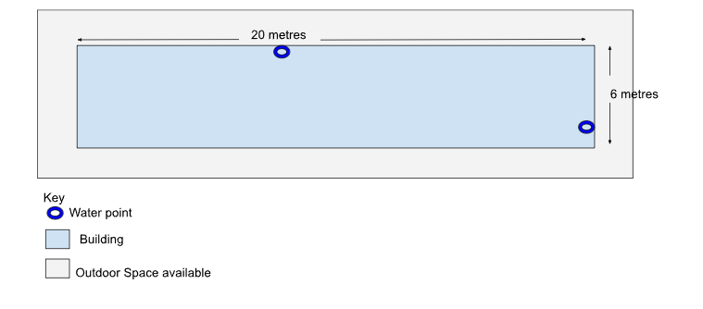
The Animal Centre where you work has had a new building built. At the moment, it has no design plans, with just two locations identified where water is accessible.
Design the above areas on flipchart paper, taking into account what you know about stress, normal and abnormal behaviour and the five needs. Your design will need to house all the following:
- four groups of rabbits (three pairs and a group of four)
- four groups of guinea pigs (four groups of four)
- one group of ferrets (10 ferrets).
You should consider:
- a clear pathway where people can access the animals
- an area for food storage, preparation and water
- identifying building materials
- electrical outlets (including lighting).
Your diagram does not have to be to scale but does need to include dimensions of enclosures within the building.
When designing your building, you should plan for internal and external doors, windows and internal walls and this will be built according to your specifications.
You will need to add annotations to explain and justify all the decisions your group has made.

Peer review form
Name(s) of designer(s):

Evaluator’s name:

Criteria | Strengths  (What is good?) | Areas for improvement  (What needs improving? How could this be improved?)
Animal welfare
Is the animals’ welfare being considered?
Do the enclosures meet the five needs?
Does the design aim to prevent stress?
Suitability
Does the design meet the needs of the specific animal species?
Is there reference to minimum housing dimensions and relevant husbandry guidelines?
Does the design effectively accommodate biosecurity measures?
Access and usability
Is the design appropriate for its intended use?
Is human access designed appropriately, allowing for easy working conditions?
Does the design allow for safe working around the animals that minimises stress and allows easy capture and working with the animals?
Feasibility
Could the design realistically be created?
Are the proposed materials readily accessible and reasonably affordable?
Does the design and material choice allow for good biosecurity?
Is good health maximised by the design chosen?
Building materials
Are suitable materials being used that prevent disease spread?
Do the materials maximise animal welfare?

The following materials relate to lesson 10: Evaluation of designs and peer review.
No additional materials are required for this lesson.


I
FUNDED BY
PRODUCED BY

This programme is funded by the Department for Education
WCG has produced this resource on behalf of the Education and Training Foundation

