
SUPPORT HOLISTIC DELIVERY OF CORE CONTENT AND OCCUPATIONAL SPECIALISM CONTENT
ET-FOUNDATION.CO.UK
T LEVEL IN DESIGN, SURVEYING AND PLANNING FOR CONSTRUCTION

SECTION 1: FRAMEWORK FOR LEARNING
The Framework for Learning sets out one approach to scaffolding and sequencing a series of lessons to support holistic delivery of Core Content and Occupational Specialism content.
Sequencing and scaffolding
The Framework for Learning (FfL) embeds core skills and knowledge from the specification for the T Level Technical Qualification in Design, surveying and planning for construction. The teaching and learning is intended to support 20 hours of holistic delivery of some of the Core Content from this T Level and some of Performance Outcome 2: Analyse the built environment.
The FfL simulates industry practices and processes and its stages can be applied to a variety of given project scenarios and briefs, although those suggested here focus on proposing sustainable retrofit design solutions to a heritage building. To do this, a case study (Wish Hill) is used throughout the FfL and learners are given regular opportunities to apply their learning from this example to other, shorter case studies.
The teaching and learning has been sequenced so that learners will develop the following knowledge and skills from the core of the T Level:
- Building fabric and insulation improvements (lesson 2)
- Window and door energy efficiency upgrades (lesson 3)
- Heating and renewable energy options (lesson 4)
- Ventilation and moisture control (lesson 6)
- Sustainable water and drainage solutions (lesson 7)
- Planning laws and heritage constraints (lesson 8).
In doing so, learners will gain insight into real-world retrofitting challenges in historic buildings while developing skills in critical thinking, problem-solving and professional report writing.
The FfL concludes with a written report, where students will be given the opportunity to apply the core knowledge and skills learnt. Through this report, they will make evidence-based recommendations for sustainable design solutions while respecting a building’s historic character.
The teaching and learning sequence has also been organised to plan for the underpinning English skills that learners will need to develop to produce this written report.
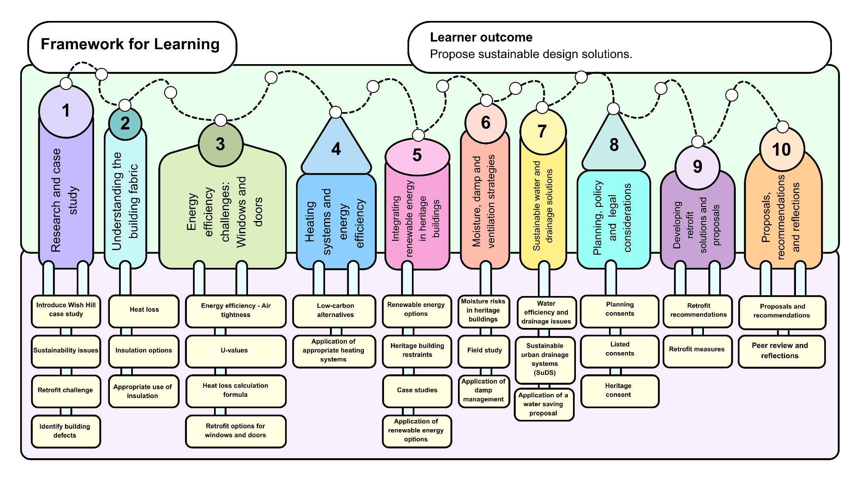

SECTION 2: LESSON PLANS
This section includes 10 lesson plans. The lesson plans follow the FfL. The lesson plans include the:
- lesson title
- targeted specification content coverage
- lesson number in the sequence
- total amount of time required to deliver the lesson
- teacher and learner activities to be undertaken throughout the lesson
- resources needed to deliver the lesson (see Note below)
- details of how the lesson supports the development of English, maths and digital skills (where appropriate)
- details of how the lesson can be adapted to meet learners’ specific needs
- next steps in learning such as homework activities and links to the next lesson.
Note:
There is an assumption that the learning environment will include the following:
- whiteboard/smartboard or similar
- materials to take notes, e.g. pens, paper, audio recorder, digital device and software
- equipment to present a slide deck and video, e.g. projector, smartboard
- digital devices (e.g. laptop, tablet) for all learners
- internet access
- learner access to word-processing, spreadsheet and presentation software

Lesson 1
Title: Research and case study
Targeted content reference:
Core Content
10.2 Students must understand the impact of sustainable solutions on social, environmental, economic and human factors, and be able to apply sustainable solutions for design, surveying and planning of construction.
Occupational Specialism
Performance Outcome 2: Analyse the built environment:
S2.2 Analyse information available to determine requirements of the task.
K2.5 Students will understand how and why sustainability seeks to balance environmental and social objectives and the need for an ethical approach to the built environment.
S2.3 Interpret information and data, including from visual and other sources.
Lesson sequence number: 1
Timing: 2 hours
Prior learning: None
Timing | Teacher activity | Learner activity | Support materials
20 minutes | Explain the importance of sustainable retrofitting in construction. | Listen and engage in discussion on sustainable retrofitting. | Slide deck  Whiteboard/flipchart  Greenleaf Road retrofit case study video  Wish Hill interactive tour  Wish Hill case study (Learners will each need a hard copy of this document as they will be required to annotate and highlight sections as they go through the lesson sequence)
20 minutes | Define key concepts: sustainability, retrofit, heritage conservation. | Take notes and ask questions.
20 minutes | Provide an overview of the lesson sequence and explain it will end in a final written report.
20 minutes | Show the Greenleaf Road retrofit case study video on retrofitting historic buildings. | Watch the Greenleaf Road retrofit case study video and discuss key takeaways.
20 minutes | Introduce the Wish Hill case study, giving background on its history, construction and graded listing.
20 minutes | Show the Wish Hill interactive tour on screen and model its navigation. Ask targeted questions to check learners’ understanding. | Watch Wish Hill interactive tour on screen. Ask questions about the case study and respond to teacher questions.
30 minutes | Distribute and introduce the written version of the Wish Hill case study. | Read the Wish Hill case study document, underline key facts about the building and answer questions on the slides.
30 minutes | Instruct learners to form pairs and read through the Wish Hill case study document together and highlight key points and answer the questions on the slides. | Highlight major sustainability issues in the case study: walls, windows, heating, drainage.
 | Guide students through key building details (materials, condition, listing constraints). Note key points on whiteboard/flipchart. | Participate in discussion, asking questions where needed.
 | Facilitate a question-and-answer discussion to check understanding. | Ask and answer questions and discuss initial observations.
40 minutes | Introduce the guided group task (retrofit challenge). | Listen to teacher instruction on the retrofit challenge.
40 minutes | Split the class into small groups and assign each group a specific aspect of the building (e.g. walls, windows, heating). Circulate among groups and support learners to read and synthesise the various source documents accurately. Correct any misunderstandings. | Work in groups to analyse their assigned topic and summarise findings.
40 minutes | Ask groups to discuss and suggest initial improvement ideas.  Move around, providing guidance and prompting deeper discussion. | Brainstorm ideas for retrofitting solutions.  Prepare to share key findings with the class.
30 minutes | Explain what a problem statement is and why it is important. Explain problem statement writing guide from the slides (framework and examples). | Listen and ask questions to clarify understanding.
30 minutes | Instruct learners to create a problem statement in line with the framework. | Working individually, use the framework to write a 150–200-word problem statement.
30 minutes | While learners draft their reports, circulate and encourage learners to summarise key sustainability challenges, heritage constraints and initial solutions. | Draft their problem statement.
30 minutes | Ask learners to form original groups and share their problem statements with peers. Instruct learners to use the prompts on the slides for these peer reviews. | In original groups, conduct peer reviews of everyone’s problem statements and provide feedback.
30 minutes | Instruct learners to refine their problem statements considering their feedback from peers. | Refine their problem statements using the peer feedback.
Other:
English: Support learners to synthesise information from the source documents during the small-group activity by circulating the room and ensuring key points are identified.
Adaptation:
SEND: Use of dictation tools, such as Word dictation, for Greenleaf and Wish Hill case studies. If LSAs are available, they could also assist with support for reading. Learners could be given scaffolded note taking tools/frameworks such as the Cornell method, mind maps or spider diagrams to conduct the research activities. For visually impaired or dyslexic learners, provide the worksheet in an adapted font suitable for their individual needs.
Next steps in learning:
Lesson 2: Understanding the building fabric.

Lesson 2
Title: Understanding the building fabric
Targeted content reference:
Core Content
10.1 Students will understand the importance of sustainability when planning and delivering a construction project.
10.2 Students must understand the impact of sustainable solutions on social, environmental, economic and human factors, and be able to apply sustainable solutions for design, surveying and planning of construction.
Occupational Specialism
Performance Outcome 2: Analyse the built environment:
S2.2 Analyse information available to determine requirements of the task.
K5.2 Students will understand how and why sustainability seeks to balance environmental and social objectives and the need for an ethical approach to the built environment.
S2.3 Interpret information and data, including from visual and other sources. How sustainability is embedded into solutions.
Lesson sequence number: 2
Timing: 2 hours
Prior learning: Lesson 1.
Timing | Teacher activity | Learner activity | Support materials
20 minutes | Introduction to heat loss: explain how heat loss occurs through solid walls. Provide an overview of heat loss and its effects on building efficiency. | Listen and take notes. | Slide deck  Learner hard copies of the Wish Hill case study (from lesson 1)
20 minutes | Group discussion: why insulation is important and the challenges of retrofitting historic buildings. Guide the discussion with key prompts from the slides. | Participate, share thoughts and reflect on thermal efficiency versus heritage preservation.
20 minutes | Set up the group task: compare traditional insulation (fibreglass, rigid board) versus breathable alternatives (wood fibre, lime-based). | Work in small groups, researching and discussing different insulation options.
20 minutes | Take feedback from each group. | Present findings to the class.
20 minutes | Discuss the impact of heritage considerations on insulation choices. Provide context on how heritage constraints influence insulation decisions. | Listen and ask questions.
20 minutes | Lead a class discussion: why can’t we just add insulation everywhere?  Facilitate the discussion, introducing different perspectives on insulation and heritage. | Engage in the discussion, sharing views and reasoning.
20 minutes | Wrap up and support learners to summarise the day’s key points about insulation in heritage buildings. Model one example and then ask learners to summarise in a similar way. | Review the lesson and summarise key takeaways. Reflect on the key points learnt.
Other:
English: Model summarising information/ideas about insulation in heritage buildings during the lesson plenary.
Adaptation:
SEND: If LSAs are available, they could assist with support for reading the source materials. Learners could use note taking tools/frameworks such as Cornell method, mind maps, spider diagrams for taking notes at the start of the lesson (introduction to heat loss) and for making notes during the group task and class discussion.
Next steps in learning:
Lesson 3: Energy efficiency challenges: windows and doors.

Lesson 3
Title: Energy efficiency challenges: Windows and doors
Targeted content reference:
Core Content
10.1 Students will understand the importance of sustainability when planning and delivering a construction project.
10.2 Students must understand the impact of sustainable solutions on social, environmental, economic and human factors, and be able to apply sustainable solutions for design, surveying and planning of construction.
10.5 Students must understand the principles of heritage and conservation within a construction environment.
Occupational Specialism
Performance Outcome 2: Analyse the built environment:
S2.2 Analyse information available to determine requirements of the task.
K5.2 Students will understand how and why sustainability seeks to balance environmental and social objectives and the need for an ethical approach to the built environment.
S2.3 Interpret information and data, including from visual and other sources. How sustainability is embedded into solutions.
Lesson sequence number: 3
Timing: 2 hours
Prior learning: Lessons 1 and 2.
Timing | Teacher activity | Learner activity | Support materials
10 minutes | Introduce energy efficiency and air leakage in heritage windows. | Listen, take notes and ask questions. | Slide deck (including link to U-value building components)  Learner hard copies of the Wish Hill case study (from lesson 1)
15 minutes | Explain U-values and how windows contribute to heat loss. Use the U-value link from the slide to compare building components. | Listen, take notes and ask questions.
15 minutes | Lead a discussion about different glazing types and their impact on sustainability. | Contribute to the discussion.
15 minutes | Guide students to look at the sections of the Wish Hill case study which relate to window conditions. | Listen, take notes and ask questions.
15 minutes | Put learners into pairs to read and analyse the case study by highlighting window deterioration issues. | Read and analyse the case study, identifying window deterioration issues by highlighting the relevant sections of their hard copy of the case study and creating a bulleted summary of the window deterioration issues.
15 minutes | Lead a discussion about their summary findings and the process of creating summaries. | Contribute to the discussion and share ideas about window deterioration issues.
25 minutes | Introduce the heat loss calculation formula from the slides and demonstrate how to use it to make heat loss calculations. | Listen, take notes and ask questions.
25 minutes | Put learners into pairs and set the task (to calculate potential heat loss through existing windows).
25 minutes | Circulate among the pairs of learners and support their calculations, reiterating following the steps from the formula slide. | Work in pairs to apply formulas. If time, complete the extension task from the slide (comparing heat loss for different window types).
20 minutes | Introduce the questions from the slide around energy efficiency, heritage and repair and replacement. | Listen and ask questions.
20 minutes | Put learners back into their pairs. | Discuss the questions from the slide.
20 minutes | Lead a discussion and ask learners to feed back their ideas and responses to the questions. | Contribute to the discussion. Make notes of key points.
10 minutes | Introduce slides on retrofit options: secondary glazing versus slim profile double glazing. | Listen, take notes and ask questions.
20 minutes | Split the class into two teams ready for a debate on replacement versus refurbished windows. One team should argue for window replacement and the other for refurbishment. | Split the class into two teams ready for a debate on replacement versus refurbished windows. One team should argue for window replacement and the other for refurbishment.
20 minutes | Give learners a few minutes to prepare for the debate. | Prepare for the debate.
 | Lead the debate. | Participate in the debate.
5 minutes | Summarise key learning and explain next steps. Ask targeted questions to check learning. | Listen and respond to questions. Ask questions to clarify homework task.
5 minutes | Outline the homework. | Listen and ask questions.
Other:
English: Support and scaffold learners to summarise information by creating a bulleted summary of the window deterioration issues in the case study.
Maths: Instruct and support learners to follow and apply formulae by making heat loss calculations based on the case study.
Adaptation:
Extension: Use the heat loss formula to compare heat loss for different window types (see the link in the Support materials section).
Next steps in learning: Lesson 4: Heating systems and energy efficiency.

Lesson 4
Title: Heating systems and energy efficiency
Targeted content reference:
Core Content
10.8 Students must understand the advantages of alternative methods of energy production and the impact of energy use.
Occupational Specialism
Performance Outcome 2: Analyse the built environment:
S2.3 Interpret information and data, including from visual and other sources. How sustainability is embedded into solutions.
Lesson sequence number: 4
Timing: 2 hours
Prior learning: Lessons 1 to 3.
Timing | Teacher activity | Learner activity | Support materials
15 minutes | Introduce Wish Hill’s current heating system and inefficiencies. | Listen, take notes and ask questions. | Slide deck  Learner hard copies of the Wish Hill case study (from lesson 1)  Group task worksheet: Evaluating heating systems for Wish Hill  Video link for heat pumps  Video link for ground source heat pumps  Video link for infrared heaters  Video link for biomass boilers
25 minutes | Explain low-carbon alternatives: heat pumps, biomass and infrared heating. | Listen, take notes and ask questions.
25 minutes | Explain the paired task: discuss and compare heating technologies and feed back to the class. | Discuss in pairs and compare heating technologies.
25 minutes | Lead a feedback discussion. | Contribute to the discussion and feed back to the class.
40 minutes | Put learners into groups and introduce the research task about different heating systems and give access to the four video links. | Research and create a list of pros and cons for different heating systems. Complete the Group task worksheet: Evaluating heating systems for Wish Hill to show these.
40 minutes | Lead the groups to present their findings. | Present ideas and findings to the rest of the class. Listen to the contributions of other groups.
20 minutes | Lead a discussion about which heating system best suits Wish Hill. | Listen and contribute to the discussion, take notes and ask questions.
10 minutes | Summarise key learning and explain next steps. Ask reflective questions from the slide to check learning. | Listen and respond to questions.
10 minutes | Conduct a poll about heating system choices. | Contribute to the poll by raising hands.
10 minutes | Outline next steps and make links to key ideas around renewable energy. | Listen and ask questions.
Next steps in learning:
Lesson 5: Integrating renewable energy in heritage buildings.

Lesson 5
Title: Integrating renewable energy in heritage buildings
Targeted content reference:
Core Content
10.2 Students must understand the impact of sustainable solutions on social, environmental, economic and human factors, and be able to apply sustainable solutions for design, surveying and planning of construction.
Occupational Specialism
Performance Outcome 2: Analyse the built environment:
S2.2 Analyse information available to determine requirements of the task.
K5.2 Students will understand how and why sustainability seeks to balance environmental and social objectives and the need for an ethical approach to the built environment.
S2.3 Interpret information and data, including from visual and other sources. How sustainability is embedded into solutions.
Lesson sequence number: 5
Timing: 2 hours
Prior learning: Lessons 1 to 4.
Timing | Teacher activity | Learner activity | Support materials
15 minutes | Introduce renewable energy options for buildings. | Listen, take notes and ask questions. | Slide deck  Historic England website  Chester Cathedral case study  Kenwood House case study  Copper Bottom House case study  Renewable energies solutions worksheet  Energy system cost-benefit table worksheet  Learner hard copies of the Wish Hill case study (from lesson 1)
25 minutes | Explain planning restrictions for installing solar panels on listed buildings. | Listen and discuss the challenges Wish Hill might face when adopting renewables.
25 minutes | Introduce the Historic England website and the paired task. | Listen, take notes and ask questions.
25 minutes | Circulate among the pairs and ensure learners are on task and accessing the Historic England website. | Work in pairs to read through the Historic England website and draw out key points.
25 minutes | Lead a class discussion to draw out key points. | Contribute to class discussion and feed back key points.
20 minutes | Introduce the three (digital) case studies and model navigating through them with the class to explore renewable energy in historic buildings using real-world examples. | Listen, take notes and ask questions.
20 minutes | Split learners into small groups to analyse the case studies for key insights. | Analyse case studies, extract key insights and apply to the Wish Hill case study.
20 minutes | Lead a discussion to take feedback from each group. | Contribute to the discussion and feed back to the class.
20 minutes | Introduce the task to propose a renewable energy solution for Wish Hill. Explain the Renewable energies solutions worksheet. | Listen, take notes and ask questions.
20 minutes | Instruct learners to get back into their small groups to work on the task and worksheet. | Work in groups and complete the Renewable energies solutions worksheet.
20 minutes | Circulate among groups to support their discussion. | Discuss and propose a renewable energy solution for Wish Hill, justify choices and prepare to feed back.
10 minutes | Lead discussion: which renewable energy system is most suitable for Wish Hill? | Contribute to the discussion, exploring the pros and cons of different renewable energy systems.
20 minutes | Introduce the individual research task on cost-benefit analysis. | Listen and ask questions.
20 minutes | Circulate and support learners in the research and completion of the table on the Energy system cost-benefit table worksheet. | Work individually to use the Energy system cost-benefit table worksheet provided to review the energy solutions. Use the internet for research.
20 minutes | Instruct learners to pair with a peer and compare their findings. | Compare findings with peers.
10 minutes | Explore key takeaways through the discussion questions on the slide and summarise next steps. | Contribute to the discussion and offer key takeaways.
Adaptation:
SEND: For visually impaired or dyslexic learners, provide the worksheet in an adapted font suitable for their individual needs.
Next steps in learning:
Lesson 6: Moisture, damp and ventilation strategies.

Lesson 6
Title: Moisture, damp and ventilation strategies
Targeted content reference:
Core Content
10.2 Students must understand the impact of sustainable solutions on social, environmental, economic and human factors, and be able to apply sustainable solutions for design, surveying and planning of construction.
Occupational Specialism
Performance Outcome 2: Analyse the built environment:
S2.3 Interpret information and data, including from visual and other sources. How sustainability is embedded into solutions.
Lesson sequence number: 6
Timing: 2 hours
Prior learning: Lessons 1 to 5.
Timing | Teacher activity | Learner activity | Support materials
10 minutes | Introduce slides on understanding moisture risks in historic buildings. | Listen, take notes and ask questions. | Slide deck  Learner hard copies of the Wish Hill case study (from lesson 1)  Wish Hill interactive tour
10 minutes | Explain the task to explore the educational building they are in now. Show examples from slides of what they might look for.
30 minutes | Supervise learners by travelling around the building. | Work in pairs to explore the educational building for damp issues and take photographs using own devices.
30 minutes | Explain how to share photographs and model file sharing or other digital skills needed for doing so. | Share photographs by file sharing to the classroom smartboard or printing from devices and pinning to the wall.
25 minutes | Explain condensation and penetrating damp and how they can be managed in different buildings, showing examples from the slides. Draw in any relevant examples from the photographs learners have taken and shared. | Listen, take notes, ask questions and contribute findings from their own photographs.
10 minutes | Introduce why damp is a bigger issue in historic buildings. | Listen, take notes and ask questions.
25 minutes | Introduce paired task to revisit the Wish Hill case study and identify the different types of damp affecting Wish Hill. | Listen, take notes and ask questions.
25 minutes | Model the Wish Hill interactive tour and ensure learners understand how to use it to identify the information needed for the task. | Listen and ask questions.
25 minutes | Circulate among pairs and support the use of the interactive version of the case study. | In pairs, complete the task and get ready to feed back.
15 minutes | Lead a discussion, using the questions from the slide, about the types of damp and effective management of damp in older buildings. | Listen, take notes and respond to questions.
5 minutes | Summarise key points and outline next steps. | Listen, take notes and contribute to summary points.
Other:
Digital: Explain how to share photographs and model file sharing or other digital skills needed for doing so. Model the use of the interactive case study. During the learner tasks, support to help learners navigate the interactive case study.
Adaptation:
SEND: During the learner tasks, support visually impaired learners to use the audio prompts in the interactive case study.
Next steps in learning:
Lesson 7: Sustainable water and drainage solutions.

Lesson 7
Title: Sustainable water and drainage solutions
Targeted content reference:
Core Content
10.1 Students will understand the importance of sustainability when planning and delivering a construction project.
10.2 Students must understand the impact of sustainable solutions on social, environmental, economic and human factors, and be able to apply sustainable solutions for design, surveying and planning of construction.
Occupational Specialism
Performance Outcome 2: Analyse the built environment:
2.2 Analyse information available to determine requirements of the task.
K5.2 Students will understand how and why sustainability seeks to balance environmental and social objectives and the need for an ethical approach to the built environment.
S2.3 Interpret information and data, including from visual and other sources.
Lesson sequence number: 7
Timing: 2 hours
Prior learning: Lessons 1 to 6.
Timing | Teacher activity | Learner activity | Support materials
15 minutes | Explain importance of water efficiency in sustainable buildings. | Listen, take notes and ask questions. | Slide deck  Water management plan worksheet  ’Greening the grey’ (PDF download)
15 minutes | Guide learners through a review of the Wish Hill case study, identifying drainage issues and lack of water efficiency. Discuss the issues throughout. | Read along with the Wish Hill case study and contribute to the discussion by highlighting key issues.
15 minutes | Introduce sustainable urban drainage systems (SuDS), rainwater harvesting and greywater recycling. | Listen, take notes and ask questions.
15 minutes | Put learners into small groups and set up the group task. | In small groups, discuss how SUDS can improve drainage and fill in Water management plan worksheet.
15 minutes | Lead a discussion to gain feedback from the small groups. | Share ideas about SUDS with the whole class.
30 minutes | Introduce the task to propose a water saving strategy for Wish Hill. Go through the Water management plan worksheet and explain how they will be using it. | Listen, take notes and ask questions.
30 minutes | Circulate among pairs to support the activity. | Work in pairs to create a feasible water saving plan using the Water management plan worksheet (producing one completed copy per pair).
30 minutes | Collect worksheet (to review and give feedback). | Hand in completed worksheets.
30 minutes | Work through the ‘Greening the grey’ online document and highlight the various methods for retrofitting SUDs which appear in the different case studies. | Continue to work in pairs. Listen, take notes and ask and answer questions.
30 minutes | Lead a discussion on how we can improve drainage without major structural changes. | Join in the discussion and debate the pros and cons of different strategies to improve drainage without major structural changes.
15 minutes | Introduce the next lesson. | Listen and ask questions.
Adaptation:
SEND: For visually impaired or dyslexic learners, provide the worksheet in an adapted font and/or colour suitable for their individual needs.
Next steps in learning:
Lesson 8: Planning, policy and legal considerations.

Lesson 8
Title: Planning, policy and legal considerations
Targeted content reference:
Core Content
10.5 Students must understand the principles of heritage and conservation within a construction environment.
Occupational Specialism
S2.2 Analyse information available to determine requirements of the task.
K5.2 Students will understand how and why sustainability seeks to balance environmental and social objectives and the need for an ethical approach to the built environment.
Lesson sequence number: 8
Timing: 2 hours
Prior learning: Lessons 1 to 7. The ability to use and create PowerPoint slides (or similar software).
Timing | Teacher activity | Learner activity | Support materials
10 minutes | Starter task: recap quiz on lesson 7. | Complete quiz and check answers against the answer sheet. | Slide deck  Lesson 7 recap quiz  Lesson 7 recap quiz answer sheet  Historic England listed building consent webpage  Link to Historic England listed building consent advice note 16 (PDF download)  Video link: What is listed building consent?  Listed consent flashcards  Listed consent flashcards answer sheet  Peer feedback stars and wishes form  ‘Retrofitting your home’ report
20 minutes | Introduce the lesson and look at planning constraints for listed buildings. Start with the visual of a famous listed building from the slides. Then refer to the listed building consent webpage on the Historic England website and the PDF of the Historic England listed building consent advice note 16, explaining what listed building consent is, and the restrictions, government grants and incentives. | Listen, ask questions and make notes.
20 minutes | Play video: What is listed building consent? Ask targeted questions to draw out key points. | Watch the video. Answer targeted questions.
15 minutes | Introduce the Listed consent flashcard activity. | Listen and ask questions. Get into groups as directed.
15 minutes | Assist groups to sort the flashcards into two categories: those that require listed building consent and those that do not. | Sort the flashcards into two categories: those that require listed building consent and those that do not.
15 minutes | Ask learners to swap tables with another group and peer assess their responses to the flashcard activity (using the correct answers from the Listed content flashcards answer sheet). Identify, explain and correct any misconceptions or errors. | Peer assess another group’s responses to the flashcard activity (using the correct answers from the slide).
15 minutes | Deliver slides on key steps to take for planning applications for retrofit, listed and heritage buildings. | Listen, ask questions and make notes.
30 minutes | Introduce the group activity to work in small groups to create a short PowerPoint (or similar) presentation on the process of applying for listed planning consent. | Listen and ask any questions needed to clarify the task.
30 minutes | Travel the room and support learners. | Work in small groups of three or four to create a short PowerPoint (or similar) presentation on the process of applying for listed planning consent, using the framework on the slides.
30 minutes | Manage the group presentations by asking each group to present. Follow this with a few minutes for the other groups to peer assess using the Peer feedback stars and wishes form. | Give a group presentation. Listen to the presentations of other groups. Complete one Peer feedback stars and wishes form (as a group) for each presentation observed.
Adaptation:
SEND: Use the closed caption facility on PowerPoint slides for visually impaired learners during learner presentations. Print the flashcards in an adapted font and/or colour suitable for their individual needs.
Next steps in learning:
Lesson 9: Developing retrofit solutions and proposals.
Homework: Read the ‘Retrofitting your home’ report and note down key points.

Lesson 9
Title: Developing retrofit solutions and proposals
Targeted content reference:
Core Content
10.2 Students must understand the impact of sustainable solutions on social, environmental, economic and human factors, and be able to apply sustainable solutions for design, surveying and planning of construction.
10.5 Students must understand the principles of heritage and conservation within a construction environment.
Occupational Specialism
S2.3 Interpret information and data, including from visual and other sources. How sustainability is embedded into solutions.
Lesson sequence number: 9
Timing: 2 hours
Prior learning: Lessons 1 to 8 (including the homework task from lesson 8).
Timing | Teacher activity | Learner activity | Support materials
10 minutes | Lead a quick multiple-choice quiz (from the slides) on the homework from the previous lesson to draw out key points about retrofitting a home. | Listen and answer quiz questions. | Slide deck  Retrofit proposal of recommendations and measures template  Retrofit measures sorting cards  Retrofit measures sorting cards answer sheet  Retrofitting your home report (from lesson 8)
20 minutes | Deliver slides on how to approach writing a retrofit recommendation and proposal (which they will be working on next lesson). Use the slides to demonstrate what a report might look like and highlight: features of layout, such as subheadings; typical content; typical subject specialist vocabulary. | Listen, make notes and ask questions.
20 minutes | Show examples of typical measures and cost diagrams. Draw out comparisons of low and deep options. | Listen, make notes and ask questions.
10 minutes | Introduce the Retrofit proposal of recommendations and measures template. Highlight the different sections of the template and discuss the content which might feature in each. Point out the key guidance. | Listen and ask questions to clarify the writing task.
30 minutes | Display on screen the ‘Retrofitting your home’ report (used in lesson 8 homework task). Go through and highlight the various case studies and explain the group task to explore and analyse how reports are written. | Listen and ask questions to clarify the group task.
30 minutes | Travel the room and ensure groups are on task and identifying the key features of written reports. | In groups, use questions from the slide to explore and analyse how reports are written.
30 minutes | Lead a discussion, using targeted questions, to take feedback from the groups and draw out the key features of written reports. | Listen, answer questions and contribute to the discussion.
30 minutes | Introduce Retrofit measures sorting task and instruct learners to get into pairs or small groups. Distribute sorting cards. | Listen and ask questions to clarify the task.
30 minutes | Circulate among groups and correct any misconceptions. | Work in pairs or small groups to sort the cards into low cost, shallow or deep measures for retrofit proposals.
15 minutes | Instruct pairs or small groups to join with another, compare responses to the sort card activity and then check against the Sort card activity answer sheet. | Listen to the task instructions.
15 minutes | Circulate to make sure learners are on task and to observe learner responses ready for summarising. | Join with another group, compare answers and peer assess using the Sort card activity answer sheet.
15 minutes | Draw activity to a close by summarising the features of the categories of low, shallow and deep measures for retrofit proposals. | Listen and ask questions.
5 minutes | Explain what they will be doing next lesson. | Listen and ask questions.
Other:
English: Develop learners’ report writing skills by using the slides to show them what a report might look like and highlight: features of layout such as subheadings; typical content; typical subject specialist vocabulary. Also, support learners in the group activity to explore and analyse how reports are written.
Next steps in learning:
Lesson 10: Report writing and reflections.

Lesson 10
Title: Proposals, recommendations and reflections
Targeted content reference:
Core Content
10.2 Students must understand the impact of sustainable solutions on social, environmental, economic and human factors, and be able to apply sustainable solutions for design, surveying and planning of construction.
10.5 Students must understand the principles of heritage and conservation within a construction environment.
Occupational Specialism
S2.3 Interpret information and data, including from visual and other sources. How sustainability is embedded into solutions
Lesson sequence number: 10
Timing: 2 hours
Prior learning: Lessons 1 to 9.
Timing | Teacher activity | Learner activity | Support materials
10 minutes | Recap on last week’s task looking at retrofit measures and recap the measures and answer sheet by asking targeted questions. | Listen, ask and respond to questions. | Slide deck  Retrofit proposal of recommendations and measures template (from lesson 9)  Sticky notes (3 different colours)
15 minutes | Show the Retrofit proposal of recommendations and measures template as a live document on screen (this could be reproduced as a Google document or in Canva, Teams, Miro or similar. The intention is to make this a live document which learners will shortly all be able to work on in real time.) Decide which case study to focus the report on (either by deciding before the lesson or in collaboration with the learners). Model completing sections 1 to 4 on screen, reminding learners of the pertinent facts regarding the chosen case study. | Listen, ask and respond to questions.
15 minutes | Divide learners into four groups. Instruct them to think about the issues identified in the chosen case study, making notes under the five headings shown on the slide. | Work in groups to generate ideas for the identified issues section of the report.
15 minutes | Take feedback from each of the groups regarding the issues identified in the chosen case study and act as a scribe for learners to complete section 5 together in the live document. | Feed back from group discussions and share the identified issues.
20 minutes | Instruct learners to get back into their groups and allocate each one a section of the report from sections 6 to 9. Ask them to work together to draft a response to their section and complete the section in the live document. | Work in groups to generate ideas for their allocated section of the report and then complete the section in the live document.
20 minutes | While the groups work, travel the room and support learners to write their allocated report sections, ensuring they show an understanding of the typical features (including typical sentences and words) of writing a report of this nature. This may also include stopping learners momentarily to draw whole class attention to commonly misspelt words (especially of key subject-specific vocabulary) as and when necessary.
30 minutes | Invite each group to talk through their completed section while displaying the live document on screen. Invite other learners to give constructive feedback and prompt any learning points and clear up any misconceptions. | Explain their section of the live document and respond to initial feedback and questions from peers.
5 minutes | Instruct learners to return to their groups and their section of the live document and make any amendments based on the peer and teacher feedback they have just received. | Return to the live document and make any necessary amendments based on the peer and teacher feedback received.
15 minutes | Instruct learners to return to their groups and think about section 10 of the Retrofit proposal of recommendations and measures template using the prompts from the slide. | Work in groups to generate ideas for section 10 of the report and then complete the section in the live document.
15 minutes | Take feedback from each of the groups regarding the summary and recommendations section of the report and act as a scribe for learners to complete section 10 together in the live document. | Join in the whole-class discussion to feed back ideas for section 10 and instruct the teacher as scribe.
10 minutes | Hand out three different-coloured sticky notes to each learner and ask them to self-reflect on the last 10 lessons, following the prompts on the slide. | Complete the self-reflection task using the sticky notes and prompts from the slide.
10 minutes | Draw learners together and discuss some of their feedback and reflections. Sum up by highlighting how they have used the learning from the previous lessons. | Share reflections and comments.
Other:
English: Support learners to write their allocated report sections.
Adaptation:
SEND: Learners with specific writing difficulties may need to use a laptop or assigned learning support assistant to dictate and produce their report.

SECTION 3: LESSON SUPPORT MATERIALS
This section includes the handouts, worksheets, digital links and case study materials referred to in the Support materials section of each lesson plan.

The following materials relate to lesson 1: Research and case study.

Wish Hill case study
A conditions survey of a listed property in Sussex
Created by Georgina McLeod (all photographs are the writer’s own and can be reproduced).
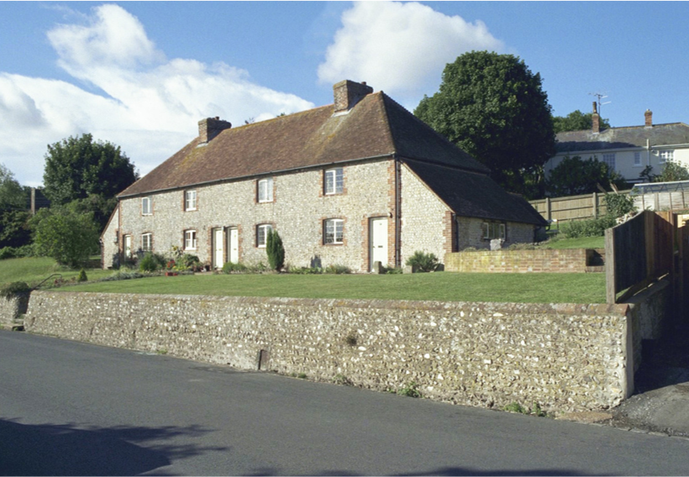McLeod, G (2024), Wish Hill Property
Building measured survey
1. General information
Survey date: May 2024
Building address: 91 Wish Hill, Eastbourne, BN20 9HQ
Wish Hill (West Side),
Willingdon
Nos. 91–97 (formerly Nos. 27–30)
Weather conditions on day of survey: sunny and clear
Building type (residential/commercial/industrial): residential
Year of construction: mid-19th century period (1830–1860)

2. Building description
Number of floors: 2
Total floor area: 62m²
Construction type (wood, concrete, steel, etc.): knapped flint solid walls
Description: End-terrace house, probably mid-C19 but typical of the district. Knapped flint, hipped tile roof. Two storeys, leaded windows, cambered arches, casements, rusticated red and black brick architraves. Rusticated brick quoins. Plain wooden doors cambered rusticated architraves. One-storey outbuilding to left.
Is the building listed and/or in a conservation area? Yes. Grade II listed and in a conservation area.
District: Eastbourne Borough Council
Recent planning applications: none listed
Recent building regulations applications: none listed
Tree preservation orders: none listed
EPC rating: exempt
Official list entry
Heritage category: listed building
Grade: II
List entry number: 1190664
Date first listed: 16-May-1971
List entry name: 91–97, WISH HILL
Statutory address 1: 91–97, WISH HILL
Details
This list entry was subject to a minor amendment on 04/03/2013
TQ 5802 9/93 1065
WISH HILL (West Side), WILLINGDON Nos. 91–97 (even)
(Formerly listed as Nos. 27–30 (consec) II
Terrace of four houses, probably mid-C19 but typical of the district. Knapped flint, hipped tile roof. Two storeys. Four windows, cambered arches, casements, rusticated red and black brick architraves. Rusticated brick quoins. Plain wooden doors cambered rusticated architraves. One-storey outbuilding to left and right.
Listing NGR: TQ5878802133
3. Exterior condition
3.1 Roof
Type of roof: timber pitched
Material: timber rafters and purlins with clay tiles
Insulation: fibreglass insulation
Condition: good
Photo reference: 31, 34, 35, 41, 42
Notes:
The original lath and plaster have been replaced with hardboard, and the loft insulation is incomplete and largely disturbed.
Most of the original rafters are intact, with some replacements in the outer regions of the roof. The original purlins are intact.
The roof has been insulated with fibreglass, but this has been disturbed and needs replacing.
The clay tiles have been replaced, and felt has been introduced, though the date of this change is unknown. There are no signs of leaks in the roof, and the chimney flashings are in good condition.
The main roof and the kitchen roof, both covered in clay tiles, are generally in excellent condition. The ridge tiles and hips also appear to be in very good shape. Drone footage reveals some lichen and moss growth, but there are no disruptions or defects in the tiles.
The rainwater goods, made of plastic, are mostly in good condition, although there is some cracking on the front elevation. The gutters need cleaning out, and on the rear elevation, it appears that rainfall has overflowed rather than properly discharging into the drain. The soffits are in good order, but the exposed rafter feet on the single-storey kitchen roof show signs of deterioration and need attention, as some sections are open to the elements.
3.2 Walls
Material: solid knapped flint and lime mortar. Cambered arches, rusticated red and black brick architraves and rusticated brick quoins. Brick plinth to rear elevation.
Insulation: none
Condition: fair
Signs of damage (cracks, dampness, etc.): deteriorated mortar and internal signs of dampness
Photo reference: 1, 2, 5, 6, 7, 8, 9, 15, 20, 39
Notes:
The traditional knapped flint walls, which exude an unmistakable rustic charm, have been patch-repaired in several places. Despite their inherent sturdiness, time has taken its toll on certain sections, where signs of wear are evident. The mortar joints, in particular, show signs of degradation and could benefit from repointing to restore both their aesthetic appeal and their structural integrity.
Area external walls: 59m²
Volume external walls: 18.5m³
Wall area North: (party wall) 29.5m²
Wall area East: 24.5m²
Wall area South: 10m²
Wall area West: 24.5m²
3.3 Windows and doors
Type: mix of leaded single-glazed timber frame casements and single-glazed timber frame windows
Material: timber
Condition: poor
Photo reference: 1, 2, 4, 5, 6, 8, 10, 11, 12, 13, 14, 15, 16, 17, 18, 19, 21, 22, 23, 24, 29, 30
Notes:
All the windows require repair or replacement in a like-for-like manner. The leaded windows are cracked in numerous places, with some areas haphazardly patched with tape. The timber frames have rotted and deteriorated to the extent that daylight is visible through several frame junctions.
Externally, the windows are in poor condition, showing significant rot and delaminated paint. Any putty that had been applied has shrunk, further compromising the integrity of the windows.
3.4 Foundations
Type: unknown
Visible issues (cracks, settling, etc.): n/a
Notes: n/a

4. Interior condition
4.1 Structural elements
Walls: solid
Floors: suspended timber floor in main dwelling and solid slab in single-storey part
Staircases: timber
Beams: timber
Notes: n/a
4.2 Electrical system
System: mains
Condition: fair
Compliance with standards: yes
Photo reference: 38
Notes: n/a
4.3 Plumbing system
System: gas boiler with radiators
Condition: good
Compliance with standards: yes
Photo reference: 36
Notes:
The boiler has recently been replaced while retaining the original wet system infrastructure. Most of the radiators appear to be older, except for the newly installed heated towel rails in the bathrooms. The original radiators lack thermostatic control valves. Hot water was successfully drawn from all taps on both the ground and first floors.
4.4 Waste
Type: mains sewage
Condition: good
Photo reference: n/a
Notes: n/a
4.5 Fire safety
Fire alarms: yes
Compliance with standards: no
Photo reference: n/a
Notes: n/a
5. Health and safety
Presence of hazardous materials (asbestos, lead paint, etc.): none visible
Ventilation: extractor bathroom
Photo reference: n/a
Notes: n/a
6. Site condition
6.1 Landscaping
Condition of grounds: fair
Drainage: manholes visible, mains sewage to street. Surface water discharge unknown.
Photo reference: n/a
Notes: n/a
6.2 Access and egress
Condition of driveways/walkways: fair
Accessibility: poor
Photo reference: n/a
Notes: no level access
6.3 Boundaries
Condition of fencing/walls: fair
Photo reference: n/a
Notes: n/a
7. Recommendations
Immediate repairs needed: windows to be replaced like for like.
Long-term maintenance suggestions:
Overview
This listed cottage, characterised by its knapped flint walls, has been well maintained in terms of its roof, which is in good condition. However, several issues with the walls, windows and internal dampness need urgent attention to preserve the structure’s integrity and heritage.
Walls
Re-pointing: The knapped flint walls have deteriorated over time and require careful re-pointing. Use a lime-based mortar suitable for historic buildings to ensure compatibility with the existing materials and to allow the walls to breathe. Engage a specialist experienced in working with heritage structures to maintain the aesthetic and structural integrity of the walls.
Windows
Replacement: The windows are in poor condition, with some leaded panes cracked and temporarily repaired with tape. Replace all windows on a like-for-like basis, preserving the historic character of the building. Ensure the new windows meet current energy efficiency standards while maintaining the traditional appearance.
Leaded windows: Special attention should be given to the leaded windows. Repair or replace these using traditional methods and materials to maintain their historical significance.
Leaded windows: Special attention should be given to the leaded windows. Repair or replace these using traditional methods and materials to maintain their historical significance.
Airtightness: Address the significant draughts and daylight visible through the window frames by ensuring the new windows are properly sealed and fitted. This will improve the energy efficiency and comfort of the dwelling.
General recommendations:
Regular maintenance: Establish a regular maintenance schedule to monitor the condition of the walls, windows and internal environment. This proactive approach will help prevent future deterioration.
Professional consultation: Engage conservation specialists and experienced contractors familiar with listed buildings to ensure all repairs and replacements comply with heritage preservation standards and local regulations.
Documentation: Document all repairs and replacements thoroughly, including photographs and detailed descriptions, to maintain a clear record for future reference and for compliance with heritage protection guidelines.
By addressing these issues promptly and sensitively, the dwelling’s structural integrity and historical value can be preserved for future generations.

Photos
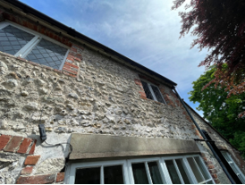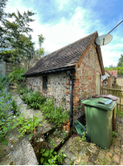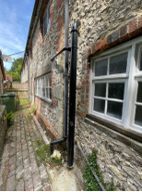
1 2 3

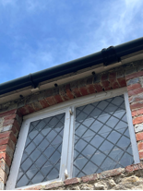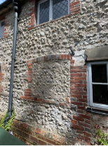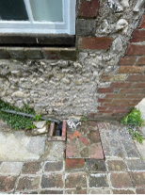
4 5 6

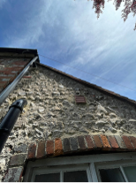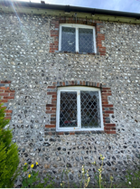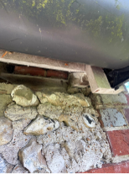
7 8 9
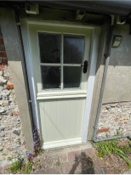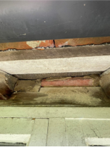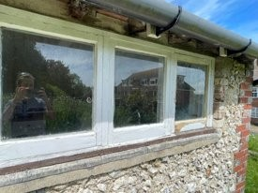
10 11 12

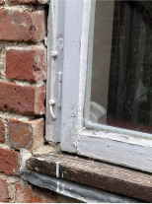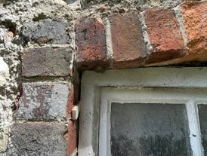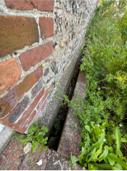
13 14 15

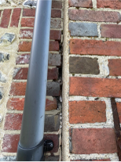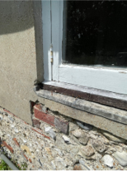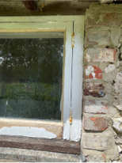
16 17 18
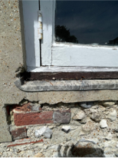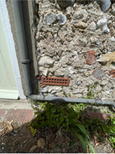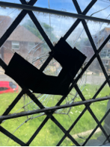
19 20 21

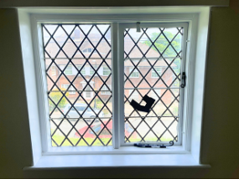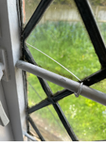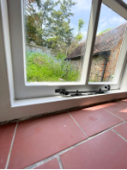
22 23 24

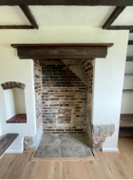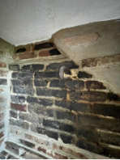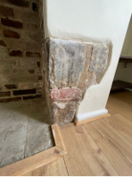
25 26 27
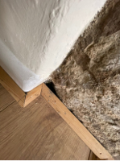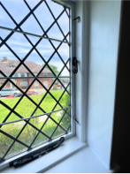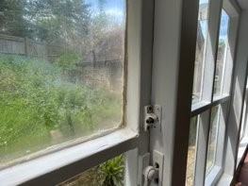
28 29 30

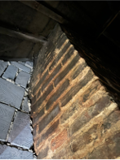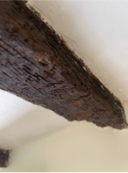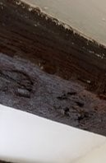
31 32 33

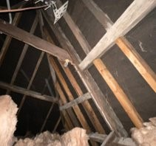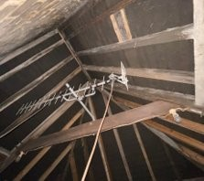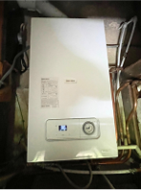
34 35 36

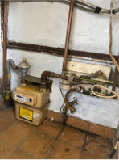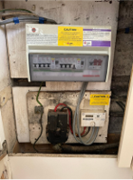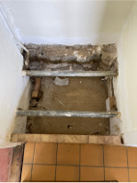
37 38 39

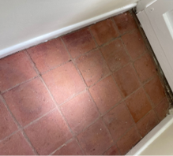
40
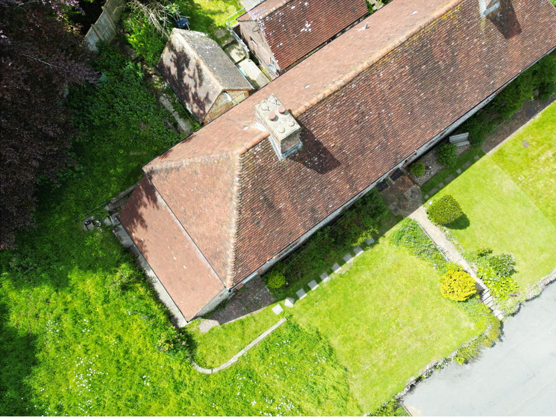41
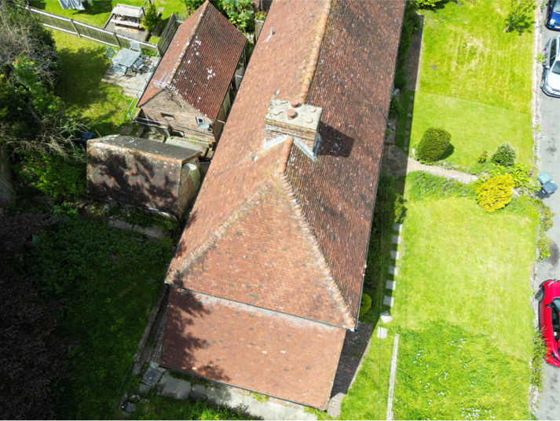42
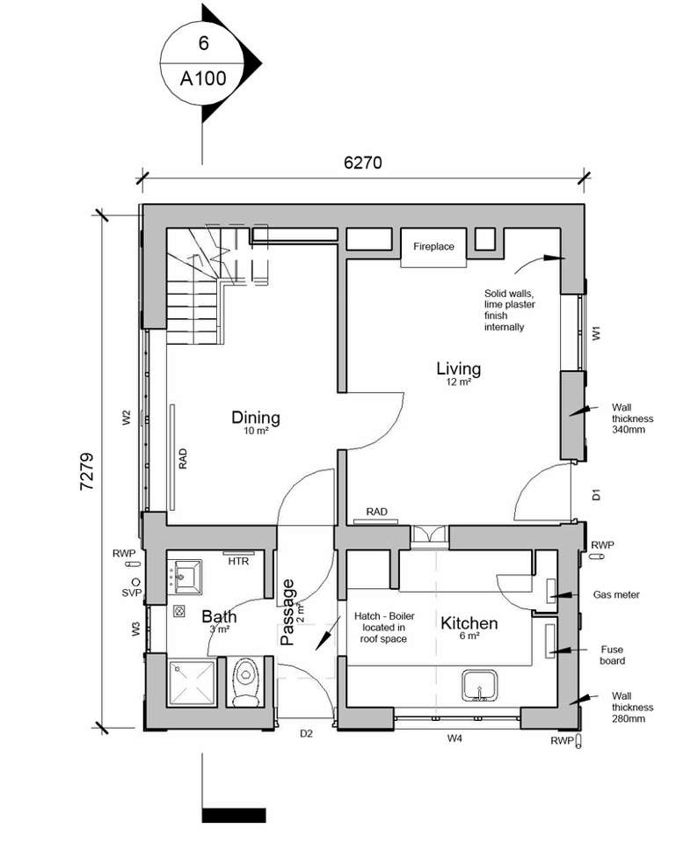
Existing ground floor plan (NTS). Produced by provider.
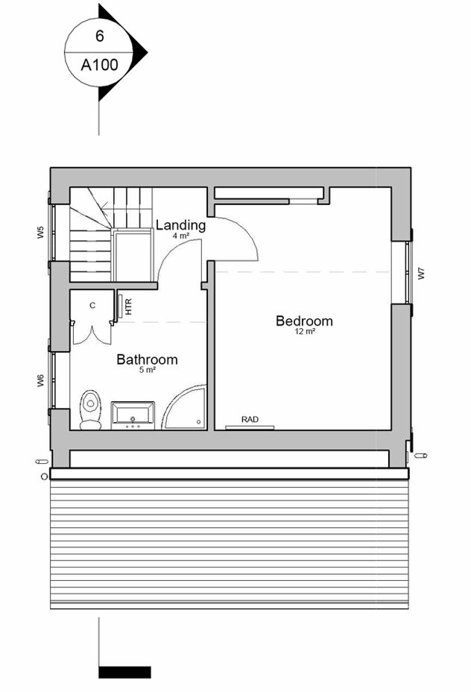Existing first floor plan (NTS). Produced by provider.
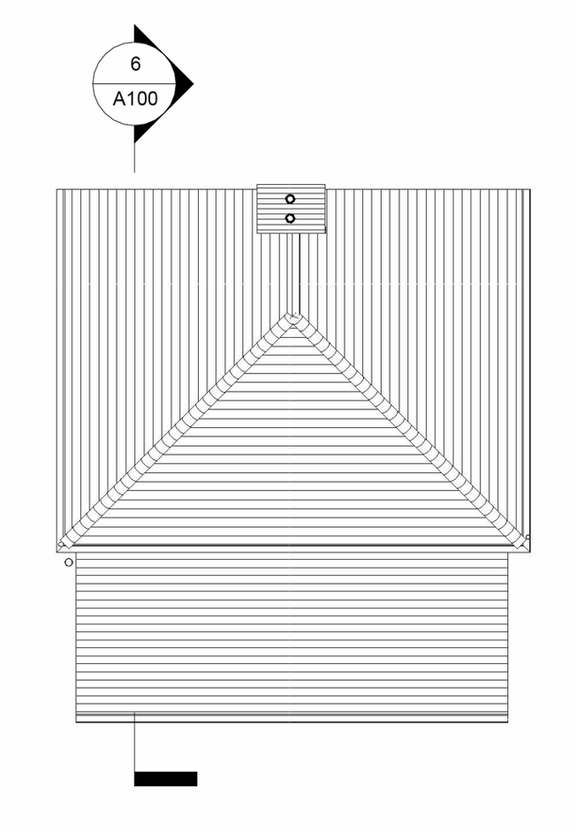Existing roof plan (NTS). Produced by provider.
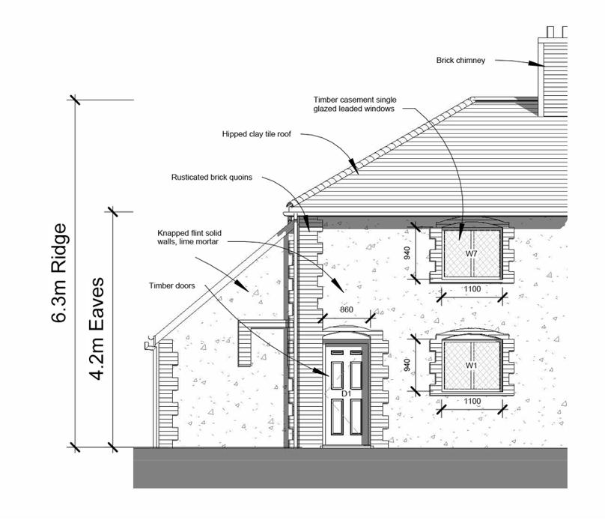Existing front east elevation (NTS). Produced by provider.
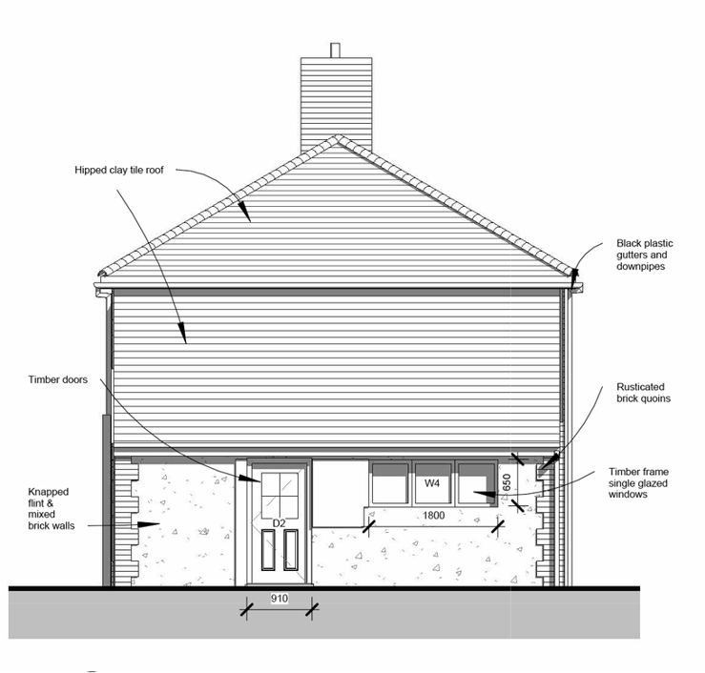Existing flank south elevation (NTS). Produced by provider.
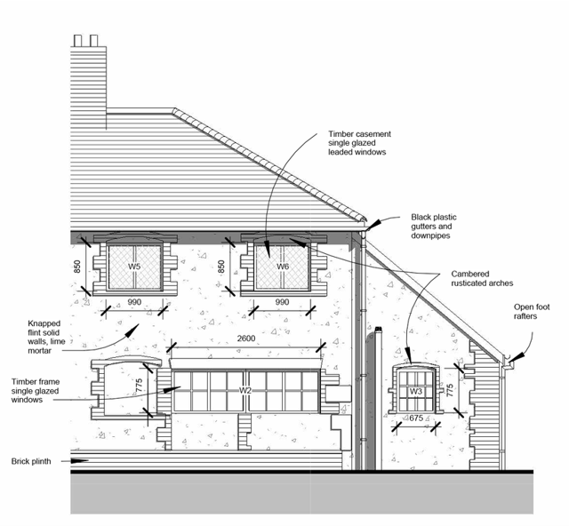Existing rear west elevation (NTS). Produced by provider.
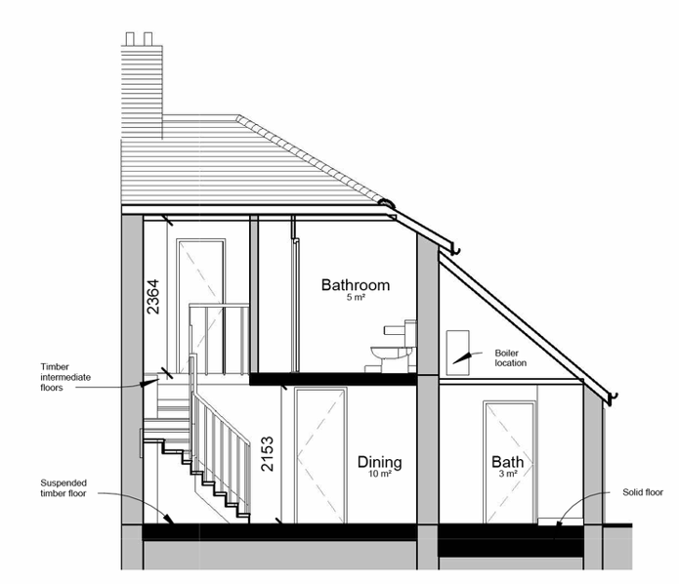Existing section (NTS). Produced by provider.
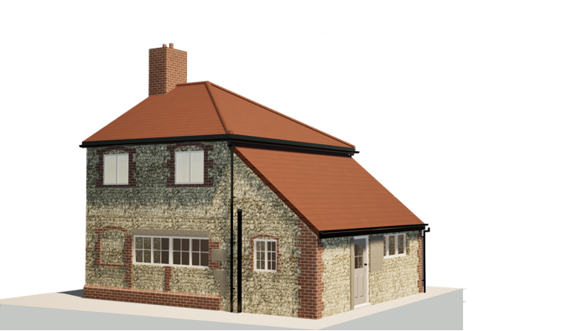3D view 1. Produced by provider.

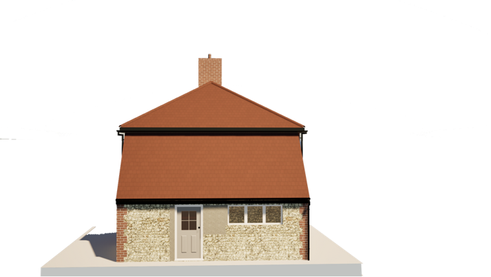3D view 2. Produced by provider.
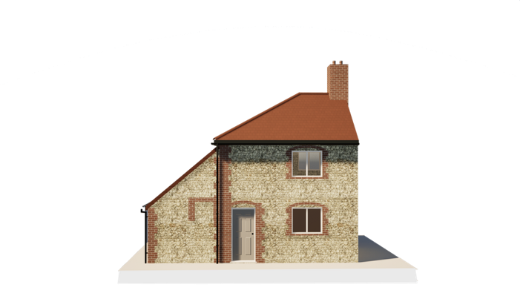3D view 3. Produced by provider.

The following materials relate to lesson 2: Understanding the building fabric.
There are no additional materials required for this lesson.

The following materials relate to lesson 3: Energy efficiency challenges: Windows and doors.
There are no additional materials required for this lesson.

The following materials relate to lesson 4: Heating systems and energy efficiency.

Group task worksheet: Evaluating heating systems for Wish Hill
Group name: ________________________________________________________
Group members: _____________________________________________________ ___________________________________________________________________
Task overview
Your group is tasked with evaluating different low-carbon heating systems for
Wish Hill. Consider the pros and cons of each option, including cost, feasibility and planning implications. Use the table below to structure your analysis.
Step 1: Assessing heating options
Heating system | Pros | Cons | Cost (high/medium/low) | Feasibility for Wish Hill (high/medium/low)
Heat pumps (air source)
Heat pumps (ground source)
Biomass boilers
Infrared heating panels

Step 2: Decision-making
1. Which heating system does your group recommend for Wish Hill?
___________________________________________________________________
2. Justification (consider heritage restrictions, sustainability and cost-effectiveness):
___________________________________________________________________
___________________________________________________________________
_________________________________________________________________________________________________________________________________________________________________________________________________________
3. Potential challenges and solutions:
___________________________________________________________________
_________________________________________________________________________________________________________________________________________________________________________________________________________
Step 3: Presentation preparation
Make sure your group is ready to present the following:
- a summary of your preferred heating system
- a justification of your choice based on key factors
- an explanation of potential challenges and suggestions for solutions
Reflection questions (think about these with your group):
- What was the most important factor in your decision?
- How do heritage restrictions influence heating choices?
- What did you learn about low-carbon heating systems?

The following materials relate to lesson 5: Integrating renewable energy in heritage buildings.

Renewable energies solutions worksheet
Group name: ________________________________________________________
Student names: ______________________________________________________
___________________________________________________________________
Task: Identifying renewable energy solutions for Wish Hill
Step 1: Assessing renewable energy options
Research and discuss the renewable energy options below. Consider how each could be integrated into Wish Hill while maintaining heritage integrity.
Renewable energy source | Advantages | Challenges | Suitability for Wish Hill (Yes/No) | Justification
Solar PV panels
Wind turbines
Ground source heat pumps
Air source
heat pumps
Biomass heating

Step 2: Key factors to consider
1. Planning restrictions:
- What are the main heritage constraints affecting the installation of renewables at Wish Hill?
- How might these constraints be addressed?
2. Environmental and economic impact:
- Which system provides the greatest carbon reduction?
- What are the estimated costs and long-term savings?
3. Practicality and feasibility:
- Which energy source is the easiest to implement given the existing infrastructure?
- Are there any hybrid solutions that could work?
Step 3: Final recommendation
Chosen renewable energy solution: ___________________________________________________________________
Justification:
______________________________________________________________________________________________________________________________________
______________________________________________________________________________________________________________________________________
____________________________________________________________________________________________________________________________________________________________________________________________________________________________________________________________________________

Energy system cost-benefit table worksheet
Group name: ________________________________________________________
Student names: ______________________________________________________
___________________________________________________________________
Task: Evaluating the cost and benefits of renewable energy systems
Complete the table below by assessing the costs, benefits and feasibility of different renewable energy systems for Wish Hill. You may need to do some research in your group to make these assessments.
Energy system | Initial cost (£) | Long-term savings (£) | Environmental impact | Feasibility for Wish Hill
Solar PV panels
Wind turbines
Ground source heat pumps

Air source heat pumps
Biomass heating

Group discussion questions:
1. Which system offers the best balance between cost and long-term savings?
2. How do environmental benefits compare across different energy systems?
3. What are the main feasibility concerns for installing these systems at Wish Hill?

The following materials relate to lesson 6: Moisture, damp and ventilation strategies.
There are no additional materials required for this lesson.

The following materials relate to lesson 7: Sustainable water and drainage solutions.

Water management plan worksheet
Section 1: General information
Project name: _______________________________________________________
Location: ___________________________________________________________
Date: ______________________________________________________________
Team members: ______________________________________________________
Section 2: Current water uses and issues
- What are the main water-related issues in the area (e.g. flooding, water waste, poor drainage)?
________________________________________________________________________________________________________________________________________________________________________________________________________________________________________________________________________________________________________________________________
- What are the main sources of water use in the building/site (e.g. toilets, irrigation, washing)?
________________________________________________________________________________________________________________________________________________________________________________________________________________________________________________________________
Section 3: Water saving strategies
- What sustainable drainage solutions (SUDS) could be implemented?
- permeable paving
- swales and detention basins
- green roofs
- rain gardens
- other: ___________________________________________________
- Which water reuse strategies could be applied?
- rainwater harvesting
- greywater recycling
- efficient fixtures (low-flow taps, dual-flush toilets)
- leak detection systems
- Describe how your proposed solution will reduce water waste and
improve drainage.
________________________________________________________________________________________________________________________________________________________________________________________________
Section 4: Action plan and implementation
- What are the key steps to implement the water saving plan?
Step 1: __________________________________________________________
________________________________________________________________
Step 2: __________________________________________________________
________________________________________________________________
Step 3: __________________________________________________________
________________________________________________________________
- Who would be responsible for maintaining the system?
________________________________________________________________________________________________________________________________
Section 5: Reflection and review
- What challenges might arise in implementing these strategies?
________________________________________________________________________________________________________________________________________________________________________________________________________________________________________________________________
- How could the plan be improved or expanded in the future?
________________________________________________________________________________________________________________________________________________________________________________________________________________________________________________________________
Completed by: __________________________________
Submission date: ________________________________

The following materials relate to lesson 8: Planning, policy and legal considerations.

Lesson 7 recap quiz
Name: _________________________
Date: __________________________
- What does the term sustainable drainage mean?
a) Using traditional concrete drains
b) Preventing all water from entering the ground
c) Managing rainfall to mimic natural water processes
d) Collecting water only from roofs
- Name two methods of sustainable urban drainage systems (SUDS):
________________________________________________________________________________________________________________________________
- What is greywater recycling?
a) Collecting and treating rainwater from roofs.
b) Reusing wastewater from toilets.
c) Reusing water from sinks, showers, and washing machine.
d) Filtering seawater for reuse in homes.
- Why is water efficiency important in sustainable construction? (Tick all that apply.)
☐ Saves water resources.
☐ Increases water bills.
☐ Reduces environmental impact.
☐ Helps adapt to climate change.
- In the Wish Hill case study, what were two key drainage or water-related issues identified?
________________________________________________________________________________________________________________________________
- Explain how rainwater harvesting can contribute to sustainability in buildings.
________________________________________________________________________________________________________________________________________________________________________________________________________________________________________________________________
- List one economic, one environmental and one social benefit of using SUDS
in a community.
Economic: ________________________________________________________
Environmental: ____________________________________________________
Social: ___________________________________________________________

- What is meant by retrofitting in the context of sustainable drainage?
a) Removing old systems entirely.
b) Installing SUDS in new buildings only.
c) Updating existing infrastructure to improve drainage sustainably.
d) Using non-permeable materials to block water.
- Identify one strategy that can help reduce surface water runoff without major structural change.
________________________________________________________________________________________________________________________________
- (Extended response)
Explain how ethical and sustainable thinking can influence the design of water systems in a construction project. Your answer should consider environmental and social factors.
_______________________________________________________________________________________________________________________________________________________________________________________________________________________________________________________________________________________________________________________________________________________________________________________________________________________________________________________________________________________________________________________________________________________________________________________________________________________________________________________________________________________________________________________________________________________________________________________________________________________________________________________________________________________________________

Lesson 7 recap quiz answer sheet
- c) Managing rainfall to mimic natural water processes.
- Accept any two of the following:
- permeable paving
- swales
- green roofs
- rain gardens
- soakaways
- filter strips.
- c) Reusing water from sinks, showers and washing machines.
- ✔ Saves water resources.
✔ Reduces environmental impact.
✔ Helps adapt to climate change.
- Sample answers (any two):
- surface water flooding
- poor drainage infrastructure
- high water consumption / lack of efficiency.
- Rainwater harvesting collects water from roofs and stores it for non-potable uses (e.g. flushing toilets or watering plants). This reduces demand on mains water, helps manage stormwater and supports sustainability.
- Economic: reduces long-term flood damage costs.
Environmental: reduces pollution entering water bodies.
Social: improves public space aesthetics and safety.
- c) Updating existing infrastructure to improve drainage sustainably.
- Examples:
- installing water butts
- using permeable surfaces
- creating rain gardens
- adding green roofs.

- Sample answer:
Ethical and sustainable thinking ensures water systems protect both people and the planet. Environmentally, this means reducing water wastage and managing rainwater to prevent flooding. Socially, it promotes public health and access to clean water. Designing systems with these priorities supports long-term community wellbeing and environmental protection.

Listed consent flashcards
(Teachers to cut out and create packs.)

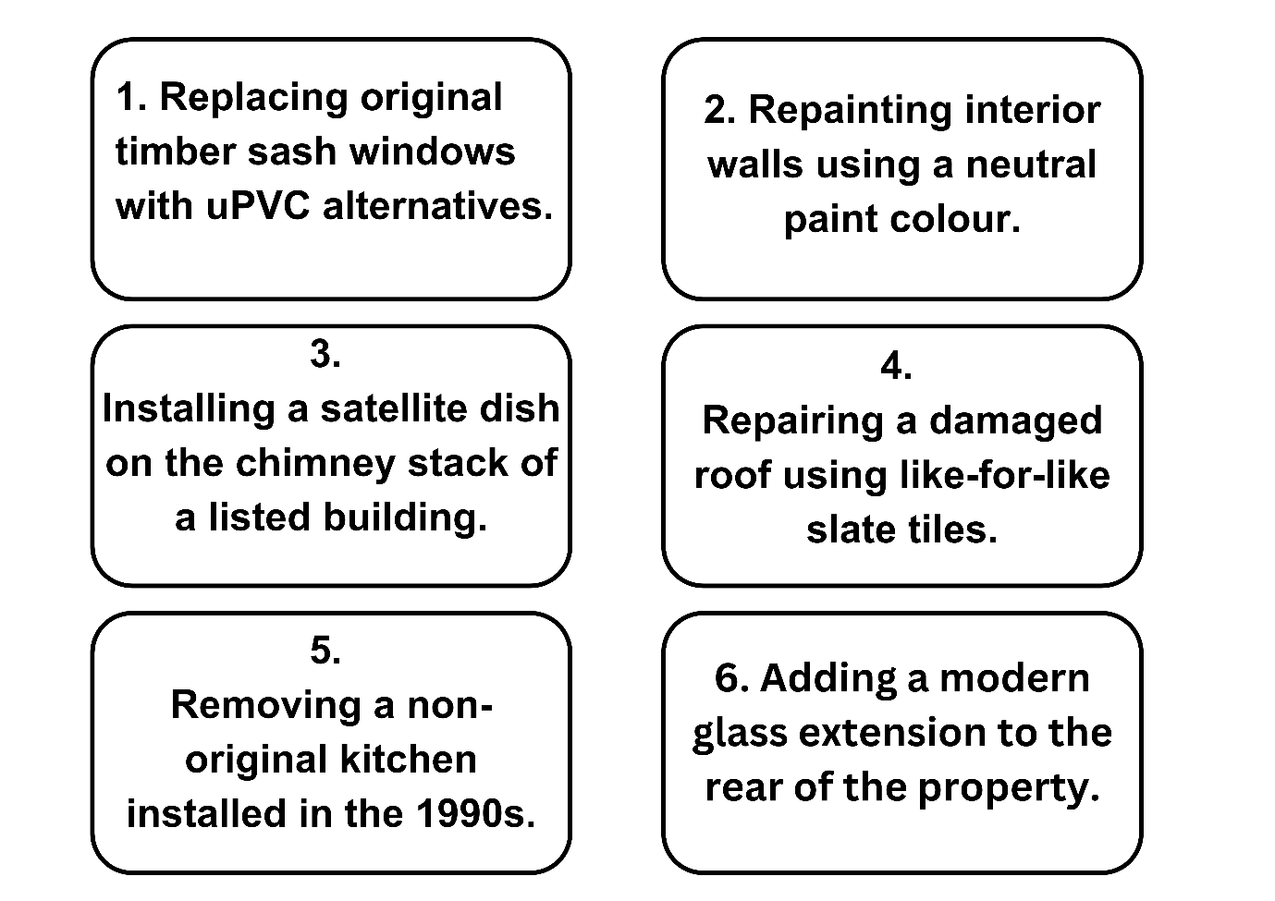

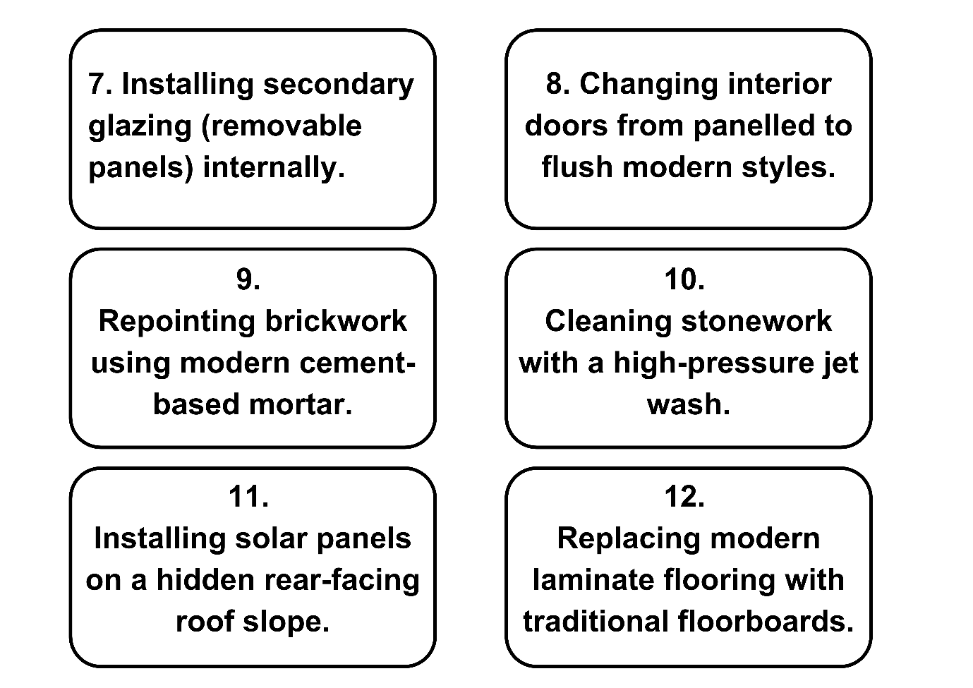
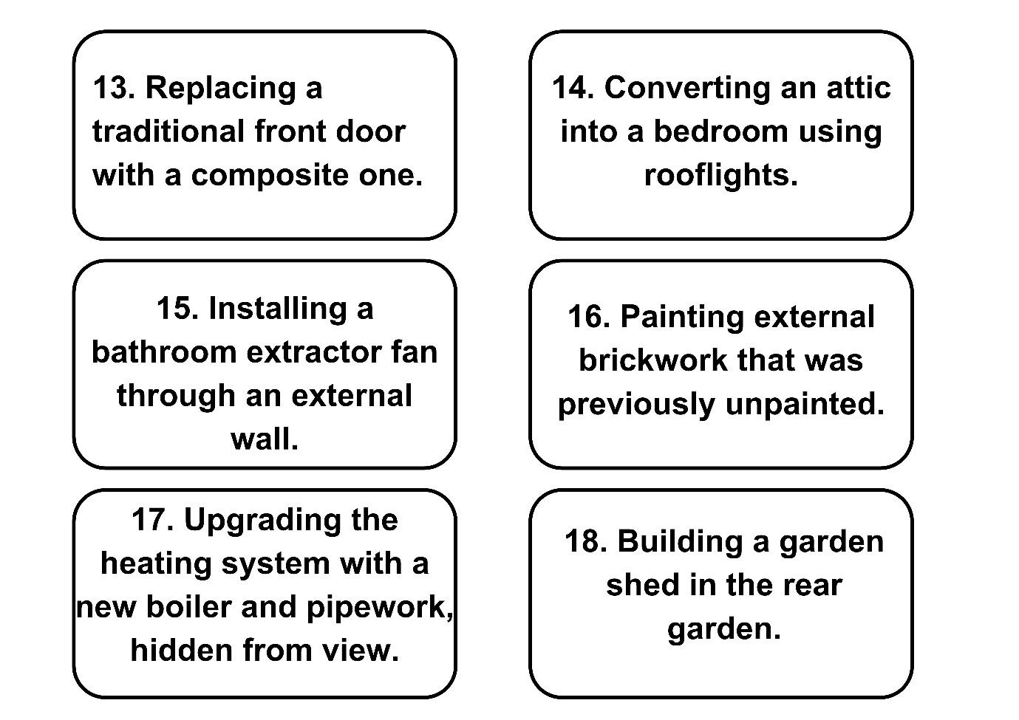
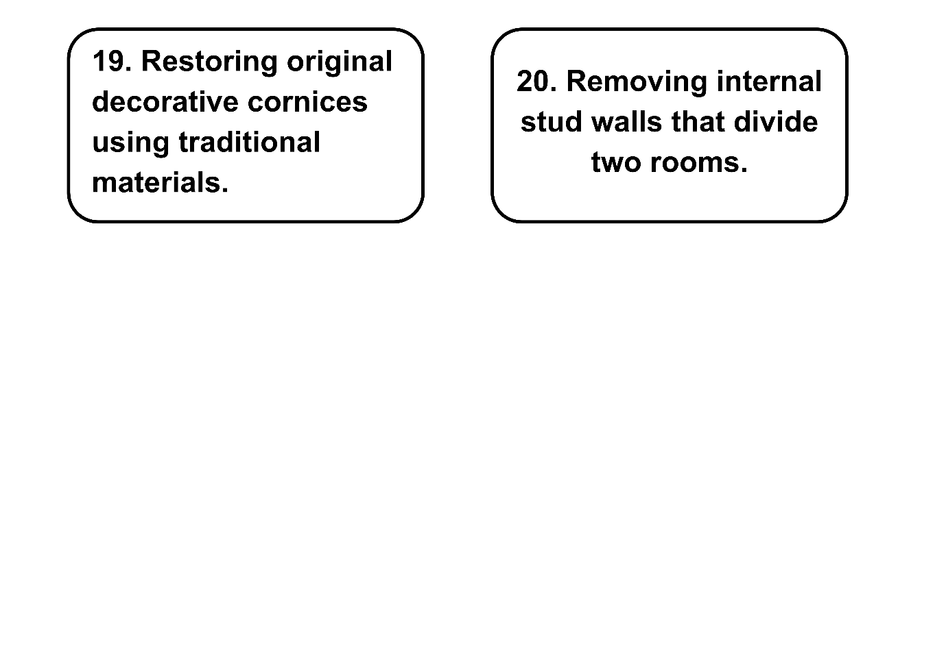

Listed consent flashcards answer sheet
Flashcard number | Consent required? | Reason
1 | Yes | Replacing original features affects character.
2 | No | Repainting interior walls does not usually affect significance.
3 | Yes | Affects appearance and historic fabric.
4 | No | Like-for-like repair typically does not require consent.
5 | Possibly not | If kitchen is not of historic significance.
6 | Yes | Major alteration to structure and appearance.
7 | No | Reversible internal additions usually exempt.
8 | Yes | Original features being removed.
9 | Yes | Modern mortar can damage historic fabric.
10 | Yes | Risk of damage to historic materials.
11 | Yes | External alteration, even if hidden.
12 | No | Replacing with traditional materials may not need consent.
13 | Yes | Affects building’s historic appearance.
14 | Yes | Structural and visual change to roof.
15 | Yes | External wall penetration alters fabric.
16 | Yes | Alters external appearance and material condition.
17 | No | Internal modernisation with no visual impact.
18 | No | Outbuildings usually exempt if not attached.
19 | No | Restoration using traditional methods usually supported.
20 | Yes | Changes layout; may affect significance.

Peer feedback stars and wishes form
Group being reviewed: ___________________________
Reviewed by (your group): ___________________________
Stars
Write two things this group did well (e.g. teamwork, explanation, accuracy).
- ______________________________________________________________
- ______________________________________________________________
Wishes
Write one way the group could improve their approach or understanding.
_________________________________________________________________
Quick Checklist
Tick all that apply:
☐ Most flashcards correctly sorted.
☐ Clear reasoning shared for decisions.
☐ Worked well as a team.
☐ Respected listed building principles.
☐ Asked questions or checked resources when unsure.

The following materials relate to lesson 9: Developing retrofit solutions and proposals.

Retrofit proposal of recommendations and measures template
1. Retrofit proposal for [address/property name]
Student name:
Date of submission:
Course title: (T-Level design, surveying and planning)
2. Contents page
Use auto-generated list if using Word or Google Docs.
Should include subheadings such as:
- Introduction
- Property overview
- Existing issues
- Proposed measures
- Sustainability impacts
- Cost analysis
- Summary and recommendations
3. Introduction
- Brief overview of the project.
- Purpose of the retrofit.
- Summary of the report structure.
4. Property overview
- Type of building (e.g. three-bed semi-detached, 1950s).
- Current condition.
- Energy performance rating (EPC or estimated).
- Any constraints (heritage/listed, location).
5. Identified issues
- Heat loss
- Poor insulation
- Outdated heating system
- High energy bills
- Potential risks (e.g. damp, structural inefficiencies)
6. Proposed retrofit measures
Use subheadings for each category:
- Low-cost measures (e.g. draught-proofing, LED lighting)
- Shallow retrofit measures (e.g. loft insulation, smart thermostat)
- Deep retrofit measures (e.g. air source heat pump, external wall insulation)
Include diagrams or tables, where helpful.
7. Cost and benefit comparison
- Estimated costs for each measure
- Payback period or long-term savings
- Example table headings:
Measure | Type | Cost (£) | Energy savings | Payback (yrs)
8. Sustainability impacts
- Environmental (carbon reduction, energy efficiency)
- Economic (cost savings, property value)
- Social/human (comfort, health, community impact)
- Reference any relevant legislation or guidance.
9. Heritage and conservation considerations
- If applicable, highlight how the retrofit respects listed status or historical features.
- Use of traditional materials.
- Planning permissions or restrictions.
10. Summary and recommendations
- Key findings
- Best value-for-impact measures
- Final proposal plan
- Next steps (if project were to proceed)

Retrofit measures sorting cards
(Teachers to cut out and create packs.)
Sorting cards: Low-cost measures
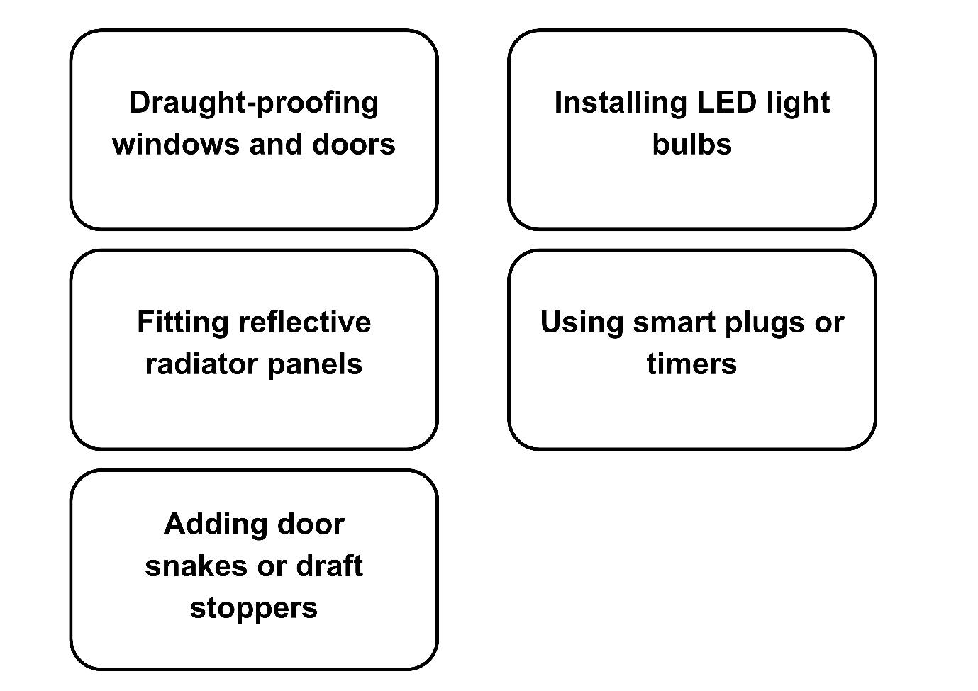
Sorting cards: Shallow retrofit measures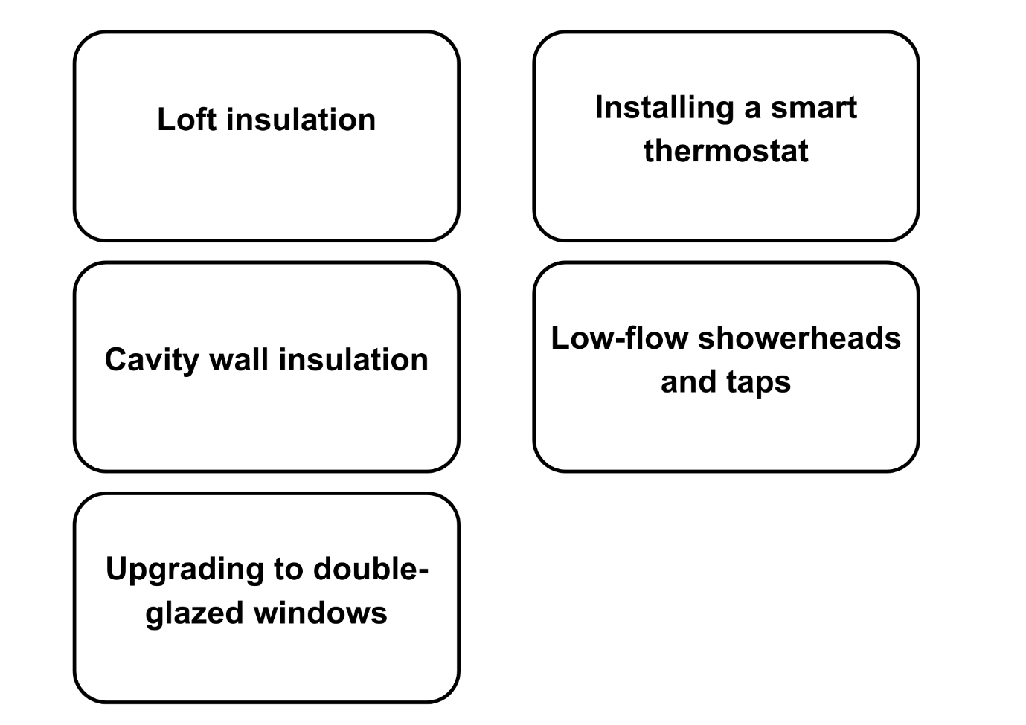

Sorting cards: Deep retrofit measures
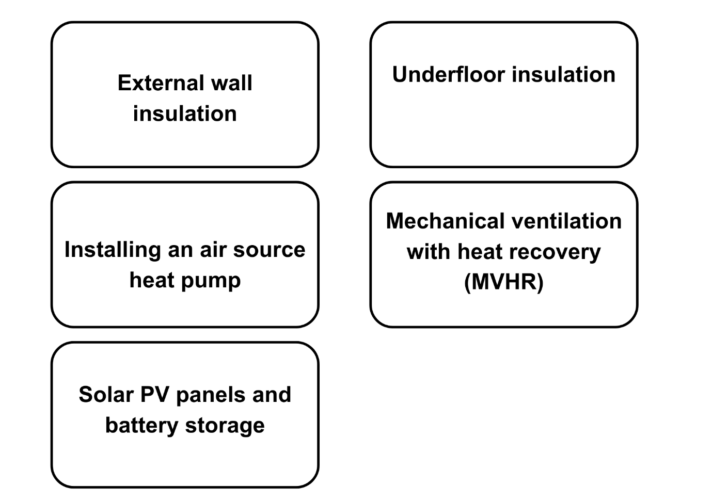

Retrofit measures sorting cards answer sheet
Low-cost measures:
Draught-proofing windows and doors
Installing LED light bulbs
Fitting reflective radiator panels
Using smart plugs or timers
Adding door snakes or draught stoppers
Shallow retrofit measures:
Loft insulation
Cavity wall insulation
Upgrading to double-glazed windows
Installing a smart thermostat
Low-flow showerheads and taps
Deep retrofit measures:
External wall insulation
Underfloor insulation
Installing an air source heat pump
Mechanical ventilation with heat recovery (MVHR)
Solar PV panels and battery storage

The following materials relate to lesson 10: Report writing and reflections
There are no additional materials required for this lesson.


FUNDED BY
PRODUCED BY

This programme is funded by the Department for Education
East Sussex College Group has produced this resource on behalf of the Education and Training Foundation

