


Development of communication skills

ET-FOUNDATION.CO.UK
T LEVEL IN DESIGN, SURVEYING AND PLANNING FOR CONSTRUCTION
INTRODUCTION
At the core of this Framework for Learning (FfL) is a project-based approach, where learners are immersed in a realistic case study. This approach supports learners to go beyond theoretical knowledge, engaging them in the practical application of their skills. From the outset, learners are introduced to the project's context, objectives, and the real-world implications of their work. As the lessons progress, they delve into various aspects of communication within the construction and built environment industry.
What makes this FfL especially relevant for T Level learners is its alignment with a skill that is highly valued by employers in the Construction and the built environment route: communication. Within the FfL are opportunities for collaborative work and problem-solving which are also Core Skills in the T Level in Design, surveying and planning. The inclusion of specific lessons on written and video communication reflects the current industry trends and challenges, ensuring the learners are well-versed in the latest practices.
The content of this FfL is drawn from Core Skill 1 (CS1) – Communication. The learner activities are designed to develop communication. To maximise this learning, it is expected that learners will have knowledge of:
- stakeholders and target audiences
- sketching and drawing plans.
This set of lessons develops skills in:
- written, oral and visual communication using reports and presentations for construction professionals, clients or for non-technical audiences such as the public
- oral communication by participating in group and class discussions to examine concepts and approaches to produce solutions to construction problems.

The FfL has a focus on communication, but the learner activities will naturally provide opportunities to develop Core Skill 2 (CS2) – Work with others through group work activities.

This resource is tailored to mirror the demands and realities of the construction and built environment industry, making it particularly relevant for learners in these fields.
This resource has three sections:
Framework for Learning (FfL)
The resource includes a Framework for Learning (FfL). This covers 30 hours of learning over 10 lessons and provides ideas for further development. Lessons are not expected to be delivered consecutively. It is expected that learners practice the skills they are developing through other lessons. Lesson activities are designed to allow the lesson to be split over more than one session therefore enabling flexible delivery models. This allows you to adjust the delivery of the lessons as required. However, the FfL is designed to scaffold learning and it is recommended that they are delivered in the order presented.

Lesson plans
There is a lesson plan for each stage in the framework for learning. There are ten lesson plans.
The lessons have been designed based on classes of approximately 15-20 learners.
Resources
There is a separate slide deck that can be used with the lessons.
Each lesson has a worksheet and/or handouts to support learning. Some of these handouts are taken directly from the Internet and the source is identified. All resources can be found in a separate section towards the end of this document.
Guidance for students
This section is designed to support students as they prepare for their ESP assessment. This includes some general information regarding the ESP assessment but includes specific information regarding the application of communication skills.

SECTION 1: FRAMEWORK FOR LEARNING

The Framework for Learning (FfL) has been carefully scaffolded into four stages. This supports learners to develop the skill of adapting communication to different audiences.

Stage 1

This stage focuses on writing skills, providing a foundation for learners to practice tailoring their written communication to different readers. The descriptive writing and persuasive writing lessons are designed to help learners consider the needs and perspectives of their target audience. Lesson four draws on the learning by putting the descriptive and persuasive writing into practice through writing a construction and the built environment context press release which is adapted for a set audience.

This stage is covered by lessons 1 to 4 and is 12 hours.

Stage 2

This stage focuses on developing visual communication skills, giving learners experience of conveying information to diverse audiences through sketching. This stage builds visual literacy skills essential in construction and the ability to adapt visual content to different stakeholders.

This stage is covered by lessons 5 and 6 and is 7 hours.

Stage 3

This stage moves into speaking skills developing descriptive and persuasive oral communication. The stage helps learners to express ideas orally which builds on previous written skills developed in stage one. Oral presentations are built into this stage which will support learners to gain confidence communicating to various audiences. The stage is planned to help learners adapt their speaking style and content to different audiences.

This stage is covered by lessons 7 and 8 and is 5.5 hours.

Stage 4

This stage draws together stages 1, 2 and 3. It integrates the writing, visual, and oral skills and develops communication skills to strategically adapt communication approaches to different contexts and audiences. This stage prepares learners to effectively combine and tailor communication to meet the needs of diverse stakeholders in the construction and built environment industry.

This stage is covered by lessons 9 to 10 and is 5.5 hours.

While focused on individual communication skills, the FfL provides multiple opportunities to work in groups. This will help learners to develop skills in collaboration and teamwork.

The sequencing of the stages is designed to gradually build competence and confidence in adapting communication but could potentially be amended or reversed to suit the needs of different learners and delivery contexts.

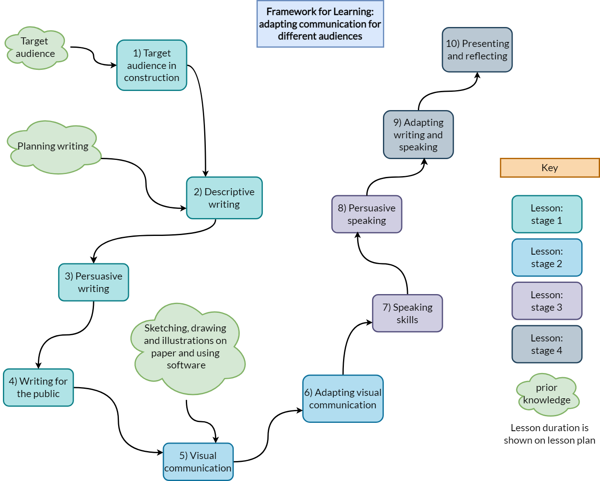
Lesson 1

Title: Target audience in construction

Targeted content reference:
Core Skill 1 (CS1) – Communication: Produce reports and presentations for construction professionals, clients or for non-technical audiences such as the public.

Lesson sequence number: 01

Time: 3 hours.

Prior learning
Definition of target audience. Knowledge of construction regeneration.
Timing | Teacher activity | Learner activity / formative assessment | Resources
10 minutes | Presentation to introduce programme of learning. | Listen and take notes. | Slide deck  Sticky notes  The Big Town Vision handout  Stakeholder handout  Stakeholder impacts worksheet  Stakeholder impacts worksheet – teacher version  Sentiment analysis worksheet  Pen and paper  Three different coloured highlighters
15 minutes | Presentation to introduce lesson.  Define the term stakeholders and provide examples – slide ‘What is a stakeholder’ and ‘Example of stakeholders’.  Present details of the group activity to learners. Check learners understand activity.  Allocate small groups. | Listen, take notes and answer questions asked.  Listen and clarify the requirements of the activity.
30 minutes | Ask each group to share an idea of a stakeholder. Continue to work around class until there are no more ideas.  Facilitate a discussion to determine a list of stakeholders based on the learner ideas. | In small groups identify the main stakeholders that would need information about a whole-town development project.  Share ideas with class.  Agree on a list of project stakeholders.
15 minutes | Present information about project stakeholders in construction and impacted stakeholders to the class and distribute the Stakeholder handout. | Look at example stakeholders on presentation slides. Compare them with the list created. Add in any stakeholders that were missed.  Read the Stakeholder handout.
20 minutes | Present details of the pair activity to learners and distribute copies of The Big Town Vision handout. Allocate pairs.  Circulate around the pairs to check learners understand the requirements of the activity.  Ask learners to share feedback with the class. | Listen and take notes.  Read The Big Town Vision handout and discuss the content with peer.  Highlight the key information that would be most relevant to different audiences such as business owners, visitors and tourists, and residents in different colours.  Share feedback with the class.
50 minutes | Present details of independent activity to learners and distribute the Stakeholder impacts worksheet.  Circulate around the learners supporting their identification of the various impacts using the Stakeholder impacts worksheet – teacher version.  Ask learners to share impacts with the class. Facilitate learner participation and check quality of answers and communication. | Individually identify three key benefits and three potential negative impacts of the development for the three stakeholders.  Complete Stakeholder impacts worksheet and answer question.  Compare answers with a peer and discuss differences.  Share impacts with class.
15 minutes | Presentation on sentiment analysis. | Take notes during the presentation.
20 minutes | Present details of individual activity to learners and distribute Sentiment analysis worksheet.  Ask learners to share examples of their changed text with the class. | Individually, complete the Sentiment analysis worksheet.  Share examples of changed text with the class.
5 minutes | Summarise key points from the lesson.  Explain final task.  Handout sticky notes and ask learners to answer question.  Next steps. | Listen and take notes.  Answer the question on a sticky note and put it on the board / wall: “If this regeneration project was in your town what would you think about the Big Town regeneration proposal and why?”
Other information:
English skills: Practised through reading information about regeneration project, engaging in discussions, notetaking and writing activities.
Digital skills: None.
Maths: Addition when conducting sentiment analysis activity.
Adaptive teaching: Pair learners with different skill levels for discussions and activities.
Extension activities: Perform sentiment analysis on the Big Town Plan handout.
Next steps in learning
Take a positive piece of text from the Big Town Plan pdf and rewrite it to be negative or take a negative piece of text and rewrite it to be positive.

Lesson 2

Title: Descriptive writing

Targeted content reference:
Core Skill 1 (CS1) - Communication: Produce reports and presentations for construction professionals, clients or for non-technical audiences such as the public.

Lesson sequence number: 02

Time: 3.5 hours.

Prior learning
Target audiences
Planning writing
Design or presentation software skills / ability to use design software
Lesson 1
Timing | Teacher activity | Learner activity / formative assessment | Resources
5 minutes | Introduce lesson. | Listen and take notes. | Slide deck  Poster tack  Descriptive writing in construction handout  Smithfield Riverside development images  Vision document worksheet  Big Town Plan pdf [unmasked link is available in the references section]  Access to design or presentation application  A device with internet, word processing and email software  Pen and paper
20 minutes | Present details of the group activity to learners and distribute Descriptive writing in construction handout.  Allocate groups.  Support discussion.  Ask each group to share ideas with class. | Work in small groups to conduct an idea exchange on the uses of descriptive writing in the construction industry. Discuss the variations between these uses and share your existing knowledge with each other.  Share ideas with class.
10 minutes | Ask each group of learners for feedback.  Address any queries raised during activity and feedback. | Provide feedback and ask questions for clarification.
10 minutes | Define vision in the context of a construction project.  Explain why architects use images to support their vision statement. | Listen and take notes.
35 minutes | Share details of the scenario with the learners. Ask the learners if they have any questions.  Present details of the activity to learners and distribute Smithfield Riverside development images and Big Town Plan pdf.  Define key visual assets and explain their use in the construction industry.  Ask the class to discuss ideas on the most appropriate images for use to convey the vision message.  Ask each learner to review the images and select an image to use in their vision document. | Listen and ask questions.  Work in pairs to review the Smithfield Riverside development images in the role of architect.  Identify key visual assets to use in a vision document.  Discuss descriptive words and language devices that can be used in the vision document.  Select an image to use in the vision document.
40 minutes | Present details of the vision document drafting activity to learners and distribute Vision document worksheet electronically. Ensure learners have word processing software open to draft document.  Assess participation and quality of work. | Individually draft a 300–500-word vision document using the Vision document worksheet on a computer.
60 minutes | Present details of the vision document design activity to learners.  Assess participation and quality of work. | Individually use a suitable design or presentation application to create a 2-page A4 Vision handout in full colour.  Print vision document.
20 minutes | Ask learners to swap their vision document with a peer and to give verbal feedback based on the criteria shown on the slide.  Circulate around pairs and support feedback process. | Swap vision document with a peer and provide verbal feedback based on the criteria shown on the slide.
5 minutes | Summarise the key learning from this lesson using the slide. | Listen and take notes.  Ask final questions.
5 minutes | Final task and next steps. | Print your name on the vision document and hand the completed document to the teacher.
Other information:
English skills: Practised through engaging in discussions, notetaking and writing a vision document.
Digital skills: Using applications to create a visually appealing handout.
Adaptive teaching: Pair learners with different skill levels for discussions and activities. Feedback may be given in a different format to support different learning styles.
Extension activities: Review the vision document of a peer and identify three improvements that could be made. Verbally feed back to the peer.
Next steps in learning
Create a vision document for a project or development in your local area using descriptive writing. These projects can be found in the local press or on a local authority website.

Lesson 3

Title: Persuasive writing

Targeted content reference:
Core Skill 1 (CS1) - Communication: Produce reports and presentations for construction professionals, clients or for non-technical audiences such as the public.

Lesson sequence number: 03

Time: 3 hours.

Prior learning
Target audience
Lesson 1 and 2
Timing | Teacher activity | Learner activity / formative assessment | Resources
10 minutes | Introduce lesson. Highlight importance of effective investor communications. | Listen and ask clarifying questions. | Slide deck  Smithfield Riverside development framework pdf [unmasked link is available in the references section]  UK government international investors page  Effective investor letters – Example 1, 2 3, and 4  Letter analysis worksheet  Letter template  Letter checklist template  Reflection activity  A device with internet, word processing and email software  Pen and paper
10 minutes | Present overview of Smithfield Riverside development, its community benefits, and need for investor support. | Listen and ask clarifying questions.
30 minutes | Allocate groups.  Explain purpose of activity and distribute Smithfield Riverside development framework pdf and UK government international investors page.  Facilitate discussion on strategies to highlight community benefits to potential investors. | Skim read Smithfield Riverside development framework pdf and UK Government international investors page.  In small groups, discuss and share ideas on how to highlight community benefits to potential investors.  Share key ideas with class.
20 minutes | Present details of activity.  Review persuasive business writing techniques. Distribute Effective investor letters and Letter analysis worksheet.  Allocate a single letter for each pair to analyse. Ask learners to analyse the letter using the letter analysis worksheet.  Support pair analysis. | Listen and take notes.  In pairs, analyse one example letter. Identify persuasive techniques and positive language devices. Record these on the Letter analysis worksheet.
15 minutes | Ask pairs to provide suggestions of key elements to include in a letter to potential investors.  As a class, agree the key language elements to include in the letter. Ask learners to record the key elements on the Letter checklist template. | Share key elements to include in investor letters.  Agree language key elements and record onto Letter checklist template.
50 minutes | Ask learners to write a letter to an investor for the Smithfield Riverside development using the Letter template.  Monitor and support learners as they draft their investor letters. Provide guidance and feedback as needed. | Independently draft a persuasive investor letter using the Letter template. Highlight Smithfield Riverside's community benefits.
20 minutes | Have learners exchange drafts with a peer for feedback.  Support peer review process. | Review a peer's draft letter and provide constructive feedback using the Letter checklist template. Receive feedback on own draft letter.
20 minutes | Ask learners to complete Reflection activity.  Facilitate debrief discussion on the letter writing process and stakeholder perspectives.  Summarise the key learning from this lesson using the slide. | Complete Reflection activity.  Share thoughts on the letter writing process.  Listen and take notes.
5 minutes | Ask learners to write one thing they found difficult on a sticky note and stick it to the wall.  Next steps. | Write down one thing that was difficult about this lesson on a sticky note and stick it to the wall or board.
Other information:
English skills: Practiced through analysing persuasive writing techniques, writing invitation to tenders, and providing constructive feedback.
Adaptive teaching: Pair learners with different skill levels for discussions and activities.
Extension activity: Use feedback to amend draft.
Create a set of words that could be used in persuasive communications.
Next steps in learning
Write a persuasive letter to a local council member advocating for a new community construction project, such as a park or community centre, using the techniques learned in this lesson.

Lesson 4

Title: Writing for the public

Targeted content reference:
Core Skill 1 (CS1) – Communication: Synthesise information from given case studies, construction projects or site visits.

Lesson sequence number: 04

Time: 2.5 hours.

Prior learning
Research skills.
Lesson 1, 2 and 3.
Timing | Teacher activity | Learner activity / formative assessment | Resources
10 minutes | Introduce the lesson.  Presentation to ask starter question. Ask learners to think about starter question in construction terms.  Ask class for thoughts.  Share slides about flood zone area classification system and maps. | Listen and take notes.  Share thoughts with class.  Listen and take notes. | Slide deck  Whiteboard or flip chart and pens  Research links  Riverside flooding worksheet  Teacher’s completed Riverside flooding worksheet  Data handout  Press release preparation worksheet  Peer review feedback form  A device with internet, word processing and email software  Pen and paper
50 minutes | Present details of the activity to learners and distribute Resource links and Riverside flooding worksheet.  Split into groups of three to four learners. Check learners have access to a computer.  Facilitate discussion within groups on riverside flooding. Refer to completed Teacher’s completed riverside flooding worksheet for examples of what might be included.  Ask each group to share findings with class. Record findings on whiteboard or flipchart. | Work in small groups to research floodplain best practice using the Resource links and find out which areas of the development are at risk from flooding.  Complete Riverside flooding worksheet.  Share findings with class and update worksheet, as necessary.
10 minutes | Presentation to explain communication of sensitive topics to stakeholders and press releases as a form of communication.  Ask learners to consider the question.  Select 2-3 learners to share their answer.  Present ‘How to communicate sensitively’ slide. | Take notes during the presentation.  Consider the question and prepare an answer.  Share answer if asked.  Listen and take notes.
10 minutes | Presentation to introduce press releases. | Listen and take notes.
30 minutes | Present details of the pair activity to learners and distribute Data handout, Peer review feedback form and Press release preparation worksheet.  Allocate pairs.  Circulate around the pairs to support their critical thinking.  Ask learners to complete the Press release preparation worksheet electronically. | Read the Press release preparation worksheet and Peer review feedback form.  In pairs, review the Data handout.  Identify key information you could use in a press release about the proposed flood mitigations.  Complete the Press release preparation worksheet electronically.
35 minutes | Circulate around class to support learners in their creation of their draft press release using a word processing application. Ensure all learners can peer review at least 2 other press releases.  Check learner participation and quality of peer feedback. | Individually draft a press release of no more than 250 words using a word processing application and email it to your manager (teacher) and two peers.  Peer review two press releases and provide feedback and two suggestions for improvements via email.
5 minutes | Summarise the key learning from this lesson using the slide.  Next steps. | Listen and take notes.  Ask final questions.
Other information:
English skills: Practised through reading case studies, engaging in discussions, notetaking and writing press release.
Digital skills: Email, internet research, production of electronic press release.
Adaptive teaching: Pair learners with different skill levels for discussions and activities.
Extension activities: Ask learners to review peer feedback and make improvements where appropriate.
Next steps in learning
Adapt the press release for a magazine article which talks about the benefits of the flood defences for the local community.

Lesson 5

Title: Visual communication

Targeted content reference:
Core Skill 1 (CS1) - Communication: Produce reports and presentations for construction professionals, clients or for non-technical audiences such as the public.

Lesson sequence number: 05

Time: 3 hours.

Prior learning
Lesson 1.
Basic understanding of landscape architecture, design principles and measurement.
Timing | Teacher activity | Learner activity / formative assessment | Resources
10 minutes | Introduce the lesson.  Present the importance of visual communications in landscape architecture.  Ask learners to share examples of visual communications in landscape architecture they have seen. | Listen and take notes.  Discuss examples of visual communications in landscape architecture. | Slide deck  AI concept art handout  Use of AI images in construction  Checklist template  Project details handout  Pencils, pens and paper  Colouring pencils  Ruler.
10 minutes | Presentation to explain how AI is being used in concept art. Explain limitations and problems with their use as well as legitimate potential uses. | Listen and take notes.
45 minutes | Present details of the activity to learners and distribute AI concept art handout, and Checklist template. Allocate groups.  Circulate and check learners understand the requirements of the activity.  Ask groups to review the examples and identify key elements that make them effective or ineffective.  Ask each group to share findings with class. Address misconceptions and distribute Use of AI images in construction.  Assist class in creating an agreed checklist of key elements of visual communications that are essential when communicating a design vision to a client. | Listen and clarify the requirements of the activity.  In small groups, review the AI generated images in the AI concept art handout using the guidance in the handout.  Identify and assess key elements that make them effective or ineffective when communicating a design vision to a client.  Discuss judgements with the class.  Create a checklist of key elements of effective visual communications that are essential when communicating a design vision to a client using the Checklist template.
5 minutes | Presentation to explain the purpose of site plans. | Take notes during the presentation.
30 minutes | Present details of the activity to learners and distribute the Project details handout. Explain the purpose of the project details is to ensure the plan meets the needs of the client.  Allocate pairs.  Ask pairs to sketch ideas for the proposed landscape architecture development for Worthing East Seafront on plain paper.  Ask learners to use their completed checklist template regularly to ensure they are including the key elements of effective visual communications.  Circulate around the pairs to support their design. | In pairs, identify the key elements that are required for the Worthing East Seafront regeneration project from the Project details handout.  Sketch ideas for the proposed regeneration development at Worthing East Seafront.  Use the completed checklist template to ensure best practice is being followed.
45 minutes | Presentation to introduce the site plan exercise. Ensure all learners have pens or pencils for the drawing exercise.  Remind the learners to stick within the project guidelines when creating their plan on the template in the Project details handout.  Circulate around room to discuss placement of design elements. | Listen.  Individually, sketch a plan view for a landscape architecture design for the Worthing East Seafront using pencils or pens on the Project details handout template.
30 minutes | Ask learners to place their designs in a convenient location so they can be viewed by peers.  Ask learners to assess how well each design communicates the artist’s intentions.  Encourage the class to provide constructive feedback and suggestions.  Assess learners for quality of plans, presentation and engagement. | Place designs in the location indicated by teacher.  Circulate and look at each design. Assess how well each plan communicates the design to the audience. Provide feedback and suggestions to peers.
5 minutes | Summarise the key learning from this lesson using the slide.  Next steps. | Listen and take notes.  Ask final questions.
Other information:
English skills: Group discussion, critical thinking and justification of choices, presentation skills, listening skills.
Adaptive teaching: Pair learners with different skill levels for discussions and activities.
Extension activities: Justify the plan design in terms of appropriateness for the location at Worthing East Seafront.
Next steps in learning
Reflect on the site plan design process. Identify three areas of improvement. Update site plan taking account of areas of improvement.

Lesson 6

Title: Adapting visual communication

Targeted content reference:
Core Skill 1 (CS1) - Communication: Produce reports and presentations for construction professionals, clients or for non-technical audiences such as the public.

Lesson sequence number: 06

Time: 4 hours.

Prior learning
Computer software for presentations
How to create a presentation
Timing | Teacher activity | Learner activity / formative assessment | Resources
10 minutes | Introduce the session Adapting visual communication. Explain the importance of tailoring visual communications to different audiences.  Present Project stakeholders in construction and Impacted stakeholders slides. Discuss examples of key stakeholder groups that were referenced in lesson 1. | Listen and take notes.  Share examples of different stakeholders they may need to communicate with. | Slide deck  A device to show the YouTube video to the class. For example, a TV or smartboard linked to the internet.  Whiteboard or flip chart  Sticky notes  Visual communication resource links  Target audience presentation activity handout  Presentation planning questionnaire  Summary of “How to avoid death by PowerPoint” TED Talk.  A device with internet, word processing, presentation and email software  Pen and paper.
40 minutes | Present strategies for communication slides.  Present class activity, examples of visual communications. Distribute Visual communication resource links handout. Ask learners to review and match examples to stakeholders. Encourage learners to discuss the matches to justify their choices. | Listen and take notes.  Click on the Visual communication resource links. Review the website content. Match examples to stakeholders. Discuss and justify choices.
20 minutes | Introduce group activity presentation planning. Distribute Target audience presentation activity handout and Presentation planning questionnaire. Allocate groups of four to five learners.  Read the slides for the project scenario and project details.  Discuss the project details with the class. Address any questions.  Assign each group a single audience from the Target audience presentation activity handout and allocate a target audience and message to each group. | Listen and clarify the requirements of the activity.  Listen and take notes.  Participate in the discussion and ask clarifying questions.
40 minutes | Instruct learners to discuss within their groups the specific requirements, interests, concerns, and level of understanding of their allocated target audience. This discussion should guide the tailoring of their presentation to meet the requirements for the message. Ensure each group has a clear understanding of their audience.  Circulate and provide support.  Ask students how the communication visuals and language could be adapted to the audience and message. | Work in groups to read allocated target audience and message from Target audience presentation activity handout. Discuss target audience and their needs.  Discuss how to adapt visual and language to that audience and the message to be delivered.
40 minutes | Show learners the “How to avoid death by PowerPoint” TED Talk video.  https://www.youtube.com/watch?v=Iwpi1Lm6dFo  Facilitate discussion on key observations from the TED Talk.  Distribute Summary of “How to avoid death by PowerPoint” TED Talk. | Watch and listen to the video.  Discuss key observations from the TED Talk with the class.  Read Summary of “How to avoid death by PowerPoint” TED Talk.
15 minutes | Presentation to explain the create presentation activity.  Ask groups to complete their Presentation planning questionnaire. | Listen and take notes.  Complete Presentation planning questionnaire.
60 minutes | Present details of the activity. Ask learners to open their presentation software.  Ask group to allocate tasks / slides to each member.  Instruct learners to prepare their presentations, considering the specific attributes of their target audience. Encourage the use of appropriate language, visuals, and examples that will resonate well with the audience.  Remind learners to review the whole presentation and ensure it meets the requirements outlined in the “How to avoid death by PowerPoint” TED Talk.  Extension activity: learners prepare to interact with the audience by developing comprehensive speaker notes. These notes should include potential questions and concerns the audience may have about the construction project, along with well-thought-out responses. | Listen.  Open the presentation software.  Review the completed Presentation planning questionnaire.  Group allocates the creation of each slide to their members, ensuring everyone can contribute.  Create the presentation.  When the presentation is complete, the group should review the presentation and share ideas on how to improve it based on the techniques from “How to avoid death by PowerPoint.”  If there is time, complete the extension activity.
5 minutes | Ask learners to email completed presentation to the teacher. | Email completed presentation to teacher.
10 minutes | Summarise the key learning from this lesson using the slide.  Next steps. | Listen and take notes.  Ask final questions.
Other information:
English skills: Practised through reading case studies, engaging in discussions, notetaking and writing email.
Digital skills: Email sent to teacher. Produce presentation slides.
Adaptive teaching: Pair learners with different skill levels for discussions and activities.
Extension activities: Learners prepare to interact with the audience by developing comprehensive speaker notes. These notes should include potential questions and concerns the audience may have about the construction project, along with well-thought-out responses. Learners prepare to interact with the audience by developing comprehensive speaker notes. These notes should include potential questions and concerns the audience may have about the construction project, along with well-thought-out responses.
Next steps in learning
Research how other visual communications tools such as infographics and videos can be used and adapted for different purposes and audiences. Instruct learners to explore examples of infographics and videos created for expert audiences, the public, clients, planning committees, and community engagement. Have them analyse how the visual style, content, language and storytelling approach differs depending on the target audience and communication goal. Consider questions like: What level of technical detail is included or omitted? How is the information structured and presented? What design techniques are used to make it engaging? How is it framed to persuade the audience? What call-to-action, if any, is included?

Lesson 7

Title: Speaking skills

Targeted content reference:
Core Skill 1 (CS1) - Communication: Participate in question-and-answer sessions and respond to questions from a range of different types of stakeholders.

Lesson sequence number: 07

Time: 3 hours.

Prior learning
Basic understanding of the Shrewsbury Riverside Development project.
Target audience.
Timing | Teacher activity | Learner activity / formative assessment | Resources
5 minutes | Introduce the lesson.  Presentation to explain the importance of speaking skills in construction and the importance of professional discussions. | Listen and take notes. Ask questions for clarification. | Slide deck  Whiteboard or flip chart  Professional discussion conventions handout  Debate game activity handout  Impromptu speech topics  Preprepared speeches  Reflection activity worksheet  Timer  Pen and paper  Mini-whiteboards and pens
60 minutes | Present details of the debate game activity. Divide the class into 2 equal groups.  Distribute the Debate game activity handout and Professional discussion conventions handout with part 1 going to one group and part 2 going to the second group.  Ask learners to read and prepare the debate. They should nominate two people to be the debate team.  Ask the members of the debate teams to stand at the front of the class. Support the debate.  Allow time for questions at the end and support the process. | Listen to instructions and move into groups.  Read the Debate game activity handout and Professional discussion conventions handout.  Prepare the debate and nominate two people to be the debate team.  Debate team members move to front of the class. Undertake the debate, following the instructions.  Ask / answer questions.
20 minutes | Pose the questions on the slide.  Distribute the mini-whiteboards and pens.  Ask learners to write their answer on the mini whiteboard.  Ask the learners to hold up their answer on the mini whiteboard.  Facilitate a discussion on the challenges of working for an organisation that is not aligned to your ideals with the class using the slide notes for more detail. | Consider the question.  Write your answer on the mini whiteboard.  Hold up the answer.  Participate in the class discussion on internal conflict.
20 minutes | Present details of the impromptu speeches activity and divide learners into groups of 3-5. Distribute the Impromptu speech topics.  Ask learners to read the Impromptu speech topics and select a topic for discussion. Give them one timed minute to prepare.  Support and monitor the impromptu speeches activity. | Listen and clarify the requirements of the activity.  Read the Impromptu speech topics and select one to prepare. Prepare for one minute.  Take it in turns to give your speech to your group. Take no more than 2 minutes per speech. Do not answer any questions on your speech.
20 minutes | Bring groups together for class discussion on the previous exercise. Use prompts on the slide as points for discussion.  Support discussion using teacher notes from slide. | Review discussion prompts.  Contribute to the class discussion.
20 minutes | Present details of the pair activity. Ask learners to read the Preprepared speeches one after another then pose and answer questions as appropriate. | First person in the pair reads out Preprepared speeches (1).  Ask / answer questions related to that speech using the Preprepared speeches Q&A.  Repeat for other member of the pair with Preprepared speeches (2).
30 minutes | Present details of the reflection activity and distribute the Reflection activity worksheet. | Listen and clarify the requirements of the activity.  Complete the Reflection activity worksheet.
5 minutes | Summarise the key learning from this lesson using the slide.  Present next steps. | Listen and ask questions.
Other information:
English skills: Practiced through analysing video transcripts, scriptwriting, and presenting teaser videos.
Digital skills: Developed through recording, editing, and enhancing videos using mobile devices and apps.
Adaptive teaching: Pair learners with different skill levels for video analysis and scriptwriting activities.
Extension Activities: Ask for feedback from the class.
Next steps in learning
Learners prepare a 5-minute speech on a construction-related topic of their choice. Present to a peer. Peers to provide constructive feedback. Learners to reflect on their performance and set personal goals for improvement.

Lesson 8

Title: Persuasive speaking

Targeted content reference:
Core Skill 1 (CS1) - Communication: Participate in question-and-answer sessions and respond to questions from a range of different types of stakeholders.

Lesson sequence number: 08

Time: 2.5 hours.

Prior learning
Target audience.

Lesson requirements
Read Teacher instructions and print and cut Game cards prior to the session.
Timing | Teacher activity | Learner activity / formative assessment | Resources
5 minutes | Presentation to introduce lesson and distribute the Project scenario.  Explain the importance of persuasive speaking in addressing project challenges. | Listen.  Discuss the scenario and think about potential project issues. | Slide deck  Whiteboard or flip chart  Poster tack  Project scenario  Teacher instructions  Game cards  Voting slips  A container suitable for use as a ballot box  30 second timer  Pen and paper
15 minutes | Present details of the activity to learners. Divide the class into small groups of two to three people. Follow Teacher instructions to start the game and distribute the Game cards.  Circulate and support discussion. | Select Game cards as per Teacher instructions.  Stakeholders work in allocated groups to create a persuasive argument for getting additional funding due to the assigned issue using the Game cards.  Community members discuss projects that the community stakeholder group would support and consider the position of the character card allocated.
40 minutes | Present details of the funding activity to learners.  Ask the first stakeholder group to come to the front of the class. Each stakeholder group will present the argument for the funding to be allocated to them.  Start presentations. | Move to the front of the class when asked. Present your argument to the community members.  Community members take notes and ask questions or provide comments on the funding proposal.  Stakeholder groups answer questions and rebut challenges to the argument.  Write notes about which arguments you find most effective and why.  Repeat for each stakeholder group.
10 minutes | Distribute Voting slips. Ensure a ballot box is accessible. Ask learners to complete the voting slip for the most persuasive argument.  Collect in the Game cards and remove votes from ballot box. Place to one side. | Community members identify which stakeholder group has the most persuasive argument.  Complete the Voting slips and place vote into the ballot box.  Return the Game cards.
30 minutes | Present the elevator pitch slides.  Present details of the elevator pitch activity. Select 3-5 issue cards from the Game cards. Read each issue card out and ask learners to select the one they want to address. | Listen and take notes.  Individually, choose one of the issues from the Game cards and note its characteristics and cost.  Prepare a concise 30 second elevator pitch to convince a key decision maker (rest of class) to allocate the extra funds.
30 minutes | Present details of the elevator pitch presentation activity to learners. Time each learner for 30 seconds and stop them when they get to 30 seconds. Line up next learners for speed. | Deliver elevator pitches (minimum 50% of class).  Listen to other elevator pitches and write notes about which arguments you find most effective and why.  Class votes on the most compelling elevator pitch and places vote into the ballot box.
10 minutes | Select two learners to count the different ballots.  Support class discussion on the differences between a presentation to community groups and an elevator pitch.  Share the results of the ballots. | Count ballots.  Discuss the differences in community presentations and elevator pitches.  Listen.
10 minutes | Ask learners to write a summary of the most important point they learned during the lesson and one question they still have.  Exit ticket. | Write a summary of the most important point learnt in this session and one question that you would like answered.  Stick your elevator pitch to the board or wall.
Other information:
English skills: Practised through reading case studies, engaging in discussions, notetaking and writing email.
Digital skills: Email.
Adaptive teaching: Pair learners with different skill levels for discussions and activities.
Extension Activities: Learners write a persuasive email or letter to a project stakeholder addressing one of the issues.
Next steps in learning
Record yourself giving a speech then play it back and identify areas for improvement.
Research and watch effective speakers, such as TED Talks. Review the techniques used and practice them.

Lesson 9

Title: Adapting writing and speaking

Targeted content reference:
Core Skill 1 (CS1) - Communication: Produce reports and presentations for construction professionals, clients or for non-technical audiences such as the public.

Lesson sequence number: 09

Time: 3 hours.

Prior learning
How to use a design or presentation application
Lessons 1 to 8
Timing (minutes) | Teacher activity | Learner activity / formative assessment | Resources
5 minutes | Presentation to introduce lesson. | Listen and take notes. Ask questions for clarification. | Slide deck  Whiteboard or flip chart  Access to design or presentation application  A device with internet, word processing and email software  Pen and paper  Press release instructions  Investor speech instructions  Investor presentation instructions  Project issues
15 minutes | Recap using the Importance of adaptation and Adapting communication slides.  Discuss examples with learners. | Listen and take notes.  Share examples of communications targeted to specific audiences.
45 minutes | Present details of the press release activity to learners.  Provide each learner with the Project issues and Press release instructions handouts.  Circulate to provide guidance and ensure learners are using reassuring language appropriate for the public. Provide feedback on drafts. | Listen and take notes. Ask questions for clarification.  Read Press release instructions handout. Select an issue from Project issues.  Work independently to write a press release to the public linked to the project issue. Refine press release based on the feedback from teacher.
45 minutes | Present details of the investor speech activity to learners.  Distribute Investor speech instructions handout.  Instruct learners to plan a presentation and speech that lasts no more than 7-10 minutes.  Circulate to provide guidance and ensure learners are considering their investor audience. Provide feedback on drafts. | Listen and take notes. Ask questions for clarification.  Read Investor speech instructions handout.  Listen and take notes.  Work independently to write a persuasive speech to investors linked to the project issue. Refine speech based on the feedback.
60 minutes | Present details of the investor presentation activity to learners.  Distribute Investor presentation instructions handout.  Circulate to provide guidance and ensure learners are considering their investor audience and limiting slides. Provide feedback on drafts.  Remind learners to plan a presentation and speech that lasts no more than 7-10 minutes. | Listen and take notes. Ask questions for clarification.  Read instructions of the Investor presentation instructions handout.  Work independently to create a presentation aimed at a group of investors to support the speech. Use the information provided in the issue card.  Plan the presentation and speech to last no more than 7-10 minutes.  Refine the presentation based on the feedback.  Check timings by practicing speech.
10 minutes | Remind learners they will be presenting their speech next session.  Summarise learning from this lesson using the ‘Summary’ slide. | Note any areas that need to be completed before next lesson.
Other information:
English skills: Practised through reading project brief, engaging in discussions, writing scripts, and providing peer feedback.
Digital skills: Video creation and editing, image selection, and internet research.
Adaptive teaching: Learners can work at their own pace and level during the individual activities.
Extension activity: Learners exchange their work with a partner to provide peer feedback and suggest improvements.
Next steps in learning
In the next lesson, learners will give their speech and presentation in the class. They should ensure it is ready to present by refining the speech, press release and presentation.

Lesson 10

Title: Presenting and reflecting

Targeted content reference:
Core Skill 1 (CS1) – Communication: Produce reports and presentations for construction professionals, clients or for non-technical audiences such as the public.

Lesson sequence number: 10

Time: 2.5 hours.

Prior learning
Completion of previous lessons in this series.
How to use a presentation clicker.
Timing | Teacher activity | Learner activity / formative assessment | Resources
10 minutes | Presentation to introduce lesson. Explain there will be small group presentations and a review. | Listen and take notes. | Slide deck  Presentation software  TV or projector for presentation  Presentation clicker (if available)  Investor presentations (from lesson 9)  Investor speech (from lesson 9)  Peer review form  Reflection worksheet  Pen and paper
60 minutes | Allocate learners into groups of no more than 4. Separate the groups so each group can see a screen for the presentation. Use more than one classroom (adjust times if this is not possible).  Distribute Peer review forms (there should be enough forms for each learner to receive at least two pieces of feedback).  For each group ensure their first Investor presentation is loaded and shown on the screen or projector.  Remind learners to listen carefully to each Investor speech and make notes for feedback or questions to ask.  Ask the first person in each group to start when ready.  When each person has finished, ensure there is an opportunity for the audience to ask questions.  Ask the learners to complete a Peer review form for the person who was speaking / presenting.  Repeat speech / presentation / feedback process for the remaining groups.  Return Peer review forms to the learners that were reviewed. Ask the learners to review their feedback. | Move to allocated group.  Select one person to do the first presentation.  First person in each group gets ready to present. Other groups members make sure pen and paper are ready to take notes.  Read speech and present slides when required. Otherwise, listen and take notes for feedback or questions to ask.  Ask to questions / respond to questions.  Use the Peer review form to provide feedback and suggestions for improvement.  Take part in remaining presentations as instructed by the teacher.  Return Peer review forms to learners that were reviewed. Read own feedback. Reflect on comments.
45 minutes | Lead a whole-class discussion on lessons learnt from the peer review process and communication skills that were developed over this set of lessons.  Work through the questions on the reflecting on our communication journey slide to encourage learners to share their thoughts. | Share insights and lessons learned from the peer review process and communication skills that were developed over this set of lessons.  Consider the questions on the slide and provide your thoughts to the class.
30 minutes | Introduce the self-reflection activity and distribute the Reflection worksheet.  Circulate to provide support and answer questions. | Reflect on personal growth and development throughout the communication in construction programme.  Complete the Reflection worksheet, considering personal growth, challenges, and future goals.
5 minutes | Wrap up the lesson and encourage learners to continue reflecting on their growth and setting goals for the future. | Share final thoughts and ask any remaining questions.
Other information:
English skills: Practised through discussions, peer review, and self-reflection.
Digital skills: Developed through managing presentation delivery.
Adaptive teaching: Discuss presentation and speech with students who may find it difficult and adapt requirements as appropriate.
Next steps in learning
Learners record themselves delivering their persuasive speech and investor presentation. Self-evaluate their tone, body language, and clarity for the audience, and identify areas for improvement.
Learners to find a mentor at their placement in the construction industry and conduct an interview about how the mentor adapts communications to different audiences in their job role.
Write a reflection on key communication insights gained over this course.

Section 2

Resources for lessons

Worksheets and resources for each lesson are given in the following pages. They may be customised to meet your needs.

Some resources are hosted on the internet. Where possible, documents have been downloaded and included in the Resource Files Pack. In other cases, small extracts of the text of images have been included in this documentation for ease of use. Learners should be encouraged to explore the primary sources where possible.

Lesson 1 – Stakeholder handout

Stakeholder | Role and responsibilities
Project owner/client | - initiates the project  - provides funding and resources  - defines project objectives and requirements.
Architects and designers | - develop project designs and specifications.  - ensure compliance with building codes and regulations  - collaborate with engineers and other professionals.
Engineers (structural, mechanical, electrical, etc.) | - design and oversee technical aspects of the project  - ensure safety, functionality, and efficiency of systems  - collaborate with architects and other engineers.
Construction managers and contractors | - oversee the construction process  - coordinate subcontractors and suppliers  - ensure project is completed on time and within budget.
Subcontractors and suppliers | - provide specialised services or materials  - work under the direction of the main contractor  - contribute to specific aspects of the project.
Local government and regulatory agencies | - issue permits and approvals  - enforce building codes and regulations  - ensure public safety and environmental compliance.
Local businesses | - may be affected by the construction project  - provide input and feedback during the planning process  - benefit from or experience impacts of the completed project.
Visitors and tourists | - may be attracted to the area due to the completed project  - provide economic benefits to the local community  - experience the project's amenities and offerings.
Local residents | - may be affected by the construction project  - provide input and feedback during the planning process  - benefit from or experience impacts of the completed project.
End users/occupants | - use the completed project  - provide input on design and functionality  - benefit from the project's intended purpose.

Lesson 1 – The Big Town Vision handout

Activity
Highlight the key information that would be most relevant to:

- local businesses
- visitors and tourists
- residents.

Use a different colour pen for each audience group.

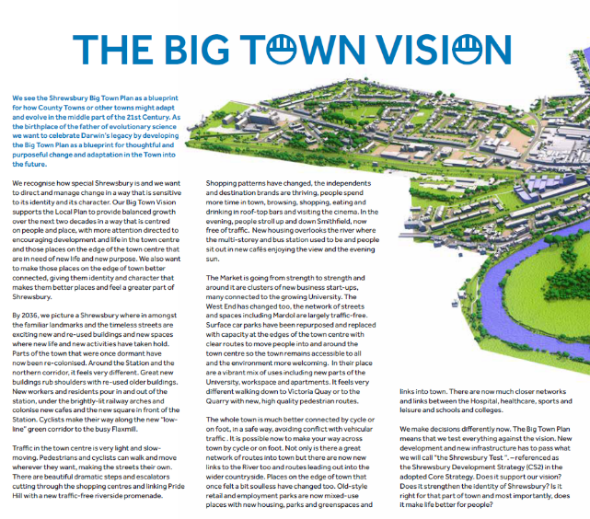
© Shropshire Council, 2018. Shrewsbury Big Town Plan. [Online]
Available at: https://www.shropshire.gov.uk/media/16707/shrewsbury-big-town-plan.pdf
[Accessed 27 3 2024].

Accessibility: An enlarged copy can be found on page 6 of Shrewsbury Big Town Plan 2018 PDF. (Shropshire Council, 2018)

Lesson 1 – Stakeholder impacts worksheet

- Fill in the impacts table with at least three positive and three negative impacts the Shrewsbury Big Town plan regeneration project will likely have on each of the stakeholder groups: local businesses, visitors and tourists, and residents.

To get you started, here are examples of potential impacts to consider:
- local businesses: positive - increased foot traffic from new apartments and university could bring more customers
- residents: negative - years of disruptive construction noise and access issues near homes.

Impacts Table

Stakeholder | Positive impacts | Negative impacts
Local businesses
Visitors and tourists
Residents

2i) Identify which stakeholder is most likely to be disadvantaged by this development.

2ii) Explain why the stakeholder identified in 2i) is most likely to be disadvantaged by this development.

Lesson 1 – Stakeholder impacts worksheet – teacher version

For each stakeholder group, identify at least three positive and three negative impacts the Shrewsbury Big Town plan regeneration project will have on them.

Stakeholder | Positive impacts | Negative impacts
Local businesses | - increased foot traffic and customers  - opportunities to open new businesses  - improved town centre environment may attract more shoppers  - better pedestrian and cyclist access brings more potential customers  - being located near high-quality public spaces can boost business. | - construction and roadwork could disrupt customer access  - rising rents from regeneration may price out some businesses  - new chain businesses may outcompete some local independent shops  - parking and vehicle access for deliveries may become more difficult  - character of town and customer base may change in unpredictable ways.
Visitors and tourists | - more vibrant, active town centre with mix of uses to explore  - new pedestrian routes, public spaces, and riverside promenade to enjoy  - easier pedestrian and cyclist access from rail station to destinations  - new cafes and evening activities to experience  - connections via cycle route to west end and other areas to discover. | - construction could be disruptive and make navigating town confusing  - visitor parking and vehicle access may be more limited  - familiar town character and landmarks may change or disappear  - increased crowds from university and growth could diminish experience  - new housing and workspaces make town feel less visitor focused.
Residents | - better, safer pedestrian and cyclist access throughout town  - new riverside promenade and traffic-free public spaces to enjoy  - more local shopping, dining and amenities within walking distance  - vibrant town centre with more activities both day and evening  - proximity to university facilities, jobs and economic growth. | - years of disruptive construction noise, dust, access issues  - parking and vehicle access near homes may become more difficult  - population growth from university may change town character  - anti-social behaviour may increase with evening/night activities  - rents and cost of living in town centre may increase.

Which stakeholder is most likely to be disadvantaged by this development and why?

As to which stakeholder is most likely to be disadvantaged, learners may choose residents, as they will have to live with the day-to-day disruptions and changes to their hometown over many years of redevelopment. The long-term benefits to residents rely on the vision being fully realised, but in the short term, quality of life may decrease during the messy construction period with uncertainty about the outcomes. Local independent businesses would be a second choice, as they face the pressures of years of disruption and potential displacement if rents increase and chain retailers move in.

Lesson 1 – Sentiment analysis worksheet (4 pages)

Sentiment analysis has become an important tool for the construction industry to manage public perception, meet client expectations, mitigate risks, and protect brand reputation. Construction projects often impact communities and stakeholders, leading to varying sentiments and opinions. By analysing public sentiment through social media, news articles, and online forums, construction companies can identify and address concerns proactively, maintain positive community relations, and prevent project delays due to opposition.

Sentiment analysis enables construction firms to understand client satisfaction levels, identify potential issues with suppliers or subcontractors, and make informed decisions to ensure successful project delivery.

Instructions

First, read the "10 Goals for Shrewsbury" text. Using one colour, highlight all the phrases that express a positive sentiment or idea. Then, using a different colour, highlight any phrases that convey a negative sentiment. Total the positive and negative phrases you found in the spaces provided below the text.

Next, do the same highlighting exercise for the second text, " New £77m plans for Shrewsbury Riverside will starve public investment for the rest of county.". Again, total the positive and negative phrases from that text.

Once you have identified the positive and negative sentiments in both texts, answer the questions at the bottom of the worksheet: " Which of these pieces of text was most positive about the Shrewsbury Big Town Plan? Why?” and “What was the most negative phrase you found within the two pieces of text and what impact could that phrase have on other stakeholders?”

Finally, choose 3 of the 10 goals listed and rewrite them to express a negative sentiment instead of a positive one. To do this, replace some of the key words in each goal with their antonyms (words with opposite meanings). For example, you could change "We want to make it much better for the pedestrian and cyclist" to "We want to make it much worse for the pedestrian and cyclist".

Be sure to write your reworded negative goals in the space provided. Remember, this exercise is to help you recognise how word choice can change the sentiment of a statement from positive to negative.

Share examples of your changed text with the class.

Highlight all positive phrases in one colour and all negative phrases in a different colour. Total them and record them below.

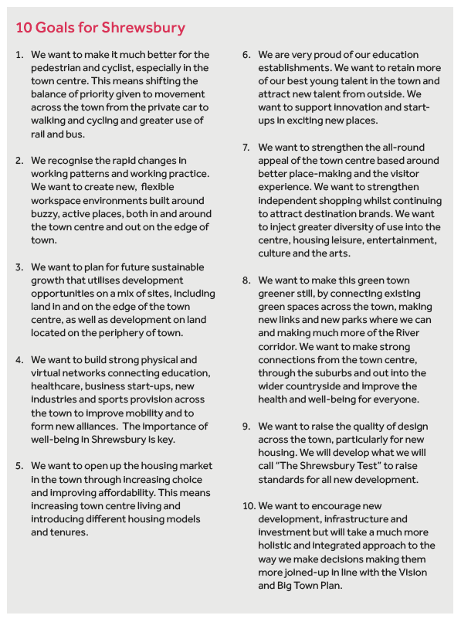
© Shropshire Council, 2018. Shrewsbury Big Town Plan. [Online] Available at: https://www.shropshire.gov.uk/media/16707/shrewsbury-big-town-plan.pdf
[Accessed 27 3 2024].

Accessibility: This is available on page 11 of Shrewsbury Big Town Plan 2018 PDF if it needs to be enlarged. (Shropshire Council, 2018)

Positive: ___________ Negative:___________ Neutral:________________

Highlight all positive phrases in one colour and all negative phrases in a different colour. Total them and record them below.

New £77m plans for Shrewsbury Riverside will starve public investment for the rest of county. (Bodders, 2022)

Next Wednesday, Shropshire Council’s cabinet will discuss plans for redeveloping the riverside area of Shrewsbury on Smithfield Road. This follows a public consultation a year ago, which highlighted the need to prioritise pedestrian and cycling access and to tackle climate change.

The proposals from Shropshire Council involve spending £77m building 270 homes, a multi-agency hub and offices with 500 spaces for workers, the Pride Hill Leisure Centre (cinema, restaurants etc.), offices, a hotel and a Transport Hub – a multistorey car park with 400 spaces plus bike racks to you and me. I wonder how many of spaces will be reserved for cabinet members and council directors as they are currently at Shirehall?

Smithfield Road will be closed and become a green park alongside the River Severn. Traffic will be diverted along Raven Meadows, which the public documents call New Smithfield Road.

The Riverside Centre and the Pride Hill Shopping Centre will be demolished.

The council, which is rapidly running out of money, will have to raise the £77 million it needs for this scheme through loans. That could cost council taxpayers more than £4 million in interest payments. And, it goes without saying the council’s limited funds are going into Shrewsbury yet again. If this goes ahead, the rest of Shropshire will be starved of investment by the council for a generation.

Respondents to last year’s consultation were concerned that there no replacement for the bus station in the concept plans, concerns also raised by Bus Users Shropshire and Sustainable Transport Shropshire. The need for a bus station is mentioned in the council paperwork. It is absent from the public plans. Deputy council leader Ed Potter told BBC Radio Shropshire this morning that the plans clearly show a new bus station in the last phase of the development, Phase Three. He failed to mention, or perhaps didn’t know, that the potential location of the bus station is only shown in a council document marked “official – sensitive.”

The public cabinet document, the Smithfield Riverside Development Framework (SDF), shows the current bus station site as a potential surface car park during Phase 2 or Phase 3 of the development. Indeed, the SDF shows little relationship to what the council is planning. There is no bus station on the indicative plan, though it is mentioned in the accompanying text.

I don’t oppose major redevelopment of Shrewsbury town centre, but this set of papers is a mess. I do not believe that they form a basis for rational and informed decision making. The cabinet should tell Ed Potter, who holds the portfolio for economic development, to withdraw them and come back with a more consistent, less confusing set of proposals in March. The revised papers should the go to full council in May.

I don’t expect the cabinet to do this. The current administration has a habit of rushing through half though out and badly prepared proposals. That’s what led to the purchase of the shopping centres at the top of the market at £51 million.

The council also need a development partner for Shrewsbury town centre. A company that has experience in area wide development and is prepared to share the financial risks. That it has no partner speaks volumes about the risks Shropshire Council is now expecting council taxpayers to shoulder.

If this goes ahead, the rest of Shropshire will be starved of investment by the council for a generation.

© Bodders, A., 2022. New £77m plans for Shrewsbury Riverside will starve public investment for the rest of county. [Online]
Available at: https://andybodders.co.uk/2022/02/10/new-79m-plans-for-shrewsbury-riverside-will-starve-the-rest-of-county-from-public-investment/
[Accessed 27 03 2024].

Positive: ___________ Negative:___________ Neutral:________________

Which of these pieces of text was most positive about the Shrewsbury Big Town Plan? Why?

What was the most negative phrase you found within the two pieces of text and what impact could that phrase have on other stakeholders?

Rewrite 3 of the 10 goals for Shrewsbury in a negative voice by changing some words into their antonyms. Remember: an antonym is a word that is opposite in meaning.

E.g. you could replace ‘better’ for ‘worse.’

Goal Number ___________

Negative Sentiment

Goal Number ___________

Negative Sentiment

Goal Number ___________

Negative Sentiment

Explain why using positive but accurate language is important when communicating with construction stakeholders.

Lesson 2 - Descriptive writing in construction handout

Descriptive writing helps you effectively communicate your ideas, designs, and concepts to clients, stakeholders, and other professionals in the industry.

Key areas

Project proposals and bids:
- clearly outline the scope of work, materials, timelines, and costs
- use persuasive language to convince clients to choose your proposal.
Architectural and design documents:
- describe the layout, features, and aesthetics of a building or space
- use vivid language to help clients visualise the final product.
Specifications and technical documents:
- provide detailed descriptions of materials, equipment, and construction methods
- use clear and concise language to ensure all parties understand the requirements.
Progress reports and updates:
- describe the project's progress, challenges, and milestones
- use descriptive writing to keep stakeholders informed and engaged.
Marketing and promotional materials:
- showcase your company's expertise, past projects, and unique selling points
- use compelling descriptions to attract potential clients and build brand reputation.

Tips for effective descriptive writing

- Know your audience: Tailor your language and content to your target reader, whether it's a client, colleague, or stakeholder.
- Use sensory details: Engage the reader's senses by describing how things look, feel, sound, smell, or taste.
- Be specific: Use concrete details and examples to make your descriptions more vivid and memorable.
- Use active voice: Choose active verbs and sentences to make your writing more engaging and dynamic.
- Vary sentence structure: Mix short and long sentences to create a more interesting rhythm and flow.
- Use analogies and metaphors: Compare unfamiliar concepts to familiar ones to help readers better understand your ideas.
- Revise and edit: Always review your work for clarity, coherence, and effectiveness.

Examples of descriptive writing in construction

"The sleek, modern facade of the building features floor-to-ceiling windows that flood the interior with natural light, creating an inviting and energising atmosphere."

"The proposed community centre will serve as a vibrant hub for residents, offering a range of amenities including a state-of-the-art fitness centre, a cozy library with comfortable reading nooks, and a spacious event hall for community gatherings and performances."

Lesson 2 - Smithfield Riverside development images (5 pages) (Spacehub, 2024)

An architect is a professional who designs buildings and spaces. They consider factors such as functionality, safety, sustainability, and aesthetics. Architects play a key role in urban regeneration projects. They collaborate with urban planners, engineers, and other stakeholders to revitalise and transform urban areas.

In an urban regeneration project, an architect's responsibilities may include:

- assessing the existing built environment and understanding the project's goals and constraints
- developing conceptual designs and permanent plans that align with the project's vision and objectives
- creating detailed architectural drawings, 3d models, and visualisations to communicate their designs effectively
- ensuring that the proposed designs comply with building codes, regulations, and accessibility requirements
- collaborating with other professionals, such as urban planners, landscape architects, and engineers, to integrate their designs into the overall project
- engaging with the local community and stakeholders to gather input and feedback on the proposed designs.

To communicate their ideas and designs, architects use various tools and techniques, such as:

- sketches and hand drawings
- digital illustrations and renderings
- floor plans and elevations
- 3d models and physical prototypes
- presentations and reports.

On the next pages you will see examples of communication through drawing. AI has generated these images to give you an impression of what the development might look like.

Landscape architecture

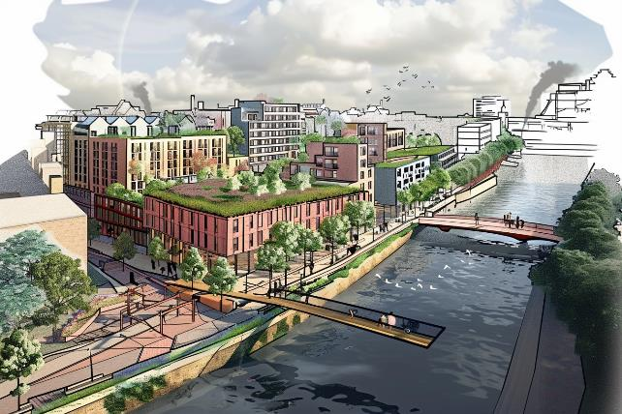


AI generated image created with Midjourney V6 April 2024 (Author image)

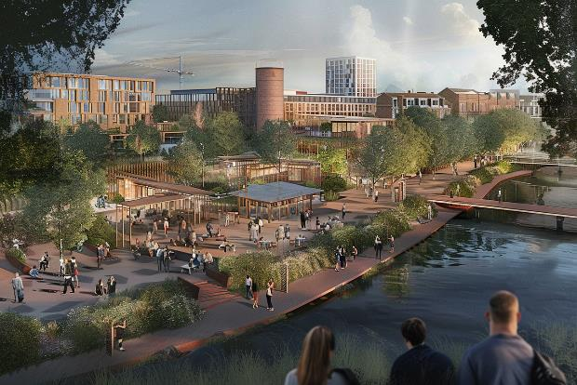
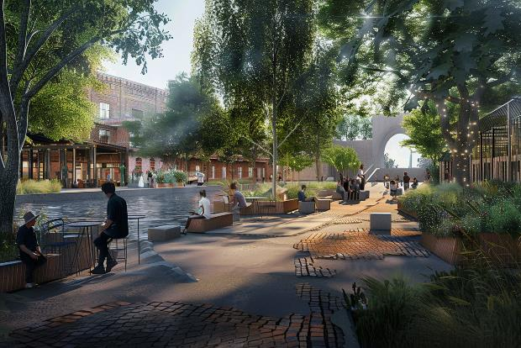
AI generated image created with Midjourney V6 April 2024 (Author image)

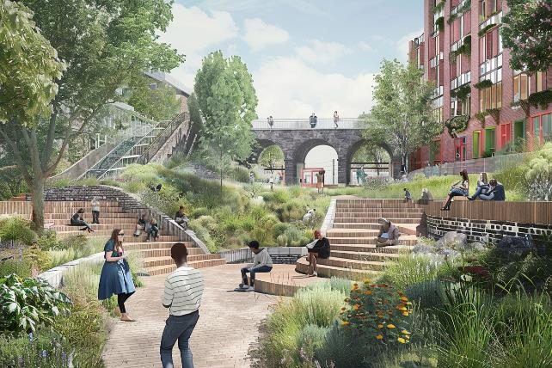
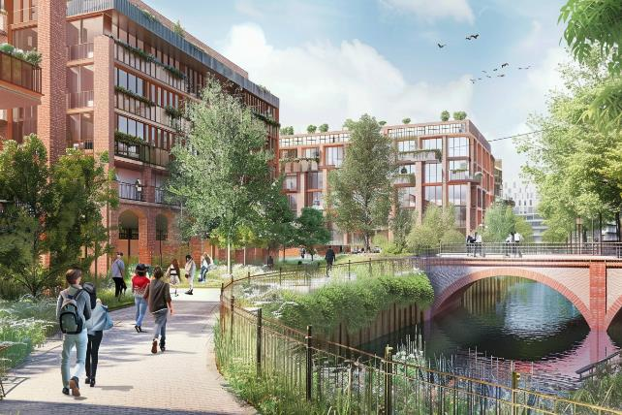
AI generated image created with Midjourney V6 April 2024 (Author image)

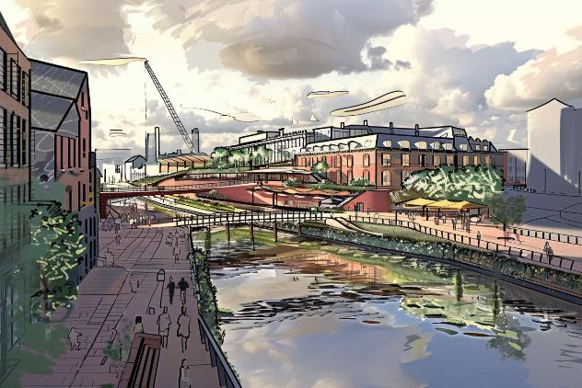
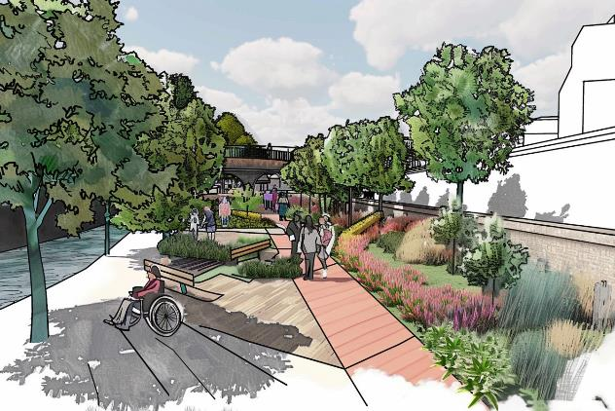

AI generated image created with Midjourney V6 April 2024 (Author image)

Lesson 2 – Vision document worksheet

What is a vision document?

A vision document is a tool for communicating the purpose, goals, and key features of a development project, such as the Smithfield Riverside Development in Shrewsbury. It serves as a high-level overview that conveys the essence of the project to various stakeholders, including investors, local authorities, community members, and potential buyers or tenants.

Instructions

Open a blank document on your computer to draft the text.

Follow these steps to create your vision document.

Step 1: Introduction (50-75 words)
- begin with a brief overview of the Smithfield riverside development project
- clearly state the main objectives and goals of the project
- use concise and engaging language to capture the reader's attention.

Step 2: Key Features (100-150 words)
- identify and highlight the unique selling points of the development
- describe the innovative design elements that set this project apart
- emphasise the sustainable features incorporated into the design
- discuss how the development will benefit the local community.

Step 3: Design Concept (75-100 words)
- describe the architectural style of the development
- provide an overview of the layout and floorplans
- mention the materials and finishes that will be used
- use descriptive language to create a vivid picture of the design concept.

Step 4: Target Audience (50-75 words)
- identify the demographics of the target audience for this development
- discuss the needs and expectations of this audience
- explain how the development caters to the target audience's preferences.

Step 5: Conclusion (50-75 words)
- summarise the key points discussed in the vision document
- reiterate the unique features and benefits of the development.

Step 6: Select Supporting Images
- choose one or two high-quality images that showcase the development's design and features
- ensure the images are relevant and visually appealing
- place the images strategically within the document to support the written content.

Step 7: Format and Review
- use a clear and professional font, such as arial, in an appropriate size (11-12pt)
- ensure proper spacing between sections and paragraphs for readability
- review the document for clarity, coherence, and persuasiveness
- check for any spelling, grammar, or punctuation errors
- confirm that the document does not exceed two sides of a4.

Step 8: Revise and Refine
- based on your review, make any necessary revisions to improve the document's impact
- consider seeking feedback from peers or mentors to further refine the content
- make final adjustments based on the feedback received.

Step 9: Extension Task: Design
- open your design or presentation application and create an interesting and visually appealing design using the text and images you selected
- check readability and font size.

Step 10: Save and Submit
- save the final version of your vision document in a widely compatible format, such as pdf
- ensure the file is named appropriately, e.g., "smithfieldriversidedevelopment_visiondocument.pdf"
- submit the document as instructed by your teacher.

Lesson 3 – UK government international investors page

https://www.great.gov.uk/international/content/investment/sectors/greener-buildings/

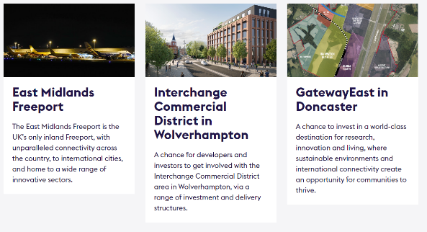
© UK.gov 2024

Each section highlights a unique investment opportunity.

- East Midlands Freeport: Touted as the UK's only inland Freeport, it emphasises its excellent connectivity and innovative sectors.
- Interchange Commercial District in Wolverhampton: This section offers developers and investors information about the commercial district, suggesting various investment and delivery structures.
- Gateway East in Doncaster: Positioned as a world-class destination for research and innovation, this section focuses on sustainable development and international connectivity.

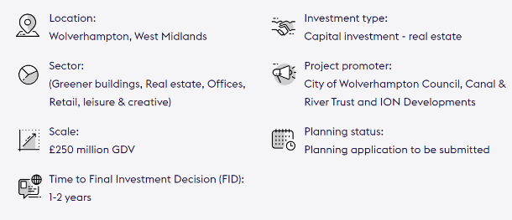
© UK.gov 2024

Lesson 3 – Effective investor letters

Example 1: Affordable housing development

Dear [Investor],

I am writing to introduce you to an exciting opportunity to invest in Riverview Apartments, a new 100-unit affordable housing development in Downtown Springfield. By providing much-needed quality housing for low-income working families, Riverview will fill a critical need in our community.

As an investor, you will benefit from:

- ongoing revenue through shared ownership
- attractive 10-year tax credits and deductions for affordable housing investments
- the satisfaction of strengthening the community and improving residents' lives.

Riverview boasts modern, energy-efficient designs with community amenities like a nursery, skills training centre, and garden. It will catalyse further Downtown revitalisation.

With your investment, we can break ground on Riverview this year and welcome residents next summer. Let's discuss how you can be part of this impactful, rewarding project. I will contact you next week to arrange a meeting.

Sincerely,
[Your Name]
Riverview Apartments

Example 2: Sustainable office tower

Dear [Investor],

I am excited to offer you the chance to invest in Greenway Tower, a state-of-the-art 500,000 square metre mixed use building. Greenway will be the first net-zero energy high-rise in the region, attracting top corporate and private tenants.

Greenway presents multiple benefits to investors:

- Average 10% annual returns over 10 years with 75% pre-leased commitment
- Hedge against rising energy costs and carbon taxes through self-generated renewable power
- Reputational gains from enabling major companies to achieve sustainability goals.

The iconic tower, designed by renowned architects, will feature advanced green technologies and health-focused amenities to drive tenant satisfaction, productivity and retention.

With your investment, Greenway Tower can demonstrate the business case for sustainable development at scale. I would appreciate the opportunity to discuss the project financials with you in detail. Please let me know your availability for a call.

Best regards,
[Your Name]
Greenway Enterprises

Example 3: Mixed-Use Urban Village

Dear [Investor],

I am writing to discuss an opportunity to invest in Harmony Village, an innovative mixed-use neighbourhood that will redefine urban living in Centre City. Harmony Village will combine apartments, retail, offices, and engaging public spaces in a vibrant, walkable community.

Key benefits for investors include:

- diversified, recession-resistant revenue streams
- a prime infill location with unmet demand for modern housing and retail.

Harmony Village will offer a rich urban lifestyle with convenient access to employers, transportation, dining and entertainment. Its pedestrian-friendly streets and programmed plaza will create an attractive third place for the neighbourhood.

As an investor, you can earn compelling risk-adjusted returns while shaping the future of Centre City. I would welcome the chance to walk you through project plans and financials. Please reply with some times to connect.

Sincerely,
[Your Name]
Harmony Development Group

Example 4: Charity

Dear [Investor],

I hope this letter finds you well. My name is Samir, and I am writing to you about an exciting opportunity to support the Greenvale Community Centre project in Ashford, Kent. Our mutual friend, Antonia, recommended I reach out to you, knowing your passion for supporting initiatives that create lasting, positive change in local communities.

The Greenvale Community Centre will be a state-of-the-art, multi-purpose facility designed to serve the diverse needs of Ashford's growing population. The centre will provide a range of vital services and amenities, including childcare, adult education classes, recreational activities, and meeting spaces for community groups. By creating a welcoming, inclusive hub for residents of all ages and backgrounds, the Greenvale Community Centre aims to foster a stronger sense of community, promote lifelong learning, and enhance the overall quality of life in Ashford.

To bring this vision to life, we are seeking the support of socially conscious investors who recognise the importance of investing in the fabric of our communities. By contributing to the Greenvale Community Centre project, you will be making a tangible, lasting impact on the lives of countless individuals and families in Ashford.

Your investment will help to fund the construction of the centre, which will be built to the highest standards of sustainability and accessibility. The project will incorporate green building practices, such as energy-efficient heating and cooling systems, rainwater harvesting, and the use of recycled materials, to minimise its environmental footprint and reduce long-term operating costs.

In addition to the social and environmental benefits, investing in the Greenvale Community Centre offers several advantages for supporters. As a registered charity, donations to the project are eligible for Gift Aid, allowing you to increase the value of your contribution at no extra cost. Furthermore, by aligning yourself with a high-profile community initiative, you will have the opportunity to enhance your reputation as a socially responsible investor and inspire others to follow your lead.

Antonia spoke highly of your commitment to making a difference in the lives of others and your understanding of the importance of strong, vibrant communities. I would be delighted to have the opportunity to discuss the Greenvale Community Centre project with you in more detail and explore how you can be a part of bringing this transformative vision to life.

Please let me know if you would be available for a call or meeting in the coming weeks. I would be happy to share more about our plans, the impact we anticipate, and the specific investment opportunities available.

Thank you for considering this request. I look forward to the possibility of working together to create a brighter future for the people of Ashford.

Warm regards,

Samir
Greenvale Community Centre Project Lead

Lesson 3 – Letter analysis worksheet

Instructions: Read the provided investor letter carefully and answer the following questions. This worksheet should take approximately 10 minutes to complete.

What is the main objective of the letter?

How does the writer make the purpose clear?

Who is the intended audience for this letter?

Is the intended audience a stakeholder? If so, explain why?

How does the writer grab the reader's attention in the opening paragraph?

Identify at least three examples of positive, persuasive language used in the letter.

How does the writer's tone contribute to the overall persuasiveness of the letter?

Does the writer provide specific evidence, examples, or data to support their claims? If so,
how do these details strengthen the writer's argument?

How does the writer highlight the potential benefits for the investor?

What action does the writer want the reader to take? Is the call to action clear, specific, and persuasive?

How persuasive do you find this letter?



Provide a brief explanation for your rating.

Lesson 3 – Letter template

Scenario and instructions

As the project manager, you have been asked to write a letter to potential investors for the Smithfield Riverside Development.

The letter should persuade investors to provide money to support the project. You may choose any community benefit to highlight to the investor.

- use the provided template to draft your letter
- focus on highlighting Smithfield riverside's community benefits
- incorporate persuasive techniques and positive language
- tailor your message to investor interests and concerns
- aim for a concise, professional, and compelling letter.

Template

Dear [Investor Name],

Introduction Paragraph

Start with a greeting and a brief introduction of yourself and your organisation. Mention any mutual connections or how you came to know about the investor. Clearly state the purpose of your letter.

Project Overview Paragraph

Provide a concise overview of your construction project, highlighting its key features, objectives, and potential impact on the community. Use persuasive language to emphasise the project's significance and alignment with the investor's values.

Community Benefits Paragraph

Elaborate on how your project will benefit the local community. Discuss the social, economic, and environmental advantages, such as job creation, improved infrastructure, or increased access to amenities. Use specific examples and data to support your claims.

Investor Benefits Paragraph

Explain the potential benefits for the investor, such as financial returns, social impact, or reputational gains. Highlight any unique or innovative aspects of your project that set it apart from other investment opportunities.

Call to Action Paragraph

Clearly state the action you want the investor to take, such as scheduling a meeting or requesting further information. Provide specific details on how they can get involved and what the next steps would be.

Closing Paragraph

Thank the investor for their time and consideration. Reiterate your enthusiasm for the project and your belief in its potential to create positive change. Express your hope for the opportunity to discuss the project further.

Signature

Close with a professional salutation, such as "Sincerely" or "Best regards," followed by your name and title.

[Your Name]
[Your Title]

Lesson 3 – Letter checklist template

Identify the key language elements that should be included in an investor letter. Check off each element when you complete the peer review.

Key language elements | Description | ü

Lesson 3 – Reflection activity (2 pages)

In the Wheel of Life, rate your current level of proficiency in each of the eight communication skills listed. Consider a scale of 1 to 5, where 1 represents "Needs Improvement" and 10 represents "Highly Proficient."

Wheel of Life

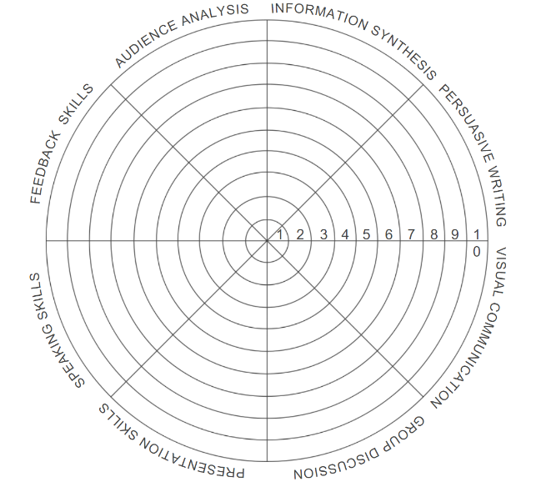
(Author image)

Reflect on your Wheel of Life and identify three skills you would like to focus on improving.

For each of the three skills you selected that most need improvement, brainstorm and write down three 5-minute activities you can undertake to enhance your proficiency in those areas.

Example activity

Speaking skills: Give a 5-minute speech on a given topic.

Feedback methods: Write a constructive feedback paragraph for a peer's work, focusing on specific areas for improvement.

Your activity

Activity 1

Activity 2

Activity 3

Circle or highlight the most important skills for you to develop in the next 5 years.
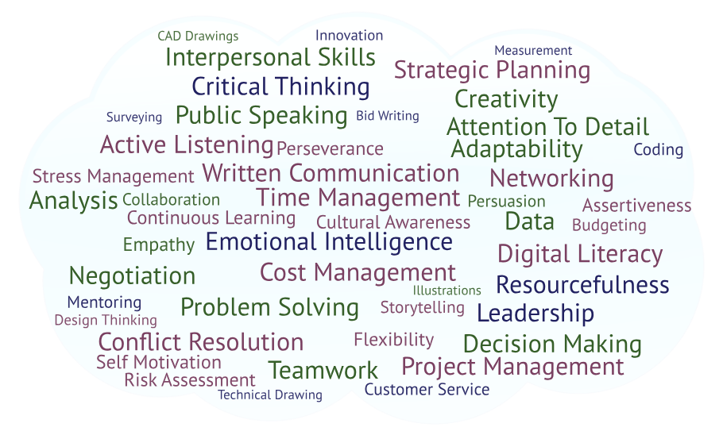

(Author image)
Lesson 4 – Research links

Flood Research

Designing Buildings Wiki – Floodplain

https://www.designingbuildings.co.uk/wiki/Floodplain

Flood Zone Map, Shrewsbury Town Centre

https://www.arcgis.com/apps/mapviewer/index.html?webmap=0f27e3dd34434cfe8d34748a079401a1

Shrewsbury River Severn Flood Defence Plans (Frankwell Solution)

https://assets.publishing.service.gov.uk/media/5a750f2ae5274a3cb2869546/gemi0304bhes-e-e.pdf

Ordinary watercourses - applying for consent for works

https://www.shropshire.gov.uk/drainage-and-flooding/development-responsibility-and-maintenance/new-development-and-watercourse-consenting/ordinary-watercourses-applying-for-consent-for-works/

Managing flood risk

https://www.local.gov.uk/topics/severe-weather/flooding/flood-and-coastal-erosion-risk-management/managing-flood-risk

Managing floods naturally

https://www.shropshirewildlifetrust.org.uk/managing-floods-naturally

Severn Valley water management scheme

https://consult.environment-agency.gov.uk/west-midlands/svwms/

Smithfield Riverside development

Shrewsbury Smithfield Riverside Development Smithfield Riverside Development Framework

https://shropshire.gov.uk/committee-services/documents/s29512/Appendix%20A%20-%20SDF%20final%20document.pdf

Shrewsbury Smithfield Riverside Development

https://www.smithfieldriverside.com/background

Shrewsbury Masterplan Vision

https://shrewsburybigtownplan.org/wp-content/uploads/2021/01/Shrewsbury-Masterplan-Vision-Jan-2021.pdf
Lesson 4 – Riverside flooding worksheet

Using the research links, work in groups to answer the following questions.

- What causes riverside flooding and how do floodplains help mitigate the impact?

- Are there any flood prevention measures or infrastructure in place Shrewsbury, such as levees, dams, or retention basins?

- Are there any ongoing or proposed flood management projects or initiatives in the area?

- Is the Smithfield Riverside development in a flood risk area? If so, what zone(s)?

- Will the new development need to apply for special permission from the council due to flooding?

Lesson 4 – Teacher’s completed Riverside flooding worksheet

Using the research links, work in groups to answer the following questions.

- What causes riverside flooding and how do floodplains help mitigate the impact?

A floodplain is land adjacent to a watercourse over which water flows or would flow in times of flood if defences were not in place.

https://www.designingbuildings.co.uk/wiki/Floodplain

During heavy or prolonged rainfall events, rivers can experience large flows which cause them to exceed their capacity. In the natural environment open spaces near the river function as storage areas or ‘flood plains' for out-of-channel flow, alleviating downstream flood risk.

Urbanisation can severely affect this natural process. Faster run-off rates from upstream urban areas can result in an increase in flow in the rivers downstream, and building on the flood plain can significantly increase the risk of flooding both directly to the development concerned and on a wider basis by removing capacity from the flood plain.

https://www.local.gov.uk/topics/severe-weather/flooding/flood-and-coastal-erosion-risk-management/managing-flood-risk

Therefore, floodplains help to reduce downstream flood risk.

- Are there any flood prevention measures or infrastructure in place Shrewsbury, such as levees, dams, or retention basins?

Yes, there is a flood defence scheme in Frankwell.

https://assets.publishing.service.gov.uk/media/5a750f2ae5274a3cb2869546/gemi0304bhes-e-e.pdf

Demountable and permanent flood defences are used.

- Are there any ongoing or proposed flood management projects or initiatives in the area?

- Increasing soil infiltration by increasing the amount of land that is actively aerated which allows water to soak away.
- Storing water by using natural features such as ponds, ditches or low-lying land or by creating new ponds and areas to store water.
- Slowing water by increasing resistance to flow. For example, by planting trees on the floodplain or constructing “leaky dams” in channels.

https://www.shropshirewildlifetrust.org.uk/managing-floods-naturally

Working with partners and communities, we will investigate interventions including engineered solutions such as the construction of flood storage areas and embankments; natural flood risk management measures that slow the flow of water upstream such as tree planting or the creation of leaky dams; alternative farming and land management practices and other enhanced storage options across the catchment.

https://consult.environment-agency.gov.uk/west-midlands/svwms/

- Is the Smithfield Riverside development in a flood risk area? If so, what zone(s)?

The flood zone map shows the Riverside development is in zones 2 and 3.

https://www.arcgis.com/apps/mapviewer/index.html?webmap=0f27e3dd34434cfe8d34748a079401a1

- Will the new development need to apply for special permission from the council due to flooding?

Yes.

Both permanent and temporary works affecting a watercourse may require consent. Temporary works could be the damming of a watercourse to allow permanent work such as the installation of a bridge.

https://www.shropshire.gov.uk/drainage-and-flooding/development-responsibility-and-maintenance/new-development-and-watercourse-consenting/ordinary-watercourses-applying-for-consent-for-works/

Lesson 4 – Data handout (8 pages)

Work in pairs to review the Data Handout. Identify key information you could use in a press release about the proposed flood mitigations. Make notes about the information you could use and where you found it.

Complete the Press release preparation handout using this information.

Flood Zone Map of Shrewsbury including Smithfield Road area. (ArcGIS Online, 2024)

https://www.arcgis.com/apps/mapviewer/index.html?webmap=0f27e3dd34434cfe8d34748a079401a1

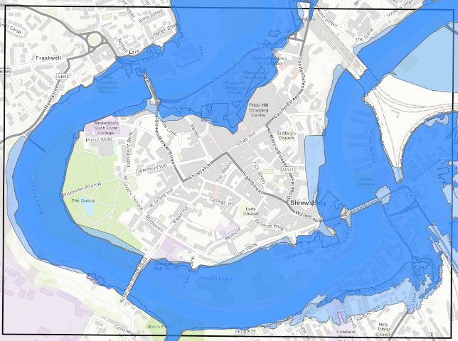
© ArcGIS Online, 2024. Flood Zone Map, Shrewsbury Area. [Online]
Available at: https://www.arcgis.com/apps/mapviewer/index.html?webmap=0f27e3dd34434cfe8d34748a079401a1 [Accessed 27 03 2024].

River Severn at Welsh Bridge. (GOV.UK, 2024)

https://check-for-flooding.service.gov.uk/station/2036

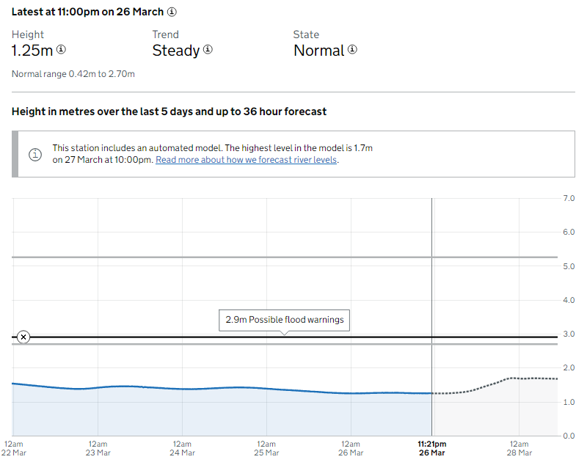

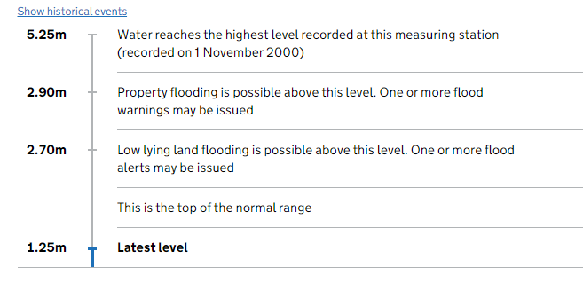
© GOV.UK, 2024. River Severn level at Welsh Bridge. [Online]
Available at: https://check-for-flooding.service.gov.uk/station/2036
[Accessed 26 03 2024].

Smithfield Riverside development phase 1. (Smithfield Riverside, 2024)

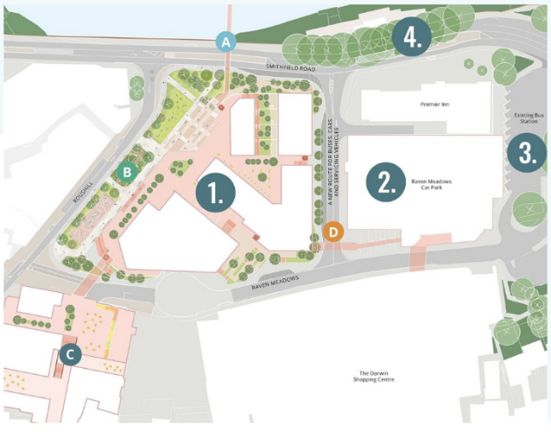
© Smithfield Riverside, 2024. A PHASED MASTERPLAN. [Online] Available at: https://www.smithfieldriverside.com/plans [Accessed 26 03 2024].

Closeup of phase 1. (Smithfield Riverside, 2024)

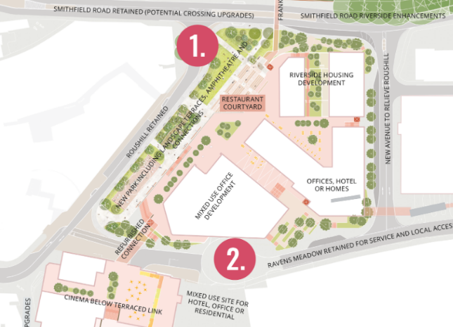

© Smithfield Riverside, 2024. A PHASED MASTERPLAN. [Online] Available at: https://www.smithfieldriverside.com/plans [Accessed 26 03 2024].

Artist’s impression 1 (Glenn Howells Architects, 2021)

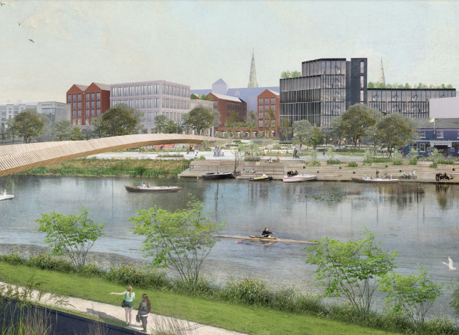

© Glenn Howells Architects, 2021. Shrewsbury Big Town Plan. [Online]
Available at: https://shrewsburybigtownplan.org/wp-content/uploads/2021/01/Shrewsbury-Masterplan-Vision-Jan-2021.pdf
[Accessed 26 03 2024].
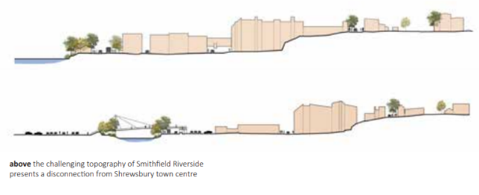
© Glenn Howells Architects, 2021. Shrewsbury Big Town Plan. [Online]
Available at: https://shrewsburybigtownplan.org/wp-content/uploads/2021/01/Shrewsbury-Masterplan-Vision-Jan-2021.pdf
[Accessed 26 03 2024].

Artist’s impression 2 (Shropshire Council, 2022)

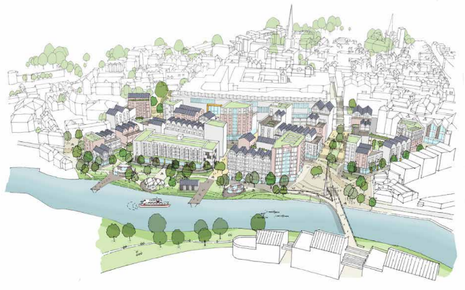

© Shropshire Council, 2022. Smithfield Riverside Development Framework. [Online]
Available at: https://shropshire.gov.uk/committee-services/documents/s29512/Appendix%20A%20-%20SDF%20final%20document.pdf
[Accessed 26 03 2024].

Flood Guidance in the Smithfield Riverside Development Framework (Shropshire Council, 2022)

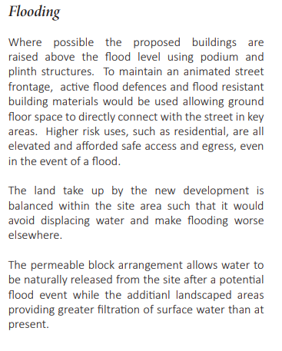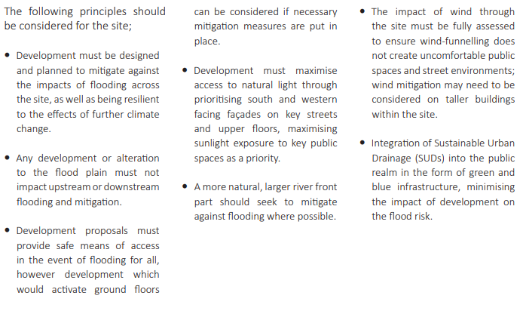
© Shropshire Council, 2022. Smithfield Riverside Development Framework. [Online]
Available at: https://shropshire.gov.uk/committee-services/documents/s29512/Appendix%20A%20-%20SDF%20final%20document.pdf
[Accessed 26 03 2024].

Flood Resilience (Zevenbergen, 2016)

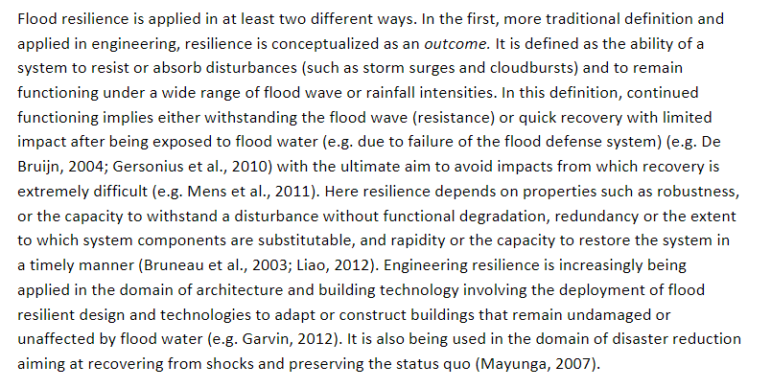
© Zevenbergen, C., 2016. Flood Resilience. In: M. Florin & I. Linkov, eds. International Risk Governance Centre Resource Guide on Resilience. Lausanne: EPFL International Risk Governance Center, p. 280.

Lesson 4 – Press release preparation worksheet (3 pages)

Complete the worksheet electronically.

What is a press release?

A press release is an official statement issued by an organisation to the news media and other targeted publications to provide information about a specific matter, event, or development. A project manager or architect might use a press release to address potential issues and discuss how they plan to mitigate them.

Tips

- Identify the issue: Clearly state the potential issue or concern that has been raised regarding the project.
- Provide context: Briefly explain the background of the project and how the issue fits into the larger picture.
- Outline the mitigation plan: Describe the specific steps and measures being taken to address the issue.
- Emphasise commitment: Reaffirm the project team's commitment to addressing the issue and ensuring the project's success. Minimise negative impacts on the community and environment.
- Invite collaboration: Encourage stakeholders to provide input and collaborate in finding solutions to the identified issue.
- Provide contact information: Include contact details for a designated spokesperson.

You can use a structure to gather all the information you need to write your press release.

Press releases should always be checked before they are published. This helps to prevent errors and omissions.

Once you have reviewed the Data handout, complete the following steps to gather the data needed for your press release.

Target audience:
Who is the primary audience for this press release?

What are their main concerns or interests related to the project?

Key information:
What are the specific flood mitigation measures being implemented in the Smithfield Riverside Development?

How will these measures reduce the risk of flooding in the area?

Reassuring keywords and phrases:

List words and phrases to use that convey a sense of safety, security, and resilience, such as: "Long-term flood risk reduction".

Incorporate these keywords strategically throughout your press release to reinforce the positive impact of the flood mitigation measures.

Quotes and testimonials:
If possible, include a testimonial from a local resident or community leader expressing support for the flood mitigation measures and their potential benefits.

Call to action:
What do you want your audience to do after reading the press release?
Consider including a call to action, such as visiting a project website for more information, attending a community meeting, or providing feedback through a designated channel.

Contact information:
Provide contact details for the project spokesperson or a designated point of contact for media inquiries.

Include the project's website URL, if available, for readers to access additional information.

Example press release

Summit Institute Discovers Roman Remains on Campus

The Summit Institute, a leading further education institution in the United Kingdom, has announced the discovery of significant Roman remains on its campus grounds during a routine construction project. The finds, which include well-preserved architectural features and artifacts, have been preliminarily dated to the 2nd century AD.

The Summit Institute immediately halted construction work and notified the relevant authorities, including Historic England and the local council's archaeology department. The institute has pledged its full cooperation and support in the investigation and preservation of these important historical assets.

Dr Marsha Mellow, Head of the History Department at the Summit Institute, stated, "This discovery provides an incredible opportunity to deepen our understanding of Roman presence in the area. We are committed to collaborating closely with experts in the field to ensure that these remains are properly documented, studied, and preserved for future generations."

The Summit Institute has engaged a team of experienced archaeologists and conservators to assess the extent and significance of the finds. The institute will also be collaborating with the local community and stakeholders to develop a comprehensive plan for the sensitive management of the site, balancing the needs of preservation, education, and campus development.

For further information or inquiries, please contact:
Dr Marsha Mellow
Head of History Department, Summit Institute
xxx@summitinstitute.ac.uk
+44 20 1000000x

Instructions

You now have enough information to create a basic press release.

Draft a press release to reassure these stakeholders that the flood mitigations are being put into place for the Smithfield Riverside development to prevent a potential increase in flood risk to the surrounding area.

Your press release should be no longer than 200-300 words and should be emailed to your teacher and two peers for review.

Draft Press Release

Lesson 4 - Peer review feedback form (2 pages)

Name of person being reviewed: ____________________________________________

Is the press release easy to understand?
Does it flow logically from one point to the next?
Does the press release focus on the most pertinent information regarding the flood defences?
Is there any unnecessary detail that could be removed?
Are the facts about the flood defences and their expected impact accurately represented?
Is the tone appropriate for a press release, striking a balance between professional and accessible?
Is the language clear, avoiding jargon where possible?
Does the press release effectively reassure stakeholders about the flood defences?
Does it highlight the benefits and address potential concerns?
Is the press release well-structured, with a clear headline, introduction, body, and conclusion?
Are there any grammatical or spelling errors?

Peer review feedback form

Name of person being reviewed: ____________________________________________

Is the press release easy to understand?
Does it flow logically from one point to the next?
Does the press release focus on the most pertinent information regarding the flood defences?
Is there any unnecessary detail that could be removed?
Are the facts about the flood defences and their expected impact accurately represented?
Is the tone appropriate for a press release, striking a balance between professional and accessible?
Is the language clear, avoiding jargon where possible?
Does the press release effectively reassure stakeholders about the flood defences?
Does it highlight the benefits and address potential concerns?
Is the press release well-structured, with a clear headline, introduction, body, and conclusion?
Are there any grammatical or spelling errors?

Lesson 5 – AI concept art handout (8 pages)

How design is used to communicate with the client

Design is a powerful tool for communicating ideas, concepts, and solutions to clients. In the context of architectural and urban design projects design is used to effectively convey the proposed vision and engage the client in the following ways:

Visual representation:
- sketches, drawings, and renderings help clients visualise the proposed design solutions
- 2D plan views, elevations, and sections provide a clear understanding of the layout, scale, and spatial relationships of the project
- 3D models, both physical and digital, give clients a more immersive experience of the design.
Concept communication:
- design is used to communicate the overarching concept and theme of the project. for example, creating a vibrant, sustainable and community-oriented seafront or a respectful regeneration project
- the choice of colours, materials, and forms in the design can evoke specific emotions and convey the intended character of the development
- diagrams and schematic drawings can illustrate the key design principles, such as connectivity, accessibility, and integration with the existing context.
Functionality and user experience:
- design communicates how the proposed spaces and amenities will function and cater to the needs of the users
- drawings and diagrams can showcase the circulation patterns of the various components, such as retail, parks, and mixed-use buildings
- perspectives can highlight specific user experiences and activities. this helps the client understand how people will interact with and enjoy the designed spaces.
Context and site analysis:
- design is used to demonstrate how the proposed development responds to and integrates with the existing site context
- site analysis diagrams, such as sun paths, wind patterns, and view corridors, help clients understand the design decisions made in response to the site conditions
- streetscape elevations and sections can show how the new development relates to the surrounding buildings and enhances the overall urban fabric.
Iterative process and collaboration:
- design is an iterative process, and presenting multiple design options allows clients to provide feedback and engage in the decision-making process
- sketches and diagrams can be used to explore and refine ideas collaboratively with the client
- design presentations and workshops provide opportunities for dialogue, enabling clients to express their preferences, concerns, and aspirations for the project.

Instructions

Review the AI generated images over the next few pages and identify the key features that assist the architect in communicating the design vision to the client. You should also identify issues that the use of AI introduces such as paths that don’t go anywhere, elements that make no sense or problems with design feasibility.

Refer to the detail on the previous page.

Write a list of key features that you think should be included in a plan view of a regeneration project.



AI generated image created with Midjourney V6 March 2024 (Author image)
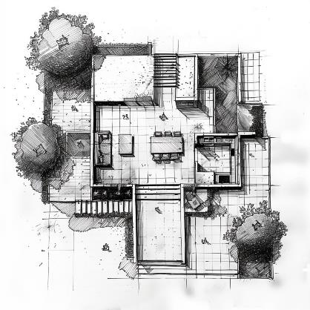
AI generated image created with Midjourney V6 March 2024 (Author image)

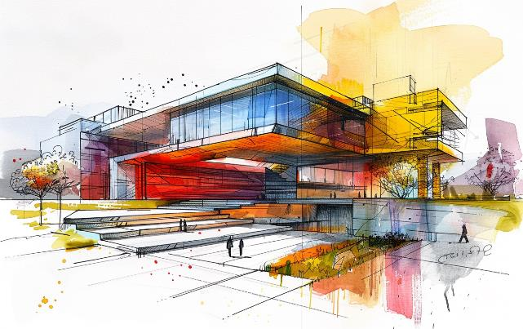

AI generated image created with Midjourney V6 March 2024 (Author image)

AI generated image created with Midjourney V6 March 2024 (Author image)

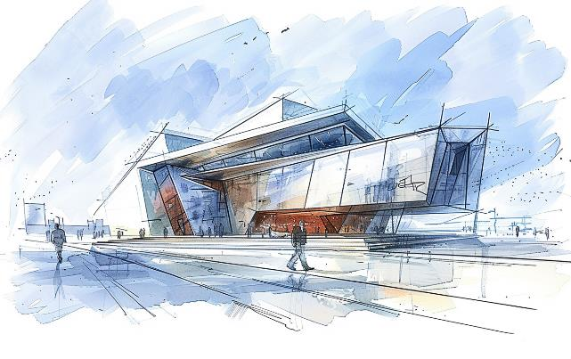
AI generated image created with Midjourney V6 March 2024 (Author image)

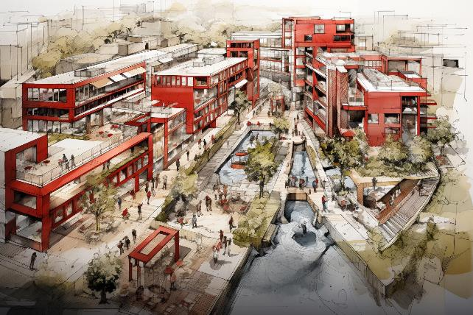
AI generated image created with Midjourney V5.2 March 2024 (Author image)

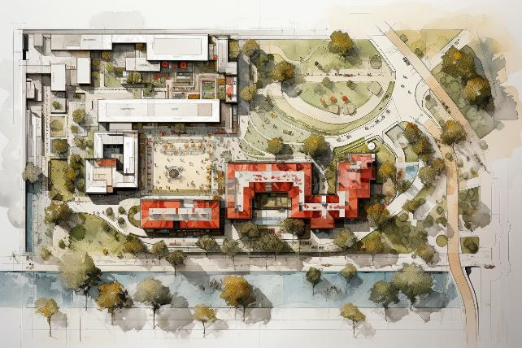
AI generated image created with Midjourney V5.2 March 2024 (Author image)

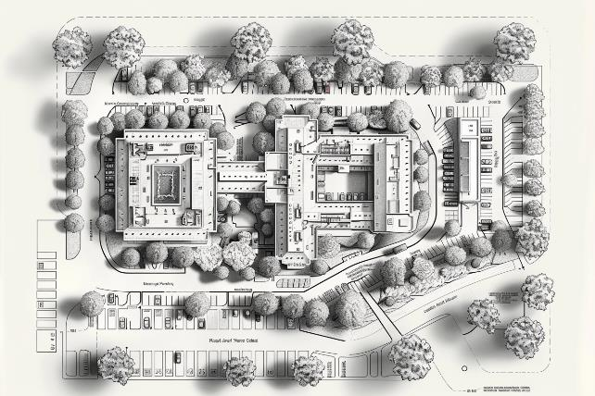
AI generated image created with Midjourney V6 March 2024 (Author image)

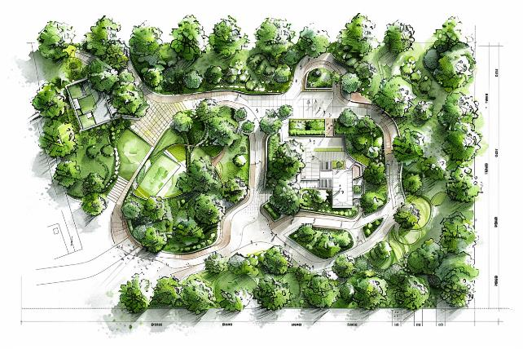
AI generated image created with Midjourney V6 March 2024 (Author image)

Lesson 5 – Use of AI images in construction (2 pages)

Artificial Intelligence (AI) is revolutionising various aspects of architecture and construction, including the generation and use of images. AI-generated images offer numerous benefits and applications in these fields, helping professionals to visualise, plan, and communicate their projects more effectively.

Benefits of AI images in architecture and construction

- AI algorithms can generate highly realistic images of proposed buildings, interiors, and landscapes, allowing clients and stakeholders to better understand and visualise the final product.
- Creating detailed, photorealistic images using traditional methods can be time-consuming and expensive. AI-generated images can be produced more quickly and cost-effectively, streamlining the design process.
- AI images can help bridge the gap between the architect's vision and the client's understanding, facilitating better communication and decision-making throughout the project.
- AI tools allow architects and designers to easily generate multiple variations of a design, enabling them to experiment with different styles, colours, and layouts before finalising the concept.
- Incorporating AI-generated images into presentations and marketing materials can help architecture and construction firms showcase their projects in a more compelling and engaging way.

Applications of AI images in architecture and construction:

- AI can generate images of potential building designs based on specific parameters, such as style, size, and location, helping architects explore and refine their ideas in the early stages of a project.
- AI tools can create realistic images of interior spaces, including furniture layouts, colour schemes, and lighting, allowing clients to visualise and provide feedback on the proposed design.
- AI-generated images can help landscape architects communicate their vision for outdoor spaces, including hardscaping, planting, and water features.
- AI images can be used to visualise and analyse the impact of proposed developments on the surrounding urban environment, aiding in decision-making and public consultation processes.
- AI-generated images can be integrated into virtual reality (VR) and augmented reality (AR) applications, creating immersive experiences that allow clients and stakeholders to explore and interact with the proposed design.

Problems with using AI-generated images in architecture and construction:

- Lack of imagination: AI algorithms are trained on existing data and may struggle to generate truly original or innovative designs. The images produced may be derivative or lack the creative spark that human designers can bring to a project.
- Inconsistency: AI-generated images may lack consistency in style, scale, or level of detail. This can be particularly problematic when trying to create a cohesive set of images for a single project or presentation.
- Strange and illogical concepts: AI algorithms can sometimes generate images that include bizarre or illogical elements, such as physically impossible structures or nonsensical combinations of objects. These errors can be difficult to spot and correct, leading to confusion or misinterpretation.
- Lack of context: AI-generated images may not consider the broader context of a project, such as the surrounding environment, cultural considerations, or practical constraints. This can result in designs that are not feasible or appropriate for the specific location or purpose.
- Limited understanding of materials and construction techniques: AI algorithms may not have a deep understanding of the properties and limitations of various building materials or the practical considerations of construction techniques. This can lead to images that depict structures or designs that are not technically possible or economically viable.
- Difficulty in capturing intangible qualities: Certain intangible qualities, such as atmosphere, ambiance, or emotional response, can be challenging for AI algorithms to capture in generated images. These subtle but important aspects of design may be lost or overlooked in AI-generated representations.
- Overreliance and deskilling: An overreliance on AI-generated images may lead to a deskilling of architecture and construction professionals. If designers and architects become too dependent on AI tools, they may lose the ability to think critically, problem-solve, and create innovative solutions on their own.
- Ethical and legal concerns: The use of AI-generated images raises ethical and legal questions, such as copyright issues, ownership of the generated content, and potential biases in the algorithms used to create the images. These concerns must be carefully considered and addressed when incorporating AI-generated images into professional practice.
- Misinterpretation and miscommunication: AI-generated images may be misinterpreted by clients or stakeholders who are not familiar with the technology or its limitations. This can lead to miscommunication and unrealistic expectations about the final design or construction outcome.
- Lack of personal touch: AI-generated images may lack the personal touch and unique perspective that human designers bring to a project. The emotional connection and storytelling aspect of design may be diminished when relying heavily on AI-generated visuals.

Lesson 5 – Checklist template

Review the AI generated images and identify a list of key considerations when communicating a design vision to a client. Work with the class to agree a final list to include in the checklist template.

Key considerations | Description | ü

Lesson 5 – Project details (5 pages)

Worthing East Seafront (also available in the resources as Lesson 5 - Worthing East Seafront.png)

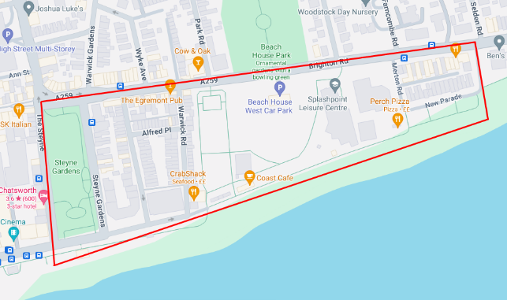

Steyne Gardens Map Pin https://maps.app.goo.gl/jpkW85m3XMDMwxUQ6

Brighton Road length of development 620m
Steyne Gardens from Brighton Road to Beach 220m
Brighton Road to Beach at New Parade End 100m

Scenario

Worthing Council has decided to revitalise the East Seafront area to enhance its recreational offerings, green spaces, and community amenities. The redevelopment will focus on the stretch along Brighton Road, extending from Steyne Gardens to New Parade.

The plan should include the following key elements:

A new mixed-use leisure centre complex near the centre of the development, featuring:
- an indoor swimming pool
- a fitness centre and gym
- a multi-purpose sports hall
- retail units on the ground floor (e.g., sports shops, health food stores)
- cafes and restaurants with outdoor seating areas.
Two new parks:
- one larger park adjacent to the leisure centre, with landscaped gardens, walking paths, a children's play area, and a small amphitheatre for outdoor events
- a smaller linear park along the seafront promenade, with seating areas, public art installations, and exercise stations.

Mixed-use buildings along Brighton Road:
- ground floor units for shops, cafes, and other commercial uses that cater to both residents and visitors
- upper floors containing a mix of residential apartments and office spaces
- building heights varying between 3 to 5 stories to create visual interest and minimise the impact on existing views.
Improved public area and connections:
- widened sidewalks along Brighton Road to create a more pedestrian-friendly environment
- dedicated cycle lanes to encourage sustainable transportation
- enhanced landscaping, including street trees, planters, and public seating
- improved pedestrian crossings and connections between the seafront, parks, and surrounding areas.
Integration with existing site features:
- create visual and physical links between the new development and the surrounding context.

The plan should be overlaid on the existing map and shared with the client as a concept.

More than one concept can be created.

Beach House is a listed building and must be carefully integrated into the plan.


Image © Historic England https://historicengland.org.uk/listing/the-list/list-entry/1025808

Instructions

Rough sketch your designs onto paper. You should consider at least 5 loose layouts that include all the large elements from the project details. You do not need to put in any detail at this point. It is important that you communicate a consistent vision. Therefore, while you are sketching, you should carefully consider how to communicate your vision to your client.

When you have discussed your vision and shown your sketches to your peer you are ready to move onto the final design. A template is provided for you to complete.

Here are some ideas that you may wish to use in your design. Consider what these communicate to the client.

Leisure Centre Complex:
- rectangular or curved building footprint
- clearly defined entrances and exits
- outdoor seating areas and plazas adjacent to the building
- landscaping and trees around the perimeter.
Parks and Landscaping:
- organic, curvilinear shapes for gardens and planting areas
- geometric or abstract shapes for hardscaped areas and paths
- symbols or icons to represent water features, public art, and playgrounds
- varied line weights and hatch patterns to differentiate between paved and planted areas
- amphitheatre represented by concentric circles or a fan-shaped layout.
Mixed-Use Buildings:
- rectangular building footprints with clear divisions between units
- setbacks and variations in the building line to create visual interest
- symbols or labels to indicate ground-floor commercial units and upper-floor uses
- rooftop gardens and terraces represented by dashed lines or distinct hatch patterns.
Public Areas and Connectivity:
- clear hierarchy of streets, sidewalks, and paths using different line weights and colours
- crosswalks and pedestrian zones marked with zebra stripes or distinct paving patterns
- bicycle lanes indicated by dashed lines or symbols
- street trees and planting areas lining the sidewalks and roads
- public art and sculpture represented by symbols or icons.
Integration with Existing Assets:
- beach house and other existing buildings clearly labelled and outlined
- landscaping and public spaces around existing buildings to create a seamless transition
- sight lines and visual connections between new development and existing assets represented by dashed lines or arrows.

You saw a simple plan overview of a regeneration project in Lesson 2. Consider how the designers use simple shapes and colour to communicate the use of the area.

Smithfield Riverside development phase 1. (Smithfield Riverside, 2024)

© Smithfield Riverside, 2024. A PHASED MASTERPLAN. [Online] Available at: https://www.smithfieldriverside.com/plans [Accessed 26 03 2024].

A3 Plan outline

Sketch your plan to scale on the template Remember to include the key features from the project details. Beach house must not be changed. You must stay within the black outline. You should annotate your drawing and provide a key to improve communication.

Use a ruler and colour pencils.

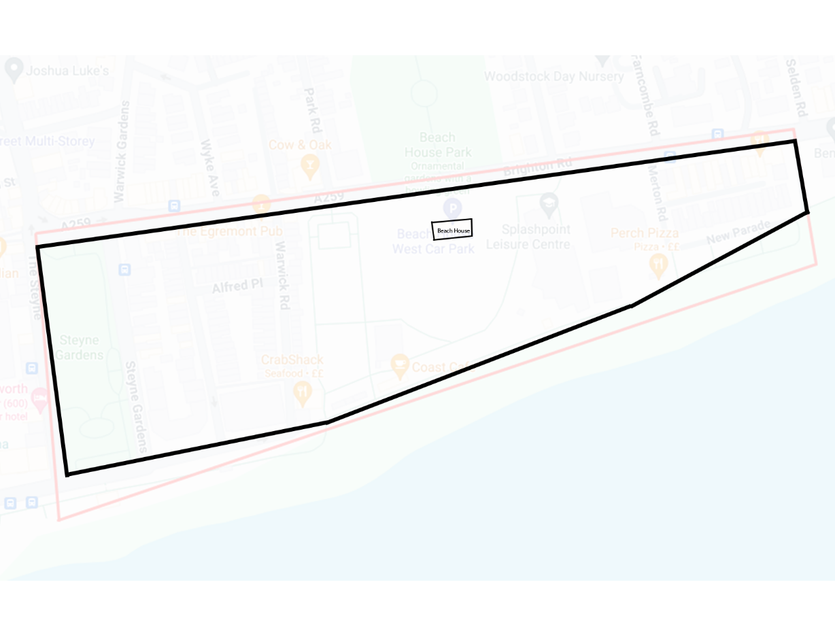

Lesson 6 – Visual communication resource links

The Essential Role of Technical Drawings in Architecture
https://www.archisoup.com/technical-drawings

UK Planning Maps
https://www.ukplanningmaps.com/site-plan

What is a site plan
https://getasiteplan.com/site-plan/

Detail Library
https://detail-library.co.uk/

Construction Details
https://www.labc.co.uk/business/construction-details

Designing buildings – construction details
https://www.designingbuildings.co.uk/Construction_details

Construction detail types
https://biblus.accasoftware.com/en/construction-details-types/

Archisoup – construction details
https://www.archisoup.com/construction-details

Inspiration landscape designs
https://www.creativebloq.com/inspiration/landscape-designs-11121231

Landzine – realised projects
https://landezine.com/landscapes/landscape-architecture/realized-projects/

EPD Landscape – community consultation
https://www.epdlandscape.co.uk/?skills=community-consultation

Community advisory boards
https://www.publicengagement.ac.uk/resources/briefings/terms-reference-convening-knowledge-about-community-advisory-boards-cabs

General public engagement
https://www.publicengagement.ac.uk/

Wynne Williams Associates - public consultation
https://w-wa.co.uk/consultation-community-engagement/

Place Services
https://www.placeservices.co.uk/what-we-do/built-environment/urban-design-landscape-architecture/facilitation,-training-and-community-engagement/

Breeam Communities
https://breeam.com/standards/communities
Think Architecture – Sustainable landscape design principles
https://www.thinkaec.com/sustainable-landscape-design-principles/

Royal Parks Management plans
https://www.royalparks.org.uk/park-management/management-plans

UK Government international investment
https://www.great.gov.uk/international/content/investment/sectors/greener-buildings/

Lesson 6 – Target audience presentation activity handout (3 pages)

Instructions

- You will be allocated one of the target audiences listed below.
- Discuss the requirements of the target audience with your group.
- Plan the presentation using the presentation planning questionnaire.
- Prepare a presentation tailored to your target audience, considering their specific interests, concerns, and level of understanding.
- Use appropriate language, visuals, and examples to effectively convey the key message to your audience.
- Be creative in your presentation style and format to ensure your message resonates with your target audience but stick to the guidelines from “How to avoid death by PowerPoint” TED Talk.
- Be prepared to answer questions and address any concerns your audience may have regarding the construction project. You can do this by writing speaker notes in the presentation.

Scenario

UK Construction Project: Redevelopment of the former Ironworks industrial site in Middlewich, Cheshire, into a mixed-use development called "Middlewich Yards." The project will feature 250 residential units (a mix of apartments and townhouses), 5,000 square meters of commercial space (including offices, retail, and restaurants), and a 1,000 square meter community centre with a library, meeting rooms, and a public garden.

Project details:

- Developer: Brightstone Properties Ltd.
- Architects: Innovate Architects & Co.
- Main Contractor: BuildRight Construction Ltd.
- Project Timeline: 2024-2027
- Estimated Project Cost: £75 million
- Sustainability Features: Green roofs, solar panels, rainwater harvesting, and electric vehicle charging points.

Target audiences:

Local residents

A community meeting to address concerns about the impact of the construction project on the neighbourhood. Message: The construction project will bring long-term benefits to the community, such as improved facilities, job opportunities, and enhanced local amenities.

Potential buyers

A marketing event to showcase the residential units and attract potential buyers. Message: The development offers modern, sustainable, and high-quality homes in a convenient location, perfect for families and young professionals.

Local business owners

A networking event to discuss the potential benefits of the development for local businesses. Message: The mixed-use development will attract new customers, create opportunities for business growth, and contribute to the overall economic vitality of the area.

Local council members

A presentation to the local council to secure support and necessary approvals for the project. Message: The redevelopment aligns with the council's goals for sustainable urban regeneration, addressing housing needs, and promoting economic growth in the area.

Environmental groups

A stakeholder meeting to discuss the project's environmental impact and mitigation measures. Message: The development incorporates green spaces, energy-efficient design, and sustainable construction practices to minimise its environmental footprint and contribute to a greener future.

Investors

An investment pitch to secure funding for the construction project. Message: The mixed-use development offers a strong return on investment, with a diverse range of income streams and a high demand for residential and commercial spaces in the area.

Construction workers

A team briefing to discuss the project timeline, safety measures, and site logistics. Message: The construction project provides stable employment opportunities, with a focus on safety, skill development, and fostering a positive work environment.

Local planning authority

A pre-application meeting to discuss the project's compliance with local planning policies and building regulations. Message: The development has been designed to meet all relevant planning policies and building regulations, contributing to the sustainable growth of the area while respecting its heritage and character.

Local heritage society

A consultation meeting to discuss the project's impact on local heritage assets and proposed mitigation measures. Message: The development will sensitively integrate with the surrounding heritage assets, preserving and enhancing the area's historical character while bringing new life to the former industrial site.

Lesson 6 – Summary of “How to avoid death by PowerPoint” TED Talk

Based on the TEDx talk by David JP Phillips, here are the key things people should do to improve their PowerPoint presentations and the cognitive science behind why:

- Have only one message per slide. Having multiple messages splits attention, just like trying to listen to two conversations at once. Stick to one clear message per slide.
- Minimise text on slides, especially if also speaking. When slides have lots of text and the presenter is speaking, it causes the "redundancy effect" and leads to very little being remembered. Use short text and images on slides while speaking.
- Make the most important content the biggest on the slide. We are biologically wired to focus on large objects. Often the biggest thing is the headline when it should be the main content.
- Use contrast to direct focus, like highlighting key points. Our eyes are drawn to contrast. Presenters can use this to guide attention.
- Use a dark background, not white. White backgrounds make the slides higher contrast than the presenter. Dark backgrounds put the focus on the speaker.
- Limit each slide to a maximum of 6 objects. It takes 500% more cognitive energy to count objects than to simply see them. Slides with 6 or fewer objects allow the audience to easily process the content. More than 6 requires a lot of extra mental effort.

Lesson 6 – Presentation planning questionnaire (5 pages)

- Who is your target audience?
  - What are their interests, concerns, and level of understanding regarding the project?
  - How can you tailor your content and language to effectively communicate with them?

- What is the key message you want to convey to your target audience?
  - Why is this message important to them?
  - How can you make your message clear, concise, and compelling?

- What essential information about the Middlewich Yards project should you include?
  - Which project features and benefits are most relevant to your target audience?
  - How can you present this information in an engaging and easy-to-understand manner?

- How will you structure your presentation to effectively communicate your message?
  - What is the logical flow of information?
  - How will you introduce the topic, develop your main points, and conclude your presentation?

- What visuals (e.g., images, diagrams, charts) can you use to support your message?
  - How can these visuals enhance understanding and engagement?
  - Are your visuals clear, relevant, and professional?

- How will you address potential concerns or objections from your target audience?
  - What questions or issues might they raise?
  - How can you proactively address these concerns in your presentation?

- How will you engage your target audience during the presentation?
  - What opportunities for interaction, questions, or feedback will you provide?
  - How can you maintain a connection with your audience throughout the presentation?

- How will you conclude your presentation effectively?
  - What are the key takeaways you want your audience to remember?
  - How can you reinforce your main message and leave a lasting impression?

Using the details from the questionnaire, list the slides and content you will need.

Lesson 7 – Debate game activity handout

Part 1 (Side 1)

Instructions

- Prepare (15 minutes): As a team, discuss and gather arguments supporting the premise that anyone should be allowed to build a house without restriction if they own the land. Consider points such as property rights, freedom of choice, and economic benefits.
- Select team members (1 minute): Choose two people to represent your team in the debate. One person will present the opening statement and the first argument, while the other will present the second argument and the rebuttal.
- Opening statement (3 minutes): The first team member presents a brief introduction outlining the main arguments supporting the premise.
- Argument (5 minutes): The first team member presents the first argument in detail, providing evidence and examples to support the premise.
- Rebuttal (3 minutes): After the opposing team presents their argument, the second team member rebuts their points and reinforces your team's stance.
- Questions from the audience (5 minutes): The audience gets 5 minutes to ask questions of any member of the debate team.

Premise: Anyone should be allowed to build a house without restriction if they own the land.

Part 2 (side 2)

Instructions

- Prepare (15 minutes): As a team, discuss and gather arguments opposing the premise that anyone should be allowed to build a house without restriction if they own the land. Consider points such as safety regulations, environmental impact, and community aesthetics.
- Select team members (1 minute): Choose two people to represent your team in the debate. One person will present the opening statement and the first argument, while the other will present the second argument and the rebuttal.
- Opening statement (3 minutes): The first team member presents a brief introduction outlining the main arguments against the premise.
- Argument (5 minutes): The first team member presents the first argument in detail, providing evidence and examples to counter the premise.
- Rebuttal (3 minutes): After the opposing team presents their rebuttal, the second team member defends your team's stance and highlights the flaws in the opposing team's arguments.
- Questions from the audience (5 minutes): The audience gets 5 minutes to ask questions of any member of the debate team.

Premise: Nobody should be allowed to build a house without restriction if they own the land.
Lesson 7 – Professional discussion conventions handout (2 pages)

In professional settings, it is essential to follow certain conventions to ensure effective, respectful, and productive discussions. This handout outlines the key conventions to keep in mind when engaging in professional discussions.

Preparation:
- review the agenda or topic beforehand to ensure you are well-informed and can contribute meaningfully to the discussion
- bring any relevant materials, such as notes, documents, or data, to support your points.
Active Listening:
- pay attention to the speaker and avoid interrupting or talking over others
- show interest and engagement through nonverbal cues, such as nodding and maintaining eye contact
- take notes to capture important points and to help formulate your own thoughts and questions
- avoiding distractions: minimising distractions, such as looking at your phone or fidgeting, shows respect and attentiveness.
Speaking:
- indicate your desire to speak by raising your hand or using a similar gesture
- wait for the current speaker to finish before contributing your own ideas
- use clear, concise language and avoid jargon or technical terms that may not be familiar to everyone.
Professionalism:
- maintain a respectful and professional tone, even if you disagree with someone's viewpoint
- avoid personal attacks or derogatory language
- be mindful of your body language and facial expressions, ensuring they convey openness and respect.
Contribution:
- offer insights, opinions, and ideas that are relevant to the topic at hand
- support your points with evidence, examples, or data when appropriate
- ask questions to clarify understanding or to encourage further discussion.
Time Management:
- be mindful of the allotted time for the discussion and ensure your contributions are concise and to the point
- allow others the opportunity to speak and contribute their ideas.
Consensus Building:
- work towards finding common ground and building consensus, even if there are differing opinions
- be open to compromise and alternative perspectives.
Follow-up:
- take responsibility for any action items or activities assigned to you during the discussion
- follow up on any questions or concerns that were raised but not fully addressed during the discussion.

Common phrases:

"I'd like to add to that point..."
"Building on what [name] said..."
"I have a question regarding..."
"Can you clarify what you meant by...?"
"I respectfully disagree with that point because..."
"Let's explore that idea further..."
"I think we should consider..."
"To summarise our discussion so far..."

Nonverbal communication cues

Body language:
- sitting up straight or standing with shoulders back conveys confidence and attentiveness
- leaning slightly forward shows interest and engagement in the discussion
- subtly mirroring the body language of others can help build rapport and create a sense of connection.
Facial expressions:
- maintaining appropriate eye contact with the speaker or audience demonstrates interest and respect
- a genuine smile can convey warmth, friendliness, and openness to ideas
- nodding your head occasionally shows agreement, understanding, or encouragement for the speaker to continue
- raising your eyebrows can express surprise, interest, or a desire to ask a question.
Gestures:
- using hand gestures can help emphasise points, add visual interest, and convey enthusiasm
- pointing at a person or object can direct attention and help clarify ideas
- showing open palms can signal honesty, openness, and a willingness to collaborate.

Lesson 7 – Impromptu speech topics

Instructions

- Select one of the following topics.
- Use your one minute of time to prepare a speech by jotting a series of bullet points.
- Give the speech to the other members of your group.
- Listen to the other members of your group give their speeches.

Topics

- The importance of volunteering in your local community.
- The role of social media in modern communication.
- The benefits of learning a foreign language.
- The impact of technology on the job market.
- The importance of mental health awareness among teenagers.
- The benefits of participating in extracurricular activities.
- The role of art and creativity in education.
- The importance of physical fitness for overall well-being.
- The impact of climate change on the UK.
- The benefits of a balanced diet for teenagers.
- The importance of time management skills for success.
- The role of diversity and inclusion in modern society.
- The impact of peer pressure on teenage decision-making.
- The benefits of reading for personal growth and development.
- The importance of financial literacy for young adults.
- The role of leadership skills in personal and professional success.
- The impact of social inequality on education.
- The benefits of mindfulness and meditation for stress reduction.
- The importance of critical thinking skills in the digital age.
- The role of empathy and kindness in building strong relationships.
- The impact of globalisation on the UK economy.
- The benefits of a strong support system for personal growth.
- The importance of adaptability in a rapidly changing world.
- The role of curiosity in lifelong learning.
- The impact of gender stereotypes on career choices.
- The benefits of taking calculated risks for personal and professional growth.
- The importance of effective communication skills in the workplace.
- The role of resilience in overcoming challenges and setbacks.
- The impact of social media on body image and self-esteem.
- The benefits of setting goals and working towards them.

Lesson 7 – Preprepared speeches (6 pages – print speech one and speech two separately)

Instructions

- Read speech one
- Answer questions
- Listen to your opposite read speech two
- Ask at least 5 of the questions for speech two.
- Listen to the answers.

Speech one

Imagine for a moment that you're standing at the edge of a cliff, overlooking a vast, beautiful canyon. The view is breathtaking, and you can't help but feel a sense of awe and wonder. But then, you realise something: you have no idea how you got there, or where you're supposed to go next.

This is what life can feel like when we don't have clear goals and directions. We might be surrounded by incredible opportunities and possibilities, but without a sense of purpose or direction, we risk feeling lost and unfulfilled.

That's where the power of goal setting comes in. When we take the time to sit down and really think about what we want to achieve, both in the short-term and the long-term, we give ourselves a roadmap for success. We create a clear vision of where we want to go, and we can start taking concrete steps to get there.

Now, I know what some of you might be thinking: "But I'm only 16, I don't need to have my whole life figured out yet!" And you're absolutely right. But here's the thing: setting goals isn't about having everything figured out, it's about giving yourself a sense of direction and purpose.

When I was a few years older than you, I set a goal for myself to volunteer abroad. I had no idea how I was going to make it happen, but I knew it was something I wanted to do. So, I started saving up money from my part-time job, and I researched different volunteer programs. It took a lot of hard work and dedication, but two years later, I found myself teaching English in a small village in Thailand.

That experience taught me so much about myself and the world around me. It showed me that I could achieve anything I set my mind to, as long as I was willing to put in the effort. And it gave me a sense of purpose and fulfilment that I had never experienced before.

But the benefits of goal setting go beyond just achieving the goal itself. The process of working towards a goal, of pushing ourselves outside of our comfort zones and learning new skills, is just as valuable as the end result. It helps us grow and develop as individuals, and it gives us a sense of confidence and self-worth that can carry over into all aspects of our lives.

So, my challenge to all of you today is this: take some time to think about what you want to achieve, both in the short-term and the long-term. It doesn't have to be anything grandiose or life-changing, but it should be something that excites and motivates you. Write it down, make a plan, and then start taking action.

Will it be easy? No, probably not. But will it be worth it? Absolutely. Because at the end of the day, the greatest gift we can give ourselves is the opportunity to grow, to learn, and to become the best versions of ourselves.

So, let's embrace the power of goal setting, and let's start creating the lives we want for ourselves. Because when we do, we open up a world of possibilities and opportunities that we never even knew existed.

Speech one answers

- The right goals are ones that align with your values, passions, and long-term vision for your life. They should challenge you to grow and develop, but also be achievable with hard work and dedication. Trust your instincts and be honest with yourself about what truly matters to you.
- It's okay to not have everything figured out! Start by setting shorter-term goals that excite and motivate you and use the process of working towards them to clarify your longer-term aspirations. Seek out new experiences, talk to people you admire, and don't be afraid to explore different paths.
- Stay motivated by breaking your goal down into smaller milestones, celebrating your progress along the way, and reminding yourself of why the goal matters to you. Surround yourself with supportive people, visualise your success, and focus on the journey, not just the destination.
- Setbacks and obstacles are a normal part of the goal-setting process. When you face them, don't get discouraged - instead, use them as opportunities to learn, adapt, and grow. Seek out advice and support from others and remember that every challenge you overcome makes you stronger and more resilient.
- Reassess your goals regularly - at least once a year, or whenever you experience a significant change in your life or priorities. Be flexible and willing to adjust your goals as needed, but also stay committed to your overall vision and values.
- Setting goals is only a bad thing if you become so obsessed with achieving them that you neglect other important aspects of your life, like your relationships, health, or well-being. Strive for balance and remember that goals are meant to enrich your life, not consume it.
- Break down a big goal into smaller, more manageable steps by working backwards from the end result and identifying the key milestones along the way. Focus on taking action on one step at a time and celebrate your progress as you go.
- Hold yourself accountable by sharing your goals with others, tracking your progress in a journal or app, and setting regular check-ins with yourself to assess your performance. Consider finding an accountability partner or joining a support group of people working towards similar goals.
- Failure is a natural part of the learning and growth process. Embrace it as an opportunity to learn and improve, rather than a reflection of your worth or abilities. Remember that every successful person has failed many times along the way - what matters is how you respond and keep moving forward.
- Balance your personal goals with other responsibilities and priorities by being realistic about your time and energy, setting clear boundaries, and communicating your needs and expectations to others. Remember that taking care of yourself and your relationships is just as important as achieving your goals - it's all about finding a healthy, sustainable balance.

Speech two questions

- What specific emerging technologies are most likely to disrupt the construction industry?
- How soon do you think we'll see widespread adoption of these technologies in construction?
- What skills should young people in construction focus on developing to stay competitive?
- Will there still be a need for manual labour in construction, or will machines replace human workers entirely?
- How can construction companies best integrate these new technologies into their existing workflows?
- What are some of the potential drawbacks or challenges of adopting these new technologies in construction?
- How might these technologies change the way construction projects are designed and managed?
- What role will human creativity and problem-solving play in a more automated construction industry?
- Are there any specific job roles in construction that are more likely to be automated than others?
- How can young people in construction stay informed about emerging technologies and their potential impact on the industry? ￼

Speech two

Instructions

- Listen to your opposite read speech one.
- Ask at least 5 of the questions for speech one.
- Listen to the answers.
- Read speech two.
- Answer questions.

Questions for speech one

- How do I know if I'm setting the right goals for myself?
- What if I'm not sure what I want to achieve in the long-term?
- How can I stay motivated when working towards a challenging goal?
- What if I face setbacks or obstacles while pursuing my goals?
- How often should I reassess and adjust my goals?
- Can setting goals ever be a bad thing, like if I become too obsessed with achieving them?
- What's the best way to break down a big goal into smaller, more manageable steps?
- How can I hold myself accountable for making progress towards my goals?
- What if I'm afraid of failing at my goals?
- How do I balance my personal goals with other responsibilities and priorities in my life?
Speech two

Picture this: you're a young person, just starting out in your career, and you're looking at the construction industry. It's a solid choice, right? Good pay, stable work, and the satisfaction of building something with your own two hands. But then you start hearing whispers about new technologies, about machines that can lay bricks and pour concrete faster than any human ever could. And suddenly, you're not so sure about your future anymore.

This is the reality that many young people in the construction industry are facing today. The rise of emerging technologies, from 3D printing to robotics to artificial intelligence, is changing the game in ways we never could have imagined just a few short years ago.

Now, I know what some of you might be thinking: "But construction is all about manual labour, how could machines possibly replace human workers?" And it's a fair question. But the truth is, we're already seeing it happen.

Take bricklaying, for example. There are now robots that can lay bricks six times faster than a human worker, with perfect accuracy and precision. And it's not just bricklaying - there are machines that can paint, machines that can tile, even machines that can install drywall.

But before we start panicking about a robot takeover, let's take a step back and look at the bigger picture. Yes, some jobs in the construction industry may become automated in the coming years. But that doesn't mean there won't be new opportunities emerging as well.

Think about it - with new technologies comes the need for new skills. We'll need people who can program and maintain these machines, people who can integrate them into existing construction processes, and people who can think creatively about how to use them to build better, faster, and more efficiently.

And let's not forget about the human element. No matter how advanced our technologies become, there will always be a need for people who can communicate effectively, who can problem-solve on the fly, and who can lead teams and inspire others.

So, what does this mean for you, as a young person considering a career in construction? It means that now, more than ever, it's important to stay curious and adaptable. It means being willing to learn new skills and take on new challenges, even if they're outside of your comfort zone.

And most importantly, it means not being afraid of change. Because let's face it - change is inevitable. The construction industry of tomorrow will look quite different from the construction industry of today, and that's okay. In fact, it's exciting.

So, embrace the change, and embrace the opportunities that come with it. Take the time to learn about emerging technologies and how they might impact your chosen field. Network with people who are already working with these technologies and seek out mentors who can guide you along the way.

And more than anything else, don't let fear hold you back. Yes, the future may be uncertain, but that's what makes it so exciting. With the right mindset and the right skills, you can be a part of shaping that future - and building a better world for all of us.

So go out there and start exploring. Start learning. Start building. Because the construction industry of tomorrow needs people like you - people who are willing to take risks, to think differently, and to lead the way into a new era of innovation and possibility.

Answers for speech two

- Some of the most disruptive emerging technologies in construction include 3D printing, robotics, artificial intelligence, drones, and virtual and augmented reality.
- The pace of adoption will vary depending on factors like cost, regulatory considerations, and industry acceptance, but many experts predict significant uptake within the next 5-10 years.
- Young people in construction should focus on developing skills in areas like programming, data analysis, problem-solving, communication, and adaptability.
- While some manual labour tasks may become automated, there will still be a need for human workers to oversee and complement the work of machines, particularly in areas that require creativity, critical thinking, and people skills.
- Construction companies can best integrate new technologies by investing in training and education for their workforce, partnering with technology providers, and gradually phasing in new tools and processes alongside existing ones.
- Some potential drawbacks of adopting new technologies in construction include high upfront costs, the need for ongoing maintenance and updates, and the risk of over-reliance on machines at the expense of human judgment and expertise.
- New technologies may enable more complex and innovative designs, faster project timelines, and greater collaboration between project stakeholders, but they will also require new approaches to project management and coordination.
- Human creativity and problem-solving will remain essential in a more automated construction industry, particularly when it comes to adapting to unexpected challenges, developing innovative solutions, and ensuring that projects meet the needs of end-users.
- Job roles that involve repetitive, manual tasks, such as bricklaying, painting, and basic assembly, are more likely to be automated than those that require complex decision-making, creativity, or interpersonal skills.
- Young people in construction can stay informed about emerging technologies by attending industry conferences and workshops, reading trade publications and blogs, participating in online forums and discussion groups, and seeking out mentorship opportunities with experienced professionals who are already working with these technologies.

Lesson 7 - Reflection activity worksheet (2 pages)

Part 1: Likert Scale Questions

I felt well-prepared for the debate, discussion and speeches.
I actively listened to others during the debate, discussion and speeches.
I contributed relevant and meaningful ideas to the discussion.
I used clear and concise language when speaking.
I maintained a professional tone and demeanour throughout the debate, discussion and speeches.
I effectively used nonverbal cues to convey engagement and respect.
I asked questions to clarify understanding or encourage further discussion.
I used appropriate nonverbal communication.
I worked towards building consensus and finding common ground.
I feel confident in my ability to engage in professional debates, discussions and speeches.

Part 2: Short answer questions

Describe a moment during the lesson when you felt particularly engaged or proud of your contribution.

Identify an area where you believe you could improve your discussion skills. What steps can you take to address this area?

How did the use of professional conventions impact the overall effectiveness and productivity of the discussion?

Reflect on your nonverbal communication during the lesson. What nonverbal cues did you use effectively? Are there any nonverbal cues upon which you could improve?

Consider a moment when you disagreed with someone's viewpoint during the debate. How did you manage this situation? Would you approach it differently in the future?

Circle or highlight the most important skills for you to develop in the next 5 years.

Lesson 8 – Project scenario

The Summit Institute is undertaking a major campus expansion project to create a state-of-the-art learning facility that will serve its growing learner community. The project includes the construction of a new building featuring modern classrooms, specialised labs, a learner hub, a multi-purpose auditorium, and outdoor learning spaces.

However, as the project progresses, several issues have arisen that require additional funding to be addressed. These issues, if not resolved, could lead to project delays, compromised quality, or failure to meet the college's objectives.

As a member of the project team, you must persuasively present one of these issues to various project stakeholder or community members groups and convince them of the necessity of allocating extra funds to address the problem effectively.

Each community member group will have a different opinion of whether the funds should be allocated to that issue or another. You will need to adjust your argument based on who you are talking to.



AI generated image of the college atrium. (Author image)
Lesson 8 – Teacher instructions (2 pages)

- The class will be split into small (2-3 people) project stakeholder or community member groups (2-4 members), with each group receiving a stakeholder card (either a project stakeholder or a community member) that outlines their role, interests, and concerns regarding the project. There needs to be at least 3 project stakeholder groups.
- Each project stakeholder group will randomly select a project issue card from the pack.
- Each "community members" (i.e., the interested party stakeholder groups) will randomly select a character card and will comment as that character.
- Groups will have 15 minutes to prepare their arguments for being awarded funding to resolve the issue (project stakeholder groups) or what their position is if they are an interested party (positive, negative, neutral or “it depends!”). They will prepare questions to ask based on their community position.
- Each group of project stakeholder learners will present their project issue to the "community members", explaining why additional funds are needed to address the issue.
- The project stakeholder groups will ask questions, express concerns, and challenge the presenters based on the information provided on their stakeholder cards.
- The presenters must respond persuasively to the questions and concerns raised by the stakeholders, adapting their arguments to address the specific interests and priorities of each group.

You may replay or get learners to reselect cards if necessary to make the game work smoother.

The game cards are on the following pages.

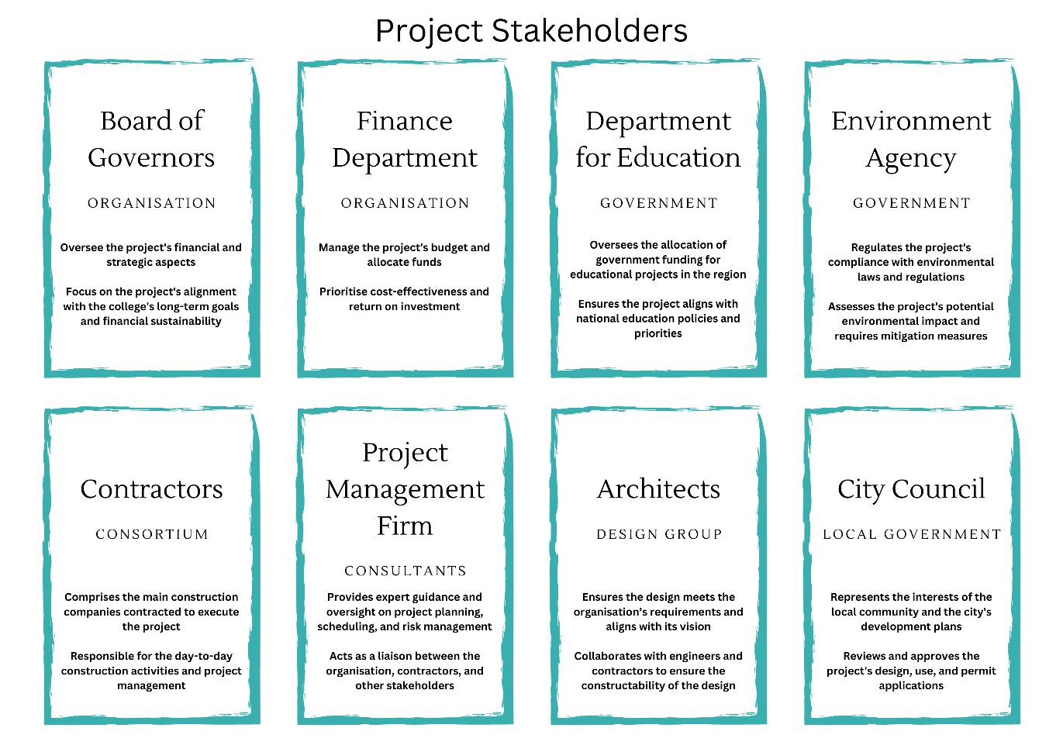
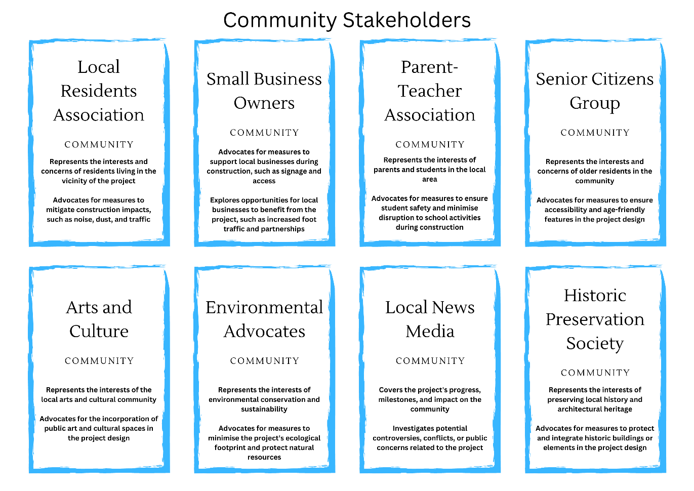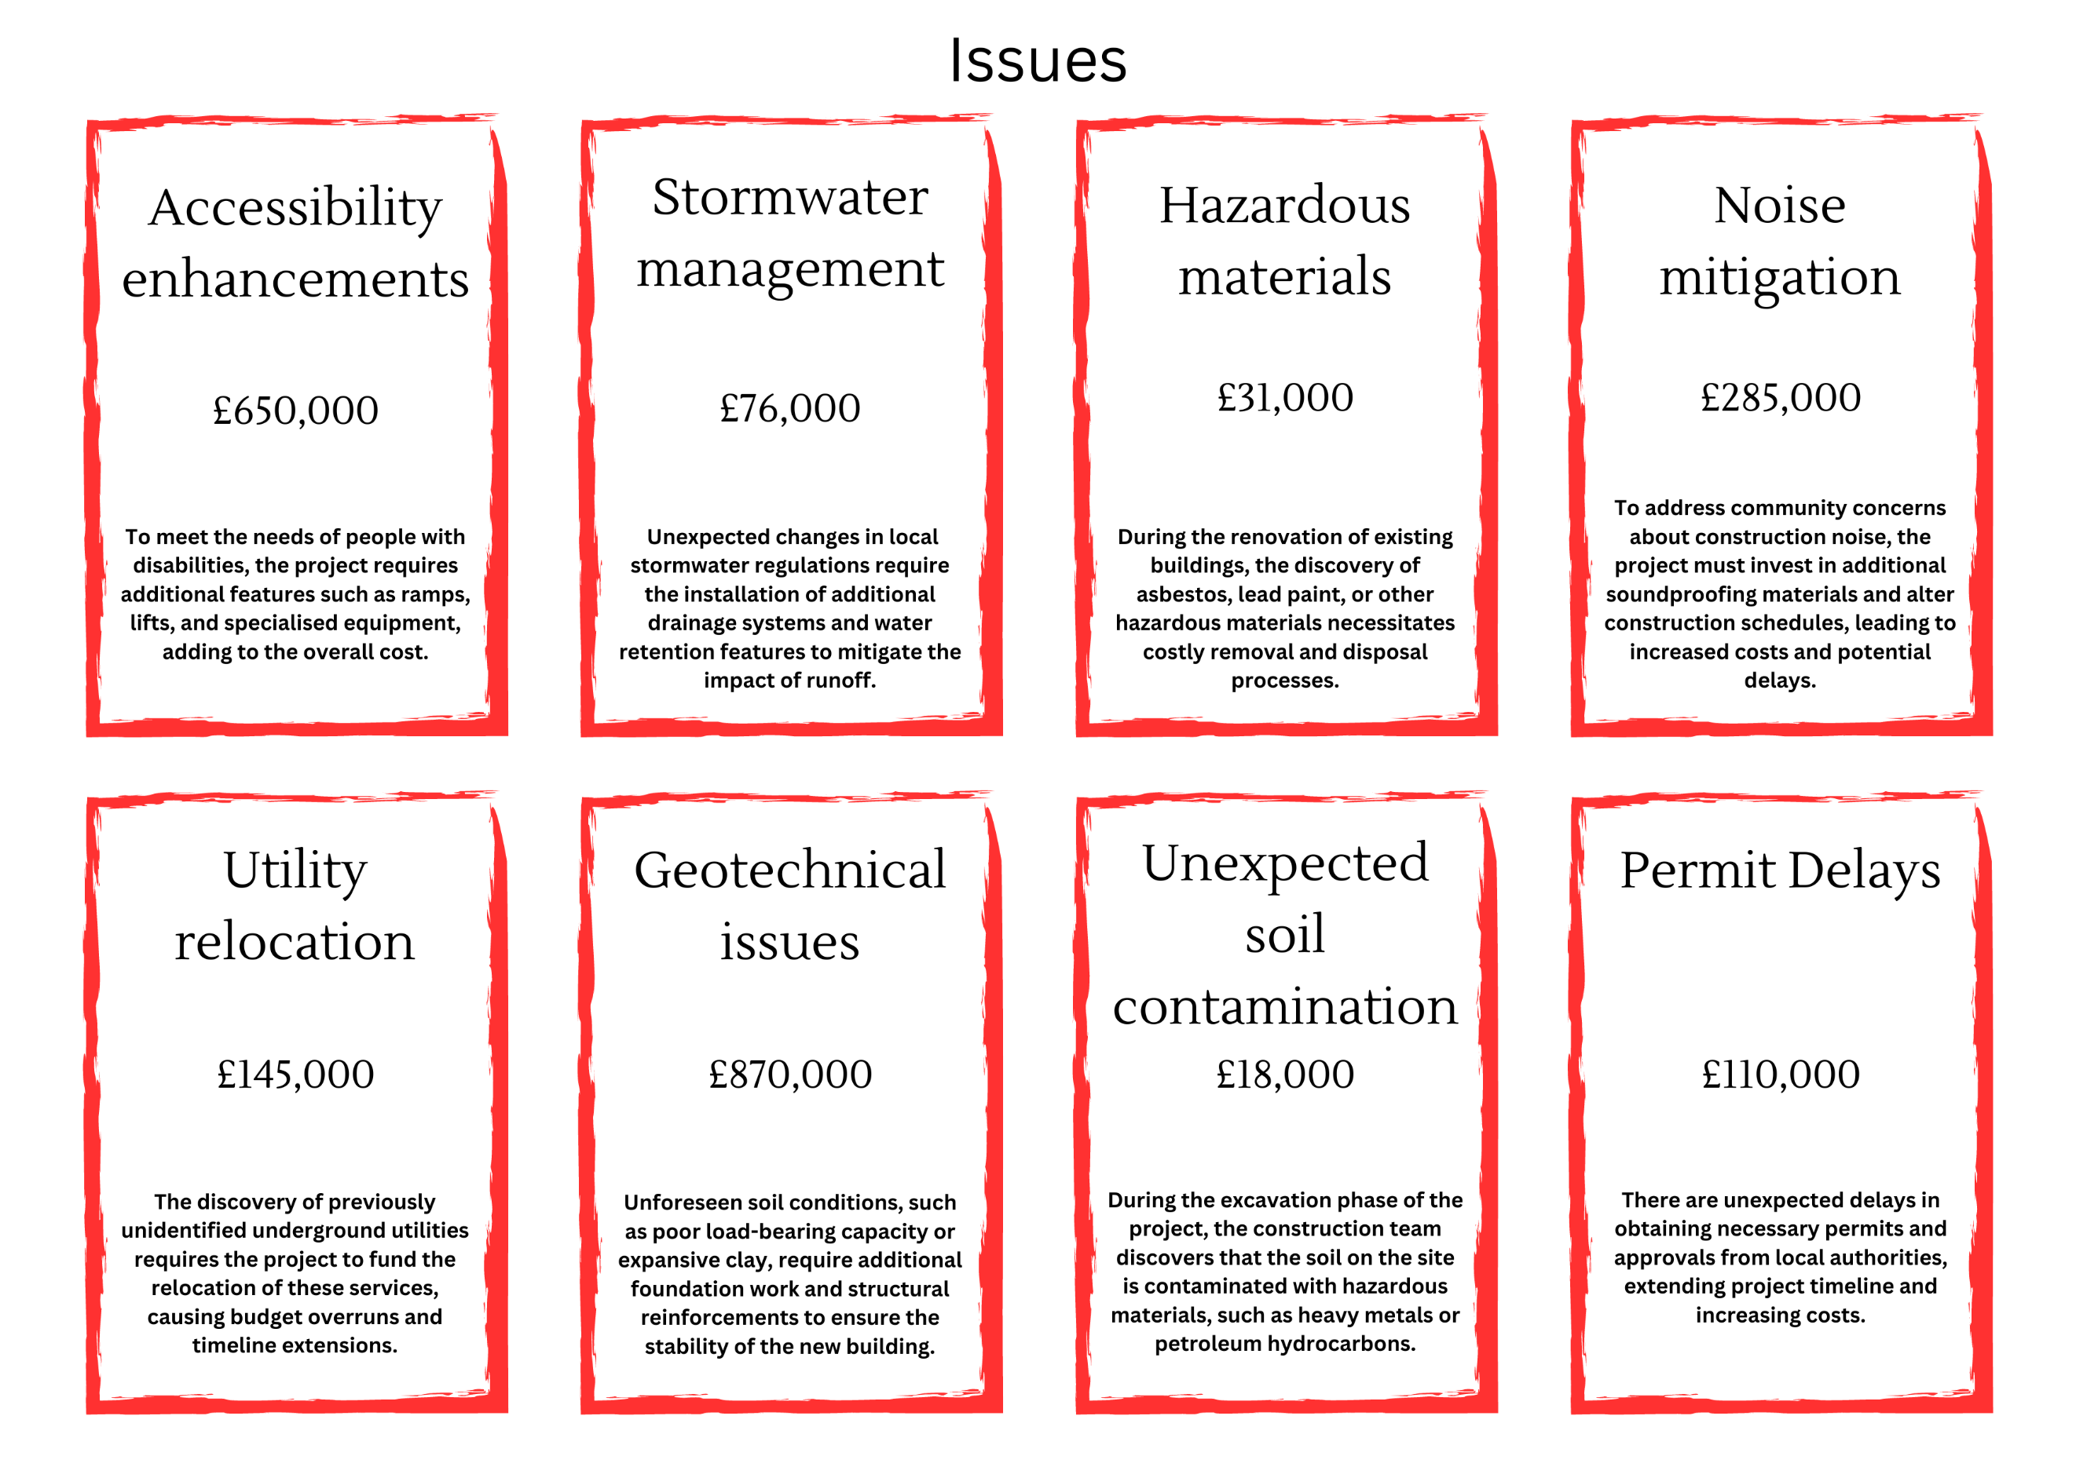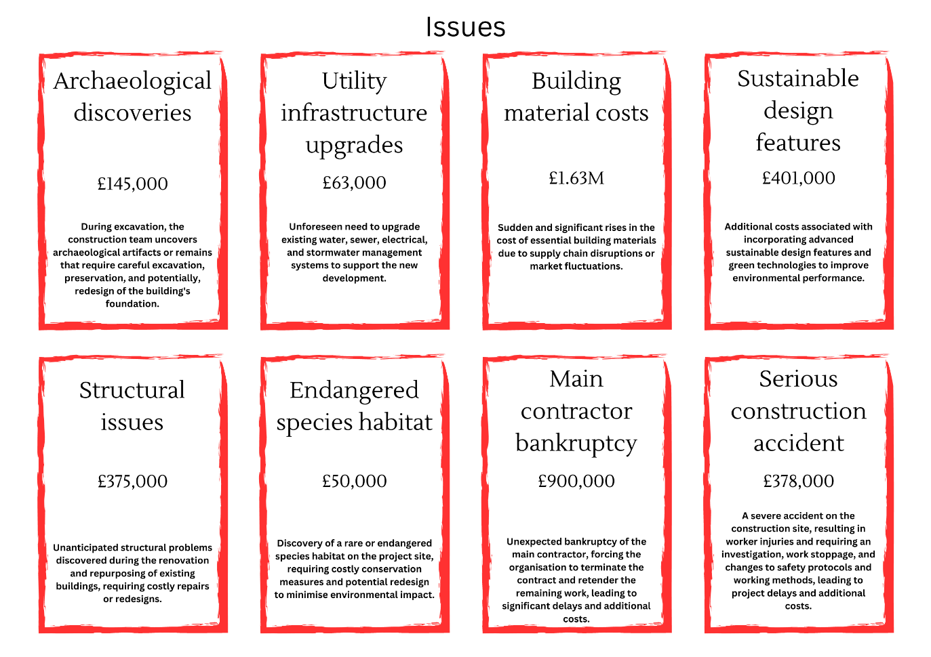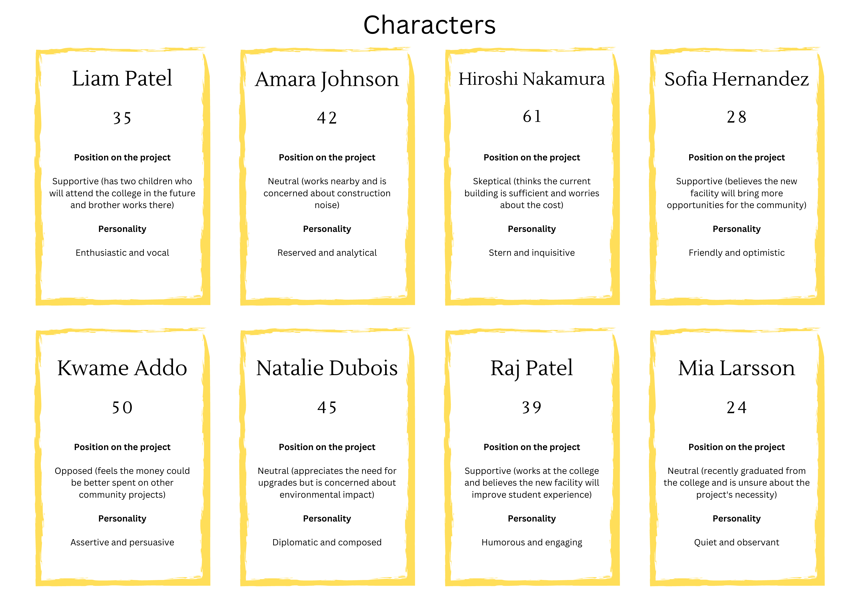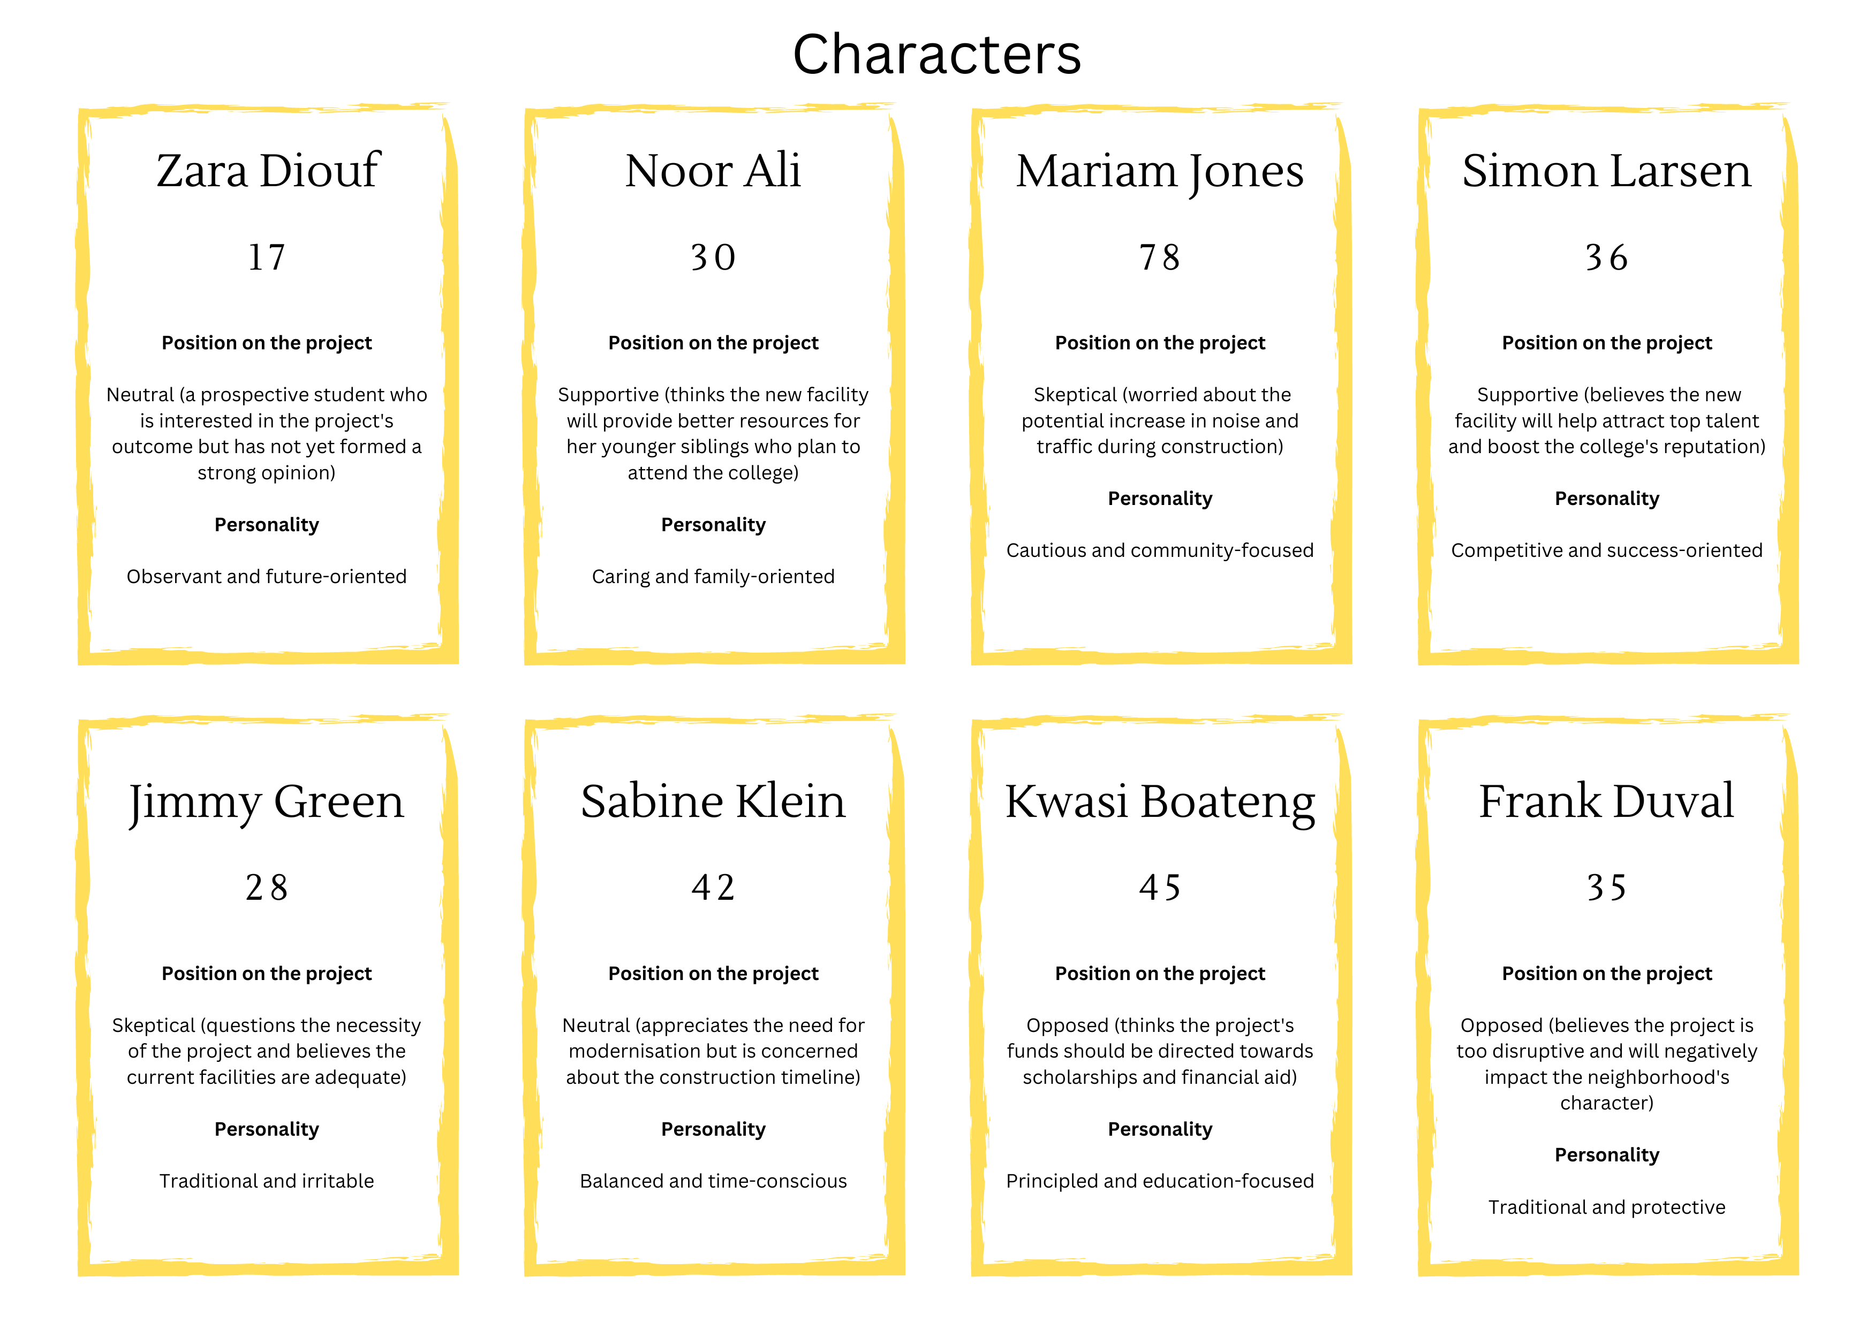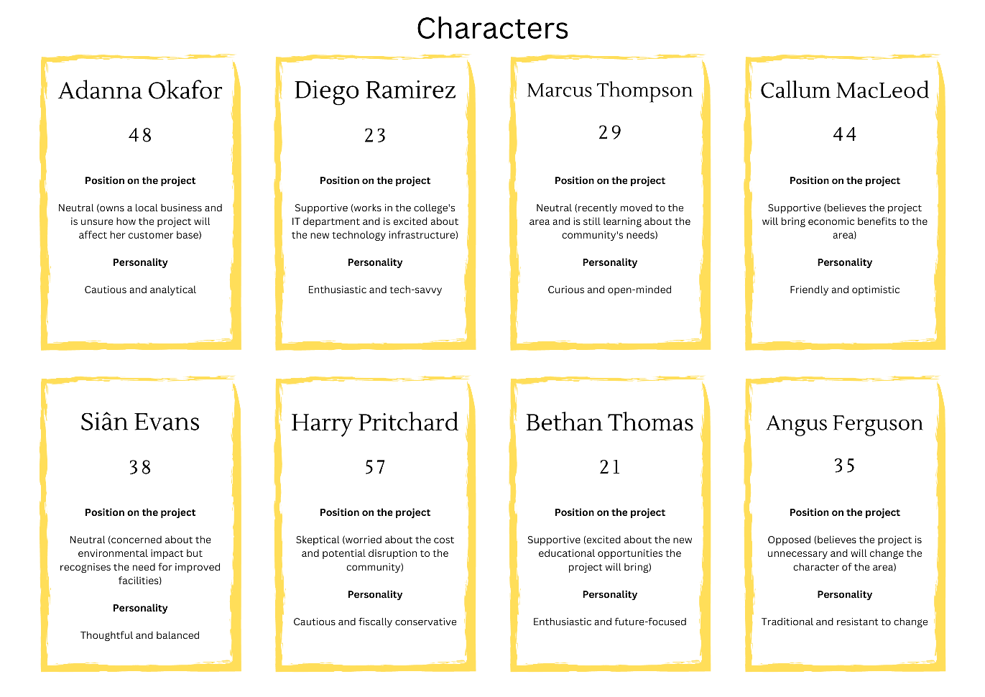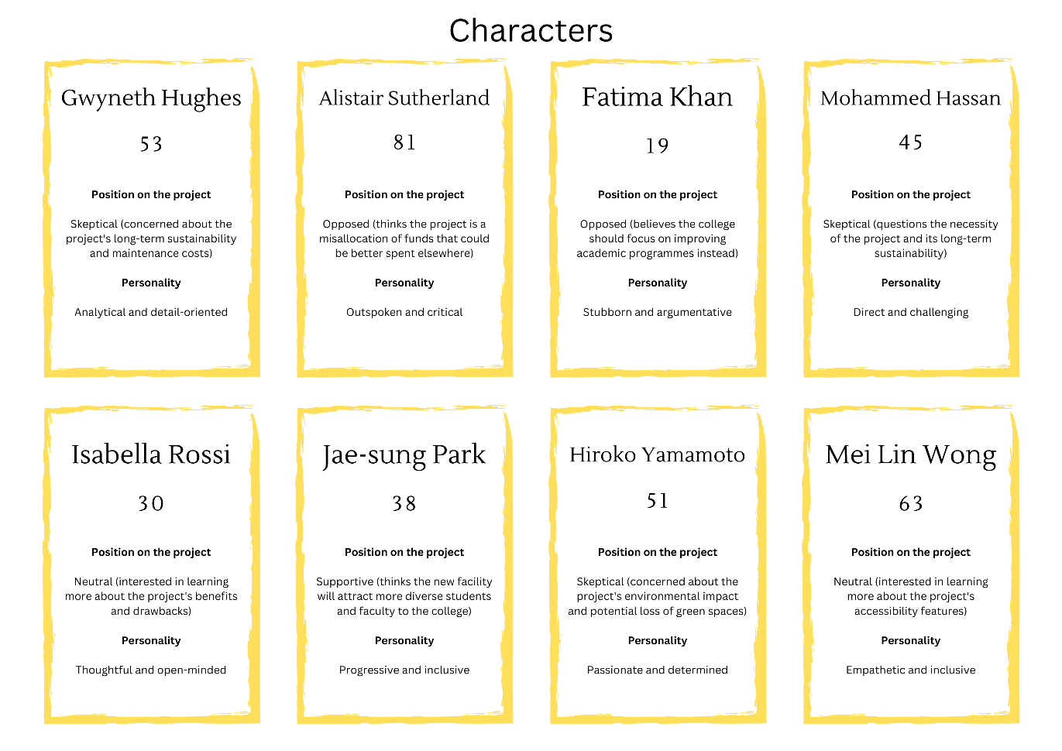
Here are other games that you may choose to play with your learners that are not included in the lesson plan.

Conflict resolution scenarios

Use the character cards to create realistic conflict scenarios that might arise during a construction project. Have learners role-play as the characters and practice resolving conflicts using effective communication techniques.

Stakeholder engagement workshop

Divide learners into teams representing different stakeholder groups (using the stakeholder cards). Each team must develop a communication strategy to engage with the other stakeholders and build consensus around a particular project issue.

Public speaking challenge

Have learners draw a random project issue card and a corresponding stakeholder card. They must then prepare and deliver a short presentation addressing the issue and persuading the stakeholder to support their position.

Active listening exercise

In pairs, learners take turns playing the roles of different characters from the community. One learner expresses their concerns about the project, while the other practices active listening skills, such as paraphrasing, asking clarifying questions, and demonstrating empathy.

Media interview simulation

Learners role-play as project managers or spokespersons and must respond to tough questions from "reporters" (played by other learners) using the project issue cards as prompts. This exercise helps develop skills in crafting clear, concise messages and managing difficult questions.

Negotiation game

Divide the class into small groups representing different stakeholders with competing interests (using the stakeholder cards). Each group must negotiate with the others to reach a mutually beneficial agreement on a project issue, practicing skills such as active listening, finding common ground, and making concessions.

Elevator pitch contest

Learners draw a random project issue card and have a limited time (e.g., 30 second to 1 minute) to deliver a compelling "elevator pitch" to a key stakeholder (played by another learner or instructor). The pitch should succinctly explain the issue and persuade the stakeholder to support the proposed solution.

Crisis communication drill

Use the project issue cards to create hypothetical crisis scenarios (e.g., construction accidents, environmental hazards, or public relations issues). Learners must work in teams to develop and deliver crisis communication plans, practicing skills such as message development, spokesperson training, and media management.

Empathy mapping exercise

Divide learners into groups and assign each group a different stakeholder card. Have the groups create "empathy maps" for their assigned stakeholders, identifying their needs, concerns, and communication preferences. This exercise helps learners develop a deeper understanding of different perspectives and tailor their communication approaches accordingly.

Lesson 8 – Voting slips (2 pages – print one sided)

Part 1: persuasive argument to allocate funds to issue

The issue I want to fund is: ____________________________________________

Part 1: persuasive argument to allocate funds to issue

The issue I want to fund is: ____________________________________________

Part 1: persuasive argument to allocate funds to issue

The issue I want to fund is: ____________________________________________

Part 1: persuasive argument to allocate funds to issue

The issue I want to fund is: ____________________________________________

Part 1: persuasive argument to allocate funds to issue

The issue I want to fund is: ____________________________________________

Part 1: persuasive argument to allocate funds to issue

The issue I want to fund is: ____________________________________________

Part 1: persuasive argument to allocate funds to issue

The issue I want to fund is: ____________________________________________

Part 2: elevator pitch

The issue I want to fund is: ____________________________________________

Part 2: elevator pitch

The issue I want to fund is: ____________________________________________

Part 2: elevator pitch

The issue I want to fund is: ____________________________________________

Part 2: elevator pitch

The issue I want to fund is: ____________________________________________

Part 2: elevator pitch

The issue I want to fund is: ____________________________________________

Part 2: elevator pitch

The issue I want to fund is: ____________________________________________

Part 2: elevator pitch

The issue I want to fund is: ____________________________________________

Lesson 9 – Project issues

Teacher instructions:

Give each learner one of the following four project issues to create a press release:

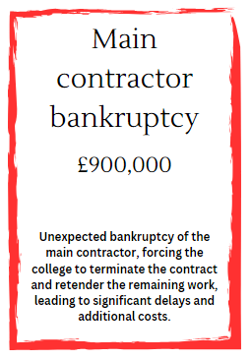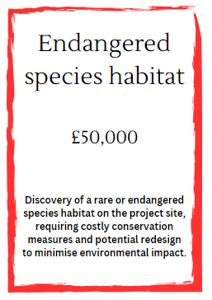
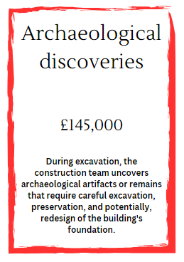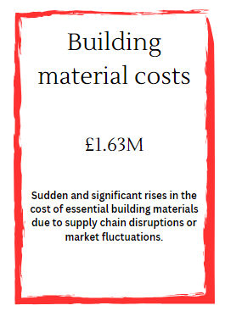

Lesson 9 – Press release instructions

Instructions

- Review the details on the project issue card.
- Put yourself in the shoes of a company spokesperson preparing a press release to the public.
- Draft a 2-3 paragraph press release in your word processing application addressing the issue described on the card.
- Use a reassuring tone to show the public that the issue is being managed responsibly.
- Explain the situation honestly but positively, focusing on the actions being taken.
- Avoid using overly technical jargon or engineering terminology.
- Emphasise safety and highlight the company's concern for protecting the public.
- Include a quote from the project manager or executive to humanise the response.
- Close with a forward-looking statement on resolving the issue properly.

Tips

A good press release for the public should be concise, factual and easily understandable to a general audience. It needs to promote public confidence that the company is being transparent and taking appropriate corrective actions. The tone should be contrite about the issue but optimistic about the resolution. Provide clear next steps and timelines where possible. Try and incorporate persuasive language within the text.
Lesson 9 – Investor speech instructions

Instructions

- Review the details on the project issue card.
- Prepare a persuasive 5-minute speech to be delivered to a group of the company's investors.
- Address the key facts about the issue and how it occurred.
- Acknowledge the seriousness of the issue and the company's full commitment to resolving it.
- Provide reassurance that the company has the technical expertise and resources to address it.
- Outline at a high-level the action plan and timeline for resolving the issue.
- Reiterate the company's history and values around safety/quality/responsibility.
- Express confidence that the company will emerge stronger and prevent future such occurrences.
- Welcome ongoing investor support and open channels of communication as the issue is worked through.

Tips

Remember that investors have a financial stake in the company and will be genuinely concerned about anything that threatens the company's reputation, sales, legal standing, etc. While they will want assurances, they will also expect an honest and transparent assessment, not just empty promises. Back up reassurances with concrete examples and facts. Connect this situation to the company's core values. Plan to deliver the speech with an even, confident tone. Anticipate likely questions or concerns and try to proactively address them in the speech content. Try and incorporate persuasive language communication skills.

Lesson 9 – Investor presentation instructions

Instructions

- Review the details on the project issue card.
- Create a short slide presentation (5 slides max) to go along with your investor speech.
- Remember the lessons from the "How to avoid death by PowerPoint" presentation:
- use a dark background
- use very minimal text on the slides - don't just repeat the speech verbatim
- rely on visuals like photos, graphics, charts to convey information
- avoid fancy animations, transitions and cluttered layouts
- use a consistent visual theme and branding
- make text large enough to easily read
- each slide should make 1 key point that complement the speech.

Suggested 5 slide flow

- Title slide with issue summary statement.
- Timeline graphic showing history and projection.
- Action plan graphic or table.
- Contextual slides with key facts (e.g. safety record, examples of expertise).
- Closing slide with contact info and forward-looking statement.
Lesson 10 – Peer review form

Presenter name _____________________________________

How well did the presenter meet the needs of the case study requirements?

How clear was the presentation of information?

How effectively did the presenter engage the audience?

How well did the presenter communicate key information using visual representation?

How well was persuasive language used?

How well were was descriptive language used?

How well was the topic adapted for this audience?

Additional comments or suggestions

Lesson 10 – Reflection worksheet (6 pages)

In the wheel of life, rate your current level of proficiency in each of the eight communication skills listed. Consider a scale of 1 to 5, where 1 represents "needs improvement" and 10 represents "highly proficient."

Wheel of Life

Author image

Reflect on your radius chart/wheel of life and compare it with the wheel of life you completed in lesson 7.

Answer the following questions:

You have been introduced to several key communications skills and had opportunities to vary your communication methods to suit the target audience. Describe your journey.

Which skill did you most enjoy learning about? How will you develop this skill further?

Which skill did you find most challenging and why?

Reflect on the 5-minute activities from the reflection that was completed in lesson 3. Which activities did you find most effective in helping you improve your communication skills, and why?

Consider the feedback you received from peers and teachers throughout the programme. How did this feedback influence your skill development and self-assessment? How does feedback relate to communication?

What new insights have you gained about your communication skills through this reflective process?

Moving forward, what strategies from the lessons learned from this programme will you apply to further enhance your communication skills?

How do you envisage your improved communication skills benefiting you in your personal, academic, and future professional life?

Set three new activities for yourself based on your end-of-programme wheel of life.

Example activity

Speaking skills: Give a 5-minute speech on a given topic.

Feedback methods: Write a constructive feedback paragraph for a peer's work, focusing on specific areas for improvement.

Your activities

Activity 1

Activity 2

Activity 3

What steps will you take to achieve your goals and continue your growth beyond this programme?

Circle or highlight the most important skills for you to develop in the next 5 years. Save a copy of the completed word cloud and set a reminder in your calendar to review it in one year.

Author image

References
ArcGIS Online, 2024. Flood Zone Map, Shrewsbury Area. [Online]
Available at: https://www.arcgis.com/apps/mapviewer/index.html?webmap=0f27e3dd34434cfe8d34748a079401a1
[Accessed 27 03 2024].
Bodders, A., 2022. New £77m plans for Shrewsbury Riverside will starve public investment for the rest of county. [Online]
Available at: https://andybodders.co.uk/2022/02/10/new-79m-plans-for-shrewsbury-riverside-will-starve-the-rest-of-county-from-public-investment/
[Accessed 27 03 2024].
Glenn Howells Architects, 2021. Shrewsbury Big Town Plan. [Online]
Available at: https://shrewsburybigtownplan.org/wp-content/uploads/2021/01/Shrewsbury-Masterplan-Vision-Jan-2021.pdf
[Accessed 26 03 2024].
GOV.UK, 2024. River Severn level at Welsh Bridge. [Online]
Available at: https://check-for-flooding.service.gov.uk/station/2036
[Accessed 26 03 2024].
Shropshire Council, 2018. Shrewsbury Big Town Plan. [Online]
Available at: https://www.shropshire.gov.uk/media/16707/shrewsbury-big-town-plan.pdf
[Accessed 27 3 2024].
Shropshire Council, 2022. Smithfield Riverside Development Framework. [Online]
Available at: https://shropshire.gov.uk/committee-services/documents/s29512/Appendix%20A%20-%20SDF%20final%20document.pdf
[Accessed 26 03 2024].
Smithfield Riverside, 2024. A PHASED MASTERPLAN. [Online]
Available at: https://www.smithfieldriverside.com/plans
[Accessed 26 03 2024].
Spacehub, 2024. Smithfield Riverside. [Online]
Available at: https://spacehubdesign.com/project/smithfield-riverside/
[Accessed 27 3 2024].
Zevenbergen, C., 2016. Flood Resilience. In: M. Florin & I. Linkov, eds. International Risk Governance Centre Resource Guide on Resilience. Lausanne: EPFL International Risk Governance Center, p. 280.

Section 3

Guidance for the use of communication skills in the employer set project assessment

Overview of ESP
The Employer-set project (ESP) is one of the assessments for the core of the T Level in Design, surveying and planning for construction. A student doesn’t pass or fail the ESP. It is graded A* - E (with a U for learners whose work does not meet minimum requirements for a grade). The grade then contributes to of the overall grade for the Core with the Core exam grade contributing the remainder.

The ESP consists of a well-defined, real industry style brief developed by employers. The brief will be complex and non-routine. This means that it possibly relates to something you have not encountered before or were not expecting. The brief is designed to enable you to show how you can apply the knowledge and skills you have developed during your course.
The brief sets out the context for the assessment. There are then five tasks that you will need to complete in relation to the brief. These are:

- complete reports and project management documentation
- complete annotated sketches and CAD designs for internal and exterior detail
- complete presentations to justify their designs
- complete costing exercises
- complete a group exercise.

All tasks are completed in controlled conditions. This means that there may be restrictions to how you complete your tasks including time available, access to resources such as the internet, how you save documents, communication with other learners. You will be given specific details of these before you start the ESP assessment.

Communication Skills and the ESP
Throughout your course, you have been developing your reading, writing, listening and speaking communication skills.

In the ESP assessment, you will use the reading skills in all tasks.

You will use other communication skills as follows:

In Task 1 you will produce a written formal report.

In Task 2 you will
- produce annotated sketches
- develop presentation materials to justify your design proposals supported by detailed written speaker notes.

In Task 4 you will work in groups to solve a problem. As a group, you develop a slide deck for a presentation and deliver part of the presentation. This will be recorded.

An examiner will award the marks for this assessment.

Written communication
When submitting written evidence, it is important to check your work before submission. Use the ‘Editor’ facility in Word to check for spelling and grammar. You will also need to check formatting such as font size, justification, use of bold and italics for headings etc.

The examiner will be looking at content for knowledge and the use of technical language. They will also be looking for the level of reasoning and how you have structured an argument or key conclusions. Use what you have learned about selecting key information, highlighting key points and using positive and persuasive language.

Presentations
This examiner will be looking at the recording of your presentation. It is important therefore to consider how you appear in the video. You need to be heard on the video. Practice projecting your voice and annunciating key terms, this means speaking clearly. Think about where you stand. Take time to move to the side of the slide deck and clearly facing the camera. Your teacher will probably be sat next to the camera, so look at them so that it will look as if you are speaking directly to the camera. Think about positive body language including facial expressions. Practice in front of a mirror.

The examiner is also looking at your digital materials – your slide deck. They will want to see use of animations and transitions in your slide deck. They will also look for spelling, grammatical and formatting errors.

Group work
When carrying out the group task, you will be using your listening and speaking skills. It is important to show that these skills are being used. Listening skills are evident when repeating or paraphrasing what someone else has said. Use what your group members say and then build on it. For example, great idea to do x, and we could then add y to this.

Using your communication skills to gain marks
There are 6 marks for the Task 2 presentation materials. There are 9 marks for the group presentation in Task 4. This is 15% of the marks for the assessment. It may not seem to be important but maximising these marks can mitigate for lost marks associated with technical knowledge or technical skills when creating your designs.

The key aspects the examiner is looking for is:
- choice of language, technical vocabulary, consideration of the audience
- slide structure, slide order, size and font of text, use of images/diagrams
- use of colour, use of animations and transitions

To gain maximum marks, you must show:

Highly effective communication of technical information which is consistently appropriate for the audience and delivered in a fluent, clear and concise manner
- consider how you can ensure that each slide has content clearly directed to the audience, avoid generic statements, focus on audience needs
- fluency relates to how well the content flows, so it is important to think about how you structure your presentation
- concise requires you to be focussed, avoid waffle, and avoid having slides with lots of writing. Your detailed speaker notes will have the detail needed so focus on key points on the slides.

Selects and applies techniques for organising and presenting content that are fully appropriate
- consider how your information looks on the slide; is there sufficient space, are headings clear and differentiated
- are there bullet points or other techniques to separate key points

Excellent use of digital features to enhance the quality of the presentation
- This relates to transitions and animations. Avoid using too many, but consider how you can introduce the content to build up your argument using the transitions. Can you use animation to highlight key points.

General
Some general points to consider:
- Have the first slide in a different format so that it is clearly introductory and with an appropriate title – it would be good to mention the audience in the title
- Ensure you have considered the use of font and font size in your slide deck.
- Use the same font size for all slide titles and a different but consistent font size for the content.
- Check spelling of all slides.
- Check your punctuation – particularly full stops and capital letters.
- Check formatting – is all your content aligned.
- Include technical language where appropriate – consider including a definition of technical terms if there is a non-technical audience.
- Incorporate advanced techniques such as images, transitions and animations to demonstrate your digital skills.

Technical knowledge
There are marks for the technical knowledge you include in your presentation. In particular, the marks are for justification. This means going beyond simply explaining but clearly demonstrating beyond doubt how your proposals meet the requirements of the brief better than other alternatives. You will demonstrate your knowledge of construction and the built environment, how your proposal meets the requirements of the brief, and what the audience needs are. You therefore need to consider in the structure of your presentation:
- the key requirements of the brief
- how your proposal meets those key requirements
- the alternatives that were considered but not included in the final proposal
- the construction and built environment content you used to support your proposal.

You should think about how you organise your digital presentation to include each of these.


FUNDED BY
PRODUCED BY

Shrewsbury Colleges Group has produced this resource on behalf of the Education and Training Foundation
This programme is funded by
the Department for Education

