


T LEVEL IN HEALTH
Development of the Core Skill: Presenting

ET-FOUNDATION.CO.UK
Introduction
This resource is designed to help providers to plan for and develop learners’ presentation skills, which will support the learner throughout their T Level, Industry Placement and the Employer-set project (ESP) assessment. Presenting is an essential skill for working in the health sector.

This resource focuses on the skills required to present information effectively. The learning is scaffolded by starting with skills to deliver verbal presentations without using any tools then moving on to introducing non-digital and digital tools to enhance presentations. The learning then extends to adapting presentation styles to meet different stakeholder needs. With each stage of learning, there is opportunity for the learners to gain feedback and reflect on their skills so that they can develop them.

The sequencing of this resource is recommended to be delivered towards the end and into the second term of the first year. This will allow time for the development of other Core Skills under the T Level in Health specification.

Core Skills are assessed through the ESP, so the development of the skills should be before any mock ESP assessments and the ESP assessment itself.

English, mathematics and digital (EMD) competencies, based on the General English Competencies (GEC), General Mathematics Competencies (GMC) and General Digital Competencies (GDC), are embedded in each T Level. This resource also provides opportunities to develop these competencies. Presenting is Core Skill 6 (CS6) within the T Level in Health specification. Specific EMD competencies for T Level in Health Core Skill 6 include:

- GEC1 Conveying technical information to different audiences
- GDC2 Presenting information and ideas

This is a standalone resource.

This resource has four sections:

- Framework for learning
The resource includes a Framework for Learning (FfL) covering 21.5 hours of learning. The FfL details how the learning of the presenting skills is scaffolded and sequenced.

- Lesson plans
There are 11 lessons in total. There is a lesson plan for each stage in the sequencing and scaffolding of learning in the FfL. Lesson plans refer to resources (including support materials) that are required to support delivery.
- Support materials
The support materials identified in the lesson plans are also available towards the end of this document.

A separate slide deck is also provided for use with the lessons.

- Guidance for learners
Guidance materials are provided for learners to make effective use of the Core Skill in the ESP assessment. The guidance specifically refers to Core Skill 6: Presenting.

Section 1: Framework for learning

This resource supports the development of Core Skill 6: Presenting. The framework sets out one approach to scaffolding and sequencing the development of verbal presentation skills. It focuses on developing the skills needed to deliver effective presentations using non-digital and digital tools that support delivery. This resource also supports the development of verbal and non-verbal communication skills, confidence in delivering presentations, digital skills and health-related knowledge.

The resource focuses on presenting information related to nursing, but this resource could be replicated and used in a variety of healthcare settings.

It is recommended that these 21.5 hours of learning be introduced at the end of term 1. This resource relates to developing a Core Skill that is later assessed in the ESP. Learners should be given sufficient time to practise this skill before the assessment.

To maximise this learning, it is expected that learners will have prior knowledge of:
- data sources in a range of health and science environments, and they will be able to interpret them, including:
  - results of investigations
  - patient history
  - patient test results
  - published literature
- the roles of health stakeholders – patients, customers, health professionals
- the types of information needed when obtaining a client history
- key abbreviations used in the healthcare sector
- a range of verbal and non-verbal communication techniques and potential communication barriers, and how to overcome them to support an individual’s condition
- the considerations when providing person-centred care to people with pre-existing conditions or living with illness
- how mental health conditions, dementia and learning disabilities can influence a person’s needs in relation to overall care
- how to promote independence and self-care and the positive impact of these on the healthcare sector
- the importance of practising and promoting the 6Cs in relation to demonstrating person-centred care skills, through one’s own actions and promoting the approach with others
- methods for supporting people to look after themselves at various stages of life.

This prior knowledge will help learners to present information with confidence and provide opportunities for storytelling.

The overall outcome of the learning from this resource is to present information effectively to specified stakeholders. To achieve this outcome, the learning is scaffolded in four stages, as follows:

Stage 1: Presenting using non-digital formats (7 hours)
This stage starts by developing the skills to deliver presentations without any digital tools. Learners will engage with diagnostic self-assessment to establish their baseline skills to deliver a good presentation. Those skills can then be enhanced by non-digital tools. Learners will learn how to use flipcharts, whiteboards and images as tools to support the presentation of information.

This stage of learning is covered in lessons 1 to 4.

Stage 2: Presenting using digital formats (PowerPoint) and oral delivery (5.5 hours)
This stage develops the skills of using digital tools to present information. This stage will focus only on PowerPoint software as a digital tool. Learners will develop their presentation skills (non-digital) in conjunction with the skill of using PowerPoint to present information. The learning builds on stage 1 by expanding the range of tools learners can use by incorporating diagrams and graphs into their PowerPoint presentations.

This stage of learning is covered in lessons 5 to 7.

Stage 3: Adapting presentation style to meet the needs of stakeholders (6 hours)
This stage builds on the learning from stages 1 and 2, and it introduces the concept of adapting the presentation style for different stakeholders in health contexts.

This stage of learning is covered in lessons 8 to 10.

Stage 4: Present information effectively to specified stakeholders (3 hours)
This stage draws together stages 1, 2 and 3 by presenting information using digital and non-digital formats for different stakeholders for a specified purpose.

This stage of learning is covered in lesson 11.

The timings of group activities in this resource are based on class sizes of about 15-20 learners.

Framework for learning
Flipcharts
Stage 2

Presenting using digital formats (PowerPoint) and oral delivery

(5.5 hours)

Stage 1

Presenting using non digital formats

Verbal: written and oral delivery

(7 hours)

Tools for layout of information
Digital and non-digital
Present to healthcare professionals
Present to patient
Case study
Healthcare professionals
Patient/customer
Stakeholders
Stage 3

Adapting presentation style to meet the needs of stakeholders

(6 hours)

Stage 4

Effectively present information to specified stakeholders

(3 hours)
Tools for layout of information
Paper handouts
Whiteboards

Section 2: Lesson plans

Title: Presenting using oral communication

Targeted content reference:
Core Skill 6.1: Presenting using non-digital formats

Lesson sequence number: 01

Timing: 90 minutes
Prior learning
The role of the nurse
How to peer review
Timing | Teacher activity | Learner activity / formative assessment | Resources
5 minutes | Present an overview of the sequence of learning, referring to the framework of learning diagram.  Present what the lessons will focus on: Presenting information using oral communication. | Listen and take notes | Presentation slides  Framework for learning  Medication role-play handout  Access to the internet  https://youtu.be/LSYTFJqvEug  Situation, Background, Assessment and Recommendation  (SBAR) communication tool template  SBAR role play  Flipchart/whiteboard and pens  Sticky notes
10 minutes | Present key principles of oral communication in healthcare, using examples.  Facilitate a discussion about how the key principles can be applied in healthcare. Ask the learners for further examples of when oral communication is used. | Listen and take notes  Participate in class discussion, answering the questions asked by the teacher
5 minutes | Present Medication role-play activity.  Allocate groups of three. | Listen to and clarify the activity requirements
20 minutes | Circulate to ensure learners are clear about the activity requirements.  At the end of the activity, refer learners to the slide to self-rate their performance. | In groups of three, complete role plays, taking turns in the roles of patient, nurse and peer reviewer  Peer reviewer to take notes  Provide feedback to peers  Self-rate own performance
5 minutes | Show learners the YouTube video: How to give an SBAR Report | What is it and how SBAR used | Lecturio Nursing | Fundamentals Theory. (4.08 minutes). | Watch the video and take notes on the SBAR communication tool and examples given
5 minutes | Distribute SBAR communication tool template and SBAR role-play handouts.  Present the SBAR activity.  Allocate pairs. | Listen and clarify the activity requirements
20 minutes | Circulate to ensure learners are clear about the activity requirements.  At the end of the activity, refer learners to the slide to self-rate their performance. | In pairs, complete the role plays, taking turns in the roles of the nurse and specialist doctor  Provide feedback to peers  Self-rate own performance
10 minutes | Issue sticky notes to learners.  Write on a flipchart/whiteboard “Non-digital formats used to support oral presentations of information in health”.  Invite learners to put sticky notes on the flipchart/whiteboard.  Facilitate a discussion relating to the sticky notes. | Write words associated with “non-digital formats used to support oral presentations of information in health”
5 minutes | Present information about the non-digital formats used.  Present information about tools that can enhance presenting information in health. | Listen and take notes
5 minutes | Set out instructions for next steps. | Listen to and clarify the requirements for the next steps in learning
Other information (for example, adaptive teaching, English, maths and digital)
English: Speaking in groups and providing peer feedback, presenting information orally to the patient and to the specialist doctor, listening and observation skills through peer reviews, reading and summarising the information in the scenario and case study, writing skills through taking notes and completing the SBAR.

Adaptive teaching is supported by using stretch questions; explain the implications of not using the key principles of communication.
SBAR activity: Ask whether their oral communication differed to that used with the patient and why.
Next steps in learning
Practise reading out loud and verbal presentation where possible.
Observe communication on television.
Consider:
- what was communicated
- how well the information was communicated
- what key principles were observed.

Title: Presenting using handouts with imagery

Targeted content reference:
Core Skill 6.1: Presenting using non-digital formats (verbal delivery, paper handouts and tools for layout)

Lesson sequence number: 02

Timing: 90 minutes
Prior learning:
The healthcare sector
Timing | Teacher activity | Learner activity / formative assessment | Resources
5 minutes | Present what the lesson will focus on: Presenting using paper with imagery.  Present information about paper handouts and explain the advantages of using paper handouts.  Facilitate a discussion on the advantages of using paper handouts as a tool when presenting information in a healthcare setting. | Listen and take notes  Contribute to a class discussion on the advantages of using paper handouts as a tool when presenting information in a healthcare setting | Presentation slides  Fluid balance chart scenario  Input and output feedback sheet  Pens  Care plan case study  Access to digital technology  Peer assessment form (handout)
5 minutes | Set out instructions for the Fluid balance chart scenario activity (part 1).  Allocate groups of three and:  - give learner 1 the Fluid balance chart scenario  - give learner 2 nothing at this stage  - give learner 3 a pen and paper.  Advise learners that they are unable to take any notes; they must listen. | Listen to and clarify the requirements for the Fluid balance chart scenario activity (part 1)
5 minutes | Circulate to ensure learners are clear about the activity requirements. | In allocated groups of three, complete the following activity:  - Learner 1: Read the Fluid balance chart scenario to learner 2  - Learner 2: Listen to the information from learner 1, but do not take notes, and relay the information you have just received to learner 3  - Learner 3: Listen to the information from learner 2, but do not take notes, and relay the information back to learner 1  In your allocated groups, compare the information relayed from learner 3 to learner 1 to see how much of the information was correct
5 minutes | Set out instructions for the Fluid balance chart scenario activity (part 2).  Allocate groups of three and:  - give learner 1 the Fluid balance chart scenario  - give learner 2 nothing at this stage  - give learner 3 a pen and paper.  Advise learners that they are unable to take any notes; they must listen. | Listen to and clarify the requirements for the Fluid balance chart scenario activity (part 2)
10 minutes | Circulate to ensure learners are clear about the activity requirements. | In allocated groups of three, complete the following activity:  - Learner 1: Read the scenario to learner 2, who will fill in the details on the fluid balance chart  - Learner 2: Relay the information to learner 3, who takes notes on the Input and output feedback sheet
10 minutes | Facilitate class discussion about how the two conversations compare with each other. | Participate in the class discussion  Learners feed back findings, comparing the Fluid balance scenario activity parts 1 and 2
5 minutes | Present the Care plan case study activity.  Distribute the care plan case study.  Instruct the learners to create a digital handout that will assist the audience with understanding the information presented in the case study. | Listen to and clarify the requirements for the Care plan case study activity
15 minutes | Circulate to ensure learners are clear about the activity requirements.  Instruct the learners to print out the handout. | Individually, read the Care plan case study and instructions  Create a digital handout that will assist your audience when you are delivering the care plan information  Print out the handout
5 minutes | Allocate learners into pairs.  Instruct the learners to give a copy of their handout to their peer.  Instruct the learners to take it in turns to present the case study to their peer while the peer uses the handout. | Listen to and clarify the activity requirements  Give a copy of your handout to a peer
10 minutes | Circulate to ensure learners are clear about the activity requirements. | Work in pairs  Present the information from the case study to your peer while your peer uses the handout
10 minutes | Distribute the Peer assessment form.  Instruct the learners to assess their peer after their presentation.  Instruct learners to hand the peer assessment form back to their peer. | Fill out the Peer assessment form for your peer
5 minutes | Set out the instructions for next steps. | Listen to and clarify the requirements for the next steps in learning
Other information (for example, adaptive teaching, English, maths and digital)
English: Speaking and listening in group work and to the class in the fluid balance chart activity, writing skills through taking notes.
Digital: Creating a digital handout to assist with presenting.
Adaptive teaching is supported by having written instructions for the activities on the presentation slides accompanied by verbal instruction.
Next steps in learning
Evaluate the use of handouts in other classes. Assess how beneficial the handouts were for your learning and understanding in other classes.

Title: Presenting using flipcharts

Targeted content reference:
Core Skill 6.1: Presenting using non-digital formats (verbal delivery and flipcharts)

Lesson sequence number: 03

Timing: 120 minutes
Prior learning:
The role of the nurse
Timing | Teacher activity | Learner activity / formative assessment | Resources
5 minutes | Present what the lesson will focus on: Presenting information using flipcharts. | Listen and take notes | Flipchart  Coloured flipchart pens (including yellow)  Peer assessment form (flipchart/whiteboard)  Access to the internet  TED video: https://www.ted.com/talks/edith_elliott_and_shahed_alam_the_most_powerful_untapped_resource_in_health_care  Using flipcharts: Teacher guidance  Self-assessment form
5 minutes | Write the following on a flipchart:  - Discuss what information a nurse presents to patients.  - Record key points on a flipchart.  Present the activity to learners.  Allocate activity groups (three or four learners per group). | Listen to and clarify the activity requirements  Move to allocated activity groups
15 minutes | Circulate to ensure learners are clear about the activity requirements. | In allocated groups, complete the following activity:  - Discuss what information a nurse presents to patients  - Record key points on a flipchart
20 minutes | Distribute the Peer assessment forms and explain what needs to be completed.  Invite one group at a time to present their discussion points. | Present the key points from the activity  Use the flipchart to support the presentation of information  Peer-observe group presentations and make notes about the key strengths and development areas of the presentation and use of the flipchart  Complete a Peer assessment form for each group  Circulate feedback forms to each group after each presentation  Read the feedback provided
10 minutes | Instruct learners to watch the video and look for any good examples of information presented well.  Show the TED video: The most powerful untapped resource in healthcare.  https://www.ted.com/talks/edith_elliott_and_shahed_alam_the_most_powerful_untapped_resource_in_health_care | Watch the video and make notes about any examples of information being presented well
10 minutes | Facilitate feedback about learners’ observations from the video. Ask each learner in the class to contribute until all observations have been shared. | Feed back examples of information being presented well in the TED talk
20 minutes | Refer to the Using flipcharts: Teacher guidance.  Present premade flipchart 1.  Facilitate an interactive discussion about each point on the flipchart.  Once complete, start a new, blank flipchart page. Put the following heading on the blank flipchart: “How to present using a flipchart”.  Facilitate a class discussion. Ask learners to come and write each point on the flipchart.  Draw the discussion together by highlighting how flipcharts:  - offer a visual representation  - capture live information  - support interactive engagement. | Listen and contribute to a discussion about flipchart top tips and a discussion about how to present using a flipchart  Take notes
30 minutes | Write the activity on a flipchart.  In the same groups as earlier:  - Repeat the activity from earlier.  - Record key points on a flipchart about the information a nurse presents to patients (5 minutes).  - Present the information using the flipchart.  - Complete a Self-assessment form for your own group presentation, making judgements on any improvements made since the first presentation.  - Identify your own areas for improvement in presenting information using a flipchart.  Distribute a Self-assessment form to each learner.  Invite one group at a time to present their discussion points.  Present the activity.  Circulate to ensure learners are clear about the activity requirements. | Listen to and clarify the activity requirements  Move back into allocated groups  Complete the activity detailed on the flipchart
5 minutes | Set out the instructions for next steps. | Listen to and clarify the activity requirements
Other information (for example, adaptive teaching, English, maths and digital)
English: Speaking in group work and to the class, listening and observing skills through video observation and peer reviews, writing skills through taking notes and completing reviews of presentations.
Adaptive teaching is supported by having written instructions for the activities on the flipchart accompanied by verbal instruction.
Next steps in learning
Observe the presentation of information in other lessons. Assess how well lessons use flipcharts to present information.
Consider how what you have learnt about flipcharts might apply to whiteboards.

Title: Presenting using whiteboards

Targeted content reference:
Core Skill 6.1: Presenting using non-digital formats
Knowledge B2.5: The role of the components in performing the functions of the cardiovascular system

Lesson sequence number: 04

Timing: 120 minutes
Prior learning:
The role of the nurse
What a bedside whiteboard is
Timing | Teacher activity | Learner activity / formative assessment | Resources
5 minutes | Present what the lesson will focus on: Presenting using whiteboards. | Listen and take notes | Presentation slides  Mini whiteboards (or laminated cards) and pens  Bedside whiteboard activity handout  Access to the internet  Peer assessment form (flipchart/whiteboard)  Flipchart/whiteboard and pens
5 minutes | Start by facilitating a discussion about where whiteboards are used in health settings.  Present the information in the bullets. | Contribute to a class discussion on where whiteboards are used in health  Listen and take notes
5 minutes | Start by facilitating a discussion about why whiteboards are used in health settings.  Present the information in the bullets. | Contribute to a class discussion on why whiteboards are used in health settings  Listen and take notes
5 minutes | Present the Bedside whiteboard activity.  Distribute the Bedside whiteboard activity handouts.  Allocate pairs. | Listen to and clarify the activity requirements
10 minutes | Circulate to ensure learners are clear about the activity requirements. | Complete the Bedside whiteboard activity:  - Individually, write patient information on a mini whiteboard  - In pairs, complete the role-play activity  - Individually, complete a Peer assessment form and provide feedback
5 minutes | Present the blocked artery activity.  Distribute the Peer assessment form (flipchart/whiteboard) handouts. | Listen to and clarify the activity requirements
60 minutes | Circulate to ensure learners are clear about the activity requirements. | Complete the blocked artery activity:  - Research what the heart looks like and what causes a blocked artery  - On a mini whiteboard, draw an image of a heart that shows a blocked artery  - Give a five-minute presentation to the class detailing the causes of blocked arteries – you must use the image to present the information  - Complete peer reviews for each group using the Peer assessment form (flipchart/whiteboard) handout
5 minutes | Present the recap self-reflection activity. | Listen and take notes
15 minutes | Ask learners to share their answers. Rotate around the class.  Write key points on a flipchart. | Answer questions  Feed back to the group and join in the class discussion
5 minutes | Set out the instructions for next steps.  Discuss making a personal action plan to improve presentation skills using non-digital formats. | Listen to and clarify the activity requirements
Other information (for example, adaptive teaching, English, maths and digital)
English: Presenting information about patients and the heart and providing oral feedback to peers, listening and observation skills through observation and peer reviews, writing skills through taking notes and completing peer reviews of the presentations, reading and summarising research information relating to the heart.
Mathematics: Calculating mean and percentage difference in the Bedside whiteboard activity.
Digital: Researching what the heart looks like and what causes a blocked artery.
Adaptive teaching: Pair learners with different skill levels for discussions and activities.
Next steps in learning
Make a personal action plan to improve your presentation skills using non-digital formats.

Title: Presenting using PowerPoint (part 1)

Targeted content reference:
Core Skill 6.1: Presenting using digital formats (PowerPoint presentations, tools for layout)

Lesson sequence number: 5

Timing: 120

Prior learning
IT skills: How to use PowerPoint
How to work out percentages
Timing | Teacher activity | Learner activity / formative assessment | Resources
5 minutes | Present what the lesson will focus on: Presenting using PowerPoint.  Present the slide on Why are PowerPoint presentations used in the healthcare sector?.  Distribute the Outcome star activity.  Refer to Outcome star activity: Teacher guidance.  Instruct learners to individually complete the Outcome star activity, rating their prior skills and knowledge on PowerPoint presentations. Inform the learners this will be used throughout future lessons to keep track of their progression. | Listen and take notes | Presentation slides  Outcome star activity  Outcome star activity: Teacher guidance  Access to the internet  Video: https://vimeo.com/391834567  Case study (patient A)  Calculator  Peer assessment form (presenting using PowerPoint)  Self-assessment form (presenting using PowerPoint)  Access to PowerPoint  Flipchart/whiteboard and pens
5 minutes | Circulate to ensure learners are clear about the activity requirements.  Advise learners to retain the handout as it will be used in future lessons. | Complete Outcome star activity
5 minutes | Instruct learners to watch the video: 10 ways to improve your PowerPoint presentation skills. https://vimeo.com/391834567 | Listen and take notes
15 minutes | Present slides on the Ten ways to improve your PowerPoint presentation skills.  Facilitate class discussions on the 10 points covered in the video and slides. | Contribute to class discussions and take notes
5 minutes | Allocate groups of three or four.  Distribute Case study (patient A). Instruct the learners to read Case study (patient A) and clarify that the activity is to be completed in groups.  Advise learners that they will need calculators. | Read Case study (patient A) and clarify all the activity requirements
45 minutes | Circulate to ensure learners are clear about the activity requirements. | In allocated groups, complete the case study (patient A) activity
5 minutes | Distribute the Peer assessment forms. Instruct the learners to present their five-minute digital presentation to peers in their allocated groups. Peers to complete a Peer assessment form for each presentation. | Listen. Clarify the activity requirements
20 minutes | Circulate to ensure learners are clear about the activity requirements. | Present five-minute digital presentation to peers in the allocated group  Complete Peer assessment form and hand back to group peers
10 minutes | Facilitate discussion about feedback. Identify any common themes and write up on a flipchart/whiteboard.  Instruct the learners to fill in the Self-assessment form and to revisit and complete the Outcome star activity. | Contribute to class discussion  Fill in the Self-assessment form and Outcome star activity
5 minutes | Set out the instructions for next steps. | Listen to and clarify the requirements for the next steps
Other information (for example, adaptive teaching, English, maths and digital)
English: Taking part in class discussion, listening and observing skills through observing presentations and peer reviews, writing skills through taking notes and completing reviews of presentations, speaking while presenting to peer group.
Digital skills: Creating a PowerPoint presentation using a variety of digital skills.
Mathematics: Converting average blood pressure.
Adaptive teaching is supported by having an activity handout as a guide to follow as well as verbal instruction. Pair learners with different skill levels for discussions and activities.
Next steps in learning
Observe PowerPoint presentations in other lessons.
Assess how well the presentations used the 10 top tips.
Consider what skills you need to develop after observing others presenting using PowerPoint.

Title: Presenting using PowerPoint (part 2)

Targeted content reference:
Core Skill 6.1: Presenting using digital formats (PowerPoint presentations)

Lesson sequence number: 6

Timing: 90 minutes

Prior learning
IT skills: How to use PowerPoint
Timing | Teacher activity | Learner activity / formative assessment | Resources
5 minutes | Present what the lesson will focus on: Presenting using PowerPoint (part 2). | Listen and take notes | Presentation slides  Access to the internet  Video review form (presenting using PowerPoint)  Psychodermatology: More Than Skin Deep https://www.youtube.com/watch?v=ELHrtqvmu6Q  Peer assessment forms from previous lesson  Self-assessment form from previous lesson  Presentation from last lesson  Case study (patient B)
15 minutes | Distribute the Video review form.  Instruct the learners that throughout the video they will be observing and reviewing the use of PowerPoint and completing the Video review form.  Show the learners the TED talk video: Psychodermatology: More Than Skin Deep  https://www.youtube.com/watch?v=ELHrtqvmu6Q | Listen to and clarify the activity requirements  Watch the video and fill in the Video review form
15 minutes | Facilitate discussion about video observations. Encourage the learners to use the points noted in the review form. Ask each class member in turn to feed back to the class until all learners have provided feedback.  Use the Video review feedback slide in the presentation slide deck to record common themes/feedback. | Contribute to class discussion about video observations highlighting good points and development areas
5 minutes | Present the presentation improvement activity.  Distribute the Peer assessment forms and Self-assessment forms.  Allocate the same groups as the previous lesson. Groups of three to four. | Listen and clarify activity requirements
45 minutes | Instruct the learners to present their five-minute improved PowerPoint presentation.  Instruct the learners to each fill out a Peer assessment form for their peers. Instruct the learners to fill in the Self-assessment form. | Complete the presentation improvement activity  - Reread the Peer feedback and Self-assessment forms from the previous lesson  - Individually, update PowerPoint presentations using feedback  - Add a final slide highlighting the feedback received and the changes made to the PowerPoint  - In allocated groups, present five-minute digital presentation to peers in allocated group  - Complete Peer assessment form and hand back to peers  - Complete Self-assessment form
5 minutes | Set out the instructions for next steps. | Listen to and clarify the requirements for the next steps
Other information (for example, adaptive teaching, English, maths and digital)
English: Taking part in class discussion, listening and observing skills through observing presentations and peer reviews, writing skills through taking notes and completing reviews of presentations, speaking while presenting to peer group.
Digital skills: Adapting a PowerPoint presentation using a variety of digital skills to improve the presentation.
Adaptive teaching is supported by instructions of activities on presentation slides, handouts as well as verbal instruction. Pair learners with different skill levels for discussions and activities.
Next steps in learning
Read Case study (patient B). Complete activity part a) Research.

Title: Presenting using PowerPoint (part 3)

Targeted content reference:
Core Skill 6.1: Presenting using digital formats (PowerPoint presentations)

Lesson sequence number: 7

Timing: 120

Prior learning
Role of the nurse
Timing | Teacher activity | Learner activity / formative assessment | Resources
5 minutes | Present what the lesson will focus on: Presenting using PowerPoint. | Listen and take notes | Presentation slides  Access to the internet  Individual case study (patient B) research notes  Case study (patient B)  Reflection (PowerPoint)  Outcome star  Peer assessment forms
10 minutes | Facilitate discussion of feedback about findings from Case study (patient B) slide and research activity. | Contribute to a class discussion on:  - depression and anxiety causes and symptoms  - statistics surrounding mental health in males (UK statistics)  - uses of cognitive behavioural therapy  - anti-depressants (purpose and possible side effects)  - support groups available for individuals experiencing job loss or bereavement and depression or anxiety
5 minutes | Present the Case study (patient B) activity b) using presentation slides.  Instruct the learners to reread through the Case study (patient B). | Listen to and clarify activity requirements
50 minutes | Circulate to ensure learners are clear about the activity. | Individually, complete case study (patient B) activity b)
5 minutes | Allocate groups of three or four. This should be different groups to help develop confidence to deliver presentations to different audiences.  Distribute the Peer assessment forms. Instruct the learners to present their five-minute digital presentation to peers in their allocated groups. Peers to complete a Peer assessment form for each presentation. | Listen to and clarify the activity requirements
20 minutes | Circulate to ensure learners are clear about the activity. | Present five-minute digital presentation to peers in the allocated group  Complete Peer assessment form and hand back to group peers
5 minutes | Distribute Reflection (PowerPoint) form to learners.  Instruct the learners to reflect on their presentation knowledge and skills by completing the third box of the Outcome star with their rating (1-5) and Reflection (PowerPoint) form. | Listen to and clarify the activity requirements
15 minutes | Circulate to ensure learners are clear about the activity.  Facilitate discussion asking learners to share the Outcome star ratings. | Complete the Reflection (PowerPoint) form and final box in the Outcome star  Share Outcome star ratings.
5 minutes | Set out the instructions for next steps. | Listen to and clarify the requirements for the next steps
Other information (for example, adaptive teaching, English, maths and digital)
English: Taking part in class discussion, listening and observing skills through observing presentations and peer reviews, writing skills through taking notes and completing reviews of presentations, speaking while presenting to peer group.
Digital skills: Individually creating a PowerPoint presentation using a variety of digital skills.
Adaptive teaching is supported by instructions of activity on presentation slides as well as verbal instruction. Pair learners with different skill levels for discussions and activities.
Next steps in learning
Set a personal action plan to improve presentation skills using PowerPoint.

Title: Adapting style format for patients / customers

Targeted content reference:
Core Skill 6.2: Presenting outcomes to a range of stakeholders
Core Skill 6.3: Applying considerations for adapting presentation style when presenting to a range of stakeholders

Lesson sequence number: 8

Timing: 120

Prior learning
Role of the nurse
Timing | Teacher activity | Learner activity / formative assessment | Resources
5 minutes | Present what the lesson will focus on: Adapting style format for patients/customers. | Listen and take notes | Presentation slides  Access to the internet  Scenario cards: Teacher guidance  Scenario cards: Activity  Scenario cards: Resources  Flipchart paper and pens
5 minutes | Present information about varying needs of patients/ customers and considerations when presenting information to patients/customers. | Participate in class discussion and make notes
20 minutes | Arrange the learners into a circle.  - Pick a learner that will start to ‘pass the message’. See message below.  - Whisper to the learner the phrase that needs to be passed to the person next to them.  - Each learner in the circle will then pass the message on by whispering to their neighbour until the message has completed a full circle.  Repeat using a different message a further two times.  Messages:  - You need to take one red tablet in the morning and one white tablet in the evening after food for seven days. If you forget to take the tablet, take it as soon as possible.  - You will need to fast for six hours before your operation, but you can take small sips of water as required.  - Do not take your tablets with food, you need to take them on an empty stomach or you will be sick.  After each message has completed a circuit, compare the initial message to the final message.  Once completed, present slide Pass the message. | Listen, and clarify activity requirements  Play ‘pass the message’  Listen, contribute to class discussion and take notes
20 minutes | Present slide Importance of adapting content and format for patients/customers. | Listen and take notes
5 minutes | Refer to the Scenario cards: Teacher guidance.  Allocate groups of four.  Distribute the Scenario cards and explain the activity. | Listen to and clarify the activity requirements
15 minutes | Circulate to ensure learners are clear about the activity. | Read the Scenario cards  Role play x4 using Scenario card information
10 minutes | Facilitate group discussion about what the learners found difficult and what was easy when completing role plays. Ask learners what formats they used for each role play. | Participate in class discussion
5 minutes | Split class into four groups.  Present Adapting presentation of information for patients/customers activity slide.  Allocate each group flipchart paper and pens.  Allocate each group one of the following:  - Visually and hearing-impaired patient  - Child patient aged 10 with hearing impairment  - Dementia patient with carer  - Non-English-speaker patient with interpreter | Listen to and clarify activity requirements
30 minutes | Circulate to ensure learners are clear about the activity.  Facilitate class feedback. | In allocated group, complete Adapting presentation of information for patient/customer activity  Allocate a spokesperson to feed back to the rest of the class  Present key points from discussion using flipchart to present information
5 minutes | Set out the instructions for next steps. | Listen to and clarify the requirements for the next steps.
Other information (for example, adaptive teaching, English, maths and digital)
English: Taking part in class discussion, listening and observing skills through observing presentations and peer reviews, writing skills through taking notes and completing reviews of presentations. Speaking while presenting information in pairs and group.
Adaptive teaching is supported by instructions of activity presented verbally and with case study flash cards. Pair learners with different skill levels for discussions and activities.
Next steps in learning
Research situations where information is presented to patients/customers.
Produce a list of 10 situations.

Title: Adapting style format for healthcare professionals

Targeted content reference:
Core Skill 6.2: Presenting outcomes to a range of stakeholders
Core Skill 6.3: Applying considerations for adapting presentation style when presenting to a range of stakeholders

Lesson sequence number: 9

Timing: 120

Prior learning
Role of the nurse
Diabetes
Multidisciplinary team meetings
Timing | Teacher activity | Learner activity / formative assessment | Resources
5 minutes | Present what the lesson will focus on: Adapting style format for healthcare professionals. | Listen and take notes | Presentation slides  Access to the internet  New treatment for diabetes type 2 information handout  Multidisciplinary team meeting activity (patient C care plan review) handout  Flipchart/whiteboard and pens  PowerPoint
5 minutes | Present adapting style formats (healthcare professionals) slide. | Listen and take notes
5 minutes | Present New treatment activity slide. Distribute New treatment for diabetes type 2 information handout.  Allocate one of the following formats to each group:  - formal  - informal  - case study  - interactive.  Instruct learners to individually plan a five-minute presentation using the New treatment for diabetes type 2 information sheet.  Once completed, learners to present to peers in their allocated group using their allocated format.  Inform the learners they can use PowerPoint/flipchart/whiteboard/handouts/leaflets to assist in their presentation but must give reasoning as to why they have used the format. | Listen to and clarify the activity requirements  Peers are to take the role of the audience receiving the information
30 minutes | Circulate to ensure learners are clear about the activity. | Individually, plan a presentation using the New treatment for diabetes type 2 information sheet in the format allocated to you
30 minutes | Allocate groups of three or four.  Instruct learners to present their individual presentations to their allocated groups.  Instruct the learners to give oral feedback to each peer. | Individually, present presentation to allocated groups  Observe peer presentations and provide oral feedback
15 minutes | Facilitate discussion with the class to establish what they thought the best delivery tool was for the information and audience and why. | Participate in class discussion
5 minutes | Present Multidisciplinary team meeting activity using presentation slides.  Allocate groups of four.  Distribute Multidisciplinary team meeting activity (patient C care plan review) handout. | Listen to and clarify the requirements for the activity
20 minutes | Circulate to ensure learners are clear about the activity.  Ask learners how the multidisciplinary team meeting may have to be adapted if the patient is present. | Role play meeting  Answer question
5 minutes | Highlight key learning from the lesson. Set out the instructions for next steps. | Listen to and clarify the requirements for the next steps
Other information (for example, adaptive teaching, English, maths and digital)
English: Taking part in class discussion, acting through role play, listening and observing skills through observing presentations and peer reviews, writing skills through taking notes and completing reviews of presentations, speaking while presenting information.
Adaptive learning: Pair learners with different skill levels for discussions and activities.
Next steps in learning
Think about who stakeholders are in the NHS. Create a mind map including NHS stakeholders.

Title: Adapting style format for stakeholders

Targeted content reference:
Core Skill 6.2: Presenting outcomes to a range of stakeholders
Core Skill 6.3: Applying considerations for adapting presentation style when presenting to a range of stakeholders

Lesson sequence number: 10

Timing: 120

Prior learning
Role of the nurse
Timing | Teacher activity | Learner activity / formative assessment | Resources
5 minutes | Present what the lesson will focus on: Adapting style format for stakeholders. | Listen and take notes | Presentation slides  Access to the internet  Adapting style format for stakeholder activity sheet  Peer assessment form (adapting style format for stakeholders)  Reflection (adapting style format)  Flipchart/whiteboard and pens
5 minutes | Present Stakeholders in healthcare slide. | Listen and take notes
5 minutes | Allocate groups of three or four.  Allocate each group one of the following stakeholder roles:  - Hospital administrator  - Patient  - Insurance provider  - Healthcare professional  Distribute the Adapting style format for stakeholder activity sheet to the groups. Groups to present to the class.  Instruct the groups to plan a two-minute presentation from the information they have been provided in the handout.  Inform the learners they can create PowerPoints / use flipcharts / use whiteboards / create handouts or create leaflets to assist in their presentation but must give reasoning as to why they have used the style format. | Listen to and clarify the activity requirements
40 minutes | Circulate to ensure learners are clear about the activity. | In allocated groups, plan a two-minute presentation using the information detailed in the Adapting style format for stakeholder activity sheet
5 minutes | Instruct the allocated groups to present their two-minute presentations to the class.  Distribute Peer assessment form for the group. | Listen to and clarify the activity requirements
40 minutes | Circulate to ensure learners are clear about the activity. | In allocated group, present presentation to the class  Fill out peer assessment form
15 minutes | Instruct the learners to fill out the Reflection form on their development of adapting style formats. | Listen to and clarify the activity requirements  Fill out the Reflection form
5 minutes | Set out the instructions for next steps. | Listen to and clarify the requirements for the next steps
Other information (for example, adaptive teaching, English, maths and digital)
English: Taking part in class discussion, listening and observing skills through observing presentations and peer reviews, writing skills through taking notes and completing reviews of presentations. Speaking while presenting information.
Digital: Using technology (e.g. PowerPoint) to create and present the presentation.
Adaptive teaching: Pair learners with different skill levels for discussions and activities. Having autonomy over the tools they use to present.
Next steps in learning
Set a personal action plan to improve presentation skills when adapting style formats.

Title: Present information effectively to specified stakeholders

Targeted content reference:
Core Skill 6.1: Presenting using digital formats (PowerPoint presentations)
Core Skill 6.2: Presenting outcomes to a range of stakeholders
Core Skill 6.3: Applying considerations for adapting presentation style when presenting to a range of stakeholders

Lesson sequence number: 11

Timing: 180

Prior learning
Role of the nurse
Hand over procedure
Timing | Teacher activity | Learner activity / formative assessment | Resources
10 minutes | Present what the lesson will focus on: Present information effectively to specified stakeholders.  Present Present information effectively to specified stakeholders slide.  Present slide on Case study / report activity (patient D).  Distribute Case study / report activity sheet (patient D).  Instruct the learners to read the Case study / report activity sheet (patient D). | Listen and take notes  Read the Case study / report activity sheet (patient D)  Clarify requirements for the activity | Presentation slides  Access to the internet  Case study / report activity sheet (patient D)  Flipchart/whiteboard and pens  PowerPoint  Peer assessment form  Reflection (Core Skill 6: Presenting)
90 minutes | Instruct the learners to carry out their individual research.  Instruct the learners to prepare their presentations.  Circulate to ensure learners are clear about the activity. | Research the causes, effects and risk factors of hypertension  Prepare your presentations
20 minutes | Instruct the learners to work in groups of three to deliver their individual patient presentation to each other. Peer 1 (healthcare worker) to deliver to peers 2 and 3 (patient and carer).  Circulate to ensure learners are clear about the activity.  Instruct the learners to give verbal feedback to peer after the presentation. | Listen to and clarify the activity requirements  Deliver your five-minute presentation to your peers  Give verbal feedback to peer after they present
40 minutes | Allocate groups of six.  Instruct the learners to deliver their individual presentation to healthcare professionals.  Circulate to ensure learners are clear about the activity.  Instruct the learners to give verbal feedback to peer after the presentation.
15 minutes | Instruct the learners to complete a final reflection of the whole of Core Skill 6: Presenting. | Fill out the reflection sheet
5 minutes | Set out the instructions for next steps. | Listen to and clarify the requirements for the next steps
Other information (for example, adaptive teaching, English, maths and digital)
English: Taking part in class discussion, listening and observing skills through observing presentations and peer reviews, writing skills through taking notes and completing reviews of presentations and reflection. Speaking while presenting information.
Digital: Using technology (e.g. PowerPoint) to support the creating and delivering of the presentation.
Adaptive learning: Pair learners with different skill levels for discussions and activities.
Next steps in learning
Practice presentation skills in preparation for the ESP assessments.

Section 3: Lesson support materials

Medication role play

Activity
- Read the following information before completing the role play.

Scenario
A patient is being prescribed codeine for pain following a knee operation.

Medication information:

- Always follow the instructions about how to take codeine. Codeine can be addictive.
- An adult dose of codeine for pain is one or two 30mg tablets, taken every four hours, up to a maximum of eight tablets (240mg) in 24 hours.
- If you get side effects from taking codeine, we may have to lower your dose.
- If your symptoms do not go away, we may increase your dose or prescribe a different medicine.
- Swallow your codeine tablet whole with a drink of water. Take it with, or just after, a meal or snack so that it is less likely to make you feel sick.
- You can take codeine at any time of day but try to take it at the same times every day and space your doses out evenly.
- If you forget to take a dose, check the information on the leaflet inside the packaging or ask your pharmacist or doctor for advice on what to do.
- Never take two doses at the same time to make up for a forgotten one.
- If you often forget doses, it may help to set an alarm to remind yourself.
- It is important not to take more than your prescribed dose, even if you think it is not enough to relieve your pain. Come back and speak to us first if you think you need a different dose. Taking too much codeine can be dangerous. It may make you feel very sleepy, sick or dizzy. You may also find it difficult to breathe.

- Prepare what you will say to the patient.

- Take it in turns to play the role of nurse, patient and peer reviewer.
- Nurse: Explain to the patient how to take codeine correctly.
- Patient: Seek clarification and answer any questions asked by the nurse.
- Peer reviewer: Take notes about how well the key principles of oral communication have been applied.

- Once all role plays have been completed, provide oral feedback to your peers about how well they demonstrated the key principles of oral communication.

SBAR communication tool template

S | Situation:
B | Background:
A | Assessment:
R | Recommendation:

SBAR role play

Individually:
- Read the following information before completing the role play.

Case study
You are a nurse working on ward 12 in your local hospital. You are concerned because one of your patients, patient A, is reporting being in great discomfort. You are concerned because there is not the usual amount of urine in the patient’s catheter bag.

Patient A is a 79-year-old male recovering from bladder cancer treatment. He has had a catheter bag in place since his treatment.

Patient A is concerned that the urine in his catheter bag is cloudy and slightly red. After this disclosure, observations were carried out, and it was discovered that patient A’s temperature is 39°C; these are signs of a possible infection and that his catheter might be clogged.

You would like the specialist to come to see the patient to check him over. You recommend that a blood sample be taken from patient A to check for infection.

- Complete the SBAR template using the information provided in the case study.

- Prepare what you will say to the specialist doctor.

In pairs:
- Take it in turns to play the role of nurse and specialist doctor.
- Nurse: Explain to the specialist doctor the situation, background, assessment and recommendation.
- Specialist doctor: Take notes about how well the information and the key principles of oral communication have been applied.

- Once all role plays have been completed, provide oral feedback to your peers about how well they communicated the information using the oral communication key principles.

Fluid balance chart scenario

Patient A is female, and her date of birth is 06/02/1953. Patient A was admitted to your ward last night, and the consultant has requested that a fluid balance chart be completed following an illness that has left her dehydrated. The patient weighs 68.9kg.

Patient A’s input is as follows:

7am: 1 cup of tea (300ml)
8am: 1 cup of water (50ml)
1pm: 1 bowl of soup (350ml)
4pm: 1 cup of water (150ml)

Patient A’s output is as follows:

9am: urine (80ml)
3pm: vomit (110ml)

Fluid balance chart

Surname:
Forename:
Date of birth:
Sex:
Weight:
Input |  |  |  |  | Output
Time | Type | Vol (ml) | Type | Vol (ml) | Urine  (ml) | Vomit  (ml) | Faeces/stools  (ml) | Other | Initials
6.00
7.00
8.00
9.00
10.00
11.00
12.00
13.00
14.00
15.00
16.00
17.00
12-hour subtotal:
Signature:

Input and output feedback sheet
Patient details:

Surname:
Forename:
Date of birth:
Sex:
Weight:

Fluid input details:

Fluid output details:

Total:

Care plan case study

Individually:
- Read the following case study and care plan for patient A.

Day | Name  Patient A | Location  Home |  | DNR  Y/N
Monday  Date:  07/01 | Time: 8.05  Comment:  B/P: 130/92  Temp: 38  Initial: RR | Time: 12.15  Comment:  B/P: 130/93  Temp: 38  Initial: SB | Time: 16.30  Comment:  B/P: 131/94  Temp: 38.1  Initial: JS | Time: 21.10  Comment:  B/P: 132/95  Temp: 38.2  Initial: JS
Tuesday  Date:  08/01 | Time: 07.50  Comment:  B/P: 131/93  Temp: 38.1  Initial: SB | Time: 12.10  Comment:  B/P: 138/96  Temp: 39  Initial: SB | Time: 16.00  Comment:  B/P: 154/102  Temp: 39  Initial: JS | Time: 21.30  Comment:  B/P: 175/118  Temp: 39.1  Initial: JS

Patient A is a client with Care.Co, a home care company. Patient A has just been discharged from hospital following a hip replacement. The care coordinator requires an update on patient A’s temperature and blood pressure every two days. The care coordinator needs notes about any concerns or dramatic changes.

- Create a digital handout that will record the information.

- Print out the handout you have created and hand it to your peer.

- Present the information while your peer fills out the handout.

- Your peer will then fill out the Peer assessment form.

- Repeat the process for your peer.

Peer assessment form (handout)

Topic: Presenting information using handouts

Peer:

Aspects observed | Comments:
Presentation of information | Good points:  Areas for improvement:
Design of the handout | Good points:  Areas for improvement:
Effectiveness of the handout | Good points:  Areas for improvement:
Peer assessed by:

Peer assessment form (flipchart/whiteboard)

Topic: Presenting information using a flipchart/whiteboard

Group:

Aspects observed | Comments:
Verbal communication | Good points:  Areas for improvement:
Use of the flipchart/whiteboard | Good points:  Areas for improvement:
Quality of the flipchart/whiteboard content | Good points:  Areas for improvement:
Peer assessed by:

Using flipcharts: Teacher guidance

Prepare flipchart 1 in advance of the lesson. Use a variety of colours to illustrate their use.

Flipchart 1: Write the following on a flipchart page:

Flipchart top tips: [make this yellow]
- Bullet points reinforce key information.
- Each point should not include too much information.
- Writing needs to be neat.
- Attention to spelling and grammar is important to be professional.
- Size of writing needs to allow the audience to read it.
- Use of colour can impact points.

Interactive discussion questions to be used with the flipchart

- What can you use for bullet points? Dots, stars and so on.
- Why should you not include much information on a flipchart? Flipcharts are often used alongside verbal presentation of the information.
- Why does the writing need to be neat? So that people can read it.
- Why is attention to spelling and grammar important? To be professional.
- How does the size of the writing affect the presentation quality? If it is too small, the audience cannot read it.
- What colour is the most difficult to read and why? Yellow, because it is difficult to see, and this can be a barrier to reading the information.
- What colour is the clearest? A dark colour like black or blue.

Flipchart 2: Ideas to summarise with learners.

How to present using a flipchart:
- Make sure it is positioned correctly for the audience.
- Do not read word for word from the flipchart – tell a story / bring it to life.
- Stand close to your flipchart.
- Stand to the side of your flipchart.
- Use shorthand – no need to capture complete sentences.
- Create wordy flipchart pages so that the audience will not have to wait for you to write.
- Use diagrams to illustrate points visually.

Self-assessment form

Topic: Presenting information using a flipchart

Aspects observed | Comments about the group
Verbal communication | Good points:  Areas for improvement:
Use of the flipchart | Good points:  Areas for improvement:
Quality of the flipchart | Good points:  Areas for improvement:

What do I need to focus on to improve my skills in presenting information using a flipchart?

Bedside whiteboard activity

- Write the following patient information on your mini whiteboard:

Name: X Periment
Likes to be known by: X
Nil by mouth: Y
Allergies: Peanuts
Goal: Discharge in four days

Observation chart
Time | 08.00 | 10.00 | 12.00 | 14.00
Blood pressure | 120/80 | 126/90 | 130/92 | 132/96
Temperature | 36.8 | 37.1 | 37.2 | 37.5
Oxygen saturation | 96 | 94 | 94 | 90

- Calculate the mean for each observation.

- Calculate the percentage difference between the 08.00 and 14.00 temperature and oxygen saturation readings.

In pairs:
- Take it in turns to play the role of on-duty nurse and handover nurse. Present a bedside handover to your colleague. You must include calculations in your presentation.
- On-duty nurse: Explain to the handover nurse the key information detailed on the whiteboard.
- Handover nurse: Take notes about how well the information was presented using the whiteboard and chart.

- Once all role plays have been completed, provide oral feedback to your peers about how well they communicated the information using the whiteboard and chart.

Answers
Mean:
Temperature = 37.15°C
Oxygen saturation = 93.5 per cent
Blood pressure = 127/90mmHg
Temperature = increase 1.9 per cent
Oxygen saturation = decrease 6.25 per cent
Outcome star activity
Presenting using digital formats (PowerPoint)
The star is to be used to self-evaluate your PowerPoint knowledge and skills. It is to be used to self-reflect over time. Start by completing the outer boxes. You are required to evaluate your skills at three key points:

- At the start of PowerPoint Presentation (part 1).
- At the end of PowerPoint Presentation (part 2).
- After reviewing peer feedback on PowerPoint Presentation (part 3).

Use of PowerPoint animation
Knowledge of what makes a good PowerPoint presentation
Presenting skills oral communication

Presenting skills using non-verbal communication
Confidence in delivering PowerPoint presentations
Presenting effective PowerPoint
presentations

Outcome star activity: teacher guidance
Instruct the learners to fill out the outcome star. Learners need to rate themselves between 1-5:
1 = None or very little knowledge/skill
2 = A small amount of knowledge/skill
3 = A medium amount of knowledge/skill but lacks confidence in the subject
4 = A lot of knowledge/skill and quite confident in the area
5 = Excellent amount of knowledge/skill in the area and very confident
Learners need to add their number rating to the outer box of each point only for the first session. The learners need to fill in the remaining boxes when instructed during later lessons.

Case study (patient A)

Patient A is a 36-year-old female that is 32 weeks pregnant. Patient A is having weekly check-ups with her midwife at her local clinic, as her blood pressure is high and her midwife is concerned that patient A is showing signs of pre-eclampsia. Patient A’s last five blood pressure results were as follows:

Week 1 of observation | 125/86
Week 2 of observation | 135/92
Week 3 of observation | 142/96
Week 4 of observation | 145/97
Week 5 of observation | 152/99

The midwife recommends that patient A keep her weekly appointments to keep track of her blood pressure. The midwife also recommends that patient A collects her urine for the 24 hours prior to the next appointment and brings it with her.

Activity

- Use the case study to create a digital PowerPoint presentation that shows:

1. a brief overview of what pre-eclampsia is
2. a brief description of patient A’s situation
3. a graph or chart recording patient A’s blood pressure readings
4. overall blood pressure average
5. recommendations from the midwife and their reasoning.

You will have access to the internet for research purposes. When create your PowerPoint, think about:

- choosing appropriate slide layouts and designs
- using text, visuals and multimedia effectively
- creating a clear and coherent structure
- incorporating transitions and animations
- ensuring consistency and readability.
Your PowerPoint presentation should last no longer than five minutes.
b) Present a five-minute PowerPoint presentation to your allocated group.
Peer assessment form (presenting using PowerPoint)

Topic: Presenting information using PowerPoint
Date:

Peer:

Aspects observed | Comments
Background, font, font size, special effects | Good points  Areas for improvement
Use of charts, graphs and images | Good points  Areas for improvement
Point, turn and talk technique | Good points  Areas for improvement
Overall presentation | Good points  Areas for improvement
Peer assessed by:

Self-assessment form (presenting using PowerPoint)

Topic: Presenting using PowerPoint

Date:

Aspects observed | Comments about the PowerPoint presentation
Background, font, font size, special effects | Good points:  Areas for improvement:
Use of charts, graphs and images | Good points:  Areas for improvement:
Point, turn and talk technique | Good points:  Areas for improvement:
Overall presentation | Good points:  Areas for improvement:

What do I need to focus on to improve my skills in presenting information using PowerPoint?

Video review form (presenting using PowerPoint)

Topic: Presenting information using PowerPoint (video assessment)

Name:

Aspects observed | Comments
The font, size and colours used in the PowerPoint | Good points  Areas for improvement
Point, turn and talk technique | Good points  Areas for improvement
Overall presentation | Good points  Areas for improvement
General comments:

Case study (patient B)

Patient B is a 43-year-old male who has recently experienced significant life stressors, including losing his job and suffering the loss of a close family member. These events are having a detrimental effect on his mental health, leading to symptoms of depression and anxiety.

Patient B has feelings of overwhelming sadness, hopelessness and difficulty coping with daily tasks. He reports persistent insomnia, loss of appetite and frequent tearfulness. Patient B also has feelings of guilt related to both his job loss and the recent death in his family.

Patient B’s long-term goals include:

- Psychotherapy: Patient B will engage in cognitive behavioural therapy (CBT).
- Medication: Patient B will be prescribed anti-depressants to alleviate his symptoms.
- Support groups: Patient B will be encouraged to join support groups for individuals experiencing job loss and bereavement.

Activity
- Research:
- depression and anxiety cause and symptoms
- statistics surrounding depression and anxiety (males, UK based statistics)
- uses of CBT
- anti-depressants (purpose and possible side effects)
- support groups available for individuals experiencing job loss or bereavement and depression or anxiety.

Take notes of your findings.

- Using case study (patient B) and your research findings, prepare a five-minute PowerPoint presentation with:
- a brief overview of what depression and anxiety is
- a brief description of patient B’s situation
- a graph or chart displaying statistics around depression and anxiety
- a brief overview of CBT and how this could support patient B
- a brief overview of anti-depressants (purpose and possible side effects) and how this could support patient B
- a brief overview and recommendations of support groups and how these could help patient B.

Consider:
- choosing appropriate slide layouts and designs
- using text, visuals and multimedia
- creating a clear and coherent structure
- incorporating transitions and animations
- consistency and readability.

- Present a five-minute PowerPoint presentation to your allocated group.

Reflection (PowerPoint)

Things I do well… | Things I have learnt…
Things I need to improve… | My goal for next time…

Scenario cards: Teacher guidance

In preparation for the lesson, print out the:

- flash cards so that there is one set for every four learners
- flash-card resources so that there are two sets for every four learners
- peer assessment forms so that there is one for each learner
- self-assessment forms so that there is one for each learner.

Allocate groups of four then divide each group into pairs. Pair number 1 will be given scenarios 1 and 2. Pair number 2 will be given scenarios 3 and 4.

Each pair will take it turns to be the patient/customer and the healthcare worker. The learners will need be given time to read through the scenarios, plan their conversation with their patient/customer and decide what (if any) materials they would like to use.

Once both learners have completed the case study, they should complete a peer review form for their peer.

Learners to swap scenarios with the other pair in their group and repeat the activity.

Scenario cards: Activity

Role play 1: Healthcare worker  A is a 25-year-old female who is deaf has come to your GP surgery today.  A experiences occasional headaches and fever.  You will need to explain to A how to take paracetamols properly to alleviate her symptoms.  You will need to explain side effects.  * Take into consideration any needs when you are presenting the information and use any of the information prompts you feel are necessary. | Role play 1: Patient/Customer  You are a 25-year female A who is deaf and gone to see your GP.  You have been experiencing occasional headaches and fever.  You need to understand how to take paracetamol properly to alleviate your symptoms.

Role play 2: Healthcare worker  B is a 12-year-old male who has been experiencing constipation. B has been prescribed Movicol by his paediatrician to relieve his symptoms.  You will need to explain to B how to take it.  You will need to explain any side effects.  * Take into consideration any needs when you are presenting the information and use any of the information prompts you feel are necessary. | Role play 2: Patient/Customer  You are a 12-year-old male, B, experiencing constipation. Your paediatrician has prescribed Movicol to help relieve your symptoms.  You need the healthcare worker to explain how Movicol works and how to take it.

Role play 3: Healthcare worker  C is a 30-year-old man with learning difficulties.  C needs to provide a urine sample for some tests he is to have.  C will need clear instructions on how to complete this task.  * Take into consideration any needs when you are presenting the information and use any of the information prompts you feel are necessary. | Role play 3: Patient/Customer  You are a 30-year-old male with learning difficulties.  You need to provide a urine sample for some tests you are to have.  You will need to receive clear instructions on the process and procedure for collecting and providing this sample.

Role play 4: Healthcare worker  D is an 18-year-old male who was visually impaired but is now registered blind.  He has occasional joint pain, and he has been advised to take ibuprofen to help relieve the pain and swelling.  You will need to explain to D how to take ibuprofen.  You will need to explain any side effects.  * Take into consideration any needs when you are presenting the information and use any of the information prompts you feel are necessary. | Role play 4: Patient/Customer  You are an 18-year old male, D, who was visually impaired but is now registered blind.  You occasionally have joint pain and have been advised to take ibuprofen for this.  You will need instructions on how to take it.

Scenario card resources
(All images are author’s photographs)

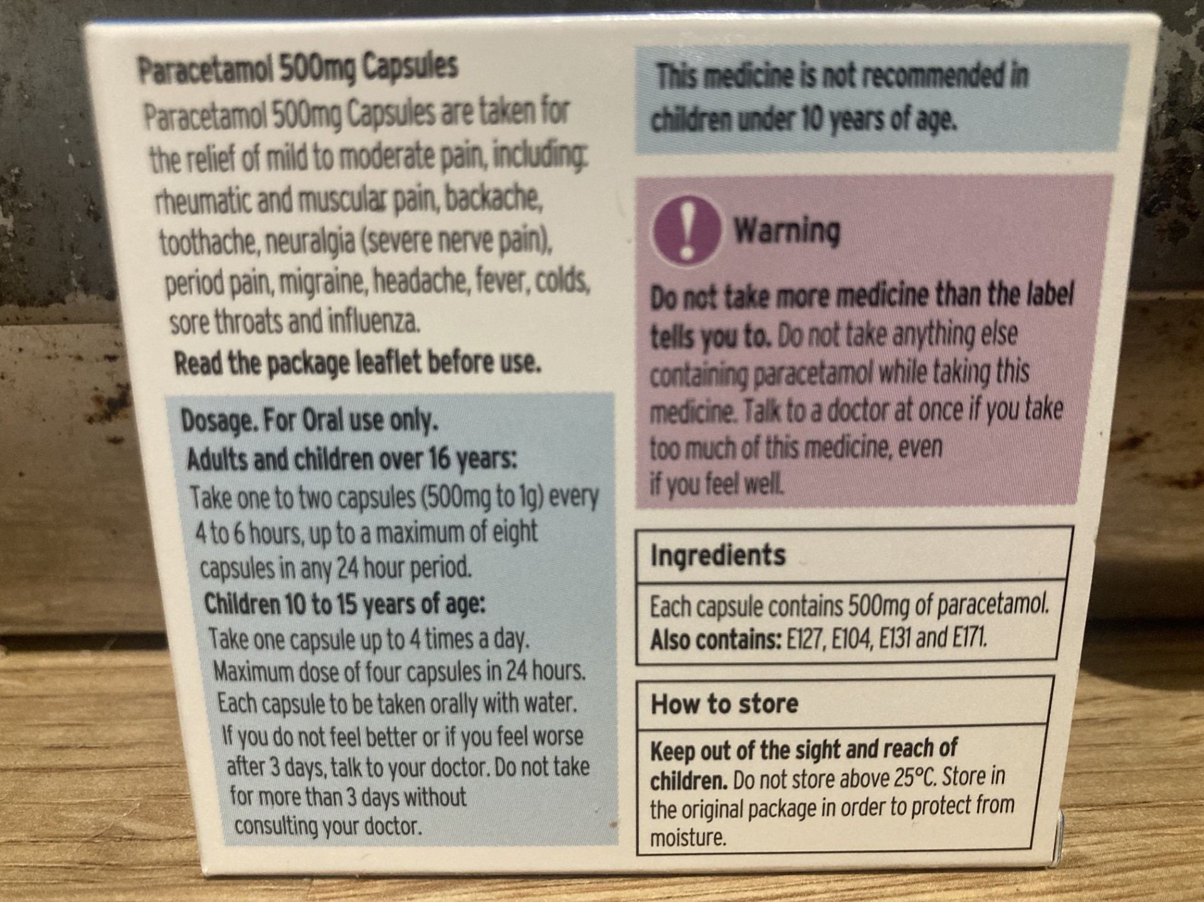
Paracetamols

Dosage:

You will need to take

times per day

How to take:

Orally with water
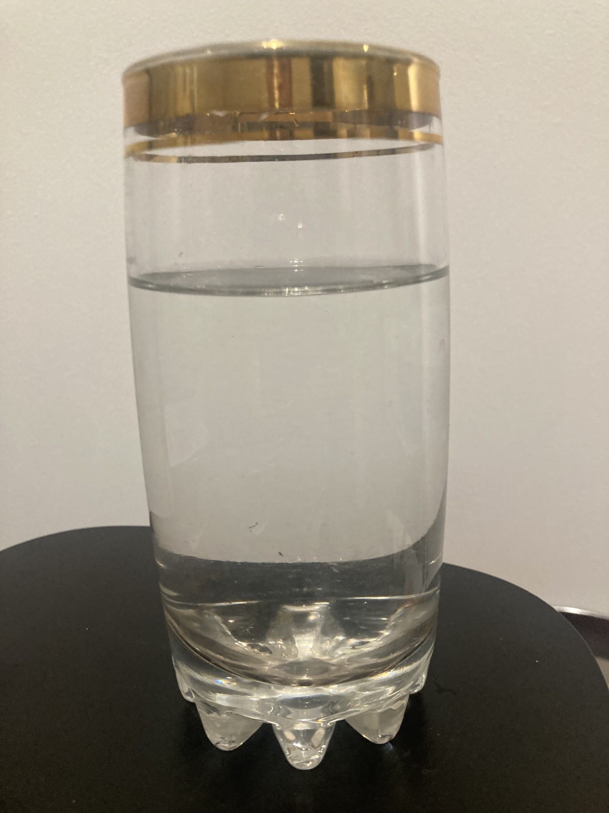

Possible side effects:

Phone 999 if you have any of these side effects

- Swollen lips, mouth, throat, tongue
- Confused drowsy, dizzy
- A rash that is swollen, raised, itchy, blistered or peeling

- your lips, mouth, throat or tongue suddenly become swollen

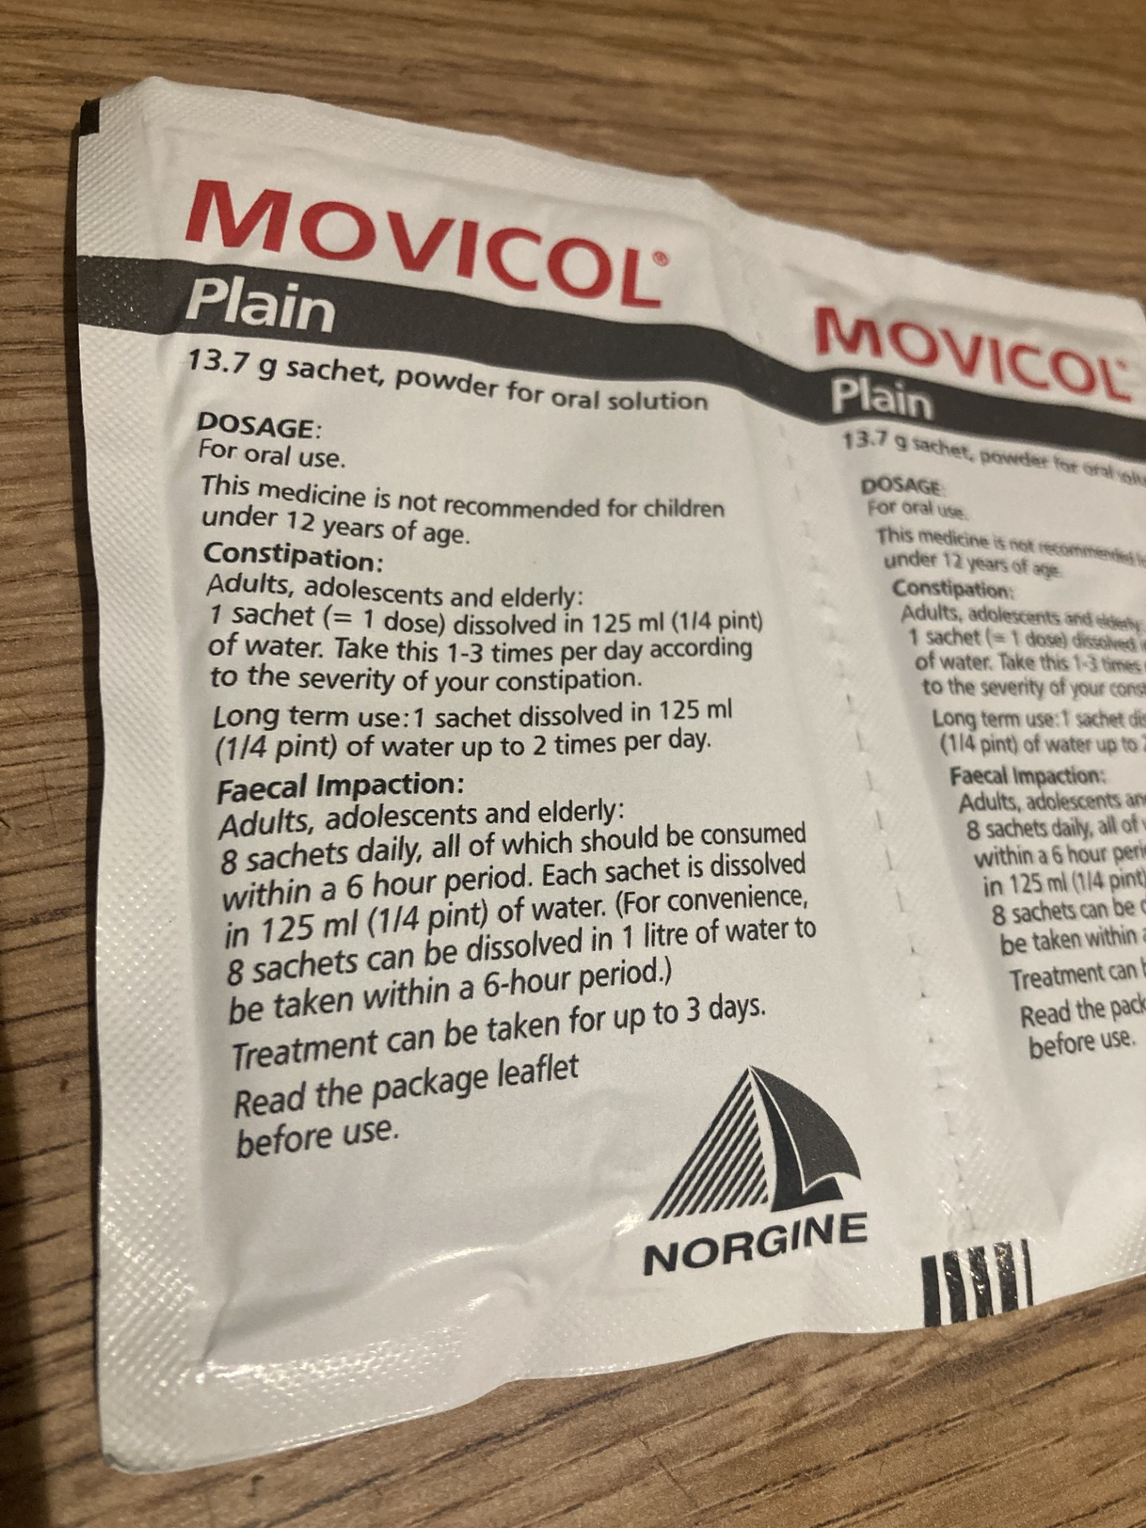
Movicol

You need to dissolve one sachet in ml of water up to three times per day.

Possible side effects:
- Diarrhoea – drink lots of fluids, such as water or squash, to avoid dehydration
- Indigestion
- Stomach pain (rumbles or aches)
- Bloating and wind (farting and burping)
- Feeling or being sick (nausea or vomiting)
- Sore bottom (anus)

How to take a urine sample:
- Take the bottle to the toilet. 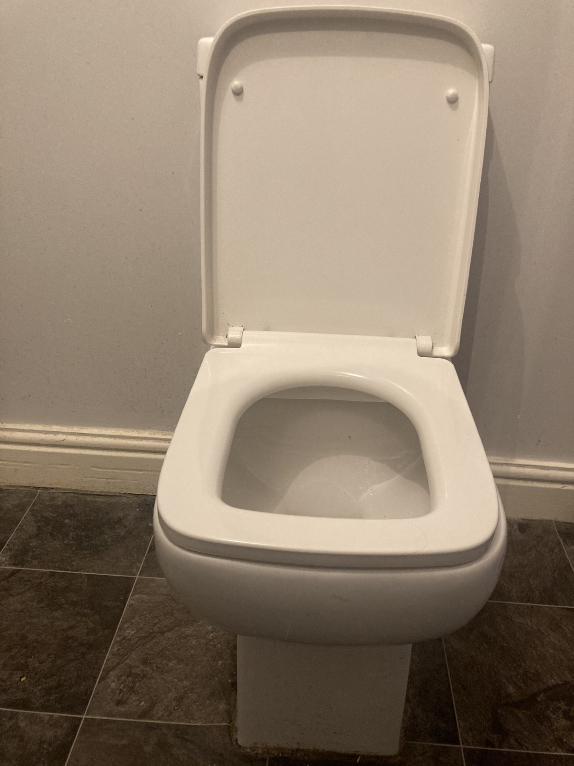
- Open the bottle. 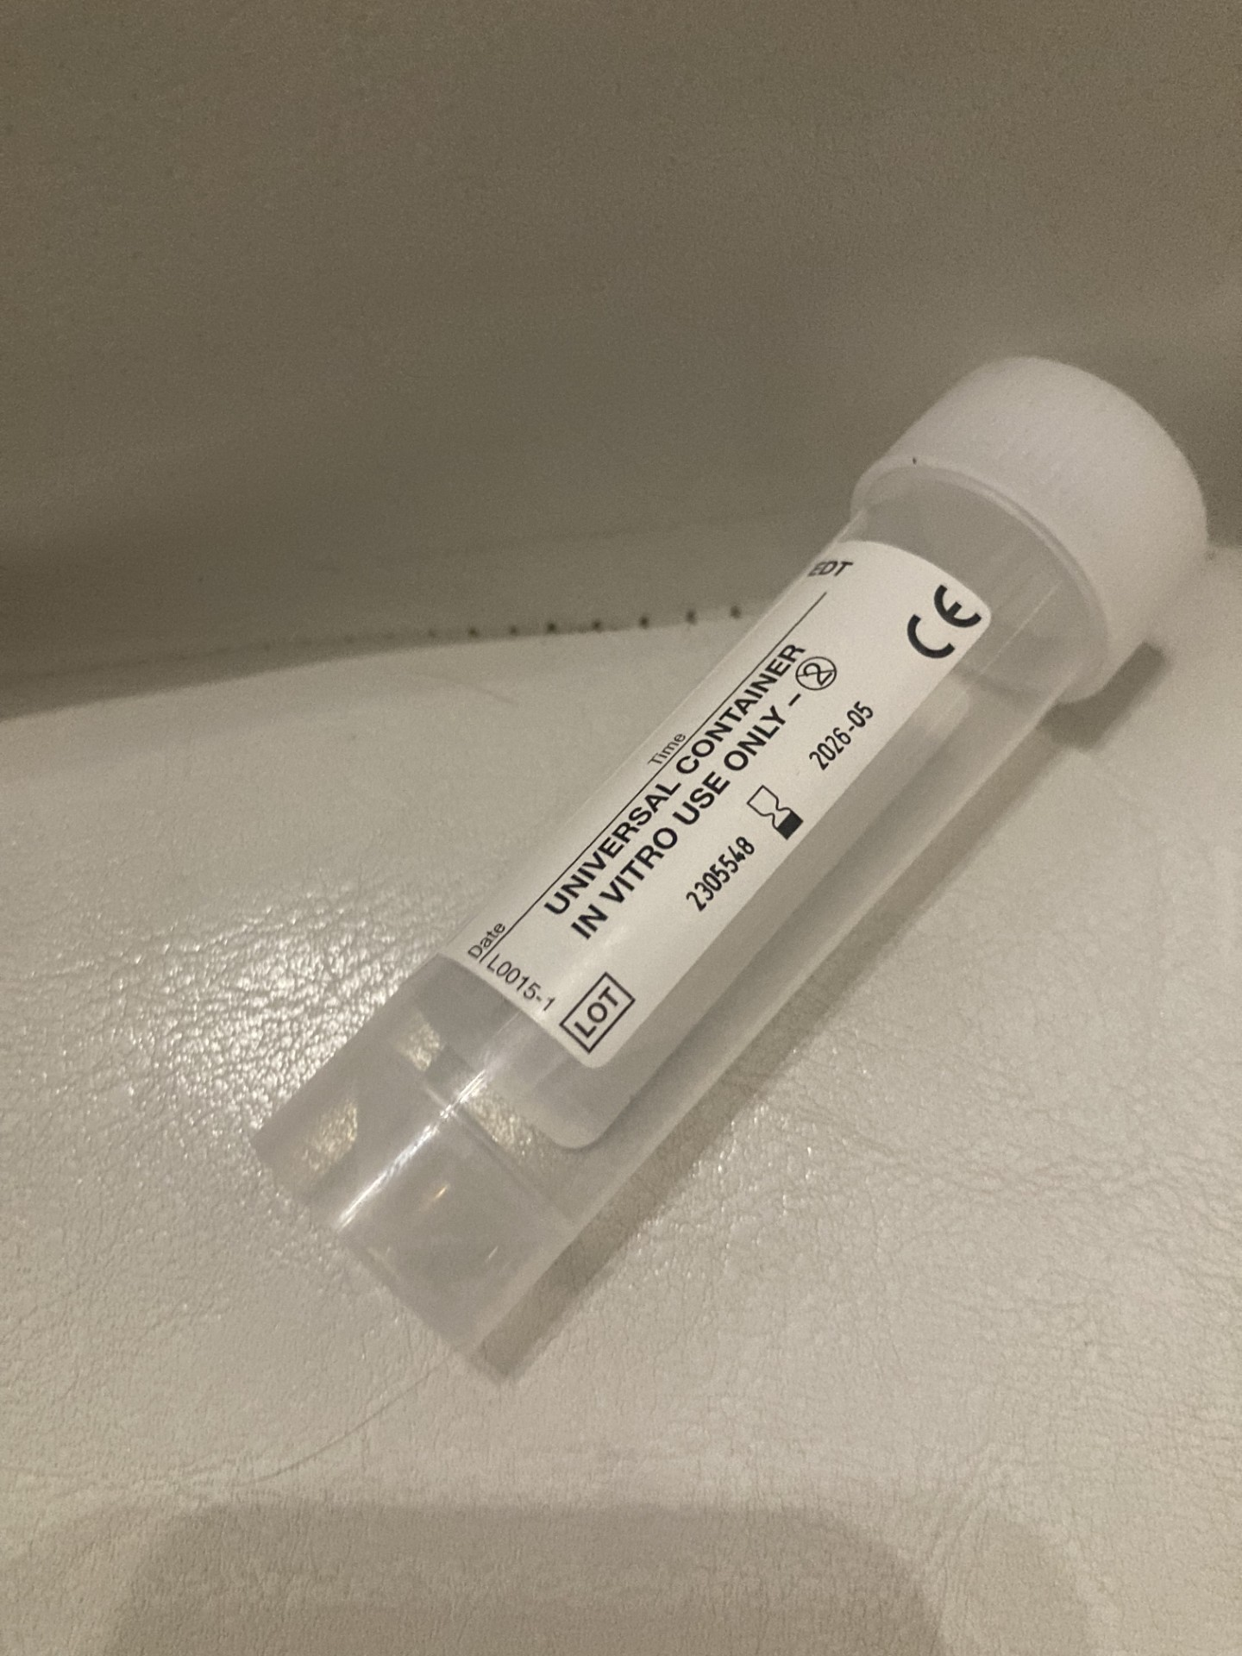

- Urinate into the bottle until the urine reaches the line. Put the lid back on.
- Place the bottle in the bag provided. 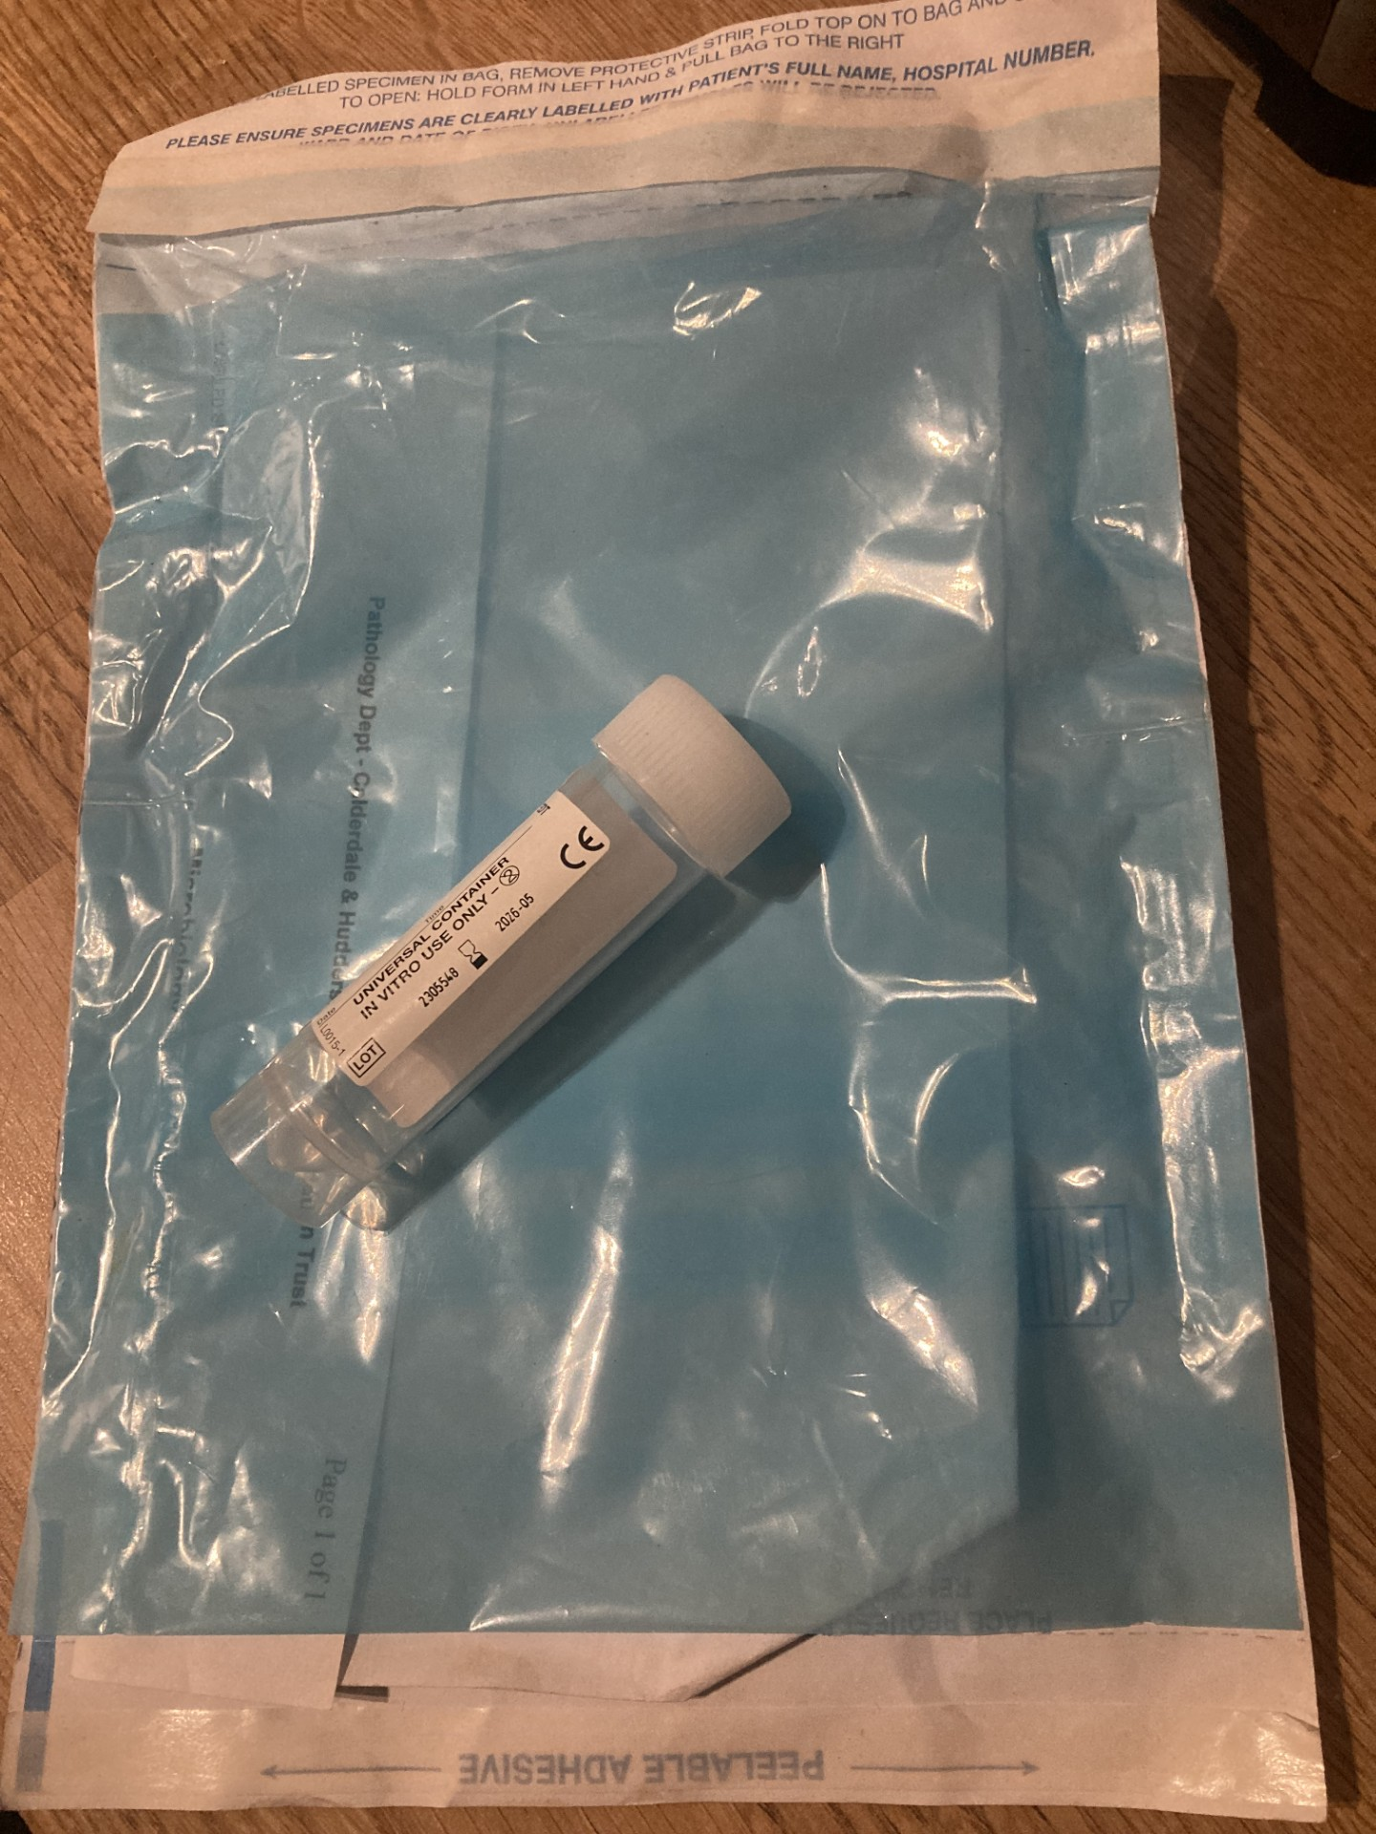

Bring the bag back to the surgery on the same day.

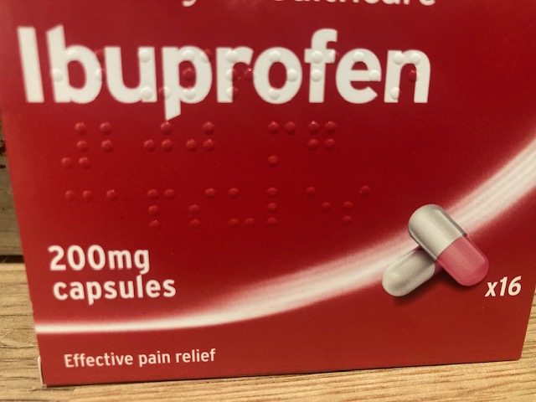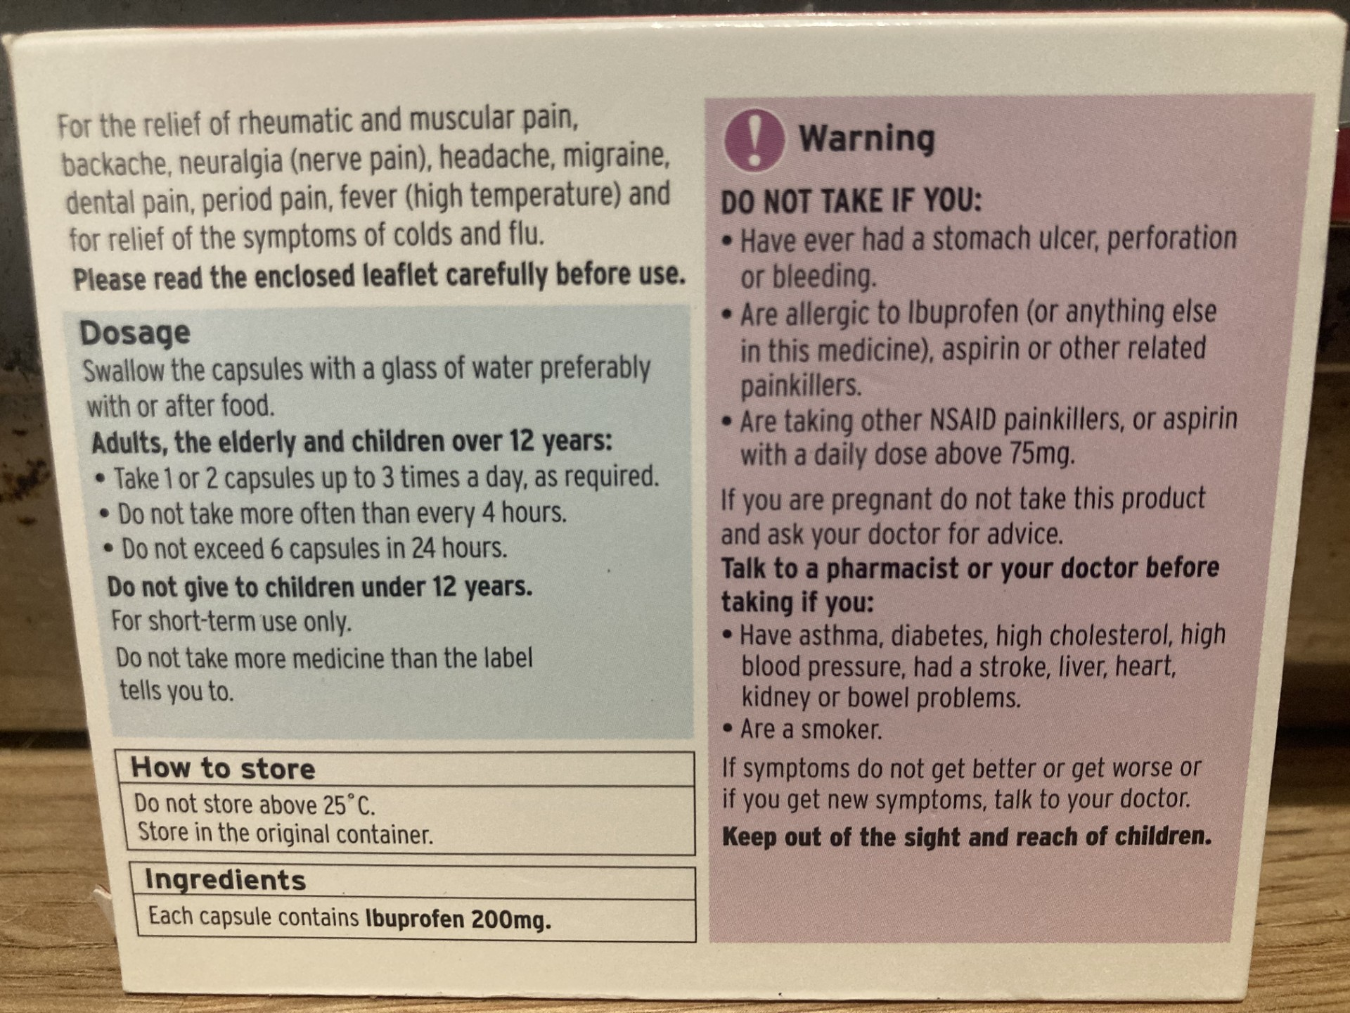
Ibuprofen
Dosage:

You will need to take

times per day

How to take:

Orally with water

Possible side effects include:
- headaches
- dizziness
- drowsiness, fatigue and restless sleep
- thirst and sweating
- tingling or numbness in hands and feet
- ringing in the ears
- blurred vision and eye irritation
- fluid retention and ankle swelling.

New treatment for diabetes type 2 information handout

* Hypothetical new treatment for Type 2 diabetes (GlucoZen)

Overview
GlucoZen is a groundbreaking medication designed to manage type 2 diabetes effectively by targeting multiple aspects of glucose regulation. Its unique formulation and mode of administration make it a promising option for patients seeking improved glycaemic control and reduced reliance on traditional insulin therapy.

How to take GlucoZen

Preparation
Each GlucoZen kit contains pre-filled syringes with both GlucoStab and GlucoReg formulations. Before administration, ensure proper storage according to package instructions (refrigeration may be required). Inspect the medication for any signs of damage or tampering before use.

Administration
- Select an injection site on the abdomen or thigh, rotating sites with each injection to minimise tissue irritation.
- Clean the injection site with an alcohol swab and allow it to dry completely.
- Administer the injection subcutaneously according to the instructions provided by your healthcare provider.
- Dispose of the used syringe and needle properly in a sharps container.

Dosage and frequency
The recommended starting dose of GlucoZen is determined by your healthcare provider based on your individual needs and medical history.

GlucoZen is typically administered once weekly, preferably on the same day each week, to maintain consistent blood glucose levels.

Monitoring
Regular monitoring of blood glucose levels is essential to assess the effectiveness of GlucoZen and adjust the dosage as needed. You may also monitor other parameters such as kidney function and electrolyte levels periodically.

Safety considerations
GlucoZen may cause side effects such as mild injection site reactions, urinary tract infections and hypotension. Check any pre-existing medical conditions, allergies or medications being taken before starting GlucoZen. Seek medical attention if you experience severe or persistent side effects while taking GlucoZen.

Conclusion
GlucoZen offers a convenient and effective treatment option for patients with type 2 diabetes, providing sustained glycaemic control with once-weekly administration. By combining insulin sensitisation and renal glucose excretion, GlucoZen addresses multiple pathophysiological mechanisms underlying type 2 diabetes, offering hope for improved outcomes and quality of life for patients.
Multidisciplinary team meeting activity (patient C care plan review) handout

Instructions

- Allocate roles to each of the group members (care coordinator (diabetic nurse) / consultant clinician / dietitian / healthcare support worker).

- Act out the role play.

- Complete the goal-setting sheet for patient C while still in your roles.

Care coordinator (diabetic nurse): Informal presentation format of patient C data

Introduce yourself and invite the other team member to introduce themselves.

Profile: Patient C is an 80-year-old woman who was diagnosed with type 2 diabetes 15 years ago. She lives alone in her own home and manages her diabetes with oral medications and dietary modifications. Patient C has recently been experiencing difficulty in controlling her blood sugar levels. Her primary care physician has referred her for additional support from a multidisciplinary team including consultant clinician, diabetic nurse, dietitian and a healthcare support worker.

* Ask the consultant clinician to give an overview of patient C’s situation from an evidence-based practice perspective.

Consultant clinician: Formal presentation format data in relation to patient C evidence-based practice

NICE guidelines state that blood sugar level should be 48mmol/mol or less (this is the same as 6.5 per cent or less). Keeping your HbA1c level under control means it is less likely to lead to other problems caused by diabetes. We need to decide a target level for patient C that does not cause her problems (such as a lot of hypos) and help her reach it.

Furthermore, in accordance with the British National Formulary (BNF) HbA1c should usually be measured in patients with type 2 diabetes and monitored every three to six months until HbA1c and medication are stable, at which point monitoring can be reduced to every six months. This is what I recommend for patient C.

Best practice guidelines should be used to monitor patient C’s blood sugar levels and review medications.

* Ask the nurse to give an overview of patient C’s medical history and presenting issues.

Care coordinator (diabetic nurse): Informal presentation format of patient A data

Medical history:
- Type 2 diabetes diagnosed 15 years ago
- Hypertension controlled with medications
- Osteoarthritis affecting her mobility
- History of mild cognitive impairment

Presenting issues:
- Poor glycaemic control despite adherence to oral medications and dietary modifications
- Limited mobility due to osteoarthritis, impacting physical activity levels
- Challenges with meal planning and portion control
- Concerns about potential hypoglycaemia and medication side effects

* Suggest that patient C’s needs to be collaborated with to develop a personalised diabetes management plan. Ask the dietitian if they would like to add anything.

Dietitian: Case study presentation format

I would like to conduct a comprehensive dietary assessment to identify patient C’s current eating habits, nutritional status and dietary preferences. I will provide individualised nutrition counselling focused on carbohydrate counting, meal timing and portion control to help stabilise blood sugar levels. In addition, I will discuss incorporating healthy food choices into patient C’s daily routine while considering her taste preferences, cooking abilities and budget constraints.

Healthcare support worker: Interactive presentation format

I spend a lot of time with patient C. I believe she would benefit from some health education on the importance of

local support groups – online information – social interaction

How does this sound? Shall we discuss patient C’s goals?

Adapting style format for stakeholder activity sheet

A healthcare organisation is implementing a new electronic medical records (EMR) system:

Hospital administration
Focus on the efficiency and cost-saving benefits of the EMR system. Highlight how the new system will streamline administrative processes, reduce paperwork and improve resource allocation. Emphasise the potential for increased revenue through improved billing accuracy and reduced documentation errors.

Healthcare professionals
Highlight the benefits of the EMR system in improving patient care and outcomes. Showcase how the system will provide access to comprehensive patient records, facilitate communication between healthcare providers and support evidence-based decision-making. Address any concerns about workflow disruptions and provide training and support resources to ease the transition.

Patients
Focus on how the EMR system will enhance the patient experience and quality of care. Explain how the system will enable healthcare providers to access accurate and up-to-date medical information, leading to more informed treatment decisions and improved coordination of care. Assure patients of the privacy and security measures in place to protect their sensitive health information.

Insurance providers
Highlight how the EMR system will support accurate and timely documentation of patient encounters, leading to improved billing accuracy and reduced claim denials. Showcase how the system can facilitate communication between healthcare providers and insurance companies, expediting the claims processing and reimbursement process. Address any concerns about data sharing and privacy protections to reassure insurance providers of compliance with industry standards.

* By tailoring the presentation of information to each stakeholder group in this healthcare case study, the organisation can communicate the benefits of the EMR system effectively and address the specific interests and concerns of each party involved.

Activity
In allocated groups, plan a two-minute presentation targeting the stakeholder allocated.
You can create a PowerPoint / use a flipchart / use a whiteboard / create a handout or create leaflets to enhance the presentation. The format(s) selected must be appropriate to the stakeholder and situation. In addition to the presentation, you are required to explain the reasons why the style format has been used.

Peer assessment form (adapting style format for stakeholders)

Topic: Adapting style format for stakeholders

Peer:

Aspects observed | Comments:
Presentation of information | Good points:  Areas for improvement:
Choice of format | Good points:  Areas for improvement:
Effectiveness of the format used | Good points:  Areas for improvement:
Peer assessed by:

Reflection (adapting style format)

Things I do well… | Things I have learnt…
Things I need to improve… | My goal for next time…

Case study / report activity sheet (patient D)

Use the case study (patient D) to research the health issue that features in the information provided. You will then be required to use your research findings to create two five-minute presentations. One presentation will be to the patient, and the second will be for other healthcare professionals.

The presentation to the patient will need to include possible causes of the condition, lifestyle factors that may increase the risk of the condition and factors that could help reduce long-term risks.

The presentation to other healthcare professional will need to include healthcare data which clearly identifies the causes, increased risk factors and risk reduction strategies.

Instructions:

- Read the case study below (patient D).
- Individually, carry out research about the causes, effects and risk factors of hypertension (use reliable UK based resources).
- Decide which format you will be using for the patient presentation and healthcare professional presentation.

Case study (patient D)

Patient D is a female aged 49 with type 2 diabetes. She is classed as morbidly obese and has leg oedema. The patient is in the clinic today for a review of medication and a physical health check. Patient D presents with breathlessness, swollen left and right ankles, low oxygen levels and high blood pressure (hypertension).

During the consultation, patient D informs staff that she smokes 20 cigarettes a day and that she is unable to take regular exercise due to her oedema and painful joints. Her diet mainly consists of fast food that she gets delivered to her home. She also drinks alcohol every evening. Patient D lives in rented accommodation and the landlord is planning on selling the property, and this is a significant cause of stress and anxiety.

Reflection (Core Skill 6: Presenting)

Things I do well… | Things I have learnt…
Things I need to improve… | My goal for next time…

Section 4: Guidance for learners

Guidance materials are provided for learners to make affective use of the Core Skill in the Employer-set project (ESP) assessment.

Overview of ESP
The ESP is one of the assessments for the core of the T Level in Health and is worth 30 per cent of the overall core grade, with the core exams making up the other 70 per cent. The ESP is graded A*-E (with a U for those learners whose assessments do not meet the minimum requirements for a grade).

The ESP is a real industry style brief that is developed with employers. The brief consists of a choice of real lifestyle case studies for you to choose from. You will use your chosen case study throughout your ESP assessment. The brief is designed to enable you to demonstrate your skills and knowledge both practically and in written form. The brief is designed so that you can demonstrate and apply the knowledge and skills you have developed throughout your course.

Throughout the ESP there are six Core Skills that you will need to demonstrate through a series of tasks, which are:

CS1: Demonstrating person-centred care skills
CS2: Communicating
CS3: Team working
CS4: Reflective evaluation
CS5: Researching
CS6: Presenting.

All tasks will be completed under controlled conditions over a set amount of time. This means that there may be restrictions on how you complete your tasks, including the time available, access to resources and how you save documents. You will be given specific details of these before you start the ESP assessment.

You will be required to carry out the following tasks:
- Pre-task activity: Research
- Task 1: Synthesis task – report
- Task 2 (a): Role play
- Task 2 (b): Healthcare plan
- Task 3 (b): Presentation
- Task 4: Reflective account

The pre-task activity is not marked. All of the other tasks hold an equal weighting of marks.

Presenting skills and the ESP

Throughout your learning, you will have developed your presenting skills in many ways, through role play, class activities and presentations using PowerPoint. You will have used digital resources to support your presentations.

In the ESP assessment, task 3b requires you to use presentation skills. In task 3b, you will need to:
- produce and conduct a presentation, with two hours available for planning
- deliver a 15-minute presentation
- answer questions on your presentation for up to 15 minutes.

Your presentation must demonstrate the use of digital presentation aids such as PowerPoint slides.

An examiner will award the marks for this assessment. This examiner will be looking at the recording of your presentation, including the responses to questions. It is important therefore to consider how you appear in the video. This is why the lessons you have had included feedback.

It is important that you can be heard on the video, so consider how you project your voice and how clear you are at articulating your words – this means speaking clearly.

Make sure that you do not stand between the camera and your slide deck and do not stand with your back to camera. Try to stand to the side. As your tutor will probably be sitting next to the camera, if you are looking at your tutor, that will be picked up by the camera. The same applies when answering questions.

When you were developing your presenting skills, you may have had feedback regarding your body language, so it is important to practise using positive body language in your presentations.

The examiner will also look at your digital materials – your PowerPoint presentation slides. You will need to ensure that there are no spelling, grammatical or formatting errors, as such errors would affect the marks you are awarded. Use some of the two hours available for planning to check the slide deck.

It is important to consider the key points you want to communicate in your oral presentation. This will help you to articulate the information well and deliver the information needed in the time available.

You will be marked on your communication skills, including body language, tone, pace, eye contact and rapport with the audience.

You need to connect with your audience. This could be by introducing yourself and the patient that your presentation is concerning. Eye contact is also very important throughout your presentation to keep the connection.

Throughout your presentation, be aware of distracting habits such as shifting body weight, fiddling with hands and saying ‘um’. These should be minimised as much as possible. Try to stand relaxed and maybe clasp your hands in front of you while avoiding crossing your arms.

You are also marked on the use of the digital resources. It is important to make sure you and the digital resources work together to enhance the presentation.

Five considerations for your ESP presentation:
- Bring your presentation to life by telling a story.
- Think about what the audience profile looks like.
- Pitch the presentation to that audience profile.
- Keep it simple.
- Make the presentation interactive.

Using presenting skills to gain marks
There are 20 marks for this task, which is 20 per cent of the total marks for this assessment, showing the importance of applying your skills correctly.

Technical knowledge
There are marks for
- the justification of the care and support outlined in your healthcare plan
- the alterations you make to your healthcare plan following your peer feedback.

This means clearly explaining, using your knowledge of person-centred care, how your proposal meets the requirements of the brief. You therefore need to consider in the structure of your presentation:

- the key requirements of the brief and overview of your chosen case study
- how your role play and healthcare plan meet those key requirements
- the alterations you made to your healthcare plan following peer feedback
- the information you used to support your healthcare plan.

You should think about how you organise your digital presentation to include each of those aspects.

Presentation slide deck
There are marks for how the slide deck is organised to support the presentation. A well organised slide deck will help you with your presentation and gain you marks, so remember to:
  - have an introductory slide with an appropriate title
  - ensure you have considered the use of font and font size in your slide deck
  - have a consistent font size for all slide titles
  - check the spelling on all your slides
  - check your punctuation – particularly full stops and capital letters
  - check the formatting to ensure your content is aligned properly
  - include technical language where appropriate – consider including a definition of technical terms if there is a non-technical audience
  - incorporate advanced techniques such as images, transitions and animations to demonstrate your digital skills.

The presentation
The marks for presenting skills are awarded based on:
- the structure of the presentation – this will show evidence of planning and that consideration has been given to the logical flow of the content
- the terminology used – that it is accurate and appropriate for the target audience.

You can plan for this in your two hours of planning time. You may find it helpful to put key terms on a slide to ensure that you refer to them in the presentation. If you have a non-technical audience, you might want to plan to explain the terms or show the meaning of the terms on one of your slides.

Questions
After you have delivered the presentation, you will be asked questions regarding the information you have delivered. Marks will be awarded for the answers you give to those questions. When answering the questions, you may want to refer to a slide to assist you in answering, particularly if it has technical information or language to help you.

You know that you cannot plan for every possible question that may be asked. The questions will focus on the choices you made during the project, including choices regarding alterations you made to your healthcare plan. You cannot write out a response in advance – a question you expect may not be asked or it could be asked in a different way so that the planned response would not apply. However, it is important to consider the key points you want to raise.

You may be asked some probing questions to encourage you to expand on a particular point you have made. This does not mean that you have said anything wrong. It may entail just adding additional information or clarifying some points.

Consider how to respond to requests for information. Give yourself time to answer. You might want to have a pen and paper to write down the question, as it may be helpful to see it written down. You may want to use the pen and paper to jot down some key points. Give yourself time to think. This is allowed.


FUNDED BY
PRODUCED BY

This programme is funded by
the Department for Education
Stacey Bowers, Calderdale College has produced this resource on behalf of the Education and Training Foundation

